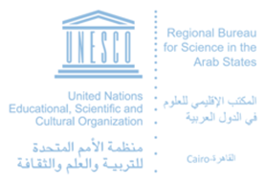

Proposal for Regional Accessibility Week

If you are interested to participate in the Arab Regional ICT Accessibility Week scheduled from 24-28 September 2017 please fill the following form:

Name of Organization:
Event Title:
Event Description:
Date of Propose Event: | Location (City, Country):
Contact details of Focal Point
Name: | E-mail:

Please send the form before the 28th of July 2017 to :
ITU:
- Mr. Karim Abdelghani, Regional Programme Coordinator for Arab States, karim.abdelghani@itu.int

UNESCO:
- Dr. Paul Hector, Advisor for Communication & Information, p.hector@unesco.org
- Ms. Neveen Abd Al Wahab, Programme Asst. for Communication & Information, aa.neveen@unesco.org

