***(This Document is the Property of the Government of the Republic of Zambia)***



**Republic of Zambia**

Enhancing ICT Development and connectivity for the land locked developing Countries

Global South-South Development

Expo Mini partnership forum

**________________________________**

Ministry of Communications and Transport

P.O Box 50065

**LUSAKA**

31st October, 2013

Milner Makuni, [milnermakuni@mct.gov.zm](mailto:milnermakuni@mct.gov.zm), +260977788597

1. **Introduction**
2. Enhancing Information and Communication Technology (ICT) initiatives is important for improving the connectivity of landlocked developing Countries (LLDCs) whose fundamental challenge is related to their lack of direct access to the sea. The Global South-South development expo Mini partnership forum will focus on ways of enhancing and scaling up initiatives on ICTs and will feature how South-South and Triangular cooperation at regional and international levels can help enhance the development of ICTs in LLDCs. The forum shall showcase major achievements and best practices and how to enhance the role of the private and public sectors in development of ICT, including the role of ICTs in climate change adaptation and emergency communication.
3. The Government of the Republic of Zambia was invited on 31st October, 2013 in Nairobi by UN-OHRLLS to make a presentation on how to enhance ICT development in order to accelerate the development of Landlocked Developing Countries based on your country’s experience.
4. Zambia

Zambia is a landlocked country located in Southern Africa between 8◦ S and 18◦ S and between 20◦E and 35◦E. It is surrounded by eight (8) neighbouring Countries. The geographical territory is 752,618 square kilometres. Socio economic indicators as at 31st December, 2013 include the following;

* Gross Domestic Product growth rate - 7.3
* Annual Average Inflation (%) - 6.6
* Exchange Rate - 1USD is equal to 5.12 ZMK

1. National Development Plan
2. The revised Sixth National Development Plan (R-SNDP- 2013-2016) strategic focus is to address the low levels of employment in the economy, investing in rural development and reducing widening inequalities in the economy. The strategies will include:

* Infrastructure Development;
* Employment and Job Creation;
* Rural Development; and
* Human Development.

In order to fulfil the strategic focus of the R-SNDP and its broad objectives, infrastructure development will be the main anchor of development process driven by ICT and Science and Technology.

1. **E-Government**
2. E-Government has been identified world-wide as a powerful enabler of good governance and catalyst for socio-economic development and promotes competitiveness.
3. In 2013, the Government of the Republic of Zambia enhanced the mainstreaming of ICT in key sectors of the economy in order to promote innovation, improve efficiency and thereby accelerate development. Specifically Government will promote the utilisation of electronic means in the delivery of goods and services in the following sectors; agriculture, health, education, business and local Government.
4. Examples of e-government implementation in 2013 include the online tax web based system by the Zambia Revenue Authority. Furthermore, Government commenced the integration of communications infrastructure that would enable each ministry and public sector agency to communicate and share information effectively and efficiently through the Government Wide Area Network (GWAN) and Data Centre in a secured environment. The Quasi-government telecommunication company, ZAMTEL was awarded the contract in June, 2013 and has since commenced ICT installation and upgrading optic fibre in sixteen Ministries out of the 20 Ministries as at 30th September, 2013. ZAMTEL is expected to connect 16 Ministries in Lusaka in phase 1 by 31st December, 2013.

A Government informational Web Portal was developed in April, 2013. The web portal is an online platform providing information on different government services across public service institutions. Informational Portal is functional - <http://www.zambia.gov.zm/>.

Transactional Portal – The next Phase of web services is for an interactive web portal that provides transactional services. The following services have been prioritised for implementation during Phase 1 (January to December,2013) ;

1. National Identity
2. Lands Management
3. Taxation
4. Motor Vehicle and Driver Licensing
5. Business and Company Registration
6. **Extension of Information and Communication Technology services to un served and underserved areas.**

In order topromote the widespread availability and usage of electronic communication services throughout Zambia, and to bridge the digital divide between urban, peri-urban and rural areas, Parliament in 2009 passed the Information and Communications Technology (ICT) Act No 15 of 2009. The ICT act established a Universal Access and Service Fund to address the provision of electronic communications services in un-served or under-served areas and communities. The Ministry in June 2012 issued statutory Instrument No. 38 to guide the operation of the fund. In 2013, a private telecommunication service provider was awarded a tender to implement Mobile Communication services to cover 169 chiefdoms and other un-served areas.

1. **Interconnecting and Sharing of ICT Infrastructure**

The Government issued a Statutory Instrument on Interconnection, Co-location and Access. The SI aims to provide a legal and regulatory framework for interconnecting and sharing of ICT infrastructure amongst the operators to support growth of the sector, to avoid duplication of infrastructure, to ensure equitable access and to ensure delivery of efficient and affordable services to the customers. This will in turn reduce the cost of communication services in the Country.

1. **Mobile Communication Services**

There are three Mobile service providers namely; ZAMTEL, MTN and AIRTEL which collectively have a subscriber base of over 10,666,580 Million, reflecting a penetration of 78.05% per 100 inhabitants, which is above the average figure for Africa 59.8%.

There is a growing number of mobile applications due to increased demand and usage. Mobile money transfer services have increased and customers send money, buy airtime, and make basic utility payments using their mobile phones.

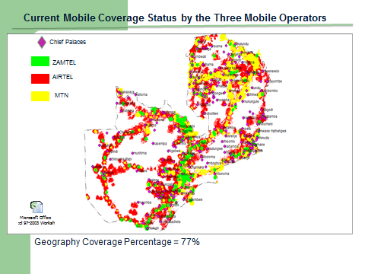

1. **Fixed Telephone line service**

The fixed line service (PSTN) continued to experience a somewhat stagnated growth. In the second quarter of 2013, there were 85,185 subscribers to the fixed line service.

1. **Internet**

There are more than 27 licensed Internet service providers. The traditional fixed internet subscription stood at 17, 717 in the second quarter of 2013. Whilst the mobile internet segment continued to grow. As of June 2013, there were 2,626,840 subscribers. The mobile internet user penetration stood at 19.46% at the end of the second quarter of 2013.

1. **National Connectivity – Optic Fibre**

In terms of national fibre backbone infrastructure, three operators namely ZESCO, ZAMTEL and CEC -Liquid have optical fibre networks providing the backbone infrastructure.

On fibre connectivity, **35 districts** are connected to fibre either through ZESCO, ZAMTEL or CEC Liquid and 7 additional districts will be connected by December, 2013.

Duplication of Infrastructure in urban areas that is along the line of rail. Internet costs still high despite fall of internet bandwidth worldwide. However, growth in Mobile Internet encouraging. Consideration being sought through the broadband policy on enhancing the National Optic fibre backbone

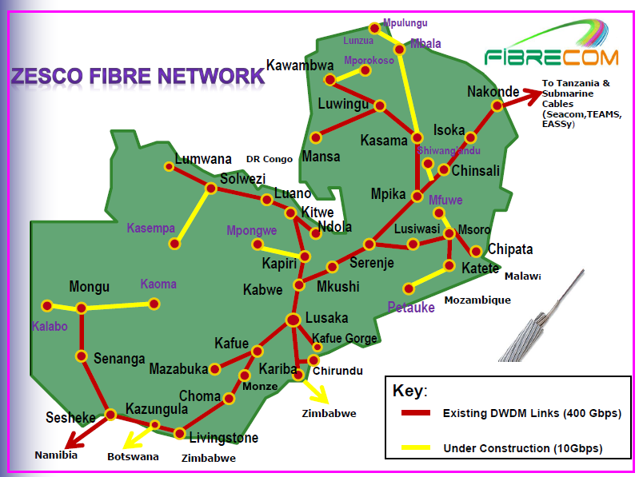

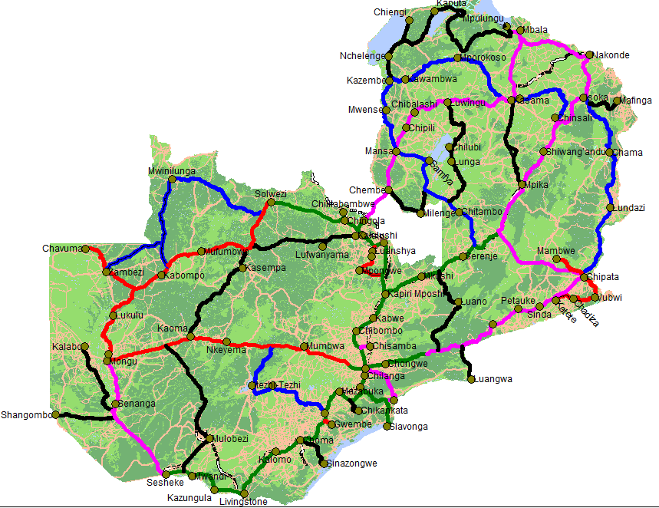

1. **OPTICAL FIBRE –International Connectivity**
   * There are a number of existing optical fibre cables on both the eastern and western Africa seaboard linking Africa to Europe (Seacom, EASSy, SAT 3, SAFE and WASC.
   * Zamtel, MTN as well as Airtel have capacity investments in some of the undersea cables,
   * Zambia is currently connected to the undersea fibre cables through Namibia and Tanzania.
   * Once the sufficient interconnection with undersea fibre cables is done it is anticipated that there will be abundant bandwidth and that prices for internet connectivity will substantially reduce.

[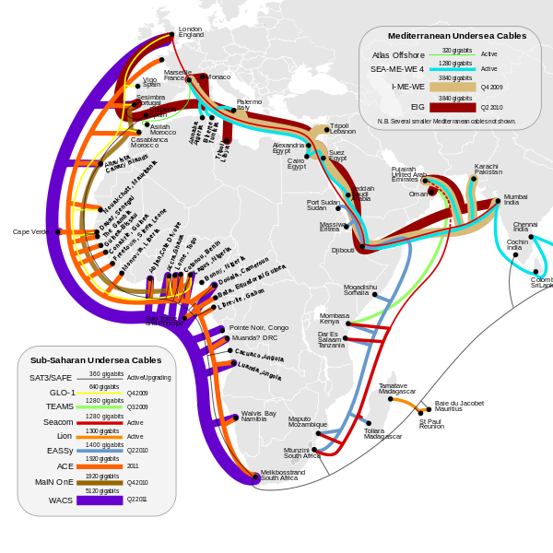](https://upload.wikimedia.org/wikipedia/commons/d/d4/Cable_map18.svg)

1. **Challenges**
2. Inadequate ICT skilled human resource
3. High cost of service provision
4. Limited broadband infrastructure across the country
5. Lack of local content targeting citizens and businesses
6. Poor utilisation of ICTs in public service delivery
7. Lack of weather data capture and processing facilities; and
8. Limited utilisation of ICTs for commerce by private sector
9. Lessons learnt
10. Internet service costs inland proved more expensive than internet service through access to the sea cable hence need to review some of our carrier of carrier service provider cost structure in country
11. Government provision of appropriate electronic services can enhance relevant content on internet
12. Collaborative initiative with private sector can facilitate extension of ICTs to un served and under served areas in a more cost effective way
13. Success of E-Government depends on greater business preparedness, competency in change management and effective business process re-engineering. Managing the many linked dependencies and risks between individual service delivery areas of the E-Government strategy and realizing the benefits of change poses a number of challenges.
14. The increased mobile growth is an opportunity for mobile applications deployment and access of electronic services by the majority citizens and businesses.
15. Appropriate ICT for development policy, regulatory environment and strategies are required to exploit the use of ICT in socio-economic development.