
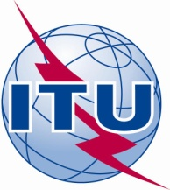
Build on Broadband: A Winning Formula for the Millennium Development Goals
ITU Side Event at the Fourth UN Conference on the Least Developed Countries
Istanbul, Turkey, 10 May 2011
8:00- 9:45 a.m.
Tophane Hall, Istanbul Congress Centre (ICC)

Tad Deriso
President & CEO
Mid-Atlantic Broadband Cooperative
United States

- The potential of broadband technology to help meet the MDGs
- Key discussion points

- Open-access fiber optic backbone networks create new opportunities for private sector participation;
- Public funding of open networks are key element in creating environment for private sector telecom investments in rural areas that have a higher hurdle rate for return on investment analysis;
- MBC, as an operator of a wholesale, open-access network in Rural Virginia since 2006, has seen first hand how those networks lead to improved broadband capacity for schools, and lower the cost of access;
- Economic development trends surrounding cloud computing and data centers create unique opportunities for rural areas that have access to open-access fiber backbone networks;
- Political support and building consensus on open-access fiber network initiatives and policies should not be taken lightly. A strict adherence to wholesale services and availability of dark fiber for providers will help increase the acceptance for new backbone initiatives that use public funding;
- Keep operational costs at a minimum, and use smart strategies to determine in-house capabilities versus outsourced functions.

