Document CWG-COP-21/INF/11
18 September 2024
English only
Contribution by United Kingdom
THE UNITED KINGDOM’S REGULATORY APPROACH UNDER THE ONLINE SAFETY ACT
Purpose
Update on the UK’s regulatory approach to Child Online Protection under the Online Safety Act.
Action required
This report is transmitted to the Council Working Group on child online protection for information.
_______________
References
See Resources section below.

The UK’s regulatory approach to protecting children online
The UK passed the Online Safety Act (OSA) in October 2023 with the aim of creating a safer life online for users of online services. The OSA does this by adopting a “systems and processes” approach to online safety. This means that online services within scope —including search engines and services which host user-generated content— must take proactive steps to identify and mitigate risks of harm to consumers, including children. Such an approach is intended to prevent harm before it occurs, and contrasts with content-focused regulatory approaches where the emphasis is on the removal of content already available, with consequent impacts on freedom of expression.
The new rules under the OSA will be implemented in three phases:
1 Codes of practice and guidance related to protecting users from the most serious harms such as terrorism and child sexual exploitation and abuse (CSEA)
2 Protecting children. For example, it includes measures related to preventing children from accessing pornographic material and content which encourages or promotes eating disorders
3 Additional duties for ‘categorised’ services which are services that meet certain criteria related to their number of users and risk of harm
Services in scope of the OSA are subject to these rules if they have links to the UK, irrespective of where in the world they are based.
This contribution outlines the key features of the UK’s approach to online safety to support other ITU members considering their approaches to protecting children online, and to encourage international regulatory coherence. It covers:
– Independent regulation
– Respect for Human Rights
– Evidence-based approach
– Systems and processes, including risk assessments and transparency
– Regulatory coherence and international collaboration
– Media literacy.

Independent regulation
The OSA gives powers and duties to Ofcom, the UK’s communications regulator. Ofcom is independent from UK Government and the companies that it regulates, and its duties are set out in statute. It has its own independently appointed Board and Chief Executive - there are no political appointments to Ofcom and it is accountable to Parliament, not Government. Its principal duty is “to further the interests of citizens in relation to communications matters, and to further the interests of consumers in relevant markets, where appropriate by promoting competition”. Ofcom has developed a regulatory approach which is characterised as evidence-based, proportionate and transparent.

Respect for Human Rights
Human Rights abuses can occur on online services, and children are particularly vulnerable to such abuses. Upholding users’ fundamental human rights while protecting users, especially children, from harm is crucial, but not always straightforward.
Ofcom has substantial experience taking decisions with regard to Human Rights and particularly Freedom of Expression. It strives to adopt a holistic and inclusive approach to creating a safer online environment that enables Human Rights to flourish —where there are proper guardrails in place to prevent online harms, discrimination, abuse, and the silencing of voices, and allow for freedom of expression and opinion. This is an online environment where children can learn and explore safely without fear of exploitation, where their best interests are upheld, and where all people have privacy, dignity, and choice around who and what they engage with.
Ofcom has rigorously assessed its plans to ensure they are consistent with Freedom of Expression and Privacy in particular. A key feature of the OSA is that Ofcom will not act as a content regulator with the ability to take down specific pieces of content.
Under the OSA, Ofcom has several specific duties regarding Human Rights, including a general duty to incorporate Human Rights into the exercise of its regulatory activities. The OSA also imposes specific obligations on regulated services, and Ofcom is responsible for ensuring that services adequately meet these duties, for example regarding content of democratic importance. Ofcom conducts Human Rights Impact Assessments which are published as part of public consultations.

Evidence-based approach
Ofcom takes an evidence-based approach to regulating online services, allowing it to target interventions where they matter most. Ofcom has various teams responsible for gathering and assessing evidence:
– Research and Intelligence lead on understanding user experiences and attitudes through quantitative and qualitative consumer research and passive monitoring tools, as well as understanding the online industry through the analysis of industry datasets.
– Behavioural Insights houses our behavioural economics and psychology expertise, particularly in using online randomised controlled trials.
– Media Literacy research team publish annual reports on adults’ and children’s media literacy, as well as deep dive analysis on relevant topics.
– Economics and Analytics help us to understand the characteristics of online businesses and their incentives to behave in certain ways, alongside evaluating the impact of services’ safety measures.
– Trust and Safety, Technology Policy, and Data Innovation teams provide technical expertise in assessing current and emerging technologies used by online services.
Ofcom has invested in an extensive programme of research to date, with its recent annual report outlining over 40 separate pieces of research related to online safety that Ofcom has undertaken to inform its approach. This includes research on what mitigations online services utilise, what they don’t do and what could be done. Ofcom is committed to working alongside the global community of researchers with whom Ofcom shares common interests so the regulator has also published a research agenda that outlines areas of interest for future research regarding online safety. Alongside this, Ofcom has considered over 500 quality-assured sources that represent children’s own voices, as well as parents, carers, practitioners and other experts. In the past year alone, Ofcom’s research on children’s online experiences has involved speaking to over 15 000 children and 7 200 parents.
Taking an evidence-based approach enables Ofcom to be proportionate and targeted in any interventions, ensuring a balance of protecting users, requiring online services to take action and making sure that action is effective and the burden on online services is proportionate to the risks that users face.

Systems and processes
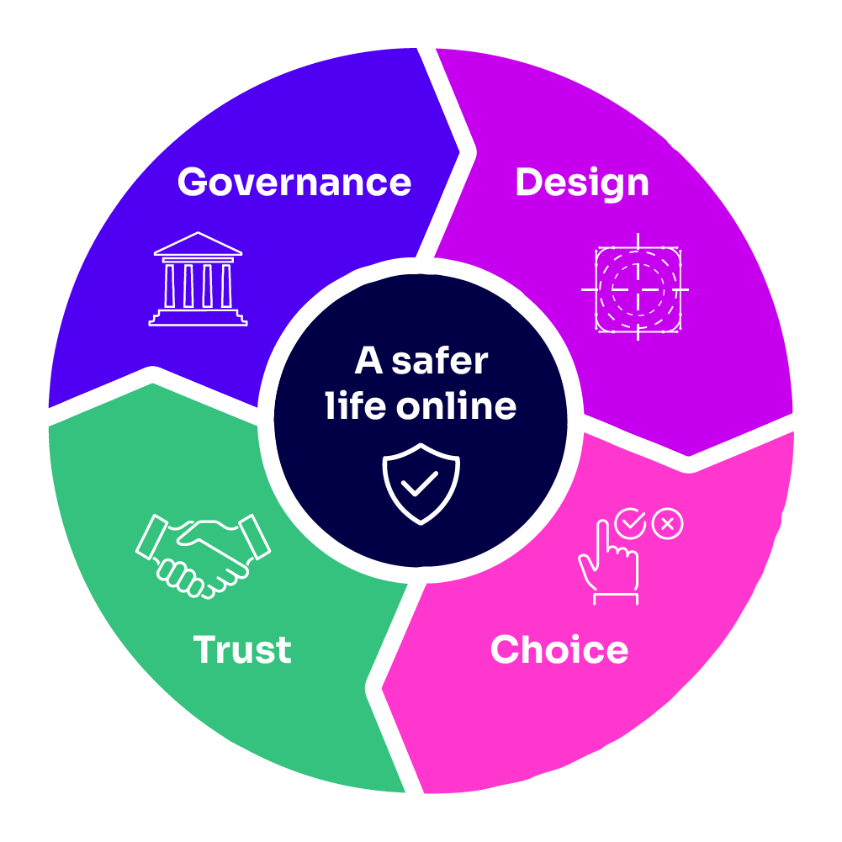
The OSA requires online services to take a “systems and process” approach to ensuring child online safety, by assessing the risk of harm to users of their service and then putting in place safety measures to mitigate against those harms. There is a particular focus on children, for example preventing child sexual exploitation and abuse (CSEA), suicide and eating disorder content.
The OSA contrasts with content-focused regulatory approaches where the emphasis is on removal of content within specified timeframes, and concern is often voiced about consequent impacts on freedom of expression and other human rights, particularly for members of minority or marginalised groups.
Services are required to be accountable for the safety of their child users through structured internal governance and accountability measures. They must also give children more practical tools to control and shape their online lives, such as giving them options to decline group invitations, blocking and muting user accounts and disabling comments on their own posts. Some examples of what we mean by systems and processes are included below.
This approach is intended to ensure that online services are obliged to ensure their services adequately address child online protection thus preventing harm rather than reacting after incidents have taken place. It also enables a more flexible and sophisticated response to risks to children online, that can potentially evolve to adaptations and emerging threats more readily than a simple ‘take down’ approach.
Risk assessments are a key feature of good governance and as such, the OSA requires online services to carry out risk assessments and to keep these up to date. The purpose of the risk assessment is to ensure online services have an adequate understanding of the risks that arise from their service, so that they can take suitable measures to manage and mitigate those risks. The OSA requires online services —many for the first time— to take responsibility for identifying and mitigating the risks that their services pose and designing the service in such a way as to protecting children online. The risk assessments must be ‘suitable and sufficient’ and written records must be kept.
Ofcom’s evidence-based approach found widespread support in best practice industry frameworks and standards for providing guidance on risks assessments as well as adopting a staged and iterative process. Ofcom must publish guidance to assist online services with undertaking risk assessments and it has published draft guidance which it is consulting on.
Transparency is another key feature of the OSA that ensures online services are accountable for protecting children online. It does this in 3 ways:
1 Transparency of online services – Ofcom is required to issue a transparency notice each year to categorised services requiring them to publish the information set out in the notice. Ofcom will also publish its own transparency report at least once a year which will summarise findings from online service transparency reports, and will benchmark best practice. This will shine a light on safety matters, share good practice and highlight where improvements can be made.
2 Transparency of Ofcom’s approach – Trust in Ofcom is central to our ability to operate effectively, so Ofcom ensures to communicate what we are doing transparently. This includes both deliberations and outcomes. For example, Ofcom published its and its approach to international engagement.
3 Open engagement with experts to understand their perspectives – This includes civil society groups, academics, expert bodies, law enforcement agencies and international policymakers. Ofcom has already consulted on two of our online safety codes of practice and is due to publish a third consultation next year.
Transparency is a critical tool to ensure platforms are both proactively and reactively protecting children online, whilst also enabling trust in us as a regulator. Therefore, Ofcom has also consulted on its transparency reporting guidance and its information guidance regarding information gathering powers.

Regulatory coherence and international cooperation
With global online services now being required to comply with online safety legislation in multiple jurisdictions there is a growing risk that compliance will become increasingly difficult for companies subject to regulation. The idea of regulatory coherence is not that regulation should be developed at the international level, or that national regimes should converge on a single model. Rather, it is that national regimes should develop with an awareness of others, and that by sharing good practices and approaches, and elements of the regulatory toolkit, regulators can make it easier for companies to comply across jurisdictions, at scale, with legal certainty; and that children are consequently better protected online across all jurisdictions.
A key vehicle for international regulatory coordination is the Global Online Safety Regulators Network (GOSRN). It is the only global space dedicated exclusively to coordination amongst an expert community of regulators on online safety policy development, supervision, and enforcement. Ofcom co-founded the network in 2022 and is the Chair in 2024. This and other international engagement enables Ofcom to develop an approach to regulating for online safety that is informed by international best practice, and to share its own developments with experts at other regulators.

Media Literacy
Alongside the regulation of platforms, the building of media literacy and digital skills is a crucial part of the policy toolkit for protecting children online. While Ofcom has an important role to play, media literacy must be the responsibility of everyone —online platforms in particular, but also parents, educators, third-sector organisations, providers of health and social care, professionals working with children, and others. This is why Ofcom plans to engage with education authorities and schools to encourage and support media literacy education. The UK believes ITU-D can play a valuable role in promoting digital literacy initiatives, in cooperation with other UN bodies like UNESCO, as they empower children and parents to better understand risks and how they can protect themselves. Ofcom published an Evaluation toolkit to support the sector in planning and carrying out media literacy interventions, which has been the subject of a contribution to ITU-D Study Group 2.
Alongside its work supporting underserved communities, Ofcom, with the support and engagement of academics, platforms and interest groups represented on its external working group, has created Best Practice Design Principles for media literacy. These are intended to help online services:
– become accountable for making media literacy a priority and increase transparency surrounding the development and impact of media literacy interventions;
– ensure the development of timely media literacy interventions that put user needs at the centre of the design process; and
– monitor and evaluate media literacy interventions on an ongoing basis.

Conclusion
Ofcom is implementing the UK’s online safety laws in a way that balances the need to take action quickly with the need to establish credible, evidence-based regulation, with proposals tested through fair and open consultation. This is vital to ensure the UK’s regulation is fit for purpose and users have confidence in it. More detail on Ofcom’s implementation plans can be found here.

Resources

International collaboration
– Global Online Safety Regulators Network position statement on human rights and online safety regulation: Position-statement-Human-rights-and-online-safety-regulation.pdf (esafety.gov.au)
– Global Online Safety Regulators Network position statement on Regulatory Coherence: GOSRN Position Statement on Regulatory Coherence (ofcom.org.uk)

Ofcom’s approach to implementing the OSA
– Ofcom’s approach to implementing the OSA: Ofcom's approach to implementing the Online Safety Act
– Ofcom research agenda: Online safety: our research agenda - Ofcom

Evidence base
– Ofcom database of research on protecting children: Protecting children - Ofcom
– Research into risk factors that may lead children to harm online: Research into risk factors that may lead children to harm online (ofcom.org.uk)
– Research on children’s experiences encountering online content prompting eating disorders, self-harm and suicide: Experiences of children encountering online content promoting eating disorders, self-harm and suicide - Ofcom
– Research on understanding pathways to online violent content among children: Understanding pathways to online violent content among children - Ofcom
– Ofcom research on evaluating the effectiveness of online safety measures: Evaluating online safety measures - Ofcom
– Protecting children from harms online - Volume 3: The causes and impacts of online harms to children (ofcom.org.uk)

Media Literacy
– Consultation on Ofcom’s Three Year Media Literacy Strategy 2024-2027: A consultation on Ofcom’s Three-Year Media Literacy Strategy
– Ofcom’s media literacy evaluation toolkit: A toolkit for evaluating media literacy interventions - Ofcom
– Best Practice Design Principles for Media Literacy: Best Practice Design Principles for Media Literacy - Ofcom
– Research on what works in delivering community programmes: What works in delivering community programmes - Ofcom
– Overview of Ofcom’s work to support organisations boosting online literacy skills in local communities: Ofcom supports organisations boosting online literacy skills in local communities - Ofcom

______________

Ofcom’s remit also covers TV, radio and video-on-demand sectors, video-sharing platforms, fixed line telecoms, telecoms security, mobile services, postal services, plus radio spectrum.
See the Communications Act 2003 and Part 7 of the Online Safety Act 2023.
See here and here.
See research available here.

