Recommendation ITU-R SM.2149-0
(09/2022)
Guidance on supplementary elements
on the use of Appendix 10 of the Radio Regulations to convey information related to harmful interference to space radiocommunication services

SM Series
Spectrum management

Foreword
The role of the Radiocommunication Sector is to ensure the rational, equitable, efficient and economical use of the radio-frequency spectrum by all radiocommunication services, including satellite services, and carry out studies without limit of frequency range on the basis of which Recommendations are adopted.
The regulatory and policy functions of the Radiocommunication Sector are performed by World and Regional Radiocommunication Conferences and Radiocommunication Assemblies supported by Study Groups.

Policy on Intellectual Property Right (IPR)
ITU-R policy on IPR is described in the Common Patent Policy for ITU-T/ITU-R/ISO/IEC referenced in Resolution ITU-R 1. Forms to be used for the submission of patent statements and licensing declarations by patent holders are available from http://www.itu.int/ITU-R/go/patents/en where the Guidelines for Implementation of the Common Patent Policy for ITU-T/ITU-R/ISO/IEC and the ITU-R patent information database can also be found.

Series of ITU-R Recommendations
(Also available online at http://www.itu.int/publ/R-REC/en)
Series | Title
BO | Satellite delivery
BR | Recording for production, archival and play-out; film for television
BS | Broadcasting service (sound)
BT | Broadcasting service (television)
F | Fixed service
M | Mobile, radiodetermination, amateur and related satellite services
P | Radiowave propagation
RA | Radio astronomy
RS | Remote sensing systems
S | Fixed-satellite service
SA | Space applications and meteorology
SF | Frequency sharing and coordination between fixed-satellite and fixed service systems
SM | Spectrum management
SNG | Satellite news gathering
TF | Time signals and frequency standards emissions
V | Vocabulary and related subjects

Note: This ITU-R Recommendation was approved in English under the procedure detailed in Resolution ITU-R 1.

Electronic Publication
Geneva, 2022

© ITU 2022
All rights reserved. No part of this publication may be reproduced, by any means whatsoever, without written permission of ITU.

RECOMMENDATION ITU-R SM.2149-0
Guidance on supplementary elements on the use of
Appendix 10 of the Radio Regulations to convey information related to
harmful interference to space radiocommunication services
(2022)
Scope
Administrations operating space radiocommunication systems which encounter instances of harmful interference should use the information in this Recommendation when providing the particulars relating to the harmful interference to involved administrations. The form in this Recommendation should be used to provide supplementary guidance information in the format prescribed in Appendix 10 of the Radio Regulations (RR).
Keywords
Space radiocommunication services, harmful interference, reporting form, Appendix 10
Abbreviations/Glossary
Definition of harmful interference in the ITU RR:
“Interference which endangers the functioning of a radionavigation service or of other safety services or seriously degrades, obstructs, or repeatedly interrupts a radiocommunication service operating in accordance with Radio Regulations” (No. 1.169 of the RR).
BR Radiocommunication Bureau
CDF Cumulative distribution function
CR Circular Letter (Concerning Radio Regulation Frequency Registration)
EESS Earth exploration-satellite service
epfd equivalent power flux-density
FDOA Frequency difference of arrival
GSO Geostationary-satellite orbit
HEO Highly elliptical orbit
IFIC International Frequency Information Circular
LEO Low Earth orbit
LHCP Left-hand circular polarized
MEO Medium Earth orbit
NORAD North American Aerospace Defence (Satellite Catalogue Number)
pfd power flux-density
QTE TRUE bearing (see the most recent version of Recommendation ITU-R M.1172)
RHCP Right-hand circular polarized
RR Radio Regulations
SIRRS Satellite Interference Reporting and Resolution System
TDOA Time difference of arrival
TLE Two-line element set
UTC Universal Time Coordinated
Related ITU Recommendations and Reports
Recommendation ITU-R RS.2106 – Detection and resolution of radio frequency interference to Earth exploration-satellite service (passive) sensors
Report ITU-R SM.2181 – Use of Appendix 10 of the Radio Regulations to convey information related to emissions from both GSO and non-GSO space stations including geolocation information
Report ITU-R SM.2182 – Measurement facilities available for the measurement of emissions from both GSO and non-GSO space stations
Report ITU-R SM.2424 – Measurement techniques and new technologies for satellite monitoring
The ITU Radiocommunication Assembly,
considering
a) that Article 15 of the RR describes the procedure for the resolution of cases of harmful interference;
b) that the resolution of harmful interference affecting space stations requires the cooperation and exchange of information among multiple parties, including the administrations involved, the space monitoring facility, and the ITU Radiocommunication Bureau;
c) that, in accordance with No. 15.27 of the RR, full particulars relating to harmful interference shall, whenever possible, be given in the form in Appendix 10 of the RR;
d) that Appendix 10 of the RR was designed with terrestrial services in mind, its applicability to emissions from space stations is limited;
e) that it would be desirable and helpful for administrations that a common reporting form for all services be established based on the current information in Appendix 10 of the RR;
f) that reporting harmful interference affecting certain radio services may require additional information to that contained in Appendix 10 of the RR;
g) that such dedicated form of reporting harmful interference cases should be kept minimum;
h) that the Satellite Interference Reporting and Resolution System (SIRRS) online application is the primary mechanism (as per CR/435) for formal submissions of reports and subsequent exchanges of information concerning cases of harmful interference affecting space services;
i) that this online application implemented by the Radiocommunication Bureau in response to Resolution 186 of the ITU Plenipotentiary Conference is an open platform that can support the submission of supplementary information in the format of this Recommendation,
noting
a) that Recommendation ITU-R RS.2106 provides a reporting form and guidance for Administrations operating EESS (passive) satellite sensors which encounter instances of harmful interference, in addition to the form in Appendix 10 of the RR;
b) that the additional necessary information in considering f) may be different for the cases of different space radiocommunication services and interference scenarios;
c) that reporting forms and examples mentioned in Annexes 1 and 3 would be useful for administrations and ease their efforts,
recognizing
a) that obligations to eliminate harmful interference are set forth in relevant provisions of the ITU Constitution, the Radio Regulations and bilateral coordination agreements;
b) that No. 15.22 of the RR requests that Member States exercise the utmost goodwill and mutual assistance in the application of the provisions of Article 45 of the Constitution and that of Section VI of Article 15 of the RR to the settlement of problems of harmful interference;
c) that No. 13.2 of the RR stipulates: “When an administration has difficulty in resolving a case of harmful interference and seeks the assistance of the Bureau, the latter shall, as appropriate, help in identifying the source of the interference and seek the cooperation of the responsible administration in order to resolve the matter”;
d) that the continuous synergistic implementation of these actions by all sectors involved in satellite radiocommunications can guarantee that harmful interference is kept to a minimum for the satellite community and end users,
recommends
1 that the guidance information in Annex 1 should, whenever possible, be provided when reporting harmful interference affecting space radiocommunication services under Article 15 of the RR;
2 that the interference scenarios indicated in Annex 2 could be used for guidance when reporting harmful interferences;
3 that the examples with detailed additional information indicated in Annex 3 could be used for guidance when reporting harmful interferences in each interference scenario;
4 that the following Note is part of this Recommendation.
NOTE – This Recommendation is in no way intended to modify the procedure contained in Article 15 and Appendix 10 of the RR but to provide guidance to administrations in dealing with interference to facilitate the course of action to be taken.

Annex 1
Use of Appendix 10 of the Radio Regulations to convey information related to harmful interference to space radiocommunication services

A1.1 Introduction
Article 15 of the Radio Regulations (RR) describes the procedure for the resolution of cases of harmful interference. Full particulars relating to harmful interference shall, whenever possible, be given in the form indicated in Appendix 10 of the RR.
However, Appendix 10 of the RR was designed with terrestrial services in mind, its applicability related to emissions from space stations is limited. This is even more problematic when graphical geolocation information must be conveyed.
Report ITU-R SM.2181 was developed to address these shortcomings and suggests a list of additional information to be attached together with Appendix 10 of the RR when reporting cases of harmful interference related to satellite services. The list of items as suggested in Report ITU-R SM.2181 only mentioned GSO and non-GSO cases while the guidelines in this Annex facilitate a way for reporting harmful interference for the cases of all space radiocommunication services.
These guidelines aim at introducing procedures for reporting cases of harmful interference related to all space radiocommunication services and providing guidance on preparing a report on cases of harmful interference by administrations and the Radiocommunication Bureau, as appropriate. These guidelines are developed based on the procedures for resolving harmful interference as contained in Section VI of Article 15 of the RR to maximize quality and availability of service to the user by minimizing unusable satellite capacity due to interference.

A1.2 Proposal for solution
To avoid confusion and better convey information related to harmful interference to space radiocommunication services, it is desirable to have one reporting form for reporting harmful interference cases of space radiocommunication services. A common reporting form for necessary information related to harmful interference to all space radiocommunication services would be indicated in § A1.5.
However, some of the space radiocommunication services have their special particulars concerning the report. Therefore, § A1.6 shows the supplementary information to treat cases of harmful interference of different space radiocommunication services.

A1.3 Procedures in case of harmful interference
Section VI of Article 15 of the RR provides procedures to be followed by administrations in the case of harmful interference. The following provides the key points of these procedures:
1 The administration responsible for the affected service or satellite carrier (Administration A) shall send to the administration responsible for the station which is likely causing harmful interference (Administration B) full particulars relating to the harmful interference in the form indicated in Appendix 10 of the RR (No. 15.27 of the RR).
2 When informed that a station under jurisdiction of Administration B is likely causing harmful interference to Administration A, the former Administration shall acknowledge receipt of that information as soon as possible (No. 15.35 of the RR).
3 Administration B shall immediately investigate the matter and take all required measures / actions in order to eliminate the harmful interference if it is confirmed that the interfering station is located on the territory under its jurisdiction.
4 If the cooperation between Administrations A and B has not produced satisfactory results, Administration A may forward details of the case to the Radiocommunication Bureau (BR) for its information (No. 15.41 of the RR).
5 In such a case, a request of assistance may also be sent to the Bureau with all the technical and operational details and copies of the correspondence (No. 15.42 of the RR).
In the cases that harmful interference that originate from Administration B cannot be resolved at operator level, the affected satellite licensed operators / earth station users can:
Step 1: Send a letter to its national administration (Administration A) together with the information to be provided when reporting harmful interference (see § A1.5 for description of the information to be provided) to request its help to communicate with the Administration responsible for the station suspected of causing the harmful interference (Administration B) to eliminate the interfering signal.
Step 2: If there is no response from Administration B or if satisfactory results cannot be reached, invite the national Administration A to send a letter to the ITU in accordance with No. 15.41 and No. 15.42 of the RR. The letter to the Radiocommunication Bureau should:
– Request the ITU-R Radiocommunication Bureau to act in accordance with the provisions of Section I of Article 13 of the RR to help resolving the case of harmful interference.
– Provide the facts of the cases, including all the technical and operational details and copies of correspondence between Administration A and Administration B (i.e. the correspondence associated with Step 1 above).

A1.4 Getting geolocation results for the source of harmful interference
In case of GSO satellite networks, the coverage of a satellite depends on its design and its operating frequencies and would normally cover multiple countries. An uplink from any location within the footprint of the satellite antenna could potentially create harmful interference to the satellite. Without knowing the location of the interfering source, it would be difficult, if not impossible, to identify the responsible administration to communicate with and request for elimination of the harmful interference.
To obtain geolocation results, satellite operators and their responsible administrations may already have facilities or sources for performing the geolocation. Telecommunications regulatory authorities of some countries have their own space radio monitoring facilities and some of these stations may be able to assist other administrations to perform geolocation in cases involving satellite interference; information regarding these facilities can be found in Report ITU-R SM.2182 or http://www.itu.int/online/mms/mars/monitoring/l8_station_search.sh. In addition to monitoring/geolocation facilities of administrations, there are commercial companies and satellite operators, which provide geolocation services for customers.
Additional information on interference solutions is included in Section 6 of Report ITU-R SM.2424. It describes the interference type, geolocation principles, geolocation system requirements, techniques for geolocation of transmitter on the Earth and factors affecting geolocation accuracy.

A1.5 Key particulars when reporting harmful interference to space radiocommunication services
The common reporting form for necessary information related to harmful interference to space radiocommunication services is shown below. The classification of the form is in accordance with Appendix 10 of the RR, and item a to item x in Table 1 are extracted directly from it. In addition to this, the other items are determined according to the specific characteristics of space radiocommunication services.
Some items are optional and some are necessary at a minimum to be able to understand and process the report.
TABLE 1
Key particulars concerning the reporting form of harmful interference
General information
1 | Administrations responsible for the interference  (Note: The administration responsible for the station, which is likely causing harmful interference, option – Unknown) | necessary
2 | Notifying Administration of the station receiving the interference  (Note: The notifying administration responsible for the station which is receiving the harmful interference.) | necessary
3 | Other Administrations implicated in the interference case  (Note: Other Administrations responsible for stations which are affected by the harmful interferences.)
Interference scenario
4 | Interference scenario:  A-Earth-to-space / B-Space-to-Earth / C-EESS (passive sensors) / D-Radio astronomy / E-Space-to-space  (Note: Illustrations of interference scenarios are shown in Annex 2.) | necessary
5 | Type of station responsible for the interference: Earth / Space (GSO) / Space (non-GSO) / Terrestrial / Other / Unknown
6 | Type of station receiving interference: Earth / Space (GSO) / Space (non-GSO) / Terrestrial / Other | necessary
7 | Type of stations affected by the harmful interference: Earth / Space (GSO) / Space (non-GSO) / Terrestrial / Other | necessary
Particulars concerning the station causing the interference
a | Name, Carrier-ID or other means of identification  (Note: This item is more designed for terrestrial services.  For uplink interference, it is possible to indicate the interfering earth station or terrestrial emission, when it is known.  For downlink interference and interference between satellites, it is possible to indicate the affecting satellite, therefore its special section reference number such as NORAD ID, ITU filing name, commercial name and the affecting transponder number could be mentioned here.)
b | Frequency measured  (Note: the centre of uplink frequency or downlink frequency)  Date  (Note: Date of the harmful interference spectrum plot taken. It is also possible to describe the occurrence of interference to give more information.)  Time (UTC)  (Note: Time of the spectrum plot taken. If on the above item (date), a range of date is given to describe the occurrence of interference, it is possible to also specify the exact date of the spectrum plot here.) | necessary
c | Class of emission  (Note: Class of emission of the interferer, as defined in RR Appendix 1, is normally difficult to classify, and it is possible to leave this field blank or marked as unknown. When possible, a description of the interference could be provided, such as modulation type, coding type, multiple access type and any additional signal characteristics.)

TABLE 1 (continued)
Particulars concerning the station causing the interference
d | Bandwidth of the interference(s) (indicate whether measured or estimated)
e | Field strength, pfd, epfd, brightness temperature of interfering carrier(s)  (Note: This item is used to describe the measured signal strength. Brightness Temperature is a parameter specially for EESS service. It is also possible to provide spectrum plot instead.)  Date:  (Note: Date of the measurement/spectrum plot.)  Time (UTC):  (Note: Time of the measurement/spectrum plot.)
f | Observed polarization:  (Note: H/V/LHCP/RHCP)
g | Nature of interference  (Note: Item u and item g in Table 1 has been exchanged compared to Appendix 10 of the Radio Regulations. When possible, the characteristics of the interference could be provided:  – Analog modulated carrier  – Digital modulated carrier  – CW clean carrier  – Burst signal  – Frequency hoping  – Frequency sweeping  – Cross polarization  – Co-channel  – Intermodulation  – Unwanted emissions  – Adjacent satellite interference  – Adjacent carrier interference  – Other.  When possible, the reason causing the interference could be provided:  – Antenna pointing error  – Malfunctioning equipment  – Insufficient cable shielding  – Reference to RR No. 15.1 (unnecessary emissions)  – Other) | necessary
h | Location  (Note: It is recommended to indicate the number of the interfering sources (estimated number if possible) and the locations of the interfering sources.  When possible, provide longitude if GSO / (latitude, longitude) if earth station or terrestrial station / satellite ephemeris in TLE format if non-GSO.)
i | Location of the facility which made the above measurements  (Note: The location of the measurement (e.g. where the spectrum plot taken) and the location of facility for performing geolocation and monitoring dish size.)

TABLE 1 (continued)
Particulars concerning the transmitting station interfered with
(Note: For cases of uplink interference, it refers to the earth station transmitting the wanted carrier; for cases of downlink interference, it refers to the space station transmitting the wanted carrier.)
j | Name, call sign or other means of identification  (Note: This item is more designed for terrestrial services. It could indicate name of station notified to ITU, NORAD ID, or commercial name, as appropriate.)
k | Frequency assigned  (Note: The centre frequency notified to ITU.) | necessary
l | Frequency measured  (Note: Both uplink frequency and downlink frequency could be provided.)  Date  (Note: Date of the harmful interference spectrum plot taken. It is also possible to describe the occurrence of interference to give more information.)  Time (UTC)  (Note: Time of the spectrum plot taken. If on the above item (date), a range of date is given to describe the occurrence of interference, it is possible to also specify the exact date of the spectrum plot here.)
m | Class of emission  (Note: Class of emission of the affected frequency assignment as defined in RR AP1.)
n | Bandwidth (indicates whether measured or estimated, or indicate the necessary bandwidth notified to the Radiocommunication Bureau) | necessary
o | Location/position/area  (Note: When possible, provide longitude if GSO / (latitude, longitude) if earth station / satellite ephemeris in TLE format if non-GSO.)
p | Location of the facility which made the above measurements  (Note: It can be the location of where the spectrum plot is taken and monitoring dish size.)
Particulars furnished by the receiving station experiencing the interference
(Note: For cases of uplink interference, it refers to the space station receiving the interference; for cases of downlink interference, it refers to the earth station receiving interference.)
q | Name of station  (Note: It could indicate name of station notified to ITU, NORAD ID, or commercial name, as appropriate.) | necessary
r | Location/position/area  (Note: When possible, provide longitude if GSO / (latitude, longitude) if earth station / satellite ephemeris in TLE format if non-GSO.) | necessary
s | Dates and times (UTC) of occurrence of harmful interference
t | Bearings (QTE) or other particulars  (Note: This item is more designed for terrestrial services. It is possible to leave this field blank.)
u | Class of station and nature of service  (Note: The class of station and nature of service is defined in Table 3 and Table 4 of the Preface in BR IFIC, the preface can be downloaded in http://www.itu.int/en/ITU-R/space/Pages/prefaceMain.aspx.)  (Note: Item u and item g has been exchanged compared to Appendix 10 of the Radio Regulations.) | necessary

TABLE 1 (end)
Particulars furnished by the receiving station experiencing the interference
v | Field strength or power flux-density or brightness temperature of the wanted emission at the receiving station experiencing the interference  (Note: This item is used to describe the measured signal strength. Brightness Temperature is a parameter specially for EESS service. It is also possible to provide spectrum plot instead.)  Date  (Note: Date of the measurement/spectrum plot.)  Time (UTC)  (Note: Time of the measurement/spectrum plot.)
w | Polarization of the receiving antenna or observed polarization  (Note: H/V/LHCP/RHCP.)
x | Action requested  (Note: The action you want the Administration responsible for the station causing the harmful interference to perform.) | necessary

A1.6 Additional particulars when reporting harmful interference to space radiocommunication services
The additional information presented in this section is considered as supplement to Appendix 10 of the RR for the purpose of better understand the interferences.
For Interference Scenario C (EESS (passive)), see Tables in Recommendation ITU-R RS.2106. These Tables define the fields for reporting the system characteristics of the affected EESS (passive) system.
For the Interference Scenarios A (Earth-to-space), the following Table defines the particulars of graphical information, the satellites and geolocation facilities involved in the harmful interference.
TABLE 2
Additional information concerning the reporting form of harmful interference
Graphical information
8 | Spectrum plot of interfering carriers
9 | Spectrum plot of wanted carriers
10 | Geolocation results
11 | Satellite footprint in which the interference is uplinked
12 | Satellite footprint in which the interference is downlinked
Particulars concerning the satellite in which the interferer is appearing
13 | Satellite orbit:
14 | – GSO orbit position (nominal):
15 | – LEO/MEO/HEO orbit:
16 | – Orbital period
17 | – Time of visibility
18 | – Orbit type

TABLE 2 (continued)
Particulars concerning the satellite in which the interferer is appearing
19 | – Name of the satellite system
20 | – Number of satellites in the system
21 | Satellite downlink:
22 | – Frequency range (nominal) (MHz)
23 | – Frequency range measured (MHz)
24 | Transponder in which the interferer is appearing:
25 | – Transponder on satellite
26 | Transponder name/number for uplink
27 | Transponder name/number for downlink
28 | – Polarization (downlink)
29 | – Polarization (uplink)
30 | – Centre frequency (downlink)
31 | – Bandwidth (downlink)
32 | – Centre frequency (uplink)
33 | – Bandwidth (uplink)
34 | – Description/identification of authorized signal
Particulars concerning the facilities making the measurement (for item i)
35 | Name of monitoring station:
36 | – Organization
37 | – Location (country, state, area, town)
38 | – Position of the monitoring station which made the measurements
39 | Geolocation principle  (Note: TDOA/FDOA with 2 satellite, FDOA/FDOA with 2 satellite, TDOA/TDOA with 3 satellite, doppler shift with single satellite)
40 | Satellites used for geolocation measurement:
41 | – Name of the main satellite
42 | – Name of the adjacent satellite 1
43 | – Name of the adjacent satellite 2
44 | Equipment used for interferer detection:
45 | – Antenna type (1st antenna for geolocation)
46 | – Antenna size
47 | – G/T (dB/K)
48 | – Antenna location (country, state, town)
49 | – Antenna type (2nd antenna for geolocation)
50 | – Antenna size
51 | – G/T (dB/K)
52 | – Antenna location (country, state, town)
53 | – Antenna type (3rd antenna for geolocation)

TABLE 2 (end)
Particulars concerning the facilities making the measurement (for item i)
54 | – Antenna size
55 | – G/T (dB/K)
56 | – Antenna location (country, state, town)
57 | Other equipment besides antennas
58 | Interfering signal:
59 | – Frequency measured (downlink) (MHz)
60 | – Frequency calculated (uplink) (MHz)
61 | – Bandwidth (kHz)
62 | – Power flux-density (dBm/m²/Hz)
63 | – Date of measurement (yyyy-mm-dd)
64 | – Time of measurement (UTC)
65 | Ground based geolocation measurement:
66 | – Accuracy Prediction for the measurement
67 | – Interferer position result (Lat./Lon.)
68 | – Interferer location (country, state, town)
69 | – Semi-major axis (km)
70 | – Semi-minor axis (km)
71 | – Orientation of ellipse (true north clockwise)
72 | – Repetition of geolocation measurements
73 | Remark (Note: Any descriptions concerning the interference or measurement could be addressed.)

Annex 2
Illustrations of different interference scenarios and key particulars
to be reported

A2.1 Interference Scenario A (Earth-to-space)
This case describes a geostationary satellite located at 7º East receiving interference from an earth station intended to communicate with an adjacent geostationary satellite located at 9.5º East. The interference signal is retransmitted and received together with the wanted signal by the earth station associated to the geostationary satellite located at 7º East.
Figure 1
Illustration of core elements to be reported in a case of interference in the Earth-to-space scenario
(Interference Scenario A as per item 4 of Table 1)
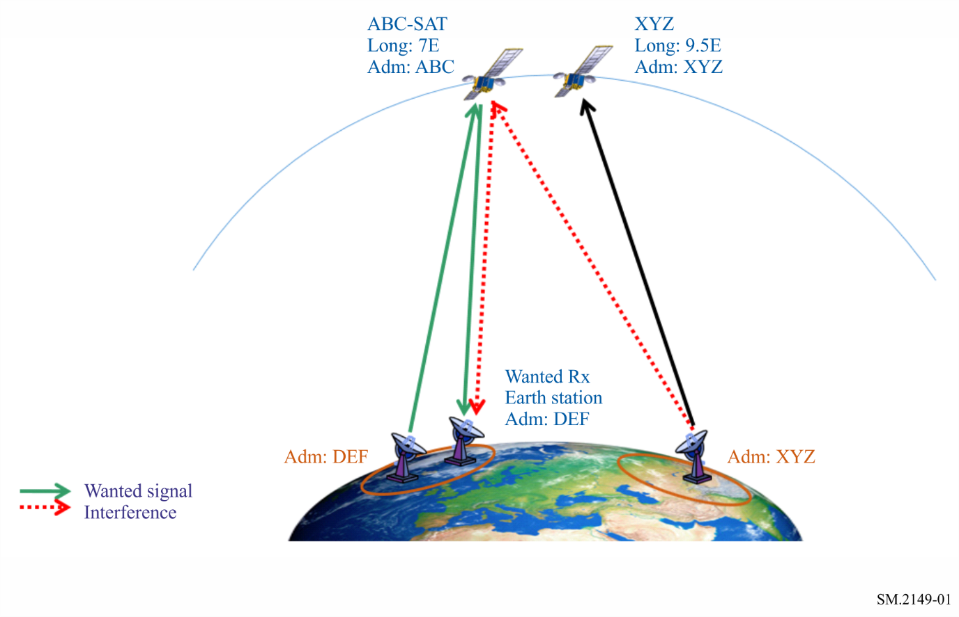
TABLE 3
Key particulars concerning the reporting form of harmful interference
General information
1 | Administrations responsible for the interference | XYZ
2 | Notifying Administration of the station receiving the interference | ABC
3 | Other Administrations implicated in the interference case | DEF
Interference scenario
4 | Interference scenario:  A-Earth-to-space / B-Space-to-Earth / C-EESS (Passive Sensors) / D-Radio astronomy / E-Space-to-space | A
5 | Type of station responsible for the interference: Earth / Space (GSO) / Space (non-GSO) / Terrestrial / Other / Unknown | Earth
6 | Type of station receiving interference: Earth / Space (GSO) /  Space (non-GSO) / Terrestrial / Other | Space (GSO)
7 | Type of stations affected by the harmful interference: Earth / Space (GSO) / Space (non-GSO) / Terrestrial / Other | Earth
Particulars concerning the station causing the interference
a | Name, Carrier-ID or other means of identification
b | Frequency measured  Date  Time (UTC) | 14 008 MHz  See Attached Spectrum Plot
c | Class of emission
TABLE 3 (end)
Particulars concerning the station causing the interference
d | Bandwidth of the interference(s) (indicate whether measured or estimated) | 6 MHz
e | Field strength, pfd, epfd, brightness temperature of interfering carrier(s)  Date  Time (UTC)
f | Observed polarization | V
g | Nature of interference | Antenna pointing error
h | Location | Lat: 15.0123; Long: 30.0123  See attached geolocation map
i | Location of the facility which made the above measurements
Particulars concerning the transmitting station interfered with
j | Name, call sign or other means of identification | DEF
k | Frequency assigned | Uplink: 14 010 MHz  Downlink: 12 080 MHz
l | Frequency measured  Date  Time (UTC) | Uplink: 14 010 MHz  Downlink: 12 080 MHz
m | Class of emission | 36M0G7W
n | Bandwidth (indicates whether measured or estimated, or indicate the necessary bandwidth notified to the Radiocommunication Bureau) | 36 MHz
o | Location/position/area
p | Location of the facility which made the above measurements
Particulars furnished by the receiving station experiencing the interference
q | Name of station | ABC-SAT
r | Location/position/area | 7° E
s | Dates and times (UTC) of occurrence of harmful interference | Date: 04.06.2019, Time: 17:43
t | Bearings (QTE) or other particulars
u | Class of Station and Nature of service | EC, CP
v | Field strength or power flux-density or brightness temperature of the wanted emission at the receiving station experiencing the interference
w | Polarization of the receiving antenna or observed polarization | Uplink: V  Downlink: H
x | Action requested | Eliminate the harmful interference

A2.2 Interference Scenario B (space-to-Earth)

A2.2.1 Case 1
This case describes an earth station associated to a geostationary satellite located at 7º East receiving interference from an adjacent geostationary satellite located at 8.5º East.
Figure 2
Illustration of core elements to be reported in a case of interference in the space-to-Earth Scenario,
originated from a space station
(Interference Scenario B as per item 4 of Table 1)
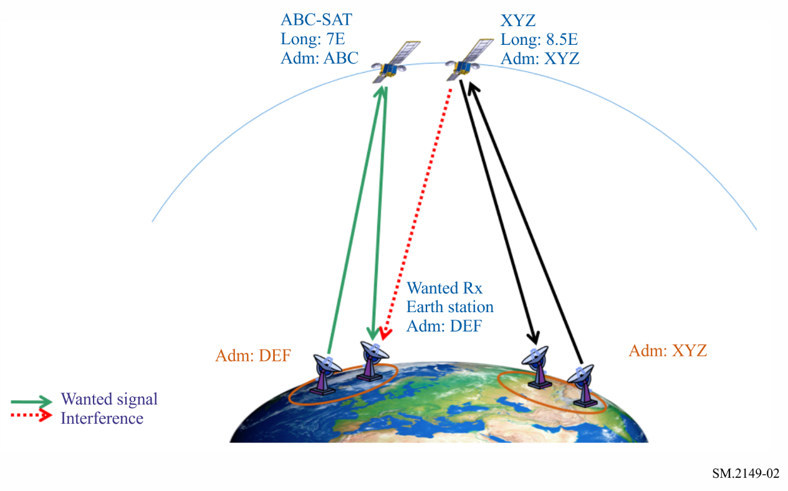
TABLE 4
Key particulars concerning the reporting form of harmful interference
General information
1 | Administrations responsible for the interference | XYZ
2 | Notifying Administration of the station receiving the interference | DEF
3 | Other Administrations implicated in the interference case | ABC
Interference Scenario
4 | Interference scenario:  A-Earth-to-space / B-Space-to-Earth / C-EESS (passive sensors) / D-Radio astronomy / E-Space-to-space | B
5 | Type of station responsible for the interference: Earth / Space (GSO) / Space (non-GSO) / Terrestrial / Other / Unknown | Space (GSO)
6 | Type of station receiving interference: Earth / Space (GSO) / Space (non-GSO) / Terrestrial / Other | Earth
7 | Type of stations affected by the harmful interference: Earth / Space (GSO) / Space (non-GSO) / Terrestrial / Other | Space (GSO)

TABLE 4 (end)
Particulars concerning the station causing the interference
a | Name, Carrier-ID or other means of identification | XYZ-SAT
b | Frequency measured  Date  Time (UTC) | 11 708 MHz  See Attached Spectrum Plot
c | Class of emission
d | Bandwidth of the interference(s) (indicate whether measured or estimated) | 27 MHz
e | Field strength, pfd, epfd, brightness temperature of interfering carrier(s)  Date  Time (UTC)
f | Observed polarization | H
g | Nature of interference | Adjacent Satellite Interference
h | Location | 8.5° E
i | Location of the facility which made the above measurements
Particulars concerning the transmitting station interfered with
j | Name, call sign or other means of identification | ABC-SAT
k | Frequency assigned | Uplink: 14 005 MHz  Downlink: 11 705 MHz
l | Frequency measured  Date  Time (UTC) | Uplink: 14 005 MHz  Downlink: 11 705 MHz
m | Class of emission | 36M0G7W
n | Bandwidth (indicates whether measured or estimated, or indicate the necessary bandwidth notified to the Radiocommunication Bureau) | 36 MHz
o | Location/position/area | 7° E
p | Location of the facility which made the above measurements
Particulars furnished by the receiving station experiencing the interference
q | Name of station | Wanted Rx earth station DEF
r | Location/position/area | Lat: 10.0123; Long: 20.0123
s | Dates and times (UTC) of occurrence of harmful interference | Date: 04.06.2019, Time: 18:19
t | Bearings (QTE) or other particulars
u | Class of station and nature of service | TC, CP
v | Field strength or power flux-density or brightness temperature of the wanted emission at the receiving station experiencing the interference
w | Polarization of the receiving antenna or observed polarization | Uplink: V  Downlink: H
x | Action requested | Eliminate the harmful interference

A2.2.2 Case 2
This case illustrates an earth station, associated to a geostationary satellite located at 7° East, receiving interference in the ground segment originated from terrestrial systems (e.g. fixed, land mobile or mobile base station).
Figure 3
Illustration of core elements to be reported in a case of interference in the space-to-Earth Scenario,
originated from a terrestrial station
(Interference Scenario B as per item 4 of Table 1)
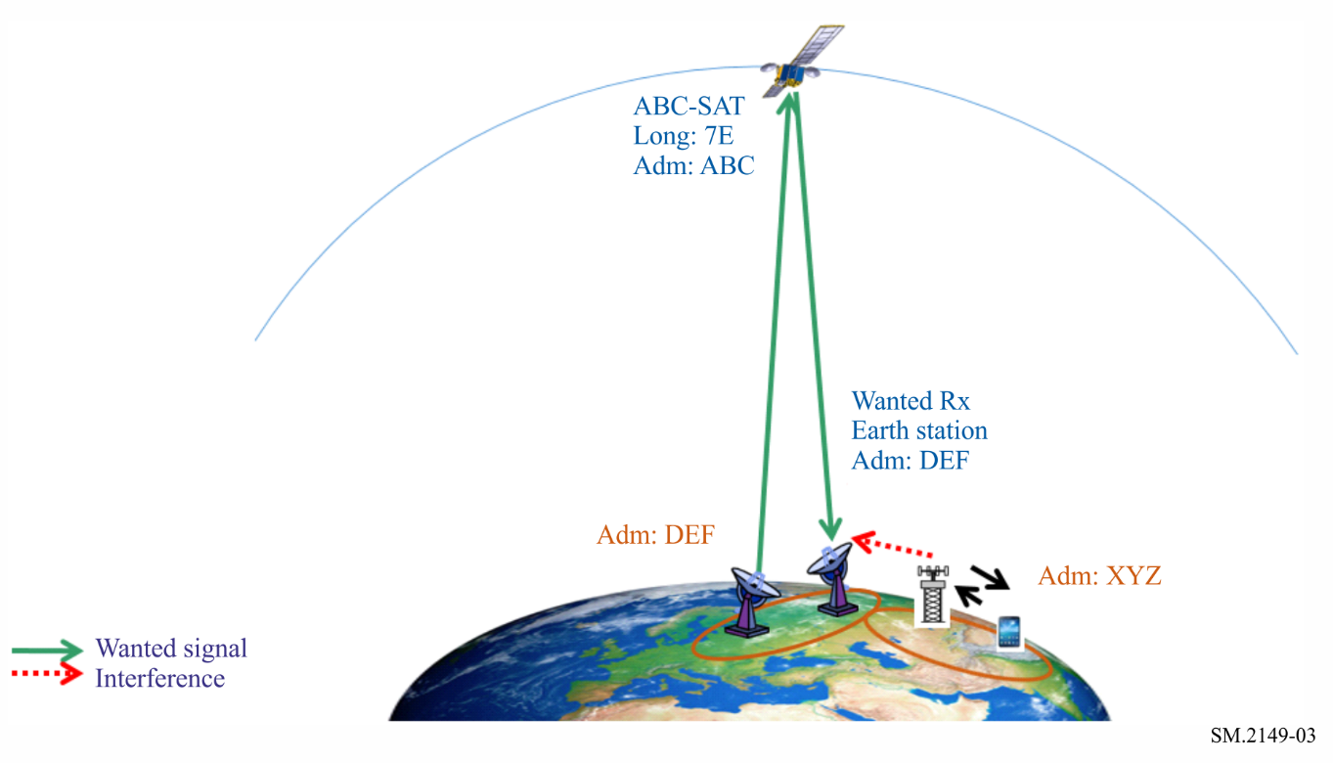
TABLE 5
Key particulars concerning the reporting form of harmful interference
General information
1 | Administrations responsible for the interference | XYZ
2 | Notifying Administration of the station receiving the interference | DEF
3 | Other Administrations implicated in the interference case | ABC
Interference Scenario
4 | Interference scenario:  A-Earth-to-space / B-Space-to-Earth / C-EESS (passive sensors) / D-Radio astronomy / E-Space-to-space | B
5 | Type of station responsible for the interference: Earth / Space (GSO) / Space (non-GSO) / Terrestrial / Other / Unknown | Terrestrial
6 | Type of station receiving interference: Earth / Space (GSO) / Space (non-GSO) / Terrestrial / Other | Earth
7 | Type of stations affected by the harmful interference: Earth / Space (GSO) / Space (non-GSO) / Terrestrial / Other | Space (GSO)

TABLE 5 (continued)
Particulars concerning the station causing the interference
a | Name, Carrier-ID or other means of identification
b | Frequency measured  Date  Time (UTC) | 3 510 MHz
c | Class of emission
d | Bandwidth of the interference(s) (indicate whether measured or estimated) | 3 MHz
e | Field strength, pfd, epfd, brightness temperature of interfering carrier(s)  Date  Time (UTC)
f | Observed polarization
g | Nature of interference | Co-channel, Digital Modulated Carrier
h | Location
i | Location of the facility which made the above measurements
Particulars concerning the transmitting station interfered with
j | Name, call sign or other means of identification | ABC-SAT
k | Frequency assigned | Uplink: 5 878 MHz  Downlink: 3 508 MHz
l | Frequency measured  Date  Time (UTC) | Uplink: 5 878 MHz  Downlink: 3 508 MHz
m | Class of emission
n | Bandwidth (indicates whether measured or estimated, or indicate the necessary bandwidth notified to the Radiocommunication Bureau) | 36 MHz
o | Location/position/area | 7° E
p | Location of the facility which made the above measurements
Particulars furnished by the receiving station experiencing the interference
q | Name of station | Wanted Rx earth station
r | Location/position/area | Lat: 10.0123; Long: −50.0123
s | Dates and times (UTC) of occurrence of harmful interference | Date: 04.06.2019  Time (UTC): 10:10
t | Bearings (QTE) or other particulars
u | Class of station and nature of service | TC, CP
v | Field strength or power flux-density or brightness temperature of the wanted emission at the receiving station experiencing the interference

TABLE 5 (end)
Particulars furnished by the receiving station experiencing the interference
w | Polarization of the receiving antenna or observed polarization | Uplink: LHCP  Downlink: RHCP
x | Action requested | Eliminate the harmful interference

A2.2.3 Case 3
This case illustrates a receiving earth station, associated to a geostationary satellite, being interfered by the aggregate of “n” non-geostationary satellites within the same constellation transmitting in the same frequency band while being visible from the earth station.
Figure 4
Illustration of core elements to be reported in a case of interference from a non-geostationary-satellite system
into an earth station associated to a geostationary-satellite network
(Interference Scenario B as per item 4 of Table 1)
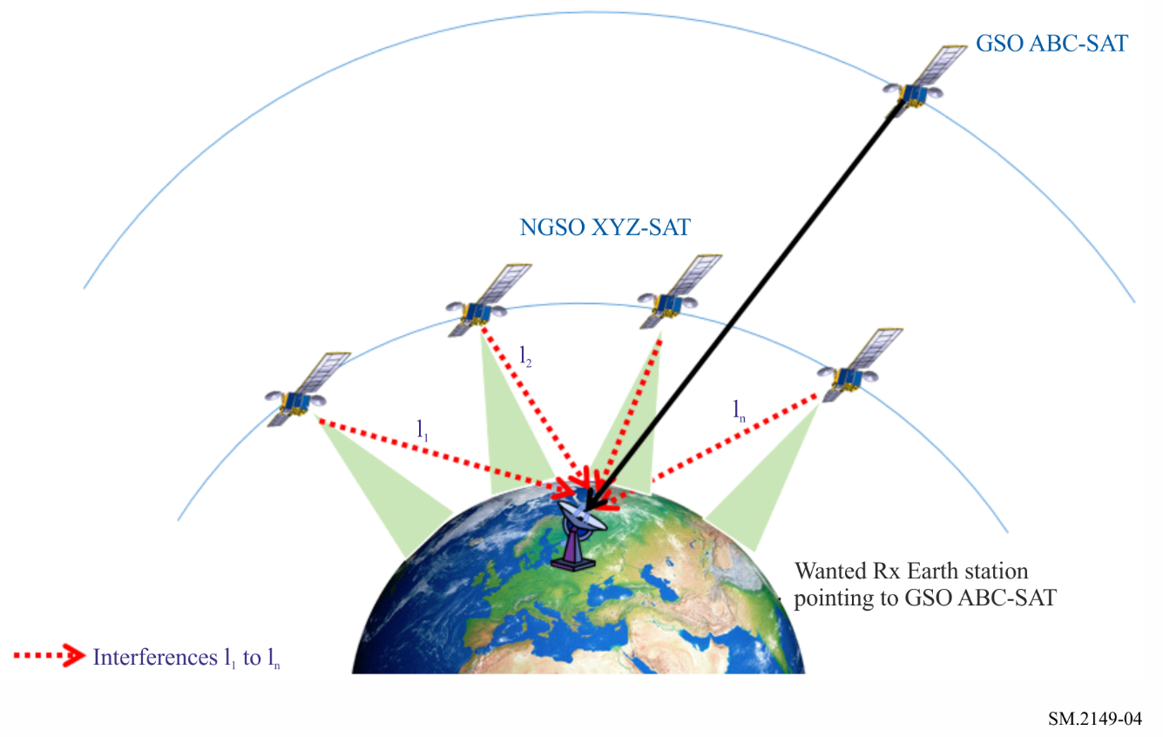
TABLE 6
Key particulars concerning the reporting form of harmful interference
General information
1 | Administrations responsible for the interference | XYZ
2 | Notifying Administration of the station receiving the interference | ABC
3 | Other Administrations implicated in the interference case | N/A
Interference scenario
4 | Interference scenario:  A-Earth-to-space / B-Space-to-Earth /C-EESS (Passive Sensors) / D-Radio astronomy / E-Space-to-space | B
5 | Type of station responsible for the interference: Earth / Space (GSO) /  Space (non-GSO) / Terrestrial / Other / Unknown | Space (non-GSO)
6 | Type of station receiving interference: Earth / Space (GSO) / Space (non-GSO) / Terrestrial / Other | Earth
7 | Type of stations affected by the harmful interference: Earth / Space (GSO) / Space (non-GSO) / Terrestrial / Other | Space (GSO)
Particulars concerning the station causing the interference
a | Name, Carrier-ID or other means of identification | XYZ-SAT
b | Frequency measured  Date  Time (UTC) | 18.07 GHz  Date: 05.06.2020  Time (UTC): 12:20
c | Class of emission
d | Bandwidth of the interference(s) (indicate whether measured or estimated)
e | Field strength, pfd, epfd, brightness temperature of interfering carrier(s)  Date  Time (UTC) | Attachment with table or graph indicating measured epfd and CDF (see example below)
f | Observed polarization
g | Nature of interference | Co-channel Aggregated Interference
h | Location
i | Location of the facility which made the above measurements | Lat: 12.0123; Long: 30.0123  Diameter: 1 m  Antenna pattern: Rec. ITU-R S.1428-1
Particulars concerning the transmitting station interfered with
j | Name, call sign or other means of identification | ABC-SAT
k | Frequency assigned | Uplink: 28.20 GHz  Downlink: 18.10 GHz
l | Frequency measured  Date  Time (UTC) | Downlink: 18.10 GHz  Date: 05.06.2020  Time (UTC): 12:20

TABLE 6 (end)
Particulars concerning the transmitting station interfered with
m | Class of emission
n | Bandwidth (indicates whether measured or estimated, or indicate the necessary bandwidth notified to the Radiocommunication Bureau) | 100 MHz (measured)
o | Location/position/area | 12° E
p | Location of the facility which made the above measurements | Lat: 12.0123; Long: 30.0123  Diameter: 1 m  Antenna pattern: Rec. ITU-R S.1428-1
Particulars furnished by the receiving station experiencing the interference
q | Name of station | Receiving ES-1
r | Location/position/area | Lat: 10.0123; Long: 20.0123  Diameter: 1 m  Antenna pattern: Rec. ITU-R S.1428-1
s | Dates and times (UTC) of occurrence of harmful interference | Date: 05.06.2020,  Time (UTC): 12:20
t | Bearings (QTE) or other particulars
u | Class of station and nature of service | TC CP
v | Field strength or power flux-density or brightness temperature of the wanted emission at the receiving station experiencing the interference
w | Polarization of the receiving antenna or observed polarization
x | Action requested | To reduce level of aggregate interference to the limits stipulated in Art. 22 of RR

Guidelines to a possible method to measure epfd from a non-geostationary-satellite system into an earth station associated to a geostationary-satellite network where Article 22 of the Radio Regulations applies
Provisions of No. 22.5C.1 of the RR defines the equivalent power flux-density (epfd) as the sum of the power flux-densities produced at a geostationary-satellite system receive station on the Earth’s surface or in the geostationary orbit, as appropriate, by all the transmit stations within a non-geostationary-satellite system, taking into account the off-axis discrimination of a reference receiving antenna assumed to be pointing in its nominal direction. The epfd is calculated using the following equation:
$epfd=10\log_{10}\left\lfloor \sum_{i=1}^{N_{a}}{{10}^{\frac{P_{i}}{10}}}∙\frac{G_{t}\left(θ_{i}\right)}{4πd_{i}^{2}}∙\frac{G_{r}\left(φ_{i}\right)}{G_{r,max}}\right\rfloor$
where:
N_{a} : number of transmit stations in the non-geostationary-satellite system that are visible from the geostationary-satellite system receive station considered on the Earthʼs surface or in the geostationary orbit, as appropriate
i : index of the transmit station considered in the non-geostationary-satellite system
P_{i} : RF power at the input of the antenna of the transmit station, considered in the non-geostationary-satellite system (dBW) in the reference bandwidth
θ_{i} : off-axis angle between the boresight of the transmit station considered in the non-geostationary-satellite system and the direction of the geostationary-satellite system receive station
G_{t}(θ_{i}) : transmit antenna gain (as a ratio) of the station considered in the non-geostationary-satellite system in the direction of the geostationary-satellite system receive station
d_{i} : distance (m) between the transmit station considered in the non-geostationary-satellite system and the geostationary-satellite system receive station
φ_{i} : off-axis angle between the bore sight of the antenna of the geostationary-satellite system receive station and the direction of the i-th transmit station considered in the non-geostationary-satellite system
G_{r}(φ_{i}) : receive antenna gain (as a ratio) of the geostationary-satellite system receive station in the direction of the i-th transmit station considered in the non-geostationary-satellite system
G_{r},_{max} : maximum gain (as a ratio) of the antenna of the geostationary-satellite system receive station
epfd : computed equivalent power flux-density (dB(W/m²)) in the reference bandwidth.
Knowing that:
$I_{i}=Pi⋅G_{r}⋅G_{t}⋅{\left[\frac{λ}{4π_{di}}\right]}^{2}$
where:
I_{i} : interference power, measured at the output of the receiving antenna, caused by the i-th transmitting non-geostationary station
λ : wavelength.
Then, from the epfd equation above:
$ⅇpfd=10\log_{10}\left[\frac{4π}{λ^{2}}⋅\frac{1}{G_{r, max}}⋅\sum_{i=1}^{n}{I_{i}}\right]$
$I Total=\sum_{i=1}^{n}{I_{i}}$can be measured at the output of the receiving antenna associated to the geostationary satellite in the absence of the wanted signal.
Knowing G_{r,max} (therefore the earth station antenna diameter as well) and the frequency band (therefore ℷ), the epfd can be calculated for a given antenna diameter, reference BW, particular location and instant of time t.
Further considerations:
– Samples of epfd_{(t)} should be measured at small intervals during a sufficient period of time to capture short-term and long-term values.
– Each sample of epfd_{(t)} should be stored. When completed, a cumulative distribution function (CDF) should be traced based on these results and compared with the RR Article 22 limits for that earth station antenna diameter.
Example of the attachment to be provided under entry e) of Table 9
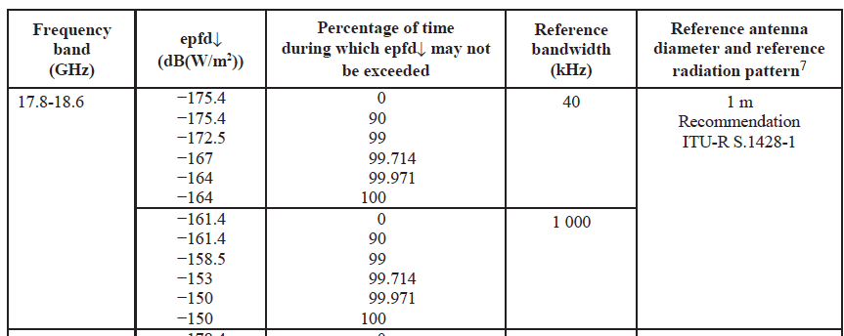
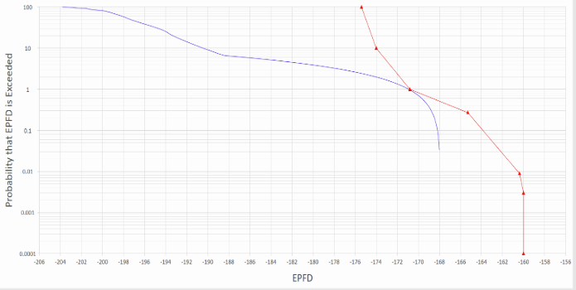
– These steps may be repeated in different locations of interest.
– This method is valid when all the interference contributions are originated from the same non-geostationary-satellite system to be measured.

A2.3 Interference Scenario C (EESS (passive))
This case illustrates a non-geostationary satellite in the Earth exploration-satellite service (passive) intended to sense natural radiations from the Earth but being interfered by out of band emissions originated from a terrestrial system operating with very high power in an adjacent band.
In this scenario, Recommendation ITU-R RS.2106 should also be used to provide further details.
Figure 5
Illustration of core elements to be reported in a case of interference in the
Earth exploration-satellite service (passive)
(Interference Scenario C as per item 4 of Table 1)
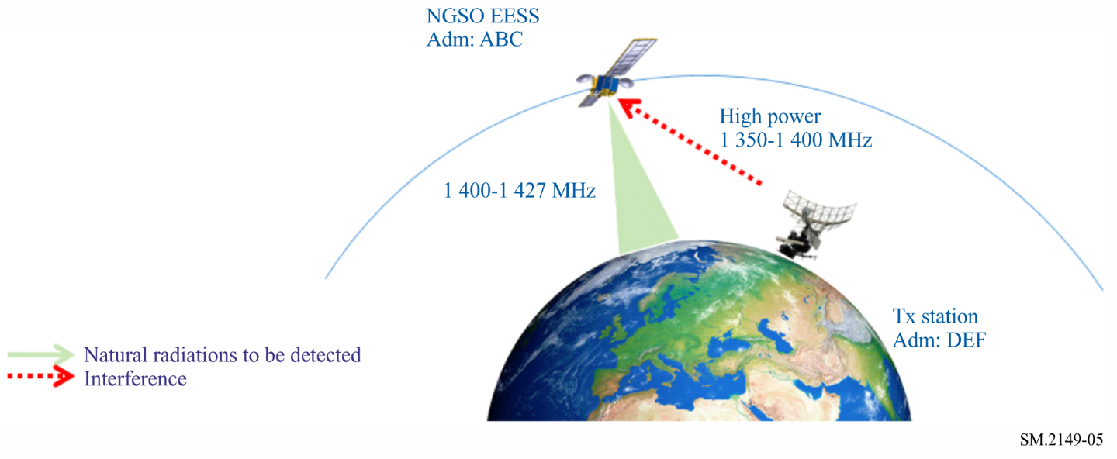
TABLE 7
Key particulars concerning the reporting form of harmful interference
General information
1 | Administrations responsible for the interference | DEF
2 | Notifying Administration of the station receiving the interference | ABC
3 | Other Administrations implicated in the interference case | N/A
Interference scenario
4 | Interference scenario:  A-Earth-to-space / B-Space-to-Earth / C-EESS (passive sensors) / D-Radio astronomy / E-Space-to-space | C
5 | Type of station responsible for the interference: Earth / Space (GSO) / Space (non-GSO) / Terrestrial / Other / Unknown | Terrestrial
6 | Type of station receiving interference: Earth / Space (GSO) / Space (non-GSO) / Terrestrial / Other | Space (non-GSO)
7 | Type of stations affected by the harmful interference: Earth / Space (GSO) / Space (non-GSO) / Terrestrial / Other | N/A
Particulars concerning the station causing the interference
a | Name, Carrier-ID or other means of identification
b | Frequency measured  Date  Time (UTC) | 1 413.5 MHz
c | Class of emission
d | Bandwidth of the interference(s) (indicate whether measured or estimated)

TABLE 7 (end)
Particulars concerning the station causing the interference
e | Field strength, pfd, epfd, brightness temperature of interfering carrier(s)  Date  Time (UTC) | Brightness temperature = 1 000 K  Date: 05.06.2019  Time (UTC): 18:20
f | Observed polarization
g | Nature of interference | Unwanted emissions,  Burst signals,  Malfunctioning of equipment
h | Location | Unknown
i | Location of the facility which made the above measurements
Particulars concerning the transmitting station interfered with
j | Name, call sign or other means of identification | Intentionally left blank
k | Frequency assigned | Intentionally left blank
l | Frequency measured  Date  Time (UTC) | Intentionally left blank
m | Class of emission | Intentionally left blank
n | Bandwidth (indicates whether measured or estimated, or indicate the necessary bandwidth notified to the Radiocommunication Bureau) | Intentionally left blank
o | Location/position/area | Intentionally left blank
p | Location of the facility which made the above measurements | Intentionally left blank
Particulars furnished by the receiving station experiencing the interference
q | Name of station | non-GSO EESS
r | Location/position/area
s | Dates and times (UTC) of occurrence of harmful interference | Date: 05.06.2019,  Time (UTC): 12:20
t | Bearings (QTE) or other particulars
u | Class of station and nature of service | E4 (EESS passive sensor)
v | Field strength or power flux-density or brightness temperature of the wanted emission at the receiving station experiencing the interference | Brightness temperature < 500 K  Date: 05.06.2019  Time (UTC): 12:20
w | Polarization of the receiving antenna or observed polarization
x | Action requested | To eliminate harmful interference

A2.4 Interference Scenario D (radio astronomy)
The case depicted below represents a radio astronomy station being interfered by unwanted emissions originated from a non-geostationary-satellite system transmitting in an adjacent frequency band.
Figure 6
Illustration of core elements to be reported in a case of interference in the radio astronomy service
(Interference Scenario D as per item 4 of Table 1)
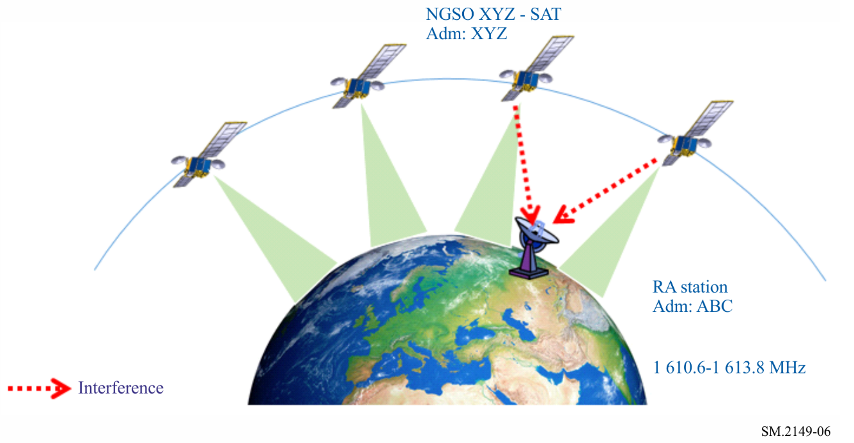
TABLE 8
Key particulars concerning the reporting form of harmful interference
General information
1 | Administrations responsible for the interference | XYZ
2 | Notifying Administration of the station receiving the interference | ABC
3 | Other Administrations implicated in the interference case | N/A
Interference scenario
4 | Interference scenario:  A-Earth-to-space / B-Space-to-Earth / C-EESS (passive sensors) / D-Radio astronomy / E-Space-to-space | D
5 | Type of station responsible for the interference: Earth / Space (GSO) / Space (non-GSO) / Terrestrial / Other / Unknown | Space (non-GSO)
6 | Type of station receiving interference: Earth / Space (GSO) / Space (non-GSO) / Terrestrial / Other | Radio astronomy station
7 | Type of stations affected by the harmful interference: Earth / Space (GSO) / Space (non-GSO) / Terrestrial / Other | N/A
Particulars concerning the station causing the interference
a | Name, Carrier-ID or other means of identification | XYZ-SAT
b | Frequency measured  Date  Time (UTC) | 1 619 MHz
c | Class of emission

TABLE 8 (end)
Particulars concerning the station causing the interference
d | Bandwidth of the interference(s) (indicate whether measured or estimated) | 2 MHz
e | Field strength, pfd, epfd, brightness temperature of interfering carrier(s)  Date  Time (UTC)
f | Observed polarization
g | Nature of interference | Unwanted emissions
h | Location | XYZ-SAT NGSO LEO
i | Location of the facility which made the above measurements
Particulars concerning the transmitting station interfered with
j | Name, call sign or other means of identification | Intentionally left blank
k | Frequency assigned | Intentionally left blank
l | Frequency measured  Date  Time (UTC) | Intentionally left blank
m | Class of emission | Intentionally left blank
n | Bandwidth (indicates whether measured or estimated, or indicate the necessary bandwidth notified to the Radiocommunication Bureau) | Intentionally left blank
o | Location/position/area | Intentionally left blank
p | Location of the facility which made the above measurements | Intentionally left blank
Particulars furnished by the receiving station experiencing the interference
q | Name of station | RAS-01
r | Location/position/area | Lat: 10.0123; Long: 23.0123
s | Dates and times (UTC) of occurrence of harmful interference | Date: 05.06.2019  Time (UTC): 15:20
t | Bearings (QTE) or other particulars
u | Class of station and nature of service | RA
v | Field strength or power flux-density or brightness temperature of the wanted emission at the receiving station experiencing the interference
w | Polarization of the receiving antenna or observed polarization
x | Action requested | To eliminate harmful interference

A2.5 Interference Scenario E (space-to-space)
The case depicted below represents a non-geostationary-satellite system NGSO1 intended to communicate by intersatellite links with a geostationary-satellite GSO1 but causing interference to an adjacent geostationary-satellite GSO2. This interference is retransmitted by GSO2 and received by its associated earth station, together with the wanted signal.
figure 7
Illustration of core elements to be reported in a case of interference in the space-to-space Scenario
(Interference Scenario E as per item 4 of Table 1)
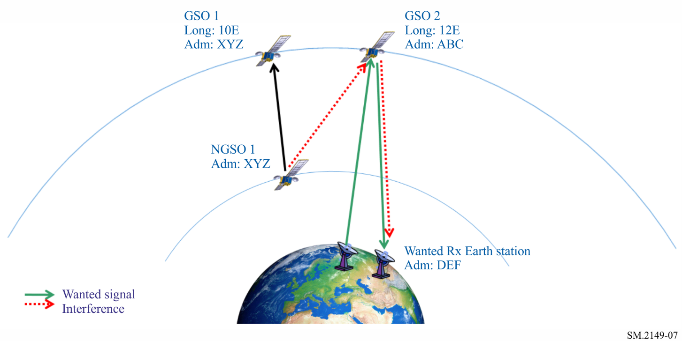
TABLE 9
Key particulars concerning the reporting form of harmful interference
General information
1 | Administrations responsible for the interference | XYZ
2 | Notifying Administration of the station receiving the interference | ABC
3 | Other Administrations implicated in the interference case | DEF
Interference scenario
4 | Interference scenario:  A-Earth-to-space / B-Space-to-Earth / C-EESS (Passive Sensors) / D-Radio astronomy / E-Space-to-space | E
5 | Type of station responsible for the interference: Earth / Space (GSO) / Space (non-GSO) / Terrestrial / Other / Unknown | Space (non-GSO)
6 | Type of station receiving interference: Earth / Space (GSO) / Space (non-GSO) / Terrestrial / Other | Space (GSO)
7 | Type of stations affected by the harmful interference: Earth / Space (GSO) / Space (non-GSO) / Terrestrial / Other | Earth
Particulars concerning the station causing the interference
a | Name, Carrier-ID or other means of identification | NGSO1
b | Frequency measured  Date  Time (UTC) | 24.7 GHz  Date: 05.06.2019  Time (UTC): 12:10
c | Class of emission
d | Bandwidth of the interference(s) (indicate whether measured or estimated) | 200 MHz

TABLE 9 (end)
Particulars concerning the station causing the interference
e | Field strength, pfd, epfd, brightness temperature of interfering carrier(s)  Date  Time (UTC)
f | Observed polarization | V
g | Nature of interference | Antenna pointing error
h | Location | From NGSO1 LEO orbit when NGSO1 spacecrafts transmits to adjacent GSO1 satellite
i | Location of the facility which made the above measurements
Particulars concerning the transmitting station interfered with
j | Name, call sign or other means of identification | Wanted Tx earth station
k | Frequency assigned | Uplink: 24.68 GHz  Downlink: 19.88 GHz
l | Frequency measured  Date  Time (UTC) | Uplink: 24.68 GHz  Downlink: 19.88 GHz  Date: 05.06.2019,  Time (UTC): 12:20
m | Class of emission | 150MG7W
n | Bandwidth (indicates whether measured or estimated, or indicate the necessary bandwidth notified to the Radiocommunication Bureau) | 150 MHz
o | Location/position/area
p | Location of the facility which made the above measurements
Particulars furnished by the receiving station experiencing the interference
q | Name of station | GSO2
r | Location/position/area | 12° E
s | Dates and times (UTC) of occurrence of harmful interference | Date: 05.06.2019  Time (UTC): 12:20
t | Bearings (QTE) or other particulars
u | Class of station and nature of service | EC, CP
v | Field strength or power flux-density or brightness temperature of the wanted emission at the receiving station experiencing the interference
w | Polarization of the receiving antenna or observed polarization | Uplink: V  Downlink: H
x | Action requested | To eliminate harmful interference

Annex 3
Example reports of harmful interference to space radiocommunication services including additional information detailed in Table 2

A3.1 Interference Scenario A (Earth-to-space)
These are the example reports of harmful interference to space radiocommunication services in Interference Scenario A (Earth-to-space) based on Table 1 and Table 2.

A3.1.1 Case 1
TABLE 10
Key particulars concerning the reporting form of harmful interference
General information
1 | Administrations responsible for the interference | Australia
2 | Notifying Administration of the station receiving the interference | China
3 | Other Administrations implicated in the interference case | None
Interference scenario
4 | Interference scenario:  A-Earth-to-space / B-Space-to-Earth / C-EESS (passive sensors) / D-Radio astronomy / E-Space-to-space | A
5 | Type of station responsible for the interference: Earth / Space (GSO) / Space (non-GSO) / Terrestrial / Other / Unknown | Earth
6 | Type of station receiving interference: Earth / Space (GSO) / Space (non-GSO) / Terrestrial / Other | Space (GSO)
7 | Type of Stations affected by the harmful interference: Earth / Space (GSO) / Space (non-GSO) / Terrestrial / Other | Earth
Particulars concerning the station causing the interference
a | Name, Carrier-ID or other means of identification | Unknown
b | Frequency measured  Date  Time (UTC) | 5 957.670 MHz  3 732.670 MHz  Occurrence of interference:  1 Jan 2017 to date of reporting  Spectrum plots time and date:  00:00-00:02 1 Jan 2017
c | Class of emission | Unknown  Description of the harmful interference: QPSK, Time and frequency stable signal
d | Bandwidth of the interference(s) (indicate whether measured or estimated) | 24 kHz, measured

TABLE 10 (continued)
Particulars concerning the station causing the interference
e | Field strength, pfd, epfd, brightness temperature of interfering carrier(s)  Date  Time (UTC) | pfd: −216 dB(W/(m² · Hz))  1 Jan 2017  00:00-00:02
f | Observed polarization | V-pol, uplink; H-pol, downlink
g | Nature of interference | Digital modulated carrier
h | Location | According to the geolocation result, the uplink interference station is located at (−13.19, 135.47) near East Arnhem, Australia
i | Location of the facility which made the above measurements | 1 Spectrum plots (Table 11, item 8 and item 9) were taken in AsiaSat Tai Po earth station (22.453° N 114.189° E) in Hong Kong, and monitoring antenna size was 3.7 m.  2 Geolocation (Table 11, item 10) were performed in Beijing, China (39.66° N 116.23° E).
Particulars concerning the transmitting station interfered with
(Note: For cases of uplink interference, it refers to the earth station transmitting the wanted carrier; for cases of downlink interference, it refers to the space station transmitting the wanted carrier)
j | Name, call sign or other means of identification | AsiaSat Tai Po earth station in Hong Kong and other receiving earth stations under the footprint of AsiaSat 5 transponder CXH
k | Frequency assigned | 36 MHz wanted satellite transponder:  5 945 MHz (V-pol, uplink)  3 720 MHz (H-pol, downlink)
l | Frequency measured  Date  Time (UTC) | 5 945 MHz (V-pol, uplink)  3 720 MHz (H-pol, downlink)  1 Jan 2017  00:00 – 00:02
m | Class of emission | 36M0G7W
n | Bandwidth (indicates whether measured or estimated, or indicate the necessary bandwidth notified to the Radiocommunication Bureau) | 36 MHz, measured
o | Location/position/area | Hong Kong and other receiving earth stations under the footprint of AsiaSat 5 transponder CXH (see Table 11, item 11). Interference present on the uplink, therefore all dish sizes are affected
p | Location of the facility which made the above measurements | Spectrum plots (Table 11, item 8 and item 9) were taken in AsiaSat Tai Po earth station (22.453° N 114.189° E) in Hong Kong and monitoring antenna size was 3.7 m

TABLE 10 (end)
Particulars furnished by the receiving station experiencing the interference
(Note: For cases of uplink interference, it refers to the space station receiving the interference; for cases of downlink interference, it refers to the earth station receiving the interference)
q | Name of station | AsiaSat 5 (NORAD ID: 35696)  Transponder CXH
r | Location/position/area | 100.5° E
s | Dates and times (UTC) of occurrence of harmful interference | 1 Jan 2017 to the date of reporting
t | Bearings (QTE) or other particulars | –
u | Class of station and nature of service | EC (space station in the fixed-satellite service)  CP (Station open to public correspondence)
v | Field strength or power flux-density or brightness temperature of the wanted emission at the receiving station experiencing the interference
w | Polarization of the receiving antenna or observed polarization | V-pol, uplink; H-pol, downlink
x | Action requested | Elimination of the interfering signal.

TABLE 11
Additional information concerning the reporting form of harmful interference
Graphical information
8 | Spectrum plot of interfering carriers | 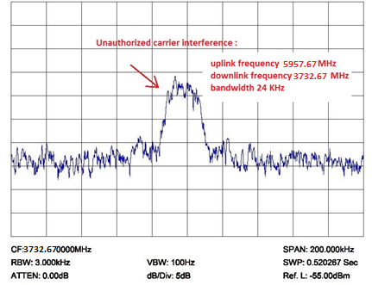
9 | Spectrum plot of wanted carriers | 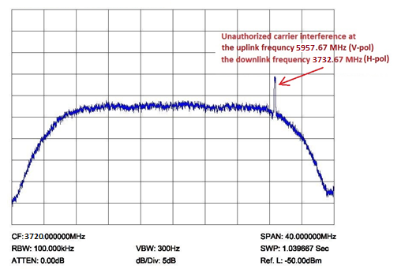

TABLE 11 (continued)
Graphical information
10 | Geolocation results | 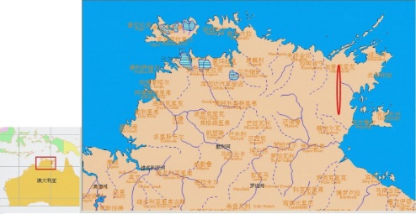
11 | Satellite footprint in which the interference is uplinked | 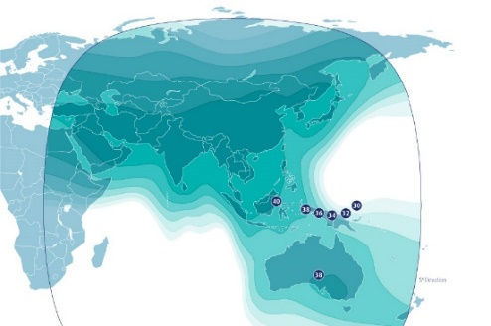
12 | Satellite footprint in which the interference is downlinked
Particulars concerning the satellite in which the interferer is appearing
13 | Satellite orbit: | GSO
14 | – GSO orbit position (nominal): | 100.5° E
15 | – LEO/MEO/HEO orbit: | –
16 | – Orbital period | –
17 | – Time of visibility | –
18 | – Orbit type | –
19 | – Name of the satellite system | –
20 | – Number of satellites in the system | –
21 | Satellite downlink:
22 | – Frequency range (nominal) (MHz)
23 | – Frequency range measured (MHz)
24 | Transponder in which the interferer is appearing: | CXH
25 | – Transponder on satellite | X
26 | Transponder name/number for uplink | CXH
27 | Transponder name/number for downlink | CXH
28 | – Polarization (downlink) | H
29 | – Polarization (uplink) | V
30 | – Centre frequency (downlink) | 3 720 MHz
31 | – Bandwidth (downlink) | 36 MHz
32 | – Centre frequency (uplink) | 5 945 MHz
33 | – Bandwidth (uplink) | 36 MHz
34 | – Description/identification of authorized signal

TABLE 11 (continued)
Particulars concerning the facilities making the measurement (for item i)
35 | Name of monitoring station: | Beijing Monitoring Station
36 | – Organization | CHINA/State Radio Monitoring Center
37 | – Location (country, state, area, town) | China, Beijing, Daxing
38 | – Position of the monitoring station which made the measurements | 39.661° N 116.255° E
39 | Geolocation principle  (Note: TDOA/FDOA with 2 satellite, FDOA/FDOA with 2 satellite, TDOA/TDOA with 3 satellite, doppler shift with single satellite) | TDOA/FDOA with 2 satellite
40 | Satellites used for geolocation measurement:
41 | – Name of the main satellite | AsiaSat 5 (100.5° E in the GSO arc)
42 | – Name of the adjacent satellite 1 | AsiaSat 7 (105.5° E in the GSO arc)
43 | – Name of the adjacent satellite 2 | –
44 | Equipment used for interferer detection:
45 | – Antenna type (1st antenna for geolocation) | Cassegrain
46 | – Antenna size | 7.3 m
47 | – G/T (dB/K) | ≥ 40.548
48 | – Antenna location (country, state, town) | China, Beijing, Daxing
49 | – Antenna type (2nd antenna for geolocation) | Cassegrain
50 | – Antenna size | 7.3 m
51 | – G/T (dB/K) | ≥ 40.548
52 | – Antenna location (country, state, town) | China, Beijing, Daxing
53 | – Antenna type (3rd antenna for geolocation) | –
54 | – Antenna size | –
55 | – G/T (dB/K) | –
56 | – Antenna location (country, state, town) | –
57 | Other equipment besides antennas | Geolocation system
58 | Interfering signal:
59 | – Frequency measured (downlink) (MHz) | 3 732.658 MHz – 3 732.682 MHz
60 | – Frequency calculated (uplink) (MHz) | 5 957.658 MHz – 5 957.682 MHz
61 | – Bandwidth (kHz) | 24 kHz
62 | – Power flux-density (dBm/m²/Hz) | –216 dB(W/(m² · Hz))
63 | – Date of measurement (yyyy-mm-dd)
64 | – Time of measurement (UTC)
65 | Ground based geolocation measurement:
66 | – Accuracy Prediction for the measurement | 10 km × 2 km
67 | – Interferer position result (Lat./Lon.) | (−13.19/135.47)
68 | – Interferer location (country, state, town) | Australia, near East Arnhem
69 | – Semi-major axis (km) | 0.6896
70 | – Semi-minor axis (km) | 0.0533
TABLE 11 (end)
Particulars concerning the facilities making the measurement (for item i)
71 | – Orientation of ellipse (true north clockwise) | −85.12
72 | – Repetition of geolocation measurements | 5
73 | Remark (Note: Any descriptions concerning the interference or measurement could be addressed.)

A3.1.2 Case 2
TABLE 12
Key particulars concerning the reporting form of harmful interference
General information
1 | Administrations responsible for the interference | Peru
2 | Notifying Administration of the station receiving the interference | Brazil
3 | Other Administrations implicated in the interference case
Interference Scenario
4 | Interference Scenario:  A-Earth-to-space / B-Space-to-Earth / C-EESS (passive sensors) / D-Radio astronomy/ E-Space-to-space | A
5 | Type of station responsible for the interference: Earth / Space (GSO) / Space (non-GSO) / Terrestrial / Other / Unknown | Earth
6 | Type of station receiving interference: Earth / Space (GSO) / Space (non-GSO) / Terrestrial / Other | Space (GSO)
7 | Type of stations affected by the harmful interference: Earth / Space (GSO) / Space (non-GSO) / Terrestrial / Other | Earth
Particulars concerning the station causing the interference
a | Name, Carrier-ID or other means of identification | Unknown
b | Frequency measured  Date  Time (UTC) | 5988.88 MHz  3763.88 MHz  Occurrence of interference:  07 May 2020 to date of reporting  Spectrum plots time and date:  11 Jun 2020  18:07 (UTC)
c | Class of emission | Unknown  Description of the harmful interference: Unknown modulation. Time and frequency stable signal.

TABLE 12 (continued)
Particulars concerning the station causing the interference
d | Bandwidth of the interference(s) (indicate whether measured or estimated) | 1.18 MHz, measured
e | Field strength, pfd, epfd, brightness temperature of interfering carrier(s)  Date  Time (UTC) | pfd: −201 dB(W/(m² · Hz))  11 Jun 2020  18:07 (UTC)
f | Observed polarization | H-pol, uplink; V-pol, downlink
g | Nature of interference | Digital modulated carrier
h | Location | According to the geolocation result, the uplink interference station is located at (5°57’36” S, 76°54’26” W) near Sucllaquiro, Peru
i | Location of the facility which made the above measurements | Spectral measurements and geolocation were performed in Rio de Janeiro, Brazil (Table 2) at 22°49’29.6” S 43°10’43.3” W.
Particulars concerning the transmitting station interfered with
(Note: For cases of uplink interference, it refers to the earth station transmitting the wanted carrier; for cases of downlink interference, it refers to the space station transmitting the wanted carrier)
j | Name, call sign or other means of identification
k | Frequency assigned
l | Frequency measured  Date  Time (UTC)
m | Class of emission
n | Bandwidth (indicates whether measured or estimated, or indicate the necessary bandwidth notified to the Radiocommunication Bureau)
o | Location/position/area
p | Location of the facility which made the above measurements
Particulars furnished by the receiving station experiencing the interference
(Note: For cases of uplink interference, it refers to the space station receiving the interference; for cases of downlink interference, it refers to the earth station receiving the interference)
q | Name of station | Anik G1 (NORAD ID: 39127)  Transponder C02B
r | Location/position/area | 107.3° W
s | Dates and times (UTC) of occurrence of harmful interference | 07 May 2020 to the date of reporting
t | Bearings (QTE) or other particulars | –
u | Class of station and nature of service | EC (space station in the fixed-satellite service)  CP (station open to public correspondence)
TABLE 12 (end)
Particulars furnished by the receiving station experiencing the interference
v | Field strength or power flux-density or brightness temperature of the wanted emission at the receiving station experiencing the interference | pfd: −201 dB(W/(m² · Hz))  11 Jun 2020  18:07 (UTC)
w | Polarization of the receiving antenna or observed polarization | H-pol, uplink; V-pol, downlink
x | Action requested | Elimination of the unwanted signal.

TABLE 13
Additional information concerning the reporting form of harmful interference
Graphical information
8 | Spectrum plot of interfering carriers | 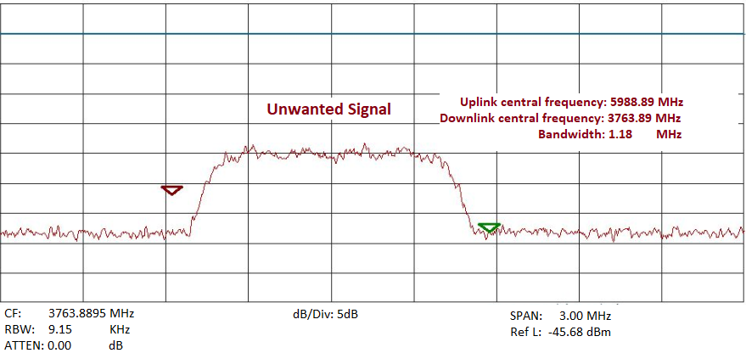
9 | Spectrum plot of wanted carriers | No wanted carriers are currently present. These were moved by the satellite operator due to interference risk from the unwanted signal.
10 | Geolocation results | 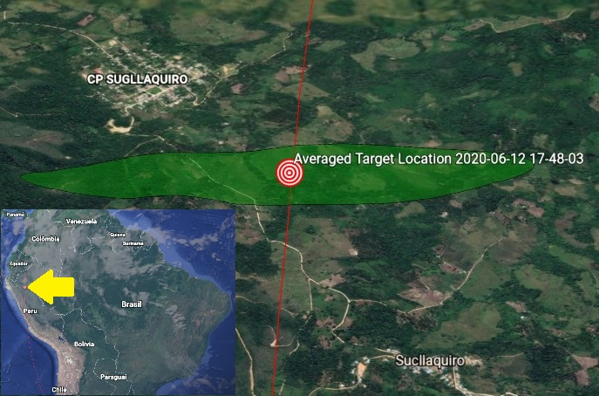

TABLE 13 (continued)
Graphical information
11 | Satellite footprint in which the interference is uplinked | 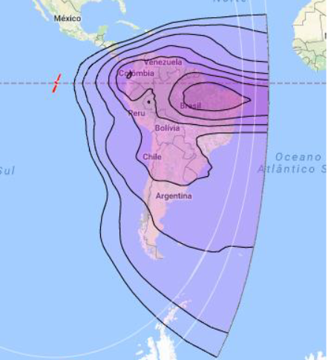
12 | Satellite footprint in which the interference is downlinked
Particulars concerning the satellite in which the interferer is appearing
13 | Satellite orbit:
14 | – GSO orbit position (nominal): | 107.5° West
15 | – LEO/MEO/HEO orbit:
16 | – Orbital period
17 | – Time of visibility
18 | – Orbit type
19 | – Name of the satellite system
20 | – Number of satellites in the system
21 | Satellite downlink:
22 | – Frequency range (nominal) (MHz)
23 | – Frequency range measured (MHz)
24 | Transponder in which the interferer is appearing:
25 | – Transponder on satellite | Transponder C02B
26 | Transponder name/number for uplink
27 | Transponder name/number for downlink
28 | – Polarization (downlink) | Linear Vertical Polarization
29 | – Polarization (uplink) | Linear Horizontal Polarization
30 | – Centre frequency (downlink) | 3 780.00 MHz
31 | – Bandwidth (downlink) | 36.0 MHz
32 | – Centre frequency (uplink) | 6 005.00 MHz
TABLE 13 (continued)
Particulars concerning the satellite in which the interferer is appearing
33 | – Bandwidth (uplink) | 36.0 MHz
34 | – Description/identification of authorized signal
Particulars concerning the facilities making the measurement (for item i)
35 | Name of monitoring station: | Satellite Radio Monitoring Station
36 | – Organization | Brazil/National Telecommunications Agency
37 | – Location (country, state, area, town) | Brazil, Rio de Janeiro state, Rio de Janeiro
38 | – Position of the monitoring station which made the measurements | (22°49’29.6” S, 43°10’43.3” W)
39 | Geolocation principle  (Note: TDOA/FDOA with 2 satellite, FDOA/FDOA with 2 satellite, TDOA/TDOA with 3 satellite, doppler shift with single satellite) | TDOA/FDOA with 2 satellites
40 | Satellites used for geolocation measurement:
41 | – Name of the main satellite | Anik G1 (107.5° W in the GSO arc)
42 | – Name of the adjacent satellite 1 | Brasilsat B4 (92.0° W in the GSO arc)
43 | – Name of the adjacent satellite 2 | –
44 | Equipment used for interferer detection:
45 | – Antenna type (1st antenna for geolocation) | Gregorian
46 | – Antenna size | 6 m
47 | – G/T (dB/K) | ≥ 27.8
48 | – Antenna location (country, state, town) | Brazil, Rio de Janeiro state, Rio de Janeiro
49 | – Antenna type (2nd antenna for geolocation) | Gregorian
50 | – Antenna size | 6 m
51 | – G/T (dB/K) | ≥ 27.8
52 | – Antenna location (country, state, town) | Brazil, Rio de Janeiro state, Rio de Janeiro
53 | – Antenna type (3rd antenna for geolocation) | –
54 | – Antenna size | –
55 | – G/T (dB/K) | –
56 | – Antenna location (country, state, town) | –
57 | Other equipment besides antennas | Geolocation system
58 | Interfering signal:
59 | – Frequency measured (downlink) (MHz) | 3 763.280 MHz – 3 764.480 MHz
60 | – Frequency calculated (uplink) (MHz) | 5 988.280 MHz – 5 989.48 MHz
61 | – Bandwidth (kHz) | 1 180 kHz
62 | – Power flux-density (dBm/m²/Hz) | –201 dB(W/(m² · Hz))
63 | – Date of measurement (yyyy-mm-dd) | 2020-06-12
TABLE 13 (end)
Particulars concerning the facilities making the measurement (for item i)
64 | – Time of measurement (UTC) | 20h48m03s
63 | Ground based geolocation measurement:
64 | – Accuracy Prediction for the measurement | 10 km × 2 km
65 | – Interferer position result (Lat./Lon.) | (−5.960007/−76.907267)
66 | – Interferer location (country, state, town) | Peru, near San Martín, Sucllaquiro
67 | – Semi-major axis (km) | 2.33
68 | – Semi-minor axis (km) | 0.46
69 | – Orientation of ellipse (true north clockwise) | −74.98
70 | – Repetition of geolocation measurements | 10
71 | Remark (Note: Any descriptions concerning the interference or measurement could be addressed.)

