Recommendation ITU-R SM.2093-0
(08/2016)
Methods for measurements of
indoor radio environment

SM Series
Spectrum management

Foreword
The role of the Radiocommunication Sector is to ensure the rational, equitable, efficient and economical use of the radio-frequency spectrum by all radiocommunication services, including satellite services, and carry out studies without limit of frequency range on the basis of which Recommendations are adopted.
The regulatory and policy functions of the Radiocommunication Sector are performed by World and Regional Radiocommunication Conferences and Radiocommunication Assemblies supported by Study Groups.

Policy on Intellectual Property Right (IPR)
ITU-R policy on IPR is described in the Common Patent Policy for ITU-T/ITU-R/ISO/IEC referenced in Resolution ITU-R 1. Forms to be used for the submission of patent statements and licensing declarations by patent holders are available from http://www.itu.int/ITU-R/go/patents/en where the Guidelines for Implementation of the Common Patent Policy for ITU-T/ITU-R/ISO/IEC and the ITU-R patent information database can also be found.

Series of ITU-R Recommendations
(Also available online at http://www.itu.int/publ/R-REC/en)
Series | Title
BO | Satellite delivery
BR | Recording for production, archival and play-out; film for television
BS | Broadcasting service (sound)
BT | Broadcasting service (television)
F | Fixed service
M | Mobile, radiodetermination, amateur and related satellite services
P | Radiowave propagation
RA | Radio astronomy
RS | Remote sensing systems
S | Fixed-satellite service
SA | Space applications and meteorology
SF | Frequency sharing and coordination between fixed-satellite and fixed service systems
SM | Spectrum management
SNG | Satellite news gathering
TF | Time signals and frequency standards emissions
V | Vocabulary and related subjects

Note: This ITU-R Recommendation was approved in English under the procedure detailed in Resolution ITU-R 1.

Electronic Publication
Geneva, 2016

© ITU 2016
All rights reserved. No part of this publication may be reproduced, by any means whatsoever, without written permission of ITU.

RECOMMENDATION ITU-R SM.2093-0*
Methods for measurements of indoor radio environment
(2016)
Scope
For indoor radio environment measurements, there is a need to have a uniform, frequency-independent method to produce comparable, accurate and reproducible results between different measurement systems. This Recommendation provides a set of processes or steps that need to be integrated in a measurement procedure resulting in these comparable results.
Keywords
Indoor radio environment measurements, noise measurements
Abbreviations
ACF Amplitude correction factor
AGC Automatic gain control
APD Amplitude probability distribution
CISPR Comité International Spécial Des Perturbations Radioélectriques
DFT Discrete Fourier Transformation
FIR Finite impulse response
IEC International Electrotechnical Commission
IN Impulsive noise
I/Q In-phase/Qadrature
LAN Local area network
LNA Low noise amplifier
PC Personal computer
PLT Power line telecommunication
RBW Resolution bandwidth
RFID Radio Frequency IDentifier
RMS Root mean square
SCN Single carrier noise
UWB Ultra-wide band
VSWR Voltage standing wave ratio
WGN White Gaussian noise
Related ITU Recommendations, Reports
Recommendation ITU-R P.372
Recommendation ITU-R SM.1753
Report ITU-R SM.2055
Report ITU-R SM.2155
Report ITU-R SM.2157
NOTE – In every case the latest edition of the Recommendation/Report in force should be used.
The ITU Radiocommunication Assembly,
considering
a) that, due to the introduction of many types of electrical and electronic equipment (emitting unintentional radio waves), and communication networks (e.g. ultra-wide band (UWB), power line telecommunication (PLT) and computers), the radio environment including interference for indoor applications might be getting worse;
b) that, radio interference from single and identifiable sources being dominant in indoor environments does not fit the definition of man-made noise specified in Recommendation ITU-R P.372;
c) that, for efficient spectrum management, administrations and/or manufacturers of radio applications operating indoors need to know the radio environment including interferences;
d) that there is a need to harmonize the measurement methods for indoor radio environment measurements to achieve reproducible results that can be mutually compared;
e) that, for the indoor radio environment measurements, certain minimum equipment specifications and measurement methods are required that are different from the ones applied to outdoor radio noise measurements covered in Recommendation ITU-R SM.1753,
recommends
that measurements of indoor radio environment should be carried out as described in Annex 1.

Annex 1
Methods for measuring indoor radio environment
TABLE OF CONTENTS
Page
Policy on Intellectual Property Right (IPR) ii
1 Introduction 5
2 Components of radio environment 6
3 Key parameters of radio environment 7
4 Measurement principles 7
5 Environmental categories 8
6 Equipment specifications 8
6.1 Receiver and preamplifier 8
6.2 Antenna 9
6.3 Devices for multiple point measurement 10
7 Measurement conditions and process 10
7.1 Measuring period 10
7.2 Frequency selection 10
7.3 Analyser settings 11
7.4 Data acquisition at multiple positions 11
8 Post processing 12
9 Data processing for radio environment analysis 12
9.1 Analysis and evaluation method for SCN 13
9.1.1 Steps for obtaining a spectrogram 13
9.1.2 Window function 15
9.1.3 Application of the Discrete Fourier Transform 15
9.1.4 SCN detection and power evaluation 16
9.2 Analysis and evaluation method for WGN 16
9.2.1 Configuration of a digital finite impulse response (FIR) filter 17
9.2.2 Calculation of the peak envelope power 17
9.2.3 Plotting of the APD 17
9.2.4 WGN power evaluation 18
9.3 Analysis and evaluation method for IN 19
9.3.1 IN sample extraction 19
9.3.2 Calculation of the IN characteristics 19
10 Result presentation 20

1 Introduction
This Annex describes methods for measuring and evaluating the indoor radio environment faced by radiocommunication applications. Considering the usage of radio devices in indoor locations, measurement of the radio environment in frequency ranges above 30 MHz may be required in practice.

2 Components of radio environment
Major radio sources in indoor environment are emissions from electrical and electronic devices used inside the respective facility.
Radio noises as described in Recommendation ITU-R P.372 may get into a facility from the outdoor environment but its interfering effect is usually less than the emissions from indoor sources.
Using the definition given in Recommendation ITU-R P.372, radio noise is the aggregate of emissions from multiple sources that do not originate from radiocommunication transmitters. If at a given measurement location there is no dominance of single noise sources, the characteristic of the radio noise often has a normal amplitude distribution and can be regarded as white Gaussian noise.
However, with the high density of noise emitting devices especially found in indoor environments, it is virtually impossible to find a location that is not at least temporarily dominated by emissions from a single source. These sources often emit impulses and/or single carriers. Since radiocommunication equipment has to operate in such an environment, it is necessary to include noise or emissions from nearby sources in measurements of the indoor radio environment. The following components of radio noise are defined in Recommendation ITU-R SM.1753.
TABLE 1
Components of radio noise
Noise component | Properties | Sources (examples)
White Gaussian noise⁽¹⁾ (WGN) | Uncorrelated electromagnetic vectors  Bandwidth equal to or greater than receiver bandwidth  Spectral power level increases linear with bandwidth | Computers, power line communication networks, wired computer networks, cosmic noise
Impulsive noise (IN) | Correlated electromagnetic vectors  Bandwidth greater than receiver bandwidth  Spectral power level rises with square of bandwidth | Ignition sparks, lightning, gas lamp starters, computers, ultra-wideband devices
Single carrier noise (SCN) | One or more distinct spectral lines  Bandwidth smaller than receiver bandwidth  Spectral power level independent of bandwidth | Wired computer networks, computers, switched mode power supplies
⁽¹⁾ In the context of this Recommendation, WGN is considered to represent a continuous noise signal which exhibits a nearly flat power spectral density in the frequency ranges around the measurement bandwidth.

Recommendation ITU-R SM.1753-2 also includes the following descriptions.
While the WGN component is sufficiently characterized by the r.m.s. value, this is much more difficult for the IN. Modern digital communication services almost always apply error correction, making it more immune especially against impulsive noise. However, when certain pulse lengths and repetition ratios are reached, IN can significantly interfere with the operation of such a service.
It is therefore desirable to measure radio noise in a way that gives not only the level of IN but also certain information about the statistical distribution of pulse parameters.
According to the description, characteristics of WGN and IN should be evaluated separately, since their mechanism of the impact on wireless communication system is different from each other.
Single carrier noise (SCN) is only detected as such when it comes from a single source near the measurement location. However, SCN is often a dominant component of the indoor radio environment where wireless systems must also work. Therefore the levels of all three components defined in Table 1 forming the indoor radio environment should be included in the measurement results.

3 Key parameters of radio environment
The measurement procedures described here will deliver the results for the following key parameters of radio environment:
WGN:
– RMS level, presented as a single value.
IN:
– Peak level, presented as a distribution;
– Impulse/burst duration, presented as a distribution;
– Impulse/burst period, presented as a distribution;
– Total impulse/burst time.
SCN:
– RMS level of the highest interfering single carrier.
The key parameters in indoor environment are presented as a distribution obtained from multiple point measurement described in section 4. The details of the evaluation procedures for the Key parameters are described in section 9.

4 Measurement principles
Unlike outdoor environments, indoor radio environments depend considerably on the exact location of the measurement points, even within a room, because there is a high density of radio noise sources in a room, and there are influences on propagation characteristics due to reflections on the walls, the ceiling or the presence of structures there.
Therefore it is not adequate to determine radio environment characteristics by measurement at only a single point in a room.
Acquiring the radio environment data at multiple points in a room or an installation is recommended. For multiple points measurement, a method that can measure SCN, WGN, and IN in a short time is necessary. The number of measurement points should be decided by considering the floor space of that location (e.g. 50 points per 100 m²).
The method described in this Recommendation adopts post processing of I/Q data obtained by a vector signal analyser or a monitoring receiver. This measurement method is referred to as “I/Q data sampling method”. It can acquire SCN, WGN, and IN data at any combination of resolution bandwidth and centre frequencies from I/Q data as long as they are inside the measured frequency band. Spectrograms, essential for SCN detection, can also be obtained from I/Q data.

5 Environmental categories
The radio environment mainly depends on dominant interference sources used in the building. Therefore, the environment categories for indoor measurement should be based on the usage of electrical and/or electric apparatuses, rather than the surrounding environment of the building as shown in Table 2. The table also shows the examples of locations for each category in order to help categorization of candidate locations.
TABLE 2
Selection criteria for indoor measurement locations and examples
Category | Definition | Examples of locations | Active time (hours)
Domestic | Single house or flat with typical electrical and electronic appliances for private use | Residence, apartment-house, dormitory, guest room in hotel | Evening times  e.g. 17:00 – 21:00, but depends on people’s lifestyle (Electric devices should be activated for measurement)
Office | Electrical and electronic appliances for business use, IT and telecommunication equipment, e.g. computers, printers, local area networks | Office work room, staff room | Working time  e.g. 9:00 – 12:00 and 13:00 – 17:00
Shopping centre | Locations with shops and supermarkets | Retail shop, restaurant, amusement area, reception area, indoor car park, museum, theatre, library | Opening time; activity of devices may depend on the number of customers.
Railway station | Major railway stations inside roofed platform area | Inside roofed platform area including subways | Depends on the traffic.  e.g. 7:00 – 10:00,  17:00 – 20:00
Airport terminal | Major airports, inside terminal building | Check-in counter area, boarding area, arrivals area | Depends on the traffic  e.g. 8:00 – 21:00
Factory | Inside factory buildings dominated by electrical machinery | Production factory, maintenance facility, warehouse | Working time  e.g. 9:00 – 12:00 and 13:00 – 17:00
Hospital | Locations dominated by medical appliances | Clinic, consultation room and treatment room in hospital | Working time  e.g. 9:00 – 12:00 and 13:00 – 17:00

6 Equipment specifications

6.1 Receiver and preamplifier
A vector signal analyser or a monitoring receiver which can produce I/Q data is required as a measurement receiver.
An external low noise amplifier (LNA) can be used to improve sensitivity. The following requirements should be applied to the combination of analyser/receiver and LNA.
TABLE 3
Measurement system (receiver/LNA) requirements
Function | Requirement
Frequency range | 30-300 MHz | 0.3-3 GHz
Minimum acquisition bandwidth (I/Q sampling rate) | 1 MHz | 5 MHz
Input (antenna input) VSWR | 50 Ω, nominal < 1.5
3rd order intercept | ≥ 10 dBm | ≥ 0 dBm
2nd order intercept | ≥ 50 dBm | ≥ 40 dBm
Preselection | Tracking or fixed filter  Low pass/high pass filter
Total noise figure | ≤ 2 dB⁽¹⁾ | ≤ 2 dB⁽¹⁾
IF rejection | > 90 dB | > 100 dB
Image rejection | > 90 dB | > 100 dB
LNA gain | ≤ 25 dB | ≤ 25 dB
LNA gain stability | ≤ 0.7 dB at 20-30°C
LNA gain flatness over the acquisition bandwidth | < 0.4 dB | < 0.5 dB
Automatic gain control (AGC) | Measurement outputs should have no AGC applied
Electromagnetic compatibility of the measurement set-up including computers and interface | All interference produced and received by the set-up should be less than 10 dB below the average noise to be measured.⁽²⁾
⁽¹⁾ This noise figure applies to the LNA.
⁽²⁾ The measurement frequency should be shifted so as to satisfy the requirement in the case that interferences are received in the measuring frequency band.

When an LNA is used, the requirements in Table 2 have to be met by the whole combination of receiver and LNA. The system noise figure of the combination is dominated by the noise figure of the LNA.
An external attenuator may be used in order to assure input impedance of analyser/receiver or LNA. For improving sensitivity, an external attenuator may not to be used.

6.2 Antenna
In indoor environments, usually dominant radio noise sources exist in the vicinity, and the arrival angle of the noise cannot be considered as uniform. Therefore, the use of directive antenna is inappropriate for measurements in these environments.
The most appropriate antenna for all measurement frequency band is a vertical half-wave dipole because it has low loss which can be regarded as lossless and omni-directional gain in the horizontal plane. A vertical ground plane antenna or sleeve antenna can also be used as they have similar characteristics to the half-wave dipole antenna.
Below 300 MHz, vertical half-wave dipoles are not practical as they are too big to be used in indoor environment. Therefore, the use of a bi-conical antenna is recommended for frequencies below 300 MHz. Careful correction of impedance mismatch and antenna loss is necessary when a short dipole antenna is used for the measurement.
However, these antennae cannot be regarded as lossless, and the internal loss of the antenna must be compensated.
For the calculation of the noise figure, it is necessary to know the antenna factor defined for noise measurement that can be used to calculate the F_{a} from measured antenna voltage. Note that the antenna factor for noise measurement is not the same as that for emission measurement in IEC CISPR Publications.
When the antenna factor is not known, it may also be measured using a reference antenna with known antenna factor. A practical way to determine the antenna factor is to compare the levels from measurement and reference antenna for a large number of emissions from random directions and average the results for each frequency band.

6.3 Devices for multiple point measurement
The receiver system, controller PC and/or an antenna are put on a hand truck in order to move across the measurement points.
The antenna is recommended to be placed separately from the receiver in order to avoid the influence of the emission from measurement receivers and/or controller PC. It is also recommended to mount the antenna on a mast mainly made of non-conductive material where the height of the antenna can be changed.
The operator of the measuring system should always keep 2 m or more away from the antenna while data acquisition in order to avoid the changes of antenna characteristics.
Examples of practical measurement set-up are shown in Attachment 1.

7 Measurement conditions and process

7.1 Measuring period
In indoor environments, the variation of key parameters of the radio environment is mainly due to the operating state of electrical and electronic equipment rather than the condition of ionospheric propagation which is sensitive in outdoor noise measurement. Thus, the measurements should be executed during the period when electric and electronic devices operate most actively in the measurement location such as working time of a facility. Examples of the active time are listed in Table 2.

7.2 Frequency selection
It is recommended to select a frequency band where no or low emission levels from broadcast or other communication applications are observed.
The simplest way to find a suitable frequency band is to use information from test measurements or historical data. However, it is not guaranteed that all measurement samples can be used because unforeseen occupancy could occur during the actual survey.
The practical way to select a proper frequency band is to find a possible candidate band by manual scanning the target frequency range.
If radiocommunication emissions cannot be avoided inside the acquisition band, they may be excluded by post processing applying the digital filters whose centre frequency and resolution bandwidth can be set to any value within the acquisition band.
When selecting frequency bands, care should be taken not to overload the pre-amplifier or I/Q detector when radio application is assigned at nearby frequency.

7.3 Analyser settings
Recommended settings for analyser/receiver are given in Table 4.
TABLE 4
Analyser/receiver settings
Measurement(Acquisition) time | Based on measurement experiences, I/Q data acquisition time of 1 second per position is practical considering the number of measurement positions in one facility.  During the I/Q data acquisition, sampling frequency has to be set to a very fast rate (at least 1/RBW).
Acquisition bandwidth | Wider than intended RBW, also at least as wide as typical radio applications in the respective frequency band.  Wider acquisition bandwidth allows more flexibility in post processing but produces larger amounts of data and requires the larger data storage.

7.4 Data acquisition at multiple positions
To decide on the exact measuring positions, the measurement area should be divided into square areas in a grid, then a random position in each square area should be selected as shown in Fig. 1. This is because when radio waves reflect off the walls, the field strength in the location may change periodically, and it may result in an unintended offset in measured data. The values acquired in this way represent the characteristics of the radio environment of each grid square.
The method to present radio environment characteristics from data acquired at multiple points is shown in § 10.
FIGure 1
Selection of multiple measuring points for indoor measurement
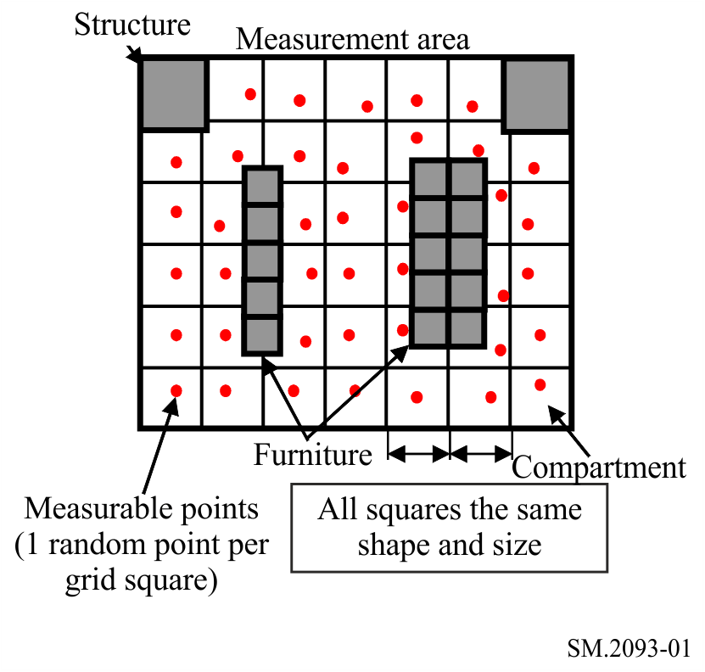

8 Post processing
Digital filter algorithms enable the analysis at any settings of center frequency and resolution bandwidth within the acquisition bandwidth (generally equal to the I/Q sampling rate) during post data processing. For evaluation of WGN and IN, it is possible to extract radio environment data by applying a digital filter passing only a part of the acquired bandwidth. Considering the properties of each of the key parameters of the radio environment as described in Section 3, the centre frequency and resolution bandwidth of this digital filter should be chosen so as to avoid influence of single carrier noise and wanted signals.
Regarding SCN, it has properties such as being continuous, relatively long in duration, and narrow in bandwidth. Therefore, it can be detected in spectrograms. Spectrograms can be obtained by applying Discrete Fourier Transformation to the acquired I/Q data.
It should be noted that the size of I/Q data becomes considerably large in proportion to the measurement time and I/Q sampling rate. Therefore, the capacity of storage used for data accumulation should be large enough.

9 Data processing for radio environment analysis
It is necessary to apply digital filter to I/Q data in order to calculate WGN and IN parameters through plotting amplitude probability distribution (APD) diagrams. For evaluation of SCN, Discrete Fourier Transformation (DFT) must be applied.
Key parameters of all three components of the radio environment can be obtained by analysing I/Q data according to the following procedures.
Level of SCN is acquired with the following steps:
1) transform I/Q data into a spectrogram by applying DFT;
2) detect SCN frequency with the highest level from the spectrogram;
3) acquire the level of SCN detected in step 2).
Level of WGN is acquired with the following steps:
1) select the centre frequency for a digital filter so as not to include the influence of SCN in the acquisition bandwidth, by using the spectrogram (obtained in step 2) of SCN level acquisition);
2) acquire amplitude data by applying a digital Gaussian filter to the I/Q data (in which the centre frequency is selected as in step 1)) and detect the envelope level of the filter output;
3) transform the amplitude data (obtained in step 2)) into an APD;
4) acquire the RMS level from the APD (obtained in step 3)) as the WGN level.
Level, duration, repetition frequency and total time of IN are acquired with the following steps;
1) extract any IN data samples by setting a threshold level to 13 dB above the WGN level (obtained in step 4) of WGN level acquisition);
2) acquire the level, duration, repetition frequency and total time of IN from the extracted IN data samples (obtained in step 1)).
These procedures are shown together as a chart shown in Fig. 2.
FIGURE 2
Procedure for acquiring three key parameters of radio environment
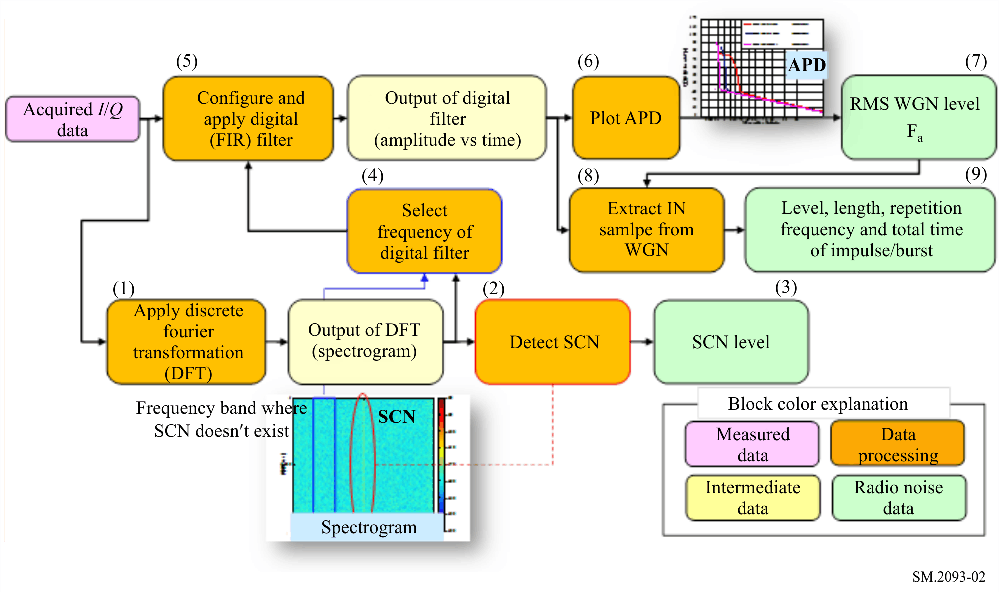
Details of the steps are as follows.

9.1 Analysis and evaluation method for SCN
This section describes the method for obtaining a spectrogram and the notes.

9.1.1 Steps for obtaining a spectrogram
In order to detect SCN, a spectrogram is obtained from measured I/Q data by applying the following steps:
1) divide the I/Q data into a series of non-overlapping segments of some constant length N;
2) apply a window function to a frame created with a segment of I/Q samples;
3) transform the segment into frequency components by applying DFT;
4) obtain the frequency components of consecutive segments by applying steps 1) to 3) repeatedly.
The transformation of the I/Q data into spectrogram by these steps is shown in Fig. 3. The time variation of the spectrum is converted into a 3D graph called spectrogram.
An example of a spectrogram obtained by these steps is shown in Fig. 4. The ordinate and the abscissa show the time and the frequency; the colour indicates the amplitude (power level).
FIGURE 3
Transformation of the I/Q data into the complex spectrum
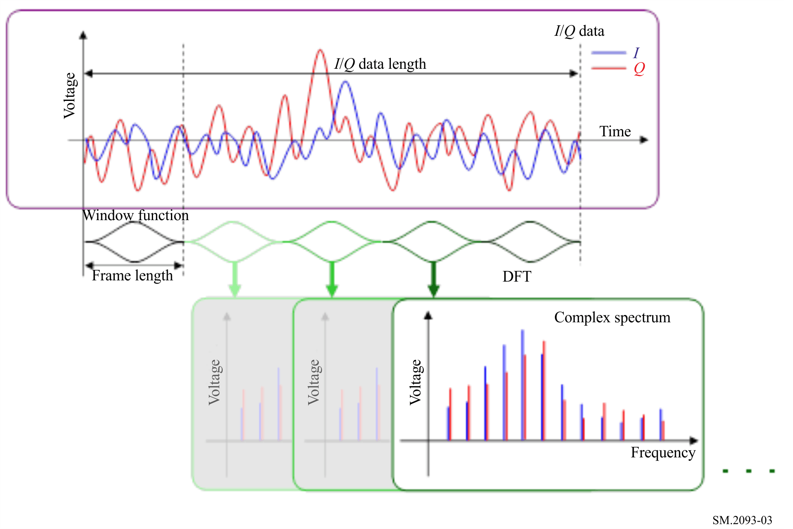
FIGURE 4
SCN component appears in a spectrogram
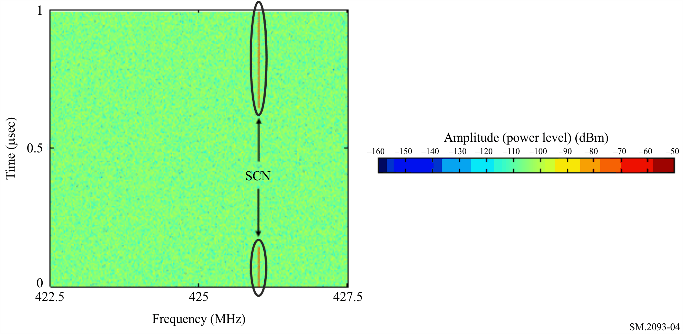
When applying the DFT, it is necessary to apply a window function to each frame in order to suppress spectral leakage resulting from discontinuities at the both edges of a frame.

9.1.2 Window function
It is recommended to apply a Gaussian window function, also used for IF filters of common spectrum analysers, because it is flexible to change the resolution of the spectrum.
The Gaussian window function is applied by multiplying each of the frames by the Gaussian function as expressed in Eq. (1), where t is time from the centre of the frame.
(1)
The value σ can be obtained from Eq. (2) for required 3 dB attenuation bandwidth of a filter b₋₃.
(2)
In order to detect SCN easily, the background noise level of spectrogram should be reduced by setting bandwidth of a filter b₋₃ narrower (see § 9.2.1).

9.1.3 Application of the Discrete Fourier Transform
The calculation of the DFT is expressed by Eq. (3) for I/Q data x(t).
(3)
where N is the number of samples in a frame.
Also, it is necessary to compensate the attenuation of amplitude due to the window function. An amplitude correction factor (ACF) is obtained by Eq. (4) for a window function of W(n).
(4)
The voltage spectrum V_{e}(f) is obtained through the envelope detection by Eq. (5), where X_{r}(f) and X_{i}(f) are real and imaginary parts of X(f) respectively.
(5)
The power spectrum P(f) in (dBm) can be obtained from the envelope voltage spectrum V_{e}(f) by Eq. (6).
(6)

9.1.4 SCN detection and power evaluation
SCNs usually exist at some specific frequencies, and their levels are higher than WGN. Also, the t of SCN is obviously longer than that of IN. Therefore, to detect SCNs in the spectrogram, the threshold level higher than the WGN level, and a threshold duration longer than the maximum duration of IN should be selected.
Detected SCNs are marked by the ellipses in Fig. 4.
The RMS level of the highest on the spectrogram is the value of interest for the evaluation of interference for narrowband radiocommunications.
When SCN is observed at several number of frequencies inside the acquisition bandwidth, the SCN RMS level (power) of the strongest carrier is selected.
When the power of SCN varied during the observation time, the power should be averaged on the time axis in order to obtain a single value for the observation duration.
SCNs have relatively narrow bandwidth, and their levels can be regarded to be independent of the bandwidth. The SCN level should be obtained as antenna input power in dBm.

9.2 Analysis and evaluation method for WGN
For acquiring WGN, the output of envelope detection of a receiver is estimated by applying a digital Gaussian filter to the I/Q data. The centre frequency of the digital filter, and the time-span of the I/Q data should be selected so as not to include the influence of SCN by checking spectrogram. The practical way to select the centre frequency of the digital filter is shown in Attachment 2.
TABLE 5
Recommended resolution bandwidth of digital filter
Frequency range | RBW of digital filter for analysis of WGN and IN
30 MHz – 450 MHz | 100 kHz
450 MHz – 1 GHz | 300 kHz
1 GHz – 3 GHz | 5 MHz
3 GHz < | 10 MHz

For the simple analysis of WGN and IN, the RBW of the digital filter is recommended to be set to the value shown in Table 5. In this context, RBW is the equivalent noise bandwidth given by the nominal 3 dB bandwidth. The detail regarding the equivalent noise bandwidth is shown in § 9.2.4.
In this measurement, RMS value for WGN is sometimes increased by the influence of impulsive noise in the case of the narrow RBW setting. On the other hand, it is more likely to contain the influence of SCN in acquired data in the case that RBW setting is widened.
Therefore, for more precise analysis, it is recommended to set the digital filter at multiple bandwidths (e.g. 10 kHz, 100 kHz and 1 MHz for 30 MHz to 450 MHz), and obtain the WGN level by selecting minimum RMS value of those multiple bandwidth settings. This method is also useful for understanding the difference of the behavior of impulsive noise in different bandwidth settings.
The bandwidth of the digital filter can be set at any values by the formula shown in § 9.2.1.

9.2.1 Configuration of a digital finite impulse response (FIR) filter
The finite impulse response (FIR) type digital filter is composed of stages, and each stage has an independent delay, an amplification gain referred to as a filter coefficient, and an adder.
The filter coefficients are complex numbers when applied to I/Q data. The impulse response, h, of the Gaussian filter is a function of time t and the centre frequency f_{c}, expressed as Eq. (7).
(7)
where σ can be obtained from Eq. (2) for the required 3 dB bandwidth.

9.2.2 Calculation of the peak envelope power
The output of the digital filter, y(t), can be obtained by the convolution of the impulse responses as shown in Eq. (8).
(8)
The output voltage of the envelope detector, y_{e}(t) (V), obtained from the filter outputs, is calculated as absolute value of y(t) as shown in Eq. (9).
(9)
where y_{r}(t) and y_{i}(t) are the real and imaginary part of the outputs of the digital filter, respectively.
Instant values of power P(t) (dBm) can be obtained by Eq. (10) for 50 Ω impedance.
(10)

9.2.3 Plotting of the APD
The RMS level of WGN can theoretically be determined by linear averaging the peak envelope power calculated by Eq. (10). However, this is only accurate if nothing else than WGN was present during the measurement, and such assumption cannot be applied in indoor environments. Therefore, the RMS level of WGN should be determined by plotting the raw data in a so called “amplitude probability distribution (APD)” graph: This graph shows the percentage of measurement data samples that exceed a certain amplitude (see Fig. 5).
FIGURE 5
Typical amplitude probability distribution
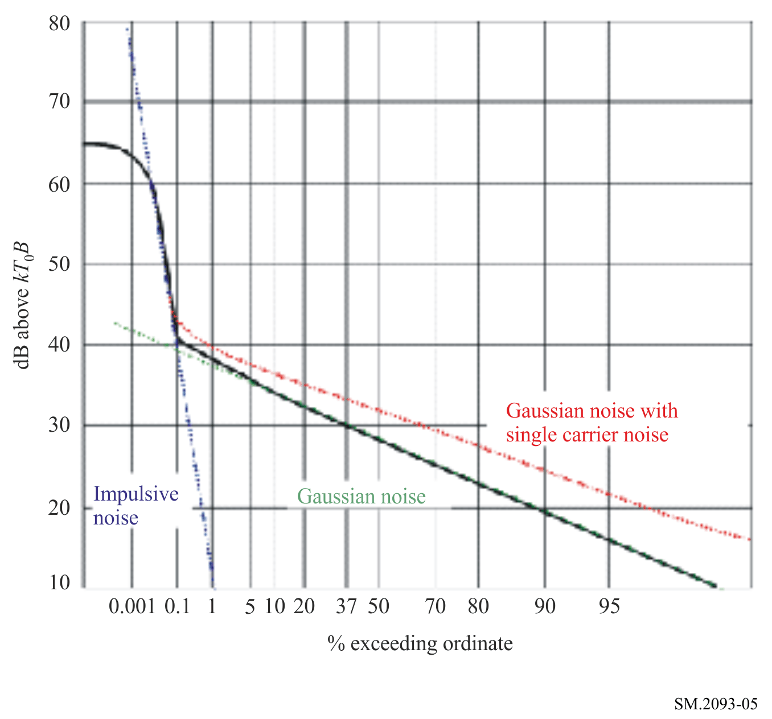
The x-axis of the APD graph has a Rayleigh scaling. With this scaling, it is easy to separate the different types of noise, because White Gaussian noise shows up as a straight sloping line. It can be shown mathematically that the gradient of this line is −10 when both scales are converted to linear. This means that the line falls by 10 dB between 0.1%, 37%, 90% and 99%.
The rising edge to the left indicates impulsive noise. When SCN and/or wanted emissions are included in measurement data, the slope of the APD plot on WGN part will become larger than –10, and the plot is elevated, as shown by the dotted red line in Fig. 5.
When no SCN or narrow-band wanted emissions are present, the overall RMS level is the value at the point where the curve crosses 37% on the abscissa. This can be achieved by selecting frequency of digital filter so as not to include those radio components (see Attachment 2).

9.2.4 WGN power evaluation
According to Recommendation ITU-R P.372, the WGN level is expressed as a noise figure of a lossless antenna due to external noise F_{a} in dB above thermal noise.
The thermal noise can be calculated as:

(11)
where:
K: Boltzmann constant 1.38*10⁻²³ (J/K)
t: ambient temperature (K)
b_{ENBW}: noise equivalent bandwidth (Hz).
Noise equivalent bandwidth b_{ENBW} can be obtained by Eq. (12) from the 3 dB bandwidth, b₋₃, of the Gaussian digital filter.
(12)
At a reference temperature t₀ of 290 K (17°C), P₀ becomes −174 dBm in 1 Hz bandwidth.
The measured noise level is the sum of external noise and noise originating from the measurement system, mainly consisting of receiver noise and, in case an LNA is used, of the noise from the LNA. The external noise factor f_{a} can be calculated using the equations in Recommendation ITU-R P.372. In real measurement environments, it is realistic to assume that the temperature of all parts of the measurement system is equal. Furthermore, it can be set to the reference temperature t₀ of 17°C without introducing a considerable error except for special cases with extreme temperatures. Under these assumptions, the key equation that can be used for the calculation of f_{a} is:
(13)
where:
f: measured total noise factor in linear units (p_{meas}/p₀)
f_{c}: noise factor associated with antenna (antenna output/available input power)
f_{t}: noise factor associated with transmission line (cable input/output power)
f_{r}: noise factor of the receiving system (receiver and LNA, if used).
All lower-case parameters are given in linear units, not decibels. WGN power as an external noise figure in dB above thermal noise (KT₀b), can be calculated by Eq. (14).
(14)

9.3 Analysis and evaluation method for IN

9.3.1 IN sample extraction
To extract only samples originating from IN, a threshold has to be applied, that is well above the WGN peaks, to the output of envelope detector. This threshold is set to 13 dB above the RMS WGN level as this is the usual CREST factor (difference between RMS and peak value) for WGN. All measurement samples above the threshold are treated as IN.

9.3.2 Calculation of the IN characteristics
To fully characterize IN, the parameters of level, total time rate, duration, repetition period, are required. The calculation method for each parameters is as follows.
(1) IN level
The IN level density (dBµV/MHz) can be obtained from Eq. (15):
(15)
where b_{IBW} is impulse bandwidth (MHz), and y_{e}(t) is peak envelope voltage given by Eq. (9)
The relationship between the impulse bandwidth b_{IBW} and the 3 dB bandwidth of the Gaussian filter, b₋₃, is given by Eq. (16).
(16)
The IN levels can also be shown by the levels correspond to a specific percentile (e.g. 0.01%) on the APD. For the evaluation of this value, APD plotting should be obtained from IN samples. The value is extracted as the levels correspond to a specific percentile (e.g. 0.01%) on the APD.
(2) IN total time rate
The total time rate is given as a percentage of the IN samples for the total number of samples.
(17)
where:
Ni: number of samples above the IN threshold
N: total number of samples.
IN total time rate can be obtained for each measured point.
(3) IN duration and repetition period
Once IN start and end samples are identified, the duration of each IN is calculated as:
(18)
where:
N₁: number of samples between IN start and end
f_{s}: sampling frequency.
The IN repetition period is calculated as:
(19)
where:
N₂: number of samples between each IN start points
f_{s}: sampling frequency.
Based on the above, the values of these two parameters are extracted from each I/Q data obtained at each measurement point, and it is recommended to present a distribution plot representing a measurement location by using all the extracted values. Because, the single point data may not be adequate for evaluating statistical characteristics for these two parameters.
IN repetition period should be evaluated not only for each adjacent IN pair on the time axis, but also for every combination of IN extracted from an I/Q data obtained at a measurement point.

10 Result presentation
For indoor environments, it is essential to measure radio environment at multiple positions in each indoor location as mentioned in § 7.4.
The cumulative distribution of measured values obtained at multiple positions can be recognized as the cumulative distribution of the radio environment in that indoor location. The distribution shows, for any given level, the proportion (of the total area) in which the level exceeds the ordinate value, as shown in Fig. 6.
It can be recognized as the proportion (of the indoor location) where a wireless system can operate normally, and this is useful for the design or installation of wireless systems. This distribution is also useful for comparison of key parameters of the radio environment between different locations.
To simplify the result, the distribution can also be presented as a boxplot. For each location, the maximum, upper 90%, median, lower 10% and minimum values are calculated and shown in a box. In the case that the cumulative probability value for each boxplot parameter cannot be obtained directly from measured data, it can be obtained by applying linear interpolation between the nearest figures of actual data.
FIGURE 6
Cumulative proportion of area in which the noise level exceeds the ordinate and boxplot
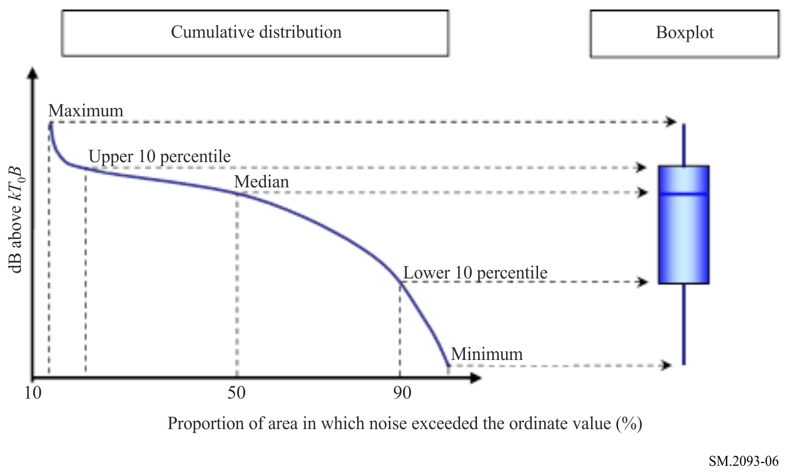
For the IN duration and repetition period, the number of events should be totaled and presented as frequency distribution for each location or environmental category. To make the result mutually comparable, the number of events is recommended to be normalized by unit time.
Examples of the frequency distribution of IN duration and repetition period are shown in Fig. 7 and Fig. 8 respectively.
FIGURE 7
An example of frequency distribution for IN duration
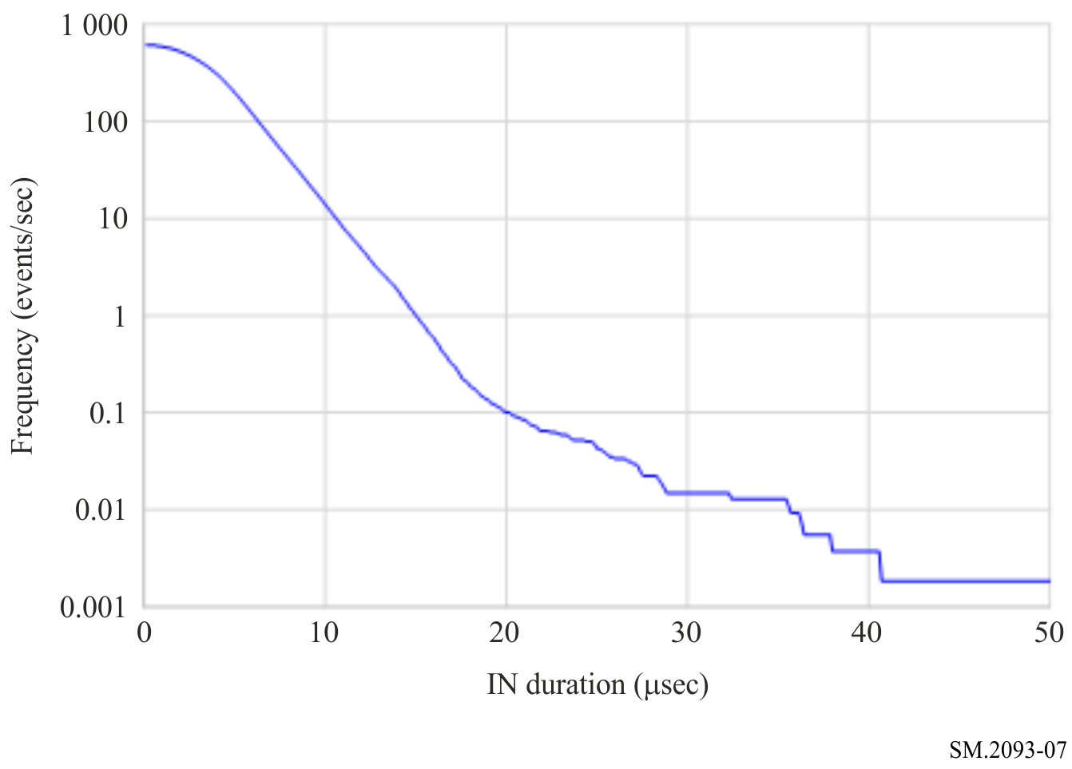
FIGURE 8
An example of frequency distribution for IN repetition period
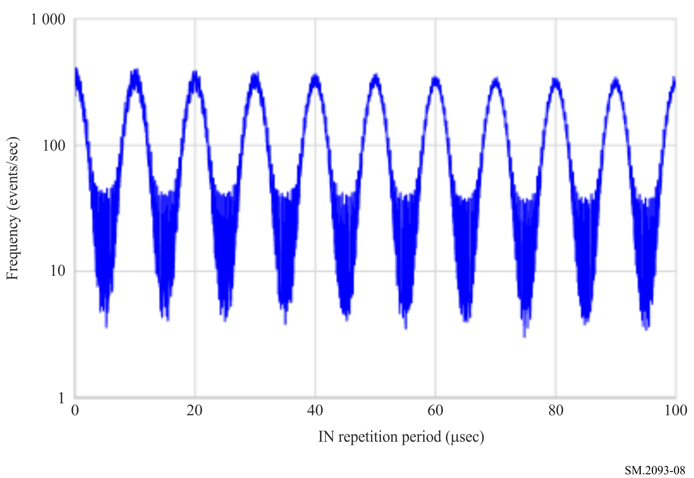

Attachment 1
to Annex 1
Examples of practical measurement set-up
Figure 9 shows the example of practical measurement set-up.
FIGURE 9
An example of practical measurement set-up
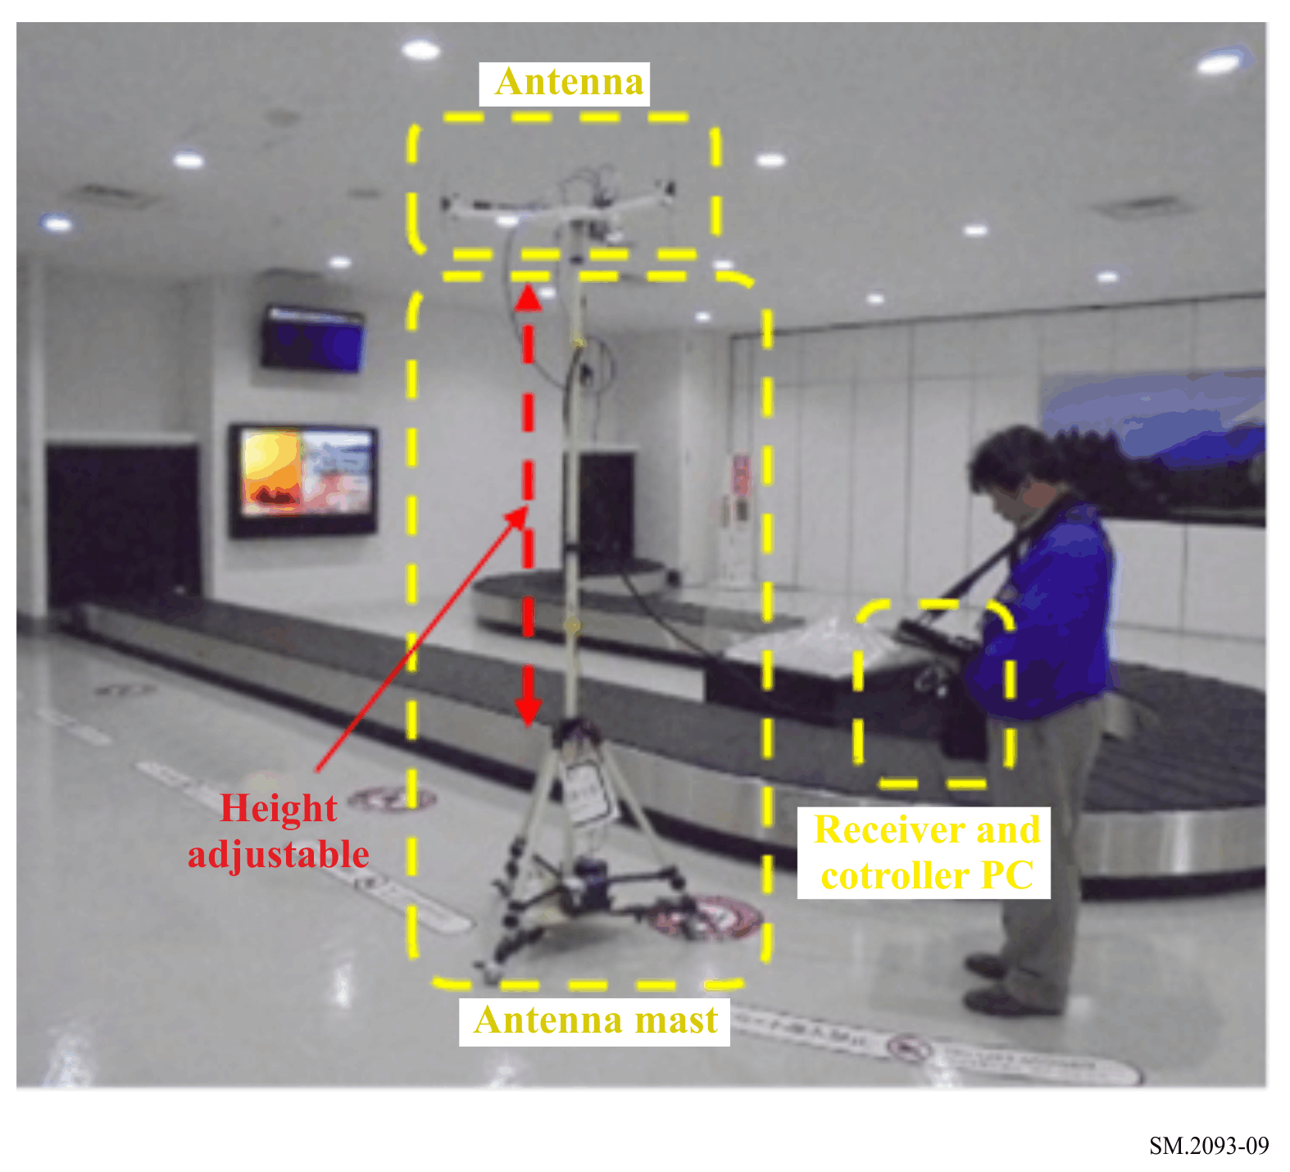

Attachment 2
to Annex 1
Frequency selection method for digital filter
In order to know precise WGN level, it is important to exclude the influence of components such as SCN or wanted emissions. On the other hand, digital filter algorithms enable the analysis at any settings of centre frequency and resolution bandwidth according to Eq. (7). This will be advantage for minimizing the influence as it enables to select a frequency which is not occupied by such radio components.
The practical steps for finding appropriate center frequency of digital filter are as follows:
1) Calculate average power spectrum by averaging the spectrogram in the time domain.
2) Calculate total power within the designed –60 dB bandwidth while shifting centre frequency among the average power spectrum.
Find the frequency which makes the smallest total power among the spectrum.
The diagram of the method is shown in Fig. 10.
FIGURE 10
Diagram for selecting center frequency of digital filter
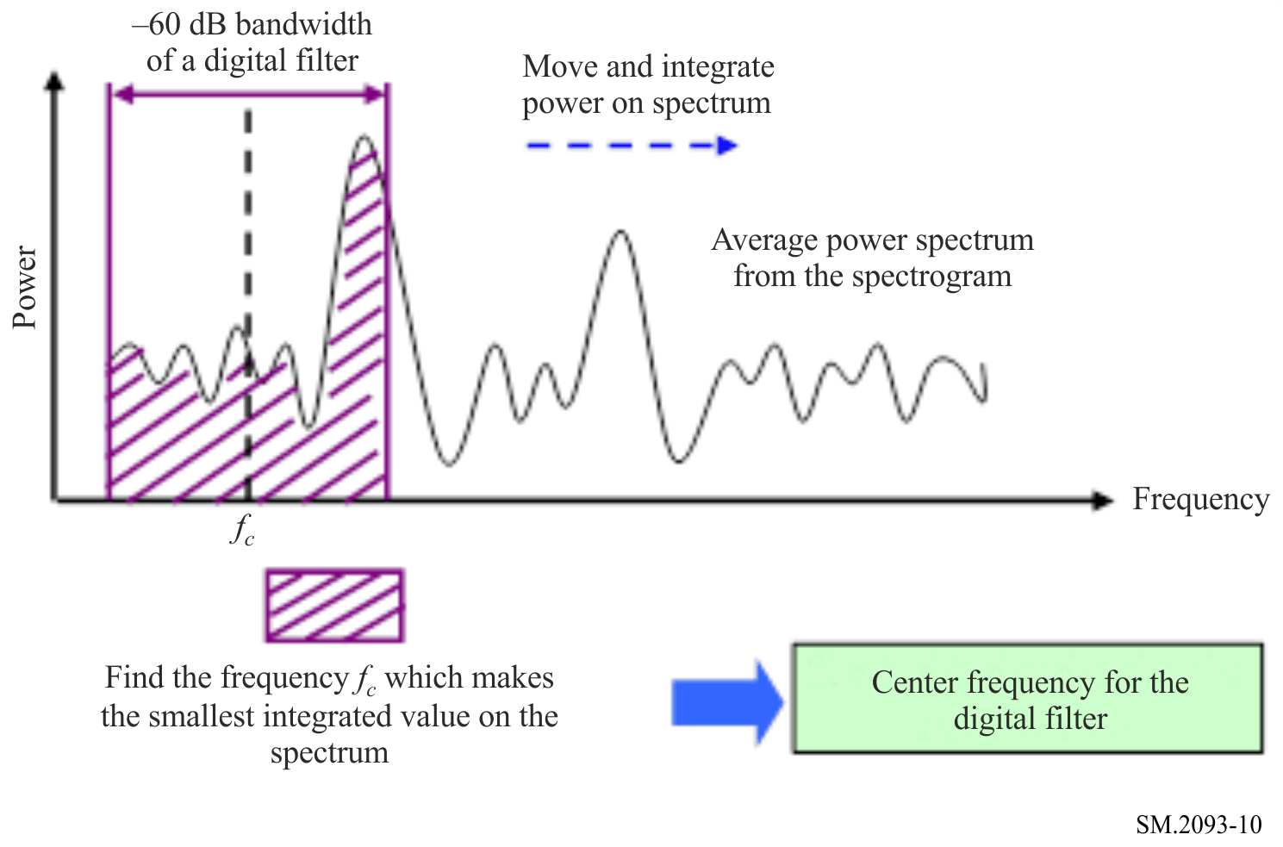

* Radiocommunication Study Group 1 made editorial amendments to this Recommendation in the year 2023 in accordance with Resolution ITU-R 1.

