Radiocommunication Study Groups
Source: Document 1/106(Rev.1)  Subject: Direction Finder (DF) immunity | Document 1/BL/3-E
 | 28 August 2014
 | English only
Radiocommunication Study Group 1
DRAFT NEW RECOMMENDATION ITU-R SM.[DF_IMMUNITY]
Test procedure for measuring direction finder immunity
against multi-path propagation

Introduction
This document presents the output of the Correspondence Group on DF Accuracy for consideration at the 2014 meeting of Working Party 1C. This document is based on Document 1C/74, Annex 5, which was prepared as an output from the June 2013 meeting of Working Party 1C.
The discussions at the last meeting aimed to simplify the recommended test methods in the output document from the Drafting Group who worked during the last meeting. The DG proposed 3 different DF accuracy measurement test setups and procedures; - DF accuracy in idealized propagation condition at OATS or anechoic chambers; - DF accuracy in operational conditions in a real environment; and - DF accuracy in emulated multi-path propagation conditions. The view was that the testing in emulated multipath conditions be simplified, and that DF accuracy measurements in a real operational environment, while very important, was primarily an acceptance test and not as useful in comparing DF accuracy between manufacturers.
During the 2014 meeting of Working Party 1C it was decided to split the document and create three individual recommendations. This recommendation covers DF immunity against multi-path propagation.
This document incorporates comments and contributions made to the Drafting Group established during the meeting to do this work. The contribution from Japan, which proposes an additional method not considered in the original document, may become a report in the future.
Summary
The Recommendation provides test procedures for measuring the immunity against multi-path propagation of fixed and mobile direction finders (DF).

DRAFT NEW RECOMMENDATION ITU-R SM.[DF_IMMUNITY]
Test procedure for measuring direction finder immunity
against multi-path propagation

Scope
The Recommendation provides test procedures for measuring the immunity against multi-path propagation of fixed and mobile direction finders (DF).
Keywords
DF, direction finder, test procedure, immunity, multi-path propagation, reflections, open-air-test-site, OATS
Related ITU Recommendations
Recommendation ITU-R SM.[DF_ACCURACY-DOC. 1/105]
NOTE – In every case the latest edition of the Recommendation/Reports in force should be used.
The ITU Radiocommunication Assembly,
considering
a) that ITU-R has published the DF immunity against distorted wave fronts of different DF methods in the ITU Handbook on Spectrum Monitoring (Edition 2011);
b) that the immunity against distorted wave fronts is an important specification of a DF since distorted wave fronts from multipath propagation are typical in practice;
c) that the specification of DF immunity against distorted wave fronts strongly depends on the test procedures applied;
d) that a test procedure for DF immunity against distorted wave fronts must be independent of the direction finder design;
e) that a well-defined test procedures for DF immunity against distorted wave fronts to test the influence of multi-path propagation under approximated real-world conditions, if adopted by all manufacturers of direction finders intended for civil radio monitoring, will have the advantage for the users of such direction finders, that an easier and more objective assessment of products from different manufacturers is possible,
recommends
1 that the measurement method in the Annex 1 should be used to determine and report the immunity against distorted wave fronts due to multi-path propagation on fixed and mobile direction-finding systems.

Annex 1
Immunity against distorted wave fronts due to multi-path propagation:
test procedure for fixed and mobile DF

1 General considerations
Under normal circumstances, wave propagation between the emitter and direction finder is disrupted by buildings, mountains, hills, etc. Even if we have direct line of sight, secondary waves will still arise due to reflection, refraction and diffraction and superimpose the direct wave at the receiving location as interfering fields. If the interfering wave component has a lower power level than the desired wave component, the bearing error can be minimized by choosing suitable design parameters in the direction finder. This recommendation serves to measure the DF immunity to distorted wave fronts caused by a secondary wave (reflection). It is meant to be used for an exemplary measurement of one single sample of the serial production version of the direction finder system under test.

2 Principle of measurement
The measurement will be conducted under simplified conditions, thus permitting great simplicity of the tests and easy repeatability of the results at any time and at any site. In order to simulate a multipath environment, an arrangement of two transmitting antennas (two-wave field produced by a single transmitter) is proposed subsequently. Both antennas are connected to the test transmitter via a power divider. By using an attenuator the amplitude of the signal which represents the reflection (secondary wave) can be set, and hence determine the amplitude relation between direct (primary) and reflecting (secondary) path. The angle of arrival and the phase angle of the secondary wave is varied. Considering the objective to simplify the measurement , effects of modulation type (including phase and time variant signals), signal duty cycle, bandwidth, signal polarization, and signal duration, noise and other signal and DF quality parameters (e.g., DF sensitivity) are intentionally ignored to reduce the complexity of the tests procedure and the time duration of the measurements. The measurement takes place in an otherwise reflection-free environment such as an open-air-test-site (OATS) or an anechoic chamber.
In addition to the recommended measurement procedure described here, it is possible to measure the DF immunity against distorted wave fronts by means of multi-channel emulators which can simulate the propagation effects of a real environment, in situations where an OATS or anechoic chamber is not readily available.

3 Measurement set up
The proposed measurement setup is shown in Figure 1. In order to ensure a well-defined dual-path propagation scenario the environment of the DF and transmitting antennas should be free of reflecting obstacles and interferences as indicated in the preliminary draft new
Recommendation ITU-R SM.[DF_ACCURACY-DOC. 1/105]. The distances between the DF antenna and both transmitting antennas, as well as the height of all antennas involved should be in line with preliminary draft new Recommendation ITU-R SM.[DF_ACCURACY-DOC. 1/105].

4 Measurement procedure
In order to simulate a basic multipath wave environment (two-wave field produced by a single transmitter), an experimental test bed as shown in Fig. 1 is recommended:
• an un-modulated continuous wave input signal S on various measurement frequencies within the operational frequency range of the direction finder is generated using a signal generator;
• the input signal S is divided into S1 and S2 signals by means of a power divider;
• the S1 signal is transmitted by transmit antenna 1, and
• attenuation and phase shift is added to the S2 signal before it is transmitted by transmit antenna 2 from a different angle than S1.
Both S1 and S2 signals must have a power level high enough to ensure a minimum SNR of 20 dB (in order to ensure that system noise does not affect the measurement results).
Due to the fact that the DF immunity to distorted wave fronts tends to vary with frequency it is required to repeat the measurement for various measurement frequencies. The measurement frequencies are selected in line with Recommendation ITU-R SM.[DF_ACCURACY-DOC. 1/105].
For each measurement frequency the S2 signal from antenna A2 (the “reflected” signal) is varied in azimuth, amplitude and phase shift as follows:
• the angle of arrival difference Δθ between the reflected wave S2 and the main wave S1 is set to 20°, 60° and 90°;
• the amplitude ratio α of the reflected wave S2 and the main wave S1 is set so that the power level of S2 is 0.25 (-6 dB) with respect to S1 at the DF antenna. Note that α takes into account all gains and losses over cables, antennas and air;
• the positive time delay difference Δτ of the reflected wave S2 is set so that a phase difference Δϕ of 0°±5°, 90°±5° and 200°±5° between S1 and S2 occurs at the DF antenna. Note that Δτ takes into account all propagation delays over cables, antennas and air. Note further that the phase shift can be applied by a variable phase shifter or a delay line, besides ±5° have been included to consider uncertainties of the setup configuration, e.g., small variations of the antenna locations during placement.
For all different settings described above the bearing error is measured and the RMS bearing error is calculated with the formula stated in Recommendation ITU-R SM.[DF_ACCURACY-DOC. 1/105], resulting in one RMS bearing error per measurement frequency. The final result is presented as a table or chart indicating the RMS bearing error for each measurement frequency as indicated in Table 1.
It should be noted that the recommended measurement procedure is focused on a single angle of arrival of the primary wave. However, it would be desired in specific cases that different angles of arrival of the primary wave are measured by rotating the antenna. If such specific test conditions are applied, this should be indicated in the test reports.
Figure 1
Measurement setup for determining the direction finder immunity to distorted wave fronts

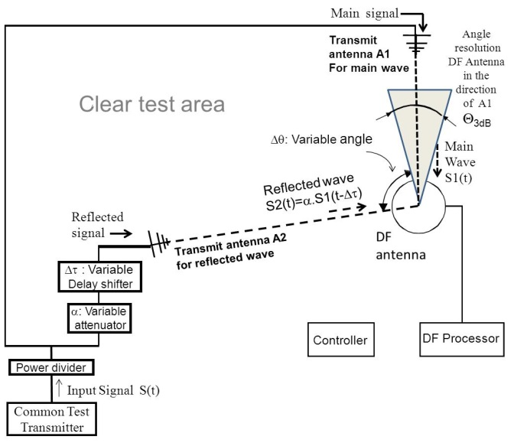
TABLE 1
Sample test data table

[Signal modulation:_____________ Signal polarization: _______ S2 relative power level at the DF antenna: __ [dB]

 | True | Δθ | Δϕ | Frequency 1 |  | Frequency 2 |  | Frequency 3 |  |  | Frequency M
Index | Azimuth |  |  | DF | Δ | DF | Δ | DF | Δ |  | DF | Δ
1 | 0° | 20° | 0°
2 |  |  | 90°
3 |  |  | 200°
 |  | 60° | 0°
 |  |  | 90°
 |  |  | 200°
 |  | 90° | 0°
 |  |  | 90°
 |  |  | 200°
… | … | … | … | … | … | … | … | … | … |  | … | …
Note that Δ is the difference between the true azimuth (angle of the transmitter’s test antenna) and the displayed bearing on the DF equipment.

Example for a specification in a data sheet of DF immunity against multi-path propagation conditions:

Frequency | f₁ | f₂ | f₃ | … | f_{N}
RMS DF error | RMS DF error at f₁ | RMS DF error at f₂ | RMS DF error at f₃ | … | RMS DF error at f_{N}

_________________

OATS definition can be found in a number of standards documents such as ANSI C63.7, CISPR or EN55 022. The OATS is considered as line-of sight (LOS) with no interference signal, no reflection and far-field (Fraunhofer Region).

