Recommendation ITU-R SM.1880-3
(08/2026)
SM Series: Spectrum management
Spectrum occupancy measurement and evaluation

Foreword
The role of the Radiocommunication Sector is to ensure the rational, equitable, efficient and economical use of the radio-frequency spectrum by all radiocommunication services, including satellite services, and carry out studies without limit of frequency range on the basis of which Recommendations are adopted.
The regulatory and policy functions of the Radiocommunication Sector are performed by World and Regional Radiocommunication Conferences and Radiocommunication Assemblies supported by Study Groups.

INTELLECTUAL PROPERTY RIGHTS
ITU draws attention to the possibility that the practice or implementation of this Recommendation may involve the use of a claimed Intellectual Property Right. ITU takes no position concerning the evidence, validity or applicability of claimed Intellectual Property Rights, whether asserted by ITU members or others outside of the Recommendation development process.
As of the date of approval of this Recommendation, ITU had received notice of intellectual property, protected by patents, which may be required to implement this Recommendation. However, implementers are cautioned that this may not represent the latest information and are therefore strongly urged to consult the appropriate ITU-R patent information available at https://www.itu.int/en/ITU-R/study-groups/Pages/itu-r-patent-information.aspx.

Series of ITU-R Recommendations
(Also available online at https://www.itu.int/publ/R-REC/en)
Series | Title
BO | Satellite delivery
BR | Recording for production, archival and play-out; film for television
BS | Broadcasting service (sound)
BT | Broadcasting service (television)
F | Fixed service
M | Mobile, radiodetermination, amateur and related satellite services
P | Radio-wave propagation
RA | Radio astronomy
RS | Remote sensing systems
S | Fixed-satellite service
SA | Space applications and meteorology
SF | Frequency sharing and coordination between fixed-satellite and fixed service systems
SM | Spectrum management
SNG | Satellite news gathering
TF | Time signals and frequency standards emissions
V | Vocabulary and related subjects

Note: This ITU-R Recommendation was approved in English under the procedure detailed in Resolution ITU-R 1.

Electronic Publication
Geneva, 2026
© ITU 2026
All rights reserved. No part of this publication may be reproduced, by any means whatsoever, without written permission of ITU.

RECOMMENDATION ITU-R SM.1880-3
Spectrum occupancy measurement and evaluation
(2011-2015-2017-2026)
Scope
Frequency channel occupancy, as well as frequency band occupancy, should have a certain level of accuracy in order to be compared or merged if necessary, although automatic occupancy measurement would not completely replace manual observations, it is still well suited for most cases. By using the technique and proper method, a more efficient use of existing equipment is possible.
Keywords
Spectrum occupancy measurements, frequency channel occupancy, revisit time, busy hour, frequency band occupancy, spectrum resource occupancy
Abbreviations/Glossary
FBO Frequency band occupancy
FCO Frequency channel occupancy
FFT Fast Fourier transform
GNSS Global navigational satellite service
IBW Instantaneous bandwidth
RMDF Radio monitoring data format
SO Spectrum occupancy
SRO Spectrum resource occupancy
Related ITU Recommendations, Reports, Handbooks
Recommendation ITU-R SM.1809 – Standard data exchange format for frequency band registrations and measurements at monitoring stations
Report ITU-R SM.2256 – Spectrum occupancy measurements and evaluation
Handbook on Spectrum Monitoring (Chapter 5 – Measurements)
The ITU Radiocommunication Assembly,
considering
a) that the increasing demand of radiocommunication services requires the most efficient use of the radio-frequency spectrum;
b) that good spectrum management can only satisfactorily proceed if the spectrum managers are adequately informed on the current usage of the spectrum and the trends in its demand;
c) that results of spectrum occupancy measurements would provide important inputs into:
– frequency allotments and assignments;
– verification of complaints concerning channel blocking;
– establishment of the degree of efficiency of spectrum usage;
d) that information obtained from frequency assignment databases does not reveal the degree of loading on each frequency channel;
e) that some administrations assign the same frequency to more than one user for shared use;
f) that it is desirable to compare measurement results from different countries in border areas and/or different bands;
g) that automatic monitoring equipment is now in use by administrations, including methods for the analysis of records, and a number of parameters can be evaluated, which are of considerable value in enabling more efficient utilization of the spectrum;
h) that in designing an automated system to gather occupancy data for use in spectrum management, one must determine what parameters are to be measured, the relationship among these parameters and how often measurements have to be taken to ensure the data are statistically significant;
i) that it is desirable to harmonize measurement procedures and techniques to facilitate the exchange of measurement results between various countries;
j) that successful merging or combining of monitoring data not only depends on the format but also on the environmental and technical conditions during acquisition,
noting
that both Report ITU-R SM.2256 and the ITU Handbook on Spectrum Monitoring in force should be used as guidance for spectrum occupancy measurements and the equipment should satisfy the requirement mentioned in that Handbook,
recognizing
a) that various principles and methods of spectrum occupancy measurements are in use in the different countries;
b) that method(s) exist(s) to get high-accuracy frequency channel occupancy data and that such data usually is the basis to form the frequency band occupancy,
recommends
1 that the measurement procedures and techniques specified in Annexes 1 and 2 should be used for spectrum occupancy measurements;
2 that a common data format, that is a line-based ASCII file derived from the radio monitoring data format (RMDF), should be used as described in Recommendation ITU-R SM.1809.

Annex 1
TABLE OF CONTENTS
Page
1 Introduction 3
2 Definitions 3
3 Requirements 4
3.1 Equipment 4
3.2 Site considerations 4
3.3 Time related parameters 4
3.4 Accuracy, statistical confidence level and required number of samples 5
3.5 Other considerations 9
3.6 Presentation and analysis of collected data 10

1 Introduction
Annex 1 describes frequency channel occupancy measurements performed with a receiver or spectrum analyser. The signal strength of each frequency step is stored. By means of post-processing the percentage of time that the signal is above a preset threshold level is determined. An example of the procedure for such post-processing is presented in Report ITU-R SM.2256 (Annex 1). Different users of a channel often produce different field-strength values at the receiver. This makes it possible to calculate and present the occupancy caused by different users.

2 Definitions
Frequency channel occupancy measurements: Measurements of channels, not necessarily separated by the same channel distance, and possibly spread over several different frequency bands to determine whether the channel is occupied or not. The goal is to measure as many channels as possible in a time as short as possible.
Frequency channel occupancy (FCO) observes the frequency spectrum of channelized radio applications. It is defined as the ratio of time duration that the signal amplitude of a certain channel exceeds the threshold level (occupied state) out of the total measurement time.
Frequency band occupancy (FBO) observes the spectrum occupancy at different frequencies for a whole frequency band, regardless of the channel spacing. During the integration time, a certain band is divided into frequency steps of a fixed size. FBO is the ratio of the number of measurements exceeding their threshold level out of the total number of measurements.
Spectrum resource occupancy (SRO) expresses the occupancy in terms of the ratio between the number of channels in use to the total number of available channels in a whole frequency band. It is the ratio of channels with signal amplitude exceeding the threshold out of the total number of channels.
Revisit time: The time taken to visit all the channels to be measured (whether or not occupied) and return to the first channel.
Observation time: The time needed by the system to perform the necessary measurements on one channel. This includes any processing overheads such as storing the results to memory/disk.
Maximum number of channels: The maximum number of channels which can be visited in the revisit time.
Transmission length: The average length of individual radio transmission duration.
Integration time: Time interval for which an individual occupancy estimate is made. Normally 5 or 15 minutes.
Duration of monitoring: The total time during which the occupancy measurements are carried out.
Preset threshold level for measurement: If a signal is received above the threshold level, the channel is considered to be occupied.
Busy hour: The highest level of occupancy of a channel in a 60-min period.

3 Requirements

3.1 Equipment
A system capable of making frequency channel occupancy measurements by using frequency band registrations will consist of a radio receiver or spectrum analyser, antenna, cable, a PC/controller with interface adaptor, and suitable acquisition and post-processing software.
Other features may include GNSS for mobile/nomadic operation of the station, communications modem for remote control and data exchange, system calibration for traceable field strength measurements, antenna switches, filters and attenuators for multiple band and/or strong EMF exposure environments.

3.2 Site considerations
The measurement site should be chosen to ensure that the expected signal strength of the emissions of interest is above the threshold level. The relation between these two parameters (signal strength and threshold level) will define an area within which the measurement is relevant for any station operating above a certain effective radiated power (e.r.p.) level or effective isotropic radiated power (e.i.r.p.) level.
The expected signal strength can be estimated by considering the locations of licensed stations in the region and their emission profile by using simulation software. The threshold can be estimated by considering the monitoring system sensitivity (noise floor) or previous measurements performed under similar conditions with the same equipment and configuration.
If no preliminary information is available, a site survey using portable equipment should be performed. This is especially important if the equipment placement is of permanent nature and future relocations may not be easily performed.
Measurement results should ideally be accompanied by a report of the analysis performed to select the site, indicating the site location, the monitoring area, and the emitters expected to be considered.

3.3 Time related parameters
There is a relationship between revisit time, observation time, and the number of channels. The expected transmission length will also influence the duration of monitoring.
The revisit time is directly dependent on the observation time and the number of channels. The observation time includes the actual measurement time plus the processing time (data transfer between receiver and controller). This influences the revisit time and should be kept as short as possible.
Revisit time = Observation time × Number of channels of identical bandwidth
The observation time per channel is limited by the scanning speed and processing time of the monitoring equipment. In order to maintain a reasonably short revisit time with relatively slow equipment, the number of channels to be measured must be reduced.
Whenever applying the above equation to spectrum analysers, when the RBW is set equal to the channel bandwidth, the Number of channels can be considered as the number of frequency bins per sweep and the observation time as the dwell time per bin.
On FFT analysers, the principle still applies. If the number or distribution of channels to be scanned exceeds the IBW, a sweep will be required. In this case, however, the number of scanned channels should be divided by the number of channels evaluated on each single FFT.
The monitoring system needs to scan at an acceptable speed in order to detect individual short transmissions.
There are principally two different approaches to obtain frequency channel occupancy measurements:
a) Capturing every transmission in the channel under observation. This approach requires a maximum revisit time that is half the minimum on or off time of any transmission in the measurement, whichever is shorter. This method delivers an accuracy that is independent of the occupancy result and may allow shorter monitoring duration.
b) Statistical approach: Especially when considering bursts of digital systems, the minimum transmission time might be too small for the practical application of the above principle. However, if the duration of monitoring is long enough to provide enough samples, the occupancy result will be correct even with far longer revisit times, because the statistical probability of catching a transmission vs. the probability of missing it is the same as the duty cycle of the transmission. The accuracy of the statistical approach, however, depends on the expected value of occupancy as described below.
The duration of monitoring is based on a combination of the revisit time, typical transmission lengths expected, number of channels to be scanned, and the desired accuracy of the results.
The duration of monitoring should be long enough to accommodate all relevant emissions. If no time distribution pattern is known, initial evaluations should consider at least 24 h or multiples of 24 h. One week of monitoring gives the difference in occupancy over the days of the week and the weekend. Seven periods of 24 h spread over a longer period of time (e.g. one year) gives even more reliable occupancy information.

3.4 Accuracy, statistical confidence level and required number of samples
From a statistics point of view, the result of spectrum occupancy measurement is an estimate or statistical value, thus it has accuracy and reliability attributes. Accuracy reflects the control of error achieved during the setup of the measurement, usually measured by relative accuracy (or relative error) as well as absolute error. Reliability indicates the confidence in the resulting data scored with confidence level (e.g. from 0 to 1). The measurement itself can be deemed as a process of sampling from a given population, and the analysis of the resulting data is essentially a process of estimating the population using the limited samples.
In practice, the result of the collection and processing of data is abbreviated as SO, but it is not a true value as just mentioned. Even in cases where, during the integration time, the monitoring equipment provides only a small number of data samples, calculation of the occupancy estimate will give a number of values characterizing the radio-channel occupancy to a greater or lesser degree. However, such values will correspond to the true value of occupancy (SO) only when averaged over a large number of integration times, while the individual evaluations may deviate considerably from SO.
On the other hand, under computer control it is possible to collect a large number of samples, more than is necessary, for determining occupancy with the required accuracy. There is an optimum number of samples, beyond which additional data may not significantly improve results. The optimum number of samples needed is discussed in the Report ITU-R SM.2256.
As stated above, the quality of the measurements is characterized by two values:
1) the absolute accuracy Δ_{SO}, which determines the accepted interval of deviations in the estimates from the true value SO;
2) confidence level, which indicates the probability of estimates falling into the interval from [SO − Δ_{SO}, SO + Δ_{SO}].
It is sometimes more convenient to define the confidence interval limits in the form SO · (1 ± δ_{SO}), where δ_{SO} = Δ_{SO} / SO is the maximum accepted relative evaluation error.
The number of samples required to achieve a certain level of confidence depends on the actual channel occupancy value: the lower the occupancy, the more samples will be needed.
Table 1 compares the number of independent and dependent samples required to reach a certain level of confidence under the assumption of a revisit time of one second (T_{R} ≈ 1 s). For the case of independent sampling, the assumed model relies upon the central limit theorem. For the case of dependent sampling, a first order Markov process is used. The calculations were performed in accordance with the methodology presented in [1]. At a similar rate of revisit time, when the transmission length is less than one second, the samples can be considered independent. In channels with transmission length exceeding one second, the samples are dependent. In general, when the transmission length is less than the revisit time, the samples can be considered independent. Further explanation is given in § 2.2 of Annex 2.
TABLE 1
Number of dependent and independent samples required to achieve 10% relative accuracy and a 95% confidence level at various occupancy percentages (assumes a 1 s sampling period)
Occupancy  (%) | Number of required independent samples | With an average transmission duration of about 1.5 s |  | With an average transmission duration of about 12 s
Occupancy  (%) | Number of required independent samples | Number of required dependent samples | Required hours of dependent sampling | Number of required dependent samples | Required hours of dependent sampling
6.67 | 5 368 | 16 641 | 4.6 | 128 910 | 35.8
10 | 3 461 | 10 730 | 3.0 | 83 112 | 23.1
15 | 2 117 | 6 563 | 1.8 | 50 837 | 14.1
20 | 1 535 | 4 759 | 1.3 | 36 861 | 10.2
30 | 849 | 2 632 | 0.72 | 20 388 | 5.7
40 | 573 | 1 777 | 0.5 | 13 760 | 3.8
50 | 381 | 1 182 | 0.32 | 9 149 | 2.5
TABLE 1 (end)
Occupancy  (%) | Number of required independent samples | With an average transmission duration of about 1.5 s |  | With an average transmission duration of about 12 s
Occupancy  (%) | Number of required independent samples | Number of required dependent samples | Required hours of dependent sampling | Number of required dependent samples | Required hours of dependent sampling
60 | 253 | 785 | 0.22 | 6 076 | 1.7
70 | 162 | 502 | 0.15 | 3 890 | 1.1

To ensure sufficiently accurate and confident measurements with economical use of computing resources, the following issues need to be taken into account.
The accuracy and confidence of occupancy estimates are determined not only by the number of samples obtained over the integration time, but also by the nature of the signals observed in the radio channel. The most exacting requirements in regard to the number of accumulated samples and operating speed of the monitoring equipment come into play in the case of radio channels with predominantly pulsed signals having duration of less than one thousandth of the integration time. This type of analysed signal is also characteristic when it comes to the measurement of frequency-band occupancy. In the case of channels with pulsed signals, the number of samples required to produce accurate and confident measurements is determined by the actual level of channel occupancy, as can be seen from Table 2.
TABLE 2
Number of samples required to achieve a maximum 10% relative error δ_{SO} or a 1% absolute error Δ_{SO} with a 95% confidence level
Channel occupancy,  % | Required relative error δ_{SO} = 10% |  | Required absolute error Δ_{SO} = 1%
Channel occupancy,  % | Resulting magnitude of absolute error (%) | Required number of independent samples | Resulting magnitude of relative error (%) | Required number of independent samples
1 | 0.1 | 38 047 | 100.0 | 380
2 | 0.2 | 18 832 | 50.0 | 753
3 | 0.3 | 12 426 | 33.3 | 1 118
4 | 0.4 | 9 224 | 25.0 | 1 476
5 | 0.5 | 7 302 | 20.0 | 1 826
10 | 1.0 | 3 461 | 10.0 | 3 461
15 | 1.5 | 2 117 | 6.7 | 4 900
20 | 2.0 | 1 535 | 5.0 | 6 149
30 | 3.0 | 849 | 3.3 | 8 071
40 | 4.0 | 573 | 2.5 | 9 224
50 | 5.0 | 381 | 2.0 | 9 608
60 | 6.0 | 253 | 1.7 | 9 224
70 | 7.0 | 162 | 1.4 | 8 071
TABLE 2 (end)
Channel occupancy,  % | Required relative error δ_{SO} = 10% |  | Required absolute error Δ_{SO} = 1%
Channel occupancy,  % | Resulting magnitude of absolute error (%) | Required number of independent samples | Resulting magnitude of relative error (%) | Required number of independent samples
80 | 8.0 | 96 | 1.3 | 6 149
90 | 9.0 | 43 | 1.1 | 3 459

As can be seen from Table 2, a fixed (10%) limitation of the relative error value for low channel occupancy (less than 5%) will lead to a significant increase in the required number of samples due to the need to ensure a small resulting absolute error. At the same time, providing a comparable level of accuracy for high channel occupancy (over 30%) requires only a small number of samples. On the contrary, a fixed (1%) limitation of the absolute error value will lead to an increase in the required number of samples for high channel occupancy (over 20%) due to the small resulting relative error. At the same time, ensuring this level of accuracy for channel occupancy values of less than 3% requires only a small number of samples.
A possible solution that will minimize the required number of samples over the entire range of occupancy values is a characterization in which the permissible relative error is normally limited for high occupancy, and the permissible absolute error is limited for low occupancy. In the case of a transition from one type of restriction to another with an occupancy value of 10%, the required number of samples will be determined by the values highlighted in bold in Table 2, which is acceptable from a practical point of view.
Measurement errors for different occupancy values and differing numbers of processed data samples can be estimated using the graph shown in Fig. 1. Green dots at curves indicate values of absolute errors for some particular numbers of samples, particularly for 1 800 and 3 600. The upper left-hand part of the graph is a shaded inadvisable area, signifying that to estimate occupancy with such a small number of samples is not recommended owing to an unacceptable increase in error. More detailed information may be found in Annex 1 to Report ITU-R SM.2256.
If, however, lengthy signals are observed in the radio channel, the required number of samples will depend primarily on the average number of signals observed during the integration time and will generally be markedly lower than in the case of pulsed signals. Suggestions on occupancy evaluation for channels with lengthy signals may be found in Annex 1 to Report ITU-R SM.2256.
FIGURE 1
Dependency of the relative error of occupancy estimates (δ_{SO}, %) on the number of accumulated samples (J_{m}) with a 95% confidence level for channels with pulsed signals
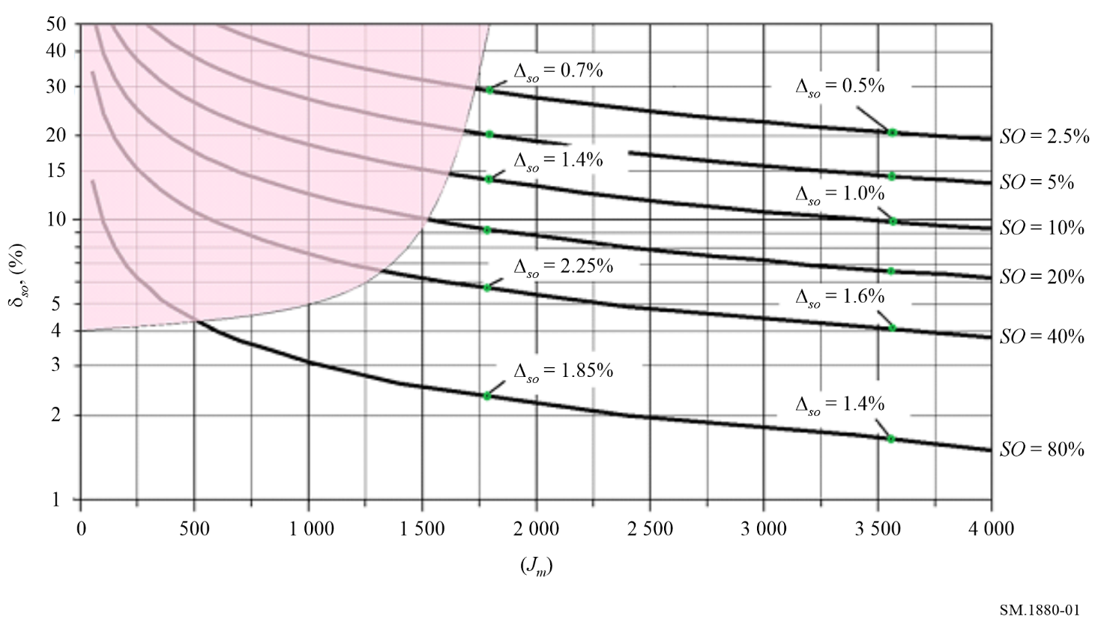

3.5 Other considerations

3.5.1 Emission identification
Simply recording the level does not allow discrimination between wanted and unwanted emissions or more than one user operating on a single frequency within the coverage area of the monitoring system. All emissions, if they are above the chosen threshold value, are usually treated as occupied channels.
Using modern real time data acquisition and post-processing software may enable discrimination between different users taking into consideration information such as field-strength, direction of arrival at the receiver, selective code information or modulation characteristics.

3.5.2 Monitoring mobile transmissions
It is possible that a wanted mobile unit (Mobile A) will be located significantly further from the monitoring site than the user’s own base site (Base A). Therefore, the received signal strength may be less than the monitoring threshold value set, although strong enough at the intended base site to be useable (see Fig. 2).
FIGURE 2
Monitoring mobile transmissions
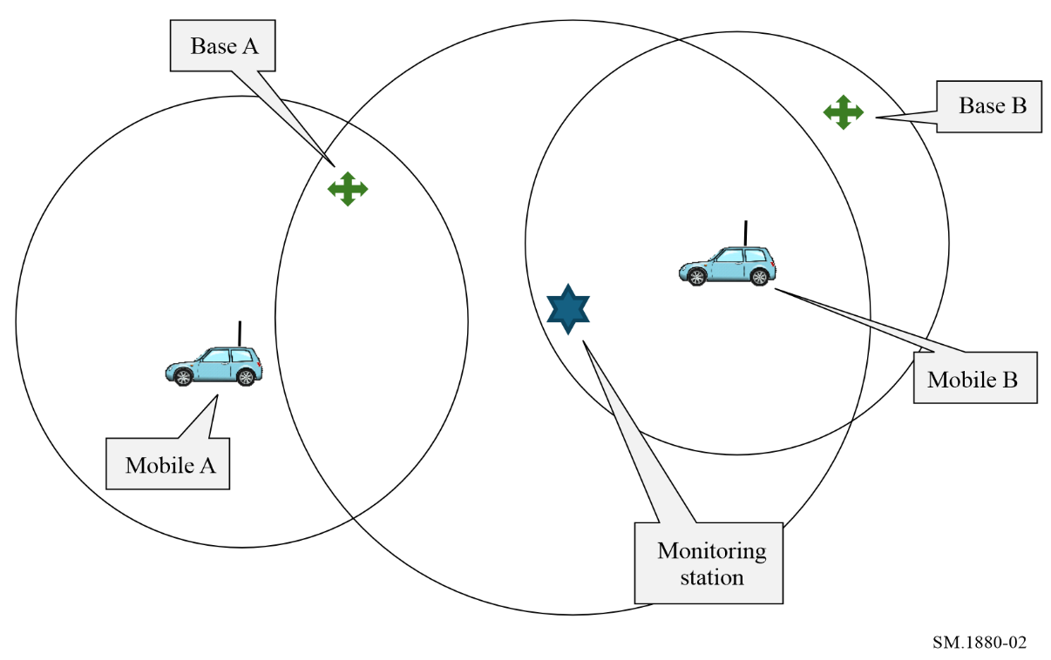
Conversely, a mobile unit from an out-of-area co-channel user (Mobile B) may be received at the monitoring site but not heard at the main user’s base site.
Either of the above situations might lead to misleading results since the occupancy results might not be representative of the entire mobile network, but only of the region covered by the monitoring site.

3.5.3 Propagation
If possible, propagation conditions should also be considered when setting receiver threshold levels and be observed and changes noted for the duration of monitoring. These conditions may include weather, humidity or physical changes that may result in multi-path such as temporary blockage from nearby traffic or aircraft. Changes to propagation and the associated times and reasons should be noted in the final report.

3.6 Presentation and analysis of collected data
The measurement data can be stored at the end of each integration time, every 5, 15, 30 or 60 minutes as required. From this data, it is possible to generate presentations based on tables, textual graphs, line/bar graphs and maps. After the desired information is extracted, the raw sampled data can be discarded.
The presentation should, as a minimum, include the location of the monitoring site, date and duration of monitoring, frequency, type of user(s), threshold level, occupancy in the busy hour, changes to propagation, integration time and revisit time.

3.6.1 Representative example of field strength used to discriminate between different users
If field strength is recorded, additional information can be extracted from the measurement.
The left plot in Fig. 3 is a commonly used way to present the occupancy with a resolution of 15 min, normally with only one curve. The red curve in the left plot represents the total occupancy caused by all users on that channel. The green curve is the occupancy caused by the station received with about 50 dB(μV/m) (see right side plot) and the blue curve is the occupancy caused by all the other users, in this case the second user received with about 29 dB(μV/m).
The plot in the middle represents the received levels over time. Only received levels above the threshold level (20 dB(μV/m)) are evaluated.
The right plot shows the statistical distribution of the received field strength levels. In this example 29 dB(μV/m) has been measured about 200 times in a 24-hour period, 50 dB(μV/m) about 350 times, etc.
FIGURE 3
Enhanced processing of occupancy data
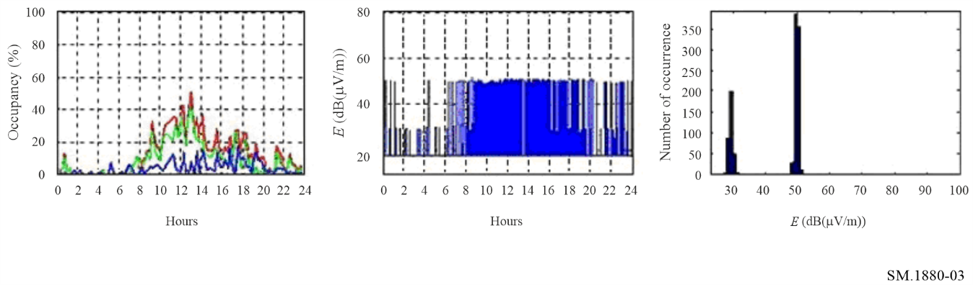

3.6.2 Representation of frequency band occupancy by percentage
Instead of presenting only the occupancy from every single channel, the occupancy of the whole measured frequency band can also be presented.
Figure 4 shows the occupancy integrated over 24 h from every single frequency step – in this example, the frequency step is 2.5 kHz, the measurement band is 2.5 MHz and the band occupancy measurement result is 20.18%.
FIGURE 4
Step and band occupancy over 24 h integration time
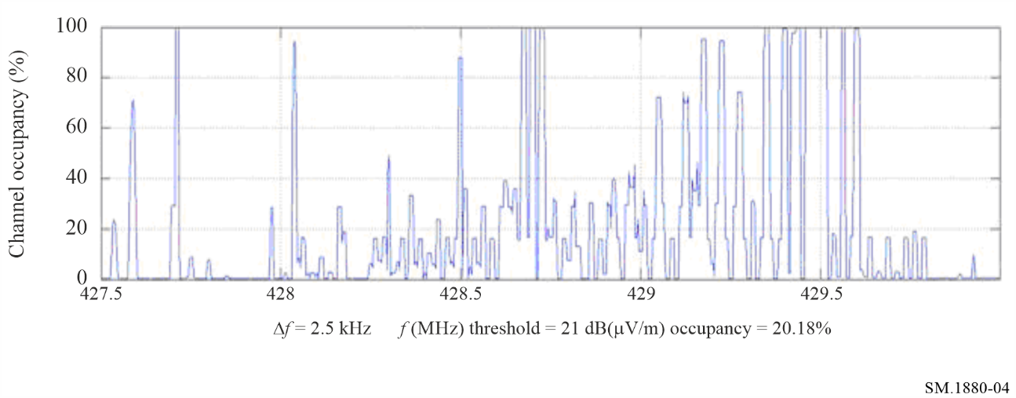
As an example, assume that a frequency band can be scanned in 1 000 steps every 10 s. Over a 24 h integration time, 8 640 field-strength values are produced . If the threshold level is exceeded a total of 4 320 times, the band occupancy will be 50%. In the plot above, there is no time information and no indication of whether the occupancy changed throughout the duration of monitoring. Only the final result for each frequency step is displayed. This limitation should be considered when using this type of presentation.

3.6.3 Representation of frequency channel occupancies in a band by colours
Channel occupancies across a band can also be expressed as a spectrogram by using a colour scale and the integration time (e.g. 15 minutes) over the monitoring duration. An example is given in Fig. 5.
In this presentation, the time information is still available (96 values/24 h). The colour bar is presenting the percent occupancy (and not the field strength). The left Y-axis shows 96 periods of 15 min which represents (in this example) the duration of monitoring.
FIGURE 5
Frequency channel occupancy in a band using colours (spectrogram)
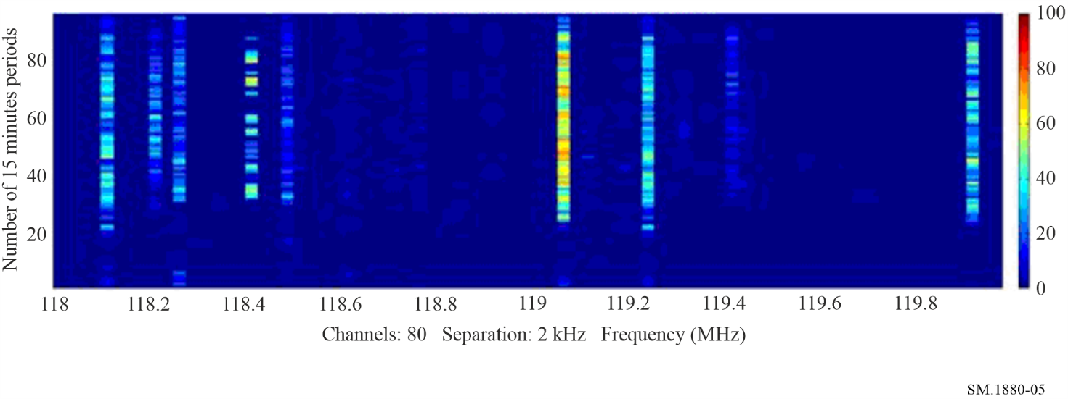

Annex 2
Determination of required samples for different sampling methods
TABLE OF CONTENTS
Page
1 Sampling methods 13
1.1 Dependent sampling 13
1.2 Independent sampling 14
2 Calculation of the minimum required samples 14
2.1 Independent sampling 15
2.2 Dependent sampling 16

1 Sampling methods
A practical aim of occupancy measurements is to achieve accurate results with minimum measurement effort. If a frequency channel could be measured continuously for the whole monitoring period, there would be an absolute accurate result for its relative occupancy. However, this would produce an unnecessary amount of data and normally would not allow monitoring multiple channels concurrently with the same monitoring equipment. For practical reasons it is therefore common to take only “snapshots” (samples) of the occupancy state of a frequency channel in more or less equal time intervals. These time intervals are the revisit time, the reciprocal value is the sampling speed. It is obvious that the higher the sampling speed and the more samples are collected, the more accurate the occupancy result will be. It can be mathematically proven that, among other parameters, the required minimum number of samples to reach a given accuracy and confidence level depends on “dependent” or “independent” sampling. The difference between these two sampling methods, when applied to channel occupancy measurements, mainly lies in the fact whether it is possible to catch every single transmission on the channel or not. This is explained with the following two examples. They also show that in practical occupancy measurements, both cases can occur, and it is sometimes difficult to determine which sampling method is applied.

1.1 Dependent sampling
The example used here assumes an analogue frequency channel where average transmission lengths (and the pauses between them) are on the order of seconds. This may be called a channel with “lengthy signals”. Modern fast monitoring equipment is used which is capable of measuring thousands of channels per second. Therefore, if 100 frequency channels are measured concurrently, the revisit time on each channel will be 100 ms. This means that every transmission on each of the ten channels will be detected. In fact, it is oversampled because a transmission of 1 s length is captured 10 times.
FIGURE 6
Sampling of a frequency channel with lengthy signals
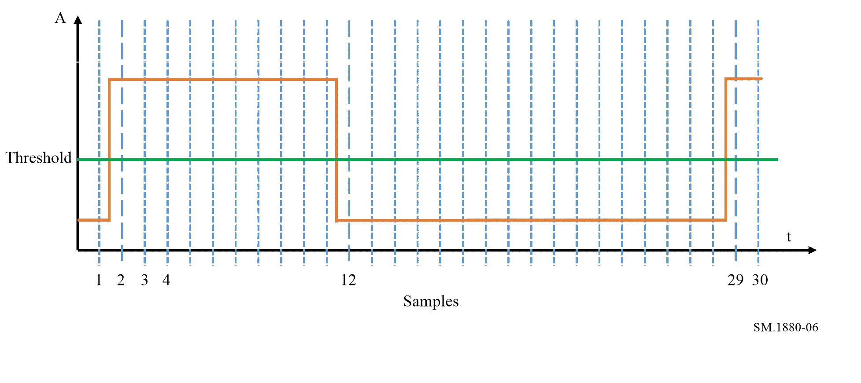
In the example in Fig. 6, only samples 2, 12 and 29 detected a state change (from occupied to not occupied or vice versa) and therefore have a different value than their previous samples. The other 27 samples show the same state as their predecessors. Statistically speaking, the chance of a sample having the same state as the previous sample is much higher than hitting a state change. So, the value of a sample is dependent on the value of the previous sample.

1.2 Independent sampling
The example used for independent sampling assumes a channel with pulsed digital signals. Even with fast monitoring receivers, the burst times are often much shorter than revisit times. It is therefore not possible to capture each single burst (transmission) on each channel. The bursts are rather captured only by chance.
FIGURE 7
Sampling of a frequency channel with pulsed signals
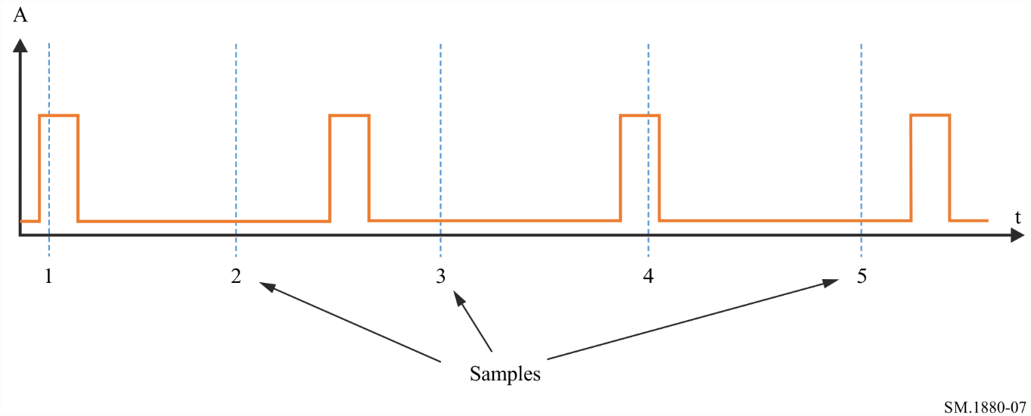
Because the sampling is normally not synchronized with the burst rate, each sample in Fig. 7 hits a burst or a pause on a random statistical basis. The chance for each sample to show the channel occupied is only dependent on the timing of the signal itself, but not on the state of the previous sample. This situation is called “independent sampling”.

2 Calculation of the minimum required samples
The transmission occupancy of a selected channel is defined as a two-state random process. The first state is labelled “occupied” and is defined as the event that, during an observation, the signal strength at a monitor receiver is above a given threshold.
The complementary event is that the signal strength is below this threshold. Because the state of the channel is random, its state at any given measurement time cannot be predicted. However, its state can be described in terms of probability law [1].
Consider the two-valued random process: X(t) = 1, if signal at time t is above threshold level, and X(t) = 0, otherwise [1].
Let X(n) = x_{i}, so that the sequence of measurements x₁, x₂, x₃, …, x_{n} is represented by a sequence of 0’s and 1’s, where 1 means the detected strength in the channel exceeds a given threshold, and 0 means that the detected strength in the channel does not exceed that threshold. Here x_{i} is a sample of X(t), regardless of the time interval.
From a statistics point of view, the result of spectrum occupancy measurement is an estimate or statistical value, thus it has accuracy and reliability attributes. As mentioned earlier, the key issue of the occupancy measurement is how to get enough information by spending less work in a certain confidence level, so the relative accuracy and confidence level are crucial.

2.1 Independent sampling
Also, from a statistics point of view, the independent and identically distribution of samples is obviously the simplest case.
The basic idea of this method is to take the samples of x_{i} to estimate the true value of spectrum occupancy (SO) over the current integration time.
The variable X(n) obeys to have a 0-1 distribution with the parameter ρ (the probability of the detected strength in the channel exceeding a given threshold), so the probability density function of X(n) is given by:
$f(x,ρ)=ρ^{x}(1-ρ)^{1-x}$ $x=0,1$; $0<ρ<1$
In spectrum occupancy measurements, the modern receivers or spectrum analysers are widely used. Due to their high speed, a huge quantity of data will normally be produced in a certain given integration time, which exactly provides the basis of using the central limit theorem, so for x_{i},
$\frac{\sum_{i=1}^{n}{X_{i}-nρ}}{\sqrt{nρ(1-ρ)}}=\frac{n\overline{X}-nρ}{\sqrt{nρ(1-ρ)}}$ ~ N(0,1)
where $\overline{X}$ is the mean value of the samples and is also the spectrum occupancy calculation result (SOCR).
The confidence level P_{SOC} is given by:
$P_{SOC}=P\{-μ_{\frac{α}{2}}≤\frac{n\overline{X}-nρ}{\sqrt{nρ(1-ρ)}}≤μ_{\frac{α}{2}}\}=1-α$
where $μ_{\frac{α}{2}}$ is the upper value with the significance level α of the standard normal distribution (with mean = 0 and standard deviation = 1).
The confidence level is denoted as $1-α$.
Solving for ρ, there is $A≤ρ≤B$, [A, B] is the interval estimation of ρ.
The mean value of samples $\overline{X}$ with n scans (measurements) and m detections is given by:
$\overline{X}=\frac{\sum_{i=0}^{n}{X_{i}}}{n}=\frac{m}{n}$
Then, the relative accuracy of occupancy is:
$δ_{SO}=\frac{B-A}{2\overline{X}}$
For the example of a relative accuracy of 10% and a confidence level of 95%, the number of required independent samples versus different spectrum occupancy is shown as Fig. 8.
FIGURE 8
Spectrum occupancy versus number of samples
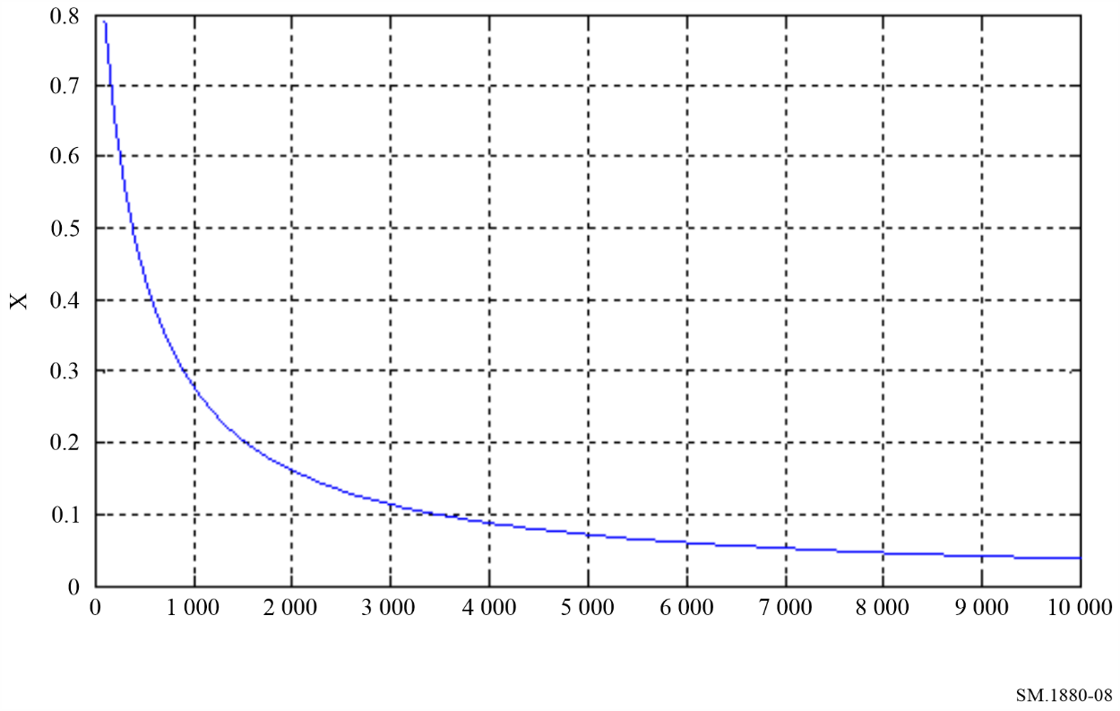

2.2 Dependent sampling
For dependent sampling, the sequence can be represented by a Markov-chain of first order. Although more complicated mathematical models can also be used, for the situations of interest to monitoring, the results from such complex models differ little from first-order Markov results [1]. When measuring channel occupancy based on dependent samples, the number of samples required to meet the requirements for accuracy and reliability should be increased in relation to the required number of independent samples [1]. The correction factor determining the increase in the number of samples is approximately 2 times higher than the ratio q of the transmission length in the radio channel to the revisit time. For example, at q = 1.5, the value of the required correction factor turns out to be close to three, and at q = 12, the number of samples and the time of data collection will need to be increased by about 24 times in relation to the case of independent samples (see Table 1 of Annex 1 to this Recommendation). It should be noted that at T_{R} = 1 s, the values of the q parameter will coincide with the transmission length.
References

[1] SPAULDING, A.D., HAGN, G.H. [August 1977], On the definition and estimation of spectrum occupancy, IEEE Trans. In EMC, Vol. EMC-19, No. 3, pp. 269-280.

Bins in statistics refer to groups (or categories or classes) of data that fall within a certain range of values.

