Recommendation ITU-R SM.1838-1
(09/2023)
SM Series: Spectrum management
Test procedure for measuring the noise figure of radio monitoring receivers

Foreword
The role of the Radiocommunication Sector is to ensure the rational, equitable, efficient and economical use of the radio-frequency spectrum by all radiocommunication services, including satellite services, and carry out studies without limit of frequency range on the basis of which Recommendations are adopted.
The regulatory and policy functions of the Radiocommunication Sector are performed by World and Regional Radiocommunication Conferences and Radiocommunication Assemblies supported by Study Groups.

Policy on Intellectual Property Right (IPR)
ITU-R policy on IPR is described in the Common Patent Policy for ITU-T/ITU-R/ISO/IEC referenced in Resolution ITU-R 1. Forms to be used for the submission of patent statements and licensing declarations by patent holders are available from http://www.itu.int/ITU-R/go/patents/en where the Guidelines for Implementation of the Common Patent Policy for ITU-T/ITU-R/ISO/IEC and the ITU-R patent information database can also be found.

Series of ITU-R Recommendations
(Also available online at https://www.itu.int/publ/R-REC/en)
Series | Title
BO | Satellite delivery
BR | Recording for production, archival and play-out; film for television
BS | Broadcasting service (sound)
BT | Broadcasting service (television)
F | Fixed service
M | Mobile, radiodetermination, amateur and related satellite services
P | Radiowave propagation
RA | Radio astronomy
RS | Remote sensing systems
S | Fixed-satellite service
SA | Space applications and meteorology
SF | Frequency sharing and coordination between fixed-satellite and fixed service systems
SM | Spectrum management
SNG | Satellite news gathering
TF | Time signals and frequency standards emissions
V | Vocabulary and related subjects

Note: This ITU-R Recommendation was approved in English under the procedure detailed in Resolution ITU-R 1.

Electronic Publication
Geneva, 2023

© ITU 2023
All rights reserved. No part of this publication may be reproduced, by any means whatsoever, without written permission of ITU.

RECOMMENDATION ITU-R SM.1838-1
Test procedure for measuring the noise figure of radio monitoring receivers
(2007-2023)
Scope
This Recommendation belongs to a set of Recommendations describing the test methods to determine technical parameters of radio monitoring receivers that are important for the users of these receivers. This Recommendation specifies test methods for the determination of the noise figure of a radio monitoring receivers.
Keywords
Test procedure, noise figure, radio monitoring receiver
The ITU Radiocommunication Assembly,
considering
a) that ITU-R has published the Typical recommended specifications for analogue and digital monitoring receivers in the ITU Handbook on Spectrum Monitoring (Edition 2011), but that nothing is said about the test procedures behind such specifications;
b) that the specification of the noise figure (NF) strongly depends on the test procedures applied;
c) that the noise figure of a receiver is a parameter which determines its ability to receive weak signals and to produce output signals with a usable level and an acceptable quality;
d) that the noise figure specified in the data sheet of a receiver depends extremely on the test frequencies used, the receiver operating conditions and the ambient temperature prevailing during the tests;
e) that the noise figure characteristic has a direct influence on the suitability of a receiver to fulfil certain monitoring tasks;
f) that a unique test procedure for the measurement of the noise figure is required to make the specifications published by various manufacturers comparable because it will not be possible to convert specifications based on different test procedures with arguable effort;
g) that a defined test procedure for the noise figure has to be independent of the receiver design;
h) that a well-defined test procedure for the noise figure, if adopted by all the manufacturers of radio monitoring receivers, will have the advantage for the users of such receivers, that an easier and more objective assessment of products from different manufacturers is possible;
j) that supplementary information about these noise figure measurements can be found in Report ITU-R SM.2125 – Parameters of and measurement procedures on HF/VHF/UHF monitoring receivers and stations,
recommends
1 that the measurement methods described in Annex 1 should be used to specify the noise figure of a radio monitoring receiver;
2 that the measurement methods described in Annex 1 and Annex 2 may be used to check the performance of monitoring receivers.

Annex 1
Test procedure for measuring the noise figure
of radio monitoring receivers

1 General aspects
The noise figure depends mainly on the following parameters:
– the frequencies used for the test;
– the receiver settings (e.g. preamplifier, attenuator);
– the temperature prevailing during the tests.
Furthermore, to correctly assess the noise figure:
– the measurements have to be done over the whole frequency range of the receiver;
– a maximum value for the noise figure must be specified and published by the manufacturer in the data sheet over the receiver’s whole operating range. Since noise figure values are frequency dependent the manufacturer can choose to additionally specify the noise figure for selected frequency bands or ranges;
– a mean value (the arithmetic mean of a number of test measurements) may also be indicated;
– the published noise figure values have to be valid over the entire temperature range indicated in the data sheet. Limitations, if any, have to be mentioned in the data sheet.

2 Basics of the noise figure measurements
The noise figure is one of the main specifications of a monitoring receiver. The noise figure is closely tied to the sensitivity of the monitoring receiver.
The noise figure of a monitoring receiver is the factor by which the noise power delivered by the monitoring receiver increases when a reference noise is applied to the input. The noise figure is referenced to the input of the monitoring receiver and is measured at the output.
The noise figure of a monitoring receiver can be measured by several methods:
– “gain” method
– “Y-factor” method (noise source method)
– “sensitivity” method.
The measurements must be done over the whole frequency range by tuning the receiver to the test signals with the frequencies f₁, f₂, ... f_{n}. Per octave at least two frequencies being evenly distributed over the full frequency range of the receiver have to be chosen.
The receiver must be set up under normal operating conditions. All the attenuators of the monitoring receiver, if any, are to be set to their minimum attenuation.
The automatic gain control (AGC) must be switched off during the tests.
If a switchable preamplifier exists, the measurements must be done in the condition “preamplifier on”. Additionally, the measurements can be done in the condition “preamplifier off”. The condition “preamplifier on” may also be expressed as “high sensitivity mode” or “low noise mode”.

3 Definition of the test procedures for measuring the noise figure of receivers
The noise figure measurements have to be performed following the guidelines in §§ 1 and 2.

3.1 “Gain” method

3.1.1 Principle
The noise figure formula at 25° C is the following:

NF = P_{out} + 174 – Gain
where:
NF : noise figure of the system to be measured (dB)
P_{out} : noise power density on the output of the system (dBm/Hz)
Gain : gain of the system to be measured (dB).

3.1.2 Measurement set-up
The measurement set-up in Fig. 1 should be used for the gain method.
Figure 1
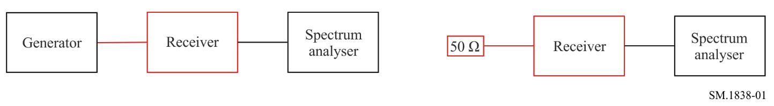
Measurement procedure
Step 1: Connect a signal generator to the monitoring receiver input and tune the monitoring receiver to the measurement frequency. Apply a CW tone with a level providing an SNR > 30 dB.
Step 2: Using the spectrum analyser, measure the level of the input power, N_{e} (dBm), then of the output power of the monitoring receiver, N_{s} (dBm). The gain is then Gain = N_{s} − N_{e}.
Step 3: Connect the 50 Ω load to the monitoring receiver input. Using the spectrum analyser, measure the noise power density, P_{out} (dBm/Hz). The monitoring receiver should be set for the same parameters (manual gain, frequency, position of amplifiers or attenuators) for both the gain measurement (Steps 1 and 2) and the noise figure measurement (Step 3).
Step 4: Apply the formula given in § 3.1.1.

3.2 “Y-factor” method

3.2.1 Principle
The principle of this method is to apply a calibrated noise source to the input of the monitoring receiver.
The noise density is measured, using a spectrum analyser and the noise diode in state ON or OFF. The following formula is then applied:

where:
NF : noise figure of the monitoring receiver to be measured (dB)
ENR : excess noise ratio of the noise source (dB)
Y : noise density difference (dB), measured when the source is switched ON and when it is switched OFF.

3.2.2 Measurement set-up
The measurement set-up in Fig. 2 should be used for the Y-factor method.
Figure 2
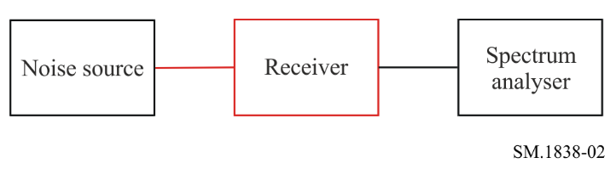
Measurement procedure
Step 1: Connect the noise source to the monitoring receiver input, set the noise source power supply ON and tune the monitoring receiver to the measurement frequency.
Step 2: Using the spectrum analyser, measure the noise density, N_{ON}, on the output (dBm/Hz).
Step 3: Switch OFF the noise source power supply and measure the noise density, N_{OFF}, on the monitoring receiver output. The parameter Y = N_{OFF} – N_{ON.}
Step 4: Apply the formula given in § 3.2.1.

3.3 Sensitivity measurement to determine the noise figure
This indirect method can be used but may give a different result than a measurement with the other two methods. The reason is that more components (IF section including demodulator, audio section and psophometric audio filter) in the receiver chain are included in the measurement. However, the noise figure of receivers for analogue modulation can be properly determined using this method.

3.3.1 Principle
The noise figure can be derived from the monitoring receiver’s AM sensitivity using the following formula:
where:
NF: monitoring receiver noise figure (dB)
S: sensitivity limit of the monitoring receiver (dBm), reduced by the signal-to-interference ratio including noise and distortion (SINAD) value of the sensitivity measurement (e.g. 12 dB at AM)
Res: effective noise bandwidth of the filter used for the measurement (Hz)
m: index of AM (A3E) modulation, used for the sensitivity measurement.
Figure 3 indicates the relation between noise figure and sensitivity.
Figure 3
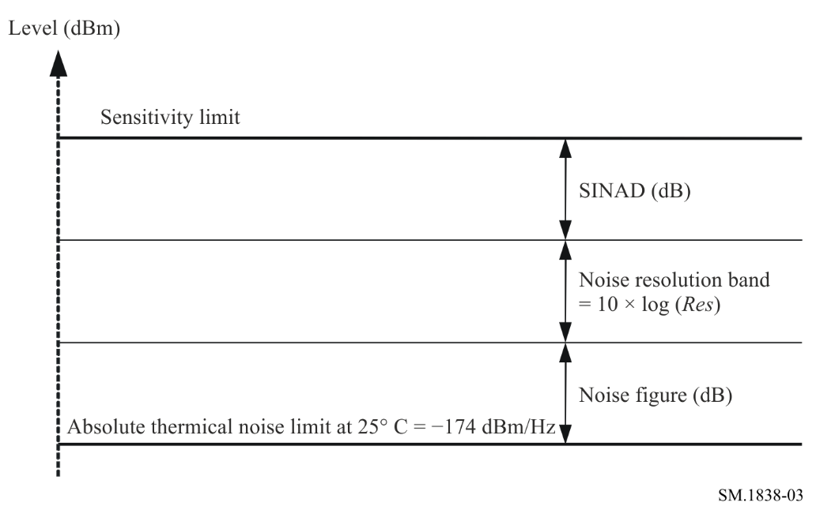

3.3.2 Measurement set-up
Monitoring sensitivity is defined as the minimum input signal required for proper demodulation of the received signal.
For this measurement the audio level has to be determined by a SINAD measurement, using a psophometric filter (Recommendation ITU-T P.53) simulating the human ear. The monitoring receiver sensitivity is measured according to the sensitivity measurement method described in Recommendation ITU-R SM.1840.

3.3.3 Measurement parameters
The sensitivity measurement will be done for AM only at the test frequencies. The selection of the test frequencies is done according to § 2.
If the sensitivity value is expressed in µV it must be converted to dBm with:
Value (dBµV) = 20 log value (µV) e.g., for 1 µV: 20 log 1(µV) = 0 dBµV
Value (dBm) = Value (dBµV) − 107 e.g., for 0 dBµV: 0 dBµV − 107 = −107 dBm
assuming an input impedance of 50 Ω.

Annex 2
Test procedure for performance check of radio monitoring receivers

1 General aspects
The method described in this Annex is for users of a monitoring receiver when they want to check its performance. The advantage of this method is that no additional equipment is needed, but the accuracy of the result depends on the accuracy in level measurements of the device under test itself. Only when the receiver is calibrated and corrected accordingly, can this method be regarded as comparable to the others defined in this Recommendation.

1.1 Principle
The principle of this method is that radio monitoring receivers can measure the noise power at their input.
With a defined 50 Ω load connected to the input of the receiver, the noise figure and the total noise power at the input are related by the formula:

$NF=P_{n}-10logBW+174$
where:
NF : noise figure of the monitoring receiver to be calculated (dB)
P_{n} : the noise power (dBm) measured by receiver
BW : effective noise bandwidth of the filter used for the measurement (Hz).
This method requires the use of the device under test’s RMS detector and assumes a temperature of 25° C.

1.2 Measurement set-up
The measurement set-up in Fig. 4 should be used for the performance check method.
Figure 4
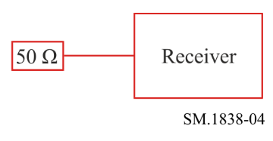
1.3 Measurement procedure
Step 1: Connect the 50 Ω load to the monitoring receiver input and tune the monitoring receiver to the measurement frequency.
Step 2: Take readings of the noise power P_{n} (dBm) measured by the receiver.
Step 3: Apply the formula given in § 1.1.

