Recommendation ITU-R SM.1539-2
(09/2024)
SM Series: Spectrum management
Variation of the boundary between the out-of-band and spurious domains required for the application of Recommendations ITU-R SM.1541 and ITU-R SM.329

Foreword
The role of the Radiocommunication Sector is to ensure the rational, equitable, efficient and economical use of the radio-frequency spectrum by all radiocommunication services, including satellite services, and carry out studies without limit of frequency range on the basis of which Recommendations are adopted.
The regulatory and policy functions of the Radiocommunication Sector are performed by World and Regional Radiocommunication Conferences and Radiocommunication Assemblies supported by Study Groups.

Policy on Intellectual Property Right (IPR)
ITU-R policy on IPR is described in the Common Patent Policy for ITU-T/ITU-R/ISO/IEC referenced in Resolution ITU-R 1. Forms to be used for the submission of patent statements and licensing declarations by patent holders are available from http://www.itu.int/ITU-R/go/patents/en where the Guidelines for Implementation of the Common Patent Policy for ITU-T/ITU-R/ISO/IEC and the ITU-R patent information database can also be found.

Series of ITU-R Recommendations
(Also available online at https://www.itu.int/publ/R-REC/en)
Series | Title
BO | Satellite delivery
BR | Recording for production, archival and play-out; film for television
BS | Broadcasting service (sound)
BT | Broadcasting service (television)
F | Fixed service
M | Mobile, radiodetermination, amateur and related satellite services
P | Radiowave propagation
RA | Radio astronomy
RS | Remote sensing systems
S | Fixed-satellite service
SA | Space applications and meteorology
SF | Frequency sharing and coordination between fixed-satellite and fixed service systems
SM | Spectrum management
SNG | Satellite news gathering
TF | Time signals and frequency standards emissions
V | Vocabulary and related subjects

Note: This ITU-R Recommendation was approved in English under the procedure detailed in Resolution ITU-R 1.

Electronic Publication
Geneva, 2024

© ITU 2024
All rights reserved. No part of this publication may be reproduced, by any means whatsoever, without written permission of ITU.

RECOMMENDATION ITU-R SM.1539-2
Variation of the boundary between the out-of-band and spurious domains required for the application of Recommendations ITU-R SM.1541 and ITU-R SM.329
(2001-2002-2024)
Scope
This Recommendation serves as a basis for the variation of the boundary between the out-of-band and spurious domains.
Keywords
Variation of the boundary, out-of-band domain, spurious domain, frequency separation, necessary bandwidth
The ITU Radiocommunication Assembly,
considering
a) that Recommendations ITU-R SM.1541 and ITU-R SM.329 give the definitions of the terms “out-of-band domain” and “spurious domain”, but that these definitions do not precisely specify the boundary between the out-of-band (OoB) and spurious domains;
b) that the boundary between the OoB and spurious domains is important for the application of both Recommendations ITU-R SM.1541 and ITU-R SM.329;
c) that the boundary between the OoB and spurious domains is, in general, a function of the necessary bandwidth, but may be functions of different parameters other than the necessary bandwidth in certain applications;
d) that the boundary between the OoB and spurious domains may require variations, in particular, for narrow-band and wideband transmissions, as well as for primary radars;
e) that Report ITU-R SM.2421 contains useful information on the issue in application to digital radio systems,
recognizing
a) that Recommendation ITU-R SM.1138, which is incorporated by reference into the Radio Regulations (RR), deals with the determination of necessary bandwidth for various emissions;
b) that Recommendation ITU-R SM.853 and Report ITU-R SM.2048 present additional information concerning the determination of necessary bandwidth for certain emissions, including unmodulated and modulated pulse emissions and various types of digital modulation;
c) that Recommendations ITU-R SM.1541 (recommends 2.3) and ITU-R SM.329 (recommends 1.4 and 2.3) discuss the necessary bandwidth for certain emissions for the purpose of determining the boundary between the OoB and spurious domains,
noting
that, according to Recommendations ITU-R SM.1541 and ITU-R SM.329, normally the boundary between the OoB and spurious domains is the frequency separated from the centre frequency of the emission by 250% of the necessary bandwidth of the emission (see recognizing c)),
recommends
that Annex 1 should be referred to in the case of variation of the boundary between the OoB and spurious domains which may be required for the application of Recommendations ITU-R SM.1541 and ITU-R SM.329.

Annex 1
Variation of the boundary between the OoB and spurious domains

1 Introduction
As stated in recommends 2.3 of Recommendation ITU-R SM.1541 and recommends 2.3 of Recommendation ITU-R SM.329, the boundary between the OoB and spurious domains, which is generally specified as being separated from the centre frequency by 250% of the necessary bandwidth, needs to be modified for narrow-band and wideband (including multicarrier) systems, and certain other situations. This Annex provides:
– a set of guidelines on values of bandwidths across the spectrum at which the general definition needs to be varied; and
– a set of known situations in which additional guidelines are required.

2 Boundary variations for narrow-band and wideband systems
For the definition of necessary bandwidth, its applicability to multichannel or multicarrier transmitters/transponders, and its use in the fixed and radiodetermination services, see recommends 1.4 of Recommendation ITU-R SM.329.
Figure 1 shows the spurious boundary as a function of necessary bandwidth, indicating the boundary variations. The normal separation between the centre frequency and the spurious domain boundary is 250% of the necessary bandwidth, as shown in Fig. 1, between the vertical dashed lines.
For some narrow-band emissions, it is appropriate to avoid specifying OoB and spurious domains in very narrow bandwidths near to the emission, which will usually be under the control of the same operator. On the other hand, it is necessary to restrict the linear growth of the OoB domain versus necessary bandwidth for wideband emissions, in order to restrict the incursion of the OoB domain into adjacent bands.
Figure 1 shows how the boundary is determined for the narrow-band and wideband cases. When the necessary bandwidth of the emission is less than the lower threshold value B_{L}, the boundary is a constant 2.5 B_{L}. Conversely, when the necessary bandwidth exceeds the upper threshold value B_{U}, the boundary increases at a lower rate, having a value of 1.5 B_{N} + B_{U}. Table 1 shows the formulas for the narrow-band, normal and wideband cases.
figure 1
Spurious domain boundary as a function of necessary bandwidth
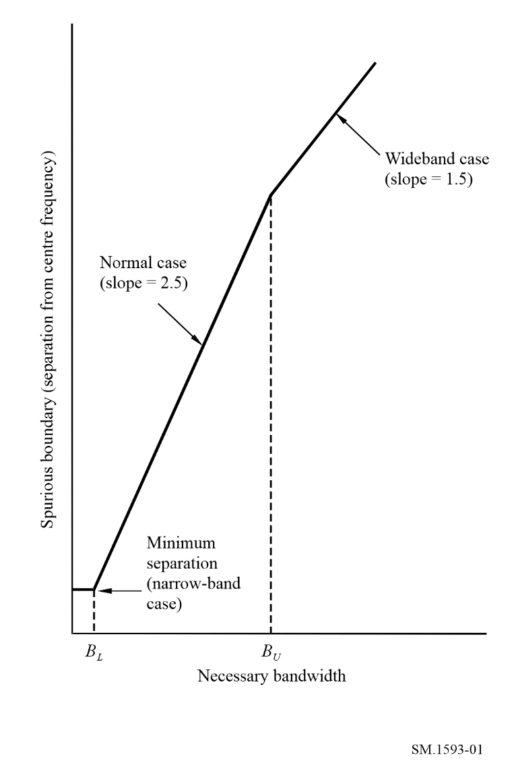
TABLE 1
Type of emission | Necessary  bandwidth (B_{N}) | Frequency separation between  the centre frequency and  the spurious boundary
Narrow-band case | < B_{L} | 2.5 B_{L}
Normal case | B_{L} to B_{U} | 2.5 B_{N}
Wideband case | > B_{U} | B_{U} + 1.5 B_{N}

It should be noted that Table 1 can apply to asymmetric emissions, since the offset is specified based on the centre of the necessary bandwidth. For situations where the boundary is not defined in terms of necessary bandwidth, see § 3.
In the case of narrow-band and wideband systems, the variation of the spurious boundary also affects the OoB masks specified in Recommendation ITU-R SM.1541. This is covered in recommends 5 of Recommendation ITU-R SM.1541. It also concerns OoB masks that may be reconstructed by breakpoints presented by various x dB bandwidths given in Report ITU-R SM.2048 for many classes of emissions.
Table 2 provides guidance for determining general values of separation between the centre frequency of an emission and the beginning of its spurious domain. A minimum separation applies to the narrow-band case, while the normal and wideband cases have separate formulas for determining the boundary.
TABLE 2
Guideline values for frequency separation between the centre frequency
and the boundary of the spurious domain
Frequency  range | Narrow-band case  (B_{N} < B_{L}) |  | Normal  separation | Wideband case  (B_{N} > B_{U})
 | B_{L} | Separation |  | B_{U} | Separation
9 kHz < fc < 150 kHz | 250 Hz | 625 Hz | 2.5 B_{N} | 10 kHz | 1.5 B_{N} + 10 kHz
150 kHz < fc < 30 MHz | 4 kHz | 10 kHz | 2.5 B_{N} | 100 kHz | 1.5 B_{N} + 100 kHz
30 MHz < fc < 1 GHz | 25 kHz | 62.5 kHz | 2.5 B_{N} | 10 MHz | 1.5 B_{N} + 10 MHz
1 GHz < fc < 3 GHz | 100 kHz | 250 kHz | 2.5 B_{N} | 50 MHz | 1.5 B_{N} + 50 MHz
3 GHz < fc < 10 GHz | 100 kHz | 250 kHz | 2.5 B_{N} | 100 MHz | 1.5 B_{N} + 100 MHz
10 GHz < fc < 15 GHz | 300 kHz | 750 kHz | 2.5 B_{N} | 250 MHz | 1.5 B_{N} + 250 MHz
15 GHz < f_{C} < 26 GHz | 500 kHz | 1.25 MHz | 2.5 B_{N} | 500 MHz | 1.5 B_{N} + 500 MHz
fc > 26 GHz | 1 MHz | 2.5 MHz | 2.5 B_{N} | 500 MHz | 1.5 B_{N} + 500 MHz
NOTE 1 – In Table 2, fc is the centre frequency of the emission. If the assigned frequency band of the emissions extends across two frequency ranges, then the values corresponding to the higher frequency range may be used for the whole assignment.
NOTE 2 – For situations in which the above guidelines are not applicable, additional guidelines are provided in § 3.
NOTE 3 – Further studies need to be conducted within the ITU-R to confirm the values of frequency separation in Table 2.

Example 1: The necessary bandwidth of an emission at 26 MHz is 1.8 kHz. Since 2.5 B_{N} is only 4.5 kHz, the minimum separation applies. The spurious domain begins 10 kHz each side of the centre of the necessary bandwidth.
Example 2: The necessary bandwidth of an emission at 8 GHz is 200 MHz. Since the wideband case applies for B_{N} > 100 MHz at that frequency, the spurious domain begins 400 MHz each side of the centre of the necessary bandwidth. Using the general separation formula, the OoB domain would have extended to 2.5 × 200 MHz = 500 MHz either side of the centre frequency.

3 Situations where additional guidelines are required
The above guidelines are suitable for general application but specific cases where further guidelines are necessary are given in the following sections.

3.1 Situations where the boundary is not defined in terms of necessary bandwidth
Some systems specify OoB emissions relative to channel bandwidth, or channel spacing. These may be used as a substitute for the necessary bandwidth in § 2, provided they are found in ITU-R Recommendations.

3.2 Particular service types and bands
The values of frequency separation in Table 2 are selected to cover most, but not all situations. Rather than set those values at the worst case in each range, it is more realistic to use a more stringent value, and list those cases requiring different values separately. Tables 3 and 4 show those cases which have been identified.
TABLE 3
Narrow-band variations for systems or services and frequency bands
Service | Frequency range |  | Narrow-band case (B_{N} < B_{L})
 |  |  | BL  (kHz) | Separation  (kHz)
Fixed service | 14 kHz-1.5 MHz |  | 20 | 50(1)
 | 1.5-30 MHz | P_{T} > 50 W | 80 | 200(2)
 |  | PT ≤ 50 W | 30 | 75(2)
(1) The separation value is based on an assumption that the maximum value of the necessary bandwidth is about 3 kHz for the frequency range 14 kHz-1.5 MHz. The value of 50 kHz separation is extremely large as compared with the necessary bandwidth. It is because unwanted emissions of high power transmitters under modulated conditions have to be below the spurious limit (70 dBc) at the boundary between the OoB and spurious domains.
(2) P_{T} is the transmitter power. The separation values are based on an assumption that the maximum value of the necessary bandwidth is about 12 kHz for the frequency range 1.5-30 MHz. The value of 200 kHz separation for P_{T} > 50 W is extremely large as compared with the necessary bandwidth. It is because unwanted emissions of high power transmitters under modulated conditions have to be below the spurious limit, 70 dBc, at the boundary between the OoB and spurious domains. Also, if future systems in the fixed service operating in this frequency range require a necessary bandwidth larger than 12 kHz, it may become necessary to review the 200 kHz separation. These separation values were derived from the Category A spurious domain emission limits in Recommendation ITU-R SM.329.

TABLE 4
Wideband variations for systems or services and frequency bands
Service | Frequency range | Wideband case (B_{N} > B_{U})
 |  | B_{U} | Separation
Fixed service | 14-150 kHz | 20 kHz | 1.5 B_{N} + 20 kHz
Fixed-satellite service (FSS) | 3.4-4.2 GHz | 250 MHz | 1.5 B_{N} + 250 MHz
FSS | 5.725-6.725 GHz | 500 MHz | 1.5 B_{N} + 500 MHz
FSS | 7.25-7.75 GHz and 7.9-8.4 GHz | 250 MHz | 1.5 B_{N} + 250 MHz
FSS | 10.7-12.75 GHz | 500 MHz | 1.5 B_{N} + 500 MHz
Broadcasting-satellite service (BSS) | 11.7-12.75 GHz | 500 MHz | 1.5 B_{N} + 500 MHz
FSS | 12.75-13.25 GHz | 500 MHz | 1.5 B_{N} + 500 MHz
FSS | 13.75-14.8 GHz | 500 MHz | 1.5 B_{N} + 500 MHz

3.3 Primary radars in the radiodetermination and other services
According to recommends 2.3 of Recommendation ITU-R SM.329, the spurious domain emission generally begins at a frequency separation equal to 250% of the necessary bandwidth, with exceptions for certain kinds of systems, including those with digital or pulsed modulation. RR Appendix 3 includes similar provisions. However, it is difficult to apply the general boundary concept of 250% of the necessary bandwidth to primary radar stations in the radiodetermination and other services, such as the meteorological aids service, the space research service, and the Earth exploration-satellite service.
For the case of primary radar systems the OoB mask rolls off at 20 dB per decade from the 40 dB bandwidth to the spurious limit specified in Table 2 of Recommendation ITU-R SM.329. The detailed definition of the OoB/spurious domain boundary is contained in Annex 8 of Recommendation ITU-R SM.1541.
The above specification of the boundary is the subject of ongoing ITU studies with a design objective of 40 dB per decade roll-off from the 40 dB bandwidth.

