Recommendation ITU-R SM.1448-1
(10/2019)
Determination of the coordination area around an earth station in the frequency bands between 100 MHz and 105 GHz

SM Series
Spectrum management

Foreword
The role of the Radiocommunication Sector is to ensure the rational, equitable, efficient and economical use of the radio-frequency spectrum by all radiocommunication services, including satellite services, and carry out studies without limit of frequency range on the basis of which Recommendations are adopted.
The regulatory and policy functions of the Radiocommunication Sector are performed by World and Regional Radiocommunication Conferences and Radiocommunication Assemblies supported by Study Groups.

Policy on Intellectual Property Right (IPR)
ITU-R policy on IPR is described in the Common Patent Policy for ITU-T/ITU-R/ISO/IEC referenced in Resolution ITU-R 1. Forms to be used for the submission of patent statements and licensing declarations by patent holders are available from http://www.itu.int/ITU-R/go/patents/en where the Guidelines for Implementation of the Common Patent Policy for ITU-T/ITU-R/ISO/IEC and the ITU-R patent information database can also be found.

Series of ITU-R Recommendations
(Also available online at http://www.itu.int/publ/R-REC/en)
Series | Title
BO | Satellite delivery
BR | Recording for production, archival and play-out; film for television
BS | Broadcasting service (sound)
BT | Broadcasting service (television)
F | Fixed service
M | Mobile, radiodetermination, amateur and related satellite services
P | Radiowave propagation
RA | Radio astronomy
RS | Remote sensing systems
S | Fixed-satellite service
SA | Space applications and meteorology
SF | Frequency sharing and coordination between fixed-satellite and fixed service systems
SM | Spectrum management
SNG | Satellite news gathering
TF | Time signals and frequency standards emissions
V | Vocabulary and related subjects

Note: This ITU-R Recommendation was approved in English under the procedure detailed in Resolution ITU-R 1.

Electronic Publication
Geneva, 2019

© ITU 2019
All rights reserved. No part of this publication may be reproduced, by any means whatsoever, without written permission of ITU.

RECOMMENDATION ITU-R SM.1448-1*, **
Determination of the coordination area around an Earth station
in the frequency bands between 100 MHz and 105 GHz
(2000-2019)
Scope
The Recommendation addresses the determination of the coordination area around a transmitting or receiving Earth station that is sharing spectrum in frequency bands between 100 MHz and 105 GHz with terrestrial radiocommunication services, or the area surrounding a transmitting Earth station that is sharing the same bidirectionally allocated frequency band with receiving Earth stations. This Recommendation provides additional information and examples to complement Appendix 7 of the Radio Regulations.
Keywords
Coordination area, coordination contour, coordination distance, Earth station, geostationary orbit, non-geostationary orbit
Abbreviations/Glossary
GSO Geostationary orbit
NGSO Non-geostationary orbit
TIG Time-invariant gain
TVG Time-variant gain
The ITU Radiocommunication Assembly,
considering
a) that, there is a possibility of interference to, or from, an earth station which shares, on an equal primary basis, the same frequency bands with terrestrial stations, or with other earth stations operating in the opposite direction of transmission;
b) that, to avoid such interference, it is desirable to coordinate the transmitting or receiving earth station with terrestrial stations, or with other earth stations operating in the opposite direction of transmission;
c) that this coordination will need to be undertaken within a coordination area surrounding an earth station when sharing with terrestrial services, or surrounding a transmitting earth station when sharing with receiving earth stations in bidirectionally allocated bands, extending to distances beyond which the permissible level of interference will not be exceeded for a specific percentage of time;
d) that this area may extend into territory under the jurisdiction of another Member State and hence require coordination between administrations;
e) that, prior to a detailed examination, it is desirable to establish methods of determining, on the basis of general assumptions, a coordination area around a coordinating earth station;
f) that such interference will depend upon several factors, including transmitter powers, type of modulation, antenna gains in the direction of the interference path, the time variation of the antenna gain in the case of earth stations operating with non-geostationary space stations, the permissible interference power at the receiver, mechanisms of radio-wave propagation, radio-meteorological zones, the mobility of the earth station, and the distance from the earth station;
g) that it is desirable to develop and maintain an ITU-R Recommendation suitable to serve as source text for the updating of Appendix 7 of the Radio Regulations (RR) (see Notes 1 and 4),
recognizing
a) that provisions of the RR state the methods to be used to determine the coordination areas/distances, including predetermined coordination distances;
b) the relevant ITU-R studies;
c) that other ITU-R Recommendations provide special methods to determine the coordination areas/distances for particular applications,
recommends
1 that the methods and system parameters described in Annexes 1 and 2 and their Attachments should be used for determining coordination areas of transmitting and receiving earth stations;
2 that the following Notes 2 and 3 are considered as an integral part of this Recommendation.
NOTE 1 – This Recommendation should be updated based on changes to the RR resulting from decisions of world radiocommunication conferences (WRCs).
NOTE 2 – The propagation information contained in this Recommendation originates from a number of ITU-R P-series Recommendations previously referred to in Recommendation ITU-R P.620. These source Recommendations have been developed for a variety of purposes. However, the future maintenance of the propagation information requires that particular attention is paid to the possible consequences for compatibility with this integrated Recommendation’s various objectives and procedures.
NOTE 3 – The methods for the determination of the coordination area in this Recommendation differ from those of Appendix 30A to the RR.
NOTE 4 – A history of the revisions to Recommendation ITU-R SM.1448 is contained in the supplement on the maintenance of Recommendation ITU-R SM.1448 (see Doc. 1/200).

TABLE OF CONTENTS
Page
Annex 1 – Methods for the determination of the coordination area of an earth station 6
1 Introduction 6
1.1 Overview 6
1.2 Structure of the Recommendation 7
1.3 Basic concepts 7
1.4 Sharing scenarios 15
1.5 Propagation model concepts 17
1.6 The coordination contour: concepts and construction 20
2 Determination of the earth station coordination area with respect to terrestrial stations 26
2.1 Earth stations operating with geostationary space stations 27
2.2 Earth stations operating with non-geostationary space stations 28
3 Determination of the coordination area between earth stations operating in bidirectionally allocated frequency bands 31
3.1 Coordinating and unknown earth stations operating with geostationary space stations 32
3.2 Coordinating or unknown earth stations operating with non-geostationary space stations 34
4 General considerations for the determination of the propagation mode (1) required distance 35
4.1 Radio-climatic information 35
4.2 Minimum coordination distance for propagation modes (1) and (2) 35
4.3 Maximum coordination distance for propagation mode (1) 36
4.4 Guidance on application of propagation mode (1) procedures 37
5 General considerations for the determination of the propagation mode (2) required distance 38
5.1 The required distance for propagation mode (2) 38
Attachment 1 to Annex 1 – Determination of the required distance for propagation mode (1) 39
1 Adjustments for earth station horizon elevation angle and distance 39
2 Frequencies between 100 MHz and 790 MHz 40
Page
3 Frequencies between 790 MHz and 60 GHz 42
4 Frequencies between 60 GHz and 105 GHz 45
Attachment 2 to Annex 1 – Determination of the required distance for propagation mode (2) 47
1 Overview 47
2 Maximum calculation distance 47
3 Calculation of the propagation mode (2) contour 47
3.1 Iterative calculations 53
4 Construction of the propagation mode (2) contour 54
Attachment 3 to Annex 1 – Antenna gain towards the horizon for an earth station operating with a geostationary space station 55
1 General 55
2 Determination of the angular separation φ(α) 56
3 Determination of antenna gain 59
Attachment 4 to Annex 1 – Antenna gain toward the horizon for an earth station operating with non-geostationary space stations 59
1 Determination of the horizon antenna gain using the TIG method 60
1.1 Determination of satellite visibility limits 60
1.2 Determination of minimum and maximum horizon gain from the minimum visible elevation angle profile 62
1.3 Example calculation of the horizon antenna gain using the TIG method 63
2 Determination of the horizon antenna gain distribution for the TVG method 65
3 Equations for use in determining the locations of orbiting satellites 66
Attachment 5 to Annex 1 – Determination of the supplementary contour distance using the TVG method 69
1 Determination of the supplementary contour distance using the TVG method 69
2 Example of the calculation of a supplementary contour using the TVG method 70
Attachment 6 to Annex 1 – Determination of the coordination area for a transmitting earth station with respect to receiving earth stations operating with geostationary space stations in bidirectionally allocated frequency bands 72
Page
1 Introduction 72
2 Determination of the bidirectional contour for propagation mode (1) 73
2.1 Calculation of horizon gain for unknown receiving earth stations operating with geostationary space stations 73
2.2 Example propagation mode (1) contour calculation for both earth stations operating with geostationary space stations 74
2.3 Example supplementary contour calculation for a transmitting earth station operating with non-geostationary space stations and a receiving earth station operating with geostationary space stations using the TVG method 76
3 Determination of the bidirectional rain scatter contour 80
Attachment 7 to Annex 1 – Determination of auxiliary contours for propagation mode (2) 82
1 Determination of auxiliary contours for propagation mode (2) 82
2 The step-by-step algorithm 84
3 Reference radiation patterns for line-of-sight radio-relay system antennas 85
Attachment 8 to Annex 1 – Parameters 86
Annex 2 – System parameters and predetermined coordination distances for determination of the coordination area around an earth station 89
1 Introduction 89
2 Calculation of the permissible interference power of an interfering emission 90
2.1 Calculation of the noise temperature of the receiving system 91
2.2 Determination of the factor NL 91
2.3 Determination of the factor Ms 92
2.4 Determination of the factor W 92
3 Horizon antenna gain for a receiving earth station with respect to a transmitting earth station 92

Annex 1
Methods for the determination of the coordination area of an earth station

1 Introduction
This Annex addresses the determination of the coordination area (see RR No. 1.171) around a transmitting or receiving earth station that is sharing spectrum in frequency bands between 100 MHz and 105 GHz with terrestrial radiocommunication services or with earth stations operating in the opposite direction of transmission.
The coordination area represents the area surrounding an earth station sharing the same frequency band with terrestrial stations, or the area surrounding a transmitting earth station that is sharing the same bidirectionally allocated frequency band with receiving earth stations, within which the permissible level of interference may be exceeded and hence coordination is required. The coordination area is determined on the basis of known characteristics for the coordinating earth station and on conservative assumptions for the propagation path and for the system parameters for the unknown terrestrial stations (see Tables 14 and 15), or the unknown receiving earth stations (Table 16), that are sharing the same frequency band.

1.1 Overview
Annexes 1 and 2 contain procedures and system parameters for calculating an earth station’s coordination area and they are used where the Radio Regulations do not specify other methods, including predetermined distances.
The procedures allow the determination of a distance in all azimuthal directions around a transmitting or receiving earth station beyond which the predicted path loss would be expected to exceed a specified value for all but a specified percentage of the time. This distance is called the coordination distance (see RR No. 1.173). When the coordination distance is determined for each azimuth around the coordinating earth station it defines a distance contour, called the coordination contour (see RR No. 1.172), that encloses the coordination area.
It is important to note that, although the determination of the coordination area is based on technical criteria, it represents a regulatory concept. Its purpose is to identify the area within which detailed evaluations of the interference potential need to be performed in order to determine whether the coordinating earth station or any of the terrestrial stations, or in the case of a bidirectional allocation any of the receiving earth stations that are sharing the same frequency band, will experience unacceptable levels of interference. Hence, the coordination area is not an exclusion zone within which the sharing of frequencies between the earth station and terrestrial stations or other earth stations is prohibited, but a means for determining the area within which more detailed calculations need to be performed. In most cases a more detailed analysis will show that sharing within the coordination area is possible since the procedure for the determination of the coordination area is based on unfavourable assumptions with regard to the interference potential.
For the determination of the coordination area, two separate cases are to be considered:
– case when the earth station is transmitting and hence capable of interfering with receiving terrestrial stations or earth stations;
– case when the earth station is receiving and hence may be the subject of interference from transmitting terrestrial stations.
Calculations are performed separately for great circle propagation mechanisms (propagation mode (1)) and, if required by the sharing scenario (see § 1.4), for scattering from hydrometeors (propagation mode (2)). The coordination contour is then determined using the greater of the two distances predicted by the propagation mode (1) and propagation mode (2) calculations for each azimuth around the coordinating earth station. Separate coordination contours are produced for each sharing scenario. Guidance and examples of the construction of coordination contours, and their component propagation mode (1) and propagation mode (2) contours, are provided in § 1.6.
To facilitate bilateral discussion it can be useful to calculate additional contours, defining smaller areas, that are based on less conservative assumptions than those used for the calculation of the coordination contour.

1.2 Structure of the Recommendation
The procedures and the system information are provided in two Annexes. The procedures are contained in Annex 1 and the system information in Annex 2. In this Annex, the general principles are separated from the detailed text on methods. The general principles are contained in the main body of the Annex, while the methods are contained in a series of Attachments to Annex 1. This structure enables each section of Annex 1 and each Attachment to focus on a specific aspect of the coordination area calculations. It also enables the user to select only those sections that are relevant for a specific sharing scenario.
Figure 1 and Table 1 are provided to help the user to navigate through the Annexes and the Attachments. Table 1 also indicates the relevant sections that need to be explored for a specific coordination case.

1.3 Basic concepts
Determination of the coordination area is based on the concept of the permissible interference power at the antenna terminals of a receiving terrestrial station or earth station. Hence, the attenuation required to limit the level of interference between a transmitting terrestrial station or earth station and a receiving terrestrial station or earth station to the permissible interference power for p% of the time is represented by the “minimum required loss”, which is the loss that needs to be equalled or exceeded by the predicted path loss for all but p% of the time.
For propagation mode (1) the following equation applies:
L_{b}(p ) = P_{t} + G_{t} + G_{r} – P_{r}(p) dB (1)
where:
p: maximum percentage of time for which the permissible interference power may be exceeded
L_{b}(p ): propagation mode (1) minimum required loss (dB) for p% of the time; this value must be exceeded by the propagation mode (1) predicted path loss for all but p% of the time
P_{t}: maximum available transmitting power level (dBW) in the reference bandwidth at the terminals of the antenna of a transmitting terrestrial station or earth station
P_{r}(p ): permissible interference power of an interfering emission (dBW) in the reference bandwidth to be exceeded for no more than p% of the time at the terminals of the antenna of a receiving terrestrial station or earth station that may be subject to interference, where the interfering emission originates from a single source
G_{t}: gain (dB relative to isotropic) of the antenna of the transmitting terrestrial station or earth station. For a transmitting earth station, this is the antenna gain towards the physical horizon on a given azimuth; for a transmitting terrestrial station, the maximum main beam axis antenna gain is to be used
G_{r}: gain (dB relative to isotropic) of the antenna of the receiving terrestrial or earth station that may be subject to interference. For a receiving earth station, this is the gain towards the physical horizon on a given azimuth; for a receiving terrestrial station, the maximum main beam axis antenna gain is to be used.
figure 1
Representation of structure
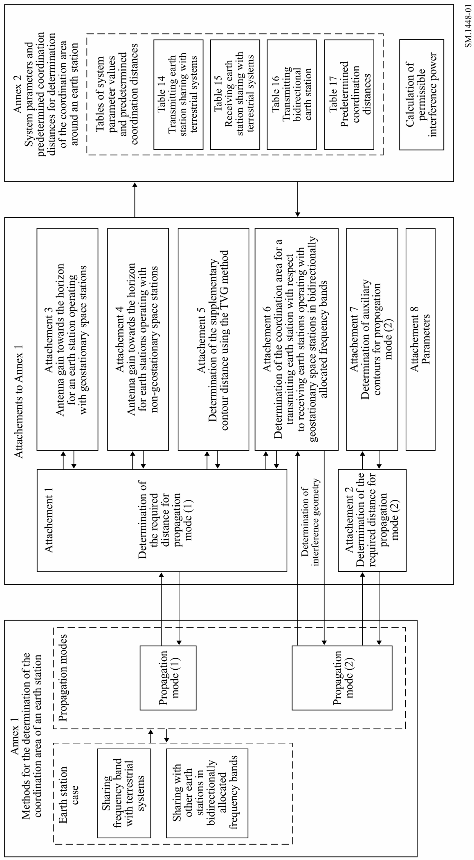

TABLE 1
Cross-reference between sharing scenarios and calculation methods

 | Sharing scenarios of § 1.4 of Annex 1
Applicable sections and Attachments  to Annex 1 and Annex 2 | § 1.4.1 Earth stations  operating with geostationary space stations | § 1.4.2 Earth stations  operating  with non-  geostationary space stations(1) | § 1.4.3 Earth stations  operating with both  geostationary and non-geostationary space stations | § 1.4.4 Earth stations  operating in bidirectionally allocated frequency bands | § 1.4.5  Broadcasting-satellite service earth stations | § 1.4.6 Mobile (except  aeronautical mobile) earth stations | § 1.4.7 Aeronautical mobile earth stations | § 1.4.8  Transportable earth stations | § 1.4.9  Fixed earth stations  operated at unspecified locations within a  specific service area
§ 1.3 Basic concepts | X | X | X | X | X | X | X | X | X
§ 1.5 Propagation model concepts | X | X | X | X | See § 1.4.1, § 1.4.2, § 1.4.3 or § 1.4.4 as applicable and § 1.6 | See § 1.4.1, § 1.4.2, § 1.4.3 or § 1.4.4 as applicable and § 1.6 | See § 1.4.1, § 1.4.2, § 1.4.3 or § 1.4.4 as applicable and § 1.6 | See § 1.4.1, § 1.4.2, § 1.4.3 or § 1.4.4 as applicable and § 1.6 | See § 1.4.1, § 1.4.2, § 1.4.3 or § 1.4.4 as applicable and § 1.6
§ 1.6 The coordination contour: concepts and construction | X | X | X | X
§ 2.1 Earth stations operating with  geostationary space stations | X |  | X
§ 2.2 Earth stations operating with non-geostationary space stations |  | X | X
TABLE 1 (continued)
 | Sharing scenarios of § 1.4 of Annex 1
Applicable sections and Attachments  to Annex 1 and Annex 2 | § 1.4.1 Earth stations  operating with geostationary space stations | § 1.4.2 Earth stations  operating  with non-  geostationary space stations(1) | § 1.4.3 Earth stations  operating with both  geostationary and non-geostationary space stations | § 1.4.4 Earth stations  operating in bidirectionally allocated frequency bands | § 1.4.5  Broadcasting-satellite service earth stations | § 1.4.6 Mobile (except  aeronautical mobile) earth stations | § 1.4.7 Aeronautical mobile earth stations | § 1.4.8  Transportable earth stations | § 1.4.9  Fixed earth stations  operated at unspecified locations within a  specific service area
§ 3 Determination of the coordination area between earth stations operating in bidirectionally allocated frequency bands |  |  |  | X
§ 4 General considerations for the determination of the propagation mode (1) required distance | X | X | X | X
§ 5 General considerations for the determination of the propagation mode (2) required distance | X |  | X
Attachment 1 Determination of the required distance for propagation mode (1) | X | X | X | X

TABLE 1 (end)
 | Sharing scenarios of § 1.4 of Annex 1
Applicable sections and Attachments  to Annex 1 and Annex 2 | § 1.4.1 Earth stations  operating with geostationary space stations | § 1.4.2 Earth stations  operating with non-geostationary space stations(1) | § 1.4.3 Earth stations  operating with both  geostationary and non-geostationary space stations | § 1.4.4 Earth stations  operating in bidirectionally allocated frequency bands | § 1.4.5  Broadcasting-satellite service earth stations | § 1.4.6 Mobile (except aeronautical mobile) earth stations | § 1.4.7 Aeronautical mobile earth stations | § 1.4.8  Transportable earth stations | § 1.4.9  Fixed earth stations  operated at unspecified locations within a  specific service area
Attachment 2 Determination of the required distance for propagation mode (2) | X |  | X |  | See § 1.4.1, § 1.4.2, § 1.4.3 or § 1.4.4 as applicable and § 1.6 | See § 1.4.1, § 1.4.2, § 1.4.3 or § 1.4.4 as applicable and § 1.6 | See § 1.4.1, § 1.4.2, § 1.4.3 or § 1.4.4 as applicable and § 1.6 | See § 1.4.1, § 1.4.2, § 1.4.3 or § 1.4.4 as applicable and § 1.6 | See § 1.4.1, § 1.4.2, § 1.4.3 or § 1.4.4 as applicable and § 1.6
Attachment 3 Antenna gain towards the horizon for earth stations operating with geostationary space stations | X |  | X
Attachment 4 Antenna gain towards the horizon for earth stations operating with non-geostationary space stations |  | X | X | X
Attachment 5 Determination of the supplementary contour distance using the TVG method |  | X | X | X
Attachment 6 Determination of the coordination area for a transmitting earth station with respect to receiving earth stations operating to geostationary space stations in bidirectionally allocated frequency bands |  |  |  | X
Attachment 7 Determination of auxiliary contours for propagation mode (2) | X |  | X
Attachment 8 Parameters | X | X | X | X
Annex 2 System parameters and predetermined coordination distances for determination of the coordination area around an earth station | X | X | X | X
(1) For an earth station using a non-tracking antenna the procedure of § 2.1 is used. For an earth station using a non-directional antenna the procedures of § 2.1.1 are used.

For propagation mode (2), a volume scattering process is involved and a modification of the above approach is necessary. Where the coordinating earth station antenna beam intersects a rain cell, a common volume may be formed with a terrestrial station beam or an earth station beam (operating in the opposite direction of transmission in bidirectionally allocated frequency bands). In the case of a terrestrial station, the assumptions are made that the terrestrial station beamwidth is relatively large in comparison with that of the coordinating earth station (terrestrial station gain values are given in Tables 14 and 15) and that the terrestrial station is some distance from the common volume. The terrestrial station beam is therefore assumed to illuminate the whole rain cell, which is represented by a vertical cylinder filled with hydrometeors that give rise to isotropically scattered signals. This scattering process may give rise to unwanted coupling between the coordinating earth station and terrestrial stations or other earth stations operating in bidirectionally allocated frequency bands, via the common volume.
The earth station antenna gain and its beamwidth are interdependent. The size of the common volume, and the number of scattered signals arising within that volume, increases as the gain of the earth station antenna transmitting or receiving those signals decreases, the one effect compensating for the other. A term which approximates the full integral required to evaluate the volume scattering process within the earth station antenna beam is included in equation (83). Therefore in the procedure for evaluation of interference that may arise from propagation mode (2) mechanisms a simplifying assumption can be made that the path loss is independent of the earth station antenna gain .
Hence for propagation mode (2), equation (1) reduces to:
L_{x}(p ) = P_{t} + G_{x} – P_{r}(p ) dB (2)
where:
L_{x}(p ): minimum loss required for propagation mode (2)
G_{x}: maximum antenna gain (dBi) assumed for the terrestrial station. Tables 14 and 15 give values of G_{x} for the various frequency bands.
To facilitate the calculation of propagation mode (2) auxiliary contours (see § 1.6.2.2) the calculation is further modified by placing the terrestrial network antenna gain G_{x} within the iterative loop for the propagation mode (2) required loss calculations.
Hence equation (2) further reduces to:
L(p ) = P_{t} – P_{r}(p ) dB (3)
where:
L(p ): propagation mode (2) minimum required loss (dB) for p% of the time; this value must be exceeded by the propagation mode (2) predicted path loss for all but p% of the time.
For both modes of propagation, P_{t} and P_{r}(p) are defined for the same radio-frequency bandwidth (the reference bandwidth). Further, L_{b}(p), L(p) and P_{r}(p) are defined for the same small percentage of the time, and these values are set by the performance criteria of the receiving terrestrial station or receiving earth station that may be subject to interference.
For an earth station operating with geostationary space stations, Appendix 3 to Annex 1 provides the numerical method for determining the minimum angle between the earth station antenna main beam axis and the physical horizon as a function of azimuth, and the corresponding antenna gain. In the case of a space station in a slightly inclined geostationary orbit, the minimum elevation angle and corresponding horizon gain will depend on the maximum inclination angle to be coordinated.
For an earth station operating with non-geostationary space stations, the antenna gain of the earth station in the direction of the horizon varies as a function of time and Attachment 4 to Annex 1 provides the numerical methods for its determination.
For an earth station operating in a frequency band with a bidirectional allocation, the antenna gain to be used in determining the propagation mode (1) minimum required loss is calculated using the methods in Attachments 3 or 4 to Annex 1, as appropriate.
Determination of the coordination area requires the calculation of the predicted path loss and its comparison with the minimum required loss, for every azimuth around the coordinating earth station, where:
– the predicted path loss is dependent on several factors including the length and general geometry of the interfering path (e.g. antenna pointing, horizon elevation angle), antenna directivity, radio climatic conditions, and the percentage of the time during which the predicted path loss is less than the minimum required loss; and
– the minimum required loss is based on system and interference model considerations.
The required coordination distance is the distance at which these two losses are considered to be equal for the stated percentage of time.
In determining the coordination area, the pertinent parameters of the coordinating earth station are known, but knowledge of the terrestrial stations or other earth stations sharing that frequency range is limited. Hence it is necessary to rely on assumed system parameters for the unknown terrestrial stations or the unknown receiving earth stations. Furthermore, many aspects of the interference path between the coordinating earth station and the terrestrial stations or other earth stations (e.g. antenna geometry and directivity) are unknown.
The determination of the coordination area is based on unfavourable assumptions regarding system parameter values and interference path geometry. However, in certain circumstances, to assume that all the worst-case values will occur simultaneously is unrealistic, and leads to unnecessarily large values of minimum required loss. This could lead to unnecessarily large coordination areas. For propagation mode (1), detailed analyses, supported by extensive operational experience, have shown that the requirement for the propagation mode (1) minimum required loss can be reduced because of the very small probability that the worst-case assumptions for system parameter values and interference path geometry will exist simultaneously. Therefore, a correction is applied within the calculation for the propagation mode (1) predicted path loss in the appropriate sharing scenario to allow benefit to be derived from these mitigating effects. The application of this correction factor is described in more detail in § 4.4.
This correction applies to cases of coordination with the fixed service. It is frequency, distance and path dependent. It does not apply in the case of the coordination of an earth station with mobile stations, nor with other earth stations operating in the opposite direction of transmission, nor in the case of propagation via hydrometeor scatter (propagation mode (2)).
A number of propagation models are used to cover the propagation mechanisms that exist in the full frequency range. These models predict the path loss as a monotonically increasing function of distance. Therefore, coordination distances are determined by calculating the path loss iteratively for an increasing distance until either the minimum required loss is achieved, or a maximum calculation distance limit is reached (see § 1.5.3).
The iteration method always starts at a defined value of minimum distance, d_{min} (km), and iteration is performed using a uniform step size, s (km), for increasing the distance. A step size of 1 km is recommended.

1.4 Sharing scenarios
The following subsections describe the basic assumptions made for the various earth station sharing scenarios. These subsections need to be read in conjunction with the information contained in Table 1 and § 1.6 which contains guidance on the development of a coordination contour. Except as discussed in §§ 1.4.5 to 1.4.9, the earth stations around which coordination areas are determined are assumed to be fixed earth stations authorized to operate at a single permanent location.

1.4.1 Earth stations operating with geostationary space stations
For earth stations operating with a space station in the geostationary orbit, the space station appears to be stationary with respect to the Earth. However variations in gravitational forces acting on the space station and limitations in positional control mean that a geostationary space station’s orbital parameters are not constant. Movement from the space station’s nominal orbital position in an east/west direction (longitudinal tolerance) is limited under the Radio Regulations (see Nos. 22.6 to 22.18), but movement in the north/south direction (inclination excursion) is not specified.
Relaxation in the north/south station-keeping of a geostationary space station allows its orbit to become inclined, with an inclination that increases gradually with time. Therefore the determination of the coordination area requires consideration of the range of movement of the earth station antenna. If the earth station operates to multiple space stations in slightly inclined orbits, all possible pointing directions of the antenna main beam axis need to be considered and the minimum elevation angle for each azimuth used. Although the direction of pointing of the earth station antenna may in practice vary with time, the earth station antenna may also be pointing in one direction for considerable periods of time. Hence the gain of the earth station antenna in the direction of the horizon is assumed to be constant. For an earth station operating with a space station in an orbit as described above, an assumption of constant horizon gain as the inclination angle increases may lead to a conservative estimation of the coordination area, the degree of conservatism increasing with increasing inclination angle.
For an earth station operating with a geostationary space station the coordination area is determined using the procedures described in § 2.1.

1.4.2 Earth stations operating with non-geostationary space stations
Earth stations operating with non-geostationary space stations may use a directional or a non-directional antenna. Furthermore, earth stations using a directional antenna may track the orbital path of a non-geostationary space station.
While an earth station operating with a geostationary space station is assumed to have a constant antenna gain towards the horizon, for an earth station antenna that is tracking the orbital path of a non-geostationary space station, the antenna gain towards the horizon will vary with time. Therefore, it is necessary to estimate the variation of the antenna gain with time towards the horizon for each azimuth in order to determine the coordination area. The procedure is described in § 2.2.
For an earth station operating with a non-geostationary space station, the motion of a relatively high gain tracking antenna reduces the probability of interference due to propagation mode (2) mechanisms and hence the propagation mode (2) required distances will be relatively short. The minimum coordination distance dmin (see § 1.5.3) will provide adequate protection in these cases. The propagation mode (2) contour is therefore taken to be identical to a circle whose radius is the minimum coordination distance. Propagation mode (2) calculations are not required in these circumstances and the coordination area is determined using the propagation mode (1) procedure in § 2.2 only.
For an earth station operating with a non-geostationary space station using a non-directional antenna, a similar situation applies, and the low gain means that propagation mode (2) required distances will be less than the minimum coordination distance. Hence, for the case of a non-directional antenna the propagation mode (2) contour is also coincident with the circle of radius dmin, and the coordination area is determined using the propagation mode (1) procedures described in § 2.1.1 only.
For an earth station operating with a non-geostationary space station using a non-tracking directional antenna, the potential for interference arising from propagation mode (2) is the same as for an earth station operating with a geostationary space station. Hence, for the case of non-tracking directional antenna the coordination area is determined using both the propagation mode (1) and propagation mode (2) procedures described in § 2.1.

1.4.3 Earth stations operating with both geostationary and non-geostationary space stations
For earth stations that are sometimes intended to operate with geostationary space stations and at other times with non-geostationary space stations, separate coordination areas are determined for each type of operation. In such cases, the coordination area for the geostationary space station is determined using the procedures described in § 2.1 and the coordination area for the non-geostationary space station is determined using the procedure described in § 2.2. For each case, the percentage of time, p, is specified for all the operational time that the receiving earth station is expected to spend in reception from geostationary space stations or non-geostationary space stations, as appropriate.

1.4.4 Earth stations operating in bidirectionally allocated frequency bands
For earth stations operating in some frequency bands there may be allocations with equal rights to space services operating in both the Earth-to-space and space-to-Earth directions. In this case, where two earth stations are operating in opposite directions of transmission it is only necessary to establish the coordination area for the transmitting earth station, as receiving earth stations will automatically be taken into consideration. Hence, a receiving earth station operating in a bidirectionally allocated frequency band will only be involved in coordination with a transmitting earth station if it is located within the transmitting earth station’s coordination area.
For a transmitting earth station operating with either geostationary or non-geostationary satellites in a bidirectionally allocated frequency band, the coordination area is determined using the procedures described in § 3.

1.4.5 Broadcasting-satellite service earth stations
For earth stations in the broadcasting-satellite service operating in the unplanned bands, the coordination area is determined by extending the periphery of the specified service area within which the earth stations are operating by the coordination distance based on a typical broadcasting-satellite service (BSS) earth station. In calculating the coordination distance, no additional protection can be assumed to be available from the earth station horizon elevation angle, i.e. A_{h} = 0 dB in Attachment 1 to Annex 1, for all azimuth angles around the earth station.

1.4.6 Mobile (except aeronautical mobile) earth stations
For a mobile (except aeronautical mobile) earth station, the coordination area is determined by extending the periphery of the specified service area, within which the mobile (except aeronautical mobile) earth stations are operating, by the coordination distance. The coordination distance may be represented by a predetermined coordination distance (see Table 17), or it may be calculated. In calculating the coordination distance, no additional protection can be assumed to be available from the earth station horizon elevation angle, i.e. A_{h} = 0 dB in Attachment 1 to Annex 1, for all azimuths around the earth station.

1.4.7 Aeronautical mobile earth stations
For aeronautical mobile earth stations, the coordination area is determined by extending the periphery of the specified service area within which the aeronautical mobile earth station operates, by an appropriate predetermined coordination (see Table 17) distance for the respective services.

1.4.8 Transportable earth stations
For a transportable earth station the coordination area is calculated for each individual location.

1.4.9 Fixed earth stations operated at unspecified locations within a specific service area
Where it is permitted to coordinate earth stations on an area basis, the following method is used.
For fixed earth stations that operate at unspecified locations within a service area defined by the administration, the coordination area is determined by extending the periphery of this service area by the maximum coordination distance (see § 4.3). It is recognized that this is a conservative approach and that further studies will be necessary in the future. Given this conservative approach for determining with whom to coordinate, while development work on these studies are being undertaken, administrations are encouraged, particularly where propagation distances are likely to be significantly lower than the maximum coordination distance, to develop bilateral agreements regarding the implementation of such earth stations in order to minimize the number of earth stations requiring detailed coordination.

1.5 Propagation model concepts
For each mode of propagation, according to the requirements of the specific sharing scenario (see § 1.4) it is necessary to determine the predicted path loss. The determination of this predicted path loss is based on a number of propagation mechanisms.
Interference may arise through a range of propagation mechanisms whose individual dominance depends on climate, radio frequency, time percentage in question, distance and path topography. At any given point in time, one or more mechanisms may be present. The propagation mechanisms that are considered within this Annex in the determination of the interference potential are as follows:
– Diffraction: Insofar as it relates to diffraction losses occurring over the earth station’s local physical horizon. This effect is referred to below as “site shielding”. The remainder of the path along each radial is considered to be flat and therefore free of additional diffraction losses.
– Tropospheric scatter: This mechanism defines the “background” interference level for paths longer than about 100 km, beyond which the diffraction field becomes very weak.
– Surface ducting: This is the most important short-term interference mechanism over water and in flat coastal land areas, and can give rise to high signal levels over greater distances, sometimes exceeding 500 km. Such signals can exceed the equivalent “free-space” level under certain conditions.
– Elevated layer reflection and refraction: The treatment of reflection and/or refraction from layers at heights of up to a few hundred metres is an important mechanism that enables signals to by-pass any diffraction losses due to the underlying terrain under favourable path geometry situations. Here again, the impact can be significant over long distances.
– Hydrometeor scatter: Hydrometeor scatter can be a potential source of interference between terrestrial station transmitters and earth stations because it may act isotropically, and can therefore have an impact irrespective of whether the common volume is on or off the great-circle interference path between the coordinating earth station and terrestrial stations, or other receiving earth stations operating in bidirectionally allocated frequency bands.
In this Annex, propagation phenomena are classified into two modes as follows:
– Propagation mode (1): propagation phenomena in clear air (tropospheric scatter, ducting, layer reflection/refraction, gaseous absorption and site shielding). These phenomena are confined to propagation along the great-circle path.
– Propagation mode (2): hydrometeor scatter.

1.5.1 Propagation mode (1)
For the determination of the propagation mode (1) required distances, the applicable frequency range has been divided into three parts:
– For VHF/UHF frequencies between 100 MHz and 790 MHz and for time percentages from 1% to 50% of an average year: the propagation model is based on observational data and includes all of the propagation mode (1) mechanisms except site shielding (which is applied separately).
– From 790 MHz to 60 GHz and for time percentages from 0.001% to 50% of an average year: the propagation model takes account of tropospheric scatter, ducting and layer reflection/refraction. In this model, separate calculations are made for each of the propagation mode (1) mechanisms.
– From 60 GHz to 105 GHz and for time percentages from 0.001% to 50% of an average year: the millimetric model is based upon free-space loss and a conservative estimate of gaseous absorption, plus an allowance for signal enhancements at small time percentages.
The variation in predicted path loss due to the horizon elevation angle around an earth station is calculated by the method described in § 1 of Attachment 1 to Annex 1, using the horizon elevation angles and distances along different radials from the earth station. For all frequencies between 100 MHz and 105 GHz, the attenuation arising from the horizon characteristics is included in the value of propagation mode (1) predicted path loss, unless its use is specifically prohibited for a particular sharing scenario (see § 1.4.5, 1.4.6, 1.47 and 1.4.9).
In the determination of the propagation mode (1) required distance, the world is divided into four basic radio-climatic zones. These zones are defined as follows:
– Zone A1: coastal land, i.e. land adjacent to a Zone B or a Zone C area (see below), up to an altitude of 100 m relative to mean sea or water level, but limited to a maximum distance of 50 km from the nearest Zone B or Zone C area; in the absence of precise information on the 100 m contour, an approximation (e.g. 300 feet) may be used. Large inland areas of at least 7 800 km² which contain many small lakes, or a river network, comprising more than 50% water, and where more than 90% of the land is less than 100 m above the mean water level may be included in Zone A1 .
– Zone A2: all land, other than coastal land as defined in Zone A1 above.
– Zone B: “cold” seas, oceans and large bodies of inland water situated at latitudes above 30°, with the exception of the Mediterranean Sea and the Black Sea. A “large” body of inland water is defined, for the administrative purpose of coordination, as one having an area of at least 7 800 km², but excluding the area of rivers. Islands within such bodies of water are to be included as water within the calculation of this area if they have elevations lower than 100 m above the mean water level for more than 90% of their area. Islands that do not meet these criteria should be classified as land for the purposes of calculating the area of the water.
– Zone C: “warm” seas, oceans and large bodies of inland water situated at latitudes below 30°, as well as the Mediterranean Sea and the Black Sea.

1.5.2 Propagation mode (2)
For the determination of the propagation mode (2) required distance, interference arising from hydrometeor scatter can be ignored at frequencies below 1 000 MHz and above 40.5 GHz outside the minimum coordination distance (see § 1.5.3.1). Below 1 000 MHz, the level of the scattered signal is very low and above 40.5 GHz, although significant scattering occurs, the scattered signal is then highly attenuated along the path from the scatter volume to the receiving terrestrial station or earth station. Site shielding is not relevant to propagation mode (2) mechanisms as the interference path is via the main beam of the coordinating earth station antenna.

1.5.3 Distance limits
The effect of interference on terrestrial and space systems often needs to be assessed by considering long-term and short-term interference criteria. These criteria are generally represented by a permissible interference power not to be exceeded for more than a specified percentage of time.
The long-term interference criterion (typically associated with percentages of time ≥ 20%) allows the error performance objective (for digital systems) or noise performance objective (for analogue systems) to be met. This criterion will generally represent a low level of interference and hence require a high degree of isolation between the coordinating earth station and terrestrial stations, or other receiving earth stations operating in bidirectionally allocated bands.
The short-term criterion is a higher level of interference, typically associated with time percentages in the range 0.001% to 1% of time, which will either make the interfered-with system unavailable, or cause its specified short-term interference objectives (error rate or noise) to be exceeded.
Annex 1 and Annex 2 address only the protection provided by the short-term criterion. There is therefore an implicit assumption that if the short-term criterion is satisfied, then any associated long-term criteria will also be satisfied. This assumption may not remain valid at short distances because additional propagation effects (diffraction, building/terrain scattering etc.) requiring a more detailed analysis become significant. A minimum coordination distance is therefore needed to avoid this difficulty. This minimum coordination distance is always the lowest value of coordination distance used. At distances equal to or greater than the minimum coordination distance, it can be assumed that interference due to continuous (long-term) propagation effects will not exceed levels permitted by the long-term criteria.
In addition to the minimum coordination distance, it is also necessary to set an upper limit to the calculation distance. Hence the coordination distance, on any azimuth, must lie within the range between the minimum coordination distance and the maximum calculation distance.

1.5.3.1 Minimum coordination distance
For the reasons stated in § 1.5.3, it is necessary to set a lower limit, d_{min}, for the coordination distance. The iterative calculation of the coordination distance starts at this minimum distance, and this distance varies according to radiometeorological factors and the frequency band (see § 4.2). This same minimum coordination distance applies both to propagation mode (1) and propagation mode (2) calculations.

1.5.3.2 Maximum calculation distance
Maximum calculation distances are required for propagation modes (1) and (2). In the case of mode (1), this distance corresponds to the maximum coordination distance, d_{max1}, given in § 4.3 for each of the four radioclimatic Zones. The propagation mode (1) maximum calculation distance is therefore dependent on the mixture of radioclimatic Zones in the propagation path, as described in § 4.3.
The maximum calculation distance for propagation mode (2) is given in § 2 of Attachment 2 to Annex 1.

1.6 The coordination contour: concepts and construction
The coordination distance, determined for each azimuth around the coordinating earth station, defines the coordination contour that encloses the coordination area. The coordination distance lies within the range defined by the minimum coordination distance and the maximum calculation distance.
In this Annex, the procedures determine the distance at which the minimum required loss is equal to the predicted path loss. In addition, some procedures require that, for any azimuth, the greater of the distances determined for propagation mode (1) and propagation mode (2) is the distance to be used in determining the coordination contour. In both these cases, the distance at which the minimum required loss is equal to the predicted path loss may or may not be within the range of valid values that define the limits for the coordination distance. Hence, the distance determined from the application of all the procedures is referred to as the required distance.
The coordination area is determined by one of the following methods:
– calculating, in all directions of azimuth from the earth station, the coordination distances and then drawing to scale on an appropriate map the coordination contour; or
– extending the service area in all directions by the calculated coordination distance(s); or
– for some services and frequency bands, extending the service area in all directions by a predetermined coordination distance.
Where a coordination contour includes the potential interference effects arising from both propagation mode (1) and propagation mode (2), the required distance used for any azimuth is the greater of the propagation mode (1) and propagation mode (2) required distances.
The sharing scenarios and the various procedures contained in this Annex are based on different assumptions. Hence, the coordination area developed for one sharing scenario is likely to be based on different sharing considerations, interference paths and operational constraints than the coordination area developed under a different sharing scenario. Separate coordination areas are therefore required for each sharing scenario described in § 1.4, and each coordination area is specific to the radiocommunication services covered by the sharing scenario under which it was developed. Further, the coordination area developed for one sharing scenario cannot be used to determine the extent of any impact on the radiocommunication services covered by a different sharing scenario. Thus, a coordinating earth station operating in a bidirectionally allocated frequency band that is also allocated to terrestrial services will have two separate coordination areas:
– one coordination area for determining those administrations with terrestrial services that may be affected by the operation of the coordinating earth station; and
– one coordination area for determining those administrations with receiving earth stations that may be affected by the operation of the coordinating (transmitting) earth station.
This means that the establishment of the coordination area for an earth station will generally require the determination of several individual coordination areas, each drawn on a separate map. For example, an earth station which transmits to a geostationary space station in the band 10.7-11.7 GHz will need to develop the following coordination areas with respect to:
– analogue terrestrial services which receive in the same band; this will comprise the potential effects arising from both propagation mode (1) and propagation mode (2) interference paths;
– an earth station operating with a geostationary space station which receives in the same band; this will comprise the potential effects arising from both propagation mode (1) and propagation mode (2) interference paths;
– an earth station operating with a non-geostationary space station which receives in the same band; this will comprise the potential effects arising from propagation mode (1) interference paths.
In addition, separate coordination contours are produced if the earth station both transmits and receives in bands shared with terrestrial services. However, for earth stations in bidirectionally allocated frequency bands, the coordination contours with respect to other earth stations are only produced for a transmitting earth station (see § 1.4.4).
Examples of coordination contours for each of the sharing scenarios in § 1.4 are provided in Fig. 2. It will be noticed that for some of the sharing scenarios there is a commonality to the construction of the coordination contour (shown by a solid line) that encompasses each coordination area. For those sharing scenarios where both propagation mode (1) and propagation mode (2) interference paths need to be taken into consideration, the parts of the propagation mode (1) contour and that part of the propagation mode (2) contour located within the overall coordination contour may be drawn using dashed lines.
In addition to the coordination contour, supplementary contours and auxiliary contours (see § 1.6.1 and 1.6.2) may be drawn to facilitate more detailed sharing discussions. Supplementary contours are based on the coordinating earth station sharing frequency bands with other radiocommunication services, or other types of radio systems in the same service, that have less onerous sharing criteria than the radio system used for developing the coordination area. These supplementary contours may be developed by the same method used to determine the coordination contour, or by other methods as agreed on a bilateral basis between administrations. Auxiliary contours are based on less conservative assumptions, with regard to the interference path and operational constraints, for the unknown terrestrial stations, or earth stations. Auxiliary contours are developed separately for propagation mode (1) and propagation mode (2) interference paths. In this context, the contours from which the coordination contour was developed are called main contours, and the auxiliary contours for propagation mode (1) and propagation mode (2) are referenced to the appropriate main contour. The various assumptions used for developing auxiliary contours to the propagation mode (1) contour, or the propagation mode (2) contour, can also be applied to supplementary contours. Hence, auxiliary contours may be drawn for either a main or a supplementary contour.
figure 2
Examples of coordination contours for each of the sharing scenarios listed in § 1.4
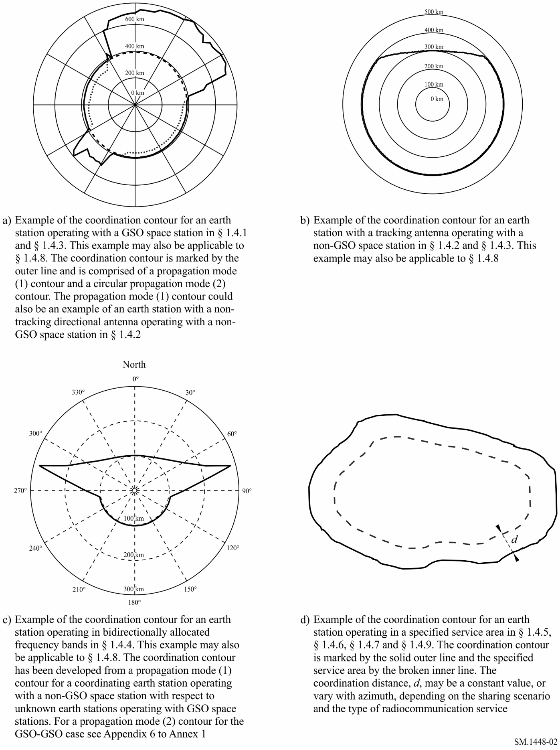
Supplementary contours are always drawn on a separate map as they apply to other types of radio system within the same radiocommunication service, or to radio systems in different radiocommunication services. However, as auxiliary contours apply to the various assumptions used in developing the main, or supplementary, contour they are always drawn on the same map that contains the corresponding main, or supplementary, contour.
While the use of supplementary or auxiliary contours allows less conservative assumptions with regard to the interference path and operational constraints to be taken into consideration, earth stations may transmit or receive a variety of classes of emissions. Hence, the earth station parameters to be used in the determination of the coordination contour, and any supplementary or auxiliary contours, are those which lead to the greatest distances for each earth station antenna beam and each allocated frequency band which the coordinating earth station shares with other radiocommunication systems.

1.6.1 Supplementary contours
The coordination area is based on the worst-case sharing considerations, interference paths and operational constraints; hence, it is determined with respect to the type of terrestrial station (or in a frequency band with a bidirectional space allocation, an earth station operating in the opposite direction of transmission) that would yield the largest coordination distances. Therefore, in the case of terrestrial services: fixed stations using tropospheric scatter have been assumed to be operating in frequency bands that may typically be used by such radiocommunication systems; and fixed stations operating in line-of-sight configurations and using analogue modulation have been assumed to be operating in other frequency bands. However, other radiocommunication systems (e.g. other terrestrial stations), that typically have lower antenna gains, or otherwise less stringent system parameters, than those on which the coordination area is based, may also operate in the same frequency range. Therefore it is possible for the administration seeking coordination to identify a supplementary contour using either the methods in § 2 or 3 of the main body of this Annex 1, where they are applicable, or other agreed methods. Subject to bilateral agreement between administrations, these supplementary contours can assume the role of the coordination contour for an alternative type of radio system in the same service, or another radiocommunication service.
When a supplementary contour is to be developed for other types of systems, for example digital fixed systems, the necessary system parameters may be found in one of the adjacent columns in Tables 14, 15 and 16. If no suitable system parameters are available then the value of the permissible interference power, Pr(p), may be calculated using equation (142) of § 2 in Annex 2.
In addition, supplementary contours may be prepared by the administration seeking coordination in order to define smaller areas, based on more detailed methods, for consideration when agreed bilaterally between the concerned administrations. These contours can be a useful aid for the rapid exclusion of terrestrial stations or earth stations from further consideration. For earth stations operating with non-geostationary space stations, supplementary contours may be generated using the method in § 2.2.2 of the main body of this Annex 1.
The supplementary contour is depicted on a separate map from the coordination contour and may have its own set of auxiliary contours (see § 1.6.2). Supplementary contours may comprise of propagation mode (1) interference paths and, depending on the sharing scenario, propagation mode (2) interference paths. In addition, the propagation mode (1) element of a supplementary contour may, if appropriate for the radiocommunication service, utilize the same level of correction factor (see § 4.4 of the main body of this Annex) that was applied in the determination of the coordination contour. However, all parts of each supplementary contour must fall on or between the contour defined by the minimum coordination distance and the corresponding propagation mode (1) or propagation mode (2) main contour.

1.6.2 Auxiliary contours
As noted, the coordination area is based on the worst-case assumptions with regard to sharing considerations, interference paths and operational constraints. However, practical experience has shown that, in many cases, the separation distance required for the coordinating earth station, on any azimuth, can be substantially less than the coordination distance since the worst-case assumptions do not apply to every terrestrial station or earth station. There are two main mechanisms that contribute to such a difference between the separation distance and the coordination distance:
– the terrestrial station antenna gain (or e.i.r.p.), or receiving earth station antenna gain, in the direction of the coordinating earth station is less than that assumed in calculating the coordination contour;
– appropriate allowance can be made, for example, for the effects of site shielding not included in the coordination distance calculations.
Auxiliary contours are drawn on the map used for the radiocommunication system to which they apply (i.e. the main contour or supplementary contour as appropriate), and must use the same method as that used to determine the corresponding main or supplementary contour. In addition all parts of each auxiliary contour must fall on or between the contour defined by the minimum coordination distance and the corresponding main or supplementary contour. Auxiliary contours may assist in eliminating from detailed coordination terrestrial stations or earth stations that are located in the coordination area and hence have been identified as potentially affected by the coordinating earth station. Any terrestrial station or earth station that lies outside an auxiliary contour and has an antenna gain towards the coordinating earth station that is less than the gain represented by the relevant auxiliary contour need not be considered further as a significant source, or subject, of interference.

1.6.2.1 Auxiliary contours for propagation mode (1)
Propagation mode (1) auxiliary contours are calculated using the same method as the corresponding main, or supplementary, contour but with values for the propagation mode (1) minimum required loss, in equation (23) in § 4.4 of the main body of this Annex that are progressively reduced by, for example, 5, 10, 15, 20 dB, etc., below the value derived from the parameters assumed in Tables 14, 15 and 16 for the corresponding main or supplementary propagation mode (1) contour, until the minimum coordination distance is reached. Thus auxiliary propagation mode (1) contours allow for those cases where the antenna gain, or e.i.r.p. of terrestrial stations, or the antenna gain of receiving earth stations, is less than the value assumed in Tables 14, 15 and 16.
Propagation mode (1) auxiliary contour distances are calculated without the correction factor (see § 4.4 of the main body of this Annex), and hence could be larger, on any azimuth, than the corresponding main, or supplementary, propagation mode (1) distance. To prevent this, in those cases where a correction factor applies to the main or supplementary contour, the maximum propagation mode (1) auxiliary contour distance on any azimuth is limited to the corresponding main or supplementary propagation mode (1) distance. In effect this means that the correction factor will limit the possible range of auxiliary contour values so that only those auxiliary contours with values greater than the applied correction factor will be shown within the main or supplementary contour (see Fig. 3). For example, if the value of correction factor applicable to the propagation mode (1) main or supplementary contour is 10 dB, then the first auxiliary contour drawn would be for a reduction in minimum required loss of 5 dB and hence the auxiliary contour value would be −15 dB (by convention auxiliary contours are shown as negative quantities as they represent a reduction in the terrestrial, or receiving earth station, antenna gain, or the terrestrial station e.i.r.p.).
Propagation mode (2) interference effects may still need to be considered even if propagation mode (1) interference effects have been eliminated from detailed coordination, as the propagation models are based on different interference mechanisms.
Figure 3
Propagation mode (1) main contour and auxiliary contours
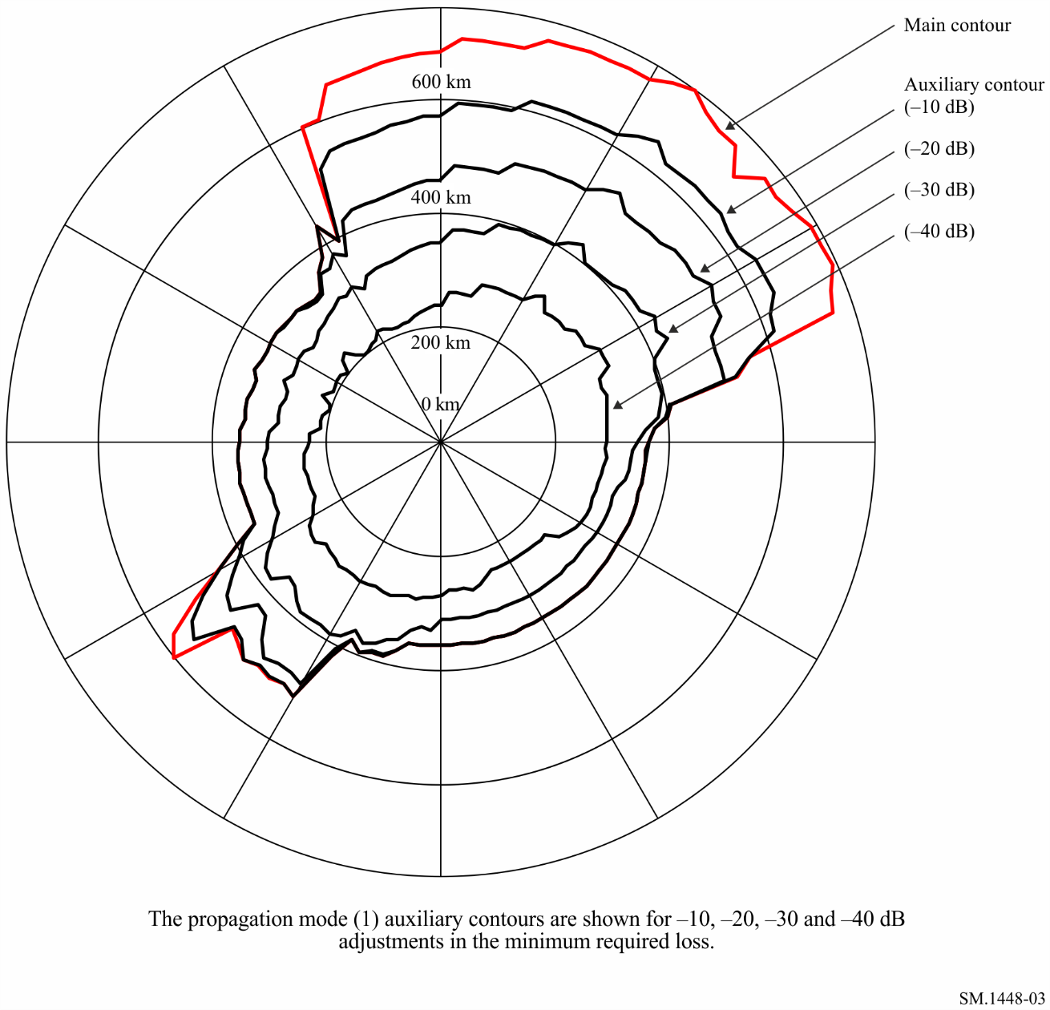

1.6.2.2 Auxiliary contours for propagation mode (2)
The propagation mode (2) contour around an earth station is calculated assuming the main beams of the coordinating earth station and the terrestrial station intersect exactly (see § 1.3 of the main body of this Annex). However, it is unlikely that these antenna main beams will intersect exactly. It is therefore possible to generate propagation mode (2) auxiliary contours that take account of any offset in the pointing of the terrestrial station antenna beam from the direction of the coordinating earth station. This offset would result in partial beam intersections and hence a reduced interference potential. These propagation mode (2) auxiliary contours are calculated according to the method described in Attachment 7 to Annex 1.
Propagation mode (2) auxiliary contours are not generated for different values of antenna gain or e.i.r.p. but for different values of beam avoidance angle. Hence, if there is a need to consider both a lower value of antenna gain, or e.i.r.p., for the terrestrial station and propagation mode (2) auxiliary contours, it is first essential to consider the impact of the reduction in antenna gain, or e.i.r.p., on the propagation mode (2) contour. This is achieved by generating a supplementary contour (see § 1.6.1) corresponding to the lower value of antenna gain or e.i.r.p. for the terrestrial station, which is drawn on a separate map. Auxiliary mode (2) contours can then be generated inside this propagation mode (2) supplementary contour for different values of the beam avoidance angle. Hence, propagation mode (2) auxiliary contours may be most frequently applied in conjunction with a supplementary contour rather than with the coordination contour.
The correction factor discussed in § 1.3 of the main body of this Annex does not apply to propagation mode (2) interference paths and hence is also not applicable to propagation mode (2) auxiliary contours. In addition propagation mode (2) auxiliary contours cannot be developed for the bidirectional case.
Propagation mode (2) auxiliary contours are prepared for appropriate values of terrestrial station main beam avoidance angle (see Fig. 4). When the antenna characteristics of the terrestrial stations are known, the appropriate antenna pattern should be used when determining the propagation mode (2) auxiliary contours. If this is not available, the reference antenna pattern given in § 3 of Attachment 7 to Annex 1 may be used.
Figure 4
Propagation mode (2) main contour and auxiliary contours
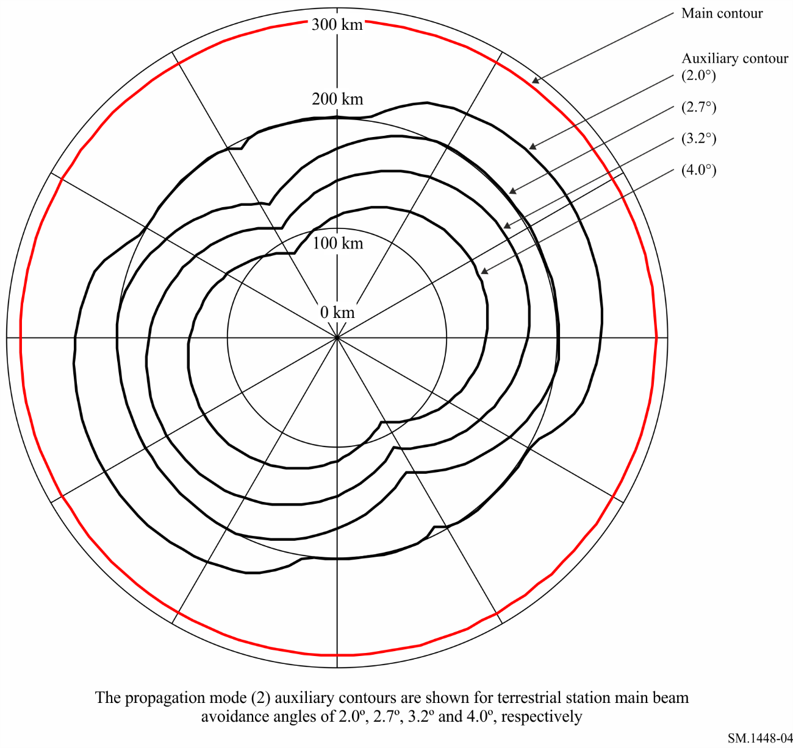

2 Determination of the earth station coordination area with respect to terrestrial stations
This section contains the procedures for determining the coordination area for the case of earth stations sharing frequency bands with terrestrial stations. These procedures cover the cases for earth stations operating with space stations in the geostationary orbit, or in non-geostationary orbits, and are described in the following subsections.
For earth stations operating with space stations in non-geostationary orbits, consideration has to be given to the potential time-varying nature of the earth station’s antenna gain towards the horizon.

2.1 Earth stations operating with geostationary space stations
For an earth station operating with geostationary space stations, the value of G_{t} and G_{r} towards the horizon is considered to be constant with time. The percentage of time associated with L_{b} in equation (1) is the same as the time percentage, p, associated with P_{r}(p). When determining the coordination area between a coordinating earth station operating with a geostationary space station and terrestrial systems, the coordination distance on any azimuth is the greater of the propagation mode (1) and propagation mode (2) required distances. The required distances for propagation mode (1) and propagation mode (2) are determined using the procedures described in § 2.1.1 and § 2.1.2 respectively, after taking into consideration the following discussion on station-keeping.
When the north/south station-keeping of a geostationary space station is relaxed, the orbit of the space station becomes inclined with an inclination that increases gradually with time. As viewed from the Earth, the position of the space station traces a figure of eight during each 24-hour period. This movement of the space station from its nominal position may require small corresponding adjustments in the elevation angle of the earth station antenna beam. Hence, to avoid considering the time variation in antenna gain in the direction of the horizon, the coordination area of an earth station operating with a space station in a slightly inclined geostationary orbit is determined for the minimum angle of elevation and the associated azimuth at which the space station is visible to the earth station (see Attachment 3 to Annex 1).
When the earth station is used to transmit to multiple space stations in slightly inclined orbits, all possible pointing directions of the antenna main beam axis need to be considered. However, when determining the coordination area, only a bounding envelope need be considered, based on the maximum excursions in latitude and longitude of the sub-satellite points of space stations at all potential locations on the segment of interest along the geostationary arc. The bounding curve used to determine the minimum off-axis angle (i.e. the minimum value of the angle between the main beam axis and the horizon) is based on the maximum orbital inclination that will be allowed during the operational life of the space stations. The use of the bounding envelope simplifies the calculation of the minimum off-axis angle. It also does not require the specific values of the space station locations on the geostationary arc, particularly as not all of these may be known beforehand, and some may require repositioning at a later time.

2.1.1 Determination of the coordinating earth station’s propagation mode (1) contour
Determination of the propagation mode (1) contour is based on great circle propagation mechanisms and it is assumed, for the interference path, that all the terrestrial stations are pointing directly at the coordinating earth station’s location. The required distance, on each azimuth, for propagation mode (1) is that distance which will result in a value of propagation mode (1) predicted path loss that is equal to the propagation mode (1) minimum required loss, L_{b}(p) (dB), as defined in § 1.3.
L_{b}(p ) = P_{t} + G_{e} + G_{x} – P_{r}(p ) dB (4)
where:
P_{t} and P_{r}(p): as defined in § 1.3
G_{e}: gain of the coordinating earth station antenna (dBi) towards the horizon at the horizon elevation angle and azimuth under consideration
G_{x}: maximum antenna gain (dBi) assumed for the terrestrial station. Tables 14 and 15 give values for G_{x} for the various frequency bands.
The propagation mode (1) required distance is determined using the procedures described in § 4, and the detailed methods in Attachment 1 to Annex 1. Specific guidance relevant to the application of the procedures is provided in § 4.4.

2.1.2 Determination of the coordinating earth station’s propagation mode (2) contour
The required distance for hydrometeor scatter is that distance that will result in a propagation mode (2) predicted path loss equal to the propagation mode (2) minimum required loss L(p), as defined in equation (3). This propagation mode (2) required distance is determined using the guidance in § 5, and the detailed methods in Attachment 2 to Annex 1.
For an earth station operating with a geostationary space station having a slightly inclined orbit, the rain-scatter contours for each of the satellite’s two most extreme orbit positions are determined individually, using the relevant elevation angles and their associated azimuths to the satellite. The rain scatter area is the total area contained within the two resulting overlapping contours.
For an earth station intended to operate with space stations at various geostationary orbit locations, the rain-scatter contours for the most easterly and for the most westerly orbit location are determined individually. The rain-scatter area is then the total area contained within the two resulting overlapping contours. If either or both of the space stations are in slightly inclined orbits then the most extreme orbit positions are used as appropriate.

2.2 Earth stations operating with non-geostationary space stations
For an earth station that operates with non-geostationary space stations and whose antennas track the space stations, the antenna gain in the direction of the horizon on any azimuth varies with time. Two methods are available to take this effect into account and are described in the sections below:
– the time-invariant gain (TIG) method (see § 2.2.1); and
– the time-variant gain (TVG) method (see § 2.2.2).
The TIG method is used to determine the coordination contour. This method provides ease of implementation since it is not dependent on the availability of the distribution of the values for the horizon gain of the earth station antenna. As a consequence of this simplification, it usually overestimates the necessary distance. In order to reduce the coordination burden and on the basis of bilateral and multilateral agreements, administrations can use the TVG method to draw supplementary contours and obtain less conservative results.
In the case of a receiving earth station, the permissible interference power Pr(p) is specified with respect to the actual percentage of time the receiver is in operation, rather than the total elapsed time. Thus, the percentage of time, p, is specified for all the operational time that the receiving earth station is expected to spend in reception from non-geostationary space stations, but excludes any reception time involving geostationary space stations.
In considering the horizon gain of the antenna for either a transmitting or a receiving earth station, only the horizon gain values during the operational time are to be considered. In developing the cumulative distributions of horizon gain for the TVG method, the percentages of time are percentages of operational time. Thus, there may be periods, or percentages, of time for which no horizon gain is specified. This presents no problem in the implementation of either method described in this section, and it is consistent with the permissible interference power for the unknown receiving stations specified in Table 14 and with the permissible interference powers for receiving earth stations, as discussed in the preceding paragraph, in Table 15.
The distributions of the horizon antenna gain are determined using Attachment 4 to Annex 1. Reference or measured antenna radiation patterns may be used as described in Attachment 3 to Annex 1.

2.2.1 Determination of coordination area using the TIG method
This method uses fixed values of antenna gain based on the maximum assumed variation in horizon antenna gain on each azimuth under consideration. The values of horizon antenna gain defined below are used for each azimuth when applying equation (4) to determine the propagation mode (1) required distances:
G_{e} = G_{max} for (G_{max} – G_{min}) ≤ 20 dB
G_{e} = G_{min} + 20 for 20 dB < (G_{max} – G_{min}) < 30 dB (5)
G_{e} = G_{max} – 10 for (G_{max} – G_{min}) ≥ 30 dB
where:
G_{e}: gain of the coordinating earth station antenna (dBi) towards the horizon at the horizon elevation angle and azimuth under consideration in equation (4)
G_{max}, G_{min}: maximum and minimum values of the horizon antenna gain (dBi), respectively, on the azimuth under consideration.
The maximum and minimum values of the horizon antenna gain, on the azimuth under consideration, are derived from the antenna pattern and the maximum and minimum angular separation of the antenna main beam axis from the direction of the physical horizon at the azimuth under consideration.
Where a single value of minimum elevation angle for the main beam axis of the earth station antenna is specified for all azimuths, the minimum and maximum values of the horizon gain can be determined, for each azimuth under consideration, from the antenna pattern and the horizon elevation angle at that azimuth. The plot of the horizon elevation angle against azimuth is called the horizon profile of the earth station.
Additional constraints may be included in the determination of the maximum and minimum values of the horizon antenna gain where an earth station is operating with a constellation of non-geostationary satellites at a latitude for which no satellite is visible at the earth station’s specified minimum elevation angle over a range of azimuths. Over this range of azimuth angles, the minimum elevation angle of the earth station antenna main beam axis is given by the minimum elevation angle at which any satellite of the constellation is visible at that azimuth. The azimuthal dependence of this minimum satellite visibility elevation angle may be determined from consideration of the orbital altitude and inclination of the satellites in the constellation, without recourse to simulation, using the procedure in § 1.1 of Attachment 4 to Annex 1. In this case, the horizon antenna gain to be used in the method depends on the profile of the composite minimum elevation angle. This minimum composite elevation angle at any azimuth is the greater of the minimum satellite visibility elevation angle, at the azimuth under consideration, and the specified minimum elevation angle for the earth station which is independent of the azimuth.
Thus, at each azimuth under consideration, the maximum horizon antenna gain will be determined from the minimum value of the angular separation between the earth station horizon profile at this azimuth and the profile of the minimum composite elevation angle. Similarly, the minimum horizon antenna gain will be determined from the maximum value of the angular separation from the earth station horizon profile at this azimuth to the profile of the minimum composite elevation angle. The procedure for calculating the minimum and maximum angular separations from the profile of the minimum composite elevation angle is given in § 1.2 of Attachment 4 to Annex 1.
The propagation mode (1) required distance is then determined using the procedures described in § 4, and the detailed methods in Attachment 1 to Annex 1. Specific guidance relevant to the application of the propagation calculations is provided in § 4.4.

2.2.2 Determination of supplementary contour using the TVG method
The TVG method requires the cumulative distribution of the time-varying horizon antenna gain of an earth station operating with a non-geostationary space station. In comparison to the TIG method, the TVG method usually produces smaller distances, but requires greater effort in determining the cumulative distribution of the horizon gain of the earth station antenna for each azimuth to be considered.
The TVG method closely approximates the convolution of the distribution of the horizon gain of the earth station antenna and the propagation mode (1) path loss. This method may produce slightly smaller distances than those obtained by an ideal convolution. An ideal convolution cannot be implemented due to the limitations of the current model for propagation mode (1). The propagation mode (1) required distance, at the azimuth under consideration, is taken as the largest distance developed from a set of calculations, each of which is based on equation (4) of the main body of this Annex. For convenience, in these calculations, equation (4) may be rewritten for the n-th calculation in the following form:
dB (6)
with the constraint
where:
Pt, Pr( p): as defined in equations in § 1.3 of the main body of this Annex where p is the percentage of time associated with permissible interference power Pr(p)
Gx: maximum antenna gain assumed for the terrestrial station (dBi). Tables 14 and 15 give values for Gx for the various frequency bands
Ge (pn): the horizon gain of the coordinating earth station antenna (dBi) that is exceeded for p_{n}% of the time on the azimuth under consideration
Lb, (pv): the propagation mode (1) minimum required loss (dB) for pv% of the time; this loss must be exceeded by the propagation mode (1) predicted path loss for all but pv% of the time.
The values of the percentages of time, pn, to be used in equation (6) are determined in the context of the cumulative distribution of the horizon antenna gain. This distribution needs to be developed for a predetermined set of values of horizon antenna gain spanning the range from the minimum to the maximum values for the azimuth under consideration. The notation Ge(pn) denotes the value of horizon antenna gain for which the complement of the cumulative distribution of the horizon antenna gain has the value corresponding to the percentage of time pn. The pn value is the percentage of time that the horizon antenna gain exceeds the n-th horizon antenna gain value. The procedure in § 2 of Attachment 4 to Annex 1 may be used to develop this distribution.
For each value of pn, the value of horizon antenna gain for this time percentage, Ge( pn), is used in equation (6) to determine a propagation mode (1) minimum required loss. The propagation mode (1) predicted path loss is to exceed this propagation mode (1) required loss for no more than pv % of the time, as specified by the constraint associated with equation (6). A series of propagation mode (1) distances are then determined using the procedures described in § 4, and the detailed methods in Attachment 1 to Annex 1. Specific guidance relevant to the application of the propagation calculations is provided in § 4.4.
The propagation mode (1) required distance is then the maximum distance in the series of propagation mode (1) distances that are obtained for any value of pn, subject to the constraint associated with equation (6). A detailed description of the method for using equation (6) to determine the propagation mode (1) required distance is provided in Attachment 5 to Annex 1.

3 Determination of the coordination area between earth stations operating in bidirectionally allocated frequency bands
This section describes the procedures to be used for determination of the coordination area for an earth station transmitting in a frequency band allocated to space services in both Earth-to-space and space-to-Earth directions.
There are various coordination scenarios, involving only non-time-varying antenna gains, or only time-varying antenna gains (both earth stations operate with non-geostationary space stations) or, one time-varying antenna gain and one non-time-varying antenna gain.
The following subsections describe the methods for the determination of coordination area which are specific to each of these bidirectional cases. The procedures applicable to the coordination scenario where both earth stations operate with geostationary space stations are given in § 3.1. The other bidirectional coordination scenarios are considered in § 3.2, where particular attention is given to the approaches for using the horizon antenna gain of the receiving earth station for each of the possible coordination scenarios in the appropriate procedure of § 2.
Table 16 provides the parameters that are to be used in the determination of the coordination area. Table 16 also indicates whether, in each band, the receiving earth stations operate with geostationary or non-geostationary space stations. In some bands, receiving earth stations may operate with both geostationary and non-geostationary space stations. Table 2 indicates the number of coordination contours which need to be drawn for each coordination scenario and the section(s) containing the applicable calculation methods. Once drawn, each coordination contour must be appropriately labelled.
TABLE 2
Coordination contours required for each bidirectional scenario
Coordinating earth station operating with space stations in the | Unknown receiving earth station operating with space stations in the | Section containing the method to determine  Gt and Gr | Contours required
 |  |  | No. | Details
Geostationary orbit | Geostationary orbit | § 3.1 | 1 | A coordination contour comprising both propagation mode (1) and propagation mode (2) contours
 | Non-geostationary orbit | § 3.2.1 | 1 | A propagation mode (1) coordination contour
 | Geostationary or non-geostationary orbits(1) | § 3.1 and 3.2.1 | 2 | Two separate coordination contours, one for the geostationary orbit (propagation mode (1) and mode (2) contours) and one for the non-geostationary orbit (propagation mode (1) contour)
Non-geostationary orbit | Geostationary orbit | § 3.2.2 | 1 | A propagation mode (1) coordination contour
 | Non-geostationary orbit | § 3.2.3 | 1 | A propagation mode (1) coordination contour
 | Geostationary or non-geostationary orbits(1) | § 3.2.2 and 3.2.3 | 2 | Two separate propagation mode (1) coordination contours, one for the geostationary orbit and one for the non-geostationary orbit
(1) In this case, the bidirectional frequency band may contain allocations in the space-to-Earth direction for space stations in both the geostationary orbit and non-geostationary orbits. Hence, the coordinating administration will not know whether the unknown receiving earth stations are operating with space stations in the geostationary orbit or non-geostationary orbit.

3.1 Coordinating and unknown earth stations operating with geostationary space stations
When both the coordinating and the unknown earth stations operate with space stations in the geostationary orbit, it is necessary to develop a coordination contour comprising both propagation mode (1) and propagation mode (2) contours, using the procedures described in § 3.1.1 and 3.1.2, respectively.

3.1.1 Determination of the coordinating earth station’s propagation mode (1) contour
The procedure for the determination of the propagation mode (1) contour in this case differs from that described in § 2.1.1 in two ways. First, the parameters to be used for the unknown receiving earth station are those in Table 16. Second, and more significantly, the knowledge that the unknown earth stations operate with geostationary satellites can be used to calculate the worst-case value of the horizon antenna gain of the receiving earth station towards the transmitting earth station for each azimuth at the transmitting earth station. The propagation mode (1) required distance is that distance which will result in a value of propagation mode (1) predicted path loss which is equal to the propagation mode (1) minimum required loss, L_{b}(p ) (dB), as defined in § 1.3, and repeated here for convenience.
L_{b}(p ) = P_{t} + G_{t} + G_{r} – P_{r}(p ) dB (7)
where:
P_{t} and P_{r}(p ): as defined in § 1.3
G_{t}: gain of the coordinating (transmitting) earth station antenna (dBi) towards the horizon at the horizon elevation angle and the azimuth under consideration
G_{r}: the horizon antenna gain of the unknown receiving earth station towards the transmitting earth station on the specific azimuth from the coordinating earth station. Values are determined by the procedure in § 2.1 of Attachment 6 to Annex 1, based on parameters from Table 16.
To facilitate the determination of the values of G_{r} to be used at an azimuth from the transmitting earth station, several simplifying approximations must be made:
− that the horizon elevation of the receiving earth station is zero degrees on all azimuths;
− that the receiving earth station operates with a space station that has zero degrees orbital inclination and may be located anywhere on the geostationary orbit that is above the minimum elevation angle, given in Table 16, for the location of the receiving earth station;
− that the latitude of the receiving earth station is the same as that of the transmitting earth station;
− that plane geometry can be used to interrelate the azimuth angles at the respective earth stations, rather than using the great circle path.
The first three assumptions provide the basis for determining the horizon antenna gain of the receiving earth station on any azimuth. The assumption of 0° horizon elevation angle is conservative since the increase in horizon antenna gain due to a raised horizon would, in practice, be more than offset by any real site shielding. The last two assumptions in the list simplify the calculation of the sum of G_{t} and G_{r} along any azimuth. Since the propagation mode (1) required distances are small, in global geometric terms these approximations may introduce a small error in the determination of the horizon antenna gain of the receiving earth station antenna that, in any case, will not exceed 2 dB. Because of the assumption of plane geometry, for a given azimuth at the transmitting earth station the appropriate value of the horizon antenna gain of the receiving earth station is the value on the reciprocal (i.e. ±180°, see § 2.1 of Attachment 6 to Annex 1) azimuth at the receiving earth station.
The propagation mode (1) required distance is then determined using the procedures described in § 4, and the detailed methods in Attachment 1 to Annex 1. Specific guidance relevant to the application of the propagation calculations is provided in § 4.4.

3.1.2 Determination of the coordinating earth station’s propagation mode (2) contour
The procedure for the determination of the propagation mode (2) contour for a transmitting earth station operating with a geostationary space station uses the same simplifying approximations as made in § 3.1.1, but it is based on a geometrical construction that avoids the requirement for a complex propagation model (see § 3 of Attachment 6 to Annex 1). Auxiliary contours cannot be used in this method, as the calculations are not based on the propagation mode (2) required loss.
The propagation mode (2) contour is determined using the elevation angle and the azimuth from the coordinating transmitting earth station to the space station, together with the following two considerations:
– the minimum coordination distance (see § 4.2), which will be the required distance for some azimuths; and
– a worst-case required distance determined by the hydrometeor scatter geometry for a receiving earth station located in either of two 6° azimuth sectors. Within these sectors, the receiving earth station is assumed to be operating at the minimum elevation angle to a space station in the geostationary orbit and its main beam intersects the beam for the coordinating transmitting earth station at the point where the latter beam passes through the rain height, hR. Although the scattering can occur anywhere between the coordinating earth station and this point, the intersection of the two beams at this point represents the worst-case interference scenario. Hence, it results in the worst-case distance requirement for receiving earth stations located in the two azimuth sectors.
For an earth station operating with a space station in an inclined orbit, the lowest expected operational antenna elevation angle and its associated azimuth are used in the calculations.
The propagation mode (2) contour is determined using the method in § 3 of Attachment 6 to Annex 1.

3.2 Coordinating or unknown earth stations operating with non-geostationary space stations
For the cases where a coordinating (transmitting) earth station operates with non-geostationary space stations, the following procedures assume that the earth station antenna is tracking the space station, otherwise see § 1.4.2.
When the receiving earth station is operating with non-geostationary space station(s), it is possible only to identify a time-invariant horizon gain to be used, at all azimuths, for the determination of the coordination area, and the method described in § 2.2.1 is used.
Table 16 provides values of horizon antenna gain to be used in the calculations.
One or more of the following three procedures may be needed to determine the required propagation mode (1) coordination contours of Table 2. Propagation mode (2) contours are not required for any of the cases where either of the earth stations operates with space stations in non-geostationary orbits.

3.2.1 A coordinating earth station operating with a geostationary space station with respect to unknown earth stations operating with non-geostationary space stations
When the coordinating earth station operates with a space station in the geostationary orbit and the unknown earth stations operate with space stations in non-geostationary orbits, the propagation mode (1) coordination area is determined using the procedures described in § 2.1.1. The only modification needed is to use the horizon antenna gain, G_{r}, of the unknown receiving earth station in place of the terrestrial station gain, G_{x}. The appropriate values for this gain and the appropriate system parameters are contained in Table 16.

3.2.2 A coordinating earth station operating with a non-geostationary space station with respect to unknown earth stations operating with geostationary space stations
When the coordinating earth station operates to space stations in non-geostationary orbits and the unknown earth stations operate with space stations in the geostationary orbit, the horizon antenna gain, G_{r}, for the unknown receiving earth station is determined in accordance with the simplifying approximations of § 3.1.1, as elaborated in § 2.1 of Attachment 6 to Annex 1, and the parameters of Table 16. Determination of the propagation mode (1) coordination area then follows the procedure of § 2.2 by using the appropriate horizon gain of the receiving earth station at each azimuth under consideration and the appropriate system parameters from Table 16.

3.2.3 Coordinating and unknown earth stations operating with non-geostationary space stations
When the coordinating earth station operates with space stations in non-geostationary orbits and the unknown earth stations operate with space stations in non-geostationary orbits, the propagation mode (1) coordination area is determined using the procedure described in § 2.2. The only modification is to use the horizon antenna gain, G_{r}, of the unknown receiving earth station in place of the terrestrial station antenna gain. The appropriate values for this gain and the appropriate system parameters are given in Table 16.

4 General considerations for the determination of the propagation mode (1) required distance
For the determination of the propagation mode (1) required distances, the applicable frequency range has been divided into three parts. The propagation calculations for the VHF/UHF frequencies between 100 MHz and 790 MHz are based upon propagation mode (1) predicted path loss curves. From 790 MHz to 60 GHz the propagation modelling uses tropospheric scatter, ducting and layer reflection/refraction models. At higher frequencies up to 105 GHz, the model is based on a free-space loss and a conservative assumption for gaseous absorption. The possible range of time percentages is different in the different propagation models.
After taking site shielding (§ 1 of Attachment 1 to Annex 1) into consideration, for the coordinating earth station only, the following methods are used to determine the propagation mode (1) required distances:
– For frequencies between 100 MHz and 790 MHz, the method described in § 2 of Attachment 1.
– For frequencies between 790 MHz and 60 GHz, the method described in § 3 of Attachment 1.
– For frequencies between 60 GHz and 105 GHz, the method described in § 4 of Attachment 1.
The three methods referred to above rely on a value of propagation mode (1) minimum required loss, determined according to the appropriate system parameters in Tables 14, 15 and 16.

4.1 Radio-climatic information
For the calculation of the propagation mode (1) required distance, the world has been classified in terms of a radio-meteorological parameter representing clear-air anomalous propagation conditions. The percentage of time β_{e} for which these clear-air anomalous propagation conditions exist, is latitude dependent and is given by:
with:
where ζ is the latitude of the earth station’s location (degrees).
For frequencies between 790 MHz and 60 GHz, the path centre sea level surface refractivity, N₀, is used in the propagation mode (1) calculations. This can be calculated using:
(12)

4.2 Minimum coordination distance for propagation modes (1) and (2)
The minimum coordination distance can be calculated in two steps. First calculate distance d_{x} using:
km (13)
where β_{e} is given in § 4.1.
Then calculate the minimum coordination distance at any frequency, f (GHz) in the range 100 MHz to 105 GHz using:
The distance from which all iterative calculations start (for both propagation mode (1) and propagation mode (2)), is the minimum coordination distance, d_{min}, as given in equations (14) to (19).

4.3 Maximum coordination distance for propagation mode (1)
In the iterative calculation described in Attachment 1 to Annex 1, it is necessary to set an upper limit, d_{max1}, to the propagation mode (1) coordination distance.
For frequencies less than or equal to 60 GHz and propagation paths entirely within a single Zone, the distance shall not exceed the maximum coordination distance given in Table 3 for that Zone.
For mixed paths, the required distance can comprise one or more contributions from Zones A1, A2, B and C. The aggregate distance for any one zone must not exceed the value given in Table 3. The overall required distance must not exceed the value in Table 3 for the zone in the mixed path having the largest Table 3 value. Thus, a path comprising both Zones A1 and A2 must not exceed 500 km.
TABLE 3
Maximum coordination distances for propagation mode (1)
for frequencies below 60 GHz
Zone | d_{max1}  (km)
A1 | 500
A2 | 375
B | 900
C | 1 200

For frequencies above 60 GHz, the maximum coordination distance, d_{max1}, is given by:
(20)
where p is defined in § 1.3.

4.4 Guidance on application of propagation mode (1) procedures
As explained in § 1.3, for those cases where earth stations are sharing with terrestrial stations, it is appropriate to apply a correction factor, C_{i} (dB), to the worst-case assumptions on system parameters and interference path geometry. This correction factor takes into account the fact that the assumption that all the worst-case values will occur simultaneously is unrealistic when determining the propagation mode (1) required distances.
The characteristics of terrestrial systems depend on the frequency band, and the value of the correction factor to be applied follows the frequency dependence given in equation (21). At frequencies between 100 MHz and 400 MHz, and between 60 GHz and 105 GHz, sharing between earth stations and terrestrial systems is a recent development and there is little established practical experience, or opportunity to analyse operational systems. Hence, the value of the correction factor is 0 dB in these bands. Between 400 MHz and 790 MHz and between 4.2 GHz and 60 GHz, the value of the correction factor is reduced in proportion to the logarithm of the frequency, as indicated in equation (21).
The value of the nominal correction to be used at any frequency f (GHz) is therefore given by:
(21)
where:
X: 15 dB for a transmitting earth station and 25 dB for a receiving earth station.
In principle, the value of the nominal correction factor, X(f ), is distance and path independent. However, there are a number of issues relating to interference potential at the shorter distances, and it is not appropriate to apply the full nominal correction at these distances. The correction factor C_{i} is therefore applied proportionally with distance along the azimuth under consideration, starting with 0 dB at d_{min}, such that the full value of X(f ) is achieved at a nominal distance of 375 km from the earth station.
Hence, the correction is applied using the correction constant Z(f ) (dB/km) where:
dB/km (22)
The correction factor C_{i} (dB) is calculated in equations (29b) and (53) from the correction constant Z(f ) (dB/km).
At distances greater than 375 km, the correction factor C_{i} to be applied is the value of C_{i} at 375 km distance.
In addition, the correction factor is applied to its highest value only on land paths. The correction factor is 0 dB for wholly sea paths. A proportion of the correction factor is applied on mixed paths. The amount of correction to be applied to a particular path is determined by the path description parameters used for the propagation mode (1) calculation (correction factors C_{i} and C_{2i} in § 2 and § 3 respectively of Attachment 1 to Annex 1). As the correction factor is distance dependent, it is applied automatically within the iterative calculation used to determine the propagation mode (1) required distance (see Attachment 1 to Annex 1).
The correction factor does not apply to the bidirectional case and therefore in the determination of the bidirectional coordination contour:
dB/km
For the determination of propagation mode (1) auxiliary contours, the propagation mode (1) minimum required loss L_{b}(p ) for p% of time in equation (1) (see § 1.3) is replaced by:
L_{bq}(p) = L_{b}(p ) + Q dB (23)
where:
Q: auxiliary contour value (dB).
Note that auxiliary contour values are assumed to be negative (i.e. −5, −10, −15, −20 dB, etc.).

5 General considerations for the determination of the propagation mode (2) required distance
The determination of the contour for scattering from hydrometeors (e.g. rain scatter) is predicted on a path geometry that is substantially different from that of the great-circle propagation mechanisms. Hydrometeor scatter can occur where the beams of the earth station and the terrestrial station intersect (partially or completely) at, or below, the rain height h_{R} (see § 3 of Attachment 2 to Annex 1). It is assumed that at heights above this rain height the effect of scattering will be suppressed by additional attenuation, and it will not, therefore, contribute significantly to the interference potential. For the determination of the propagation mode (2) contour, it is assumed that the main beam of any terrestrial station exactly intersects the main beam of the coordinating earth station. The mitigating effects of partial beam intersections can be determined using propagation mode (2) auxiliary contours.
Since, to a first approximation, microwave energy is scattered isotropically by rain, interference can be considered to propagate equally at all azimuths around the common volume centred at the beam intersection (see § 1.3). Generally, the beam intersection will not lie on the great-circle path between the two stations. A common volume can therefore result from terrestrial stations located anywhere around the earth station, including locations behind the earth station.
The propagation mode (2) contour is a circle with a radius equal to the propagation mode (2) required distance. Unlike the case for propagation mode (1), the propagation mode (2) contour is not centred on the earth station’s physical location, instead it is centred on a point on the earth’s surface immediately below the centre of the common volume.
A common volume can exist, with equal probability, at any point along the earth station beam between the earth station’s location and the point at which the beam reaches the rain height. To provide appropriate protection for/from terrestrial stations, the centre of the common volume is assumed to be half way between the earth station and the point at which its beam intersects the rain height. The distance between the projection of this point on to the Earth's surface and the location of the earth station is known as Δd (see § 4 of Attachment 2 to Annex 1). The centre of the propagation mode (2) contour is therefore Δd (km) from the earth station on the azimuth of the earth station’s main beam axis.

5.1 The required distance for propagation mode (2)
Propagation mode (2) required distances are measured along a radial originating at the centre of the rain scatter common volume. The calculation requires iteration for distance, starting at the same minimum distance as that defined for propagation mode (1) until either the required propagation mode (2) minimum required loss, or a latitude-dependent propagation mode (2) maximum calculation distance, is achieved. The propagation mode (2) calculations use the method described in Attachment 2 to Annex 1. The calculations only need to be performed in the frequency range 1 000 MHz to 40.5 GHz. Outside this frequency range, rain scatter interference can be neglected and the propagation mode (2) required distance is set to the minimum coordination distance given by equations (14) to (19).

Attachment 1
to Annex 1
Determination of the required distance for propagation mode (1)

1 Adjustments for earth station horizon elevation angle and distance
For propagation mode (1), the required distance depends on the characteristics of the physical horizon around the earth station. The horizon is characterized by the horizon distance d_{h} (see below), and the horizon elevation angle ε_{h}. The horizon elevation angle is defined here as the angle (degrees), viewed from the centre of the earth station antenna, between the horizontal plane and a ray that grazes the physical horizon in the direction concerned. The value of ε_{h} is positive when the physical horizon is above the horizontal plane and negative when it is below.
It is necessary to determine horizon elevation angles and distances for all azimuths around an earth station. In practice it will generally suffice to do this in azimuth increments of 5°. However, every attempt should be made to identify, and take into consideration, minimum horizon elevation angles that may occur between those azimuths examined in 5° increments.
For the purposes of the determination of the propagation mode (1) required distance it is useful to separate the propagation effects related to the local horizon around the earth station which, on some or all azimuths, may be determined by nearby hills or mountains, from the propagation effects on the remainder of the path. This is achieved by referencing the propagation model to a 0° horizon elevation angle for the coordinating earth station, and then to include a specific term A_{h} to deal with the known horizon characteristics of the earth station being coordinated. Where appropriate, A_{h} modifies the value of the path loss, on each azimuth, from which the propagation mode (1) required distance is derived.
There are two situations in which the level of attenuation for the propagation mode (1) path loss with respect to the reference 0° case can change:
– The first is where the coordinating earth station has a positive horizon elevation angle (on a particular azimuth). In this case, it will benefit from additional diffraction propagation losses over the horizon (generally referred to as site shielding). As a result, the attenuation A_{h} is positive and the value of the required path loss is reduced, with respect to the reference 0° horizon elevation angle case (see equations (28a) and (28b)).
– The second situation is where the coordinating earth station is at a location above the local foreground, and has a negative (downward) horizon elevation angle on a particular azimuth. In this case, a measure of additional protection is necessary because the path angular distance along the radial is reduced and hence the path loss for a given distance will be lower than for the zero degree elevation angle case. It is convenient to deal with this effect as part of the site shielding calculation. As a result, the attenuation A_{h} will be negative and the value of the required path loss is increased, with respect to the reference 0° horizon elevation angle case.
The contribution made by the attenuation arising from the coordinating earth station’s horizon characteristics to the propagation mode (1) minimum required loss modifies the value of path loss that then needs to be determined in the three propagation mode (1) models. The attenuation A_{h} is calculated for each azimuth around the coordinating earth station as follows.
The distance of the horizon, d_{h}, from the earth station’s location, is determined by:
The contribution made by the horizon distance, d_{h}, to the total site shielding attenuation is given by A_{d} (dB) for each azimuth using:
dB (24)
where f is the frequency (GHz) throughout this Attachment.
The total site shielding attenuation along each azimuth from the coordinating earth station is given by:
The value of Ah must be limited to satisfy the conditions:
–10 ≤ A_{h} ≤ (30 + ε_{h}) (26)
In equations (24), (25) and (26) the value of ε_{h} must always be expressed in degrees. The limits defined in equation (26) are specified because protection outside these limits may not be realized in practical situations.

2 Frequencies between 100 MHz and 790 MHz
The propagation model given in this section is limited to an average annual time percentage, p, in the range 1% to 50%.
An iterative process is used to determine the propagation mode (1) required distance. First, equation(28) is evaluated. Then, commencing at the minimum coordination distance, d_{min}, given by the method described in § 1.5.3 in the main body of Annex 1, equations (29) to (32) are iterated for distances d_{i} (where i = 0, 1, 2,...) incremented in steps of s (km) as described in § 1.3 in the main body of Annex 1. In each iteration, d_{i} is the distance considered. This process is continued until either of the following expressions becomes true:
(27a)
or:
(27b)
The required distance, d₁, or the auxiliary contour distance, d_{q}, are then given by the distance for the last iteration, i.e.:
d1 = di (27c)
or:
dq = di (27d)
As the eventual mix of zones along a path is unknown, all paths are treated as if they are potential land and sea paths. Parallel calculations are undertaken, the first assuming the path is all land and a second assuming it is all sea. A non-linear interpolation is then performed, the output of which depends upon the current mix of land and sea losses in the distance, d_{i}. Where the current mix along the path includes sections of both warm sea and cold sea zones, all the sea along that path is assumed to be warm sea.
For the main or supplementary contour:
L₁(p ) = L_{b}(p ) – A_{h} (28a)
For an auxiliary contour:
L_{1q}(p ) = L_{bq}(p ) – A_{h} (28b)
where:
L_{b}(p ) (dB) and L_{bq}(p ) (dB): minimum required loss required for p% of the time for the main or supplementary contour and the auxiliary contour with value Q (dB), respectively (see equation (23)).
Iterative calculations
At the start of each iteration calculate the current distance for i = 0, 1, 2,…:
d_{i} = d_{min} + i · s (29a)
The correction factor, C_{i} (dB), (see § 4.4 of Annex 1) for the distance, d_{i}, is given by:
(29b)
where Z(f) is given by equation (22) in § 4.4 of Annex 1.
At distances greater than 375 km, the value of the correction factor (C_{i} in equation (29b)) to be applied is the value of C_{i} at the 375 km distance.
The loss, L_{bl}(p ), where it is assumed that the path is wholly land (Zones A1 or A2), is evaluated successively using:
(30)
The loss, L_{bs}(p ), where it is assumed that the path is wholly cold sea (Zone B) or warm sea (Zone C), is evaluated successively using:
(31a)
(31b)
The predicted path loss at the distance considered is then given by:
(32)
where:
d_{tm} (km): longest continuous land (inland + coastal) distance, i.e. Zone A1 + Zone A2 along the current path.

3 Frequencies between 790 MHz and 60 GHz
The propagation model given in this section is limited to an average annual time percentage (p ) in the range 0.001% to 50%.
An iterative process is used to determine the propagation mode (1) required distance. First, equations (34) to (43) are evaluated. Then, commencing at the minimum coordination distance, d_{min}, equations (44) to (54) are iterated for distances d_{i}, where i = 0, 1, 2,..., incremented in steps of s (km) as described in § 1.3 of Annex 1. For each iteration, d_{i} is the distance considered. This process is continued until either of the following expressions becomes true:
(33a)
or:
(33b)
The required distance, d₁, or the auxiliary contour distance, d_{q}, is then given by the current distance for the last iteration, i.e.
d₁ = d_{i} (33c)
or:
d_{q} = d_{i} (33d)
Specific attenuation due to gaseous absorption
Calculate the specific attenuation (dB/km) due to dry air:
The specific attenuation due to water vapour is given as a function of ρ (the water vapour density (g/m³)) by the following equation:
(35)
Calculate the specific attenuation (dB/km) due to water vapour for the troposcatter propagation model using a water vapour density of 3.0 g/m³:
γwt = γw (3.0) (36a)
Calculate the specific attenuation (dB/km) due to water vapour for the ducting propagation model using a water vapour density of 7.5 g/m³ for paths over land, Zones A1 and A2, using:
γwdl = γw (7.5) (36b)
Calculate the specific attenuation (dB/km) due to water vapour for the ducting propagation model using a water vapour density of 10.0 g/m³ for paths over sea, Zones B and C, using:
γwds = γw (10.0) (36c)
Note that the value of 10 g/m³ is used for both Zones B and C in view of the lack of data on the variability of water vapour density on a global basis, particularly the minimum values.
Calculate the frequency-dependent ducting specific attenuation (dB/km):
(37)
For the ducting model
Calculate the reduction in attenuation arising from direct coupling into over-sea ducts (dB):
(38)
where d_{c} (km) is the distance from a land based earth station to the coast in the direction being considered.
d_{c} is zero in other circumstances.
Calculate the minimum loss to be achieved within the iterative calculations:
(39)
For the main or supplementary contour:
(40a)
For an auxiliary contour:
(40b)
where:
L_{b}(p ) (dB) and L_{bq}(p ) (dB): minimum required loss required for p% of the time for the main or supplementary contour and the auxiliary contour with value Q (dB) respectively (see equation (23)).
For the tropospheric scatter model
Calculate the frequency-dependent part of the losses (dB):
(41)
Calculate the non-distance-dependent part of the losses (dB):
(42)
where:
εh: earth station horizon elevation angle (degrees)
N₀: path centre sea level surface refractivity (see equation (12), § 4.1 of Annex 1).
Calculate the minimum required value for the distance dependent losses (dB):
For the main, or supplementary, contour:
(43a)
For an auxiliary contour:
(43b)
where:
L_{b}(p ) (dB) and L_{bq}(p ) (dB): minimum required loss required for p% of the time for the main or supplementary contour and the auxiliary contour of value Q (dB) respectively (see equation (23)).
Iterative calculations
At the start of each iteration, calculate the distance considered for i = 0, 1, 2, ..:
d_{i} = d_{min} + i · s (44)
Calculate the specific attenuation due to gaseous absorption (dB/km):
(45)
where:
d_{t} (km): current aggregate land distance, Zone A1 + Zone A2, along the current path.
Calculate the following zone-dependent parameters:
(46)
where:
d_{lm} (km): longest continuous inland distance, Zone A2, along the path considered;
(47)
where:
d_{tm} (km): longest continuous land (i.e. inland + coastal) distance, Zone A1 + Zone A2 along the path considered.
μ1 shall be limited to μ1 ≤ 1.
(48)
σ shall be limited to σ ≥ −3.4.
(49)
μ2 shall be limited to μ2 ≤ 1.
where ζ_{r} is given in equations (10) and (11), § 4.1 in Annex 1.
Calculate the path-dependent incidence of ducting, β, and a related parameter, used to calculate the time dependency of the path loss:
(51)
where β_{e} is given in equations (8) and (9), § 4.1 in Annex 1.
(52)
Calculate the correction factor, C_{2i} (dB) (see § 4.4 in Annex 1) using:
(53)
where Z(f) is calculated using equation (22) in § 4.4 in Annex 1.
At distances greater than 375 km the value of the correction factor C_{2i} in equation (53) to be applied is the value of C_{2i} at the 375 km distance.
Calculate the distance-dependent part of the losses (dB) for ducting:
(54)
and for tropospheric scatter:
(55)
For the determination of distances for auxiliary contours, C_{2i} = 0 dB.

4 Frequencies between 60 GHz and 105 GHz
This propagation model is valid for average annual percentage time (p ) in the range from 0.001% to 50%.
An iterative process is used to determine the propagation mode (1) required distance. First, equations (56) to (60) are evaluated. Then commencing at the minimum coordination distance, d_{min}, equations(61) and (62) are iterated for distances d_{i}, where i = 0, 1, 2,..., incremented in steps of s (km) as described in § 1.3 of Annex 1. For each iteration, d_{i} is the distance considered.
This process is continued until either of the following expressions becomes true:
(55a)
or:
(55b)
The required distance, d₁, or the auxiliary contour distance d_{q} are then given by the current distance for the last iteration: i.e.
d1 = di (55c)
or:
dq = di (55d)
Calculate the specific attenuation (dB/km) for dry air in the frequency range 60 GHz to 105 GHz using:
Calculate the specific attenuation (dB/km) for an atmospheric water vapour density of 3 g/m³ using:
(57)
Calculate a conservative estimate of the specific attenuation (dB/km) for gaseous absorption using:
γ_{gm} = γ_{om} + γ_{wm} dB/km (58)
For the required frequency and the value of earth station site shielding, A_{h} (dB), as calculated using the method described in § 1 of this Attachment, calculate the minimum loss to be achieved in the iterative calculations:
L₇(p ) = 92.5 + 20 log (f) + A_{h} dB (59)
For the main or supplementary contour:
L₈(p ) = L_{b}(p ) – L₇ dB (60a)
For an auxiliary contour:
dB (60b)
where:
L_{b}(p ) (dB) and Lbq(p ) (dB): minimum required loss required for p% of the time for the main or supplementary contour and the auxiliary contour of value Q (dB) respectively (see equation (23)).
Iterative calculations
At the start of each iteration calculate the distance for i = 0, 1, 2, ...:
d_{i} = d_{min} + i · s (61)
Calculate the distance-dependent losses for the distance:
(62)
For frequencies above 60 GHz, the correction factor (see § 4.4 of Annex 1) is 0 dB. Therefore, no correction term has been added to equation (62).

Attachment 2
to Annex 1
Determination of the required distance for propagation mode (2)

1 Overview
The algorithm given below allows propagation mode (2) path loss, L_{r}(p ) (dB), to be obtained as a monotonic function of rainfall rate, R(p ) (mm/h), and with the hydrometeor scatter distance, r_{i} (km), as a parameter. The model is valid for average annual time percentage (p ) in the range 0.001% to 10%. The procedure to determine the hydrometeor scatter contour is as follows:
a) The value of R(p ), is determined for the appropriate rain climatic Zones A to Q.
b) Values of L_{r}(p ), are then calculated for incremental values of r_{i}, starting at the minimum coordination distance d_{min}, in steps of s (km), as described in § 1.3 of Annex 1. The correct value of r_{i} is that for which the corresponding value of L_{r}(p ) equals or exceeds the propagation mode (2) minimum required loss L(p ). This value of r_{i} is the propagation mode (2) required distance and is denoted d_{r}.
c) If the iterative calculation results in r_{i} equalling or exceeding the appropriate maximum calculation distance (d_{max2}) given in § 2, then the calculation is terminated and d_{r} is assumed to be equal to d_{max2}. Hence the iteration stops when either of the following expressions becomes true:
L_{r}(p ) ≥ L(p ) (63a)
or:
r_{i} ≥ d_{max2} (63b)
d) The contour for propagation mode (2) is a circle of radius d_{r} (km) centred on a point along the azimuth of the earth station antenna main beam at a horizontal distance of Δd (km) from the earth station.

2 Maximum calculation distance
As discussed in § 1.5.3 of Annex 1, it is necessary to set upper limits to the maximum distance used in the iterative calculation of the required distance. The maximum calculation distance to be used for propagation mode (2) (d_{max2}) is latitude dependent and is given in the following equation:
km
where h_{R} is defined in equations (75) and (76).

3 Calculation of the propagation mode (2) contour
Determine R(p ), the rainfall rate (mm/h) exceeded on average for p% of a year. The world has been divided into a number of rain climatic zones (see Figs 5, 6 and 7) which show different precipitation characteristics.
The curves shown in Fig. 8 represent consolidated rainfall-rate distributions, each applicable to several of these rain climatic zones.
Determine which rain climatic zone is applicable to the location of the earth station:
– For 0.001% < p < 0.3% and the applicable rain climatic zone:
Determine R(p ) either from Fig. 8 or from equations (64) to (68).
– For p ≥ 0.3%:
Use equation (69) with values of R(0.3%) and p_{c} obtained from Table 4.
Figure 5
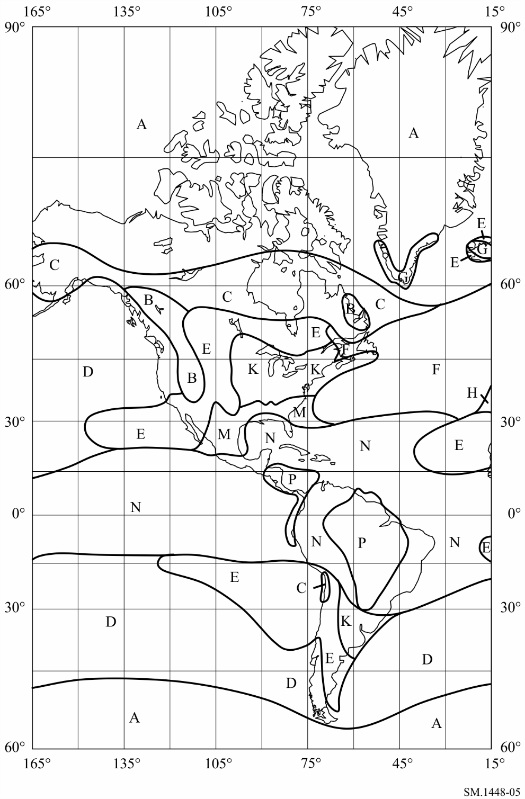
Figure 6
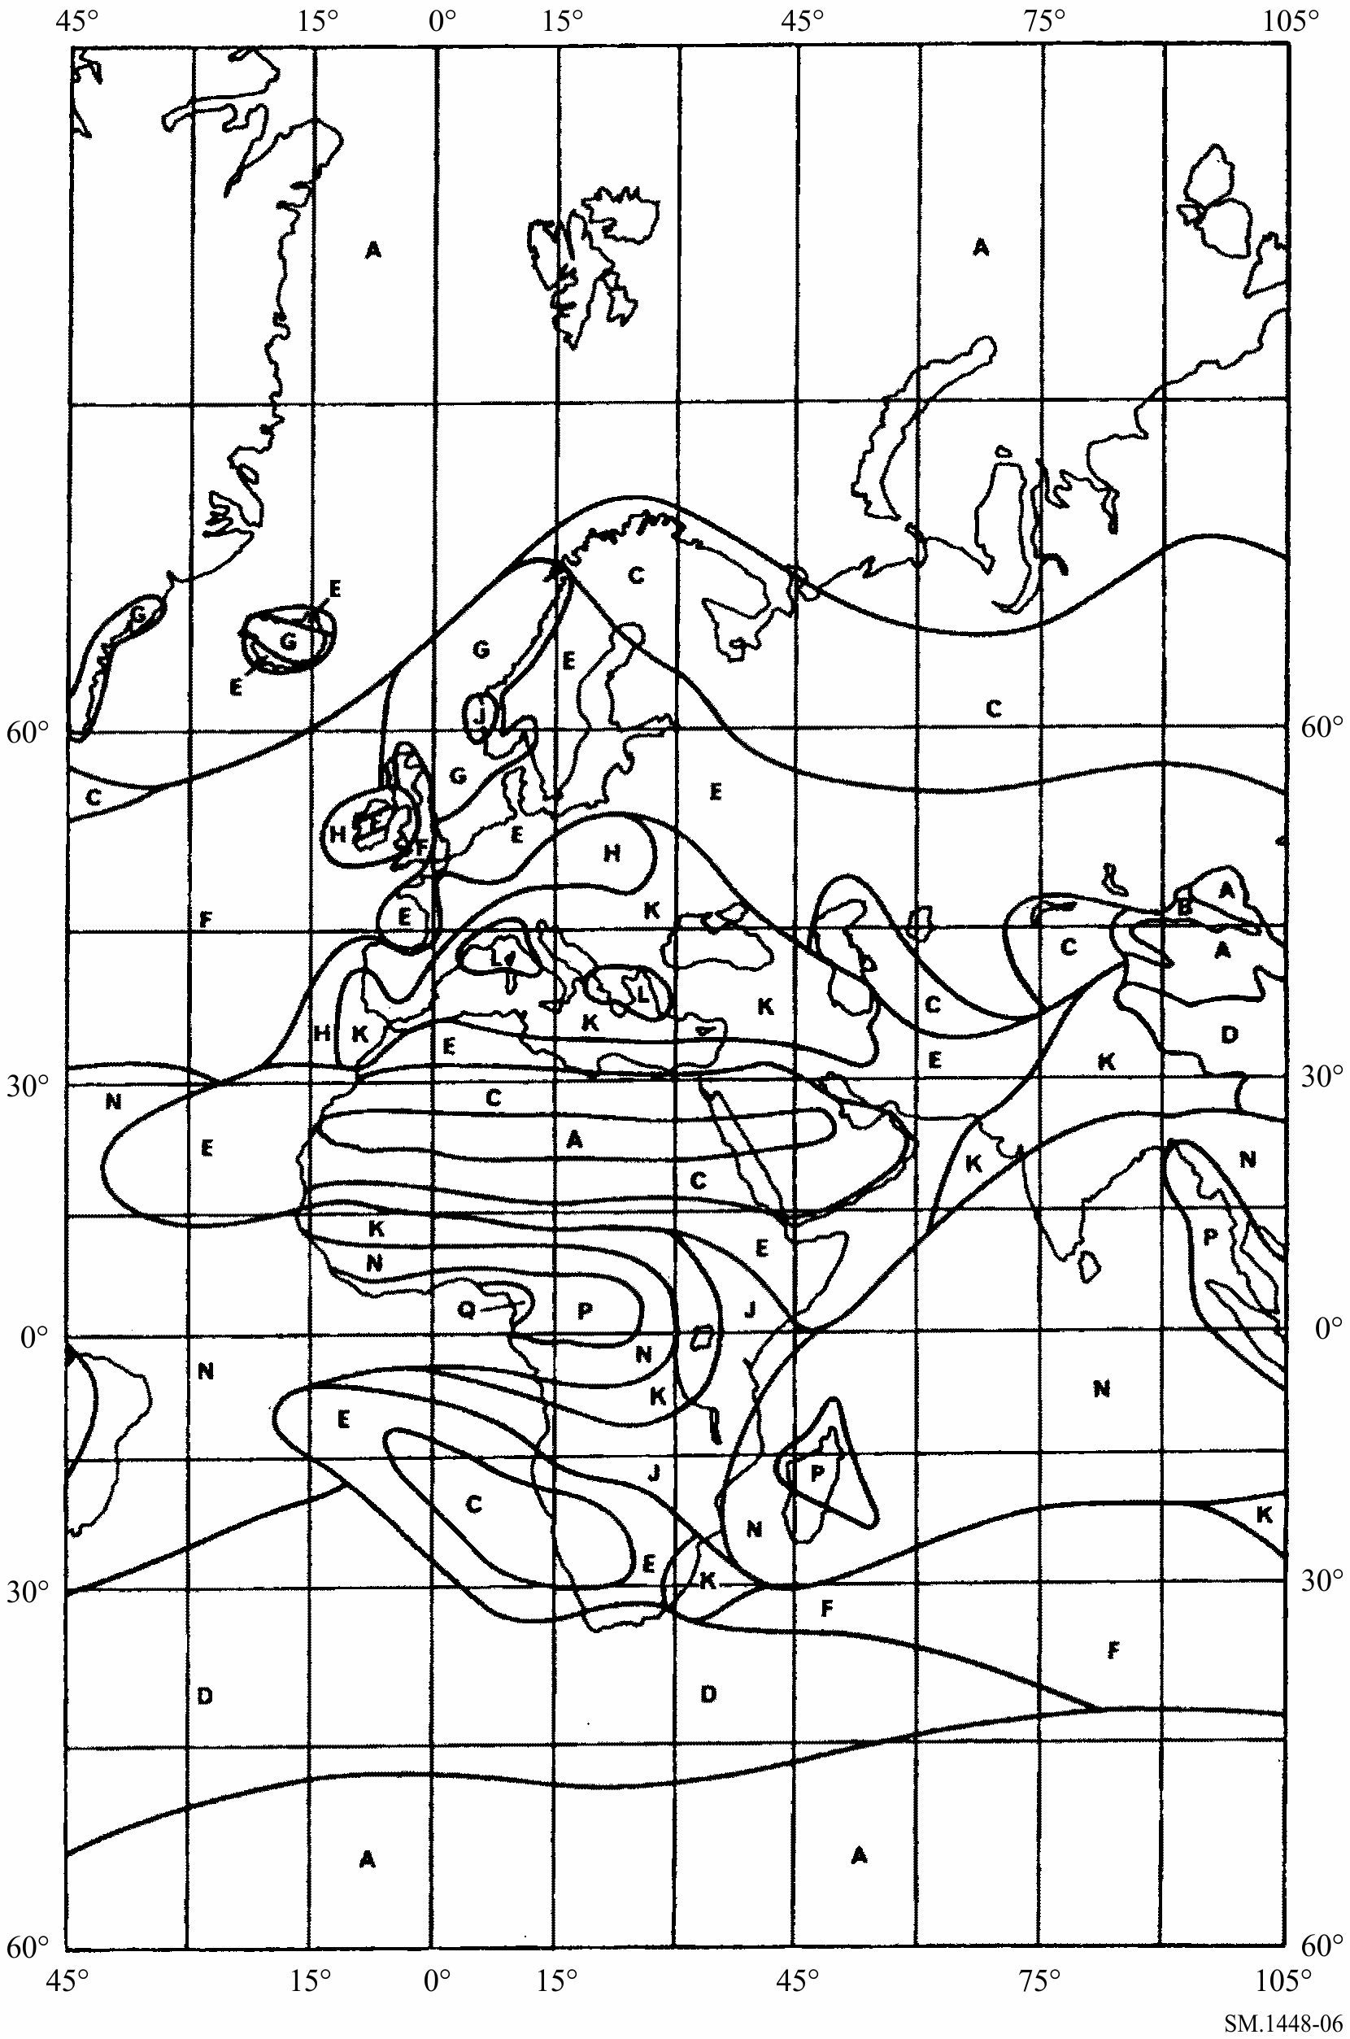
Figure 7
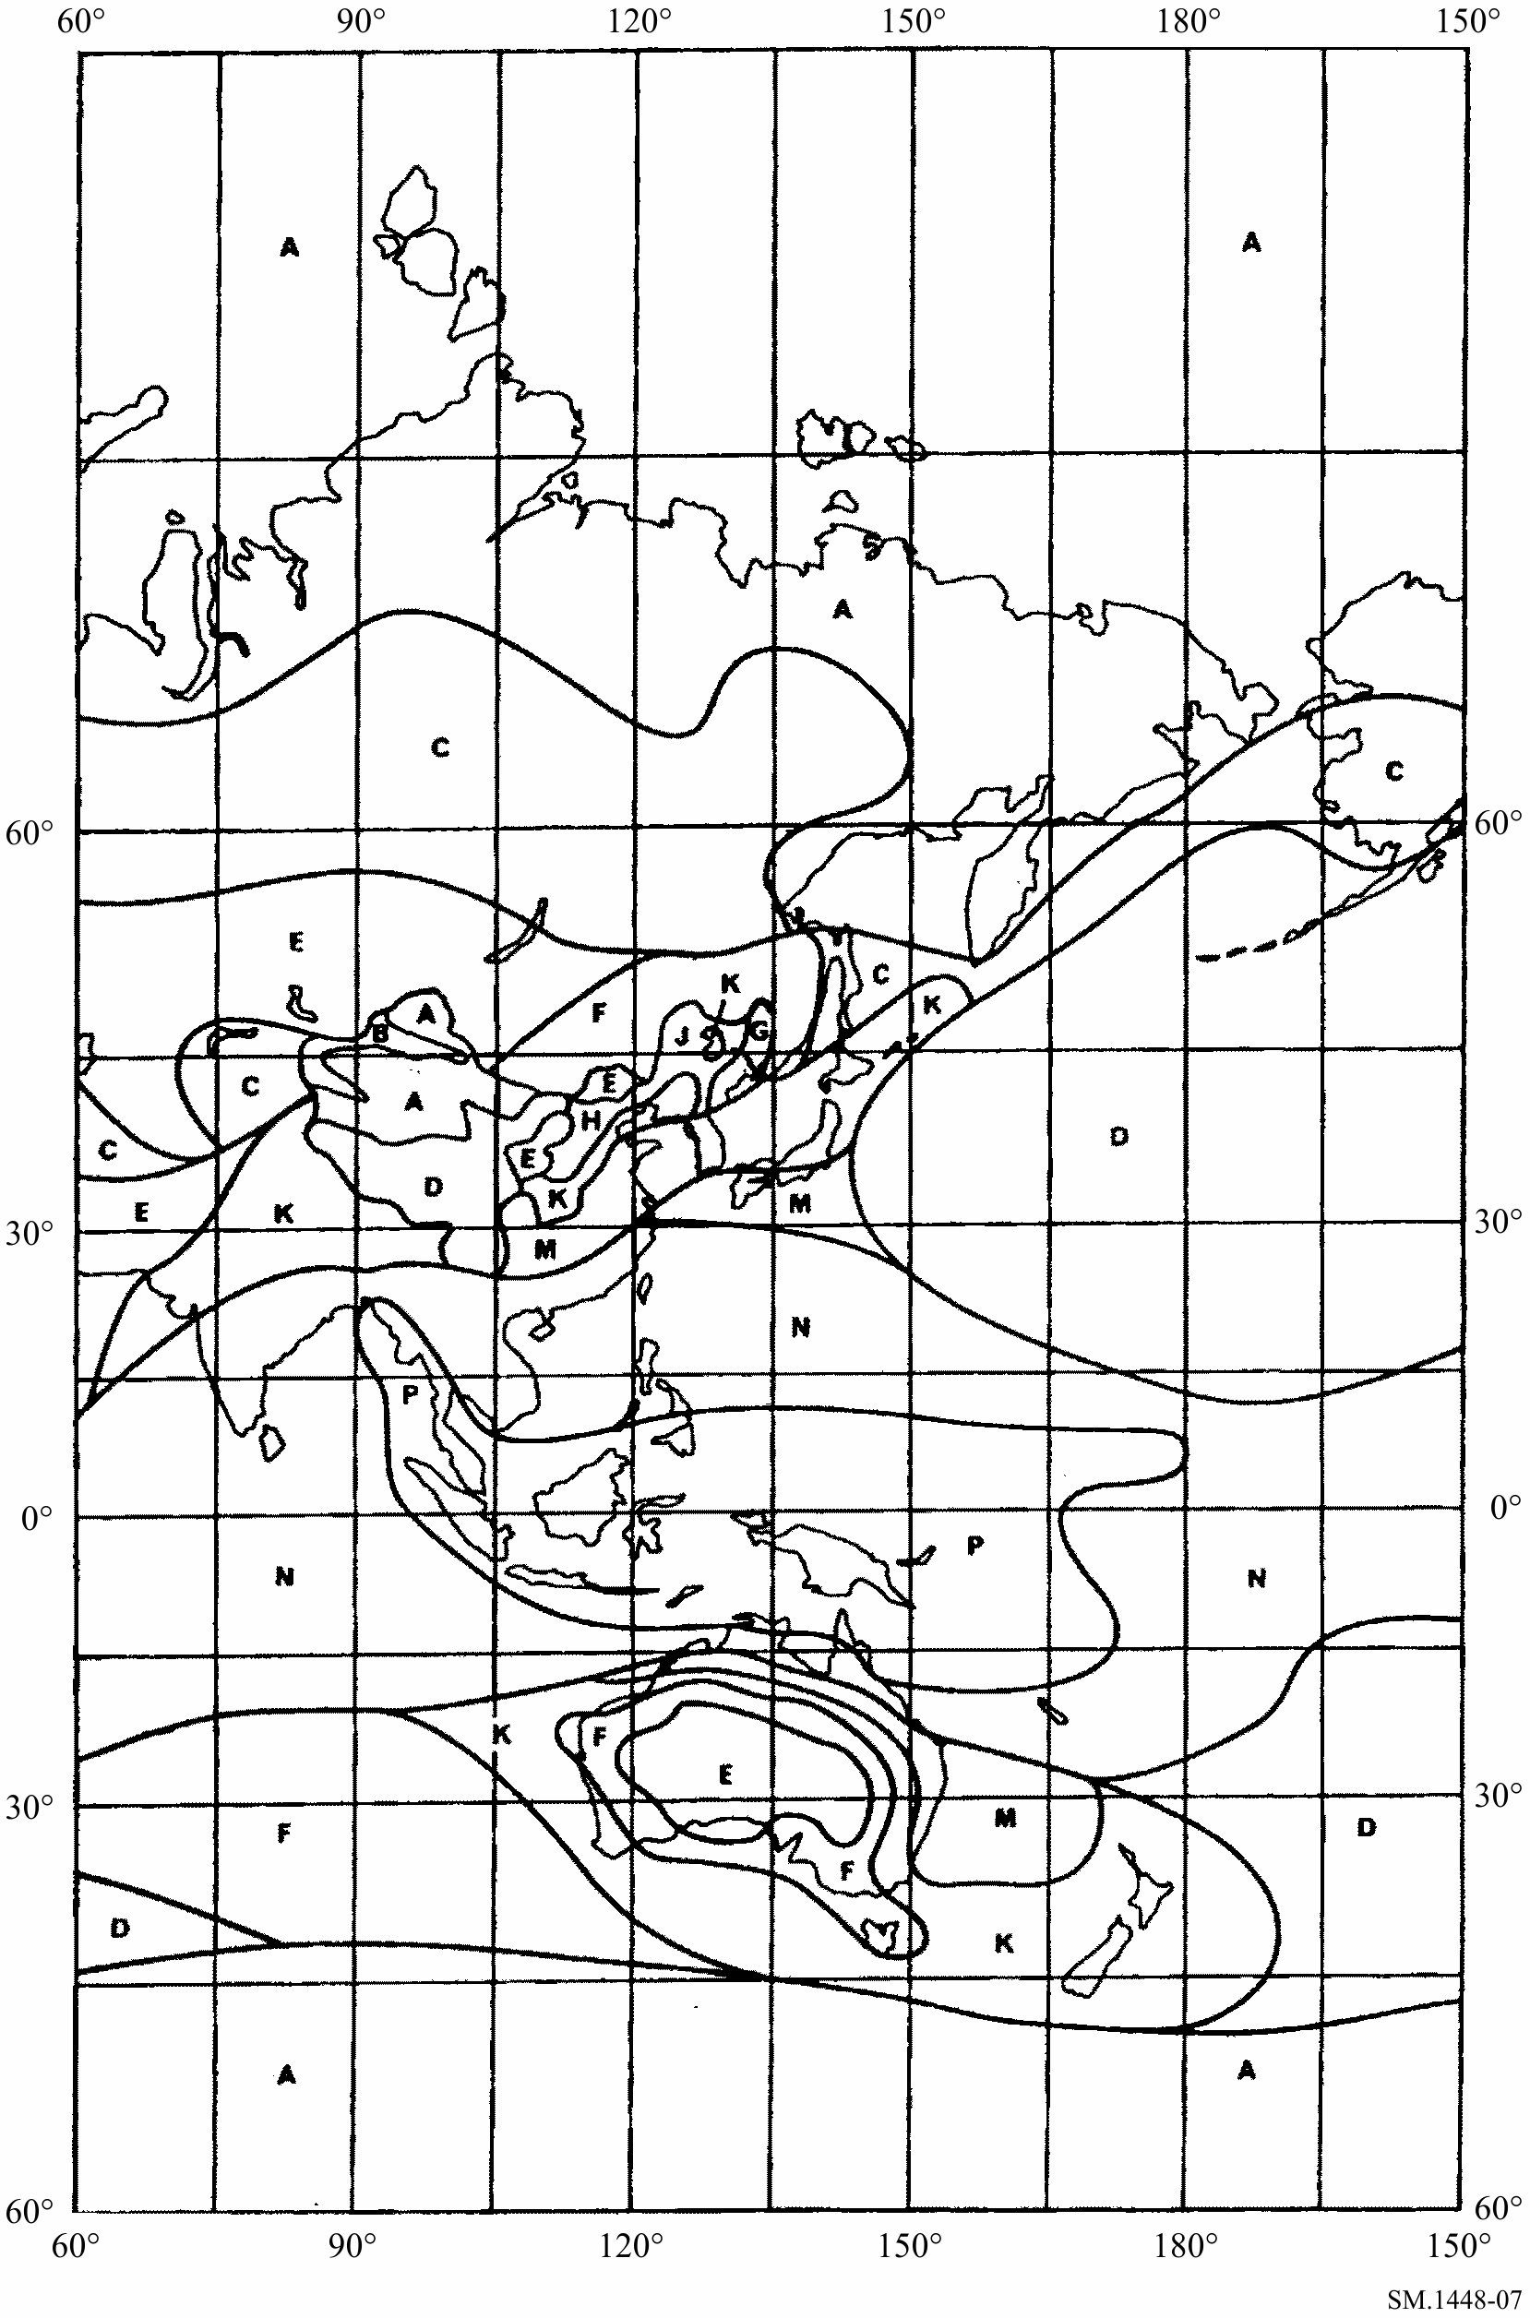
Figure 8
Consolidated cumulative distributions of rainfall rate for
the rain climatic zones shown in Figs 5, 6 and 7
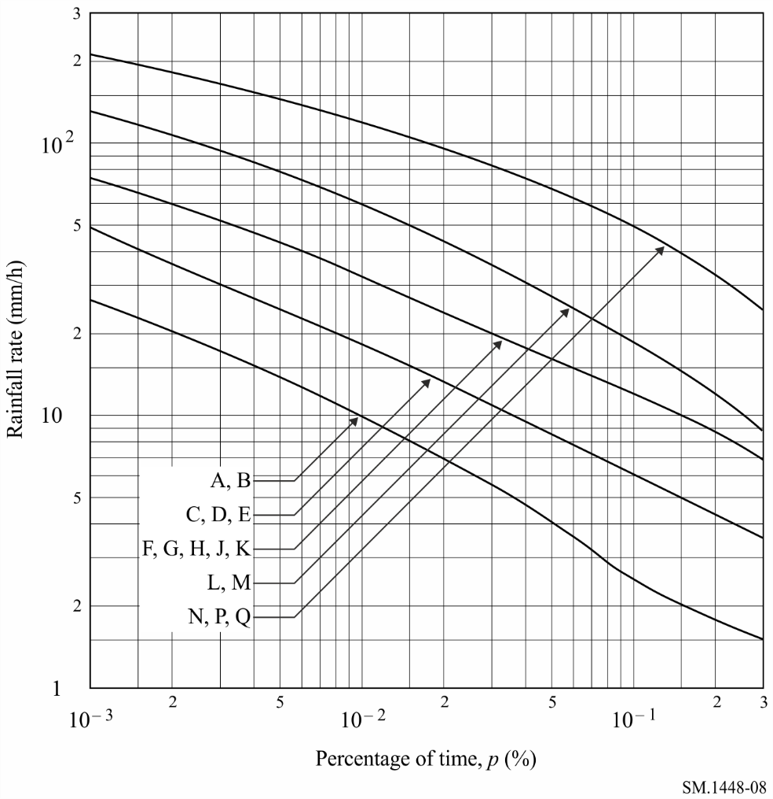

Rain climatic Zones A, B
mm/h (64)

Rain climatic Zones C, D, E
mm/h (65)

Rain climatic Zones F, G, H, J, K
mm/h (66)

Rain climatic Zones L, M
mm/h (67)

Rain climatic Zones N, P, Q
mm/h (68)
TABLE 4
Values of R and pc for the different rain climatic zones
Rain climatic zone | R (0.3%)  (mm/h) | pc  (%)
A, B | 1.5 | 2
C, D, E | 3.5 | 3
F, G, H, J, K | 7.0 | 5
L, M | 9.0 | 7.5
N, P, Q | 25.0 | 10
where:
pc (%): reference time percentage above which the rainfall rate R(p) can be assumed to be zero.
(69)
Determine the specific attenuation (dB/km) due to rain using values of k and α from Table 5 in equation (71). Values of k and α at frequencies other than those in Table 5 can be obtained by interpolation using a logarithmic scale for frequency, a logarithmic scale for k and a linear scale for α.
TABLE 5
Values of k and α for vertical polarization as a function of the frequency
Frequency  (GHz) | k | α
1 | 0.0000352 | 0.880
4 | 0.000591 | 1.075
6 | 0.00155 | 1.265
8 | 0.00395 | 1.31
10 | 0.00887 | 1.264
12 | 0.0168 | 1.20
14 | 0.029 | 1.15
18 | 0.055 | 1.09
20 | 0.0691 | 1.065
22.4 | 0.090 | 1.05
25 | 0.113 | 1.03
28 | 0.150 | 1.01
30 | 0.167 | 1.00
35 | 0.233 | 0.963
40 | 0.310 | 0.929
40.5 | 0.318 | 0.926

Let:
R = R(p ) (70)
Then the specific attenuation (dB/km) due to rain is given by:
(71)
Calculate the effective diameter of the rain cell:
(72)
Then, calculate the effective scatter transfer function:
(73)
Calculate the additional attenuation outside the common volume:
(74)
Determine the rain height above ground, h_{R} (km):
For North America and Europe west of 60° E longitude:
hR = 3.2 – 0.075 (ζ – 35) for 35 ≤ ζ ≤ 70 (75)
where:
ζ: latitude of the coordinating earth station.
For all other areas of the world:
Determine the specific attenuation due to water vapour absorption (a water vapour density of 7.5 g/m3 is used):
(77)

3.1 Iterative calculations
Evaluate equations (78) to (83) inclusive for increasing values of r_{i}, where r_{i} is the current distance considered (km) between the region of maximum scattering and the possible location of a terrestrial station and i = 0, 1, 2,... Continue this process until either of the conditions given in equations (63a) and (63b) is true. Then the rain-scatter required distance d_{r} is the current value of r_{i}.
r_{i} = d_{min} + i · s (78)
Determine the loss above the rain height, L_{ar} (dB), applicable to scatter coupling:
Calculate the additional attenuation for the departure from Rayleigh scattering:
Calculate the effective path length for oxygen absorption:
Calculate the effective path length for water vapour absorption:
Determine the propagation mode (2) path loss, L_{r} (dB):
(83)
where:
γo: as given in equation (34)
Gx: terrestrial network antenna gain in Tables 14 or 15.

4 Construction of the propagation mode (2) contour
In order to determine the centre of the circular propagation mode (2) contour, it is necessary to calculate the horizontal distance to this point from the earth station, along the azimuth of the earth station antenna main beam axis. The distance, Δd (km), to the centre of the propagation mode (2) contour is given by:
(84)
where:
εs: earth station antenna main beam axis elevation angle
Δd: shall be limited to the distance (d_{r} – 50) km.
The propagation mode (2) required distance, d_{r}, must lie within the range between the minimum coordination distance, d_{min}, and the propagation mode (2) maximum calculation distance, d_{max2}.
Draw the propagation mode (2) contour as a circle of radius d_{r} (km) around the centre determined above. The propagation mode (2) contour is the locus of points on this circle. However, if any part of the propagation mode (2) contour falls within the contour defined by the minimum coordination distance, this arc of the propagation mode (2) contour is taken to be identical to the contour based on the minimum coordination distance and the propagation mode (2) contour is then no longer circular.

Attachment 3
to Annex 1
Antenna gain towards the horizon for an earth station
operating with a geostationary space station

1 General
The gain component of the earth station antenna in the direction of the physical horizon around an earth station is a function of the angular separation between the antenna main beam axis and the horizon in the direction under consideration. When the earth station is used to transmit to a space station along the geostationary orbit, or to one or more space stations in a slightly inclined orbit, all possible pointing directions of the antenna main beam axis need to be considered. For earth station coordination, knowledge of φ(α), the minimum possible value of the angular separation that will occur during the operation of the space station, is required for each azimuth.
When a geostationary space station maintains its location close to its nominal orbital position, the earth station’s main beam axis elevation angle, ε_{s}, and the azimuth angle, α_{s}, to the space station from the earth station’s latitude, ζ, are uniquely related. Fig. 9 shows the possible location arcs of positions of a space station on the geostationary orbit in a rectangular azimuth/elevation plot. It shows arcs corresponding to a set of earth station latitudes and the intersecting arcs correspond to points on the orbit with a fixed difference in longitude East or West of the earth station. Fig. 9 also shows a portion of the horizon profile ε_{h}(α). The off-axis angle φ(α) between the horizon profile at an azimuth of 190° and a space station located 28° W of an earth station at 43° N latitude is indicated by the great-circle arc shown dashed on Fig. 9.
figure 9
Position arcs of geostationary satellites with horizon and the arc from the horizon
at azimuth 190° to a satellite 28° W of an earth station at 43° N latitude
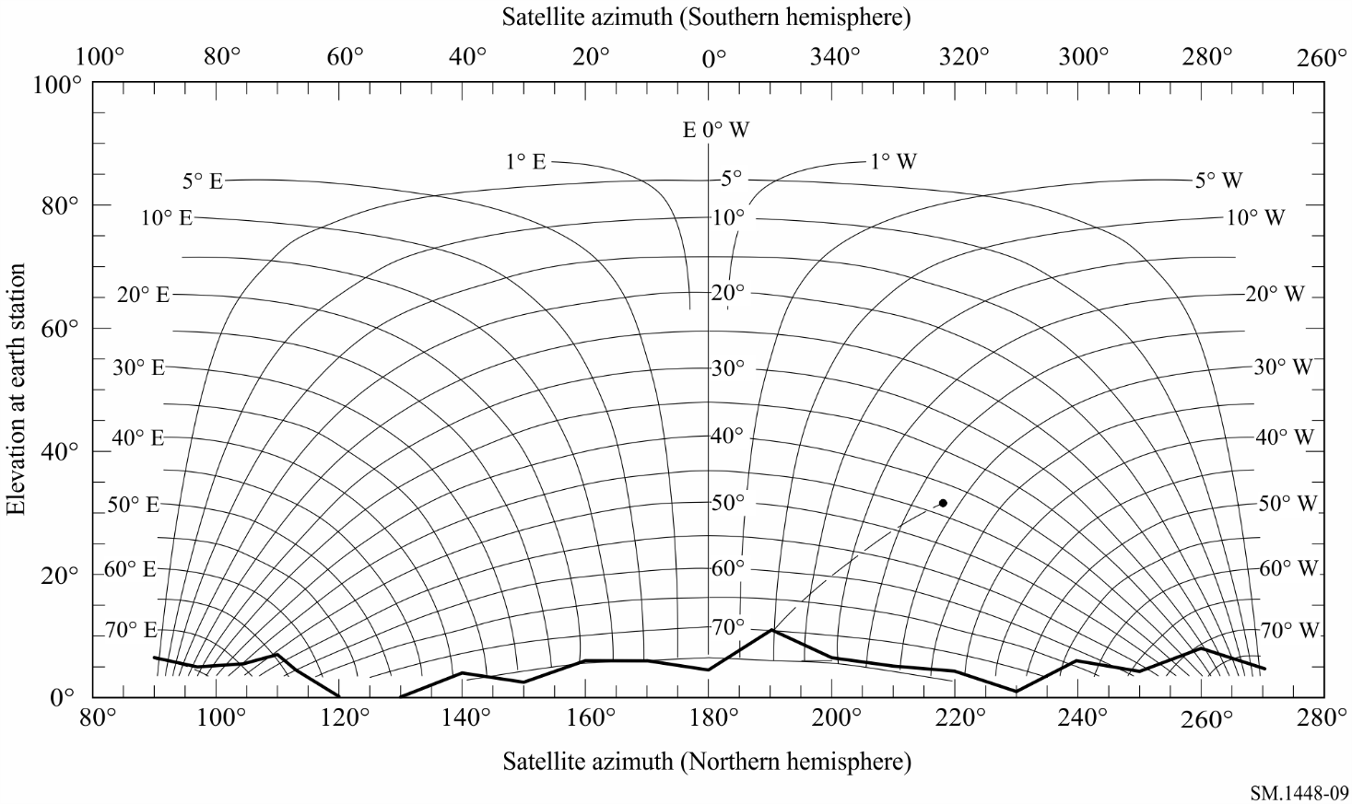
When the north/south station-keeping of a geostationary satellite is relaxed, the orbit of the satellite becomes inclined, with an inclination that increases gradually with time. As viewed from the Earth, the position of the satellite traces a figure eight during each 24-hour period. Figure 10 shows the variations in the trajectories of a set of satellites, each with 10° inclination, spaced by 3° along the geostationary orbit from 28° W to 44° E, with respect to an earth station at 43° N latitude. For purposes of coordination area determination, only a bounding envelope of these trajectories needs to be considered. A simple bounding envelope based on the maximum excursions in latitude and longitude of the sub-satellite points of satellites at all possible positions along the arc, as shown in Fig. 10, may be used. Figure 10 also shows, with a dashed curve, the great-circle arc corresponding to the minimum off-axis angle φ(α) between this envelope and the horizon profile at an azimuth of 110°.
figure 10
Position arcs of geostationary satellites with horizon and the arc from the horizon at azimuth 110°
to satellites with 10° inclination on the geostationary orbital arc
from 28° W to 44° E of an earth station at 43° N latitude
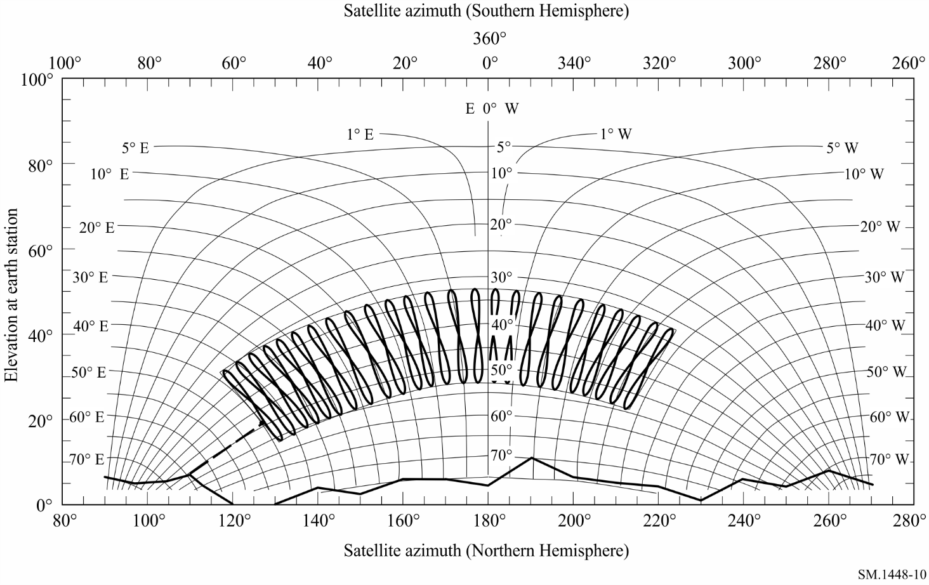
For a transmitting earth station operating in a frequency band that is also allocated for bidirectional use by receiving earth stations operating with geostationary space stations, refer to § 2.1 of Attachment 6 to Annex 1.

2 Determination of the angular separation φ(α)
For the determination of the off-axis angle φ(α), two cases are distinguished. These depend on whether a single space station or a portion of the geostationary orbit is to be considered, and whether or not the earth station will operate to space stations in slightly inclined orbits. The following equations may be used in all of these cases:
(85)
(86)
(87)
(88)
(89)
(90)
where:
ζ: latitude of the earth station (positive for north; negative for south)
δ: difference in longitude between the earth station and a space station
i: latitude of a sub-satellite point (positive for north; negative for south)
ψs(i, δ): great-circle arc between the earth station and a sub-satellite point
αs(i, δ): space station azimuth as seen from the earth station
εs(i, δ): space station elevation angle as seen from the earth station
ϕ(α, i, δ): angle between the main beam and the horizon direction corresponding to the azimuth, α, under consideration when the main beam is steered towards a space station with a sub-satellite point at latitude, i, and longitude difference, δ
α: azimuth of the direction under consideration
εh: elevation angle of the horizon at the azimuth under consideration, α
φ(α): angle to be used for horizon gain calculation at the azimuth under consideration, α
K: orbit radius/Earth radius, which for the geostationary orbit is assumed to be 6.62.
All arcs mentioned above are in degrees.
Case 1: Single space station, no orbital inclination
For a space station operating with no orbital inclination at an orbital position with difference in longitude δ₀, equations (85) to (90) may be applied directly using i = 0 to determine φ(α) for each azimuth α. Thus:
ϕ(α) = ϕ(α, 0, δ0) (91)
where:
δ₀: difference in longitude between the earth station and the space station.
Case 2: Space stations on a portion of the geostationary orbital arc, no orbital inclination
For space stations operating with no orbital inclination on a portion of the geostationary orbital arc, equations (85) to (90) may be applied directly, using i = 0 to develop the minimum value of off-axis angle. For each azimuth α, the angle ϕ(α) is the minimum value of ϕ(α, 0, δ) for any position along the arc. Thus:
ϕ(α) = min ϕ(α, 0, δ) (92) δw ≤ δ ≤ δe
where:
δe: difference in longitude at the eastern extreme of the operational portion of the orbital arc
δw: difference in longitude at the western extreme of the operational portion of the orbital arc.
Case 3: Space stations on a portion of the geostationary orbital arc, with orbital inclination
For space stations operating in slightly inclined orbits on a portion of the geostationary arc with nominal longitude difference between δe, and δw, the maximum orbital inclination over their lifetimes, i_{s}, must be considered. Equations (85) to (90) may be applied to develop the minimum off-axis angle to each of four arcs in azimuth/elevation that bound the trajectory of the space station in angle and elevation. The bounding arcs correspond to the maximum and minimum latitudes of the sub-satellite points and the extremes of the difference in longitude between the earth and space stations when the space station is operating at its maximum inclination. Thus:
ϕ(α) = min ϕn(α) (93) n = 1 to 4
with:
ϕ1(α) = min ϕ(α, –is, δ) (94) δw – δs ≤ δ ≤ δe + δs
ϕ2(α) = min ϕ(α, is, δ) (95) δw – δs ≤ δ ≤ δe + δs
ϕ3(α) = min ϕ(α, i, δw – δs) (96) –is ≤ i ≤ is
ϕ4(α) = min ϕ(α, i, δe + δs) (97) –is ≤ i ≤ is
δs = (is / 15)2 (98)
where:
is: maximum operational inclination angle of the satellite orbit
δs: maximum longitude change from nominal value of the sub-satellite point of a satellite with orbital inclination is.
Case 4: Single space station, with inclined orbits
For a single space station, operating at a nominal longitude difference of δ0, with a maximum orbital inclination of is over its lifetime, the determination of ϕ(α) is the same as for Case 3, except that here δe = δw = δ0.
The determination of the minimum off-axis angles in equations (93) to (97) may be made by taking increments along a bounding contour. The step size in inclination i or longitude δ should be between 0.5° and 1.0° and the end points of the respective ranges should be included in the calculation.
The horizon profile ε_{h}(α) used in the determination of φ(α) is specified at increments in azimuth α that do not exceed 5°.

3 Determination of antenna gain
The relationship φ(α) is used to derive a function for the horizon antenna gain (dBi), G(φ) as a function of the azimuth α, by using the actual earth station antenna pattern, or a formula giving a good approximation. For example, in cases where the ratio between the antenna diameter and the wavelength is equal to or greater than 35, the following equation is used:
(99)
degrees
Where a better representation of the actual antenna pattern is available, it may be used.
In cases where D/λ is not given, it may be estimated from the expression:
where:
G_{amax}: main beam axis antenna gain (dBi)
D: antenna diameter (m)
λ: wavelength (m)
G₁: gain of the first side lobe (dBi).

Attachment 4
to Annex 1
Antenna gain toward the horizon for an earth station operating with non-geostationary space stations
This Attachment presents methods which may be used to determine the antenna gain towards the horizon for an earth station operating to non-geostationary satellites using the TIG method described in § 2.2.1 of Annex 1 and the statistical method described in § 2.2.2 of Annex 1 and provides an example of the application of the TIG method.

1 Determination of the horizon antenna gain using the TIG method
In its simplest implementation, the TIG method depends on the minimum elevation angle of the beam axis of the earth station antenna (ε_{sys}), which is a system parameter that has the same value on all azimuths from the earth station. If the horizon elevation angle at an azimuth under consideration is ε_{h} (degrees), the minimum separation angle from the horizon at this azimuth to any possible pointing angle for the main beam axis of the antenna (φ_{min}) is equal to the difference between these two angles (ε_{sys} − ε_{h}), but it is not less than zero degrees. The maximum separation angle from the horizon at this azimuth to any possible pointing angle for the main beam axis of the antenna (φ_{max}) is equal to the difference between the sum of these two angles and 180° (180 − ε_{sys} − ε_{h}). The maximum and minimum values of horizon gain for the azimuth under consideration are obtained from the gain pattern of the earth station antenna at these off-axis angles. Where no pattern is available the pattern of § 3 of Attachment 3 to Annex 1 may be used.
Additional constraints may be included in the determination of the maximum and minimum values of horizon antenna gain where an earth station operates with a constellation of non-geostationary satellites that are not in near-polar orbit. In this case, depending on the latitude of the earth station, there may be portions of the hemisphere above the horizontal plane at the earth station in which no satellite will appear. To include these visibility limitations within this method, it is first necessary to determine, for a closely spaced set of azimuth angles around the earth station, the minimum elevation angle at which a satellite may be visible. This minimum satellite visibility elevation angle (εν) may be determined from consideration of the visibility of the edge of the shell formed by all possible orbits having the orbital inclination and altitude of the satellites in the constellation.
The lowest elevation angle towards which the main-beam axis of the earth station antenna will point on any azimuth is the minimum composite elevation angle (ε_{c}), which is equal to the greater of the minimum satellite visibility elevation angle (ε_{ν}) and the minimum elevation angle of the earth station (ε_{sys}). After the minimum composite elevation angle has been determined for all azimuths by the procedure of § 1.1 of this Attachment, the resulting profile of the minimum composite elevation angles can be used, in the procedure of § 1.2 of this Attachment, to determine the maximum and minimum values of horizon gain at any azimuth.

1.1 Determination of satellite visibility limits
The visibility limits of a constellation of satellites can be determined from the inclination angle of the most inclined satellite and the altitude of the lowest satellite in the constellation. For this determination, six cases may be distinguished, but not all of these may be applicable for a given constellation and a given earth station latitude. The azimuth and the corresponding lower limit on the elevation angle are developed by a parametric method using a set of points on the edge of the orbital shell of the constellation. The approach is to develop this relationship for azimuths to the east of a station in the northern hemisphere. Elevation angles for azimuths to the west of the station and for all azimuths for stations in the Southern hemisphere are obtained by symmetry. The following equations, which are applicable to circular orbits only, may be used for the complete determination of the horizon antenna gain in all practical cases:
(100)
(101)
(102)
with:
(103)
where:
i_{s}: orbital inclination of the satellites in the constellation assumed to be positive and between 0° and 90°
ζ_{e}: modulus of the latitude of the earth station
δ: difference in longitude from the earth station to a point on the edge of the orbital shell of the constellation
ψ(δ): great-circle arc between the earth station and a point on the surface of the Earth directly below the point on the edge of the orbital shell of the constellation
α(δ): azimuth from the earth station to a point on the edge of the orbital shell
α₀(δ): principal azimuth, an azimuth between 0° and 180°, from an earth station to a point on the edge of the orbital shell
εν(δ): elevation angle from the earth station to a point on the edge of the orbital shell
K₁: orbit radius/Earth radius for the lowest altitude satellite in the constellation (Earth radius = 6 378.14 km)
ψ_{m} = arccos (1/K₁).
All arcs mentioned above are in degrees.
For any latitude on the surface of the Earth, the azimuth for which the minimum elevation angle to a satellite can be greater than zero, and the corresponding elevation angles, may be determined by implementing the calculations under the following case(s). No more than two of these cases will be applicable for any latitude. For situations not specifically addressed in the following cases, no satellite is visible at elevation angles at or below 90° on any azimuth.
Case 1: For: ζ_{e} ≤ i_{s} – ψ_{m}
For this case, a satellite may be visible to the horizon for all azimuths about the earth station (ε_{ν} = 0).
Case 2: For: i_{s} – ψ_{m} < ζ_{e} ≤ arcsin (sin i_{s} cos ψ_{m})
For this case, the azimuth angles and elevation are developed parametrically by choosing a set of values of δ, uniformly spaced on the interval 0 to δ₁, and applying equations (100) to (103). For this purpose the spacing between values is not to exceed 1.0°, and the end points are to be included.
At any principal azimuth (α₀(δ)) that is not included in the set, the minimum elevation angle is zero (ε_{ν} = 0), except for azimuths where Case 6 additionally applies.
Case 3: For: arcsin (sin is cos ψm) < ζ_{e} < is and ζe < 180° − ψ_{m} − i_{s}
For this case, the azimuth angles and elevation are developed parametrically by choosing a set of values of δ, uniformly spaced on the interval 0 to δ₂, and applying equations (100) to (103). For this purpose the spacing between values is not to exceed 1.0°, and the end points are to be included.
At any principal azimuth (α₀(δ)) that is not included in the set, the minimum elevation angle is zero (ε_{ν} = 0), except for azimuths where Case 6 additionally applies.
Case 4: For: i_{s} ≤ ζ_{e} < i_{s} + ψ_{m} and ζ_{e} < 180° – i_{s} – ψ_{m}
For this case, the minimum elevation angle is given explicitly in terms of the principal azimuth angle α₀, as follows:
where:
Note that a minimum elevation angle of 90° in this formulation indicates that no satellite is visible at elevation angles at or below 90° on these azimuths. Furthermore, within the range of principal azimuths where the minimum elevation angle is zero, Case 6 may additionally apply.
Case 5: For 180° – i_{s} – ψ_{m} ≤ ζ_{e} ≤ 90°
For this case, a satellite may be visible to the horizon for all azimuths about the earth station (εν = 0).
Case 6: For ζ_{e} < ψ_{m} – i_{s}
This case may occur additionally with Case 2, Case 3 or Case 4 and a satellite may be visible only above a minimum elevation angle for other principal azimuths.
For this case, the other principal azimuths and the corresponding elevation angles are developed parametrically by choosing a set of values of δ, uniformly spaced on the interval 0 to δ₃, and applying equations (100) to (103) with i_{s} replaced by –i_{s}. For this purpose the spacing between values is not to exceed 1.0° and the end points are to be included.

1.2 Determination of minimum and maximum horizon gain from the minimum visible elevation angle profile
The horizon gain of the earth station antenna is determined from the profile of values of the minimum composite elevation angle (ε_{c}). At any azimuth, the minimum composite elevation angle is the greater of the minimum satellite visibility elevation angle at that azimuth (ε_{ν}) and the minimum elevation angle for the earth station (ε_{sys}). The following procedure may be used to determine the maximum and minimum values of horizon antenna gain for each azimuth under consideration.
The following equation may be used to determine the angular separation between the horizon profile, at an azimuth angle α and horizon elevation angle ε_{h}, and a point on the profile of the minimum composite elevation angle, where the minimum composite elevation angle is ε_{c} at an azimuth angle of α_{c}:
ϕ(α, αc) = arccos [sin εh (α) sin (εc (αc)) + cos εh (α) cos (εc (αc)) cos (α – αc)] (104)
where:
α: azimuth of the direction under consideration
ε_{h} (α): elevation angle of the horizon at the azimuth under consideration, α
ε_{c} (α_{c}): minimum composite elevation angle at the azimuth, α_{c}
α_{c}: azimuth corresponding to ε_{c}.
The minimum value of the separation angle φ_{min}, for the azimuth under consideration, is determined by finding the minimum value of φ(α, α_{c}) for any azimuth α_{c}, and the maximum value, φ_{max}, is determined by finding the maximum value of φ(α, α_{c}) for any azimuth α_{c}. The azimuth angles (α) are usually taken in increments of 5°; however, to accurately determine the minimum separation angle, the values of the minimum composite elevation angle, ε_{c}, need to be determined for a spacing of 1° or less in the azimuth α_{c}. Where the procedures in § 1.1 of this Attachment do not provide a profile of minimum composite elevation angle with a close enough spacing in azimuth angles, linear interpolation may be used to develop the necessary intermediate values. The maximum and minimum horizon antenna gains, G_{max} and G_{min}, to be used in the equations of § 2.2.1 of Annex 1 for the azimuth under consideration are obtained by applying the off-axis angles, φ_{min} and φ_{max}, respectively, in the earth station antenna pattern. If the earth station antenna pattern is not known then the antenna pattern in § 3 of Attachment 3 to Annex 1 is used. In many cases, φ_{max} will be large enough on all azimuths so that G_{min} will be equal to the minimum gain of the antenna pattern at all azimuths.

1.3 Example calculation of the horizon antenna gain using the TIG method
This method is illustrated for a receiving earth station operating with a non-geostationary space station with the parameters given in Table 6. The value of the minimum composite elevation angle of the earth station, εc, is taken as the greater of the minimum elevation angle for the system εsys; and the minimum satellite visibility elevation angle determined from the constellation for an earth station at a latitude of 40°. Thus, the minimum composite elevation angle for this example varies from 6° to 35°.
TABLE 6
Simulation parameters used in example
Constellation altitude | 1 469 km
Shape of orbit | Circular
Orbit inclination | 53°
Number of planes | 20
Number of satellite per plane | 4
Phase-shift between the first satellites of adjacent planes | 67.5°
Zone type | A2 (Inland)
Percentage of time: p% | 0.0015%
Latitude of the earth station | 40° N
Antenna pattern | Max (29 – 25 log(ϕ) or –10) dBi
Minimum elevation angle of the earth station | 6°
TABLE 6 (end)
Frequency | 11.2 GHz
Horizon elevation angle | 0°
Maximum Interference power limit (Pr(p)) | –143 dBW
Fixed service transmit power | –3 dBW
Fixed service antenna gain | 45 dBi

Figure 11 shows the minimum composite elevation angle and the minimum separation angle, ϕmin, for the case of a 0° horizon elevation angle as a function of azimuth. Figure 12 shows the maximum horizon antenna gain as a function of azimuth.
In this example, the minimum gain of the coordinating receiving earth station towards the horizon has a constant value of −10 dBi at each azimuth. Since the maximum gain is always lower than 9.6 dBi, Ge equals Gmax in each azimuth (Gmax - Gmin < 20 dB).
Figure 13 shows the coordination contour for the example parameters and TIG horizon gain in Fig. 12. The effect of the use of a minimum composite elevation angle is to reduce the required distance for azimuths between 310° and 50°.
figure 11
Minimum composite elevation angle, εc , and minimum separation angle, φ_{min} , as a funtion of azimuth
for an earth station located at 40° N latitude, operating to a non-GSO fixed-satellite service system
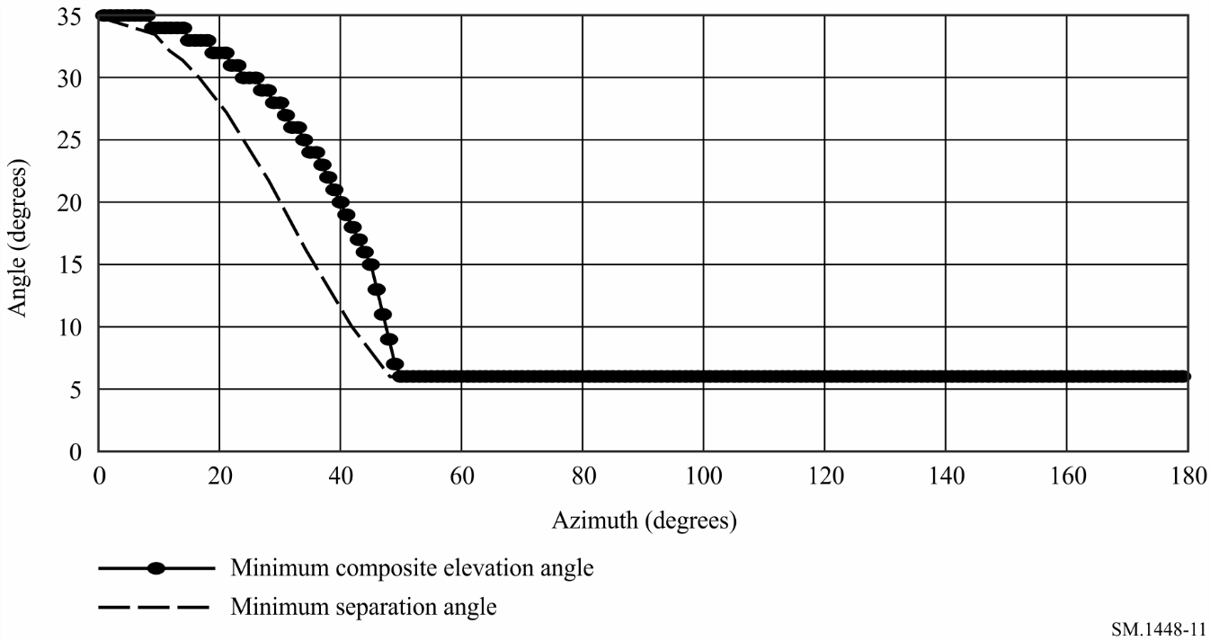
figure 12
Horizon antenna gain, Ge , as a funtion of azimuth
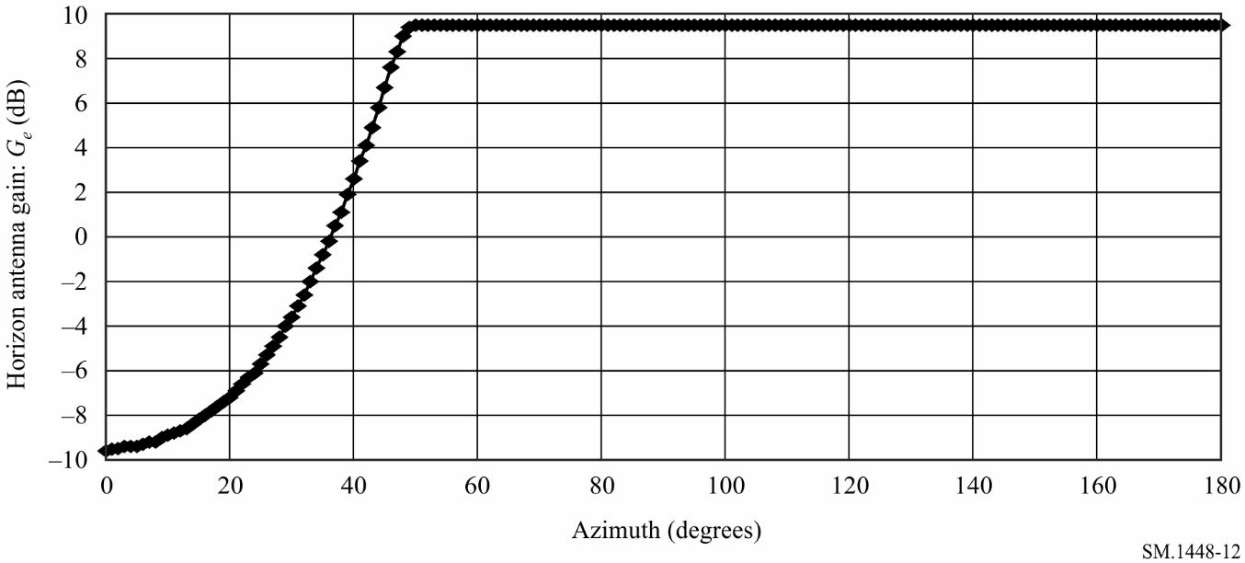
figure 13
Propagation mode (1) contour for the given example
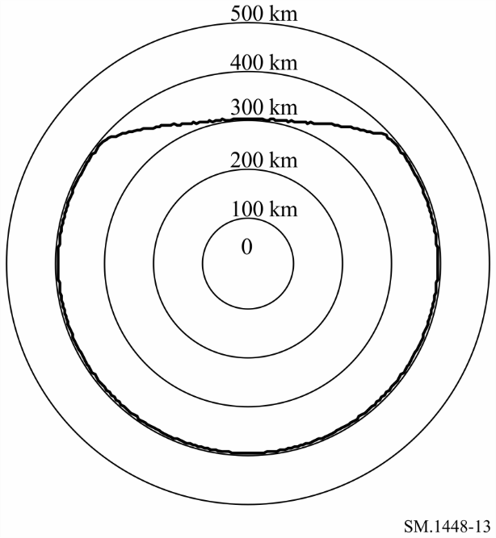

2 Determination of the horizon antenna gain distribution for the TVG method
The TVG method for the determination of an earth station’s supplementary contour requires the determination of the horizon antenna gain statistics for all azimuths (in suitable increments, e.g. 5°) around the earth station. The determination of the horizon antenna gain distribution requires both earth station and orbital information including whether, or not, station keeping is used to maintain a single orbital path (repeating/non-repeating ground track system). Considering the guidelines of § 2.2 to Annex 1, the cumulative distribution of the time-varying horizon gain of a transmitting or a receiving earth station antenna operating to non-geostationary space stations is calculated as follows:
Step 1: Simulate the constellation of non-geostationary space stations over a sufficiently long period, with a time step appropriate for orbit altitude, to obtain a valid representation of the antenna gain variations. For repeating ground track constellations, simulate the orbital path for each satellite visible from the earth station over a period of the ground track. For non-repeating ground track constellations, simulate the orbit of each satellite in the constellation over a period long enough to get a stable representation of the distribution.
Step 2: At each time step, determine the azimuth and elevation angle of each satellite that is both visible at the earth station and above the minimum elevation angle at which the earth station operates. In addition to the minimum elevation angle, other criteria could be used to avoid certain geometric configurations, e.g. geostationary orbit arc avoidance (no transmission between an earth station and a non-geostationary satellite that is within ±X° from the geostationary orbit arc).
Step 3:– At each step, and for each satellite in communication with the earth station, use the actual earth station antenna pattern, or a formula giving a good approximation of it, to calculate the gain towards the horizon at each azimuth and elevation angle around the earth station.
Step 4: The horizon antenna gain varies over the range Gmin to Gmax. These values may be obtained by the methods in § 1 of this Attachment. Then choose a gain increment g (dB) and partition the gain range by a number of gain levels between Gmin and Gmax,
i.e., G = { Gmin, Gmin + g, Gmin + 2 g,..., Gmax}
These gain levels determine a set of gain intervals so that the n-th gain interval (n = 1, 2, 3, …) includes gain values equal to, or greater than, Gmin + (n – 2)g and less than Gmin + (n – 1)g.
A value of g = 0.1 to 0.5 dB is recommended.
For each azimuth on the horizon around the earth station, accumulate the time that the horizon gain takes a value in each gain interval of width g (dB).
Step 5: The probability density function (pdf) on each azimuth is determined by dividing the time in each gain interval by the total simulation time.
Step 6: Determine the cumulative distribution function (cdf) of horizon antenna gain at each azimuth by accumulating the gain density function at that azimuth. The value of the required cdf at any specific gain value is the percentage of time that the gain is less than, or equal to, that gain value.

3 Equations for use in determining the locations of orbiting satellites
The following equations may be used in the above algorithmic approach to determine the location of satellites in a constellation. These equations are applicable to both circular and elliptical orbits.
For a spherical earth, the elevation angle, εs, to a non-geostationary satellite as seen from an earth station operating to a non-geostationary space station is given by:
(105)
where:
λr = ωe – Ωr
ωe: Earth rotation rate = 4.178075 × 10–3 (degrees/s)
Ωr: rate of precession of the nodes of the non-geostationary satellite orbit, Ωr = -[(1.15325 × 10-4) / (1 - e2)2] (re / a)3.5 cos (is) (degree/s)
ψ: angle between the vectors from the Earth’s centre to the non-geostationary satellite and from the Earth’s centre to the coordinating earth station (degrees)
rs: distance from the Earth’s centre to the non-geostationary satellite at time t (km)
re: distance from the Earth’s centre to the coordinating earth station = 6 378.14 km
a: the semi-major axis of the non-geostationary satellite orbit (km)
e: the eccentricity of the non-geostationary satellite orbit (e = 0 for circular orbits and 0 < e < 1 for elliptical orbits)
λs: longitude (see Note 1) of ascending node of the non-geostationary satellite orbit at time t = 0 (degrees)
is: inclination angle of the non-geostationary satellite orbit (degrees)
ωp: argument of perigee of the non-geostationary satellite orbit at time t (degrees)
ν: true anomaly of the non-geostationary satellite in its orbit at time t (degrees)
λe, ζ: longitude and latitude of the coordinating earth station (degrees)
t: current time (s).
NOTE 1 – If the orbit is highly elliptical then there may be a need to relate this parameter to the right ascension of the ascending node.
The satellite vector from the Earth’s centre as a function of time is given by:
(106)
The sub-satellite longitude (λt) and latitude (ζ t) as functions of time are (see Note 2):
(107)
NOTE 2 – The arctangent in equations (107) and (108) must be calculated using a four-quadrant arctangent function.
The azimuth (αs) of the non-geostationary satellite as seen from the coordinating earth station is:
(108)
where:
(109)
The angle ϕ(αs, εs) expressed as a function of the azimuth and elevation angles (αs and εs) of the coordinating earth station’s main beam axis and the horizon azimuth and horizon elevation angles (α, εh (α)) in the direction under consideration, is given by:
(110)
For elliptical orbits, ν, rs and the argument of perigee ωp are not constant with time as in circular orbits and the true anomaly of a satellite in its elliptical orbit at time t is given by:
degrees (111)
where ξt (rad) is the eccentric anomaly which is obtained by solving the following equation:
ηt = ξ t – e sin(ξ t) rad (112)
If the initial mean anomaly η0 is known at an initial time t0, then the mean anomaly ηt at some later time t is given by:
ηt = η0 + ηr (t – t0) rad (113)
rad (114)
rad (115)
where:
ηr: mean angular rotation rate, ηr = μ0.5/a1.5 (rad/s)
μ: Earth gravitational constant = 398 600.5 (km3/s2)
ν0: true anomaly as specified at time t0 (degrees).
Note that the suitable value of ξt is determined through an iterative approach.
The distance from the Earth’s centre to the non-geostationary satellite in its elliptical orbit at time t is:
km (116)
The argument of perigee, which is the angle between the ascending node and the perigee is given by:
degrees (117)
where:
ωp0 : argument of perigee at time t0 (degrees).
degrees/s (118)

Attachment 5
to Annex 1
Determination of the supplementary contour distance
using the TVG method

1 Determination of the supplementary contour distance using the TVG method
This calculation is based on a cumulative distribution of the horizon gain of the earth station antenna for each azimuth to be considered (in suitable angular increments e.g. 5°). Appropriate distributions for this purpose may be developed by the method in § 2 of Attachment 4 to Annex 1. The process for calculating the supplementary contour distance for each azimuth is described in the following procedure.
Step 1: From the complementary cumulative distribution of the horizon antenna gain, for the azimuth under consideration, determine the percentage of time, pn, that the horizon gain exceeds the level Gen, where:
(119)
with:
Gmin: minimum value of horizon gain
g: gain increment.
Step 2: For each percentage, pn, that is equal to or greater than 2p%, the percentage of time to be used in determining the propagation mode (1) path loss is pv.
for pn ≥ 2p% (120)
For each percentage of time, determine the distance, dn (km), for which the propagation mode (1) predicted path loss is equal to the propagation mode (1) minimum required loss using the propagation model in accordance with § 4 of Annex 1 and the equation:
dB (121)
The values of pv must be within the range of percentage of time of the propagation mode (1) model (see § 1.5.1 of Annex 1).
Step 3: The propagation mode (1) required distance for the azimuth under consideration is the largest of the distances, dn (km), calculated in Step 2, except when this largest distance is attained for the smallest value of pn that is equal to or greater than 2p in accordance with equation (120). In such cases, the propagation mode (1) required distance for the azimuth under consideration is the distance determined from equation (121) with Gen = Gmax and pν = 50%, where Gmax is the maximum value of horizon antenna gain.
Step 4: The propagation mode (1) supplementary contour distance for the azimuth under consideration is the required distance as determined in Step 3, except that the distance must be between the minimum coordination distance, dmin, and the maximum coordination distance, dmax1. These limits are given in § 4.2 and § 4.3 of the main body of this Attachment, respectively.

2 Example of the calculation of a supplementary contour using the TVG method
This example considers a transmitting earth station operating to a non-GSO space station and a receiving terrestrial station in the 6 875-7 055 MHz frequency band. The system parameters used to determine the propagation mode (1) supplementary contour are listed in Table 7.
TABLE 7
System parameters used in example
Orbit parameters of the non-geostationary satellites
Altitude (km) | 1 414
Number of satellites | 48
Inclination angle (degrees) | 52
Parameters for the coordinating earth station operating to non-geostationary space stations
Latitude (degrees) | 50
Longitude (degrees) | 0
Minimum operating elevation angle (degrees) | 10
Antenna pattern | Equation (99)
Transmit maximum antenna gain (dBi) | 43.5
Transmit power (dBW) | 10.5
Bandwidth (MHz) | 1.23
Parameters for the terrestrial receiving station
Modulation | Digital
p% | 0.0025
Receive antenna gain (dBi) | 47
Reference bandwidth (MHz) | 1
Threshold interference level, Pr ( p) (dBW) | –103

Table 8 shows details of the calculations for the determination of the supplementary contour distances. The distances were determined at the centre frequency of the band using the procedure in § 1 of this Attachment. A step size increment of 0.1 km and a horizon antenna gain increment of 0.1 dB were used in developing the horizon gain distributions, in accordance with § 2 of Attachment 4 to Annex 1. The largest value in column dn (km) in these Tables represents the supplementary contour distance at the specified azimuth. Figure 14 plots the supplementary contour, as determined from the supplementary contour distances, at azimuth increments of 5 degrees.
TABLE 8
Calculated distances for a transmitting earth station operating to
non-GSO space stations (azimuth = 70°)
Index of gain  level n | Horizon antenna  gain Gen  (dBi) | Complement CDF  pn (%) | pv = p/pn  (%) | Required loss  Lbn(pv)  (dB) | Distance  dn  (km)
1 | –10.0 | 100.00 | 0.0025 | 145.50 | 113.34
2 | –9.5 | 14.75 | 0.0169 | 146.00 | 101.64
3 | –9.0 | 13.77 | 0.0182 | 146.50 | 103.94
4 | –8.5 | 12.84 | 0.0195 | 147.00 | 106.24
5 | –8.0 | 11.93 | 0.0210 | 147.50 | 108.44
6 | –7.5 | 11.07 | 0.0226 | 148.00 | 110.54
7 | –7.0 | 10.24 | 0.0244 | 148.50 | 112.64
8 | –6.5 | 9.45 | 0.0265 | 149.00 | 114.64
9 | –6.0 | 8.69 | 0.0288 | 149.50 | 116.64
10 | –5.5 | 7.97 | 0.0314 | 150.00 | 118.44
11 | –5.0 | 7.28 | 0.0343 | 150.50 | 120.24
12 | –4.5 | 6.63 | 0.0377 | 151.00 | 121.94
13 | –4.0 | 6.02 | 0.0415 | 151.50 | 123.54
14 | –3.5 | 5.43 | 0.0460 | 152.00 | 125.04
15 | –3.0 | 4.87 | 0.0513 | 152.50 | 126.34
16 | –2.5 | 4.35 | 0.0575 | 153.00 | 127.54
17 | –2.0 | 3.85 | 0.0649 | 153.50 | 128.44
18 | –1.5 | 3.39 | 0.0737 | 154.00 | 129.24
19 | –1.0 | 2.94 | 0.0850 | 154.50 | 129.74
20 | –0.7 | 2.70 | 0.0926 | 154.80 | 129.94
21 | –0.6 | 2.62 | 0.0954 | 154.90 | 130.04
22 | –0.5 | 2.53 | 0.0988 | 155.00 | 129.94
23 | 0.0 | 2.15 | 0.1163 | 155.50 | 129.84
24 | 0.5 | 1.79 | 0.1397 | 156.00 | 129.14
25 | 1.0 | 1.46 | 0.1712 | 156.50 | 127.84
26 | 1.5 | 1.15 | 0.2174 | 157.00 | 125.54
27 | 2.0 | 0.86 | 0.2907 | 157.50 | 121.74
28 | 2.5 | 0.61 | 0.4098 | 158.00 | 116.04
29 | 3.0 | 0.38 | 0.6579 | 158.50 | 106.04
30 | 3.5 | 0.18 | 1.3889 | 159.00 | 100.94
31 | 4.0 | 0.01 | 20.0000 | 159.50 | 100.94

figure 14
Propagation mode (1) coordination contour for the given example
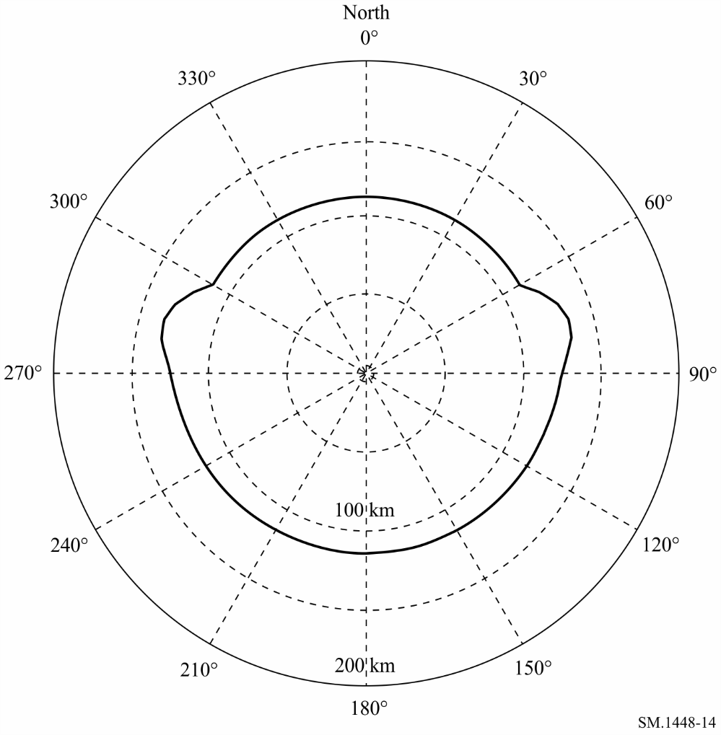

Attachment 6
to Annex 1
Determination of the coordination area for a transmitting earth station with
respect to receiving earth stations operating with geostationary space stations
in bidirectionally allocated frequency bands

1 Introduction
The propagation mode (1) contour of a transmitting earth station with respect to unknown receiving earth stations operating with geostationary space stations requires the determination of the horizon gain of the antenna of the receiving earth station at each azimuth of the transmitting earth station. Different methods then need to be applied to determine the coordination area of the coordinating earth station, depending on whether it operates with geostationary or non-geostationary space stations. When both the coordinating earth station and the unknown receiving earth stations operate with geostationary space stations, it is also necessary to determine a propagation mode (2) contour.
The coordination area of a transmitting earth station, with respect to unknown receiving earth stations that operate to non-geostationary space stations, can be determined by minor modifications to the methods applicable to the determination of coordination area of transmitting earth stations with respect to terrestrial stations (see §§ 3.2.1 and 3.2.3 of Annex 1).

2 Determination of the bidirectional contour for propagation mode (1)
For a transmitting earth station operating in a frequency band that is also allocated for bidirectional use by receiving earth stations operating with geostationary space stations, further development of the procedures in Attachment 3 to Annex 1 is needed. It is necessary to determine the horizon gain of the unknown receiving earth station, the horizon gain to be used at each azimuth at the coordinating (transmitting) earth station, for the determination of the bidirectional contour.

2.1 Calculation of horizon gain for unknown receiving earth stations operating with geostationary space stations
The value of G_{r}, the horizon gain of the receiving earth station, for each azimuth, α, at the transmitting earth station is found by the following steps:
Step 1: The receiving earth station may be operating with any satellite in the geostationary orbit above a minimum elevation angle, ε_{min}, contained in Table 16. The maximum difference in longitude (δ_{b} (degrees)) between the receiving earth station and its associated space station occurs at this minimum elevation angle, ε_{min}, and is given by:
(122)
where:
ζ: latitude of the receiving earth station, which is assumed to be the same as the transmitting earth station
K: ratio of the radius of the satellite orbit to the radius of the Earth, equal to 6.62.
Step 2: For each azimuth, α, at the transmitting earth station:
– determine the azimuth α_{r} from the receiving earth station to the transmitting earth station:
αr = α + 180° for α < 180°
αr = α – 180° for α ≥ 180°
– for each azimuth α_{r}, determine the minimum angular separation, ϕ(α_{r}), between the receiving earth station main beam axis and the horizon at this azimuth using Case 2 in § 2 of Attachment 3 to Annex 1. For this evaluation take values of δ between −δ_{b} and +δ_{b} in steps of 1° or less, making sure to include the end points.
The minimum angular separation, φ(α_{r}), may be used with the gain pattern in § 3 of Attachment 3 to Annex 1 to determine the horizon gain for this azimuth, α, unless a different gain pattern is referenced in Table 16.
Figure 15 shows plots of the minimum angular separation between the horizon at zero degrees elevation on an azimuth α_{r} and a satellite on the geostationary orbit at an elevation above 3°. Plots are shown for a set of values of the station latitude, ζ, which is assumed to be the same for both transmitting and receiving earth stations. Figure 15 also provides a scale showing the corresponding azimuth, α, of the transmitting earth station.
figure 15
Illustration of minimum angular distance between points on the geostationary-satellite orbit (GSO)
and the horizontal plane
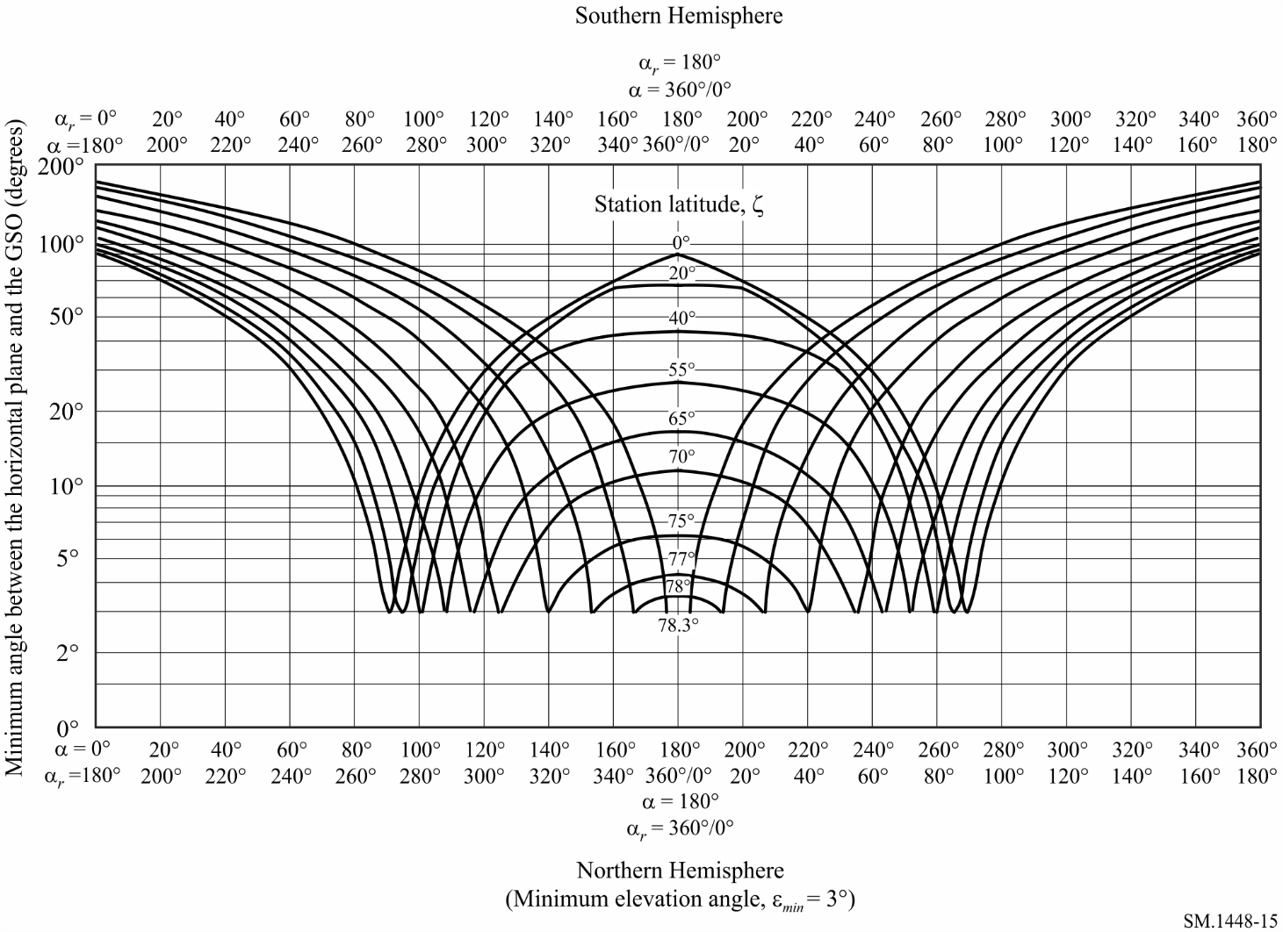

2.2 Example propagation mode (1) contour calculation for both earth stations operating with geostationary space stations
The minimum angular separation between the receiving earth station’s main beam axis and the horizon at each azimuth, for a station at 40° latitude was used, with the earth station antenna reference pattern of Attachment 3 to Annex 1, to generate the plot of the horizon antenna gain of the receiving earth station as a function of (α) and (αr) and is shown in Fig. 16.
figure 16
Example of full-arc horizon antenna gain for 0° horizon elevation angle and
5° minimum antenna elevation angle at 40° N latitude
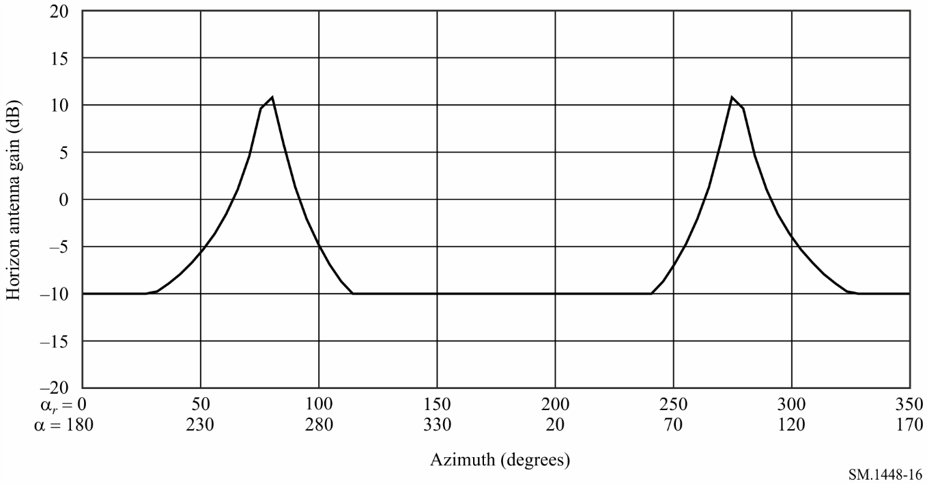
Figure 17 shows the sum of the antenna gains Gt(α) + Gr(αr) at each azimuth of the transmitting earth station for this example.
figure 17
Composite horizon antenna gain Gt + Gr for the example of Fig. 16
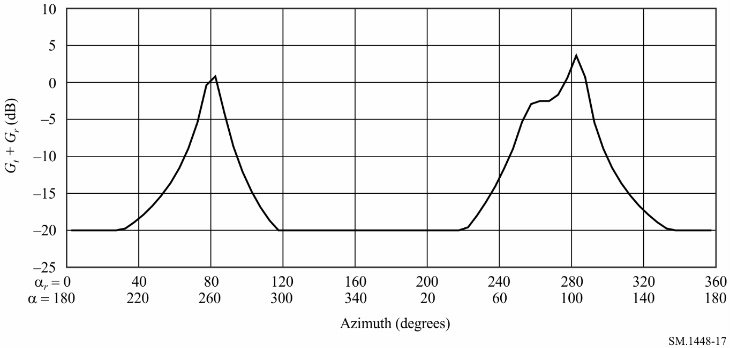

An example of the propagation mode (1) contour, developed using the horizon-gain plot in Fig. 17 is shown with the relevant system parameters in Fig. 18.
figure 18
Example of a bidirectional propagation mode (1) coordination area
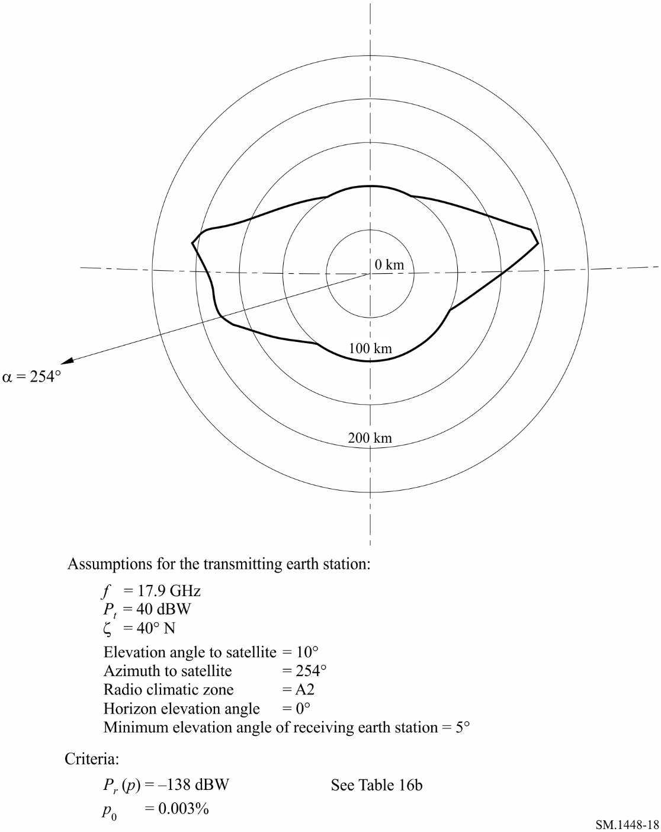

2.3 Example supplementary contour calculation for a transmitting earth station operating with non-geostationary space stations and a receiving earth station operating with geostationary space stations using the TVG method
This section presents an example of the determination of the propagation mode (1) supplementary contour for a transmitting earth station, operating to non-geostationary space stations, with respect to a receiving earth station, operating to geostationary space stations, in the 6 875-7 055 MHz frequency band. The earth station and satellite orbit parameters are given in Table 9.
TABLE 9
Earth stations and satellite orbit parameters used in the example
Orbit parameters of the non-geostationary satellites
Altitude (km) | 1 414
Number of satellites | 48
Inclination angle (degrees) | 52
Parameters for the coordinating earth station operating to non-geostationary space stations
Latitude (degree) | 50
Longitude (degree) | 0
Minimum operating elevation angle (degree) | 10
Antenna gain pattern | Equation (99)
Transmit antenna gain (dBi) | 50
e.i.r.p./carrier (dBW) | 56.5
Transmission bandwidth (kHz) | 1 230
Parameters for receiving earth stations operating to geostationary space stations (from Table 16a)
Modulation | Digital (N )
Percentage of time, p% | 0.005
NL (dB) | 1
Ms (dB) | 2
W (dB) | 0
Receive antenna gain (dB) | 50.7
Te (K) | 75
Reference bandwidth (MHz) | 1
Pr( p) (dBW) | −151

The minimum angular separation between the receiving earth station’s main beam axis and the horizon at each azimuth for a station at 50° latitude was used, with the earth station antenna reference pattern of Attachment 3 to Annex 1, to generate the plot of the horizon antenna gain of the receiving earth station as a function of (α) and (αr) shown in Fig. 19.
Figure 19
Horizon antenna gain of the receiving earth station at 50° N latitude with a 3° minimum elevation angle
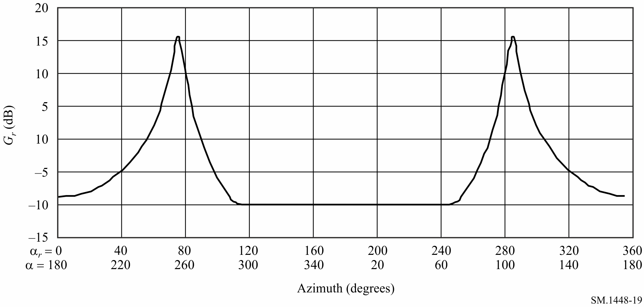
Figure 20 shows complementary CDFs of the horizon antenna gain of the transmitting earth station operating to non-GSO satellites at three azimuths. These distributions, which give the percentage of time that a specific value of horizon gain is exceeded, were developed by the procedure in § 2 of Attachment 4 to Annex 1.
Figure 20
Complementary CDF of the horizon antenna gain of the
transmitting earth station at azimuths 60°, 120° and 180°
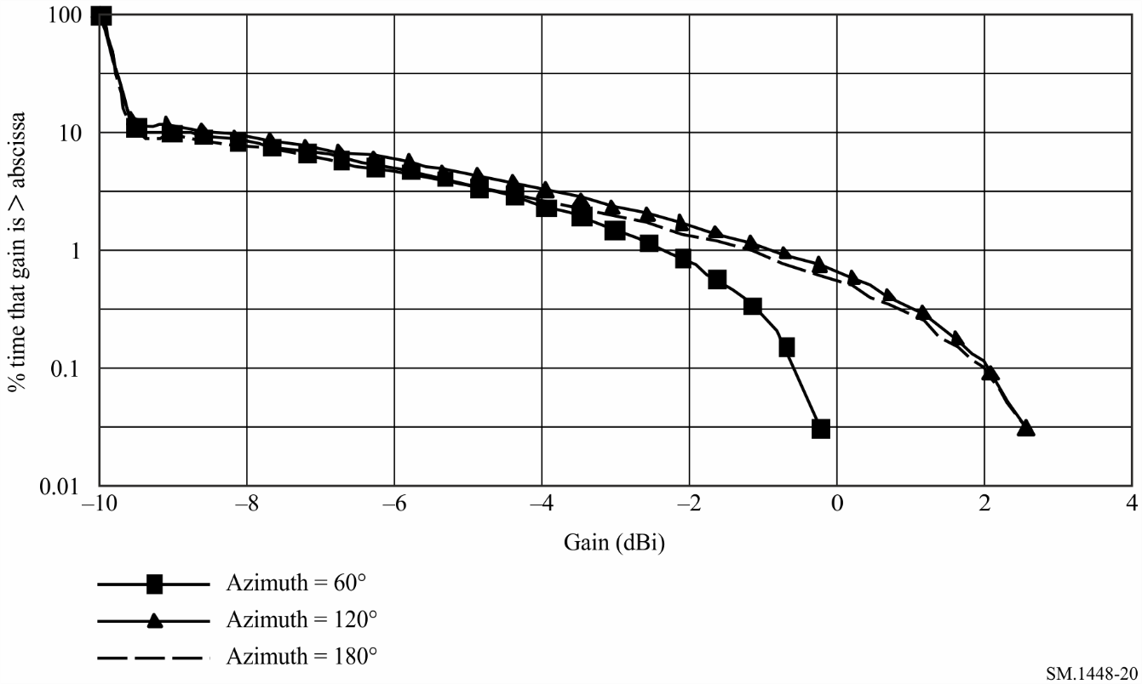
For each azimuth at the transmitting earth station, the appropriate value of horizon gain for the receiving earth station from Fig. 19 is used with the corresponding horizon gain distribution of the transmitting earth station, as indicated in Fig. 20, in the procedure of § 1 of Attachment 5 to Annex 1.
Table 10 shows an example of the determination of the distance, for the example parameters in Table 9 at a 60° azimuth, for the transmitting earth station, operating to a non-geostationary space station, with respect to the unknown receiving geostationary earth station, operating to a geostationary space station. The distances were calculated by the procedure cited above, at the centre frequency of the band, for a step size increment of 0.1 dB over the range of the horizon antenna gain. The largest value of distance in column dn (km) of Table 10 is selected as the propagation mode (1) required distance at the specified azimuth.
TABLE 10
Distances, dn, for a transmitting earth station operating to non-GSO space stations with respect to a receiving earth station operating to a geostationary space station (azimuth = 60°)
Index of gain  level n | Horizon antenna  gain Gen  (dBi) | Complement CDF  pn (%) | pv = p/pn  (%) | Required loss  Lbn(pv)  (dB) | Distance  dn  (km)
1 | –10.0 | 100.00 | 0.005 | 149.66 | 146.74
2 | –9.5 | 11.15 | 0.045 | 150.16 | 119.74
3 | –9.0 | 10.17 | 0.049 | 150.66 | 121.84
4 | –8.5 | 9.24 | 0.054 | 151.16 | 123.84
5 | –8.0 | 8.35 | 0.060 | 151.66 | 125.54
6 | –7.5 | 7.51 | 0.067 | 152.16 | 127.14
7 | –7.0 | 6.71 | 0.075 | 152.66 | 128.44
8 | –6.5 | 5.96 | 0.084 | 153.16 | 129.54
9 | –6.0 | 5.25 | 0.095 | 153.66 | 130.34
10 | –5.5 | 4.58 | 0.109 | 154.16 | 130.84
11 | –5.0 | 3.96 | 0.126 | 154.66 | 130.84
12 | –4.5 | 3.39 | 0.147 | 155.16 | 130.54
13 | –4.0 | 2.86 | 0.175 | 155.66 | 129.54
14 | –3.5 | 2.36 | 0.212 | 156.16 | 127.84
15 | –3.0 | 1.92 | 0.260 | 156.66 | 125.34
16 | –2.5 | 1.52 | 0.329 | 157.16 | 121.64
17 | –2.0 | 1.15 | 0.435 | 157.66 | 116.04
18 | –1.5 | 0.84 | 0.595 | 158.16 | 108.74
19 | –1.0 | 0.56 | 0.893 | 158.66 | 100.94
20 | –0.5 | 0.33 | 1.515 | 159.16 | 100.94
21 | 0.0 | 0.15 | 3.333 | 159.66 | 100.94
22 | 0.5 | 0.03 | 16.667 | 160.16 | 100.94
23 | 0.6 | 0.01 | 20.000 | 160.26 | 100.94

Figure 21 shows a plot of the supplementary contour as determined from the supplementary contour distances for all azimuths.
Figure 21
Propagation mode (1) coordination contour for a transmitting earth station operating with
non-GSO space stations and a receiving earth station operating with a GSO space station
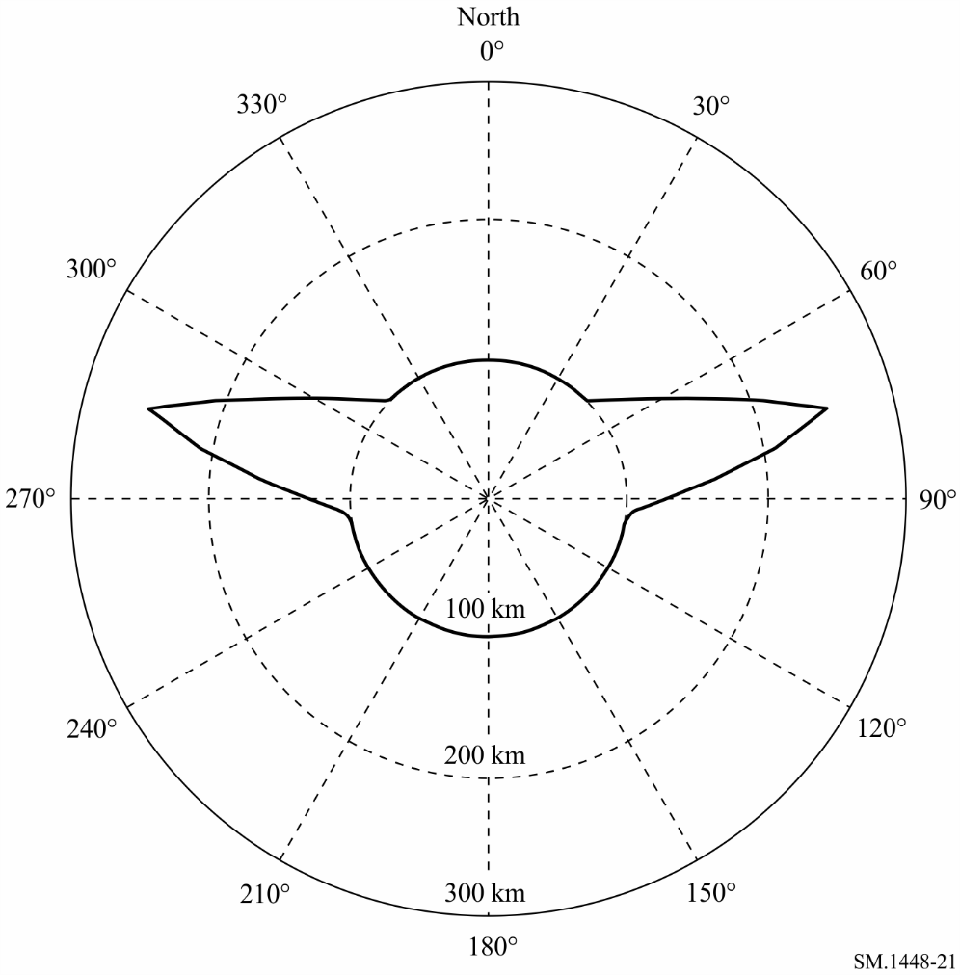

3 Determination of the bidirectional rain scatter contour
The procedure for the determination of the bidirectional rain scatter area, as described in § 3.1.2 of Annex 1, is as follows:
The horizontal distance d_{s} (km) from the coordinating earth station to the point at which the main beam axis attains the rain height h_{R} is calculated by:
km (123)
where the rain height, h_{R}, can be determined from equations(75) or (76) of Attachment 2 to Annex 1 and ε_{s} is the minimum elevation angle of the transmitting earth station.
The maximum calculation distance, d_{emax}, to be used in the determination of the propagation mode (2) contour, for the case of a coordinating earth station operating in bidirectionally allocated frequency bands, is dependent on the rain height. It is the greater distance determined from:
demax = 130.4 km or
where the minimum coordination distance, d_{min}, is given in § 4.2 of Annex 1.
The point, at the distance d_{s} from the earth station, on the azimuth α_{s} of the coordinating earth station’s main beam axis, is the geographic point immediately below the main beam axis intersection with the rain height, and is the reference point from which the maximum calculation distance d_{emax} is determined (see Fig. 22).
If the maximum calculation distance, d_{emax}, is greater than the minimum coordination distance, d_{min}, then calculate the maximum latitude at which a receiving earth station may operate with a geostationary satellite with a minimum elevation angle ε_{min}:
(124)
where:
ε_{min}: given in Table 16
K: ratio of the radius of the satellite orbit to the radius of the Earth, equal to 6.62.
If the coordinating earth station latitude in the northern hemisphere is greater than ζ_{max}, or if the coordinating earth station latitude in the southern hemisphere is less than −ζ_{max} or −71°, then the rain scatter contour is a circle of radius d_{min}, centred on the transmitting earth station.
For all other cases, the coordination area is developed by the following procedure:
Step 1: The unknown receiving earth station is assumed to be operating with a satellite at the minimum elevation angle ε_{min}. It is also assumed that the receiving earth station is relatively close to the coordinating earth station in geometric terms and hence a plane geometry approximation can be applied within the coordination area. If the receiving earth station’s main beam axis passes through the intersection of the coordinating earth station’s main beam axis with the rain height, the azimuths from the point on the ground immediately below this intersection to the possible locations of a receiving earth station are given by:
and
α_{w2} = 360° – α_{w1}
where ζ is the latitude of the transmitting earth station.
Step 2: Mark on a map of an appropriate scale the coordinating earth station’s location and draw from this location a line of distance, d_{s}, along the azimuth, α_{s}, to the point below the coordinating earth station’s main beam axis intersection with the rain height.
Step 3: From the main beam axis intersection point in Step 2, mark on the map the distance, d_{emax}, along the two azimuths, α_{w2} and α_{w1}, and on each azimuth at the distance, d_{emax}, draw two equal distance arcs of width 3° clockwise and counter-clockwise. The two arcs, each having a total width of 6°, are the first boundary elements of the bidirectional rain scatter area.
Step 4: Mark a circle of radius equal to the minimum coordination distance, d_{min}, around the coordinating earth station’s location, and then draw straight lines from the northern edges of the two arc segments tangential to the northern rim of the circle, and from the southern edges of the two arc segments tangential to the southern rim of the circle.
The area bounded by the two 6° wide arcs, the four straight lines, and the circular sections (of which there is always at least one) between the two northern and the two southern tangent points with the straight lines, constitutes the bidirectional rain scatter area.
Figure 22 illustrates the construction of the bidirectional rain scatter area for a coordinating earth station depicted in Fig. 18. (The resulting rain scatter area contains the possible loci of all receiving earth station locations from which a beam path towards the geostationary-satellite orbit will intersect the main beam of the transmitting earth station antenna.)
figure 22
Example of the bidirectional rain scatter area
(Not to scale)
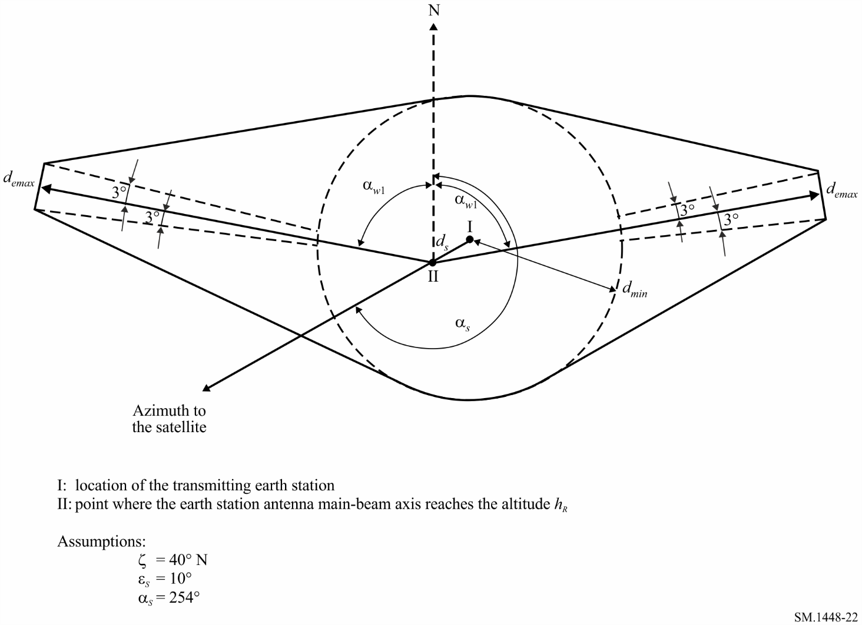

Attachment 7
to Annex 1
Determination of auxiliary contours for propagation mode (2)

1 Determination of auxiliary contours for propagation mode (2)
Propagation mode (2) auxiliary contours allow the azimuthal offset of a terrestrial station antenna beam from the coordinating earth station’s location to be taken into consideration. Figure 23 shows the hydrometeor scatter region projected on to the horizontal plane. In this Figure, the earth station and the terrestrial station are located at the points A and B, respectively, where the terrestrial station is on a radial defined by the angle ω from the point C at the centre of the propagation mode (2) main, or supplementary, contour. Point C is also the centre of the auxiliary contour.
figure 23
Propagation geometry in the horizontal plane
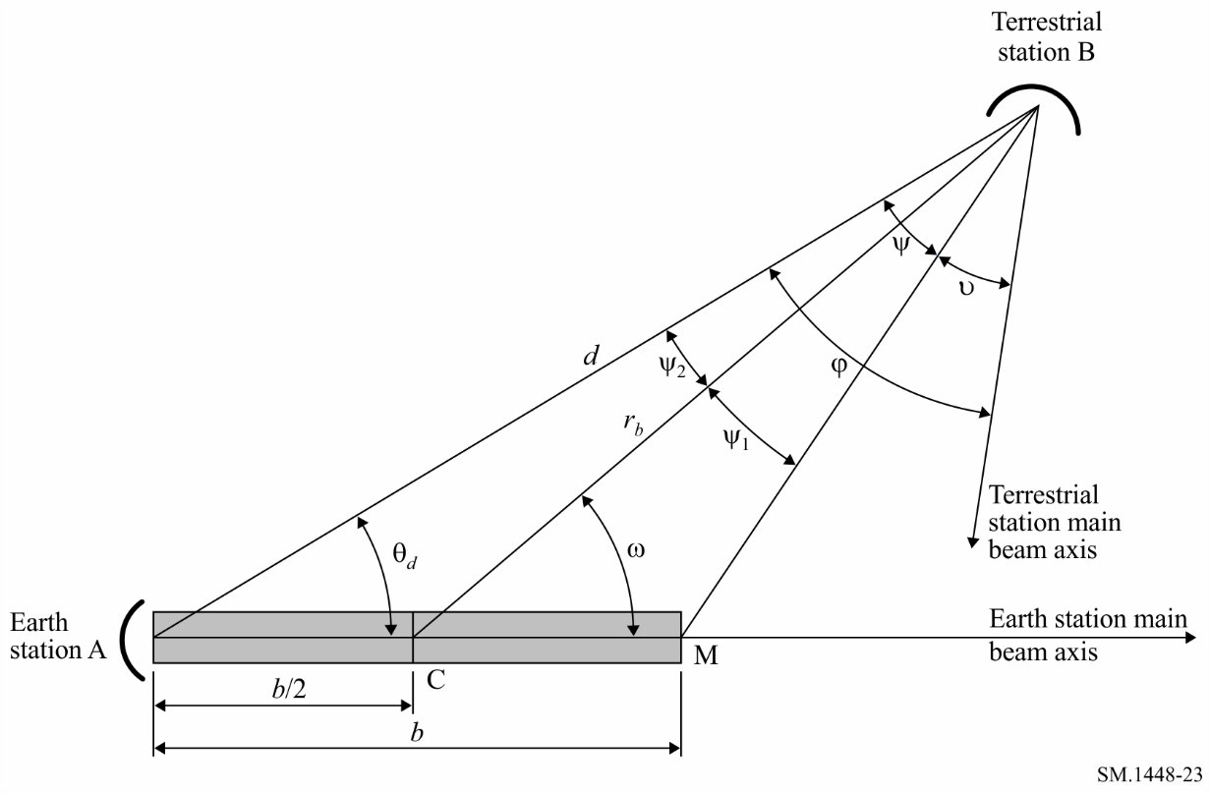

The shaded area in Fig. 23 represents the critical region, along the earth station’s main beam axis, between the earth station and the rain height. Within this critical region a common volume can be formed between the earth station beam and the beam of any terrestrial stations within the propagation mode (2) main, or supplementary, contour. This critical region’s length is b and its maximum horizontal extent is at point M. Intersection of this critical region by the terrestrial station main beam axis would result in significant hydrometeor scatter interference via main lobe-to-main lobe coupling.
For a given point within the propagation mode (2) main, or supplementary, contour, the angle subtended by the critical region is termed the critical angle, ψ. The protection angle, υ, represents the angle of the terrestrial station main beam axis away from the critical region. The beam avoidance angle between the terrestrial station’s main beam axis and the earth station’s location is φ. It is the sum of the two angles ψ and υ and it is this quantity that has a fixed value for a specific auxiliary contour. Each auxiliary contour is generated by varying the angle, ω, and deriving the distance, r_{b}, from point C to the auxiliary contour. As the angle ω increases from 0° to 360°, the angles ψ and υ change, but their sum remains the same.
The algorithm in § 2 of this Attachment can be used to calculate the auxiliary propagation mode (2) contour for a given value of beam avoidance angle ϕ.
The method is based on iteratively decrementing the distance, r_{b}, between terrestrial station and the centre of the common volume, and starting at the main contour distance d_{r}, until either the shortest value of r_{b} is found for which the required minimum loss is achieved, or the minimum coordination distance is reached. For each value of r_{b}, the critical angle ψ is determined and then the protection angle υ is calculated. The terrestrial station antenna gain corresponding to υ and the current distance r_{b} are used to obtain the propagation mode (2) path loss in equation (83) in Attachment 2 to Annex 1.
The above process is repeated for each angle ω, to generate a complete auxiliary contour for a given value of beam avoidance angle ϕ. For some combinations of beam avoidance angle and angle ω, an auxiliary contour may coincide with the main, or supplementary, propagation mode (2) contour.

2 The step-by-step algorithm
Auxiliary propagation mode (2) contours are constructed by calculating distances along radials from the centre of the circular mode (2) main, or supplementary, contour, which is the point C, at the distance b/2 from the earth station along the azimuth of its main beam axis. The distance b/2 is equal to Δd, where Δd is given by equation (84) in Attachment 2 to Annex 1.
For the selected value of beam avoidance angle, ϕ, generate the auxiliary contour for values of angle, ω, ranging from 0° to 180° in steps of 1°, as follows:
a) Set r_{b} to the main, or supplementary, mode (2) contour distance d_{r} calculated as described in § 3.1 of Attachment 2 to Annex 1.
b) Compute ψ from:
(125)
(126)
(127)
c) If ψ > ϕ then the auxiliary mode (2) contour coincides with the main or supplementary mode (2) contour for the current value of ω, and the calculation for that value of ω is completed, and go to step j). Otherwise proceed through the following steps d) to i) until one of the terminating conditions described in step f) and step i) is satisfied.
d) Decrement r_{b} by subtracting 0.2 km from its value.
e) Recalculate the critical angle ψ using equations (125), (126) and (127).
f) If (0.5 b sin ω/sin ψ₂) < d_{min}, the auxiliary mode (2) contour coincides with the minimum coordination distance d_{min} and the calculation for the current value of ω is completed – go to step j). Otherwise, proceed to step g).
g) Compute the protection angle υ = φ − ψ.
h) Calculate G(υ), the terrestrial station antenna gain at the angle υ relative to the beam axis, using the reference antenna pattern given in this Attachment.
i) In equation (83) in Annex 2, use the gain calculated in step h) in place of G_{x} and the value considered of r_{b} in place of r_{i}, and calculate the corresponding propagation mode (2) path loss L_{r}. If L_{r} < L(p ), then increment r_{b} by adding 0.2 km to its value and take this as the distance for the current radial. Otherwise, repeat from step d).
j) Once the value of r_{b} has been found for the current value of angle ω, calculate the angle θ_{d} from the location of the earth station, and if appropriate the distance, d, to that contour point using:
(128)
(129)
An auxiliary propagation mode (2) contour is symmetrical about the earth station main beam axis. Thus, values of d and θ_{d} corresponding to the values of ω from 181° to 359° can be found by noting that results for a given value of ω are the same as for (−ω) or (360° − ω).
The step size for incrementing r_{b} used above, 0.2 km, is suitable for most situations. It controls the granularity of the result when viewed as a set of r_{b} values. For low values of earth station beam elevation, the granularity becomes more noticeable in the values of d and θ_{d}, and a smaller step size may be used.

3 Reference radiation patterns for line-of-sight radio-relay system antennas
The reference radiation pattern for line-of-sight radio-relay system antennas in this section is used for the unknown terrestrial station antenna in the propagation mode (2) auxiliary contour calculations when the actual antenna pattern is not available.
a) In cases where the ratio between the antenna diameter and the wavelength is greater than 100, the following equation is used:
for 0 < ϕ < ϕm (130)
for ϕm ≤ ϕ < ϕr (131)
for ϕr ≤ ϕ < 48° (132)
for 48 ≤ ϕ ≤ 180° (133)
(134)
(135)
(136)
b) In cases where the ratio between the antenna diameter and the wavelength is less than or equal to 100, the following equation is used:
for 0 < ϕ < ϕm (137)
for ϕm ≤ ϕ < 100 (138)
for 100 ≤ ϕ < 48° (139)
for 48° ≤ ϕ ≤ 180° (140)
c) In cases where only the maximum antenna gain is known, D/λ can be estimated from the following expression:
(141)
where:
Gamax: main beam axis antenna gain (dBi)
D: antenna diameter (m)
λ: wavelength (m)
G₁: gain of the first side lobe (dBi).

Attachment 8
to Annex 1
Parameters
The input parameters that may be needed for the determination of the coordination area around an earth station are listed in Table 11. Other parameters used in the determination of coordination area are listed in Table 12.
TABLE 11
Input parameters
Parameter | Units | Definition | Reference | Status
a | km | The semi-major axis of the non-GSO | Attachment 4, § 3 | Optional⁽¹⁾
d_{h} | km | The distance of the horizon from the earth station’s location (default value = 0.5 km) | Attachment 1, § 1 | Optional
D | m | The antenna diameter | Attachment 3, § 3 | Optional⁽²⁾
e |  | The eccentricity of a non-GSO (e = 0 for circular orbits and 0 < e < 1 for elliptical orbits). | Attachment 4, § 3 | Optional⁽¹⁾
f | GHz | Frequency, 100 MHz-105 GHz | Annex 1, § 4.2 | Input
g | dB | A gain increment used in the determination of the horizon antenna gain distribution | Attachment 4, § 2  Attachment 5, § 1 | Optional⁽³⁾
Ga_{max} | dBi | Maximum on-beam axis antenna gain | Attachment 3, § 3 | Optional⁽²⁾
G(ϕ) | dBi | Antenna gain at an angle ϕ (degrees) from the main-beam axis | Attachment 3, § 3 | Optional⁽²⁾
is | degrees | Maximum operational inclination angle of the orbit of a geostationary satellite, or the nominal inclination angle of a non-GSO, or the latitude limit of orbital motion | Attachment 3, § 2  Attachment 4, § 1.1  Attachment 4, § 3 | Input⁽⁴⁾ or optional⁽³⁾
K1 |  | The orbit radius/Earth radius for the lowest altitude satellite in a constellation | Attachment 4, § 1.1 | Optional⁽³⁾
 |  | The numerical loss in the transmission line (e.g. a waveguide) between the antenna terminal and the receiver front end | Annex 2, § 2 | Input⁽⁵⁾
Pt | dBW | The maximum available transmit power in the reference bandwidth at the terminals of the antenna of a transmitting earth station | Annex 1, § 1.3, 2.1.1 and 2.2.2 | Input⁽⁶⁾
Q | dB | Auxiliary contour value | Annex 1, § 4.4 | Optional
t | s | A time used for determining satellite position(s) | Attachment 4, § 3 | Optional⁽¹⁾
t0 | s | Initial time | Attachment 4, § 3 | Optional⁽¹⁾
Ta | K | The noise temperature contributed by the antenna of a coordinating receiving earth station | Annex 2, § 2 | Input⁽⁵⁾
Tr | K | The receiver noise temperature referred to the antenna terminal of a coordinating receiving earth station | Annex 2, § 2 | Input⁽⁵⁾
α | degrees | The azimuth angle of the direction under consideration | Attachment 1, § 1 | Input
TABLE 11 (end)
Parameter | Units | Definition | Reference | Status
δe | degrees | The difference in longitude at the eastern extreme of the operational portion of the orbital arc | Attachment 3, § 2 | Input⁽⁴⁾
δw | degrees | The difference in longitude at the western extreme of the operational portion of the orbital arc | Attachment 3, § 2 |  | Input⁽⁴⁾
εh | degrees | The elevation angle of the horizon at the azimuth α  under consideration. ε_{h}(α) is the horizon profile | Attachment 1, § 1, Attachment 3, § 1 and Attachment 4, § 3 |  | Input
εsys | degrees | The earth station antenna main beam minimum elevation angle, applicable to all azimuths | Attachment 4, § 1 |  | Input⁽³⁾
ζ | degrees | Τhe earth station latitude (North positive, South negative) | Annex 1, § 4.1, Attachment 3, § 2 and Attachment 4, § 1 |  | Input
η0 | rad | The initial mean anomaly | Attachment 4, § 3 |  | Optional⁽¹⁾
λe | degrees | The longitude of an earth station (East positive, West negative) | Annex 1, § 1.5.1 and Attachment 4, § 3 |  | Input
λs | degrees | The longitude of the ascending node of the non-GSO at time t0 | Attachment 4, § 3 |  | Optional⁽¹⁾
ν0 | degrees | The true anomaly as specified at time t₀ | Attachment 4, § 3 |  | Optional⁽¹⁾
ξ0 | rad | Eccentric anomaly at time t₀ | Attachment 4, § 3 |  | Optional⁽¹⁾
υ | degrees | Protection angle used in determining rain scatter auxiliary contour | Attachment 7, § 1  and 2 |  | Optional
ωp0 | degrees | The argument of perigee of the non-GSO at time t0 | Attachment 4, § 3 |  | Optional⁽¹⁾
⁽¹⁾ A parameter needed for the application of the orbital equations for non-GSO satellites in § 3 of Attachment 4 to Annex 1.
⁽²⁾ The horizon gain needed for the determination of coordination area may be determined in several equivalent ways from different specified inputs. See Attachment 3 and 4 to Annex 1.
⁽³⁾ For earth stations operating to non-GSO space stations.
⁽⁴⁾ For earth stations operating to geosynchronous space stations.
⁽⁵⁾ An input parameter to equation (143). If a notifying administration has used this equation to determine the thermal noise temperature, Te, of the receiving earth station, the parameter Te may be used in the determination of coordination area.
⁽⁶⁾ This power may be derived from the maximum power density supplied to the input to the antenna (dB(W/Hz)) and the reference bandwidth B.

TABLE 12
Other parameters used
Parameter | Without  subscript | With  subscript | With  argument | Units | Definition | Reference
A |  | √ |  | dB | Attenuation | Attachments 1 and 2
B | √ |  |  | km | Length of critical rain scatter region | Attachment 7, § 2
B | √ |  |  | Hz | The reference bandwidth, i.e., the bandwidth in the receiving station that is subject to the interference and over which the power of the interfering emission can be averaged | Annex 2, § 2
C |  | √ |  | dB | Correction factor | Annex 1, § 4.4
D |  | √ |  | km | Distance, usually from the earth station | Throughout
G | √ | √ | √ | dBi | Antenna gain at an angle from the main-beam axis or toward the horizon | Throughout
TABLE 12 (continued)
Parameter | Without  subscript | With  subscript | With  argument | Units | Definition | Reference
h_{R} |  | √ |  | km | Rain height above ground | Annex 1, § 3.1.2 and Attachment 2, § 3
i | √ |  |  | degrees | The latitude of a sub-satellite point | Attachment 3, § 2
K | √ |  |  |  | Scale factor for the determination of the specific attenuation due to rain | Attachment 2, § 3
K | √ |  |  | J/K | Boltzmann's constant, 1.38 × 10^{–23} J/K. | Annex 2, § 2
K | √ | √ |  |  | Satellite orbit radius/Earth radius | Attachment 3, § 2  Attachment 4, § 1.1
L | √ | √ | √ | dB | Minimum required loss for p% of time; or components of this loss | Annex 1, § 1.3 and Attachment 2, § 1
M_{s} |  |  |  | dB | The link performance margin | Annex 2, § 2
N | √ |  |  |  | The number of equivalent equal level, equal probability entries of interference, assumed to be uncorrelated for small percentages of the time | Annex 2, § 2
N0 |  |  |  |  | The sea level surface refractivity at path centre for frequencies between 790 MHz and 60 GHz | Annex 1, § 4.1
N_{L} |  |  |  | dB | The link noise contribution | Annex 2, § 2
P | √ | √ |  | % | The percentage of time for which the permissible interference may be exceeded | Annex 1, § 1.3
Pr ( p) |  |  |  | dBW | Permissible interference power of an interfering emission in the reference bandwidth to be exceeded for no more than p% of the time. | Annex 1, § 1.3 and Annex 2, § 2
Pt |  |  |  | dBW | The maximum available transmit power in the reference bandwidth at the terminals of the antenna of a transmitting terrestrial station | Annex 1, § 1.3, 2.1.1 and 2.2.2
r |  | √ |  | km | Radial distance parameters | Attachments 2, 4 and 7
R | √ |  | √ | mm/h | Rainfall rate | Attachment 2, § 1
R_{cv} |  |  |  |  | Effective scatter transfer function | Attachment 2, § 3
s | √ |  |  | km | The distance increment used in the iterative calculation of the required distance | Annex 1, § 1.3
T |  | √ |  | K | An equivalent thermal noise temperature | Annex 2, § 2
W | √ |  |  | dB | A thermal noise equivalence factor for interfering emissions in the reference bandwidth | Annex 2, § 2
X(f) |  |  | √ | dB | Nominal correction at frequency f | Annex 1, § 4.4
Ζ(f) |  |  | √ | dB/km | Correction constant at frequency f | Annex 1, § 4.4
α | √ |  |  |  | Exponent for determining the specific attenuation due to rain | Attachment 2, § 3
α | √ | √ | √ | degrees | An azimuth angle measured at the coordinating earth station | Attachments 3, 4 and 6
β | √ |  |  |  | The path-dependent incidence of ducting | Attachment 1, §3
βe |  |  |  | % | The percentage of time for which clear-air anomalous propagation conditions exist | Annex 1, § 4.1
γ |  | √ | √ | dB/km | A specific attenuation | Attachments 1 and 2
Γ1 |  |  |  |  | A parameter related to the path-dependent incidence of ducting | Attachment 1, §3
Γ2 |  |  |  | dB | Additional attenuation due to scatter outside the common volume | Attachment 2, §3

TABLE 12 (end)
Parameter | Without  subscript | With  subscript | With  argument | Units | Definition | Reference
Δd |  |  |  | km | The horizontal distance to the centre of the circular propagation mode (2) contour from the earth station, along the azimuth of the earth station main beam axis | Annex 1, § 5  Attachment 2, § 4
δ | √ | √ |  | degrees | A difference in longitude measured from an earth station | Attachments 3 and 4
ε |  | √ | √ | degrees | An elevation angle measured from the earth station location | Attachments 2, 3 and 4 and Annex 2
ζ | √ | √ |  | degrees | A parameter equal or related to the latitude of the earth station | Annex 1, § 4.1, Attachments 3 and 4
η |  | √ |  | rad⁽¹⁾ | The mean anomaly or its rate of rotation | Attachment 4, § 3
θd |  |  |  | degrees | An angle used in the construction of the propagation mode⁽²⁾ auxiliary contour | Attachment 7, § 2
λ | √ |  |  | M | The wavelength of the interfering power | Attachments 3 and 7
λ |  | √ |  | degrees⁽¹⁾ | A longitude parameter or its rate of change | Attachment 4, § 3
μ | √ |  |  | km³/s² | The Earth gravitational constant | Attachment 4, § 3
μ |  | √ |  |  | A parameter used to determine β | Attachment 1, § 3
ν | √ | √ |  | degrees | A parameter for the true anomaly of a non-geostationary satellite in its orbit | Attachment 4, § 3
ξ |  | √ |  | rad | Eccentric anomaly of a non-GSO satellite | Attachment 4, § 3
ρ | √ |  |  | g/m³ | Atmospheric water vapour density | Attachment 1, § 3
σ, τ | √ |  |  |  | Parameters used to determine μ₁ and μ₂ | Attachment 1, § 3
ϕ | √ | √ | √ | degrees | An angle measured from the axis of an antenna main beam | Attachments 3, 4 and 7
ψ | √ | √ | √ | degrees | Various arc lengths and angles | Attachments 3, 4 and 7
ω | √ | √ |  | degrees⁽¹⁾ | Various angles or their rates of change | Attachment 4, § 3 and Attachment 7
Ωr |  |  |  | degree/s | Rate of precession of the nodes of the non-geostationary satellite | Attachment 4, § 3
⁽¹⁾ With subscript r the parameter is a rate of change with units/s.

Annex 2
System parameters and predetermined coordination distances for
determination of the coordination area around an earth station

1 Introduction
Tables 14 to 16 contain the system parameter values required by the methods in Annex 1 to determine the coordination area around an earth station when the band is shared with terrestrial radiocommunication services or other earth stations operating in the opposite direction of transmission.
Table 14 is limited to those system parameter values required for the case of a transmitting earth station sharing with terrestrial services; Table 15 is limited to those parameter values required for the case of a receiving earth station sharing with terrestrial services; Table 16 is limited to those parameter values required for the case of a transmitting earth station which is sharing in a bidirectionally allocated band with other earth stations operating in the opposite direction of transmission.
These system parameter tables include primary allocations to the space and terrestrial services in Article 5 of the RR in all bands between 100 MHz and 105 GHz. Some of the columns have incomplete information. In some cases, this is because there is no requirement to calculate coordination distances as pre-determined coordination distances apply. In other cases, the service allocations are new and the systems may not be introduced for some years. Hence, the system parameters are the subject of ongoing development within the Radiocommunication Study Groups.
Parameters specific to the earth station, for which coordination is being sought, are provided to the Radiocommunication Bureau in the format specified in Appendix 4 of the RR as part of the notification and coordination procedures.
The row in each table entitled “method to be used” directs the user to the appropriate section of the main body of Annex 1 which describes the methods to be followed for the determination of the coordination area.
Note that the earth station for which the coordination area is to be determined is identified by the service designation given in the first row of each table.
When a supplementary contour is to be developed, for example for digital fixed systems, the necessary system parameters may be found in one of the adjacent columns in Tables 14, 15 and 16. If no suitable system parameters are available, then the value of the permissible interference power (P_{r}(p )) may be calculated using equation (142) in § 2.
The predetermined coordination distances specified in Table 17 are used for transmitting and receiving earth stations, in cases defined by the corresponding frequency sharing situation.

2 Calculation of the permissible interference power of an interfering emission
Tables 14, 15 and 16 contain values for the parameters which are required for the calculation of the permissible interference power of the interfering emission (dBW), in the reference bandwidth, to be exceeded for no more than p% of the time at the receiving antenna terminal of a station subject to interference, from a single source of interference, using the general formula:
dBW (142)
where:
k: Boltzmann's constant (1.38 × 10⁻²³ J/K)
T_{e}: thermal noise temperature of the receiving system (K), at the terminal of the receiving antenna (see § 2.1 of this Annex)
N_{L}: link noise contribution (see § 2.2 of this Annex)
B: reference bandwidth (Hz), i.e. the bandwidth in the receiving station that is subject to the interference and over which the power of the interfering emission can be averaged
p: percentage of the time during which the interference from one source may exceed the permissible interference power value; since the entries of interference are not likely to occur simultaneously, p = p₀/np
p₀: percentage of the time during which the interference from all sources may exceed the threshold value;
np: number of equivalent, equal level, equal probability entries of interference, assumed to be uncorrelated for small percentages of the time
M_{s}: link performance margin (dB) (see § 2.3 of this Annex)
W: a thermal noise equivalence factor (dB) for interfering emissions in the reference bandwidth; it is positive when the interfering emissions would cause more degradation than thermal noise (see § 2.4 of this Annex).
In certain cases, an administration may have reason to believe that, for its receiving earth station, a departure from the values associated with the earth station, as listed in Table 15, may be justified. Attention is drawn to the fact that for specific systems the bandwidths B or, for example in the case of demand assignment systems, the percentages of the time p and p₀ may have to be changed from the values given in Table 15.

2.1 Calculation of the noise temperature of the receiving system
The noise temperature (K) of the receiving system, referred to the output terminals of the receiving antenna, may be determined (unless specifically given in Table 14) from:
K (143)
where:
Ta: noise temperature (K) contributed by the receiving antenna
ℓt1: numerical loss in the transmission line (e.g. a waveguide) between the antenna terminal and the receiver front end
Tr: noise temperature (K) of the receiver front end, including all successive stages at the front end input.
For radio-relay receivers and where the waveguide loss of a receiving earth station is not known, a value of ℓ_{t1} = 1.0 is used.
In case of determination of the coordination contours between two earth stations operating in the opposite direction of transmission, the following earth station receiving system noise temperatures should be used if the value is not provided in Table 16. This assumption is necessary because the receiving earth station takes the place of a receiving terrestrial station in the calculations.
TABLE 13
Frequency range  (GHz) | Te  (K)
f < 10 | 75
10 < f < 17 | 150
f > 17 | 300

2.2 Determination of the factor N_{L}
The factor N_{L} is the noise contribution to the link. In the case of a satellite transponder, it includes the uplink noise, intermodulation, etc. In the absence of table entries, it is assumed:
N_{L} = 1 dB for fixed-satellite links
= 0 dB for terrestrial links

2.3 Determination of the factor Ms
The factor M_{s} is the factor by which the link noise under clear-sky conditions would have to be raised in order to equal the permissible interference power.

2.4 Determination of the factor W
The factor W (dB) is the level of the radio-frequency thermal noise power relative to the received power of an interfering emission which, in the place of the former and contained in the same (reference) bandwidth, would produce the same interference (e.g. an increase in the voice or video channel noise power, or in the bit error ratio). The factor W generally depends on the characteristics of both the wanted and the interfering signals.
When the wanted signal is digital, W is usually equal to or less than 0 dB, regardless of the characteristics of the interfering signal.

3 Horizon antenna gain for a receiving earth station with respect to a transmitting earth station
For the determination of the coordination area of a transmitting earth station with respect to a receiving earth station in a bidirectionally allocated band, it is necessary to calculate the horizon antenna gain of the unknown earth station. In cases where the unknown receiving earth stations operate with geostationary satellites, Table 16 provides the necessary receiving earth station parameters for the calculation procedure, which is described in § 2.1 of Attachment 6 to Annex 1.
In the case where the unknown receiving earth station operates with non-geostationary satellites, the horizon antenna gain to be used for all azimuths is provided in Table 16. The tabulated values were determined by using the method described in § 2.2.1 of Annex 1, which uses the maximum and minimum values of horizon antenna gain. For this purpose the maximum horizon antenna gain is the gain of the antenna for an off-axis angle equal to the minimum operating elevation angle. The minimum horizon antenna gain is the gain at large off-axis angles, usually more than 36° or 48°.
In determining the TIG horizon antenna gain entries in Table 16, the difference between the maximum and minimum horizon antenna gain did not exceed 30 dB. Consequently, the TIG horizon antenna gain was taken as the lesser of the maximum horizon antenna gain or 20 dB more than the minimum horizon antenna gain. For the purpose of determining the TIG horizon antenna gain, the reference antenna pattern of § 3 of Attachment 3 to Annex 1 was used, except in cases noted in the Tables where a different pattern was deemed to be more appropriate.

TABLE 14a
Parameters required for the determination of coordination distance for a transmitting earth station
Transmitting space  radiocommunication  service designation |  | Mobile-satellite, space operation | Earth  exploration-satellite,  meteorological  satellite |  | Space  operation | Space research, space  operation | Mobile-  satellite | Space  operation |  | Mobile-  satellite,  radio-  determination- satellite | Mobile-  satellite |  | Space operation,  space  research |  | Mobile-  satellite |  | Space research,  space  operation, Earth exploration-satellite
Frequency bands (MHz) |  | 148.0-149.9 | 401-403 |  | 433.75-434.25 | 449.75-450.25 | 806-840 | 1 427-1 429 |  | 1 610-1 626.5 | 1 668.4-1 675 |  | 1 750-1 850 |  | 1 980-2 025 |  | 2 025-2 110  2 110-2 120  (Deep space)
Receiving terrestrial  service designations |  | Fixed,  mobile | Meteorological aids |  | Amateur, radiolocation  fixed,  mobile | Fixed,  mobile,  radio-  location | Fixed, mobile  broadcasting,  aeronautical radionavigation | Fixed, mobile |  | Aeronautical  radionavigation | Fixed,  mobile |  | Fixed, mobile |  | Fixed, mobile |  | Fixed, mobile
Method to be used |  | § 2.1, § 2.2 | § 2.1, § 2.2 |  | § 2.1, § 2.2 | § 2.1, § 2.2 | § 1.4.6 | § 2.1, § 2.2 |  | § 1.4.6 | § 1.4.6 |  | § 2.1, § 2.2 |  | § 1.4.6 |  | § 2.1, § 2.2
Modulation at terrestrial station (see Note 1) |  | A | A | N |  | A and N | A and N | A | N |  | A | N | A | N | A | N | A
Terrestrial station interference parameters and criteria | p0(%) | 1.0 |  |  |  | 0.01 | 0.01 | 0.01 | 0.01 |  | 0.01 | 0.01 | 0.01 | 0.01 | 0.01 |  | 0.01
 | np | 1 |  |  |  | 2 | 2 | 2 | 2 |  | 2 | 2 | 2 | 2 | 2 |  | 2
 | p (%) | 1.0 |  |  |  | 0.005 | 0.005 | 0.005 | 0.005 |  | 0.005 | 0.005 | 0.005 | 0.005 | 0.005 |  | 0.005
 | NL (dB) | – |  |  |  | 0 | 0 | 0 | 0 |  | 0 | 0 | 0 | 0 | 0 |  | 0
 | Ms (dB) | – |  |  |  | 20 | 20 | 33 | 33 |  | 33 | 33 | 33 | 33 | 26  (see Note 2) |  | 26  (see Note 2)
 | W (dB) | – |  |  |  | 0 | 0 | 0 | 0 |  | 0 | 0 | 0 | 0 | 0 |  | 0
Terrestrial station parameters | Gx (dBi)  (see Note 3) | 8 |  |  |  | 16 | 16 | 33 | 33 |  | 35 | 35 | 35 | 35 | 49  (see Note 2) |  | 49  (see Note 2)
 | Te(K) | – |  |  |  | 750 | 750 | 750 | 750 |  | 750 | 750 | 750 | 750 | 500  (see Note 2) |  | 500  (see Note 2)
Reference bandwidth | B(Hz) | 4 × 103 |  |  |  | 12.5 × 103 | 12.5 × 103 | 4 × 103 | 106 |  | 4 × 103 | 106 | 4 × 103 | 106 | 4 × 103 |  | 4 × 103
Permissible interference power | Pr(p) (dBW)  in B | −153 |  |  |  | −139 | −139 | −131 | −107 |  | −131 | −107 | −131 | −107 | −140 |  | −140
Note 1 A: analogue modulation; N: digital modulation.
Note 2 The parameters for the terrestrial station associated with transhorizon systems have been used. Line-of-sight radio-relay parameters associated with the frequency band 1 668.4-1 675 MHz may also be used to determine a supplementary contour.
Note 3 Feeder losses are not included.

TABLE 14b
Parameters required for the determination of coordination distance for a transmitting earth station
Transmitting space radiocommunication  service designation |  | Fixed-satellite,  mobile-satellite | Aero-nautical mobile-satellite (R) service | Aero-nautical mobile-satellite (R) service | Fixed-  satellite | Fixed-  satellite | Fixed-  satellite | Fixed-  satellite |  | Earth  exploration-satellite,  space  operation,  space  research |  | Fixed-satellite,  mobile-satellite,  meteorological- satellite |  | Fixed-  satellite |  | Fixed-  satellite |  | Fixed-  satellite | Fixed-  satellite  (see Note 3) | Fixed-  satellite | Fixed-  satellite  (see Note 3)
Frequency bands (GHz) |  | 2.655-2.690 | 5.030-5.091 | 5.030-5.091 | 5.091-5.150 | 5.091-5.150 | 5.725-5.850 | 5.725-7.075 |  | 7.100-7.250 (see Note 5) |  | 7.900-8.400 |  | 10.7-11.7 |  | 12.5-14.8 |  | 13.75-14.3 | 15.43-15.65 | 17.7-18.4 | 19.3-19.7
Receiving terrestrial  service designations |  | Fixed,  mobile | Aeronautical radio-  navigation | Aeronautical mobile (R) | Aeronautical radio-  navigation | Aeronautical mobile (R) | Radiolocation | Fixed, mobile |  | Fixed, mobile |  | Fixed, mobile |  | Fixed, mobile |  | Fixed, mobile |  | Radiolocation radionavigation (land only) | Aeronautical radionavigation | Fixed, mobile | Fixed, mobile
Method to be used |  | § 2.1 | § 2.1, § 2.2 | § 2.1, § 2.2 |  |  | § 2.1 | § 2.1 |  | § 2.1, § 2.2 |  | § 2.1 |  | § 2.1 |  | § 2.1, § 2.2 |  | § 2.1 |  | § 2.1, § 2.2 | § 2.2
Modulation at terrestrial  station (see Note 1) |  | A |  |  |  |  |  | A | N | A | N | A | N | A | N | A | N | − |  | N | N
Terrestrial station interference parameters and criteria | p0 (%) | 0.01 |  |  |  |  |  | 0.01 | 0.005 | 0.01 | 0.005 | 0.01 | 0.005 | 0.01 | 0.005 | 0.01 | 0.005 | 0.01 |  | 0.005 | 0.005
 | np | 2 |  |  |  |  |  | 2 | 2 | 2 | 2 | 2 | 2 | 2 | 2 | 2 | 2 | 1 |  | 2 | 2
 | p (%) | 0.005 |  |  |  |  |  | 0.005 | 0.0025 | 0.005 | 0.0025 | 0.005 | 0.0025 | 0.005 | 0.0025 | 0.005 | 0.0025 | 0.01 |  | 0.0025 | 0.0025
 | NL (dB) | 0 |  |  |  |  |  | 0 | 0 | 0 | 0 | 0 | 0 | 0 | 0 | 0 | 0 | 0 |  | 0 | 0
 | Ms (dB) | 26  (see Note 2) |  |  |  |  |  | 33 | 37 | 33 | 37 | 33 | 37 | 33 | 40 | 33 | 40 | 1 |  | 25 | 25
 | W (dB) | 0 |  |  |  |  |  | 0 | 0 | 0 | 0 | 0 | 0 | 0 | 0 | 0 | 0 | 0 |  | 0 | 0
Terrestrial station parameters | Gx (dBi)  (see Note 4) | 49  (see Note 2) | 6 | 10 | 6 | 6 |  | 46 | 46 | 46 | 46 | 46 | 46 | 50 | 50 | 52 | 52 | 36 |  | 48 | 48
 | Te (K) | 500  (see Note 2) |  |  |  |  |  | 750 | 750 | 750 | 750 | 750 | 750 | 1 500 | 1 100 | 1 500 | 1 100 | 2 636 |  | 1 100 | 1 100
Reference bandwidth | B (Hz) | 4 × 103 | 150 × 103 | 37.5 × 103 | 150 × 103 | 106 |  | 4 × 103 | 106 | 4 × 103 | 106 | 4 × 103 | 106 | 4 × 103 | 106 | 4 × 103 | 106 | 107 |  | 106 | 106
Permissible interference power | Pr( p) (dBW)  in B | −140 | −160 | −157 | −160 | −143 |  | −131 | −103 | −131 | −103 | −131 | −103 | −128 | −98 | −128 | −98 | −131 |  | −113 | −113
Note 1 A: analogue modulation; N: digital modulation.
Note 2 The parameters for the terrestrial station associated with transhorizon systems have been used. Line-of-sight radio-relay parameters associated with the frequency band 5 725-7 075 MHz may also be used to determine a supplementary contour with the exception that Gx = 37 dBi.
Note 3 Feeder links of non-geostationary -satellite systems in the mobile-satellite service.
Note 4 Feeder losses are not included.
Note 5 Actual frequency bands are 7 190-7 250 MHz for the Earth exploration-satellite service, 7 100-7 155 MHz and 7 190-7 235 MHz for the space operation service and 7 145-7 235 MHz for the space research service.

TABLE 14c
Parameters required for the determination of coordination distance for a transmitting earth station
Transmitting space  radiocommunication service designation |  | Fixed-  satellite | Fixed-  satellite  (see Note 2) | Fixed-  satellite  (see Note 3) | Space  research | Earth  exploration-satellite,  space research | Fixed-satellite,  mobile-satellite,  radionavigation-satellite | Fixed-  satellite  (see Note 2)
Frequency bands (GHz) |  | 24.65-25.25  27.0-29.5 | 28.6-29.1 | 29.1-29.5 | 34.2-34.7 | 40.0-40.5 | 42.5-47  47.2-50.2  50.4-51.4 | 47.2-50.2
Receiving terrestrial  service designations |  | Fixed, mobile | Fixed, mobile | Fixed, mobile | Fixed, mobile, radiolocation | Fixed, mobile | Fixed, mobile,  radionavigation | Fixed,  mobile
Method to be used |  | § 2.1 | § 2.2 | § 2.2 |  | § 2.1, § 2.2 | § 2.1, § 2.2 | § 2.2
Modulation at terrestrial station (see Note 1) |  | N | N | N |  | N | N | N
Terrestrial station interference parameters and criteria | p0(%) | 0.005 | 0.005 | 0.005 |  | 0.005 | 0.005 | 0.001
 | np | 1 | 2 | 1 |  | 1 | 1 | 1
 | p(%) | 0.005 | 0.0025 | 0.005 |  | 0.005 | 0.005 | 0.001
 | NL (dB) | 0 | 0 | 0 |  | 0 | 0 | 0
 | Ms(dB) | 25 | 25 | 25 |  | 25 | 25 | 25
 | W (dB) | 0 | 0 | 0 |  | 0 | 0 | 0
Terrestrial station parameters | Gx (dBi)  (see Note 4) | 50 | 50 | 50 |  | 42 | 42 | 46
 | Te(K) | 2 000 | 2 000 | 2 000 |  | 2 600 | 2 600 | 2 000
Reference bandwidth | B (Hz) | 106 | 106 | 106 |  | 106 | 106 | 106
Permissible interference power | Pr( p) (dBW)  in B | −111 | −111 | −111 |  | −110 | −110 | −111
Note 1 A: analogue modulation; N: digital modulation.
Note 2 Non-geostationary satellites in the fixed-satellite service.
Note 3 Feeder links to non-geostationary-satellite systems in the mobile-satellite service.
Note 4 Feeder losses are not included.

TABLE 15a
Parameters required for the determination of coordination distance for a receiving earth station
Receiving space  radiocommunication  service designation |  |  | Space operation, space research | Meteoro-logical- satellite, mobile-satellite | Space  research | Space research, space operation | Space operation | Mobile-satellite | Meteoro-logical-satellite | Mobile-satellite | Space  research | Space operation | Meteoro-logical- satellite | Broad-casting- satellite | Mobile-satellite | Broadcasting- satellite  (DAB) |  | Mobile-satellite,  land-mobile satellite,  maritime mobile-satellite
Frequency bands (MHz) |  |  | 137-138 | 137-138 | 143.6-143.65 | 174-184 | 163-167 272-273  (see Note 5) | 335.4-399.9 | 400.15-401 | 400.15-401 | 400.15-401 | 401-402 | 460-470 | 620-790 | 856-890 | 1 452-1 492 |  | 1 518-1 530  1 555-1 559  2 160-2 200  (see Note 1)
Transmitting terrestrial  service designations |  |  | Fixed,  mobile | Fixed,  mobile | Fixed, mobile, radio-location | Fixed, mobile,  broad-casting | Fixed, mobile | Fixed, mobile | Meteoro-logical  aids | Meteoro-  logical  aids | Meteoro-logical  aids | Meteoro-logical aids,  fixed, mobile | Fixed, mobile | Fixed, mobile,  broad-casting | Fixed, mobile,  broadcasting | Fixed, mobile,  broadcasting |  | Fixed, mobile
Method to be used |  |  | § 2.1 | § 2.1 | § 2.1 | § 2.1 | § 2.1 | § 1.4.6 | § 1.4.6 | § 1.4.6 | – | § 2.1 | § 2.1 | § 1.4.5 | § 1.4.6 | § 1.4.5 |  | § 1.4.6
Modulation at earth station (see Note 2) |  |  | N |  | N |  | N |  |  |  | N | N |  |  |  | N |  | N
Earth station  interference  parameters  and criteria | p0(%) |  | 0.1 |  | 0.1 |  | 1.0 |  | 0.012 |  | 0.1 | 0.1 | 0.012 |  |  |  | 10
 | np |  | 2 |  | 2 |  | 1 |  | 1 |  | 2 | 2 | 1 |  |  |  | 1
 | p(%) |  | 0.05 |  | 0.05 |  | 1.0 |  | 0.012 |  | 0.05 | 0.05 | 0.012 |  |  |  | 10
 | NL (dB) |  | 0 |  | 0 |  | 0 |  | 0 |  | 0 | 0 |  |  |  |  | 0
 | Ms(dB) |  | 1 |  | 1 |  | 1 |  | 4.3 |  | 1 | 1 |  |  |  |  | 1
 | W (dB) |  | 0 |  | 0 |  | 0 |  | 0 |  | 0 | 0 |  |  |  |  | 0
Terrestrial station parameters | E (dBW)  in B (see Note 3) | A | – |  | – |  | 15 |  |  |  | – | – | 5 |  |  | 38 | 37  (see Note 4)
 |  | N | – |  | – |  | 15 |  |  |  | – | – | 5 |  |  | 38 | 37
 | Pt (dBW)  in B | A | – |  | – |  | –1 |  |  |  | – | – | –11 |  |  | 3 | 0
 |  | N | – |  | – |  | –1 |  |  |  | – | – | –11 |  |  | 3 | 0
 | Gx (dBi) |  | – |  | – |  | 16 |  |  |  | – | – | 16 |  |  | 35 | 37
Reference bandwidth | B (Hz) |  | 1 |  | 1 |  | 103 |  | 177.5 × 103 |  | 1 | 1 | 85 |  |  | 25 × 103 | 4 × 103
Permissible interference power | Pr( p) (dBW)  in B |  | −199 |  | −199 |  | −173 |  | −148 |  | −208 | −208 | −178 |  |  |  | −176
Note 1: In the band 2 160-2 200 MHz, the terrestrial station parameters of line-of-sight radio-relay systems have been used. If an administration believes that, in this band transhorizon systems need to be considered, the parameters associated with the frequency band 2 500-2 690 MHz may be used to determine the coordination area.
Note 2: A: analogue modulation; N: digital modulation.
Note 3: E is defined as the equivalent isotropically radiated power of the interfering terrestrial station in the reference bandwidth.
Note 4: This value is reduced from the nominal value of 50 dBW for the purposes of determination of coordination area, recognizing the low probability of high power emissions falling fully within the relatively narrow bandwidth of the earth station.
Note 5: The fixed-service parameters provided in the column for 163-167 MHz and 272-273 MHz are only applicable to the band 163-167 MHz.

TABLE 15b
Parameters required for the determination of coordination distance for a receiving earth station
Receiving space  radiocommunication  service designation |  |  | Space operation  (GSO and non-GSO) | Meteoro-logical-  satellite  (non-GSO) | Meteoro-logical-  satellite  (GSO) |  | Space research  near-Earth  (non-GSO and  GSO) |  | Space  research  deep space  (non-GSO) | Space operation  (non-GSO  and GSO) | Earth exploration-  satellite  (GSO) | Broadcasting-  satellite | Mobile-satellite,  radio-  determination-  satellite | Fixed-satellite,  broadcasting  satellite |  | Fixed-satellite
 |  |  |  |  |  |  | Unmanned | Manned
Frequency bands (GHz) |  |  | 1.525-1.535 | 1.670-1.710 | 1.670-1.710 |  | 1.700-1.710  2.200-2.290 |  | 2.290-2.300 | 2.200-2.290 | 2.200-2.290 | 2.310-2.360 | 2.4835-2.500  (see Note 6) | 2.500-2.690 |  | 3.400-4.200
Transmitting terrestrial  service designations |  |  | Fixed | Fixed, mobile, meteorological  aids | Fixed, mobile,  meteorological  aids |  | Fixed, mobile |  | Fixed,  mobile | Fixed, mobile | Fixed, mobile | Fixed, mobile,  radiolocation | Fixed, mobile,  radiolocation | Fixed, mobile  radiolocation |  | Fixed, mobile
Method to be used |  |  | § 2.1, § 2.2 | § 2.2 and  (see Note 1) | § 2.1 and  (see Note 1) |  | § 2.1, § 2.2 |  | § 2.2 | § 2.1, § 2.2 | § 2.1 | § 1.4.5 | § 1.4.6 | § 1.4.5 and § 2.1 |  | § 2.1
Modulation at earth station  (see Note 2) |  |  | N | N | N |  | N |  | N | N | N |  | N | A | N | A | N
Earth station  interference  parameters  and criteria | p0(%) |  | 1.0 | 0.006 | 0.011 |  | 0.1 | 0.001 | 0.001 | 1.0 | 1.0 |  | 10 | 0.03 | 0.003 | 0.03 | 0.005
 | np |  | 1 | 3 | 2 |  | 2 | 1 | 1 | 2 | 2 |  | 1 | 3 | 3 | 3 | 3
 | p(%) |  | 1.0 | 0.002 | 0.0055 |  | 0.05 | 0.001 | 0.001 | 0.5 | 0.5 |  | 10 | 0.01 | 0.001 | 0.01 | 0.0017
 | NL (dB) |  | 0 | 0 | 0 |  | 0 |  | 0 | 0 |  |  | 0 | 1 | 1 | 1 | 1
 | Ms (dB) |  | 1 | 2.8 | 0.9 |  | 1 |  | 0.5 | 1 |  |  | 1 | 7 | 2 | 7 | 2
 | W (dB) |  | 0 | 0 | 0 |  | 0 |  | 0 | 0 |  |  | 0 | 4 | 0 | 4 | 0
Terrestrial station parameters | E (dBW)  in B  (see Note 3) | A | 50 | 92  (see Note 4) | 92  (see Note 4) |  | −27  (see Notes 4, 5) |  | −27  (see Note 5) | 72 | 72  (see Note 4) |  | 37 | 72  (see Note 4) | 72  (see Note 4) | 55 | 55
 |  | N | 37 | – | – |  | –27 |  | −27 | 76 | 76 |  | 37 | 76 | 76 | 42 | 42
 | Pt (dBW)  in B | A | 13 | 40  (see Note 4) | 40  (see Note 4) |  | −71  (see Notes 4, 5) |  | −71  (see Note 5) | 28 | 28  (see Note 4) |  | 0 | 28  (see Note 4) | 28  (see Note 4) | 13 | 13
 |  | N | 0 | – | – |  | −71 |  | −71 | 32 | 32 |  | 0 | 32 | 32 | 0 | 0
 | Gx (dBi) |  | 37 | 52 | 52 |  | 44 |  | 44 | 44 | 44 |  | 37 | 44 | 44 | 42 | 42
Reference bandwidth | B (Hz) |  | 103 | 106 | 4 × 103 |  | 1 |  | 1 | 106 | 106 |  | 4 × 103 | 106 | 106 | 106 | 106
Permissible interference power | Pr( p) (dBW)  in B |  | −184 | −142 | −177 |  | −216 |  | −222 | −154 | −154 |  | −176
Notes to Table 15b:
Note 1: See Table 17
Note 2:A: analogue modulation; N: digital modulation.
Note 3: E is defined as the equivalent isotropically radiated power of the interfering terrestrial station in the reference bandwidth.
Note 4: In this band, the parameters for the terrestrial stations associated with transhorizon systems have been used. If an administration believes that transhorizon systems do not need to be considered, the line-of-sight radio-relay parameters associated with the frequency band 3.4-4.2 GHz may be used to determine the coordination area, with the exception that E = 50 dBW for analogue terrestrial stations; and Gx= 37 dBi. However, for the space research service only, (see Note 5 below) when transhorizon systems are not considered, E= 20 dBW and Pt= −17 dBW for analogue terrestrial stations, E= −23 dBW and Pt= −60 dBW for digital terrestrial stations; and Gx = 37 dBi.
Note 5: These values are estimated for 1 Hz bandwidth and are 30 dB below the total power assumed for emission.
Note 6: In the band 2.4835-2.5 GHz the terrestrial station parameters of line-of-sight radio-relay systems have been used. If an administration believes that, in this band, transhorizon systems need to be considered, the parameters associated with the frequency band 2 500-2 690 MHz may be used to determine the coordination area.

TABLE 15c
Parameters required for the determination of coordination distance for a receiving earth station
Receiving space  radiocommunication  service designation |  |  | Fixed-satellite |  | Fixed-satellite,  radio-  determination  satellite | Fixed-satellite | Fixed-  satellite |  | Meteoro-  logical-satellite  (see Notes  7, 8) | Meteoro-  logical-satellite  (see Note 9) | Earth exploration-  satellite  (see Note 7) | Earth exploration-  satellite  (see Note 9) | Space  research  (see Note 10) |  | Fixed-satellite |  | Broadcasting-satellite |  | Broad-casting-satellite | Fixed-satellite  (see Note 7)
 |  |  |  |  |  |  |  |  |  |  |  |  | Deep space
Frequency bands (GHz) |  |  | 4.500-4.800 |  | 5.150-5.216 | 6.700-7.075 | 7.250-7.750 |  | 7.450-7.550 | 7.750-7.900 | 8.025-8.400 | 8.025-8.400 | 8.400-8.450 | 8.450-8.500 | 10.7-12.75  13.4-13.65  (see Note 7) |  | 12.5-12.75  (see Note 12) |  | 17.7-17.8 | 17.7-18.8  19.3-19.7
Transmitting terrestrial  service designations |  |  | Fixed, mobile |  | Aeronautical radionavigation | Fixed, mobile | Fixed, mobile |  | Fixed, mobile | Fixed, mobile | Fixed, mobile | Fixed, mobile | Fixed, mobile |  | Fixed, mobile |  | Fixed, mobile |  | Fixed | Fixed, mobile
Method to be used |  |  | § 2.1 |  | § 2.1 | § 2.2 | § 2.1 |  | § 2.1, § 2.2 | § 2.2 | § 2.1 | § 2.2 | § 2.2 |  | § 2.1, § 2.2 |  | § 1.4.5 |  | § 1.4.5 | § 2.1
Modulation at earth  station (see Note 1) |  |  | A | N |  | N | A | N | N | N | N | N | N | N | A | N | A | N |  | N
Earth station  interference  parameters  and criteria | p0 (%) |  | 0.03 | 0.005 |  | 0.005 | 0.03 | 0.005 | 0.002 | 0.001 | 0.083 | 0.011 | 0.001 | 0.1 | 0.03 | 0.003 | 0.03 | 0.003 |  | 0.003
 | np |  | 3 | 3 |  | 3 | 3 | 3 | 2 | 2 | 2 | 2 | 1 | 2 | 2 | 2 | 1 | 1 |  | 2
 | p (%) |  | 0.01 | 0.0017 |  | 0.0017 | 0.01 | 0.0017 | 0.001 | 0.0005 | 0.0415 | 0.0055 | 0.001 | 0.05 | 0.015 | 0.0015 | 0.03 | 0.003 |  | 0.0015
 | NL (dB) |  | 1 | 1 |  | 1 | 1 | 1 | – | – | 1 | 0 | 0 | 0 | 1 | 1 | 1 | 1 |  | 1
 | Ms(dB) |  | 7 | 2 |  | 2 | 7 | 2 | – | – | 2 | 4.7 | 0.5 | 1 | 7 | 4 | 7 | 4 |  | 6
 | W (dB) |  | 4 | 0 |  | 0 | 4 | 0 | – | – | 0 | 0 | 0 | 0 | 4 | 0 | 4 | 0 |  | 0
Terrestrial station parameters | E (dBW)  in B  (see Note 2) | A | 92  (see Note 3) | 92  (see Note 3) |  | 55 | 55 | 55 | 55 | 55 | 55 | 55 | 25  (see Note 5) | 25  (see Note 5) | 40 | 40 | 55 | 55 |  | 35
 |  | N | 42  (see Note 4) | 42  (see Note 4) |  | 42 | 42 | 42 | 42 | 42 | 42 | 42 | −18 | −18 | 43 | 43 | 42 | 42 | 40 | 40
 | Pt(dBW)  in B | A | 40  (see Note 3) | 40  (see Note 3) |  | 13 | 13 | 13 | 13 | 13 | 13 | 13 | −17  (see Note 5) | −17  (see Note 5) | −5 | –5 | 10 | 10 |  | –10
 |  | N | 0 | 0 |  | 0 | 0 | 0 | 0 | 0 | 0 | 0 | −60 | −60 | −2 | −2 | −3 | −3 | −7 | −5
 | Gx (dBi) |  | 52  (see Notes  3, 4) | 52  (see Notes  3, 4) |  | 42 | 42 | 42 | 42 | 42 | 42 | 42 | 42 | 42 | 45 | 45 | 45 | 45 | 47 | 45
Reference bandwidth  (see Note 6) | B (Hz) |  | 106 | 106 |  | 106 | 106 | 106 | 107 | 107 | 106 | 106 | 1 | 1 | 106 | 106 | 27 × 106 | 27 × 106 |  | 106
Permissible interference power | Pr( p) (dBW)  in B |  |  |  |  | −151.2 |  |  | −125 | −125 | −154  (see Note 11) | −142 | −220 | −216 |  |  | −131 | −131

Notes to Table 15c:
Note 1 A: analogue modulation; N: digital modulation.
Note 2 E is defined as the equivalent isotropically radiated power of the interfering terrestrial station in the reference bandwidth.
Note 3 In this band, the parameters for the terrestrial stations associated with transhorizon systems have been used. If an administration believes that transhorizon systems do not need to be considered, the line-of-sight radio-relay parameters associated with the frequency band 3.4-4.2 GHz may be used to determine the coordination area.
Note 4 Digital systems assumed to be non-transhorizon. Therefore G_{x} = 42.0 dBi. For digital transhorizon systems, parameters for analogue transhorizon systems above have been used.
Note 5 These values are estimated for 1 Hz bandwidth and are 30 dB below the total power assumed for emission.
Note 6 In certain systems in the fixed-satellite service it may be desirable to choose a greater reference bandwidth B. However, a greater bandwidth will result in smaller coordination distances and a later decision to reduce the reference bandwidth may require recoordination of the earth station.
Note 7 Geostationary-satellite systems.
Note 8 Non-geostationary satellites in the meteorological-satellite service notified in accordance with RR No. 5.461A may use the same coordination parameters.
Note 9 Non-geostationary satellite systems.
Note 10 Space research earth stations in the frequency band 8.4-8.5 GHz operate with non-geostationary satellites.
Note 11 For large earth stations: P_{r}(p) = (G − 180) dBW
For small earth stations: P_{r}(20%) = 2 (G − 26) − 140 dBW for 26 < G ≤ 29 dBi
P_{r}(20%) = G − 163 dBW for G > 29 dBi
P_{r}(p)% = G − 163 dBW for G ≤ 26 dBi
Note 12 Applies to the broadcasting-satellite service in unplanned bands in Region 3.

TABLE 15d
Parameters required for the determination of coordination distance for a receiving earth station
Receiving space  radiocommunication  service designation |  |  | Meteoro-logical- satellite | Fixed-satellite | Fixed-satellite  (see Note 3) | Broad-casting-satellite | Earth exploration-satellite  (see Note 4) | Earth exploration-satellite  (see Note 5) | Space research (deep space) | Space research |  | Fixed-satellite (see Note 6) | Fixed-  satellite  (see Note 5) | Mobile-satellite | Broadcasting-satellite, fixed-satellite | Mobile-satellite | Radio-navigation-satellite
 |  |  |  |  |  |  |  |  |  | Unmanned | Manned
Frequency bands (GHz) |  |  | 18.0-18.4 | 18.8-19.3 | 19.3-19.7 | 21.4-22.0 | 25.5-27.0 | 25.5-27.0 | 31.8-32.3 | 37.0-38.0 |  | 37.5-40.5 | 37.5-40.5 | 39.5-40.5 | 40.5-42.5 | 43.5-47.0 | 43.5-47.0
Transmitting terrestrial service designations |  |  | Fixed, mobile | Fixed, mobile | Fixed, mobile | Fixed, mobile | Fixed, mobile | Fixed, mobile | Fixed,  radio-  navigation | Fixed, mobile |  | Fixed, mobile | Fixed, mobile | Fixed, mobile | Broadcasting, fixed | Mobile | Mobile
Method to be used |  |  | § 2.1 | § 2.1, § 2.2 | § 2.2 | § 1.4.5 | § 2.2 | § 2.1 | § 2.1, § 2.2 | § 2.1, § 2.2 |  | § 2.2 | § 2.1 | § 1.4.6 | § 1.4.5, § 2.1 | § 1.4.6 | –
Modulation at earth station  (see Note 1) |  |  | N | N | N |  | N | N | N | N |  | N | N | N | – | N
Earth station interference parameters and criteria | p0 (%) |  | 0.05 | 0.003 | 0.01 |  | 0.25 | 0.25 | 0.001 | 0.1 | 0.001 | 0.02 | 0.003
 | np |  | 2 | 2 | 1 |  | 2 | 2 | 1 | 1 | 1 |  | 2
 | p (%) |  | 0.025 | 0.0015 | 0.01 |  | 0.125 | 0.125 | 0.001 | 0.1 | 0.001 |  | 0.0015
 | NL (dB) |  | 0 | 0 | 0 |  | 0 | 0 | 0 | 0 |  | 1 | 1
 | Ms (dB) |  | 18.8 | 5 | 5 |  | 11.4 | 14 | 1 | 1 |  | 6.8 | 6
 | W (dB) |  | 0 | 0 | 0 |  | 0 | 0 | 0 | 0 |  | 0 | 0
Terrestrial station parameters | E (dBW) in B  (see Note 2) | A |  | – | – |  | – | – | – | – |  | – | – | – | –
 |  | N | 40 | 40 | 40 | 40 | 42 | 42 | −28 | −28 |  | 35 | 35 | 35 | 44 | 40 | 40
 | Pt (dBW) in B | A |  | – | – |  | – | – | – | – |  | – | – | – | –
 |  | N | −7 | −7 | −7 | −7 | −3 | −3 | −81 | −73 |  | −10 | −10 | −10 | −1 | −7 | −7
 | Gx(dBi) |  | 47 | 47 | 47 | 47 | 45 | 45 | 53 | 45 |  | 45 | 45 | 45 | 45 | 47 | 47
Reference bandwidth  (see Note 7) * | B (Hz) |  | 107 | 106 | 106 |  | 107 | 107 | 1 | 1 |  | 106 | 106 | 106 | 106
Permissible interference power | Pr ( p) (dBW)  in B |  | −115 | −140 | −137 |  | −120 | −116 | −216 | −217 |  | −140
Notes to Table 15d
NOTE 1 A: analogue modulation; N: digital modulation.
NOTE 2 E is defined as the equivalent isotropically radiated power of the interfering terrestrial station in the reference bandwidth.
NOTE 3 Non-geostationary mobile-satellite service feeder links.
NOTE 4 Non-geostationary-satellite systems.
NOTE 5 Geostationary-satellite systems.
NOTE 6 Non-geostationary fixed-satellite service systems.
NOTE 7 In certain systems in the fixed-satellite service it may be desirable to choose a greater reference bandwidth B. However, a greater bandwidth will result in smaller coordination distances and a later decision to reduce the reference bandwidth may require recoordination of the earth station.

TABLE 16a
Parameters required for the determination of coordination distance for a transmitting earth station
in bands shared bidirectionally with receiving earth stations
Space service designation  in which the transmitting  earth station operates |  | Mobile-satellite | Earth  exploration-satellite,  meteorological-satellite | Mobile-satellite |  | Fixed-satellite, mobile-satellite | Aeronautical mobile-satellite (R) service |  | Fixed-  satellite  (see Note 3) |  | Fixed-satellite | Fixed-satellite, meteorological-satellite | Fixed-satellite
Frequency bands (GHz) |  | 0.272-0.273 | 0.401-0.402 | 1.670-1.675 |  | 2.655-2.690 | 5.030-5.091 |  | 5.150-5.216 |  | 6.700-7.075 | 8.025-8.400 | 8.025-8.400
Space service designation in which the receiving earth station operates |  | Space operation | Space  operation | Meteorological-satellite |  | Fixed-satellite, broadcasting-satellite | Aeronautical mobile-satellite (R) service |  | Fixed-satellite | Radio-determination-satellite | Fixed-satellite | Earth  exploration-  satellite | Earth exploration-  satellite
Orbit (see Note 6) |  | Non-GSO | Non-GSO | Non-GSO | GSO |  | Non-GSO | GSO | Non-GSO |  | Non-GSO | Non-GSO | GSO
Modulation at receiving earth station (see Note 1) |  | N | N | N | N |  |  |  |  |  | N | N | N
Receiving earth station interference parameters and criteria | p0 (%) | 1.0 | 0.1 | 0.006 | 0.011 |  |  |  |  |  | 0.005 | 0.011 | 0.083
 | np | 1 | 2 | 3 | 2 |  |  |  |  |  | 3 | 2 | 2
 | p (%) | 1.0 | 0.05 | 0.002 | 0.0055 |  |  |  |  |  | 0.0017 | 0.0055 | 0.0415
 | NL (dB) | 0 | 0 | 0 | 0 |  |  |  |  |  | 1 | 0 | 1
 | Ms (dB) | 1 | 1 | 2.8 | 0.9 | 2 |  |  | 2 | 2 | 2 | 4.7 | 2
 | W (dB) | 0 | 0 | 0 | 0 |  |  |  |  |  | 0 | 0 | 0
Receiving earth station parameters | Gm(dBi)  (see Note 2) | 20 | 20 | 30 | 45 |  | 45 | 45 | 48.5 |  | 50.7
 | Gr(dBi)  (see Note 4) | 19 | 19 | 19  (see Note 9) | (see Note 8) |  | 8 | (see Note 8) * | 10 |  | 10 | 10 | (see Note 8)
 | min  (see Note 5) | 10° | 10° | 5° | 3° | 3° | 10° | 10° | 3° | 3° | 3° | 5° | 3°
 | Te (K)  (see Note 7) | 500 | 500 | 370 | 118 | 75 | 340 | 340 | 75 | 75 | 75
Reference bandwidth | B (Hz) | 103 | 1 | 106 | 4 × 103 |  | 37.5 × 103 | 37.5 × 103 |  |  | 106 | 106 | 106
Permissible interference power | Pr( p) (dBW)  in B | −177 | −208 | −145 | −178 |  | −163.5 | −163.5 |  |  | −151 | −142 | −154
Notes to Table 16a:
Note 1 A: analogue modulation; N: digital modulation.
Note 2 On-axis gain of the receive earth station antenna.
Note 3 Feeder links of non-geostationary-satellite systems in the mobile-satellite service.
Note 4 Horizon antenna gain for the receive earth station (refer to § 3 of the main body of Annex 1 and to § 3 of this Annex).
Note 5 Minimum elevation angle of operation in degrees (non-geostationary or geostationary).
Note 6 Orbit of the space service in which the receiving earth station operates (non-geostationary or geostationary).
Note 7 The thermal noise temperature of the receiving system at the terminal of the receiving antenna (under clear-sky conditions). Refer to § 2.1 of Annex 2 for missing values.
Note 8 Horizon antenna gain is calculated using the procedure of Attachment 6 to Annex 1. Where no value of Gm is specified, a value of 42 dBi is to be used.
Note 9 Non-geostationary horizon antenna gain, Ge = Gmin + 20 dB (see § 2.2.1 of the main body of Attachment 1), with Gmin = 10 – 10 log (D/λ), D/λ = 13 (refer to Attachment 3 to Annex 1 for definition of symbols).
Note 10 (SUP WRC-03).

TABLE 16b
Parameters required for the determination of coordination distance for a transmitting earth station
in bands shared bidirectionally with receiving earth stations
Space service designation  in which the transmitting  earth station operates |  | Fixed-satellite |  |  | Fixed-satellite |  |  | Fixed-satellite | Fixed-satellite | Fixed-  satellite  ( see Note 3) | Fixed-  satellite  ( see Note 3) | Earth exploration-  satellite,  space research
Frequency bands (GHz) |  | 10.7-11.7 |  |  | 12.5-12.75 |  |  | 17.3-17.8 | 17.7-18.4 | 19.3-19.6 | 19.3-19.6 | 40.0-40.5
Space service designation in which the receiving earth station operates |  | Fixed-satellite |  |  | Fixed-satellite |  |  | Broadcasting-satellite | Fixed-satellite, meteorological- satellite | Fixed-satellite (see Note 3) | Fixed-satellite (see Note 4) | Fixed-satellite, mobile-satellite
Orbit (see Note 7) |  | GSO |  | Non-GSO | GSO |  | Non-GSO |  | GSO | Non-GSO | GSO | GSO | Non-GSO
Modulation at receiving earth station (see Note 1) |  | A | N | N | A | N |  |  | N | N
Receiving earth station interference parameters and criteria | p0 (%) | 0.03 | 0.003 |  | 0.03 | 0.003 |  |  | 0.003 | 0.01 | 0.003 | 0.003
 | np | 2 | 2 |  | 2 | 2 |  |  | 2 | 1 | 2 | 2
 | p (%) | 0.015 | 0.0015 |  | 0.015 | 0.0015 |  |  | 0.0015 | 0.01 | 0.0015 | 0.0015
 | NL (dB) | 1 | 1 |  | 1 | 1 |  |  | 1 | 0 | 1 | 1
 | Ms (dB) | 7 | 4 |  | 7 | 4 |  |  | 6 | 5 | 6 | 6
 | W (dB) | 4 | 0 |  | 4 | 0 |  |  | 0 | 0 | 0 | 0
Receiving earth station parameters | Gm(dBi)  (see Note 2) |  |  | 51.9 |  |  | 31.2 |  | 58.6 | 53.2 | 49.5 | 50.8 | 54.4
 | Gr(dBi)  (see Note 5) | (see Note 9) | (see Note 9) | 10 | (see Note 9) | (see Note 9) | 11  (see Note 11) |  | (see Note 9) | 10 | (see Note 10) | (see Note 9) | 7  (see Note 12)
 | min  (see Note 6) | 5° | 5° | 6° | 5° | 5° | 10° |  | 5° | 5° | 10° | 10° | 10°
 | Te (K)  (see Note 8) | 150 | 150 |  | 150 | 150 |  |  | 300 | 300 | 300 | 300
Reference bandwidth | B (Hz) | 106 | 106 |  | 106 | 106 |  |  | 106 | 106
Permissible interference power | Pr( p) (dBW)  in B | −144 | −144 | −144 | −144 | −144 | −144 |  | −138 | −141
Notes to Table 16b:
Note 1 A: analogue modulation; N: digital modulation.
Note 2 On-axis gain of the receive earth station antenna.
Note 3 Feeder links of non-geostationary -satellite systems in the mobile-satellite service.
Note 4 Geostationary-satellite systems.
Note 5 Horizon antenna gain for the receive earth station (refer to § 3 of the main body of Attachment 1 and to § 3 of this Annex).
Note 6 Minimum elevation angle of operation in degrees (non-GSO or GSO).
Note 7 Orbit of the space service in which the receiving earth station operates (GSO or non-GSO).
Note 8 The thermal noise temperature of the receiving system at the terminal of the receiving antenna (under clear-sky conditions). Refer to § 2.1 of Annex 2 for missing values.
Note 9 Horizon antenna gain is calculated using the procedure of Attachment 6 to Annex 1. Where no value of Gm is specified, a value of 42 dBi is to be used.
Note 10 Horizon antenna gain is calculated using the procedure of Attachment 6 to Annex 1, except that the following antenna pattern may be used in place of that given in § 3 of Attachment 3 to Annex 1 G = 32 − 25 log φ for 1° ≤ φ < 48°; and G = −10 for 48° ≤ φ < 180° (refer to Attachment 3 to Annex 1 for definition of symbols).
Note 11 Non-geostationary horizon antenna gain. G_{e}=G_{max} (see § 2.2.1 of the main body of Annex 1) with the antenna pattern modelled by the equation G = 36 − 25 log (φ) (refer to Attachment 3 to Annex 1 for definition of symbols).
Note 12 Non-geostationary horizon antenna gain. G_{e}=G_{max} (see § 2.2.1 of the main body of Annex 1) with the antenna pattern modelled by the equation G = 32 − 25 log (φ) (refer to Attachment 3 to Annex 1 for definition of symbols).

TABLE 17
Predetermined coordination distances
 | Frequency sharing situation |  | Coordination distance (in sharing  situations involving services  allocated with equal rights)  (km)
 | Location/Type of earth station | Location/Type of terrestrial station
 | Ground-based in the bands below 1 GHz to which No. 9.11A applies. Ground-based mobile in the bands within the range 1-3 GHz to which No. 9.11A applies | Mobile (aircraft) | 500
 | Aircraft (all bands)* | Ground-based | 500
 | Aircraft (all bands)* | Mobile (aircraft) | 1 000
 | Ground-based in the bands:  400.15-401 MHz  1 668.4-1 675 MHz | Station in the meteorological aids service (radiosonde) | 580
 | Aircraft in the bands:*  400.15-401 MHz  1 668.4-1 675 MHz | Station in the meteorological aids service (radiosonde) | 1 080
 | Ground-based in the radiodetermination-satellite service (RDSS) in the bands:  1 610-1 626.5 MHz  2 483.5-2 500 MHz  2 500-2 516.5 MHz | Ground-based | 100
 | Airborne earth station in the radiodetermination-satellite service (RDSS) in the bands:  1 610-1 626.5 MHz  2 483.5-2 500 MHz  2 500-2 516.5 MHz | Ground-based | 400
 | Receiving earth stations in the meteorological-satellite service | Station in the meteorological aids service | The coordination distance is considered to be the visibility distance as a function of the earth station horizon elevation angle for a radiosonde at an altitude of 20 km above mean sea level, assuming 4/3 Earth radius (see Note 1)
 | Non-GSO MSS feeder-link earth stations (all bands) | Mobile (aircraft) | 500
 | Non-GSO MSS feeder-link earth stations in the band  5 091-5 150 MHz | Station in the aeronautical radionavigation service | (see Note 2)
 | Receiving earth stations in the space research service in the band:  2 200-2 290 MHz | Mobile (aircraft) | 880
 | Ground-based in the bands in which the frequency sharing situation is not covered in the rows above | Mobile (aircraft) | 500
Notes to Table 17:
Note 1: The coordination distance, d (km), for fixed earth stations in the meteorological-satellite service vis-à-vis stations in the meteorological aids service assumes a radiosonde altitude of 20 km and is determined as a function of the physical horizon elevation angle ε_{h} (degrees) for each azimuth, as follows:
d = 100 for εh ≥ 11°
for 0° < εh < 11°
d = 582 for εh ≤ 0°
The minimum and maximum coordination distances are 100 km and 582 km, and correspond to physical horizon angles greater than 11° and less than 0°.
Note 2: For the coordination distance in the frequency band 5 091-5 150 MHz vis-à-vis stations in the aeronautical radionavigation service, see No. 5.444A.

______________

* This Recommendation should be brought to the attention of Radiocommunication Study Groups 3, 4, 5, 6 and 7.
** Recommendation ITU-R P.620-4, as subsequently modified for incorporation into this Recommendation is the main source for the propagation information that is self-contained within the document. Recommendation ITU-R P.620-4 contains a single text version of the propagation information without referral to external Recommendations.
When p is a small percentage of the time, in the range 0.001% to 1.0%, the interference is referred to as “short-term”; if p ≥ 20%, it is referred to as “long-term” (see § 1.5.3).
If the earth station antenna has a wide beamwidth, the method can still be used to determine the propagation mode (2) contour. However, the fact that the antenna beam may be wider than the rain cell and hence not actually fully filled with hydrometeors will mean that the interference potential may be slightly overestimated.
See equation (83).
These additional areas may be declared as coastal Zone A1 areas by administrations for inclusion in the ITU Digital World Map (IDWM).
The same procedures are also used to develop supplementary and auxiliary contours (see §§ 1.6.1 and 1.6.2).
The method requires the antenna pattern to be monotonic in terms of the reduction in gain either side of the main beam axis.
For the application of Appendix 7 under Article 11, the coordination area as defined in (No. 1.171) only applies to a single Earth station and single geostationary space station.
In this paragraph in Appendix 7 (Rev.WRC-15) references to the ‘rain-scatter contour’ are associated with the term ‘coordination’.
Application of Appendix 7 under Article 11 is with respect to a single earth station and single geostationary space station.
In Appendix 7 (Rev.WRC-15) this reference is to § 3.1.1.
In Appendix 7 (Rev.WRC-15) the direction of transmission is Earth to space.
In Appendix 7 (Rev.WRC-15) this reference is to § 2.2.
While no site shielding can be assumed for the receiving earth station, any site shielding that may exist at the transmitting earth station is considered by taking into account the horizon elevation angle in accordance with § 1 of Attachment 1 to Annex 1
This procedure does not apply for the case of an earth station sharing a frequency band with other earth stations operating in the opposite direction of transmission, as for that specific case the propagation mode (2) contour is based on a geometric construction.
For the application of Appendix 7 under RR Article 11, the coordination area as defined in (RR No. 1.171) only applies to a single Earth station and single geostationary space station.
In this section and in § 2 of Annex 5 to Appendix 7 (Rev.WRC-15) the term “coordination” is used in association with individual references to propagation mode (1) and propagation mode (2).
In the Appendix 7 (Rev.WRC-15) system parameter tables the term is shown with both “n” and “N”.
* In Appendix 7 (Rev.WRC-15) this cell entry references Table Note 6.
* In Appendix 7 (Rev.WRC-15) this cell entry is a fixed value, which is not possible. For the method both Earth stations are assumed to be at the same latitude (see § 3.1.1 of Attachment 1).
* In Appendix 7 (Rev.WRC-15) this entry is shown with the term “Aircraft (mobile)”.

