Recommendation ITU-R SM.1268-5
(08/2019)
Method of measuring the maximum frequency deviation of FM broadcast emissions at monitoring stations

SM Series
Spectrum management

Foreword
The role of the Radiocommunication Sector is to ensure the rational, equitable, efficient and economical use of the radio-frequency spectrum by all radiocommunication services, including satellite services, and carry out studies without limit of frequency range on the basis of which Recommendations are adopted.
The regulatory and policy functions of the Radiocommunication Sector are performed by World and Regional Radiocommunication Conferences and Radiocommunication Assemblies supported by Study Groups.

Policy on Intellectual Property Right (IPR)
ITU-R policy on IPR is described in the Common Patent Policy for ITU-T/ITU-R/ISO/IEC referenced in Resolution ITU-R 1. Forms to be used for the submission of patent statements and licensing declarations by patent holders are available from http://www.itu.int/ITU-R/go/patents/en where the Guidelines for Implementation of the Common Patent Policy for ITU-T/ITU-R/ISO/IEC and the ITU-R patent information database can also be found.

Series of ITU-R Recommendations
(Also available online at http://www.itu.int/publ/R-REC/en)
Series | Title
BO | Satellite delivery
BR | Recording for production, archival and play-out; film for television
BS | Broadcasting service (sound)
BT | Broadcasting service (television)
F | Fixed service
M | Mobile, radiodetermination, amateur and related satellite services
P | Radiowave propagation
RA | Radio astronomy
RS | Remote sensing systems
S | Fixed-satellite service
SA | Space applications and meteorology
SF | Frequency sharing and coordination between fixed-satellite and fixed service systems
SM | Spectrum management
SNG | Satellite news gathering
TF | Time signals and frequency standards emissions
V | Vocabulary and related subjects

Note: This ITU-R Recommendation was approved in English under the procedure detailed in Resolution ITU-R 1.

Electronic Publication
Geneva, 2019

© ITU 2019
All rights reserved. No part of this publication may be reproduced, by any means whatsoever, without written permission of ITU.

RECOMMENDATION ITU-R SM.1268-5*
Method of measuring the maximum frequency deviation
of FM broadcast emissions at monitoring stations
(1997-1999-2011-2014-2017-2019)
Scope
This Recommendation describes methods to measure deviation and multiplex power of FM broadcasting stations during normal programme operation and verify compliance with the conditions assumed by broadcast network planning procedures.
Keywords
FM broadcasting, frequency deviation, measurement, modulation power, monitoring
Related ITU Recommendations, Reports
Recommendation ITU-R BS.412.
NOTE – In every case, the latest edition of the Recommendation/Report in force should be used.
The ITU Radiocommunication Assembly,
considering
a) that planning parameters of FM broadcasting networks are provided in Recommendation ITU-R BS.412;
b) that protection ratios for the planning of broadcasting transmitter frequencies are based on a maximum frequency deviation of ±75 kHz (or ±50 kHz) and a maximum power of the modulation signal which does not exceed the power of a sinusoidal tone which causes a ±19 kHz frequency deviation;
c) that various broadcast transmissions exceed the maximum frequency deviation and/or modulation power owing to different types of programmes, additional components of the composite signal (e.g. radio data system (RDS)) and audio compression;
d) that limitation of peak frequency deviation and modulation power is required owing to mutual protection of broadcast planning and the aeronautical radionavigation service in the frequency band above 108 MHz;
e) that monitoring of broadcast emissions is necessary to prevent transmissions from exceeding a maximum frequency deviation and a maximum modulation power;
f) that common measurement procedures are necessary in order to achieve mutual acceptance of measurement results by the parties concerned, e.g. frequency managers, monitoring services and broadcasters;
g) that the number of broadcasting stations using additional signals as RDS and high speed data signals is increasing and these systems are highly sensitive to interference from adjacent channels,
recognizing
a) that the method described in Annex 1 is a simple “go-no go” test based on a spectrum mask which cannot replace precise measurements of the frequency deviation;
b) that the method described in Annex 1 cannot be applied on transmissions with 50 kHz peak deviation due to the fact that no appropriate spectrum mask is available;
c) that the method described in Annex 2 is also applicable on transmissions with 50 kHz peak deviation,
recommends
1 that the method described in Annex 1 may be used as a verification to indicate whether the frequency deviation of an FM broadcasting station exceeds the limits;
2 that the method described in Annex 2 should be used when the values of the deviation and modulation power are required.

Annex 1
Simple spectrum mask based method to indicate
the exceeding of frequency deviation limits

1 Requirements
For this measurement, any spectrum analyser and test receiver with analyser capabilities can be used.

2 Connection transmitter and spectrum analyser
With the aid of a measurement antenna.

3 Measurement conditions
– during three measurements of 5 min each, the transmitter to be judged should be modulated with a representative programme material for that particular transmitter. Additional measurements may be carried out to ensure that the programme material is truly representative;
– impulse interferences should not occur (for example interference from an ignition source);
– signal/interference + noise should be ≥ 50 dB.

4 Adjustments of the spectrum analyser
The spectrum analyser should be adjusted as follows:
– centre frequency (CF) = f0 (carrier frequency of the transmitter);
– RBW 10 kHz (IF filter);
– VBW 10 kHz (video filter);
– span: 340 kHz;
– sweeptime: 340 ms (1 ms/kHz);
– max hold mode;
– input attenuation is dependent on input level.
Settings for digital signal processor (DSP) analysers will be different but should provide equivalent results.

5 Measurement instruction
a) Record the transmitter signal over a 5 min period.
b) Observation of the analyser and acoustic controls at the receiver should be used as a means to ensure that no measurement results are evaluated which have been distorted by impulse interference. For the same reason the measurement is repeated twice.
c) Overlay the graphical measurement with the mask as described in § 7.
d) The centre of the x-axis of the mask shall correspond with the centre frequency (f0).
e) Adjust the reference level so that the maximum amplitude of the measurement corresponds to 0 dB.
f) Determine whether the measurement is within the limits of the mask.

6 Limits
If any of the measured spectra exceeds the mask, the transmitter deviation is assumed not to meet the requirements.

7 Mask construction
a) The calibration of the mask should be consistent with the analyser settings.
b) The centre of the x-axis is aligned to f₀.
c) The top of the y-axis corresponds with the 0 dB reference level.
d) Straight lines connect the coordinates:
x-axis  (kHz) | y-axis  (dB) |  | x-axis  (kHz) | y-axis  (dB)
f₀ − 74 | 0 |  | f₀ + 74 | 0
f₀ − 107.5 | −15 |  | f₀ + 107.5 | −15
f₀ − 124 | −30 |  | f₀ + 124 | −30
f₀ − 152.5 | − 40 |  | f₀ + 152.5 | − 40

The graphic display of the table is shown in Fig. 1.
FIGURE 1
Shape of the mask
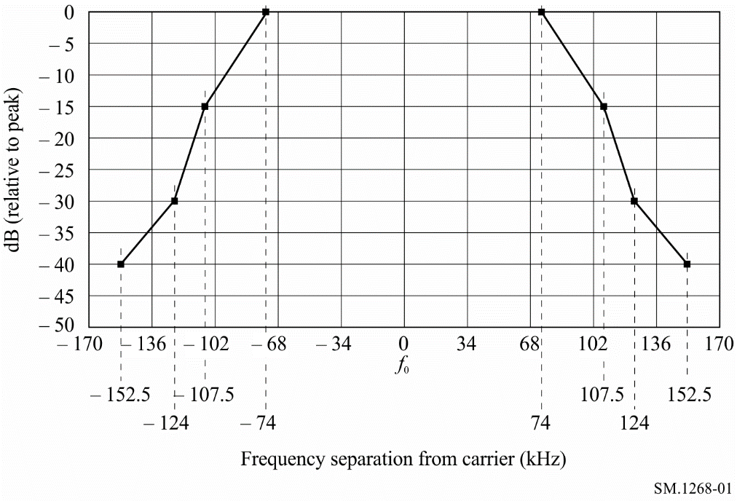

Annex 2
Method of measuring the maximum frequency deviation
of FM broadcast emissions at monitoring stations
TABLE OF CONTENTS
Page
1 General 5
1.1 Definitions 5
1.2 Introduction 7
1.3 Limits 7
1.4 Observation time 8
2 Required conditions for measurements 8
2.1 Required wanted-to-unwanted RF signal level ratio E_{n}/E_{s} at the measurement equipment 8
2.2 Multipath propagation and distortion 10
2.3 Wanted signal level at the receiver input 12
3 Characteristics of suitable measuring equipment 12
3.1 Reflection measurements 12
Page
3.2 Frequency deviation measurements 13
3.3 Modulation power measurements 13
4 Result evaluation 14
5 Presentation of measurement results 14
5.1 Modulation power 14
5.2 Frequency deviation 14

1 General

1.1 Definitions

Frequency deviation:
In the case of frequency modulation, the deviation of the frequency from the frequency of the unmodulated carrier f₀.

Instantaneous deviation:
In the case of frequency modulation, the instantaneous deviation Δf(t) is the difference between the instantaneous frequency at any given time (t) and the unmodulated carrier frequency (f₀). The instantaneous frequency is:
f(t) = f₀ + Δf(t)

Peak deviation:
In the case of frequency modulation, the peak deviation Δf is the absolute maximum of the difference between the unmodulated carrier frequency (f₀) and the instantaneous frequency f(t).

Composite signal:
This signal includes all stereo information (including the pilot tone) and may also include the traffic radio signal, the RDS signal and other additional signals.

Modulation power (also called multiplex power):
The relative power averaged over 60 s of the modulation signal according to the equation:
$modulation power \left[dBr\right]=10×\log\left\{\frac{2}{60s}×\int_{t_{0}}^{t_{0}+60s}{{\left(\frac{∆f\left(t\right)}{19 kHz}\right)}^{2}dt}\right\}$
where:
Δf(t): instantaneous deviation (kHz)
t: time
t₀: any start time.

0 dBr:
Is the average power of a signal equivalent to the power of a sinusoidal tone which causes a peak deviation of ±19 kHz.

AM depth:
Variation of the instantaneous RF amplitude with time.
$AM depth \left[\%\right]=100*\frac{U_{max}- U_{min}}{2*U_{ref}}$
where:
U_{max}: highest received voltage in the measurement time in µV
U_{min}: lowest received voltage in the measurement time in µV
U_{ref}: linear average received voltage in the measurement time in µV.

Mean value of AM depth:
${AM depth \left[\%\right]}_{mean} =100/∆t\int_{t_{0}}^{t_{0}+ ∆t}{\frac{U_{max}(t) - U_{min}(t)}{2*U_{ref}(t)}} dt$
with ∆t ≥ 10 s.

Channel response:
Relative frequency-dependant difference between maximum and minimum RF amplitude.
$Channel response \left[\%\right]=100*\frac{U_{max}- U_{min}}{2*U_{0}}$
where:
U_{max}: highest received voltage in µV
U_{min}: lowest received voltage in µV
U₀: received voltage at the centre frequency in µV.
FIGURE 2
Channel response
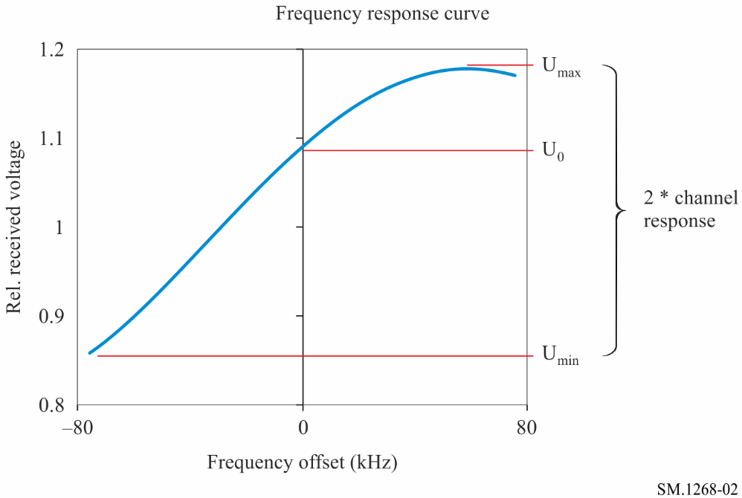
On first sight, the values for channel response and AM depth seem to be equal. Due to physical effects, however, the change in amplitude may not coincide in time with the change of frequency. This makes it difficult for analogue reflection meters to measure the frequency response curve accurately in all cases.

Mean value of channel response:
${Channel response \left[\%\right]}_{mean}=100/∆t\int_{t_{0}}^{t_{0}+∆t}{\frac{U_{max}(t)- U_{min }(t)}{2*U_{0} (t)} dt}$
with ∆t ≥ 10 s.

Reflection gradient:
Maximum slope (gradient) of the frequency-dependant RF amplitude
$Gradient \left[\frac{\%}{kHz}\right]=100*d(\frac{U}{U_{ref}})/df$
where:
U: instantaneous received voltage in µV
U_{ref}: linear average received voltage over frequency in µV
f: momentary offset from centre frequency in kHz.
FIGURE 3
Gradient
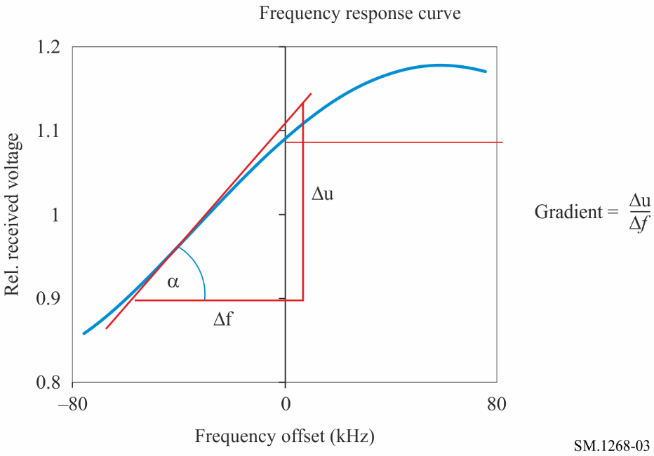

1.2 Introduction
There are various reasons, such as a reduction in the time required for the measurements, which make it seem sensible to carry out frequency deviation measurements in the field and not directly at the transmitter output. Compliance by the signal to be measured with the characteristics listed below is required in addition to compliance by the measuring equipment with the requirements described in § 3 in order to avoid measurement uncertainties.

1.3 Limits
The protection ratios specified in Recommendation ITU-R BS.412 for the planning of FM sound broadcasting transmitters apply on the condition that a peak deviation of ±75 kHz is not exceeded and that the average modulation power over any interval of 60 s does not exceed that of a single sinusoidal tone which causes a peak deviation of ±19 kHz.

1.4 Observation time
The observation time should be at least 15 min. In some cases, one hour or even longer may be required to be sure to measure programme material that leads to maximum values for frequency deviation and modulation power.

2 Required conditions for measurements

2.1 Required wanted-to-unwanted RF signal level ratio E_{n}/E_{s} at the measurement equipment
This ratio depends on the characteristics of the equipment used for the measurements. For the required accuracy defined in §§ 3.1 and 3.2, the level of unwanted emissions has to be below the values given in Tables 1 and 2.
Measurement receivers usually have either Gaussian or channel filters. In practical environments, Gaussian filters may be less suitable for peak deviation measurements than channel filters.
a) Measurement receivers with Gaussian IF filters
TABLE 1
Frequency difference ± Δf  (kHz) | Required protection ratio  (dB)
0 | 40
X

In Table 1, “B” is the nominal 3 dB bandwidth of the measurement filter in kHz.
The following diagram illustrates the required protection ratios with three example measurement bandwidths.
FIGURE 4
Required protection ratios for receivers with Gaussian filters
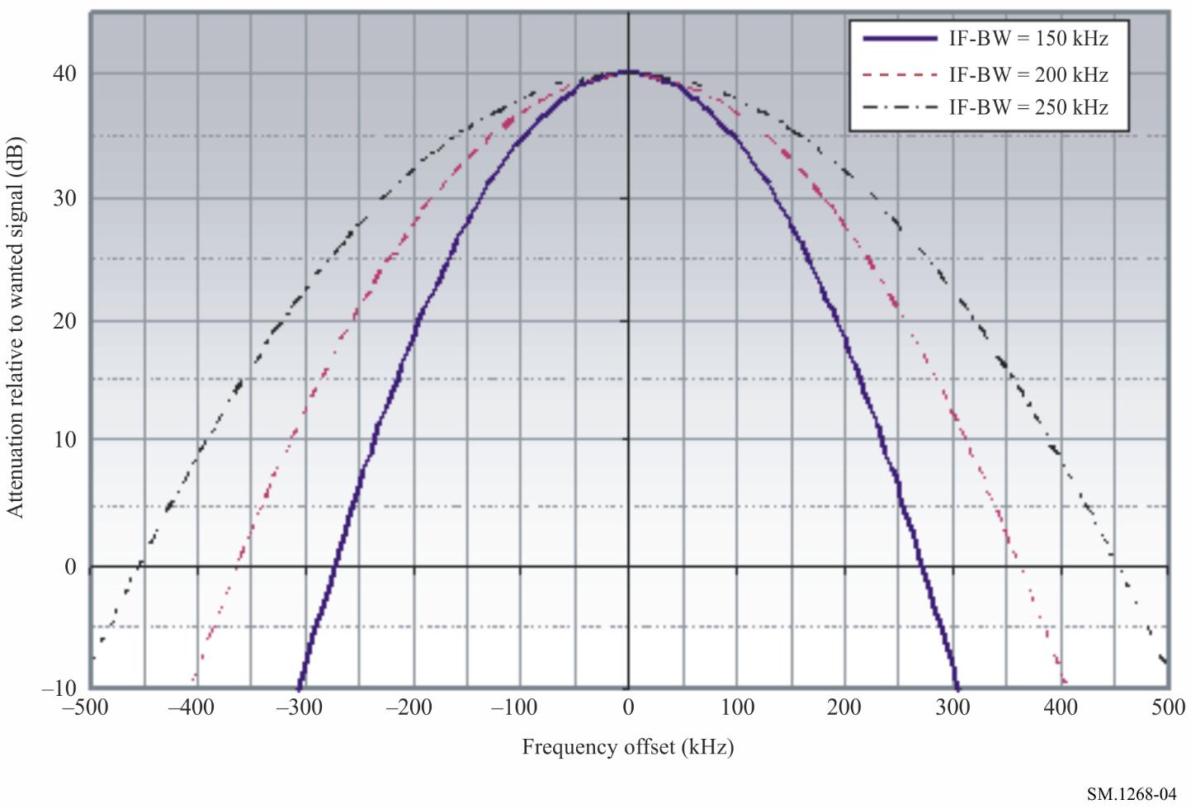
b) Measurement receivers with channel filters
TABLE 2
Frequency difference ± Δf  (kHz) | Required protection ratio  (dB)
0 | 40
B/2 | 35
X (for X > B/2) | 35 − 0.2*(X − B/2)

In Table 2, “B” is the nominal 3 dB bandwidth of the measurement filter in kHz. A linear interpolation is used between discrete values.
The following diagram illustrates the required protection ratios with three example measurement bandwidths.
FIGURE 5
Required protection ratios for receivers with channel filters
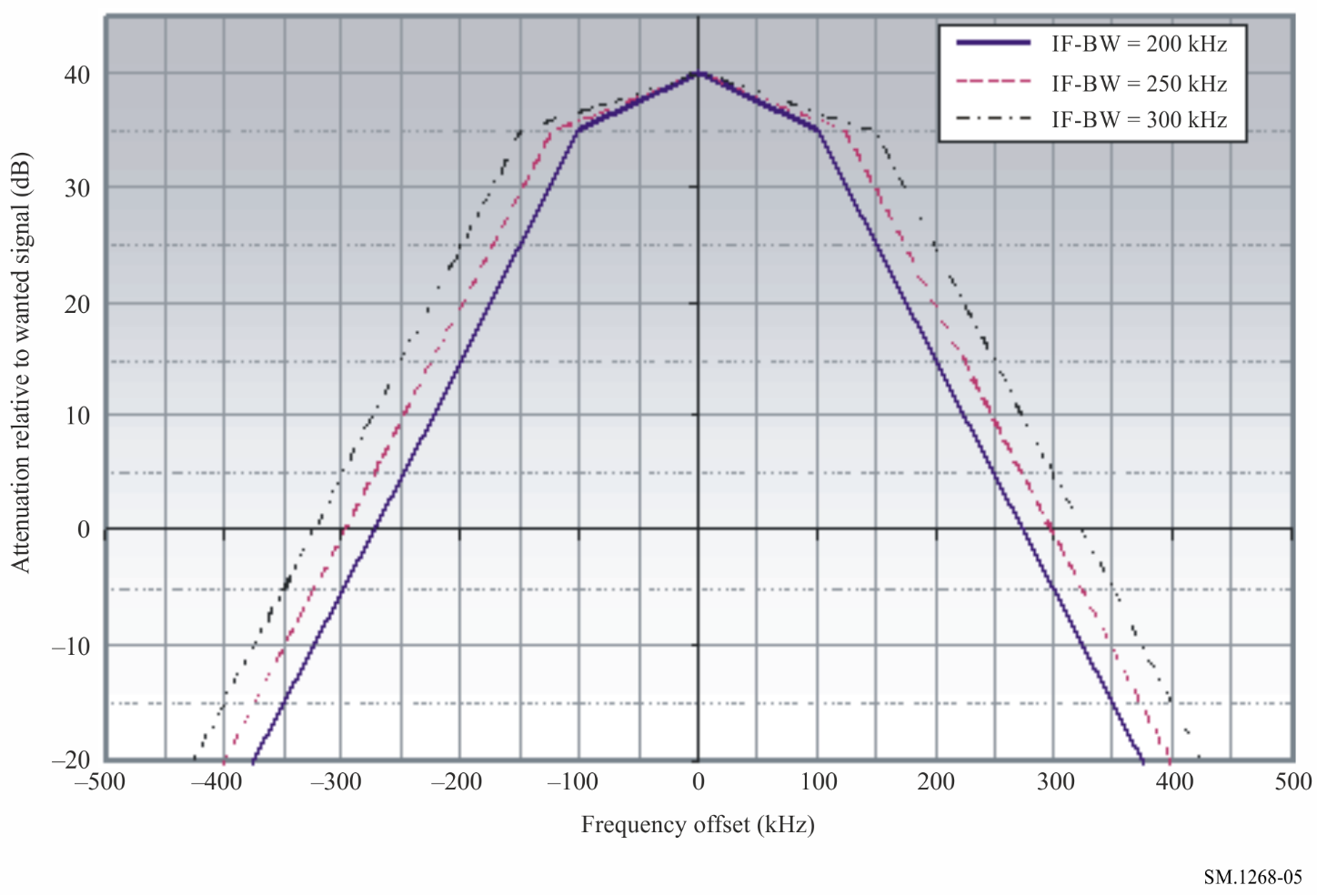
It is essential that the applicable protection ratios given above are observed because even a minor increase in unwanted signal levels will result in considerable measurement errors.

2.2 Multipath propagation and distortion
Delayed signals from the wanted transmitter as well as signals from other co-channel or adjacent channel transmitters shall be small enough to ensure that measurement results are not influenced by the effects of multipath propagation. In case of multipath reception only, it is considered to be sufficient if the product of delay time and amplitude ratio in percent is:
(U_{r}/U_{d}) ⋅ τ < 64% ⋅ μs (1)
where:
U_{r}: amplitude of the reflected signal
U_{d}: amplitude of the direct signal
τ: time delay (µs).
However, this product cannot be measured directly. A more general way of specifying the distortion created by both multipath reception and signals from other transmitters is based on the fact that all of these components result in a certain amplitude modulation of the received signal. This resulting amplitude modulation may be defined by the maximum gradient of the dependence of RF amplitude on RF frequency and is called distortion degree. In most cases, its value can be measured with reflection meters. However, the influence of the reflection gradient on the accuracy of deviation measurement depends on the path length difference between direct and reflected wave(s). The following two cases have to be distinguished:
a) The reflected wave(s) arrive(s) less than about 10 µs after the direct wave. This corresponds to a length difference between both waves of less than 3 km and is a typical situation in urban areas where the main reflections originate from the ground or nearby buildings. In this case, the reflection gradient is a suitable parameter to assess the effect of reflection. The corresponding maximum permissible gradient for stereophonic reception is 0.4%/kHz.
b) The reflected wave(s) arrive(s) more than about 10 µs after the direct wave. This corresponds to a length difference between both waves of more than 3 km and is a typical situation in rural areas where the main reflections originate from far away mountains. This results in high reflection gradients without seriously affecting the accuracy of the deviation measurement. In this case, AM depth and channel response are more suitable parameters to characterize the effect of reflection.
Laboratory tests have shown that the measurement location is suitable in any case if the AM depth is less than 5%, which corresponds to a suppression of the reflected wave by 26 dB, relative to the direct wave. In case of short echo delays, the measurement location may still be suitable if the quotient of channel response and AM depth is higher than 0.5.
In practice, it is sometimes not easy to decide which echo delay dominates. The following decision chart provides guidance on the determination of the suitability of a selected measurement location regarding reflection.
FIGURE 6
Decision chart
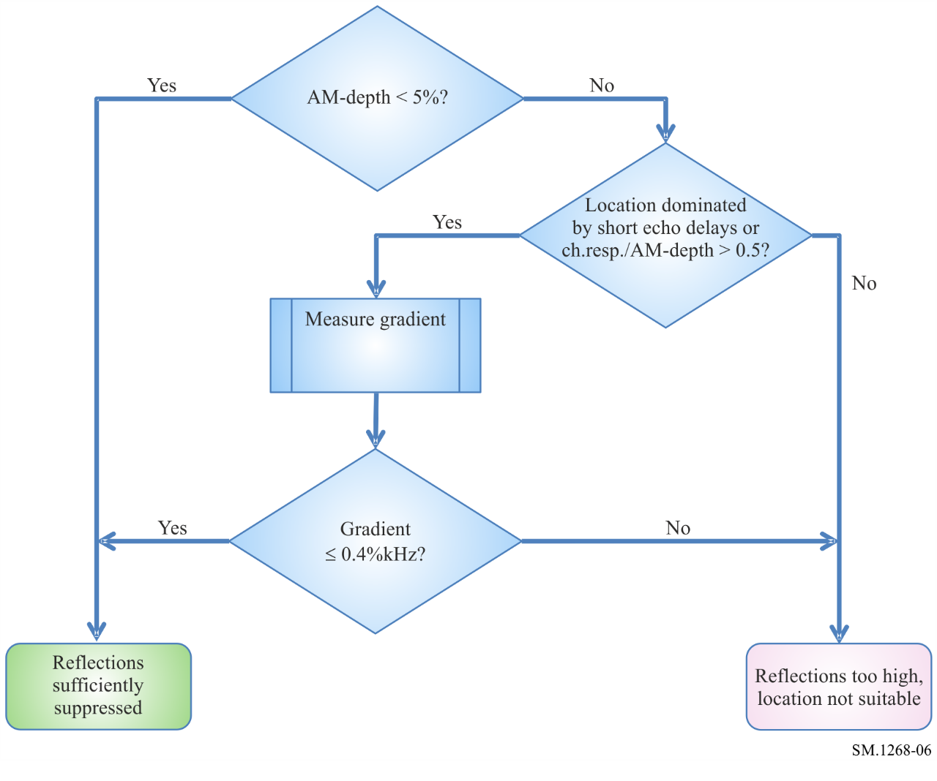
Short-term variations of the reflection environment (e.g. due to moving cars) should be excluded during the reflection measurement. Therefore, it is recommended to perform the reflection measurement only once prior to the deviation measurement. The final values for channel response and AM depth used for validation of the measurement location are the average results over a time of at least 10 seconds in order to ensure that instances where the signal is fully modulated are included in the result.
It is essential that the distortion degree does not exceed the limits above, because even minor increases will result in considerable measurement errors. It is possible to minimise the influence of reflections by changing the height of the receiving antenna. The optimum height is the height where the maximum field strength is obtained.

2.3 Wanted signal level at the receiver input
To ensure a sufficient AF signal-to-noise ratio, the wanted signal input level for the receiver should be at least −47 dBm.

3 Characteristics of suitable measuring equipment
To ensure that all the peaks of the frequency deviations are captured, the equipment must be able to detect the deviation caused by the highest component of the base band signal or composite signal.
For this reason, if digital measuring equipment is used, it must have a sampling rate of 200 kHz or higher depending on the maximum composite signal frequency.

3.1 Reflection measurements
Due to a lack of directivity of the measurement antenna, it will in most cases not be possible to measure the field strengths of wanted and unwanted emissions separately and use formula (1) to calculate the degree of distortion and multipath propagation. A more practical way to measure this parameter is the use of reflection meters that actually measure the amount of amplitude modulation in the received signal and compute the degree of multipath propagation using formula (2).
Ideally the reflection meter shall have a measurement bandwidth of 150 kHz. However, most reflection meters available have a bandwidth that is considerably smaller. In this case, the maximum permissible degree of multipath propagation is less than the 0.4%/kHz stated in § 2.2. Figure 7 shows the corrected values for maximum indicated degree of distortion, depending on the measurement bandwidth of the reflection meter.
FIGURE 7
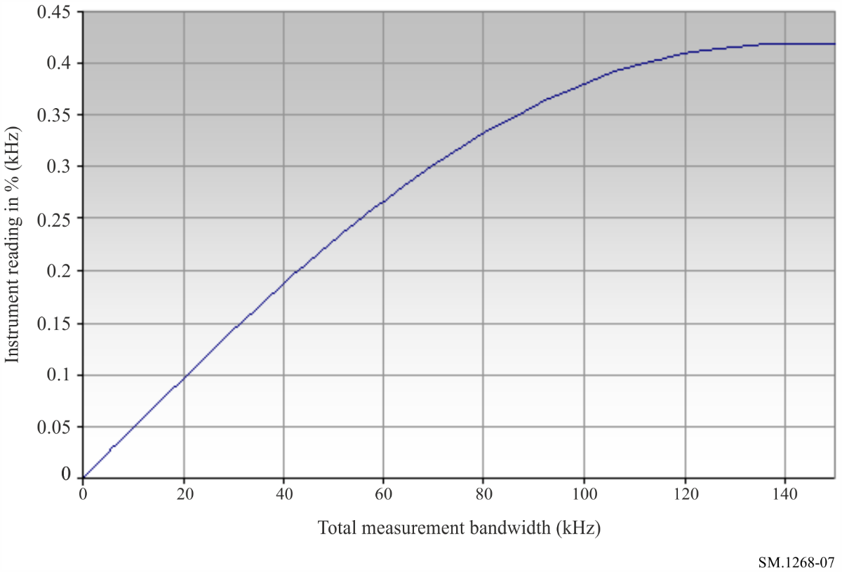
Reflection meters that apply sampling and digital evaluation of the gradient measurement have to apply a sampling speed of at least 1 MHz. This rate results in 10 usable samples per modulation period even at a highest assumed modulation frequency of 100 kHz. The algorithm to reduce the samples to a continuous gradient line has to apply a linear averaging function of the sample amplitudes.

3.2 Frequency deviation measurements
The measuring equipment used should be able to measure deviations of 100 kHz or higher. In addition, the measuring equipment must possess such characteristics that take into account the required measurement bandwidth, filter shape factor, etc. to ensure that nonlinearity and distortion do not lead to an inaccuracy greater than specified in Table 3.
TABLE 3
Instrument accuracy for deviation measurements
Instantaneous deviation | Required accuracy
≤ 80 kHz | ±2 kHz
> 80 kHz | ±5%

3.3 Modulation power measurements
The modulation power (dBr) is specified in dBr according to § 1.1. The measuring equipment shall be able to measure modulation power in the range from −6 dBr to +6 dBr. The instrument accuracy shall at least meet the values specified in Table 4.
TABLE 4
Instrument accuracy for modulation power measurements
Modulation power  (dBr) | Required accuracy  (dB)
< −2 | ±0.4
−2 to + 2 | ±0.2
> 2 | ±0.4

4 Result evaluation
It is considered inappropriate to regard the occurrence of single samples of the instantaneous frequency deviation above 75 kHz as a violation of the deviation limit, because:
a) the dynamic modulation of an FM broadcast transmitter by normal programme content may include modulation peaks that occur extremely seldom, and may not be reproducible in a second measurement;
b) even when the measurement conditions stated in § 2 are met, external interference cannot completely be avoided at all times.
For these reasons, and considering the measurement uncertainty with an aimed confidence level of 95%, an FM broadcast transmitter can be regarded as violating the deviation limit if a certain number of measurement samples exceed ± (75 kHz plus measurement uncertainty). 10⁻⁴% (equal to 10⁻⁶) of the measurement samples exceeding 77 kHz deviation (see Table 3) may be considered as a practical value.
Since the modulation power is averaged over a period of 60 s, short peaks included in the programme content or caused by external interference are already cancelled out to a great extent. Therefore, an FM broadcast transmitter can be regarded as violating the modulation power limit if the highest measured multiplex power value exceeds 0 dBr + measurement uncertainty. 0.2 dBr may be considered as a practical value, see Table 4.
NOTE – In the case that the network operator himself monitors the limits, it is recommended that the actual measurement uncertainty of the test receiver is subtracted from the limit values (75 kHz for deviation and 0.0 dBr for multiplex power). This ensures that these limit values are not violated when independently supervised by authorities according to the result evaluation above.

5 Presentation of measurement results

5.1 Modulation power
The modulation power shall be presented as a function of time during the measurement interval. The maximum value recorded must be indicated.

5.2 Frequency deviation
The percentage of samples exceeding 75 kHz + measurement uncertainty, see § 4, has to be indicated.
To provide more information the deviation can be represented by histograms and as a function of time. The graphs of frequency deviation are processed as follows:
a) divide the range of frequency deviation of interest (i.e. 150 kHz) into the desired resolution (for example 1 kHz) to give the number of bins B (in this case B=150 bins);
b) for each bin, count the number of samples which have a value within the bin;
c) for each bin x, add counts from bin x to bin B and normalize by the total number of samples N. The result is a plot of the complementary accumulated distribution as shown in Fig. 8;
d) additionally obtain M peak values during the observation time of the deviation. M depends on the resolution of the medium (device, screen, printer, etc.) on which the results are presented and on the observation time. The integration time of the peak values is observation time divided by M. Practical values of the integration time may be 1 s or 10 s. Those M peak values of the frequency deviation shall be presented as a function of time during the measurement interval as in Fig. 9.
FIGURE 8
Complementary accumulated distribution plot of deviation (histogram)
assuming a measurement uncertainty of 2 kHz
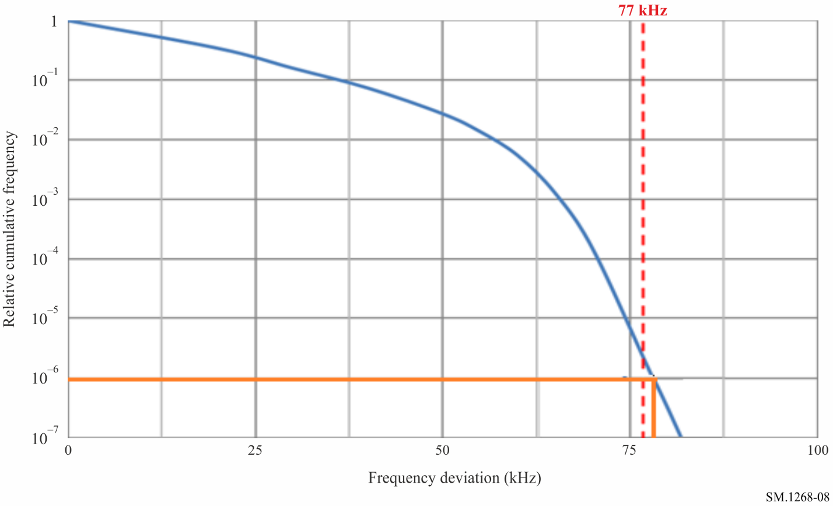
NOTE – The maximum frequency deviation exceeds 77 kHz in this example.
FIGURE 9
Plot of deviation as a function of time
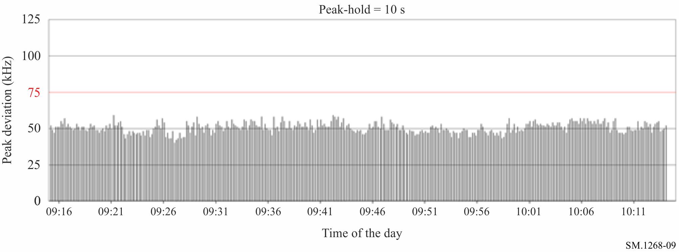

* Radiocommunication Study Group 1 made editorial amendments to this Recommendation in the year 2023 in accordance with Resolution ITU-R 1.
This corresponds to a field strength of about 68 dB(µV/m) using an antenna as recommended in Recommendation ITU-R BS.599, Fig. 1, Curve B (12 dB front-to-back ratio).

