Recommendation ITU-R SA.1164-3
(12/2018)
Sharing and coordination criteria for service links in data collection systems using GSO satellites in the Earth exploration-satellite and meteorological-satellite services

SA Series
Space applications and meteorology

Foreword
The role of the Radiocommunication Sector is to ensure the rational, equitable, efficient and economical use of the radio-frequency spectrum by all radiocommunication services, including satellite services, and carry out studies without limit of frequency range on the basis of which Recommendations are adopted.
The regulatory and policy functions of the Radiocommunication Sector are performed by World and Regional Radiocommunication Conferences and Radiocommunication Assemblies supported by Study Groups.

Policy on Intellectual Property Right (IPR)
ITU-R policy on IPR is described in the Common Patent Policy for ITU-T/ITU-R/ISO/IEC referenced in Annex 1 of Resolution ITU-R 1. Forms to be used for the submission of patent statements and licensing declarations by patent holders are available from http://www.itu.int/ITU-R/go/patents/en where the Guidelines for Implementation of the Common Patent Policy for ITU-T/ITU-R/ISO/IEC and the ITU-R patent information database can also be found.

Series of ITU-R Recommendations
(Also available online at http://www.itu.int/publ/R-REC/en)
Series | Title
BO | Satellite delivery
BR | Recording for production, archival and play-out; film for television
BS | Broadcasting service (sound)
BT | Broadcasting service (television)
F | Fixed service
M | Mobile, radiodetermination, amateur and related satellite services
P | Radiowave propagation
RA | Radio astronomy
RS | Remote sensing systems
S | Fixed-satellite service
SA | Space applications and meteorology
SF | Frequency sharing and coordination between fixed-satellite and fixed service systems
SM | Spectrum management
SNG | Satellite news gathering
TF | Time signals and frequency standards emissions
V | Vocabulary and related subjects

Note: This ITU-R Recommendation was approved in English under the procedure detailed in Resolution ITU-R 1.

Electronic Publication
Geneva, 2018

© ITU 2018
All rights reserved. No part of this publication may be reproduced, by any means whatsoever, without written permission of ITU.

RECOMMENDATION ITU-R SA.1164-3
Sharing and coordination criteria for service links in data collection systems using GSO satellites in the Earth exploration-satellite
and meteorological-satellite services
(Question ITU-R 142/7)
(1995-1997-1999-2018)
Scope
This Recommendation provides the sharing and coordination criteria to protect service links for data collection systems in the earth exploration-satellite and meteorological-satellite services using the aggregate interference criteria given in Recommendation ITU-R SA.1163.
Keywords
Sharing criteria, coordination criteria, power limits, data collection systems
Related ITU-R Recommendations and Reports
Recommendations ITU-R SA.1023 – Methodology for determining sharing and coordination criteria for systems in the Earth exploration-satellite and meteorological-satellite services
Recommendations ITU-R SA.1163 – Interference criteria for service links in data collection systems in the Earth exploration-satellite and meteorological-satellite services
Recommendations ITU-R SM.1448 – Determination of the coordination area around an earth station in the frequency bands between 100 MHz and 105 GHz
The ITU Radiocommunication Assembly,
considering
a) that the frequency bands allocated to the Earth exploration-satellite service (EESS) (including the meteorological-satellite (MetSat) service) may be shared by several systems, including those operating in other services;
b) that Recommendation ITU-R SA.1163 specifies the interference criteria needed to determine the sharing criteria;
c) that sharing criteria may be determined using the methodology described in Recommendation ITU-R SA.1023;
d) that the typical deployment of interfering stations may change over a period of years as a result of growth in the number of systems and revisions to frequency band allocations that are adopted by world radiocommunication conferences;
e) that by governing the use of the radio-frequency spectrum in their territory and through international coordination of frequency assignments, administrations may exercise a degree of control over the number of systems that may generate interference at significant levels;
f) that the interference levels encountered by shipborne earth stations in the MetSat service are unlikely to be worse than those encountered by earth stations operating on land;
g) Recommendation ITU-R SM.1448, which provides the methodologies for determining when coordination is warranted between transmitting terrestrial stations and earth stations,
recommends
1 that the single entry interference levels presented in Table 1, based on the analysis described in Annex 1, should be used as sharing and coordination criteria, or as the basis for alternative forms of sharing criteria (e.g. pfd limits), for the protection of stations operating in the EESS and MetSat service;
2 that a 6% peak increase in equivalent link noise temperature should be used as the threshold for coordination between transmitting space stations and receiving earth stations operating in the MetSat service;
3 that the deployment of interferers specified in Annex 1 and for the 401-403 MHz band in Annex 2, should be reviewed periodically in order to determine whether the typical interference environment and consequential sharing criteria should be revised.
TABLE 1
Sharing criteria for stations in the EESS and MetSat service
Frequency  band  (MHz) | Station  subject to  interference | Interfering signal power (dBW) in the reference bandwidth to be exceeded no more than  20% of the time |  | Interfering signal power (dBW) in the reference bandwidth to be exceeded no more than  p% of the time
 |  | Space-to-Earth | Terrestrial | Space-to-Earth | Terrestrial
401-403  Earth-to-space | Space  station | –201.5 dBW per  100 Hz (2) (3) | –201.5 dBW per  100 Hz (2) | –186.4 dBW per  100 Hz (1) (3)  p = 0.075 | –187.7 dBW per  100 Hz (2)  p = 0.025
1 670-1 690  space-to-Earth | Earth  station | –218.8 dBW per  100 Hz (2) | –198.8 dBW per  100 Hz(2) | –195.1 dBW per  100 Hz(2)  p = 0.0025 | –193.6 dBW per  100 Hz (2)  p = 0.011
2 025-2 110  Earth-to-space | Space  station | –211.2 dBW per  100 Hz (2) | –194.3 dBW per  100 Hz(2) | –187.6 dBW per  100 Hz(2)  p = 0.0025 | –186.0 dBW per  100 Hz (2)  p = 0.011
460-470  space-to-Earth | Earth  station | –207.5 dBW per  100 Hz (1) | –187.5 dBW per  100 Hz(1) | –183.9 dBW per  100 Hz (2)  p = 0.01 | –182.3 dBW per  100 Hz (2)  p = 0.045
(1) The interfering signal powers (dBW) in the reference bandwidths are specified for reception at elevation angles > 5°.
(2) The interfering signal powers (dBW) in the reference bandwidths are specified for reception at elevation angles > 3°.
⁽³⁾ These values account for multiple interferers in the space-to-space direction. See Annex 2.
Notes relative to Table 1:
NOTE 1 – The single-entry interfering signal power thresholds in Table 1 are the permissible levels of interfering signal power that fall within the specified reference bandwidth. Accordingly, the total power in interfering signals that are narrower than the reference bandwidth should be considered in frequency sharing analyses. In cases where the interfering bandwidth exceeds the reference bandwidth or does not fully overlap the passband of a specific receiver under study, the available frequency dependent rejection should be applied in conjunction with the specified permissible interference levels. The pertinent ITU-R SM Recommendations should be consulted for guidance on this matter.

NOTE 2 – The sharing criteria can be expressed as permissible pfd into the main beam of the receive antenna by subtracting 10 log (G λ2/4π) from the values given in Table 1, where G is the antenna gain and λ is the wavelength.
NOTE 3 – In deriving the above sharing criteria from permissible total levels of interfering signal power, no allowance has been made for interference from spurious emissions.
NOTE 4 – The specified level of single-entry interfering signal power may be directly converted to, and applied as, equivalent values of pfd only for earth stations that use low-gain, non-tracking antennas.
NOTE 5 – Both the long-term (20% of the time) and short-term (< 1% of the time) sharing criteria must be met in order for interference to be at or below permissible levels.
NOTE 6 – Sharing criteria specified for terrestrial interfering signal paths are applicable to ground-based stations. The criteria for space-to-Earth interfering signal paths also pertain to air-to-ground paths.

Annex 1
Basis of sharing and coordination criteria

1 Introduction
This Annex presents the implementation of Recommendation ITU-R SA.1023 using the interference criteria arrived at in Recommendation ITU-R SA.1163. The permissible interference levels are subdivided according to Recommendation ITU-R SA.1023 into space and terrestrial categories and then into the number of anticipated interferers in each category. The basis for these allotments is shown in Table 2 and a discussion of the interference environment in each band is presented below.

2 401-403 MHz band
The 401-402 MHz band is allocated on a primary basis to the meteorological-aids, space operation (space-to-Earth direction), EESS (Earth-to-space), and MetSat (Earth-to-space) services on a primary basis and to the fixed and mobile (except aeronautical mobile) services on a secondary basis. The allocations of space services in both directions within the band presents the need to account for interference that may occur in the space-to-space direction. This case is elaborated more specifically in Annex 2.
The 402-403 MHz band is allocated to the meteorological-aids, EESS (Earth-to-space), and MetSat (Earth-to-space) services on a primary basis and to the fixed, and mobile (except aeronautical mobile) services on a secondary basis.
For most of the time, stations in the EESS and MetSat service are expected to produce higher interference levels than the terrestrial services. In the short-term, propagation enhancements on terrestrial interference paths and the location variability of mobile stations may result in similar interference levels from space-to-Earth and terrestrial stations.

3 460-470 MHz band
The 460-470 MHz band is allocated to the mobile and fixed services on a primary basis and the Meteorological satellite service. For most of the time interference will occur from terrestrial stations. For brief periods additional interference sources from space systems can be expected.

4 1 670-1 690 MHz band
The 1 670-1 690 MHz band is allocated on a primary basis to the meteorological aids, MetSat (space-to-Earth), fixed and mobile services and, the 1 670-1 675 MHz band is allocated to the mobile-satellite service (Earth-to-space) on a primary basis.

5 2 025-2 110 MHz band
The 2 025-2 110 MHz band is allocated on a primary basis to the fixed and mobile services, to the space research service (Earth-to-space and space-to-space), to the space operation service (Earth-to-space and space-to-space), and to the EESS (Earth-to-space and space-to-space).
TABLE 2
Parameters used to derive sharing criteria
Frequency  band  (MHz) | Long-term apportionment between categories of interferers |  | Short-term apportionment between categories of interferers |  | Equivalent number of  long-term interferers |  | Equivalent number of  short-term interferers
 | Interfering signal path |  | Interfering signal path |  | Interfering signal path |  | Interfering signal path
 | Space-to-Earth | Terrestrial | Space-to-Earth | Terrestrial | Space-to-Earth | Terrestrial | Space-to-Earth | Terrestrial
401-403 | 90% | 10% | 75% | 25% | 9 ⁽¹⁾ | 1 | 1 | 1
1 670-1 690 | 1% | 99% | 10% | 90% | 1 | 1 | 1 | 2
2 025-2 110 | 1% | 99% | 10% | 90% | 1 | 2 | 1 | 2
460-470 | 1% | 99% | 10% | 90% | 1 | 1 | 1 | 2
⁽¹⁾ This value accounts for the number of space-to-Earth interferers in view of the Earth-to-space victim link at the GSO. See Annex 2.

Annex 2
Application of the sharing and coordination criteria in the band 401-403 MHz

1 Introduction
This Annex discusses the application of the sharing criteria for protecting the Data Collection Systems (DCS) in the 401-403 MHz band in view of allocation updates and prospective usage.
Recently there has been a growing interest in the use of small satellite systems for a variety of uses, including Earth sensing missions and communications missions. Some of these new systems have filed for the use of the 401-402 MHz space operations band (space-to-Earth), which is co-primary with the Meteorological Aids service, the Earth exploration-satellite (Earth-to-space) service (EESS), and the meteorological satellite (Earth-to-space) (MetSat) service.
Small satellites can use the 401-402 MHz band for space operations in the space-to-Earth direction. Because of their small size, the antennas used for space-to-Earth communications can also be small in size, limiting the amount of antenna gain that can be achieved. In addition, maintaining pointing of a space-to-Earth antenna may not be possible. These factors could result in a significant level of interfering radio frequency energy directed towards geostationary orbit, where the DCS signals are received on meteorological satellites.

2 Power limit to protect DCS
This Annex elaborates on the need for power limits to account for transmitters in the space operations service in the 401-403 MHz band, to protect EESS and MetSat receiving space stations on geostationary satellites where the interfering path is in the space-to-space direction. This analysis illustrates the adaptation of existing sharing criteria to the special case of expanding use of the space-to-Earth allocation to control the potential of interference to the DCS operations.
Table 1 of Recommendation ITU-R SA.1163 defines long- and short-term interference criteria for the 401 to 403 MHz band. The long-term criteria, specified at the input to the satellite receiver, is given as −191.5 dB(W/100 Hz). The long-term criteria value is relevant to this analysis because interference from a full constellation of satellites in low Earth orbit can be characterized as long-term when viewed from an EESS or MetSat receiver stationed in the geostationary orbit.
The following sections derive a power limit to protect EESS and MetSat receivers, and then translates this to a pfd that can be evaluated along the geostationary orbit. A rational method is described for assessing the relationship between the aggregate interference criteria and a single-entry limit, in the current environment of rapidly increasing space system developments. First, the likely maximum number of co-frequency, in-view, low Earth orbit Space Operations transmitters is estimated. Second, the applicable interference criterion from Recommendation ITU-R SA.1163 is divided by this value to provide a single-entry interference power limit at the EESS receiver in geostationary orbit. This single-entry power limit is then translated into a single-entry pfd limit, which can be evaluated at geostationary orbit.

2.1 Estimation of co-frequency, in-view, low-Earth-orbit transmitters in the Space Operations service as seen from geostationary orbit
It is assumed that there can be no more than one low-earth orbit satellite transmitting to any given space operations ground station on a given frequency. The area around the ground station within which this is applied can be called a single-frequency exclusion zone. For an assumed common orbital altitude for the constellation of 400 km, the co-frequency exclusion zone is approximately 9 200 000 km² in area (see Fig. 1). The total area in view of the geostationary satellite is 226 000 000 km². There are then approximately 25 of these exclusion zones in view of a geostationary satellite. If it is further assumed that the same frequency cannot be used in adjacent exclusion zones because there will be geographic overlap in the real case, then in the highest density case the same frequency could be used in approximately 1/3 of these exclusion zones (three-color frequency re-use), or roughly eight or nine zones (see Fig. 2). This analysis assumes that 9 zones could be re-using a common space operations frequency within view of a geostationary satellite.
FIGURE 1
Single-frequency exclusion zone
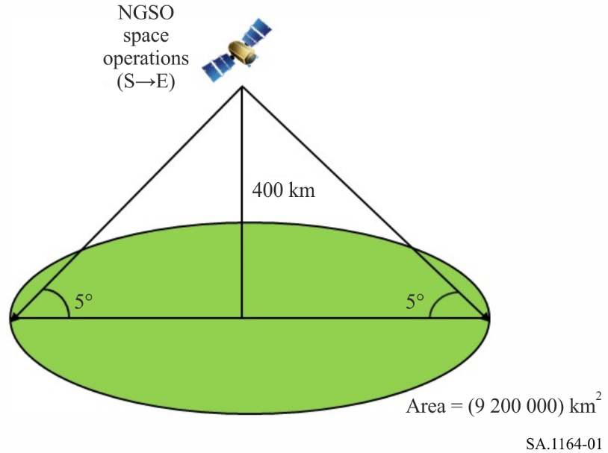
FIGURE 2
3-color frequency re-use
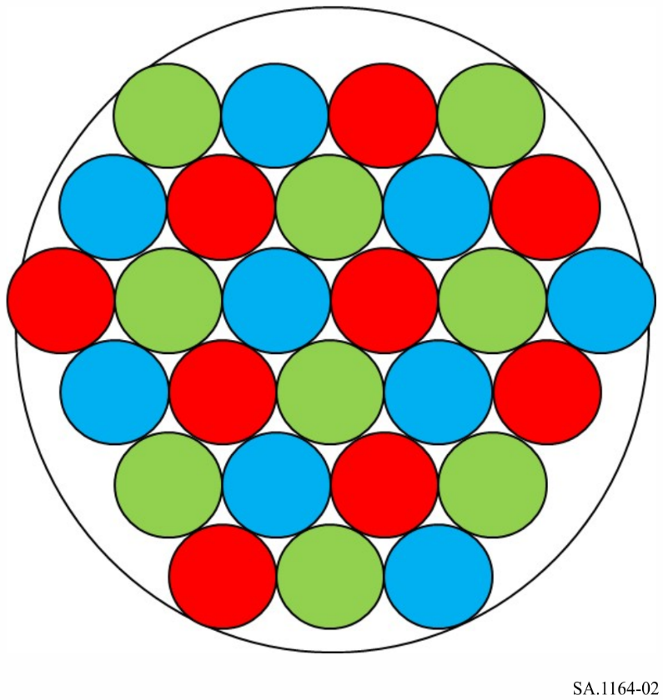

2.2 Power limit calculation (long-term) to protect DCS
Given that an estimated nine satellites in view of a DCS receiver could be using the same frequency, and that the apportionment of interference power on the space-to-Earth path is 90% of the total interference power (from Table 2), the single-entry interference power limit at the DCP-R satellite receiver is therefore:
−191.5 dB(W/100 Hz) + 10*LOG10(0.9) − 10*LOG10(9) = −201.5 dB(W/100 Hz).

2.3 Pfd calculation (long-term) to protect DCS
The conversion to a single-entry pfd limit is given in Table 3.
TABLE 3
Long-term sharing criteria and pfd calculation to protect DCS Item
Long-term sharing criteria and pfd calculation to protect DCS Item | Value | Units
Interference criteria (Rec. ITU-R SA.1163, Table 1) | −191.5 | dB(W/100 Hz)
Apportionment to space-to-Earth interference path | 90 | %
Interference criteria, space-to-Earth path component | −192.0 | dB(W/100 Hz)
Equivalent number of long-term interferers | 9 | -
Sharing criteria (single entry) | −201.5 | dB(W/100 Hz)
DCPR spacecraft receive antenna gain ⁽¹⁾ | 13.8 | dBi
Receive isotropic area | −13.5 | dB(m²)
Pfd (single entry) in reference bandwidth | −201.8 | dB(W/m²/100 Hz)
⁽¹⁾ DCPR spacecraft receive antenna gain is taken from Rec. ITU-R SA.1163, Table 1.

The equivalent sharing criteria, stated as a single entry pfd at geostationary orbit, is then −201.8 dB(W/m²/100 Hz). This is the single-entry limit to be met by any satellite in the space operations service that is operating in the band 401 to 403 MHz.

See Report ITU-R SA.2312-0 – Characteristics, definitions and spectrum requirements of nanosatellites and picosatellites, as well as systems composed of such satellites.
Table 2 of Report ITU-R SA.2312-0 describes the antenna directionality of typical nanosatellite and picosatellite systems as “Typically only 1 or 2 active antennas per band, often omnidirectional (for example due to lack of attitude control and/or antenna pointing mechanisms)”.

