Recommendation ITU-R RS.2066-1
(03/2024)
RS Series: Remote sensing systems
Protection of the radio astronomy service in the frequency band 10.6-10.7 GHz from unwanted emissions of synthetic aperture radars operating in the Earth exploration-satellite service (active) around 9 600 MHz

Foreword
The role of the Radiocommunication Sector is to ensure the rational, equitable, efficient and economical use of the radio-frequency spectrum by all radiocommunication services, including satellite services, and carry out studies without limit of frequency range on the basis of which Recommendations are adopted.
The regulatory and policy functions of the Radiocommunication Sector are performed by World and Regional Radiocommunication Conferences and Radiocommunication Assemblies supported by Study Groups.

Policy on Intellectual Property Right (IPR)
ITU-R policy on IPR is described in the Common Patent Policy for ITU-T/ITU-R/ISO/IEC referenced in Resolution ITU-R 1. Forms to be used for the submission of patent statements and licensing declarations by patent holders are available from http://www.itu.int/ITU-R/go/patents/en where the Guidelines for Implementation of the Common Patent Policy for ITU-T/ITU-R/ISO/IEC and the ITU-R patent information database can also be found.

Series of ITU-R Recommendations
(Also available online at https://www.itu.int/publ/R-REC/en)
Series | Title
BO | Satellite delivery
BR | Recording for production, archival and play-out; film for television
BS | Broadcasting service (sound)
BT | Broadcasting service (television)
F | Fixed service
M | Mobile, radiodetermination, amateur and related satellite services
P | Radiowave propagation
RA | Radio astronomy
RS | Remote sensing systems
S | Fixed-satellite service
SA | Space applications and meteorology
SF | Frequency sharing and coordination between fixed-satellite and fixed service systems
SM | Spectrum management
SNG | Satellite news gathering
TF | Time signals and frequency standards emissions
V | Vocabulary and related subjects

Note: This ITU-R Recommendation was approved in English under the procedure detailed in Resolution ITU-R 1.

Electronic Publication
Geneva, 2024

© ITU 2024
All rights reserved. No part of this publication may be reproduced, by any means whatsoever, without written permission of ITU.

RECOMMENDATION ITU-R RS.2066-1
Protection of the radio astronomy service in the frequency band 10.6-10.7 GHz from unwanted emissions of synthetic aperture radars operating in the Earth exploration-satellite service (active) around 9 600 MHz
(2014-2024)
Scope
This Recommendation provides an operational procedure to avoid main-beam to main-beam coupling between Earth exploration-satellite service (EESS) (active) SAR-4 systems when transmitting near 9 600 MHz and radio astronomy service (RAS) stations performing observations in the band 10.6-10.7 GHz in order to avoid damage to the sensitive RAS low noise amplifier.
Keywords
EESS (active), RAS, mitigation
Abbreviations/Glossary
SAR Synthetic Aperture Radar
Related ITU Recommendations/Reports
Recommendation ITU-R RS.2043 – Characteristics of synthetic aperture radars operating in the Earth exploration-satellite service (active) around 9 600 MHz
Report ITU-R RA.2188 – Power flux-density and e.i.r.p. levels potentially damaging to radio astronomy receivers
Report ITU-R RS.2274 – Spectrum requirements for spaceborne synthetic aperture radar applications planned in an extended allocation to the Earth exploration-satellite service around 9 600 MHz
Report ITU-R RS.2308 – Radio frequency compatibility of unwanted emissions from 9 GHz EESS synthetic aperture radars with the Earth exploration-satellite service (passive), space research service (passive), space research service and radio astronomy service operating in the frequency bands 8 400-8 500 MHz and 10.6-10.7 GHz, respectively
The ITU Radiocommunication Assembly,
considering
a) that the frequency band 9 300-9 800 MHz is allocated to EESS (active) on a primary basis;
b) that the frequency band 9 800-9 900 MHz is allocated to EESS (active) on a secondary basis;
c) that the frequency band 10.6-10.7 GHz is allocated to the RAS on a primary basis;
d) that EESS (active) systems operating active radars around 9 600 MHz use high power chirp emissions in the space-to-Earth direction;
e) that radio astronomy stations operating in the frequency band 10.6-10.7 GHz use extremely sensitive low noise amplifiers;
f) that Report ITU-R RA.2188 provides the power flux-density and e.i.r.p. levels potentially damaging RAS low noise amplifiers/front-ends;
g) that the level of interference received by RAS stations from the emissions of EESS (active) systems may, under rare conditions of mainbeam to main beam coupling, reach or exceed the critical levels as given by Report ITU-R RA.2188,
recommends
1 that, in order to ensure compatibility of EESS SAR with RAS stations, EESS SAR systems operating around 9 600 MHz should avoid, to the maximum possible extent, to illuminate an area around radio astronomy stations. The size of such an area is defined in Annex 1. Annex 2 provides the list of RAS stations capable to operate in the frequency band 10.6-10.7 GHz and which may perform observations during times of illumination;
2 that, in the event that the conditions referred to in recommends 1 are not met, the operator of the EESS SAR system should contact the operator of the concerned radio astronomy station at least seven calendar days before an event for EESS SAR routine operations and at least 24 hours for EESS SAR acquisition of images in cases of emergency only such as disaster management in order to coordinate and, if necessary, to agree on mitigation or other preventive measures.

Annex 1
Determination of the protection area surrounding RAS stations
The emission beam contour corresponding to the margin determined by applying Recommendation ITU-R RA.2188 defines the damage zone for a potential boresight-to-boresight coupling of both antenna beams. Such a contour has the shape of an ellipse with a major axis δθ_{h} in the horizontal and the minor axis δθ_{v} in the vertical beam direction, thus defining an area where the power level at the RAS station would exceed −18 dBW. The projection onto the Earthʼs surface provides the dimension of an area of size with an extension of ±δh in the horizontal direction and ±δv in the vertical direction around the radio astronomy station which should be protected. Table 1 provides the parameter range for the avoidance of accidental damage to an RAS receiver with an antenna diameter of 100 m with regard to SAR-4 as described in Recommendation ITU-R RS.2043.
TABLE 1
Parameters for the avoidance of accidental damage to RA receivers
Incident angle Φ | Horizontal offset angle δθ_{h} | Vertical offset angle δθ_{v} | Horizontal separation (km) δh | Vertical separation (km) δv
20° | 1.02° | 1.8° | 9.6 | 18.2
55° | 0.5° | 1.1° | 7.4 | 28.1

Figure 1 provides the size of the area around the RAS station to be protected, depending on the RAS antenna diameter and the incidence angle. It can be seen that there is no constraint for RAS stations having an antenna diameter less than 17 m, and that the maximum separation distance from the RAS station is 28 km for most RAS stations.
figure 1
Size of the area around RAS stations to be protected assuming EESS SAR-4 characteristics
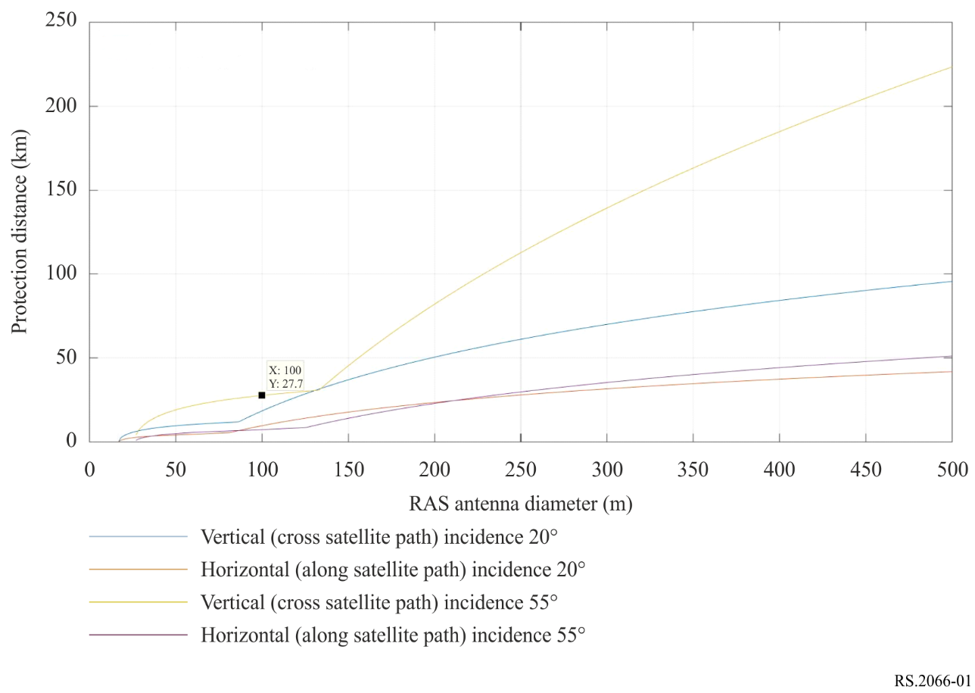
More generally, for a given incident angle i, the distance between the SAR satellite and the acquisition area is given by:
$d=\sqrt{{\left(r+h\right)}^{2}-r^{2}*sin²(i)}-r*cos(i)$
where:
r: Earth radius (km)
i: incidence angle (°)
h: SAR altitude (km).
The corresponding angle between the nadir and the acquisition area in the vertical plane is given by:
$θ_{v}=asin\left(\frac{r*sin\left(i\right)}{r+h}\right)$
where:
r: Earth radius (km)
i: incidence angle (°)
h: SAR altitude (km).
The maximum gain of the RAS antenna can be derived from the antenna diameter and the frequency using the following equation:
$G_{r}=8.9+20\log{(πDf)}$
where:
D: RAS antenna diameter (m)
f: frequency (GHz).
From these values, the SAR antenna gain limit that allows the received power limit of −18 dBW to be met is given by:
$Ge={Pr}_{limit}+L_{p}-G_{r}-P_{e}$
where:
Pr_{limit}: received power not to be exceeded (−18 dBW below 20 GHz)
L_{p}: free space loss (dB)
G_{r}: RAS maximum antenna gain (dBi)
P_{e}: SAR peak power (dBW).
Using the horizontal and vertical SAR antenna patterns, it is possible to determine the corresponding offset angles δθ_{h} and δθ_{v}. From these angles, one can derive the horizontal and vertical separation distances δh and δv.
$δh=r*asin\left(\frac{dtan\left(δθ_{h}\right)}{r}\right)$
where:
r: Earth radius (km)
d: slant range (km)
$δθ_{h}$: horizontal offset angle (degree).
The slant range between the satellite and the RAS station that meets the received power limit is given by:
$d+δd=\left(r+h\right)cos\left(θ_{v}+δθ_{v}\right)-\sqrt{r^{2}-\left(r+h\right)²sin²\left(θ_{v}+δθ_{v}\right)}$
where:
r: Earth radius (km)
d: slant range between satellite and acquisition area (km)
h: SAR satellite altitude (km)
θ_{v}: angle between nadir and acquisition area in the vertical plane (°)
$δθ_{v}$: vertical offset angle (degree).
And also, one can derive the vertical separation distance, δv:
$δv=r\left(asin\left(\frac{\left(d+δd\right)}{r}sin\left(θ_{v}+δθ_{v}\right)\right)-asin\left(\frac{d}{r}sin\left(θ_{v}\right)\right)\right)$
where:
r: Earth radius (km)
d: slant range between satellite and acquisition area (km)
d+$δd$: slant range between satellite and RAS station (km)
θ_{v}: angle between nadir and acquisition area in the vertical plane (°)
$δθ_{v}$: vertical offset angle (degree).

Annex 2
List of radio astronomy stations capable of operating in the band 10.6-10.7 GHz

Region 1
Country | Name | N latitude | E longitude | Antenna size
Belgium | Humain | 50° 11' 30" | 05° 15' 27" | 64 m
Finland | Metsahövi | 60° 13' 04" | 24° 23' 37" | 13.7 m, 13.2 m
France | Nancay | 47° 23' 00" | 02° 12' 00" | 16 × 1.1 m
Germany | Effelsberg | 50° 31' 29" | 06° 53' 03" | 100 m
 | Stockert | 50° 34' 10" | 06° 43' 19" | 10 m
 | Wettzell | 49° 08' 41" | 12° 52' 40" | 20 m,  2 × 13.2 m
Italy | Matera | 40° 38' 58.2" | 16° 42' 14.45" | 20 m, 13.2 m
 | Medicina | 44° 31' 14" | 11° 38' 49" | 32 m, 2.4 m
 | Noto | 36° 52' 33'' | 14° 59' 20'' | 32 m
 | Sardinia | 39° 29' 34" | 09° 14' 42" | 64 m
Latvia | Ventspils | 57° 33' 12" | 21° 51' 17" | 32 m
Norway | Ny Ålesund | 78° 55' 45" | 11° 52' 15" | 2 × 13.2 m
Portugal
 | Santa Maria | 36° 59' 07" | ‒25° 07' 33" | 13 m
Russia | Badari | 51° 46' 10" | 102° 14' 00" | 32 m, 13.2 m
 | Kaliazyn | 57° 13' 22" | 37° 54' 01" | 64 m
 | Pushchino | 54° 49' 20" | 37° 37' 53" | 22 m
 | Svetloe | 60° 31' 56" | 29° 46' 54" | 32 m, 13.2 m
 | Zelenchukskaya | 43° 49' 34" | 41° 35' 12" | 32 m, 13.2 m
South Africa | Hartebeesthoek | –25° 53' 22" | 27° 41' 05" | 26 m, 13.2 m
 | MeerKAT | –30° 43' 16" | 21° 24' 40" | 64 × 13.5 m
 | SKA1-MID | –30° 42' 47" | 21° 26' 38" | 133 × 15 m
Spain | Gran Canaria | 28° 01' 34" | ‒15° 40' 16" | 13.2 m
 | Robledo | 40° 25' 38" | –04° 14' 57" | 70 m, 34 m
 | Tenerife | 28° 18' 00" | –16° 30' 35" | 12 m
 | Yebes | 40° 31' 27" | –03° 05' 13" | 40 m, 13.2 m
Sweden | Onsala | 57° 23' 45" | 11° 55' 35" | 20 m, 25 m,  2 × 13.2 m
Switzerland | Bleien | 47° 20' 24" | 08° 06' 42" | 5 m, 7 m
 | Zurich | 47° 22' 40.8" | 08° 33' 03" | 5 m
Turkey | Kayseri | 38° 42' 37" | 35° 32' 43" | 13 m
UK | MERLIN Cambridge | 52° 10' 01" | 00° 02' 14" | 32 m
 | MERLIN Knockin | 52° 47' 25" | –02° 59' 50" | 25 m
 | MERLIN Darnhall | 53° 09' 23" | –02° 32' 09" | 25 m
 | MERLIN Jodrell Bank | 53° 14' 07" | –02° 18' 23" | 26 m
 | MERLIN Pickmere | 53° 17' 19" | –02° 26' 44" | 25 m
 | MERLIN Defford | 52° 06' 02" | –02° 08' 40" | 25 m

List of radio astronomy stations capable of operating in the band 10.6-10.7 GHz
Region 2
Country | Name | N latitude | E longitude | Antenna size
Brasil | Itapetinga | –23° 11' 05" | –46° 33' 28" | 14 m
Canada | Algonquin Radio Obsy | 45° 57' 19" | –78° 04' 23" | 46 m
Chile | ALMA | –23° 01' 09" | –67° 45' 12" | 54 × 12 m, 12 × 7 m
Mexico | INAOE RT5 | 18° 59' 04" | –97° 18' 32" | 50 m
USA | Allen Telescope Array (ATA), Hat Creek Radio Observatory | 40° 49' 03" | –121° 28' 24" | 42 × 6 m
 | Arecibo | 18° 20' 39" | –66° 45' 10" | 305 m
 | Goddard Geophysical and Astronomic Observatory (GGAO) | 39° 01' 19" | –76° 49' 37" | 12 m
 | Goldstone Deep Space Communications Complex (GDSCC) | 35° 25' 33" | –116° 53' 22" | 70.3 m
 | Robert C. Byrd Telescope, Green Bank Observatory | 38° 25' 59" | –79° 50' 23" | 100 m
 | Westford Radio Telescope, Haystack Observatory | 42° 36' 47" | –71° 29' 38" | 18.3 m
 | Kōkeʻe Park Geophysical Observatory (KPGO) | 22° 07' 34" | –159° 39' 54" | 20 m, 12 m
 | Jansky Very Large Array (JVLA) | 33° 58' 22"  to  34° 14' 56" | –107° 24' 40"  to  –107° 48' 22" | 27 × 25 m
 | McDonald Geodetic Observatory (MGO) | 30° 40' 48" | –104° 01' 26" | 12 m
 | VLBA Brewster, WA | 38° 25' 59" | –79° 50' 23" | 25 m
 | VLBA Fort Davis, TX | 30° 38' 06" | –103° 56' 41" | 25 m
 | VLBA Hancock, NH | 42° 56' 01" | –71° 59' 12" | 25 m
 | VLBA Kitt Peak, AZ | 31° 57' 23" | –111° 36' 45" | 25 m
 | VLBA Los Alamos, NM | 35° 46' 30" | –106° 14' 44" | 25 m
 | VLBA Mauna Kea, HI | 19° 48' 05" | –155° 27' 20" | 25 m
 | VLBA North Liberty, IA | 41° 46' 17" | –91° 34' 27" | 25 m
 | VLBA Owens Valley, CA | 37° 13' 54" | –118° 16' 37" | 40 m,  5 × 2 m,  8 × 2 m,  2 × 27 m
 | VLBA Pie Town, NM | 34° 18' 04" | –108° 07' 09" | 25 m
 | VLBA St. Croix, VI | 17° 45' 24" | –64° 35' 01" | 25 m

List of radio astronomy stations capable of operating in the band 10.6-10.7 GHz
Region 3
Country | Name | N latitude | E longitude | Antenna size
Australia | Parkes | –33° 00' 00" | 148° 15' 44" | 64 m
 | Katherine | –14° 22' 30" | 132° 09' 07" | 12 m
 | Mopra | –31° 16' 04" | 149° 05' 58" | 22 m
 | ATCA (Narrabri) | –30° 18' 47" | 149° 33' 52" | 6 × 22 m
 | Tidbinbilla | –35° 24' 18" | 148° 58' 59" | 70 m, 34 m
 | Hobart (Mt. Pleasant) | –42° 48' 18" | 147° 26' 21" | 26 m, 12 m
 | Ceduna | –31° 52' 05" | 133° 48' 37" | 30 m
 | Yarragadee | –29° 02' 47" | 115° 20' 48" | 12 m
China | Miyun | 40° 33' 29" | 116° 58' 37" | 50 m
 | Sheshan | 31° 05' 58" | 121° 11' 59" | 25 m, 13 m
 | Nanshan | 43° 28' 16" | 87° 10' 40" | 26 m, 13.2 m
 | Tianma | 31° 05' 13" | 121° 08' 00" | 65 m, 13 m
 | CSRH | 42° 12' 31" | 115° 14' 45" | 60 × 2 m
 | QTT | 43° 36' 04" | 89° 40' 57" | 110 m
France | Tahiti | −17° 31' 05" | −149° 26' 13" | 12 m
Japan | Nobeyama | 35° 56' 40" | 138° 28' 21" | 45 m
 | VERA-Mizusawa | 39° 08' 01" | 141° 07' 57" | 20 m, 10 m
 | VERA-Iriki | 31° 44' 52" | 130° 26' 24" | 20 m
 | VERA-Ogasawara | 27° 05' 31" | 142° 13' 00" | 20 m
 | VERA-Ishigakijima | 24° 24' 44" | 124° 10' 16" | 20 m
 | Ishioka | 36° 12' 33" | 140° 13' 08" | 13.2 m
 | Kashima | 35° 57' 21" | 140° 39' 36" | 34 m
 | Usuda | 36° 07' 57" | 138° 21' 46" | 64 m
 | Ibaraki | 36° 41' 51" | 140° 41' 32" | 32 × 2 m
 | Gifu | 35° 28' 03" | 136° 44' 14" | 11 m
 | Yamaguchi | 34° 12' 58" | 131° 33' 26" | 32 m
 | Tsukuba-NICT | 36° 03' 33" | 140° 08' 05" | 1.6 m
 | Koganei-NICT | 35° 42' 37" | 139° 29' 17" | 2.4 m, 11 m
Korea | KSWC (Jeju) | 33° 25' 40" | 126° 17' 45" | 1.8 m
 | SGOC (Sejong) | 36° 31' 22" | 127° 18' 12" | 22 m
 | K-SRBL | 36° 23' 54" | 127° 22' 31" | 2.1 m
 | KVN-Yonsei | 37° 33' 55" | 126° 56' 27" | 21 m
 | KVN-Ulsan | 35° 32' 44" | 129° 14' 59" | 21 m
 | KVN-Tamna | 33° 17' 21" | 126° 27' 34" | 21 m
New Zealand | Warkworth | –36° 25' 59" | 174° 39' 52" | 30 m, 12 m

In the vertical direction, there is an asymmetry of 5.6% for δθ_{v} and δv between inner and outer off-set angles and distances which has been neglected. Only the larger outer value has been listed. The ground projections of the margin contours which are distorted ellipses were approximated by rectangles.
In this column, X m means antenna of X metres diameter and Y × X m means Y antennas of X metre diameter.
In this column, X m means antenna of X metres diameter and Y × X m means Y antennas of X metres diameter.
In this column X m means antenna of X meters diameter and Y × X m means Y antennas of X meter diameter.

