Recommendation ITU-R RS.1861-1
(12/2021)
Typical technical and operational characteristics of Earth exploration-satellite service (passive) systems using allocations between 1.4 and 275 GHz

RS Series
Remote sensing systems

Foreword
The role of the Radiocommunication Sector is to ensure the rational, equitable, efficient and economical use of the radio-frequency spectrum by all radiocommunication services, including satellite services, and carry out studies without limit of frequency range on the basis of which Recommendations are adopted.
The regulatory and policy functions of the Radiocommunication Sector are performed by World and Regional Radiocommunication Conferences and Radiocommunication Assemblies supported by Study Groups.

Policy on Intellectual Property Right (IPR)
ITU-R policy on IPR is described in the Common Patent Policy for ITU-T/ITU-R/ISO/IEC referenced in Resolution ITU-R 1. Forms to be used for the submission of patent statements and licensing declarations by patent holders are available from http://www.itu.int/ITU-R/go/patents/en where the Guidelines for Implementation of the Common Patent Policy for ITU-T/ITU-R/ISO/IEC and the ITU-R patent information database can also be found.

Series of ITU-R Recommendations
(Also available online at http://www.itu.int/publ/R-REC/en)
Series | Title
BO | Satellite delivery
BR | Recording for production, archival and play-out; film for television
BS | Broadcasting service (sound)
BT | Broadcasting service (television)
F | Fixed service
M | Mobile, radiodetermination, amateur and related satellite services
P | Radiowave propagation
RA | Radio astronomy
RS | Remote sensing systems
S | Fixed-satellite service
SA | Space applications and meteorology
SF | Frequency sharing and coordination between fixed-satellite and fixed service systems
SM | Spectrum management
SNG | Satellite news gathering
TF | Time signals and frequency standards emissions
V | Vocabulary and related subjects

Note: This ITU-R Recommendation was approved in English under the procedure detailed in Resolution ITU-R 1.

Electronic Publication
Geneva, 2021

© ITU 2021
All rights reserved. No part of this publication may be reproduced, by any means whatsoever, without written permission of ITU.

RECOMMENDATION ITU-R RS.1861-1*
Typical technical and operational characteristics of Earth exploration-satellite service (passive) systems using allocations between 1.4 and 275 GHz
(Question ITU-R 243/7)
(2010-2021)
Scope
This Recommendation provides typical technical and operational characteristics of Earth exploration-satellite service (passive) systems using allocations between 1.4 and 275 GHz for utilization in sharing studies.
Keywords
Earth exploration-satellite service, EESS (passive), remote sensing, conical scan, cross-track/nadir, push-broom, limb, interferometric, raster
Abbreviations/Glossary
AFOV Angular field of view
EESS Earth exploration-satellite service
IFOV Instantaneous field of view
NGSO Non-geostationary satellite orbit
NWP Numerical weather prediction
Related Recommendations and Reports
Recommendation ITU-R RS.515 – Frequency bands and bandwidths used for satellite passive remote sensing
Recommendation ITU-R RS.1813 – Reference antenna pattern for passive sensors operating in the Earth exploration-satellite service (passive) to be used in compatibility analyses in the frequency range 1.4-100 GHz
Recommendation ITU-R RS.2017 – Performance and interference criteria for satellite passive remote sensing
The ITU Radiocommunication Assembly,
considering
a) that Earth exploration-satellite service (EESS) (passive) observations may receive emissions from active services;
b) that there are exclusive EESS (passive) allocations in which all emissions are prohibited by RR No. 5.340;
c) that EESS (passive) is allocated on a co-primary basis with active services in certain bands;
d) that studies considering protection for EESS (passive) systems are taking place within ITU-R;
e) that in order to perform compatibility and sharing studies with EESS (passive) systems, the technical and operational characteristics of those systems must be known,
recommends
that the technical and operational parameters presented in Annex 1 of this Recommendation should be taken into account in studies considering EESS (passive) systems using allocations between 1.4 and 275 GHz.

Annex 1
Typical technical and operational characteristics of Earth exploration-satellite service (passive) systems using allocations between 1.4 and 275 GHz
TABLE OF CONTENTS
Page
Policy on Intellectual Property Right (IPR) ii
Annex 1 Typical technical and operational characteristics of Earth exploration-satellite service (passive) systems using allocations between 1.4 and 275 GHz 2
1 Introduction 4
2 Current missions and predicted deployments 4
3 Typical orbits 4
4 Types of measurements 4
4.1 Fixed-pointing, multiple frequency and polarization radiometric sensing 5
4.2 Conical scanning radiometers 5
4.3 Cross-track/nadir scanning radiometers 6
4.4 Push-broom radiometers 8
4.5 Limb scanning radiometers 9
4.6 Interferometric radiometers 9
4.7 Raster scanning radiometers 9
4.8 Wide strip and thin circle combined scanning radiometers 10
5 Definition of parameters 11
6 Parameters of typical systems 14
6.1 Typical parameters of passive sensors operating in the 1 400-1 427 MHz frequency band 15
6.2 Typical parameters of passive sensors operating in the 6 425-7 250 MHz frequency band 18
6.3 Typical parameters of passive sensors operating in the 10.6-10.7 GHz frequency band 19
6.4 Typical parameters of passive sensors operating in the 18.6-18.8 GHz frequency band 21
6.5 Typical parameters of passive sensors operating in the 21.2-21.4 GHz frequency band 25
6.6 Typical parameters of passive sensors operating in the 22.21-22.5 GHz frequency band 26
6.7 Typical parameters of passive sensors operating in the 23.6-24 GHz frequency band 27
6.8 Typical parameters of passive sensors operating in the 31.3-31.8 GHz frequency band 34
6.9 Typical parameters of passive sensors operating in the 36-37 GHz frequency band 36
6.10 Typical parameters of passive sensors operating in the 50.2-50.4 GHz frequency band 41
6.11 Typical parameters of passive sensors operating in the 52.6-54.25 GHz frequency band 44
6.12 Typical parameters of passive sensors operating in the 54.25-59.3 GHz frequency band 48
6.13 Typical parameters of passive sensors operating in the 86-92 GHz frequency band 53
6.14 Typical parameters of passive sensors operating in the 114.25-122.25 GHz frequency band 58
6.15 Typical parameters of passive sensors operating in the 148.5-151.5 GHz frequency band 62
6.16 Typical parameters of passive sensors operating in the 155.5-158.5 GHz frequency band 64
6.17 Typical parameters of passive sensors operating in the 164-167 GHz frequency band 65
6.18 Typical parameters of passive sensors operating in the 174.8-191.8 GHz frequency band 69
6.19 Typical parameters of passive sensors operating in the 200-209 GHz frequency band 77
6.20 Typical parameters of passive sensors operating in the 226-252 GHz frequency range 78

1 Introduction
Passive sensors are used in the remote sensing of the Earth and its atmosphere by Earth exploration and meteorological satellites in certain frequency bands allocated to the Earth exploration-satellite service (EESS) (passive). The products of these passive sensor operations are used extensively in meteorology, climatology, and other disciplines for operational and scientific purposes. However, these sensors are sensitive to any emissions within their allocated band. Therefore, any RF emissions above a certain level may constitute interference to the passive sensors using those bands. In addition, it should be noted that passive sensors may not be able to differentiate the wanted signal from the interference and that interference may not be identifiable in the passive sensor products.

2 Current missions and predicted deployments
Several administrations and at least two recognized international organization operated more than 30 satellites in the EESS (passive) at the end of the year 2021. An additional two to three satellites are anticipated to be deployed per year for the foreseeable future. Individual satellites typically carry one to three passive sensing payloads operating below 275 GHz (some systems have also channels above 275 GHz, not specifically addressed in the present Recommendation). Each payload may conduct measurements simultaneously at three to tens of frequency channels as well as on two or more polarizations at a single channel. Additionally, hyperspectral passive microwave sensors can conduct measurements simultaneously in hundreds of frequency channels.
NOTE ‒ In the course of the first revision of this Recommendation, a number of sensors described in Recommendation ITU-R RS.1861-0 have been deleted. To avoid confusion in the future, their sensor designation (e.g. sensor A3) have not been reused. As a result, in some sections, the list of sensors do not follow a strict numerical order.

3 Typical orbits
Most of the EESS (passive) systems operate in non-geostationary satellite orbit (NGSO). Orbits are typically circular with an altitude between 350 and 1 400 km. Many EESS (passive) systems operate in a sun-synchronous orbit. An area on the surface of the Earth may be observed by a NGSO satellite every day, although from different look angles on subsequent days. Observations with identical look angles may occur, but they are separated by orbital repeat cycles typically longer than two weeks.
In certain circumstances, multiple satellites operate in formation. Formation flying EESS satellites allow the capability to measure a portion of the atmosphere or surface of the Earth using both multiple instruments and multiple orientations. Measurements from multiple spacecraft will be separated within an amount of time shorter than the time constant of the phenomena being measured. Nominally this separation is on the order of 5 to 15 min, but can be as little as 15 s.
Two formations are used between multiple systems operating in NGSO. In one formation, two or more satellites directly follow each other performing measurements of the same parcel of atmosphere or the Earth’s surface as demonstrated by satellites A and B in Fig. 1. In the other formation, a nadir pointing passive sensor conducts a measurement while another spacecraft conducts a near-simultaneous measurement at the Earth’s limb as demonstrated by satellites A and C in Fig. 1.
Some of the EESS (passive) systems operate in geostationary satellite orbit (GSO).

4 Types of measurements
All EESS passive sensing systems perform a form of radiometry. Radiometry senses how much energy a body radiates based on its temperature. The amount of energy radiated from a perfect “blackbody” varies with frequency and is given by Planck’s equation. However, no substance is truly a perfect blackbody radiator and radiates different emission levels at different frequencies which conveys information regarding the observed substances. Frequencies of particular interest for EESS (passive) applications are provided in Recommendation ITU-R RS.515.
Within a passive sensor’s field of view, there may be multiple radiators in inter alia atmosphere, water vapour, suspended ice particles, and cloud liquid water, emitting in the sensor’s bandwidth. Measurements not conducted on the Earth’s limb will also receive background emissions from water, soil, surface ice, or some combination of all three.
A single passive sensor cannot by itself identify how much energy is radiated by each substance in its field of view. For this reason, data products of most value are derived from measurements of multiple sensors operating at multiple frequencies. By performing radiometric measurements at multiple frequencies, the types of each natural emitter (e.g. water vapour, suspended ice, O₃, etc.) and their concentrations may be derived. Any interference received by one sensor may corrupt the comparison result of multiple other sensor measurements.
FIGURE 1
Formation flying orientations
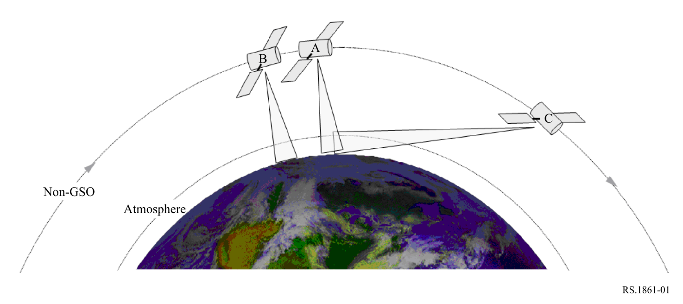

4.1 Fixed-pointing, multiple frequency and polarization radiometric sensing
Sensing concurrently at multiple frequencies and polarizations offers the possibilities of identifying the presence of multiple natural emitters present in the field of view of the sensor as well as creating profiles of their concentrations. Profiling (a.k.a. sounding) sensors may be nadir-pointing or pointed at the limb of the Earth. Applications of profiling sensors includes the determination of atmospheric chemistry profiles of H₂O, O₃, ClO, BrO, HCl, OH, HO₂, HNO₃, HCN, and N₂O through limb measurements.
Fixed pointing radiometers are also used to determine path delay of the radar signals caused by atmospheric water vapour. This information is used to improve measurement resolution of altimeters.
Radiometers designed for the whole Earth viewing perform continuous, hemispheric microwave soundings of temperature and humidity profiles as well as rain mapping.

4.2 Conical scanning radiometers
Many of the passive microwave sensors designed for imaging the Earth’s surface features use a conical scan configuration. Scans are typically performed by rotating the antenna at an offset angle from the nadir direction which maintains a constant ground incidence angle along the entire scan-lines. This feature allows for the uniform interpretation of surface measurements since the footprints will remain constant in size, and also because the polarization characteristics of the signal have an angular dependence which in this case is kept constant. Conical scanning radiometers are used to monitor various water processes including precipitation, oceanic water vapour, cloud water, near-surface wind speed, sea surface temperature, soil moisture, snow cover, and sea ice parameters. They can also be used to provide information on the integrated column precipitation content, its area distribution, and its intensity. Conical scanning antennas gather information over wide areas as shown in Fig. 2.
FIGURE 2
Geometry of conical scan passive microwave radiometers
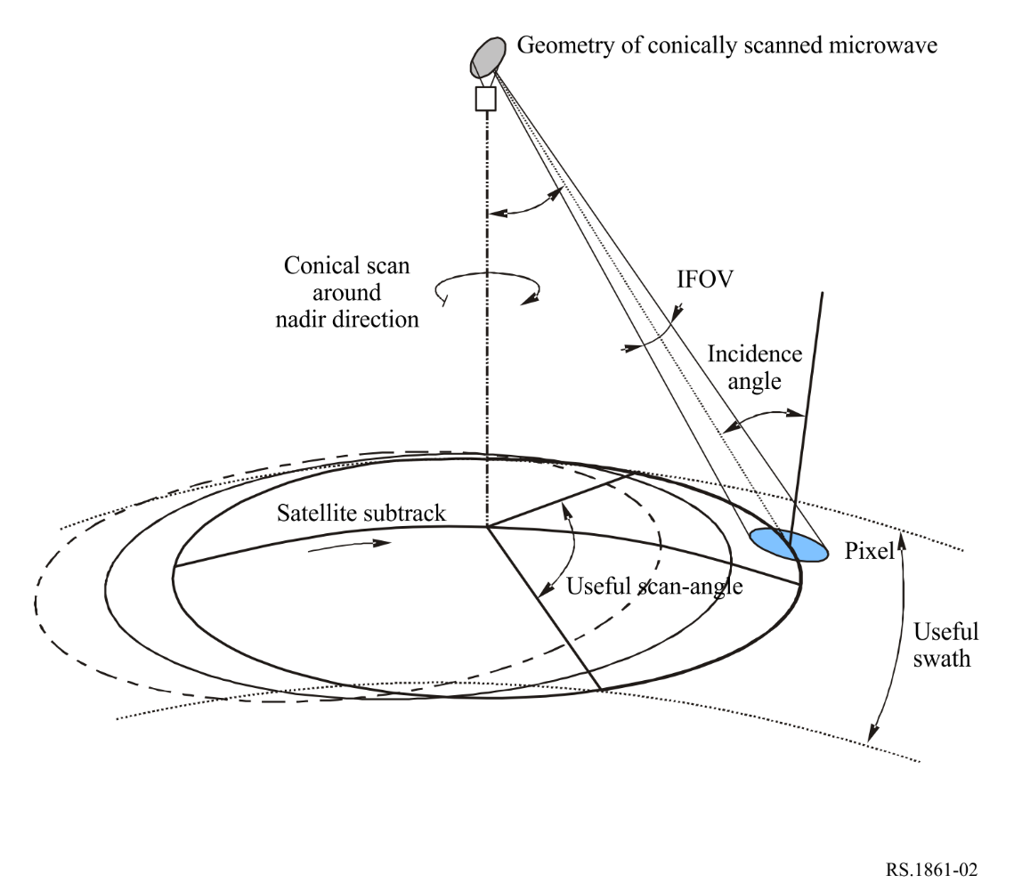

4.3 Cross-track/nadir scanning radiometers
The cross-track/nadir scanning is typically performed across the surface of the Earth, perpendicular to the orbital path, as shown in Fig. 3. Cross-track/nadir scanning is performed by physically rotating a reflector 360° through the nadir direction. As the reflector is directed away from the surface of the Earth, sensor channels are still used as calibrations are performed by measuring the cosmic background (i.e. cold sky) in addition to a known ‘warm’ source on the spacecraft, as shown in Fig. 4.
Scanning radiometric measurements are performed over wide areas creating virtual maps of the parameter being measured. This data product determines the horizontal spatial variability of a parameter rather than measuring the parameters at specific points. As the sensor scans away from nadir, the incidence angle increases and thus the footprint size increases and becomes more elliptical. Scanning measurements are also typically performed at multiple frequencies and polarizations.
Typical applications of cross-track/nadir scanning radiometers include the measurement of temperature profiles in the upper atmosphere (especially the stratosphere) and to provide a cloud-filtering capability for tropospheric temperature observations. They also are used to provide daily global observations of temperature and moisture profiles at high temporal resolution, and to measure cloud liquid water content and provide qualitative estimates of precipitation rate.
FIGURE 3
Typical cross-track Earth scanning pattern
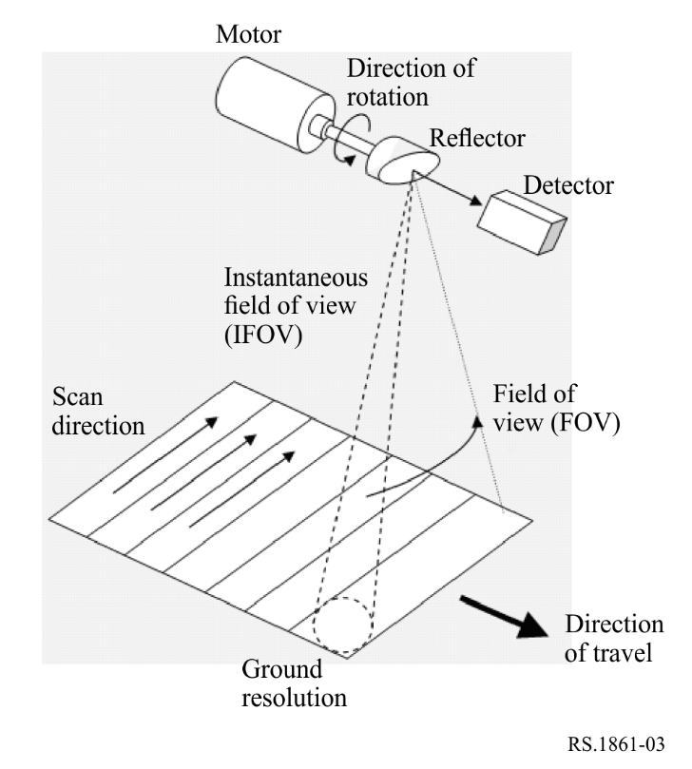
FIGURE 4
Typical sensing scanning pattern over 360°
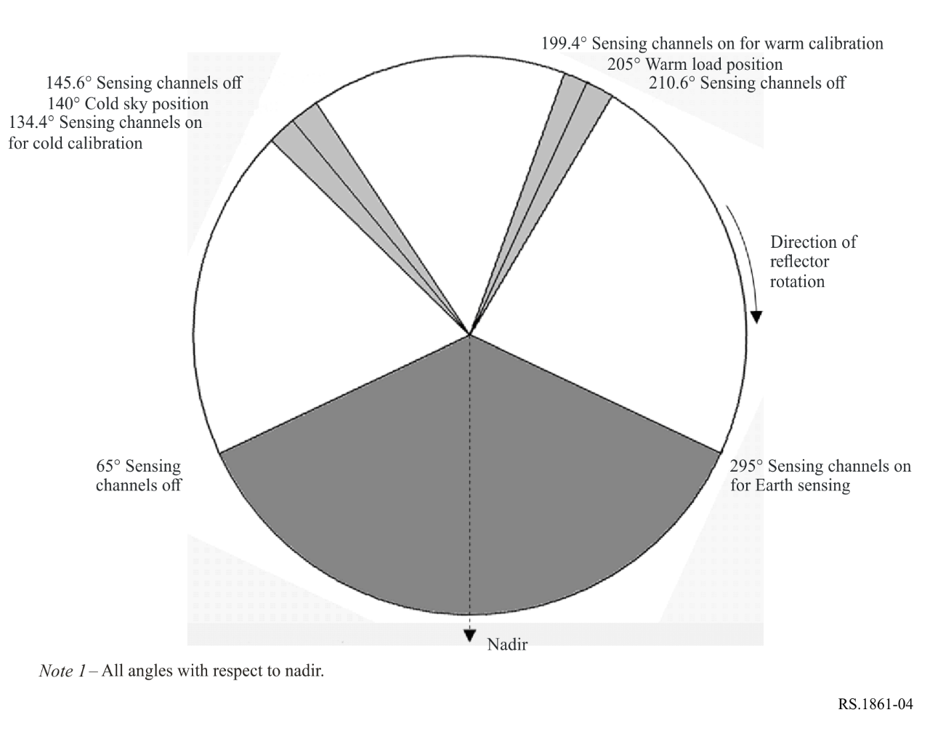

4.4 Push-broom radiometers
A ‘push-broom’ (along track) sensor consists of a line of sensors arranged perpendicular to the flight direction of the spacecraft, as illustrated in Fig. 5. Different areas of the Earth’s surface are detected as the spacecraft flies forward. The push-broom is a purely static instrument with no moving parts. The major desirable feature of the push-broom is that all resolution elements in a scan line are acquired simultaneously, and not sequentially as with mechanically scanned sensors, enabling this type of sensor to significantly increase the achievable radiometric resolution. Push-broom sensors can be used for a variety of applications, including temperature profiles measurements of the atmosphere, and soil moisture and ocean salinity measurements.
FIGURE 5
Typical push-broom radiometer configuration
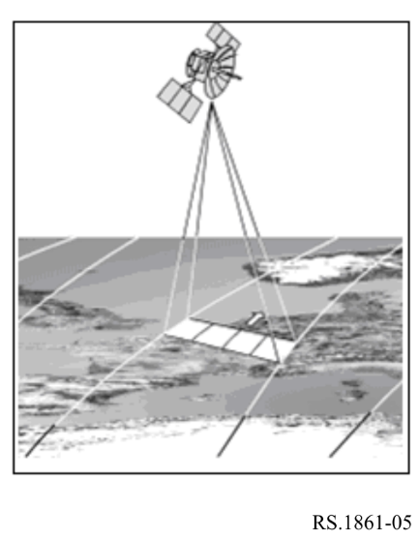

4.5 Limb scanning radiometers
Some of the limb sounding radiometers also perform elevation scanning of the Earth’s limb in order to cover the whole vertical range and improve the vertical resolution.

4.6 Interferometric radiometers
Unlike real aperture radiometers, interferometric radiometers use aperture synthesis technology to achieve brightness temperature measurements of the objective. Interferometric radiometers generally configure distributed small antenna elements to comprise a thinned array in order to reduce the complexity of antenna structure and in turn to deploy an antenna array with larger size to improve the spatial resolution. Because the spatial frequency distribution of brightness temperature is obtained by cross correlating the measurements from different two antenna elements, and then the brightness temperature image can be reconstructed from its spatial frequency distribution through Fourier transform, generally there is no need to scan mechanically for interferometric radiometers. But some interferometric systems also move or rotate their antenna elements to further reduce the number of elements.

4.7 Raster scanning radiometers
One of GSO sensors with real aperture antenna will use raster scan mode to achieve observations of the full Earth disk or a designated square region. In raster scanning, the beam sweeps horizontally left-to-right at a steady rate, then blanks and rapidly moves back to the left, where it turns back on and sweeps out the next line, as shown in Fig. 6. During this time, the vertical position is also steadily increasing (downward). GSO raster scanning radiometers can provide temperature and humidity profiles, cloud ice/liquid water columnar amount and gross profile, precipitation rate (particularly in cyclone or convection) with very high temporal resolution. Raster scanning radiometers are currently only identified in frequencies of 114.25 GHz and higher.
FIGURE 6
Typical raster scanning pattern
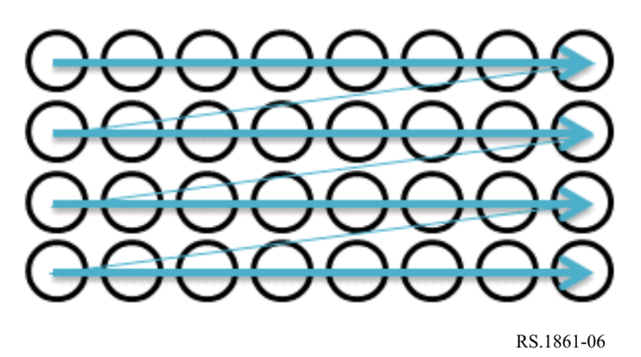

4.8 Wide strip and thin circle combined scanning radiometers
GSO radiometers also focus on rapidly changing weather phenomenon observation. It needs to use real aperture design to ensure the calibration accuracy and the observation reality of dynamic targets. The wide strip and thin circle combined scanning radiometer, as illustrated in Fig. 7(a) and (b), can realize calibration in every one second and scan on stable satellite platform in GSO. This scan mode combines the general scan (wide strip) of satellite and detail local scan (thin circle) of sensor.
As shown in Fig. 7, with the movement of the satellite, the large sensors on the satellite move alternately from west to east and from east to west, and step along the south direction. By this way, it forms the general scan in two dimensional stripes. At the same time, as shown the small black circles in Fig. 7, the small rotating scanning mirror inside the antenna scans quickly in a circle, in which total 110° angle range and the rest 250° are used for observation and calibration, and forms the detail local scan. As a result, the new beam scanning system with three-dimensional motion and two-dimensional coverage can solve the problem of large disturbance torque of the antenna motion, and also to meet the requirements of region coverage and time resolution. One step of the general scan and one circle of the detail local scan spend the same time. The main observation channels include oxygen absorption channel, water absorption channel and window channel.
FIGURE 7
Scanning pattern of real aperture radiometers
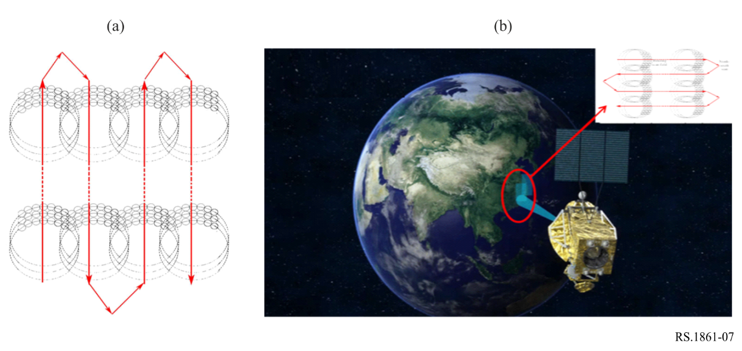

5 Definition of parameters
Table 1 provides the definitions of the technical and operational EESS parameters associated with passive sensors and their operation.
TABLE 1
Definitions of technical and operational EESS parameters for passive sensors
Parameter | Definition
Sensor type | Various types of radiometers are possible depending on the technology of the radiometer: interferometric radiometer, fixed pointing, conical scan, nadir/cross-track scan, push-broom, limb scan radiometer
Orbit parameters
Altitude | The height above the mean sea level
Inclination | Angle between the equator and the plane of the orbit
Eccentricity | The ratio of the distance between the foci of the (elliptical) orbit to the length of the major axis
Repeat period | The time for the footprint of the antenna beam to return to (approximately) the same geographic location
Sensor antenna parameters
Antenna characteristics vary among sensors. Measured antenna patterns are provided in § 6, where available. A reference radiation pattern is currently being developed for use in other cases
Number of beams | The number of beams is the number of Instantaneous Field of View (IFOV) on Earth from which data are acquired at one time
Antenna size | For real aperture radiometers, it is the diameter of the antenna reflector;  For interferometric radiometers, it is the size of antenna array.
Maximum antenna gain | The maximum antenna gain can be the real one, or, if it is not known, it can be computed using the antenna efficiency η and D diameter of the reflector (when applicable), with the formula:  $$Maximum_antenna_gain=η{\left(π\frac{D}{λ}\right)}^{2}$$
Polarization | Specification of linear (i.e. vertical, horizontal ,+45 º, −45º) or circular (i.e. left-hand, right-hand) polarization
−3 dB beamwidth | The −3 dB beamwidth, θ_{3dB}, is defined as the angle between the two directions in which the radiation intensity is one-half the maximum value. This value provides a simple and general comparison of the width of the antenna’s main lobe.  For interferometric radiometers, it is the beamwidth of synthetic beam.  Note: The full antenna pattern is susceptible to interference and should be used in interference analyses.

TABLE 1 (cont.)
Parameter | Definition
Instantaneous field of view | The instantaneous field of view (IFOV) for a real aperture system is the area over which the detector is sensitive to radiation, generally defined as the linear dimensions of the beam on the Earth corresponding to the −3 dB beamwidth. By knowing the altitude of the satellite, the dimension of the IFOV can be calculated on the Earth’s surface at the boresight direction (or at the tangent point for limb sounding sensors): the IFOV is generally expressed in km × km representing the minor and major axis of the footprint. The area of the IFOV (in km²) is also provided. The IFOV is a measure of the size of the resolution element.  In a scanning system the IFOV refers to the solid angle subtended by the detector when the scanning motion is stopped. For conical scan radiometers, two values are usually computed:  – along-track: in the direction of the platform motion (along the in-track direction);  – cross-track: in the direction orthogonal to the motion of the sensor platform.  For nadir scan radiometers, such as that shown in Fig. 3, the nadir  IFOV = H×θ_{3dB}, where H is the altitude of the satellite and θ_{3dB} is the half-power beamwidth. The area of the nadir IFOV is $π(\frac{H×θ3dB}{2})^{2}$  See also Fig. 8.  Since the direct measurements of interferometric radiometers are done in the spatial frequency domain, the IFOV parameter which usually describes the characteristic of spatial domain may not be applicable to interferometric radiometers.
Off-nadir pointing angle | The angle between the nadir and the pointing direction. It is the angle α in Fig. 8
Incidence angle at Earth | The angle between the pointing direction and the normal to the Earth’s surface. It is the angle i as in Fig. 8
Swath width/Coverage | The swath width is defined as the linear ground distance covered in the cross-track direction for NGSO radiometersor the angular field of view (AFOV), scanning angle. For a nadir radiometer, it depends on the maximum off nadir angle. The field of view (FOV) is the total range of viewing of a sensor into the direction of the target. The cross-track component of the FOV is equivalent to the swath width.  GSO radiometers normally need to cover the full Earth disk or part of the disk.
Main beam efficiency | Note: This parameter is only included for the 10.6-10.7 GHz and 36-37 GHz bands due to its use in Resolution 751 (WRC-07) and Resolution 752 (WRC-07), respectively. The main beam efficiency is defined as the ratio of the energy received in the main beam, which is 2.5 times the antenna’s −3 dB beamwidth, to the energy received in the complete antenna pattern. This parameter is not the same as the antenna efficiency.
Antenna efficiency | A measure of how effective an antenna is at receiving electromagnetic waves. The antenna efficiency is defined as the ratio of the maximum effective area of the antenna to the aperture area. This parameter is not the same as main beam efficiency. It is in particular used to compute the value of maximum antenna gain (see above)
Beam dynamics | The beam dynamics is defined as follows:  – For conical scans of NGSO systems, it is the rotating speed of the beam;  – For mechanical nadir scans of NGSO systems, it is the scan period, and the observation time in each scan period (i.e. the time of fulfilling one swath width scanning) may also be needed since the rotating speed of the antenna is commonly not constant;  – For NGSO interferometric radiometers, it may not be applicable.  – For GSO radiometers, it is the observation time of accomplishing a full disk scan or a special regional scan.
Sensor antenna pattern | Antenna gain as a function of off-axis angle. For interferometric radiometers, it is the pattern of synthetic beam.

TABLE 1 (end)
Parameter | Definition
Cold calibration antenna gain | Antenna gain in the direction of (cold) space. This could be the maximum gain of the primary antenna or the secondary antenna
Cold calibration horizontal angle | Horizontal angle (degrees relative to satellite track) of the cold calibration measurement. This angle is measured in the tangent plane relative to the along-track direction
Cold calibration vertical angle | Vertical angle (degrees relative to nadir direction) of the cold calibration measurement. This angle is measured out from the tangent plane
Sensor receiver parameters
Sensor integration time | The sensor integration time corresponds to the short period of time allocated for the radiative measurement of the instantaneous area of observation by the detector of a sensor
Channel bandwidth | The channel bandwidth is the range of frequencies around a centre frequency used by the passive sensor
Measurement spatial resolution
Horizontal resolution | The spatial resolution is often defined as the ability to distinguish between two closely spaced objects on an image. It is generally expressed in both horizontal (usually cross-track direction) and vertical (along-track direction) resolutions. (Note that “vertical”, in this sense, does not refer to altitude.) For limb sounding sensors, horizontal resolution is in the direction parallel with the surface, and vertical resolution is in the altitude direction.  There may be some difference between the spatial resolution and the IFOV size for one radiometer depending on its integration time and the moving speeds of its antenna and the platform.
Vertical resolution

FIGURE 8
Scanning configuration
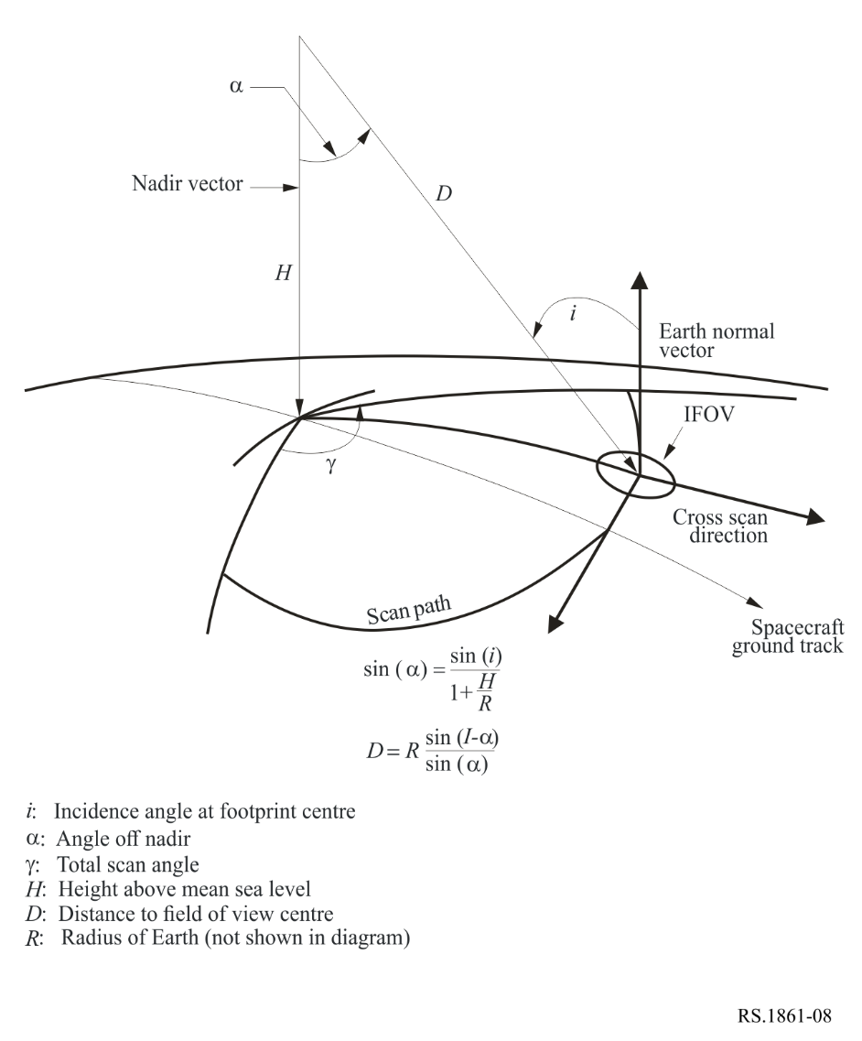
Note that the field of view’s projection on the Earth’s surface becomes elliptical due to the increased incidence angle from nadir to the edge of the swath width (half swath).

6 Parameters of typical systems
This section provides typical parameters of passive sensors for EESS (passive) bands between 1 GHz and 275 GHz. Table 2 lists the EESS (passive) bands and the section in this text that contains the passive sensor parameters for each frequency band. A consistent set of parameters is used for each band to support worst-case static analyses and dynamic analyses to determine interference levels into passive sensors.
TABLE 2
List of EESS (passive) bands
EESS (passive) band | Section containing passive  sensor parameters
1 400-1 427 MHz | 6.1
6 425-7 250 MHz | 6.2
10.6-10.7 GHz | 6.3
18.6-18.8 GHz | 6.4
21.2-21.4 GHz | 6.5
22.21-22.5 GHz | 6.6
23.6-24 GHz | 6.7
31.3-31.8 GHz | 6.8
36-37 GHz | 6.9
50.2-50.4 GHz | 6.10
52.6-54.25 GHz | 6.11
54.25-59.3 GHz | 6.12
86-92 GHz | 6.13
114.25-122.25 GHz | 6.14
148.5-151.5 GHz | 6.15
155.5-158.5 GHz | 6.16
164-167 GHz | 6.17
174.8-191.8 GHz | 6.18
200-209 GHz | 6.19
226-252 GHz | 6.20

6.1 Typical parameters of passive sensors operating in the 1 400-1 427 MHz frequency band
Frequencies near 1 400 MHz are ideal for measuring soil moisture, and also for measuring sea surface salinity and vegetation biomass. Soil moisture is a key variable in the hydrologic cycle with significant influence on evaporation, infiltration and runoff. In the vadose zone, soil moisture governs the rate of water uptake by vegetation. Sea surface salinity has an influence on deep thermohaline circulation and the meridional heat transport. Variations in salinity influence the near surface dynamics of tropical oceans. To date, there is no capability to globally measure soil moisture and sea surface salinity directly from in-situ measurements, so the protection of this passive frequency band is essential for obtaining measurements on a global basis.
Some of the remote sensing missions operating in this band collect soil moisture data in the entire passive microwave band. Others missions use this frequency band collect measurements of ocean salinity with the goal of observing and modelling the processes that relate sea surface salinity variations to climatic changes in the hydrologic cycle, and to understand how these variations influence the general ocean circulation. Still other missions will use a different technological approach and will measure both soil moisture and ocean salinity.
Table 3 provides the characteristics and parameters of sensors on these missions.
TABLE 3
EESS (passive) sensor characteristics in the 1 400-1 427 MHz frequency band
 | Sensor A1 | Sensor A2 | Sensor A4
Sensor type | Interferometric radiometer | Conical scan | Conical scan
Orbit parameters
Altitude (km) | 757 | 670 | 820
Inclination (degree) | 98 | 98 | 98.702
Eccentricity | 0 | 0 | 0.0011441
Repeat period (days) | 3 | 3 | 29
Sensor antenna parameters
Number of beams | 1 | 1 | 1
Antenna size | N/A | 6.2 m | 7.4 m
Maximum beam gain (dBi) | 9 | 37 | 39.1
Polarization | V, H | V, H | V, H
−3 dB beamwidth (degree) | 71.6 | 2.6 | 1.89-2.20
Instantaneous field of view | 756 km² | 50.1 × 38.5 km | 77 × 43 km
Off-nadir pointing angle (degree) | 25 | 35.5 | 46.5
Incidence angle at Earth (degree) | 2°/48 | 39.9 | 55
Swath width (km) | 1 000 | 1 000 | >1 900
Antenna efficiency |  | 0.60
Beam dynamics | Fixed | 14.6 rpm | 7.8 rpm
Sensor antenna pattern | Fig. 9 | Fig. 10
Cold calibration antenna gain (dBi) | N/A | N/A | 39.1
Cold calibration angle (degrees re. satellite track) | N/A | N/A | 0 º
Cold calibration angle (degrees re. nadir direction) | N/A | N/A | 45º-180º
Sensor receiver parameters
Sensor integration time | 1.2 s | 84 ms | 55.4 ms
Channel bandwidth (MHz) | 27 | 27 | 27
Measurement spatial resolution
Horizontal resolution (km) | 40 | 39 | 77
Vertical resolution | N/A | N/A | 43 km

FIGURE 9
Sensor A1 antenna pattern for the 1 400-1 427 MHz frequency band
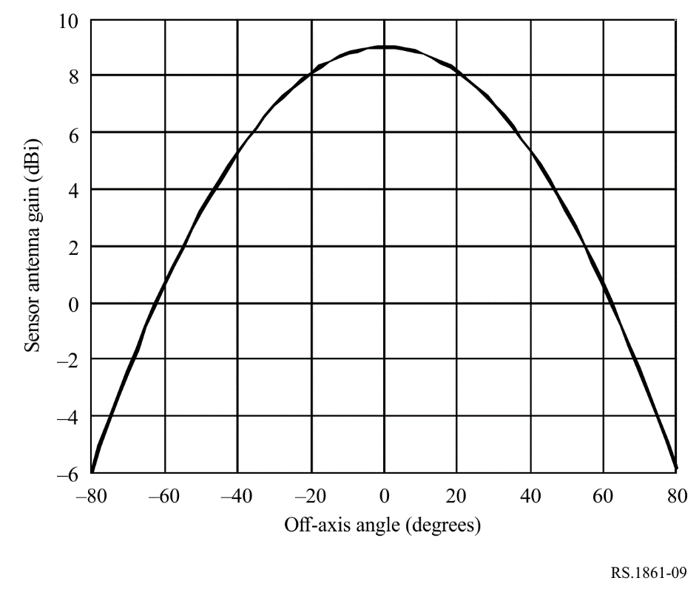
FIGURE 10
Sensor A2 antenna patterns for the 1 400-1 427 MHz frequency band
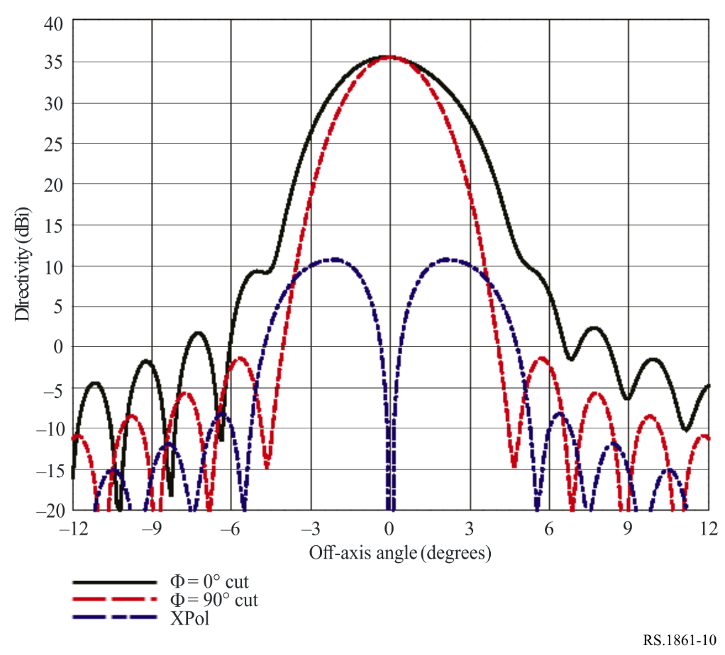

6.2 Typical parameters of passive sensors operating in the 6 425-7 250 MHz frequency band
The 6-7 GHz frequency band channel is essential for observing global soil moisture, global sea surface temperature, temperature of sea ice and sea surface wind through cloud, in combination with other channels.
In measurement of soil moisture, measurement in higher frequencies is strongly influenced by vegetation and the atmosphere, and the 6-7 GHz frequency band is the most suitable for obtaining relatively higher spatial resolution measurements. In the case of measurement of sea surface temperature, measurement in higher frequencies is strongly influenced by the atmosphere and lower temperature is more difficult to measure in higher frequencies. This combination of effects makes the 6-7 GHz frequency band the most suitable for obtaining sea surface temperature.
Table 4 summarizes the parameters of passive sensors that are or will be operating in the 6.425-7.25 GHz frequency band.
TABLE 4
EESS (passive) sensor characteristics in the 6 425-7 250 MHz frequency band
 | Sensor B3 | Sensor B4 | Sensor B5 | Sensor B6 | Sensor B7
Sensor type | Conical scan | Conical scan | Conical scan | Conical scan | Conical scan
Orbit parameters
Altitude (km) | 830 | 699.6 | 820 | 970 | 665.96
Inclination (degree) | 98.85 | 98.186 | 98.702 | 99.3 | 98.06
Eccentricity | 0 | 0.002 | 0.0011441 | 0.00117 | 0.0015
Repeat period (days) |  | 16 | 29 | 14 | 3
Sensor antenna parameters
Number of beams | 1 | 1 | 4 | 1 | 1
Antenna size (m) | 1.0 | 2.0 | 7.4 | 1.0 | 2.0
Maximum beam gain | 35.5 dBi | 40.6 dBi | 51.5 dBi | 36 dBi | 40.6 dB
Polarization | V, H | V, H | V, H | V, H | V, H
−3 dB beamwidth (degree) | 2.5 | 1.8 | 0.43-0.58 | 3.11 | 1.8
Instantaneous field of view (km) | 70 × 167 | 35 × 62 | 19 × 11 | 74 × 122 | 33 × 57
Off-nadir pointing angle | 53.3° | 47.5° | 46.5° | 44° | 47.7°
Incidence angle at Earth | 65° | 55° | 55° | 53° | 55°
Swath width (km) | 2 200 | 1 450 | >1 900 | 1 700 | 1 535
Antenna efficiency |  | 0.57 |  | 0.6 | 0.57
Beam dynamics | 2.5 s/scan period, counter clockwise | 40 rpm | 7.8 rpm | 3.57 s/scan | 40 rpm
Sensor antenna pattern | See Rec. ITU-R RS.1813 | See Rec. ITU-R RS.1813 |  | See Rec. ITU-R RS.1813 | See Rec. ITU-R RS.1813
Cold calibration antenna gain | 22.3 dBi | 25.6 dBi | 51.5 dBi | 25 dB | 25.6 dBi

TABLE 4 (end)
 | Sensor B3 | Sensor B4 | Sensor B5 | Sensor B6 | Sensor B7
Cold calibration angle (degrees re. satellite track) | 315º | 115.5º | 0 º | 158° | 118.7º
Cold calibration angle (degrees re. nadir direction) | 90º | 97.0º | 45º-180º | 80 ° | 94.6º
Sensor receiver parameters
Sensor integration time | 5 ms | 2.6 ms | 13.7 ms | 10 ms | 2.5ms
Channel bandwidth | 350 MHz centred at 6.925 GHz and at 7.3 GHz | 350 MHz centred at 6.925 GHz and at 7.3 GHz | 400 MHz centred at 6.925 GHz | 350 MHz | 350 MHz centred at 6.925 GHz and at 7.3 GHz
Measurement spatial resolution |  |  |  | 95 km
Horizontal resolution (km) | 32 | 35 | 19 | 122 | 33
Vertical resolution (km) | 32 | 62 | 11 | 74 | 57

6.3 Typical parameters of passive sensors operating in the 10.6-10.7 GHz frequency band
The 10.6-10.7 GHz frequency band is of primary interest to measure rain, snow, sea state, and ocean wind. Tables 5 and 6 summarizes the parameters of passive sensors that are or will be operating in the 10.6-10.7 GHz frequency band.
TABLE 5
EESS (passive) sensor characteristics in the 10.6-10.7 GHz frequency band
 | Sensor C1 | Sensor C4 | Sensor C5 | Sensor C6
Sensor type | Conical scan | Conical scan | Conical scan | Conical scan
Orbit parameters
Altitude (km) | 817 | 835 | 699.6 | 830
Inclination (degree) | 98 | 98.85 | 98.186 | 98.85
Eccentricity | 0 | 0 | 0.002 | 0
Repeat period |  |  | 16 days
Sensor antenna parameters
Number of beams | 1 | 1 | 1 | 1
Antenna size (m) | 0.9 | 0.65 | 2.0 | 1.0
Maximum beam gain (dBi) | 36 | 33,7 | 44.1 | 38.7
Polarization | H, V | H, V | H, V | H, V
−3 dB beamwidth (degree) | 2.66 | 2.9 | 1.2 | 2.0
Instantaneous field of view (km) | 56 × 30 | 82 × 196 | 42 × 24 | 56 × 133
Off-nadir pointing angle (degree) | 44.3 | 53.3 | 47.5 | 53.3
Incidence angle at Earth (degree) | 52 | 65 | 55 | 65
Swath width (km) | 1 594 | 1 600 | 1 450 | 2 200
Main beam efficiency ⁽¹⁾ |  |  | 93%
TABLE 5 (end)
 | Sensor C1 | Sensor C4 | Sensor C5 | Sensor C6
Antenna efficiency | 0.40 | 0.89 | 0.52 | 0.60
Beam dynamics | 20 rpm | 2.5 s/scan period, clockwise | 40 rpm | 2.5 s/scan period, counter clockwise
Sensor antenna pattern | Rec. ITU-R RS.1813 | Rec. ITU-R RS.1813 | Rec. ITU-R RS.1813 | Rec. ITU-R RS.1813
Cold calibration ant. gain (dBi) | N/A | 25 | 29.6 | 25.5
Cold calibration angle (degrees re. satellite track) | N/A | 315º | 115.5º | 315º
Cold calibration angle (degrees re. nadir direction) | N/A | 90º | 97.0º | 90º
Sensor receiver parameters
Sensor integration time (ms) | 1 | 5 | 2.6 | 5
Channel bandwidth | 100 MHz | 100 MHz centred at 10.65 GHz | 100 MHz centred at 10.65 GHz | 100 MHz centred at 10.65 GHz
Measurement spatial resolution
Horizontal resolution (km) | 38 | 32 | 24 | 32
Vertical resolution (km) | 38 | 32 | 42 | 32
⁽¹⁾ This parameter is included for this band due to its use in Resolution 751 (WRC-07).

TABLE 6
EESS (passive) sensor characteristics in the 10.6-10.7 GHz frequency band
 | Sensor C7 | Sensor C8 | Sensor C9 | Sensor C10 | Sensor C11
Sensor type | Conical scan | Conical scan | Conical scan | Conical scan | Conical scan
Orbit parameters
Altitude (km) | 407 | 820 | 407 | 970 | 665.96
Inclination (degree) | 50° | 98.702° | 65° | 99.3° | 98.06°
Eccentricity | 0.003 | 0.0011441 | 0 | 0.00117 | 0.0015
Repeat period (days) |  | 29 | 43.5 | 14 | 3
Sensor antenna parameters
Number of beams | 1 | 4 | 1 | 1 | 2
Antenna size (m) | 1.1 | 7.4 | 1.22 | 1.0 | 2.0
Maximum beam gain (dBi) | 39.6 | 50.5 | 40.6 | 37 | 44.1
Polarization | H, V | H, V | H/V | V, H | H,V
−3 dB beamwidth (degree) | 1.6 | 0.50-0.74 | 1.72 | 2.36 | 1.2
Instantaneous field of view (km) | 30 × 18 | 19 × 11 | 32.1 × 19.4 | 56 × 93 | 22 × 38
Off-nadir pointing angle | 48.6° | 46.5° | 48.5° | 44° | 47.7°
Incidence angle at Earth | 53° | 55° | 52.8° | 53° | 55°
Swath width (km) | 800 | >1 900 | 921 | 1 700 | 1 535
Main beam efficiency ⁽¹⁾ |  |  | 91.1% | 97% | 93%
TABLE 6 (end)
 | Sensor C7 | Sensor C8 | Sensor C9 | Sensor C10 | Sensor C11
Antenna efficiency | 0.606 |  |  | 0.6 | 0.59
Beam dynamics | 30 rpm | 7.8 rpm | 32 rpm | 3.57 s | 40 rpm
Sensor antenna pattern | Rec. ITU-R RS.1813 |  | Rec. ITU-R RS.1813 | Rec. ITU-R RS.1813 | Rec. ITU-R RS.1813
Cold calibration antenna gain (dBi) | 36.8 | 50.5 | 27.8 | 27 | 29.6
Cold calibration angle (degrees re. satellite track) | 180° | 0 º | 206.7° (CCW) | 158° | 118.7º
Cold calibration angle (degrees re. nadir direction) | 90° | 45º-180º | 107.5° | 80° | 94.6º
Sensor receiver parameters
Sensor integration time (ms) | 2.08 | 13.4 | 3.6 | 10 | 2.5
Channel bandwidth | 100 MHz centred at 10.65 GHz | 100 MHz centred at 10.65 GHz | 100 MHz centred at 10.65 GHz | 100 MHz | 100 MHz centred at 10.65 GHz and 500 MHz centred at  10.25 GHz
Measurement spatial resolution |  |  |  | 72 km
Horizontal resolution (km) | 22.2 | 19 | 19.4 | 93 | 22
Vertical resolution (km) | 29.9 | 11 | 32.1 | 56 | 38
⁽¹⁾ This parameter is included for this band due to its use in Resolution 751 (WRC-07).

6.4 Typical parameters of passive sensors operating in the 18.6-18.8 GHz frequency band
The 18.6-18.8 GHz frequency band is essential for observing global rain rates, sea state, sea ice, water vapour, ocean wind speed, soil emissivity, and humidity. Tables 7 and 8 summarizes the parameters of passive sensors that are or will be operating in the 18.6-18.8 GHz frequency band.
TABLE 7
EESS (passive) sensor characteristics in the 18.6-18.8 GHz frequency band
 | Sensor D3 | Sensor D4 | Sensor D5 | Sensor D6 | Sensor D7
Sensor type | Conical scan | Conical scan | Conical scan | Conical scan | Conical scan
Orbit parameters
Altitude (km) | 865.6 | 835 | 699.6 | 830 | 407
Inclination (degree) | 20 | 98.85 | 98.186 | 98.85 | 50
Eccentricity | 0 | 0 | 0.002 | 0 | 0.003
Repeat period (days) | 7 |  | 16
Sensor antenna parameters

TABLE 7 (end)
 | Sensor D3 | Sensor D4 | Sensor D5 | Sensor D6 | Sensor D7
Number of beams |  | 1 | 1 | 1 | 1
Antenna size (m) | 0.65 | 0.65 | 2.0 | 1.0 | 1.1
Maximum beam gain (dBi) |  | 38.7 | 49.4 | 43.6 | 44.4
Polarization | V, H | V, H | V, H | V, H, V+45°, V-45° | V, H
−3 dB beamwidth (degree) | 0.67 | 1.9 | 0.65 | 1.2 | 1.0
Instantaneous field of view (km) | 10 | 54 × 128 | 22 × 14 | 34 × 80 | 19 × 11
Off-nadir pointing angle (degree) | 44.5 | 53.3 | 47.5 | 53.3 | 48.6
Incidence angle at Earth (degree) | 52.3 | 65 | 55.0 | 65 | 53
Swath width (km) |  | 1 600 | 1 450 | 2 200 | 800
Antenna efficiency |  |  | 0.5679 | 0.5974 | 0.594
Beam dynamics | 20 rpm | 2.5 s scan period, clockwise | 40 rpm | 2.5 s scan period, counter clockwise | 30 rpm
Sensor antenna pattern | Rec. ITU-R RS.1813 | Rec. ITU-R RS.1813 | Rec. ITU-R RS.1813 | Rec. ITU-R RS.1813 | Rec. ITU-R RS.1813
Cold calibration antenna gain (dBi) | N/A | 30 | 33.9 | 30.7 | 41.4
Cold calibration angle (degrees re. satellite track) | N/A | 315º | 115.5º | 315º | 180°
Cold calibration angle (degrees re. nadir direction) | N/A | 90º | 97.0º | 90º | 90°
Sensor receiver parameters
Sensor integration time (ms) | N/A | 5 | 2.6 | 5 | 2.08
Channel bandwidth | N/A | 200 MHz centred at 18.7 GHz | 200 MHz centred at 18.7 GHz | 200 MHz centred at 18.7 GHz | 200 MHz centred at 18.7 GHz
Measurement spatial resolution
Horizontal resolution (km) | 40 | 32 | 14 | 32 | 15.4
Vertical resolution (km) | 40 | 32 | 22 | 32 | 19

TABLE 8
EESS (passive) sensor characteristics in the 18.6-18.8 GHz frequency band
 | Sensor D8 | Sensor D9 | Sensor D10 | Sensor D11 | Sensor D12 | Sensor D13 | Sensor D14
Sensor type | Conical scan | Conical scan | Nadir | Conical scan | Fixed-pointing | Conical scan | Conical scan
Orbit parameters
Altitude (km) | 820 | 407 | 1 336  890.6 * | 970 | 970 | 665.96 | 830
Inclination (degree) | 98.702 | 65 | 66  77.6 * | 99.3 | 99.3 | 98.06 | 98.7
Eccentricity | 0.0011441 | 0 | 0 | 0.00117 | 0.00117 | 0.0015 | 0.001
Repeat period (days) | 29 | 43.5 | 9.92  20.9 * | 14 | 14 | 3 | 29
Sensor antenna parameters
Number of beams | 8 | 1 | 1  2* | 1 | 3 | 1 | 1
Antenna size (m) | 7.4 | 1.22 | effectively 0.61 m;  physical reflector is 1 m, but beam is intentionally de-focused | 1.0 | 0.92 | 2.0 | 0.76
Maximum beam gain (dBi) | 59.6 | 45.6 | 40.5 | 43 | 43 | 49.4 | 41.5
Polarization | H, V | H/V | Dual Linear | V, H | V, H | V, H | V, H
−3 dB beamwidth (degree) | 0.17-0.21 | 0.98 | 1.6 | 1.29 | 1.25 | 0.65 | 1.65
Instantaneous field of view (km) | 7 × 4 | 18.1 × 10.9 | 37 × 37  25 × 25 * | 31 × 51 | 21.0 × 21.0 | 21 × 12 | 36 × 60  (1 703 km²)
Off-nadir pointing angle (degree) | 46.5 | 48.5 | 0  ±2.65° cross-track* | 44 | −2.4 | 47.7 | 44.8
Incidence angle at Earth (degree) | 55 | 52.8 | 0  3.0 * | 53 | -2.4 | 55.0 | 52.8

TABLE 8 (end)
 | Sensor D8 | Sensor D9 | Sensor D10 | Sensor D11 | Sensor D12 | Sensor D13 | Sensor D14
Swath width (km) | >1 900 | 921 | 37  25 * | 1 700 | N/A | 1 535 | 1 700
Antenna efficiency |  |  | 0.79 | 0.6 | 0.63 | 0.57 | 0.6
Beam dynamics | 7.8 rpm | 32 rpm | N/A | 3.57 s | N/A | 40 rpm | 45 rpm  (1.33 s)
Sensor antenna pattern |  | Rec. ITU-R RS.1813 | Rec. ITU-R  RS.1813 | Rec. ITU-R RS.1813 | Rec. ITU-R RS.1813 | Rec. ITU-R RS.1813 | Rec. ITU-R RS.1813
Cold calibration ant. gain | 59.6 dBi | 31.9 dBi | 24.4 dBi | 32 dB | 21.8 dB | 33.9 dB
Cold calibration angle (degrees re. satellite track) | 0 º | 206.7° (CCW) | 53.5º azimuth from velocity vector | 158° | 0° | 118.7º | 165.5° to 203°
Cold calibration angle (degrees re. nadir direction) | 45º-180º | 107.5° | 77.4º elevation angle from nadir | 80° | 90° | 94.6º
Sensor receiver parameters
Sensor integration time (ms) | 5.0 | 3.6 | 62.5 | 10 | 200 | 2.5 | 1 to 8
Channel bandwidth | 200 MHz centred at 18.7 GHz | 200 MHz centred at 18.7 GHz | 200 MHz centred at 18.7 GHz | 200 MHz | ±250 MHz | 200 MHz centred at 18.7 GHz | 200 MHz centred at 18.7 GHz
Measurement spatial resolution |  |  |  | 40 km | 21.0 km
Horizontal resolution (km) | 7 | 10.9 | 37  25 * | 51 | 21.0 | 12
Vertical resolution (km) | 4 | 18.1 | 37  25 * | 31 | 21.0 | 21
NOTE – * indicates that a particular sensor is flown on different missions, with different orbit and sensor parameters.

6.5 Typical parameters of passive sensors operating in the 21.2-21.4 GHz frequency band
The 21.2-21.4 GHz frequency band in addition to the 23.6-24 GHz frequency band are used for measurements of water vapour and liquid water both on the Earth’s surface and in the atmosphere. They are on either side of the 22.235 GHz water-vapour spectral line. Atmospheric measurements are used with oxygen, O₂, temperature measurements to remove the effect of water vapour on temperature profiles. Table 9 summarizes the parameters of passive sensors that are or will be operating in the 21.2-21.4 GHz frequency band.
TABLE 9
EESS (passive) sensor characteristics in the 21.2-21.4 GHz frequency band
 | Sensor E1 | Sensor E2
Sensor type | Mechanical nadir scan | Push-broom⁽¹⁾
Orbit parameters
Altitude (km) | 833 | 850
Inclination (degree) | 98.6 | 98
Eccentricity | 0
Repeat period (dayys) | 9
Sensor antenna parameters
Number of beams | 1 beam; 30 earth fields per 8 s scan period | 90
Antenna size (m) | 0.3 | 0.9
Maximum beam gain (dBi) | 34.4 | 45
Polarization | V | H, V
−3 dB beamwidth | 3.3° | 1.1°
Instantaneous field of view | Nadir FOV: 48.5 km  Outer FOV: 149.1 × 79.4 km | 16 km × 2 282 km
Off-nadir pointing angle | ±48.33° cross-track
Swath width (km) | 2 343 | 2 282
Antenna efficiency | 0.62 | 0.78
Beam dynamics | 8 s scan period | N/A (beams are unchanging)
Sensor antenna pattern | −10 dBi back lobe gain | −12 dBi back lobe gain
Cold calibration ant. gain (dBi) | 34.4 | 35
Cold calibration angle (degrees re. satellite track) | 90° | 90°
Cold calibration angle (degrees re. nadir direction) | 83°
Total FOV cross/along-track | Outer FOV: 149.1 × 79.4 km  Nadir FOV: 48.5 km | 100/1.1°
Sensor receiver parameters
Sensor integration time (ms) | 158 | N/A
Channel bandwidth | 200 MHz centred at 21.3 GHz | N/A

TABLE 9 (end)
 | Sensor E1 | Sensor E2
Measurement spatial resolution
Horizontal resolution (km) | 45 | 16
Vertical resolution (km) | N/A | 16
⁽¹⁾ Push-broom is a concept that has not yet been implemented at this frequency.

6.6 Typical parameters of passive sensors operating in the 22.21-22.5 GHz frequency band
Passive sensors use the 22.21-22.5 GHz frequency band to collect radiometric data on integrated water vapor content. One representative sensor is characterized in Table 10.
TABLE 10
EESS (passive) sensor characteristics in the 22.21-22.5 GHz frequency band
 | Sensor R1
Sensor type | Conical
Orbit parameters
Altitude (km) | 833
Inclination (degree | 98.6
Eccentricity | 0
Repeat period (days) | 25
Sensor antenna parameters
Number of beams | 1
Antenna size (m) | 0.61
Maximum beam gain (dBi) | 40.0
Polarization | V
−3 dB beamwidth | 2.09° (max)
Instantaneous field of view | 46.5 × 73.6 (Footprint size due to 1 × 2 averaging)
Off-nadir pointing angle (degree) | 45
Incidence angle at Earth (degree) | 53.1
Swath width (km) | 1 707
Antenna efficiency | 0.50
Beam dynamics (s) | 1.9
Sensor antenna pattern | See Rec. ITU-R RS.1813
Cold calibration ant. gain | NA
Cold calibration angle (degrees re. satellite track) | NA
Cold calibration angle (degrees re. nadir direction) | NA
Total FOV cross/along-track | Effective field of view (EFOV): 44.8 km (along scan) × 73.6 km (90° to scan);  1 × 2 spatial averaging

TABLE 10 (end)
 | Sensor R1
Sensor receiver parameters
Sensor integration time | 4.22 ms (for a single {unaveraged} sample)
Channel bandwidth | 450 MHz (max) centred at 22.235 GHz
Measurement spatial resolution
Horizontal resolution (km) | 73.6
Vertical resolution (km) | 46.5

6.7 Typical parameters of passive sensors operating in the 23.6-24 GHz frequency band
In case of a sounder, passive measurements around frequencies 23.8 GHz (total water vapour content), 31.5 GHz (window channel) and 90 GHz (liquid water) provide auxiliary data which play a predominant role in the retrieval process of temperature measurements performed in the O₂ absorption spectrum. These auxiliary measurements must have radiometric and geometric performances and availability criteria consistent with those of the temperature measurements. In case of a conical scanning radiometer, it is possible to measure horizontal water vapour distribution with other channels. The main characteristics of the sensors are given in Tables 11 and 12.

TABLE 11
EESS (passive) sensor characteristics in the 23.6-24 GHz frequency band
 | Sensor F1 |  | Sensor F4 | Sensor F5 | Sensor F6 | Sensor F7 | Sensor F8 | Sensor F9 | Sensor F10
Sensor type | Conical scan | Mechanical nadir scan |  | Mechanical nadir scan | Conical scan | Push-broom | Conical scan | Mechanical nadir scan | Conical scan
Orbit parameters
Altitude (km) | 817 | 833  822 * |  | 824 | 835 | 850 | 699.6 | 830 | 830
Inclination (degree) | 20 | 98.6  98.7 * |  | 98.7 | 98.85 | 98 | 98.186 | 98.7 | 98.7
Eccentricity | 0 | 0  0.001 |  | 0 | 0 | 0 | 0.002 | 0.001 | 0.001
Repeat period (days) | 7 | 9  29 * |  | 9 |  |  | 16 | 29 | 29
Sensor antenna parameters
Number of beams | 1 | 30 earth fields per 8 s scan period |  | 2 | 1 | 90 | 1 | 1 | 1
Antenna size (m) | 0.6 | 0.3  0.274 * |  | 0.203 | 0.65 | 0.9 | 2.0 | 0.35 | 0.76
Maximum beam gain (dBi) | 40 | 34.4 |  | 30.4 | 40.8 | 45 | 48.5 | 37 | 41.5
Polarization | H, V | V  QV * |  | QV | H, V | H, V | H, V | QH | V, H
−3 dB beamwidth (degree) | 1. 81 | 3.3 |  | 5.2 | 1.5 | 1.1 | 0.75 | 2.7 | 1.65

TABLE 11 (cont.)
 | Sensor F1 |  | Sensor F4 | Sensor F5 | Sensor F6 | Sensor F7 | Sensor F8 | Sensor F9 | Sensor F10
Instantaneous field of view (km) | 63 × 38 | Nadir FOV: 48.5  Outer FOV: 149.1 × 79.4  147 × 79 * |  | Nadir FOV: 74.8  Outer FOV: 323.1 × 141.8 | 43 × 101 | 16 × 2 282 | 26 × 15 | Nadir FOV: 39  (1 202 km²)  Outer FOV: 130 × 67  (6 769 km²) | 36 × 60  (1 703 km²)
Off-nadir pointing angle (degree) | 44.5 | ±48.33  cross-track |  | ±52.725 cross-track | 53.3 |  | 47.5 | ±49.31  cross-track | 44.8
Incidence angle at Earth (degree) | 52.3 | 0 (nadir)  57.5 * |  |  | 65 |  | 55 | 0 (nadir)  58.9 | 52.8
Swath width (km) | 1 607 | 2 343  2 186 * |  | 2 503 | 1 600 | 2 282 | 1 450 | 2 220 | 1 700
Antenna efficiency | 0.60 | 0.60 |  | 0.60 | 0.60 | 0.60 | 0.60 | 0.60 | 0.60
Beam dynamics | 31.9 rpm | 8 s scan period |  | 8/3 s scan period cross-track; 96 earth fields per scan period | 2.5 s scan period, clockwise | 90 resolution elements/  line | 40 rpm | 2.254 s | 45 rpm  (1.33 s)
Sensor antenna pattern | Rec. ITU-R RS.1813 | Fig. 11 |  | Rec. ITU-R RS.1813 | Rec. ITU-R RS.1813 | −12 dBi back lobe gain | Rec. ITU-R RS.1813 | Rec. ITU-R RS.1813 | Rec. ITU-R RS.1813
Cold calibration ant. gain (dBi) | N/A | 34.4 |  | 30.4 | 32 | 35 | 32.4
Cold calibration angle (degrees re. satellite track) | N/A | 90°  −90° ± 3.9° * |  | 0 | 315° | 90° | 115.5º | 78° to 83° | 165.5° to 203°
Cold calibration angle (degrees re. nadir direction) | N/A | 83° |  | 82.175° | 90° | 83° | N/A

TABLE 11 (end)
 | Sensor F1 |  | Sensor F4 | Sensor F5 | Sensor F6 | Sensor F7 | Sensor F8 | Sensor F9 | Sensor F10
Sensor receiver parameters
Sensor integration time (ms) | 1 | 158 |  | 18 | 5 | N/A | 2.5 | 13.7 | 1 to 8
Channel bandwidth (MHz) | 400 | 270  centred at 23.8 GHz |  | 270  centred at 23.8 GHz | 400  centred at 23.8 GHz | N/A | 400  centred at 23.8 GHz | 270  centred at 23.8 GHz | 400  centred at 23.8 GHz
Measurement spatial resolution
Horizontal resolution (km) | 40 | 45  48 * |  | 75 | 32 | 16 | 15
Vertical resolution (km) | N/A | 45  48 * |  | 75 | 32 | 16 | 25
NOTE – * indicates that a particular sensor is flown on different missions, with different orbit and sensor parameters.

TABLE 12
EESS (passive) sensor characteristics in the 23.6-24 GHz frequency band
 | Sensor F11 | Sensor F12 | Sensor F13 | Sensor F14 | Sensor F15 | Sensor F16 | Sensor F17 | Sensor F18
Sensor type | Nadir | Nadir | Conical scan | Conical scan | Conical scan | Conical scan | Fixed-pointing | Conical scan
Orbit parameters
Altitude (km) | 1 336  890.6 * | 814.5 | 830 | 407 | 407 | 970 | 970 | 665.96
Inclination (degree) | 66  77.6 * | XX | 98.85 | 50 | 65 | 99.3 | 99.3 | 98.06
Eccentricity | 0 |  | 0 | 0.003 | 0 | 0.00117 | 0.00117 | 0.0015
Repeat period (days) | 9.92  20.9 * |  |  |  | 43.5 | 14 | 14 | 3
Sensor antenna parameters
Number of beams | 1  2 * | 1 | 1 | 1 | 1 | 1 | 3 | 1
Antenna size (m) | effectively 0.61 m; physical reflector is 1 m,  but beam is intentionally de-focused | 0.6 | 1 | 1.1 | 1.22 | 1.0 | 0.92 | 2.0
Maximum beam gain | 42.3 dBi | 41 dBi | 45.7 dBi | 46.5 dBi | 46.6 dBi | 45 dBi | 45 dB | 48.5 dBi
Polarization | Dual Linear |  | V,H | H, V | V | V | V, H | H, V
−3 dB beamwidth (degree) | 1.4 | 1.8 | 1 | 0.8 | 0.85 | 1.12 | 0.98 | 0.65

TABLE 12 (cont.)
 | Sensor F11 | Sensor F12 | Sensor F13 | Sensor F14 | Sensor F15 | Sensor F16 | Sensor F17 | Sensor F18
Instantaneous field of view (km) | 33 × 33  22 × 22 * | 25  (495 km²) | 29 × 68  (1 557 km²) | 15 × 9 | 16.0 × 9.7 | 27 × 44 | 16.6 × 16.6 | 24 × 14
Off-nadir pointing angle (degree) | 0  ±2.65 cross-track * | 1.9  along-track | 53.3 | 48.6 | 48.5 | 44 | 2.2 | 47.7
Incidence angle at Earth (degree) | 0  3.0* | 2.1 | 65 | 53 | 52.8 | 53 | 2.2 | 55
Swath width (km) | 33  22 * |  | 2 200 | 800 | 921 | 1 700 | N/A | 1 535
Antenna efficiency | 0.73 | 0.60 | 0.60 | 0.594 |  | 0.6 | 0.69 | 0.60
Beam dynamics | N/A |  | 2.5 s scan period, counter clockwise | 30 rpm | 32 rpm | 3.57 s | N/A | 40 rpm
Sensor antenna pattern | Rec. ITU-R RS.1813 | Rec. ITU-R RS.1813 | Rec. ITU-R RS.1813 | Rec. ITU-R RS.1813 | Rec. ITU-R RS.1813 | Rec. ITU-R RS.1813 | Rec. ITU-R RS.1813 | Rec. ITU-R RS.1813
Cold calibration ant. gain | 26.1 dBi |  | 33 dBi | 43.5 dBi | 33.4 dBi | 34 dB | 21.9 dB | 32.4 dBi
Cold calibration angle (degrees re. satellite track) | 53.5° azimuth from velocity vector |  | 315° | 180° | 206.7° (CCW) | 158° | 0° | 118.7º
Cold calibration angle (degrees re. nadir direction) | 77.4° elevation angle from nadir |  | 90° | 90° | 107.5° | 80° | 90° | 94.6º

TABLE 12 (end)
 | Sensor F11 | Sensor F12 | Sensor F13 | Sensor F14 | Sensor F15 | Sensor F16 | Sensor F17 | Sensor F18
Sensor receiver parameters
Sensor integration time (ms) | 62.5 |  | 5 | 2.08 | 3.6 | 10 | 200 | 2.5
Channel bandwidth (MHz) | 400  centred at 23.8 GHz |  | 400  centred at 23.8 GHz | 400  centred at 23.8 GHz | 400  centred at 23.8 GHz | 400 | ±250 | 400  centred at 23.8 GHz
Measurement spatial resolution |  |  |  |  |  | 34 km | 16.6 km
Horizontal resolution (km) | 33  22 * |  | 32 | 8.8 | 9.7 | 44 | 16.6 | 14
Vertical resolution (km) | 33  22 * |  | 32 | 15.0 | 16.0 | 27 | 16.6 | 24
NOTE – * indicates that a particular sensor is flown on different missions, with different orbit and sensor parameters.

FIGURE 11
Sensor F4 antenna pattern (23.8 GHz)
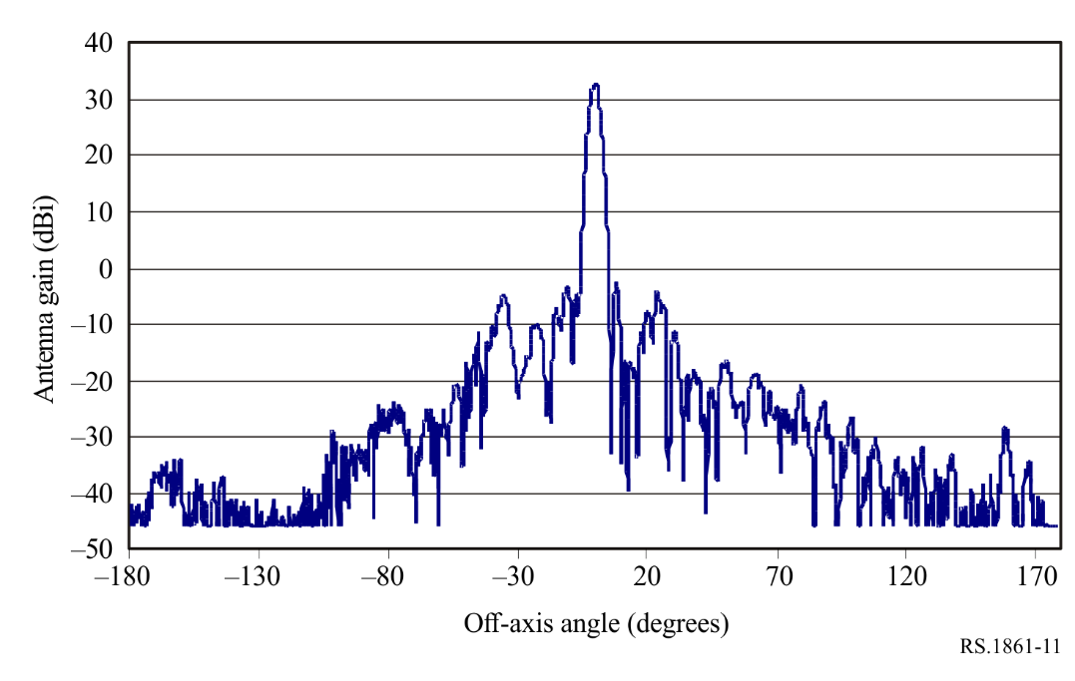

6.8 Typical parameters of passive sensors operating in the 31.3-31.8 GHz frequency band
Passive measurements around frequencies 23.8 GHz (total water vapour content), 31.5 GHz (window channel) and 90 GHz (liquid water) provide auxiliary data which play a predominant role in the retrieval process of temperature measurements performed in the O₂ absorption spectrum. These auxiliary measurements must have radiometric and geometric performances and availability criteria consistent with those of the temperature measurements.
This frequency band is one of the frequency bands used for close-to-nadir atmospheric sounding in conjunction with the frequency bands such as 23.8 GHz and 50.3 GHz for the characterization each layer of the Earth’s atmosphere. The 31.3-31.5 GHz frequency band will also be used in conjunction with the frequency band 31.5-31.8 GHz as a ‘split window’. This will allow a comparison of the measurements conducted in the two sub-bands to check the quality of the data. This will then allow using the full band when the quality is expected good to increase the sensitivity of the sensor.
Tables 13 and 14 summarize the parameters of passive sensors that are or will be operating in the 31.3-31.8 GHz frequency band.
TABLE 13
EESS (passive) sensor characteristics in the 31.3-31.8 GHz frequency band
 | Sensor G1 | Sensor G2 | Sensor G3
Sensor type | Nadir scan | Nadir scan | Conical scan
Orbit parameters
Altitude (km) | 833  822 * | 824 | 835
Inclination (degree) | 98.6 | 98.7 | 98.85
Eccentricity | 0.001 | 0 | 0
Repeat period (days) | 9  29 * | 9
TABLE 13 (end)
 | Sensor G1 | Sensor G2 | Sensor G3
Sensor antenna parameters
Number of beams | 30 earth fields per 8 s scan period | 2 | 1
Antenna size (m) | 0.30  0.274 * | 0.203 | 0.65
Maximum beam gain (dBi) | 34.4 | 30.4 | 43.2
Polarization | V  QV * | QV | H, V
−3 dB beamwidth (degree) | 3.3 | 5.2 | 1.1
Instantaneous field of view | Nadir FOV: 48.5 km  Outer FOV:  149.1 × 79.4 km  147 × 79 km* | Nadir FOV: 74.8 km  Outer FOV:  323.1.1 × 141.8 km | 31 km × 74 km
Off-nadir pointing angle (degree) | ±48.33 cross-track | ±52.725 cross-track | 53.3
Incidence angle at Earth (degree) | 0  57.5 * | 0 | 65
Swath width (km) | 2 343  2 186 * | 2 500 | 1 600
Antenna efficiency | 0.60 | 0.60 | 0.60
Beam dynamics | 8 s scan period | 8/3 s scan period cross-track; 96 earth fields per scan period | 2.5 s scan period, clockwise
Sensor antenna pattern | Rec. ITU-R  RS.1813 | Rec. ITU-R  RS.1813 | Rec. ITU-R  RS.1813
Cold calibration ant. gain (dBi) | 34.4 | 30.4 | 34
Cold calibration angle (degrees re. satellite track) | 90°  −90° ± 3.9°* | 0 | 315
Cold calibration angle (degrees re. nadir direction) | 83.33° | 82.175° | 90
Sensor receiver parameters
Sensor integration time (ms) | 158 | 18 | 5
Channel bandwidth | 180 MHz centred at 31.4 GHz | 180 MHz centred at 31.4 GHz | 0.5 GHz
Measurement spatial resolution
Horizontal resolution (km) | 44  48 * | 75 | 32
Vertical resolution (km) | 44  48 * | 75 | 32
NOTE – * indicates that a particular sensor is flown on different missions, with different orbit and sensor parameters.
TABLE 14
EESS (passive) sensor characteristics in the 31.3-31.8 GHz frequency band
 | Sensor G4 | Sensor G5 | Sensor G6
Sensor type | Mechanical nadir scan | Conical scan | Conical scan
Orbit parameters
Altitude (km) | 830 | 830 | 830
Inclination (degree) | 98.7 | 98.7 | 98.85
Eccentricity | 0.001 | 0.001 | 0
Repeat period (days) | 29 | 29
Sensor antenna parameters
Number of beams | 1 | 1 | 1
Antenna size (m) | 0.35 | 0.76 | 1
Maximum beam gain (dBi) | 38 | 45.7 | 48.2
Polarization | QH | V,H | V,H
−3 dB beamwidth (degree) | 2.7 | 1 | 0.77
Instantaneous field of view | Nadir FOV: 39 km  (1 202 km²)  Outer FOV: 130 × 67 km  (6 769 km²) | 22 × 36 km  (625 km²) | 22 km ×  51 km  (875 km²)
Off-nadir pointing angle (degree) | ±49.31 cross-track | 44.8 | 53.3
Incidence angle at Earth (degree) | 0 (nadir)  58.9 | 52.8 | 65
Swath width (km) | 2 220 | 1 700 | 2 200
Antenna efficiency | 0.60 | 0.60 | 0.61
Beam dynamics | 2.254 s | 45 rpm (1.33 s) | 2.5 s scan period, counter clockwise
Sensor antenna pattern | Rec. ITU-R RS.1813 | Rec. ITU-R RS.1813 | Rec. ITU-R RS.1813
Cold calibration ant. gain |  |  | 35 dBi
Cold calibration angle (degrees re. satellite track) | 78° to 83° | 165.5° to 203° | 315
Cold calibration angle (degrees re. nadir direction) |  |  | 90
Sensor receiver parameters
Sensor integration time (ms) | 13.7 | 1 to 8 | 5
Channel bandwidth | 180 MHz  centred at 31.4 GHz | 200 MHz  centred at 31.4 GHz | 1 GHz centred  at 31.5 GHz
Measurement spatial resolution
Horizontal resolution (km) |  |  | 32
Vertical resolution (km) |  |  | 32

6.9 Typical parameters of passive sensors operating in the 36-37 GHz frequency band
The 36-37 GHz frequency band is vital for the study of global water circulation, rain rates, snow, sea ice and clouds. Tables 15 and 16 summarize the parameters of passive sensors that are or will be operating in the 36-37 GHz frequency band.
TABLE 15
EESS (passive) sensor characteristics in the 36-37 GHz frequency band
 | Sensor H1 | Sensor H4 | Sensor H5 | Sensor H6 | Sensor H7
Sensor type | Conical scan | Conical scan | Conical scan | Conical scan | Conical scan
Orbit parameters
Altitude (km) | 865.6 | 835 | 699.6 | 830 | 407
Inclination (degree) | 20° | 98.85° | 98.186° | 98.85° | 50°
Eccentricity | 0 | 0 | 0.002 | 0 | 0.003
Repeat period (days) | 7 |  | 16
Sensor antenna parameters
Number of beams |  | 1 | 1 | 1 | 1
Antenna size (m) | 0.65 | 0.65 | 2.0 | 1 | 1.1
Maximum beam gain (dBi) | 45 | 44.5 | 54.8 | 49.4 | 50.3
Polarization | H | H, V | H, V | H, V, V+45°, V-45° | H, V
−3 dB beamwidth (degree) | 1.8 | 0.9 | 0.35 | 0.67 | 0.65
Instantaneous field of view (km) | 62 × 38 | 26 × 61 | 12 × 7 | 19 × 45 | 12 × 7.3
Off-nadir pointing angle (degree) | 44.5 | 53.3 | 47.5 | 53.3 | 48.6
Incidence angle at Earth | 52.3° | 65° | 55° | 65° | 53°
Swath width (km) | 1 607 | 1 600 | 1 450 | 2 200 | 800
Main beam efficiency ⁽¹⁾ | 96% | 94% | 93%
Antenna efficiency | 0.60 | 0.76 | 0.52 | 0.60 | 0.606
Beam dynamics | 31.9 rpm | 2.5 s scan period, clockwise | 40 rpm | 2.5 s scan period, counter clockwise | 30 rpm
Sensor antenna pattern | Rec. ITU-R RS.1813 | Rec. ITU-R RS.1813 | Rec. ITU-R RS.1813 | Rec. ITU-R RS.1813 | Rec. ITU-R RS.1813
Cold calibration antenna gain (dBi) | N/A | 35.5 | 39.3 | 36.5 | 47.3
Cold calibration angle (degrees re. satellite track) | N/A | 315° | 115.5º | 315° | 180°
Cold calibration angle (degrees re. nadir direction) | N/A | 90° | 97.0 | 90° | 90°

TABLE 15 (end)
 | Sensor H1 | Sensor H4 | Sensor H5 | Sensor H6 | Sensor H7
Sensor receiver parameters
Sensor integration time (ms) | 1 | 5 | 2.6 | 5 | 2.08
Channel bandwidth | 1 GHz | 1 GHz centred at 36.5 GHz | 1 GHz centred at 36.5 GHz | 1 GHz centred at 36.5 GHz | 1 GHz centred at 36.5 GHz
Measurement spatial resolution
Horizontal resolution (km) | 40 | 32 | 6.8 | 32 | 11.5
Vertical resolution (km) | N/A | 32 | 12 | 32 | 12.2
⁽¹⁾ This parameter is included for this band due to its use in Resolution 752 (WRC-07).

TABLE 16
EESS (passive) sensor characteristics in the 36-37 GHz frequency band
 | Sensor H8 | Sensor H9 | Sensor H10 | Sensor H11 | Sensor H12 | Sensor H13
Sensor type | Conical scan | Nadir | Conical scan | Conical scan | Fixed-pointing | Conical scan
Orbit parameters
Altitude (km) | 820 | 814.5 | 407 | 970 | 970 | 665.96
Inclination (degree) | 98.702 | 98.65 | 65 | 99.3 | 99.3 | 98.06
Eccentricity | 0.001 144 1 | 0.001 148 | 0 | 0.00117 | 0.00117 | 0.0015
Repeat period (days) | 29 | 27 | 43.5 | 14 | 14 | 3
Sensor antenna parameters
Number of beams | 8 | 1 | 1 | 1 | 3 | 1
Antenna size (m) | 7.4 | 0.6 | 1.22 | 1.0 | 0.92 | 2.0
Maximum beam gain | 59.6 dBi | 44 dBi | 47.3 dBi | 48 dBi | 49 dB | 54.8 dBi
Polarization | H, V | V | H/V | V, H | V, H | H, V
−3 dB beamwidth (degree) | 0.15-0.24 | 1.31 | 0.81 | 0.71 | 0.67 | 0.35
Instantaneous field of view | 5 × 3 | 19 diameter | 15.6 × 9.4 | 17 × 28 | 11.3 ×11.3 | 11 × 6
Off-nadir pointing angle (degree) | 46.5 | 1.8 | 48.5 | 44 | 0 | 47.7
Incidence angle at Earth (degree) | 55 | 2 | 52.8 | 53 | 0 | 55
Swath width (km) | >1 900 | N/A | 921 | 1 700 | N/A | 1 535
Main beam efficiency (see Note below) |  |  |  | 96% | 95.5% | 93%
Antenna efficiency |  |  |  | 0.6 | 0.58 | 0.53
Beam dynamics | 7.8 rpm | N/A | 32 rpm | 3.57 s | N/A | 40 rpm
Sensor antenna pattern |  | Fig 12 | Rec. ITU-R RS.1813 | Rec. ITU-R RS.1813 | Rec. ITU-R RS.1813 | Rec. ITU-R RS.1813

TABLE 16 (end)
 | Sensor H8 | Sensor H9 | Sensor H10 | Sensor H11 | Sensor H12 | Sensor H13
Cold calibration antenna gain | 59.6 dBi | 26.08 dBi | 34.3 dBi | 38 dB | 21.9 dB | 39.2 dBi
Cold calibration angle (degrees re. satellite track) | 0º | Deep sky pointing for cold calibration through a dedicated horn | 206.7° (CCW) | 158° | 0° | 118.7º
Cold calibration angle (degrees re. nadir direction) | 45º-180º | Deep sky pointing for cold calibration through a dedicated horn | 107.5° | 80° | 90° | 94.6º
Sensor receiver parameters
Sensor integration time (ms) | 3.6 | 152.88 | 3.6 | 10 | 200 | 2.5
Channel bandwidth | Minimum of 300 MHz centred at 36.5 GHz | 1 GHz centred at 36.5 GHz | 1 000 MHz centred at 36.5 GHz | 1 000 MHz | ±500 MHz | 840 MHz centred at 36.42 GHz
Measurement spatial resolution |  |  |  | 22 km | 11.3 km
Horizontal resolution (km) | 5 | 19 | 9.4 | 28 | 11.3 | 6
Vertical resolution (km) | 3 | 19 | 15.6 | 17 | 11.3 | 11
NOTE – This parameter is included for this band due to its use in Resolution 752 (WRC-07).

FIGURE 12
Sensor H9 antenna pattern (36.5 GHz)
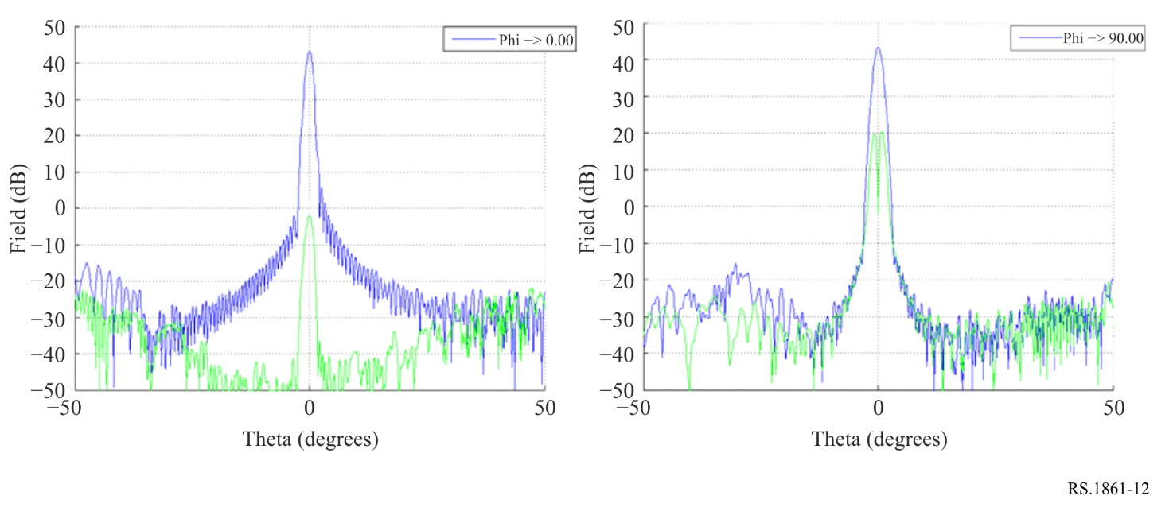

6.10 Typical parameters of passive sensors operating in the 50.2-50.4 GHz frequency band
This frequency band is one of several frequency bands between 50 GHz and 60 GHz that are used collectively to provide three-dimensional temperature profiles of the atmosphere. Tables 17 and 18 summarize the parameters of passive sensors that are or will be operating in the 50.2-50.4 GHz frequency band.
TABLE 17
EESS (passive) sensor characteristics in the 50.2-50.4 GHz frequency band
 | Sensor I2 | Sensor I3 | Sensor I4 | Sensor I5 | Sensor I6
Sensor type | Mechanical nadir scan | Push-broom | Mechanical nadir scan | Mechanical nadir scan | Conical scan
Orbit parameters
Altitude (km) | 833  822 * | 850 | 824 | 830 | 830
Inclination (degree) | 98.6  98.7 * | 98 | 98.7 | 98.7 | 98.7
Eccentricity | 0  0.001 * | 0 | 0 | 0.001 | 0.001
Repeat period (days) | 9  29 * |  | 9 | 29 | 29
Sensor antenna parameters
Number of beams | 30 earth fields per 8 s scan period | 90 | 2 | 1 | 1
Antenna size (m) | 0.15 | 0.5 | 0.203 | 0.35 | 0.76
Maximum beam gain (dBi) | 34.4 | 45 | 37.9 | 42 | 46.4
Polarization | V  QV * | H, V | QH | QH | V, H
TABLE 17 (end)
 | Sensor I2 | Sensor I3 | Sensor I4 | Sensor I5 | Sensor I6
−3 dB beamwidth (degree) | 3.3 | 1.1 | 2.2 | 1.4 | 1
Instantaneous field of view (km) | Nadir FOV: 48.5  Outer FOV: 149.1 × 79.4  147 × 79 * | 16 km × 2 282 km | Nadir FOV: 31.6 km  Outer FOV: 136.7 × 60 | Nadir FOV: 20  (323 km²)  Outer FOV:  67 × 35  (1 816 km²) | 22 × 36  (625 km²)
Off-nadir pointing angle (degree) | ±48.33 cross-track |  | ±52.725 cross-track | ±49.31 cross-track | 44.8
Incidence angle at Earth (degree) | 57.5 |  |  | 0 (nadir)  58.9 | 52.8
Swath width (km) | 2 343  2 186 | 2 282 | 2 500 | 2 220 | 1 700
Antenna efficiency | 0.60 | 0.60 | 0.60 | 0.60 | 0.60
Beam dynamics | 8 s scan period | 90 resolution elements per swath | 8/3 s scan period cross-track; 96 earth fields per scan period | 2.254 s | 45 rpm (1.33 s)
Sensor antenna pattern | Rec. ITU-R RS.1813 | Rec. ITU-R RS.1813 | Rec. ITU-R RS.1813 | Rec. ITU-R RS.1813 | Rec. ITU-R RS.1813
Cold calibration antenna gain (dBi) | 34.4 | 35 | 37.9
Cold calibration angle (degrees re. satellite track) | 90°  −90° ± 3.9° * | 90° | 0 | 78° to 83° | 165.5° to 203°
Cold calibration angle (degrees re. nadir direction) | 83.33° | 83° | 82.175°
Sensor receiver parameters
Sensor integration time (ms) | 165 | N/A | 18 | 13.7 | 1 to 8
Channel bandwidth (MHz) | 180  centred at 50.3 GHz | N/A | 180  centred at 50.3 GHz | 180  centred at 50.3 GHz | 180  centred at 50.3 GHz
Measurement spatial resolution
Horizontal resolution (km) | 48 | 16 | 32
Vertical resolution (km) | 48 | 16 | 32
NOTE – * indicates that a particular sensor is flown on different missions, with different orbit and sensor parameters.

TABLE 18
EESS (passive) sensor characteristics in the 50.2-50.4 GHz frequency band
 | Sensor I7 | Sensor I8 | Sensor I9 | Sensor  GSO-I1 | Sensor  GSO-I2
Sensor type | Conical scan | Conical scan | Cross-track nadir scan | Wide strip and thin circle combined scan | Interferometric radiometer
Orbit parameters
Altitude (km) | 407 | 830 | 595 | 35 800 | 35 800
Inclination (degree) | 50 | 98.85 | 97.79 | N/A | N/A
Eccentricity | 0.003 | 0 | 0.001 | N/A | N/A
Repeat period |  |  | 9 days/30 min (single satellite/constellation) | N/A | N/A
Sensor antenna parameters
Number of beams | 1 | 1 | 1 | 1 | 1
Antenna size (m) | 1.1 | 1 | 0.16 | 5 | 5
Maximum beam gain (dBi) | 53.0 | 52,8 | 36.3 | 66 | 66.2
Polarization | V, H | V, H | QH/QV | H | H
−3 dB beamwidth (degree) | 0.5° |  | 2.7° | 0.09° | 0.083°
Instantaneous field of view (km) | 8.3 × 5.3 | 13 × 30  302.4 km² | Nadir FOV: 28  (618 km²)  Outer FOV: 54 × 118  (4 954 km²) | N/A | N/A
Off-nadir pointing angle (degree) | 46.1 | 53.3 | ±54.4 cross-track | N/A | N/A
Incidence angle at Earth (degree) | 50 | 65 | 0 (nadir)  62.8 | N/A | N/A
Swath width (km) | 800 | 2 200 | 1 900 | 8 scan stripes, each strip 0.9° × 7.2°, thin circle diameter 1.1° | Full disk
Antenna efficiency | 0.594 | 0.62 | 0.6 | 0.60 | 0.60
Beam dynamics | 30 rpm | 2.5 s scan period, counter clockwise | 1.1 s (45 rpm) | General scan:  0.64°/min  Local scan:  25.75 rpm | Full disk: 10 min
Sensor antenna pattern | Rec. ITU-R RS.1813 | Rec. ITU-R RS.1813 | Rec. ITU-R  RS.1813 | Rec. ITU-R RS.1813 | Rec. ITU-R RS.1813
Cold calibration antenna gain (dBi) | 50.0 | 40 | 36.3
Cold calibration angle (degrees re. satellite track) | 180° | 315° | 78° to 83° |  | N/A
Cold calibration angle (degrees re. nadir direction) | 90° | 90°
Sensor receiver parameters
Sensor integration time (ms) | 2.08 | 5 | 2 |  | 20
Channel bandwidth (MHz) | 200 | 200 | 180  centred at 50.3 GHz | 200 | 200
Measurement spatial resolution
Horizontal resolution (km) | 9.3 | 32 |  | 50 (nadir) | 52 (nadir)
Vertical resolution (km) | 8.3 | 32 |  | 50 (nadir) | 52 (nadir)

6.11 Typical parameters of passive sensors operating in the 52.6-54.25 GHz frequency band
This frequency band is one of the frequency bands used for close-to-nadir atmospheric sounding in conjunction with the frequency bands at 23.8 GHz, 31.5 GHz and 50.3 GHz to characterize each layer of the atmosphere.
Tables 19 and 20 summarize the parameters of passive sensors that are or will be operating in the 52.6-54.25 GHz frequency band.
TABLE 19
EESS (passive) sensor characteristics in the 52.6-54.25 GHz frequency band
 | Sensor J1 | Sensor J3 | Sensor J4 | Sensor J5 | Sensor J6
Sensor type | Mechanical nadir scan | Mechanical nadir scan | Conical scan | Mechanical nadir scan | Conical scan
Orbit parameters
Altitude (km) | 833  822 * | 824 | 835 | 830 | 830
Inclination (degree) | 98.6  98.7 * | 98.7 | 98.85 | 98.7 | 98.7
Eccentricity | 0  0.001* | 0 | 0 | 0.001 | 0.001
Repeat period (days) | 9  29 * | 9 |  | 29 | 29
Sensor antenna parameters
Number of beams | 30 earth fields per 8 s scan period | 2 | 1 | 1 | 1
Antenna size (m) | 0.15 | 0.203 | 0.65 | 0.35 | 0.76
Maximum beam gain (dBi) | 34.4 | 37.9 | 47.6 | 42 | 46.5
Polarization | V, H  QV, QH* | QH | V | QH/QV
−3 dB beamwidth (degree) | 3.3 | 2.2 | 0.65 | 1.4 | 1
Instantaneous field of view (km) | Nadir FOV:  48.5  Outer FOV:  149.1 × 79.4  147 × 79 * | Nadir FOV: 31.6  Outer FOV: 136.7 × 60 | IFOV 18 × 44 | Nadir FOV: 20  (323 km²)  Outer FOV:  67 × 35  (1 816 km²) | 22 × 36  (625 km²)
Off-nadir pointing angle (degree) | ±48.33 cross-track | ±52.725 cross-track | 53.3 | ±49.31 cross-track | 44.8
Incidence angle at Earth (degree) | 0  57.5 * |  | 65 | 0 (nadir)  58.9 | 52.8
Swath width (km) | 2 343  2 186 * | 2 500 | 1 600 | 2 220 | 1 700
Antenna efficiency | 0.60 | 0.60 | 0.60 | 0.60 | 0.60

TABLE 19 (end)
 | Sensor J1 | Sensor J3 | Sensor J4 | Sensor J5 | Sensor J6
Beam dynamics | 8 s scan period | 8/3 s scan period cross-track; 96 earth fields per scan period | 2.5 s scan period, clockwise | 2.254 s | 45 rpm (1.33 s)
Sensor antenna pattern | Rec. ITU-R RS.1813 | Rec. ITU-R RS.1813 | Rec. ITU-R RS.1813 | Rec. ITU-R RS.1813 | Rec. ITU-R RS.1813
Cold calibration antenna gain (dBi) | 34.4 | 37.9 | 39
Cold calibration angle (degrees re. satellite track) | 90°  −90° ± 3.9°* | 0 | 315° | 78° to 83° | 165.5° to 203°
Cold calibration angle (degrees re. nadir direction) | 83.33° | 82.175° | 90°
Sensor receiver parameters
Sensor integration time (ms) | 165 | 18 | 5 | 13.7 | 1 to 8
Channel bandwidth | 400 MHz centred at 52.8 GHz  170 MHz centred at 53.596 GHz | 400 MHz centred at 52.8 GHz  170 MHz centred at 53.596 GHz | 400 MHz centred at 52.8,  53.3 and  53.8 GHz | Table 21 | Table 22
Measurement spatial resolution
Horizontal resolution (km) | 47  48 * | 32 | 48
Vertical resolution (km) | 47  48 * | 32 | 48
NOTE – * indicates that a particular sensor is flown on different missions, with different orbit and sensor parameters.

TABLE 20
EESS (passive) sensor characteristics in the 52.6-54.25 GHz frequency band
 | Sensor J7 | Sensor J8 | Sensor J9 | Sensor  GSO-J1 | Sensor  GSO-J2
Sensor type | Conical scan | Conical scan | Cross-track nadir scan | Wide strip and thin circle combined scanr | Interferometric radiometer
Orbit parameters
Altitude (km) | 830 | 407 | 595 | 35 800 | 35 800
Inclination (degree) | 98.85 | 50 | 97.79 | N/A | N/A
Eccentricity | 0 | 0.003 | 0.001 | N/A | N/A

TABLE 20 (cont.)
 | Sensor J7 | Sensor J8 | Sensor J9 | Sensor  GSO-J1 | Sensor  GSO-J2
Repeat period |  |  | 9 days/30 min (single satellite/  constellation) | N/A | N/A
Sensor antenna parameters
Number of beams | 1 | 1 | 1 | 1 | 1
Antenna size (m) | 1 | 1.1 | 0.16 | 5 | 5
Maximum beam gain (dBi) | 52.8 | 53.5 | 36.8 | 66. | 66.7
Polarization |  | H, V | QH/QV | V/H | H
−3 dB beamwidth (degree) | 0.45 | 0.5 | 2.7 | 0.09 | 0.08
Instantaneous field of view (km) | 13 × 30  (302.4 km²) | 8.3 × 5.3 | Nadir FOV: 28  (618 km²)  Outer FOV: 54 × 118  (4 954 km²) | N/A | N/A
Off-nadir pointing angle (degree) | 53.3 | 46.1 | 54.4 | N/A | N/A
Incidence angle at Earth (degree) | 65 | 50 | 0 (nadir)  62.8 | N/A | N/A
Swath width (km) | 2 200 | 800 | 1 900 | 8 scan stripes, each strip 0.9° × 7.2°, thin circle diameter 1.1° | Full disk
Antenna efficiency | 0.61 | 0.592 | 0.6 | 0.60 | 0.60
Beam dynamics | 2.5 s scan period, counter clockwise | 30 rpm | 1.1s (45 rpm) | General scan:  0.64°/min  Local scan:  25.75 rpm | Full disk: 10 min
Sensor antenna pattern | Rec. ITU-R RS.1813 | Rec. ITU-R RS.1813 | Rec. ITU-R  RS.1813 | Rec. ITU-R RS.1813 | Rec. ITU-R RS.1813
Cold calibration antenna gain (dBi) | 40 | 50.5 | 36.8
Cold calibration angle (degrees re. satellite track) | 315° | 180° | 78° to 83° |  | N/A
Cold calibration angle (degrees re. nadir direction) | 90° | 90°

TABLE 20 (end)
 | Sensor J7 | Sensor J8 | Sensor J9 | Sensor  GSO-J1 | Sensor  GSO-J2
Sensor receiver parameters
Sensor integration time (ms) | 5 | 2.08 | 2 | 20 | 20
Channel bandwidth (MHz) | 400 MHz centred at 52.8, 53.3 and  53.8 GHz | 400 MHz centred at 52.8 GHz  400 MHz centred at 53.24 GHz  400 MHz centred at 53.75 GHz | Table 23 | 400 MHz centred at 52.8 GHz  400 MHz centred at 53.596 GHz | 400 MHz centred at 52.8 GHz  400 MHz centred at 53.596 GHz
Measurement spatial resolution
Horizontal resolution (km) | 32 | 9.3 |  | 50 | 50 (nadir)
Vertical resolution (km) | 32 | 8.3 |  | 50 (nadir) | 50

TABLE 21
Sensor J5 passive sensor characteristics for channels between 52.6 and 54.25 GHz
Centre frequency  (GHz) | Bandwidth  (MHz)
52.8 | 400
53.246 ± 0.08 | 2 × 140
53.596 ± 0.115 | 2 × 170
53.948 ± 0.081 | 2 × 142

TABLE 22
Sensor J6 passive sensor characteristics for channels
between 52.6 and 54.25 GHz
Centre frequency  (GHz) | Bandwidth  (MHz)
52.61 | 400
53.24 | 400
53.75 | 400

TABLE 23
Sensor J9 passive sensor characteristics for channels between 52.6 and 54.25 GHz
Centre frequency  (GHz) | Bandwidth  (MHz)
52.8 | 400
53.246 | 300
53.596 | 370

6.12 Typical parameters of passive sensors operating in the 54.25-59.3 GHz frequency band
The 54.25-59.3 GHz frequency band is of primary interest for atmospheric temperature profiling (O₂ absorption lines). Tables 24 and 25 summarize the parameters of passive sensors that are or will be operating between 54.25 and 59.3 GHz. The frequency range from 54.25 to 60.3 GHz is covered by many smaller frequency bands with varying bandwidths and polarizations (see Tables 26 through 32).
TABLE 24
EESS (passive) sensor characteristics operating in the 54.25-59.3 GHz frequency band
 | Sensor K2 | Sensor K3 | Sensor K4 | Sensor K5
Sensor type | Mechanical nadir scan | Mechanical nadir scan | Conical scan | Conical scan
Orbit parameters
Altitude (km) | 824 | 833  822 * | 835 | 830
Inclination (degree) | 98.7 | 98.6  98.7 * | 98.85 | 98.85
Eccentricity | 0 | 0  0.001* | 0 | 0
Repeat period (days) | 9 | 9  29 *
Sensor antenna parameters
Number of beams | 2 | 30 earth fields per 8 s scan period | See Table 28 | See Table 28
Antenna size (m) | 0.203 | 0.15 | 0.65 | 1
Maximum beam gain (dBi) | 37.9 | 34.4 | 47.6 | 53.4
Polarization | See Table 26 | See Table 27 | See Table 28 | See Table 28
−3 dB beamwidth | 2.2° | 3.3° | 0.65° | 0.42°
Instantaneous field of view | Nadir FOV: 31.6 km  Outer FOV: 136.7 × 60 km | Nadir FOV: 48.5 km (3.3°)  Outer FOV: 149.1 × 79.4 km  147 × 79 km* | Outer FOV 18 × 43 km | 12 × 28 km  264 km²
Off-nadir pointing angle (degree) | ±52.725 cross-track | ±48.33 cross-track | 53.3 | 53.3
Incidence angle at Earth |  | 57.5°* | 65° | 65°
Swath width (km) | 2 500 | 2 343 | 1 600 | 1 600
TABLE 24 (end)
EESS (passive) sensor characteristics operating in the 54.25-59.3 GHz frequency band
 | Sensor K2 | Sensor K3 | Sensor K4 | Sensor K5
Antenna efficiency | 0.60 | 0.60 | 1.00 | 0.62
Beam dynamics | 8/3 s scan period cross-track; 96 earth fields per scan period | 8 s scan period | 2.5 s scan period, clockwise | 2.5 s scan period, clockwise
Sensor antenna pattern | See Rec. ITU-R RS.1813 | See Rec. ITU-R RS.1813 | See Rec. ITU-R RS.1813 | See Rec. ITU-R RS.1813
Cold calibration ant. gain (dBi) | 37.9 | 34.4 | 39 | 40
Cold calibration angle (degrees re. satellite track) | 0 | 90°−90° ± 3.9° * | 315° | 315°
Cold calibration angle (degrees re. nadir direction) | 82.175° | 83.33° | 90° | 90°
Sensor receiver parameters
Sensor integration time (ms) | 18 | 165 | 5 | 5
Channel bandwidth | See Table 26 | See Table 27 | See Table 28 | See Table 28
Measurement spatial resolution
Horizontal resolution (km) | 32 | 48 | See Table 29 | See Table 29
Vertical resolution (km) | 32 | 48 | See Table 29 | See Table 29

TABLE 25
EESS (passive) sensor characteristics operating in the 54.25-59.3 GHz frequency band
 | Sensor K6 | Sensor K7 | Sensor GSO-K1 | Sensor  GSO-K2
Sensor type | Cross-track scan | Conical scan | Wide strip and thin circle combined scan | Interferometric radiometer
Orbit parameters
Altitude (km) | 595 | 830 | 35 800 | 35 800
Inclination (degree) | 97.79 | 98.7 | N/A | N/A
Eccentricity | 0.001 | 0.001 | N/A | N/A
Repeat period | 9 days/30 min (single satellite/  constellation) | 29 days | N/A | N/A
Sensor antenna parameters
Number of beams | 1 | 1 | 1 | 1
Antenna size (m) | 0.16 | 0.35 | 5 | 5
Maximum beam gain (dBi) | 37.4 | 44 | 66 | 67.3
Polarization | QH/QV | QH/QV | See Table 32 | See Table 32
−3 dB beamwidth (degree) | 2.7 | 1.4 | 0.09 | 0.074

TABLE 25 (end)
 | Sensor K6 | Sensor K7 | Sensor GSO-K1 | Sensor  GSO-K2
Instantaneous field of view | Nadir FOV: 28 km  (618 km²)  Outer FOV: 54 × 118 km  (4 954 km²) | Nadir FOV: 20 km  (323 km²)  Outer FOV: 67 × 35 km  (1 816 km²) | N/A | N/A
Off-nadir pointing angle (degree) | 54.4 | ±49.31 cross-track |  | N/A
Incidence angle at Earth (degree) | 0 (nadir)  62.8 | 0 (nadir)  58.9 | N/A | N/A
Swath width | 1 900 km | 2 220 km | 8 scan stripes, each strip 0.9°× 7.2°, thin circle diameter 1.1° | Full disk
Antenna efficiency | 0.6 | 0.6 | 0.60 | 0.60
Beam dynamics | 1.1 s (45 rpm) | 2.254 s | General scan:  0.64°/min  Local scan:  25.75 rpm | Full disk: 10 min
Sensor antenna pattern | Rec. ITU-R  RS.1813 | Rec. ITU-R RS.1813
Cold calibration ant. gain (dBi) | 37.4
Cold calibration angle (degrees re. satellite track) | 78° to 83° | 78° to 83° |  | N/A
Cold calibration angle (degrees re. nadir direction)
Sensor receiver parameters
Sensor integration time (ms) | 2 | 13.7 |  | 20
Channel bandwidth | See Table 30 | See Table 31 | See Table 32 | See Table 32
Measurement spatial resolution
Horizontal resolution (km) |  |  | 50 | 47 (nadir)
Vertical resolution (km) |  |  | 50 | 47 (nadir)

TABLE 26
Sensor K2 passive sensor characteristics for channels between 54.25 and 59.3 GHz
Centre frequency  (GHz) | Channel bandwidth  (MHz) | Polarization
54.4 | 400 | QH
54.94 | 400 | QH
55.5 | 330 | QH
57.290344 | 330 | QH
57.073344, 57.507344 | 78 | QH
57.660544, 57.564544, 57.016144, 56.920144 | 36 | QH
57.634544, 57.590544, 56.990144, 56.946144 | 16 | QH
57.622544, 57.602544, 56.978144, 56.958144 | 8 | QH
57.617044, 57.608044, 56.972644, 56.963644 | 3 | QH

TABLE 27
Sensor K3 passive sensor characteristics for channels between 54.25 and 59.3 GHz
Centre frequency  (GHz) | Channel bandwidth  (MHz) | Polarization
54.4 | 400 | H, QH*
54.94 | 400 | V, QV*
55.5 | 330 | H, QH*
57.290344 | 330 | H, QH*
57.073344, 57.507344 | 78 | H, QH*
57.660544, 57.564544, 57.016144, 56.920144 | 36 | H, QH*
57.634544, 57.590544, 56.990144, 56.946144 | 16 | H, QH*
57.622544, 57.602544, 56.978144, 56.958144 | 8 | H, QH*
57.617044, 57.608044, 56.972644, 56.963644 | 3 | H, QH*
NOTE – * indicates that a particular sensor is flown on different missions, with different parameters.

TABLE 28
Sensors K4 and K5 passive sensor characteristics for channels between 54.25 and 60.5 GHz
Centre frequency  (GHz) | Number of beams | Channel bandwidth  (MHz) | Polarization | Altitude of peak sensitivity  (km)
54.64 | 1 | 400 | V | 10
55.63 | 1 | 400 | V | 14
57.290344 ± 0.322 ± 0.1 | 4 | 50 | H | 20
57.290344 ± 0.322 ± 0.05 | 4 | 20 | H | 25
57.290344 ± 0.322 ± 0.025 | 4 | 10 | H | 29
57.290344 ± 0.322 ± 0.01 | 4 | 5 | H | 35
57.290344 ± 0.322 ± 0.005 | 4 | 3 | H | 42

TABLE 29
Sensors K4 and K5 passive sensor measurement spatial resolutions
for channels between 54.25 and 60.5 GHz
 | Sensor K4 |  | Sensor K5
Centre frequency  (GHz) | Measurement spatial resolution  (horizontal)  (km) | Measurement spatial resolution  (vertical)  (km) | Measurement spatial resolution  (horizontal)  (km) | Measurement spatial resolution  (vertical)  (km)
54.64 | 48 | 48 | 32 | 32
55.63 | 48 | 48 | 32 | 32
57.290344 ± 0.322 ± 0.1 | 48 | 48 | 48 | 48
57.290344 ± 0.322 ± 0.05 | 48 | 48 | 48 | 48
57.290344 ± 0.322 ± 0.025 | 48 | 48 | 96 | 96
57.290344 ± 0.322 ± 0.01 | 48 | 48 | 96 | 96
57.290344 ± 0.322 ± 0.005 | 48 | 48 | 96 | 96

TABLE 30
Sensor K6 passive sensor characteristics for channels between 54.25 and 59.3 GHz
Centre frequency  (GHz) | Channel bandwidth  (MHz) | Polarization
54.40 | 400 | H
54.94 | 400 | H
55.50 | 330 | H
57.290344 | 330 | H

TABLE 31
Sensor K7 passive sensor characteristics for channels between 54.25 and 59.3 GHz
Centre frequency  (GHz) | Bandwidth  (MHz)
54.4 | 400
54.94 | 400
55.5 | 330
57.290344 | 330
57.290344 ± 0.217 | 2 × 78
57.290344 ± 0.3222 ± 0.048 | 4 × 36
57.290344 ± 0.3222 ± 0.022 | 4 × 16
57.290344 ± 0.3222 ± 0.010 | 4 × 8
57.290344 ± 0.3222 ± 0.0045 | 4 × 3

TABLE 32
Sensors GSO-K1 and GSO-K2 passive sensor characteristics
for channels between 54.25 and 59.3 GHz
Centre frequency  (GHz) | Channel bandwidth  (MHz) | Polarization
57.290344 ± 0.217 | 80 | H
57.290344 ± 0.322 ± 0.048 | 40 | H
57.290344 ± 0.322 ± 0.022 | 20 | H
57.290344 ± 0.322 ± 0.010 | 10 | H
57.290344 ± 0.322 ± 0.0045 | 5 | H

6.13 Typical parameters of passive sensors operating in the 86-92 GHz frequency band
The 86-92 GHz frequency band is essential for the measurement of clouds, oil spills, ice, snow, and rain. It is also used as a reference window for temperature soundings near 118 GHz. Tables 33 and 34 summarize the parameters of passive sensors that are or will be operating within the 86 and 92 GHz frequency band.

TABLE 33
EESS (passive) sensor characteristics operating in the 86-92 GHz frequency band
 | Sensor L1 | Sensor L4 | Sensor L5 | Sensor L6 | Sensor L7 | Sensor L8 | Sensor L9 | Sensor L10
Sensor type | Conical scan | Mechanical nadir scan | Mechanical nadir scan | Mechanical nadir scan | Conical scan | Conical scan | Mechanical nadir scan | Conical scan
Orbit parameters
Altitude (km) | 867 | 833  822 * | 833  822 * | 824 | 835 | 700 | 83 | 830
Inclination (degree) | 20 | 98.6  98.7 * | 98.6  98.7 * | 98.7 | 98.85 | 98.2 | 98.7 | 98.7
Eccentricity | 0 | 0  0.001* | 0  0.001* | 0 | 0 | 0.002 | 0.001 | 0.001
Repeat period (days) | 7 | 9  29 * | 9  29 * | 9 |  | 16 | 29 | 29
Sensor antenna parameters
Number of beams | 1 | 30 earth fields per 8 s scan period | 30 earth fields per 8 s scan period  1 beam (steerable in 90 earth fields per scan period)* | 2 | 2 | 2 | 1 | 1
Antenna size (m) | 0.65 | 0.15 | 0.3  0.22 * | 0.203 | 0.65 | 2 | 0.35 | 0.76
Maximum beam gain (dBi) | 50 | 34.4 | 47  44.8 * | 37.9 | 52.5 | 62.4 | 43 | 55.1
Polarization | H, V | H  QV * | H  QV * | QV | H, V | H, V | QH/QV | V, H
−3 dB beamwidth (degree) | 0.43 | 3.3 | 1.1 | 2.2 | 0.6 | 0.15 | 1.15 | 1

TABLE 33 (cont.)
 | Sensor L1 | Sensor L4 | Sensor L5 | Sensor L6 | Sensor L7 | Sensor L8 | Sensor L9 | Sensor L10
Instantaneous field of view (km) | 10 km × 17 km | Nadir FOV: 48.5 km  Outer FOV: 149.1 × 79.4 km  147 × 79 km* | Nadir FOV: 16 km (1.1°)  Outer FOV: 53 × 27 km* | Nadir FOV: 31.6 km × 31.6 km  Outer FOV: 136.7 × 60 km | 17 km × 40 km | A: 5.1 km × 2.9 km  B: 5.0 km × 2.9 km | Nadir FOV: 17 km  (218 km²)  Outer FOV: 55 × 28 km  (1 225 km²) | 22 × 36 km  (625 km²)
Off-nadir pointing angle (degree) | 44.5 | ±48.33 cross-track | ±48.95  49.4* | ±52.725 cross-track | 53.3 | 47.5° | ±49.31 cross-track | 44.8
Incidence angle at Earth (degree) | 53.5° | 30 positions  57.5°* | Various angles from 0°  59°* |  | 65° | 55° | 0° (nadir)  58.9° | 52.8°
Swath width (km) | 1 700 | 2 343  2 186 * | 2 343  2 193 * | 2 500 | 1600 | 1 450 | 2 220 | 1 700
Antenna efficiency | 0.27 | 0.14 | 0.64 | 0.17 | 0.81 | 0.52 | 0.6 | 0.6
Beam dynamics | 20 rpm | 8 s scan period | 8/3 s scan period | 8/3 s scan period cross-track;  96 earth fields per scan period | 2.5 s scan period, clockwise | 40 rpm | 2.254 s | 45 rpm (1.33 s)
Sensor antenna pattern |  |  |  |  |  |  | See Rec. ITU-R RS.1813 | See Rec. ITU-R RS.1813
Cold calibration ant. gain (dBi) | N/A | 34.4 | 34.4  44.8 * | 37.9 | 44 | 43.4
Cold calibration angle (degrees re. satellite track) | N/A | 90°  −90° ± 3.9°* | End of scan (at 48.95°)  −90° ± 3.9°* | 0 | 315° | 115.5º | 78° to 83° | 165.5° to 203°
Cold calibration angle (degrees re. nadir direction) | N/A | 83.33° | 83.33°  73.6  (66° to 81°)* | 82.175° | 90° | 97.0º

TABLE 33 (end)
 | Sensor L1 | Sensor L4 | Sensor L5 | Sensor L6 | Sensor L7 | Sensor L8 | Sensor L9 | Sensor L10
Sensor receiver parameters
Sensor integration time (ms) | 2 | 180  165 * | 185  18 * | 18 | 5 | 1.2 | 13.7 | 1 to 8
Channel bandwidth (MHz) | 2 700 MHz centred at 89 GHz | 6 000 MHz centred at 89 GHz | Centred at 89 GHz  ±500 MHz, each with a bandwidth of 1 000 MHz  2 800 MHz centred at 89 GHz* | 2 000 MHz centred at 87-91.9 GHz | 2.5 GHz centred at 91.655 GHz | 3 000 MHz centred at 89 GHz | 4 000 MHz  Centred at 89 GHz | 4 000 MHz Centred at 89 GHz
Measurement spatial resolution
Horizontal resolution (km) | 10 | 40.5  48 * | 40.5  16 * | 32 | 16 | 2.9
Vertical resolution (km) | N/A | 48 | 16 | 32 | 16 | 5.1
NOTE – * indicates that a particular sensor is flown on different missions, with different orbit and sensor parameters.
TABLE 34
EESS (passive) sensor characteristics operating in the 86-92 GHz frequency band
 | Sensor L11 | Sensor L12 | Sensor L13 | Sensor L14 | Sensor L15 | Sensor L16 | Sensor L17 | Sensor  GSO-L1 | Sensor  GSO-L2
Sensor type | Conical scan | Conical scan | Cross-track nadir scan | Conical scan | Mechanical nadir scan | Nadir | Conical scan | Wide strip and thin circle combined scanning radiometer | Interferometric radiometer
Orbit parameters
Altitude (km) | 830 | 407 | 595 | 407 | 550 | 1 336 | 665.96 | 35800 | 35800
Inclination (degree) | 98.85 | 50 | 97.79 | 65 | 30 | 66 | 98.06 | N/A | N/A
TABLE 34 (cont.)
 | Sensor L11 | Sensor L12 | Sensor L13 | Sensor L14 | Sensor L15 | Sensor L16 | Sensor L17 | Sensor  GSO-L1 | Sensor  GSO-L2
Eccentricity | 0 | 0.003 | 0.001 | 0 | 0 | 0 | 0.0015 | N/A | N/A
Repeat period |  |  | 9 days/30 min (single satellite/constellation) | 43.5 days | 18.6 days | 9.92 days | 3 days | N/A | N/A
Sensor antenna parameters
Number of beams | 2 | 1 | 1 | 1 | 1 | 1 | 2 | 1 | 1
Antenna size (m) | 1 | 1.1 | 0.16 | 1.22 | 0.083 | 1 | 2 | 5 | 5
Maximum beam gain (dBi) | 57.4 | 58 | 41.3 | 53.8 | 35.0 | 57.0 | 62.4 | 69.5 | 71.1
Polarization | V, H | H, V | QH/QV | H/V | H/V | Single Linear | H, V | V | V
−3 dB beamwidth (degree) | 0.27 | 0.4 | 1.75 | 0.38 | 2.89 | 0.31 | 0.15 | 0.07 | 0.05
Instantaneous field of view (km) | 8 × 18  (105 km²) | 7.5 × 4.5 | Nadir FOV: 18  (259 km²)  Outer FOV: 35 × 76  (2 076 km²) | 7.2 × 4.4 | Nadir IFOV: 27.7  Outer IFOV: 195.6 × 65.6 | 7 × 7 | A: 5 × 3  B: 5 × 3 | 39 × 39 | N/A
Off-nadir pointing angle (degree) | 53.3 | 48.6 | 54.4 | 48.5 | ±60 cross-track | 3.4 along-track | 47.7 | N/A | N/A
Incidence angle at Earth (degree) | 65 | 53 | 0 (nadir)  62.8 | 52.8 | ≤ 70.2 | 4.1 | 55 | N/A | N/A
Swath width (km) | 2 200 | 800 | 1 900 | 921 | 2480 | 7 | 1535 | 8 scan stripes, each strip 0.9° × 7.2°, thin circle diameter 1.1° | Full disk
Antenna efficiency | 0.63 | 0.60 |  |  | 0.53 | 0.56 | 0.50 | 0.60 | 0.60
Beam dynamics | 2.5 s scan period, counter clockwise | 30 rpm | 1.1 s (45 rpm) | 32 rpm | 2 s scan period | N/A | 40 rpm | General scan:  0.64°/min  Local scan:  25.75 rpm | Full disk: 10 min
Sensor antenna pattern | Rec. ITU-R RS.1813 | Rec. ITU-R RS.1813 | Rec. ITU-R  RS.1813 | Rec. ITU-R RS.1813 | Rec. ITU-R RS.1813 | Rec. ITU-R RS.1813 | Rec. ITU-R RS.1813 | Rec. ITU-R RS.1813 | Rec. ITU-R RS.1813
Cold calibration ant. gain (dBi) | 45 | 55 | 41.3 | 37.7 | 35.0 | N/A | 43.4
TABLE 34 (end)
 | Sensor L11 | Sensor L12 | Sensor L13 | Sensor L14 | Sensor L15 | Sensor L16 | Sensor L17 | Sensor  GSO-L1 | Sensor  GSO-L2
Cold calibration angle (degrees re. satellite track) | 315° | 180° | 78° to 83° | 206.7° (CCW) | 0° | N/A | 118.7º |  | N/A
Cold calibration angle (degrees re. nadir direction) | 90° | 90° |  | 107.5° | 120° | N/A | 94.6º
Sensor receiver parameters
Sensor integration time (ms) | 5 | 2.08 | 2 | 3.6 | 8.3 | 125 | 1.2 |  | 20
Channel bandwidth | 2.5 GHz centred at 91.655 GHz | 3000 MHz centred at 89 GHz | 4 000 MHz centred at 89 GHz | 6 000 MHz centred at 89 GHz | 1 000 MHz centred at 90.256 GHz | 5 GHz centred at 90 GHz | 3 000 MHz centred at 89 GHz | 2000 MHz centred at 88.2 GHz | 2000 MHz centred at 88.2 GHz
Measurement spatial resolution
Horizontal resolution (km) | 16 | 8.7 |  | 4.4 | 27.7 | 7 | 3 | 39 (nadir) | 30 (nadir)
Vertical resolution (km) | 16 | 7.5 |  | 7.2 | 27.7 | 7 | 5 | 39 (nadir) | 30 (nadir)

6.14 Typical parameters of passive sensors operating in the 114.25-122.25 GHz frequency band
The frequency range 114.25-122.25 GHz is of primary interest for atmospheric temperature profiling (O₂ absorption lines). Table 35 summarizes the parameters of passive sensors that are or will be operating in the frequency range of 114.25 and 122.25 GHz.

TABLE 35
EESS (passive) sensor characteristics operating in the 114.25 - 122.25 GHz frequency band
 | Sensor M1 | Sensor M2 | Sensor M3 | Sensor M4 | Sensor M5 | Sensor M6 | Sensor GSO-M1 | Sensor GSO-M2
Sensor type | Limb sounder | Conical scan | Conical scan | Nadir scan | Mechanical nadir scan | Conical scan | Raster scan | Wide strip and thin circle combined scan
Orbit parameters
Altitude (km) | 705 | 407 | 836 | 836 | 550 | 830 | 35 800 | 35 800
Inclination (degree) | 98.2 | 50 | 98.75 | 98.75 | 30 | 98.7 | N/A | N/A
Eccentricity | 0 | 0.003 | 0.003 | 0.003 | 0 | 0.001 | N/A | N/A
Repeat period (days) | 16 |  | 5.5 | 5.5 | 18.6 | 29 | N/A | N/A
Sensor antenna parameters
Number of beams | 1 | 1 | 1 | 1 | 1 | 1 | 1 | 1
Antenna size (m) | 1.6 (V) × 0.8 (H) | 1.1 | 1.1 | 0.22 | 0.083 | 0.76 | 3 | 5
Maximum beam gain (dBi) | 62 | 60.5 | 60.5 | 46.5 | 37.8 | 55.5 | 69.2 | 70.5
Polarization | H, V | V | V | H | H/V | V | H | H
−3 dB beamwidth (degree) | 0.119 × 0.245 | 0.35 | 0.35 | 1.8 | 2.41 | 0.33 | 0.06 | 0.055
Instantaneous field of view (km) | 6.5 × 13 | 5.8 × 3.7 | 11.5 × 7.4 | Nadir: 26 | Nadir IFOV: 23.1  Outer IFOV: 162.6 × 54.7 | 7 × 12  (68 km²) | Nadir: 37 | Nadir:  34
Off-nadir pointing angle | Limb | 46.1° | 42.6° | ±53.35° cross-track | ±60° cross-track | 44.8° | N/A | N/A
Incidence angle at Earth (degree) | N/A | 50 | 50 | 0 (nadir) | ≤ 70.2 | 52.8 | N/A | N/A
Swath width (km) | N/A | 800 | 1 400 | 2 000 | 2 480 | 1 700 | Full disk | 8 scan stripes, each strip 0.9° × 7.2°, thin circle diameter 1.1°
Antenna efficiency | 0.80 | 0.604 | 0.604 | 0.604 | 0.56 | 0.6 | 0.60 | 0.60

TABLE 35 (end)
 | Sensor M1 | Sensor M2 | Sensor M3 | Sensor M4 | Sensor M5 | Sensor M6 | Sensor GSO-M1 | Sensor GSO-M2
Beam dynamics | Scans continuously in tangent height from the surface to ~92 km in 24.7 s, 240 scans/orbit | 30 rpm | 30 rpm | 8/3 s scan period  1.71 s for 96 earth fields per scan period | 2 s scan period | 45 rpm (1.33 s) | Full disk: 45 min | General scan:  0.64°/min  Local scan:  25.75 rpm
Sensor antenna pattern | See Rec. ITU-R RS.1813 with minor mods (see NOTE below) | See Rec. ITU-R RS.1813 | See Rec. ITU-R RS.1813 | See Rec. ITU-R RS.1813 | See Rec. ITU-R RS.1813 | See Rec. ITU-R RS.1813 | See Rec. ITU-R RS.1813 | See Rec. ITU-R RS.1813
Cold calibration ant. gain (dBi) | N/A | 57.5 | 57.5 | 46.5 | 37.8
Cold calibration angle (degrees re. satellite track) | N/A | 180° | 180° | 90° | 0° | 165.5° to 203° | N/A
Cold calibration angle (degrees re. nadir direction) | N/A | 90° | 90° | 74° | 120°
Sensor receiver parameters
Sensor integration time | 0.166 s | 2.08 ms | 2.08 ms | 17 ms | 8.3 ms | 1 to 8 ms | 10 ms
Channel bandwidth | See Table 36 | See Table 37 | See Table 37 | See Table 38 | See Table 39 | See Table 40 | See Table 38 | See Table 41
Measurement spatial resolution
Horizontal resolution (km) | 13 | 7.7 | 15.3 | 42 (nadir) | 23.1 |  | 49 (nadir)
Vertical resolution (km) | 6.5 | 5.8 | 11.5 | 26 (nadir) | 23.1 |  | 37 (nadir)

NOTE – The antenna model from Recommendation ITU-R RS.1813-1 can be adjusted to support elliptical reflectors with the following modifications:
• The maximum antenna gain be defined as: $G_{max}=10\log_{10}\left(ηπ^{2}\frac{D_{max}D_{min}}{λ^{2}}\right)$.
• The antenna diameter be defined as: $D(α)=\sqrt{D_{max}^{2}\cos^{2}\left(α\right)+ D_{min}^{2}\sin^{2}\left(α\right)}$. Therefore, the antenna diameter becomes a function of the angle (α ϵ [0°, 90°]) in the plane that is perpendicular to the antenna boresight vector and between the intended direction of emission and the antenna beam’s major axis.
• The existing functions for G(φ) and φ_{m} should be evaluated for each point in the alpha/phi space.

TABLE 36
Sensor M1 passive sensor characteristics for channels between 114.25 and 122.25 GHz
Centre frequency  (GHz) | Channel bandwidth  (MHz)
115.3 | 500
117 | 500
118.753 | 10
118.753 | 1250
120.5 | 500
122 | 500

TABLE 37
Sensor M2 and M3 passive sensor characteristics
for channels between 114.25 and 122.25 GHz
Centre frequency  (GHz) | Channel bandwidth  (MHz) | Polarization
118.7503 ± 3.2 | 1 000 | V
118.7503 ± 2.1 | 800 | V
118.7503 ± 1.4 | 800 | V
118.7503 ± 1.2 | 800 | V

TABLE 38
Sensor M4 and GSO-M1 passive sensor characteristics for channels between
114.25 and 122.25 GHz
Centre frequency  (GHz) | Channel bandwidth  (MHz) | Polarization
118.7503 ± 0.08 | 40 | H
118.7503 ± 0.2 | 200 | H
118.7503 ± 0.3 | 330 | H
118.7503 ± 0.8 | 400 | H
118.7503 ± 1.1 | 400 | H
118.7503 ± 2.5 | 400 | H
118.7503 ± 3.0 | 2 000 | H

TABLE 39
Sensor M5 passive sensor characteristics for channels between 114.25 and 122.25 GHz
Centre frequency  (GHz) | Channel bandwidth  (MHz)
114.5 | 1000
115.95 | 800
116.65 | 600
117.25 | 600
117.8 | 500
118.24 | 380
118.58 | 300

TABLE 40
Sensor M6 passive sensor characteristics for channels between 114.25 and 122.25 GHz
Centre frequency  (GHz) | Channel bandwidth  (MHz)
118.75 ± 3.2 | 2 × 500
118.75 ± 2.1 | 2 × 400
118.75 ± 1.4 | 2 × 400
118.75 ± 1.2 | 2 × 400

TABLE 41
Sensor GSO-M2 passive sensor characteristics for channels between 114.25 and 122.25 GHz
Centre frequency  (GHz) | Channel bandwidth  (MHz) | Polarization
118.7503 ± 0.08 | 40 | H
118.7503 ± 0.2 | 200 | H
118.7503 ± 0.3 | 330 | H
118.7503 ± 0.8 | 400 | H
118.7503 ± 1.1 | 400 | H
118.7503 ± 2.5 | 400 | H
118.7503 ± 3.0 | 2 000 | H
118.7503 ± 5.0 | 2 000 | H

6.15 Typical parameters of passive sensors operating in the 148.5-151.5 GHz frequency band
The 148.5-151.5 GHz frequency band is essential for passive sensor measurement of N₂O, Earth’s surface temperature, and cloud parameters. It is also used as a reference window for temperature soundings. Table 42 summarizes the parameters of passive sensors that are or will be operating in the148.5 and 151.5 GHz frequency band.
TABLE 42
EESS (passive) sensor characteristics operating in the 148.5 and 151.5 GHz frequency band
 | Sensor N1
Sensor type | Cross-track nadir scan
Orbit parameters
Altitude (km) | 705
Inclination (degree) | 98.2
Eccentricity | 0.0015
Repeat period (days) | 16
Sensor antenna parameters
Number of beams | 1
Antenna size (m) | 0.219
Maximum beam gain (dB) | 45
Polarization | Linear
−3 dB beamwidth (degree) | 1.1
Instantaneous field of view
Off-nadir pointing angle (degree) | ±48.95
Incidence angle at Earth (degree) | 56.9
Swath width (km) | 1 650
Antenna efficiency | 0.27
Beam dynamics | Scan period of 8/3 s
Sensor antenna pattern | See Fig. 13
Cold calibration ant. gain (dB) | 45
Cold calibration angle (degrees re. satellite track) | 90°
Cold calibration angle (degrees re. nadir direction) | 65-81°
Sensor receiver parameters
Sensor integration time (ms) | 18
Channel bandwidth | 4 000 MHz @ 150 GHz
Measurement spatial resolution
Horizontal resolution (km) | 13.5
Vertical resolution (km) | 13.5

FIGURE 13
Sensor N1 antenna pattern for the 148.5-151.5 GHz frequency band
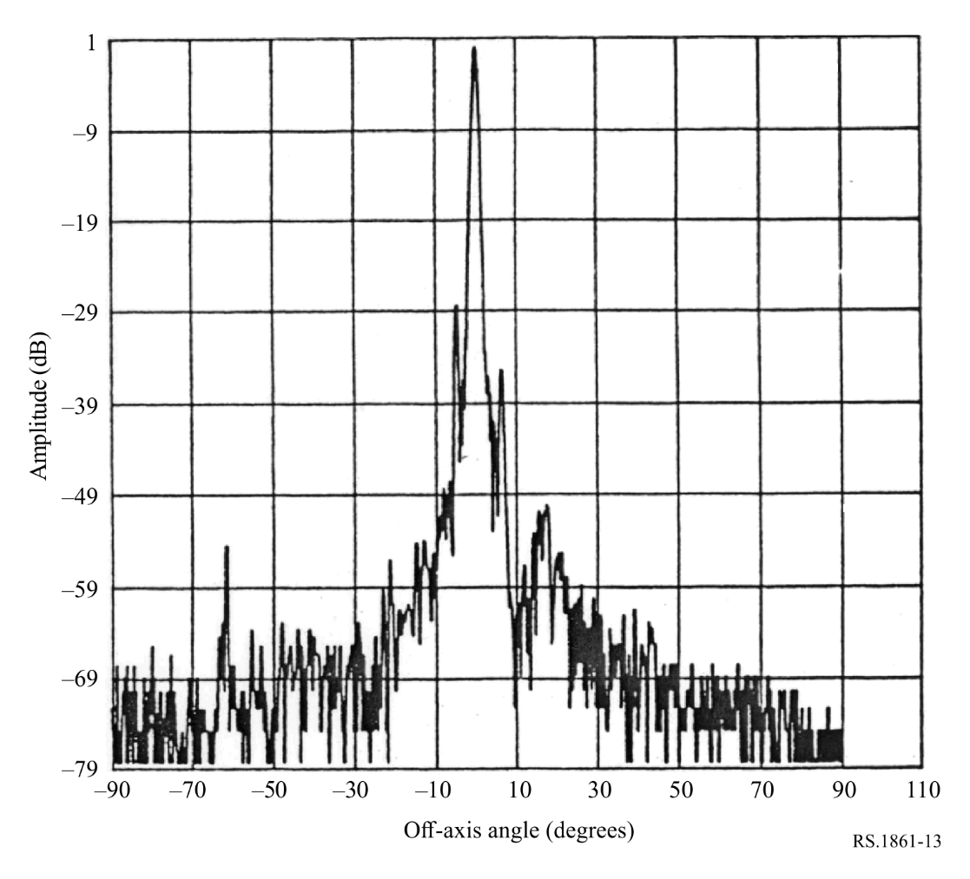

6.16 Typical parameters of passive sensors operating in the 155.5-158.5 GHz frequency band
The frequency band 155.5-158.5 GHz is of primary interest to measure Earth and cloud parameters. Table 43 summarizes the parameters of passive sensors that are or will be operating in the frequency band 155.5-158.5 GHz.
WRC-2000 decided to remove the EESS (passive) allocation in the frequency band 155.5-158.5 GHz per RR No. 5.562F, In the band 155.5-158.5 GHz, the allocation to the Earth exploration-satellite (passive) and space research (passive) services shall terminate on 1 January 2018. (WRC-2000).
There are currently six EESS (passive) satellites with sensors operating in this frequency band. It is important to retain the sensor parameters in this Recommendation until these satellites are no longer operational. This frequency band is not planned for passive sensing for future systems.
TABLE 43
EESS (passive) sensor characteristics operating in the 155.5-158.5 GHz frequency band
 | Sensor O1 | Sensor O2
Sensor type | Conical scan | Cross-track nadir scan
Orbit parameters
Altitude (km) | 865 | 822
Inclination (degree) | 20 | 98.7
Eccentricity | 0 | 0.001
Repeat period (days) | 7 | 29
Sensor antenna parameters
Number of beams |  | 1
Antenna size (m) | 0.65 | 0.22
Maximum beam gain (dBi) | 60 | 44.8
Polarization | H, V | QV
−3 dB beamwidth (degree) |  | 1.1
Instantaneous field of view |  | Nadir FOV: 16 km  Outer FOV: 53 × 27 km
Off-nadir pointing angle (degree) | 44.5 | 49.45
Incidence angle at Earth (degree) | 52.3 | 59
Swath width (km) |  | 2 193
Antenna efficiency | 0.88 | 0.23
Beam dynamics | 20 rpm | Scan period of 8/3s
Sensor antenna pattern
Cold calibration ant. gain (dBi) | N/A | 44.8
Cold calibration angle (degrees re. satellite track) | N/A | −90° ± 3.9°
Cold calibration angle (degrees re. nadir direction) | N/A | 73.6  (66° to 81°)
Sensor receiver parameters
Sensor integration time (ms) | N/A | 18
Channel bandwidth (GHz) | 2 | < 2.8
Measurement spatial resolution
Horizontal resolution (km) | 6 | 16
Vertical resolution (km) | 6 | 16

6.17 Typical parameters of passive sensors operating in the 164-167 GHz frequency band
The 164-167 GHz frequency band is of primary interest to measure N₂O, cloud water and ice, rain, CO, and ClO. Tables 44 and 45 summarize the parameters of passive sensors that are or will be operating in the 164-167 GHz frequency band.
TABLE 44
EESS (passive) sensor characteristics operating in the 164-167 GHz frequency band
 | Sensor P2 | Sensor P3 | Sensor P4 | Sensor P5 | Sensor P6
Sensor type | Mechanical nadir scan | Conical scan | Conical scan | Conical scan | Nadir scan
Orbit parameters
Altitude (km) | 824 | 830 | 407 | 836 | 836
Inclination (degree) | 98.7 | 98.85 | 50 | 98.75 | 98.75
Eccentricity | 0 | 0 | 0.003 | 0.003 | 0.003
Repeat period (days) | 9 |  |  | 5.5 | 5.5
Sensor antenna parameters
Number of beams | 2 | 1 | 1 | 1 | 1
Antenna size (m) | 0.127 | 1 | 0.8 | 0.8 | 0.22
Maximum beam gain (dBi) | 43.9 | 62.6 | 60.6 | 60.6 | 49.4
Polarization | QH | V | V | V | V
−3 dB beamwidth (degree) | 1.1 | 0.15 | 0.35 | 0.35 | 1.2
Instantaneous field of view | Nadir FOV: 15.8 km  Outer FOV: 68.4 × 30 km | 4 km × 9 km | 6.5 km × 3.9 km | 12.9 km × 7.8 km | Nadir: 18 km
Off-nadir pointing angle (degree) | ±52.725 cross-track | 53.3 | 48.6 | 44.9 | ±53.35 cross-track
Incidence angle at Earth (degree) | 0 | 65° | 53° | 53° | 0° (nadir)
Swath width (km) | 2 500 | 2 200 | 800 | 1 400 | 2 000
Antenna efficiency | 0.51 | 0.61 | 0.597 | 0.597 | 0.61
Beam dynamics | 8/3 s scan period cross-track;  96 earth fields per scan period | 2.5 s scan period, counter clockwise | 30 rpm | 30 rpm | 8/3 s scan period  1.71 s for 96 earth fields per scan period
Sensor antenna pattern |  | Rec. ITU-R RS.1813 | Rec. ITU-R RS.1813 | Rec. ITU-R RS.1813 | Rec. ITU-R RS.1813
Cold calibration ant. gain (dBi) | 43.9 | 49.4 | 57.6 | 57.6 | 49.4
Cold calibration angle (degrees re. satellite track) | 0° | 315° | 180° | 180° | 90°
Cold calibration angle (degrees re. nadir direction) | 82.175° | 90° | 90° | 90° | 74°

TABLE 44 (end)
 | Sensor P2 | Sensor P3 | Sensor P4 | Sensor P5 | Sensor P6
Sensor receiver parameters
Sensor integration time (ms) | 18 | 5 | 2.08 | 2.08 | 17
Channel bandwidth | 3 000 MHz centred at 164-167 GHz | 3 000 MHz centred at 165.5 GHz | 1 350 MHz centred at 165.5 ± 0.75 GHz | 1 350 MHz centred at 165.5 ± 0.75 GHz | 1 500 MHz centred at 166 GHz
Measurement spatial resolution
Horizontal resolution (km) | 32 | 32 | 8.1 | 16.1 | 34 (nadir)
Vertical resolution (km) | 32 | 32 | 6.5 | 12.9 | 18 (nadir)

TABLE 45
EESS (passive) sensor characteristics operating in the 164-167 GHz frequency band
 | Sensor P7 | Sensor P8 | Sensor P9 | Sensor P10 | Sensor P11 | Sensor P12 | Sensor GSO-P1 | Sensor GSO-P2
Sensor type | Cross-track nadir scan | Conical scan | Nadir | Conical scan | Nadir scan | Conical scan | Raster scan | Wide strip and thin circle combined scan
Orbit parameters
Altitude (km) | 595 | 407 | 1 336 | 665.96 | 830 | 830 | 35 800 | 35 800
Inclination (degree) | 97.79 | 65 | 66 | 98.06 | 98.7 | 98.7 | N/A | N/A
Eccentricity | 0.001 | 0 | 0 | 0.0015 | 0.001 | 0.001 | N/A | N/A
Repeat period | 9 days/30 min (single satellite/constellation) | 43.5 days | 9.92 days | 3 days | 29 days | 29 days | N/A | N/A
Sensor antenna parameters
Number of beams | 1 | 1 | 1 | 1 | 1 | 1 | 1 | 1
Antenna size (m) | 0.16 | 1.22 | 1 | 2 | 0.35 | 0.76 | 3 | 5
Maximum beam gain (dBi) | 46.6 | 54.3 | 61.0 | 57.2 | 43 | 60 | 72.1 | 73
Polarization | QH/QV | H/V | Single Linear | V | QH/QV | V | V | V
−3 dB beamwidth (degree) | 0.8 | 0.37 | 0.18 | 0.23 × 0.30 | 1.15 | 0.33 | 0.04 | 0.04
Instantaneous field of view | Nadir FOV: 8 km  (54 km²)  Outer FOV: 16 × 35  (433 km²) | 6.3 × 4.1 km | 4 × 4 km | 4 km × 9 km | Nadir FOV: 17 km  (218 km²)  Outer FOV: 55 × 28 km  (1 225 km²) | 7 × 12 km  (68 km²) | Nadir: 26 km | Nadir: 25 km
Off-nadir pointing angle (degree) | 54.4 | 45.4 | 3.4 along-track | 45.5 | ±49.31 cross-track | 44.8 | N/A | N/A
Incidence angle at Earth (degree) | 0 (nadir)  62.8 | 49.2 | 4.1 | 51.9 | 0 (nadir)  58.9 | 52.8 | N/A | N/A

TABLE 45 (end)
 | Sensor P7 | Sensor P8 | Sensor P9 | Sensor P10 | Sensor P11 | Sensor P12 | Sensor GSO-P1 | Sensor GSO-P2
Swath width (km) | 1900 | 819 | 4 | 1 398 | 2 220 | 1 700 | Full disk | 8 scan stripes, each strip 0.9°×7.2°, thin circle diameter 1.1°
Antenna efficiency |  |  | 0.42 |  | 0.6 | 0.6 | 0.60 | 0.60
Beam dynamics | 1.1 s (45 rpm) | 32 rpm | N/A | 40 rpm | 2.254 s | 45 rpm (1.33 s) | Full disk: 45 min | General scan:  0.64°/min  Local scan:  25.75 rpm
Sensor antenna pattern | Rec. ITU-R RS.1813 | Rec. ITU-R RS.1813 | Rec. ITU-R RS.1813 | Rec. ITU-R RS.1813 | Rec. ITU-R RS.1813 | Rec. ITU-R RS.1813 | Rec. ITU-R RS.1813 | Rec. ITU-R  RS.1813
Cold calibration ant. gain (dBi) | 46.6 | 43.1 | N/A | 37.0 |  | N/A
Cold calibration angle (degrees re. satellite track) | 78° to 83° | 206.7° (CCW) | N/A | 118.7° | 78° to 83° | 165.5° to 203° | N/A
Cold calibration angle (degrees re. nadir direction) |  | 107.5° | N/A | 94.6° |  | N/A
Sensor receiver parameters
Sensor integration time (ms) | 2 | 3.6 | 125 | 2.5 | 13.7 | 1 to 8 | 10 | 10
Channel bandwidth | 2 800 MHz centred at  165.5 GHz | 4 000 MHz centred at  166 GHz | 6 GHz  centred at 166 GHz | 4 000 MHz centred at 165.5 GHz | 2 x 1 350 MHz centred at 165.5 ± 0.725 GHz | 2x1 425 MHz centred at  165.5 ± 0.73 GHz | 3 000 MHz centred at 165.5 GHz | 3 000 MHz centred at 165.5 GHz
Measurement spatial resolution
Horizontal resolution (km) |  | 4.1 | 4 | 4 |  |  | 39 (nadir) | 35 (nadir)
Vertical resolution (km) |  | 6.3 | 4 | 9 |  |  | 26 (nadir) | 25 (nadir)

6.18 Typical parameters of passive sensors operating in the 174.8-191.8 GHz frequency band
The 174.8-191.8 GHz frequency band is essential for passive sensor measurements of N₂O and O₃, in addition to water vapour profiling. Tables 46 and 47 summarize the parameters of passive sensors that are or will be operating in the 174.8-191.8 GHz frequency band.
TABLE 46
EESS (passive) sensor characteristics operating in the 174.8-191.8 GHz frequency band
 | Sensor Q2 | Sensor Q3 | Sensor Q4 | Sensor Q5 | Sensor Q6 | Sensor Q7 | Sensor Q8 | Sensor Q9 | Sensor Q10
Sensor type | Cross-track scan | Limb sounder | Mechanical nadir scan | Conical scan | Nadir scan | Nadir scan | Conical scan | Conical scan | Cross-track  nadir scan
Orbit parameters
Altitude (km) | 705 | 705 | 824 | 835 | 867 | 822 | 830 | 407 | 595
Inclination (degree) | 98.2 | 98.2 | 98.7 | 98.85 | 20 | 98.7 | 98.85 | 50 | 97.79
Eccentricity | 0 | 0 | 0 | 0 | 0 | 0.001 | 0 | 0.003 | 0.001
Repeat period | 16 days | 16 days | 9 days |  | 7 days | 29 days |  |  | 9 days/30 min (single satellite/constellation)
Sensor antenna parameters
Number of beams | 1 | 1 | 96 earth fields per scan period | 6 | 6 | 1  (steerable in  90 earth fields per scan period) | 10 | 1 | 1
Antenna size (m) | 0.219 | 1.6 (V) × 0.8 (H) | 0.127 | 0.65 | 0.2 | 0.22 | 1 | 0.7 | 0.16
Maximum beam gain (dBi) | 45 | 65 | 43.9 | 58.5 | 49 | 44.8 | 63.8 | 60.6 | 47.5
Polarization | Linear | V | QH | V | H | QV | V | See Table 33 | QH/QV
−3 dB beamwidth (degree) | 1.1 | 0.084 × 0.165 | 1.1 | 0.4 | 0.66 | 1.1 | 0.13 | 0.35 | 0.8
Instantaneous field of view | 14 km | 4.5 km × 9 km | Nadir FOV: 15.8 km  Outer FOV: 68.4 × 30 km | Outer FOV:  11 × 27 km | At nadir 10 km × 10 km  At swath limit 14 km × 22 km | Nadir FOV: 16 km  Outer FOV: 53 × 27 km | 3.6 km × 8.5 km  24 km² | 5.8 km × 3.7 km | Nadir FOV: 8 km  (54 km²)  Outer FOV: 16 × 35 km  (433 km²)
Off-nadir pointing angle | ±48.95° | N/A | ±52.725° cross-track | 53.3° | 42° | 49.4° | 53.3° | 46.1° | 54.4°
Incidence angle at Earth | 56.9° | N/A | N/A | 65° | 55° | 59° | 65° | 50° | 0° (nadir)  62.8°
TABLE 46 (cont.)
 | Sensor Q2 | Sensor Q3 | Sensor Q4 | Sensor Q5 | Sensor Q6 | Sensor Q7 | Sensor Q8 | Sensor Q9 | Sensor Q10
Swath width | 1 650 km | N/A | 2 500 km | 1 600 km | 1 700 km | 2 193 km | 2 200 km | 800 km | 1 900 km
Antenna efficiency | 0.18 | 0.68 | 0.42 | 0.65 | 0.54 | 0.17 | 0.66 | 0.64
Beam dynamics | 8/3 s scan period | Scans continuously in tangent height from the surface to ~92 km in  24.7 s  240 scans/ orbit | 8/3 s scan period cross-track | 2.5 scan period, clockwise | 1 revolution per  1.639 s | 8/3 s scan period cross-track | 2.5 scan period, counter clockwise | 30 rpm | 1.1 s (45 rpm)
Sensor antenna pattern | See Fig. 14 | Rec. ITU-R RS.1813 with minor mods (see NOTE in § 6.14) |  | Rec. ITU-R RS.1813 |  |  | Rec. ITU-R RS.1813 | Rec. ITU-R RS.1813 | Rec. ITU-R RS.1813
Cold calibration ant. gain | 45 dB | N/A | 43.9 dBi | 49.5 dBi | N/A | 44.8 dBi | 51 dBi | 57.6 dBi | 47.5 dBi
Cold calibration angle (degrees re. satellite track) | 90° | N/A | 0 | 315° | N/A | −90° ± 3.9° | 315° | 180° | 78° to 83°
Cold calibration angle (degrees re. nadir direction) | 65° to 81° | N/A | 82.175° | 90° | N/A | 73.6  (66° to 81°) | 90° | 90°
Sensor receiver parameters
Sensor integration time | 18 ms | 0.166 s | 18 ms | 5 ms | 7.34 ms | 18 ms | 5 ms | 2.08 ms | 2 ms
Channel bandwidth | 1 000 MHz centred at 183.31 ± 1.00 GHz  2 000 MHz centred at 183.31 ± 3.00 GHz  4 000 MHz centred at 183.31 ± 7.00 GHz | 1 250 MHz centred at 181.5987 and 183.3142 GHz  158 MHz centred at 177.2652 GHz  10 MHz centred at 183.3142 GHz | See Table 48 | 1.5 GHz centred at 183.31 ± 7 GHz  1.0 GHz centred at 183.31 ±  3 GHz  0.5 GHz centred at 183.31 ±  1 GHz | 6 channels from 200 MHz to 2 GHz centred at 183.31 GHz | 0.5 GHz centred at 183.311 ± 1 GHz  1.0 GHz centred at 183.311 ±  3 GHz  1.1 GHz centred at 190.311 ±  1 GHz | See Table 49 | See Table 50 | See Table 51
TABLE 46 (end)
 | Sensor Q2 | Sensor Q3 | Sensor Q4 | Sensor Q5 | Sensor Q6 | Sensor Q7 | Sensor Q8 | Sensor Q9 | Sensor Q10
Measurement spatial resolution
Horizontal resolution (km) | 13.5 | 9 | 16 | 32 | 10  cross-track | 16 | 32 | 7.7
Vertical resolution (km) | 13.5 | 4.5 | 16 | 32 | 10 | 16 | 32 | 5.8

TABLE 47
EESS (passive) sensor characteristics operating in the 174.8-191.8 GHz frequency band
 | Sensor Q11 | Sensor Q12 | Sensor Q13 | Sensor Q14 | Sensor Q15 | Sensor Q16 | Sensor  GSO-Q1 | Sensor  GSO-Q2
Sensor type | Conical scan | Mechanical nadir scan | Conical scan | Nadir scan | Conical scan | Conical scan | Wide strip and thin circle combined scan | Raster scan
Orbit parameters
Altitude (km) | 407 | 550 | 665.96 | 830 | 830 | 830 | 35 800 | 35 800
Inclination (degree) | 65 | 30 | 98.06 | 98.7 | 98.7 | 98.7 | N/A | N/A
Eccentricity | 0 | 0 | 0.0015 | 0.001 | 0.001 | 0.001 | N/A | N/A
Repeat period (days) | 43.5 | 18.6 | 3 | 29 | 29 | 29 | N/A | N/A
Sensor antenna parameters
Number of beams | 1 | 1 | 2 | 1 | 1 | 1 | 1 | 1
Antenna size (m) | 1.22 | 0.083 | 2 | 0.35 | 0.76 | 0.255 | 5 | 3
Maximum beam gain (dBi) | 53.8 | 41.6 | 57.9 | 43 | 56.9 | 52 | 73.2 | 72.1
Polarization | V | H/V | V | QH/QV | V | V | See Table 55 | See Table 56
−3 dB beamwidth | 0.37° | 1.69° | 0.23°×0.27° | 1.15° | 0.33° | 0.5° | 0.038° | 0.04°

TABLE 47 (cont.)
EESS (passive) sensor characteristics operating in the 174.8-191.8 GHz frequency band
 | Sensor Q11 | Sensor Q12 | Sensor Q13 | Sensor Q14 | Sensor Q15 | Sensor Q16 | Sensor  GSO-Q1 | Sensor  GSO-Q2
Instantaneous field of view | 5.8 × 3.8 km | Nadir IFOV: 16.2 km  Outer IFOV: 113.6 × 38.4 km | 4 km × 8 km | Nadir FOV: 17 km  (218 km²)  Outer FOV: 55 × 28 km  (1 225 km²) | 7 × 12 km  (68 km²) | 11 × 18 km  (155 km²) | Nadir: 25 km | Nadir: 24 km
Off-nadir pointing angle | 45.4° | ±60° cross-track | 45.5° | ±49.31° cross-track | 44.8° | 44.7° / 45.2° | N/A | N/A
Incidence angle at Earth | 49.2° | ≤ 70.2° | 51.9° | 0° (nadir)  58.9° | 52.8° | 52.7° | N/A | N/A
Swath width | 819 km | 2 480 km | 1 398 km | 2 220 km | 1 700 km | 1 700 km | 8 scan stripes, each strip 0.9°× 7.2°, thin circle diameter 1.1° | Full disk
Antenna efficiency |  | 0.57 |  | 0.60 | 0.6 | 0.6 | 0.23 | 0.49
Beam dynamics | 32 rpm | 2 s scan period | 40 rpm | 2.254 s | 45 rpm (1.33 s) | 45 rpm  (1.33 s) | General scan:  0.64°/min  Local scan:  25.75 rpm | Full disk: 45 min
Sensor antenna pattern | See Rec. ITU-R RS.1813 | See Rec. ITU-R RS.1813 | See Rec. ITU-R RS.1813 | See Rec. ITU-R RS.1813 | See Rec. ITU-R RS.1813 | See Rec. ITU-R RS.1813 | See Rec. ITU-R RS.1813 | See Rec. ITU-R RS.1813
Cold calibration ant. gain | 43.9 dBi | 41.6 dBi | 38.1 dBi |  |  | 44 dBi
Cold calibration angle (degrees re. satellite track) | 206.7° (CCW) | 0° | 118.7° | 78° to 83° | 165.5° to 203° | 130° to 135° |  | N/A
Cold calibration angle (degrees re. nadir direction) | 107.5° | 120° | 94.6°

TABLE 47 (end)
 | Sensor Q11 | Sensor Q12 | Sensor Q13 | Sensor Q14 | Sensor Q15 | Sensor Q16 | Sensor  GSO-Q1 | Sensor  GSO-Q2
Sensor receiver parameters
Sensor integration time (ms) | 3.6 | 8.3 | 2.5 | 13.7 | 1 to 8 | 2 to 3 | 10 | 10
Channel bandwidth | 2 000 MHz centred at  176.31,  180.31,  186.31,  and 190.31 GHz | 2 000 MHz centred at 184.41, 186.51, and 190.31 GHz | 2 000 MHz centred at 183.31 ± 3.00 GHz  2 000 MHz centred at 183.31 ± 7.00 GHz | See Table 52 | See Table 53 | See Table 54 | See Table 55 | See Table 56
Measurement spatial resolution
Horizontal resolution (km) | 3.8 | 16.2 | 4 |  |  |  | 25 (nadir) | 36 (nadir)
Vertical resolution (km) | 5.8 | 16.2 | 8 |  |  |  | 25 (nadir) | 24 (nadir)

FIGURE 14
Sensor Q2 antenna pattern for the 174.8 and 191.8 GHz frequency range
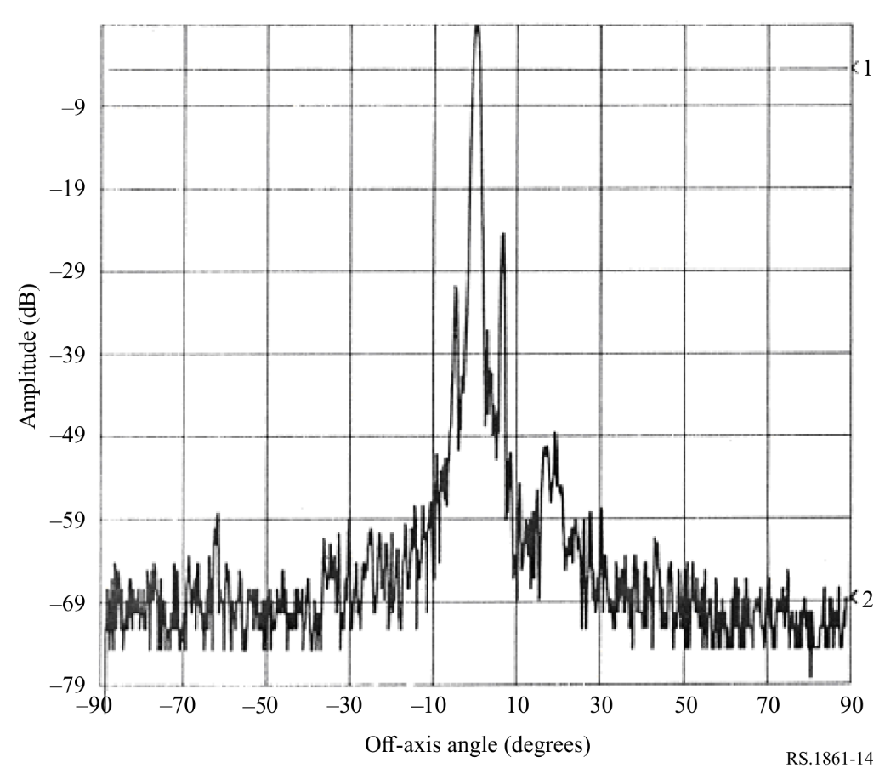
TABLE 48
Sensor Q4 passive sensor characteristics for channels between 174.8 and 191.8 GHz
Centre frequency  (GHz) | Channel bandwidth  (MHz) | Polarization
183.31 ± 4.5 | 2 000 | QH
183.31 ± 1.8 | 1 000 | QH
190.31 | < 2 200 | V

TABLE 49
Sensor Q8 passive sensor characteristics for channels between 174.8 and 191.8 GHz
Centre frequency  (GHz) | Channel bandwidth  (MHz)
183.31 ± 7 | 2000
183.31 ± 4.5 | 2000
183.31 ± 3 | 1000
183.31 ± 1.8 | 1000
183.31 ± 1 | 500

TABLE 50
Sensor Q9 passive sensor characteristics for channels between 174.8 and 191.8 GHz
Centre frequency  (GHz) | Channel bandwidth  (MHz) | Polarization
183.31 ± 2.0 | 1 500 | V
183.31 ± 3.4 | 1 500 | V
183.31 ± 7.0 | 2 000 | V

TABLE 51
Sensor Q10 passive sensor characteristics for channels between 174.8 and 191.8 GHz
Frequency  (GHz) | Bandwidth  (MHz)
176.311 | 2 000
178.811 | 2 000
180.311 | 1 000
181.511 | 1 000
182.311 | 500

TABLE 52
Sensor Q14 passive sensor characteristics for channels between 174.8 and 191.8 GHz
Frequency  (GHz) | Bandwidth  (MHz)
183.311 ± 7.0 | 2 × 2 000
183.311 ± 4.5 | 2 × 2 000
183.311 ± 3.0 | 2 × 1 000
183.311 ± 1.8 | 2 × 1 000
183.311 ± 1.0 | 2 × 500

TABLE 53
Sensor Q15 passive sensor characteristics for channels between 174.8 and 191.8 GHz
Frequency  (GHz) | Bandwidth  (MHz)
183.31 ± 7.0 | 2 × 2 000
183.31 ± 6.1 | 2 × 1 500
183.31 ± 4.9 | 2 × 1 500
183.31 ± 3.4 | 2 × 1 500
183.31 ± 2.0 | 2 × 1 500

TABLE 54
Sensor Q16 passive sensor characteristics for channels between 174.8 and 191.8 GHz
Frequency  (GHz) | Bandwidth  (MHz)
183.31 ± 7.0 | 2 × 2 000
183.31 ± 3.4 | 2 × 1 500
183.31 ± 2 | 2 × 1 500

TABLE 55
Sensor GSO-Q1 passive sensor characteristics for channels between 174.8 and 191.8 GHz
Centre frequency  (GHz) | Channel bandwidth  (MHz) | Polarization
183.31 ± 7 | 4 000 | H
183.31 ± 4.5 | 4 000 | H
183.31 ± 3 | 2 000 | H
183.31 ± 1.8 | 2 000 | H
183.31 ± 1 | 1 000 | H

TABLE 56
Sensor GSO-Q2 passive sensor characteristics for channels between 174.8 and 191.8 GHz
Centre frequency  (GHz) | Channel bandwidth  (MHz) | Polarization
183.31 ± 1.0 | 500 | H
183.31 ± 1.8 | 1 000 | H
183.31 ± 3.0 | 1 000 | H
183.31 ± 4.5 | 2 000 | H
183.31 ± 7.0 | 2 000 | H

6.19 Typical parameters of passive sensors operating in the 200-209 GHz frequency band
Table 57 summarizes the parameters of passive sensors that are or will be operating in the 200-209 GHz frequency band.
TABLE 57
EESS (passive) sensor characteristics operating in the 200-209 GHz frequency band
 | Sensor S1 | Sensor S2
Sensor type | Mechanical nadir scan | Limb sounder
Orbit parameters
Altitude (km) | 550 | 705
Inclination (degree) | 30 | 98.2
Eccentricity | 0 | 0
Repeat period (days) | 18.6 | 16
Sensor antenna parameters
Number of beams | 1 | 1
Antenna size (m) | 0.083 | 1.6 (V) × 0.8 (H)
Maximum beam gain (dBi) | 44.1 | 65
Polarization | H/V | V
−3 dB beamwidth (degree) | 1.64 | 0.078 × 0.152
Instantaneous field of view (km) | Nadir IFOV: 15.7  Outer IFOV: 110.2 × 37.2 | 4.1 × 8.0
Off-nadir pointing angle | ±60° cross-track | N/A
Incidence angle at Earth (degree) | ≤ 70.2 | N/A
Swath width (km) | 2 480 | N/A
Antenna efficiency | 0.81 | 0.55
Beam dynamics | 2 s scan period | Scans continuously in tangent height from the surface to ~92 km in 24.7 s, 240 scans/orbit
Sensor antenna pattern | Rec. ITU-R RS.1813 | Rec. ITU-R RS.1813 with minor mods (see NOTE in § 6.14)
Cold calibration ant. gain (dBi) | 44.1 | N/A
Cold calibration angle (degrees re. satellite track) | 0° | N/A
Cold calibration angle (degrees re. nadir direction) | 120° | N/A
Sensor receiver parameters
Sensor integration time | 8.3 ms | 0.166 s
Channel bandwidth | 2 000 MHz  centred at 204.80 GHz | 1 250 MHz centred at 200.9798, 204.3566, and 206.1367 GHz
Measurement spatial resolution
Horizontal resolution (km) | 15.7 | 8.0
Vertical resolution (km) | 15.7 | 4.1

6.20 Typical parameters of passive sensors operating in the 226-252 GHz frequency range
This frequency range is particularly important in providing information to the weather and climate models on ice clouds, especially cirrus clouds, cloud ice water path and cloud ice effective radius, all in support of numerical weather prediction (NWP) and nowcasting. In particular the band is important for measuring cloud ice water paths and cirrus clouds and it is key to estimate the cloud ice content. This is a quasi-window band which allows measuring radiances at both horizontal and vertical polarisations through the atmosphere due to minimum atmospheric absorption compared to the neighbouring bands, allowing to retrieve information on different ice crystal habits.
Tables 58 and 59 summarize the parameters of passive sensors that are or will be operating in the frequency range of 226 and 252 GHz.
TABLE 58
EESS (passive) sensor characteristics operating between 226 and 252 GHz
 | Sensor T1 | Sensor T2
Sensor type | Conical scan | Limb sounder
Orbit parameters
Altitude (km) | 830 | 705
Inclination (degree) | 98.7 | 98.2
Eccentricity | 0.001 | 0
Repeat period (days) | 29 | 16
Sensor antenna parameters
Number of beams | 1 | 1
Antenna size (m) | 0.255 | 1.6 (V) × 0.8 (H)
Maximum beam gain (dBi) | 52 | 67.5
Polarization | V and H | H
−3 dB beamwidth (degree) | 0.5 | 0.060 × 0.123
Instantaneous field of view (km) | 11 × 18  (155 km²) | 3.2 × 6.4
Off-nadir pointing angle (degree) | 44.7 | N/A
Incidence angle at Earth (degree) | 52.7 | N/A
Swath width (km) | 1 700 | N/A
Antenna efficiency | 0.64 | 0.69
Beam dynamics | 45 rpm (1.33 s) | Scans continuously in tangent height from the surface to ~92 km in 24.7 s, 240 scans/orbit
Sensor antenna pattern | Rec. ITU-R RS.1813 | Rec. ITU-R RS.1813 with minor mods (see NOTE in § 6.14)
Cold calibration ant. gain (dBi) | 47 | N/A
Cold calibration angle (degrees re. satellite track) | 130° to 135° | N/A
Cold calibration angle (degrees re. nadir direction) |  | N/A
Sensor receiver parameters
Sensor integration time | 2 to 3 ms | 0.166 s
Channel bandwidth | See Table 60 | See Table 61
Measurement spatial resolution
Horizontal resolution (km) |  | 6.4
Vertical resolution (km) |  | 3.2

TABLE 59
EESS (passive) sensor characteristics operating between 226 and 252 GHz
 | Sensor T3 (MWS)
Sensor type | Nadir Scan
Orbit parameters
Altitude (km) | 830
Inclination (degree) | 98.7
Eccentricity | 0.001
Repeat period (days) | 29
Sensor antenna parameters
Number of beams | 1
Antenna size (m) | 0.35
Maximum beam gain (dBi) | 56
Polarization | QV
−3 dB beamwidth (degree) | 1.15°
Instantaneous field of view (km) | Nadir FOV: 17  (218 km²)  Outer FOV: 55 × 28  (1 225 km²)
Off-nadir pointing angle (degree) | ±49.31° cross-track
Incidence angle at Earth (degree) | 0 (nadir)  58.9
Swath width (km) | 2 220
Antenna efficiency | 0.60
Beam dynamics (s) | 2.254
Sensor antenna pattern | Rec. ITU-R RS.1813
Cold calibration ant. gain (dBi)
Cold calibration angle (degrees re. satellite track) | 78° to 83°
Cold calibration angle (degrees re. nadir direction)
Number of beams
Sensor receiver parameters
Sensor integration time (ms) | 13.7
Channel bandwidth | 2 000 MHz centred at 229 GHz
Measurement spatial resolution
Horizontal resolution
Vertical resolution

TABLE 60
Sensor T1 passive sensor characteristics for channels between 239 and 248 GHz
Centre frequency  (GHz) (see NOTE below) | Frequency range  (GHz) | Channel bandwidth  (MHz)
243.2 ± 2.5 | 239.2-242.2  244.2-247.2 | 2 × 3 000
NOTE – The T1 instrument has also multiple channels in bands above 275 GHz (three channels around 325 GHz, three channels around 448 GHz and one channel at 664 GHz).

TABLE 61
Sensor T2 passive sensor characteristics for channels between 231 and 248 GHz
Centre frequency  (GHz) | Channel bandwidth  (MHz)
231.86 | 500
232.46 | 500
233.9515 | 1 250
234.86 | 500
235.7151 | 10
235.7151 | 1 250
236.66 | 500
242.66 | 500
244.46 | 500
246.86 | 500
247.46 | 500

______________

* Radiocommunication Study Group 7 made editorial amendments to this Recommendation in the year 2023 in accordance with Resolution ITU-R 1.
The ‘vadose zone’ is the portion of Earth between the land surface and the zone of saturation which extends from the top of the ground surface to the water table.

