Recommendation ITU-R RS.1166-6

(06/2025)

RS Series: Remote sensing systems

Performance and interference criteria for active spaceborne sensors

Foreword

The role of the Radiocommunication Sector is to ensure the rational, equitable, efficient and economical use of the radio-frequency spectrum by all radiocommunication services, including satellite services, and carry out studies without limit of frequency range on the basis of which Recommendations are adopted.

The regulatory and policy functions of the Radiocommunication Sector are performed by World and Regional Radiocommunication Conferences and Radiocommunication Assemblies supported by Study Groups.

# Policy on Intellectual Property Right (IPR)

ITU-R policy on IPR is described in the Common Patent Policy for ITU-T/ITU-R/ISO/IEC referenced in Resolution ITU‑R 1. Forms to be used for the submission of patent statements and licensing declarations by patent holders are available from <https://www.itu.int/ITU-R/go/patents/en> where the Guidelines for Implementation of the Common Patent Policy for ITU‑T/ITU‑R/ISO/IEC and the ITU-R patent information database can also be found.

|  |  |
| --- | --- |
| Series of ITU-R Recommendations  (Also available online at <https://www.itu.int/publ/R-REC/en>) | |
| **Series** | Title |
| **BO** | Satellite delivery |
| **BR** | Recording for production, archival and play-out; film for television |
| **BS** | Broadcasting service (sound) |
| **BT** | Broadcasting service (television) |
| **F** | Fixed service |
| **M** | Mobile, radiodetermination, amateur and related satellite services |
| **P** | Radiowave propagation |
| **RA** | Radio astronomy |
| **RS** | Remote sensing systems |
| **S** | Fixed-satellite service |
| **SA** | Space applications and meteorology |
| **SF** | Frequency sharing and coordination between fixed-satellite and fixed service systems |
| **SM** | Spectrum management |
| **SNG** | Satellite news gathering |
| **TF** | Time signals and frequency standards emissions |
| **V** | Vocabulary and related subjects |

|  |
| --- |
|  |

|  |
| --- |
| ***Note***: *This ITU-R Recommendation was approved in English under the procedure detailed in Resolution ITU-R 1.* |

*Electronic Publication*

Geneva, 2025

© ITU 2025

All rights reserved. No part of this publication may be reproduced, by any means whatsoever, without written permission of ITU.

RECOMMENDATION ITU-R RS.1166-6

Performance and interference criteria[1]* for active spaceborne sensors

(1995-1998-1999-2006-2009-2023-2025)

Scope

This Recommendation presents the performance and interference criteria for spaceborne active sensors in the bands allocated to the EESS (active). The Annex describes the technical bases for development of performance and interference criteria for various types of spaceborne active sensors. The sensor types include radar sounders, synthetic aperture radar (SAR) imagers, scatterometers, altimeters, precipitation radars and cloud profile radars.

Keywords

Synthetic aperture radar (SAR) imager, altimeter, scatterometer, precipitation radar, cloud profile radar

Abbreviations/Glossary

DPR Dual precipitation radar

DSD Drop size distribution

GPM Global precipitation measurement

IFOV Instantaneous field of view

ITCZ Inter-tropical convergence zone

MCMC Markov chain Monte Carlo

NESZ Noise-equivalent sigma zero

PR Precipitation radar

RMSE Root-mean square error

SAR Synthetic aperture radar

SWE Snow water equivalent

TRMM Tropical rainfall measuring mission

VPRF Variable pulse repetition frequency

The ITU Radiocommunication Assembly,

considering

*a)* that spaceborne active microwave remote sensing requires specific frequency ranges depending on the physical phenomena to be observed;

*b)* that certain frequency bands have been allocated for spaceborne active microwave remote sensing;

*c)* that these bands are also allocated to other radio services;

*d)* that studies have established measurement sensitivity requirements;

*e)* that performance requirements for active sensors can be stated in terms of precision of measurement of physical parameters and availability, measured at the satellite, assuming that degradation from other elements in the system is negligible;

*f)* that definition of performance objectives for active spaceborne microwave sensors is a prerequisite for the establishment of the associated interference criteria;

*g)* that interference criteria are needed to ensure that systems can be designed to achieve adequate performance in the presence of interference, assess compatibility with systems in other services and, if needed, to assist in developing sharing criteria;

*h)* that Annex 1 presents the technical bases for performance and interference criteria based on representative active sensors,

recommends

1 that the performance criteria given in Table 1 should be considered for instruments used in active sensing of the Earth’s aquifers, ice sheets, land, oceans and atmosphere:

TABLE 1

| Frequency band | Performance criteria for remote sensing instruments | | | | | |
| --- | --- | --- | --- | --- | --- | --- |
| Radar sounder | SAR imager | Scatterometer | Altimeter | Precipitation radar | Cloud profile radar |
| 40-50 MHz | NESZ of  −10 dB (1) |  |  |  |  |  |
| 432-438 MHz |  | NESZ of  −36 dB |  |  |  |  |
| 1 215-1 300 MHz |  | NESZ of  –36 dB | NESZ of  −32 dB |  |  |  |
| 3 100-3 300 MHz |  | NESZ of  –26 dB |  | Sea level precision  ≤ 3 cm |  |  |
| 5 250-5 570 MHz |  | NESZ of  −30 dB over land and –33 dB over ocean | Wind speed  ≥ 2 m/s | Sea level precision  ≤ 2 cm |  |  |
| 8 550-8 650 MHz |  | NESZ of  −21 dB | Wind speed  ≥ 3 m/s | Sea level precision  ≤ 3 cm |  |  |
| 9 200-10 400 MHz |  | NESZ of  −18 dB | Wind speed  ≥ 3 m/s | Sea level precision  ≤ 3 cm |  |  |
| 13.25-13.75 GHz |  | NESZ of  −27 dB | Wind speed  ≥ 3 m/s | Sea level precision  ≤ 2 cm | Minimum rain rates from  0.7-0.75 mm/h |  |
| 17.2-17.3 GHz |  | NESZ of  −26 dB | Wind speed  ≥ 3 m/s |  | Minimum rain rates from  0.7-0.75 mm/h |  |

TABLE 1 (*end*)

| Frequency band | Performance criteria for remote sensing instruments | | | | | |
| --- | --- | --- | --- | --- | --- | --- |
| Radar sounder | SAR imager | Scatterometer | Altimeter | Precipitation radar | Cloud profile radar |
| 24.05-24.25 GHz |  |  |  |  | Minimum rain rates from  0.7-0.75 mm/h |  |
| 35.5-36 GHz |  | NESZ of  −22 dB | Wind speed  ≥ 3 m/s | Sea level precision  ≤ 2 cm | Minimum rain rates from 0.05-0.2 mm/h | −24 dBZ  ±10% |
| 78-79 GHz |  |  |  |  |  | −27 dBZ  ±10% |
| 94-94.1 GHz |  |  |  |  | Minimum rain rates from  0.05 mm/h | −35 dBZ  ±10% |
| 133.5-134 GHz |  |  |  |  |  | −34 dBZ  ±10% |
| 237.9-238 GHz |  |  |  |  |  | −44 dBZ  ±10% |
| (1) See § 2.2 in Annex 1 to this Recommendation for details.  NESZ: Noise-equivalent sigma zero, a noise floor measure of system sensitivity to low radar backscatter areas, equivalent to the minimum reflectivity, a metric considered in previous versions of this Recommendation.  dBZ: “Unit” radar reflectivity used in meteorology which represents a logarithmic power ratio (in decibels, or dB) with respect to radar reflectivity factor, Z, referred to a value of 1 mm6/m3. | | | | | | |

2 that the interference and data availability criteria given in Table 2 be applied for instruments used for active sensing of the Earth’s aquifers, ice sheets, land, oceans and atmosphere.

TABLE 2

|  |  |  |  |  |
| --- | --- | --- | --- | --- |
| Sensor type | Interference criteria | | Data availability criteria (%) | |
| Performance degradation | *I*/*N* (dB) | Systematic | Random |
| Radar sounder | 10% degradation in NESZ (1) | −10 | 99 | 95 |
| SAR imager | 10% degradation of standard deviation of pixel power  SWE retrieval radar: 10% error on minimum SWE retrieved | −6 | 99 | 95 |
| Scatterometer | 8% degradation in measurement of normalized radar backscatter to deduce wind speeds | −5 | 99 | 95 |

TABLE 2 (*end*)

|  |  |  |  |  |
| --- | --- | --- | --- | --- |
| Sensor type | Interference criteria | | Data availability criteria (%) | |
| Performance degradation | *I*/*N* (dB) | Systematic | Random |
| Altimeter | 4% degradation in height noise | −3 | 99 | 95 |
| Precipitation radar | 7% increase in minimum rainfall rate | −10 | 99.8 | 99.8 |
| Cloud profile radar | 10% degradation in minimum cloud reflectivity | −10 | 99 | 95 |
| (1) See § 2.3 in Annex 1 to this Recommendation for details.  SWE: Snow water equivalent. | | | | |

For bands with secondary allocation, the interference criteria are provided only to indicate performance degradation with regard to primary services.

Annex 1  
  
Performance and interference criteria for   
spaceborne active sensors

TABLE OF CONTENTS

*Page*

1 Introduction 5

1.1 Systematic and random interference 6

2 Radar sounders 6

2.1 Operational characteristics of the radar sounders 7

2.2 Performance criteria of radar sounders 7

2.3 Interference criteria of radar sounders 7

3 Synthetic aperture radar (SAR) imagers 7

3.1 Performance criteria of SARs 7

3.2 Interference criteria of SAR 8

3.2.1 Processing gain of noise and noise-like interference 9

3.2.2 Processing gain of other interference signals 9

3.2.3 Calculation of allowable interference 11

3.2.4 Interference criteria 12

3.2.5 Availability criterion 13

3.3 Snow water equivalent (SWE) retrieval radars 13

4 Scatterometers 14

4.1 Performance criteria 15

4.2 Interference criteria 16

5 Altimeters 18

5.1 Performance criteria 18

5.2 Interference criteria 19

6 Precipitation radars 20

6.1 Precipitation radars based upon GPM DPR 20

6.1.1 Performance criteria at 13.597/13.603 GHz 21

6.1.2 Interference criteria 23

6.1.3 GPM 35 GHz band precipitation radar 24

7 Cloud profile radars 24

7.1 Performance criteria for 94 GHz cloud profile radar 24

7.2 Interference criteria for 94 GHz cloud profile radar 24

7.3 Availability criteria of the cloud profile radar 24

8 Measurement area of interest for the evaluation of systematic interference 24

9 Transient impulse interference considerations 25

9.1 Determination of peak transient power for some modulation schemes 25

10 Typical EESS (active) sensor parameters to be used in determining impact from differing types of interference 27

# 1 Introduction

Performance criteria for active spaceborne sensors are needed in order to develop interference criteria. Interference criteria, in turn, can be used to assess the compatibility of radionavigation and radiolocation systems and active sensors in common frequency bands.

This Annex presents the technical basis for development of performance and interference criteria for various types of spaceborne active sensors. The sensor types include radar sounders, synthetic aperture radar (SAR) imagers, scatterometers, altimeters, precipitation radars and cloud profile radars.

The criteria are based on current and planned spaceborne active sensor science system designs and associated operating requirements. Future spaceborne active sensor science systems, beyond the ones considered in this recommendation, would have to be examined to determine if they could accept the same levels of interfering signals and associated spatial and temporal conditions.

It should be noted that the performance criteria for several active sensor types, including those for radar sounders and SAR imagers, are expressed in terms of the noise-equivalent sigma zero (NESZ), which is a noise floor measure of system sensitivity to low radar backscatter areas. This metric is equivalent to the minimum reflectivity, which was used previously in earlier versions of this Recommendation.

## 1.1 Systematic and random interference

*recommends* 2 states that the interference and data availability criteria given in Table 2 be applied for instruments used for active sensing of the Earth’s land, oceans and atmosphere. Table 2 provides the data availability criteria as it applies to two types of interference: systematic and random.

Systematic interference is defined as interference which occurs repeatedly at the same location. When systematic interference is present, the data availability criteria in Table 2 of 99% should be applied for all sensor types except for the precipitation radar, for which 99.8% applies.

Application of the systematic data availability to sharing and compatibility analyses first involves a determination of the interference under investigation as to its reoccurrence in the repeated sensor measurement of a specific location. If the interference under investigation is found to reoccur repeatedly in sensor measurements of the same location, albeit possibly with different kinds of signal originating from that location (e.g., frequency hopping radars; scanning radars), then the interference is deemed to be systematic interference; therefore, the systematic interference data availability criterion should be used in the evaluation of the study results.

Random interference is described as interference events causing brief individual outages (i.e. most outages lasting 2 s or less) and which are randomly dispersed over all observation time and areas. For the purposes of the sharing and compatibility analyses performed, this would apply to the observation time and the measurement area chosen for evaluation of the data availability criteria. Random interference has less serious consequences than systematic interference so that the random data availability criteria in the presence of random interference is 95% except for precipitation radars, for which it is 99.8%.

Application of the data availability criteria to sharing and compatibility analyses first involves a determination of the interference under investigation as to which type of interference should be evaluated; that is, Systematic or Random. The analysis should then determine the number of interference events exceeding the interference threshold criteria that occur in a measurement area of interest and the summary of results should provide an evaluation of that result in regard to the applicable data availability criteria.

# 2 Radar sounders

This section presents information on the performance and interference criteria for spaceborne active radar sounders in the frequency band 40-50 MHz. The performance and interference criteria can be used to analyse the compatibility of active spaceborne radar sounders operation with systems from other services in this band.

## 2.1 Operational characteristics of the radar sounders

The use of the frequency band 40-50 MHz by radar sounders in the Earth exploration-satellite service (active) shall be in accordance with the geographical area restrictions and the operational and technical conditions defined in Resolution **677 (WRC‑23)**.

## 2.2 Performance criteria of radar sounders

Spaceborne radar sounders are typically used to produce radar maps of subsurface scattering layers to locate and characterize underground water and ice deposits. The choice of 40-50 MHz frequency range represents a trade-off between penetration depth and resolution and can be used to provide detailed mapping of the spatial resolution of shallow aquifers up to about 100 m in subsurface depth in arid areas as well as to perform basal interface topography and determine ice-sheet thickness on the order of 3 km to 5 km.

The objective of a spaceborne radar sounder mission is to produce a radar map with a subsurface NESZ of −10 dB at 100 m depth or to produce a radar map with a subsurface ice-sheet NESZ of −10 dB at 3 km to 5 km.

## 2.3 Interference criteria of radar sounders

In arid areas, the interference should degrade the NESZ less than 10% in 95% of the operational areas of the spaceborne radar sounder as defined in Resolution **677 (WRC-23)**, in arid areas at a depth of 100 m. In mapping of ice-sheet thickness, the interference should degrade the NESZ less than 10% in 95% of the operational areas of the spaceborne radar sounder as defined in Resolution **677 (WRC‑23)**, in ice-sheets at thicknesses of 3 km to 5 km. Ten percent degradation in minimum reflectivity corresponds to an interference-to-noise ratio of −10 dB. This follows from the observation that, to first order, the NESZ varies proportionally with *S*/*N*tot, where *S* is the signal power and *N*tot is the total noise power consisting of nominal noise plus contributions due to interference, each power with respect to the bandwidth of interest. Assuming the interference is statistically independent of the noise, it follows that *N*tot = *N* + *I*, where *N* is the nominal noise power and *I* is the interference power. When compared with the nominal signal-to-noise ratio *S*/*N*, the degradation in the NESZ varies as 1/(1 + *I*/*N*). From this, it follows that a 10% degradation corresponds approximately to an interference-to-noise ratio *I*/*N* of −10 dB. This interference criterion corresponds to an interference power level of −144 dBW over 10 MHz, assuming a system noise temperature of 290 K.

In order to meet mission objectives these levels may not be exceeded for percentages of the areas of interest of more than 1% for systematic occurrences of interference and more than 5% for random occurrences of interference.

# 3 Synthetic aperture radar (SAR) imagers

This section presents information on the performance and interference criteria for spaceborne active imaging radar sensors in the frequency bands 432-438 MHz, 1 215-1 300 MHz, 3 100-3 300 MHz, 5 250-5 570 MHz, 8 550-8 650 MHz, 9 200-10 400 MHz, 13.25-13.75 GHz, 17.2-17.3 GHz and 35.5-36 GHz. The performance and interference criteria can be used to analyse the compatibility of active spaceborne imaging radar sensor operation with radionavigation and radiolocation systems, as well as systems from other services in these bands.

## 3.1 Performance criteria of SARs

Space borne synthetic aperture radars (SARs) are typically used to produce radar image maps of the terrain below as the spacecraft motion creates a synthetic aperture over a typical aperture time of 0.2‑10 s. Any signals which interfere during this aperture time affect the imaging of that particular feature. Many SARs image mainly land and land/water transitions at the coasts. A finite number of selected sites are chosen by the researchers to image over a range of look angles as the 1‑to‑14 day repeat orbits drift slightly. Any interference that disrupts SAR measurement data obtained from an observed terrestrial site during any one of the measurements taken at different look angles would adversely affect overall measurement performance. Another use of SARs is to produce topographic maps which can be used for digital elevation models. Some SARs use repeat pass interferometry in order to produce topographic maps over two passes. Interference on either one of the passes would affect the performance adversely.

A requirement for SAR imaging or topography missions is to acquire at least 99% of the possible data from selected sites over land or land/ocean transitions. This budget for lost data is separate from other sources of loss such as those due to the spacecraft systems or to the SAR instrument.

The availability requirement for SAR data is 99%, assuming that the losses are of short duration and random over data acquisition time and areas. However, the 99% availability requirement should be applied to both the option based on the percentage of the area of interest that is compromised, as well as that on the observation times during which measurements are compromised. Especially for polar orbiting instruments, significant observation time is spent over the high-latitude regions, which can introduce an underestimation of the interference in other areas if only the observation time serves as availability criterion. It should be noted that determining if the 99% availability requirement can be met is a relatively straightforward analysis; however, it is difficult to analyse outages for its characteristic of random dispersion over all observation time and areas. Interference at a given geographical location on a systematic basis is of a more serious concern, especially when encountered over one of a researcher’s site of interest, where ground truth experiments or validation experiments may be occurring at the same time. Interference at a given geographical location for SAR imaging or topographic missions could create a gap in the global coverage map.

## 3.2 Interference criteria of SAR

The interference criteria for spaceborne imaging radars have been established as those presented in Table 2. In Table 2, the interference criterion for synthetic aperture radars is an *I*/*N* of −6 dB, which corresponds to a 10% measurement degradation of the standard deviation of SAR pixel power. This can be seen by noting that, to first order, the standard deviation of SAR pixel power varies proportionally with $\sqrt{S/{N_{\text{tot}}}}$, where *S* is the signal power and *N*tot is the total noise power consisting of nominal noise plus contributions due to interference, each power with respect to the bandwidth of interest. Assuming the interference is statistically independent of the noise, it follows that *N*tot = *N* + *I*, where *N* is the nominal noise power and *I* is the interference power. When compared with the nominal *S*/*N*, the standard deviation of SAR pixel power varies as $\sqrt{1/{\left(1+I/N\right)}}$. From this, it follows that a 10% degradation corresponds approximately to an interference-to-noise ratio *I*/*N* of −6 dB.

This interference level may be exceeded upon consideration of the interference mitigation effect of SAR processing discrimination and the modulation characteristics of the systems operating in the shared band. In order to meet mission objectives these levels may not be exceeded for percentages of the areas of interest of more than 1% for systematic occurrences of interference and more than 5% for random occurrences of interference.

It should be noted that applying the interference criteria to the percentage of images affected may result in an underestimation of interferences in non-polar regions for instruments that spent a significant amount of time over the polar regions due to their orbit. It is therefore suggested to apply the criteria to both percentages of images affected (observation times affected) and areas of interest affected.

SAR raw data are processed both in range and azimuth to produce a radar image. A point target return is spread linearly in frequency both in range and azimuth dimensions. The processor correlates the data in both dimensions, and the processing gain typically ranges from 20 to 40 dB for the return echo. Noise and interference signals have much lower processing gains. The receiver noise has nearly 0 dB gain in range. Interference signals at the same input level as the noise, have different processing gains depending upon the waveform modulation type.

### 3.2.1 Processing gain of noise and noise-like interference

The system noise, referenced to the antenna port, consists mainly of the antenna noise and front-end receiver noise. This noise can be modelled as a white, stationary, Gaussian noise process. The processor correlator is essentially a matched filter for the linear FM, or chirp, pulses. The range processing gain for noise is 0 dB. The azimuth processing gain is *N*2 for the coherent integration of *N* returns during a synthetic aperture and *N* for the noise. The synthetic aperture integration time and appropriate PRF are needed to process the pixels to a certain resolution size in azimuth ρ*AZ*. This is calculated as follows:

$G_{N_{AZ}}=T_{I}PRF$

$T_{I}=\frac{λR_{S}}{{vL}_{eff}}$

$PRF=1.2\frac{v}{ρ_{AZ}}$ (assuming a stripmap mode)

where:

*GNAZ* : azimuth processing gain of noise

*TI* : SAR azimuth integration time

*PRF* : pulse repetition frequency

λ : wavelength

*RS* : slant range

*v* : spacecraft platform velocity

*Leff* : effective antenna length in azimuth

ρ*AZ* : azimuth resolution.

As an example, for a 600 MHz bandwidth SAR with a 3 m antenna near 9.6 GHz in stripmap mode, λ = 0.031 25 m, *RS* = 535.8 km at 20° incidence angle, *v*= 7.05 km/s and *Leff* = 3 m, then *TI* = 0.8 s. For ρ*A*Z = 1 m, then *PRF* = 8 460 Hz, and the azimuth processing gain for noise *GNAZ* is 38 dB.

For the same SAR using a 1.2 GHz bandwidth in spotlight mode, the integration time in azimuth would be more important. If the SAR main beam is illuminating the target area during 3 s and the *PRF* is 6 000 Hz, the azimuth processing gain becomes 42 dB.

### 3.2.2 Processing gain of other interference signals

#### 3.2.2.1 Range processing gain for pulsed continuous wave (CW) interference

Assuming that the RF centre frequency of the interference pulsed CW signals is within the processing band frequency, then the processing gain of interference relative to noise varies with the percentage of overlapping width of the CW pulse with respect to the linear FM pulse width as shown in Fig. 1.

Figure 1

Time and frequency characteristics of chirp and pulse

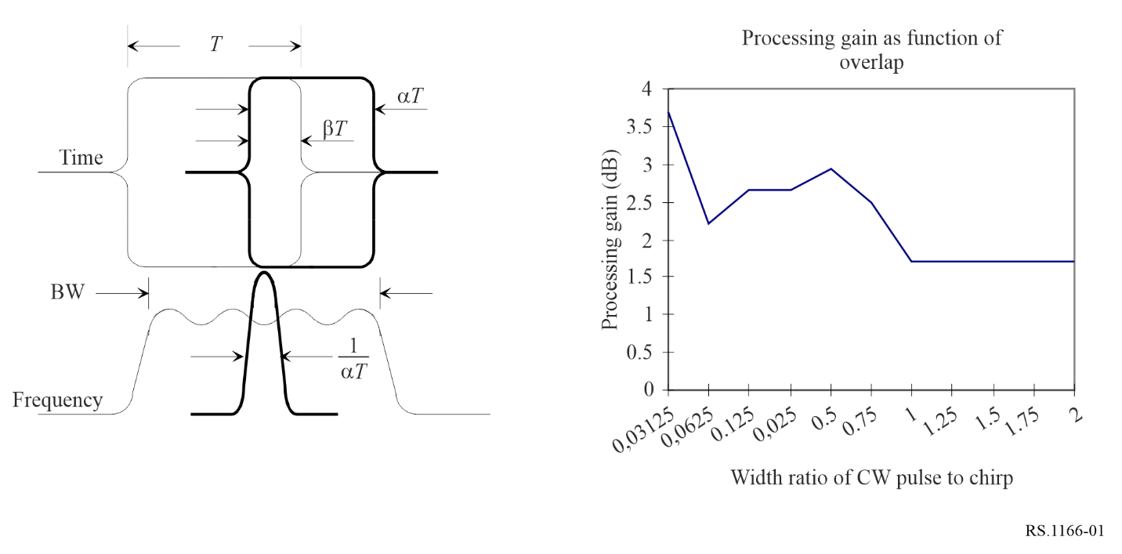

Assuming the interference pulse width is less than the chirp pulse width and is enveloped by the chirp (i.e. α = β), then the processing gain is shown as a function of the fractional pulse width in Fig. 1.

#### 3.2.2.2 Range processing gain for non-pulsed CW interference signals

The RF centre frequency of the non-pulsed CW interference signal is assumed to be in the processing frequency band. For a level of interference signal equal to the noise level, the CW processing gain is 1.7 dB. For each image pixel, this is the same as for a pulsed CW interference signal with the same width as the chirp pulse, the width ratio is unity.

#### 3.2.2.3 Range processing gain for linear FM interference signals

The linear FM interference spectrum is assumed to fall within the processing frequency band, and the interference pulse is assumed to overlap the return echo pulse as shown in Fig. 1.

Let the chirp signal *f*(*t*) be represented by the following:

$f\left(t\right)=rect\left(t/{T_{1}}\right)e^{{j2πf}_{0}+{jπμt}^{2}}$ (1)

where:

rect(*t*) : rectangle function of unity width

*f*0 :RF carrier frequency

μ : slope.

The processing gain of the interference pulse varies as the slope ratio |µ′/µ| for approximately the same pulse width (i.e. α = 1) as shown in Fig. 2. The slope of the interference pulse is μ′ and the slope of the radar chirp is μ.

Figure 2

Processing gain of linear FM interference

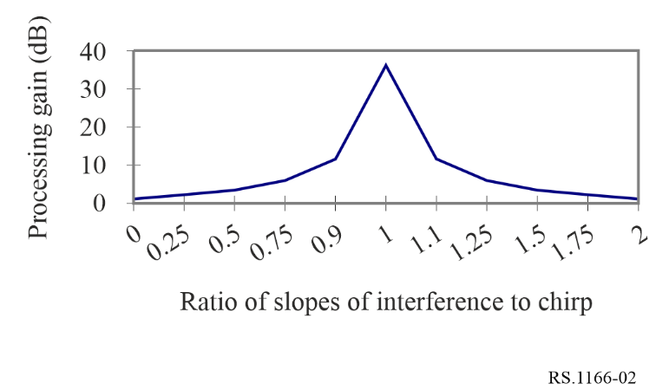

#### 3.2.2.4 Range processing gain for other radar interference waveforms/modulation

Interfering terrestrial radars have various waveforms/ modulations such as Barker codes, non-linear FM, etc. Each of these may be modelled, and processing gains relative to noise calculated. These modulations are not covered herein. It could be noted that the maximum processing gain of other pulsed waveforms or modulations would not be greater than that of the linear FM interference (as shown in Fig. 2) due to the unmatched filtering. However, even though the range processing gain is not covered in detail herein, the azimuth processing gain still pertains to these pulsed waveforms.

#### 3.2.2.5 Azimuth processing gain of pulsed interference signals

The SAR azimuth processing is performed through the summation of echo returns as the antenna beam illumination on the ground passes by the target area. For noise, the azimuth processing gain is *N*, for the integration of *N* pulses during a synthetic aperture. For interfering pulses, the phasing of the interfering signal within each range window differs from return to return since the pulsed interference signal and the SAR have different PRFs. For the interfering pulsed signal, previous analyses using simulations for successive range windows and the summation of returns during a SAR integration interval showed that the instantaneous peak powers for azimuth processed interference pulses vary between 0 dB and 9.5 dB.

### 3.2.3 Calculation of allowable interference

The allowable interference levels as specified above may differ upon consideration of the interference mitigation effect of SAR processing discrimination and modulation characteristics of the systems operating in the band. The allowable interfering signal power *PI* can be determined from the following:

$P_{I}=I/N∙P_{N}∙\frac{G_{N_{AZ}}}{G_{I_{AZ}}}∙\frac{G_{N_{RNG}}}{G_{I_{RNG}}}$ (2)

where:

*I*/*N*: allowable ratio of the interference-to-noise at the processor output

*PN* : noise power at the antenna port

$G_{N_{AZ}}$: processing gain of noise in azimuth

$G_{I_{AZ}}$: processing gain of the interfering signal in azimuth

$G_{N_{RNG}}$: processing gain of noise in range

$G_{I_{RNG}}$: processing gain of the interfering signal in range.

The processing gains are the products of the range processing gains and the azimuth processing gains. The range processing gain for interference is normally small, that is, less than 4 dB; however, the azimuth processing gain for interference is normally 20 dB to 40 dB lower than that for noise.

The methodology used to determine the maximum acceptable interfering signal is as follows:

1) Calculate the input noise power *PN* according to the receiver characteristics of SAR system.

2) Calculate the range processing gain *GNRNG* and azimuth processing gain *GNAZ* of the noise as described in § 3.2.1.

3) Calculate the range processing gain *GIRNG* and azimuth processing gain *GIAZ* of the interference according to the interference waveform as described in § 3.2.2.

4) In the case that SNR = 0 dB, the output power of the noise equals that of the signal. For allowable interfering criteria *I*/*N* = −6 dB, the output power of the maximum interfering signal is obtained by subtracting 6 dB from the output noise power.

5) The maximum allowable input power of the interference signal *PI* can be determined through equation (2) from the values of *PN*, *GNRNG*, *GNAZ*, *GIRNG*, *GIAZ* and *I*/*N* computed in Steps 1 to 4 above.

For instance, in the case of a wideband SAR operating at 9.6 GHz and receiving interference from an airborne radar, both the radar and the SAR use linear FM pulses with widely different chirp slopes. The SAR chirp slope is 45-450 MHz/μs and the airborne radar chirp slope is 0.5 MHz/μs. The ratio of the interfering chirp slope to the SAR chirp slope |µ′/µ| is only 0.001 to 0.01, and from Fig. 2, the corresponding range processing gain is about 2.3 dB. For allowable *I*/*N* = −6 dB, *PN* = −83.7 dBm, *GNAZ*/*GIAZ* = 38 dB, and *GNRNG*/*GIRNG* = −2.3 dB, then *PI* should not exceed −54 dBm. Considering that the range processing gain of the signal is 44 dB, and the value of the azimuth processing gain is twice that of the noise, then the input power of the minimum desired signal can be calculated as −165.7 dBm. Table 3 shows the calculation results for processor gains for noise, the minimum desired return echo signal (SNR = 0 dB), and the maximum acceptable interfering signal for the case of SAR at 9.6 GHz receiving interfering signals from the airborne radar.

TABLE 3

Range and azimuth processing gains for noise, signal and interference for a 600 MHz SAR   
in stripmap mode at 9.6 GHz, with a 50 µs pulse

|  |  |  |  |  |
| --- | --- | --- | --- | --- |
| Signal type | Input power (dBm) | Range processing gain (dB) | Azimuth processing gain (dB) | Output power (dBm) |
| Noise | −83.7 | 0.0 | 38 | −45.7 |
| Minimum desired signal | −165.7 | 44 | 76 | −45.7 |
| Maximum acceptable interfering radar signal | −63.5 to −54 | 2.3 | 0.0 to 9.5 | −51.7 |

It should be noted that, according to equation (2) there is no SAR processing gain impact on noise-like interference such as the interference that would be due to a high density of wideband transmitter on the ground. Indeed, in this case *GNAZ*/*GIAZ* = 0 dB and *GNRNG*/*GIRNG* = 0 dB leading to a *PI* which should not exceed −89.7 dBm.

### 3.2.4 Interference criteria

The criteria for unacceptable degradation in performance for imaging or topographical interferometric SARs can be computed using the procedure in § 3.2.3.

These criteria apply to non-FM pulsed interference sources with pulse durations of 2 μs or less. For other pulse durations, the criteria vary by only ±0.6 dB.

It should be noted that for each SAR, their interference criteria level has to be calculated using the system characteristics of that SAR.

### 3.2.5 Availability criterion

In shared frequency bands, availability of SAR data should exceed 99% for each selected measurement area site.

## 3.3 Snow water equivalent (SWE) retrieval radars

This section presents information on the performance for SWE retrieval instruments in the frequency bands 13.25-13.75 GHz and 17.2-17.3 GHz.

The physical basis to estimate SWE from dual frequency SAR measurements carried out in the 13.5 and 17.2 GHz frequency bands at local scale (50 m to 500 m resolution), is volume scattering by millimetre-scale snow grain size. To achieve accurate SWE retrievals, radiative transfer modelling of the snow volume coupled with physical land surface modelling of snow is required.

A successful retrieval of SWE is done by minimizing a cost function between measured and modelled backscatter intensity:

$F= \left\{\sum_{i=1}^{N}{\frac{w_{i}}{2s_{i}^{2}}{\left(σ_{i}^{obs}-σ_{i}^{model}(SWE, x)\right)}^{2}+\frac{w_{x}}{2s_{x}^{2}}{\left(x-\overline{x}\right)}^{2}}\right\}$ (3)

where:

$σ_{i}^{obs}$: observed backscatter at the *i*-th channel (i.e. for a given frequency and polarization)

$σ_{i}^{model}$: predicted volume scattering modelled by radiative transfer theory

$s_{i}$: error standard deviations of the radar measurements.

The snow parameters *x* for a given snow layer consists in: snow depth, snow density, snow temperature, snow liquid content and snow grain size. $s_{x}^{2}$ is the variance of a priori constraints on the snow parameters. Since this approach contains more unknowns than it has observations (a typical mission will have four observations for *N* × 5 snow properties where *N* is the number of snow layers), Bayesian approaches, such as Markov chain Monte Carlo (MCMC) optimization models are used to identify the different snow properties that replicate the SAR backscatter signal.

To ensure that the MCMC model does not converge to a local minima of unrealistic snow properties, it is initiated with a priori knowledge from multi-layered snow information extracted from land surface models. Land surface model outputs serve as initial input to MCMC models but cannot be used directly to estimate SWE at the local scale since the land surface model outputs are generated at the km-scale. The MCMC model will then be able to optimize the snow states at the km-scale to local snow states by converging to values that replicate the 13.5 and 17.2 GHz backscatter.

A typical SWE retrieval radar will retrieve SWE with an accuracy of 30 mm RMSE (~10% error of peak SWE on average) for non-alpine regions and an error of 25% for alpine-regions due to added inherent challenges of working with SAR data in highly variable topography. From equation (3), a direct error on the backscattered signal will directly impact the accuracy of the retrieved SWE without taking into account any other errors coming from the snow state estimations from the land surface model outputs. This is why a typical SWE retrieval radar aims for a backscatter signal stability < 0.5 dB and an absolute accuracy < 1 dB at 13.5 GHz and < 0.5 dB at 17.2 GHz. The higher absolute accuracy requirement at 17.2 GHz is essential due to the higher sensitivity of the backscatter signal at that frequency to the snow volume (see Fig. 3). With volume scattering being the dominant scattering mechanism in the cross-polarized channel (VH) for both frequencies, the NESZ needs to be below −25 dB and −26 dB for 13.5 and 17.2 GHz respectively, in order to capture the volume scattering component of the snowpack.

Figure 3

Tower-based backscatter measurements of snow at 13.3 and 16.7 GHz for different SWE values

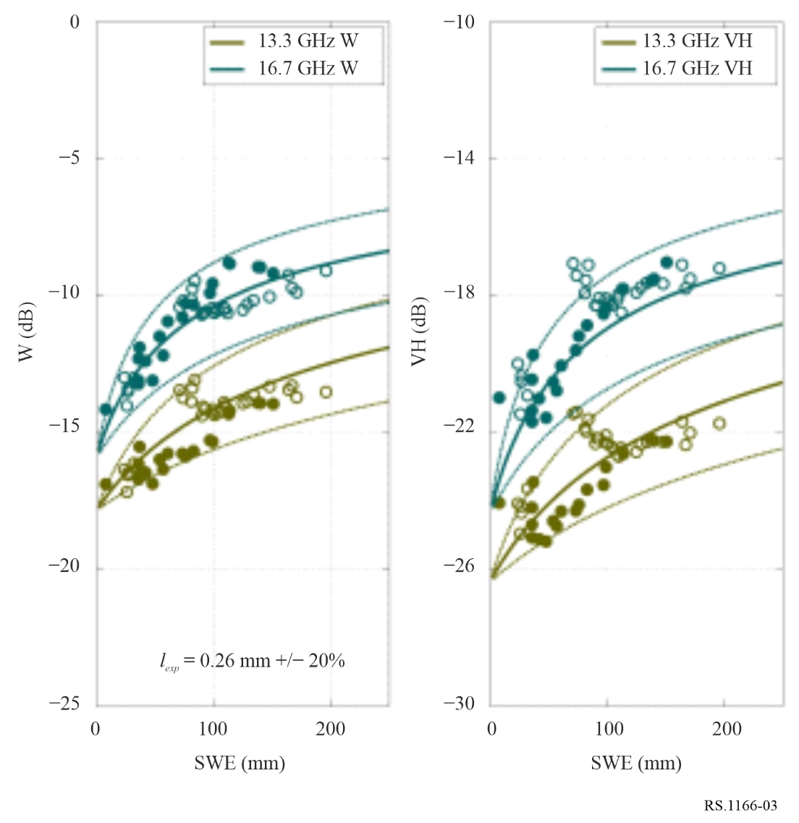

*Note to Fig. 3:* The 16.7 GHz measurements are outside the range of 17.2-17.3 GHz. However, these measurements and their sensitivity to SWE are still relevant to that frequency range.

Field experiments using airborne SAR measurements at 13.3 GHz and 16.7 GHz have also shown that interference coming from calibration targets such as trihedral corner reflectors, prevents accurate SWE retrieval within a 100 m radius of the target due to higher backscatter measurements than what would be expected from measured snow properties on the ground. More work is currently being done in order to assess the impact of a higher NESZ (higher than the −25 dB and −26 dB for 13.5 and 17.2 GHz, respectively) and a high error on the backscatter measurement to the accuracy of SWE retrievals.

# 4 Scatterometers

This section presents information on performance and interference criteria for spaceborne scatterometers in the frequency bands 1.215-1.3 GHz, 5.25-5.57 GHz, 8.55-8.65 GHz, 9.2-10.4 GHz, 13.25‑13.75 GHz, 17.2-17.3 GHz and 35.5-36.0 GHz. It provides performance and interference criteria for active spaceborne scatterometers that can be used to analyse the compatibility of active spaceborne scatterometers and radionavigation and radiolocation systems in these bands.

Unwanted radio frequency emissions reaching the scatterometer’s receiver can corrupt the radar’s scatterometer measurement of σ0, where σ0 is the normalized radar backscatter coefficient. The amount of degradation will depend on the statistics of the external interference.

## 4.1 Performance criteria

In scatterometer systems, an estimate of the echo return signal power is made by first measuring the “signal  noise” power (i.e. the echo return plus the system noise contribution), and then subtracting the “noise-only” power (an estimate of the system noise alone, or “noise floor”). The system noise includes thermal emissions from the Earth, as well as those introduced by the antenna, waveguides, and the receiver noise figure. To optimize system performance, the “signal  noise” and the “noise‑only” measurements are made over different bandwidths and/or at different times. This strategy relies on the fact that the nominal system noise is inherently white during the measurement sequence (stationary, and with a flat spectral power distribution).

If external interference is present, the new composite background noise is the sum of the interference and the nominal system noise. Given the narrow bands used by scatterometers, it may be possible to approximate the noise as white. However, depending on the strength, modulation, antenna gain pattern, and geometry of the interfering source, the composite noise may not be white over the measurement sequence. The “noise-only” measurement will then not correspond to the noise of the “signal  noise” measurement and errors in the estimation of 0 will result.

The estimated σ0 error that results from a given “noise-only” measurement error can be quantified with the following equation:

$σ_{0}Error \left(dB\right)=10\log\left[{1+\left(α-1\right)}/{SNR σ_{0}}\right]$ (4)

where:

*SNR* σ0 (dB)  10 log (*S*/*N*) = signal-to-noise ratio of the σ0 estimation process

with:

*S*: echo return power spectral density

*N*: nominal noise floor power spectral density (approximately −200 dB(W/Hz) at the scatterometer receiver input for both “fan beam” and “spot beam” antennas).

and

$α \left(dB\right)=10\log\left({\left[N+\left({I_{s+n}}/{B_{s+n}}\right)\right]}/{\left[N+\left({I_{n}}/{B_{n}}\right)\right]}\right)$ (5)

with:

$I_{s+n}$: average power from interfering source in *Bs*+ *n* during the “signal  noise” measurement period

$B_{s+n}$: “signal + noise” measurement bandwidth

$I_{n}$: average power from interfering source in *Bn* during the “noise-only” measurement period

$B_{n}$: “noise-only” measurement bandwidth.

The impact of external interference is most severe for winds with low speed. The lowest wind speed to be measured by spaceborne scatterometers is 2 or 3 m/s, depending on the band. Results of computer simulations conducted for non-stationary interference to the NSCAT scatterometer have shown that a maximum value of α (see equation (5)) that will allow performance requirements to be met for 3 m/s wind speeds is 0.7 dB. Interference is defined as non-stationary when its occurrences are dynamic and its statistics vary with time and do not exhibit consistent spectral, amplitude, phase or temporal patterns.

Scatterometers in the future may employ spot beam antennas rather than fan beam antennas as are used for NSCAT. The main differences, besides the antenna pattern, between the two types of scatterometers are the transmitted e.i.r.p. and receive antenna gain. Results of computer simulations conducted for non-stationary interference have shown that a maximum value of α  6 dB (see equation (5)) can be tolerated with the “spot beam” antenna and still meet the performance requirements for 3 m/s wind speeds.

The allowable loss of scatterometer data due to interference from radio frequency stations randomly dispersed across the oceans is 5% for all the data taken over the global oceans.

It should be noted that determining if the 95% availability requirement can be met is a relatively straightforward analysis; however, it is difficult to analyse outages for its characteristic of random dispersion over all observation times and areas.

The allowable loss for systematic interference is 1%. Systematic interference is defined as the loss of measurement data, i.e. interference exceeding the threshold protection criteria, at the same geographical locations where sensor measurements were obtained. These maximum allowable losses have been derived from the NSCAT science requirement for measuring at least 90% of global vector winds over the oceans and taking into consideration other randomly distributed data losses introduced mainly in areas with intense rainfall.

## 4.2 Interference criteria

Figure 4 is a plot of equation (5) for a scatterometer with a receiver noise floor of *N* = −200 dB(W/Hz). It shows α as a function of the power spectral density of the interfering signal *Is*+ *n* /*Bs*+ *n*). Note that different results for α will be obtained depending on how the interference is changing over time or over bandwidth. Figure 4 contains a family of plots for several values of the parameter $10\log\left[{\left({I_{s+n}}/{B_{s+n}}\right)}/{\left({I_{n}}/{B_{n}}\right)}\right]$.

FIGURE 4

Plots for several values of the parameter $10\log\left[{\left({I_{s+n}}/{B_{s+n}}\right)}/{\left({I_{n}}/{B_{n}}\right)}\right]$ (white noise)

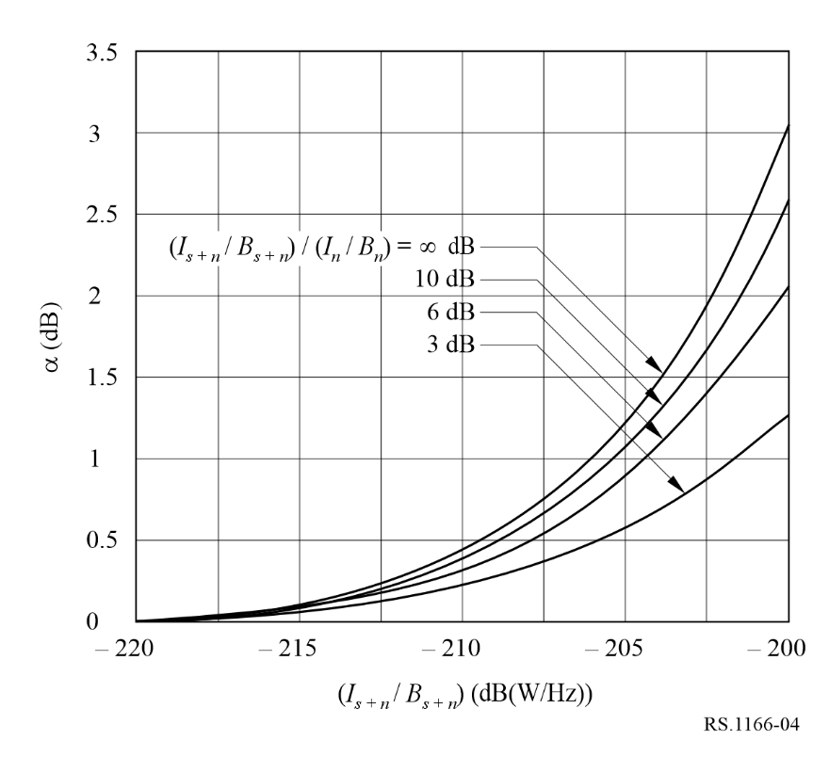

The time separation of the “signal + noise” measurement period from the centre of the “noise-only” measuring period is approximately 0.23 s for the NSCAT scatterometer. During this time the angle from the NSCAT spacecraft scatterometer to a specific point on the ground will change by approximately 0.1°. Due to the narrow beamwidth of the fan beam antenna (0.42°, 3 dB beamwidth), changes of several dB in received interference levels can be encountered as the NSCAT scatterometer side lobes move through an interfering transmitter beam. Engineering judgement has led to a value of 6 dB as the assumed maximum expected change in $10\log\left[{\left({I_{s+n}}/{B_{s+n}}\right)}/{\left({I_{n}}/{B_{n}}\right)}\right]$ during the measurement period when interference is not present. From Fig. 4, it is therefore concluded that the maximum interference power spectral density that any one of the six fan beam antennas of the example NSCAT scatterometer can sustain without degraded measurement accuracy is −207 dB(W/Hz) or −174 dBW over any 2 kHz bandwidth within the 1 MHz bandwidth of the processing channel.

For white-noise like interference, the maximum acceptable interference spectral power density would be approximately −194 dB (W/Hz) at the input of the receiver which, in this example, translates to an interference criterion of −161 dBW over any 2 kHz bandwidth within the 1 MHz bandwidth of the processing channel.

In the case of non-white noise, the interference criterion for a scatterometer which uses a spot beam antenna can be determined for the worst case assumption of  This situation represents the case in which the interference is present for either the “signal  noise” or the “noise-only” measurement, but not for both simultaneously.

This highlights the fact that the interference event has to be examined in detail in regard to the timing of the sensor sampling. At the interference event transition boundaries, the interference present during each of the “signal noise” and the “noise-only” measurements can vary which amplifies the deleterious impact of the interference on the sensor measurements.

From Fig. 5, it is therefore concluded that the maximum interference power spectral density that the “spot beam” antenna of an NSCAT-like scatterometer can sustain without degradation in the measurement is −195 dB(W/Hz). This requirement must hold for any 10 kHz bandwidth within the overall 1 MHz processing channel. However, it must be noted that these results are provided as an example only based on the NSCAT-like scatterometer and that analysis of the particular EESS systems under consideration is required.

FIGURE 5

Plots for several values of the parameter $10\log\left[{\left({I_{s+n}}/{B_{s+n}}\right)}/{\left({I_{n}}/{B_{n}}\right)}\right]$ (non-white noise)

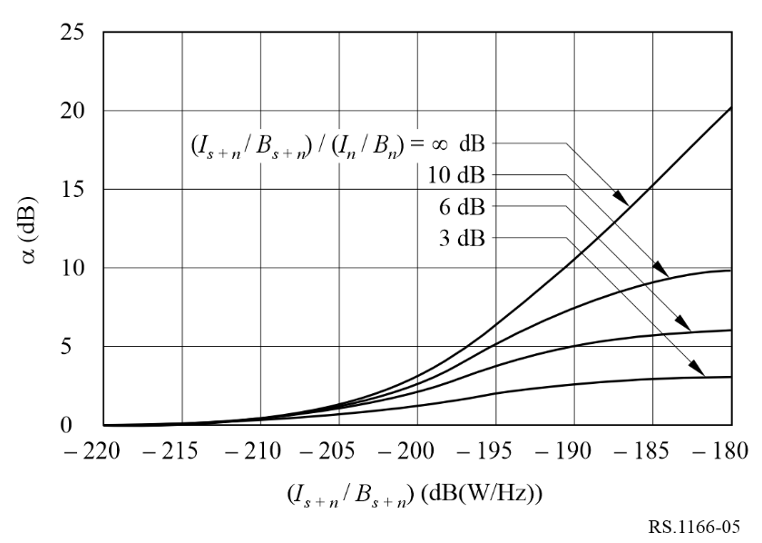

For white-noise like interference, the maximum interference spectral power density would be approximately −185 dB (W/Hz) at the input of the receiver for a scatterometer with a “spot beam” antenna.

In shared frequency bands, availability of scatterometer data should exceed 95% for all locations in the sensor service area where the loss is randomly dispersed and should exceed 99% for each measurement area where the loss occurs systematically at the same locations. It should be noted that determining if the 95% availability requirement can be met is a relatively straightforward analysis; however, it is difficult to analyse outages for its characteristic of random dispersion over all observation times and areas.

# 5 Altimeters

This section presents information on the performance and interference criteria for spaceborne altimeters in the frequency bands 3.1-3.3 GHz, 5.25-5.57 GHz, 8.55-8.65 GHz, 9.2-10.4 GHz[2], 13.25‑13.75 GHz and 35.5-36 GHz.

## 5.1 Performance criteria

Spaceborne altimeters produce, after data processing, measurement of sea level with a precision of at least 2 or 3 cm depending on the band. An increase of 0.1 cm in the height noise due to interference would not materially affect the data and would be acceptable. In other words, a 4% degradation in height noise due to interference could be tolerated as it would not preclude meeting current mission objectives.

A requirement for altimeter missions is acquisition of at least 90% of all possible data over oceans and measurable bodies of water within land masses. The design goal is higher than this minimum requirement and has been established as the acquisition of 95% of all possible measurable data. Observations must be taken to include measurements as close to the land-sea interface as possible (about 15 km from the land-sea interface, altimeter waveform distortions occur and prevent accurate height estimation). The budget for lost data must accommodate all sources of loss including those due to spacecraft systems, the altimeter instrument, manoeuvres, interference, etc.

The availability requirement for altimetry data is 95%, assuming that the associated individual outages are brief and randomly dispersed over all observation time and areas (i.e. most outages lasting 2 s or less). It should be noted that although determining if the 95% availability requirement can be met is a relatively straightforward analysis, it is difficult to analyse outages for its characteristic of random dispersion over all observation time and geographic areas.

The impact of interference that is always present at a given sensor measurement area is much more serious than that of random interference, because valid measurements can never be obtained from those geographical areas. To address this serious concern, the requirement for altimeters is to be able to obtain valid data for a minimum of 99% of the time over each measurement area of interest.

## 5.2 Interference criteria

Typical altimeters have link budgets that result in *S*/*N* of 13 dB (except for 35.5-36 GHz altimeters) in the receiver range resolution bandwidth of 39.9 dB/Hz (9 772.3 Hz). The altimeter height noise varies as 1  2 / (*S*/*N*). For a return signal having a *S*/*N* of 13 dB before interference, the addition of interference causes the following increase in height measurement noise as provided in Table 4.

TABLE 4

Increase of altimeter height measurement noise vs Interference level[3]

|  |  |  |  |  |
| --- | --- | --- | --- | --- |
| Interference level | *S* /*N* (dB) | | Degradation (%) | |
| Non-white interference | White interference | Non-white interference | White interference |
| None | 13 | 13 | Baseline | Baseline |
| 10 dB below noise | 12.6 | 12.99 | 1 | 0.05 |
| 3 dB below noise | 11.25 | 12.5 | 4.5 | 1 |
| Equal to noise | 10 | 11.5 | 9 | 3.8 |
| 10 dB above noise | 2.6 | 3 | 91 | 82 |

For 35.5-36 GHz altimeters, atmospheric effects and technological constraints result in a less favourable link budget (*S*/*N* close to 10 dB) and so the sensitivity to interference level is higher, the following values have to be taken into account:

TABLE 5

Increase of altimeter height measurement noise vs Interference level[4]

|  |  |  |  |  |
| --- | --- | --- | --- | --- |
| Interference level | *S* /*N* (dB) | | Degradation (%) | |
| Non-white interference | White interference | Non-white interference | White interference |
| None | 10 | 10 | Baseline | Baseline |
| 10 dB below noise | 9.6 | 9.98 | 1.7 | 0.08 |
| 6 dB below noise | 9.0 | 9.9 | 4.2 | 0.5 |
| 3 dB below noise | 8.2 | 9.5 | 8.4 | 1.2 |
| 1.5 dB below noise | 7.7 | 9.1 | 11.8 | 3.8 |
| Equal to noise | 7.0 | 8.5 | 17 | 6.9 |
| 10 dB above noise | −0.4 | 0 | 167 | 150 |

The criterion for harmful interference to these example altimeters is, therefore, an aggregate interfering signal power level of −117 dB(W/320 MHz) at 13-14 GHz and a level of −119 dB(W/450 MHz) at 35.5‑36.0 GHz which would cause an unacceptable increase in the height measurement noise. It must be noted that criterion for harmful interference must be calculated according to the system characteristics of the sensor under consideration.

In shared frequency bands, availability of altimeter data should exceed 95% for all locations in the sensor service area where the loss occurs randomly dispersed over all observation time and areas and should exceed 99% for each measurement area where the loss occurs systematically at the same locations.

# 6 Precipitation radars

This section presents information on performance and interference criteria for spaceborne precipitation radars in the frequency bands 13.25-13.75 GHz, 17.2-17.3 GHz, 24.05-24.25 GHz, and 35.5‑36.0 GHz. The performance and interference criteria for active spaceborne precipitation radars provided in *recommends* 1 and 2 of this Recommendation can be used to analyse the compatibility of active spaceborne precipitation radar operation with radionavigation and radiolocation systems in these bands. This section provides an example analysis based on the Global Precipitation Measurement (GPM) Dual Precipitation Radar (DPR) which operates at 13.597/13.603 GHz and 35.547/35.553 GHz.

GPM employs a variable pulse repetition frequency (VPRF) radar to increase the number of samples in an instantaneous field of view (IFOV). The 35 GHz transmitter is designed to detect light rain and delineate between rain and snow, and the 13 GHz radar is used to detect heavy rain. The dynamic ranges of both radars were designed to be able to estimate the drop size distribution (DSD) of the precipitation.

## 6.1 Precipitation radars based upon GPM DPR

The first spaceborne precipitation radar was the Tropical Rainfall Measuring Mission (TRMM) Precipitation Radar (PR) launched in 1997. Following the success of the TRMM, the GPM mission launched in February 2014. The GPM mission currently measures precipitation from space and provides a reference standard to correlate precipitation measurements obtained from other spaceborne sensors.

Mission objectives and the design of the GPM DPR have been examined in order to develop performance and interference criteria that can subsequently be used to assess the compatibility of the PR. Interference criteria are presented which quantify the permissible level of interference and amount of data loss due to interference that would still allow for meeting mission objectives.

### 6.1.1 Performance criteria at 13.597/13.603 GHz

The science requirement for the GPM DPR is to achieve, after data processing, measurement of rain rates equal to or greater than rain rates of 0.22 mm/h at 13.597/13.603 GHz.

Here is the probability distribution function (pdf) of rainfall rates from GPM Version 7 (red is V7, black is V6) between 40° S and 40° N. Note that these are Ku-band only retrievals and the minimum detectable rainfall rate is about 0.2 mm/h rather than 0.5 mm/h. Therefore, if interference increases the minimum detectable rainfall to over 0.5 mm/h, it will have a substantial impact.

FIGURE 6

pdf of rainfall rates from GPM Version 7 (red) and 6 (black) (lower latitudes)

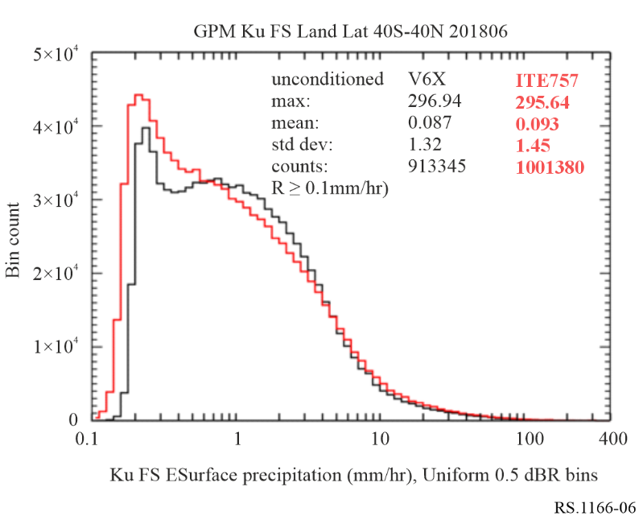

The peak occurs near 0.2 mm/hr. Below is the distribution of rain volume (basically rain*area).

FIGURE 7

Distribution of rain volume (lower latitudes)

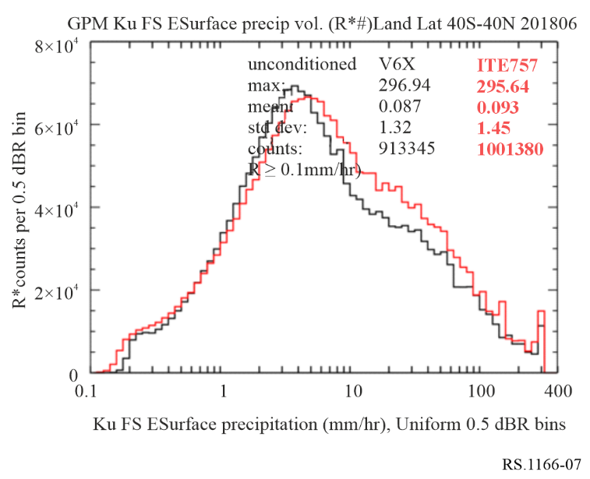

The peak in rain volumes shifts to about 4 mm/hr, but the total to the left of 0.5 mm/hr, while not huge, is still significant. These plots are for lower latitudes. A similar plot for southern high latitudes is shown below.

FIGURE 8

Distribution of rain volume (southern high latitudes)

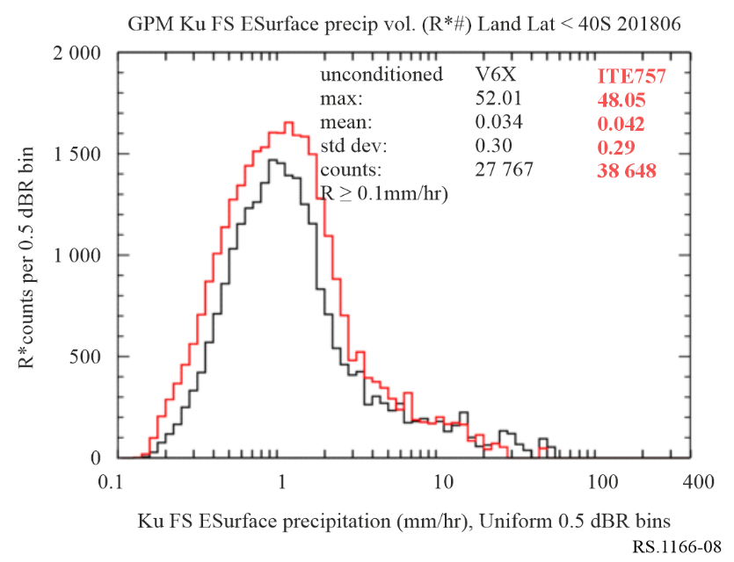

Distribution of rain volume over southern high latitudes shows that the contribution from light rainfall is even larger than for lower latitudes. So it is critically important to know whether interference will shift the minimum detectable rainfall to the right. Shifting the threshold of detectable precipitation to the right could have substantial implications for measuring light rainfall, especially at higher latitudes for GPM and the future AOS Ku-band radar.

The needed availability of rainfall data is a function of where the rainfall occurs. Obtaining all potential rain measurements is important; however, measurements in the Inter-Tropical Convergence Zone (ITCZ) are of particular importance is an area bounded by the Earth’s equator and 10° N latitude, and the wide belt area extending from the Maritime continent to the South Pacific (called Australian Monsoon Trough and South Pacific Convergence Zone or SPCZ). These most important areas are generally bounded by latitudes of 0°-10° N and 50°‑180° E and 0°‑10° S. Therefore, the most critical area is in the ITCZ. Figure 9 shows the convergence zones of particular interest for precipitation radar measurements.In addition, special “ground truth” sites are employed to correlate the PR data with simultaneous terrestrial measurements. A criterion for loss of data in the ITCZ when interference occurs randomly is 0.2% of the possible data. However, as noted elsewhere in this Recommendation, random interference is difficult (if not impossible) to characterize and account for in an interference analysis.

FIGURE 9

Convergence zones of particular interest for precipitation radar measurements

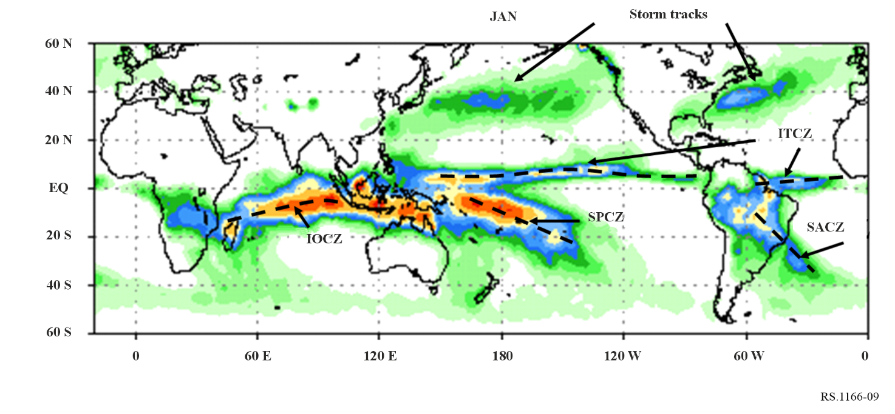

### 6.1.2 Interference criteria

Noise-like interference resulting in an increase in rain rate measurement from 0.2 to 0.5 mm/h corresponds to a performance degradation of 7%. Therefore, the interference should be 10 dB below the system noise level. The noise level is sensor specific and needs to be calculated for each scenario. The equation for calculating the noise level is given:

$N=10\log\left(T^{*}{k_{B}}^{*}BW\right)⋅\left({dBW}/{BW}\right)$

where:

*T* : system noise temperature in Kelvin

*kB*: 1.381 × 10−23 (Boltzmann’s constant)

*BW* : system bandwidth.

In shared frequency bands, availability of precipitation radar data should exceed 99.8% of all locations in the sensor service area in the case where the loss occurs randomly. It should be noted that determining if the 99.8% availability requirement can be met is a relatively straightforward analysis; however, it is difficult to analyse availability loss due to interference for its characteristic of random dispersion over all observation time and areas.

### 6.1.3 GPM 35 GHz band precipitation radar

#### 6.1.3.1 Performance criteria

The percentage of the weak rainfall in the high latitude region is larger than that in the tropical region. Therefore, it is necessary to measure the weak rain as much as possible in order to obtain a bias-free estimate of the rainfall distribution statistics over the high latitude region. Measurements of 0.2 mm/h rain rate are one of the measurement requirements in the GPM DPR mission. For this reason, a minimum detectable radar reflectivity of less than 12 dBZ is specified as the performance criteria of the 35 GHz precipitation radar.

#### 6.1.3.2 Interference criteria

The radar reflectivity of 12 dBZ corresponds to 0.2 mm/h rain rate. This value may increase to 0.22 mm/h. This performance degradation corresponds to a 10% increase of the system noise temperature, or about a 0.5 dB increase of the system noise level. This criterion is essentially the same for the 13 GHz precipitation radar. As for the criterion of the data loss by interference, the same criteria for the 13 GHz precipitation radar applies to the 35 GHz precipitation radar. The permissible data loss for the 35 GHz GPM precipitation radar is 0.2%.

It should be noted that the permissible interference level provided in this example is correct for only this example. For each Precipitation Radar, their permissible interference levels have to be calculated using the system characteristics of that Precipitation Radar.

# 7 Cloud profile radars

This section presents information on performance and interference criteria for spaceborne cloud profile radar sensors in the frequency bands 94.0-94.1 GHz.

## 7.1 Performance criteria for 94 GHz cloud profile radar

The objective of a spaceborne cloud profiling mission is to measure the reflectivity profile for all clouds within the field of view with a minimum reflectivity of −35 dBZ.

## 7.2 Interference criteria for 94 GHz cloud profile radar

Interference should degrade *Zmin* less than 10% in 95% of the service area. Ten percent degradation in *Zmin* corresponds to an interference-to-noise ratio of −10 dB. This interference criterion corresponds to an interference power level of −160 dBW over 300 kHz.

## 7.3 Availability criteria of the cloud profile radar

For random interference signals, the interference should degrade *Zmin* less than 10% in 95% of the service area. If the interference signal is not random, it should degrade *Zmin* less than 10% in 99% of the intended service area. It should be noted that it is difficult to analyse interference for its characteristic of random dispersion over all observation time and areas.

# 8 Measurement area of interest for the evaluation of systematic interference

In order to perform analyses that evaluate interference in regard to its impact on the active sensor’s systematic data availability criteria it is necessary to define 1) the dimensions of the measurement area; 2) the location of the geographical area that should be considered in simulations; and 3) the manner in which the measurement is taken. Together, the size and location of the geographical area that should be considered in sharing analyses has been referred to as “the measurement area of interest”. The manner in which the measurement is taken is dependent on the operational characteristics of the sensor and the method in which the sensor data is used.

In shared frequency bands, availability of all sensor data, with the exception of precipitation radar, should exceed 95% of all locations in the sensor service area in the case where the loss occurs randomly, and it should exceed 99% of all locations in the case where the loss occurs systematically within the measurement area of interest. In the case of precipitation radars, the random and systematic data availability criteria is 99.8%.

In regard to the measurement area of interest, any systematic interference in excess of the applicable interference threshold would result in measurement loss 100% of the time for the specific measurement area of interest.

# 9 Transient impulse interference considerations

It is important to note that ITU-R sharing and compatibility studies are typically conducted with the mean (average) power of the interfering transmitter rather than the peak transient power. In the case of a peak detecting active spaceborne sensor such as an altimeter, use of the mean power of the interfering transmitter instead of the peak transient power will underestimate the level of interference affecting the peak detecting sensor measurements.

Active spaceborne sensors that detect average return signal power are not affected additionally by transient transmissions of modulation symbols with higher power than the transmitted average power. However, sensors that detect peak return signal power are sensitive to the transient transmission amplitudes that occur above the average power of an interfering signal.

## 9.1 Determination of peak transient power for some modulation schemes

Figure 10 provides the results of CCDF measurements made of the power peaks of a DVB-S2 single carrier transmitter[5] with five commonly used modulation schemes when presented with a randomly generated data stream. Single carrier transmission operation was considered.

Pulse shape filtering was used in the transmission. Non-linear components and multi‑carrier operation were not included in this investigation. As is expected, 50% of the time peak power is 0 dB above the average power. However, 1% of the time, four of the five modulation schemes have power peaks 4 dB higher than the average. Peak impulse power is greater than 5 dB above the mean for all of the commonly used modulation schemes shown in Fig. 9 and peak impulse power is greater than 7 dB above the mean power for 32 APSK and 16 QAM. As an example, Table 6 below tabulates the power peaks for the modulation schemes at the 10%, 1%, 0.1%, and 0.01% of time levels vs bandwidths. Table 6 also provides for each of the bandwidths the number of symbols per second that would occur at those power peaks for the percentage of time levels.

As an example, an altimeter that operates in the 13.4-13.75 GHz band and samples about 2 000 radar echoes per second resulting from about 2 000 chirps. The altimeter detects peak returned power. Table 6 shows the number of symbols/s versus the peak power above the mean expected for various modulations and transmission bit rates. Table 6 indicates in the tabulation where the transmission modulation symbols per second rate exceeds the altimeter sample rate. An examination of these highlighted entries indicates that in considering the effect of transient peak impulse power, a minimum additional value of interference transmission power above the mean should be applied.

This examination of the impact of peak power on the altimeter peak detecting sensor was conservative in its estimate of additional power that should be accounted for in interference studies. As indicated in Fig. 10, peaks of higher power symbols occur at lower frequency rates than the example altimeter pulse rate of about 2 000/second.

These higher power symbols will also be detected by the altimeter sensor but since these higher power symbols occur at a lower frequency rate than the sample rate they will not affect every altimeter sample. Further study may provide a method for fully accounting for the impact of all higher power symbols on the degradation of measurement samples taken by peak detecting sensors.

Figure 10 and Table 6 provide power peak/percentage of time results of modulations when considering single carrier transmission per FSS earth station operation. When a transmitting station employs multiple carriers within a transmission (multicarrier operation), the interaction between the multiple carriers within the same filtered bandwidth of the transmitter will increase the peak power of symbols significantly over that of a single carrier ES transmitter. Examination of multicarrier transmission in regard to the peak power of symbols produced will require further study.

FIGURE 10

CCDF of peak power for common modulations employed

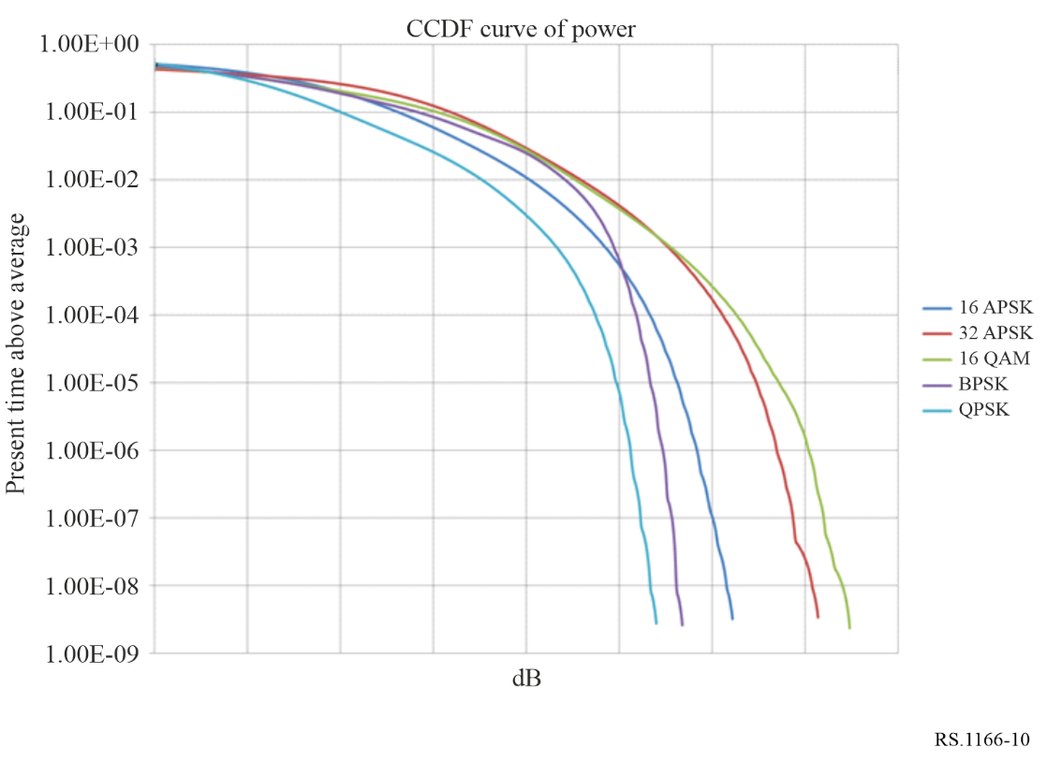

TABLE 6

Tabulation of peak power as a percentage of time and the corresponding symbols/sec  
for the FSS transmission types

|  |  |  |  |  |  |  |  |  |
| --- | --- | --- | --- | --- | --- | --- | --- | --- |
| Transmission bit rate/modulation | 10% of time above average (dB) | Symbols/s  (k) | 1% (dB) | Symbols/s  (k) | 0.1% (dB) | Symbols/s  (k) | 0.01% (dB) | Symbols/  (k) |
| **580 kHz** |  |  |  |  |  |  |  |  |
| 16 APSK | 2.6 | 232 (1) | 4.0 | 23.2 (1) | 4.8 | 2.3 (1) | 5.3 | 0.2 |
| 32 APSK | 3.2 | 290 (1) | 4.6 | 29 (1) | 5.5 | 2.9 (1) | 6.1 | 0.3 |
| 16 QAM | 3.1 | 232 (1) | 4.5 | 23.2 (1) | 5.6 | 2.3 (1) | 6.3 | 0.2 |
| BPSK | 2.8 | 58 (1) | 4.4 | 5.8 (1) | 4.9 | 0.6 | 5.2 | 0.1 |
| QPSK | 2.0 | 116 (1) | 3.5 | 11.6 (1) | 4.3 | 1.2 | 4.7 | 0.1 |
| **30.84 MHz** |  |  |  |  |  |  |  |  |
| 16 APSK | 2.6 | 12 336 (1) | 4.0 | 1 232 (1) | 4.8 | 123.2 (1) | 5.3 | 12.4 (1) |
| 32 APSK | 3.2 | 15 420 (1) | 4.6 | 1 540 (1) | 5.5 | 154.0 (1) | 6.1 | 15.5 (1) |
| 16 QAM | 3.1 | 12 336 (1) | 4.5 | 1 232 (1) | 5.6 | 123.2 (1) | 6.3 | 12.4 (1) |
| BPSK | 2.8 | 3 084 (1) | 4.4 | 308 (1) | 4.9 | 30.8 (1) | 5.2 | 3.1 (1) |
| QPSK | 2.0 | 6 168 (1) | 3.5 | 616 (1) | 4.3 | 61.6 (1) | 4.7 | 6.2 (1) |
| **2.94 MHz** |  |  |  |  |  |  |  |  |
| 16 APSK | 2.6 | 1 176 (1) | 4.0 | 117.6 (1) | 4.8 | 11.8 (1) | 5.3 | 1.2 |
| 32 APSK | 3.2 | 1 470 (1) | 4.6 | 147 (1) | 5.5 | 14.7 (1) | 6.1 | 1.5 |
| 16 QAM | 3.1 | 1 176 (1) | 4.5 | 117.6 (1) | 5.6 | 11.8 (1) | 6.3 | 1.2 |
| BPSK | 2.8 | 294 (1) | 4.4 | 29.4 (1) | 4.9 | 2.9 (1) | 5.2 | 0.3 |
| QPSK | 2.0 | 588 (1) | 3.5 | 58.8 (1) | 4.3 | 5.9 (1) | 4.7 | 0.6 |

|  |
| --- |
| (1) Transmission modulation symbols per second rate exceeds the altimeter sample rate. |

For ITU-R sharing studies involving peak detecting active spaceborne sensors, an examination of the frequency of symbols with higher power in comparison to the frequency of detection by the active spaceborne sensor is needed to determine the additional level above the mean power of the interfering transmitter that should be taken into account.

# 10 Typical EESS (active) sensor parameters to be used in determining impact from differing types of interference

The parameters of the six types of spaceborne active sensors listed in Table 7 can be used in evaluating the impact of various types of interference to the measurements obtained by the active sensor. The values given in Table 7 are typical values which can be used for a preliminary evaluation; however, the actual values of the active sensor in the frequency band under consideration should be used in any final determination of interference impact.

TABLE 7

Typical EESS (active) sensor processing parameters for interference impact assessment

|  |  |  |  |  |  |  |
| --- | --- | --- | --- | --- | --- | --- |
| Sensor type | Peak/Average power detection | Sub sample size  (ms) | Number of subsamples in a sample | Pixel size  (km2) | Minimum measurement area of interest | Background noise measurement |
| Radar sounder | Average |  |  |  |  | Yes |
| SAR imager | Average |  |  |  |  | Yes |
| Scatterometer | Average |  |  |  |  | Yes |
| Altimeter | Peak | 50 | 100 | 1 | 10 km2 (consecutive pixels) | Yes |
| Precipitation radar | Average |  |  |  |  | Yes |
| Cloud profile radar | Average |  |  |  |  | Yes |

1. * Interference criteria do not imply automatically sharing criteria.
2. Altimeters operate anywhere in the frequency band 9.2-10.4 GHz with a bandwidth of 300 MHz.
3. Except for 35.5-36 GHz altimeters.
4. For 35.5-36 GHz altimeters.
5. This implies the transmit filter of a RRC with a .25 alpha (α).