Recommendation ITU-R P.841-7
(08/2022)
Conversion of annual statistics to
worst-month statistics

P Series
Radiowave propagation

Foreword
The role of the Radiocommunication Sector is to ensure the rational, equitable, efficient and economical use of the radio-frequency spectrum by all radiocommunication services, including satellite services, and carry out studies without limit of frequency range on the basis of which Recommendations are adopted.
The regulatory and policy functions of the Radiocommunication Sector are performed by World and Regional Radiocommunication Conferences and Radiocommunication Assemblies supported by Study Groups.

Policy on Intellectual Property Right (IPR)
ITU-R policy on IPR is described in the Common Patent Policy for ITU-T/ITU-R/ISO/IEC referenced in Resolution ITU-R 1. Forms to be used for the submission of patent statements and licensing declarations by patent holders are available from http://www.itu.int/ITU-R/go/patents/en where the Guidelines for Implementation of the Common Patent Policy for ITU-T/ITU-R/ISO/IEC and the ITU-R patent information database can also be found.

Series of ITU-R Recommendations
(Also available online at http://www.itu.int/publ/R-REC/en)
Series | Title
BO | Satellite delivery
BR | Recording for production, archival and play-out; film for television
BS | Broadcasting service (sound)
BT | Broadcasting service (television)
F | Fixed service
M | Mobile, radiodetermination, amateur and related satellite services
P | Radiowave propagation
RA | Radio astronomy
RS | Remote sensing systems
S | Fixed-satellite service
SA | Space applications and meteorology
SF | Frequency sharing and coordination between fixed-satellite and fixed service systems
SM | Spectrum management
SNG | Satellite news gathering
TF | Time signals and frequency standards emissions
V | Vocabulary and related subjects

Note: This ITU-R Recommendation was approved in English under the procedure detailed in Resolution ITU-R 1.

Electronic Publication
Geneva, 2022

© ITU 2022
All rights reserved. No part of this publication may be reproduced, by any means whatsoever, without written permission of ITU.

RECOMMENDATION ITU-R P.841-7
Conversion of annual statistics to worst-month statistics
(Question ITU-R 201/3)
(1992-1999-2001-2003-2005-2016-2019-2022)
Scope
This Recommendation provides methods for the conversion of annual percentage into worst-month percentage for propagation related parameters.
Keywords
Worst-month statistics, annual statistics, conversion method
The ITU Radiocommunication Assembly,
considering
a) that for design of radiocommunication systems the required statistics of propagation effects pertain to the worst-month period of reference;
b) that the concept of worst-month is defined in Recommendation ITU-R P.581;
c) that the reference statistics for many radiometeorological data and propagation prediction methods is “the long-term average annual” distribution;
d) that consequently there is a need for a method that provides for the conversion of the “annual” to the “worst-month” statistics;
e) that the worst-month cumulative probability and the worst-month exceedance probability are needed,
recommends
that, when monthly statistics are not available, the method given in Annex 1 be used to convert exceedance probability to worst-month exceedance probability and convert cumulative probability to worst-month cumulative probability.

Annex 1
1 The average annual worst-month exceedance probability, p_{w}, is calculated from the average annual exceedance probability, p, using the conversion factor Q:
$p_{w}=Q p$ (1)
where 1 ≤ Q ≤ 12, and both p and p_{w} refer to the same threshold levels.
The cumulative probability, $q$, and worst-month cumulative probability, $q_{w}$, can be converted to the exceedance probability, $p$, and worst-month exceedance probability, $p_{w}$, and vice versa as follows:
$q=100-p, q_{w}=100-p_{w}$ (2)
$p=100-q, p_{w}=100-q_{w}$ (3)
2 Q is a two parameter (Q₁, β) function of p (%):
(4)
3 The calculation of the average annual time exceedance probability from the given value of the average annual worst-month time exceedance probability is done through the inverse relationship:
$p={p_{w}}/Q$ (5)
and the dependence of Q on p_{w} can be easily derived from the above given dependence of Q on p. The resulting relationship for 12 p₀ < p_{w}(%) < Q₁ 3^{(1–β)} is ( p₀ = (Q₁/12)^{1/β}):
(6)
4 For global planning purposes the following values for the parameters Q₁ and β should be used:
Q₁ = 2.85, β = 0.13
(see Fig. 1). This leads to the following relationship between p and p_{w}:
(7)
for 1.9 × 10^{–4} < p_{w}(%) < 7.8.
figure 1
Solid line: Q vs. p with parameters Q₁ = 2.85 and β = 0.13; dashed line: theoretical upper bound
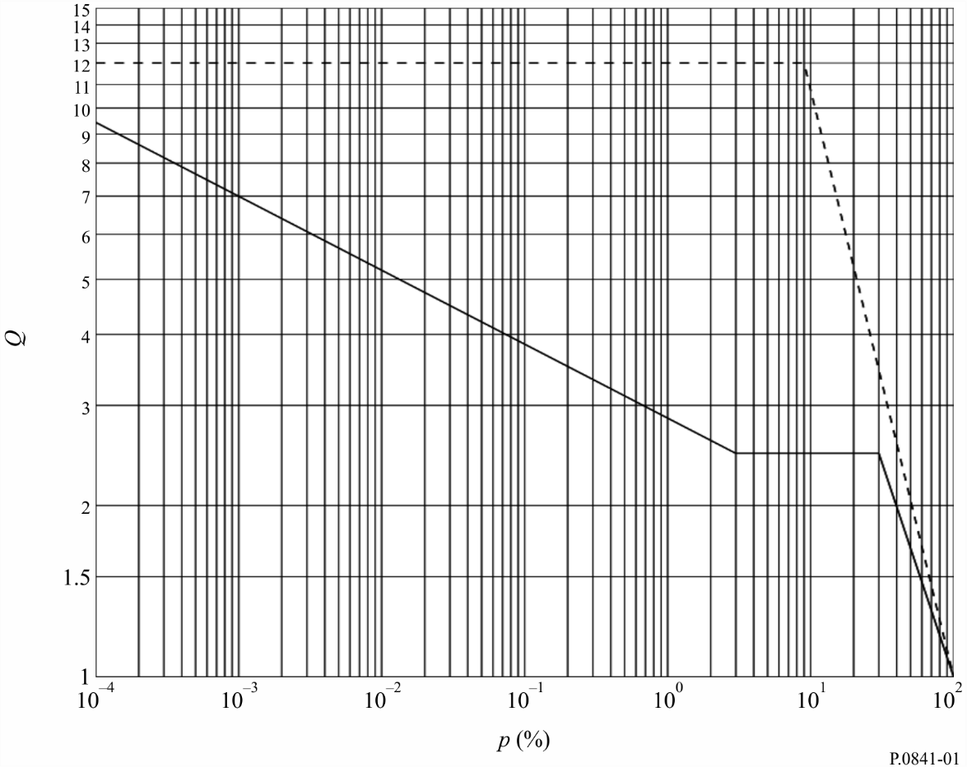
For global rain rate applications, the following values for the parameters Q₁ and β should be used:
Q₁ = 2.82, β = 0.15, for tropical, subtropical and temperate climate regions with frequent rain Q₁ = 4.48, β = 0.11, for dry temperate, polar and desert regions (see Fig. 2). This leads to the following relationship between p and p_{w}:
(8)
where 7.7 × 10⁻⁴ < p_{w}(%) < 7.17, for tropical, subtropical and temperate climate regions with frequent rain:
(9)
where 1.5 × 10⁻³ < p_{w}(%) < 11.91, for dry temperate, polar and desert regions.
figure 2
Example of the dependence of Q on p with global subregion parameters
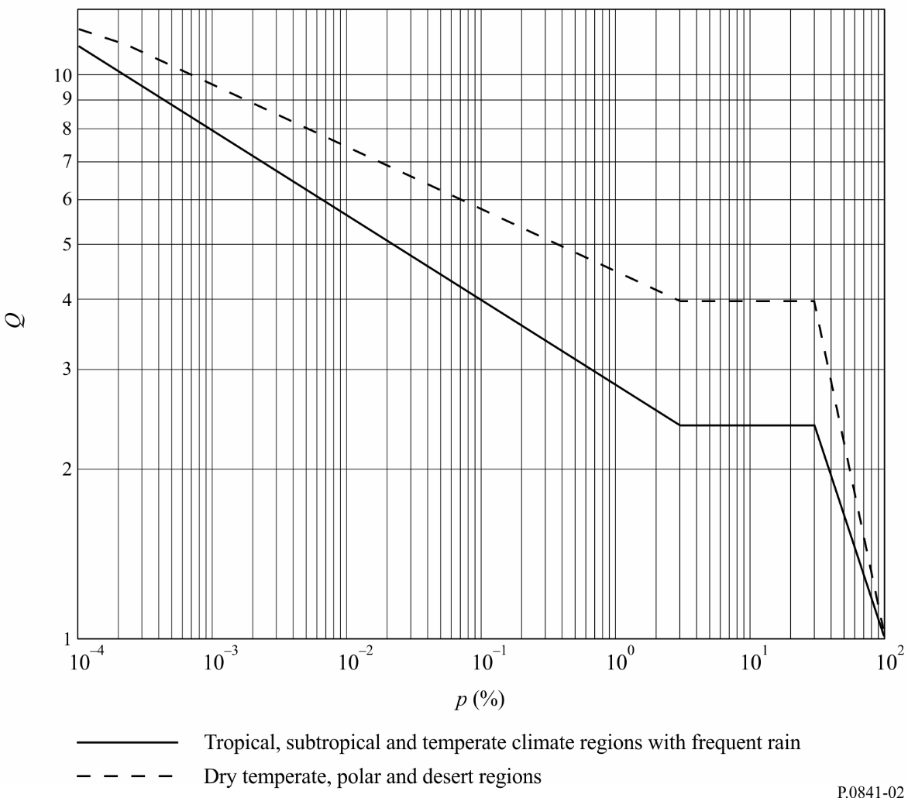
5 For more precision the values of Q₁ and β for the different climatic regions and various propagation effects given in Table 1 should be used where appropriate.
6 For trans-horizon paths of land or sea, the β and Q1 values are calculated from those values for sea and land given in Table 1, where N_{s} is the local surface refractivity of the Earth lying in the troposcatter common volume.
7 Entries under rain rate for Australia are based on 6-min time interval measurements taken from 20 sites over periods lasting from 25 to 101 years. Examples of site locations for each climatic region in Australia are given in the first column of Table 1. Entries under rain rate for Brazil have been derived for measurements of rainfall rates at nine sites over a 46-year period using fast response rain gauges.
TABLE 1
β and Q₁ values for various propagation effects and locations
 | Rain effect  terrestrial attenuation | Rain effect  slant path attenuation | Rain rate | Multipath | Trans-horizon  land | Trans-horizon  sea
Global | 0.13, 2.85 | 0.13, 2.85 |  | 0.13, 2.85 | 0.13, 5.8-0.03exp  (Ns/75) | 0.13, 5.8-0.03exp  (Ns/75)
Tropical, subtropical and temperate climate regions with frequent rain |  |  | 0.15, 2.82
Dry temperate, polar and desert regions |  |  | 0.11, 4.48
Europe  North West | 0.13, 3.0 | 0.16, 3.1 |  | 0.13, 4.0 | 0.18, 3.3
Europe  North West  1.3 GHz |  |  |  |  |  | 0.11, 4.9
Europe  North West  11 GHz |  |  |  |  |  | 0.19, 3.7
Europe  Mediterranean | 0.14, 2.6 | 0.16, 3.1
Europe  Nordic | 0.15, 3.0 | 0.16, 3.8 |  | 0.12, 5.0
Europe  alpine | 0.15, 3.0 | 0.16, 3.8
Europe  Poland | 0.18, 2.6
Europe  Russian Federation | 0.14, 3.6
Europe  UK  40 and 50 GHz |  | 0.13, 2.54
Congo | 0.25, 1.5
Canada  Prairie and North | 0.08, 4.3
Canada  Coast and Great Lake | 0.10, 2.7

TABLE 1 (continued)
 | Rain effect  terrestrial attenuation | Rain effect  slant path attenuation | Rain rate | Multipath | Trans-horizon  land | Trans-horizon  sea
Canada  Central and Mountains | 0.13, 3.0
United States of America  Virginia |  | 0.15, 2.7
Russian Federation  North European  region |  |  | 0.10, 4.57
Russian Federation  Central and  West European region |  |  | 0.16, 2.38
Russian Federation  Middle Volga  region and South Ural |  |  | 0.10, 4.27
Russian Federation  Central Steppe and South  European region |  |  | 0.15, 2.69
Russian Federation  West Siberian  region |  |  | 0.14, 3.72
Russian Federation  Middle Siberian  Plateau and Jakutia |  |  | 0.11, 5.04
Russian Federation  South Far East |  |  | 0.13, 3.53
Australia  Temperate/  coastal |  |  | 0.17, 2.65
Australia  Subtropical/  coastal |  |  | 0.15, 3.15
Australia  Tropical/arid |  |  | 0.12, 4.35

TABLE 1 (end)
 | Rain effect  terrestrial attenuation | Rain effect  slant path attenuation | Rain rate | Multipath | Transhorizon  land | Transhorizon  sea
Brazil  Equatorial |  |  | 0.13, 2.85
Brazil  Tropical maritime |  |  | 0.21, 2.25
Brazil  Tropical inland |  |  | 0.13, 3.00
Brazil  Subtropical |  |  | 0.13, 2.85
Indonesia | 0.22, 1.7
Japan  Tokyo | 0.20, 3.0
Japan  Yamaguchi |  | 0.15, 4.0
Japan  Kashima |  | 0.15, 2.7
South Korea |  |  | 0.12, 4.6
Kyrgyzstan  Flat regions |  |  | 0.09, 5.95
Kyrgyzstan  Mountainous regions |  |  | 0.10, 6.70
Kyrgyzstan  Coastal region of Ysyk-Kol lake |  |  | 0.14, 4.73
China  South |  |  | 0.15, 3.12
China  North |  |  | 0.13, 4.12
China  Desert |  |  | 0.10, 5.40

The terms exceedance probability, time fraction of excess and complementary cumulative distribution function (CCDF) are synonymous.

