ITU-R P.838-3 建议书

**预测方法中使用的雨天衰减的具体模型**

（ITU-R 201/3号研究课题）

(1992-1999-2003-2005)

国际电联无线电通信全会，

考虑到

a) 由于降雨强度的关系，有必要计算由于下雨带来的衰减，

建议

# 1 使用下列程序。

具体的衰减γ*R* (dB/km)可以从降雨强度*R* (mm/h)的幂次律关系中算出：

 (1)

作为频率范围为1至1 000 GHz的频率 *f* (GHz)的函数，系数*k*和*α*的值由下列等式确定，这些等式是通过从离散计算中获得的从曲线拟合到幂次律系数来推出的：

 (2)

 (3)

其中：

*f*： 频率 (GHz)

*k*： *kH* 或*kV*

α： α*H* 或α*V*。

水平极化的系数*kH* 的常数值在表1中给出，而垂直极化的系数*kV*的常数值在表2中给出。表3给出了水平极化的系数*αH*的常数值，而表4给出了垂直极化的系数*αV*的常数值。

表 1  
*kH* 系数

|  |  |  |  |  |  |
| --- | --- | --- | --- | --- | --- |
| *j* | *aj* | *bj* | *cj* | *mk* | *ck* |
| 1 | –5.33980 | –0.10008 | 1.13098 | –0.18961 | 0.71147 |
| 2 | –0.35351 | 1.26970 | 0.45400 |
| 3 | –0.23789 | 0.86036 | 0.15354 |
| 4 | –0.94158 | 0.64552 | 0.16817 |

表 2  
*kV* 系数

|  |  |  |  |  |  |
| --- | --- | --- | --- | --- | --- |
| *j* | *aj* | *bj* | *cj* | *mk* | *ck* |
| 1 | –3.80595 | 0.56934 | 0.81061 | –0.16398 | 0.63297 |
| 2 | –3.44965 | –0.22911 | 0.51059 |
| 3 | –0.39902 | 0.73042 | 0.11899 |
| 4 | 0.50167 | 1.07319 | 0.27195 |

表 3  
*αH*系数

|  |  |  |  |  |  |
| --- | --- | --- | --- | --- | --- |
| *j* | *aj* | *bj* | *cj* | *mα* | *cα* |
| 1 | –0.14318 | 1.82442 | –0.55187 | 0.67849 | –1.95537 |
| 2 | 0.29591 | 0.77564 | 0.19822 |
| 3 | 0.32177 | 0.63773 | 0.13164 |
| 4 | –5.37610 | –0.96230 | 1.47828 |
| 5 | 16.1721 | –3.29980 | 3.43990 |

表 4  
*αV*系数

|  |  |  |  |  |  |
| --- | --- | --- | --- | --- | --- |
| *j* | *aj* | *bj* | *cj* | *mα* | *cα* |
| 1 | –0.07771 | 2.33840 | –0.76284 | –0.053739 | 0.83433 |
| 2 | 0.56727 | 0.95545 | 0.54039 |
| 3 | –0.20238 | 1.14520 | 0.26809 |
| 4 | –48.2991 | 0.791669 | 0.116226 |
| 5 | 48.5833 | 0.791459 | 0.116479 |

对于线极化和圆极化中所有的路径几何，可以通过等式（2）和（3）中给定的值由下列等式计算出等式（1）中的系数：

 (4)

 (5)

此处θ是路径斜角，τ是相对水平位置的极化斜角（对于圆极化，τ=45。）。

可以在图1至4中快速查阅系数*k*和*α*的图形显示，表5列出了在给定频率上的系数的数值。

图 1  
水平极化的系数

频率 (GHz)

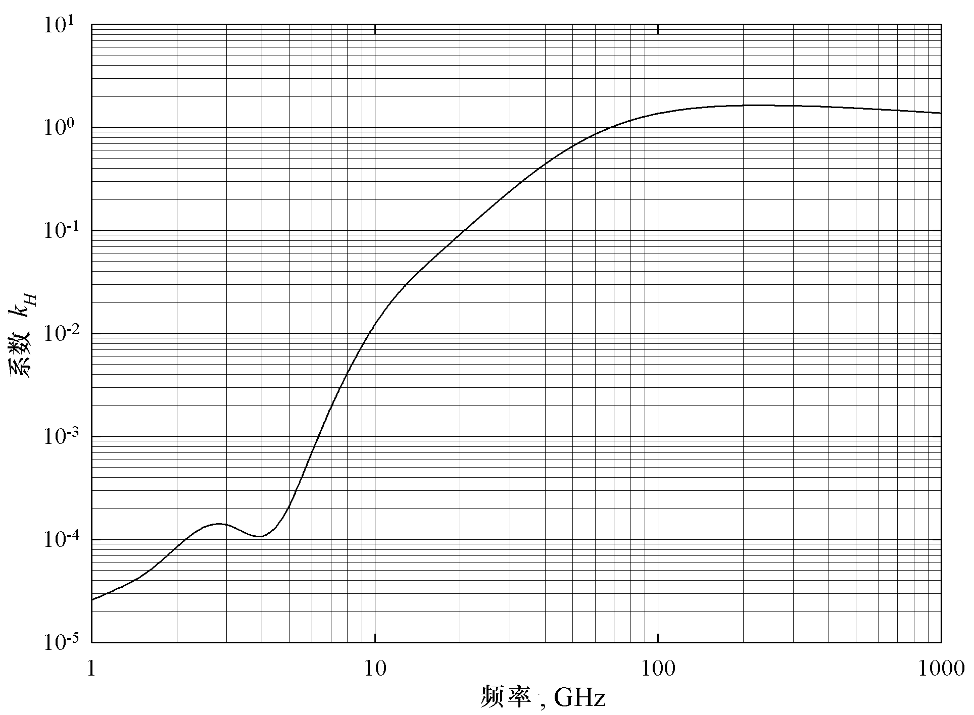

图 2  
水平极化的系数*α*

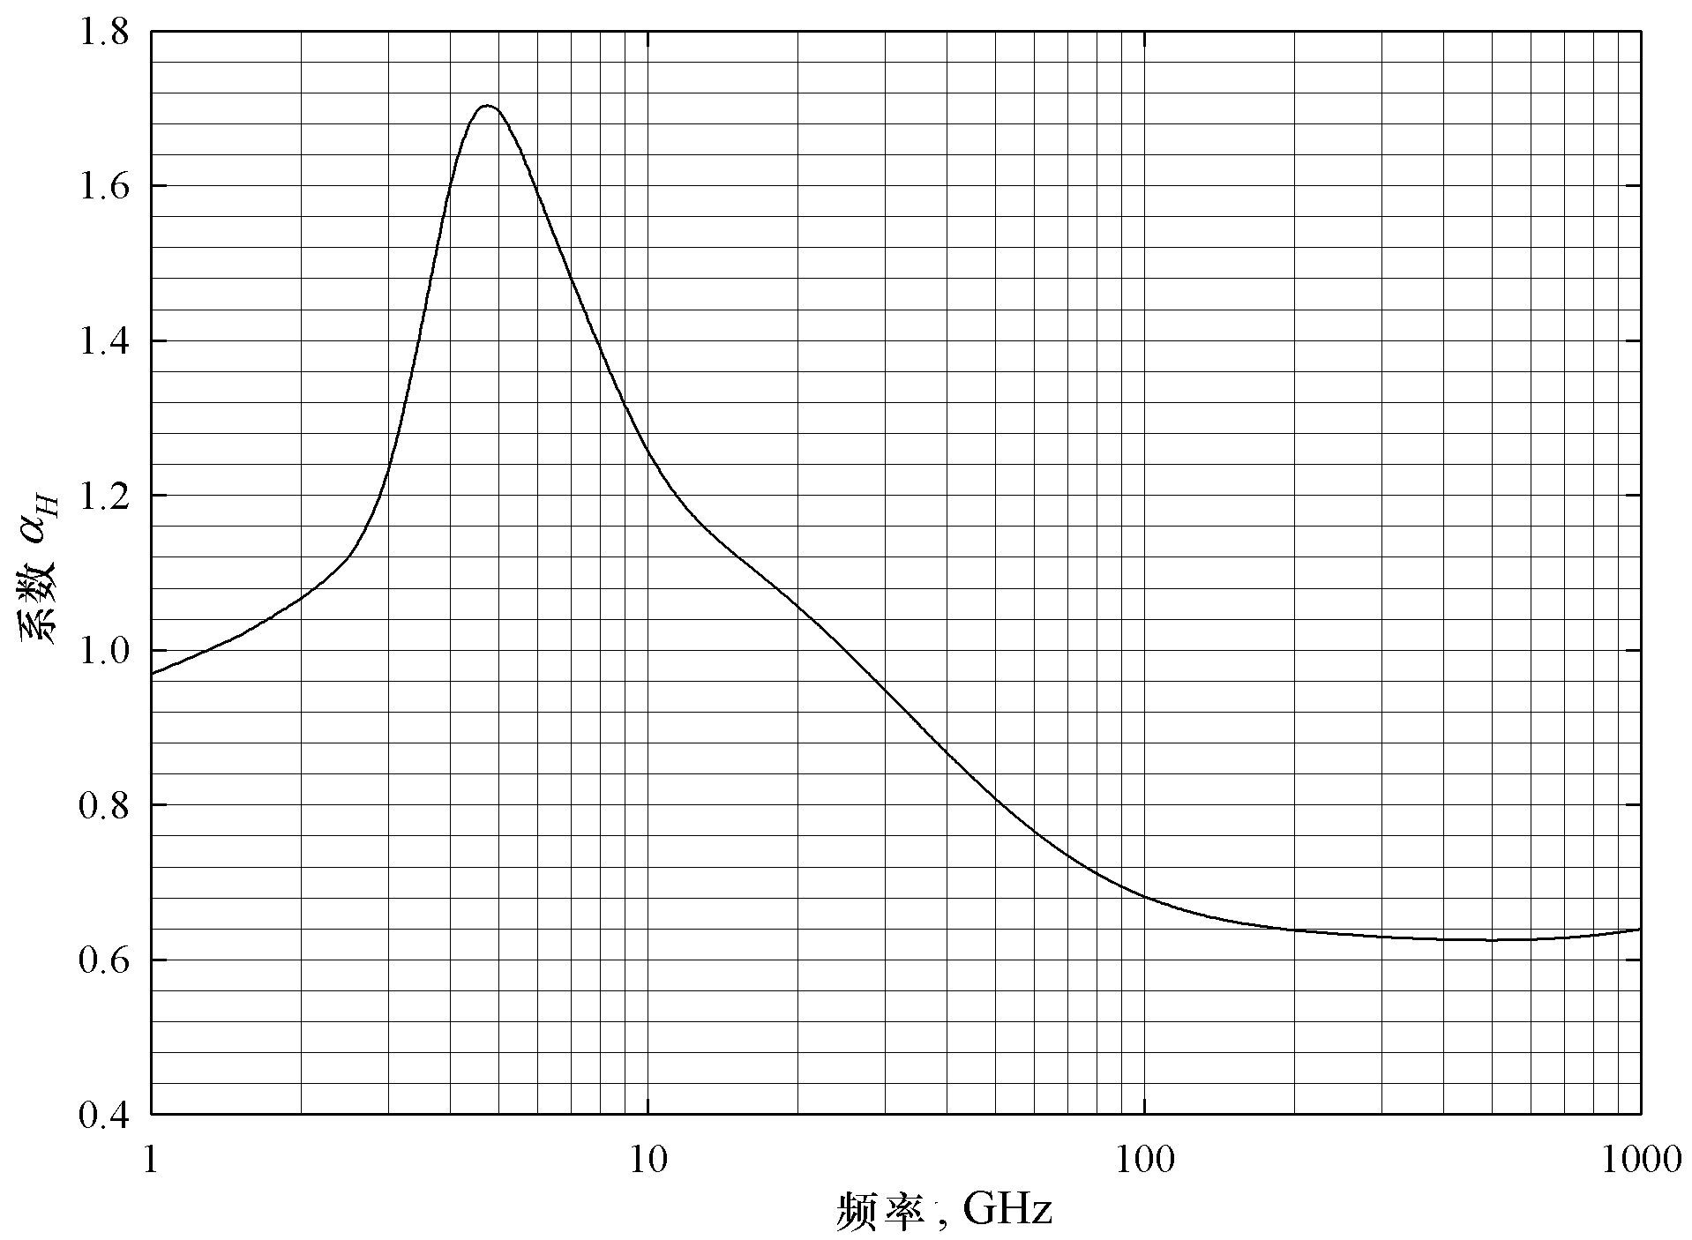

频率（GHz）

图 3  
垂直极化的系数*k*

频率（GHz）

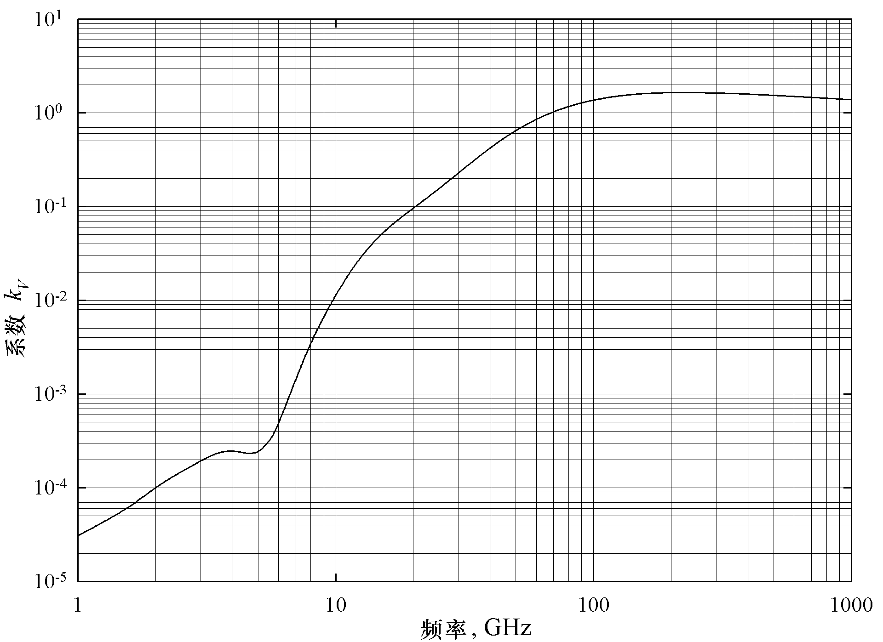

频率（GHz）

图 4  
垂直极化的系数*α*

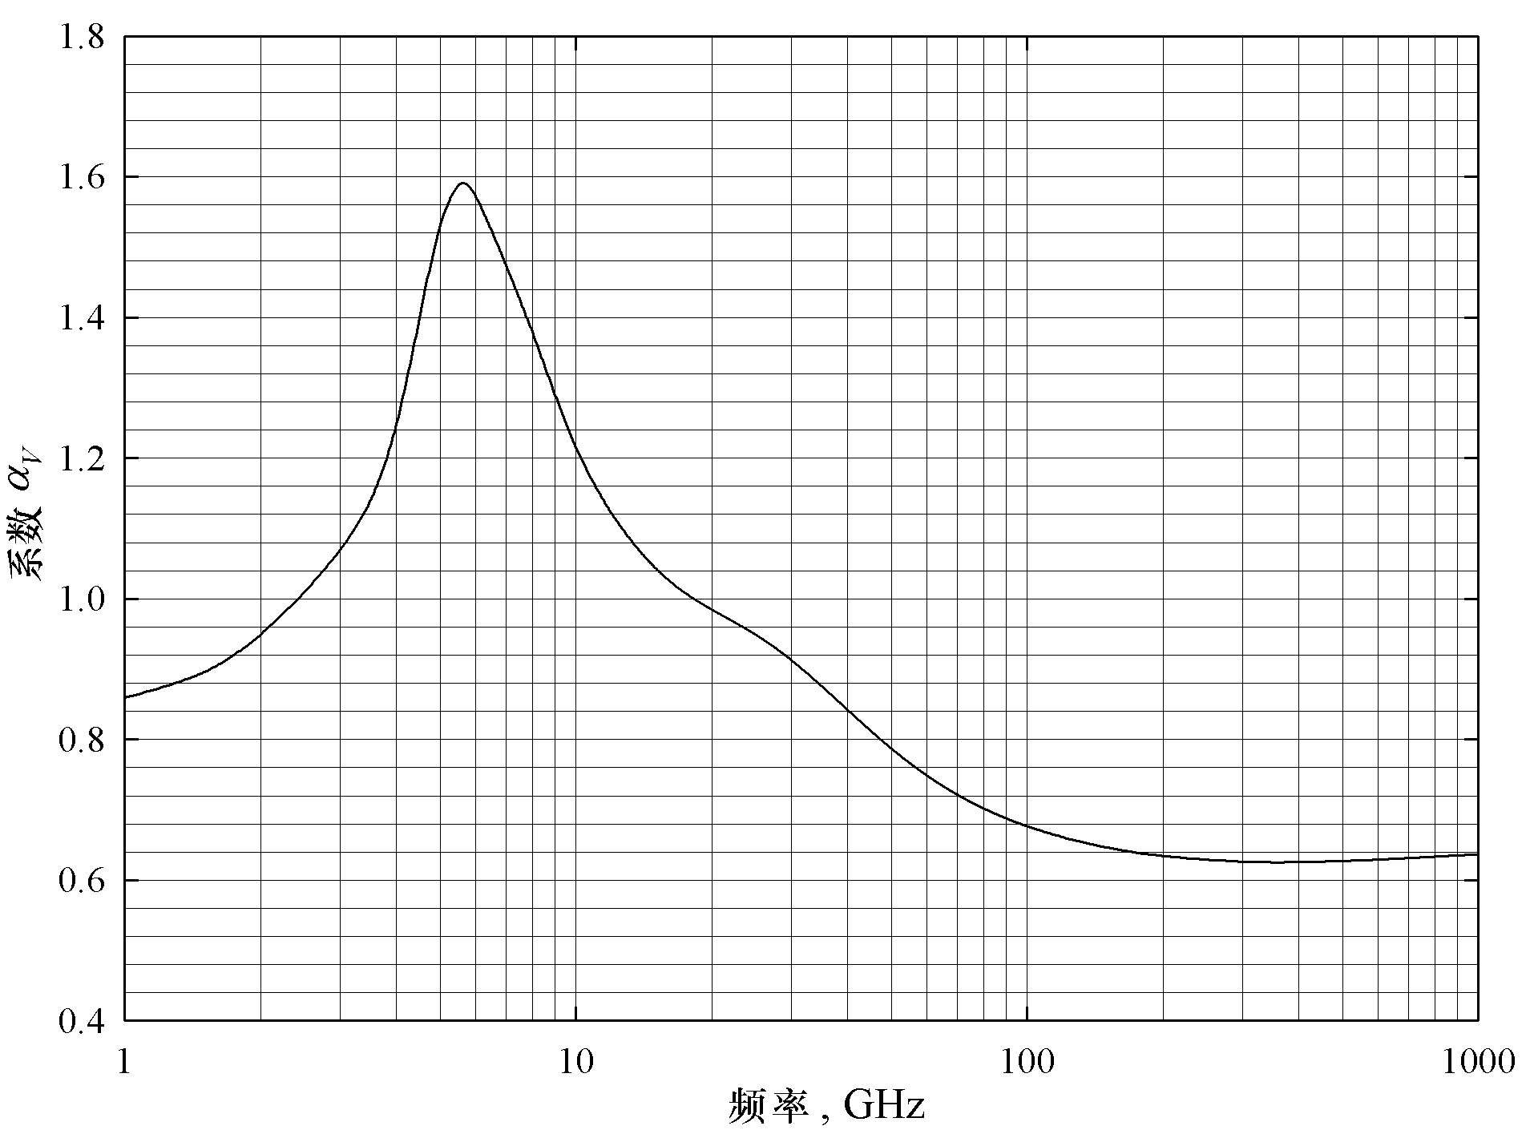

频率（GHz）

表 5  
使用等式 (4)、(5) 和 (1) 以及与频率相关的系数估算具体的雨天衰减

| 频率(GHz) | *kH* | *αH* | *kV* | *αV* |
| --- | --- | --- | --- | --- |
| 1 | 0.0000259 | 0.9691 | 0.0000308 | 0.8592 |
| 1.5 | 0.0000443 | 1.0185 | 0.0000574 | 0.8957 |
| 2 | 0.0000847 | 1.0664 | 0.0000998 | 0.9490 |
| 2.5 | 0.0001321 | 1.1209 | 0.0001464 | 1.0085 |
| 3 | 0.0001390 | 1.2322 | 0.0001942 | 1.0688 |
| 3.5 | 0.0001155 | 1.4189 | 0.0002346 | 1.1387 |
| 4 | 0.0001071 | 1.6009 | 0.0002461 | 1.2476 |
| 4.5 | 0.0001340 | 1.6948 | 0.0002347 | 1.3987 |
| 5 | 0.0002162 | 1.6969 | 0.0002428 | 1.5317 |
| 5.5 | 0.0003909 | 1.6499 | 0.0003115 | 1.5882 |
| 6 | 0.0007056 | 1.5900 | 0.0004878 | 1.5728 |
| 7 | 0.001915 | 1.4810 | 0.001425 | 1.4745 |
| 8 | 0.004115 | 1.3905 | 0.003450 | 1.3797 |
| 9 | 0.007535 | 1.3155 | 0.006691 | 1.2895 |
| 10 | 0.01217 | 1.2571 | 0.01129 | 1.2156 |
| 11 | 0.01772 | 1.2140 | 0.01731 | 1.1617 |
| 12 | 0.02386 | 1.1825 | 0.02455 | 1.1216 |
| 13 | 0.03041 | 1.1586 | 0.03266 | 1.0901 |
| 14 | 0.03738 | 1.1396 | 0.04126 | 1.0646 |
| 15 | 0.04481 | 1.1233 | 0.05008 | 1.0440 |
| 16 | 0.05282 | 1.1086 | 0.05899 | 1.0273 |
| 17 | 0.06146 | 1.0949 | 0.06797 | 1.0137 |
| 18 | 0.07078 | 1.0818 | 0.07708 | 1.0025 |
| 19 | 0.08084 | 1.0691 | 0.08642 | 0.9930 |
| 20 | 0.09164 | 1.0568 | 0.09611 | 0.9847 |
| 21 | 0.1032 | 1.0447 | 0.1063 | 0.9771 |
| 22 | 0.1155 | 1.0329 | 0.1170 | 0.9700 |
| 23 | 0.1286 | 1.0214 | 0.1284 | 0.9630 |
| 24 | 0.1425 | 1.0101 | 0.1404 | 0.9561 |
| 25 | 0.1571 | 0.9991 | 0.1533 | 0.9491 |
| 26 | 0.1724 | 0.9884 | 0.1669 | 0.9421 |
| 27 | 0.1884 | 0.9780 | 0.1813 | 0.9349 |
| 28 | 0.2051 | 0.9679 | 0.1964 | 0.9277 |
| 29 | 0.2224 | 0.9580 | 0.2124 | 0.9203 |
| 30 | 0.2403 | 0.9485 | 0.2291 | 0.9129 |
| 31 | 0.2588 | 0.9392 | 0.2465 | 0.9055 |
| 32 | 0.2778 | 0.9302 | 0.2646 | 0.8981 |
| 33 | 0.2972 | 0.9214 | 0.2833 | 0.8907 |
| 34 | 0.3171 | 0.9129 | 0.3026 | 0.8834 |
| 35 | 0.3374 | 0.9047 | 0.3224 | 0.8761 |
| 36 | 0.3580 | 0.8967 | 0.3427 | 0.8690 |
| 37 | 0.3789 | 0.8890 | 0.3633 | 0.8621 |
| 38 | 0.4001 | 0.8816 | 0.3844 | 0.8552 |
| 39 | 0.4215 | 0.8743 | 0.4058 | 0.8486 |
| 40 | 0.4431 | 0.8673 | 0.4274 | 0.8421 |
| 41 | 0.4647 | 0.8605 | 0.4492 | 0.8357 |
| 42 | 0.4865 | 0.8539 | 0.4712 | 0.8296 |
| 43 | 0.5084 | 0.8476 | 0.4932 | 0.8236 |
| 44 | 0.5302 | 0.8414 | 0.5153 | 0.8179 |
| 45 | 0.5521 | 0.8355 | 0.5375 | 0.8123 |
| 46 | 0.5738 | 0.8297 | 0.5596 | 0.8069 |
| 47 | 0.5956 | 0.8241 | 0.5817 | 0.8017 |
| 48 | 0.6172 | 0.8187 | 0.6037 | 0.7967 |
| 49 | 0.6386 | 0.8134 | 0.6255 | 0.7918 |
| 50 | 0.6600 | 0.8084 | 0.6472 | 0.7871 |
| 51 | 0.6811 | 0.8034 | 0.6687 | 0.7826 |
| 52 | 0.7020 | 0.7987 | 0.6901 | 0.7783 |
| 53 | 0.7228 | 0.7941 | 0.7112 | 0.7741 |
| 54 | 0.7433 | 0.7896 | 0.7321 | 0.7700 |
| 55 | 0.7635 | 0.7853 | 0.7527 | 0.7661 |
| 56 | 0.7835 | 0.7811 | 0.7730 | 0.7623 |
| 57 | 0.8032 | 0.7771 | 0.7931 | 0.7587 |
| 58 | 0.8226 | 0.7731 | 0.8129 | 0.7552 |
| 59 | 0.8418 | 0.7693 | 0.8324 | 0.7518 |
| 60 | 0.8606 | 0.7656 | 0.8515 | 0.7486 |
| 61 | 0.8791 | 0.7621 | 0.8704 | 0.7454 |
| 62 | 0.8974 | 0.7586 | 0.8889 | 0.7424 |
| 63 | 0.9153 | 0.7552 | 0.9071 | 0.7395 |
| 64 | 0.9328 | 0.7520 | 0.9250 | 0.7366 |
| 65 | 0.9501 | 0.7488 | 0.9425 | 0.7339 |
| 66 | 0.9670 | 0.7458 | 0.9598 | 0.7313 |
| 67 | 0.9836 | 0.7428 | 0.9767 | 0.7287 |
| 68 | 0.9999 | 0.7400 | 0.9932 | 0.7262 |
| 69 | 1.0159 | 0.7372 | 1.0094 | 0.7238 |
| 70 | 1.0315 | 0.7345 | 1.0253 | 0.7215 |
| 71 | 1.0468 | 0.7318 | 1.0409 | 0.7193 |
| 72 | 1.0618 | 0.7293 | 1.0561 | 0.7171 |
| 73 | 1.0764 | 0.7268 | 1.0711 | 0.7150 |
| 74 | 1.0908 | 0.7244 | 1.0857 | 0.7130 |
| 75 | 1.1048 | 0.7221 | 1.1000 | 0.7110 |
| 76 | 1.1185 | 0.7199 | 1.1139 | 0.7091 |
| 77 | 1.1320 | 0.7177 | 1.1276 | 0.7073 |
| 78 | 1.1451 | 0.7156 | 1.1410 | 0.7055 |
| 79 | 1.1579 | 0.7135 | 1.1541 | 0.7038 |
| 80 | 1.1704 | 0.7115 | 1.1668 | 0.7021 |
| 81 | 1.1827 | 0.7096 | 1.1793 | 0.7004 |
| 82 | 1.1946 | 0.7077 | 1.1915 | 0.6988 |
| 83 | 1.2063 | 0.7058 | 1.2034 | 0.6973 |
| 84 | 1.2177 | 0.7040 | 1.2151 | 0.6958 |
| 85 | 1.2289 | 0.7023 | 1.2265 | 0.6943 |
| 86 | 1.2398 | 0.7006 | 1.2376 | 0.6929 |
| 87 | 1.2504 | 0.6990 | 1.2484 | 0.6915 |
| 88 | 1.2607 | 0.6974 | 1.2590 | 0.6902 |
| 89 | 1.2708 | 0.6959 | 1.2694 | 0.6889 |
| 90 | 1.2807 | 0.6944 | 1.2795 | 0.6876 |
| 91 | 1.2903 | 0.6929 | 1.2893 | 0.6864 |
| 92 | 1.2997 | 0.6915 | 1.2989 | 0.6852 |
| 93 | 1.3089 | 0.6901 | 1.3083 | 0.6840 |
| 94 | 1.3179 | 0.6888 | 1.3175 | 0.6828 |
| 95 | 1.3266 | 0.6875 | 1.3265 | 0.6817 |
| 96 | 1.3351 | 0.6862 | 1.3352 | 0.6806 |
| 97 | 1.3434 | 0.6850 | 1.3437 | 0.6796 |
| 98 | 1.3515 | 0.6838 | 1.3520 | 0.6785 |
| 99 | 1.3594 | 0.6826 | 1.3601 | 0.6775 |
| 100 | 1.3671 | 0.6815 | 1.3680 | 0.6765 |
| 120 | 1.4866 | 0.6640 | 1.4911 | 0.6609 |
| 150 | 1.5823 | 0.6494 | 1.5896 | 0.6466 |
| 200 | 1.6378 | 0.6382 | 1.6443 | 0.6343 |
| 300 | 1.6286 | 0.6296 | 1.6286 | 0.6262 |
| 400 | 1.5860 | 0.6262 | 1.5820 | 0.6256 |
| 500 | 1.5418 | 0.6253 | 1.5366 | 0.6272 |
| 600 | 1.5013 | 0.6262 | 1.4967 | 0.6293 |
| 700 | 1.4654 | 0.6284 | 1.4622 | 0.6315 |
| 800 | 1.4335 | 0.6315 | 1.4321 | 0.6334 |
| 900 | 1.4050 | 0.6353 | 1.4056 | 0.6351 |
| 1 000 | 1.3795 | 0.6396 | 1.3822 | 0.6365 |