Recommendation ITU-R P.836-6
(12/2017)
Water vapour: surface density
and total columnar content

P Series
Radiowave propagation

Foreword
The role of the Radiocommunication Sector is to ensure the rational, equitable, efficient and economical use of the radio-frequency spectrum by all radiocommunication services, including satellite services, and carry out studies without limit of frequency range on the basis of which Recommendations are adopted.
The regulatory and policy functions of the Radiocommunication Sector are performed by World and Regional Radiocommunication Conferences and Radiocommunication Assemblies supported by Study Groups.

Policy on Intellectual Property Right (IPR)
ITU-R policy on IPR is described in the Common Patent Policy for ITU-T/ITU-R/ISO/IEC referenced in Annex 1 of Resolution ITU-R 1. Forms to be used for the submission of patent statements and licensing declarations by patent holders are available from http://www.itu.int/ITU-R/go/patents/en where the Guidelines for Implementation of the Common Patent Policy for ITU-T/ITU-R/ISO/IEC and the ITU-R patent information database can also be found.

Series of ITU-R Recommendations
(Also available online at http://www.itu.int/publ/R-REC/en)
Series | Title
BO | Satellite delivery
BR | Recording for production, archival and play-out; film for television
BS | Broadcasting service (sound)
BT | Broadcasting service (television)
F | Fixed service
M | Mobile, radiodetermination, amateur and related satellite services
P | Radiowave propagation
RA | Radio astronomy
RS | Remote sensing systems
S | Fixed-satellite service
SA | Space applications and meteorology
SF | Frequency sharing and coordination between fixed-satellite and fixed service systems
SM | Spectrum management
SNG | Satellite news gathering
TF | Time signals and frequency standards emissions
V | Vocabulary and related subjects

Note: This ITU-R Recommendation was approved in English under the procedure detailed in Resolution ITU-R 1.

Electronic Publication
Geneva, 2017

© ITU 2017
All rights reserved. No part of this publication may be reproduced, by any means whatsoever, without written permission of ITU.

RECOMMENDATION ITU-R P.836-6∗
Water vapour: surface density and total columnar content
(Question ITU-R 201/3)
(1992-1997-2001-2001-2009-2013-2017)
Scope
This Recommendation provides methods to predict the surface water vapour density and total columnar water vapour content on Earth-space paths.
The ITU Radiocommunication Assembly,
considering
a) that for the calculation of refractive effects and gaseous attenuation, information on the water vapour density of the atmosphere is needed;
b) that this information is available for all locations on the Earth and for all seasons,
recommends
that the information in Annexes 1 and 2 should be used for global calculations of propagation effects that require an estimate of surface water vapour density or total columnar content of water vapour and its seasonal variation, when more accurate local data are not available.

Annex 1

1 Surface water vapour density
Atmospheric water vapour and oxygen cause absorption at millimetre wavelengths especially in the proximity of absorption lines (see Recommendation ITU-R P.676). The concentration of atmospheric oxygen is relatively constant; however, the concentration of water vapour varies both geographically and with time.
The annual values of surface water vapour density, ρ, in g/m³, and corresponding water vapour scale height, vsch, in km, exceeded for 0.1, 0.2, 0.3, 0.5, 1, 2, 3, 5, 10, 20, 30, 50, 60, 70, 80, 90, 95, and 99% of an average year are an integral part of this Recommendation and are available in the form of digital maps provided in the Supplement file R-REC-P.836-6-201712-I!!ZIP-E.zip.
The monthly values of surface water vapour density, ρ, in g/m³, and corresponding water vapour scale height, vsch, in km, exceeded for 1, 2, 3, 5, 10, 20, 30, 50, 60, 70, 80, 90, 95, and 99% of an average month are an integral part of this Recommendation and are available in the form of digital maps provided in the Supplement file.
The surface water vapour density data is from 0° to 360° in longitude and from +90° to −90° in latitude, with a resolution of 1.125º in both latitude and longitude. The surface water vapour density at any desired location on the surface of the Earth can be derived by the following interpolation method (if local data for the height above mean sea level at the desired location is not available, the map in Recommendation ITU-R P.1511 can be used):
a) determine the two probabilities, p_{above} and p_{below}, above and below the desired probability, p, from the set: 0.1, 0.2, 0.3, 0.5, 1, 2, 3, 5, 10, 20, 30, 50, 60, 70, 80, 90, 95 and 99% for annual statistics and from the set: 1, 2, 3, 5, 10, 20, 30, 50, 60, 70, 80, 90, 95 and 99% for monthly statistics;
b) for the two probabilities, p_{above} and p_{below}, determine the surface water vapour densities, , , and at the four closest grid points;
c) using the annual or the monthly water vapour scale height data file corresponding to the probabilities p_{above} and p_{below}, determine the corresponding water vapour scale height at the four closest grid point, vsch₁, vsch₂, vsch₃ and vsch₄ for each probability, p_{above} and p_{below};
d) using the TOPO_0DOT5.txt topographic altitude digital map that is an integral part of this Recommendation and is provided in the Supplement file, determine the topographic altitudes, alt₁, alt₂, alt₃ and alt₄, at the four closest grid points using the bicubic interpolation method specified in Annex 1 of Recommendation ITU-R P.1144 (the TOPO_0DOT5 data is from -0.5° to 360.5° in longitude and from +90.5° to −90.5° in latitude, with a resolution of 0.5° in both latitude and longitude);
e) for each of the four closest grid points and each probability, determine the water vapour densities, ρ₁, ρ₂, ρ₃ and ρ₄, at the desired altitude, alt, by scaling the water vapour densities, , , and , using the following relation:

for i = 1, 2, 3, 4 (1)

f) determine the water vapour densities, ρ_{above} and ρ_{below}, at the probabilities p_{above} and p_{below} and at the desired location by performing a bi-linear interpolation of the four values of water vapour density, ρ₁, ρ₂, ρ₃ and ρ₄, at the four grid points as described in Recommendation ITU-R P.1144 (for reference the procedure to determine ρ_{above} and ρ_{below} from , , and is shown in Fig. 1);
g) determine the water vapour density, ρ, at the desired probability, p, by interpolating ρ_{above} and ρ_{below} vs. p_{above} and p_{below} to p on a linear ρ vs. log p scale.
For reference, the relationships between water vapour density, water vapour pressure and relative humidity are given in Recommendation ITU-R P.453.
FIGURE 1
Interpolation procedure at probabilities above and below the desired probability
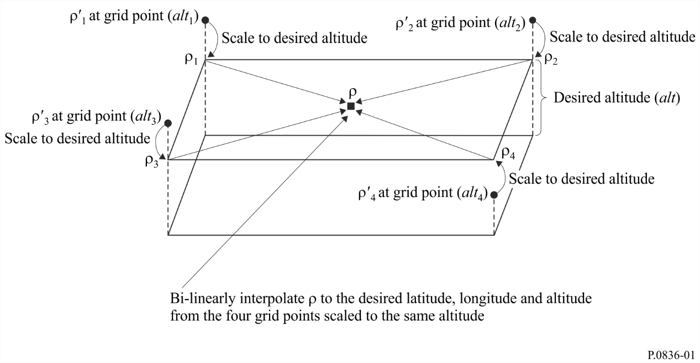

Annex 2

1 Total water vapour content
For some applications, the total water vapour content along a path can be used for the calculation of excess path length and for the attenuation due to atmospheric water vapour, where the attenuation due to atmospheric water vapour is assumed to be proportional to the total water vapour content through its specific mass absorption coefficient.
The total water vapour content, expressed in kg/m² or, equivalently, in mm of precipitable water, can be obtained from radiosonde soundings, navigation satellite measurements, and radiometric observations. Radiosonde data is widely available; however, it has limited time resolution and is only applicable to zenith paths. The total water vapour content can be retrieved from radiometric measurements at appropriate frequencies along the desired path.
The annual values of total columnar water vapour content, V, in kg/m² and corresponding water vapour scale height, vsch, in km, exceeded for 0.1, 0.2, 0.3, 0.5, 1, 2, 3, 5, 10, 20, 30, 50, 60, 70, 80, 90, 95 and 99% of the year are an integral part of this Recommendation and are available in the form of digital maps provided in the supplement file.
The monthly values of total columnar water vapour content, V, in kg/m² and corresponding water vapour scale height, vsch, in km, exceeded for 1, 2, 3, 5, 10, 20, 30, 50, 60, 70, 80, 90, 95, and 99% of each average month are an integral part of this Recommendation and are available in the form of digital maps provided in the supplement file.
The total water vapour content data is from 0° to 360° in longitude and from +90° to −90° in latitude, with a resolution of 1.125° in both latitude and longitude. The total water vapour content at any desired location on the surface of the Earth can be derived by the following interpolation method (if local data for the height above mean sea level at the desired location is not available, the map in Recommendation ITU-R P.1511 can be used):
a) determine the two probabilities, p_{above} and p_{below}, above and below the desired probability, p, from the set: 0.1, 0.2, 0.3, 0.5, 1, 2, 3, 5, 10, 20, 30, 50, 60, 70, 80, 90, 95 and 99% for annual statistics and from the set: 1, 2, 3, 5, 10, 20, 30, 50, 60, 70, 80, 90, 95 and 99% for monthly statistics;
b) for the two probabilities, p_{above} and p_{below}, determine the total columnar water vapour content, , , and at the four closest grid points;
c) using the annual or the monthly water vapour scale height corresponding to the probabilities p_{above} and p_{below}, determine the corresponding water vapour scale height at the four closest grid points, vsch₁, vsch₂, vsch₃, and vsch₄ for each probability, p_{above} and p_{below};
d) using the TOPO_0DOT5.txt topographic altitude digital map that is an integral part of this Recommendation and is provided in the Supplement file, determine the topographic altitudes, alt₁, alt₂, alt₃, and alt₄, at the four closest grid points using the bicubic interpolation method specified in Annex 1 of Recommendation ITU-R P.1144 (the TOPO_0DOT5 data is from -0.5° to 360.5° in longitude and from +90.5° to −90.5° in latitude, with a resolution of 0.5° in both latitude and longitude);
e) for each of the four closest grid points and each probability, determine the total columnar water vapour content, V₁, V₂, V₃ and V₄, at the desired altitude, alt, by scaling the total columnar water vapour content, , , and , using the following relation:

for i = 1, 2, 3, 4 (2)
f) determine the total columnar water vapour content, V_{above} and V_{below}, at the probabilities p_{above} and p_{below} and at the desired location by performing a bi-linear interpolation of the four values of total columnar water vapour content, V₁, V₂, V₃ and V₄, at the four grid points as described in Recommendation ITU-R P.1144 (for reference the procedure to determine V_{above} and V_{below} from , , and is shown in Fig. 2);
g) determine the total columnar water vapour content, V, at the desired probability, p, by interpolating V_{above} and V_{below} vs. p_{above} and p_{below} to p on a linear V vs. log p scale.
FIGURE 2
Interpolation procedure at probabilities above and below the desired probability
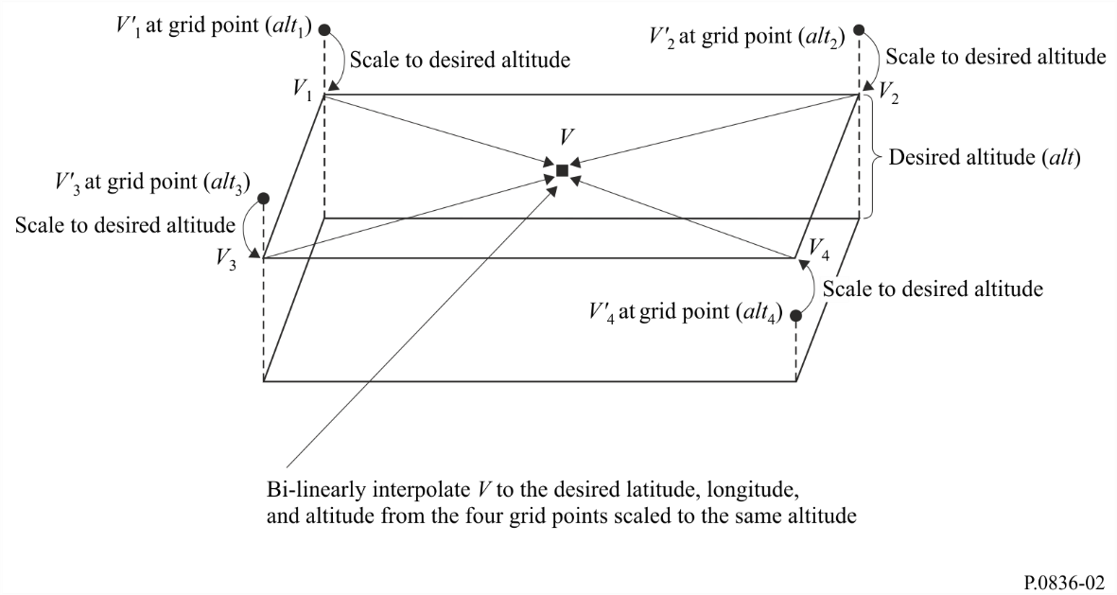

∗ Radiocommunication Study Group 3 made editorial amendments to this Recommendation in the year 2021 in accordance with Resolution ITU-R 1.
The units of alt, alt_{i}, and vsch_{i} must be identical (e.g. either km or m).
The units of alt, alt_{i}, and vsch_{i} must be identical (e.g. either km or m).

