Recommendation ITU-R P.835-7
(08/2024)
P Series: Radiowave propagation
Reference atmospheres

Foreword
The role of the Radiocommunication Sector is to ensure the rational, equitable, efficient and economical use of the radio-frequency spectrum by all radiocommunication services, including satellite services, and carry out studies without limit of frequency range on the basis of which Recommendations are adopted.
The regulatory and policy functions of the Radiocommunication Sector are performed by World and Regional Radiocommunication Conferences and Radiocommunication Assemblies supported by Study Groups.

Policy on Intellectual Property Right (IPR)
ITU-R policy on IPR is described in the Common Patent Policy for ITU-T/ITU-R/ISO/IEC referenced in Resolution ITU-R 1. Forms to be used for the submission of patent statements and licensing declarations by patent holders are available from http://www.itu.int/ITU-R/go/patents/en where the Guidelines for Implementation of the Common Patent Policy for ITU-T/ITU-R/ISO/IEC and the ITU-R patent information database can also be found.

Series of ITU-R Recommendations
(Also available online at https://www.itu.int/publ/R-REC/en)
Series | Title
BO | Satellite delivery
BR | Recording for production, archival and play-out; film for television
BS | Broadcasting service (sound)
BT | Broadcasting service (television)
F | Fixed service
M | Mobile, radiodetermination, amateur and related satellite services
P | Radiowave propagation
RA | Radio astronomy
RS | Remote sensing systems
S | Fixed-satellite service
SA | Space applications and meteorology
SF | Frequency sharing and coordination between fixed-satellite and fixed service systems
SM | Spectrum management
SNG | Satellite news gathering
TF | Time signals and frequency standards emissions
V | Vocabulary and related subjects

Note: This ITU-R Recommendation was approved in English under the procedure detailed in Resolution ITU-R 1.

Electronic Publication
Geneva, 2024

© ITU 2024
All rights reserved. No part of this publication may be reproduced, by any means whatsoever, without written permission of ITU.

RECOMMENDATION ITU-R P.835-7
Reference atmospheres
(Question ITU-R 214/3)
(1992-1994-1997-1999-2005-2012-2017-2024)
Scope
Recommendation ITU-R P.835 provides reference atmospheres for the calculation of gaseous attenuation and related effects on terrestrial and Earth-space paths.
Keywords
Total pressure, barometric pressure, temperature, water vapour density
Acronyms/Abbreviations
ASCII American Standard Code for Information Interchange
ECMWF European Centre for Medium-Range Weather Forecasts
ERA5 ECMWF Fifth Generation Reanalysis Product
a.m.s.l. above mean sea level
Related ITU-R Recommendations and Handbook
Handbook on Radiometeorology (Edition 2013)
Recommendation ITU-R P.528
Recommendation ITU-R P.530
Recommendation ITU-R P.618
Recommendation ITU-R P.619
Recommendation ITU-R P.676
Recommendation ITU-R P.836
Recommendation ITU-R P.1144
Recommendation ITU-R P.1510
Recommendation ITU-R P.1511
Recommendation ITU-R P.1853
Recommendation ITU-R P.2001
Recommendation ITU-R P.2041
Recommendation ITU-R P.2145
NOTE – The latest revision/edition of the Recommendation/Handbook should be used.
List of symbols
$H$ geopotential height above mean sea level
$Z$ geometric height above mean sea level
$P$ total (barometric) pressure
$T$ temperature
$ρ$ water vapour density
$e$ water vapour partial pressure
The ITU Radiocommunication Assembly,
considering
a) that reference atmospheres for calculating various atmospheric propagation parameters on terrestrial and Earth-space paths are needed;
b) that numerical weather prediction systems provide average annual and monthly vertical profiles of atmospheric parameters, within their temporal and spatial resolutions,
recommends
1 that the ITU-R reference atmosphere in Annex 1 should be used to determine temperature, total (barometric) pressure, and water-vapour density vs. geometric height when a single global vertical profile of atmospheric parameters is needed;
2 that the seasonal reference atmospheres in Annex 2 should be used to determine temperature, total (barometric) pressure and water vapour density vs. geometric height when average seasonal data as a function of latitude are needed;
3 that the average global profiles of temperature, total (barometric) pressure, and water vapour density vs. geometric height in Annex 3, which were derived from numerical weather forecasts, should be used when reference data for a specific location are needed.

Annex 1

1 ITU-R reference atmosphere
The following ITU-R reference atmosphere provides simple reference total (barometric) pressure, temperature, and water vapour density profiles vs. geometric height from mean sea level to 100 km above mean sea level.

1.1 Temperature and pressure
The total (barometric) pressure and temperature for the ITU-R reference atmosphere is derived from the U.S. Standard Atmosphere, 1976. The U.S. Standard Atmosphere, 1976 is an idealized steady-state hypothetical vertical distribution of atmospheric temperature and total (barometric) pressure, which is roughly representative of year-round, mid-latitude conditions. The atmospheric temperature and pressure profiles are defined in two height regimes: 1) geopotential heights ($H)$from 0 km$'$ to 84.852 km$'$, and 2) geometric heights $(Z)$ from 86 km to 100 km. The conversions between geopotential height, $H$ (km), and geometric height, $Z$ (km), adopted by the U.S. Standard Atmosphere, 1976, are:
$H=\frac{6 356.766Z}{6 356.766+Z}$ (1a)
and
$Z=\frac{6 356.766H}{6 356.766-H}$ (1b)
where a geopotential height of 84.852 km$'$ corresponds to a geometric height of 86 km. Since various P-series Recommendations (e.g. Recommendation ITU-R P.676 Annex 1) use geometric height, the temperature and pressure at a geometric height $Z$ < 86 km can be calculated by converting geometric height, $Z,$ to the corresponding geopotential height, $H,$ and calculating the temperature and pressure at the corresponding geopotential height, $H$.
In the first height regime, the temperature T (K) at geopotential height $H$ (km$'$) is:
T($H$) = 288.15 – 6.5 $H$ for 0 ≤ $H$ < 11 (2a)
T($H$) = 216.65 for 11 < $H$ < 20 (2b)
T($H$) = 216.65 + ($H$−20) for 20 < $H$ < 32 (2c)
T($H$) = 228.65 + 2.8 ($H$−32) for 32 < $H$ < 47 (2d)
T($H$) = 270.65 for 47 < $H$ < 51 (2e)
T($H$) = 270.65 – 2.8 ($H$−51) for 51 < $H$ < 71 (2f)
T($H$) = 214.65 – 2.0 ($H$−71) for 71 < $H$ ≤ 84.852 (2g)
and the pressure P (hPa) at geopotential height $H$ (km$'$) is:
P($H$) =$1 013.25 {\left[\frac{288.15}{288.15-6.5 H}\right]}^{-34.1632/6.5}$ for 0 < $H$ < 11 (3a)
P($H$) =$226.3226 exp\left[-34.1632 (H-11)/216.65\right]$ for 11 < $H$ ≤ 20 (3b)
P($H$) = $54.74980 {\left[\frac{216.65}{216.65+ (H-20)}\right]}^{34.1632}$ for 20 < $H$ ≤ 32 (3c)
P($H$) = $8.680422 {\left[\frac{228.65}{228.65+2.8 (H-32)}\right]}^{34.1632/2.8}$ for 32 < $H$ ≤ 47 (3d)
P($H$) =$1.109106 exp\left[-34.1632 (H-47)/270.65\right]$ for 47 < $H$ ≤ 51 (3e)
P($H$) = $0.6694167 {\left[\frac{270.65}{270.65-2.8 (H-51)}\right]}^{-34.1632/2.8}$ for 51 <$H$ ≤ 71 (3f)
P($H$) = $0.03956649 {\left[\frac{214.65}{214.65-2.0 (H-71)}\right]}^{-34.1632/2.0}$ for 71 < $H$ ≤ 84.852 (3g)
In the second height regime, the temperature T (K) at geometric height Z (km) is:
T(Z) = 186.8673 for 86 < Z < 91 (4a)
T(Z) = $263.1905-76.3232 {\left[1-{\left(\frac{Z-91}{19.9429}\right)}^{2}\right]}^{\frac{1}{2}}$ for 91 < Z < 100 (4b)
and the pressure P (hPa) at geometric height Z (km) is:
P(Z) = $exp⁡(a_{0}+a_{1}Z+a_{2}Z^{2}+a_{3}Z^{3}+a_{4}Z^{4})$ for 86 ≤ Z ≤ 100 (5)
where:
$$a_{0}= 95.571 899$$
$a_{1}=-4.011 801$
$$a_{2}= 6.424 731 ×{10}^{-2}$$
$$a_{3}=-4.789 660 ×{10}^{-4}$$
$$a_{4}= 1.340 543 ×{10}^{-6}$$
For reference, the temperature and pressure vs. geometric height are shown in Figs 1 and 2, respectively.
FIGURE 1
Temperature vs. geometric height
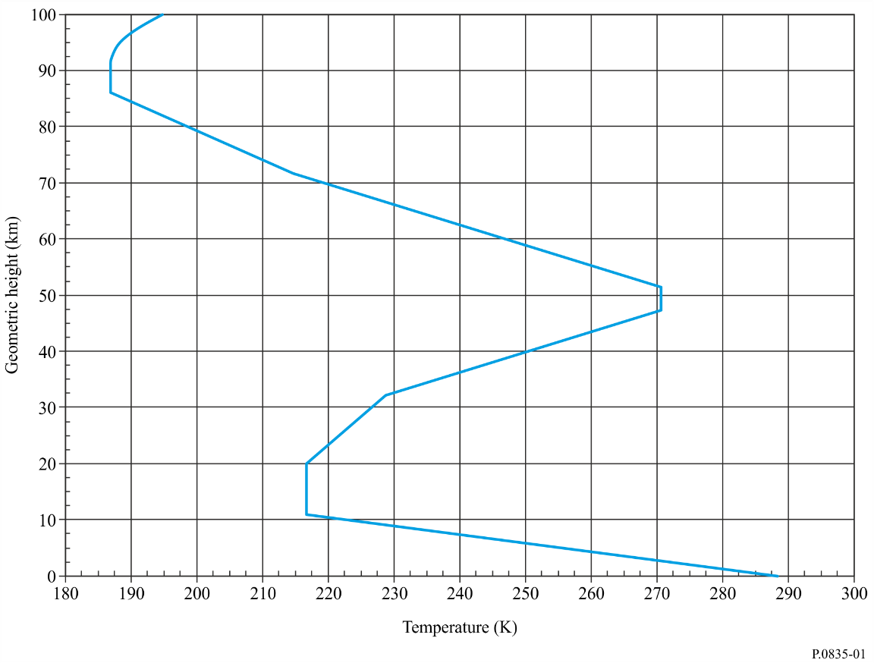
FIGURE 2
Total pressure vs. geometric height
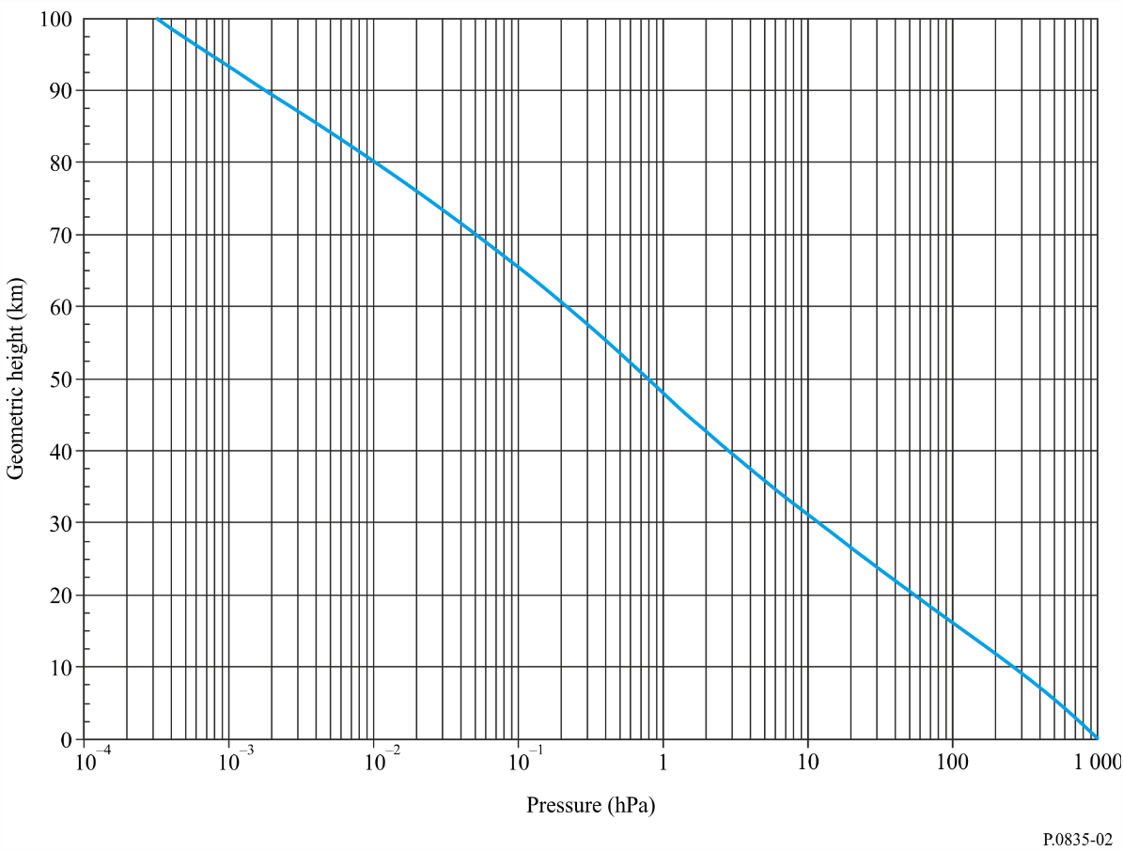

1.2 Water-vapour density
In the absence of reliable local data, the atmospheric water vapour density, $ρ$, vs. geometric height may be approximated by the following negative exponential profile:
$ρ\left(Z\right)=7.5 exp\left({-Z}/2\right)$ g/m³ (6)
which decreases exponentially with increasing geometric height, up to a geometric height where the mixing ratio e (Z)/P(Z) = 2 × 10⁻⁶, and the water vapour partial pressure, $e(Z)$, is:
$e\left(Z\right)=\frac{ρ\left(Z\right)T\left(Z\right)}{216.7}$ (7)
The water vapour density above this geometric height is then:
$ρ\left(Z\right)=2 ×{10}^{-6} \frac{P\left(Z\right) 216.7}{T(Z)}$ g/m³ (8)

Annex 2

1 Seasonal reference atmospheres
The following sections provide simple seasonal reference atmospheres for low (15° N), mid (45° N), and high (60° N) northern hemisphere latitude regimes. The low-latitude reference atmosphere is defined for all four seasons; and the mid-latitude and high-latitude reference atmospheres are defined for summer and winter.
The reference profiles for other latitudes can be derived as follows:
• For 0° N ≤ latitude ≤ 15° N and all seasons, the low-latitude annual reference atmosphere should be used.
• For 15° N < latitude < 45° N and summer and winter, the reference atmosphere should be obtained by linearly interpolating the low-latitude annual reference atmosphere and the appropriate mid-latitude seasonal reference atmosphere to the latitude of interest.
• For 45° N ≤ latitude < 60° N and summer and winter, the reference atmosphere should be obtained by linearly interpolating the appropriate seasonal mid-latitude and high-latitude reference atmospheres.
• For latitude ≥ 60° N and summer and winter, the appropriate seasonal high-latitude reference atmosphere should be used.
While these seasonal reference atmospheres were specifically derived for northern hemisphere latitudes, they may also be applicable to the corresponding southern hemisphere latitudes.

1.1 Low-latitude annual reference atmosphere
For low latitude (15° N), the following profiles may be used for all four seasons.
The temperature T (K) at geometric height Z (km) is given by:
T(Z) = 300.4222 – 6.3533 Z + 0.005 886 Z² for 0 ≤ Z < 17 (9a)
T(Z) = 194 + 2.533 (Z – 17) for 17 ≤ Z < 47 (9b)
T(Z) = 270 for 47 ≤ Z < 52 (9c)
T(Z) = 270 – 3.0714 (Z – 52) for 52 ≤ Z < 80 (9d)
T(Z) = 184 for 80 ≤ Z ≤ 100 (9e)
and the total (barometric) pressure P (hPa) at geometric height Z (km) is given by:
P(Z) = 1012.0306 – 109.0338 Z + 3.6316 Z² for 0 ≤ Z ≤ 10 (10a)
P(Z) = P₁₀ exp[–0.147 (Z – 10)] for 10 < Z ≤ 72 (10b)
P(Z) = P₇₂ exp[–0.165 (Z– 72)] for 72 < Z ≤ 100 (10c)
where P₁₀ and P₇₂ are the total pressures at 10 and 72 km, respectively.
The water vapour density $ρ$ (g/m³) at geometric height Z (km) is given by:
$ρ\left(Z\right)=19.6542 exp\left[-0.2313 Z-0.1122 Z^{2}+0.01351 Z^{3}-0.0005923 Z^{4}\right]$
for 0 ≤ Z ≤ 15 (11a)
$ρ\left(Z\right)=0$ for Z > 15 (11b)

1.2 Mid-latitude reference atmosphere
For mid-latitude (45° Ν) the following profiles may be used for the summer and winter.

1.2.1 Summer mid-latitude
The temperature T (K) at geometric height Z (km) is given by:
T(Z) = 294.9838 – 5.2159 Z – 0.07109 Z² for 0 ≤ Z < 13 (12a)
T(Z) = 215.15 for 13 ≤ Z < 17 (12b)
T(Z) = 215.15 exp[0.008128 (Z – 17)] for 17 ≤ Z < 47 (12c)
T(Z) = 275 for 47 ≤ Z < 53 (12d)
T(Z) = 275 + 111.57755{1 – exp [0.0237 (Z – 53)]} for 53 ≤ Z < 80 (12e)
T(Z) = 175 for 80 ≤ Z ≤ 100 (12f)
and the total (barometric) pressure P (hPa) at geometric height Z (km) is given by:
P(Z) = 1012.8186 – 111.5569 Z + 3.8646 Z² for 0 ≤ Z ≤ 10 (13a)
P(Z) = P₁₀ exp[− 0.147 (Z – 10)] for 10 < Z ≤ 72 (13b)
P(Z) = P₇₂ exp[−0.165 (Z – 72)] for 72 < Z ≤ 100 (13c)
where P₁₀ and P₇₂ are the total pressures at 10 and 72 km, respectively.
The water vapour density $ρ$ (g/m³) at geometric height Z (km) is given by:
$ρ$(Z) = 14.3542 exp[– 0.4174 Z – 0.02290 Z² + 0.001007 Z³] for 0 ≤ Z ≤ 15 (14a)
$ρ$(Z) = 0 for Z > 15 (14b)

1.2.2 Winter mid-latitude
The temperature T (K) at geometric height Z (km) is given by:
T(Z) = 272.7241 – 3.6217 Z – 0.1759 Z² for 0 ≤ Z < 10 (15a)
T(Z) = 218 for 10 ≤ Z < 33 (15b)
T(Z) = 218 + 3.3571 (Z – 33) for 33 ≤ Z < 47 (15c)
T(Z) = 265 for 47 ≤ Z < 53 (15d)
T(Z) = 265 – 2.0370 (Z – 53) for 53 ≤ Z < 80 (15e)
T(Z) = 210 for 80 ≤ Z ≤ 100 (15f)
and the total (barometric) pressure P (hPa) at geometric height Z (km) is given by:
P(Z) = 1018.8627 – 124.2954 Z + 4.8307 Z² for 0 ≤ Z ≤ 10 (16a)
P(Z) = P₁₀ exp[– 0.147 (Z – 10)] for 10 < Z ≤ 72 (16b)
P(Z) = P₇₂ exp[– 0.155 (Z – 72)] for 72 < Z ≤ 100 (16c)
where P₁₀ and P₇₂ are the total pressures at 10 and 72 km, respectively.
The water vapour density $ρ$ (g/m³) at geometric height Z (km) is given by:
$ρ$(Z) = 3.4742 exp[– 0.2697 Z – 0.03604 Z² + 0.0004489 Z³] for 0 ≤ Z ≤ 10 (17a)
$ρ$(Z) = 0 for Z > 10 (17b)

1.3 High latitude reference atmosphere
For high latitude (60° Ν) the following profiles may be used for the summer and winter.

1.3.1 Summer high latitude
The temperature T (K) at geometric height Z (km) is given by:
T(Z) = 286.8374 – 4.7805 Z – 0.1402 Z² for 0 ≤ Z < 10 (18a)
T(Z) = 225 for 10 ≤ Z < 23 (18b)
T(Z) = 225 exp[0.008317 (Z – 23)] for 23 ≤ Z < 48 (18c)
T(Z) = 277 for 48 ≤ Z < 53 (18d)
T(Z) = 277 – 4.0769 (Z – 53) for 53 ≤ Z < 79 (18e)
T(Z) = 171 for 79 ≤ Z ≤ 100 (18f)
and the total (barometric) pressure P (hPa) at geometric height Z (km) is given by:
P(Z) = 1008.0278 – 113.2494 Z + 3.9408 Z² for 0 ≤ Z ≤ 10 (19a)
P(Z) = P₁₀ exp[–0.140 (Z – 10)] for 10 < Z ≤ 72 (19b)
P(Z) = P₇₂ exp[–0.165 (Z – 72)] for 72 < Z ≤ 100 (19c)
where P₁₀ and P₇₂ are the total pressures at 10 and 72 km, respectively.
The water vapour density $ρ$ (g/m³) at geometric height Z (km) is given by:
$ρ$(Z) = 8.988 exp[– 0.3614 Z – 0.005402 Z²– 0.001955 Z³] for 0 ≤ Z ≤ 15 (20a)
$ρ$(Z) = 0 for Z > 15 (20b)

1.3.2 Winter high latitude
The temperature T (K) at geometric height Z (km) is given by:
T(Z) = 257.4345 + 2.3474 Z – 1.5479 Z² + 0.08473 Z³ for 0 ≤ Z < 8.5 (21a)
T(Z) = 217.5 for 8.5 ≤ Z < 30 (21b)
T(Z) = 217.5 + 2.125 (Z – 30) for 30 ≤ Z < 50 (21c)
T(Z) = 260 for 50 ≤ Z < 54 (21d)
T(Z) = 260 – 1.667 (Z – 54) for 54 ≤ Z ≤ 100 (21e)
and the total (barometric) pressure P (hPa) at geometric height Z (km) is given by:
P(Z) = 1010.8828 – 122.2411 Z + 4.554 Z² for 0 ≤ Z ≤ 10 (22a)
P(Z) = P₁₀ exp[–0.147 (Z – 10)] for 10 < Z ≤ 72 (22b)
P(Z) = P₇₂ exp[–0.150 (Z – 72)] for 72 < Z ≤ 100 (22c)
where P₁₀ and P₇₂ are the total pressures at 10 and 72 km, respectively.
The water vapour density $ρ$ (g/m³) at geometric height Z (km) is given by:
$ρ$(Z) = 1.2319 exp[0.07481 Z – 0.0981 Z² + 0.00281 Z³] for 0 ≤ Z ≤ 10 (23a)
$ρ$(Z) = 0 for Z > 10 (23b)

Annex 3

1 Global mean annual and mean monthly vertical profiles
This Annex contains mean annual and mean monthly vertical profiles of total (barometric) pressure, temperature and water vapour density at 138 altitude levels above mean sea level derived by averaging 30 years (1991-2020) of ECMWF ERA5 model level data.
These vertical profiles are integral part of this Recommendation, and are available in the form of digital maps provided as Parts 1 to 12 corresponding to each month of the year and Part 13 corresponding to the annual period. Each Part contains a zip file with four map files, P.bin, T.bin, WV.bin, and Z.bin for the applicable period. P.bin contains the pressure profiles, T.bin contains the temperature profiles, WV.bin contains the water vapour density profiles, and Z.bin contains the profiles of geometric altitude above mean sea level. The characteristics of each map file are shown in Table 1.
TABLE 1
Map file characteristics
Parameter | Value
Format | IEEE 754
Byte ordering | Little endian
Precision | Single (4 bytes/value)
Total number of bytes | 573 506 472
Latitude range | −90° N to 90°N
Latitude increment | +0.25°
Longitude range | −180° E to 180° E
Longitude increment | +0.25°
Number of latitude grid points | 721
Number of longitude grid points | 1 441
Number of altitude levels | 138
Total pressure units | hPa
Temperature units | K
Water vapour density units | g/m³
Altitude units | km, a.m.s.l.

Each parameter is stored as a 3-dimensional matrix parameter(ilevel, ilat, ilon), where, assuming indexing starts at 1, $ilevel=1, 2,…, 138;ilat=1, 2, …, 721;and ilon=1, 2,…, 1 441.$ The first byte of the four bytes corresponding to the value of total (barometric) pressure ($P)$, temperature ($T$), water vapour density (WV), or geometric altitude above mean sea level (Z) at any grid point $(Latitude_degN$, $Longitude_degE$) and altitude level ($ilevel)$ is byte number $ipos$, where $ipos$ ranges from $ipos=1$ to $ipos=573 506 469$.
$ipos=\left\{ilevel-1+\left(ilat-1\right)×138+(ilon-1)×138×721\right\}×4+1$ (24)
where:
$ilat=(Latitude_degN+90)/0.25+1$ (25)
$ilon=(Longitude_degE+180)/0.25+1$ (26)
$ilevel=(1, 2, 3, … , 138)$ (27)
There are 138 pressure, temperature, and water vapour density levels at each grid point, where $P\left(ilevel,ilat,ilon\right), T\left(ilevel,ilat,ilon\right),$ and $WV(ilevel,ilat,ilon)$ are the values of total pressure, temperature, and water vapour density at altitude above mean sea level, $Z(ilevel,ilat,ilon)$. $Z(138,ilat,ilon)$ is the ERA5 altitude of the surface of the Earth above mean sea level, and $Z(1,ilat,ilon)$ is the maximum altitude above mean sea level at the associated grid point. $Z(138,ilat,ilon)$ may be different than the topographic altitude in Recommendation ITU-R P.1511, which was determined by a combination of high-resolution satellite radar altimetry augmented by local altimetry data.

km$'$ are units of geopotential height, and km are units of geometric height.
The ERA5 geometric altitude of the surface of the Earth above mean sea level was obtained by dividing the ERA5 gravitational potential energy of a unit mass at the surface of the Earth (m²/s²) by the gravitational acceleration (9.80665 m/s²) and converting the resulting geopotential altitude of the surface of the Earth to a geometric altitude of the surface of the Earth.

