Recommendation ITU-R P.835-6
(12/2017)
Reference standard atmospheres

P Series
Radiowave propagation

Foreword
The role of the Radiocommunication Sector is to ensure the rational, equitable, efficient and economical use of the radio-frequency spectrum by all radiocommunication services, including satellite services, and carry out studies without limit of frequency range on the basis of which Recommendations are adopted.
The regulatory and policy functions of the Radiocommunication Sector are performed by World and Regional Radiocommunication Conferences and Radiocommunication Assemblies supported by Study Groups.

Policy on Intellectual Property Right (IPR)
ITU-R policy on IPR is described in the Common Patent Policy for ITU-T/ITU-R/ISO/IEC referenced in Annex 1 of Resolution ITU-R 1. Forms to be used for the submission of patent statements and licensing declarations by patent holders are available from http://www.itu.int/ITU-R/go/patents/en where the Guidelines for Implementation of the Common Patent Policy for ITU-T/ITU-R/ISO/IEC and the ITU-R patent information database can also be found.

Series of ITU-R Recommendations
(Also available online at http://www.itu.int/publ/R-REC/en)
Series | Title
BO | Satellite delivery
BR | Recording for production, archival and play-out; film for television
BS | Broadcasting service (sound)
BT | Broadcasting service (television)
F | Fixed service
M | Mobile, radiodetermination, amateur and related satellite services
P | Radiowave propagation
RA | Radio astronomy
RS | Remote sensing systems
S | Fixed-satellite service
SA | Space applications and meteorology
SF | Frequency sharing and coordination between fixed-satellite and fixed service systems
SM | Spectrum management
SNG | Satellite news gathering
TF | Time signals and frequency standards emissions
V | Vocabulary and related subjects

Note: This ITU-R Recommendation was approved in English under the procedure detailed in Resolution ITU-R 1.

Electronic Publication
Geneva, 2017

© ITU 2017
All rights reserved. No part of this publication may be reproduced, by any means whatsoever, without written permission of ITU.

RECOMMENDATION ITU-R P.835-6∗
Reference standard atmospheres
(Question ITU-R 201/3)
(1992-1994-1997-1999-2005-2012-2017)
Scope
Recommendation ITU-R P.835 provides expressions and data for reference standard atmospheres required for the calculation of gaseous attenuation on Earth-space paths.
The ITU Radiocommunication Assembly,
considering
a) the necessity for a reference standard atmosphere for use in calculating gaseous attenuation along an Earth-space path,
recommends
1 that the standard atmospheres in Annex 1 be used to determine temperature, pressure and water-vapour pressure as a function of altitude, for calculating gaseous attenuation when more reliable local data are not available;
2 that the experimental data in Annexes 2 and 3 be used for the locations of interest when seasonal and monthly variations are concerned.

Annex 1

1 Mean annual global reference atmosphere
The following mean annual global reference atmosphere reflects the mean annual temperature and pressure profiles vs. height when averaged across the globe.

1.1 Temperature and pressure
The mean annual global reference atmosphere approximates the U.S. Standard Atmosphere, 1976 with insignificant relative error. The atmospheric temperature and pressure profiles are defined in two height regimes: 1) geopotential heights from 0 km$'$ to 84.852 km$'$, and 2) geometric heights from 86 km to 100 km. The conversions between geopotential height, h$'$ (km), and geometric height, h (km), are:
$h^{'}=\frac{6356.766h}{6356.766+h}$ (1a)
and
$h=\frac{6356.766h^{'}}{6356.766-h^{'}}$ (1b)
where a geopotential height of 84.852 km$'$ corresponds to a geometric height of 86 km. Since various P-series Recommendations (e.g. Recommendation ITU-R P.676 Annex 1) use geometric height, the temperature and pressure at a geometric height h < 86 km can be calculated by converting geometric height h to the corresponding geopotential height $h'$ and calculating the temperature and pressure at the corresponding geopotential height $h'$.
In the first height regime, the temperature T (K) at geopotential height $h'$ (km$'$) is:
T($h'$) = 288.15 − 6.5 $h'$ for 0 ≤ $h'$< 11 (2a)
T($h'$) = 216.65 for 11 < $h'$ < 20 (2b)
T($h'$) = 216.65 + ($h'$−20) for 20 < $h'$ < 32 (2c)
T($h'$) = 228.65 + 2.8 ($h'$−32) for 32 < $h'$ < 47 (2d)
T($h'$) = 270.65 for 47 < $h'$ < 51 (2e)
T($h'$) = 270.65 – 2.8 ($h'$−51) for 51 < $h'$ < 71 (2f)
T($h'$) = 214.65 – 2.0 ($h'$−71) for 71 < $h'$ ≤ 84.852 (2g)
and the pressure P (hPa) at geopotential height $h'$ (km$'$) is:
P($h'$) =$1013.25 {\left[\frac{288.15}{288.15-6.5 h^{'}}\right]}^{-34.1632/6.5}$ for 0 < $h'$ < 11 (3a)
P($h'$) =$226.3226 exp\left[-34.1632 (h'-11)/216.65\right]$ for 11 < $h'$ ≤ 20 (3b)
P($h'$) = $54.74980 {\left[\frac{216.65}{216.65+ (h^{'}-20)}\right]}^{34.1632}$ for 20 < $h'$ ≤ 32 (3c)
P($h'$) = $8.680422 {\left[\frac{228.65}{228.65+2.8 (h^{'}-32)}\right]}^{34.1632/2.8}$ for 32 < $h'$ ≤ 47 (3d)
P($h'$) =$1.109106 exp\left[-34.1632 (h'-47)/270.65\right]$ for 47 < $h^{'}$ ≤ 51 (3e)
P($h'$) = $0.6694167 {\left[\frac{270.65}{270.65-2.8 (h^{'}-51)}\right]}^{-34.1632/2.8}$ for 51 <$h'$ ≤ 71 (3f)
P($h'$) = $0.03956649 {\left[\frac{214.65}{214.65-2.0 (h^{'}-71)}\right]}^{-34.1632/2.0}$ for 71 < $h'$ ≤ 84.852 (3g)
In the second height regime, the temperature T (K) at geometric height h (km) is:
T(h) = 186.8673 for 86 < h < 91 (4a)
T(h) = $263.1905-76.3232 {\left[1-{\left(\frac{h-91}{19.9429}\right)}^{2}\right]}^{\frac{1}{2}}$ for 91 < h < 100 (4b)
and the pressure P (hPa) at geometric height h (km) is:
P(h) = $exp⁡(a_{0}+a_{1}h+a_{2}h^{2}+a_{3}h^{3}+a_{4}h^{4})$ for 86 ≤ h ≤ 100 (5)
where
$$a_{0}= 95.571899$$
$a_{1}=-4.011801$
$$a_{2}= 6.424731 ×{10}^{-2}$$
$$a_{3}=-4.789660 ×{10}^{-4}$$
$$a_{4}= 1.340543 ×{10}^{-6}$$
For reference, the temperature and pressure vs. geometric height are shown in Figs 1 and 2, respectively.
FIGURE 1
Temperature vs. geometric height
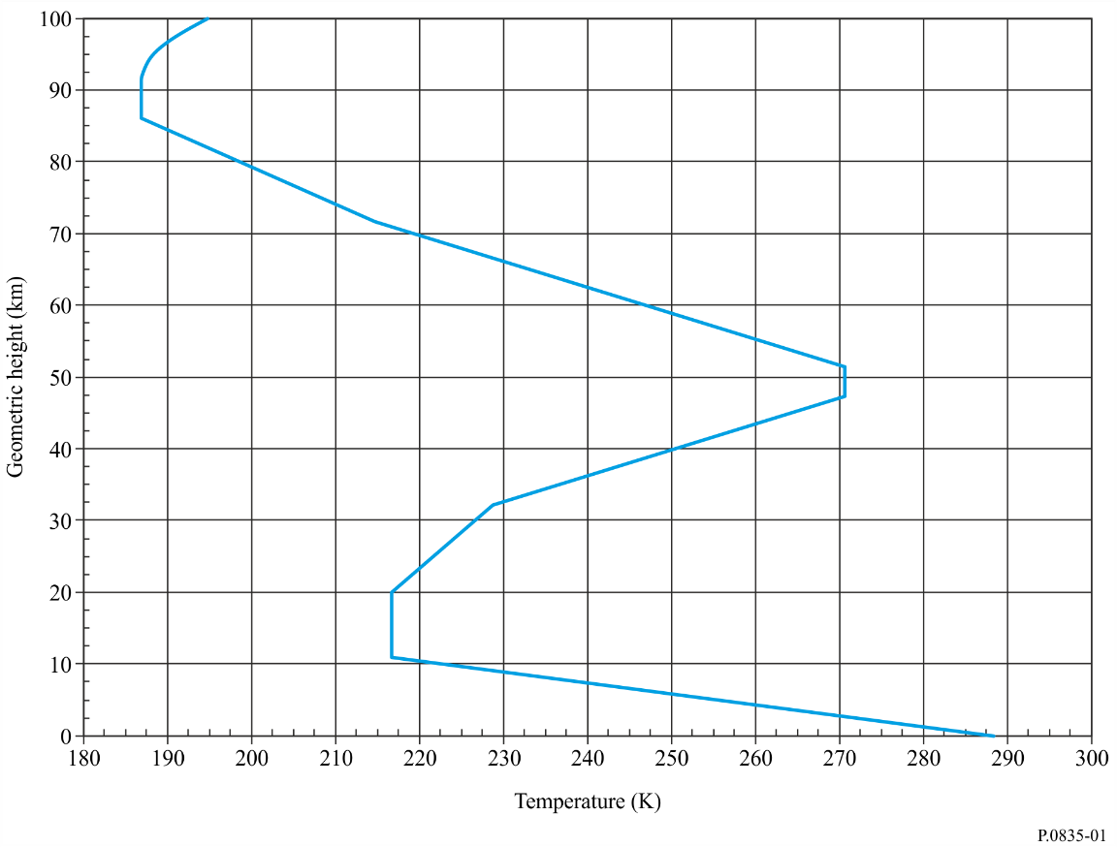
FIGURE 2
Pressure vs. geometric height
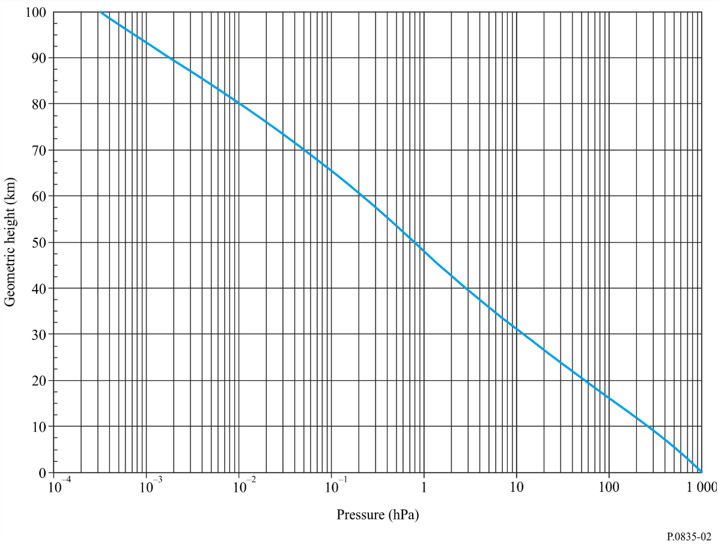

1.2 Water-vapour pressure
The distribution of water vapour in the atmosphere is generally highly variable, but may be approximated by the equation:
ρ(h) = ρ₀ exp (–h / h₀) g/m³ (6)
where the scale height h₀ = 2 km, and the standard ground-level water-vapour density is:
ρ₀ = 7.5 g/m³ (7)
Vapour pressure is obtained from the density using the equation (see Recommendation ITU-R P.453):
(8)
Water-vapour density decreases exponentially with increasing altitude, up to an altitude where the mixing ratio e (h)/P(h) = 2 × 10^{–6}. Above this altitude, the mixing ratio is assumed to be constant.

1.3 Dry atmosphere for attenuation calculations
The profile of the density of atmospheric gases other than water vapour (the “dry atmosphere”) may be found from the temperature and pressure profiles given in § 1.1.
For attenuation calculations, this density profile may be approximated by an exponential profile according to equation (6) with:
h₀ = 6 km (9)

2 Low-latitude annual reference atmosphere
For low latitudes (smaller than 22°) the seasonal variations are not very important and a single annual profile can be used.
The temperature T (K) at height h (km) is given by:
T(h) = 300.4222 – 6.3533 h + 0.005886 h² for 0 ≤ h < 17
T(h) = 194 + (h – 17) 2.533 for 17 ≤ h < 47
T(h) = 270 for 47 ≤ h < 52
T(h) = 270 – (h – 52) 3.0714 for 52 ≤ h < 80
T(h) = 184 for 80 ≤ h ≤ 100
while the pressure P (hPa):
P(h) = 1012.0306 – 109.0338 h + 3.6316 h² for 0 ≤ h ≤ 10
P(h) = P₁₀ exp [–0.147 (h – 10)] for 10 < h ≤ 72
P(h) = P₇₂ exp [–0.165 (h – 72)] for 72 < h ≤ 100
where P₁₀ and P₇₂ are the pressures at 10 and 72 km respectively.
For water vapour (g/m³):
ρ(h) = 19.6542 exp [–0.2313 h – 0.1122 h² + 0.01351 h³
– 0.0005923 h⁴] for 0 ≤ h ≤ 15
ρ(h) = 0 for h > 15

3 Mid-latitude reference atmosphere
For mid-latitudes (between 22° and 45°) the following profiles may be used for the summer and winter.

3.1 Summer mid-latitude
The temperature T (K) at height h (km) is given by:
T(h) = 294.9838 – 5.2159 h – 0.07109 h² for 0 ≤ h < 13
T(h) = 215.15 for 13 ≤ h < 17
T(h) = 215.15 exp [(h – 17) 0.008128] for 17 ≤ h < 47
T(h) = 275 for 47 ≤ h < 53
T(h) = 275 + {1 – exp [(h – 53) 0.06] } 20 for 53 ≤ h < 80
T(h) = 175 for 80 ≤ h ≤ 100
while the pressure P (hPa):
P(h) = 1012.8186 – 111.5569 h + 3.8646 h² for 0 ≤ h ≤ 10
P(h) = P₁₀ exp [− 0.147 (h – 10)] for 10 < h ≤ 72
P(h) = P₇₂ exp [−0.165 (h – 72)] for 72 < h ≤ 100
where P₁₀ and P₇₂ are the pressures at 10 and 72 km respectively.
For water vapour (g/m³):
ρ(h) = 14.3542 exp [– 0.4174 h – 0.02290 h²
+ 0.001007 h³] for 0 ≤ h ≤ 15
ρ(h) = 0 for h > 15

3.2 Winter mid-latitude
The temperature T (K) at height h (km) is given by:
T(h) = 272.7241 – 3.6217 h – 0.1759 h² for 0 ≤ h < 10
T(h) = 218 for 10 ≤ h < 33
T(h) = 218 + (h – 33) 3.3571 for 33 ≤ h < 47
T(h) = 265 for 47 ≤ h < 53
T(h) = 265 – (h – 53) 2.0370 for 53 ≤ h < 80
T(h) = 210 for 80 ≤ h ≤ 100
while the pressure P (hPa):
P(h) = 1018.8627 – 124.2954 h + 4.8307 h² for 0 ≤ h ≤ 10
P(h) = P₁₀ exp [– 0.147 (h – 10)] for 10 < h ≤ 72
P(h) = P₇₂ exp [– 0.155 (h – 72)] for 72 < h ≤ 100
where P₁₀ and P₇₂ are the pressures at 10 and 72 km respectively.
For water vapour (g/m³):
ρ(h) = 3.4742 exp [– 0.2697 h – 0.03604 h²
+ 0.0004489 h³] for 0 ≤ h ≤ 10
ρ(h) = 0 for h > 10

4 High latitude reference atmosphere
For high latitudes (higher than 45°) the following profiles may be used for the summer and winter.

4.1 Summer high latitude
The temperature T (K) at height h (km) is given by:
T(h) = 286.8374 – 4.7805 h – 0.1402 h² for 0 ≤ h < 10
T(h) = 225 for 10 ≤ h < 23
T(h) = 225 exp [(h – 23) 0.008317] for 23 ≤ h < 48
T(h) = 277 for 48 ≤ h < 53
T(h) = 277 – (h – 53) 4.0769 for 53 ≤ h < 79
T(h) = 171 for 79 ≤ h ≤ 100
while the pressure P (hPa):
P(h) = 1008.0278 – 113.2494 h + 3.9408 h² for 0 ≤ h ≤ 10
P(h) = P₁₀ exp [–0.140 (h – 10)] for 10 < h ≤ 72
P(h) = P₇₂ exp [–0.165 (h – 72)] for 72 < h ≤ 100
where P₁₀ and P₇₂ are the pressures at 10 and 72 km respectively.
For water vapour (g/m³):
ρ(h) = 8.988 exp [– 0.3614 h – 0.005402 h²
– 0.001955 h³] for 0 ≤ h ≤ 15
ρ(h) = 0 for h > 15

4.2 Winter high latitude
The temperature T (K) at height h (km) is given by:
T(h) = 257.4345 + 2.3474 h – 1.5479 h² + 0.08473 h³ for 0 ≤ h < 8.5
T(h) = 217.5 for 8.5 ≤ h < 30
T(h) = 217.5 + (h – 30) 2.125 for 30 ≤ h < 50
T(h) = 260 for 50 ≤ h < 54
T(h) = 260 – (h – 54) 1.667 for 54 ≤ h ≤ 100
while the pressure P (hPa):
P(h) = 1010.8828 – 122.2411 h + 4.554 h² for 0 ≤ h ≤ 10
P(h) = P₁₀ exp [–0.147 (h – 10)] for 10 < h ≤ 72
P(h) = P₇₂ exp [–0.150 (h – 72)] for 72 < h ≤ 100
where P₁₀ and P₇₂ are the pressures at 10 and 72 km respectively.
For water vapour (g/m³):
ρ(h) = 1.2319 exp [0.07481 h – 0.0981 h² + 0.00281 h³] for 0 ≤ h ≤ 10
ρ(h) = 0 for h > 10

Annex 2

1 Experimental data of atmospheric vertical profiles
Monthly averages of vertical profiles of temperature, pressure and relative humidity were calculated for 353 locations over the world, using 10 years (1980-1989) of radiosonde observations. This dataset (DST.STD) is available from ITU/BR and contains the mean monthly vertical profiles, for both 00.00 UTC and 12.00 UTC, of pressure, temperature and relative humidity. These profiles, calculated in the absence of rain, range from 0 to 16 km with a step of 500 m. The mean monthly profiles are contained in ASCII files named <WMO_code>.dat, where WMO_code is the code name of the site according to the World Meteorological Organization (e.g.: 03496.dat, 03496 is the WMO station code for Hemsby-in-Norfolk). An example of one profile is given in Table 2. The list of locations is contained in an ASCII file (using the comma separated value file, CSV, file format) called dst_std_lst.csv. Each record of this file contains the following field: WMO_CODE, Station Name, Country, Latitude, Longitude, Altitude above sea level. An example of such a record is given in Table 3.
Above the maximum altitude, extrapolation can be performed by using the reference profiles given in Annex 1. To translate the relative humidity into absolute values of water-vapour density, the formulae contained in Recommendation ITU-R P.453 should be used.
TABLE 2
DST.STD data format – Example of month average profile
(station 10410)
YYMMDDHH NL
99 199 0 33
Press (hPa) | Z (km) | Temp (K) | RH (%/100)
1 016.905 | 0.00 | 273.62 | 0.864E+00
956.686 | 0.50 | 273.33 | 0.830E+00
898.555 | 1.00 | 271.74 | 0.754E+00
844.014 | 1.50 | 269.59 | 0.665E+00
791.860 | 2.00 | 267.15 | 0.591E+00
742.661 | 2.50 | 264.56 | 0.518E+00
696.285 | 3.00 | 261.89 | 0.470E+00
651.977 | 3.50 | 258.94 | 0.458E+00
610.086 | 4.00 | 255.88 | 0.448E+00
570.467 | 4.50 | 252.69 | 0.445E+00
533.076 | 5.00 | 249.33 | 0.451E+00
497.767 | 5.50 | 245.90 | 0.453E+00
464.123 | 6.00 | 242.32 | 0.450E+00
432.441 | 6.50 | 238.75 | 0.450E+00
402.414 | 7.00 | 235.16 | 0.443E+00
374.177 | 7.50 | 231.59 | 0.437E+00
347.236 | 8.00 | 228.12 | 0.433E+00
322.281 | 8.50 | 224.88 | 0.427E+00
TABLE 2 (end)
YYMMDDHH NL
99 199 0 33
298.474 | 9.00 | 221.89 | 0.421E+00
276.492 | 9.50 | 219.27 | 0.416E+00
255.527 | 10.00 | 217.08 | 0.411E+00
236.297 | 10.50 | 215.62 | 0.402E+00
218.415 | 11.00 | 214.79 | 0.393E+00
201.366 | 11.50 | 214.14 | 0.348E+00
186.214 | 12.00 | 214.02 | 0.205E+00
172.093 | 12.50 | 214.24 | 0.104E+00
158.709 | 13.00 | 214.66 | 0.368E-01
146.492 | 13.50 | 214.94 | 0.351E-02
135.813 | 14.00 | 214.88 | 0.120E-02
125.690 | 14.50 | 214.50 | 0.117E-02
116.027 | 15.00 | 214.01 | 0.113E-02
106.798 | 15.50 | 213.56 | 0.110E-02
98.291 | 16.00 | 213.26 | 0.107E-02
Legend to Table 2:
YY = Year (99 for mean monthly profiles)
MM = Month (1 = January, 2 = February, ...)
DD = Day of the month (99 for mean monthly profiles)
HH = Hour of the day (UTC)
NL = Number of vertical levels (NL = 33 for STD.DST)
Press (hPa) = Atmospheric total pressure
Z (km) = Height above the Earth’s surface
Temp (K) = Air temperature
RH (%/100) = Relative humidity (as a fraction)
NOTE 1 – The level values of Temp and Press may be set to zero if unrecorded.

TABLE 3
DST_STD_LST.CSV station information file – Example of record structure
WMO code | Station name | Country | Latitude  (degrees) | Longitude (degrees) | Asl  (m)
10 410 | ESSEN | DL | 51.4 | 6.967 | 153
NOTE – Latitude and longitude values are in decimal degrees (i.e. 51.4 = 51º 24').

Annex 3

1 Numerical weather prediction data of atmospheric vertical profiles
Monthly averages, conditioned to the hour of the day, of vertical profiles of temperature, pressure and water-vapour density were calculated using the ECMWF 15-year data set (ERA15) from the re-analysis project. This data set contains the mean monthly vertical profiles at 00:00, 06:00, 12:00 and 18:00 UTC of total air pressure, air temperature and water-vapour density at 32 height levels from a reference height located around the local Earth’s surface up to about 30 km above the Earth’s surface. The data are from 0º to 360º in longitude and from +90º to −90º in latitude, with a resolution of 1.5º in both latitude and longitude. All the data are stored in files using the IEEE floating point single precision standard (4 bytes, 32 bits) in a Big-Endian format.
The data set and the associated Matlab files to access the data are an integral part of this Recommendation and are available in the Supplement file R-REC-P.835-6-201712-I!!ZIP-E.zip. The mean monthly profiles of each meteorological parameter are contained in binary files <param>_<hh>.bin, where param is the name of the meteorological parameter (pres = total air pressure (hPa), temp = air temperature (K), vapd = water-vapour density (g/m³)) and hh is the hour of the day (i.e. 00, 06, 12 and 18 (UTC)). The associated heights of the profile levels are contained in the binary file hght.bin. An example profile for Latitude = 45° N, Longitude = 9° E, July, and 12:00 UTC is given in Table 4.
TABLE 4
Example Profile
Z  (m) | Press  (hPa) | Temp  (K) | Vapd  (g/m³)
665.488 | 939.255 | 298.373 | 9.823
698.823 | 935.673 | 298.125 | 9.617
816.585 | 923.092 | 296.598 | 9.302
1 026.379 | 900.957 | 294.292 | 8.811
1 309.298 | 871.693 | 291.459 | 8.099
1 650.689 | 837.298 | 288.287 | 6.992
2 039.463 | 799.373 | 285.107 | 5.706
2 467.391 | 759.191 | 282.116 | 4.555
2 928.467 | 717.723 | 279.045 | 3.641
3 418.375 | 675.691 | 275.934 | 2.692
3 934.342 | 633.633 | 272.913 | 1.855
4 474.659 | 591.936 | 269.707 | 1.286
5 038.169 | 550.876 | 266.183 | 0.911
5 624.303 | 510.656 | 262.354 | 0.636
6 232.944 | 471.427 | 258.213 | 0.428
6 864.291 | 433.307 | 253.687 | 0.277
7 518.708 | 396.390 | 248.780 | 0.173
8 196.752 | 360.767 | 243.521 | 0.103
8 898.985 | 326.527 | 237.971 | 0.058
9 626.211 | 293.764 | 232.319 | 0.034
10 380.050 | 262.580 | 226.984 | 0.019
11 164.590 | 233.064 | 222.845 | 0.009
TABLE 4 (end)

Z  (m) | Press  (hPa) | Temp  (K) | Vapd  (g/m³)
11 988.097 | 205.263 | 220.483 | 0.003
12 861.558 | 179.195 | 219.279 | 0.001
13 796.578 | 154.827 | 218.154 | 0.001
14 809.705 | 132.043 | 217.057 | 0.001
15 931.961 | 110.604 | 216.026 | 0.000
17 225.900 | 90.110 | 215.674 | 0.000
18 818.316 | 70.037 | 216.262 | 0.000
20 961.771 | 50.038 | 219.300 | 0.000
24 267.900 | 30.039 | 223.166 | 0.000
31 427.936 | 10.320 | 232.854 | 0.000
Legend to Table 4:
Z (m) = Height with respect to sea level
Press (hPa) = Atmospheric total pressure
Temp (K) = Air temperature
Vapd (g/m³) = Water-vapour density

______________

∗ Radiocommunication Study Group 3 made editorial amendments to this Recommendation in the year 2020 in accordance with Resolution ITU-R 1.
km$'$ are units of geopotential height, and km are units of geometric height.

