Recommendation ITU-R P.617-6
(09/2025)
P Series: Radio-wave propagation
Propagation prediction techniques and data required for the design of trans-horizon radio-relay systems

Foreword
The role of the Radiocommunication Sector is to ensure the rational, equitable, efficient and economical use of the radio-frequency spectrum by all radiocommunication services, including satellite services, and carry out studies without limit of frequency range on the basis of which Recommendations are adopted.
The regulatory and policy functions of the Radiocommunication Sector are performed by World and Regional Radiocommunication Conferences and Radiocommunication Assemblies supported by Study Groups.

Policy on Intellectual Property Right (IPR)
ITU-R policy on IPR is described in the Common Patent Policy for ITU-T/ITU-R/ISO/IEC referenced in Resolution ITU-R 1. Forms to be used for the submission of patent statements and licensing declarations by patent holders are available from https://www.itu.int/ITU-R/go/patents/en where the Guidelines for Implementation of the Common Patent Policy for ITU-T/ITU-R/ISO/IEC and the ITU-R patent information database can also be found.

Series of ITU-R Recommendations
(Also available online at https://www.itu.int/publ/R-REC/en)
Series | Title
BO | Satellite delivery
BR | Recording for production, archival and play-out; film for television
BS | Broadcasting service (sound)
BT | Broadcasting service (television)
F | Fixed service
M | Mobile, radiodetermination, amateur and related satellite services
P | Radio-wave propagation
RA | Radio astronomy
RS | Remote sensing systems
S | Fixed-satellite service
SA | Space applications and meteorology
SF | Frequency sharing and coordination between fixed-satellite and fixed service systems
SM | Spectrum management
SNG | Satellite news gathering
TF | Time signals and frequency standards emissions
V | Vocabulary and related subjects

Note: This ITU-R Recommendation was approved in English under the procedure detailed in Resolution ITU-R 1.

Electronic Publication
Geneva, 2025

© ITU 2025
All rights reserved. No part of this publication may be reproduced, by any means whatsoever, without written permission of ITU.

RECOMMENDATION ITU-R P.617-6
Propagation prediction techniques and data required for the design
of trans-horizon radio-relay systems
(Question ITU-R 205/3)
(1986-1992-2012-2013-2017-2019-2025)
Scope
This Recommendation contains a propagation prediction method for the planning of trans-horizon radio-relay systems.
Keywords
Anomalous/layer-reflection, diffraction, trans-horizon, tropospheric scatter
Related ITU Recommendations
Recommendation ITU-R P.452 – Prediction procedure for the evaluation of interference between stations on the surface of the Earth at frequencies above about 100 MHz
Recommendation ITU-R P.526 – Propagation by diffraction
Recommendation ITU-R P.841 – Conversion of annual statistics to worst-month statistics
Recommendation ITU-R P.2001 – A general purpose wide-range terrestrial propagation model in the frequency range 30 MHz to 50 GHz
NOTE – The latest edition of the Recommendation in force should be used.
The ITU Radiocommunication Assembly,
considering
a) that for the proper planning of trans-horizon radio-relay systems it is necessary to have appropriate propagation prediction methods and data;
b) that methods have been developed that allow the prediction of most of the important propagation parameters affecting the planning of trans-horizon radio-relay systems;
c) that as far as possible these methods have been tested against available measured data and have been shown to yield an accuracy that is both compatible with the natural variability of propagation phenomena and adequate for most present applications in system planning,
recommends
that the prediction methods and other techniques set out in Annex 1 should be used for planning trans-horizon radio-relay systems in the respective ranges of parameters indicated.

Annex 1
TABLE OF CONTENTS
Page
1 Introduction 3
2 Integral digital products 3
3 Transmission loss for diffraction paths 3
4 Transmission loss distribution due to tropospheric scatter 3
4.1 Average annual median transmission loss distribution 4
4.2 Average worst-month median transmission loss distribution 6
5 Transmission loss and enhancement distribution due to ducting/layer reflection 6
5.1 Characterize the radio-climatic zones dominating the path 6
5.2 Point incidence of ducting 7
5.3 Site-shielding losses with respect to the anomalous propagation mechanism 8
5.4 Over-sea surface duct coupling corrections 8
5.5 Total coupling loss to the anomalous propagation mechanism 8
5.6 Angular-distance dependent loss 9
5.7 Distance and time-dependent loss 9
5.8 Basic transmission loss associated with ducting 10
6 Estimation of total transmission loss distribution 10
7 Diversity reception 10
7.1 Space diversity 10
7.2 Frequency diversity 10
7.3 Angle diversity 11
8 Effect of the siting of stations 11
Attachment 1 to Annex 1 – Additional supporting material 11
1 Seasonal and diurnal variations in transmission loss 11
2 Frequency of rapid fading on tropospheric scatter paths 12
3 Transmissible bandwidth 12
Attachment 2 to Annex 1 – Effective heights and path roughness parameter 13

1 Introduction
The only mechanisms for radio propagation beyond the horizon which occur permanently for frequencies greater than 30 MHz are those of diffraction at the Earth’s surface and scatter from atmospheric irregularities. In addition propagation due to ducting or layer-reflection may occur occasionally. Attenuation for diffracted signals increases very rapidly with distance and with frequency, and the anomalous propagation probability is relatively small, eventually the long term principal mechanism is that of tropospheric scatter. These mechanisms may be used to establish “trans-horizon” radiocommunication.
Because of the dissimilarity of the three mechanisms it is necessary to consider diffraction, ducting/layer reflection and tropospheric scatter paths separately for the purposes of predicting transmission loss and enhancements.
This Annex relates to the design of trans-horizon radio-relay systems. One purpose is to present in concise form simple methods for predicting the annual and worst-month distributions of the total transmission loss due to tropospheric scatter and ducting/layer reflection, together with information on their ranges of validity. Another purpose of this Annex is to present other information and techniques that can be recommended in the planning of trans-horizon systems.

2 Integral digital products
Only the file versions provided with this Recommendation should be used. They are an integral part of the Recommendation. Table 1 gives details of the digital products used in the method.
TABLE 1
Digital products
Filename | Ref. | Origin | Latitude (rows) |  |  | Longitude (columns)
Filename | Ref. | Origin | First row  (ºN) | Spacing  (degrees) | Number of rows | First col  (ºE) | Spacing  (degrees) | Number of cols
DN50.txt | Att.1 Annex 1 | P.452 | 90 | 1.5 | 121 | 0 | 1.5 | 241
N050.txt | Att.1 Annex 1 | P.452 | 90 | 1.5 | 121 | 0 | 1.5 | 241
The “First row” value is the latitude of the first row.
The “First col” value is the longitude of the first column. The last column is the same as the first column (360° = 0°) and is provided to simplify interpolation.
“Spacing” gives the latitude/longitude increment between rows/columns.
The files are contained in the Supplement file R-REC-P.617-6-202509-I!!ZIP-E.zip.

3 Transmission loss for diffraction paths
For radio paths extending only slightly over the horizon, or for paths extending over an obstacle or over mountainous terrain, diffraction will generally be the propagation mode determining the field strength. In these cases, the methods described in Recommendation ITU-R P.526 should be applied.

4 Transmission loss distribution due to tropospheric scatter
Signals received by means of tropospheric scatter show both slow and rapid variations. The slow variations are due to overall changes in refractive conditions in the atmosphere and the rapid fading to the motion of small-scale irregularities. The slow variations are well described by distributions of the hourly-median transmission loss which are approximately log-normal with standard deviations between about 4 and 8 dB, depending on climate. The rapid variations over periods up to about 5 min are approximately Rayleigh distributed.
In determining the performance of trans-horizon links for geometries in which the tropospheric scatter mechanism is predominant, it is normal to estimate the distribution of hourly-median transmission loss for non-exceedance percentages of the time above 50%.
A simple semi-analytical technique for predicting the distribution of average annual transmission loss in this range is given in § 4.1. The method for conversion of these annual time percentages to those for the average worst month is given in § 4.2. Attachment 1 includes additional supporting information on seasonal and diurnal variations in transmission loss, on frequency of rapid fading on tropospheric scatter paths and on transmission bandwidth.

4.1 Average annual median transmission loss distribution
The following step-by-step procedure is recommended for estimating the average annual median transmission loss L(p) not exceeded for percentages of the time p. The procedure requires the link parameters of great-circle path length d (km), frequency f (MHz), transmitting antenna gain G_{t} (dB), receiving antenna gain G_{r} (dB), horizon angle θ_{t} (mrad) at the transmitter, and horizon angle θ_{r} (mrad) at the receiver:
Step 1: Obtain the average annual sea-level surface refractivity N₀ and radio-refractive index lapserate dN for the common volume of the link in question using the digital maps of Fig. 1 and Fig. 2, respectively. These maps are available electronically from the ITU-R SG 3 website under the specification in § 2.
Figure 1
Average annual sea-level surface refractivity, N₀
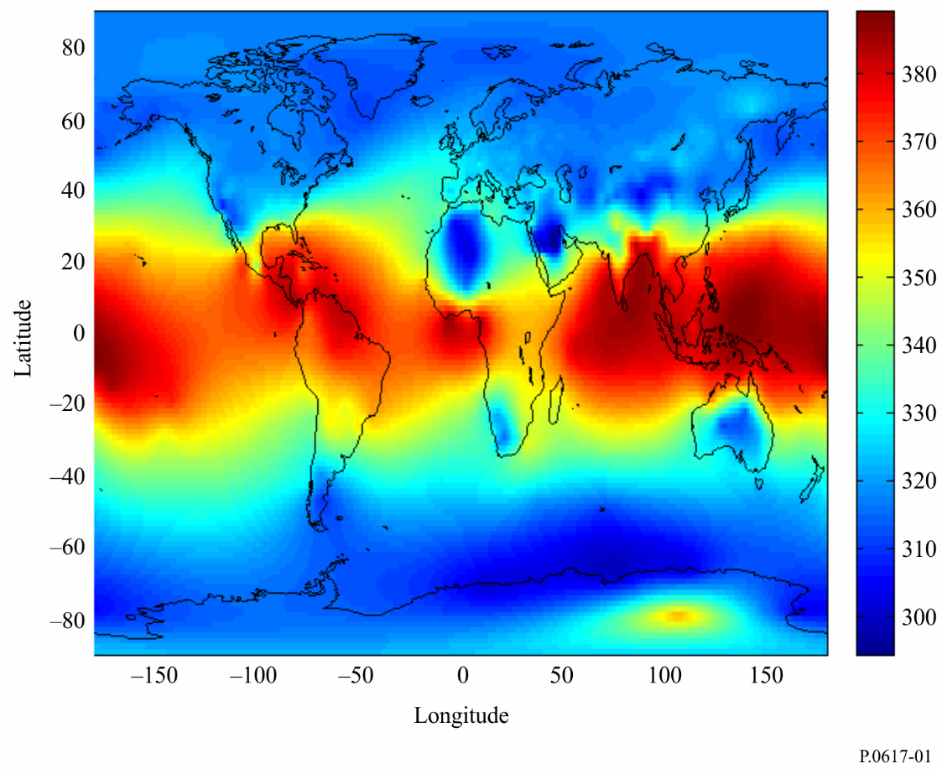
Figure 2
Average annual radio-refractivity lapse-rate through the lowest 1 km of the atmosphere, dN
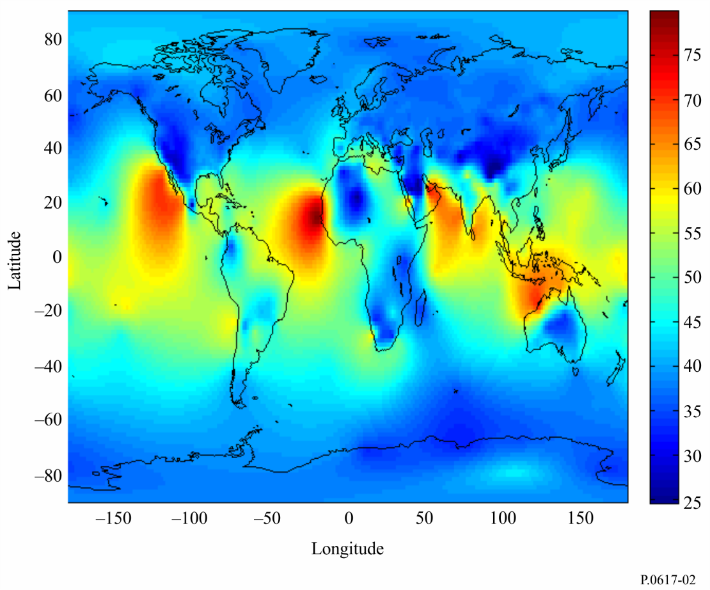
Step 2: Calculate the scatter angle θ (angular distance) from
$θ=θ_{e}+θ_{t}+θ_{r}$ mrad (1)

where θ_{t} and θ_{r} are the transmitter and receiver horizon angles, respectively, and

$θ_{e}={d∙{10}^{3}}/{ka}$ mrad (2)
with:
d : path length (km)
a : 6 370 km radius of the Earth
k : effective earth radius factor for median refractivity conditions (k = 4/3 should be used unless a more accurate value is known).
Step 3: Estimate the aperture-to-medium coupling loss Lc from:
Lc = 0.07 exp [0.055(Gt + Gr)]mmmmmmdB (3)
where G_{t} and G_{r} are the antenna gains.
Step 4: Estimate the average annual transmission loss associated with tropospheric scatter not exceeded for p% of the time from:
$L_{bs}\left(p\right)=F+22\log_{10}{f}+17.5\log_{10}{(θ^{2}+7θ+4)}+17\log_{10}{d}+L_{c}-Y_{p}$ (4)
where:
$F=0.18∙N_{0}∙\exp\left({{-h}_{s}}/{h_{b}}\right)-0.23∙dN dB$ (5)
$Y_{p}=\left\{\begin{aligned}0.035N_{0}\exp\left(-h_{0}/h_{b}\right)∙{\left(-\log\left(p/50\right)\right)}^{0.67} p<50 \\ \begin{matrix}-0.035N_{0}exp⁡(-h_{0}/h_{b})∙{(-log⁡[(100-p)/50])}^{0.67} & p≥50\end{matrix}\end{aligned}\right.$ (6)
(7a)
The angle β can be obtained by the following equation:
(7b)
Where h_{t} and h_{r} (km) are the altitudes of transmitting antenna and receiving antenna, respectively.
with:
h_{s}: height of the Earth’s surface above sea level (km)
h_{b}: scale height (km) which can be determined statistically for different climates conditions. For reference purposes, a global mean of the scale height may be defined by h_{b}=7.35 km.

4.2 Average worst-month median transmission loss distribution
For reasons of consistency with the average annual transmission loss distribution, this distribution is best determined from the average annual distribution by means of a conversion factor. The procedure is as follows:
Step 1: If the annual statistics time percentage is given, calculate the time percentage conversion of annual statistics to worst-month statistics for tropospheric scatter from Recommendation ITU-R P.841. If the worst-month time percentage is given, an inversion calculation is needed.
Step 2: Calculate the worst-month median transmission loss for the given time percentage, substituting the given or solved annual statistics time percentage into § 4.1.

5 Transmission loss and enhancement distribution due to ducting/layer reflection
Ducting and layer reflection may cause an enhancement of the signal which can effect system design. The following calculation is the same as Recommendation ITU-R P.2001-2, Attachment D: Anomalous layer reflection model.

5.1 Characterize the radio-climatic zones dominating the path
Calculate two distances giving the longest continuous sections of the path passing through the following radio-climatic zones:
d_{tm} : longest continuous land (inland or coastal) section of the path (km);
d_{lm} : longest continuous inland section of the path (km).
Table 2 describes the radio-climatic zones needed for the above classification.
TABLE 2
Radio-climatic zones
Zone type | Code | Definition
Coastal land | A1 | Coastal land and shore areas, i.e. land adjacent to the sea up to an altitude of 100 m relative to mean sea or water level, but limited to a distance of 50 km from the nearest sea area.
Inland | A2 | All land, other than coastal and shore areas defined as “coastal land” above.
Sea | B | Seas, oceans and other large bodies of water (i.e. covering a circle of at least 100 km in diameter).

Large bodies of inland water
A “large” body of inland water, to be considered as lying in Zone B, is defined as one having an area of at least 7 800 km², but excluding the area of rivers. Islands within such bodies of water are to be included as water within the calculation of this area if they have elevations lower than 100 m above the mean water level for more than 90% of their area. Islands that do not meet these criteria should be classified as land for the purposes of the water area calculation.

Large inland lake or wet-land areas
Large inland areas of greater than 7 800 km² which contain many small lakes or a river network should be declared as “coastal” Zone A1 by administrations if the area comprises more than 50% water, and more than 90% of the land is less than 100 m above the mean water level.
Climatic regions pertaining to Zone A1, large inland bodies of water and large inland lake and wetland regions, are difficult to determine unambiguously. Therefore administrations are invited to register with the ITU Radiocommunication Bureau (BR) those regions within their territorial boundaries that they wish identified as belonging to one of these categories. In the absence of registered information to the contrary, all land areas will be considered to pertain to climate Zone A2.
For reference purposes the coastal contours as contained in the ITU Digitized World Map (IDWM), available from the BR: https://www.itu.int/pub/R-SOFT-IDWM may be used.

5.2 Point incidence of ducting
Calculate a parameter depending on the longest inland section of the path:
$τ=\left[1-e^{-\left(4.12×{10}^{-4}×d_{lm}^{2.41}\right)}\right]$ (8)
Calculate parameter μ₁ characterizing the degree to which the path is over land, given by:
$μ_{1}={\left[{10}^{\frac{-d_{m}}{16-6.6τ}}+{10}^{-\left(2.48+1.77τ\right)}\right]}^{0.2}$ (9)
where the value of μ₁ shall be limited to μ₁ ≤ 1.
Calculate parameter μ₄, given by:
$μ_{4}=\left\{\begin{matrix}{10}^{\left(-0.935+0.0176\left|φ_{mn}\right|\right)\log{μ_{1}}} & for \left|φ_{mn}\right|≤70° \\ {10}^{0.3\log{μ_{1}}} & for \left|φ_{mn}\right|>70°\end{matrix}\right.$ (10)
where φ_{mn} is the path mid-point latitude.
The point incidence of anomalous propagation, β₀ (%), for the path centre location is now given by:
$β_{0}=\left\{\begin{matrix}{10}^{-0.015\left|φ_{mn}\right|+1.67}μ_{1}μ_{4} & \% & for \left|φ_{mn}\right|≤70° \\ 4.17μ_{1}μ_{4} & \% & for \left|φ_{mn}\right|>70°\end{matrix}\right.$ (11)

5.3 Site-shielding losses with respect to the anomalous propagation mechanism
Corrections to transmitter and receiver horizon elevation angles:
$g_{t}=0.1∙d_{lt}$ (12)
$g_{r}=0.1∙d_{lr}$ (13)
where d_{lt}, d_{lr} (km) are the terminal to horizon distances. For LoS paths set to distances to point with largest knife-edge loss.
The losses between the antennas and the anomalous propagation mechanism associated with siteshielding are calculated as follows.
Modified transmitter and receiver horizon elevation angles:
$θ_{st}=θ_{t}-g_{t}$ mrad (14)
$θ_{sr}=θ_{r}-g_{r}$ mrad (15)
Transmitter and receiver site-shielding losses with respect to the duct:
$A_{st}=20\log\left\lfloor 1+0.361∙θ_{st}∙{\left(f∙d_{lt}\right)}^{1/2}\right\rfloor +0.264∙θ_{st}∙f^{1/3} dB∙θ_{st}>0$ (16)
$A_{st}=0 dB otherwise$ (17)
$A_{sr}=20\log\left\lfloor 1+0.361∙θ_{sr}∙{\left(f∙d_{lr}\right)}^{1/2}\right\rfloor +0.264∙θ_{sr}∙f^{1/3} dB∙θ_{sr}>0$ (18)
$A_{sr}=0 dB otherwise$ (19)

5.4 Over-sea surface duct coupling corrections
Obtain the distance from each terminal to the sea in the direction of the other terminal:
d_{ct} = coast distance from transmitter km (20)
d_{cr} = coast distance from receiver km (21)
The over-sea surface duct coupling corrections for the transmitter and receiver, A_{ct} and A_{cr} respectively, are both zero except for the following combinations of conditions:
dB
if (ω≥ 0.75) and (d_{ct} ≤ d_{lt}) and (d_{ct} ≤ 5 km) (22)
$A_{ct}=0$ dB otherwise (23)
dB
if (ω ≥ 0.75) and (d_{cr} ≤ d_{lr}) and (d_{cr} ≤ 5 km) (24)
$A_{cr}=0$ dB otherwise (25)
where ω is the fraction of the path over sea, h_{ts}, h_{rs} are the transmitter, receiver, height above mean sea level.

5.5 Total coupling loss to the anomalous propagation mechanism
The total coupling losses between the antennas and the anomalous propagation mechanism can now be calculated as:
$A_{ac}=102.45+20∙\log\left[f\left(d_{lt}+d_{lr}\right)\right]+A_{lf}+A_{st}+A_{sr}+A_{ct}+A_{cr}$ dB (26)
A_{lf} is an empirical correction to account for the increasing attenuation with wavelength in ducted propagation:
$A_{lf}=\left(45.375-137.0f+92.5f^{2}\right)ω dB if f<0.5 GHz$ (27)
$A_{lf}=0 dB otherwise$ (28)

5.6 Angular-distance dependent loss
Specific angular attenuation within the anomalous propagation mechanism:
$γ_{d}=5∙{10}^{-5}∙k∙a∙f^{1/3}$ dB/mrad (29)
Adjusted transmitter and receiver horizon elevation angles:
$θ_{at}=min\left(θ_{t},g_{t}\right)$ mrad (30)
$θ_{ar}=min\left(θ_{r},g_{r}\right)$ mrad (31)
Adjusted total path angular-distance:
$θ_{a}=\frac{1 000∙d}{ka}+θ_{at}+θ_{ar}$ mrad (32)
Angular-distance dependent loss:
$A_{ad}=γ_{d}∙θ_{a}$ dB (33)

5.7 Distance and time-dependent loss
The loss in the anomalous propagation mechanism dependent on both great-circle distance and percentage time is calculated by first evaluating the following.
Distance adjusted for terrain roughness factor:
$d_{ar}=min\left(d-d_{lt}-d_{lr},40\right)$ km (34)
Terrain roughness factor:
$μ_{3}=exp\left\lfloor -4.6×{10}^{-5}\left(h_{m}-10\right)\left(43+6∙d_{ar}\right)\right\rfloor ∙h_{m}>10 m$ (35)
$μ_{3}=1$ otherwise (36)
where h_{m} is the path roughness parameter given in Attachment 2.
A term required for the path geometry correction:
$Α=-0.6-3.5∙{10}^{-9}∙d^{3.1}∙τ$ (37)
If α < −3.4, set α = −3.4.
Path-geometry factor:
$μ_{2}={\left[\frac{500d^{2}}{ka{\left(\sqrt{h_{te}}+\sqrt{h_{re}}\right)}^{2}}\right]}^{α}$ (38)
If μ₂ > 1, set μ₂ = 1. h_{te}, h_{re} are the effective transmitter, receiver, height above smooth surface given in Attachment 2.
Time percentage associated with anomalous propagation adjusted for general location and specific properties of the path:
$β=β_{0}∙μ_{2}∙μ_{3}$ % (39)
An exponent required for the time-dependent loss:
$Γ=\frac{1.076 exp\left\{{-10}^{-6}d^{1.13}\left\lfloor 9.51-4.8\log{β}+0.198{\left(\log{β}\right)}^{2}\right\rfloor \right\}}{({2.0058-\log{β)}}^{1.012}}$ (40)
The time-dependent loss:
$A_{at}=-12+\left(1.2+0.0037d\right)\log\left(\frac{p}{β}\right)+12{\left(\frac{p}{β}\right)}^{Γ}+\frac{50}{q}$ dB (41)
where q = 100-p.

5.8 Basic transmission loss associated with ducting
Basic transmission loss associated with anomalous propagation is given by:
$L_{ba}=A_{ac}+A_{ad}+A_{at}$ dB (42)

6 Estimation of total transmission loss distribution
For dynamic range calculations requiring estimates of the distribution for lower time percentages, pure tropospheric scatter cannot be assumed. The transmission loss values not exceeded for very small percentages of time will be determined by the anomalous propagation mechanism. Tropospheric scatter and the ducting/layer-reflection propagation mechanisms are largely correlated and are combined power-wise at these time percentages. The basic transmission loss of the two mechanisms can be combined to give a total loss with equations (4) and (42).
$L\left(p\right)=-5 log⁡\left({{10}^{-0.2L_{bs}}+10}^{-0.2L_{ba}}\right)$ dB (43)

7 Diversity reception
The deep fading occurring with tropospheric scatter propagation severely reduces the performance of systems using this propagation mode. The effect of the fading can be reduced by diversity reception, using two or more signals which fade more or less independently owing to differences in scatter path or frequency. Thus, the use of space, angle, or frequency diversity is known to decrease the percentages of time for which large transmission losses are exceeded. Angle diversity, however, can have the same effect as vertical space diversity and be more economical.

7.1 Space diversity
Diversity spacing in the horizontal or vertical can be used depending on whatever is most convenient for the location in question. Adequate diversity spacings Δh and Δv in either the horizontal or vertical, respectively, for frequencies greater than 1 000 MHz are given by the empirical relations:
m (44)
m (45)
where D is the antenna diameter in metres and I_{h} = 20 m and I_{v} = 15 m are empirical scale lengths in the horizontal and vertical directions, respectively.

7.2 Frequency diversity
For installations where it is desired to employ frequency diversity, an adequate frequency separation Δf (MHz) is given for frequencies greater than about 1 000 MHz by the relation:

MHz (46)
where:
f: frequency (MHz)
D: antenna diameter (m)
θ: scatter angle (mrad) obtained from equation (1)
I_{v}: 15 m the scale length noted above.

7.3 Angle diversity
Vertical angle diversity can also be used in which two or more antenna feeds spaced in the vertical direction are employed with a common reflector. This creates different vertically-spaced common volumes similar to the situation for vertical space diversity. The angular spacing Δ θ_{r} required to have approximately the same effect as the vertical spacing Δv (m) in equation (45) on an approximately symmetrical path is:
$Δθ_{r}=arc tan\left({Δv}/{500d}\right)$ (47)
where d is the path length (km).

8 Effect of the siting of stations
The siting of transmission links requires some care. The antenna beams must not be obstructed by nearby objects and the antennas should be directed slightly above the horizon. The precise optimum elevation is a function of the path and atmospheric conditions, but it lies within about 0.2 to 0.6 beamwidths above the horizon.
Measurements made by moving the beam of a 53 dB gain antenna away from the great-circle horizon direction of two 2 GHz transmitters, each 300 km distant, demonstrated an apparent rate-of-decrease of power received of 9 dB per degree. This occurred with increases of scattering angle over the first three degrees, in both azimuth and elevation, for each path, and for a wide range of time percentages.

Attachment 1
to Annex 1
Additional supporting material

1 Seasonal and diurnal variations in transmission loss
In temperate climates, transmission loss varies annually and diurnally. Monthly median losses tend to be higher in winter than in summer. The range is 10 to 15 dB on 150-250 km overland paths but diminishes as the distance increases. Measurements made in the European parts of the Russian Federation on a 920 km path at 800 MHz show a difference of only 2 dB between summer and winter medians. Diurnal variations are most pronounced in summer, with a range of 5 to 10 dB on 100-200 km overland paths. The greatest transmission loss occurs in the afternoon, and the least in early morning. Oversea paths are more likely to be affected by super-refraction and elevated layers than land paths, and so give greater variation. This may also apply to low, flat coastal regions in maritime zones.
In dry, hot desert climates attenuation reaches a maximum in the summer. The annual variations of the monthly medians for medium-distance paths exceed 20 dB, while the diurnal variations are very large.
In equatorial climates, the annual and diurnal variations are generally small.
In monsoon climates where measurements have been carried out (Senegal, Barbados), the maximum values of N_{s} occur during the wet season, but the minimum attenuation is between the wet and dry seasons.

2 Frequency of rapid fading on tropospheric scatter paths
The rapid fading has a frequency of a few fades per minute at lower frequencies and a few hertz at UHF. The superposition of a number of variable incoherent components would give a signal whose amplitude was Rayleigh distributed and this is found to be nearly true when the distribution is analysed over periods of up to five minutes. If other types of signal form a significant part of that received, there is a modification of this distribution. Sudden, deep and rapid fading has been noted when a frontal disturbance passes over a link. Reflections from aircraft can give pronounced rapid fading.
The frequency of the rapid fading has been studied in terms of the time autocorrelation function, which provides a “mean fading frequency” for short periods of time for which the signal is stationary. The median value of the mean fading frequency was found to increase nearly proportionally to path length and carrier frequency, and to decrease slightly with increasing antenna diameter.
Measurements have also shown that the rapidity of fading is greatest when the hourly median transmission loss is greater than the long-term median. In general, it was found that the fading rate decreased with decreasing transmission loss below the long-term median, the lowest fading rates occurring for events in which duct propagation was predominant.
It is the most rapid fading for hourly-median transmission loss values larger than the long-term median that is most important, and the few measurements available (at 2 GHz) give median fading rates between about 20 and 30 fades/min.

3 Transmissible bandwidth
The various discontinuities which give rise to scatter propagation, create propagation paths which may vary in number and in transmission time. Accordingly, the transmission coefficients for two adjacent frequencies are not entirely correlated, which leads to a distortion of the transmitted signal. The transmissible bandwidth is the bandwidth within which the distortion caused by this phenomenon is acceptable for the transmitted signal. This bandwidth therefore depends both on the nature of the transmitted signal (multiplex telephony, television picture, etc.) and on the acceptable distortion for this signal. Studies carried out in France show that:
– increasing the antenna gain widens the transmissible bandwidth to the extent where the gain degradation increases also (i.e. for gains exceeding approximately 30 dB);
– all other things being equal, the transmissible bandwidth depends on the atmospheric structure and hence on the climatic zone in question;
– the transmissible bandwidth becomes narrower as the distance increases, but this is governed by a law which is not the same for all climates;
– the transmissible bandwidth becomes narrower when there are positive angles of departure, and wider when these angles are negative.

Attachment 2
to Annex 1
Effective heights and path roughness parameter
The following modelling is the same as Recommendation ITU-R P.2001-2 section 3.8, effective heights and path roughness parameter.
The effective transmitter and receiver heights above terrain are calculated relative to a smooth surface fitted to the profile, as follows.
Calculate the initial provisional values for the heights of the smooth surface at the transmitter and receiver ends of the path, as follows:
$v_{1}=\sum_{i=2}^{n}{\left(d_{i}-d_{i-1}\right)}\left(h_{i}-h_{i-1}\right)$ (48)
$v_{2}=\sum_{i=2}^{n}{\left(d_{i}-d_{i-1}\right)}\left[h_{i}\left({2d}_{i}+d_{i-1}\right)+h_{i-1}\left(d_{i}+{2d}_{i-1}\right)\right]$ (49)
$h_{stip}=\left(\frac{2v_{1}d-v_{2}}{d^{2}}\right)$ m amsl (50)
$h_{srip}=\left(\frac{v_{2}-v_{1}d}{d^{2}}\right)$ m amsl (51)
where d_{i} is the distance from transmitter of ith profile point (km), h_{i} is the height of ith profile point above sea level (m), i:1, 2, 3 ... n, index of the profile point, n is the number of profile points.
If , re-evaluate h_{stip} using:
$h_{stip}=h_{ts}-1$ m amsl (52)
where h_{ts}=h₁+h_{tg}, h_{tg} is the height of electrical centre of transmitting.
If , re-evaluate h_{sr} using:
$h_{srip}=h_{rs}-1$ m amsl (53)
where h_{rs}=h_{n}+h_{rg}, h_{rg} is the height of receiving antenna above ground.
The slope of the least-squares regression fit is given by:
$m=\frac{h_{srip}-h_{stip}}{d}$ m/km (54)
The effective heights of the transmitter and receiver antennas above the smooth surface are now given by:
$h_{te}=h_{ts}-h_{stip} m$ (55)
$h_{re}=h_{rs}-h_{srip} m$ (56)
Calculate the path roughness parameter given by:
$h_{m}=max\left[h_{i}-\left(h_{srip}+{md}_{i}\right)\right]$ m (57)
where the profile index i takes all values from i_{lt} to i_{lr} inclusive. The i_{lt} and i_{lr} are profile indices of transmitter and receiver horizon distances.

