RECOMMENDATION ITU-R P.434-6
ITU-R REFERENCE IONOSPHERIC CHARACTERISTICS AND METHODS OF
BASIC MUF, OPERATIONAL MUF AND RAY-PATH PREDICTION*
(Questions ITU-R 212/3 and ITU-R 223/3)
(1966-1970-1974-1978-1982-1992-1995)
Rec. ITU-R P.434-6
The ITU Radiocommunication Assembly,
considering
a) that long-term reference ionospheric data and propagation prediction methods are needed for HF radio-circuit design, service planning and frequency band selection,
recommends
1 that for the prediction of ionospheric characteristics, use should be made of the formulations contained in Annex 1;
2 that for the prediction of basic and operational MUFs, use should be made of the formulations contained in Annex 2**;
3 that for the prediction of ray paths, use should be made of the formulations contained in Annex 3.

ANNEX 1
Ionospheric characteristics

1 Introduction
Expressions are provided for the evaluation of the monthly median of foF2, M(3000)F2, foE, foF1, h′F and h′F,F2 and of the monthly median, upper decile and lower decile of foEs and fbEs. Also included are representations of the percentage of occurrence of spread-F. These formulations yield values for any location, month and time-of-day for different solar epochs. In the case of foE and foF1, empirical formulae in terms of solar-zenith angle are presented. For the other ionospheric characteristics a numerical mapping technique based on orthogonal Fourier functions is applied.

2 Mapping functions
The general form of the numerical map function, Ω (λ, θ, T) is the Fourier time series:
(1)
where:
Ω : ionospheric characteristic to be mapped
λ : geographic latitude (–90° ≤ λ ≤ 90°)
θ : east geographic longitude (0° ≤ θ ≤ 360°)
(θ in degrees East of the Greenwich meridian)
T : universal time (UTC) expressed as an angle (–180° ≤ T ≤ 180°)
H : the maximum number of harmonics used to represent the diurnal variation.
The Fourier coefficients, aj (λ, θ) and bj (λ, θ), vary with the geographic coordinates, and are represented by series of the form:
(2a)
(2b)
The particular choice of the functions, Gk (λ, θ) is determined by specifying the integers k (k0, k1, k2, . . . , ki, . . . , km; km = K), where i is the order in longitude. Therefore, a numerical map can be written more explicitly in the form:
(3)
U2j,k and U2j–1,k in equations (2a), (2b) and (3), can be written as Us,k, where s is either 2j or 2j – 1.
In the numerical mapping technique, the modified magnetic dip:

has been used, where I is the magnetic dip and λ is the geographic latitude. Since X is a function of both geographic latitude and longitude, the formal expression of Ω (λ, θ, T), equation (3), is unchanged. Table 1 shows the geographic functions, Gk (λ, θ).
TABLE 1
Geographic coordinate functions Gk (λ, θ)
(X is a function of λ and θ, m is the maximum order in longitude)

k | Main  latitude  variation | k | First order  longitude | k | Second order  longitude | . . . | k | mth order  longitude
0 | 1 | k0 + 1 | cos λ cos θ | k1 + 1 | cos2 λ cos 2 θ | . . . | km–1 + 1 | cosm λ cos m θ
1 | sin X | k0 + 2 | cos λ sin θ | k1 + 2 | cos2 λ sin 2 θ | . . . | km–1 + 2 | cosm λ sin m θ
2 | sin2 X | k0 + 3 | sin X cos λ cos θ | k1 + 3 | sin X cos2 λ cos 2 θ | . . . | km–1 + 3 | sin X cosm λ cos m θ
. |  | k0 + 4 | sin X cos λ sin θ | k1 + 4 | sin X cos2 λ sin 2 θ | . . . | km–1 + 4 | sin X cosm λ sin m θ
.  .  . |  | .  .  . |  | .  .  . |  |  | .  .  .
k0 | X | k1 – 1 | X cos λ cos θ | k2 – 1 | X cos2 λ cos 2 θ | . . . | km – 1 | X cosm λ cos m θ
 |  | k1 | X cos λ sin θ | k2 | X cos2 λ sin 2 θ | . . . | km | X cosm λ sin m θ

A model of the Earth’s magnetic field for epoch 1960 based on a sixth-order spherical-harmonic analysis is employed in order to determine modified magnetic dip and gyrofrequency required in the evaluation of the numerical maps. The 1960 epoch must be used, rather than some other epoch of interest because it is that which is used in generating the values of the numerical coefficients.
The magnetic induction Fx, Fy and Fz in gauss along the geographic north, east and vertically downwards directions respectively, is given by:
(5a)
(5b)
(5c)
where:
(6a)
(6b)

with:
ϕ : northern co-latitude (= 90° – λ), where λ is the geographic latitude in degrees (north positive, –90° ≤ λ ≤ 90°)
Pn,m (cos ϕ) : associated Legendre function defined as:

(7)
: numerical coefficients for the field model in gauss
R : height-dependent scaling factor given as:
(8)
where:
hr : height at which the field is evaluated (taken as 300 km).
The total magnetic field, F, is given as:
(9)
The magnetic dip, I, and gyrofrequency, fH (MHz), are determined from:
(10)
and:
(11)

3 Prediction of foF2 and M(3000)F2
The F2-layer numerical maps are based on vertical incidence soundings of the ionosphere at a large number of ground stations all over the world. The sets of numerical coefficients defining the diurnal and geographical variations of the monthly median of foF2 (Oslo, 1966) and M(3000)F2 are based on a linear relationship with solar activity. The coefficients are the values of Us,k (see equations (2) and (3)) that define the function Ω(λ, θ, T), of the numerical map of the given characteristic for the indicated month and level of solar activity. The coefficients are available for each month of the year, and for two levels of solar activity, R12 = 0 and R12 = 100. R12 is the twelve month running mean value of the monthly sunspot numbers and is used as an index of the level of solar activity.
For most purposes it is adequate to assume a linear relationship with R12 for both foF2 and M(3000)F2. However, the relationship between foF2 and R12 becomes non-linear at a level of solar activity which is a function of geographic location, time of day and season. The most noticeable departure from linearity is for values of R12 above approximately 150. For values of R12 greater than 150, the error is reduced by assuming that higher values are effectively 150. The relationship of M(3000)F2 with R12 is effectively linear over the entire range of values of R12.

4 Prediction of foE
The method for predicting the monthly median foE is based on all published data over the years 1944-1973 from 55 ionospheric stations.
foE (MHz) is given by:
(12)
where:
A : solar activity factor, given as:
(13)
Φ : monthly mean 10.7 cm on solar radio-noise flux expressed in units of 10–22 W m–2 Hz–1. For prediction purposes, it is appropriate to approximate Φ by an estimate of Φ12, the twelve-monthly smoothed value.
B : seasonal factor, given as:
(14)
where:

λ : geographic latitude and is taken as positive in the Northern Hemisphere
δ : solar declination and is taken as positive for northern declinations.
The exponent m is a function of geographic latitude, λ:
(15a)
or:
(15b)
C : main latitude factor, given as:
(16a)
where:
(16b)
or:
(16c)
D : time-of-day factor.
1st Case: χ ≤ 73°
(17a)
where χ is the solar zenith angle in degrees. For | λ | ≤ 12°, p = 1.31; for | λ | > 12°, p = 1.20.
2nd Case: 73° < χ < 90°
(17b)
where:
(17c)
and p is as in the 1st Case.
3rd Case: χ ≥ 90°
The night-time value of D, for χ ≥ 90°, is taken as the greater of those given by:
(17d)
or:
(17e)
where h is the number of hours after sunset (χ = 90°). In polar winter conditions, when the Sun does not rise, equation (17e) should be used. p has the same value as in the 1st Case.
The minimum value of foE, is given by:
(18)
where Φ may be approximated by an estimated value of Φ12, the twelve-monthly smoothed value.
At night, if foE, when calculated by equations (12) to (17e), is less than that calculated by equation (18) the latter value should be taken.
Tests of the accuracy of the prediction method give for a data base of over 80 000 hourly comparisons for the 55 stations a median r.m.s. deviation of 0.11 MHz.

5 Prediction of foF1
Expressions for monthly median foF1 are based on data recorded from 1954 to 1966 at 39 ionospheric stations located in both hemispheres.
foF1 (MHz) is given by:
(19)
where:
n = 0.093 + 0.00461 λ – 0.0000540 λ2 + 0.00031 R12
and where λ, the value of the geomagnetic latitude in degrees taken as positive in both hemispheres, is given by:

where:
g : geographic latitude of position of interest
g0 : geographic latitude of N geomagnetic pole (taken as 78.3° N)
θ : geographic longitude of position of interest
θ0 : geographic longitude of N geomagnetic pole (taken as 69.0° W).
The maximum solar zenith angle at which the F1 layer is present (see also Figs. 1 and 2) is given by the following expressions:
(20)
where:

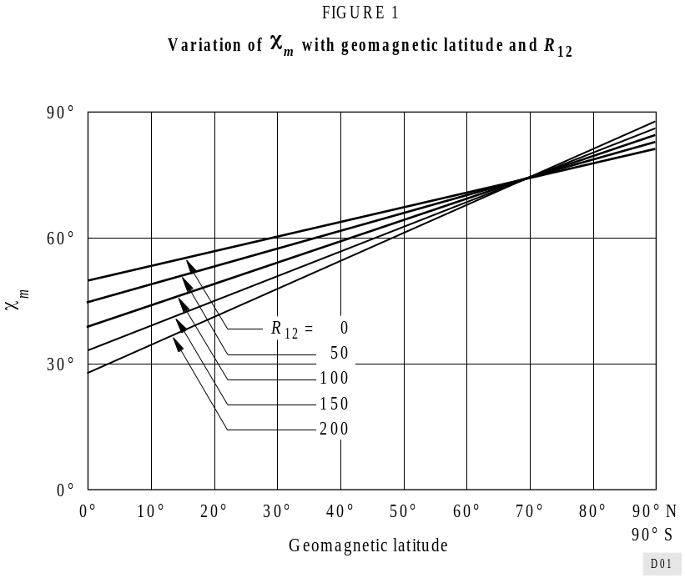
FIGURE 1...[D01] = 8 CM
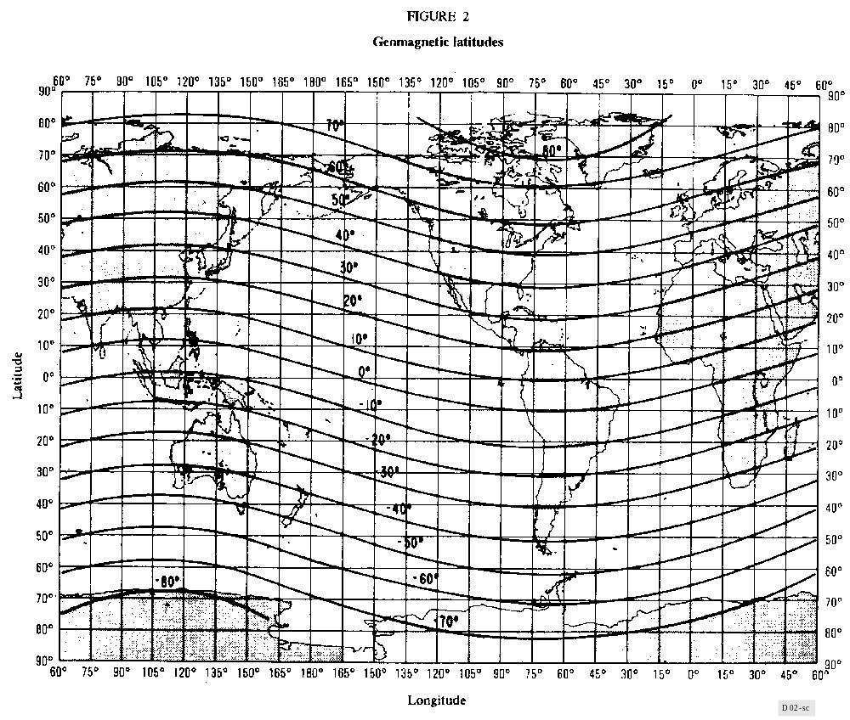
FIGURE 2...[D02] = 15 CM

6 Prediction of foEs and fbEs
A set of numerical coefficients defining the diurnal, geographical and monthly variations of the medians and upper and lower deciles of the foEs for a year of minimum and one of maximum solar activity, and a set of numerical coefficients defining the variations of the medians and upper and lower deciles of the fbEs (blanketing sporadic-E) for a year of minimum solar activity have been derived.

7 Prediction of h′F and h′F,F2
Numerical maps have been developed on a monthly basis for years of maximum and minimum solar activity of monthly median h′F, which is the minimum observed virtual height of reflection of vertical incidence signals from the F region (generally from the F2 layer at night and from the F1 layer in the daytime). Numerical maps have also been developed for years of maximum and minimum solar activity of h′F,F2. h′F,F2 is the combination of the minimum observed virtual height of reflection of vertical-incidence signals from both the F layer at night and the F2 layer in the daytime.

8 Prediction of the percentage of occurrence of spread-F
The percentage occurrence of spread-F has been determined from the ionospheric data from the world network of vertical-incidence ionosonde stations on a monthly basis for a year representative of high solar activity and for a year of low solar activity, and values have been represented numerically by means of a mapping technique.

9 Available computer programs and reference data
The ITU/BR Catalogue for Radio Spectrum Management lists available programs and reference data for evaluation by microcomputer of the ionospheric characteristics noted above. The program WOMAP displays for locations in a specified geographic area, the values of the chosen ionospheric characteristic, for a given Universal Time, month and solar epoch. The complementary program HRMNTH displays the chosen ionospheric characteristic for a given location and year, as a function of the Universal Time, for each month and the associated solar epoch.

ANNEX 2
Prediction of basic and operational MUFs

1 Introduction
Empirical formulae are presented for the evaluation of the monthly median basic MUF for the propagation path.
This MUF is estimated as the greatest of the basic MUF values for the propagation modes appropriate to the path length being considered.
The relationship between the operational MUF and basic MUF is given and a computer program is described leading to estimates of path basic MUF, operational MUF and optimum working frequency on a point-to-point propagation path of any length.

2 Mode consideration
The modes considered are:
1F2 0 to dmax
Higher order F2 modes beyond dmax
1F1 2 000-3 400 km
1E 0-2 000 km
2E 2 000-4 000 km
where the maximum ground range dmax (km) for a single hop F2 mode is given by:

with:

and x = foF2/foE, or 2 whichever is the larger.
Ionospheric characteristics for the mid-point of the great-circle path are used.

3 Prediction of F2-layer basic MUF

3.1 Ground distance D up to dmax
The F2-layer basic MUF is given by:

where:
fH : appropriate gyrofrequency (see Annex 1)
and:

with Z = 1 – 2D/dmax
C3000 : value of CD for D = 3 000 km where D is the great-circle distance (km).
The above formulae apply for the basic MUF for the x-wave at zero distance, for the o-wave at dmax and beyond and for some composite waves at intermediate distances. The corresponding o-wave basic MUF is given for all distances by deleting the last term in fH from the first formula.

3.2 Ground distance D greater than dmax
Values of F2(dmax)MUF are determined for two control-point locations at d0/2 from each terminal along the connecting great-circle path where d0 is the hop-length of the lowest order F2 mode. The path MUF is the lower of the two values.

4 Prediction of F1-layer basic MUF
Ionospheric propagation via the F1-layer is important for transmission distances in the 2 000-3 400 km range at mid and high latitudes during the summer months. For these transmission distances the F1-layer basic MUF is taken as the product of the mid-path value of foF1 (see Annex 1) and the M factor MF1. This M factor was derived from ray-tracing calculations on electron density versus height profiles obtained from representative noon ionograms recorded at mid and
high latitudes. It is assumed that these factors are applicable for all solar zenith angles. The M factor can be determined from the following numerical expressions:

where:

and where R12 is between 0 and 150 and D represents the great-circle distance in kilometres in the range of 2 000-3 400 km.

5 Prediction of E-layer basic MUF

5.1 Ground distance up to 2 000 km
Ionospheric propagation via a single reflection from the E-layer is important over distances up to 2 000 km. The E-layer basic MUF of a particular mode may be estimated as the product of the mid-path value of foE (see Annex 1) and the M factor ME. This M factor based on ray-path calculations for a parabolic model E-layer with hmE = 110 km, ymE = 20 km, when effects of the Earth’s magnetic field are neglected, is given by:

where:

and D represents the great-circle distance (km).

5.2 Ground distance between 2 000 and 4 000 km
The 2E MUF, for ranges between 2 000 and 4 000 km, is taken as E(2000)MUF expressed in terms of the mid-path foE.

6 Prediction of the operational MUF
For prediction purposes the operational MUF (see Recommendation ITU-R P.373) when determined by an F2-mode is expressed in terms of the basic MUF for different seasons, times of day and transmitter radiated power as shown in Table 2. Use of entries appropriate to mid-path conditions is suggested. When the operational MUF is determined by an E or F1 mode it is taken equal to the corresponding basic MUF.
TABLE 2
Ratio of the median operational MUF to the median
basic MUF for an F2-mode, Rop

 | Summer |  | Equinox |  | Winter
Equivalent isotropically  radiated power  (dBW) | Night | Day | Night | Day | Night | Day
≤ 30 | 1.20 | 1.10 | 1.25 | 1.15 | 1.30 | 1.20
> 30 | 1.25 | 1.15 | 1.30 | 1.20 | 1.35 | 1.25

7 Prediction of the optimum working frequency
The FOT (Recommendation ITU-R P.373) is estimated in terms of the operational MUF using the conversion factor Fl set equal to 0.95 if the path basic MUF is determined by an E or F1 mode and as given in Table 3 if the path basic MUF is determined by an F2 mode.
TABLE 3
Ratio Fl of FOT to operational MUF when determined by an F2-mode
a) R12 less than 50 as a function of season, mid-path local time t and mid-path geographic latitude λ (North or South of equator)

t  λ | 22-02 | 02-06 | 06-10 | 10-14 | 14-18 | 18-22
> 75°  65-75°  55-65°  45-55°  35-45°  25-35°  15-25°  < 15° | 0.60  0.68  0.74  0.79  0.81  0.81  0.78  0.71 | 0.65  0.71  0.76  0.78  0.79  0.74  0.67  0.70 | 0.69  0.75  0.80  0.83  0.85  0.86  0.87  0.88 | 0.72  0.76  0.80  0.85  0.87  0.82  0.75  0.86 | 0.68  0.75  0.82  0.84  0.89  0.85  0.77  0.87 | 0.67  0.70  0.73  0.76  0.77  0.78  0.79  0.79 | W  i  n  t  e  r
> 75°  65-75°  55-65°  45-55°  35-45°  25-35°  15-25°  < 15° | 0.67  0.70  0.73  0.75  0.77  0.78  0.77  0.76 | 0.72  0.75  0.78  0.80  0.81  0.80  0.75  0.66 | 0.74  0.76  0.80  0.81  0.81  0.82  0.83  0.86 | 0.73  0.74  0.75  0.76  0.77  0.78  0.81  0.89 | 0.80  0.82  0.81  0.81  0.80  0.81  0.83  0.86 | 0.65  0.69  0.73  0.76  0.78  0.74  0.69  0.75 | E  q  u  i  n  o  x
> 75°  65-75°  55-65°  45-55°  35-45°  25-35°  15-25°  < 15° | 0.68  0.70  0.72  0.75  0.79  0.79  0.77  0.74 | 0.79  0.81  0.84  0.85  0.85  0.82  0.78  0.75 | 0.84  0.83  0.83  0.82  0.80  0.78  0.77  0.80 | 0.87  0.86  0.84  0.83  0.82  0.80  0.79  0.83 | 0.85  0.86  0.86  0.85  0.83  0.81  0.79  0.82 | 0.76  0.77  0.81  0.84  0.85  0.80  0.73  0.69 | S  u  m  m  e  r
b) R12 greater than or equal to 50 and less than or equal to 100 as a function of season, mid-path local time t and mid-path geographic latitude λ (North or South of equator)

Winter: November, December, January, February in the Northern Hemisphere
and May, June, July, August in the Southern Hemisphere.
t  λ | 22-02 | 02-06 | 06-10 | 10-14 | 14-18 | 18-22
> 75°  65-75°  55-65°  45-55°  35-45°  25-35°  15-25°  < 15° | 0.76  0.79  0.82  0.84  0.83  0.78  0.74  0.77 | 0.78  0.81  0.83  0.82  0.81  0.76  0.71  0.69 | 0.68  0.74  0.79  0.83  0.85  0.85  0.85  0.87 | 0.67  0.70  0.75  0.81  0.86  0.85  0.83  0.86 | 0.62  0.73  0.80  0.84  0.86  0.85  0.82  0.85 | 0.70  0.73  0.76  0.78  0.79  0.78  0.76  0.78 | W  i  n  t  e  r
> 75°  65-75°  55-65°  45-55°  35-45°  25-35°  15-25°  < 15° | 0.64  0.68  0.70  0.73  0.75  0.77  0.75  0.79 | 0.61  0.71  0.75  0.77  0.78  0.76  0.73  0.68 | 0.73  0.77  0.80  0.81  0.82  0.82  0.84  0.86 | 0.74  0.74  0.72  0.74  0.78  0.83  0.87  0.89 | 0.74  0.78  0.78  0.76  0.76  0.78  0.81  0.84 | 0.67  0.70  0.73  0.75  0.76  0.72  0.69  0.80 | E  q  u  i  n  o  x
> 75°  65-75°  55-65°  45-55°  35-45°  25-35°  15-25°  < 15° | 0.82  0.83  0.83  0.81  0.78  0.77  0.77  0.79 | 0.80  0.82  0.82  0.81  0.78  0.83  0.69  0.63 | 0.82  0.79  0.77  0.76  0.75  0.75  0.78  0.84 | 0.85  0.82  0.79  0.77  0.78  0.79  0.82  0.85 | 0.80  0.82  0.82  0.81  0.78  0.77  0.78  0.81 | 0.79  0.82  0.83  0.82  0.78  0.74  0.73  0.77 | S  u  m  m  e  r
Summer: May, June, July, August in the Northern Hemisphere
and November, December, January, February in the Southern Hemisphere.
Equinox: March, April, September, October in both hemispheres.

TABLE 3 (continued)
c) R12 greater than 100 as a function of season, mid-path local time t and mid-path geographic latitude λ (North or South of equator)

Winter: November, December, January, February in the Northern Hemisphere
and May, June, July, August in the Southern Hemisphere.
t  λ | 22-02 | 02-06 | 06-10 | 10-14 | 14-18 | 18-22
> 75°  65-75°  55-65°  45-55°  35-45°  25-35°  15-25°  < 15° | 0.62  0.69  0.77  0.83  0.86  0.83  0.78  0.83 | 0.70  0.74  0.78  0.80  0.81  0.76  0.70  0.76 | 0.74  0.77  0.81  0.84  0.87  0.89  0.89  0.89 | 0.67  0.72  0.80  0.87  0.90  0.90  0.89  0.90 | 0.64  0.72  0.79  0.84  0.87  0.88  0.89  0.89 | 0.73  0.78  0.82  0.86  0.87  0.86  0.83  0.84 | W  i  n  t  e  r
> 75°  65-75°  55-65°  45-55°  35-45°  25-35°  15-25°  < 15° | 0.66  0.67  0.69  0.73  0.79  0.81  0.81  0.80 | 0.67  0.71  0.75  0.78  0.82  0.82  0.77  0.79 | 0.75  0.73  0.71  0.70  0.75  0.87  0.89  0.86 | 0.66  0.70  0.71  0.72  0.78  0.87  0.92  0.90 | 0.70  0.70  0.71  0.74  0.80  0.87  0.90  0.90 | 0.72  0.72  0.72  0.73  0.84  0.86  0.85  0.82 | E  q  u  i  n  o  x
> 75°  65-75°  55-65°  45-55°  35-45°  25-35°  15-25°  < 15° | 0.73  0.75  0.77  0.79  0.80  0.81  0.81  0.80 | 0.74  0.75  0.76  0.76  0.76  0.76  0.77  0.79 | 0.82  0.77  0.74  0.73  0.75  0.82  0.85  0.86 | 0.83  0.80  0.77  0.75  0.75  0.81  0.86  0.89 | 0.79  0.80  0.80  0.80  0.79  0.79  0.81  0.85 | 0.75  0.77  0.80  0.84  0.84  0.83  0.80  0.78 | S  u  m  m  e  r
Summer: May, June, July, August in the Northern Hemisphere
and November, December, January, February in the Southern Hemisphere.
Equinox: March, April, September, October in both hemispheres.

8 Computer program
The procedures described in this Annex are implemented in the computer program MUFFY, which predicts basic MUF, operational MUF and optimum working frequency as a function of time of day, for given propagation path, month and sunspot number.

ANNEX 3
Prediction of ray path
For a simplified estimation of oblique ray paths, reflection may be assumed to take place from an effective plane mirror located at height hr.
In the following:

with:
and y = x or 1.8, whichever is the larger.
a) For x > 3.33 and xr = f / foF2 ≥ 1, where f is the wave frequency
hr = h or 800 km, whichever is the smaller
where: h = A1 + B1 2.4–a for B1 and a ≥ 0
= A1 + B1 otherwise
with A1 = 140 + ( H – 47) E1
B1 = 150 + ( H – 17) F1 – A1
E1 = – 0.09707 xr3 + 0.6870 xr2 – 0.7506 xr + 0.6
F1 is such that:
F1 = – 1.862 xr4 + 12.95 xr3 – 32.03 xr2 + 33.50 xr – 10.91 for xr ≤ 1.71
F1 = 1.21 + 0.2 xr for xr > 1.71
and a varies with distance d and skip distance ds as
a = (d – ds) / ( H + 140)
where: ds = 160 + (H + 43) G
G = – 2.102 xr4 + 19.50 xr3 – 63.15 xr2 + 90.47 xr – 44.73 for xr ≤ 3.7
G = 19.25 for xr > 3.7

b) For x > 3.33 and xr < 1
hr = h or 800 km, whichever is the smaller
where: h = A2 + B2 b for B2 ≥ 0
= A2 + B2 otherwise
with A2 = 151 + ( H – 47) E2
B2 = 141 + ( H – 24) F2 – A2
E2 = 0.1906 Z 2 + 0.00583 Z + 0.1936
F2 = 0.645 Z 2 + 0.883 Z + 0.162
where: Z = xr or 0.1, whichever is the larger and b varies with normalized distance df, Z and H as follows:
b = – 7.535 df 4 + 15.75 df 3 – 8.834 df 2 – 0.378 df + 1
where:

c) For x ≤ 3.33
hr = 115 + H J + U d or 800 km, whichever is the smaller
with J = – 0.7126 y3 + 5.863 y2 – 16.13 y + 16.07
and U = 8 × 10–5 ( H – 80) (1 + 11 y –2.2) + 1.2 × 10–3 H y –3.6

* Computer programs associated with the prediction procedures and data described in this Recommendation are available from the ITU (see § 9 of Annex 1 and § 8 of Annex 2); for details see the ITU/BR Catalogue of Software for Radio Spectrum Management. ** For definitions, see Recommendation ITU-R P.373.
*

