Recommendation ITU-R P.371-9
(08/2023)
P Series: Radiowave propagation
Choice of indices for long-term ionospheric predictions

Foreword
The role of the Radiocommunication Sector is to ensure the rational, equitable, efficient and economical use of the radio-frequency spectrum by all radiocommunication services, including satellite services, and carry out studies without limit of frequency range on the basis of which Recommendations are adopted.
The regulatory and policy functions of the Radiocommunication Sector are performed by World and Regional Radiocommunication Conferences and Radiocommunication Assemblies supported by Study Groups.

Policy on Intellectual Property Right (IPR)
ITU-R policy on IPR is described in the Common Patent Policy for ITU-T/ITU-R/ISO/IEC referenced in Resolution ITU-R 1. Forms to be used for the submission of patent statements and licensing declarations by patent holders are available from http://www.itu.int/ITU-R/go/patents/en where the Guidelines for Implementation of the Common Patent Policy for ITU-T/ITU-R/ISO/IEC and the ITU-R patent information database can also be found.

Series of ITU-R Recommendations
(Also available online at https://www.itu.int/publ/R-REC/en)
Series | Title
BO | Satellite delivery
BR | Recording for production, archival and play-out; film for television
BS | Broadcasting service (sound)
BT | Broadcasting service (television)
F | Fixed service
M | Mobile, radiodetermination, amateur and related satellite services
P | Radiowave propagation
RA | Radio astronomy
RS | Remote sensing systems
S | Fixed-satellite service
SA | Space applications and meteorology
SF | Frequency sharing and coordination between fixed-satellite and fixed service systems
SM | Spectrum management
SNG | Satellite news gathering
TF | Time signals and frequency standards emissions
V | Vocabulary and related subjects

Note: This ITU-R Recommendation was approved in English under the procedure detailed in Resolution ITU-R 1.

Electronic Publication
Geneva, 2023

© ITU 2023
All rights reserved. No part of this publication may be reproduced, by any means whatsoever, without written permission of ITU.

RECOMMENDATION ITU-R P.371-9
Choice of indices for long-term ionospheric predictions
(1963-1970-1974-1978-1982-1986-1990-1995-1999-2023)
Scope
This Recommendation provides a series of relations to compute long-term ionospheric indices that are used for prediction of ionospheric characteristics.
Keywords
Ionospheric characteristics, solar radio noise flux, sun-spot number, M(3000)F2
Abbreviations/Glossary
MUF: Maximum usable frequency
R12: 12-month running mean sunspot number
Φ: Solar radio noise flux at about 10 cm wavelength
Φ₁₂: 12-month running mean value of Φ, the 2 800 MHz solar radio noise flux (i.e.)
The ITU Radiocommunication Assembly,
recommends
1 that the 12-month running mean sunspot number R12, or alternatively the 12-month running mean value of Φ, the 2 800 MHz solar radio noise flux (i.e. Φ₁₂), be adopted as the preferred index to be used for predicting monthly median values of foF2 and M(3000)F2 over all time-scales: substantially equivalent results should be obtainable by the use of either of these indices;
2 that Φ12 be adopted as the preferred index to be used for predicting monthly median values of foE and foF1 over all time-scales;
3 that predicted values of these indices should be determined by means of the modified McNish-Lincoln procedure (see Annex 1) using latest available measured monthly index values for the present solar cycle and the average of past cycle values for future cycles;
4 that where propagation predictions require simultaneous use of values of different ionospheric characteristics, the same index may be adopted for all such characteristics with little loss of accuracy;
5 that caution be shown in the use of the recommended indices at high magnetic latitudes, where the resulting ionospheric predictions may not be sufficiently accurate;
6 that caution be shown in the use of R12 indices for long-term ionospheric predictions with regards to the observatory factor.

Annex 1

1 Introduction
The concept of indices for long-term ionospheric predictions relies on the assumption that the important characteristics of the ionosphere, such as the critical frequencies of the various layers and the MUF factor M(3000)F2, depend in a systematic way on certain measurable quantities concerned with solar radiation. It should however be noted that the correlation between these indices and the actual ionospheric characteristics does not necessarily imply a causal relationship, but rather an indication of associated phenomena. Changes of solar activity in general contain three components:
– a fairly regular component with a period of about eleven years, which represents the well-known cycle of solar activity;
– a component that has a quasi-period of about a year or a little less; and
– erratic fluctuations with periods of less than a month.

2 Sunspot numbers
Solar activity can be quantified by counting the number of spots appearing on the surface of the Sun. An index called “relative number of sunspots” (or “Wolf number” or “Zürich number”) is used to quantify the number of sunspots and groups of sunspots on the surface of the Sun. Before 2015, the standard definition of the relative sunspot number, R, for each individual observer was:
$R = k(10N_{g}+N_{s})$ (1)
where N_{g} is the number of sunspot groups, N_{s} is the number of individual spots within those groups, and k is a normalization factor defined as 0.6 before 2015. This definition of the sunspot number with k = 0.6 is named version 1 (v1).
In 2015, the k factor has been set to 1, defining a version 2 (v2) of the sunspot number. As the numerical maps defining the diurnal and geographical variations of the monthly median of foF2 and M(3000)F2 are based on a linear relationship of the relative sunspot number with k = 0.6 (version 1), it is recommended to set k factor to 0.6 in the sunspot number definition when these maps are used.
In order to use the new databases (as for 2015) of R₁₂, the users should apply the following correction:
$R_{v1}=R_{v2}×0.6$ (2)
Notice that the World Data Center SILSO has recomputed all historical values of the sunspot number so that it matches version 2. This is the default option.
For studies of the main component of the solar cycle, the 12-month running mean sunspot number R12 is used because the resultant smoothing considerably reduces complicated rapidly-varying components, but does not obscure the slowly-varying component.
The definition of R12 is:
$R_{12}=\frac{1}{12}\left[\sum_{n-5}^{n+5}{R_{i}+\frac{1}{2}\left(R_{n+6}+R_{n-6}\right)}\right]$ (3)
in which Ri is the mean of the daily sunspot numbers for a single month i, and R12 is the smoothed index for the month represented by i = n.
The two main disadvantages in the use of R12 are:
– the most recent available value is necessarily centred on a month at least six months earlier than the present time;
– it cannot be used to predict the shorter-term variation in solar activity.
Nonetheless, R12 appears to be the most useful parameter for long-term studies and predictions concerning the F2 layer. Unless otherwise specified, R12 must be used in its version 1 (i.e. R₁₂ computed from R with k = 0.6).

3 Index Φ
Consistent and reasonably long series of observations of the solar radio noise flux at about 10 cm wavelength have been made by Canadian, Japanese and other laboratories. The monthly mean, Φ, of the daily values from Canada, expressed in units of 10–22 Wm–2 Hz–1, should be regarded as the reference data for this index. Φ is more closely correlated with E-layer critical frequency than are noise flux values at other wavelengths. As the solar flux observations are only available from 1947, the sunspot numbers remain one of the longest series of observations of a natural phenomenon. Therefore, the continued collection and recording of sunspot observations is encouraged.

4 Other indices
Over past years, a substantial number of different indices have been considered to try to represent long-term changes of the different ionospheric characteristics, but of these the ITU-R recommends the indices R12 and Φ12 for ionospheric predictions.

5 Correlation between Φ12 and R12
The recommended relationship between R12 and Φ12, also indicated in Fig. 1, is:
$Φ_{12}=63.7+0.728 R_{12}+8.9×{10}^{-4}R_{12}^{2}$ (4)

6 The prediction of indices
There is as yet no method whereby it is possible to predict accurately indices for the next sunspot cycle, or, more generally, for a cycle which has not yet begun. Indices that have been calculated by using harmonic analysis, or by using empirical and statistical laws applied to observations over some earlier and even recent cycles, have not proved useful in predicting those for a new cycle. After a sunspot minimum has been observed, future development of the cycle can be extrapolated to a certain extent, although the deviations have been observed to be rather extreme.
In the United States of America, R12 is predicted using an improvement of the McNish-Lincoln objective method. First a mean cycle is computed from all past values of R12 starting from the sunspot minimum of each cycle and continuing eleven years thereafter. For prediction of a value in the current cycle, the first approximation is the value of the mean cycle at the stated time after minimum. This estimate is improved by adding a correction proportional to the departure of the last observed value for the current cycle from the mean cycle. With the current computer programs, a new prediction for each month of the remainder of the cycle can be made as soon as a new observed value becomes available. The statistical uncertainty of the prediction is fairly small for the first few months after the last observed value, but becomes large for predictions 12 months or more in advance. As soon as a minimum is identified, new correction factors can be computed by including the observed values for the preceding cycle, for application to the new cycle.
figure 1
Relationship between R12 and Φ12
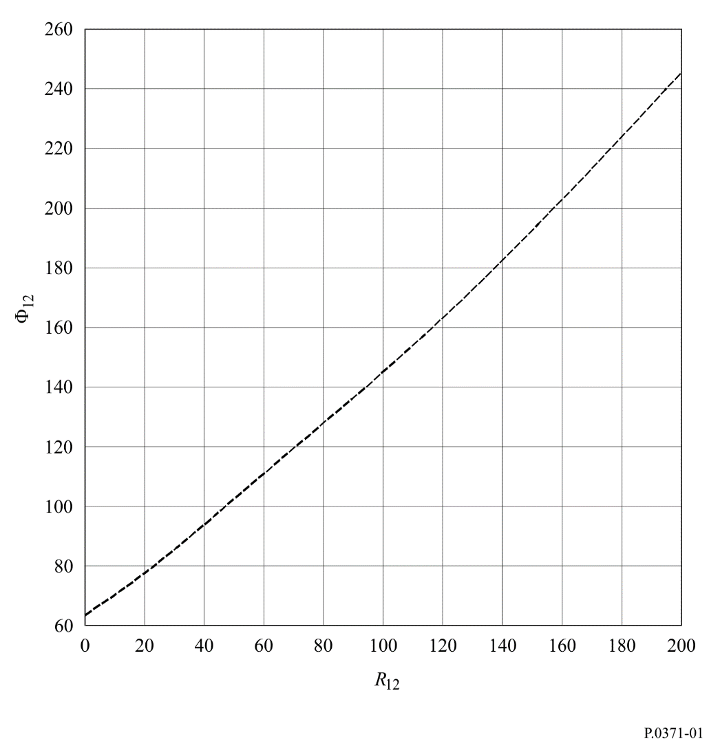
Predictions of R12 for one year ahead are also carried out by the Sunspot Index Data Centre (SIDC) in Brussels. An example of their predictions, for solar cycle 22, is shown in Fig. 2 and can be compared with the observed smoothed values.
Predictions of Φ12, based on the McNish-Lincoln method, are carried out by the Radiocommunication Bureau (BR).
Measured and predicted values of R and Φ and their 12-month running mean values (R12 and Φ12) are published by the BR in the monthly Circular of Basic Indices for Ionospheric Propagation (and are also posted on the worldwide website of the ITU).
The SIDC also makes available, via electronic mail, the measured and predicted values of R, with access through the file transfer protocol anonymous procedure.
figure 2
An example of predicted and observed sunspot numbers, R12 (cycle 22)
