Recommendation ITU-R P.341-7
(08/2019)
The concept of transmission loss
for radio links

P Series
Radiowave propagation

Foreword
The role of the Radiocommunication Sector is to ensure the rational, equitable, efficient and economical use of the radio-frequency spectrum by all radiocommunication services, including satellite services, and carry out studies without limit of frequency range on the basis of which Recommendations are adopted.
The regulatory and policy functions of the Radiocommunication Sector are performed by World and Regional Radiocommunication Conferences and Radiocommunication Assemblies supported by Study Groups.

Policy on Intellectual Property Right (IPR)
ITU-R policy on IPR is described in the Common Patent Policy for ITU-T/ITU-R/ISO/IEC referenced in Resolution ITU-R 1. Forms to be used for the submission of patent statements and licensing declarations by patent holders are available from http://www.itu.int/ITU-R/go/patents/en where the Guidelines for Implementation of the Common Patent Policy for ITU-T/ITU-R/ISO/IEC and the ITU-R patent information database can also be found.

Series of ITU-R Recommendations
(Also available online at http://www.itu.int/publ/R-REC/en)
Series | Title
BO | Satellite delivery
BR | Recording for production, archival and play-out; film for television
BS | Broadcasting service (sound)
BT | Broadcasting service (television)
F | Fixed service
M | Mobile, radiodetermination, amateur and related satellite services
P | Radiowave propagation
RA | Radio astronomy
RS | Remote sensing systems
S | Fixed-satellite service
SA | Space applications and meteorology
SF | Frequency sharing and coordination between fixed-satellite and fixed service systems
SM | Spectrum management
SNG | Satellite news gathering
TF | Time signals and frequency standards emissions
V | Vocabulary and related subjects

Note: This ITU-R Recommendation was approved in English under the procedure detailed in Resolution ITU-R 1.

Electronic Publication
Geneva, 2019

© ITU 2019
All rights reserved. No part of this publication may be reproduced, by any means whatsoever, without written permission of ITU.

RECOMMENDATION ITU-R P.341-7*, **
The concept of transmission loss for radio links
(1959-1982-1986-1994-1995-1999-2016-2019)
Scope
This Recommendation provides the definitions and associated symbols that describe the main and subsidiary terms of a radio link composed of a transmitter, receiver, antennas, associated circuits, and propagation effects.
Keywords
Radio Link, antenna parameters, loss, environment influence
The ITU Radiocommunication Assembly,
considering
a) that in a radio link between a transmitter and a receiver, the ratio between the power supplied by the transmitter and the power available at the receiver input depends on several factors such as the losses in the antennas or in the transmission feed lines, the attenuation due to the propagation factors, the losses due to faulty adjustment of the impedances or polarization, etc.;
b) that it is desirable to standardize the terminology and notations employed to characterize transmission loss and its components;
c) that Recommendation ITU-R P.525 provides the free-space reference conditions for propagation,
recommends
that, to describe the characteristics of a radio link involving a transmitter, a receiver, their antennas, the associated circuits and the propagation medium, the following terms, definitions and notations should be employed:

1 Main terms

1.1 Free-space basic transmission loss (symbols: L_{bf} or A_{bf})
The ratio, usually expressed in decibels, for a radio link between the power radiated by the transmitting antenna and the power that would be available at a conjugately matched receiver antenna input if the actual antennas were replaced by loss free isotropic antennas located in a perfectly dielectric, homogeneous, isotropic and unlimited environment, the distance between the antennas being retained (see Recommendation ITU-R P.525).
NOTE – If the distance d between the antennas is much greater than the wavelength λ, the free-space attenuation in decibels will be:
Lbf = 20 log $\left(\frac{4p d}{l}\right)$ dB (1)

1.2 Basic transmission loss (of a radio link) (symbols: L_{b} or A_{b})
The ratio, usually expressed in decibels, for a radio link between the power radiated by the transmitting antenna and the power that would be available at a conjugately matched receiver antenna input if the antennas were replaced by isotropic antennas with the same polarization as the real antennas, including the attenuation effects on the propagation path, but with the effects of obstacles close to the antennas being disregarded.
𝐿_{𝑏}=𝐿_{𝑏𝑓} + 𝐿_{𝑚} dB (2)
where L_{m} is the loss relative to free space (symbols: L_{m} or A_{m}).
NOTE – The loss relative to free space, L_{m}, may be divided into losses of different types, such as:
– absorption loss (ionospheric or atmospheric gases, precipitation, clouds, etc.);
– diffraction loss as for ground waves;
– effective reflection or scattering loss as in the ionospheric case including the results of any focusing or defocusing due to curvature of a reflecting layer;
– polarization coupling loss; this can arise from any polarization mismatch between the antennas for the particular ray path considered;
– aperture-to-medium coupling loss or antenna gain degradation, which may be due to the presence of substantial scatter phenomena on the path;
– beam spreading loss;
– effect of wave interference between the direct ray and rays reflected from the ground, other obstacles or atmospheric layers;
– clutter loss;
– building entry loss.

1.3 Transmission loss (of a radio link) (symbols: L or A)
The ratio, usually expressed in decibels, for a radio link between the power radiated by the transmitting antenna and the power that would be available at a conjugately matched receiver antenna input if actual antenna radiation patterns are substituted with no losses in the radio-frequency circuits.
NOTE 1 – The transmission loss may be expressed by:
$L=L_{b}- G_{t}-G_{r}$dB (3)
where Gt and Gr are the directivity gains (see Annex 1) of the transmitting and receiving antennas, respectively, in the direction of propagation.
NOTE 2 – The effect of the local ground close to the antenna is included in computing the antenna gain, but not in the basic transmission loss.

1.4 System loss (symbols: Ls or As)
The ratio, usually expressed in decibels, for a radio link of the radio-frequency power input to the terminals of the transmitting antenna and the resultant radio-frequency signal power available at the terminals of the receiving antenna.
$L_{s}=L+L_{tc}+ L_{rc}$dB (4)
where Ltc and Lrc are the losses, expressed in decibels, in the transmitting and receiving antennas circuits respectively, excluding the dissipation associated with the antennas radiation, i.e. the definitions of Ltc and Lrc are 10 log (r'/r), where r' is the resistive component of the antenna circuit and r is the radiation resistance.
NOTE 1 – The available power is the maximum real power which a source can deliver to a load, i.e. the power which would be delivered to the load if the impedances were conjugately matched.
NOTE 2 – The system loss may be also expressed by:
Ls = 10 log ( pt /pa) = Pt – Pa dB (5)
where:
pt : radio-frequency power input to the terminals of the transmitting antenna
pa : resultant radio-frequency signal power available at the terminals of the receiving antenna.
NOTE 3 – The system loss excludes losses in feeder lines but includes all losses in radio-frequency circuits associated with the antenna, such as ground losses, dielectric losses, antenna loading coil losses, and terminating resistor losses.

1.5 Total loss (of a radio link) (symbols: Ll or Al)
The ratio, usually expressed in decibels, between the power supplied by the transmitter of a radio link and the power supplied to the corresponding receiver in real installation, propagation and operational conditions. This is determined at the input or at the output of the transmitting and receiving antenna feed lines. The feed lines may include radio-frequency filters or multiplexers.
figure 1
Graphical depiction of terms used in the transmission loss concept

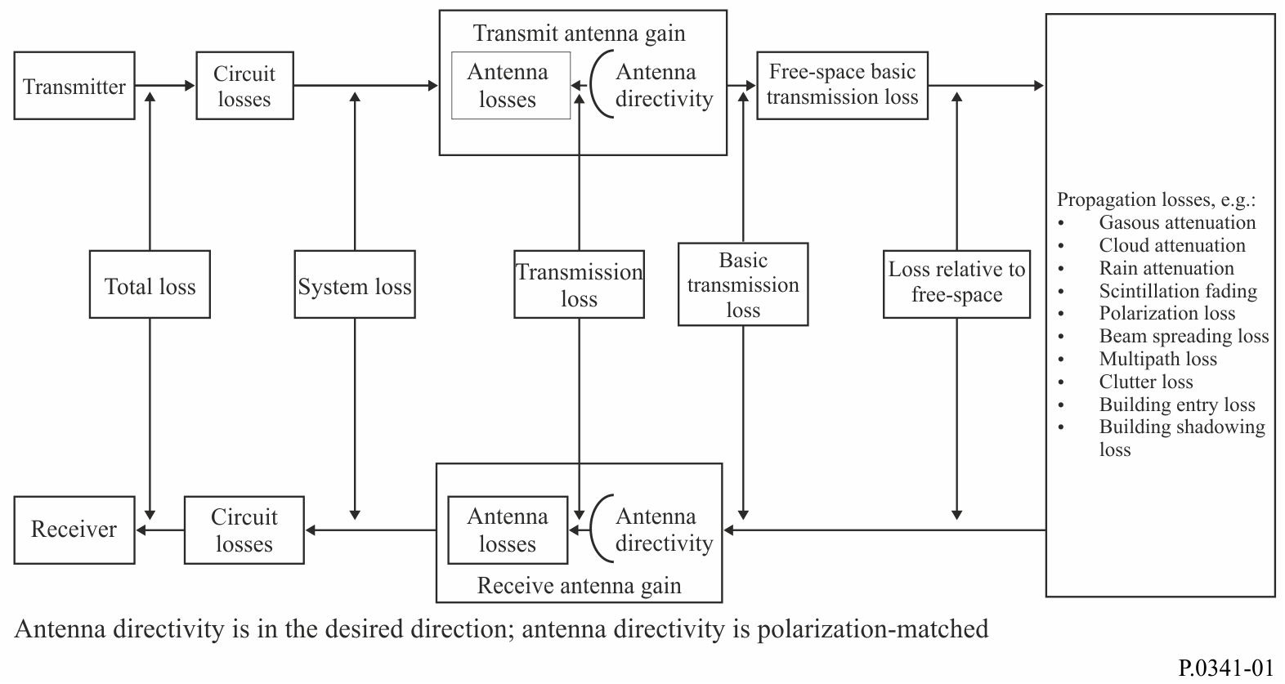

2 Subsidiary term

2.1 Ray path transmission loss (symbols: Lt or At)
The transmission loss for a particular ray propagation path taking into account the antenna gains in that ray path direction (see Annex 1). The use of this term is restricted to those cases, for example for multipath propagation, where several propagation ray paths are considered separately.
NOTE – The ray path transmission loss may be expressed by:
Lt = Lb − Gtp − Grp dB (6)
where Gtp and Grp are the plane-wave directive gains (see Annex 1) of the transmitting and receiving antennas for the directions of propagation and polarization considered.

Annex 1

1 Antenna directivity
Directivity in a given direction is defined as the ratio of the intensity of radiation (the power per unit solid angle (steradian)), in that direction, to the radiation intensity averaged over all directions.
When converting transmission loss, or, in specific cases, ray path transmission loss to basic transmission loss the plane wave directivities for the transmitting and receiving antennas at the particular direction and polarization must be taken into account. In cases where the performance of the antenna is influenced by the presence of local ground or other obstacles (which do not affect the path) the directivity is the value obtained with the antenna in situ.
In the particular case of ground wave propagation with antennas located on or near the ground, although the directivity of the receiving antenna, Gr , is determined by the above definition, the aperture for signal capture, and hence the available power, is reduced below its free-space value. Thus the value to be used for Gr must be reduced (see Annex 2).

2 Antenna gain
The power gain of an antenna is defined as the ratio, usually expressed in decibels, of the power required at the input of a loss-free reference antenna to the power supplied to the input of the given antenna to produce, in a given direction, the same field strength or the same power flux-density (pfd) at the same distance. When not specified otherwise, the gain refers to the direction of maximum radiation. The gain may be considered for a specified polarization.

3 Reference standard antennas
In the study of propagation over radio links in different frequency bands, a number of reference antennas are used and referred to in ITU-R texts.
Depending on the choice of the reference antenna a distinction is made between:
– absolute or isotropic gain (Gi), when the reference antenna is an isotropic antenna isolated in space;
– gain relative to a half-wave dipole (Gd), when the reference antenna is a half-wave dipole isolated in space, whose equatorial plane contains the given direction;
– gain relative to a short vertical antenna (Gv), when the reference antenna is a linear conductor much shorter than one quarter of the wavelength, normal to the surface of a perfectly conducting plane which contains the given direction.
(The power gain corresponds to the maximum directivity for lossless antennas.)
Table 1 gives the directivity, Gt, for some typical reference antennas. The corresponding values of the cymomotive force are also shown for a radiated power of 1 kW.
TABLE 1
Directivity for typical reference antennas and its relation to cymomotive force
Reference antenna | gt | Gt (1)  (dBi) | Cymomotive force for a radiated power of 1 kW  (V)
Isotropic in free space | 1 | 0 | 173
Hertzian dipole in free space | 1.5 | 1.75 | 212
Half-wave dipole in free space | 1.65 | 2.15 | 222
Hertzian dipole, or a short vertical monopole on a perfectly conducting ground (2) | 3 | 4.8 | 300
Quarter wave monopole on a perfectly conducting ground ⁽²⁾ | 3.3 | 5.2 | 314
⁽¹⁾ Gt = 10 log gt
The values of Gr (gr) equal the values of Gt (gt) for antennas in free space. See Annex 2 for values of Gr for antennas on a perfectly conducting ground.
⁽²⁾ In these cases, it is assumed that the antenna is near a perfectly conducting plane ground, so that radiation is confined to the half space above the ground.

Annex 2
pfd and field strength
Some radiocommunication applications use incident pfd or field strength to describe the limitations of service range.
The field strength, in decibels relative to one volt per metre, is given by:
$E=14.77+Q$ (7)
and the pfd, in decibels relative to one watt per square metre, is given by:
$S=-11.02+Q$ (8)
where:
$Q=G_{iT}-20\log{d-}L_{m}+10\log{p}- L_{tc}$ (9)
and
$E=20\log{e}$ (dB(V/m)) and e the field strength (V/m)
$S=10\log{s}$ (dB(W/m²)) and s the pfd (W/m²)
$G_{iT }$ transmitting antenna gain relative to an isotropic radiator (dB)
d distance from the transmitting antenna (m)
$L_{m }$ “loss relative to free space” as defined above
P transmitter power (W)
$L_{tc}$ transmitting antenna circuit loss (dB).

Annex 3
Influence of the environment on the antennas
When antennas are installed on or near the ground (i.e. h < λ, particularly when using frequencies less than 30 MHz) the free-space value of the antenna radiation resistance is modified by the presence of the ground. Consequently the pfd at the receiving antenna (resulting from the vector sum of direct and reflected rays) is dependent on the height of the transmitting antenna, and the effective capture area of the receiving antenna is dependent on the height of the antenna above the ground.
The influence of the environment on the operation of a pair of antennas (forming an elementary circuit) is illustrated by considering the transmission loss between two vertical loss-free short electric dipoles at heights ht and hr above a plane perfectly conducting surface. The separation, d, along the surface is very large compared to the wavelength λ.
1 The pfd s (W/m2) at height hr is given by:
(10)
where:
$p\begin{matrix}¢ \\ t\end{matrix}$ : power radiated by the transmitting antenna (W)
d, ht, hr, λ are expressed in metres;
k = $\frac{2p}{l}$

and
(11)
with Δt = 1, when ht = 0.
Equation (10) assumes that ht, hr and λ are all much less than d.
The following should be noted:
– the distance between the antennas is increased to d sec ψ,
– the electric field due to the dipole varies as cos ψ,
– the free-space radiation resistance is multiplied by (1 + Δt),
– due to the vector addition of the direct and reflected rays the free-space value of the power flux is multiplied by:

This is equivalent to the change in directivity due to the presence of the reflecting surface. The multiplying factor has the value of 2 when ht = hr = 0.
2 The effective capture area of the receiving antenna is given by:
(12)
where:
The following should be noted:
– since gt has the value 2 × 1.5 (by definition) when ht = hr = 0 it is important to note that this is not the appropriate value to use for gr; the correct value for gr is 1.5/2 = gt /4;
– the capture area in the direction of the transmitting antenna is multiplied by cos2 ψ due to directional effects;
– the change in radiation resistance is based on equation (11), where Δt and ht are replaced by Δr and hr;
– the free-space value of the capture area is multiplied by 1/(1 + Δr) by the presence of the reflecting plane; thus the presence of the reflecting plane reduces the capture area below its free-space value by a factor of 2 when ht = hr = 0.
3 Since the total power collected by the receiving antenna is given by $p\begin{matrix}' \\ a\end{matrix}$ = sae, equations (10) and (12) may be combined to give an expression for the transmission loss between two short vertical loss-free electric dipoles above a plane perfectly conducting surface.
$L = Lbf – 6.0 – 10 log \left[(1.5 cos2 y)2 \frac{cos2 (k ht sin_{}y)}{(1 + Dr) (1 + Dt)}\right]$ dB (13)
In the limiting cases where the antennas are short monopoles on the surface:
ht = hr = 0; Δt = Δr = 1; ψ = 0
L = Lbf – 3.5 dB

* This Recommendation should be brought to the attention of the Coordination Committee for Vocabulary (CCV).
** Radiocommunication Study Group 3 made editorial amendments to this Recommendation in the year 2023 in accordance with Resolution ITU-R 1.
Throughout this Recommendation, capital letters are used to denote the ratios (dB) of the corresponding quantities designated with lower-case type, e.g., Pt = 10 log pt. Pt is the input power to the transmitting antenna (dB) relative to 1 W when pt is the input power (W).
A graphical depiction of this and subsequent definitions is shown in Fig. 1.

