Recommendation ITU-R P.2170-0
(09/2025)
P Series: Radio-wave propagation
Propagation characteristics and prediction methods required for lunar radiocommunication

Foreword
The role of the Radiocommunication Sector is to ensure the rational, equitable, efficient and economical use of the radio-frequency spectrum by all radiocommunication services, including satellite services, and carry out studies without limit of frequency range on the basis of which Recommendations are adopted.
The regulatory and policy functions of the Radiocommunication Sector are performed by World and Regional Radiocommunication Conferences and Radiocommunication Assemblies supported by Study Groups.

Policy on Intellectual Property Right (IPR)
ITU-R policy on IPR is described in the Common Patent Policy for ITU-T/ITU-R/ISO/IEC referenced in Resolution ITU-R 1. Forms to be used for the submission of patent statements and licensing declarations by patent holders are available from https://www.itu.int/ITU-R/go/patents/en where the Guidelines for Implementation of the Common Patent Policy for ITU-T/ITU-R/ISO/IEC and the ITU-R patent information database can also be found.

Series of ITU-R Recommendations
(Also available online at https://www.itu.int/publ/R-REC/en)
Series | Title
BO | Satellite delivery
BR | Recording for production, archival and play-out; film for television
BS | Broadcasting service (sound)
BT | Broadcasting service (television)
F | Fixed service
M | Mobile, radiodetermination, amateur and related satellite services
P | Radio-wave propagation
RA | Radio astronomy
RS | Remote sensing systems
S | Fixed-satellite service
SA | Space applications and meteorology
SF | Frequency sharing and coordination between fixed-satellite and fixed service systems
SM | Spectrum management
SNG | Satellite news gathering
TF | Time signals and frequency standards emissions
V | Vocabulary and related subjects

Note: This ITU-R Recommendation was approved in English under the procedure detailed in Resolution ITU-R 1.

Electronic Publication
Geneva, 2025

© ITU 2025
All rights reserved. No part of this publication may be reproduced, by any means whatsoever, without written permission of ITU.

RECOMMENDATION ITU-R P.2170-0
Propagation characteristics and prediction methods required
for lunar radiocommunication
Question ITU-R 237/3
(2025)
Scope
This Recommendation provides methods that predict the attenuation relative to free-space and other radio-wave propagation characteristics described in Parts C and D of the Annex, needed for planning networks and systems operating on or near the lunar surface in the frequency range from 1 MHz to 37 GHz.
Keywords
Exosphere, regolith, bedrock, irregular lunar model (ILM)
Acronyms/Abbreviations/Glossary
LoS line-of-sight
Related ITU-R Recommendations
Recommendation ITU-R P.341 – The concept of transmission loss for radio links
Recommendation ITU-R P.525 – Calculation of free-space attenuation
Recommendation ITU-R P.618 – Propagation data and prediction methods required for the design of Earth-space telecommunication systems
NOTE – The latest edition of the Recommendation in force should be used.

The ITU Radiocommunication Assembly,
considering
a) that the lunar environment interacting with radio waves includes the lunar exosphere, regolith, and bedrock;
b) that, at frequencies above the exosphere plasma frequency, a maximum of approximately 220 kHz at the lunar surface, the lunar exosphere can be treated as free space;
c) that the characteristics of the complex relative permittivity of the lunar regolith and lunar bedrock is needed in characterizing several radio-wave propagation mechanisms in the lunar environment;
d) that radio-wave propagation in the lunar environment is needed in characterizing several radio-wave propagation mechanisms, including diffraction, reflection and scattering;
e) that radio-wave propagation in the lunar environment can be characterized by the attenuation statistics relative to free-space;
f) that the propagation characteristics of lunar point-to-area and point-to-point systems are necessary elements for radio-wave propagation prediction in the lunar environment,
recommends
that the Annex to this Recommendation should be considered to predict statistics of the attenuation relative to free-space for point-to-area and point-to-point systems operating on or near the lunar surface in the frequency range from 1 MHz to 37 GHz.

Annex
TABLE OF CONTENTS
Page
PART A – The Irregular Lunar Model (ILM): Point-to-area mode 4
A.1 Introduction 4
A.2 Functions $Gx$, $Fx,Κ$, $C1Κ$, and $BΚ$ 12
PART B – The irregular lunar model (ILM): Point-to-point mode 13
B.1 Introduction 13
B.2 Functions $Gx$, $Fx,Κ$, $C1Κ$, and $BΚ$ 20
PART C – Electrical characteristics of the surface of the Moon 22
C.1 Regolith complex relative permittivity 22
C.2 Lunar rock complex relative permittivity 26
C.3 Lunar regolith complex relative permeability 27
C.4 Complex relative permittivity of regolith and rock mixture 27
PART D – Prediction of other propagation losses 28
D.1 Free-space propagation loss 28
D.2 Propagation loss considering the atmosphere of the Earth 28

Introduction
This Annex is divided into the following four Parts:
– Part A: The Irregular Lunar Model (ILM): Point-to-area mode
– Part B: The Irregular Lunar Model (ILM): Point-to-point mode
– Part C: Electrical characteristics of the surface of the Moon
– Part D: Prediction of free-space propagation loss
The ILM predicts the median and statistical attenuation for point-to-area and point-to-point links on or near the lunar surface. The ‘point-to-area mode’ prediction method predicts the path attenuation between a transmitter and receiver over a specific area using statistical or general terrain characteristics. The ‘point-to-point mode’ prediction method predicts the path attenuation between specific transmitter and receiver locations using specific detailed terrain data and characteristics. In both cases, the transmit and receive antennas are assumed to be lossless linearly polarized (horizontal or vertical) isotropic antennas, and the receive antenna is assumed to be matched to the polarization of the incident signal. Depending on the antenna beamwidth and distance, the attenuation for systems with narrowbeam antennas may not be within the scope of this Recommendation. The attenuation for systems with circularly polarized antennas is not within the scope of this Recommendation.
Equation (a-18) calculates the median path attenuation for the point-to-area mode as a function of distance, and equation (b-16) calculates the median path attenuation for the point-to-point mode as a function of distance.
The attenuation relative to free-space that is not exceeded for the fraction of the area of interest for the point-to-area mode is calculated in § A.1.7, and the attenuation relative to free-space that is not exceeded for the fraction of equivalent terrain profiles for the point-to-point mode is calculated in § B.1.7. The function $A_{ref}\left(p\right)$ in the main function that predicts the attenuation relative to free-space. Other functions, such as $A_{diff}\left(s\right)$, with an argument of $s$ are referenced by $A_{ref}\left(p\right)$ with the appropriate argument.
The propagation loss between: a) systems on or near the lunar surface and systems in lunar orbit, and b) systems on or near the lunar surface and systems orbiting the Earth, where the line-of-sight path is unobstructed and there are no surface reflections is specified in § B.1.

PART A

The Irregular Lunar Model (ILM): Point-to-area mode

A.1 Introduction
The Irregular Lunar Model (ILM) point-to-area mode is a general-purpose radio propagation prediction method that predicts $A_{ref}\left(p\right),$the attenuation relative to free-space that is not exceeded for the fraction of the area of interest, $p \left(0<p<1\right)$, for lunar radio systems in the frequency in range from 20 MHz to 37 GHz.
The input parameters for the ILM point-to-area mode are shown in Table 1.
TABLE 1
Irregular lunar model input parameters for the point-to-area mode
$$f$$ | Frequency (MHz)
$$d$$ | Horizontal smooth surface distance between the terminals (m); $500 km>d>0.5$ km
$$p$$ | Fraction of locations ($0<p<1)$
$${h_{g}}_{1}, {h_{g}}_{2}$$ | Terminals’ antenna structural (i.e. electrical centre) heights above a sphere of radius 1 737 400 m; $0.5 m<{h_{g}}_{x}<3 km,$ where the elevation angle from the antenna to the horizon < 200 mrad.
$$∆h$$ | Terrain irregularity (m)
$$Z_{g}$$ | Surface transfer impedance of the lunar surface (regolith)
$$ψ_{i}$$ | Elevation angle from terminal to terminal
$$T_{pol}$$ | Transmit polarization (e.g. horizontal or vertical)

Calculate the wavenumber, k, from the frequency, $f$, as follows:
$k=\frac{2π}{λ}=\frac{2πf}{c}\left(m^{-1}\right)$ (a-1)
where the speed of light in vacuum, $c=299 792 458$ m/s. Since the units of frequency, $f$, are MHz, the wavenumber, $k$, is:
$k=\frac{f}{f_{0}} \left(m^{-1}\right)$ (a-2)
where $f_{0}=47.713 451 59$MHz-m.
The physical radius of the Moon, $a_{e},$is 1 737 400 m, and the effective curvature of the Moon, $γ_{e}$, is $\frac{1}{a_{e}}$ m⁻¹.
The surface transfer impedance of the lunar surface (regolith), $Z_{g},$ is a complex, dimensionless constant which depends on the relative permittivity of the lunar surface, $ε_{r}=ε^{'}+i ε”$. The relative permittivity should be calculated as a representative value considering the path profile. In the absence of a representative value, the value at the mid-point of the path should be used. If the local mineral content of TiO₂ and FeO are known, the prediction method in Part C can be used. In the absence of local data, the real part of the surface relative permittivity, $ε^{'}$, can be assumed to be 2.0. The real part of the relative permittivity of the lunar atmosphere, $ε^{'}$, can be assumed to be 1.0 for frequencies within the range of this model.
The polarization of the radio signal’s electric field vector, $T_{pol}$ (i.e. horizontal, which is defined as perpendicular to the plane of incidence at the ground reflection point, or vertical, which is defined as parallel to the plane of incidence at the ground reflection point).
At the elevation angle $ψ_{i}$, polarization p, the regolith surface transfer impedance can be written as:
$Z_{g}=\left\{\frac{1-R_{0}^{p}\left(ψ_{i}\right)}{1+ R_{0}^{p}\left(ψ_{i}\right)}\right\}\sin{ψ_{i}}, T_{pol}=v,h$ (a-3)
For a homogeneous regolith, the reflection coefficients $R_{0}^{Tpol}\left(ψ_{i}\right)$ in equation (a-3) can be replaced by the corresponding Fresnel reflection coefficients of:
$R_{0}^{Tpol}\left(ψ_{i}\right)=\left\{\begin{aligned}\frac{ε_{r}\sin{ψ_{i}}- \sqrt{ε_{r}-\cos^{2}{ψ_{i}}}}{ε_{r}\sin{ψ_{i}}+ \sqrt{ε_{r}-\cos^{2}{ψ_{i}}}}, T_{pol}=v \\ \frac{\sin{ψ_{i}}- \sqrt{ε_{r}-\cos^{2}{ψ_{i}}}}{\sin{ψ_{i}}+ \sqrt{ε_{r}-\cos^{2}{ψ_{i}}}}, T_{pol}=h\end{aligned}\right.$ (a-4)
Leading to:
$Z_{g}=\left\{\begin{aligned}\frac{\sqrt{ε_{r}-\cos^{2}{ψ_{i}}}}{ε_{r}}, T_{pol}=v \\ \sqrt{ε_{r}-\cos^{2}{ψ_{i}}}, T_{pol}=h\end{aligned}\right.$ (a-5)
At near grazing incidence, $ψ_{i}{\sim 0}_{i}$, $Z_{g}$ can be approximated as follows:
$Z_{g}=\left\{\begin{aligned}\frac{\sqrt{ε_{r}-1}}{ε_{r}}, T_{pol}=v \\ \sqrt{ε_{r}-1}, T_{pol}=h\end{aligned}\right.$ (a-6)
There are two cases for terminal siting: 1) mobile terminals, and 2) fixed terminals.
If the local lunar terrain topography is known, the terrain irregularity parameter, $Δh$, for a set of representative paths between the transmit antenna and representative receive antennas can be determined as follows.
For each representative path:
1) for a line-of-sight path, determine $d_{tx,horizon}$ (m), the distance from the transmit antenna electric centre to the horizon defined by the line-of-sight from the transmit antenna electrical centre to the receive antenna electrical centre; and for a non-line-of-sight path, determine $d_{tx,horizon}$ (m), the distance from the transmit antenna electric centre to the horizon defined by the intersection of a) line-of-sight from the transmit antenna electrical centre to the receive antenna electrical centre and b) the intervening obstacle;
2) for a line-of-sight path, determine $d_{rx,horizon}$ (m), the distance from the receive antenna electric centre to the horizon defined by the line-of-sight from the receive antenna electrical centre to the transmit antenna electrical centre; and for a non-line-of-sight path, determine $d_{rx,horizon}$ (m), the distance from the receive antenna electric centre to the horizon defined by the intersection of a) line-of-sight from the receive antenna electrical centre to the transmit antenna electrical centre and b) the intervening obstacle;
3) determine the elevation of the lunar surface relative to a sphere of radius 1 737 400 m at a set of equidistant points on the lunar surface along the path from transmit antenna to the receive antenna excluding the region of radius $\min\left(15 h_{g_{1}},0.1 d_{tx,horizon}\right)$ m around the transmit antenna and the region of radius $\min\left(15 h_{g_{2}},0.1 d_{rx,horizon}\right)$ m around the receive antenna;
4) calculate $d_{x}=d-\min\left(15 h_{g_{1}},0.1 d_{tx,horizon}\right)-\min\left(15 h_{g_{2}},0.1 d_{rx,horizon}\right)$;
5) perform a linear least-squares fit to the set of equidistant points along the path of length $d_{x}$;
6) calculate the residual differences between the set of equidistant points along the path of length $d_{x}$ and the linear least squares fit;
7) sort the set of residual differences in ascending or descending order;
8) delete the top 10% and the bottom 10% of the sorted set of differences;
9) $Δh\left(d_{x}\right)$ is equal to the difference between the maximum and minimum values of the sorted residual differences;
10) then, $Δh$ for each representative path is: $∆h=\frac{∆h\left(d_{x}\right)}{\left(1-0.8{ e}^{- \frac{d_{x}}{5×{10}^{4}}}\right)}$ (m).
The net $Δh$ is the average $Δh$ for the set of representative paths.
In the absence of local lunar topographic data, a suggested value from Table 2 can be assumed.
TABLE 2
Suggested values for the lunar terrain irregularity parameter, $Δh$ (m)
Lunar surface | $Δh$ (m)
Smooth | 0-1 500
Average crater field | 1 500-3 500
Major crater field | 3 500-5 000
Extremely rugged crater field | > 5 000
For an average lunar surface, use $Δh=3 000$ m.

A.1.1 Preparatory calculations
Define the transmit terminal as $j=1$ and the receive terminal as $j=2$. If a terminal is a mobile terminal, then:
${h_{e}}_{j}={h_{g}}_{j} \left(m\right) for j=1, 2$ (a-7)
and, if the terminal is a fixed terminal:
$B_{j}=10 \left(m\right) for j=1, 2$ (a-8)
in which case,
$B_{j}^{'}=\left(B_{j}-1\right)\sin\left(\frac{π}{2}min\left(\frac{{h_{g}}_{j}}{5},1\right)\right)+1$ (a-9)
$B_{j}^{'}=B_{j}$ if ${h_{g}}_{j}≥5 m$. The effective height of the j^{th} terminal, ${h_{e}}_{j}\left(j=1 or 2\right)$, is then:
${h_{e}}_{j}={h_{g}}_{j}+B_{j}^{'}e^{- \frac{2{h_{g}}_{j}}{∆h}} for j=1, 2$ (a-10)
Calculate the smooth lunar horizon distances, ${d_{ls}}_{j}$:
${d_{ls}}_{j}=\sqrt{2{h_{e}}_{j}a_{e}} for j=1, 2 \left(m\right)$ (a-11)
Then, the terminals’ radio horizon distances, ${d_{l}}_{j}$, and elevation angles, ${θ_{e}}_{j}$, are:
${d_{l}}_{j}={d_{ls}}_{j}e^{-0.07\sqrt{\frac{∆h}{max\left({h_{e}}_{j},5\right)}}} for j=1, 2 \left(m\right)$ (a-12)
and
${θ_{e}}_{j}=-\frac{\left[2{h_{e}}_{j}+0.65∆h\left({d_{ls_{j}}}/{d_{l_{j}}}-1\right)\right]}{{d_{ls}}_{j}} for j=1, 2$ (a-13)
The combined smooth lunar radio horizon distance, $d_{ls}$, the combined irregular terrain radio horizon distance, $d_{l}$, and the combined irregular terrain radio horizon elevation angles, $θ_{e}$, are then:
${{d_{ls}=d}_{ls}}_{1}+{d_{ls}}_{2}$ (a-14)
${{d_{l}=d}_{l}}_{1}+{d_{l}}_{2}$ (a-15)
$Θ_{e}=max\left({θ_{e}}_{1}+{θ_{e}}_{2},-d_{l}γ_{e}\right)$ (a-16)
and $Δh\left(s\right)$, which is a function of distance, s, is:
$∆h\left(s\right)=∆h\left(1-0.8{ e}^{- \frac{s}{5×{10}^{4}}}\right) \left(m\right)$ (a-17)

A.1.2 Reference attenuation
The reference attenuation, $A_{ref}$, is the predicted median attenuation relative to free-space that would be observed on similar paths. $A_{ref}$ is the following piecewise function of path horizontal distance, $d$:
$A_{ref}\left(d\right)=\left\{\begin{matrix}max\left[0,A_{el}+Κ_{1}d+Κ_{2}\ln\left(\frac{d}{d_{ls}}\right)\right] & for d≤d_{ls} \\ A_{ed}+m_{d}d & for d>d_{ls}\end{matrix}\right.$ (dB) (a-18)
where $A_{el}$ is defined in equation (a-76), $A_{ed}$ is defined in equation (a-25), and the coefficients $Κ_{1}$, $Κ_{2}$, and $m_{d}$ are calculated in the following sections. The range $d≤d_{ls}$ is defined as the line-of-sight range, and the range $d≥d_{ls}$ is defined as the diffraction range. Note that $A_{ref}$ is continuous at
$d=d_{ls}$.

A.1.3 Coefficients for the diffraction range
The coefficients for the diffraction range are calculated by evaluating the diffraction attenuation, $A_{diff}\left(d\right)$, at two distances, $d_{3}$ and $d_{4}$, which are beyond line-of-sight. Calculate:
$d_{3}=max\left(d_{ls},d_{l}+1.3787X_{ae}\right)$ (a-19)
$d_{4}=d_{3}+2.7574X_{ae}$ (a-20)
$A_{3}=A_{diff}\left(d_{3}\right)$ (a-21)
$A_{4}=A_{diff}\left(d_{4}\right)$ (a-22)
where:
$X_{ae}={\left(kγ_{e}^{2}\right)}^{-\frac{1}{3}}=a_{e}{\left(\frac{2πa_{e}}{λ}\right)}^{-\frac{1}{3}}$ (a-23)
and the function $A_{diff}$ is defined in equation (a-26).
The parameters $m_{d}$ and $A_{ed}$ are:
$m_{d}=\frac{A_{4}-A_{3}}{d_{4}-d_{3}} \left(\frac{dB}{m}\right)$ (a-24)
$A_{ed}=A_{3}-m_{d}d_{3}=\frac{A_{3}d_{4}-A_{4}d_{3}}{d_{4}-d_{3}} \left(dB\right)$ (a-25)

A.1.4 Diffraction attenuation function
The diffraction attenuation function, $A_{diff}\left(s\right)$, is a weighted combination of the ‘double knife-edge’ attenuation, $A_{k}\left(s\right)$, and “rounded lunar” diffraction attenuation, $A_{r}\left(s\right)$:
$A_{diff}\left(s\right)=\left(1-w\left(s\right)\right)A_{k}\left(s\right)+w\left(s\right)A_{r}\left(s\right) \left(dB\right)$ (a-26)
$A_{k}\left(s\right)$ is defined in equation (a-29), $A_{r}\left(s\right)$ is defined in equation (a-41), and the weighting factor, $w\left(s\right)$, is defined as:
$w\left(s\right)=\frac{1}{1+0.1\sqrt{Q\left(s\right)}}$ (a-27)
where:
$Q\left(s\right)=min\left(\frac{Δh\left(s\right)}{λ},1 000\right)\left[\sqrt{\frac{{h_{e}}_{1}{h_{e}}_{2}+C}{{h_{g}}_{1}{h_{g}}_{2}+C}}+\frac{d_{l}+a_{e}θ_{e}}{s}\right]$ (a-28)
and $C$ = 0.
The median ‘double knife-edge’ diffraction attenuation for the two irregular lunar radio horizons, $A_{k}\left(s\right)$, is:
$A_{k}\left(s\right)=Fn\left(ν_{1}\left(s\right)\right)+Fn\left(ν_{2}\left(s\right)\right) \left(dB\right)$ (a-29)
where:
$Fn\left(z\right)=-20\log_{10}\left(\left|\frac{1}{\sqrt{2i}}\int_{z}^{∞}{e^{i\frac{π}{2}u^{2}}du}\right|\right)$ (a-30)
$=-20\log_{10}\left(\left\lceil \frac{1+i}{2\sqrt{2i}}erfc\left(\frac{\sqrt{π}}{2}\left(1-i\right)z\right)\right\rceil \right)$ (a-31)
$=-20\log_{10}\left(\left\lceil \frac{1+i}{\sqrt{2i}} Q\left(\sqrt{\frac{π}{2}}\left(1-i\right)z\right)\right\rceil \right)$ (a-32)
$ν_{j}\left(s\right)=\frac{θ\left(s\right)}{2}\sqrt{\frac{2{d_{l}}_{j}\left(s-d_{l}\right)}{λ\left(s-d_{l}+{d_{l}}_{j}\right)}} for j=1, 2$ (a-33)
and:
$θ\left(s\right)=θ_{e}+sγ_{e}$ (a-34)
The ‘rounded-lunar’ diffraction attenuation is based on a ‘three radii’ method applied to the solution of the smooth spherical diffraction problem. Calculate $γ_{0}$, $γ_{1}$ and $γ_{2}$ as follows:
$Γ_{0}=\frac{θ\left(s\right)}{s-d_{l}}$ (a-35)
$Γ_{j}=\frac{2{h_{e}}_{j}}{{d_{l}}_{j}^{2}} for j=1, 2$ (a-36)
Set:
$Α_{j}={\left(\frac{k}{γ_{j}}\right)}^{\frac{1}{3}} for j=0, 1, 2$ (a-37)
and:
$Κ_{j}=\frac{1}{iα_{j}Z_{g}} for j=0, 1, 2$ (a-38)
Define the dimensionless distances:
$x_{0}=AB\left(Κ_{0}\right){ α}_{0} θ\left(s\right)+x_{1}+x_{2}$ (a-39)
and:
$x_{j}=AB\left(Κ_{j}\right){ α}_{j} γ_{j} {d_{l}}_{j} for j=1, 2$ (a-40)
where $A=63.798$. Note that only $x_{0}$ depends on $s$. The ‘rounded-lunar’ diffraction attenuation, $A_{r}\left(s\right)$, is:
$A_{r}\left(s\right)=G\left(x_{0}\right)-F\left(x_{1},Κ_{1}\right)-F\left(x_{2},Κ_{2}\right)-C_{1}\left(Κ_{0}\right)$ (a-41)
where the functions $G\left(x\right)$, $F\left(x,K\right)$, $C_{1}\left(K\right)$ and $B\left(Κ\right)$ are defined in § A.2.

A.1.5 Coefficients for the line-of-sight range
Set:
$d_{2}=d_{ls}$ (a-42)
and:
$A_{2}=A_{ed}+m_{d}d_{2} \left(dB\right)$ (a-43)
There are two general cases, depending upon the sign of $A_{ed}$.
Case 1: If $A_{ed}≥0$, set:
$d_{0}=min\left(\frac{d_{l}}{2},1.908k{h_{e}}_{1}{h_{e}}_{2}\right)$ (a-44)
$d_{1}=\frac{3}{4}d_{0}+\frac{d_{l}}{4}$ (a-45)
$A_{0}=A_{los}\left(d_{0}\right) \left(dB\right)$ (a-46)
$A_{1}=A_{los}\left(d_{1}\right) \left(dB\right)$ (a-47)
Calculate:
$K_{2}^{'}=max\left(0,\frac{\left(A_{1}-A_{0}\right)\left(d_{2}-d_{0}\right)-\left(A_{2}-A_{0}\right)\left(d_{1}-d_{0}\right)}{\left(d_{2}-d_{0}\right)\ln\left(\frac{d_{1}}{d_{0}}\right)-\left(d_{1}-d_{0}\right)\ln\left(\frac{d_{2}}{d_{0}}\right)}\right)$ (a-48)
and:
$K_{1}^{'}=\frac{A_{2}-A_{0}-K_{2}^{'}\ln\left(\frac{d_{2}}{d_{0}}\right)}{d_{2}-d_{0}}$ (a-49)
If $K_{1}^{'}≥0$, set:
$K_{1}=K_{1}^{'}$ (a-50)
$K_{2}=K_{2}^{'}$ (a-51)
however, if $K_{1}^{'}<0$, set:
$K_{2}^{''}=\frac{A_{2}-A_{0}}{\ln\left(\frac{d_{2}}{d_{0}}\right)}$ (a-52)
If $K_{2}^{''}≥0$, set:
$K_{1}=0$ (a-53)
$K_{2}=K_{2}^{''}$ (a-54)
However, if $K_{2}^{''}<0$, set:
$K_{1}=m_{d}$ (a-55)
$K_{2}=0$ (a-56)
Case 2: If $A_{ed}<0$, set:
$d_{0}=1.908k{h_{e}}_{1}{h_{e}}_{2}$ (a-57)
$d_{1}=max\left(-\frac{A_{ed}}{m_{d}},\frac{d_{l}}{4}\right)$ (a-58)
If $d_{0}<d_{1},$ set:
$A_{0}=A_{los}\left(d_{0}\right) \left(dB\right)$ (a-59)
$A_{1}=A_{los}\left(d_{1}\right) \left(dB\right)$ (a-60)
and:
$K_{2}^{'}=max\left(0,\frac{\left(A_{1}-A_{0}\right)\left(d_{2}-d_{0}\right)-\left(A_{2}-A_{0}\right)\left(d_{1}-d_{0}\right)}{\left(d_{2}-d_{0}\right)\ln\left(\frac{d_{1}}{d_{0}}\right)-\left(d_{1}-d_{0}\right)\ln\left(\frac{d_{2}}{d_{0}}\right)}\right)$ (a-61)
If $K_{2}^{'}≠0$, calculate:
$K_{1}^{'}=\frac{A_{2}-A_{0}-K_{2}^{'}\ln\left(\frac{d_{2}}{d_{0}}\right)}{d_{2}-d_{0}}$ (a-62)
If $K_{1}^{'}≥0$, set:
$K_{1}=K_{1}^{'}$ (a-63)
$K_{2}=K_{2}^{'}$ (a-64)
If $K_{1}^{'}<0$, set:
$K_{2}^{''}=\frac{A_{2}-A_{0}}{\ln\left(\frac{d_{2}}{d_{0}}\right)}$ (a-65)
If $K_{2}^{''}≥0$, then:
$K_{1}=0$ (a-66)
$K_{2}=K_{2}^{''}$ (a-67)
If $K_{2}^{''}<0$, then:
$K_{1}=m_{d}$ (a-68)
$K_{2}=0$ (a-69)
If $d_{0}≥d_{1}$ or $K_{2}^{'}=0$, then:
$A_{1}=A_{los}\left(d_{1}\right) \left(dB\right)$ (a-70)
$K_{1}^{''}=\frac{A_{2}-A_{1}}{d_{2}-d_{1}}$ (a-71)
If $K_{1}^{''}>0$, then:
$K_{1}=K_{1}^{''}$ (a-72)
$K_{2}=0$ (a-73)
Otherwise, set:
$K_{1}=m_{d}$ (a-74)
$K_{2}=0$ (a-75)
Finally, set:
$A_{el}=A_{2}-K_{1}d_{2}$ (dB) (a-76)

A.1.6 The line-of-sight range attenuation function
The line-of-sight range attenuation function, $A_{los}\left(s\right)$, is the weighted combination of the ‘extrapolated/extended diffraction range’ attenuation, $A_{d}\left(s\right)$, and the ‘two-ray’ attenuation, $A_{t}\left(s\right)$:
$A_{los}\left(s\right)=\left(1-w\right)A_{d}\left(s\right)+wA_{t}\left(s\right)$ (dB) (a-77)
$A_{d}\left(s\right)$ is defined in equation (a-79), $A_{t}\left(s\right)$ is defined in equation (a-86), and the weighting function, $w$, is:
$w=\frac{1}{1+\frac{D_{1}k∆h}{max\left(D_{2},d_{ls}\right)}}$ (a-78)
where $D_{1}=47.7$ m, and $D_{2}=10 \text{km}$. The ‘extended diffraction range’ attenuation is:
$A_{d}\left(s\right)=A_{ed}+m_{d}s$ (dB) (a-79)
For the “two-ray” attenuation, set:
$\sin{ψ\left(s\right)}=\frac{{h_{e}}_{1}+{h_{e}}_{2}}{\sqrt{s^{2}+{\left({h_{e}}_{1}+{h_{e}}_{2}\right)}^{2}}}$ (a-80)
and:
$R_{e}^{'}\left(s\right)=\frac{\sin{ψ\left(s\right)}-Z_{g}}{\sin{ψ}\left(s\right)+Z_{g}}e^{-kσ_{h}\left(s\right)\sin{ψ\left(s\right)}}$ (a-81)
where:
$σ_{h}\left(s\right)=\frac{∆h\left(s\right)}{1.282}e^{-\frac{\sqrt[4]{∆h\left(s\right)}}{2}}$ (a-82)
Set:
$Δ^{'}\left(s\right)=2\frac{k{h_{e}}_{1}{h_{e}}_{2}}{s}$ (a-83)
The effective reflection coefficient, $R_{e}\left(s\right)$, is:
$R_{e}\left(s\right)=\left\{\begin{matrix}R_{e}^{'}\left(s\right) & for \left|R_{e}'\left(s\right)\right|≥max\left(0.5,\sqrt{\sin{ψ\left(s\right)}}\right) \\ \frac{R_{e}'\left(s\right)}{\left|R_{e}'\left(s\right)\right|}\sqrt{\sin{ψ\left(s\right)}} & otherwise \end{matrix}\right.$ (a-84)
The phase difference, $δ\left(s\right)$, is:
$Δ\left(s\right)=\left\{\begin{matrix}δ^{'}\left(s\right) & for δ^{'\left(s\right)}≤\frac{π}{2} \\ π-\frac{{\left(\frac{π}{2}\right)}^{2}}{δ^{'}\left(s\right)} & otherwise\end{matrix}\right.$ (a-85)
The ‘two-ray’ attenuation, $A_{t}\left(s\right)$, is then:
$A_{t}\left(s\right)=-20\log_{10}\left|1+R_{e}\left(s\right)e^{iδ\left(s\right)}\right| \left(dB\right)$ (a-86)

A.1.7 Location variability
$A_{ref}\left(p\right),$the attenuation relative to free-space that is not exceeded for the fraction of the area of interest, $p \left(0<p<1\right)$ is calculated as follows:
Calculate $Δh\left(d\right)$, $σ$, and $z$ as follows, where $d$ is the entire path length:
$∆h\left(d\right)=∆h\left(1-0.8{ e}^{- \frac{d_{x}}{5×{10}^{4}}}\right)$ (a-87)
$Σ=10 k\frac{Δh\left(d\right)}{k Δh\left(d\right)+13}$ (a-88)
$z=Q^{-1}\left(p\right)$ (a-89)
where $d$ is the entire path length.
Then:
$A_{ref}\left(p\right)=A_{ref}+σ z \left(dB\right)$ (a-90)

A.2 Functions $G\left(x\right)$, $F\left(x,Κ\right)$, $C_{1}\left(Κ\right)$ and $B\left(Κ\right)$
$F\left(x,Κ\right)=\left\{\begin{matrix}F_{2}\left(x,Κ\right) & for 0<x≤200 \\ G\left(x\right)+0.013xe^{-\frac{x}{200}}\left[F_{1}\left(x\right)-G\left(x\right)\right] & for 200<x<2 000 \\ G\left(x\right) & for x≥2 000\end{matrix}\right.$ (a-91)
where:
$G\left(x\right)=0.05751 x-10\log_{10}{x}$ (a-92)
$F_{1}\left(x\right)=40\log_{10}\left(\max\left(x,1\right)\right)-117$ (a-93)
$F_{2}\left(x,Κ\right)=\left\{\begin{matrix}F_{1}\left(x\right) & for \left|Κ\right|<{10}^{-5} or x {\left(-\log_{10}\left|K\right|\right)}^{3}>450 \\ 2.5 x\frac{{10}^{-5}x^{2}}{\left|K\right|}+20\log_{10}\left(\left|Κ\right|\right)-15 & otherwise\end{matrix}\right.$ (a-94)
$C_{1}\left(Κ\right)=20$ (a-95)
$B\left(Κ\right)=1.607-\left|Κ\right|$ (a-96)

PART B

The irregular lunar model (ILM): Point-to-point mode

B.1 Introduction
The Irregular Lunar Model (ILM) point-to-point mode is a general-purpose radio-wave propagation prediction method that predicts $A_{ref}\left(p\right),$the attenuation relative to free-space that is not exceeded for the fraction of equivalent terrain profiles, $p \left(0<p<1\right)$, for lunar radio systems in the frequency in range from 20 MHz to 37 GHz.
The input parameters for the ILM point-to-point mode are shown in Table 3.
TABLE 3
Irregular lunar model input parameters for the point-to-point mode
$$f$$ | Frequency (MHz).
$$h_{i}$$ | Vector of uniformly-spaced horizontal distances between terminals (m); $h_{i}<100$m. Min/max smooth surface distance between terminals $500 km>d>0.1$km
$$p$$ | Fraction of locations ($0<p<1)$
$${h_{g}}_{1}, {h_{g}}_{2}$$ | Terminals’ antenna structural (i.e. electrical centre) heights above a sphere of radius 1 737 400 m; $0.5 m<{h_{g}}_{x}<3 km,$ where the elevation angle from the antenna to the horizon < 200 mrad
$$h_{i}$$ | Lunar terrain elevations at uniformly-space horizontal distances between terminals (m)
$$d$$ | Great circle distance between the transmit and receive terminals
$$Z_{g}$$ | Surface transfer impedance of the lunar surface (regolith)
$$ψ_{i}$$ | Elevation angle from terminal to terminal
$$T_{pol}$$ | Transmit polarization (e.g. horizontal or vertical)

Calculate the wavenumber, k, from the frequency, $f$, as follows:
$k=\frac{2π}{λ}=\frac{2πf}{ c} \left(m^{-1}\right)$ (b-1)
where the speed of light in a vacuum, $c=299 792 458$ m/s. Since the units of frequency, $f$, are MHz, the wavenumber, $k$, is:
$k=\frac{f}{f_{0}} \left(m^{-1}\right)$ (b-2)
where $f_{0}=47.713 451 59$MHz-m.
The physical radius of the Moon, $a_{e},$is 1 737 400 m, and the effective curvature of the Moon, $γ_{e}$, is $\frac{1}{a_{e}}$ m⁻¹.
The surface transfer impedance of the lunar surface (regolith), $Z_{g},$ is a complex, dimensionless constant which depends on the relative permittivity of the lunar surface, $ε_{r}=ε^{'}+i ε”$. The relative permittivity should be calculated as a representative value considering the path profile. In the absence of a representative value, the value at the mid-point of the path should be used. If the local mineral content of TiO₂ and FeO are known, the prediction method in Part B can be used. In the absence of local data, the real part of the surface relative permittivity, $ε^{'}$, can be assumed to be 2.0. The real part of the relative permittivity of the lunar atmosphere, $ε^{'}$, can be assumed to be 1.0 for frequencies within the range of this model.
The polarization of the radio signal’s electric field vector, $T_{pol},$ (i.e. horizontal, which is defined as perpendicular to the plane of incidence at the ground reflection point, or vertical, which is defined as parallel to the plane of incidence at the ground reflection point). The surface transfer impedance of the lunar surface, $Z_{g}$, is:
At the elevation angle $ψ_{i}$, polarization p, regolith surface transfer impedance can be written as:
$Z_{g}=\left\{\frac{1-R_{0}^{p}\left(ψ_{i}\right)}{1+ R_{0}^{p}\left(ψ_{i}\right)}\right\}\sin{ψ_{i}}, T_{pol}=v,h$ (b-3)
For a homogeneous regolith, the reflection coefficients $R_{0}^{Tpol}\left(ψ_{i}\right)$’s in equation (a-3) can be replaced by the corresponding Fresnel reflection coefficients of:
$R_{0}^{Tpol}\left(ψ_{i}\right)=\left\{\begin{aligned}\frac{ε_{r}\sin{ψ_{i}}-\sqrt{ε_{r}-\cos^{2}{ψ_{i}}}}{ε_{r}\sin{ψ_{i}}+ \sqrt{ε_{r}-\cos^{2}{ψ_{i}}}}, T_{pol}=v \\ \frac{\sin{ψ_{i}}- \sqrt{ε_{r}-\cos^{2}{ψ_{i}}}}{\sin{ψ_{i}}+ \sqrt{ε_{r}-\cos^{2}{ψ_{i}}}}, T_{pol}=h\end{aligned}\right.$ (b-4)
Leading to:
$Z_{g}=\left\{\begin{aligned}\frac{\sqrt{ε_{r}-\cos^{2}{ψ_{i}}}}{ε_{r}}, T_{pol}=v \\ \sqrt{ε_{r}-\cos^{2}{ψ_{i}}}, T_{pol}=h\end{aligned}\right.$ (b-5)
At near grazing incidence $ψ_{i}{\sim 0}_{i}$, $Z_{g}$ can be approximated as follows:
$Z_{g}=\left\{\begin{aligned}\frac{\sqrt{ε_{r}-1}}{ε_{r}}, T_{pol}=v \\ \sqrt{ε_{r}-1}, T_{pol}=h\end{aligned}\right.$ (b-6)
There are two cases for terminal siting: 1) mobile terminals, and 2) fixed terminals.
The terrain irregularity parameter, $Δh$, for the path between the transmit and receive antennas can be determined as follows.
Figure 1
Example horizon distances and angles
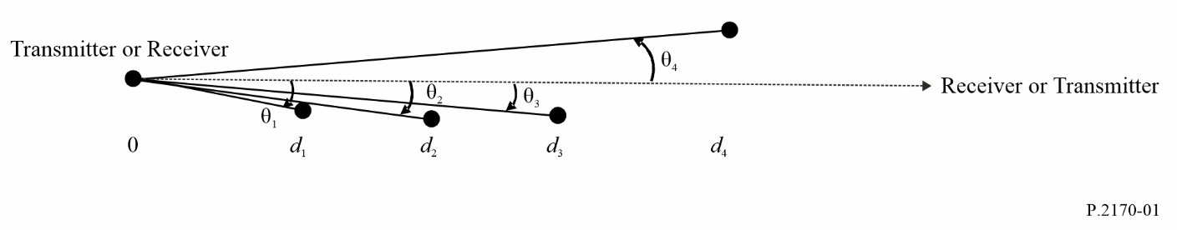
For each representative path:
1) Referring to Fig. 1, determine $d_{l1}$ (m) and $θ_{l1}$, the receive terminal horizon distance and elevation angle corresponding to the $d_{i}$ and $θ_{i}$ with maximum value of $θ_{i}$ over all equally-spaced points between the transmitter and receiver.
2) Referring to Fig. 1, determine $d_{l2}$ (m) and $θ_{l2}$, the transmit terminal horizon distance and elevation angle corresponding to the $d_{i}$ and $θ_{i}$ with maximum value of $θ_{i}$ over all equally-spaced points between the receiver and transmitter.
3) Determine the elevation of the lunar surface relative to a sphere of radius 1 737 400 m at a set of equidistant points on the lunar surface along the path from the transmit antenna to the receive antenna excluding the region of radius $\min\left(15 h_{g_{1}},0.1 d_{l1}\right)$ m around the transmit antenna and the region of radius $\min\left(15 h_{g_{2}},0.1 d_{l2}\right)$ m around the receive antenna.
4) Calculate $d_{x}=d-d_{l1}-d_{l2}$.
5) then, $Δh$ for each representative path is: $∆h=\frac{∆h\left(d_{x}\right)}{\left(1-0.8{ e}^{- \frac{d_{x}}{5×{10}^{4}}}\right)}$ (m).

B.1.1 Preparatory calculations
Define the transmit terminal as $j=1$ and the receive terminal as $j=2$. If a terminal is a mobile terminal, then:
${h_{e}}_{j}={h_{g}}_{j} \left(m\right) for j=1, 2$ (b-7)
and, if the terminal is a fixed terminal:
$B_{j}=10 \left(m\right) for j=1, 2$ (b-8)
in which case,
$B_{j}^{'}=\left(B_{j}-1\right)\sin\left(\frac{π}{2}min\left(\frac{{h_{g}}_{j}}{5},1\right)\right)+1$ (b-9)
$B_{j}^{'}=B_{j}$ if ${h_{g}}_{j}≥5 m$. The effective height of the j^{th} terminal, ${h_{e}}_{j}\left(j=1 or 2\right)$, is then:
${h_{e}}_{j}={h_{g}}_{j}+B_{j}^{'}e^{- \frac{2{h_{g}}_{j}}{∆h}} for j=1, 2$ (b-10)
Calculate the smooth lunar horizon distances, ${d_{ls}}_{j}$:
${d_{ls}}_{j}=\sqrt{2h_{ej} a_{e}} for j=1, 2 \left(m\right)$ (b-11)
The combined smooth lunar radio horizon distance, $d_{ls}$, the combined irregular terrain radio horizon distance, $d_{l}$, and the combined irregular terrain radio horizon elevation angles, $θ_{e}$, are then:
${{d_{ls}=d}_{ls}}_{1}+{d_{ls}}_{2}$ (b-12)
${{d_{l}=d}_{l}}_{1}+{d_{l}}_{2}$ (b-13)
$θ_{e}=max\left({θ_{e}}_{1}+{θ_{e}}_{2},-d_{l}γ_{e}\right)$ (b-14)
and $Δh\left(s\right)$, which is a function of distance, s, is:
$∆h\left(s\right)=∆h\left(1-0.8{ e}^{- \frac{s}{5×{10}^{4}}}\right) \left(m\right)$ (b-15)

B.1.2 Reference attenuation
The reference attenuation, $A_{ref}$, is the predicted median attenuation relative to free-space that would be observed on similar paths. $A_{ref}$ is the following piecewise function of path horizontal distance, $d$:
$A_{ref}\left(d\right)=\left\{\begin{matrix}max\left[0,A_{el}+Κ_{1}d+Κ_{2}\ln\left(\frac{d}{d_{ls}}\right)\right] & for d≤d_{ls} \\ A_{ed}+m_{d}d & for d>d_{ls}\end{matrix}\right. (dB)$ (b-16)
where $A_{el}$ is defined in equation (b-72), $A_{ed}$ is defined in equation (b-23), and the coefficients $Κ_{1}$, $Κ_{2}$, and $m_{d}$ are calculated in the following sections. The range $d≤d_{ls}$ is defined as the line-of-sight range, and the range $d≥d_{ls}$ is defined as the diffraction range. Note that $A_{ref}$ is continuous at
$d=d_{ls}$.

B.1.3 Coefficients for the diffraction range
The coefficients for the diffraction range are calculated by evaluating the diffraction attenuation, $A_{diff}\left(d\right)$, at two distances, $d_{3}$ and $d_{4}$, which are beyond line-of-sight. Calculate:
$d_{3}=max\left(d_{ls},d_{l}+1.3787X_{ae}\right)$ (b-17)
$d_{4}=d_{3}+2.7574X_{ae}$ (b-18)
$A_{3}=A_{diff}\left(d_{3}\right)$ (b-19)
$A_{4}=A_{diff}\left(d_{4}\right)$ (b-20)
where:
$X_{ae}={\left(kγ_{e}^{2}\right)}^{-\frac{1}{3}}=a_{e}{\left(\frac{2πa_{e}}{λ}\right)}^{-\frac{1}{3}}$ (b-21)
and the function $A_{diff}$ is defined in equation (b-24).
The parameters $m_{d}$ and $A_{ed}$ are:
$m_{d}=\frac{A_{4}-A_{3}}{d_{4}-d_{3}} \left(\frac{dB}{m}\right)$ (b-22)
$A_{ed}=A_{3}-m_{d}d_{3}=\frac{A_{3}d_{4}-A_{4}d_{3}}{d_{4}-d_{3}} \left(dB\right)$ (b-23)

B.1.4 Diffraction attenuation function
The diffraction attenuation function, $A_{diff}\left(s\right)$, is a weighted combination of the ‘double knife-edge’ attenuation, $A_{k}\left(s\right)$, and ‘rounded lunar’ diffraction attenuation, $A_{r}\left(s\right)$:
$A_{diff}\left(s\right)=\left(1-w\left(s\right)\right)A_{k}\left(s\right)+w\left(s\right)A_{r}\left(s\right) \left(dB\right)$ (b-24)
$A_{k}\left(s\right)$ is defined in equation (b-27), $A_{r}\left(s\right)$ is defined in equation (b-37), and the weighting factor, $w\left(s\right)$, is defined as:
$w\left(s\right)=\frac{1}{1+0.1\sqrt{Q\left(s\right)}}$ (b-25)
where:
$Q\left(s\right)=min\left(\frac{Δh\left(s\right)}{λ},1000\right)\left[\sqrt{\frac{{h_{e}}_{1}{h_{e}}_{2}+C}{{h_{g}}_{1}{h_{g}}_{2}+C}}+\frac{d_{l}+a_{e}θ_{e}}{s}\right]$ (b-26)
and $C=0$.
The median ‘double knife-edge’ diffraction attenuation for the two irregular lunar radio horizons, $A_{k}\left(s\right)$, is:
$A_{k}\left(s\right)=Fn\left(ν_{1}\left(s\right)\right)+Fn\left(ν_{2}\left(s\right)\right) \left(dB\right)$ (b-27)
where:
$Fn\left(z\right)=-20\log_{10}\left(\left|\frac{1}{\sqrt{2i}}\int_{z}^{∞}{e^{i\frac{π}{2}u^{2}}du}\right|\right)$ (b-28)
$=-20\log_{10}\left(\left\lceil \frac{1+i}{2\sqrt{2i}}erfc\left(\frac{\sqrt{π}}{2}\left(1-i\right)z\right)\right\rceil \right)$
$=-20\log_{10}\left(\left\lceil \frac{1+i}{\sqrt{2i}} Q\left(\sqrt{\frac{π}{2}}\left(1-i\right)z\right)\right\rceil \right)$
$ν_{j}\left(s\right)=\frac{θ\left(s\right)}{2}\sqrt{\frac{2{d_{l}}_{j}\left(s-d_{l}\right)}{λ\left(s-d_{l}+{d_{l}}_{j}\right)}} for j=1, 2$ (b-29)
and:
$θ\left(s\right)=θ_{e}+sγ_{e}$ (b-30)
The ‘rounded-lunar’ diffraction attenuation is based on a “three radii” method applied to the solution of the smooth spherical diffraction problem. Calculate $γ_{0}$, $γ_{1}$, and $γ_{2}$ as follows:
$γ_{0}=\frac{θ\left(s\right)}{s-d_{l}}$ (b-31)
$γ_{j}=\frac{2{h_{e}}_{j}}{{d_{l}}_{j}^{2}} for j=1, 2$ (b-32)
Set:
$α_{j}={\left(\frac{k}{γ_{j}}\right)}^{\frac{1}{3}} for j=0, 1, 2$ (b-33)
and:
$Κ_{j}=\frac{1}{iα_{j}Z_{g}} for j=0,1,2$ (b-34)
Define the dimensionless distances:
$x_{0}=AB\left(Κ_{0}\right){ α}_{0} θ\left(s\right)+x_{1}+x_{2}$ (b-35)
and:
$x_{j}=AB\left(Κ_{j}\right){ α}_{j} γ_{j} {d_{l}}_{j} for j=1, 2$ (b-36)
where $A=63.798$. Note that only $x_{0}$ depends on $s$. The ‘rounded-lunar’ diffraction attenuation, $A_{r}\left(s\right)$, is:
$A_{r}\left(s\right)=G\left(x_{0}\right)-F\left(x_{1},Κ_{1}\right)-F\left(x_{2},Κ_{2}\right)-C_{1}\left(Κ_{0}\right)$ (dB) (b-37)
where the functions $G\left(x\right)$, $F\left(x,K\right)$, $C_{1}\left(K\right)$ and $B\left(Κ\right)$ are defined in § B.2.

B.1.5 Coefficients for the line-of-sight range
Set:
$d_{2}=d_{ls}$ (b-38)
and:
$A_{2}=A_{ed}+m_{d}d_{2}$ (dB) (b-39)
There are two general cases, depending upon the sign of $A_{ed}$.
Case 1: If $A_{ed}≥0$, set:
$d_{0}=min\left(\frac{d_{l}}{2},1.908k{h_{e}}_{1}{h_{e}}_{2}\right)$ (b-40)
$d_{1}=\frac{3}{4}d_{0}+\frac{d_{l}}{4}$ (b-41)
$A_{0}=A_{los}\left(d_{0}\right)$ (dB) (b-42)
$A_{1}=A_{los}\left(d_{1}\right)$ (dB) (b-43)
Calculate:
$K_{2}^{'}=max\left(0,\frac{\left(A_{1}-A_{0}\right)\left(d_{2}-d_{0}\right)-\left(A_{2}-A_{0}\right)\left(d_{1}-d_{0}\right)}{\left(d_{2}-d_{0}\right)\ln\left(\frac{d_{1}}{d_{0}}\right)-\left(d_{1}-d_{0}\right)\ln\left(\frac{d_{2}}{d_{0}}\right)}\right)$ (b-44)
and:
$K_{1}^{'}=\frac{A_{2}-A_{0}-K_{2}^{'}\ln\left(\frac{d_{2}}{d_{0}}\right)}{d_{2}-d_{0}}$ (b-45)
If $K_{1}^{'}≥0$, set:
$K_{1}=K_{1}^{'}$ (b-46)
$K_{2}=K_{2}^{'}$ (b-47)
However, if $K_{1}^{'}<0$, set:
$K_{2}^{''}=\frac{A_{2}-A_{0}}{\ln\left(\frac{d_{2}}{d_{0}}\right)}$ (b-48)
If $K_{2}^{''}≥0$, set:
$K_{1}=0$ (b-49)
$K_{2}=K_{2}^{''}$ (b-50)
However, if $K_{2}^{''}<0$, set:
$K_{1}=m_{d}$ (b-51)
$K_{2}=0$ (b-52)
Case 2: If $A_{ed}<0$, set:
$d_{0}=1.908k{h_{e}}_{1}{h_{e}}_{2}$ (b-53)
$d_{1}=max\left(-\frac{A_{ed}}{m_{d}},\frac{d_{l}}{4}\right)$ (b-54)
If $d_{0}<d_{1},$ set:
$A_{0}=A_{los}\left(d_{0}\right)$ (dB) (b-55)
$A_{1}=A_{los}\left(d_{1}\right)$ (dB) (b-56)
and:
$K_{2}^{'}=max\left(0,\frac{\left(A_{1}-A_{0}\right)\left(d_{2}-d_{0}\right)-\left(A_{2}-A_{0}\right)\left(d_{1}-d_{0}\right)}{\left(d_{2}-d_{0}\right)\ln\left(\frac{d_{1}}{d_{0}}\right)-\left(d_{1}-d_{0}\right)\ln\left(\frac{d_{2}}{d_{0}}\right)}\right)$ (b-57)
If $K_{2}^{'}≠0$, calculate:
$K_{1}^{'}=\frac{A_{2}-A_{0}-K_{2}^{'}\ln\left(\frac{d_{2}}{d_{0}}\right)}{d_{2}-d_{0}}$ (b-58)
If $K_{1}^{'}≥0$, set:
$K_{1}=K_{1}^{'}$ (b-59)
$K_{2}=K_{2}^{'}$ (b-60)
If $K_{1}^{'}<0$, set:
$K_{2}^{''}=\frac{A_{2}-A_{0}}{\ln\left(\frac{d_{2}}{d_{0}}\right)}$ (b-61)
If $K_{2}^{''}≥0$, then:
$K_{1}=0$ (b-62)
$K_{2}=K_{2}^{''}$ (b-63)
If $K_{2}^{''}<0$, then:
$K_{1}=m_{d}$ (b-64)
$K_{2}=0$ (b-65)
If $d_{0}≥d_{1}$ or $K_{2}^{'}=0$, then:
$A_{1}=A_{los}\left(d_{1}\right)$ (dB) (b-66)
$K_{1}^{''}=\frac{A_{2}-A_{1}}{d_{2}-d_{1}}$ (b-67)
If $K_{1}^{''}>0$, then:
$K_{1}=K_{1}^{''}$ (b-68)
$K_{2}=0$ (b-69)
Otherwise, set:
$K_{1}=m_{d}$ (b-70)
$K_{2}=0$ (b-71)
Finally, set:
$A_{el}=A_{2}-K_{1}d_{2}$ (dB) (b-72)

B.1.6 The line-of-sight range attenuation function
The line-of-sight range attenuation function, $A_{los}\left(s\right)$, is the weighted combination of the “extrapolated/extended diffraction range” attenuation, $A_{d}\left(s\right)$, and the “two-ray” attenuation, $A_{t}\left(s\right)$:
$A_{los}\left(s\right)=\left(1-w\right)A_{d}\left(s\right)+wA_{t}\left(s\right)$ (dB) (b-73)
$A_{d}\left(s\right)$ is defined in equation (b-75), $A_{t}\left(s\right)$ is defined in equation (b-82), and the weighting function, $w$, is:
$w=\frac{1}{1+\frac{D_{1}k∆h}{max\left(D_{2},d_{ls}\right)}}$ (b-74)
where $D_{1}=47.7 m$, and $D_{2}=10 \text{km}$. The “extended diffraction range” attenuation is:
$A_{d}\left(s\right)=A_{ed}+m_{d}s$ (b-75)
For the “two-ray” attenuation, set:
$\sin{ψ\left(s\right)}=\frac{{h_{e}}_{1}+{h_{e}}_{2}}{\sqrt{s^{2}+{\left({h_{e}}_{1}+{h_{e}}_{2}\right)}^{2}}}$ (b-76)
and:
$R_{e}^{'}\left(s\right)=\frac{\sin{ψ\left(s\right)}-Z_{g}}{\sin{ψ}\left(s\right)+Z_{g}}e^{-kσ_{h}\left(s\right)\sin{ψ\left(s\right)}}$ (b-77)
where:
$σ_{h}\left(s\right)=\frac{∆h\left(s\right)}{1.282}e^{-\frac{\sqrt[4]{∆h\left(s\right)}}{2}}$ (b-78)
Set:
$δ^{'}\left(s\right)=2\frac{k{h_{e}}_{1}{h_{e}}_{2}}{s}$ (b-79)
The effective reflection coefficient, $R_{e}\left(s\right)$, is:
$R_{e}\left(s\right)=\left\{\begin{matrix}R_{e}^{'}\left( s\right) & for \left|R_{e}'\left(s\right)\right|≥max\left(0.5,\sqrt{\sin{ψ\left(s\right)}}\right) \\ \frac{R_{e}'\left(s\right)}{\left|R_{e}'\left(s\right)\right|}\sqrt{\sin{ψ\left(s\right)}} & otherwise\end{matrix}\right.$ (b-80)
The phase difference, $δ\left(s\right)$, is:
$δ\left(s\right)=\left\{\begin{aligned}δ^{'}\left(s\right) for δ^{'\left(s\right)}≤\frac{π}{2} \\ π-\frac{{\left(\frac{π}{2}\right)}^{2}}{δ^{'}\left(s\right)} otherwise\end{aligned}\right.$ (b-81)
The “two-ray” attenuation, $A_{t}\left(s\right)$, is then:
$A_{t}\left(s\right)=-20\log_{10}\left|1+R_{e}\left(s\right)e^{iδ\left(s\right)}\right|$ (dB) (b-82)

B.1.7 Location variability
$A_{ref}\left(p\right),$the attenuation relative to free-space that is not exceeded for the fraction of equivalent terrain profiles, $p \left(0<p<1\right)$ is calculated as follows:
Calculate $Δh\left(d\right)$, $σ$, and $z$ as follows, where $d$ is the entire path length:
$∆h\left(d\right)=∆h\left(1-0.8{ e}^{- \frac{d_{x}}{5×{10}^{4}}}\right)$ (b-83)
$σ=10 k\frac{Δh\left(d\right)}{k Δh\left(d\right)+13}$ (b-84)
$z=Q^{-1}\left(p\right)$ (b-85)
where $d$ is the entire path length.
Then:
$A_{ref}\left(p\right)=A_{ref}+σ z$ (dB) (b-86)

B.2 Functions $G\left(x\right)$, $F\left(x,Κ\right)$, $C_{1}\left(Κ\right)$, and $B\left(Κ\right)$
$F\left(x,Κ\right)=\left\{\begin{matrix}F_{2}\left(x,Κ\right), & for 0<x≤200 \\ G\left(x\right)+0.013xe^{-\frac{x}{200}}\left[F_{1}\left(x\right)-G\left(x\right)\right], & for 200<x<2 000 \\ G\left(x\right), & for x≥2 000\end{matrix}\right.$ (b-87)
where:
$G\left(x\right)=0.05751 x-10\log_{10}{x}$ (b-88)
$F_{1}\left(x\right)=40\log_{10}\left(\max\left(x,1\right)\right)-117$ (b-89)
$F_{2}\left(x,Κ\right)=\left\{\begin{matrix}F_{1}\left(x\right) & for \left|Κ\right|<{10}^{-5} or x {\left(-\log_{10}\left|K\right|\right)}^{3}>450 \\ 2.5 x\frac{{10}^{-5}x^{2}}{\left|K\right|}+20\log_{10}\left(\left|Κ\right|\right)-15 & otherwise\end{matrix}\right.$ (b-90)
$C_{1}\left(Κ\right)=20$ (b-91)
$B\left(Κ\right)=1.607-\left|Κ\right|$ (b-92)

PART C

Electrical characteristics of the surface of the Moon

C.1 Regolith complex relative permittivity

C.1.1 Inputs to regolith complex relative permittivity
The regolith complex relative permittivity requires the following parameters:
– Regolith depth
– Regolith content of titanium oxide (TiO₂) and ferrous oxide (FeO) minerals
– Regolith bulk density (specific gravity, porosity, void ratio)
– Regolith temperature
– RF frequency

C.1.2 Regolith depth
The regolith depth, $d$, is calculated as follows:
$d=9.5 +8.5 tanh\left(\frac{H+1 200}{1 632.5}\right)$ (m) (c-1)
where, $H$, is the elevation in metres. For reference, the digital elevation of the lunar surface is shown in Fig. 2. Digital lunar elevation maps at various projections, resolutions. and formats are available from https://imbrium.mit.edu/DATA/LOLA_GDR/
Lunar latitude and longitude are defined in the Mean Earth/polar axis (ME) selenographic coordinate system. The lunar Z-axis is the mean rotation axis of the Moon, and the +Z axis points toward the lunar North pole; the lunar equator, defined by the XY-plane, is perpendicular to the Z-axis and intersects the Z-axis at the Moon’s centre of mass; the lunar prime meridian, defined by the X-axis, points in the mean Earth direction as seen from the Moon (i.e. the mean sub-Earth point on the lunar surface); and the Y-axis completes the right-handed coordinate system.
FIGURE 2
Elevation map of the lunar surface (km)
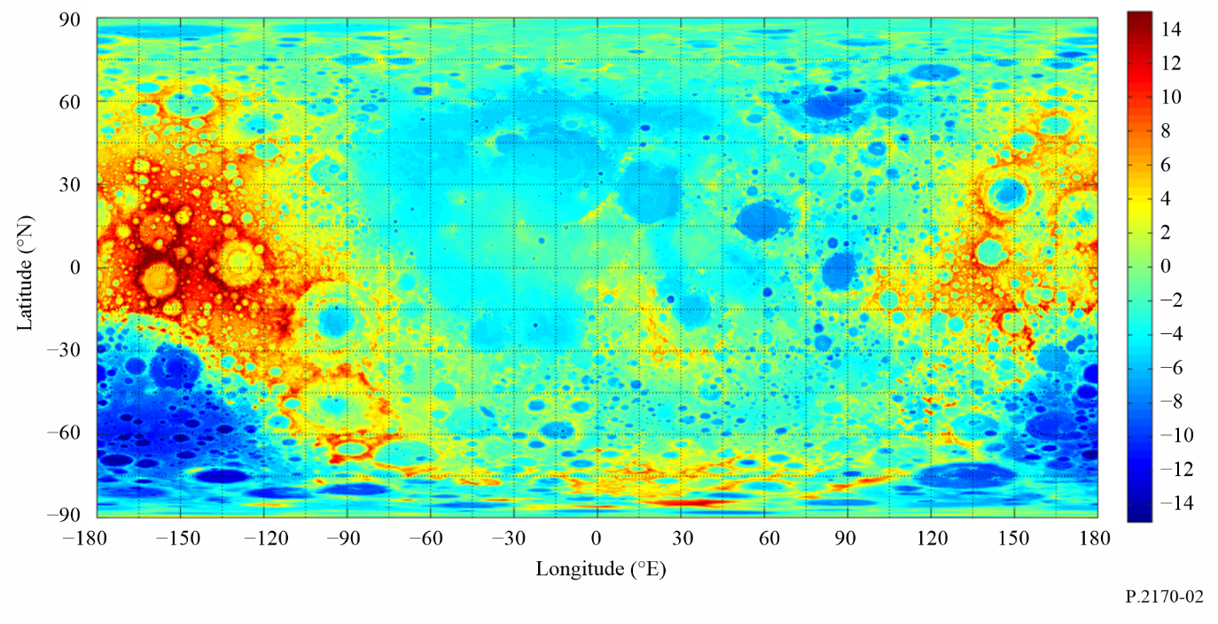

C.1.3 Mineral content
The lunar regolith permittivity is a function of the percentages of titanium oxide (TiO₂) and ferrous oxide (FeO). For reference, the lunar percentages of FeO and TiO₂ between 60° N and 60° S are shown in Figs 3 and 4. High resolution maps of FeO and TiO₂ are available at https://zenodo.org/records/7263426 and https://zenodo.org/records/7264329, respectively.
FIGURE 3
Map of lunar FeO content between latitude 60° N and 60° S
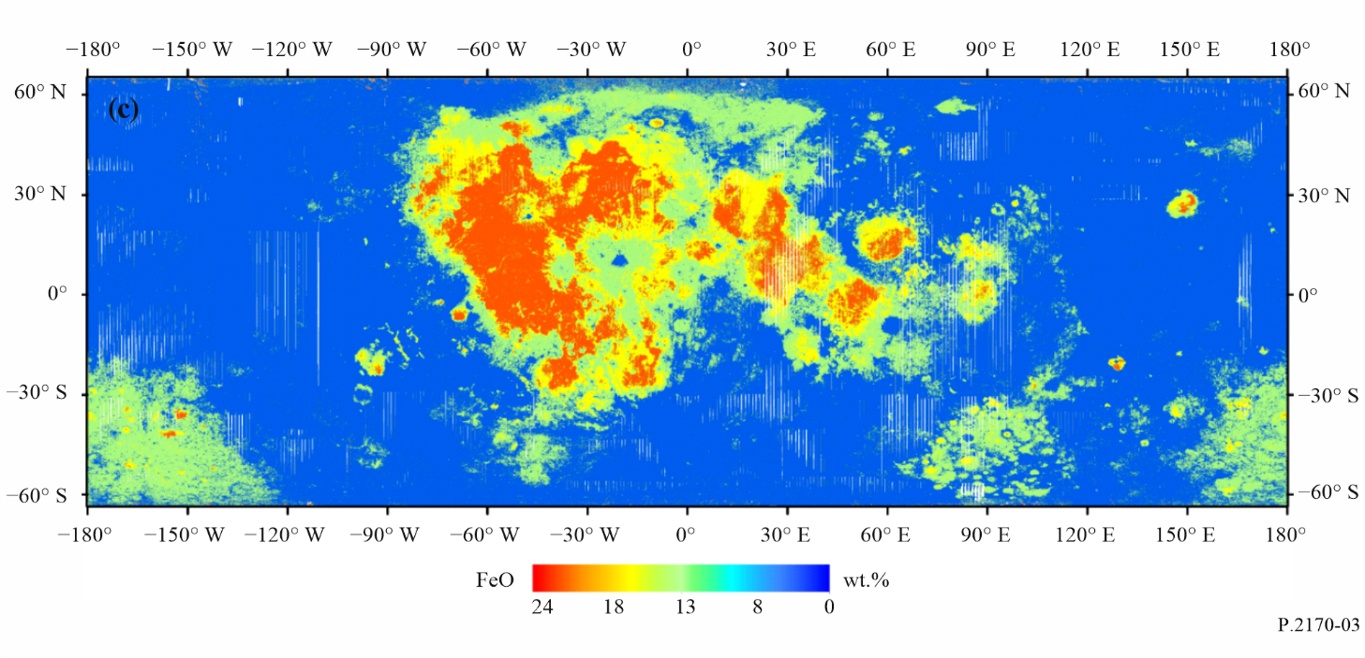
FIGURE 4
Map of lunar TiO₂ content between latitude 60° N and 60° S
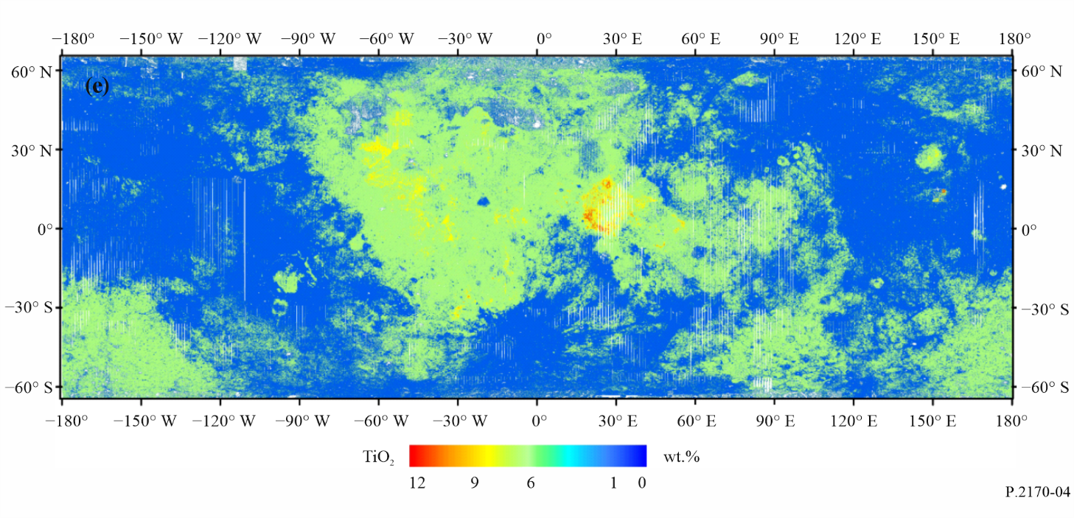

C.1.4 Bulk density
The bulk density, ρ, of a material is the mass of the material contained within a given volume, usually expressed in grams per cubic centimetre (g/cm³). The porosity, and specific gravity are other parameters related to the bulk density. The porosity, ϕ, is defined as the volume of void space between the particles divided by the total volume. The specific gravity, $G$, of a soil particle is the ratio of its mass to the mass of an equal volume of water at 4 °C. Many lunar soils have a specific gravity of 2.7; i.e. the density of the individual particles is 2.7 g/cm³, or 2.7 times that of water $ρ_{w}$ (1 g/cm³). The volume fraction, $V$, is the ratio of the volume of soil particles over the total volume. Bulk density, porosity, specific gravity, and volume fraction are interrelated as:
$ρ_{reg}=G{ ρ}_{w}\left(1- ϕ\right)$ (c-2)
$V= 1- ϕ$ (c-3)
The regolith bulk density, $ρ_{reg}\left(z\right)$, varies with regolith depth,$z$ (m) as follows:
$ρ_{reg}\left(z\right)= 1.890\frac{0.0169-z}{0.0290-z}, \frac{g}{{cm}^{3}}$ (c-4)
where the minus sign on the depth axis is not shown. Figure 5 shows the trend of bulk density vs. regolith depth.
FIGURE 5
The trend of bulk density vs. regolith depth
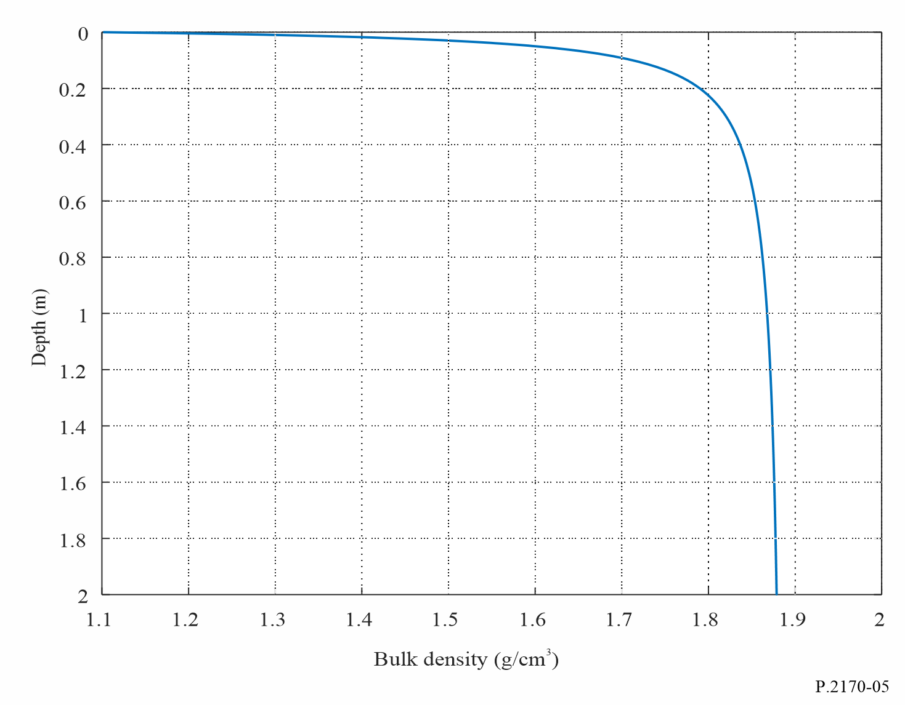

C.1.5 Temperature
The temperature of the lunar regolith varies with lunar latitude and longitude and lunar time. However, the complex relative permittivity of the lunar regolith is independent of temperature at frequencies between 1 MHz and 37 GHz.

C.1.6 Regolith complex relative permittivity at frequencies between 1 MHz and 37 GHz
At frequencies between 1 MHz and 37 GHz, the regolith complex relative permittivity, $ε_{reg},$is:
$ε_{reg}= ε_{reg}^{'}-i ε_{reg}”= ε_{reg}^{'}-i ε_{reg}^{'}\tan{δ}$ (c-5)
The real part of the regolith complex relative permittivity, $ε_{reg}^{'}$, is a function of bulk density, $ρ_{reg}$, and is independent of frequency and temperature:
$ε_{reg}^{'}= {1.919}^{ρ_{reg}}$ (c-6)
The loss tangent, $\tan{δ_{reg}}$, is a function of frequency (GHz), bulk density, and percentages of TiO₂ and $FeO$:
$\tan{δ_{reg}}= {10}^{\left\{\left(a_{1}f_{GHz}+ a_{2}\right)ρ_{reg}+ b_{1}S-b_{2})\right\}}$ (c-7)
where the coefficients$a_{1}$, $a_{2}$, $b_{1}$, $b_{2}$, and $S$ are as follows:
$a_{1}=0.0272$ GHz⁻¹
$a_{2}=0.2967$
$b_{1}=0.027$
$b_{2}=3.058$
$S=\%{TiO}_{2}+\%FeO$.
Since the density, $ρ$, is a function of regolith thickness (see equation (c-1)), the regolith complex relative permittivity is also a function of regolith depth. Figures 6 and 7 show examples of the real part of the complex relative permittivity and the loss tangent vs. regolith depth for contents of ${TiO}_{2}$ and $FeO$ contents of 4% and 15%, respectively, and a typical regolith thickness of 2 m.
FIGURE 6
Real part of regolith permittivity for frequencies above 1 MHz as a function of regolith depth ($d=2 m$)
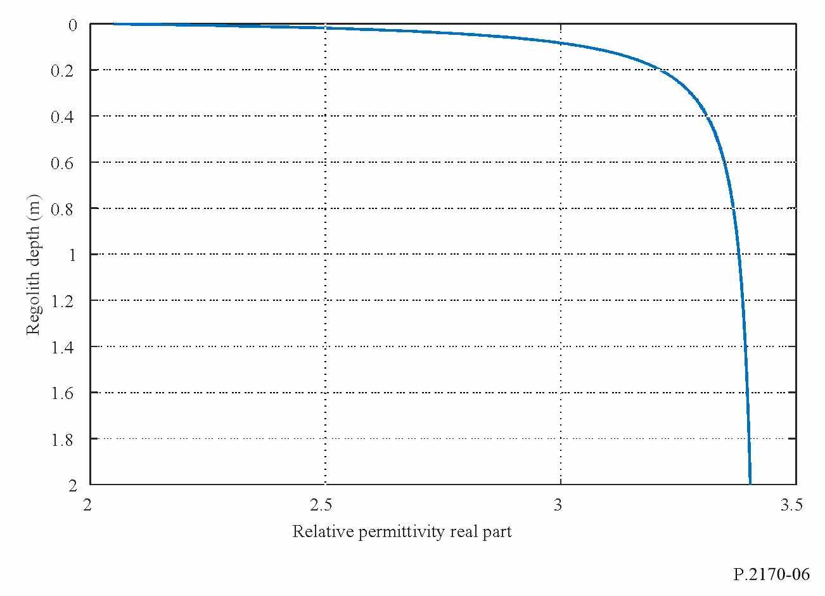
FIGURE 7
The regolith loss tangent at 1.5 GHz vs. regolith depth (TiO₂ = 4%, and FeO=15%, $d=2 m$)
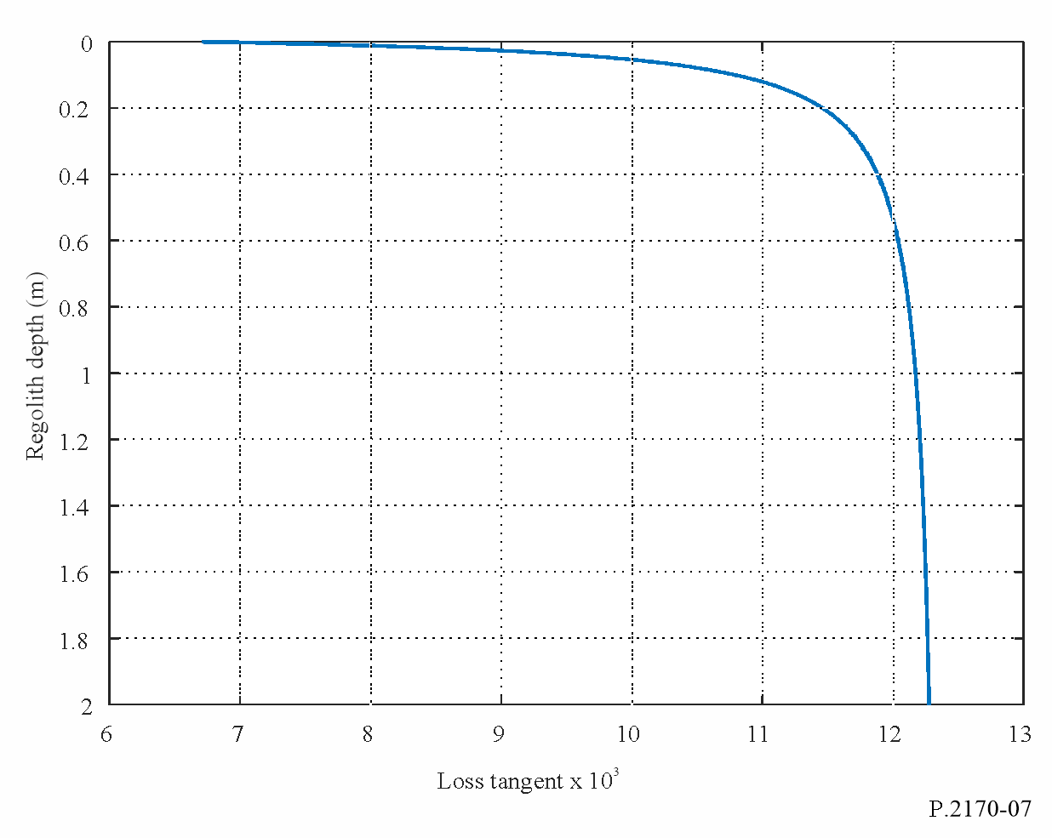

C.2 Lunar rock complex relative permittivity
Similarly to the regolith complex relative permittivity, the lunar rock complex relative permittivity $ε_{rock}$:
$ε_{rock}= ε_{rock}^{'}-i ε_{rock}^{'}\tan{δ_{rock}}$ (c-8)
Similarly to the regolith complex relative permittivity, the real part of the lunar rock complex permittivity is:
$ε_{rock}^{'}={1.919}^{ρ_{rock}}$ (c-9)
While there is no current empirical or theoretical model of lunar rock density, typical rock densities are between 2 and 3.3$g cm^{-3}$, in which case, $ε_{rock}^{'}$ varies between 3.6826 and 8.5931.
The loss tangent, $\tan{δ_{rock}}$, is a function of frequency (GHz), bulk density, percentages of TiO₂ and FeO, the dc conductivity, $σ_{rock}$, and the real part of the lunar rock complex relative permittivity as follows:
$\tan{ρ_{rock}}= {10}^{\left\{\left(a_{1}f_{GHz}+ a_{2}\right)ρ_{rock}+ b_{1}S-b_{2})\right\}} + \frac{17.984 σ_{rock}}{ε_{rock}^{'}f_{GHz}}$ (c-10)
where:
$σ_{rock}= 3×{10}^{-14} e^{0.0230T}, \frac{mho}{m}$ (c-11)
and the coefficients $a_{1}$, $a_{2}$, $b_{1}$, $b_{2}$, and $c$ are:
$a_{1}=0.0086$ GHz⁻¹
$a_{2}=0.1833$
$b_{1}=0.038$
$b_{2}=3.26$
$S=11\%$

C.3 Lunar regolith complex relative permeability
The real and imaginary parts of the lunar regolith magnetic permeability at frequencies above 300 MHz are:
$μ_{r}^{'}=1$ (c-12)
$μ_{r}^{''}=0$ (c-13)

C.4 Complex relative permittivity of regolith and rock mixture
When there is a mixture of rock and regolith, by treating the rock particles as spherical particles, the equivalent complex relative permittivity of the mixture, $ε_{mixture}$, is:
$ε_{mixture}=\frac{-B+\sqrt{B^{2}-4AC}}{2A}$ (c-14)
where:
$A=2$ (c-15)
$B=-2\left(1-V_{rock}\right)ε_{reg}+ \left(1-3V_{rock}\right)ε_{rock}$ (c-16)
$C=-ε_{reg}ε_{rock}$ (c-17)
and $V_{rock}$ is the rock volume fraction. In the absence of local data, $V_{rock}=0$ can be assumed, in which case, $ε_{mixed}=ε_{reg}$.

PART D

Prediction of other propagation losses

D.1 Free-space propagation loss
It is recommended that the free-space propagation loss specified in § 2.3 of Recommendation ITU-R P.525 be used between: a) systems on or near the lunar surface and systems in lunar orbit, b) systems on or near the lunar surface and systems orbiting the Earth, and c) system in lunar orbit and systems orbiting the Earth, where the line-of-sight path is unobstructed and there are no reflections.

D.2 Propagation loss considering the atmosphere of the Earth
The propagation loss between: a) systems on or near the surface of the Moon or in lunar orbit, and b) systems on or near the surface of the Earth or in Earth orbit, where the line-of-sight path is unobstructed and there are no reflections should be calculated as the sum of a) the free-space propagation loss specified in § 2.3 of Recommendation ITU-R P.525, and b) the applicable atmospheric propagation losses specified in § 2 of Recommendation ITU-R P.618.

Basic transmission loss defined in § 1.2 of Recommendation ITU-R P.341 is the sum of: a) attenuation relative to free-space in this Recommendation, and b) free-space basic transmission loss defined in Recommendation ITU-R P.525.
See §§ C.1.5 and C.1.6.
See §§ C.1.5 and C.1.6.
The units of angles, $θ$, in this Part are radians.
The units of angles, $θ$, in this Part are radians.

