Recommendation ITU-R P.2109-2
(08/2023)
P Series: Radiowave propagation
Prediction of building entry loss

Foreword
The role of the Radiocommunication Sector is to ensure the rational, equitable, efficient and economical use of the radio-frequency spectrum by all radiocommunication services, including satellite services, and carry out studies without limit of frequency range on the basis of which Recommendations are adopted.
The regulatory and policy functions of the Radiocommunication Sector are performed by World and Regional Radiocommunication Conferences and Radiocommunication Assemblies supported by Study Groups.

Policy on Intellectual Property Right (IPR)
ITU-R policy on IPR is described in the Common Patent Policy for ITU-T/ITU-R/ISO/IEC referenced in Resolution ITU-R 1. Forms to be used for the submission of patent statements and licensing declarations by patent holders are available from http://www.itu.int/ITU-R/go/patents/en where the Guidelines for Implementation of the Common Patent Policy for ITU-T/ITU-R/ISO/IEC and the ITU-R patent information database can also be found.

Series of ITU-R Recommendations
(Also available online at https://www.itu.int/publ/R-REC/en)
Series | Title
BO | Satellite delivery
BR | Recording for production, archival and play-out; film for television
BS | Broadcasting service (sound)
BT | Broadcasting service (television)
F | Fixed service
M | Mobile, radiodetermination, amateur and related satellite services
P | Radiowave propagation
RA | Radio astronomy
RS | Remote sensing systems
S | Fixed-satellite service
SA | Space applications and meteorology
SF | Frequency sharing and coordination between fixed-satellite and fixed service systems
SM | Spectrum management
SNG | Satellite news gathering
TF | Time signals and frequency standards emissions
V | Vocabulary and related subjects

Note: This ITU-R Recommendation was approved in English under the procedure detailed in Resolution ITU-R 1.

Electronic Publication
Geneva, 2023

© ITU 2023
All rights reserved. No part of this publication may be reproduced, by any means whatsoever, without written permission of ITU.

RECOMMENDATION ITU-R P.2109-2
Prediction of building entry loss
(2017-2019-2023)
Scope
This Recommendation provides a method for estimating building entry loss at frequencies between about 80 MHz and 100 GHz for probabilities of 0.0 < P < 1.0. The method is not site-specific, and is primarily intended for use in sharing and compatibility studies.
Keywords
Building, indoor, propagation, interference, entry
Abbreviations
BEL Building entry loss
CW Continuous wave
LoS Line of sight
Related ITU Recommendations, Reports
Recommendation ITU-R P.2040
Report ITU-R P.2346
The ITU Radiocommunication Assembly,
considering
a) that, for system planning and interference assessment it may be necessary to account for the attenuation suffered by radio waves in passing into, or out of, buildings;
b) that there is a need to give guidance to engineers to estimate coverage or predict interference from outdoor to indoor and indoor to outdoor systems,
recognizing
a) that Recommendation ITU-R P.2040 provides guidance on the effect of building materials and structures on radio waves;
b) that Report ITU-R P.2346 contains collated empirical data on building entry loss,
recommends
1 that the model in Annex 1 should be used to estimate building entry loss;
2 that Annex 2 gives definitions for various types of propagation loss associated with buildings, and provides guidance on measuring building entry losses.
NOTE – Sharing studies carried out by ITU-R on different agenda items of WRC-19 were based on the text of this Recommendation which was in force at the time of these activities or at the time which the activity was carried out.

Annex 1

1 Introduction
This Annex provides a model for building entry loss (BEL) as defined in Recommendation ITU-R P.2040. The output of the model is in the form of a cumulative distribution function of the probability that a given loss will not be exceeded.
The model makes no attempt to separate the loss suffered by a signal penetrating the exterior wall and the attenuation suffered in the path through the building. This approach has been adopted as it is felt unlikely that, in the context of ITU-R studies, sufficiently detailed building-specific information would be available.
Building entry loss exhibits great variability, both within any given building and between different buildings. Although techniques such as ray-tracing can provide useful site-specific predictions when coupled with detailed architectural data, such models will usually be inappropriate for generic applications such as spectrum sharing studies.
A statistical model that attempted to describe the entry loss characteristics of the global set of buildings would give a statistical distribution so broad as to be unhelpful. On the other hand, a model that attempted to characterise many different types of building would require more data than currently exists and would be inappropriate for generic sharing studies.
NOTE – Building types referred to in this Recommendation should be considered carefully.
The model is based on the measurement data collated in Report ITU-R P.2346 in the range 80 MHz to 73 GHz. The model can be used within a Monte Carlo method, but it should be noted that the model has only been validated against empirical data over the probability range 0.01 to 0.99.

2 Parameters
The model takes the following input parameters:
– frequency (~0.08-100 GHz);
– the probability with which the loss is not exceeded;
– building class (‘traditional’ or ‘thermally-efficient’);
– elevation angle of the path at the building façade (degrees above the horizontal).
The azimuth of the path to the outdoor terminal with respect to the building surface is not accounted for explicitly. Although theory and measurement show that signals normally incident on a building surface will suffer lower loss than those arriving at oblique angles, the statistical output of the model represents the generality of building orientations with respect to the outdoor terminal.
The basic model assumes that the indoor antenna is omnidirectional and that the building entry loss will therefore take account of all energy arriving at the terminal location. In some cases, the internal terminal may use a directional antenna which will act as a spatial filter, increasing the apparent building entry loss as energy arriving from some directions is rejected. Measurements made in two large buildings in the Republic of Korea at 32 GHz showed that the building entry loss measured with antennas of 10 degree beamwidth was 5.3 dB greater than for the omnidirectional case. Further details may be found in Report ITU-R P.2346.
Following the definition given in Recommendation ITU-R P.2040, building entry loss is here defined in isolation from any surrounding clutter. Should the building be surrounded by local clutter, additional losses may need to be determined for the relevant terminal height and position above ground using Recommendation ITU-R P.2108.
The model makes the implicit assumption that terminals have an equal probability of location at any point within a building.

2.1 Classification of building type
Experimental results, such as those collated in Report ITU-R P.2346, shows that, when characterised in terms of entry loss, buildings fall into two distinct populations: where modern, thermally-efficient building methods are used (metallised glass, foil-backed panels) building entry loss is generally significantly higher than for ‘traditional’ buildings without such materials. The model therefore gives predictions for these two cases.
This classification, of ‘thermally-efficient’ and ‘traditional’, refers purely to the thermal efficiency of construction materials. No assumption should be made on the year of construction, type (single or multi-floors), heritage or building method.
For building entry loss, it is important to consider the thermal efficiency of the complete building (or the overall thermal efficiency). A highly thermally-efficient main structure with poorly insulated windows (e.g. single glazed with thin glass) can make the building thermally-inefficient and vice versa.
Thermal transmittance, commonly referred as U-value, provides a quantifiable description of thermal efficiency. Low U-values represent high thermal efficiency. Typically, the presence of metallised glass windows, insulated cavity walls, thick reinforced concrete and metal foil back cladding is a good indication of a thermally-efficient building.

3 Model
Building entry loss will vary depending on building type, location within the building and movement in the building. The building entry loss distribution is given by a combination of two lognormal distributions. The building entry loss not exceeded for the probability, P, is given by:
$L_{BEL}^{omni}(P)=10log({10}^{0.1A(P)}+{10}^{0.1B(P)}+{10}^{0.1C} )$ dB (1)
where:
$A\left(P\right)={F^{-1}\left(P\right)σ}_{1}+μ_{1}$ (2)
$B\left(P\right)={F^{-1}\left(P\right)σ}_{2}+μ_{2}$ (3)
$C=-3.0$ (4)
$μ_{1}=L_{h}+L_{e}$ (5)
$μ_{2}=w+x log(f)$ (6)
$σ_{1}=u+v log(f)$ (7)
$σ_{2}=y+z log(f)$ (8)
where:
L_{h} : median loss for horizontal paths, given by:
$L_{h}=r+s log\left(f\right)+t {(log\left(f\right))}^{2}$ (9)
L_{e} : correction for elevation angle of the path at the building façade:
$L_{e}=0.212 |θ|$ (10)
and:
f : frequency (GHz)
θ : elevation angle of the path at the building façade (degrees)
P : probability that loss is not exceeded (0.0 ≤ P ≤ 1.0)
F⁻¹(P) : inverse cumulative normal distribution as a function of probability.
The coefficients are as given in Table 1.
TABLE 1
Model coefficients
Building type | r | s | t | u | v | w | x | y | z
Related to: | μ₁ |  |  | σ₁ |  | μ₂ |  | σ₂
Traditional | 12.64 | 3.72 | 0.96 | 9.6 | 2.0 | 9.1 | −3.0 | 4.5 | −2.0
Thermally-efficient | 28.19 | −3.00 | 8.48 | 13.5 | 3.8 | 27.8 | −2.9 | 9.4 | −2.1

For illustration, Fig. 1 plots the median building entry loss returned by the model for the two building classes. In any sharing studies, the entire distribution should always be considered. Figure 2 plots the cumulative distribution function for building entry loss predicted at horizontal incidence.
Figure 1
Median building entry loss predicted at horizontal incidence
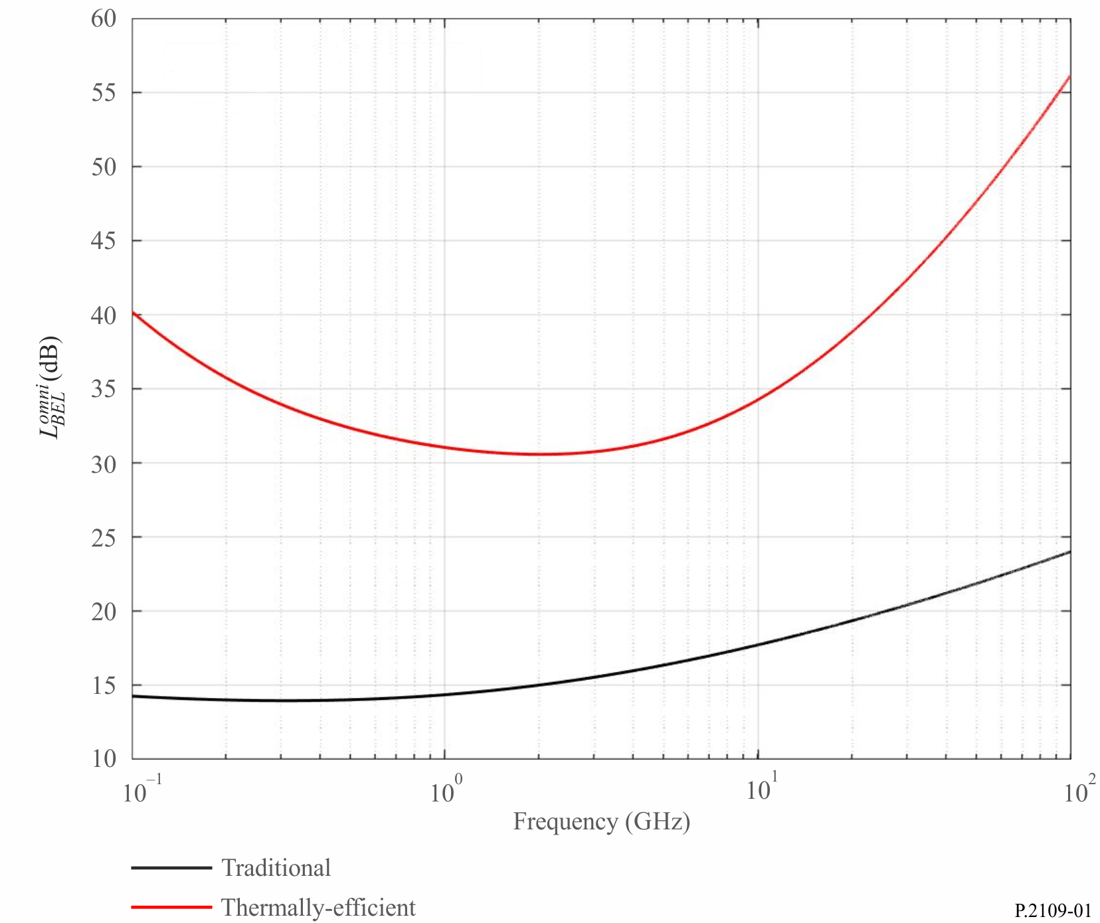
Figure 2
Building entry loss predicted at horizontal incidence
(Dashed line: Traditional, Dotted line: Thermally-efficient)
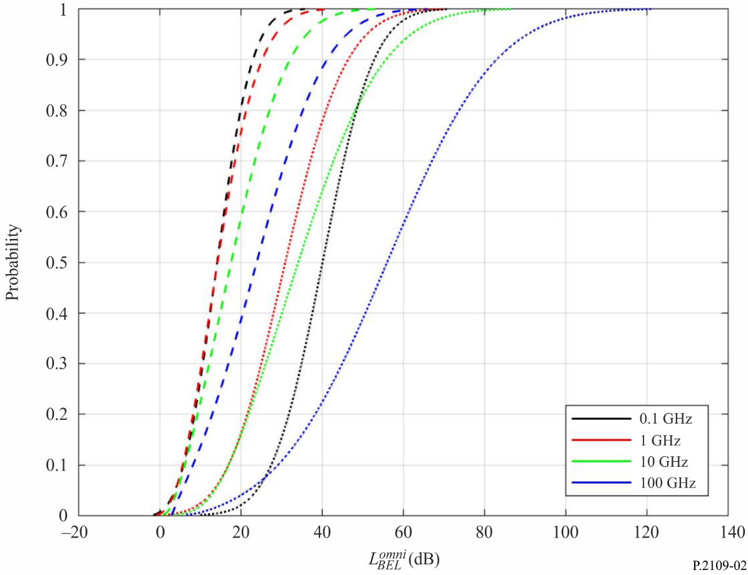

Annex 2

1 Introduction
This Annex provides definitions of terms relating to building loss, and gives guidance on recommended measurement practices.
Report ITU-R P.2346 contains a compilation of the results of measurements of building entry loss.

2 Description of scenarios involving the outdoor-indoor interface

2.1 Outside-inside propagation: issues concerning entry-loss reference field
A difficulty with defining the entry loss reference field is that the presence of the building will modify signal strengths outside it. Figure 3 illustrates, in somewhat simplified form, the issues involved. The three sections of the Figure show:
a) A relatively isolated outdoor point receives a direct and ground-reflected ray. In fact both of these rays, in an urban environment, may well arrive from a distant source via diffraction over a building to the left of the Figure. For propagation at small angles to the horizontal, there will be fairly simply and mainly vertical lobing, that is, maxima and minima when the point is moved vertically.
b) Without moving the point, a building is placed just behind it. It now receives two additional rays reflected from the building, one of which is also ground-reflected. The lobing pattern will now have fine structure in both the vertical and horizontal directions.
c) The point is now moved inside the building. For the purposes of illustration the frequency is assumed to be high enough such that only rays entering a window are significant. At a lower frequency, where penetration through the wall is significant, the ray pattern would change.
Figure 3
Simplified ray diagrams for outdoor and indoor points
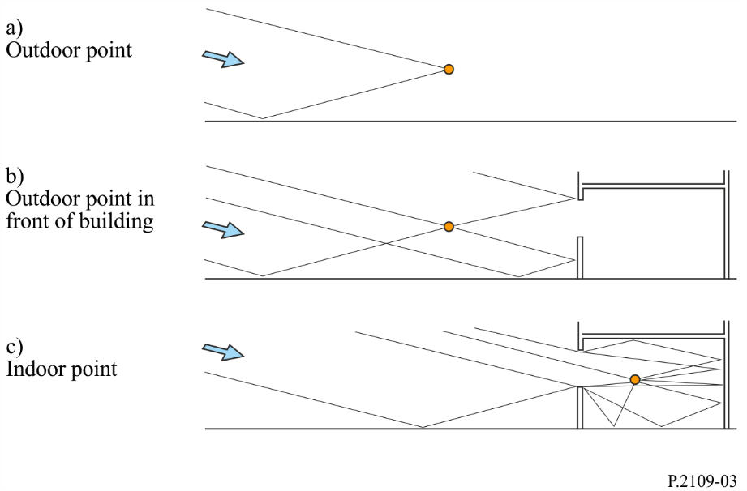
Although multipath propagation causes lobing, the power-sum of multiple rays approximates to the spatially-averaged field. In general, therefore, the presence of a building behind a receiver can be expected to increase the received signal strength. Inside the building, particularly close to the illuminated external wall, a larger number of rays is likely to be received, although many will be attenuated by transmission, reflection or diffraction. It is thus possible to have a stronger signal inside than outside.

2.2 Propagation losses in the built environment
Figure 4 shows the different kinds of building losses encountered in an outdoor-indoor and indoor-outdoor scenario. The definitions are given in the next sections.
Figure 4
Different kinds of propagation loss involving buildings
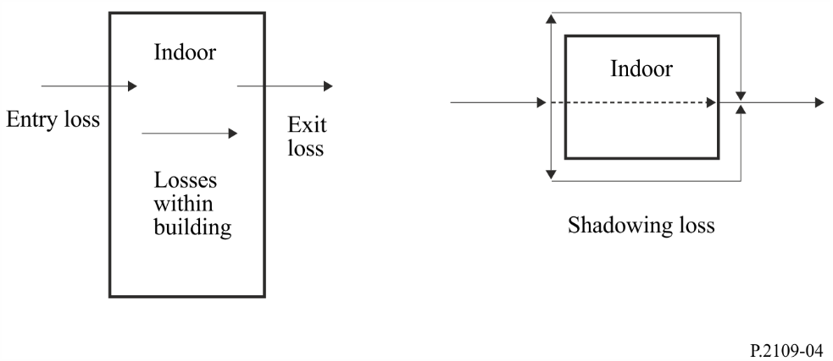

3 Definitions

3.1 Definition of building entry loss
Building entry loss is the additional loss due to a terminal being inside a building.

3.2 Definition of building shadowing loss
The building shadowing loss is the difference between the median of the location variability of the signal level outside the illuminated face of a building and the signal level outside the opposite face of the building at the same height above ground, with multipath fading spatially averaged for both signals. It can be considered as the transmission loss through a building.

3.3 Definition of (e.g. wall) penetration
Signals outside a building enter an enclosed building by penetration mostly through walls. Wall penetration can also refer to the penetration through partitions inside buildings. Inside buildings, wall penetration loss is the difference between the median of the location variability of the signal level on one side of a wall, and the signal level on the opposite side of the wall at the same height above ground, with multipath fading spatially averaged for both signals. It can be considered as the transmission loss through a wall.

3.4 Definition of aperture penetration
Aperture penetration is the penetration of signals from one side of a wall to the other side through openings on the walls like windows.

3.5 Definition of building exit loss
From reciprocity, the numerical value of building exit loss will be the same as the building entry loss. In the remainder of this text the terms are used interchangeably.

4 Measurement of building entry loss

4.1 Introduction
Building entry loss can be measured as the difference, expressed in dB, between the spatial median of the signal level outside the illuminated face of a building and the spatial median of the signal level inside the building at the same height above ground, shown as “h” in Fig. 5 below (i.e. loss = spatial median external field – spatial median internal field, where measurements are in decibel units). The purpose of the outside measurement is to approximate the field strength which would exist at the indoor location if the building did not exist. Where the distance between the outside and inside measurements is a significant portion of the overall path, the additional free space loss should be allowed for.
The outdoor field should be measured as close as possible to the building while ensuring that near-field effects are avoided and antenna characteristics are unaffected. Measurements made with directional and omnidirectional antennas may be expected to give different results; antenna characteristics should, in any case, be carefully described. Where it is not possible to measure the outdoor field incident on the building a predicted value should be used and this should be clearly stated.
Measurements should normally be performed with a line of sight (LoS) between the outdoor terminal and one face of the building under test.
Figure 5
Location of reference and measurement antennas for building entry loss measurement
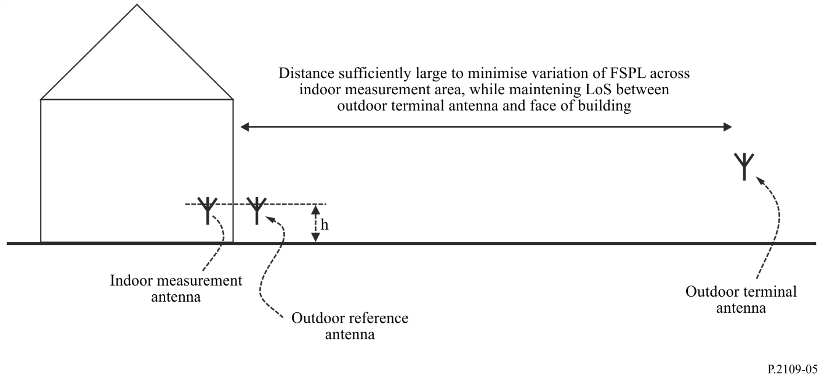
The area chosen for spatial averaging inside the building will depend on the particular application, and should be clearly stated; room-averages have been found to represent a practical and useful basis for discretisation.

4.2 Parameters to be recorded
The following parameters should be recorded when performing measurements of building entry loss.
It is assumed that each measurement set will consist of a number of samples, with the results being expressed as a tabulated cumulative distribution function of loss.
Researchers are asked to provide as much additional detail as possible; in particular, interior and exterior photographs should be supplied wherever possible.
TABLE 2
Measurement parameters
Parameter | Units or classification | Notes
Frequency | MHz
Bandwidth of test signal | MHz | 0 MHz if CW source used
Surrounding environment | Open/suburban/urban/dense urban | Required to estimate importance of coupling via energy scattered from other buildings
LoS to building? | Yes/No | Should normally be LoS to minimise measurement error
Averaging | Spectral / spatial / other | Free-format field to allow user to describe form of averaging (if any) used
Penetration depth | 1 = indoor terminal in room/space with external wall facing outdoor terminal  2 = indoor terminal in room/space with no external wall  3 = indoor terminal in room/space with other external wall
Floor on which measurements made |  | Ground floor = 0
Area within which samples taken | Square metres
Number of samples |  | Sufficient number of samples should be taken to provide for statistical confidence in the results
Reference | 1 = measured median signal  2 = predicted free space path loss | Measurement preferred where possible
Distance of outdoor terminal from building | metres
Elevation angle of path | degrees
Minimum azimuth with respect to normal to building face | degrees
Maximum azimuth with respect to normal to building face | degrees

TABLE 3
Building parameters
Parameter | Units or classification | Notes
Width | metres | Approximate footprint for irregular building
Length | metres
Height | metres
Total number of floors
Thickness of exterior walls | metres
Thickness of interior walls | metres
Thickness of floors | metres
Proportion of building elevation area composed of windows/apertures | %
Window elements | 0 = unknown  1 = single  2 = double  3 = triple  9 = other
Window coating | 0 = unknown  1 = none  2 = metallised glass  3 = internal wire mesh  4 = metal blinds/shutters  9 = other
Metallic thermal insulation fitted? | 0 = unknown  1 = no  2 = yes  9 = other
Floor material | 0 = unknown  1 = wood  2 = metal  3 = concrete  9 = other
Primary exterior wall material | 0 = unknown  1 = stone  2 = brick  3 = brick with cavity  4 = lightweight block  5 = wooden  6 = concrete  7 = glass  8 = metal  9 = other | Material forming the greatest proportion of the exterior walls

TABLE 3 (end)
Parameter | Units or classification | Notes
Secondary exterior wall material | 0 = unknown  1 = stone  2 = brick  3 = brick with cavity  4 = lightweight block  5 = wood  6 = concrete  7 = glass  8 = metal  9 = other
Internal walls | 0 = no interior walls  1 = stone  2 = brick  3 = lightweight block  4 = wood  5 = concrete  6 = plasterboard (wooden stud)  7 = plasterboard (metal stud)  8 = metallised plasterboard  9 = other
Roof materials | 0 = unknown  1 = concrete tiles  2 = slate tiles  3 = wooden shingles  4 = sheet metal  5 = wood with roofing felt  9 = other

For example, U-values of < 0.3 and < 0.9 are representative of thermally efficient main structure and metallised glass, respectively.

