Recommendation ITU-R P.2041-1
(09/2026)
P Series: Radio-wave propagation
Prediction of path attenuation on links between an airborne terminal and Space and between an airborne terminal and the surface of the Earth

Foreword
The role of the Radiocommunication Sector is to ensure the rational, equitable, efficient and economical use of the radio-frequency spectrum by all radiocommunication services, including satellite services, and carry out studies without limit of frequency range on the basis of which Recommendations are adopted.
The regulatory and policy functions of the Radiocommunication Sector are performed by World and Regional Radiocommunication Conferences and Radiocommunication Assemblies supported by Study Groups.

INTELLECTUAL PROPERTY RIGHTS
ITU draws attention to the possibility that the practice or implementation of this Recommendation may involve the use of a claimed Intellectual Property Right. ITU takes no position concerning the evidence, validity or applicability of claimed Intellectual Property Rights, whether asserted by ITU members or others outside of the Recommendation development process.
As of the date of approval of this Recommendation, ITU had received notice of intellectual property, protected by patents, which may be required to implement this Recommendation. However, implementers are cautioned that this may not represent the latest information and are therefore strongly urged to consult the appropriate ITU-R patent information available at https://www.itu.int/en/ITU-R/study-groups/Pages/itu-r-patent-information.aspx.

Series of ITU-R Recommendations
(Also available online at https://www.itu.int/publ/R-REC/en)
Series | Title
BO | Satellite delivery
BR | Recording for production, archival and play-out; film for television
BS | Broadcasting service (sound)
BT | Broadcasting service (television)
F | Fixed service
M | Mobile, radiodetermination, amateur and related satellite services
P | Radio-wave propagation
RA | Radio astronomy
RS | Remote sensing systems
S | Fixed-satellite service
SA | Space applications and meteorology
SF | Frequency sharing and coordination between fixed-satellite and fixed service systems
SM | Spectrum management
SNG | Satellite news gathering
TF | Time signals and frequency standards emissions
V | Vocabulary and related subjects

Note: This ITU-R Recommendation was approved in English under the procedure detailed in Resolution ITU-R 1.

Electronic Publication
Geneva, 2026
© ITU 2026
All rights reserved. No part of this publication may be reproduced, by any means whatsoever, without written permission of ITU.

RECOMMENDATION ITU-R P.2041-1
Prediction of path attenuation on links between an airborne terminal
and Space and between an airborne terminal
and the surface of the Earth
(2013-2026)
Scope
This Recommendation predicts the various propagation effects needed in planning airborne systems operating in either the airborne-to-space or airborne-to-Earth direction.
Keywords
Earth-space, aeronautical, gaseous attenuation
Related ITU Recommendations, Reports
Recommendation ITU-R P.528 ‒ A propagation prediction method for aeronautical mobile and radionavigation services using the VHF, UHF and SHF bands
Recommendation ITU-R P.531 ‒ Ionospheric propagation data and prediction methods required for the design of satellite networks and systems
Recommendation ITU-R P.618 ‒ Propagation data and prediction methods required for the design of Earth-space telecommunication systems
Recommendation ITU-R P.676 ‒ Attenuation by atmospheric gases and related effects
Recommendation ITU-R P.682 ‒ Propagation data required for the design of Earth-space aeronautical mobile telecommunication systems
Recommendation ITU-R P.836 ‒ Water vapour: surface density and total columnar content
Recommendation ITU-R P.839 ‒ Rain height model for prediction methods
Recommendation ITU-R P.840 ‒ Attenuation due to clouds and fog
The ITU Radiocommunication Assembly,
considering
a) that, in the design of airborne systems, there is a need for an accurate knowledge of the system performance due to radio-wave propagation between an airborne platform and a satellite, and between an airborne platform and the surface of the Earth;
b) that the airborne platform may be located at any altitude between the surface of the Earth and the top of the stratosphere;
c) that the systems may operate beyond line of sight;
d) that the frequency bands used may be in the range from 30 MHz to 50 GHz or higher,
noting
a) that the ITU-R has established and tested prediction methods that predict the long-term average impairments due to atmospheric effects (e.g. gas attenuation, rain attenuation, cloud attenuation, and the attenuation due to scintillation) between a terminal located on the surface of the Earth and space;
b) that these ITU-R Earth-space propagation prediction methods can be scaled to predict the performance of airborne links between an airborne platform and a satellite and between an airborne platform and the surface of the Earth,
recommends
that the following prediction methods should be considered to predict the long-term average impairments (e.g. attenuation and scintillation fading) due to atmospheric effects between an airborne platform and a satellite and between an airborne platform and the surface of the Earth.

1 Relation to other ITU-R Recommendations
Other P-series Recommendations address propagation from airborne platforms: Recommendation ITU-R P.528 – Propagation curves for aeronautical mobile and radionavigation services using the VHF, UHF, and SHF bands; and Recommendation ITU-R P.682 – Propagation data required for the design of Earth-space aeronautical mobile telecommunication systems.
– Recommendation ITU-R P.528 predicts the basic transmission losses for frequencies between 100 MHz and 30 GHz between two antennas at various heights and distances. While the model is predominantly intended to treat the effects of multipath, diffraction, and troposcatter, it also includes a simple rain attenuation models that is applicable to generic continental temperate locations. As a result, the model is not applicable to higher frequencies and different climates where rain and cloud attenuation dominate. Gaseous attenuation within Recommendation ITU-R P.528 is considered through the use of Recommendation ITU-R P.676.
– Recommendation ITU-R P.682 addresses the tropospheric effects, ionospheric effects, fading due to surface reflections and scattering between an airborne platform and space for frequencies near 1.5 GHz.
The airborne-space and airborne-Earth links are shown in Fig. 1.
Figure 1
Airborne-space and Airborne-Earth Links
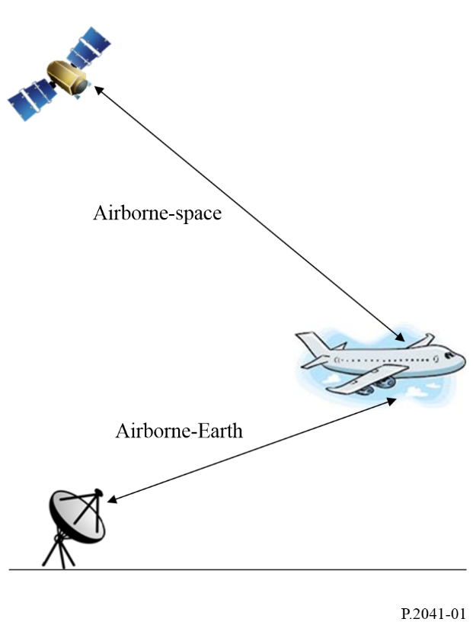
While the following prediction methods are considered to be approximately correct, they have not been tested and validated with measured data.

2 A note on the use of the digital meteorological maps
There are various maps of meteorological parameters that are functions of latitude and longitude at the surface of the Earth. For a path between an airborne platform and space, the various meteorological parameters should be determined at the point where the path between space and the airborne platform would intercept the Earth rather than the latitude and longitude of the airborne platform. This distinction, shown in Fig. 2, is important since some meteorological parameters are defined at the surface of the Earth (e.g. surface temperature, and the wet term of the radio refractivity).
Figure 2
Latitude and longitude of meteorological parameters
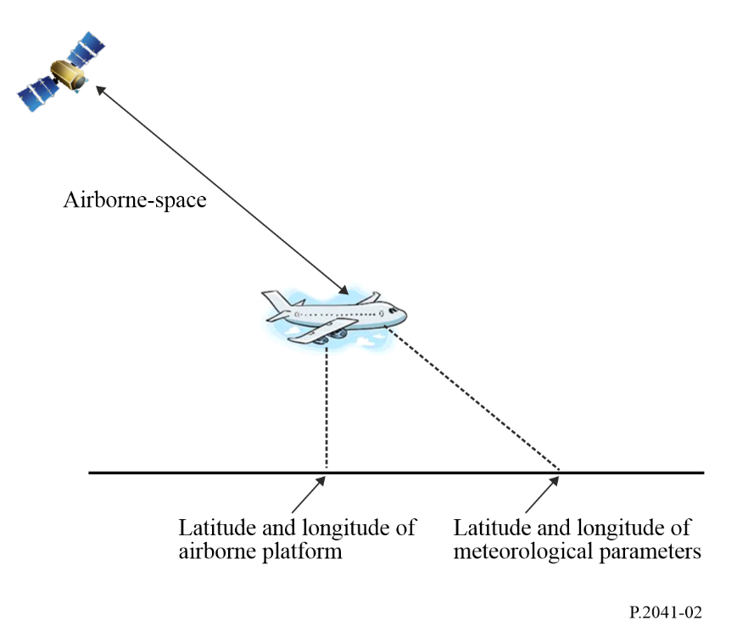

3 Applicability of the prediction methods
These predictions methods are applicable to links between an airborne platform and space and between an airborne platform and the surface of Earth, where:
– frequency 30 MHz ≤ f ≤ 55 GHz;
– elevation angle (φ) from the local horizontal plane ≥ 5°.
Depending on the frequency and elevation angle, multipath fading may need to be considered (see Recommendation ITU-R P.528); and depending on the location, time of day, and solar activity, the ionospheric scintillation may need to be considered for frequencies below about 6 GHz (see Recommendation ITU-R P.531).

4 Attenuation between an airborne platform and space

4.1 Total attenuation prediction method
If the airborne platform is below the rain height.
Similar as in Recommendation ITU-R P.618, the total attenuation between an airborne platform and space, $A_{T}^{AS}(p)$, is computed by:
$A_{T}^{AS}\left(p\right)=A_{G}^{AS}\left(p\right)+\sqrt{{\left(A_{R}^{AS}\left(p\right)+A_{C}^{AS}\left(p\right)\right)}^{2}+{\left(A_{S}^{AS}\left(p\right)\right)}^{2} }$ (1)
where:
$A_{R}^{AS}(p)$: attenuation due to rain for a fixed probability (dB)
$A_{C}^{AS}(p)$: attenuation due to clouds for a fixed probability (dB)
$A_{G}^{AS}(p)$: gaseous attenuation due to water vapour and oxygen for a fixed probability (dB)
$A_{S}^{AS}(p)$: fading due to tropospheric scintillation for a fixed probability (dB)
and
$A_{C}^{AS}\left(p\right)=A_{C}^{AS}\left(1\%\right)$ for p < 1.0% (2a)
$A_{G}^{AS}\left(p\right)=A_{G}^{AS}(1\%)$ for p < 1.0% (2b)

If the airborne platform is above the rain height.
The total attenuation between an airborne platform and space, $A_{T}^{AS}(p)$, is computed by:

$A_{T}^{AS}\left(p\right)=A_{G}^{AS}\left(p\right)+A_{C}^{AS}\left(p\right)$ (3)
where:
$A_{C}^{AS}(p)$: attenuation due to clouds for a fixed probability (dB)
$A_{G}^{AS}(p)$: gaseous attenuation due to water vapour and oxygen for a fixed probability (dB)
and
p ≥ 0.1%.

For Earth-space paths, the gaseous attenuation, cloud attenuation, rain attenuation, and scintillation fading are estimated using the various associated digital meteorological maps, usually on a 1.125° × 1.125° grid. The following paragraphs describe the method of adjusting the prediction methods that apply to Earth-space paths for paths between an airborne platform and space.

4.2 Gaseous attenuation
The gaseous attenuation for an Earth-space path is predicted by Recommendation ITU-R P.676:

$A_{G}\left(p\right)=\frac{A_{o}(p)+A_{w}\left(p\right)}{\sin{φ}}$ (4)

For a path between an airborne platform and space, the corresponding gaseous attenuation is:

$A_{G}^{AS}\left(p\right)=\frac{A_{o}^{AS}(p)+A_{w}^{AS}\left(p\right)}{\sin{φ}}$ (5)
$A_{o}^{AS}$ is predicted as follows:

$A_{o}^{AS}=A_{o}e^{-altitude/h_{o}}$ (6)

where altitude is the altitude above the surface of the Earth, $A_{o}$is the specific attenuation calculated based on mean surface meteorological parameters and$h_{o}$ using the frequency of interest and the statistical surface meteorological parameters, both $A_{o}$ and $h_{o}$ are obtained from Recommendation ITU-R P.676.
$A_{w}^{AS}$ is predicted as follows:

$A_{w}^{AS}=K_{V}∙V(p)$ (7)

where $K_{V}$ is the intermediate parameter calculated using the mean surface meteorological parameters, and $V\left(p\right)$is the integrated water vapour content at the exceedance probability 𝑝 at the desired location and the altitude of the airborne platform.

4.3 Cloud attenuation
It is difficult to predict cloud attenuation from an airborne platform to space since different cloud types are at different altitudes with different vertical extents. However, a conservative approach is to assume the cloud base is at the rain height specified in Recommendation ITU-R P.839 and the cloud top is at 6 km. Compute the cloud attenuation per Recommendation ITU-R P.840 as follows: use 100% of the total columnar content of cloud liquid water for altitudes below the rain height, 0% of the total columnar content of cloud liquid water for altitudes above the cloud top, with a linear transition of total columnar content of cloud liquid water between the cloud base and the cloud top.

4.4 Rain attenuation
Rain attenuation is predicted from Recommendation ITU-R P.618 which computes the slant-path length, $L_{s}$, from $h_{s}$, the height of the Earth station above mean sea level. For a path between an airborne platform and space, $h_{s}$ is replaced by the altitude of the airborne platform above mean sea level with the constraint that if $h_{s}$ is greater than or equal to $h_{R}$, then the rain attenuation is 0 dB.

4.5 Fading due to tropospheric scintillation
Fading due to tropospheric scintillation is predicted from Recommendation ITU-R P.618. If the airborne platform is at an altitude below the rain height specified in Recommendation ITU-R P.839, tropospheric scintillation is calculated assuming the airborne platform is located at the surface of the Earth. If the airborne platform is at an altitude above the rain height specified in Recommendation ITU-R P.839, tropospheric scintillation is ignored.

5 Attenuation between an airborne platform and the surface of the Earth

5.1 Total attenuation prediction method
Similar as in Recommendation ITU-R P.618, the total attenuation between an airborne platform and the surface of the Earth, $A_{T}^{AE}(p)$, is computed by:
$A_{T}^{AE}\left(p\right)=A_{G}^{AE}\left(p\right)+\sqrt{{\left(A_{R}^{AE}\left(p\right)+A_{C}^{AE}\left(p\right)\right)}^{2}+{\left(A_{S}^{AE}\left(p\right)\right)}^{2}}$ (8)
where:
$A_{R}^{AE}(p)$: attenuation due to rain for a fixed probability (dB)
$A_{C}^{AE}(p)$: attenuation due to clouds for a fixed probability (dB)
$A_{G}^{AE}(p)$: gaseous attenuation due to water vapour and oxygen for a fixed probability (dB)
$A_{S}^{AE}(p)$: fading due to tropospheric scintillation for a fixed probability (dB)
and
$A_{C}^{AE}\left(p\right)=A_{C}^{AE}\left(1\%\right)$ for p < 1.0% (9a)
$A_{G}^{AE}\left(p\right)=A_{G}^{AE}(1\%)$ for p < 1.0% (9b)

5.2 Gaseous attenuation
$A_{G}^{AE}(p)$ is predicted as follows:
$A_{G}^{AE}\left(p\right)=A_{G}\left(p\right)-A_{G}^{AS}(p)$ (10)
where:
$A_{G}\left(p\right)$: gaseous attenuation between the surface of the Earth and space along the same path
$A_{G}^{AS}(p)$: calculated per equation (5).

5.3 Cloud attenuation
It is difficult to predict cloud attenuation from an airborne platform to the surface of the Earth since different cloud types are at different altitudes with different vertical extents. However, a conservative approach is to include cloud attenuation predicted by Recommendation ITU-R P.840 for all altitudes.

5.4 Rain attenuation
$A_{R}^{AE}(p)$ is predicted as follows:
$A_{R}^{AE}\left(p\right)={A_{R}\left(p\right)-A}_{R}^{AS}(p)$ (11)

where $A_{R}(p)$ is the rain attenuation between the surface of the Earth and space.

5.5 Fading due to tropospheric scintillation
Fading due to tropospheric scintillation is predicted from Recommendation ITU-R P.618. Tropospheric scintillation is included for all altitudes.

6 Applicability to specific airborne missions
The prediction methods described in this Recommendation correspond to the long-term average availability at a specific altitude and elevation angle. These prediction methods can also be used to predict the worst-case or average link availability for any applicable altitude and elevation angle profile. The time duration of an impairment (e.g. rain attenuation) will be dependent on the dynamics of the airborne platform.

