Recommendation ITU-R P.1814-1
(09/2025)
P Series: Radio-wave propagation
Prediction methods required for the design of terrestrial free-space optical links

Foreword
The role of the Radiocommunication Sector is to ensure the rational, equitable, efficient and economical use of the radio-frequency spectrum by all radiocommunication services, including satellite services, and carry out studies without limit of frequency range on the basis of which Recommendations are adopted.
The regulatory and policy functions of the Radiocommunication Sector are performed by World and Regional Radiocommunication Conferences and Radiocommunication Assemblies supported by Study Groups.

Policy on Intellectual Property Right (IPR)
ITU-R policy on IPR is described in the Common Patent Policy for ITU-T/ITU-R/ISO/IEC referenced in Resolution ITU-R 1. Forms to be used for the submission of patent statements and licensing declarations by patent holders are available from https://www.itu.int/ITU-R/go/patents/en where the Guidelines for Implementation of the Common Patent Policy for ITU-T/ITU-R/ISO/IEC and the ITU-R patent information database can also be found.

Series of ITU-R Recommendations
(Also available online at https://www.itu.int/publ/R-REC/en)
Series | Title
BO | Satellite delivery
BR | Recording for production, archival and play-out; film for television
BS | Broadcasting service (sound)
BT | Broadcasting service (television)
F | Fixed service
M | Mobile, radiodetermination, amateur and related satellite services
P | Radio-wave propagation
RA | Radio astronomy
RS | Remote sensing systems
S | Fixed-satellite service
SA | Space applications and meteorology
SF | Frequency sharing and coordination between fixed-satellite and fixed service systems
SM | Spectrum management
SNG | Satellite news gathering
TF | Time signals and frequency standards emissions
V | Vocabulary and related subjects

Note: This ITU-R Recommendation was approved in English under the procedure detailed in Resolution ITU-R 1.

Electronic Publication
Geneva, 2025

© ITU 2025
All rights reserved. No part of this publication may be reproduced, by any means whatsoever, without written permission of ITU.

RECOMMENDATION ITU-R P.1814-1*
Prediction methods required for the design of terrestrial free-space optical links
(Question ITU-R 228-3/3)
(2007-2025)
Scope
This Recommendation provides propagation prediction methods for planning terrestrial free-space optical systems. It includes methods to estimate attenuation in clear air, fog and rain. It also covers scintillation and impairments by sunlight.
Keywords
Optical propagation, free-space optics, rain attenuation, fog attenuation, clear air turbulence, statistical modelling, link margin
Abbreviations/Glossary
CCDF Complementary cumulative distribution function
DSD Drop size distribution
FSO Free-space optics
IFOV Instantaneous field of view
IR Infra-red
LOS Line-of-sight
MOR Meteorological optical range
PSD Particle size distribution
RF Radio frequency
WMO World Meteorological Organization
Related ITU Recommendations
Recommendation ITU-R P.837 – Characteristics of precipitation for propagation modelling
Recommendation ITU-R P.1817 – Propagation data required for the design of terrestrial free-space optical links
NOTE – The latest edition of the Recommendation in force should be used.
The ITU Radiocommunication Assembly,
considering
a) that the visible optical and infrared spectrum is available for radiocommunications in the Earth’s environments;
b) that for the proper planning of free-space optical (FSO) radiocommunication systems operating in visible optical and infrared spectrum, it is necessary to have appropriate propagation data;
c) that methods have been developed that allow the calculation of the most important propagation parameters needed in planning free-space optical systems operating in the visible optical and infrared spectrum;
d) that these methods have been tested against available data and have been shown to yield an accuracy that is both compatible with the natural variability of propagation phenomena and adequate for most present applications in the planning of systems operating in visible optical and infrared spectrum,
recognizing
that No. 78 of article 12 of the ITU Constitution states that a function of the Radiocommunication Sector includes, “... carrying out studies without limit of frequency range and adopting recommendations ...”,
recommends
that the methods for predicting the propagation parameters given in the Annex should be used for planning free-space optical systems, in the respective ranges of validity indicated in annex.

Annex
TABLE OF CONTENTS
Page
1 Introduction 3
2 Initial considerations in designing an FSO link 3
2.1 Weather 3
2.2 Path characteristics 3
2.3 Transceiver mounting 4
3 Geometrical attenuation 4
4 Atmospheric attenuation 4
4.1 Specific atmospheric attenuation due to absorption and scattering γ_{atmo} 5
4.2 Path attenuation 10
4.3 Statistical model of the total atmospheric attenuation affecting FSO links 11
5 Scintillation effects 12
6 Ambient light effect 14
7 Link margin calculation 15
8 Other issues 15

1 Introduction
In the design of FSO links several effects must be considered including the losses due to atmospheric absorption, scattering and turbulence, microclimate environment and localized effects, link distance and link misalignment. The selection of wavelength, data rate, eye-safety issues, and ambient solar radiation must also be considered.
FSO system operation requires line-of-sight (LOS). When testing for LOS, as FSO systems use beam expansion and a collimated beam, the clearance needed between the centre of the beam and any obstructions is essentially equal to the beam radius. This is in contrast to RF systems where Fresnel zone clearance is needed.
The primary disadvantage of FSO systems is their vulnerability to atmospheric effects such as attenuation and scintillation, which can reduce link availability. The narrow beam also makes alignment of the laser communications terminal more critical than is usual for RF systems.
A key parameter in the design of FSO links is the consideration of the power budget. The link margin, (dB), which is the power available above the sensitivity of the receiver, can be found from equation (1):
$M_{link}=P_{e}-S_{r}-A_{geo}-A_{atmo}-A_{scintillation}-A_{system}$ (1)
where:
P_{e} (dBm): total power of the emitter
S_{r} (dBm): sensitivity of the receiver which also depends on the bandwidth (Data rate)
A_{geo} (dB): link geometrical attenuation due to transmit beam spreading with increasing range
A_{atmo} (dB): atmospheric attenuation due to absorption and scattering
A_{scintillation} (dB): attenuation due to atmospheric turbulence
A_{system} (dB): represents all other system dependent losses including misalignment of the beam direction, receiver optical losses, loss due to beam wander, reduction in sensitivity due to ambient light (solar radiation), etc.
The definition and computation of these terms and the initial consideration for planning an FSO link are given in the following sections.

2 Initial considerations in designing an FSO link
The choice of a suitable link location is an important issue for a successful operation of an FSO system. The installation of FSO links has to account for prevailing weather conditions, physical obstructions and surface types along the path, and transceiver mounting arrangements to ensure optimum link performance.

2.1 Weather
– Weather conditions, and in particular the local climate, in the vicinity of the chosen link path will influence the occurrence of snow, rain, drizzle fog, haze, aerosol and dust/sand that will lead to absorption and scattering of the transmitted signal.

2.2 Path characteristics
– Physical obstructions to the path between emitter and receiver are clearly to be avoided. It is well worth noting that mature trees can increase in height by between 0.5 and 1 m in one year and vary in foliage density over the year.
– Links between buildings should account for thermal vents that could result in hot air rising through the link path, and the resulting turbulence could lead to significant scintillation at the receiver.
– The topography and the type of surface beneath an FSO line-of-sight path can significantly impact the performance of the link. FSO links across river valleys, or across areas of open sea, will often experience increased incidents of fog. Building structures beneath the link may cause additional thermal activity in the air above them that may then lead to increased scintillation on the received signal.

2.3 Transceiver mounting
– Most FSO systems have very narrow beam widths, and, as a result, the accurate alignment of the emitter and receiver is critical; any misalignment causes significant signal loss. The telescope mounts must be stable and direct mounting to substantial walls, or to the top of a single column, is considered essential for reliable performance over a period of time. Movement as the result of differential thermal expansion, or buffeting by wind, should be minimized.

3 Geometrical attenuation
Even in clear weather conditions, the beam diverges and, as a result, the detector receives less signal power. The attenuation due to transmit beam spreading with increasing range is called geometrical attenuation and is given by equation (2):
$A_{geo} \left(dB\right)=10\log_{10}\left(\frac{S_{d}}{S_{capture}}\right)$ (2)
where:
S_{capture} : receiver capture surface (m²)
S_{d} : surface area of transmit beam at range d, which is approximated by:
$S_{d}=\frac{π}{4}{\left(d∙θ\right)}^{2}$
where:
θ : beam divergence (mrad)
d : emitter-receiver distance (km).
It is possible on short links for the capture area to be greater than the beam area. In these cases, the value of $A_{geo}$ should be set to zero as all of the beam energy is collected.

4 Atmospheric attenuation
The atmospheric attenuation A_{atmo} (dB) affecting FSO links requires the following processing steps:
1) Calculate the specific atmospheric attenuation for the relevant contributors (e.g. fog, haze, rain). This part is discussed in § 4.1.
2) Provide a rule to convert the specific attenuation into path attenuation for each contributor. This part is discussed in § 4.2.
3) Provide a statistical model to derive the total path attenuation from the path attenuation of each contributor: this is discussed in § 4.3.
As for item 2), when calculating the path attenuation A_{path} as the specific attenuation times the path length, A_{path} may be overestimated (statistically) as the specific attenuation is usually computed from single-point measurements. The spatial inhomogeneity of atmospheric elements (e.g. rain rate) along the path and/or complex propagation mechanism (e.g. multiple scattering) should be considered, for instance, through simple empirical correction factors. This part is discussed in § 4.2.
As for item 3), the individual attenuation components are added up together with a statistical approach, combining the corresponding complementary cumulative distribution functions (CCDFs). The CCDF of total attenuation is then used into the link budget equation (25) of § 7 to obtain the link margin required to achieve a target availability.

4.1 Specific atmospheric attenuation due to absorption and scattering γ_{atmo}
The specific atmospheric attenuation $γ_{atmo}$ (dB/km), also referred to as the extinction coefficient, can be written as the sum of two terms:
$Γ_{atmo}=γ_{clear_{air}}+γ_{excess}$ (3)
where:
$γ_{clear_{air}}$ : specific attenuation under clear air conditions due to the atmospheric constituents
$Γ_{excess}$ : specific attenuation due to the occasional presence of aerosol, haze, fog, rain, snow, hail, etc.

4.1.1 Specific clear-air attenuation $γ_{clear air}$
Attenuation under clear-air conditions is mainly due to the absorption by atmospheric constituents, i.e. gaseous molecules. Atmospheric absorption at specific optical wavelengths results from the interaction between photons and atoms or molecules in the air, which leads to the absorption of the incident photon and an increase in the temperature. The absorption coefficient depends on:
– the type of gas molecules;
– their concentration;
– the meteorological conditions (e.g. temperature and pressure).
Molecular absorption is a wavelength-selective phenomenon resulting in atmospheric transmission windows separated by atmospheric absorbing regions. The atmospheric molecules that have high absorption in the infra-red (IR) band at ground level include water vapour (H₂O), and carbon dioxide (CO₂).
Because the size of the gaseous molecules is much smaller than the wavelength, attenuation due to scattering from the gaseous molecules is negligible.
Usually, the laser wavelengths are selected to fall inside atmospheric transmission windows, so $γ_{clear_{air}}$ is negligible. The wavelengths typically used by viable FSO links are in the near-IR range (i.e. 780-850 nm or 1550 nm). However, far-IR links transmitting in the 10.6 µm window may exhibit lower attenuation levels than near-IR links in the presence of particulates whose typical size is in the order of a few microns as in the case of some types of fog.

4.1.2 Specific excess attenuation
The occasional particles (e.g. fog, rain, snow) in the atmosphere produce the specific excess attenuation in equation (3). These particles cause an angular redistribution of the incident flux, known as scattering, which reduces the flux propagation in the original direction. Although some absorb part of the incident energy, this process differs from gaseous absorption, which is a wavelength-selective process. The attenuation depends on the type and size of particles and the laser transmission wavelength.
The most common suspended particles in the troposphere are:
‒ Aerosols, i.e. colloidal systems (i.e. a mixture of two substances) in which the dispersed phase comprises either solid or liquid particles. At the same time, the dispersion medium is a gas, the air, in the case of atmospheric aerosols.
‒ Haze, i.e. an intermediate condition due to the hydration of aerosol particles when relative humidity is beyond the deliquescence point. The activation process is not engaged; hence there are no water droplets.
‒ Fog, i.e. water droplets growing around a preexisting population of condensation nuclei (i.e. the activated haze particles), when water vapour saturation is reached.
Some classes of suspended particles that are characteristic of arid and semiarid climates also cause non-negligible attenuation at optical wavelengths. Examples of these particles are dust and sand.
Rain, snow and hail are the most common hydrometeors in the atmosphere.
Table 1 lists the typical range of visibility and size for different particle types. The size of the scatterer with respect to the laser wavelength determines the properties of the scattering process, hence the wavelength dependence of the specific attenuation of a population of particles of a given type.
The aerosols’ particle size distribution (PSD) is multimodal and often modelled by as many lognormal functions. For particles much larger than the wavelength, scattering can be described by geometric optics, which is independent of the wavelength. That is the so-called geometrical optics representation of light, i.e. a plane wavefront can be thought of as composed of some small pencils of light or rays. According to the Fresnel diffraction theory, these traveling rays exist independently of the other rays after a given distance. The geometrical optics approach may be adopted to solve the problem of light scattering by a particle only if the particle is much larger than the wavelength. The specific attenuation due to rain, snow, and hail is flat from the visible to the near-IR region and beyond. Mie scattering theory can be applied to particles whose size is comparable to the laser wavelength. Fog, haze and aerosol particles are the major contributors to the Mie scattering process. The last two columns in Table 1 show the dependence of the specific attenuation on the wavelength in the FSO range and the scattering theory.
TABLE 1
Typical range of visibility and size for different types of atmospheric particles
Type of scatterer / particle | Typical visibility range | Typical size range  (particles radius) | Specific attenuation vs wavelength | Scattering
Atmospheric gases | $$> 100 km$$ | < 0.001 μm | $$\left(λ\right)\sim λ^{4}$$ | Rayleigh scattering
Aerosol, haze and light fog | $$≳ 0.5 km$$ | Nucleation mode, Aitken mode, accumulation mode and coarse mode  (0.005-1 μm) | $\left(λ\right)\sim λ^{-1.6}$ to $\left(λ\right)\sim λ^{0}$ | Mie scattering
Heavy fog | $$≲ 0.5 km$$ | 1-100 μm
Snow | 0.3-3 km | 1-10 mm | $$\left(λ\right)\sim λ^{0}$$ | Optical scattering
Rain | 0.5-10 km | 0.1-4 mm

4.1.2.1 Specific attenuation due to suspended particles $γ_{sp}$
The specific attenuation of a given particulate can be calculated analytically from the extinction cross-section of the individual particles and the PSD. However, the PSD of aerosol, haze, or fog is difficult to measure and model. Due to the lack of PSD measurements in the literature, empirical models are often adopted. Most of them, the specific attenuation is related to the atmospheric visibility V.
The definition of visibility following the Guide to Meteorological Instruments and Methods of Observation recommendations released by the World Meteorological Organization (WMO) is as follows. Visibility is equivalent to the meteorological optical range (MOR), i.e. the atmospheric path length required to reduce the irradiance (i.e. the optical power per unit area) of a perfectly collimated beam from an incandescent lamp at a colour temperature of 2 700 K, to 5% times its value at the transmitter aperture. Employing the Bouguer-Lambert law, which predicts an exponential decay of the irradiance for propagation through a uniform layer of particles, it is straightforward to retrieve the following relationship between the specific attenuation $γ_{sp}$ (in dB/km) and V (in km):
$Γ_{sp}=\frac{13}{V}$ (4)
It should be noted that this relationship holds in the visible range of the optical spectrum (conventionally midway through 400-700 nm window, i.e. at 550 nm), and nothing is stated about the type of particles present across the path. Equation (4) is written for suspended particles; however, in principle, it holds for any kind of atmospheric conditions.
Instrumental methods often make use of equation (4) to derive V from measurements of $γ_{sp}$ (or similar quantities as the scattering coefficient) within a sample volume of the atmosphere. Sometimes, a different threshold value T for the irradiance is used; hence, for convenience, equation (4) can be expressed in a more general way as:
$Γ_{sp}=\frac{K}{V}$ (5)
$Γ_{sp}=\frac{13}{V}$ (6)
Table 2 summarizes the recommended relationships to convert visibility into specific attenuation in the visible window and the associated uncertainties.
TABLE 2
Recommended values of coefficient K for equation (5), considering the measured method
Measurement method | K | Uncertainty  (standard deviation)
Visual observation of a light source at night | 9.6 | 40%
Visual observation of a black object against the sky horizon during the day | 11.3 | 22%
Instrumental measurements of the MOR | 13 | 5-20%

Most of the actual visibility sensors follow WMO recommendations and return the MOR, i.e. the visibility for T = 5%, thus, the conversion in equation (7) is required to apply the models presented in this section.
$V_{T = 2\%}={\frac{\ln{0.02}}{\ln{0.05}}V}_{T = 5\%}=1.31 V_{T = 5\%}$ (7)
The visibility is measured by the meteorological stations located in many airports worldwide and stored by online repositories, allowing local performance evaluation of FSO systems using the first-order statistics of this parameter. However, visibility is sensitive to the microclimate; hence, data collected at airports may not genuinely represent nearby urban or suburban environments.
The wavelength dependence of the $γ_{sp}-V$ relationship can be accounted for by a power-law function, which fits the asymptotic regime of Rayleigh scattering as well. The simplified equation to calculate the specific attenuation due to suspended particles valid for 0.4 μm ≤ λ ≤1.55 μm is given by the expression in equation (8). Figure 1(a) shows the specific attenuation for three wavelengths in the valid range of equation (8).
$Γ_{sp}\left(λ\right)=\frac{17}{V}{\left(\frac{0.55 μm}{λ}\right)}^{q}$ (8)
where:
V : visibility (km) defined according to the 2% threshold
λ : wavelength (μm)
q : a coefficient dependent on the size distribution of the scattering particles. It is given by:
q = 1.6 V > 50 km
= 1.3 6 km < V < 50 km (9)
$=0.16V+0.34$ 1 km ≤ V ≤ 6 km
$=V-0.5$ 0.5 km ≤ V < 1 km
$=0$ V < 0.5 km
The relation in equation (10) can be used for higher wavelengths, specifically for mid and far IR windows (i.e. centred about 3.7 and 10.6 μm). It is derived from the best fit of measurements by several authors. V is the visibility (km) defined according to the 2% threshold. The coefficients $a$ and $b$ for the valid range of wavelength and visibility are presented in Table 3. The specific attenuation calculated for both wavelengths is shown in Fig. 1(b). It should be noted that the valid visibility range for $λ=10.6 μm$ is 3 km as in Table 3.
$Γ_{sp}\left(λ\right)=aV^{b}$ (10)
TABLE 3
Coefficients $a$ and $b$ for relation in equation (10)
Transmission window | Centre-band  (μm) | Visibility  (km) | Coefficient
Transmission window | Centre-band  (μm) | Visibility  (km) | $$a$$ | $$b$$
Mid IR | 3.7 | $$0.06≤V<0.5$$  $$0.5≤V<10$$ | 13.07  10.42 | −1.11  −1.43
Far IR | 10.6 | $$0.06≤V<0.5$$  $$0.5≤V<3$$ | 5.30  2.30 | −1.30  −2.51

FIGURE 1
Specific attenuation due to suspended particles for different optical wavelengths
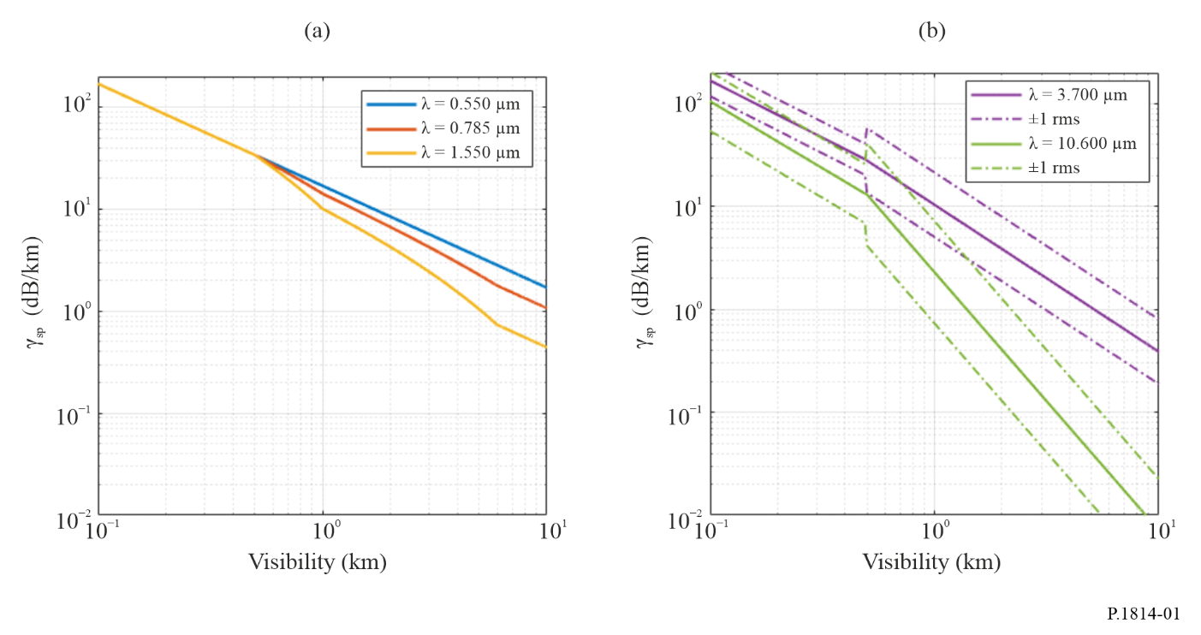

4.1.2.2 Specific attenuation due to rain γ_{rain}
As indicated in Table 1, the specific attenuation due to rain γ_{rain} is independent of the wavelength in the optical transmission windows usually adopted by commercial FSO systems, which are the classical 0.780-0.850 and 1.520-1.600 µm bands. For practical purposes, the specific attenuation γ_{rain} (in dB/km) is often calculated from the rain rate R (in mm/h) through simple power-law relationships, i.e.:
$Γ_{rain}=kR^{α}$ (11)
For a given rain rate, the coefficients k and α are sensitive to the distribution of raindrop size, namely to the drop size distribution (DSD) of precipitation, as clearly shown. Table 4 reports the best-fit k and α coefficient derived from the values of γ_{rain} calculated through classical scattering theory, assuming that the DSD is modelled with a Gamma function, the latter being dependent only on the so-called shape parameter µ and on the rain rate R. Measurements indicate that µ can mostly range between −2 and 2. Figure 2 shows the curves in equation (11) with the coefficients in Table 4 for such values of μ.
TABLE 4
Coefficients in equation (11) for different values of the DSD shape parameter (µ)
$$μ$$ | $$k$$ | $$α$$
−2 | 2.2838 | 0.4050
−1 | 1.5921 | 0.5506
0 | 1.2924 | 0.6436
1 | 1.1394 | 0.7057
2 | 1.0505 | 0.7497

FIGURE 2
Specific rain attenuation (dB/km) as a function of the rain rate (mm/h)
for different values of the shape parameter μ of the Gamma DSD
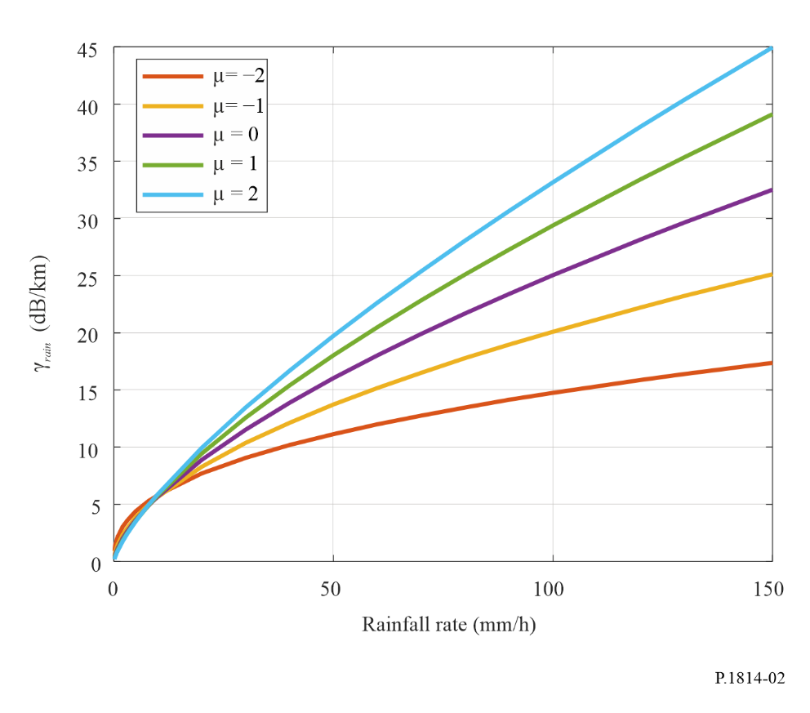

4.2 Path attenuation
This section discusses how to calculate the path attenuation along an FSO link, for path lengths L ≤ 5 km (L expressed in km).

4.2.1 Clear-air path attenuation A_{clear_air}
The spatial variability of gaseous attenuation is quite limited, even more so for path lengths shorter than 5 km. In essence, the specific clear-air attenuation $γ_{clear_{air}}$ in § 4.1.1 can be assumed to be constant along the path. Therefore, the clear-air path attenuation is simply calculated as:
$A_{clear_{air}}=γ_{clear_{air}}L$ (12)

4.2.2 Path attenuation due to suspended particles $A_{sp}$
The variability of fog concentration along the path is yet to be properly studied, and it might depend on microclimatic features (e.g. one end of the link is closer to the countryside, while the other one is in the city). Therefore, the simplest assumption is that fog concentration is relatively constant along the path, which leads to the following simple expression for the calculation of the attenuation due to suspended particles:
$A_{sp}=γ_{sp}L$ (13)

4.2.3 Path attenuation due to rain $A_{rain}$
Rainfall is characterized by a marked spatial inhomogeneity, such that it is impossible to consider the rain rate constant along an FSO link. This is even more evident during convective events, characterized by small rain cells (dimensions in the order of hundreds of meters). The spatial inhomogeneity of rainfall can be equivalently taken into account by resorting to the concept of path reduction factor $F_{rain}$, based on which the path attenuation due to rain ${A^{'}}_{rain}$ is defined as:
$A_{rain}^{'}=γ_{rain} L F_{rain}$ (14)
where:
$F_{rain}=\frac{1}{1+\frac{L\left(R-6.2\right)}{2623}}$ (15)
and R is the rain rate.
The simple scattering theory used to derive the coefficients of equation (11) in Table 4 assumes that the electromagnetic energy associated with the portion of the wavefront intercepted by a particle is lost. However, as a matter of fact, the incident energy is scattered by the particle with an angular pattern that, in the case of raindrops and optical wavelengths, exhibits a narrow peak in the forward direction. As a result, a non-negligible fraction of the radiation transmitted through a rainy atmospheric layer is received because of particle scattering. If the light beam undergoes several particle interactions before reaching the receiver, the process is called multiple scattering. Forward and multiple scattering reduce path attenuation to some extent (especially at high rain rates), which needs to be taken into account in devising a model to predict rain attenuation statistics for FSO links. As a result, the final path attenuation due to rain is given by:
$A_{rain}=A_{rain}^{'}-G_{ms}$ (16)
where G_{ms} is the multiple scattering gain, defined as:
$G_{ms}=a_{ms}L^{b_{ms}}$ (17)
The coefficients a_{ms} and b_{ms} depend on the rain rate R for a given DSD shape as follows:
$a_{ms}=p_{0}+p_{1}\ln\left(R\right)+p_{2}{\left[\ln\left(R\right)\right]}^{2}$ (18)
$b_{ms}=k_{0}+k_{1}\ln\left(R\right)+k_{2}{\left[\ln\left(R\right)\right]}^{2}$ (19)
The values of the coefficients in equations (18) and (19) are listed in Table 5 for the considered values of μ.
TABLE 5
Coefficients in equations (18) and (19)
$$μ$$ | $$p_{0}$$ | $$p_{1}$$ | $$p_{2}$$ | $$k_{0}$$ | $$k_{1}$$ | $$k_{2}$$
−2 | 0.010012 | 0.025381 | −0.001606 | 0.250329 | −0.035278 | 0.008349
−1 | 0.014551 | 0.010932 | 0.001532 | 0.279336 | 0.023974 | 0.004421
0 | 0.015940 | −0.001476 | 0.008297 | 0.117663 | 0.029602 | 0.002142
1 | 0.023468 | 0.002897 | 0.008912 | 0.090689 | 0.034955 | 0.004583
2 | −0.000316 | 0.062233 | −0.007835 | 0.192092 | −0.081869 | 0.033669

4.3 Statistical model of the total atmospheric attenuation affecting FSO links
Step 1: The path attenuation due to suspended particles $A_{sp}$ can be obtained from visibility V through equations (8), (9) and (13).
Step 2: The path attenuation due to rain $A_{rain}$ can be obtained from the rainfall rate through equations (11) and (14).
Step 3: The total excess path attenuation $A_{atmo}$ due to the atmosphere can be calculated through the following procedure:
i) Setup a path attenuation axis A (dB)
ii) Calculate the CCDF of $A_{sp}\left(p\right)$ at the points in A
iii) Calculate the CCDF of $A_{rain}\left(p\right)$ at the points in A
iv) Add together the two above CCDF values at each point in $A$ to get the CCDF of $A_{atmo}$ in A
v) Interpolate the CCDF of $A_{atmo}$ over a given probability axis p to get $A_{atmo}$ values exceeded with a probability p.
The key atmospheric drivers necessary to estimate the FSO path attenuation are the visibility $V$ and the rainfall rate $R$. Hence, step 3 requires the following input data:
1) CCDF of visibility data conditioned to the occurrence of suspended particles only at the desired location.
2) CCDF of rainfall rate at the desired location.
In the absence of local data, the following database can be used:
– for the visibility, the Global Historical Climatology Network – Daily (GHCN-Daily) dataset from NOAA, provides raw data with time series of the visibility in many locations worldwide as well as SYNOP codes to determine actual weather condition,
– for the rainfall rate, Recommendation ITU-R P.837 provides the CCDF of rainfall rate worldwide.

5 Scintillation effects
A second major atmospheric process that affects the performance of laser communication systems is turbulence-induced atmospheric scintillation which causes severe fluctuations in the received signal power.
Atmospheric turbulence produces temporary pockets of air with slightly different temperatures, different densities, and different indices of refraction. Data can be lost due to beam wander and scintillation as the laser beam becomes deformed propagating through these index of refraction inhomogeneities. The significance of each effect depends on the size of these turbulence cells with respect to the laser beam diameter.
If the sizes of the turbulence cells are larger than the beam diameter, the laser beam as a whole randomly bends, causing signal loss if the beam wanders off the receiver aperture. Longer wavelengths will have less beam wander than shorter wavelengths, although the wavelength dependence is weak.
More commonly, if the sizes of the turbulence cells are smaller than the laser beam diameter, ray bending and diffraction cause distortions in the laser beam wave front. This results in temporal fluctuations in the laser beam intensity, known as scintillation, at the receiver with a frequency spectrum from 0.01 Hz to 200 Hz.
Tropospheric scintillations effects are generally studied from the logarithm of the amplitude χ (dB) of the observed signal (“log-amplitude”), defined as the ratio in decibels between its instantaneous amplitude and its average value. The intensity and the fluctuation rate (scintillation frequency) increase with wavelength. For a plane wave and weak turbulence, the scintillation variance (dB²) can be expressed by the following relation:
$Σ_{χ}^{2}=23.17∙k^{7/6}∙C_{n}^{2}∙L^{\frac{11}{6}}$ (20)
where:
$k=\frac{2π}{λ}$ : wave number (m⁻¹)
L : length of the link (m)
$C_{n}^{2}$ : refractive index structure parameter (m^{−2/3}).
The scintillations have peak amplitude of 4σ_{χ} and the attenuation due to scintillation is 2σ_{χ}. For strong turbulence, saturation of the variance given by the above relation is observed. The parameter $C_{n}^{2}$ has a different value at optical wave lengths than at millimetre wavelengths. Scintillation at millimetre wavelengths is primarily due to humidity fluctuations, while at optical wavelengths scintillation is primarily a function of the temperature. At millimetre wavelengths, $C_{n}^{2}$ is approximately equal to 10⁻¹³ m^{−2/3} (in general, at millimetre wavelengths $C_{n}^{2}$ is between 10⁻¹⁴ and 10⁻¹² m^{−2/3}) and at optical wavelengths a value of $C_{n}^{2}$ is approximately equal to about 2 × 10⁻¹⁵ m^{−2/3} for weak turbulence (in general at optical wavelengths $C_{n}^{2}$ is between 10⁻¹⁶ and 10⁻¹³ m^{−2/3}).
Figure 3 illustrates the variation of the attenuation of a 1 550 nm wavelength optical beam for weak, mean, and strong turbulence at distances up to 2 000 m. Clearly, attenuation increases as turbulence increases. Table 6 shows the turbulence effect on optical and radio waves propagation. Scintillation is stronger on longer optical wavelengths.
FIGURE 3
Variation of the attenuation due to scintillation according to distance for various turbulence types at 1 550 nm
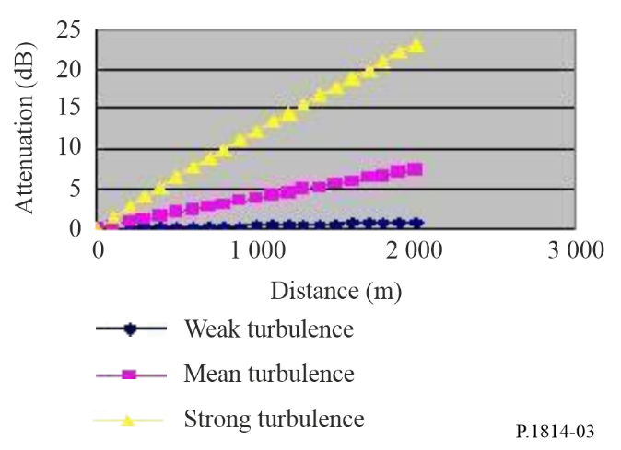
TABLE 6
Table of scintillation fade depths expected for 1 km path length
 |  | Turbulence
 | Low | Moderate | High
$C_{n}^{2}$ optic waves (m^{−2/3}) | 10⁻¹⁶ | 10⁻¹⁴ | 10⁻¹³
Attenuation (0.98 μm) (dB) | 0.51 | 5.06 | 16.00
Attenuation (1.55 μm) (dB) | 0.39 | 3.87 | 12.25
$C_{n}^{2}$ millimetre waves (m^{−2/3}) | 10⁻¹⁵ | 10⁻¹³ | 10⁻¹²
Attenuation (40 GHz) (dB) | 0.03 | 0.09 | 0.27
Attenuation (60 GHz) (dB) | 0.03 | 0.11 | 0.35

Scintillation can be reduced by using either multiple transmit beams or large receiver apertures. Also to minimize the effects of scintillation on the transmission path, FSO systems should not be installed close to hot surfaces. Because scintillation decreases with altitude it is recommended that FSO systems should be installed a little higher above the rooftop (>1 m) and away from a side wall if the installation takes place in a desert-like environment.
Margins allocated to compensate for fog or rain attenuation can compensate also for scintillation effects.

6 Ambient light effect
Solar conjunction occurs when the sun or a reflected image of the sun is in or near the instantaneous field of view (IFOV) of an optical receiver. The receive IFOV is generally at least as large as the transmit divergence. The problem becomes severe when the sun position is parallel to the optical link and the sun power penetrating inside the receiver is greater than the power received from the emitter.
Solar interference is usually reduced by arranging for the receiver to be positioned so that the sun is always off-axis.
Figure 4 represents the geometry of the sun path in the sky with regard to a free-space optical link (A is the receiver, B the emitter).
FIGURE 4
Schematic sun path with regard to a free-space optical link
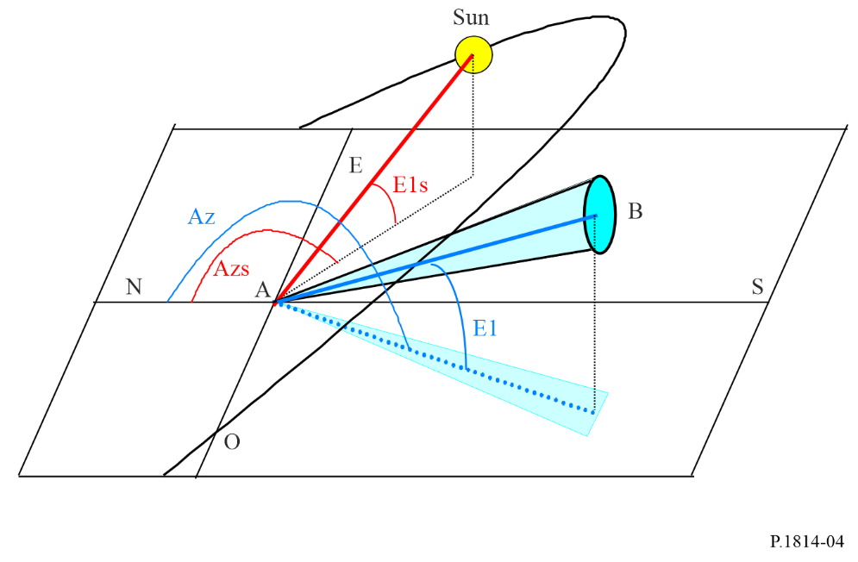
The power radiated by the sun, $P_{radiated}$ (W/m²) is defined by the following relation:
$P_{radiated}=1 200∙\cos\left(\frac{π}{2}-E_{ls}\right)$ (21)
where is the sun height (rad).
The received power is given by:
$P_{solar}={F_{solar}∙P_{radiated}∙S_{capture}∙W_{receiver}}/{100}$ (22)
where:
F_{solar} : solar spectral power as a function of wavelength
S_{capture} : receiver capture surface area (m²)
W_{receiver} : receiver bandwidth (nm)
F_{solar} : modelled by the following curve fit:
$$F_{solar}=8.97×{10}^{-13}λ^{5}-4.65×{10}^{-9}λ^{4}+9.37×{10}^{-6}λ^{3}-9.067×{10}^{-3}λ^{2}+4.05λ-5.70$$ (23)
where:
λ : wavelength (nm).

7 Link margin calculation
The link fade margin for an FSO system with a receiver at a distance d (km) from the emitter can be estimated using the following steps:
Step 1: The geometrical attenuation can be obtained from equation (1).
Step 2: Laser wavelengths are usually selected to fall inside atmospheric transmission windows so γ_{clear_air} can be considered negligible. As an alternative, estimates of the specific clear-air attenuation can be obtained from Recommendation ITU-R P.1817.
Step 3: Total attenuation $A_{atmo}$ is calculated as in § 4.3.
Step 4: The fade margin (dB) is given by:
$M_{link}=P_{e}-S_{r}-A_{system}-A_{geo}-A_{atmo}$ (24)
where:
(dBm) : total power of the emitter
(dBm) : sensitivity of the receiver
(dB) : represents all other system dependent loss. These include loss due to misalignment link, receiver optical loss, beam wander loss, ambient light attenuation (solar radiation) and others.

8 Other issues
Other factors that should be taken into account when an FSO system is designed include the following:
International safety regulations strictly limit the maximum output power of optical systems. At 1 550 nm, the regulatory agencies allow approximately 100 times more power than for “eye safe” shorter wavelengths. The disadvantage of this laser type is mainly their cost when compared to shorter wavelengths lasers operating around 850 nm.
FSO transceivers can be located behind windows. The angle the beam makes with the window is critical. The angle should be as perpendicular as possible, yet slightly angled (5 degrees) to reduce bounce-back of the beam to its receptor. Also, some windows contain glass or glass coating that reduce glare. Because these windows are often specifically designed to reject infrared, the coatings can reduce the signal by 60% or more.
Low visibilities will decrease the effectiveness and availability of FSO systems. Low visibility can occur during a specific time period within a year or day. Also, low visibility can be a localized phenomenon (coastal fog). One solution to the negative impact of low visibility is to shorten the distance between the terminals which provides a greater link margin to handle bad weather conditions.

* This Recommendation should be brought to the attention of Radiocommunication Study Groups 1 and 5.

