RECOMMENDATION ITU-R P.1546
Method for point-to-area predictions for terrestrial services in the
frequency range 30 MHz to 3 000 MHz

(2001)
The ITU Radiocommunication Assembly,
considering
a) that there is a need to give guidance to engineers in the planning of terrestrial radiocommunication services in the VHF and UHF bands;
b) that, for stations working in the same or adjacent frequency channels, the determination of the minimum geographical distance of separation required to avoid unacceptable interference due to long-distance tropospheric propagation is a matter of great importance;
c) that the curves that appear in Annexes 2, 3 and 4 are based on the statistical analysis of experimental data,
noting
a) that Recommendation ITU-R P.528 provides guidance on the prediction of point-to-area path loss for the aeronautical mobile service for the frequency range 125 MHz to 30 GHz and the distance range up to 1 800 km;
b) that Recommendation ITU-R P.452 provides guidance on the detailed evaluation of microwave interference between stations on the surface of the Earth at frequencies above about 0.7 GHz;
c) that Recommendation ITU-R P.617 provides guidance on the prediction of point-to-point path loss for trans-horizon radio-relay systems for the frequency range above 30 MHz and for the distance range 100 to 1 000 km;
d) that Recommendation ITU-R P.1411 provides guidance on prediction for short-range (up to 1 km) outdoor services;
e) that Recommendation ITU-R P.530 provides guidance on the prediction of point-to-point path loss for terrestrial line-of-sight systems,
recommends
1 that the procedures given in Annexes 1 to 6 be adopted for point-to-area prediction of field strength for the broadcasting, land mobile, maritime mobile and certain fixed services (e.g. those employing point-to-multipoint systems) in the frequency range 30 MHz to 3 000 MHz and for the distance range 1 km to 1 000 km.
ANNEX 1
Introduction

1 The propagation curves
The propagation curves in Annexes 2, 3 and 4 represent field-strength values for 1 kW effective radiated power (e.r.p.) at nominal frequencies of 100, 600 and 2 000 MHz, respectively, as a function of various parameters; some curves refer to land paths, others refer to sea paths. Interpolation or extrapolation of the values obtained for these nominal frequency values should be used to obtain field strength values for any given required frequency using the method given in Annex 5, § 6.
The curves are based on measurement data mainly relating to mean climatic conditions in temperate regions containing cold and warm seas, e.g. the North Sea and the Mediterranean Sea. The land-path curves were prepared from data obtained mainly from temperate climates as encountered in Europe and North America. The sea-path curves were prepared from data obtained mainly from the Mediterranean and the North Sea regions. Extensive studies reveal that propagation conditions in certain areas of super-refractivity bounded by hot seas are substantially different.
This Recommendation is not specific to a particular polarization.

2 Maximum field strengths
The curves have upper limits on the possible value of field strength which may be obtained under any conditions. These limits are defined in Annex 5, § 2 and appear as dashed lines on the graphs reproduced in Annexes 2, 3, and 4.

3 Computer-based tabulations
Although field strengths may be read directly from the curves presented as figures in Annexes 2, 3 and 4 of this Recommendation, it is intended that computer implementations of the method will use tabulated field strengths available from the Radiocommunication Bureau. See that part of the ITU-R website dealing with Radiocommunication Study Group 3.

4 Step-by-step method
The detailed step-by-step procedure to be used in the application of this Recommendation is given in Annex 6.

5 Designation of antennas
In this Recommendation, the term “transmitting/base antenna” is used to deal with both the concept of transmitting antenna as used in the broadcasting service and the concept of base station antenna as used in the terrestrial mobile services. Similarly, the term “receiving/mobile antenna” is used to deal with the concept of a receiving antenna as used in the broadcasting service and a mobile antenna as used in the terrestrial mobile services.

6 Transmitting/base antenna height
The method takes account of the effective height of the transmitting/base antenna, which is the height of the antenna above terrain height averaged between distances of 3 to 15 km in the direction of the receiving/mobile antenna. For land paths shorter than 15 km where the information is available the method also takes account of the height of the transmitting/base antenna above the height of representative clutter (i.e. ground cover) at the location of the transmitting/base station. The transmitting/base antenna height, h1, to be used for calculations is obtained using the method given in Annex 5, § 3.

7 Transmitting/base antenna heights used for curves
The field strength versus distance curves in Annexes 2, 3 and 4, and the associated tabulations, are given for values of h1 of 10, 20, 37.5, 75, 150, 300, 600 and 1 200 m. For any values of h1 in the range 10 m to 3 000 m an interpolation or extrapolation from the appropriate two curves should be used, as described in Annex 5, § 4.1. For h1 below 10 m, the extrapolation to be applied is given in Annex 5, § 4.2. It is possible for the value of h1 to be negative, in which case the method given in Annex 5, § 4.3 should be used.

8 Time variability
The propagation curves represent the field-strength values exceeded for 50%, 10% and 1% of time. A method for interpolating between these values is given in Annex 5, § 7. This Recommendation is not valid for field strengths exceeded for percentage times outside the range from 1% to 50%.

9 Mixed-path method
In cases where the radio path is over both land and sea the estimate of mixed-path field strength should be made using the method given in Annex 5, § 8.

10 Receiving/mobile antenna height
For land paths the curves give field-strength values for a receiving/mobile antenna height above ground, h2 (m), equal to the representative height of ground cover around the receiving/mobile antenna location. The minimum value of the representative height of ground cover is 10 m. For sea paths the curves give field-strength values for h2 = 10 m. To allow for values of h2 different from the height represented by a curve a correction should be applied according to the environment of the receiving/mobile antenna. The method for calculating this correction is given in Annex 5, § 9.

11 Terrain clearance angle correction
For land paths, improved accuracy of predicted field strengths can be obtained by taking into account terrain near the receiving/mobile antenna, if available, by means of a terrain clearance angle. When a calculation for a mixed path has been made, this correction should be included if the receiving/mobile antenna is adjacent to a land section of the path. More information on the terrain clearance angle correction is given in Annex 5, § 10.

12 Location variability
The propagation curves represent the field-strength values exceeded at 50% of locations within any area of typically 200 m by 200 m. For more information on location variability and the method for calculating the correction required for percentages of location other than 50%, see Annex 5, § 11.

13 Equivalent basic transmission loss
Annex 5, § 13 gives a method for converting from field strength for 1 kW e.r.p. to the equivalent basic transmission loss.

14 Variability of atmospheric refractive index
It is known that the median field strength varies in different climatic regions, and data for a wide range of such conditions in North America and Western Europe show that it is possible to correlate the observed values of median field strength with the refractive index gradient in the first kilometre of the atmosphere above ground level. If ns and n1 are the refractive indices at the surface and at a height of 1 km respectively, and if ΔN is defined as (ns − n1) × 106, then in a standard atmosphere, ΔN ≈ 40, the curves giving field strengths exceeded for 50% time refer to this case. If the mean value of ΔN, in a given region, differs appreciably from 40, the appropriate median field strengths for all distances beyond the horizon are obtained by applying a correction factor of 0.5 (ΔN − 40) dB to the curves. If ΔN is not known, but information concerning the mean value of Ns is available, where Ns = (ns − 1) × 106, an alternative correction factor of 0.2 (Ns − 310) dB may be used, at least for temperate climates. Whilst those corrections have so far only been established for the geographical areas referred to above, they may serve as a guide to the corrections which may be necessary in other geographical areas. The extent to which it is reliable to apply similar corrections to the curves for field strengths exceeded 1% and 10% of the time is not known. It is expected, however, that a large correction will be required for the 1% and 10% values, in regions where super-refraction is prevalent for an appreciable part of the time.

15 Compatibility with the Okumura-Hata method
Annex 7 gives the Hata equations for field strength prediction for mobile services in an urban environment, and describes the conditions under which this Recommendation gives compatible results.

16 Equations for computing the land curves
Annex 8 gives equations and coefficients which may be used to compute the land curves, including interpolation for transmitting/base antenna height h1 within the range 10 m to 1 200 m.
ANNEX 2
Frequency range 30 MHz to 300 MHz
1 The field strength versus distance curves shown in this Annex are for a frequency of 100 MHz. They may be used for frequencies in the range 30 MHz to 300 MHz but the procedure given in Annex 5, § 6 should be used to obtain improved accuracy. The same procedure should be used when the tabulated values of field strength versus distance (see Annex 1, § 3) are employed.
2 The curves in Figs. 1 to 3 represent field-strength values exceeded at 50% of the locations within any area of approximately 200 m by 200 m and for 50%, 10% and 1% of the time for land paths.
3 The field strength distribution as a function of percentage location may be calculated using the information in Annex 5, § 11. Standard deviation values, which are representative for different types of service, are listed in Table 1. Broadband digital broadcasting systems having bandwidths of at least 1.5 MHz are less subject to frequency dependent location variation than the analogue systems.
TABLE 1
Standard deviation of location variation at 100 MHz
Service | Standard deviation  (dB)
Broadcasting, analogue | 8.3
Broadcasting, digital | 5.5
Mobile, urban | 5.3
Mobile, suburban, rolling hills | 6.7
4 The curves in Figs. 4 to 8 represent field-strength values exceeded at 50% of the locations for 50%, 10% and 1% of the time for sea paths in cold seas and warm seas, for example, those observed in the North Sea and the Mediterranean, respectively.
5 In areas subject to pronounced super-refraction phenomena, account should be taken of the information contained in Annex 1, § 14.
6 The ionosphere, primarily through the effects of sporadic-E ionization, can influence propagation in the lower part of the VHF band, particularly at frequencies below about 90 MHz. In some circumstances this mode of propagation may influence the field strength exceeded for small percentages of the time at distances beyond some 500 km. Near the magnetic equator and in the auroral zone, higher percentages of the time may be involved. However, these ionospheric effects can usually be ignored in most applications covered by this Recommendation and the propagation curves of this Annex have been prepared on this assumption. (Recommendation ITU-R P.534 provides guidance on sporadic-E propagation.)
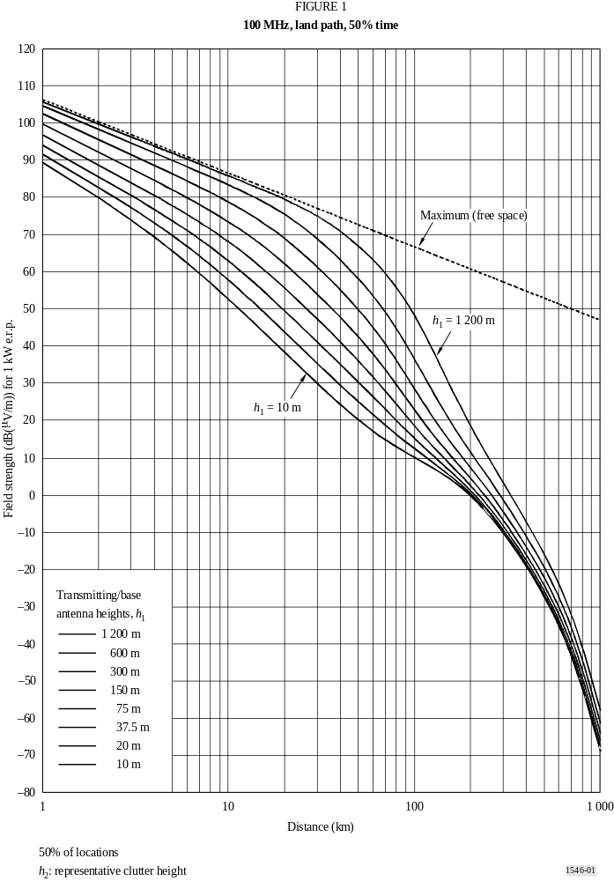
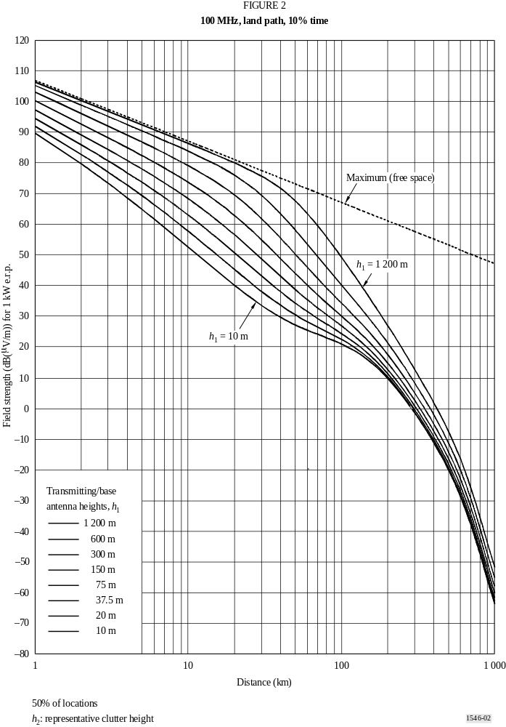
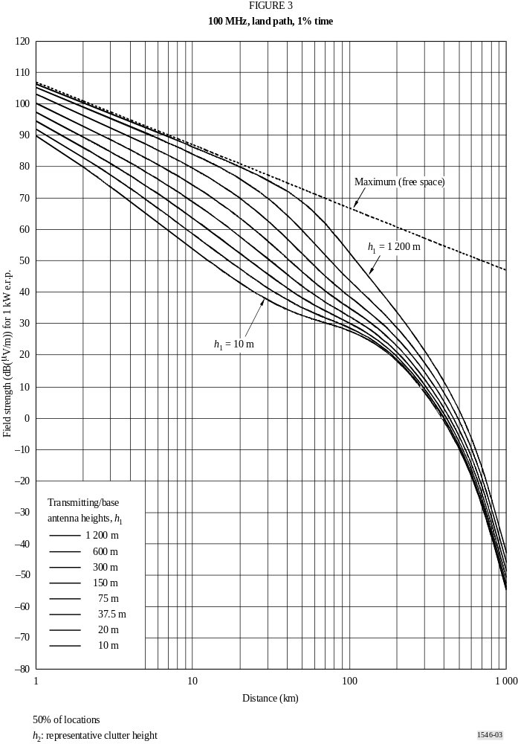
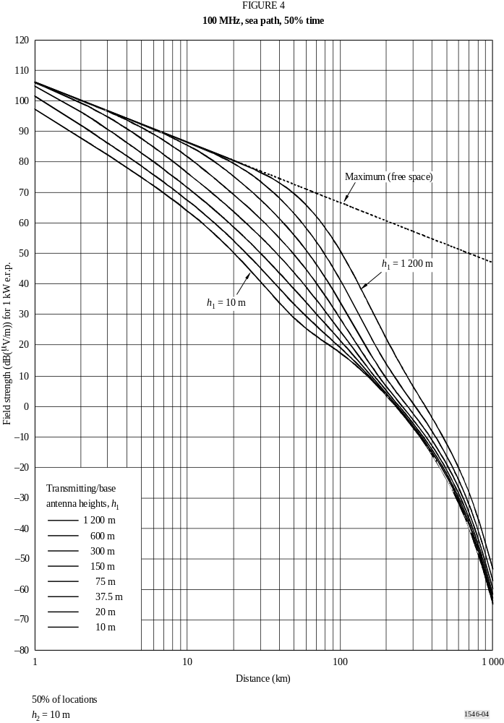
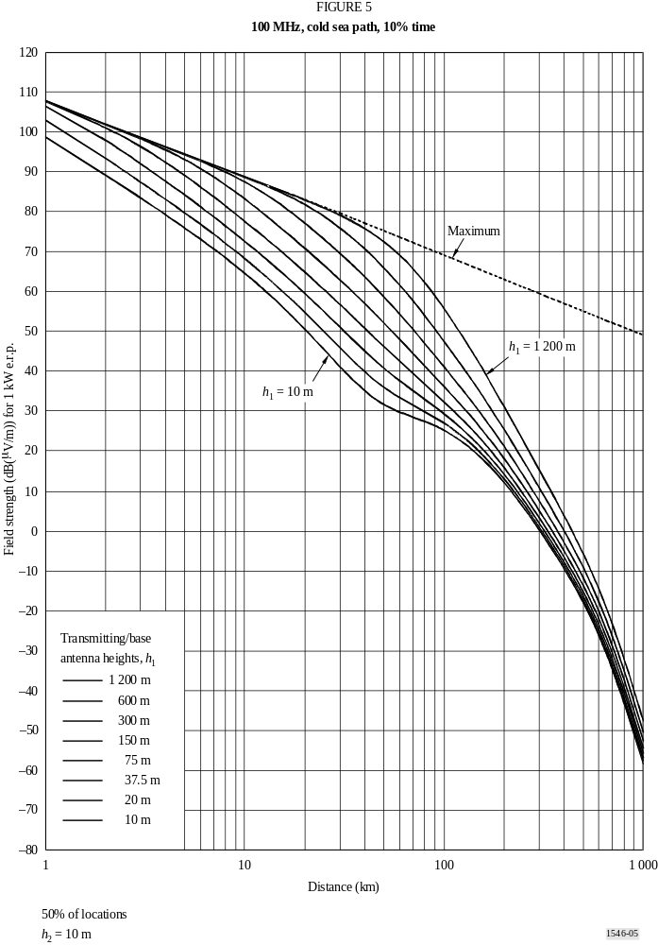
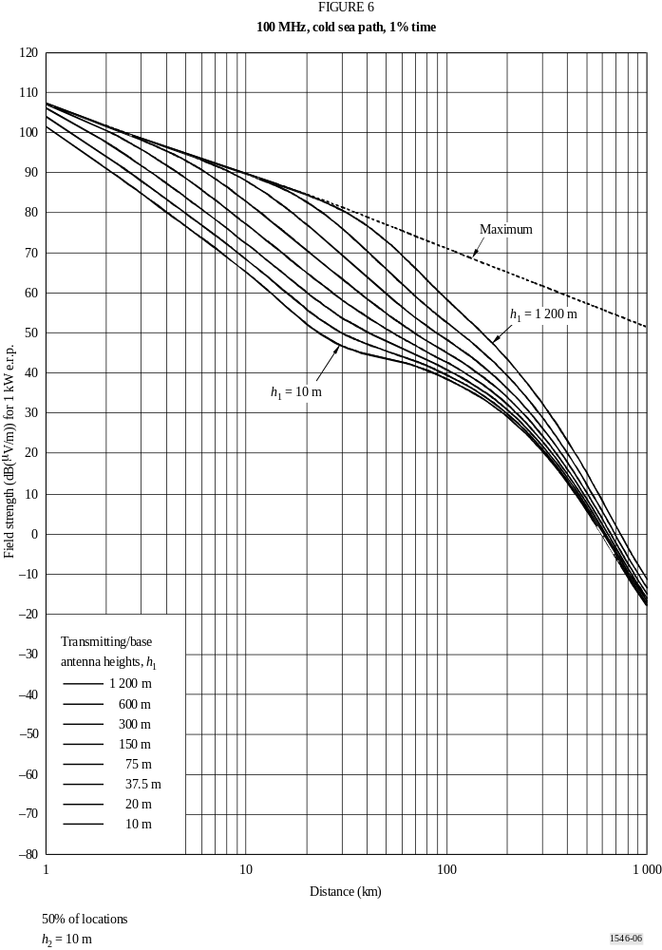
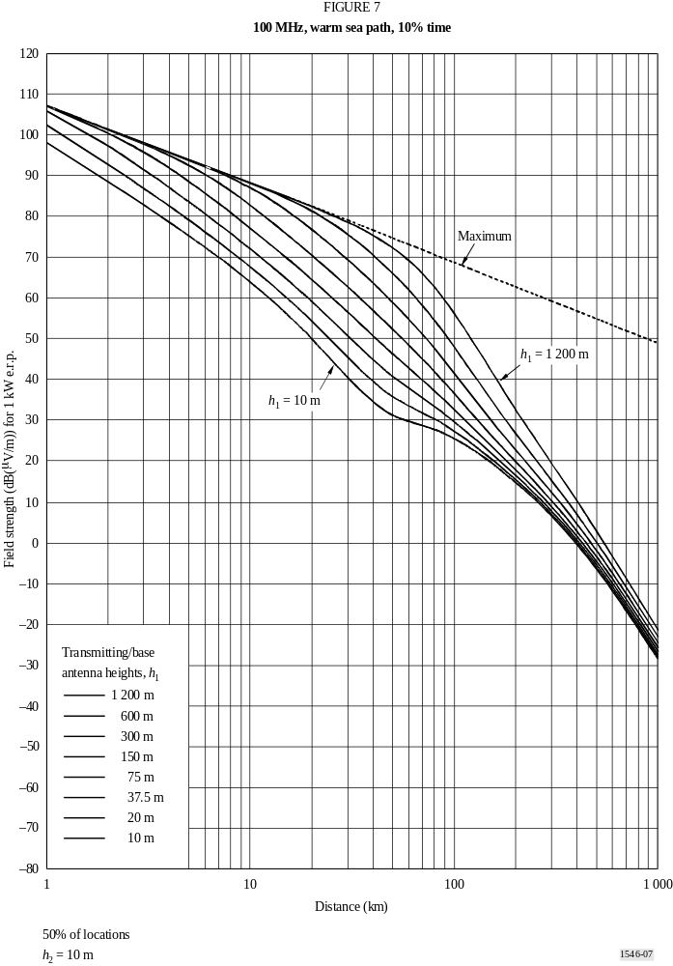
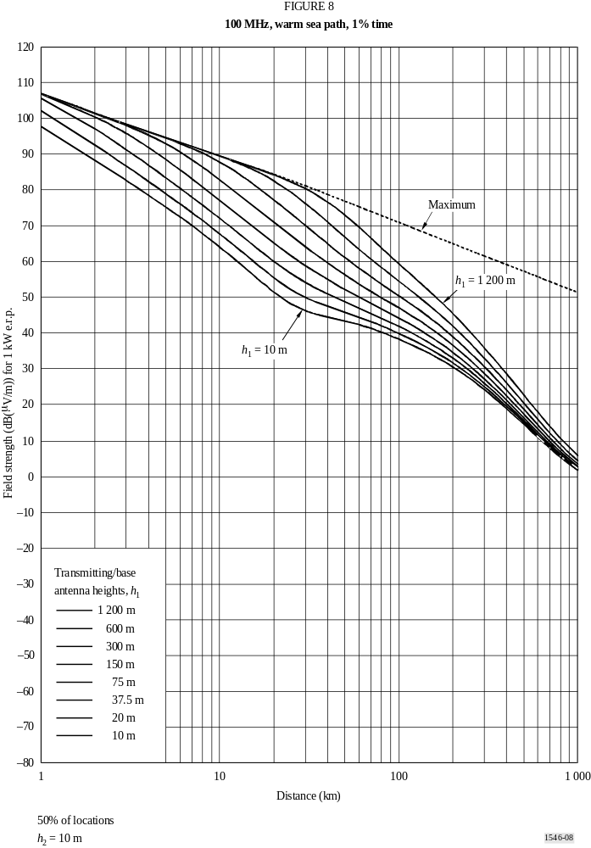
ANNEX 3
Frequency range 300 MHz to 1 000 MHz
1 The field strength versus distance curves shown in this Annex are for a frequency of 600 MHz. They may be used for frequencies in the range 300 MHz to 1 000 MHz but the procedure given in Annex 5, § 6 should be used to obtain improved accuracy. The same procedure should be used when the tabulated values of field strength versus distance (see Annex 1, § 3) are employed.
2 The curves in Figs. 9 to 11 represent field-strength values exceeded at 50% of the locations within any area of approximately 200 m by 200 m and for 50%, 10% and 1% of the time for land paths.
3 The field strength distribution as a function of percentage location may be calculated using the information in Annex 5, § 11. Standard deviation values, which are representative for different types of service, are listed in Table 2. Broadband digital broadcasting systems having bandwidths of at least 1.5 MHz are less subject to frequency dependent location variation than the analogue systems.

TABLE 2
Standard deviation of location variation at 600 MHz
Service | Standard deviation  (dB)
Broadcasting, analogue | 9.5
Broadcasting, digital | 5.5
Mobile, urban | 6.2
Mobile, suburban, rolling hills | 7.9

4 The curves in Figs. 12 to 16 represent field-strength values exceeded at 50% of the locations and for 50%, 10% and 1% of the time for sea paths in cold seas and warm seas, for example, those observed in the North Sea and the Mediterranean, respectively.
5 In areas subject to pronounced super-refraction phenomena, account should be taken of the information contained in Annex 1, § 14.
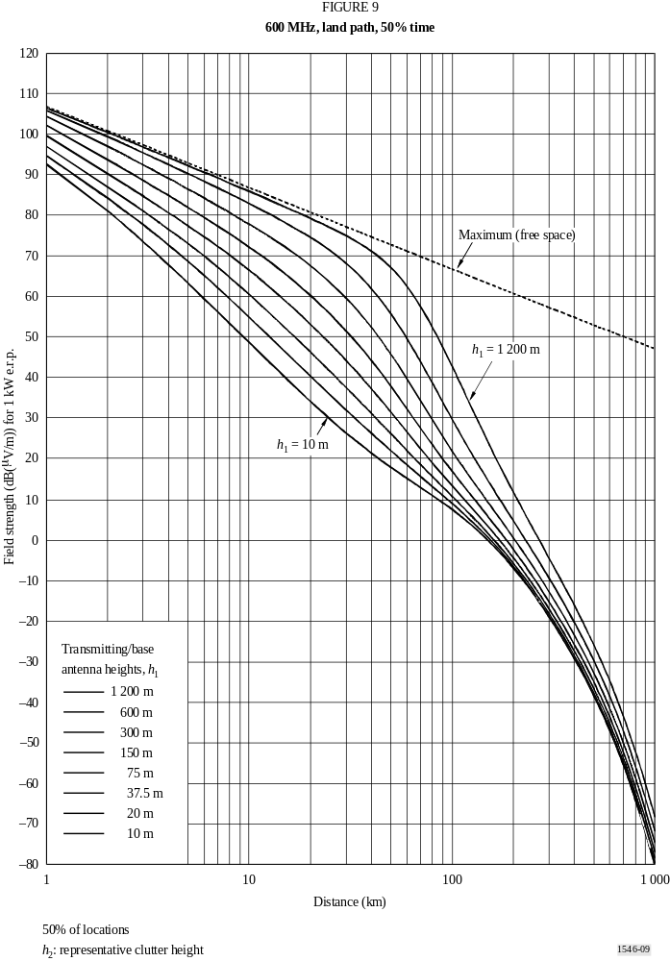
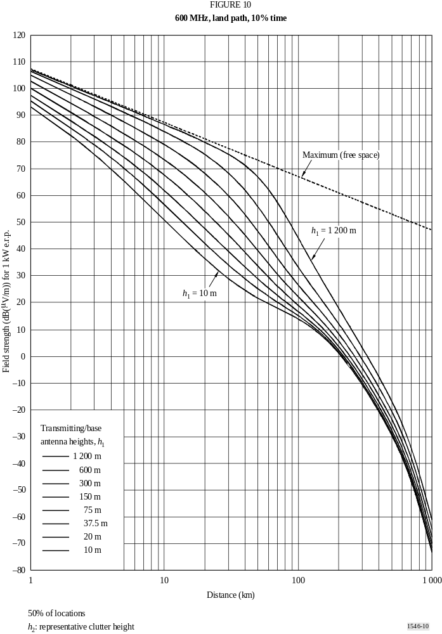
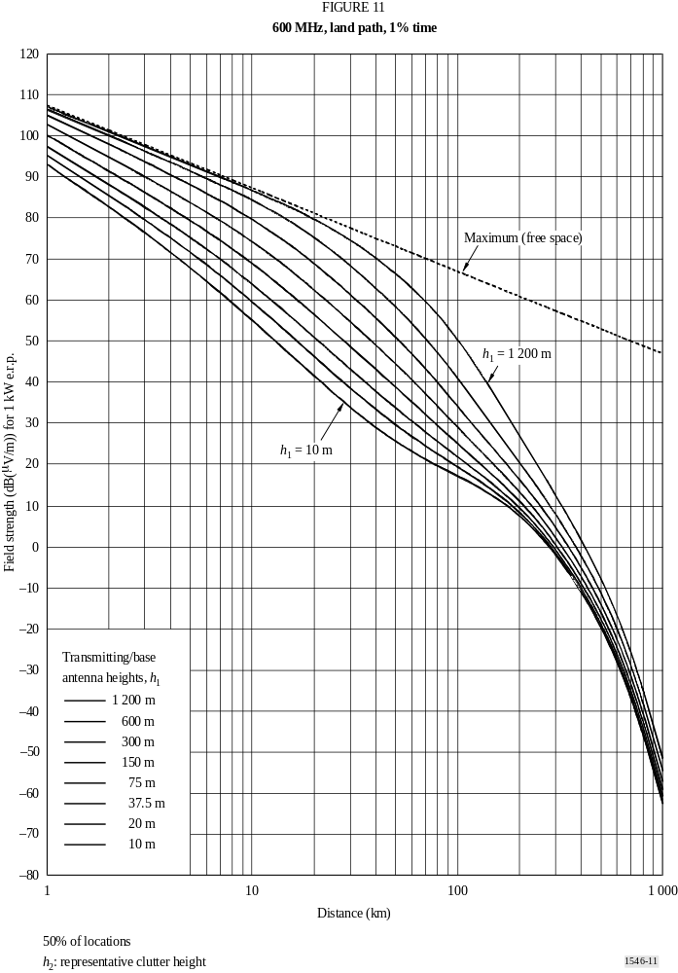
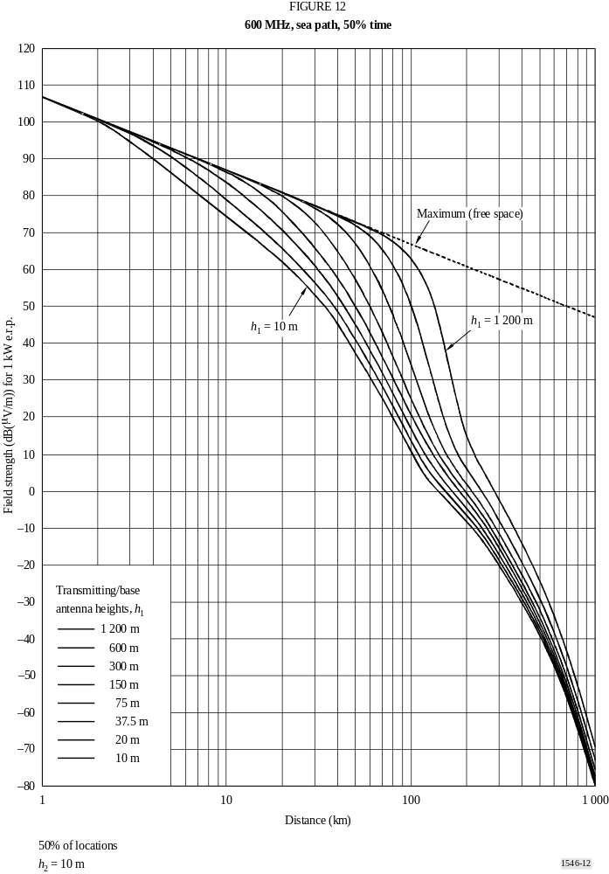
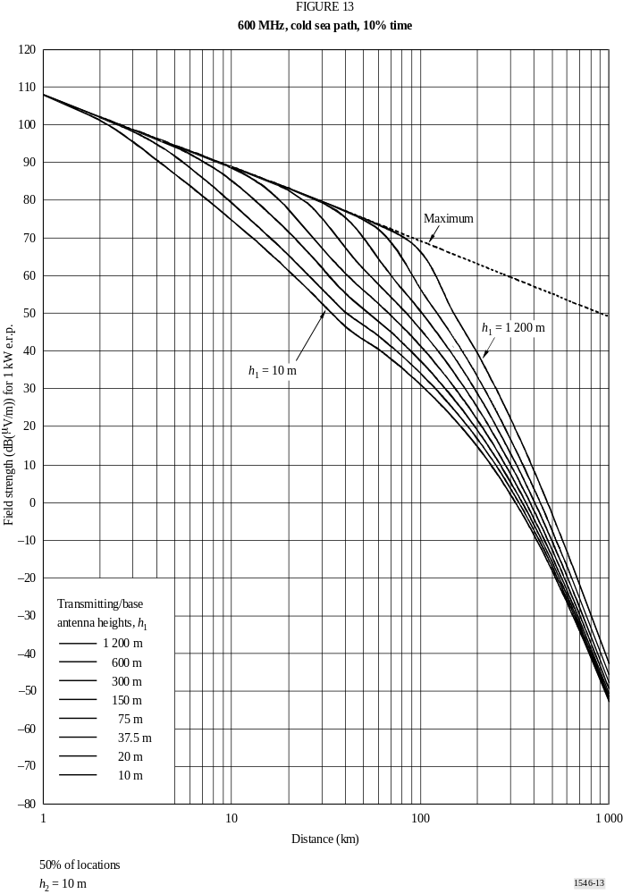
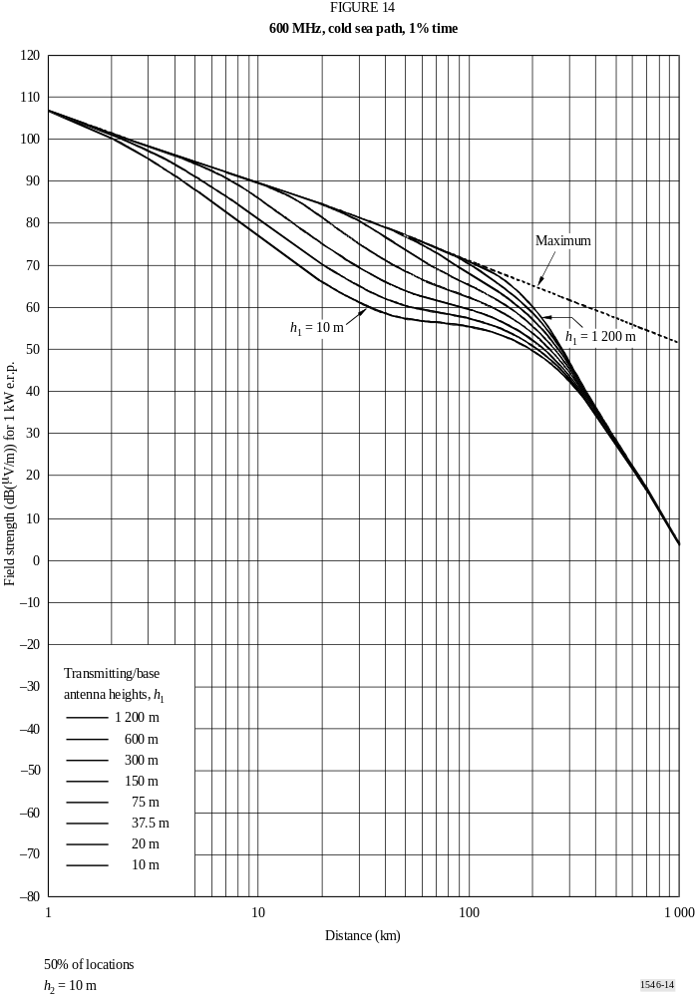
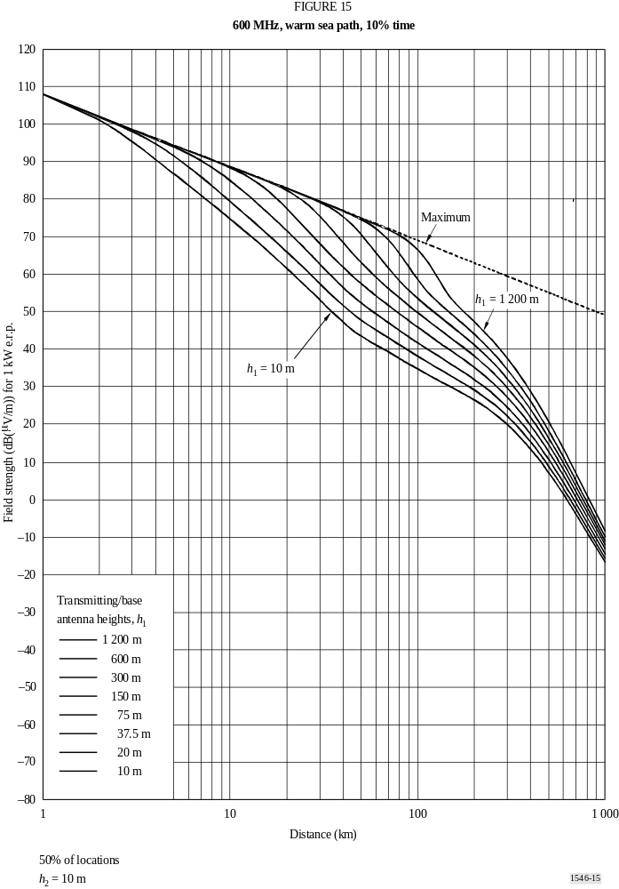
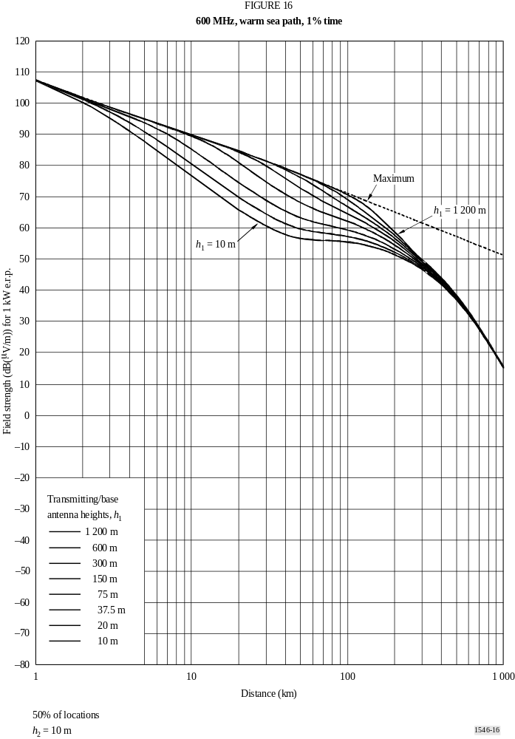
ANNEX 4
Frequency range 1 000 MHz to 3 000 MHz
1 The field strength versus distance curves shown in this Annex are for a frequency of 2 000 MHz. They may be used for frequencies in the range 1 000 MHz to 3 000 MHz but the procedure given in Annex 5, § 6 should be used to obtain improved accuracy. The same procedure should be used when the tabulated values of field strength versus distance (see Annex 1, § 3) are employed.
2 The curves in Figs. 17 to 19 represent field-strength values exceeded at 50% of the locations within any area of approximately 200 m by 200 m and for 50%, 10% and 1% of the time for land paths.
3 The field strength distribution as a function of percentage location may be calculated using the information in Annex 5, § 11. Standard deviation values, which are representative for different types of service, are listed in Table 3. Broadband digital broadcasting systems having bandwidths of at least 1.5 MHz are less subject to frequency dependent location variation than the analogue systems.

TABLE 3
Standard deviation of location variation at 2 000 MHz
Service | Standard deviation  (dB)
Broadcasting, digital | 5.5
Mobile, urban | 7.5
Mobile, suburban, rolling hills | 9.4

4 The curves in Figs. 20 to 24 represent field-strength values exceeded at 50% of the locations and for 50%, 10% and 1% of the time for sea paths in cold seas and warm seas, for example, those observed in the North Sea and the Mediterranean, respectively.
5 In areas subject to pronounced super-refraction phenomena, account should be taken of the information contained in Annex 1, § 14.
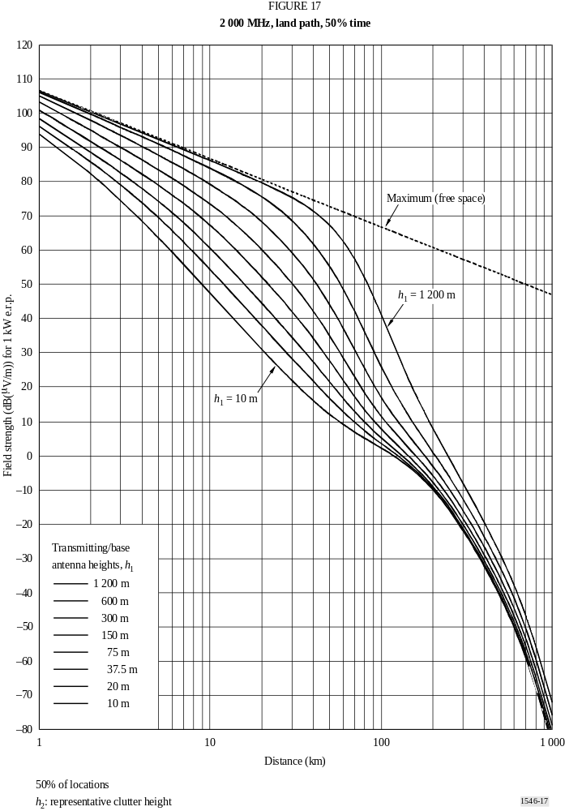
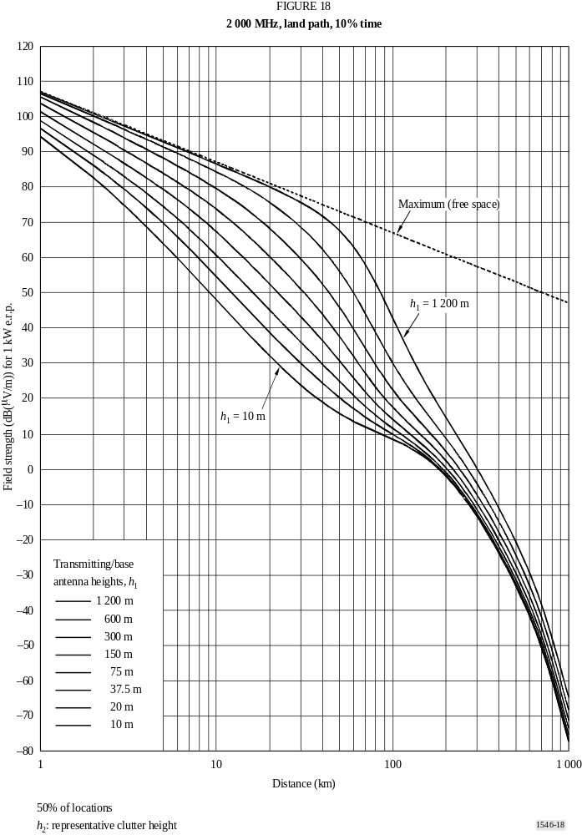
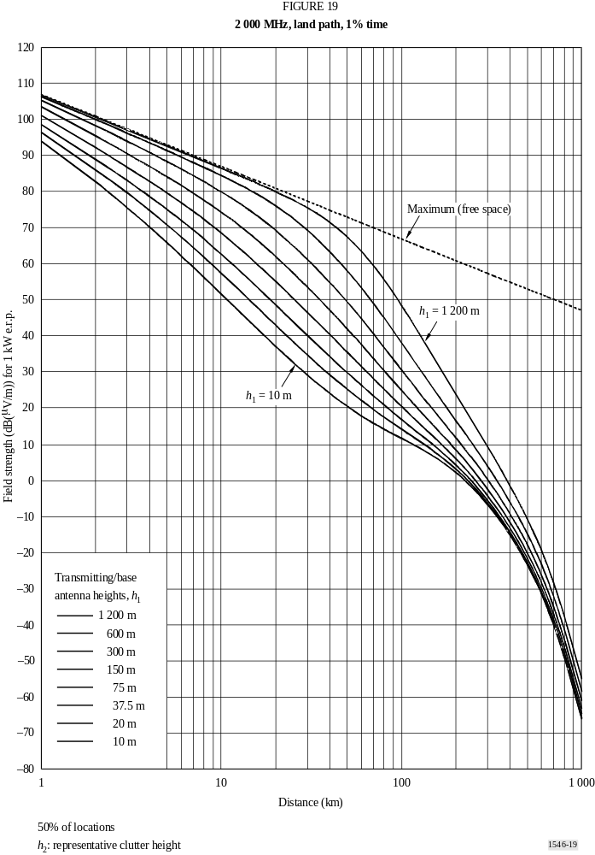
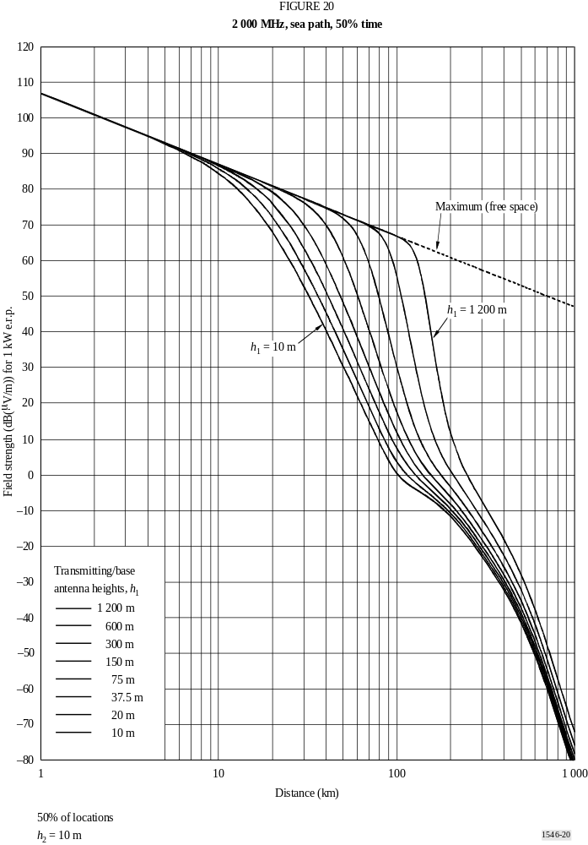
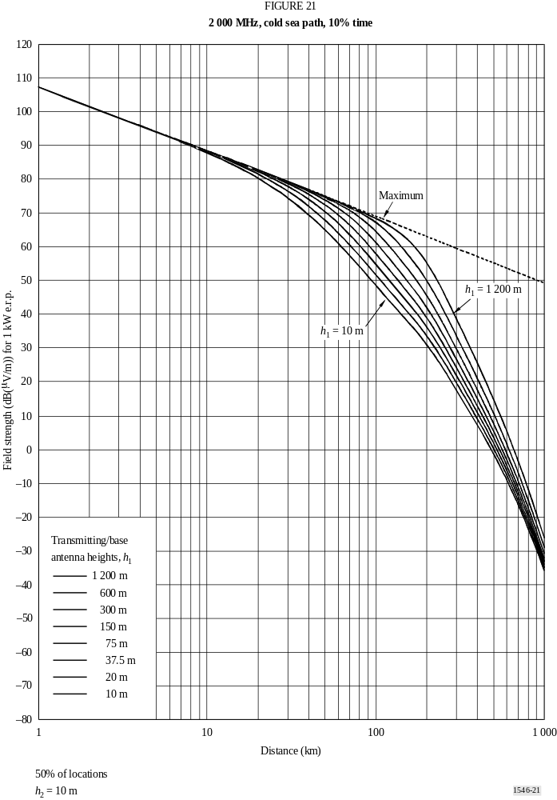
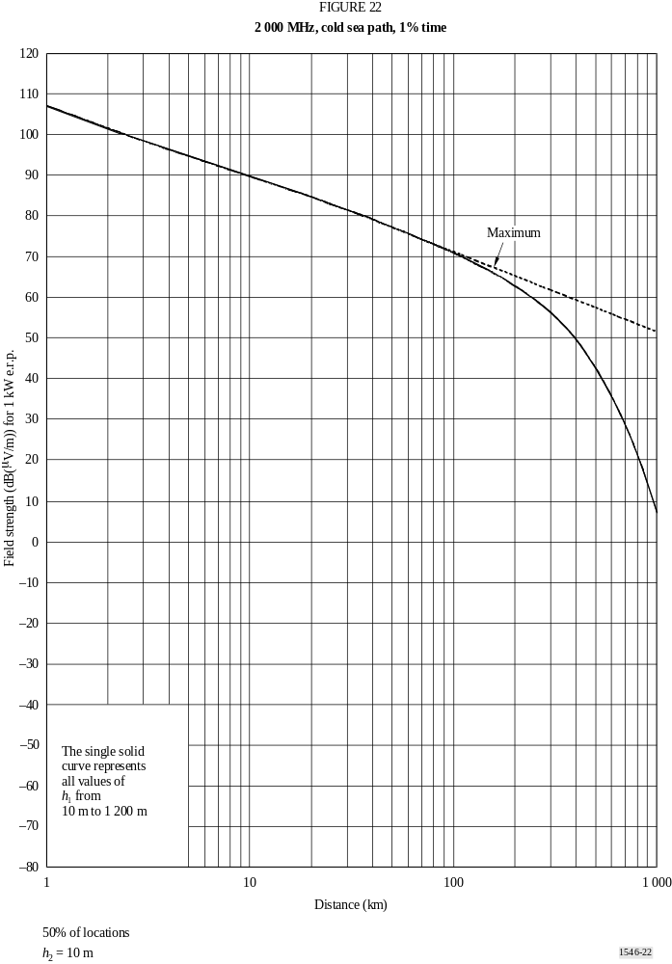
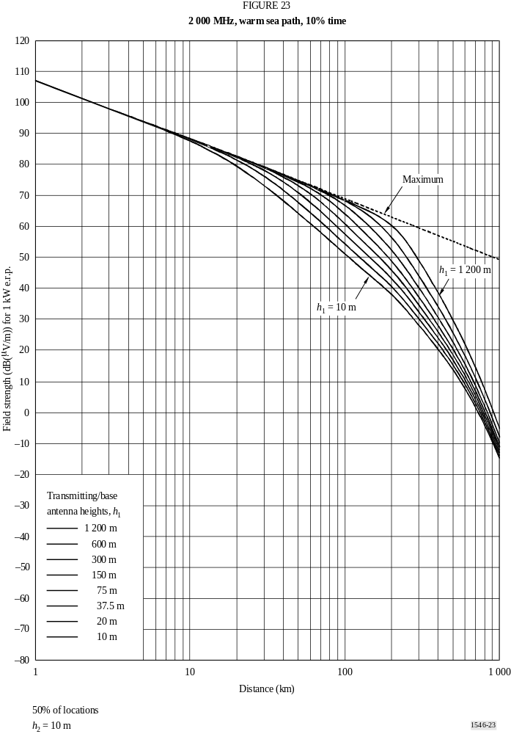
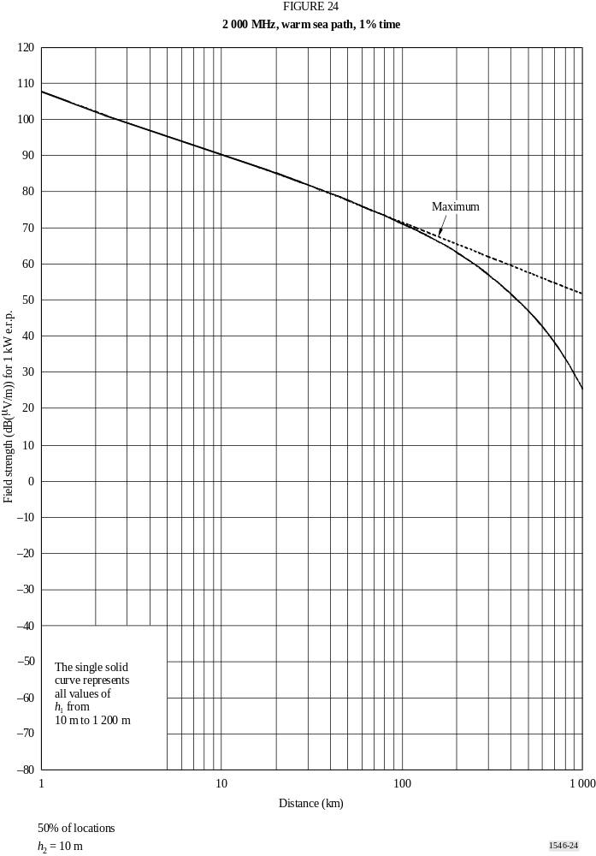
ANNEX 5
1000
Additional information and methods for
implementing the prediction method

1 Introduction
This Annex describes separate stages of the calculation. A step-by-step description of the overall method is given in Annex 6.

2 Maximum field-strength values
A field strength must not exceed a maximum value Emax given by:
Emax = Efs dB(μV/m) for land paths (1a)
Emax = Efs + Ese dB(μV/m) for sea paths (1b)
where Efs is the free space field strength for 1 kW e.r.p. given by:
Efs = 106.9 − 20 log (d) dB(μV/m) (2)
and Ese is an enhancement for sea curves given by:
E_{se} = 2.38 {1 − exp(−d / 8.94)} log(50/t) dB (3)
where:
d : distance (km)
t : percentage time.
In principle any correction which increases a field strength must not be allowed to produce values greater than these limits for the family of curves and distance concerned. However, limitation to maximum values should be applied only where indicated in Annex 6.

3 Determination of transmitting/base antenna height, h1
The transmitting/base antenna height, h1, to be used in calculation depends on the type and length of the path and on various items of height information, which may not all be available.
For sea paths h1 is the height of the antenna above sea level.
For land paths, the effective height of the transmitting/base antenna, heff, is defined as its height in metres over the average level of the ground between distances of 3 and 15 km from the transmitting/base antenna in the direction of the receiving/mobile antenna. Where the value of effective transmitting/base antenna height, heff, is not known it should be estimated from general geographic information. For path lengths of less than 15 km it is useful, although not essential, to have available the representative height of clutter in the vicinity of the transmitting/base antenna, hclut. The notional height of the transmitting/base antenna, ha (m), is then defined as the antenna
height above the clutter in its vicinity if known. If the height above clutter is not available, ha is defined as the antenna height above ground (e.g. height of the mast). Note that ha may not be negative. This Recommendation is not valid when the transmitting/base antenna is below the height of surrounding clutter.
The value of h1 to be used in calculation should be obtained using the method given in § 3.1, 3.2 or in § 3.3 as appropriate.

3.1 Land paths shorter than 15 km
For land paths less than 15 km one of the following two methods should be used:

3.1.1 Terrain information not available
Where no terrain information is available when propagation predictions are being made, the value of h1 is calculated according to path length d as follows:
h1 = ha m for d ≤ 3 km (4)
h1 = ha + (heff − ha) (d − 3) / 12 m for 3 km < d < 15 km (5)

3.1.2 Terrain information available
Where terrain information is available when propagation predictions are being made:
h1 = ha + (hb − ha) d / 15 m (6)
where hb is the height of the antenna above terrain height averaged between 0.2d and d km.

3.2 Land paths of 15 km or longer
For these paths:
h1 = heff m (7)

3.3 Sea paths
The concept of h1 for an all-sea path is that it represents the physical height of the antenna above the surface of the sea. This Recommendation is not reliable in the case of a sea path for h1 values less than about 3 m, and an absolute lower limit of 1 m should be observed.

4 Application of transmitting/base antenna height, h1
The value of h1 controls which curve or curves are selected from which to obtain field-strength values, and the interpolation or extrapolation which may be necessary. The following cases are distinguished.

4.1 Transmitting/base antenna height, h1, in the range 10 m to 3 000 m
If the value of h1 coincides with one of the eight heights for which curves are provided, namely 10, 20, 37.5, 75, 150, 300, 600 or 1 200 m, the required field strength may be obtained directly from the plotted curves or the associated tabulations. Otherwise the required field strength should be interpolated or extrapolated from field strengths obtained from two curves using:
E = Einf + (Esup − Einf) log (h1 / hinf) / log (hsup / hinf) dB(μV/m) (8)
where:
hinf : 600 m if h1 > 1 200 m, otherwise the nearest nominal effective height below h1
hsup : 1 200 m if h1 > 1 200 m, otherwise the nearest nominal effective height above h1
Einf : field-strength value for hinf at the required distance
Esup : field-strength value for hsup at the required distance.
The field strength resulting from extrapolation for h1 > 1 200 m should be limited if necessary such that it does not exceed the maximum defined in § 2.
This Recommendation is not valid for h1 > 3 000 m.

4.2 Transmitting/base antenna height, h1, in the range 0 m to 10 m
The method when h1 is less than 10 m depends on whether the path is over land or sea.
For a land path:
The procedure for extrapolating field strength at a required distance d km for values of h1 in the range 0 m to 10 m is based on smooth-Earth horizon distances (km) written as 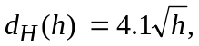 where h is the required value of transmitting/base antenna height h1 (m).
For d < dH (h1) the field strength is given by the 10 m height curve at its horizon distance, plus ΔE, where ΔE is the difference in field strengths on the 10 m height curve at distances d and the h1 horizon distance.
For d ≥ dH (h1) the field strength is given by the 10 m height curve at distance Δd beyond its horizon distance, where Δd is the difference between d and the h1 horizon distance.
This may be expressed in the following formulae where E10(d) is the field strength (dB(μV/m)) taken from the 10 m height curve for a distance d (km):
E = E10(dH (10)) + E10(d) − E10(dH (h1)) dB(μV/m) for d < dH (h1) (9a)
= E10(dH (10) + d − dH (h1)) dB(μV/m) for d ≥ dH (h1) (9b)
If in equation (9b) dH (10) + d − dH (h1) exceeds 1 000 km, even though d ≤ 1 000 km, E10 may be found from linear extrapolation for log (distance) of the curve, given by:
E10 = Einf + (Esup − Einf) log (d / Dinf) / log (Dsup / Dinf) dB(μV/m) (9c)
where:
Dinf : penultimate tabulation distance (km)
Dsup : final tabulation distance (km)
Einf : field strength at penultimate tabulation distance (dB(μV/m))
Esup : field strength at final tabulation distance (dB(μV/m)).
Note that this Recommendation is not valid for distances greater than 1 000 km. Equation (9c) should be used only for extrapolating for h1 < 10 m.
For a sea path:
Note that for a sea path, h1 should not be less than 1 m. The procedure requires the distance at which the path has 0.6 of the first Fresnel zone just unobstructed by the sea surface. This is given by:
Dh1 = D06( f, h1, 10) km (10a)
where the function D06 is defined in § 14.
If d > Dh1 it will be necessary to also calculate the 0.6 Fresnel clearance distance for a sea path where the transmitting/base antenna height is 20 m, given by:
D20 = D06( f, 20, 10) km (10b)
The field strength for the required distance, d, and value of h1, is then given by:
E = Emax dB(μV/m) for d ≤ Dh1 (11a)
= EDh1 + (ED20 − EDh1) log (d / Dh1) / log (D20 / Dh1) dB(μV/m) for Dh1 < d < D20 (11b)
= E' (1 − Fs) + E'' Fs dB(μV/m) for d ≥ D20 (11c)
where:
Emax : maximum field strength at the required distance given in § 2
EDh1 : Emax for distance Dh1 as given in § 2
ED20 = E10(D20) + (E20(D20) − E10(D20)) log (h1/10)/log (20/10)
E10(x) : field strength for h1 = 10 m interpolated for distance x
E20(x) : field strength for h1 = 20 m interpolated for distance x
E' = E10(d) + (E20(d) − E10(d)) log (h1/10)/log (20/10)
E'' : field strength for distance d calculated using the method for land paths given above
Fs = (d − D20)/d.

4.3 Negative values of transmitting/base antenna height, h1
For land paths it is possible for the effective transmitting/base antenna height heff to have a negative value, since it is based on the average terrain height at distances from 3 km to 15 km. Thus h1 may be negative.
The procedure for negative values of h1 is to obtain the field strength for h1 = 0 as described in § 4.2, and to calculate a correction based on the terrain clearance angle described in § 10. The clearance angle is calculated as follows:
– In the case that a terrain database is available, the terrain clearance angle from the transmitting/base antenna should be calculated as the elevation angle of a line which just clears all terrain obstructions up to 15 km from the transmitting/base antenna in the direction of (but not going beyond) the receiving/mobile antenna. This clearance angle, which will have a positive value, should be used in the terrain clearance angle correction method given in § 10 to obtain a correction which is added to the field strength obtained for h1 = 0. It should be noted that using this method can result in a discontinuity in field strength at the transition around h1 = 0.
– In the case where a terrain database is not available, the (positive) effective terrain clearance angle, θeff, may be estimated assuming an obstruction of height h1 at a distance of 9 km from the transmitting/base antenna. Note that this is used for all path lengths, even when less than 9 km. That is, the ground is regarded as approximating an irregular wedge over the range 3 km to 15 km from the transmitting/base antenna, with its mean value occurring at 9 km, as indicated in Fig. 25. This method takes less explicit account of terrain variations, but does not produce a discontinuity in field strength at the transition around h1 = 0. The correction to be added to the field strength in this case is calculated using:
Correction = 6.03 – J(ν) dB (12)
where:
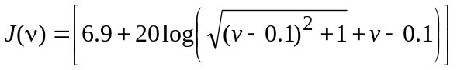 (12a)
ν = Kν θeff (12b)
and
θeff = arctan(−h1/9 000) degrees (12c)
Kν = 1.35 for 100 MHz
Kν = 3.31 for 600 MHz
Kν = 6.00 for 2 000 MHz
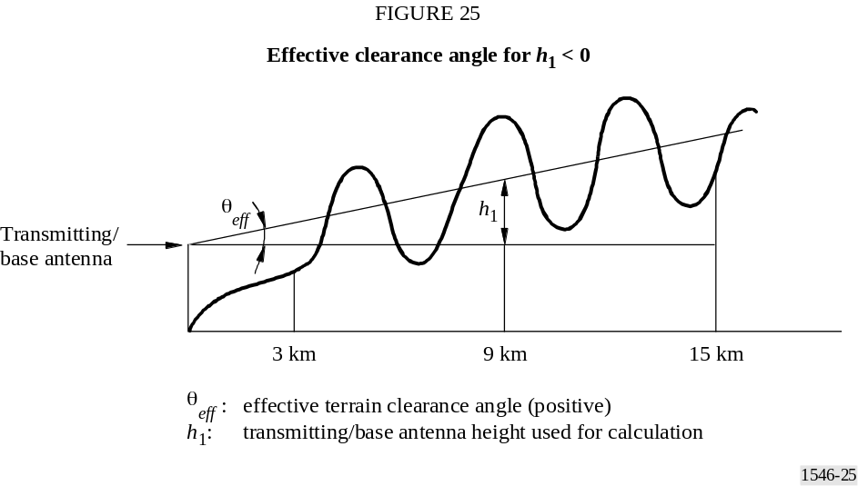

5 Interpolation of field strength as a function of distance
Figures 1 to 24 show field strength plotted against distance, d, the range 1 km to 1 000 km. No interpolation for distance is needed if field strengths are read directly from these graphs. For greater precision, and for computer implementation, field strengths should be obtained from the associated tabulations (see Annex 1, § 3). In this case, unless d coincides with one of the tabulation distances given in Table 4, the field strength, E (dB(μV/m)), should be linearly interpolated for the logarithm of the distance using:
E = Einf + (Esup − Einf) log (d / dinf) / log (dsup / dinf) dB(μV/m) (13)
where:
d : distance for which the prediction is required
dinf : nearest tabulation distance less than d
dsup : nearest tabulation distance greater than d
Einf : field strength value for dinf
Esup : field strength value for dsup.
This Recommendation is not valid for values of d less than 1 km or greater than 1 000 km.
TABLE 4
Values of distance (km) used in the tables of field strengths
1 | 14 | 55 | 140 | 375 | 700
2 | 15 | 60 | 150 | 400 | 725
3 | 16 | 65 | 160 | 425 | 750
4 | 17 | 70 | 170 | 450 | 775
5 | 18 | 75 | 180 | 475 | 800
6 | 19 | 80 | 190 | 500 | 825
7 | 20 | 85 | 200 | 525 | 850
8 | 25 | 90 | 225 | 550 | 875
9 | 30 | 95 | 250 | 575 | 900
10 | 35 | 100 | 275 | 600 | 925
11 | 40 | 110 | 300 | 625 | 950
12 | 45 | 120 | 325 | 650 | 975
13 | 50 | 130 | 350 | 675 | 1 000

6 Interpolation and extrapolation of field strength as a function of frequency
Field-strength values for a given frequency should be obtained by interpolating between the values for the nominal frequency values of 100, 600 and 2 000 MHz. In the case of frequencies below 100 MHz or above 2 000 MHz, the interpolation must be replaced by an extrapolation from the two nearer nominal frequency values. For most paths interpolation or extrapolation for log (frequency) can be used, but for some sea paths when the required frequency is less than 100 MHz it is necessary to use an alternative method.
For land paths, and for sea paths where the required frequency is greater than 100 MHz, the required field strength, E, should be calculated using:
E = Einf + (Esup − Einf) log ( f / finf) / log( fsup / finf) dB(μV/m) (14)
where:
f : frequency for which the prediction is required (MHz)
finf : lower nominal frequency (100 MHz if f < 100 MHz, 600 MHz if f > 2 000 MHz)
fsup : higher nominal frequency (600 MHz if f < 100 MHz, 2 000 MHz if f > 2 000 MHz)
Einf : field strength value for finf
Esup : field strength value for fsup.
The field strength resulting from extrapolation for frequency above 2 000 MHz should be limited if necessary such that it does not exceed the maximum value given in § 2.
For sea paths where the required frequency is less than 100 MHz an alternative method should be used, based upon the path lengths at which 0.6 of the first Fresnel zone is just clear of obstruction by the sea surface. An approximate method for calculating this distance is given in § 14.
The alternative method should be used if all of the following conditions are true:
– The path is a sea path.
– The required frequency is less than 100 MHz.
– The required distance is less than the distance at which a sea path would have 0.6 Fresnel clearance at 600 MHz, given by D06(600, h1, 10) as given in § 14.
If any of the above conditions is not true, then the normal interpolation/extrapolation method given by equation (14) should be used.
If all of the above conditions are true, the required field strength, E, should be calculated using:
E = Emax dB(μV/m) for d ≤ df (15a)
= Edf + (Ed600 − Edf) log (d / ddf) / log (d600 / df) dB(μV/m) for d > df (15b)
where:
Emax : maximum field strength at the required distance as defined in § 2
Edf : maximum field strength at distance df as defined in § 2
d600 : distance at which the path has 0.6 Fresnel clearance at 600 MHz calculated as D06(600, h1, 10) as given in § 14
df : distance at which the path has 0.6 Fresnel clearance at the required frequency calculated as D06( f, h1, 10) as given in § 14
Ed600 : field strength at distance d600 and the required frequency calculated using equation (14).

7 Interpolation of field strength as a function of percentage time
Field strength values for a given percentage of time between 1% and 50% time should be calculated by interpolation between the nominal values 1% and 10% or between the nominal values 10% and 50% of time using:
E = Esup (Qinf – Qt) / (Qinf – Qsup) + Einf (Qt − Qsup) / (Qinf − Qsup) dB(μV/m) (16)
where:
t : percentage time for which the prediction is required
tinf : lower nominal percentage time
tsup : upper nominal percentage time
Qt = Qi (t/100)
Qinf = Qi (tinf /100)
Qsup = Qi (tsup /100)
Einf : field strength value for time percentage tinf
Esup : field strength value for time percentage tsup
where Qi (x) is the inverse complementary cumulative normal distribution function.
This Recommendation is valid for field strengths exceeded for percentage times in the range 1% to 50% only. Extrapolation outside the range 1% to 50% time is not valid.
A method for the calculation of Qi (x) is given in Annex 5, § 12.

8 Mixed paths
The following description of the mixed-path method uses Eland(d) and Esea(d) to represent the field strength at distance d from the transmitting/mobile antenna at the representative clutter height, R, for all-land and all-sea paths respectively, with interpolation/extrapolation for transmitting/base antenna height h1, frequency and percentage time, as required.
The following steps should be followed to determine the field strength of any path with a mixture of land and sea parts. If the path contains both warm sea and cold sea portions, the warm sea curves should be used when calculating Esea(d). The value of h1 should be calculated using Annex 5, § 3.1, taking the height of any sea surface as though land. Normally this value of h1 will be used for both Eland(d) and Esea(d). However, if h1 is less than 3 m it should still be used for Eland(d), but a value of 3 m should be used for Esea(d).
Step 1: Calculate the total length of path that lies over land, dl.
Step 2: Calculate the quantity Δ:
If dl < 1 km,
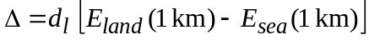 (17a)
otherwise:
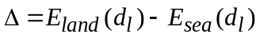 (17b)
Step 3: Calculate the mixed path value at the receiving/mobile antenna distance, dtotal:
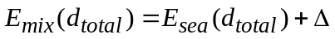 (18)
Step 4: Calculate the difference, ΔE, between the mixed-path and land path field strengths at the required total path distance, dtotal:
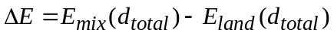 (19)
Step 5: Calculate an interpolation factor to take account of the long-range effect of land on propagation using dl, and the transmitting/base antenna height, h1:
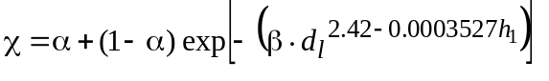 (20)
where α = 0.3 and β = 0.0001.
Step 6: Finally calculate the field strength for the mixed path:
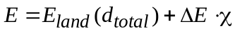 (21)

9 Reference receiving/mobile antenna height and corrections for other heights
The field-strength values given by the land curves and associated tabulations in this Recommendation are for a reference receiving/mobile antenna at a height, R (m), representative of the height of the ground cover surrounding the receiving/mobile antenna, subject to a minimum height value of 10 m. Examples of reference heights are 20 m for an urban area, 30 m for a dense urban area and 10 m for a suburban area. For sea paths the notional value of R is 10 m.
If the receiving/mobile antenna height, h2 (m), is different from R, a correction should be added to the field strength taken from the curve.
Where the receiving/mobile antenna is adjacent to land account should first be taken of the elevation angle of the arriving ray by calculating a modified representative clutter height R' (m), given by:
R' = R m for h1 ≤ 6.5d + R (22a)
= (1 000 d R – 15 h1) / (1 000 d − 15) m for h1 > 6.5d + R (22b)
where h1 is in metres and distance d is in km.
The value of R' must be limited if necessary such that it is not less than 1 m.
When the receiving/mobile antenna is in an urban environment the correction is then given by:
Correction = (6.03h2 / R') − J(ν) dB for h2 < R' (23a)
= Kh2 log (h2 / R') dB for h2 ≥ R' (23b)
where J(ν) is given by equation (12a),
and:
ν = 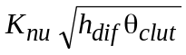 (23c)
hdif = R' − h2 m (23d)
θclut = arctan (hdif / 15) degrees (23e)
Kh2 = 3.2 + 6.2 log ( f ) (23f)
Knu = 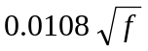 (23g)
f : frequency (MHz).
Where the receiving/mobile antenna is adjacent to land in a rural or open environment the correction is given by equation (23b) for all values of h2.
Where the receiving/mobile antenna is adjacent to sea for h2 > 10 m, the correction should be calculated using equation (23b) with R' set to 10 m.
Where the receiving/mobile antenna is adjacent to sea for h2 < 10 m, an alternative method should be used, based upon the path lengths at which 0.6 of the first Fresnel zone is just clear of obstruction by the sea surface. An approximate method for calculating this distance is given in § 14.
The distance at which the path would just have 0.6 Fresnel clearance for the required value of h1 and for h2 = 10 m, d10, should be calculated as D06( f, h1, 10) in § 14.
If the required distance is equal to or greater than d10, then again the correction for the required value of h2 should be calculated using equation (23b) with R' set to 10 m.
If the required distance is less than d10, then the correction to be added to the field strength E should be calculated using:
Correction = 0.0 dB for d ≤ dh2 (24a)
= (C10) log(d / dh2) / log(d10 / dh2) dB for dh2 < d < d10 (24b)
where:
C10 : correction for the required value of h2 at distance d10 using equation (23b) with R' set to 10 m
d10 : distance at which the path just has 0.6 Fresnel clearance for h2 = 10 m calculated as D06( f, h1, 10) as given in § 14
dh2 : distance at which the path just has 0.6 Fresnel clearance for the required value of h2 calculated as D06( f, h1, h2) as given in § 14.
This Recommendation is not valid for receiving/mobile antenna heights, h2, less than 1 m when adjacent to land or less than 3 m when adjacent to sea.

10 Terrain clearance angle correction
For land paths, and when the receiving/mobile antenna is on a land section of a mixed path, if more precision is required for predicting the field strength for reception conditions in specific areas, e.g. in a small reception area, a correction may be made based on a terrain clearance angle. This angle, θ, is measured relative to the line from the receiving/mobile antenna which just clears all terrain obstructions in the direction of the transmitter/base antenna over a distance of up to 16 km but not going beyond the transmitting/base antenna.
In general, θ is measured relative to the horizontal at the receiving/mobile antenna, being positive if the clearance line is above the horizontal. This is shown in Fig. 26a.
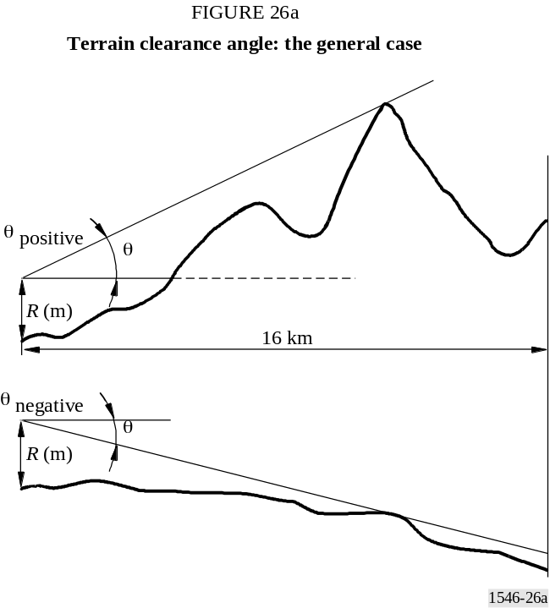
If it is known that the radio path is line of sight, θ is measured relative to the line of sight and is always negative in this case. This is shown in Fig. 26b. However, it should be noted that this procedure may result in a discontinuity in field strength at the transition between line-of-sight and non-line-of-sight conditions.
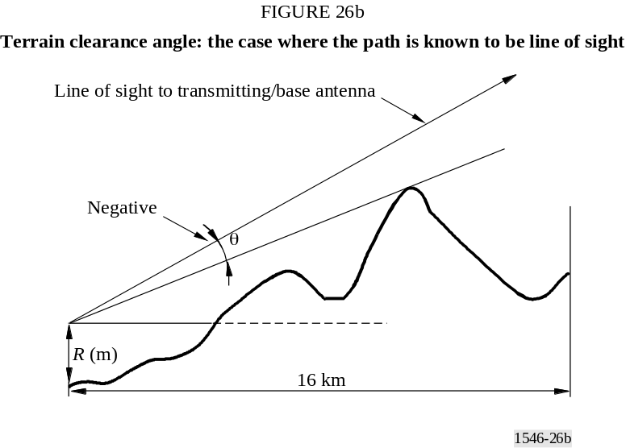
Where the relevant terrain clearance angle information is available, the correction to be added to the field strength is calculated using:
Correction = J(ν') − J(ν) dB (25)
where J(ν) is given by equation (12a):
ν' = 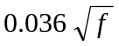 (25a)
ν = 0.065 θtca 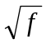 (25b)
θ tca : terrain clearance angle (degrees)
f : frequency (MHz).
The correction is valid for clearance angle θtca in the range –0.8° to +40°.
The correction for θtca < −0.8° is the same as for θtca = −0.8°.
The correction for θtca > +40.0° is the same as for θtca = +40.0°.
It should be noted that the land field strength curves take account of losses due to typical shielding of the receiving/mobile antenna by gently rolling terrain. Thus the terrain clearance angle corrections are zero at a small positive angle typical of receiving/mobile antenna positions.
Figure 27 illustrates the terrain clearance angle correction for the nominal frequencies.
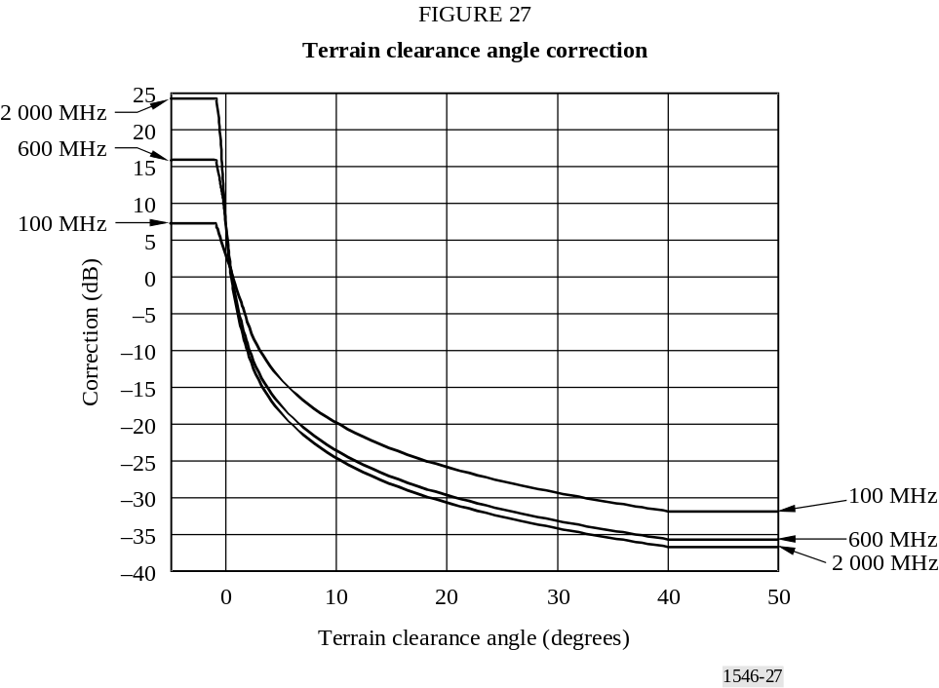

11 Location variability in land area-coverage prediction
Area-coverage prediction methods are intended to provide the statistics of reception conditions over a given area, rather than at any particular point. The interpretation of such statistics will depend on the size of the area considered.
When one terminal of a radio path is stationary, and the other terminal is moved, path loss will vary continuously with location, according to the totality of influences affecting it. It is convenient to classify these influences into three main categories:
− Multipath variations
Signal variations will occur over scales of the order of a wavelength due to phasor addition of multipath effects, e.g. reflections from the ground, buildings, etc.
– Local ground cover variations
Signal variations will occur due to obstruction by ground cover in the local vicinity, e.g. buildings, trees, etc., over scales of the order of the sizes of such objects. The scale of these variations will normally be significantly larger than that for multipath variations.
– Path variations
Signal variations will also occur due to changes in the geometry of the entire propagation path e.g. the presence of hills, etc. For all except very short paths, the scale of these variations will be significantly larger than that for local ground cover variations.
In this Recommendation, location variability refers to the spatial statistics of local ground cover variations including multipath variations. This is a useful result over scales substantially larger than
the ground cover variations, and over which path variations are insignificant. This may be an impracticable condition for an area over which path geometry is changing rapidly, such as sloping ground.
At VHF and UHF, location variability is typically quoted for an area represented by a square with a side of 100 m to 200 m, sometimes with the additional requirement that the area is flat. The important issue is whether path geometry significantly affects variations over the area concerned.
Extensive data analysis suggests that the distribution of median field strength due to ground cover variations over such an area in urban and suburban environments is approximately lognormal.
It should also be noted that multipath fading is frequency selective. Thus a knowledge of effective radio system bandwidth becomes important.
Thus for a land receiving/mobile antenna location the field strength E which will be exceeded for q% of locations is given by:
E(q) = E (median) + Qi(q / 100) σL( f ) dB (μV/m) (26)
where:
Qi (x) : inverse complementary cumulative normal distribution as a function of probability
σL : standard deviation of the Gaussian distribution of the local means in the study area.
Values of standard deviation for digital systems having a bandwidth less than 1 MHz and for analogue systems are given as a function of frequency by:
σL = K + 1.6 log( f ) dB (27)
where:
K = 2.1 for mobile systems in urban locations
= 3.8 for mobile systems in suburban locations or amongst rolling hills
= 5.1 for analogue broadcasting systems
f : frequency (MHz).
For digital systems having a bandwidth of 1 MHz or greater, a standard deviation of 5.5 dB should be used at all frequencies.
Percentage location q can vary between 1 and 99. This Recommendation is not valid for percentage locations less than 1% or greater than 99%.
The location variability correction is not applied when the receiver/mobile is adjacent to sea.

12 An approximation to the inverse complementary cumulative normal distribution function
The following approximation to the inverse complementary cumulative normal distribution function, Qi (x), is valid for 0.01 ≤ x ≤ 0.99:
Qi (x) = T(x) – ξ(x) if x ≤ 0.5 (28a)
Qi (x) = − { T(1 – x) – ξ(1 – x) } if x > 0.5 (28b)
where:
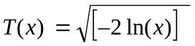 (28c)
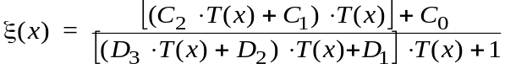 (28d)
C0 = 2.515517
C1 = 0.802853
C2 = 0.010328
D1 = 1.432788
D2 = 0.189269
D3 = 0.001308
Values given by the above equations are given in Table 5.
TABLE 5
Approximate inverse complementary cumulative normal distribution values
q% | Qi (q/100) | q% | Qi (q/100) | q% | Qi (q/100) | q% | Qi (q/100)
1 | 2.327 | 26 | 0.643 | 51 | –0.025 | 76 | –0.706
2 | 2.054 | 27 | 0.612 | 52 | –0.050 | 77 | –0.739
3 | 1.881 | 28 | 0.582 | 53 | –0.075 | 78 | –0.772
4 | 1.751 | 29 | 0.553 | 54 | –0.100 | 79 | –0.806
5 | 1.645 | 30 | 0.524 | 55 | –0.125 | 80 | –0.841
6 | 1.555 | 31 | 0.495 | 56 | –0.151 | 81 | –0.878
7 | 1.476 | 32 | 0.467 | 57 | –0.176 | 82 | –0.915
8 | 1.405 | 33 | 0.439 | 58 | –0.202 | 83 | –0.954
9 | 1.341 | 34 | 0.412 | 59 | –0.227 | 84 | –0.994
10 | 1.282 | 35 | 0.385 | 60 | –0.253 | 85 | –1.036
11 | 1.227 | 36 | 0.358 | 61 | –0.279 | 86 | –1.080
12 | 1.175 | 37 | 0.331 | 62 | –0.305 | 87 | –1.126
13 | 1.126 | 38 | 0.305 | 63 | –0.331 | 88 | –1.175
14 | 1.080 | 39 | 0.279 | 64 | –0.358 | 89 | –1.227
15 | 1.036 | 40 | 0.253 | 65 | –0.385 | 90 | –1.282
16 | 0.994 | 41 | 0.227 | 66 | –0.412 | 91 | –1.341
17 | 0.954 | 42 | 0.202 | 67 | –0.439 | 92 | –1.405
18 | 0.915 | 43 | 0.176 | 68 | –0.467 | 93 | –1.476
19 | 0.878 | 44 | 0.151 | 69 | –0.495 | 94 | –1.555
20 | 0.841 | 45 | 0.125 | 70 | –0.524 | 95 | –1.645
21 | 0.806 | 46 | 0.100 | 71 | –0.553 | 96 | –1.751
22 | 0.772 | 47 | 0.075 | 72 | –0.582 | 97 | –1.881
23 | 0.739 | 48 | 0.050 | 73 | –0.612 | 98 | –2.054
24 | 0.706 | 49 | 0.025 | 74 | –0.643 | 99 | –2.327
25 | 0.674 | 50 | 0.000 | 75 | –0.674

13 Equivalent basic transmission loss
When required, the basic transmission loss equivalent to a given field strength is given by:
Lb = 139 – E + 20 log f dB (29)
where:
Lb : basic transmission loss (dB)
E : field strength (dB(μV/m)) for 1 kW e.r.p.
f : frequency (MHz).

14 An approximation to the 0.6 Fresnel clearance path length
The path length which just achieves a clearance of 0.6 of the first Fresnel zone over a smooth curved earth, for a given frequency and antenna heights h1 and h2, is given approximately by:
D06 = 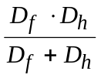 km (30)
where:
Df : frequency-dependent term
= 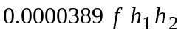 km (30a)
Dh : asymptotic term defined by horizon distances
= 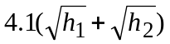 km (30b)
f : frequency (MHz)
h1, h2 : antenna heights above smooth earth (m).
In the above equations, the value of h1 must be limited, if necessary, such that it is not less than zero. Moreover, the resulting values of D06 must be limited, if necessary, such that it is not less than 0.001 km.

ANNEX 6
Procedure for the application of this Recommendation
The step-by-step procedure given below is intended to be applied to values derived from the field strength versus distance tables available from the Radiocommunication Bureau. They may, however, also be applied to values obtained from the curves in which case the distance interpolation procedure of Step 8.1.5 is not needed.
Step 1: Determine the type of the propagation path as land, cold sea or warm sea. If the path is mixed then determine two path types which are regarded as first and second propagation types. If the path can be represented by a single type then this is regarded as the first propagation type and the mixed-path method given in Step 11 is not required.
Step 2: For any given percentage of time (in the range 1% to 50% time) determine two nominal time percentages as follows:
– wanted time percentage > 1 and < 10, the lower and higher nominal percentages are 1 and 10, respectively;
– wanted time percentage > 10 and < 50, the lower and higher nominal percentages are 10 and 50, respectively.
If the required percentage of time is equal to 1% or 10% or 50%, this value should be regarded as the lower nominal percentage time and the interpolation process of Step 10 is not required.
Step 3: For any wanted frequency (in the range 30 to 3 000 MHz) determine two nominal frequencies as follows:
– where the wanted frequency < 600 MHz, the lower and higher nominal frequencies are 100 and 600 MHz, respectively;
– where the wanted frequency > 600 MHz, the lower and higher nominal frequencies are 600 and 2 000 MHz, respectively.
If the wanted frequency equals 100 or 600 or 2 000 MHz, this value should be regarded as the lower nominal frequency and the interpolation/extrapolation process of Step 9 is not required.
Step 4: Determine the lower and higher nominal distances from Table 4 closest to the required distance. If the required distance coincides with a value in Table 4, this should be regarded as the lower nominal distance and the interpolation process of Step 8.1.5 is not required.
Step 5: For the first propagation type follow Steps 6 to 11.
Step 6: For the lower nominal percentage time follow Steps 7 to 10.
Step 7: For the lower nominal frequency follow Steps 8 and 9.
Step 8: Obtain the field strength exceeded at 50% locations for a receiving/mobile antenna at the height of representative clutter, R, above ground for the required distance and transmitting/base antenna height as follows:
Step 8.1: For a transmitting/base antenna height h1 equal to or greater than 10 m follow Steps 8.1.1 to 8.1.5:
Step 8.1.1: Determine the lower and higher nominal h1 values using the method given in Annex 5, § 4.1. If h1 coincides with one of the nominal values 10, 20, 37.5, 75, 150, 300, 600 or 1 200 m, this should be regarded as the lower nominal value of h1 and the interpolation process of Step 8.1.6 is not required.
Step 8.1.2: For the lower nominal value of h1 follow Steps 8.1.3 to 8.1.5.
Step 8.1.3: For the lower nominal value of distance follow Step 8.1.4.
Step 8.1.4: Obtain the field strength exceeded at 50% locations for a receiving/mobile antenna at the height of representative clutter, R, for the required values of distance, d, and transmitting/base antenna height, h1.
Step 8.1.5: If the required distance does not coincide with the lower nominal distance, repeat Step 8.1.4 for the higher nominal distance and interpolate the two field strengths for distance using the method given in Annex 5, § 5.
Step 8.1.6: If the required transmitting/base antenna height, h1, does not coincide with one of the nominal values, repeat Steps 8.1.3 to 8.1.5 and interpolate/extrapolate for h1 using the method given in Annex 5, § 4.1. If necessary limit the result to the maximum given in Annex 5, § 2.
Step 8.2: For a transmitting/base antenna height h₁ less than 10 m determine the field strength for the required height and distance using the method given in Annex 5, § 4.2. If h1 is less than zero, the method given in Annex 5, § 4.3 should also be used.
Step 9: If the required frequency does not coincide with the lower nominal frequency, repeat Step 8 for the higher nominal frequency and interpolate or extrapolate the two field strengths using the method given in Annex 5, § 6. If necessary limit the result to the maximum field strength as given in Annex 5, § 2.
Step 10: If the required percentage time does not coincide with the lower nominal percentage time, repeat Steps 7 to 9 for the higher nominal percentage time and interpolate the two field strengths using the method given in Annex 5, § 7.
Step 11: If the prediction is for a mixed path, follow the step-by-step procedure given in Annex 5, § 8. This requires use of Steps 6 to 10 for paths of each propagation type. Note that if different sections of the path exist classified as both cold and warm sea, all sea sections should be classified as warm sea.
Step 12: If the receiving/mobile antenna height h2 is not equal to the height of representative clutter at its location, correct the field strength using the method given in Annex 5, § 9.
Step 13: If information on the terrain clearance angle at a receiving/mobile antenna adjacent to land is available, correct the field strength for terrain clearance angle at the receiver/mobile using the method given in Annex 5, § 10.
Step 14: If the field strength at a receiving/mobile antenna adjacent to land exceeded at percentage locations other than 50% is required, correct the field strength for the required percentage of locations using the method given in Annex 5, § 11.
Step 15: If necessary limit the resulting field strength to the maximum given in Annex 5, § 2. If a mixed path calculation has been made for a percentage time less than 50% it will be necessary to calculate the maximum field strength by linear interpolation between the all-land and all-sea values. This is given by:
Emax = Efs + ds Ese / dtotal dB(μV/m) (31)
where:
Efs : free-space field strength given by equation (2) in Annex 5, § 2
Ese : enhancement at small time percentages for a sea path given by equation (3) in Annex 5, § 2
ds : the total sea distance (km)
dtotal : the total path distance (km).
Step 16: If required, convert field strength to equivalent basic transmission loss for the path using the method given in Annex 5, § 13.
ANNEX 7
Comparison with the Okumura-Hata method
The curves in this Recommendation giving field strengths exceeded for 50% time for short land paths produce similar results under conditions discussed below to the Okumura-Hata method (for H2 = 10 m) given by:
E = 69.82 − 6.16 log f + 13.82 log H1 + a(H2) − (44.9 − 6.55 log H1) (log d)b (32)
where:
E : field strength (dB(μV/m)) for 1 kW e.r.p.
f : frequency (MHz)
H1 : base station effective antenna height above ground (m) in the range 30 to 200 m
H2 : mobile station antenna height above ground (m) in the range 1 to 10 m
d : distance (km)
a(H2) = (1.1 log f − 0.7) H2 − (1.56 log f − 0.8)
b = 1 for d ≤ 20 km
b = 1 + (0.14 + 0.000187 f + 0.00107 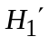) (log [0.05 d])0.8 for d > 20 km
where:
= H1 /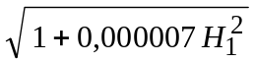
The base station effective height H1 for short paths is equivalent to the actual antenna height above the ground. The transmitting/base antenna height h1 used in the Recommendation, as defined in Annex 5, § 3, is height above clutter. It assumed that the Okumura-Hata results apply to a representative clutter height at the base station of 20 m.
Thus in the Hata equations, H1 = 30 m is equivalent to h1 = 10 m (for d ≤ 3 km) in this Recommendation.
For transmitting/base antenna heights in the valid Hata range 30 m ≤ H1 ≤ 200 m (10 m ≤ h1 ≤ 180 m) the two methods generally agree for path lengths up to about 10 km for flat terrain.

ANNEX 8
Additional information and methods to calculate the field strength of any point contained within the envelope of the land family of curves
The information in this Annex is intended to assist in computer implementations of this Recommendation. For land curves only, the field strength from any family of curves with interpolation for both distance and transmitting/base antenna height h1 may be obtained by implementing the following step-by-step procedure.
Step 1: Calculate the dimensionless parameter, k, from the required transmitter height, h1, as follows:
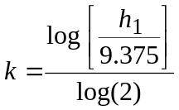 (33)
Parameter k is an integer in the range 0 to 7 which represents each member line of a family starting at h1 = 9.375 m and finishing at line h1 = 1 200 m. The first two k values actually represent h1 values of 9.375 m and 18.75 m to maintain the strict sequence of halving the height of the 1 200 m height, although the two lower curves in the tabulations provided have been calculated for 10 and 20 m for convenience.
The input range for h₁ shall be limited from 9.375 to 1 200 m. The extrapolation procedure given in Annex 5 should be used for transmitter heights outside of this range.
The following procedure constructs a member line by smoothly blending together an initial Okumura-Hata section in the range from 1 to approximately 30 km with a line derived from a functional fit to empirical data (Recommendation ITU-R P.370) in the range beyond 10 km using equation (34). This line is further blended to the free-space value as necessary using equation (41).
Equation (36) represents a simple polynomial fit to the Okumura-Hata equations in the parameter range of interest for both k and d. The remaining section of the line is constructed as a two step procedure. The first stage involves the determination of a base reference curve for the h1 = 9.375 m line (equation (38)) which is a function of only d. The second stage uses equation (40) as a function of both k and d to give an offset from the base reference curve to any desired h1 and d value.
Step 2: Calculate an intermediate field strength, Eu, at the distance, d, and transmitting height, h1, as follows:
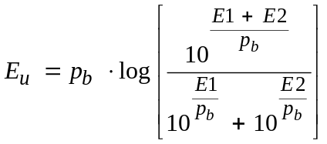 (34)
where:
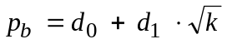 (35)
and
(36)
and
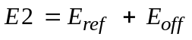 (37)
where:
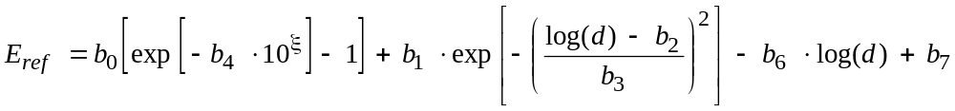 (38)
where:
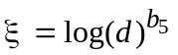 (39)
and:
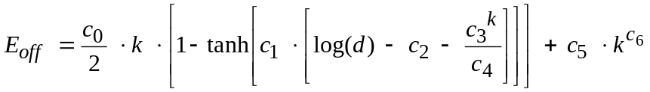 (40)
Parameters a0 to a3, b0 to b7, c0 to c6 and d0 to d1 are given in Table 6 for all frequencies and time percentages of the land curves.
Step 3: Finally calculate the field strength, Eb, at the distance, d, and transmitting height, h1, as follows:
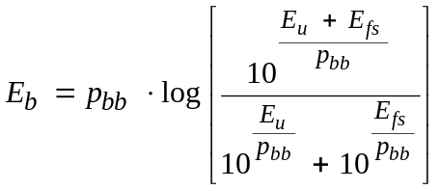 (41)
where:
Efs : free-space field strength defined in Annex 5, § 2
pbb : blend coefficient set to value 8.
TABLE 6
Coefficients for the generation of the land tabulations
Frequency | 100 MHz |  |  | 600 MHz |  |  | 2 000 MHz
Time  (%) | 50 | 10 | 1 | 50 | 10 | 1 | 50 | 10 | 1
a0 | 0.0814 | 0.0814 | 0.0776 | 0.0946 | 0.0913 | 0.0870 | 0.0946 | 0.0941 | 0.0918
a1 | 0.761 | 0.761 | 0.726 | 0.8849 | 0.8539 | 0.8141 | 0.8849 | 0.8805 | 0.8584
a2 | –30.444 | –30.444 | –29.028 | –35.399 | –34.160 | –32.567 | –35.399 | –35.222 | –34.337
a3 | 90.226 | 90.226 | 90.226 | 92.778 | 92.778 | 92.778 | 94.493 | 94.493 | 94.493
b0 | 33.6238 | 40.4554 | 45.577 | 51.6386 | 35.3453 | 36.8836 | 30.0051 | 25.0641 | 31.3878
b1 | 10.8917 | 12.8206 | 14.6752 | 10.9877 | 15.7595 | 13.8843 | 15.4202 | 22.1011 | 15.6683
b2 | 2.3311 | 2.2048 | 2.2333 | 2.2113 | 2.2252 | 2.3469 | 2.2978 | 2.3183 | 2.3941
b3 | 0.4427 | 0.4761 | 0.5439 | 0.5384 | 0.5285 | 0.5246 | 0.4971 | 0.5636 | 0.5633
b4 | 1.256 × 10–7 | 7.788 × 10–7 | 1.050 × 10–6 | 4.323 × 10–6 | 1.704 × 10–7 | 5.169 × 10–7 | 1.677 × 10–7 | 3.126 × 10–8 | 1.439 × 10–7
b5 | 1.775 | 1.68 | 1.65 | 1.52 | 1.76 | 1.69 | 1.762 | 1.86 | 1.77
b6 | 49.39 | 41.78 | 38.02 | 49.52 | 49.06 | 46.5 | 55.21 | 54.39 | 49.18
b7 | 103.01 | 94.3 | 91.77 | 97.28 | 98.93 | 101.59 | 101.89 | 101.39 | 100.39
c0 | 5.4419 | 5.4877 | 4.7697 | 6.4701 | 5.8636 | 4.7453 | 6.9657 | 6.5809 | 6.0398
c1 | 3.7364 | 2.4673 | 2.7487 | 2.9820 | 3.0122 | 2.9581 | 3.6532 | 3.547 | 2.5951
c2 | 1.9457 | 1.7566 | 1.6797 | 1.7604 | 1.7335 | 1.9286 | 1.7658 | 1.7750 | 1.9153
c3 | 1.845 | 1.9104 | 1.8793 | 1.7508 | 1.7452 | 1.7378 | 1.6268 | 1.7321 | 1.6542
c4 | 415.91 | 510.08 | 343.24 | 198.33 | 216.91 | 247.68 | 114.39 | 219.54 | 186.67
c5 | 0.1128 | 0.1622 | 0.2642 | 0.1432 | 0.1690 | 0.1842 | 0.1309 | 0.1704 | 0.1019
c6 | 2.3538 | 2.1963 | 1.9549 | 2.2690 | 2.1985 | 2.0873 | 2.3286 | 2.1977 | 2.3954
d0 | 10 | 5.5 | 3 | 5 | 5 | 8 | 8 | 8 | 8
d1 | –1 | 1 | 2 | 1.2 | 1.2 | 0 | 0 | 0 | 0

