Recommendation ITU-R P.1409-4
(09/2025)
P Series: Radio-wave propagation
Propagation data and prediction methods for systems using high altitude platform stations and other elevated stations in the stratosphere at frequencies greater than about 700 MHz

Foreword
The role of the Radiocommunication Sector is to ensure the rational, equitable, efficient and economical use of the radio-frequency spectrum by all radiocommunication services, including satellite services, and carry out studies without limit of frequency range on the basis of which Recommendations are adopted.
The regulatory and policy functions of the Radiocommunication Sector are performed by World and Regional Radiocommunication Conferences and Radiocommunication Assemblies supported by Study Groups.

Policy on Intellectual Property Right (IPR)
ITU-R policy on IPR is described in the Common Patent Policy for ITU-T/ITU-R/ISO/IEC referenced in Resolution ITU-R 1. Forms to be used for the submission of patent statements and licensing declarations by patent holders are available from https://www.itu.int/ITU-R/go/patents/en where the Guidelines for Implementation of the Common Patent Policy for ITU-T/ITU-R/ISO/IEC and the ITU-R patent information database can also be found.

Series of ITU-R Recommendations
(Also available online at https://www.itu.int/publ/R-REC/en)
Series | Title
BO | Satellite delivery
BR | Recording for production, archival and play-out; film for television
BS | Broadcasting service (sound)
BT | Broadcasting service (television)
F | Fixed service
M | Mobile, radiodetermination, amateur and related satellite services
P | Radio-wave propagation
RA | Radio astronomy
RS | Remote sensing systems
S | Fixed-satellite service
SA | Space applications and meteorology
SF | Frequency sharing and coordination between fixed-satellite and fixed service systems
SM | Spectrum management
SNG | Satellite news gathering
TF | Time signals and frequency standards emissions
V | Vocabulary and related subjects

Note: This ITU-R Recommendation was approved in English under the procedure detailed in Resolution ITU-R 1.

Electronic Publication
Geneva, 2025

© ITU 2025
All rights reserved. No part of this publication may be reproduced, by any means whatsoever, without written permission of ITU.

RECOMMENDATION ITU-R P.1409-4
Propagation data and prediction methods for systems using high altitude platform stations and other elevated stations in the stratosphere
at frequencies greater than about 700 MHz
(1999-2012-2021-2023-2025)
Scope
This Recommendation provides information on the propagation prediction methods appropriate in the consideration of radiocommunication systems or networks involving the use of high-altitude platform stations, or other stations in the stratosphere. The propagation methods are provided separately for two different goals: prediction methods for interference assessment between systems or networks involving the use of high-altitude platform stations and other radiocommunication systems or networks, and prediction methods for the design of radiocommunication systems or networks involving the use of high-altitude platform stations.
Keywords
Basic transmission loss, high-altitude platform stations, interference
Abbreviations/Glossary
HAPS High-altitude platform station
LOS Line-of-sight
TEC Total electron content
Related ITU Recommendations
Recommendation ITU-R P.528 – A propagation prediction method for aeronautical mobile and radionavigation services using the VHF, UHF and SHF bands
Recommendation ITU-R P.531 – Ionospheric propagation data and prediction methods required for the design of satellite networks and systems
Recommendation ITU-R P.618 – Propagation data and prediction methods required for the design of Earth-space telecommunication systems
Recommendation ITU-R P.619 – Propagation data required for the evaluation of interference between stations in space and those on the surface of the Earth
Recommendation ITU-R P.680 – Propagation data required for the design of Earth-space maritime mobile telecommunication systems
Recommendation ITU-R P.833 – Attenuation in vegetation
Recommendation ITU-R P.2109 – Prediction of building entry loss
NOTE – The latest edition of the Recommendation should be used.
The ITU Radiocommunication Assembly,
considering
a) that the Radio Regulations include provisions designating the use of systems employing high-altitude platform stations in the fixed service at up to 48.2 GHz and in the mobile service at about 2 GHz;
b) that the frequency bands designated are also allocated for use by other services;
c) that studies have been made into systems and networks using elevated platforms, which may be at lower heights in the stratosphere,
recommends
that the propagation mechanisms and effects set out in the Annex should be taken into account in the assessment of interference between systems or networks involving the use of high-altitude platform stations and other radiocommunication systems or networks, and in the design of systems using high-altitude platform stations and other elevated platforms in the stratosphere.

Annex
TABLE OF CONTENTS
Page
1 Introduction 2
2 Propagation prediction methods for frequency sharing and compatibility studies 3
2.1 Between high-altitude platform stations and other terrestrial stations 3
2.2 Between high-altitude stations and space stations 5
2.3 Between high-altitude stations and stations in atmosphere 7
3 The propagation prediction methods for the design of systems using high-altitude stations 8

1 Introduction
This Recommendation provides information on the propagation methods appropriate in the consideration of radiocommunication systems or networks involving the use of high-altitude platform stations, or other stations in the stratosphere. For brevity, the phrase “high-altitude station” is used to refer both high-altitude platform stations and other stations in the stratosphere.
As shown in Fig. 1, three following paths for high-altitude stations should be considered:
– “high-altitude station – stations on the surface of the Earth”;
– “high-altitude station – stations in the atmosphere”;
– “high-altitude station – stations in space”.
FIGURE 1
Propagation paths for high-altitude station
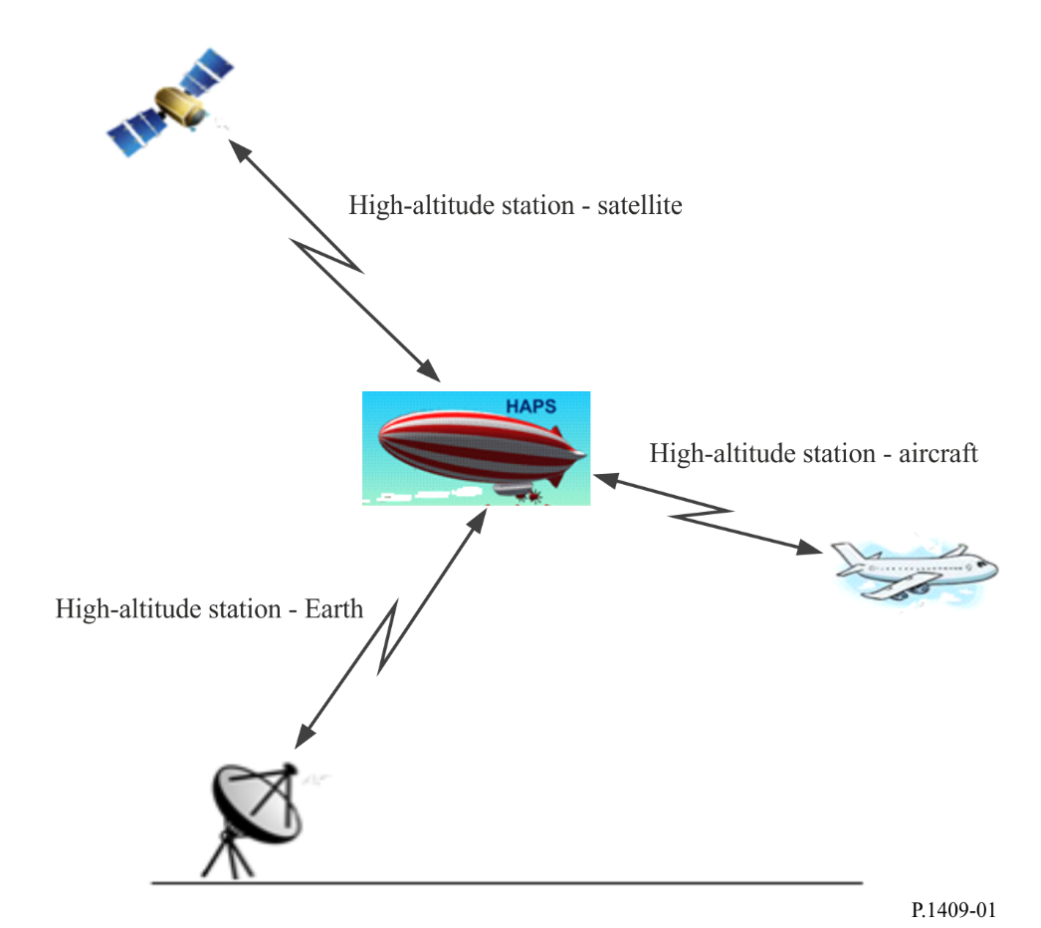
For the “high-altitude station – stations on the surface of the Earth” path two different tasks may be considered:
– design of systems using high-altitude stations;
– interference assessment between high-altitude station and station on the surface of the Earth.
For the “high-altitude station – stations in the atmosphere” and “high-altitude station – stations in space” paths only the interference assessment should be considered.
Section 2 of this Recommendation provides advice on interference between the high-altitude station and stations on the surface of the Earth (e.g. terrestrial systems), between the high-altitude station and the stations in space, and between the high-altitude station and stations in atmosphere. It provides guidance on the prediction of the relevant interference mechanisms by reference to other recommendations including Recommendations ITU-R P.619 and ITU-R P.528. Section 3 of this Recommendation provides advice on propagation issues in the design of systems using high-altitude stations.

2 Propagation prediction methods for frequency sharing and compatibility studies

2.1 Between high-altitude platform stations and other terrestrial stations
For these propagation paths, the following mechanisms and effects should be considered as appropriate:
– free-space basic transmission loss;
– atmospheric attenuation due to gaseous absorption in the troposphere;
– rain attenuation (precipitation, which includes rain, wet snow and clouds, is known to cause attenuation at frequencies above about 5 GHz; however, its presence is highly depending on the time and local location. If no reliable information regarding the precipitation is available for the local location of terrestrial station under the analysis, it is recommended to set the rain attenuation to be zero for the assessment of unwanted path.);
– rain scatter;
– tropospheric scintillation;
– tropospheric scatter;
– diffraction due to spherical Earth;
– diffraction due to terrain and/or specific obstruction (if additional geographical information of the station receiving harmful interference is available);
– clutter loss (the model in § 3.3 of Recommendation ITU-R P.2108 is applicable only for the frequency range 10-100 GHz);
– vegetation loss (if vegetation loss is needed to be considered for frequency sharing and compatibility studies, Recommendation ITU-R P.833 provides relevant information. The applicable areas and types of vegetation are limited to those described in Recommendation ITU-R P.833. If no reliable information regarding the vegetation is available for the local location of terrestrial station under the analysis, it is recommended to set the vegetation loss to be zero for the assessment of unwanted path);
– building entry loss (for applicable limits of the model, refer to Recommendation ITU-R P.2109).
For the prediction of basic transmission loss, if none of the conditions described below is met, the use of the method described in either:
1 Recommendation ITU-R P.619 or
2 Recommendation ITU-R P.528 with attention to recommends 2 of the Recommendation is recommended.
The use of the method described in Recommendation ITU-R P.619 is recommended if any one of the following conditions is met:
– When the frequency is above 30 GHz.
– When the antenna of the high-altitude station is higher than 20 km.
– When the analysis requires to take into account the diffraction loss due to specific terrain or other surface object.
– When the surface reflection multipath at the ground station is mitigated due to the presence of irregular terrain or surface obstacles.
– When the surface reflection multipath at the ground station or the facility has been mitigated using counterpoise.
When use of a directional antenna mitigates surface reflection multipath at the ground station or the facility, the use of the method described in Recommendation ITU-R P.619 is recommended in the region where the difference between the arrival angles of the direct path and the surface reflection multipath is large. Either Recommendation ITU-R P.619 or Recommendation ITU-R P.528 may be used in the region beyond distances where the difference between the arrival angles of the direct path and the surface reflection multipath becomes smaller. However, switching between the use of Recommendation ITU-R P.619 to Recommendation ITU-R P.528, or vice versa, in one analysis is not recommended. In this case, either Recommendation can be used consistently within one analysis.
Variations in the refractive index caused by atmospheric turbulence can cause spatial and temporal fades and enhancements in signal strength. The physical process consists of alternating focussing and defocusing of a radio wave. The strength of these scintillations correlates well with the wet term of the atmospheric refractive index, which is related to water-vapour density. Calculation of losses due to tropospheric scintillation should be performed using the methodology provided in § 2.5.2 of Recommendation ITU-R Р.619-5.

2.2 Between high-altitude stations and space stations
For these propagation paths, the following mechanisms and effects should be considered:
– free-space basic transmission loss;
– cross-polarization discrimination due to Faraday rotation;
– ionospheric scintillation and absorption;
– back scatter from the Earth’s surface (back scatter from the top of rain cells or from the melting layer is expected to be less important).

2.2.1 Free-space basic transmission loss
In order to calculate the free-space basic transmission loss, it is necessary to determine the length of an interference path r:
$r={\left[{\left(R+h_{ant}\right)}^{2}+{\left(R+h_{HS}\right)}^{2}-2\left(R+h_{ant}\right)\left(R+h_{HS}\right)\cos\left({r_{gr}}/R\right)\right]}^{0.5}$ (m) (1)
where:
h_{HS} : height of the high-altitude based station antenna above mean sea level (m)
h_{ant} : height of the space station antenna above mean sea level (m)
R : average Earth radius (6 371 × 10³ m)
r_{gr} : great-circle path (m) between the projection of a space station on the surface of the Earth and the projection of a high-altitude based station on the surface of the Earth, as shown in Fig. 2.
FIGURE 2
HAPS-satellite path
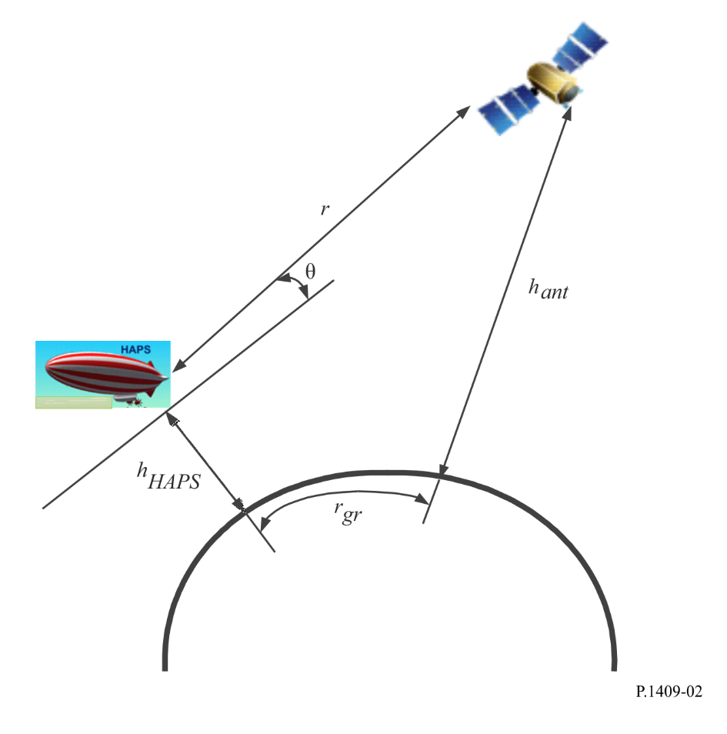
Calculation of the basic transmission loss in free space is expressed by the well-known formula:
$L_{bfs}=32.4+20\log_{10}\left(f\right)+20\log_{10}\left(r\right)$ (dB) (2)
where:
f : frequency (MHz)
r : length of the interference path (km), determined by equation (1).

2.2.2 Cross-polarization discrimination due to Faraday rotation
Faraday effect in the Earthʼs ionosphere is due to the fact that a wave with linear polarization can be considered as propagating in the ionosphere as two circular polarized waves each with a different phase velocity. So, between these two circular polarized waves appears a delay causing rotation of a resulting wave with linear polarization. The method to calculate the Faraday rotation is described in Recommendation ITU-R P.531 as follows:
$θ=2.36×{10}^{-14}\frac{B_{av}N_{T}}{f^{2}}$ (3)
where:
θ : angle of rotation (rad)
B_{av} : average Earth magnetic field (Wb ⋅ m⁻² or T)
f : frequency (GHz)
N_{T} : TEC (el ⋅ m⁻²).
If linear polarization is used, additional losses L_{F} caused by Faraday rotation, θ (rad), can be calculated by the following equation:
$L_{F}=-20\log_{10}\left[\cos\left(θ\right)\right]$ (dB) (4)

2.2.3 Scintillation and absorption of radiowaves in the ionosphere
According to Recommendation ITU-R Р.531 ionospheric scintillation on the path towards a satellite should be taken into account for frequencies lower than 3 GHz. Based on the existing data on absorption in the ionosphere contained in Recommendation ITU-R Р.531 and the ITU-R Handbook on the ionosphere and its effects on radio-wave propagation, it can be said that for equatorial and mid-latitude regions, radiowaves of frequencies above 70 MHz will assure penetration of the ionosphere without significant absorption. Measurements at middle latitudes indicate that, for a one-way traverse of the ionosphere at vertical incidence, the absorption at 30 MHz under normal conditions is typically 0.2 dB to 0.5 dB. During a solar flare, the absorption will increase but will be less than 5 dB. According to Table 1 in Recommendation ITU-R P.618, at mid-latitudes the atmospheric absorption of about 30° one-way transversal is less than 0.04 dB at 0.5 GHz, less than 0.01 dB at 1 GHz and 3 GHz and less than 1 × 10⁻⁴ dB at 10 GHz.
It can be concluded that on frequencies higher than 70 MHz scintillation and absorption losses are much lower than free-space basic transmission loss and can be neglected.

2.2.4 Back scatter from the Earth’s surface
In addition, propagation paths should be considered which involve ground scatter or ground reflection. Until further information becomes available the following guidance can be given.
In some cases, smooth surfaces with areas greater than 0.6 of the first Fresnel reflection zone may cause glints of good reflection with specular geometry. The signal in such cases may be determined from the e.i.r.p. in the appropriate direction, including the atmospheric attenuation loss due to two traverses of the troposphere for the slant angle involved, and assuming a reflection coefficient of −10 dB (some particular cases may have higher reflection coefficients).
More generally, the Earth’s surface may be considered as rough. In this case, it may be appropriate to assume radiation from the area wholly illuminated by the beam from the platform station into the half-space above the Earth’s surface, again with a typical scatter coefficient of −10 dB, i.e. assume a source on the Earth’s surface radiating isotropically with a power given by: the actual transmitter power, reduced by the atmospheric attenuation loss due to the two traverses of the troposphere for the slant angles involved, further reduced by 10 dB for the reflection coefficient, and then increased by 3 dB since the radiation is only into a half space. (See Recommendation ITU-R P.680 for further information on sea reflection.)

2.3 Between high-altitude stations and stations in atmosphere
For these propagation paths, the following mechanisms and effects should be considered:
– free-space basic transmission loss;
– diffraction;
– tropospheric scintillation;
– attenuation by atmospheric gases.
For the prediction of basic transmission loss in the frequency range 100 MHz to 30 GHz, the method of Recommendation ITU-R P.528 should be used, with attention to recommends 2 of the Recommendation.
Variations in refractive index caused by atmospheric turbulence can cause spatial and temporal fades and enhancements in signal strength. The physical process consists of alternating focussing and defocusing of a radio wave. The strength of these scintillations correlates well with the wet term of the atmospheric refractive index, which is related to water-vapour density. Calculation of losses due to tropospheric scintillation should be performed using the methodology provided in § 2.5.2 of Recommendation ITU-R Р.619-5.

3 The propagation prediction methods for the design of systems using high-altitude stations
The method of Recommendation ITU-R P.618 should be used, noting that effects due to the ionosphere will not apply.
If terrestrial stations are in environments where vegetation loss is present, the method described in Recommendation ITU-R P.833 should be used. The applicable areas and types of vegetation are limited to those described in Recommendation ITU-R P.833.
If terrestrial stations are in environments where human shielding loss is present, the following method should be used to calculate the human shielding loss. Note that the human shielding loss includes the contribution of multi-paths, such as reflection(s) and/or diffraction(s), caused by surrounding environments.
The human shielding loss model is provided for the following four cases:
i) Human shielding loss at LOS or rural environments when the antenna is at head height,
ii) Human shielding loss at urban or suburban environments when the antenna is at head height,
iii) Human shielding loss at LOS or rural environments when the antenna is at chest height,
iv) Human shielding loss at urban or suburban environments when the antenna is at chest height.
The relevant parameters for each situation are given as follows:
f : Frequency (GHz)
φ : Azimuth angle (the acute angle between the direction of the high-altitude station and the direction of the road) (degree)
θ_{a} : Elevation angle of arrival path direction (degree)
h_{s} : Average building heights (m)
P : Percentage of angles at which the human shielding loss does not exceed L_{hsl} when the human body is rotated 360 degrees (%).
Here, this model is valid for the following:
f : 0.7 GHz to 3.4 GHz
φ : 0 to 90 degrees
θ_{a} : 0 to 75 degrees
h_{s} : 5 to 30 m
P : 0 to 100%.
The human shielding loss for the four cases is given by:
$L_{hsl}=b\exp\left(aP\right)-2$ (dB) (5)
where:
Case i)
a = (0.75 + 0.125f )(0.0366 – 0.0129 log₁₀(θ_{a} + 1))
b = 1.20 + 2.71 log₁₀(θ_{a} + 1)
Case ii)
a = (0.75 + 0.125f )(0.0255 – 0.0124 log₁₀(θ_{a} + 1) + E_{aφ} + E_{ahs})
b = 0.55 + 2.76 log₁₀(θ_{a} + 1) + E_{bφ} + E_{bhs}
E_{aφ} = 0.0013 – 0.0009 log₁₀(φ + 1)
E_{ahs} = −0.0039 + 0.0032 log₁₀(h_{s})
E_{bφ} = 1.41 – 0.96 log₁₀(φ + 1)
E_{bhs} = −1.01 + 0.80 log₁₀(h_{s})
Case iii)
a = (0.875 + 0.0625f )(0.0420 – 0.0106 log₁₀(θ_{a} + 1))
b= 1.07 + 1.72 log₁₀(θ_{a} + 1)
Case iv)
a = (0.875 + 0.0625f )(0.0245 – 0.0098 log₁₀(θ_{a} + 1) + E_{aφ} + E_{ahs})
b = 0.58 + 1.941 log₁₀(θ_{a} + 1) + E_{bhs}
E_{aφ} = 0.0076 – 0.0052 log₁₀(φ + 1)
E_{ahs} = −0.0090 + 0.0073 log₁₀(h_{s})
E_{bhs} = −0.35 + 0.28 log₁₀(h_{s})
If a is less than 0, set a to 0.0001, and if b is less than 0, set b to 0.001 for Case ii) and iv). If L_{hsl} exceeds 25 dB for Case i) and ii), L_{hsl} = 25 dB is used as the upper limit. On the other hand, if L_{hsl} exceeds 40 dB for Case iii) and iv), L_{hsl} = 40 dB is used.
Figure 3 shows an example of the human head shielding loss at varying elevation angles for 2 GHz.
Figure 3
Cumulative distribution of the human shielding loss when antenna is at head height at f = 2 GHz
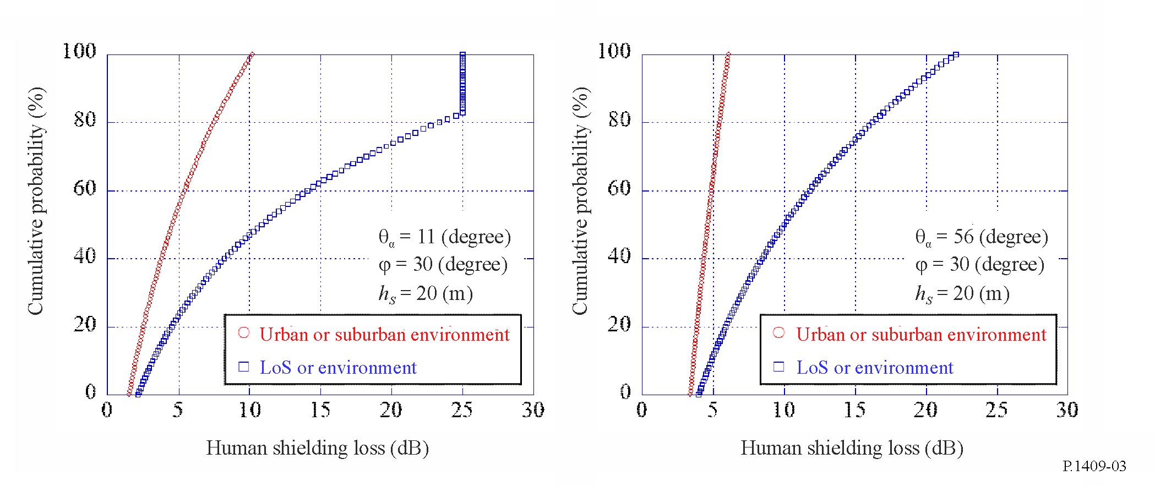
The direction of radio waves arriving at the human body and their received power in case ii) and iv) are as follows. The relevant parameters are given as follows:
f : frequency (GHz)
φ : azimuth angle between high-altitude station and earth station based on 0 degrees in the road direction in the 1st quadrant (degrees)
Δφ : azimuth angle of arrival of radio wave based on 0 degree in the road direction (degrees)
θ : elevation angle between high-altitude station and earth station (degrees)
Δθ : elevation angle of arrival of radio wave based on 0 degree in the zenithal direction (degrees)
h_{SS} : Earth station antenna height (m)
h_{BS} : High-altitude station antenna height (m)
w : road width around the earth station (m)
h_{s} : average building heights along the road around the earth station (m).
Here, this model is valid for the following:
f : 0.7 $\text{≤}$ f $\text{≤}$ 3.4 GHz
φ : 0 < φ $\text{≤}$ 90 degrees
Δφ : −180 < Δφ $\text{≤}$ 180 degrees
θ : 0 < θ $\text{≤}$ 50 degrees
Δθ : −180 < Δθ $\text{≤}$ 180 degrees
h_{SS} : 0 < h_{SS} $\text{≤}$ 5 m
h_{BS} : h_{BS} > 160 m
w : 8 $\text{≤}$ w $\text{≤}$ 25 m
h_{s} : 5 $\text{≤}$ h_{s} $\text{≤}$ 50 m.
The difference in the received power between the road and building directions in the horizontal plane is given by:
${Pd}_{NLoS}\left(∆φ\right)=10\log_{10}\left(\frac{{Pd}_{NLoS,pow}\left(∆φ\right)}{max\left({Pd}_{NLoS,pow}\left(∆φ\right)\right)}\right)$ (dB) (6)
where:
${Pd}_{NLoS,pow}\left(∆φ\right)=\frac{1}{\sqrt{{\cos\left(∆φ\right)}^{2}+{\sin\left(∆φ\right)}^{2}/η^{2}}}$ (7)
$η=min\left(1,{\left\{2.6/h_{s}^{0.5}⋅\left(1-\exp\left(-0.03φ\right)\right)+0.05\right\}}^{1.5}\right)$ (8)
The maximum value of the received power is extracted as an arrival path in the road direction. The minimum value of the received power is extracted as an arrival path in the building direction.
$Pd_{Road}=max\left({Pd}_{NLoS}\left(∆φ\right)\right)$ (dB) (9)
$Pd_{Bldg}=min\left({Pd}_{NLoS}\left(∆φ\right)\right)$ (dB) (10)
In order to reflect the losses due to reflected and diffracted waves to the received power of the arrival path in the building direction. The following L_{R}(Δh_{SS}) and L_{D}(Δh_{SS}) are the excess losses due to the arriving reflected waves and the arriving diffracted waves in the NLoS region, respectively. The L_{R}(Δh_{SS}) and L_{D}(Δh_{SS}) are expressed as follows.
When:
$Δh_{SS,k}≤Δh_{SS}<Δh_{SS,k+1}$
$L_{R}\left(Δh_{SS}\right)=L_{R}\left(Δh_{SS,k}\right)+\frac{L_{R}\left(Δh_{SS,k+1}\right)-L_{R}\left(Δh_{SS,k}\right)}{Δh_{SS,k+1}-Δh_{SS,k}}⋅\left(Δh_{SS}-Δh_{SS,k}\right)\left(k=0,1,2,3,…\right)$ (dB) (11)
where:
$Δh_{SS,k}=\frac{2kw⋅\left(h_{BS}-h_{s}\right)}{2d⋅\sin{φ}-w}$ (m) (12)
$L_{R}\left(Δh_{SS,k}\right)≈20\log_{10}\left(\frac{d_{kp}}{d_{0p}⋅R^{k}}\right)$ (dB) (13)
$R=0.33$
$d_{kp}=\frac{1}{\sin{φ_{k}}}⋅\sqrt{{\left(d⋅\sin{φ}+kw\right)}^{2}+{\left\{h_{BS}+Δh_{SS,k}-h_{s}+\frac{w⋅\left(h_{BS}-h_{s}\right)}{2d⋅\sin{φ}-w}\right\}}^{2}}$ (m) (14)
$φ_{k}=\tan^{-1}\left(\frac{d\sin{φ}+kw}{d\cos{φ}}\right)$ (degrees) (15)
$Δh_{SS}=h_{s}-h_{SS}-\frac{w\left(h_{BS}-h_{s}\right)}{2d-w}$ (m) (16)
$d=\frac{\left(h_{BS}-h_{SS}\right)}{\tan{θ}}$ (m) (17)
$L_{D}\left(Δh_{SS}\right)≈\left\{\begin{matrix}K_{1} & \left(0 m≤Δh_{SS}<1 m\right) \\ K_{2} & \left(1 m≤Δh_{SS}<10 m\right) \\ K_{3} & \left(10 m≤Δh_{SS}\right)\end{matrix}\right.$ (dB) (18)
where:
$K_{1}=\left\{5.8947 \log_{10}\left(f\right)+0.31519\right\}⋅{Δh_{SS}}^{\left(-0.003559 f+0.65122\right)}$ (18a)
$K_{2}=\left\{3.7432 \log_{10}\left(f\right)+19.245\right\}⋅\log_{10}\left(Δh_{SS}\right)+5.8947 \log_{10}\left(f\right)+0.31519$ (18b)
$K_{3}=24.5 \log_{10}\left(Δh_{SS}\right)+9.6379 \log_{10}\left(f\right)-4.93981$ (18c)
In this step, the received power of the arrival path in the building direction, which reflects losses due to reflected and diffracted waves, can be obtained.
${Pd}_{R,Bldg}=\left\{\begin{matrix}{Pd}_{Bldg} & \left(L_{D}\left(Δh_{SS}\right)-L_{R}\left(Δh_{SS}\right)≥0\right) \\ {Pd}_{Bldg}+\left(L_{D}\left(Δh_{SS}\right)-L_{R}\left(Δh_{SS}\right)\right) & \left(L_{D}\left(Δh_{SS}\right)-L_{R}\left(Δh_{SS}\right)<0\right)\end{matrix}\right.$ (dB) (19)

${Pd}_{D,Bldg}=\left\{\begin{matrix}{Pd}_{Bldg}-\left(L_{D}\left(Δh_{SS}\right)-L_{R}\left(Δh_{SS}\right)\right) & \left(L_{D}\left(Δh_{SS}\right)-L_{R}\left(Δh_{SS}\right)≥0\right) \\ {Pd}_{Bldg} & \left(L_{D}\left(Δh_{SS}\right)-L_{R}\left(Δh_{SS}\right)<0\right)\end{matrix}\right.$ (dB) (20)
The final step is that the received power of each arrival path in road and building directions can be plotted as a power vertical arrival angular profile at the earth station as follows:
${Ph}_{Road,pow}\left(Δθ\right)=\max\left({Ph}_{R,Road}\left(Δθ\right),{Ph}_{D,Road}\left(Δθ\right)\right)$ (dB) (21)
${Ph}_{Bldg,pow}\left(Δθ\right)=\max\left({Ph}_{R,Bldg}\left(Δθ\right),{Ph}_{D,Bldg}\left(Δθ\right)\right)$ (dB) (22)
where:
${Ph}_{R,Road}\left(Δθ\right)=10\log_{10}\left\{{\left(1+\frac{\left|Δθ+\left(90-θ\right)\right|}{α}\right)}^{-β}\right\} +Pd_{Road}$ (dB) (23)
${Ph}_{D,Road}\left(Δθ\right)=10\log_{10}\left\{{\left(1+\frac{\left|Δθ-\left(90-θ\right)\right|}{α}\right)}^{-β}\right\}+Pd_{Road}$ (dB) (24)
${Ph}_{R,Bldg}\left(Δθ\right)=10\log_{10}\left\{{\left(1+\frac{\left|Δθ+\left(90-θ\right)\right|}{α}\right)}^{-β}\right\}+Pd_{R,Bldg}$ (dB) (25)
${Ph}_{D,Bldg}\left(Δθ\right)=10\log_{10}\left\{{\left(1+\frac{\left|Δθ-\left(90-θ\right)\right|}{α}\right)}^{-β}\right\}+Pd_{D,Bldg}$ (dB) (26)
$α=-0.6+1.2{\left(\frac{h_{s}}{h_{SS}}\right)}^{0.23}$ (27)
$β=-0.045h_{s}+1.87+0.76\log_{10}\left(h_{SS}\right)$ (28)
Figure 4 shows examples of relative received power of arrival path for elevation direction in the road direction, ${Ph}_{Road,pow}\left(Δθ\right)$, and the building direction, ${Ph}_{Bldg,pow}\left(Δθ\right)$.
Figure 4
Prediction results of relative received power of each arrival path
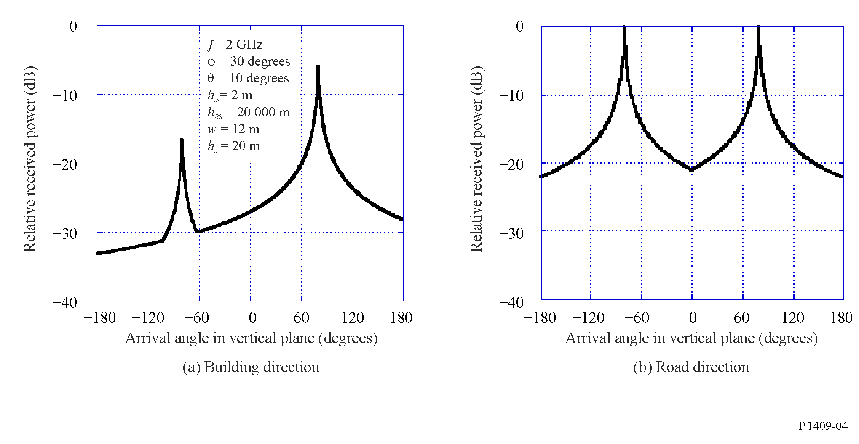
In cases ii) and iv), the power density, $p\left(d_{d}\right)$, of the impulse response obtained with omni-directional antennas at the human body normalized by that of the first path as a function of the path length difference, $d_{d}$, from the first path is given as follows:
$p\left(d_{d}\right)=10\log_{10}\left(a_{1}\left(d_{d}\right)a_{2}\left(d_{d}\right)\right)$ (dB) (29)
where:
$a_{1}\left(d_{d}\right)=\left\{\begin{matrix}1 & for d_{d}=0 \\ min\left(0.63, \left(0.59e^{-0.0172B}+\left(0.0172+0.0004B\right)h_{s}\right)e^{a_{3}}\right) & for d_{d}>0\end{matrix}\right.$ (30)
$a_{3}=-\left(0.077-0.00096B-\left(0.0014-0.000018B\right)h_{s}\right)\frac{d_{d}B}{c}{10}^{6}$ (31)
$a_{2}\left(d_{d}\right)={10}^{\frac{a_{4}\left(d_{d}\right)}{10}}$ (32)
$a_{4}\left(d_{d}\right)=a_{5}\left(d_{d}\right)a_{6}\left(d_{d}\right)$ (33)
$a_{5}\left(d_{d}\right)=0.4+0.6e^{-0.2a_{7}^{4}}+a_{7}\left(1-e^{-0.4a_{7}^{2}}\right)\frac{d_{d}}{c}{10}^{6}$ (34)
$a_{6}\left(d_{d}\right)=-\left(19.1- 9.68 \log_{10}\left(a_{7}\right)\right)B^{\left(-0.36-0.12 \log_{10}\left(a_{7}\right)\right)}{\left(\frac{h_{BS}}{1 000\tan\left(θ\right)}\right)}^{\left(-0.38+0.21\log_{10}\left(B\right)\right)}a_{9}$ (35)
$a_{7}=\frac{h_{s}}{a_{8}}$ (36)
$a_{8}=150+\frac{h_{BS}}{33.1}\sin\left(θ\right)$ (37)
$a_{9}=\log_{10}\left(1+\frac{d_{d}B}{c}{10}^{6}\right)$ (38)
θ : elevation angle between the high-altitude station and the earth station (degrees)
h_{BS} : high-altitude station antenna height (m)
$h_{s}$ : average building height (m)
B : chip rate (Mcps)
(occupied bandwidth can be converted from chip rate B and applied baseband filter)
$d_{d}$: path length difference from the first path (m)
c : the speed of light in the air (m/s).
Here, this model is valid for the following:
f : 0.7 $≤$ f $≤$ 3.4 GHz
θ : 0 < θ $\text{≤}$ 50 degrees
h_{BS} : h_{BS} > 150 m
$h_{s}$ : 5 $\text{≤}$ h_{s} $\text{≤}$ 30 m
B : 6 $\text{≤}$ B $\text{≤}$ 50 Mcps
$d_{d}$ : $d_{d} \text{≤}$ 2 000 m.
Figure 5 shows an example of the power delay profile derived using equation (29).
Figure 5
Prediction results of power delay profile
