Recommendation ITU-R P.1144-13
(11/2025)
P Series: Radio-wave propagation
Guidelines for the application of numerical methods used in propagation methods of Radiocommunication Study Group 3

Foreword
The role of the Radiocommunication Sector is to ensure the rational, equitable, efficient and economical use of the radio-frequency spectrum by all radiocommunication services, including satellite services, and carry out studies without limit of frequency range on the basis of which Recommendations are adopted.
The regulatory and policy functions of the Radiocommunication Sector are performed by World and Regional Radiocommunication Conferences and Radiocommunication Assemblies supported by Study Groups.

Policy on Intellectual Property Right (IPR)
ITU-R policy on IPR is described in the Common Patent Policy for ITU-T/ITU-R/ISO/IEC referenced in Resolution ITU-R 1. Forms to be used for the submission of patent statements and licensing declarations by patent holders are available from https://www.itu.int/ITU-R/go/patents/en where the Guidelines for Implementation of the Common Patent Policy for ITU-T/ITU-R/ISO/IEC and the ITU-R patent information database can also be found.

Series of ITU-R Recommendations
(Also available online at https://www.itu.int/publ/R-REC/en)
Series | Title
BO | Satellite delivery
BR | Recording for production, archival and play-out; film for television
BS | Broadcasting service (sound)
BT | Broadcasting service (television)
F | Fixed service
M | Mobile, radiodetermination, amateur and related satellite services
P | Radio-wave propagation
RA | Radio astronomy
RS | Remote sensing systems
S | Fixed-satellite service
SA | Space applications and meteorology
SF | Frequency sharing and coordination between fixed-satellite and fixed service systems
SM | Spectrum management
SNG | Satellite news gathering
TF | Time signals and frequency standards emissions
V | Vocabulary and related subjects

Note: This ITU-R Recommendation was approved in English under the procedure detailed in Resolution ITU-R 1.

Electronic Publication
Geneva, 2025

© ITU 2025
All rights reserved. No part of this publication may be reproduced, by any means whatsoever, without written permission of ITU.

RECOMMENDATION ITU-R P.1144-13
Guidelines for the application of numerical methods used in propagation methods of Radiocommunication Study Group 3
(1995-1999-2001-2001-2007-2009-2012-2015-06/2017-12/2017-2019-2021-2023-2025)
Scope
This Recommendation provides guidelines for the application of numerical methods used within the P-series Recommendations of Radiocommunication Study Group 3.
Keywords
Spatial interpolation, numerical integration
Glossary
Symbol | Description
n | number of Gaussian quadrature points (nodes)
$$W_{i}$$ | Gaussian quadrature weights
$X_{i}$ | Gaussian quadrature points
Other symbols not listed in the Table above are intermediate in nature and have no definition.

The ITU Radiocommunication Assembly,
considering
that there is a need to assist users of the ITU-R Recommendations P-series (developed by Radiocommunication Study Group 3),
recommends
that the information contained in the annex should be considered as guidelines for the use with the various digital maps of geophysical parameters necessary for the application of the propagation methods in the P-series Recommendations.

Annex

1a Bi-linear interpolation on a trapezoidal grid
Given: Values of X at four surrounding points:$\left(Lat_{1}, Lon_{C}\right)$, $\left(Lat_{1}, Lon_{D}\right)$, $\left(Lat_{0}, Lon_{A}\right)$, and $\left(Lat_{0}, Lon_{B}\right)$; i.e. $X\left(Lat_{1}, Lon_{C}\right)$, $X\left(Lat_{1}, Lon_{D}\right)$, $X\left(Lat_{0}, Lon_{A}\right)$, and $X\left(Lat_{0}, Lon_{B}\right)$.
Problem: Determine the value $X\left(Lat, Lon\right)$ at an intervening point $\left(Lat, Lon\right)$ using bi-linear interpolation.
Figure 1
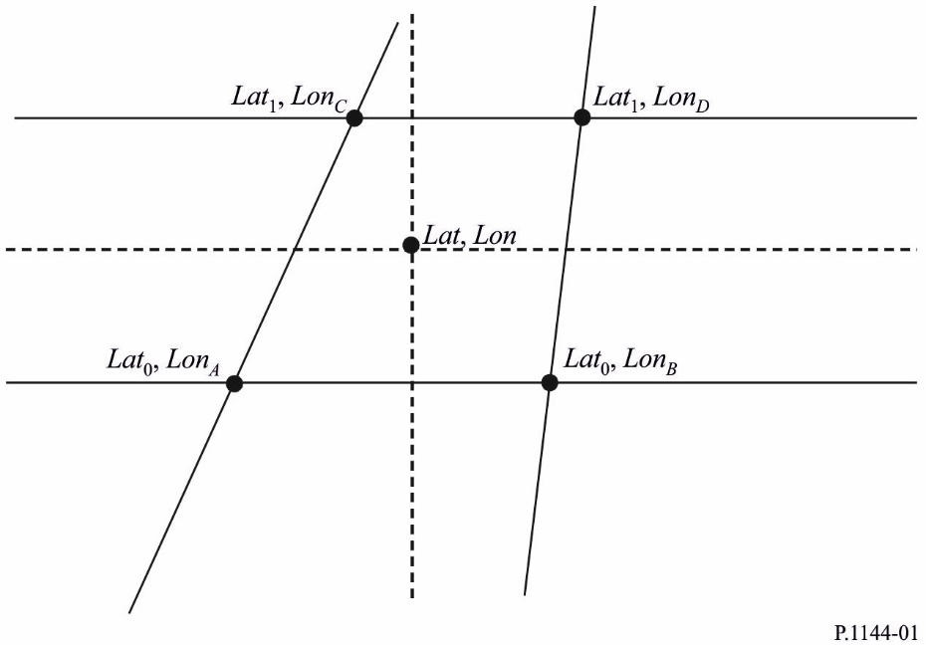
Solution: Define two auxiliary variables, $t$ and $s$:
$$t=\frac{Lat-{Lat}_{0}}{{Lat}_{1}-{Lat}_{0}} \\ s=\frac{Lon-{Lon}_{A}+t \left({Lon}_{A}-{Lon}_{C}\right)}{{Lon}_{B}-{Lon}_{A}+t \left({Lon}_{A}-{Lon}_{C}+{Lon}_{D}-{Lon}_{B}\right)}$$
and calculate:
$$X\left(Lat,Lon\right)=\left(1-s\right) \left(1-t\right) X\left(Lat_{0},Lon_{A}\right)$$
$$+\left(1-s\right) t X\left(Lat_{1},Lon_{C}\right)$$
$$+s \left(1-t\right) X\left(Lat_{0},Lon_{B}\right)$$
$$+t s X\left(Lat_{1},Lon_{D}\right)$$

1b Bi-linear interpolation on a square grid
figure 2
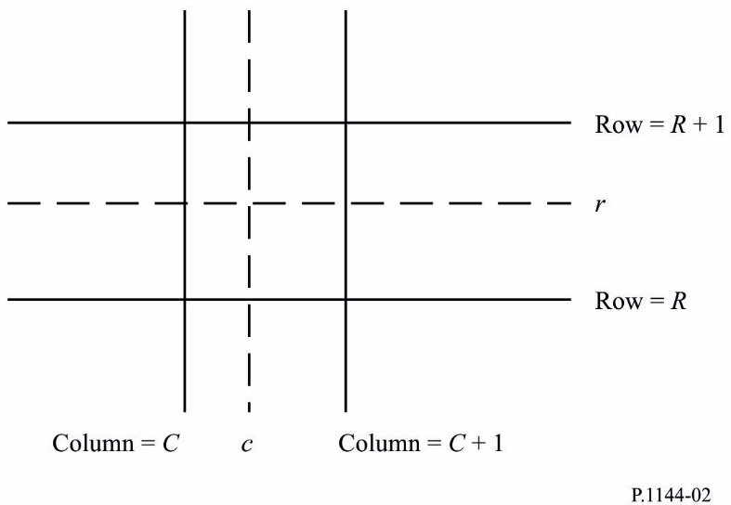
Given: Values of I at four surrounding grid points: I(R,C), I(R,C + 1), I(R + 1,C), and I(R + 1,C + 1), where R, R + 1, C, and C + 1 are integer row and column numbers.
Problem: Determine I(r,c), where r is a fractional row number between R and R + 1 and c is a fractional column number between C and C + 1, using bi-linear interpolation.
Solution: Calculate:
I(r,c) = I(R,C) [(R + 1 – r)(C + 1 – c)]
+ I(R + 1,C) [(r – R)(C + 1 – c)]
+ I(R,C + 1) [(R + 1 – r)(c – C)]
+ I(R + 1,C + 1) [(r – R)(c – C)]

2 Bi-cubic interpolation
figure 3
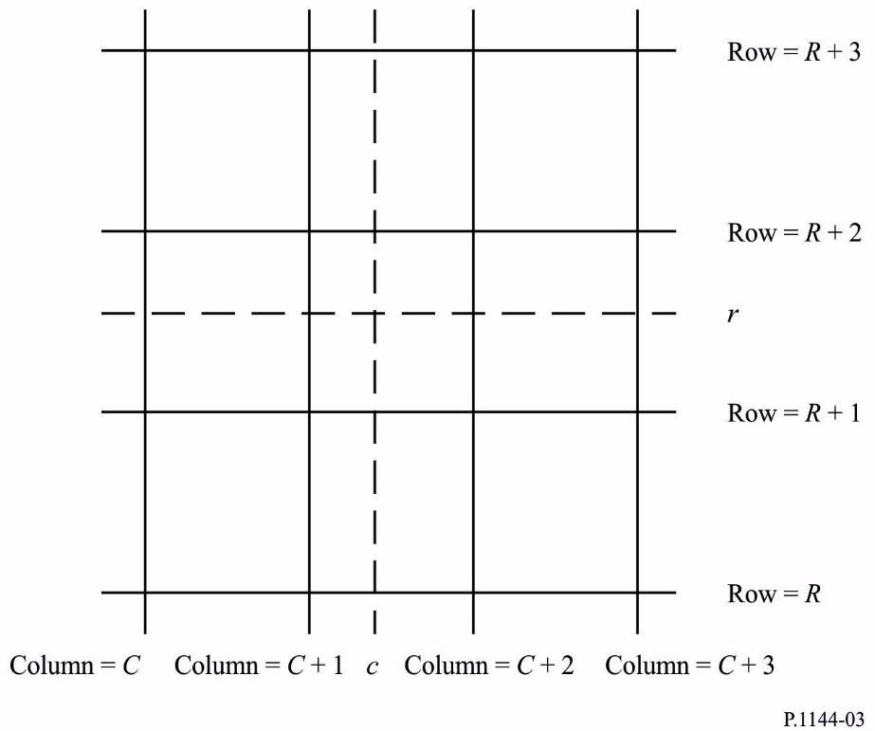
Given: Values of I at 16 surrounding grid points:
I(R,C), I(R,C + 1), I(R,C + 2), I(R,C + 3),
I(R + 1,C), I(R + 1,C + 1), I(R + 1,C + 2), I(R + 1,C + 3),
I(R + 2,C), I(R + 2,C + 1), I(R + 2,C + 2), I(R + 2,C + 3),
I(R + 3,C), I(R + 3,C + 1), I(R + 3,C + 2), I(R + 3,C + 3)
where R, R + 1, etc.; and C, C + 1, etc. are integers.
Problem: Calculate I(r,c), where r is a fractional row number between R + 1 and R + 2 and c is a fractional column number between C + 1 and C + 2, using bi-cubic interpolation.
Solution:
Step 1: For each row, X, where X = {R, R + 1, R + 2, R + 3}, compute the interpolated value at the desired fractional column c as:

$RI\left(X,c\right)=\sum_{j=C}^{C+3}{I\left(X,j\right) K\left(c-j\right)}$
where:

$K\left(δ\right)=\left\{\begin{matrix}\left(a+2\right){\left|δ\right|}^{3}-\left(a+3\right){\left|δ\right|}^{2}+1 & for & 0≤\left|δ\right|≤1 \\ a{\left|δ\right|}^{3}-5a{\left|δ\right|}^{2}+8a\left|δ\right|-4a & for & 1≤\left|δ\right|≤2 \\ 0 & for & 2≤\left|δ\right| \end{matrix}\right.$
and
$a=-0.5$
Step 2: Calculate I(r,c) by interpolating the one-dimensional interpolations, RI(R,c), RI(R + 1,c), RI(R + 2,c), and RI(R + 3,c) in the same manner as the row interpolations.

3 Gaussian quadrature integration
Gaussian quadrature integration is accurately approximate to a definite integral if the integrand, f(x), is well-approximated by a polynomial of degree 2n-1 or less over the integration interval. The value of $n$ should be selected based on the desired approximation accuracy.

3.1 Single integral
A single integral can be well-approximated by Gaussian quadrature integration noting that:
$$\int_{a}^{b}{f\left(x\right)dx}=\int_{-1}^{1}{\left(\frac{b-a}{2}\right)f\left(\frac{a+b}{2}+\frac{b-a}{2}t\right)dt}$$
$$≈\sum_{i=1}^{n}{W_{i}^{'}f\left(X_{i}^{'}\right)}$$
where:
$$W_{i}^{'}=\left(\frac{b-a}{2}\right) W_{i}$$
$$X_{i}^{'}=\frac{a+b}{2}+\frac{b-a}{2}X_{i}$$

3.2 Double integral
A double integral can be well-approximated by Gaussian quadrature integration noting that:
$$\int_{a}^{b}{\int_{c}^{d}{f\left(x,y\right) dx dy}}=\int_{-1}^{1}{\int_{-1}^{1}{\left(\frac{b-a}{2}\right)\left(\frac{d-c}{2}\right) f(}}\frac{a+b}{2}+\frac{b-a}{2}s,\frac{c+d}{2}+\frac{d-c}{2}t) ds dt$$
$$≈\sum_{i=1}^{n}{\sum_{j=1}^{n}{W_{i}^{'} Y_{j}^{'} f\left(X_{i}^{'}, Z_{j}^{'}\right)}}$$
where:
$$W_{i}^{'}=\left(\frac{b-a}{2}\right) W_{i}$$
$$X_{i}^{'}=\frac{a+b}{2}+\frac{b-a}{2}X_{i}$$
$$Y_{j}^{'}=\left(\frac{d-c}{2}\right) W_{j}$$
$$Z_{j}^{'}=\frac{c+d}{2}+\frac{d-c}{2}X_{j}$$

3.3 Algorithm to calculate Gaussian quadrature points (nodes) and weights
This algorithm calculates the points (nodes), $X_{i}$, and weights, $W_{i}$, for $i=1, 2,….,n$, where $n$ is the number of Gaussian quadrature points (nodes). The variable $eps$ is the accuracy of the machine’s floating-point system. On machines that support IEEE floating point arithmetic, $eps$ is approximately 2.2204e-16 for double precision. The function $floor\left(x\right)$ rounds x to the nearest integer less than or equal to $x.$
Step 1: Calculate $m=floor\left(\frac{n+1}{2}\right)$
Repeat Steps 2 to 13 for $i=1$ to $m$
Step 2: Calculate $X_{i}=cos\left(\frac{4i-1}{4n+2}π\right)$
Step 3: Calculate $Pm1=1$ and $P=X_{i}$
Repeat Steps 4 and 5 for $j=2 to n$
Step 4: Calculate $Pm2=Pm1$ and $Pm1=P$
Step 5: Calculate $P=\left(2-\frac{1}{j}\right)X_{i}$ $Pm1-\left(1-\frac{1}{j}\right)Pm2$
Step 6: Calculate $P^{'}=\frac{n ∙ \left(X_{i} ∙ P-Pm1\right)}{X_{i}^{2}-1}$
Step 7: Calculate $Δ=\frac{P}{P^{'}}$
Step 8: Calculate $X_{i}=X_{i}-Δ$
Step 9: If $\left|Δ\right|>eps$ then go to Step 3, otherwise go to Step 10
Step 10: Calculate $Xlast=X_{i}+Δ$
Step 11: Calculate $Pm1^{'}=\frac{\left(n-1\right) ∙ Xlast ∙ Pm1-Pm2)}{\left(Xlast^{2}-1\right)}$
Step 12: Calculate $Pm1=Pm1-Δ∙ Pm1^{'}$
Step 13: Calculate $W_{i}=\frac{2 \left(1-X_{i}^{2}\right)}{{\left(n ∙ Pm1\right)}^{2}}$
Repeat Step 14 for $i=m+1$ to $n$
Step 14: Calculate $X_{i}={-X}_{floor\left(\frac{n}{2}\right)+m+1-i}$ and $W_{i}=W_{floor\left(\frac{n}{2}\right)+m+1-i}$

Example values of $X_{i}$, the Gaussian quadrature points, and $W_{i}$, the Gaussian quadrature weights, are provided in a supplemental product on the ITU-R Study Group 3 website on digital products.

