Recommendation ITU-R P.1144-12
(08/2023)
P Series: Radiowave propagation
Guide to the application of the propagation methods of Radiocommunication Study Group 3

Foreword
The role of the Radiocommunication Sector is to ensure the rational, equitable, efficient and economical use of the radio-frequency spectrum by all radiocommunication services, including satellite services, and carry out studies without limit of frequency range on the basis of which Recommendations are adopted.
The regulatory and policy functions of the Radiocommunication Sector are performed by World and Regional Radiocommunication Conferences and Radiocommunication Assemblies supported by Study Groups.

Policy on Intellectual Property Right (IPR)
ITU-R policy on IPR is described in the Common Patent Policy for ITU-T/ITU-R/ISO/IEC referenced in Resolution ITU-R 1. Forms to be used for the submission of patent statements and licensing declarations by patent holders are available from http://www.itu.int/ITU-R/go/patents/en where the Guidelines for Implementation of the Common Patent Policy for ITU-T/ITU-R/ISO/IEC and the ITU-R patent information database can also be found.

Series of ITU-R Recommendations
(Also available online at https://www.itu.int/publ/R-REC/en)
Series | Title
BO | Satellite delivery
BR | Recording for production, archival and play-out; film for television
BS | Broadcasting service (sound)
BT | Broadcasting service (television)
F | Fixed service
M | Mobile, radiodetermination, amateur and related satellite services
P | Radiowave propagation
RA | Radio astronomy
RS | Remote sensing systems
S | Fixed-satellite service
SA | Space applications and meteorology
SF | Frequency sharing and coordination between fixed-satellite and fixed service systems
SM | Spectrum management
SNG | Satellite news gathering
TF | Time signals and frequency standards emissions
V | Vocabulary and related subjects

Note: This ITU-R Recommendation was approved in English under the procedure detailed in Resolution ITU-R 1.

Electronic Publication
Geneva, 2023

© ITU 2023
All rights reserved. No part of this publication may be reproduced, by any means whatsoever, without written permission of ITU.

RECOMMENDATION ITU-R P.1144-12
Guide to the application of the propagation methods of Radiocommunication
Study Group 3
(1995-1999-2001-2001-2007-2009-2012-2015-06/2017-12/2017-2019-2021-2023)
Scope
This Recommendation provides a guide to the Recommendations of Radiocommunication Study Group 3, which contain propagation prediction methods. It advises users on the most appropriate methods for particular applications as well as the limits, required input information, and output for each of these methods.
Keywords
Radiowave propagation, prediction methods, digital products, spatial interpolation, height reference system
Glossary
Symbol | Description
n | number of Gaussian quadrature points (nodes)
$$W_{i}$$ | Gaussian quadrature weights
$X_{i}$ | Gaussian quadrature points
Other symbols not listed in the table above are intermediate in nature and have no definition.

The ITU Radiocommunication Assembly,
considering
that there is a need to assist users of the ITU-R Recommendations P Series (developed by Radiocommunication Study Group 3),
recommends
1 that the information contained in Table 1 should be considered for guidance on the application of the various propagation methods contained in the ITU-R Recommendations P Series (developed by Radiocommunication Study Group 3);
2 that the information contained in Table 2 and Annex 1 should be considered for guidance on the use of the various digital maps of geophysical parameters necessary for the application of the propagation methods in recommends 1 above.
NOTE – For each of the ITU-R Recommendations in Table 1, there are associated information columns to indicate:
Application: the service(s) or application for which the Recommendation is intended.
Type: the situation to which the Recommendation applies, such as point-to-point, point-to-area, line-of-sight, etc.
Output: the output parameter value produced by the method of the Recommendation, such as basic transmission loss.
Frequency: the applicable frequency range of the Recommendation.
Distance: the applicable distance range of the Recommendation.
% time: the applicable time percentage values or range of values of the Recommendation; % time is the percentage of time that the predicted signal is exceeded during an average year.
% location: the applicable per cent location range of the Recommendation; % location is the percentage of locations within, say, a square with 100 to 200 m sides that the predicted signal is exceeded.
Terminal height: the applicable terminal antenna height range of the Recommendation.
Input data: a list of parameters used by the method of the Recommendation; the list is ordered by the importance of the parameter and, in some instances, default values may be used.
The information, as shown in Table 1, is already provided in the Recommendations themselves; however, the Table allows users to quickly scan the capabilities (and limitations) of the Recommendations without the requirement to search through the text.

TABLE 1
ITU-R radiowave propagation prediction methods
Method | Title | Application | Type | Output | Frequency | Distance | % time | % location | Terminal height | Input data
Rec. ITU-R P.368 | Ground-wave propagation curves for frequencies between 10 kHz and 30 MHz | All services | Point-to-point | Field strength | 10 kHz to 30 MHz | 1 to 10 000 km | Not applicable | Not applicable | Ground-based | Frequency  Ground conductivity
Rec. ITU-R P.452 | Prediction procedure for the evaluation of interference between stations on the surface of the Earth at frequencies above about 0.1 GHz | Services employing stations on the surface of the Earth; interference | Point-to-point | Basic transmission loss | 100 MHz to 50 GHz | Not specified but up to and beyond the radio horizon | 0.001 to 50  Average year and worst month | Not applicable | No limits specified, within the surface layer of the atmosphere.  (Not suitable for aeronautical applications) | Path profile data  Frequency  Percentage time  Tx antenna height  Rx antenna height  Latitude and longitude  of Tx  Latitude and longitude of Rx Meteorological data  Polarization
Rec. ITU-R P.528 | Propagation curves for aeronautical mobile and radionavigation services using the VHF, UHF and SHF bands | Aeronautical  mobile | Point-to-area | Basic transmission loss | 100 MHz to 30 GHz | Not specified but up to and beyond the radio horizon  For aeronautical applications 0 km great circle distance does not mean 0 km path length. | 1 to 99 | Not applicable | Terminal heights: 1.5 - 20 000 m | Distance  Tx height  Frequency  Rx height  Percentage time  Polarization
Rec. ITU-R P.530 | Propagation data and prediction methods required for the design of terrestrial line-of-sight systems | Line-of-sight fixed links | Point-to-point line-of-sight | Propagation loss  Diversity improvement (clear air conditions)  XPD⁽²⁾  Outage  Error performance | Approximately  150 MHz to  100 GHz | Up to 200 km if line-of-sight | All percentages of time in clear-air conditions;  1 to 0.001 in  precipitation conditions  And worst month for attenuation | Not applicable | High enough to ensure specified path clearance | Distance  Tx height  Frequency  Rx height  Percentage time  Path obstruction data  Climate data  Terrain information
TABLE 1 (continued)
Method | Title | Application | Type | Output | Frequency | Distance | % time | % location | Terminal height | Input data
Rec. ITU-R P.533 | Method for the prediction of the performance of HF circuits | Broadcasting Fixed  Mobile | Point-to-point | Basic MUF Sky-wave field strength  Available receiver power  Signal-to-noise ratio  LUF  Circuit reliability | 2 to 30 MHz | 0 to 40 000 km | All percentages | Not applicable | Not applicable | Latitude and longitude of Tx  Latitude and longitude of Rx  Sunspot number  Month  Time(s) of day  Frequencies  Tx power  Tx antenna type  Rx antenna type
Rec. ITU-R P.534 | Method for calculating sporadic-E field strength | Fixed  Mobile Broadcasting | Point-to-point  via sporadic E | Field strength | 30 to 100 MHz | 0 to 4 000 km | 0.1 to 50 | Not applicable | Not applicable | Distance  Frequency
Rec. ITU-R P.617 | Propagation prediction techniques and data required for the design of trans-horizon radio-relay systems | Trans-horizon fixed links | Point-to-point | Basic transmission loss | > 30 MHz | 100 to 1 000 km | 0.001 to 99.999 | Not applicable | No limits specified within the surface layer of the atmosphere.  (Not suitable for aeronautical applications) | Frequency  Tx antenna gain  Rx antenna gain  Path geometry
Rec. ITU-R P.618 | Propagation data and prediction methods required for the design of Earth-space telecommunication systems | Satellite | Point-to-point | Propagation loss  Diversity gain and (for precipitation condition) XPD⁽²⁾ | 1 to 55 GHz | Any practical orbit height | 0.001-5 for rain attenuation;  0.001-50 for total attenuation, 0.001-1 for XPD⁽²⁾  Also worst month for attenuation | Not applicable | No limit | Meteorological data  Frequency  Elevation angle  Height of earth station  Separation and angle between earth station sites (for diversity gain)  Antenna diameter and efficiency (for scintillation)  Polarization angle  (for XPD⁽²⁾)
Rec. ITU-R P.619 | Propagation Data Required for the Evaluation of Interference Between Stations in Space and those on the Surface of the Earth | Satellite | Point-to-point | Basic transmission loss for single-entry interference  Clear-air basic transmission loss for multiple-entry interference | 0.1 to 100 GHz | Any practical orbit height | 0.001 to 50 | Not applicable | No limit | Frequency  Earth-station elevation angle  Angular path separation  Path length  Gaseous attenuation  Scintillation “gain”  Maximum allowed attenuation of the wanted signal
TABLE 1 (continued)
Method | Title | Application | Type | Output | Frequency | Distance | % time | % location | Terminal height | Input data
Rec. ITU-R P.620 | Propagation data required for the evaluation of coordination distances in the frequency range 100 MHz to 105 GHz | Earth station frequency coordination | Coordination distance | Distance of which the required propagation loss is achieved | 100 MHz to 105 GHz | Up to 1 200 km | 0.001 to 50 | Not applicable | No limits specified within the surface layer of the atmosphere.  (Not suitable for aeronautical applications) | Minimum basic transmission loss  Frequency  Percentage of time  Earth-station elevation angle
Rec. ITU-R P.678 | Characterization of the variability of propagation phenomena and estimation of the risk associated with propagation margin | Rain rate models  Satellite | Point-to-point | Variability of propagation phenomena | 12 to 50 GHz | Any practical orbit height | 0.01-2 for rainfall rate and rain attenuation along slant paths | Not applicable | No limit | Probability of exceedance
Rec. ITU-R P.679 | Propagation data required for the design of broadcasting-satellite systems | Broadcast satellite | Point-to-area | Excess basic transmission loss  Effect of local environment | 0.5 to 5.1 GHz | Any practical orbit height | Not applicable | No limits specified | No limits specified | Frequency  Elevation angle  Features of local environment
Rec. ITU-R P.680 | Propagation data required for the design of Earth-space maritime mobile telecommunication systems | Maritime mobile satellite | Point-to-point | Sea-surface fading  Fade duration Interference (adjacent satellite) | 0.8-8 GHz | Any practical orbit height | To 0.001% via Rice-Nakagami distribution  Limit of 0.01% for interference⁽¹⁾ | Not applicable | No limit | Frequency  Elevation angle  Maximum antenna boresight gain
Rec. ITU-R P.681 | Propagation data required for the design of Earth-space land mobile telecommunication systems | Land mobile satellite | Point-to-point | Path fading  Fade duration  Non-fade duration | 0.8 to 20 GHz | Any practical orbit height | Not applicable  Percentage of distance travelled 1 to 80%⁽¹⁾ | Not applicable | No limit | Frequency  Elevation angle  Percentage of distance travelled  Approximate level of optical shadowing
Rec. ITU-R P.682 | Propagation data required for the design of Earth-space aeronautical mobile telecommunication systems | Aeronautical mobile satellite | Point-to-point | Sea-surface fading  Multipath from ground and aircraft during landing | 1 to 2 GHz (sea-surface fading)  1 to 3 GHz (multipath from ground) | Any practical orbit height | To 0.001% via Rice-Nakagami distribution⁽¹⁾ | Not applicable | No limit for sea-surface fading  Up to 1 km for ground reflection during landing | Frequency  Elevation angle  Polarization  Maximum antenna boresight gain  Antenna height
TABLE 1 (continued)
Method | Title | Application | Type | Output | Frequency | Distance | % time | % location | Terminal height | Input data
Rec. ITU-R P.684 | Prediction of field strength at frequencies below about 150 kHz | Fixed  Mobile | Point-to-point  Point-to-area | Sky-wave field strength | 30 to 150 kHz | 0 to 16 000 km | 50 | Not applicable | Not applicable | Latitude and longitude of Tx  Latitude and longitude of Rx  Distance  Tx power  Frequency  Ground constants  Season  Sunspot number  Hour of day
Rec. ITU-R P.843 | Communication by meteor-burst propagation | Fixed  Mobile Broadcasting | Point-to-point via meteor-burst | Received power  Burst rate | 30 to 100 MHz | 100 to 1 000 km | 0 to 5 | Not applicable | Not applicable | Frequency  Distance  Tx power  Antenna gains
Rec. ITU-R P.1147 | Prediction of sky-wave field strength at frequencies between about  150 and  1 700 kHz | Broadcasting | Point-to-area | Sky-wave field strength | 0.15 to 1.7 MHz | 50 to 12 000 km | 1, 10, 50 | Not applicable | Not applicable | Latitude and longitude of Tx  Latitude and longitude of Rx  Distance  Sunspot number  Tx power  Frequency
Rec. ITU-R P.1238 | Propagation data and prediction methods for the planning of indoor radiocommunication systems and radio local area networks in the frequency range 300 MHz to 100 GHz | Mobile  RLAN | In-building propagation methods | Basic transmission loss  Delay spread | 300 MHz to  450 GHz | Within buildings | Not applicable | Not applicable | Base: about 2-3 m  Mobile: about 0.5-3 m | Frequency  Distance  Floor and wall factors
Rec. ITU-R P.1410 | Propagation data and prediction methods required for the design of terrestrial broadband radio access systems operating in a frequency range from 3 to 60 GHz | Broadband radio access | Point-to-area | Coverage  Temporal coverage reduction due to rain | 3 to 60 GHz | 0-5 km | 0.001 to 1 (for calculating reduction in coverage due to rain) | Up to 100 | No limit; 0-300 m (typical) | Frequency  Cell size  Terminal heights  Building height statistical parameters
TABLE 1 (continued)
Method | Title | Application | Type | Output | Frequency | Distance |  | % time | % location | Terminal height |  | Input data
Rec. ITU-R P.1411 | Propagation data and prediction methods for the planning of short-range outdoor radiocommunication systems and radio local area networks in the frequency range 300 MHz to 100 GHz | Mobile | Short-path propagation methods | Basic transmission loss  Delay spread | 300 MHz to 100 GHz | < 1 km |  | Not applicable | Not applicable | Base: about 4-50 m  Mobile: about 0.5-3 m |  | Frequency  Distance  Street dimensions  Structure heights
Rec. ITU-R P.1546 | Method for point-to-area predictions for terrestrial services in the frequency range 30 MHz to 4 000 MHz | Terrestrial services | Point-to-area | Field strength | 30 to 4 000 MHz | 1 to 1 000 km |  | 1 to 50 | 1 to 99 | Tx/base: effective height from less than 0 m to 3 000 m  Rx/mobile: ≥ 1 m |  | Terrain height and ground cover (optional)  Path classification  Distance  Tx antenna height  Frequency  Percentage time  Rx antenna height  Terrain clearance angle  Percentage locations  Refractivity gradient
Rec. ITU-R P.1622 | Prediction methods required for the design of Earth-space systems operating between 20 THz and 375 THz | Satellite optical links | Point-to-point | Absorption loss  Scattering loss  Background noise  Amplitude scintillation  Angle of arrival  Beam wander  Beam spreading | 20 to 375 THz |  | Far-field Earth-to-space optical links | Not applicable | Not applicable | No limit | Wavelength  Terminal height  Elevation angle  Turbulence structure parameter
Rec. ITU-R P.1623 | Prediction method of fade dynamics on Earth-space paths | Satellite | Point-to-point | Fade duration, fade slope | 10 to 50 GHz |  | Any practical orbit height | Not applicable | Not applicable | No limit | Frequency  Elevation angle  Attenuation threshold  Filter bandwidth
Rec. ITU-R P.1812 | A path-specific propagation prediction method for point-to-area terrestrial services in the frequency range 30 MHz to 6 000 MHz | Terrestrial services | Point-to-area | Field strength | 30 MHz to 6 000 MHz |  | Not specified but up to and beyond the radio horizon | 1 to 50 | 1 to 99 | No limits specified, within the surface layer of the atmosphere.  (Not suitable for aeronautical applications) | Path profile data  Frequency  Percentage time  Tx antenna height  Rx antenna height  Latitude and longitude of Tx  Latitude and longitude of Rx Meteorological data  Polarization
TABLE 1 (end)
Method | Title | Application | Type | Output | Frequency | Distance | % time | % location | Terminal height | Input data
Rec. ITU-R P.1814 | Prediction methods required for the design of terrestrial free-space optical links | Terrestrial optical links | Point-to-point | Absorption loss  Scattering loss  Background noise  Amplitude scintillation  Beam spreading | 20 to 375 THz | No limit | Not applicable | Not applicable | No limit | Wavelength  Visibility (in fog)  Path length  Turbulence structure parameter
Rec. ITU-R P.1853 | Tropospheric attenuation time series synthesis | Terrestrial  satellite | Point-to-point | Rain attenuation for terrestrial paths  Total attenuation and tropospheric scintillation for Earth-space paths | 4 to 40 GHz for terrestrial paths  4 to 55 GHz for Earth-space paths | Between 2 and 60 km for terrestrial paths  GEO satellite | Not applicable | Not applicable | No limit | Meteorological data  Frequency  Elevation angle  Height of earth station  Separation and angle between earth station sites (for diversity gain)  Antenna diameter and efficiency (for scintillation)
Rec. ITU-R P.2001 | A general purpose wide-range terrestrial propagation model in the frequency range 30 MHz to  50 GHz | Terrestrial services | Point-to-point | Basic transmission loss | 30 MHz to 50 GHz | 3 to 1 000 km | 0.001 to 99.999 | Not applicable | <8000 m above m.s.l. but near the ground, within the troposphere | Path profile data  Frequency  Percentage time  Tx antenna height, gain and azimuthal direction  Rx antenna height, gain and azimuthal direction  Latitude and longitude of Tx  Latitude and longitude of Rx  Polarization
Rec. ITU-R P.2041 | Prediction of path attenuation on links between an airborne platform and Space and between an airborne platform and the surface of the Earth | Airborne | Point-to-point | Total attenuation | 1 to 55 GHz | Any height | 0.001 to 50 | Not applicable | Between the surface of the Earth and space | Meteorological data  Frequency  Elevation angle  Availability  Height of airborne platform  Antenna diameter and efficiency (for scintillation)
⁽¹⁾ Time percentage of outage; for service availability, subtract value from 100.
⁽²⁾ XPD: Cross-polarization discrimination.
TABLE 2
ITU-R digital products for radiowave propagation predictions methods
Recommendation ITU-R | Description | Grid resolution | Spatial interpolation required (see Annex 1) | Interpolation in probability | Interpolation of the variable | Comments
P.452 | Median annual ΔN  Median annual N₀ | 1.5° × 1.5° | Bi-linear | Not applicable | Not applicable | Refer to the associated Readme file for the applicable file names⁽²⁾
P.453 | Annual and monthly probability distributions of the wet term of the refractivity at the surface (Nwet) | 0.75° × 0.75° | Bi-linear | Logarithmic | Not applicable | Refer to the associated Readme file for the applicable file names⁽²⁾
P.453 | • Refractivity gradient in the lowest  65 m of the atmosphere (N-units/km)  • Refractivity gradient in the lowest 1 km of the atmosphere (N-units/km)  • Percentage of time for which refractivity gradient in the lowest 100 m < −100 N-unit/km | 0.75° × 0.75° | Bi-linear | Not defined | Not applicable | Refer to the associated Readme file for the applicable file names⁽²⁾
P.453 | Surface duct data | 1.5° × 1.5° | Bi-linear | Not defined | Not applicable | Refer to the Software for ionospheric and tropospheric propagation and radio noise web page
P.453 | Elevated duct data | 1.5° × 1.5° | Bi-linear | Not defined | Not applicable | Refer to the Software for ionospheric and tropospheric propagation and radio noise web page
P.530 | LogK logarithm of K%, the geoclimatic factor for the average worst month | 0.25° × 0.25° | Bi-linear | Not defined | Linear | See the Recommendation for the application and use of these data sets.
P.530 | dN₇₅ empirical prediction of 0.1% of the average worst month refractivity increase with height over the lowest 75 m of the atmosphere | 0.25° × 0.25° | Bi-linear | Not defined | Linear | See the Recommendation for the application and use of these data sets.
P.534 | foEs exceeded for annual percentage times | 1.5° × 1.5° | Bi-linear | Linear | Not applicable | Refer to the associated Readme file for the applicable file names⁽²⁾
P.617 | Median annual ΔN  Median annual N₀ | 1.5° × 1.5° | Bi-linear | Not applicable | Not applicable | Refer to the associated Readme file for the applicable file names⁽²⁾
P.678 | Map of the climatic ratio | 0.5° × 0.5° | Bi-linear | Not applicable | Not applicable | Refer to the associated Readme file for the applicable file names⁽²⁾
TABLE 2 (continued)
Recommendation ITU-R | Description | Grid resolution | Spatial interpolation required (see Annex 1) | Interpolation in probability | Interpolation of the variable | Comments
P.834 | • Harmonic coefficients of excess path length along Earth-space paths  • Harmonic coefficients of the hydrostatic and wet mapping functions | 1.5° × 1.5°  5° × 5° | Bi-linear  Not Required | Not defined | Not applicable | Refer to the associated Readme file for the applicable file names⁽²⁾
P.835 | Experimental Data of Atmospheric Vertical Profiles (Annex 2) | 353 Locations | Not required | Not applicable | Not applicable | Refer to the Software for ionospheric and tropospheric propagation and radio noise web page
P.835 | Weather Prediction Data of Atmospheric Vertical Profiles (Annex 3) | 1.5° × 1.5° | Not specified | Not applicable | Not applicable | Refer to the Software for ionospheric and tropospheric propagation and radio noise web page
P.836 | Total columnar water vapour exceedance probability (%) (IWVC) | 1.125° × 1.125° | Bi-linear⁽¹⁾ | Logarithmic | Linear | Refer to the associated Readme file for the applicable file names⁽²⁾
P.836 | Surface water vapour density exceedance probability (%) (Rho) | 1.125° × 1.125° | Bi-linear⁽¹⁾ | Logarithmic | Linear | Refer to the associated Readme file for the applicable file names⁽²⁾
P.836 | Water vapour scale height | 1.125° × 1.125° | Bi-linear⁽¹⁾ | Logarithmic | Linear | Refer to the associated Readme file for the applicable file names⁽²⁾
P.836 | Topographic altitude (a.m.s.l.) (km) | 0.5° × 0.5° | Bi-cubic | Not applicable | Not applicable | Refer to the Recommendation
P.837 | Monthly mean total rainfall (mm)  R_{0.01} (mm/h) | 0.25° × 0.25°  0.125° × 0.125° | Bi-linear  Bi-linear | Not applicable  Not applicable | Not applicable  Not applicable | Refer to the associated readme file for the applicable filenames⁽²⁾
P.837 | Conversion of rain rate statistics at different integration times (Annex 2) | Not applicable | Not required | Not applicable | Not applicable | Refer to the associated Readme file for the applicable file names⁽²⁾
P.839 | Mean annual 0°C isotherm height (km) | 1.5° × 1.5° | Bi-linear | Not applicable | Not applicable | Refer to the associated Readme file for the applicable file names⁽²⁾
P.840 | Annual and monthly statistics (mean, standard deviation and CCDF) statistics of integrated cloud liquid water content  Approximation of annual integrated cloud liquid water content by a log-normal distribution | 0.25° × 0.25° | Bi-linear | Logarithmic | Linear | Refer to the associated Readme file for the applicable file names⁽²⁾

TABLE 2 (continued)
Recommendation ITU-R | Description | Grid resolution | Spatial interpolation required (see Annex 1) | Interpolation in probability | Interpolation of the variable | Comments
P.1510 | Mean monthly and annual surface temperature | 0.75° × 0.75° | Bi-linear | Not applicable | Not applicable | Refer to the associated readme file for the applicable filenames⁽²⁾
P.1511 | Topographic altitude (a.m.s.l.) (m) | 0.08333° × 0.08333° | Bi-cubic | Not applicable | Not applicable | This Recommendation contains definitions of latitude, longitude, and height in P-Series Recommendations. Refer to the associated Readme file for the applicable file names⁽²⁾
P.1511 | Earth gravitational model 2008 (EGM2008) (m) | 0.08333° × 0.08333° | Bi-cubic | Not applicable | Not applicable | Refer to the associated readme file for the applicable filenames⁽²⁾
P.1812 | Median annual ΔN  Median annual N₀ | 1.5° × 1.5° | Bi-linear | Not applicable | Not applicable | Refer to the associated Readme file for the applicable file names⁽²⁾
P.1853 | Annual mean surface pressure  Annual mean water vapour density | 0.75° × 0.75° | Bi-linear | Not applicable | Not applicable | WV_Annual.txt  P_Annual.txt
P.2001 | Surface level refractivity and gradient in the lowest 1 km of the atmosphere | Multiple | Bi-linear | Not applicable | Linear | Refer to the associated Readme file for the applicable file names⁽²⁾
P.2001 and P.534 | Critical frequency for sporadic-E (F₀E_{s}) | 1.5° × 1.5° | Bi-linear | Linear | Linear | FoEs50.txt  FoEs10.txt  FoEs01.txt  FoEs0.1.txt
P.2145 | Annual and monthly statistics (mean, standard deviation and CCDF) of surface pressure  Annual and monthly statistics (mean, standard deviation and CCDF) of surface temperature  Annual and monthly statistics (mean, standard deviation and CCDF) of surface water vapour density  Annual and monthly statistics (mean, standard deviation and CCDF) of integrated water vapour content  Approximation of annual integrated water vapour content by a Weibull distribution | 0.25° × 0.25° | Bi-linear | Logarithmic | Linear | Refer to the Recommendation

TABLE 2 (end)
Recommendation ITU-R | Description | Grid resolution | Spatial interpolation required (see Annex 1) | Interpolation in probability | Interpolation of the variable | Comments
P.2148 | Annual statistics of wind speed at a height of 10 m above the surface of the Earth | 0.25° × 0.25° | Bi-linear | Logarithmic | Linear | Refer to the Recommendation
⁽¹⁾ The variables at the surrounding grid points are scaled to the desired altitude prior to spatial interpolation per the scaling procedure in the Recommendation.
⁽²⁾ The readme file is contained within the Zip (Components) file on the web page associated with the Recommendation.

For easy reference, Fig. 1 shows the relationship between the geophysical maps (black boxes) and propagation effects (white boxes).
figure 1
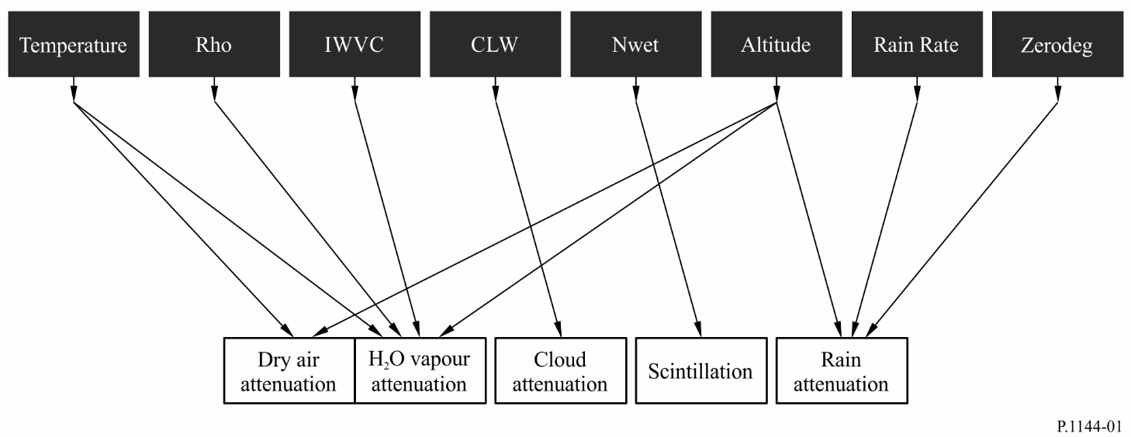

Annex 1

1a Bi-linear interpolation on a trapezoidal grid
Given: Values of X at four surrounding points:$\left(Lat_{1}, Lon_{C}\right)$, $\left(Lat_{1}, Lon_{D}\right)$, $(Lat_{0}, Lon_{A})$, and $(Lat_{0}, Lon_{B})$; i.e. $X\left(Lat_{1}, Lon_{C}\right)$, $X\left(Lat_{1}, Lon_{D}\right)$, $X(Lat_{0}, Lon_{A})$, and $X(Lat_{0}, Lon_{B})$.
Problem: Determine the value $X(Lat, Lon)$ at an intervening point $(Lat, Lon)$ using bi-linear interpolation.
Figure 2
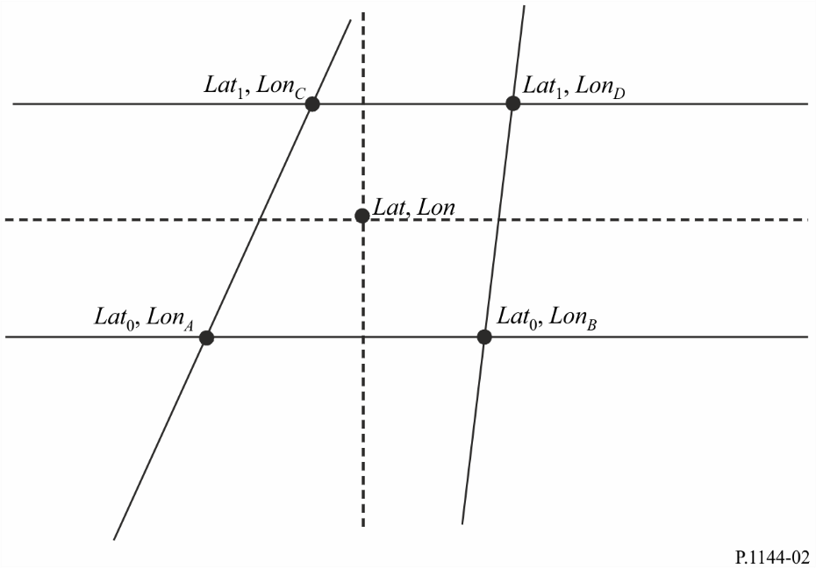
Solution: Define two auxiliary variables, $t$ and $s$:
$$t=\frac{Lat-{Lat}_{0}}{{Lat}_{1}-{Lat}_{0}} \\ s=\frac{Lon-{Lon}_{A}+t \left({Lon}_{A}-{Lon}_{C}\right)}{{Lon}_{B}-{Lon}_{A}+t \left({Lon}_{A}-{Lon}_{C}+{Lon}_{D}-{Lon}_{B}\right)}$$
and calculate:
$$X\left(Lat,Lon\right)=\left(1-s\right) \left(1-t\right) X\left(Lat_{0},Lon_{A}\right)$$
$$+\left(1-s\right) t X\left(Lat_{1},Lon_{C}\right)$$
$$+s \left(1-t\right) X\left(Lat_{0},Lon_{B}\right)$$
$$+t s X(Lat_{1},Lon_{D})$$

1b Bi-linear interpolation on a square grid
figure 3
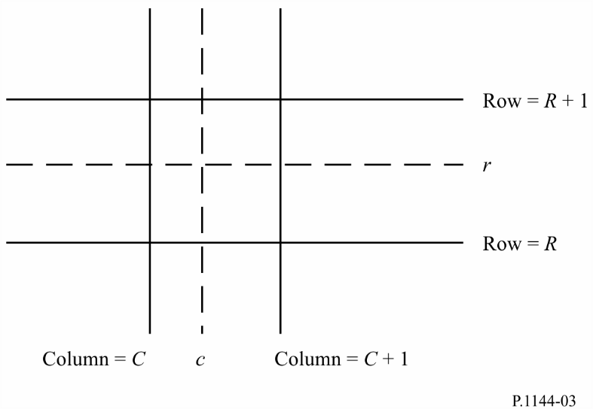
Given: Values of I at four surrounding grid points: I(R,C), I(R,C + 1), I(R + 1,C), and I(R + 1,C + 1), where R, R + 1, C, and C + 1 are integer row and column numbers.
Problem: Determine I(r,c), where r is a fractional row number between R and R + 1 and c is a fractional column number between C and C + 1, using bi-linear interpolation.
Solution: Calculate:
I(r,c) = I(R,C) [(R + 1 – r)(C + 1 – c)]
+ I(R + 1,C) [(r – R)(C + 1 – c)]
+ I(R,C + 1) [(R + 1 – r)(c – C)]
+ I(R + 1,C + 1) [(r – R)(c – C)]

2 Bi-cubic interpolation
figure 4
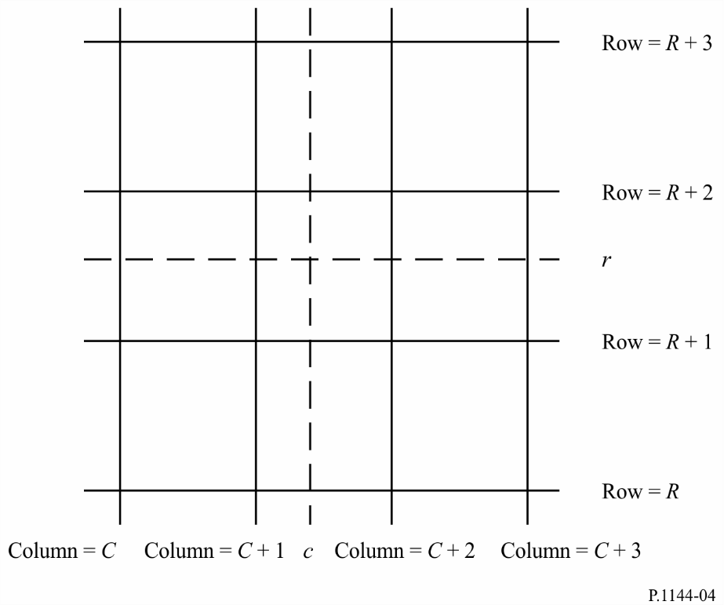
Given: Values of I at 16 surrounding grid points:
I(R,C), I(R,C + 1), I(R,C + 2), I(R,C + 3),
I(R + 1,C), I(R + 1,C + 1), I(R + 1,C + 2), I(R + 1,C + 3),
I(R + 2,C), I(R + 2,C + 1), I(R + 2,C + 2), I(R + 2,C + 3),
I(R + 3,C), I(R + 3,C + 1), I(R + 3,C + 2), I(R + 3,C + 3)
where R, R + 1, etc.; and C, C + 1, etc. are integers.
Problem: Calculate I(r,c), where r is a fractional row number between R + 1 and R + 2 and c is a fractional column number between C + 1 and C + 2, using bi-cubic interpolation.
Solution:
Step 1: For each row, X, where X = {R, R + 1, R + 2, R + 3}, compute the interpolated value at the desired fractional column c as:

where:

and
a = –0.5
Step 2: Calculate I(r,c) by interpolating the one-dimensional interpolations, RI(R,c), RI(R + 1,c), RI(R + 2,c), and RI(R + 3,c) in the same manner as the row interpolations.

3 Gaussian quadrature integration
Gaussian quadrature integration is accurately approximate to a definite integral if the integrand, f(x), is well-approximated by a polynomial of degree 2n-1 or less over the integration interval. The value of $n$ should be selected based on the desired approximation accuracy.

3.1 Single integral
A single integral can be well-approximated by Gaussian quadrature integration noting that:
$$\int_{a}^{b}{f\left(x\right)dx}=\int_{-1}^{1}{\left(\frac{b-a}{2}\right)f\left(\frac{a+b}{2}+\frac{b-a}{2}t\right)dt}$$
$$≈\sum_{i=1}^{n}{W_{i}^{'}f(X_{i}^{'})}$$
where:
$$W_{i}^{'}=\left(\frac{b-a}{2}\right) W_{i}$$
$$X_{i}^{'}=\frac{a+b}{2}+\frac{b-a}{2}X_{i}$$

3.2 Double integral
A double integral can be well-approximated by Gaussian quadrature integration noting that:
$$\int_{a}^{b}{\int_{c}^{d}{f\left(x,y\right) dx dy}}=\int_{-1}^{1}{\int_{-1}^{1}{\left(\frac{b-a}{2}\right)\left(\frac{d-c}{2}\right) f(}}\frac{a+b}{2}+\frac{b-a}{2}s,\frac{c+d}{2}+\frac{d-c}{2}t) ds dt$$
$$≈\sum_{i=1}^{n}{\sum_{j=1}^{n}{W_{i}^{'} Y_{j}^{'} f(X_{i}^{'}, Z_{j}')}}$$
where:
$$W_{i}^{'}=\left(\frac{b-a}{2}\right) W_{i}$$
$$X_{i}^{'}=\frac{a+b}{2}+\frac{b-a}{2}X_{i}$$
$$Y_{j}^{'}=\left(\frac{d-c}{2}\right) W_{j}$$
$$Z_{j}^{'}=\frac{c+d}{2}+\frac{d-c}{2}X_{j}$$

3.3 Algorithm to calculate Gaussian quadrature points (nodes) and weights
This algorithm calculates the points (nodes), $X_{i}$, and weights, $W_{i}$, for $i=1, 2,….,n$, where $n$ is the number of Gaussian quadrature points (nodes). The variable $eps$ is the accuracy of the machine’s floating-point system. On machines that support IEEE floating point arithmetic, $eps$ is approximately 2.2204e-16 for double precision. The function $floor(x)$ rounds x to the nearest integer less than or equal to $x.$
Step 1: Calculate $m=floor(\frac{n+1}{2})$
Repeat Steps 2 to 13 for $i=1$ to $m$
Step 2: Calculate $X_{i}=cos\left(\frac{4i-1}{4n+2}π\right)$
Step 3: Calculate $Pm1=1$ and $P=X_{i}$
Repeat Steps 4 and 5 for $j=2 to n$
Step 4: Calculate $Pm2=Pm1$ and $Pm1=P$
Step 5: Calculate $P=\left(2-\frac{1}{j}\right)X_{i}$ $Pm1-\left(1-\frac{1}{j}\right)Pm2$
Step 6: Calculate $P^{'}=\frac{n ∙ \left(X_{i} ∙ P-Pm1\right)}{X_{i}^{2}-1}$
Step 7: Calculate $Δ=\frac{P}{P^{'}}$
Step 8: Calculate $X_{i}=X_{i}-Δ$
Step 9: If $|Δ|>eps$ then go to Step 3, otherwise go to Step 10
Step 10: Calculate $Xlast=X_{i}+Δ$
Step 11: Calculate $Pm1'=\frac{\left(n-1\right) ∙ Xlast ∙ Pm1-Pm2)}{(Xlast^{2}-1)}$
Step 12: Calculate $Pm1=Pm1-Δ∙ Pm1'$
Step 13: Calculate $W_{i}=\frac{2 \left(1-X_{i}^{2}\right)}{{\left(n ∙ Pm1\right)}^{2}}$
Repeat Step 14 for $i=m+1$ to $n$
Step 14: Calculate $X_{i}={-X}_{floor\left(\frac{n}{2}\right)+m+1-i}$ and $W_{i}=W_{floor\left(\frac{n}{2}\right)+m+1-i}$

Example values of $X_{i}$, the Gaussian quadrature points, and $W_{i}$, the Gaussian quadrature weights, are provided in a supplemental product on the ITU-R Study Group 3 website on digital products.

