RECOMMENDATION ITU-R M.589-3*, **
Technical characteristics of methods of data transmission and interference protection for radionavigation services in the frequency bands
between 70 and 130 kHz

(1982-1986-1992-2001)

Scope
This Recommendation contains the technical characteristics, methods of data transmission and interference protection for radionavigation services in the frequency bands between 70 and 130 kHz. It specifically encourages information exchange and coordination of technical characteristics between administrations for radionavigation systems in the band 90-110 kHz. It also provides protection criteria for, and the technical characteristic of, transmitting data with Loran-C/Chayka.
The ITU Radiocommunication Assembly,
considering
a) that radionavigation systems exist or are being implemented in the three Regions of the ITU;
b) that various services, including radionavigation systems, operate in frequency bands between 70 and 130 kHz;
c) that the operating characteristics of these radionavigation systems are well established and sufficiently documented by the appropriate service providers;
d) that radionavigation being a safety service, all practical means consistent with the Radio Regulations (RR) should be taken to prevent harmful interference to any radionavigation system;
e) that users of phased pulsed radionavigation systems in the band 90-110 kHz receive no protection outside that band, yet may receive benefit from their signals outside the occupied bandwidth;
f) that in the band 90-110 kHz, different phased pulsed radionavigation systems may operate in adjacent areas, on the same assigned frequency and within the same occupied bandwidth;
g) that Loran-C and Chayka systems are characterized by ground waves that follow the Earth's contours with ranges that exceed comparably powered medium frequency systems, and by sky waves that may be received at considerably greater distances;
h) that Loran-C or Chayka systems provide an independent radionavigation system to complement the global navigation satellite system (GNSS);
j) that GNSS components exist or are being implemented and the accuracy may not be enough for some specialized navigation, or for the position sensor in electronic chart systems;
k) that safety applications require integrity information for position fixes derived from GNSS;
l) that the accuracy and integrity of GNSS can be improved considerably by the transmission of differential corrections or other data;
m) that appropriate modulation of Loran-C and Chayka transmissions enables these systems to transmit differential GNSS corrections, integrity messages and other data without interfering with the Loran-C or Chayka navigation function;
n) that the transmission of differential GNSS corrections, integrity messages and other data may benefit from the long-range transmission characteristics of Loran-C or Chayka;
o) that appropriate modulation of Loran-C and Chayka transmissions increases the efficiency of the use of the available bandwidth;
p) that a number of administrations currently provide Loran-C or Chayka coverage of coastal waters and land areas enabling a worldwide standard for the transmission of differential GNSS corrections, integrity messages and other data to be introduced efficiently and economically;
q) that other methods of data transmission using Loran-C or Chayka signals may be introduced,
recommends
1 that information be exchanged between the authorities operating radionavigation systems in the band 90-110 kHz with those operating other systems in the band 70-130 kHz employing stable transmissions;
2 that administrations operating radionavigation systems in the band 90-110 kHz in adjacent areas coordinate the technical characteristics of their individual systems in accordance with the RR;
3 that within the allocated band 90-110 kHz, the protection criteria for pulsed radionavigation systems (e.g. Loran-C and Chayka) should be in terms of unwanted to wanted emissions and in accordance with Annex 1;
4 that determination of Loran-C signal levels should be in accordance with the guidelines given in Annex 1;
5 that any method of data transmission using Loran-C and Chayka signals should preserve the utility of the existing radionavigation services;
6 that a data service using tri-state pulse position modulation of Loran-C or Chayka signals should be designed in accordance with the technical characteristics given in Annex 2.

ANNEX 1
Loran-C/Chayka protection criteria and signal level
determination guidelines

1 Protection criteria
1.1 The protection criteria for Loran-C/CW interference as a function of frequency offset are given in Fig. 1.
1.2 Near-synchronous interference at frequency, f, should satisfy the following relationship:

where:
GRI : group repetition intervals
n : any integer, and
fb : response bandwidth of the receiver (related to response time).
In the track-mode, typical Loran-C receivers have a –3 dB tracking response of 0.01 Hz for marine receivers and 0.1 Hz for aeronautical receivers. However, in the signal acquisition, or search mode, the response may be of considerably higher frequency. The value of fb = 1.0 Hz is therefore recommended to be used.
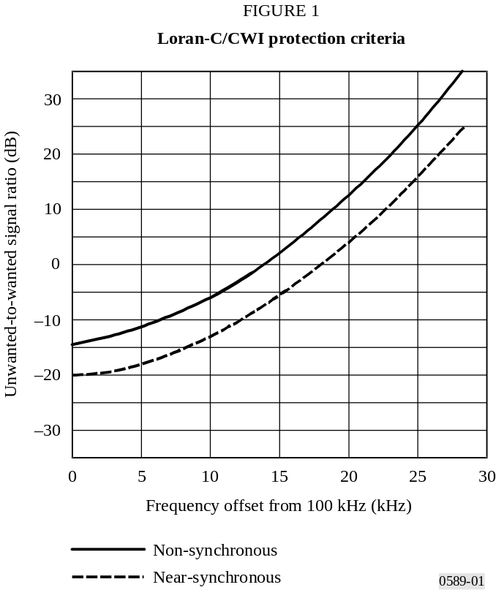
1.3 The protection criteria for Loran-C/FSK interference as a function of frequency offset are given in Fig. 2.

2 Signal level determination guidelines
The application of Figs. 1 and 2 to determine a maximum acceptable field strength of a specific unwanted signal to a known frequency requires knowledge of the expected Loran-C signal strength. This expected signal strength varies widely within the coverage area of a specific Loran-C chain. However, a minimum level may be determined at the coverage boundary.
The area of Loran-C coverage is specified by the administration operating the stations within a chain. This chain coverage area is determined on the basis of the Loran-C signal strength with respect to expected ambient noise levels. The S/N at the boundary of the coverage area is typically –10 dB. Therefore, the S/N within the defined coverage area is greater than that value. The ambient noise levels used to calculate the boundaries are derived from Recommendation ITU-R P.372 – Radio noise. The Loran-C field strength, measured at the boundary of that coverage area, then represents the minimum expected. For example, if the expected noise level is 55 dB(μV/m), a Loran-C signal level of 45 dB(μV/m) or higher would likely be found throughout the coverage area. 45 dB(μV/m) could then be used as the value of the wanted signal in conjunction with Figs. 1 and 2.
A study relative to chains operated within the United States of America reported that Loran-C signal levels within defined coverage areas may be as low as 43 dB(μV/m). Using this value, and considering a near-synchronous CWI signal between 90 and 110 kHz, the maximum unwanted-to-wanted signal level, determined from Fig. 1 is –20 dB. In this case, the unwanted field strength at the Loran-C receiver may have to be below 23 dB(μV/m) to prevent interference.
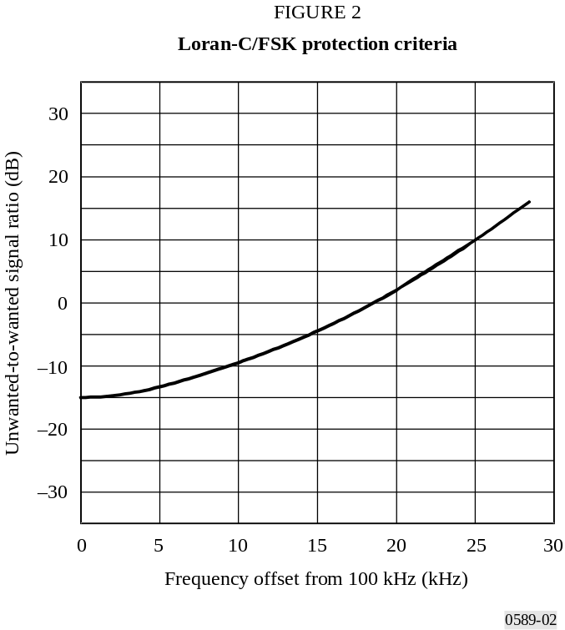

ANNEX 2
Technical characteristics of a tri-state pulse position modulation (3s-PPM)
data service using Loran-C and Chayka transmissions
in the frequency band 90-110 kHz

1 Structure
The structure given in Table 1 is used for signal specification.
TABLE 1
Structure for signal specification
1 | Physical layer | Loran-C and Chayka signal specification | As documented by the appropriate service providers
2 | Modulation/demodulation layer | Description of the 3s-PPM | § 2 of this Annex
3 | Forward error correction (FEC) layer | Description of the FEC algorithm | § 3 of this Annex
4 | Message coding layer | Description of the message coding algorithm | § 4 of this Annex

2 Modulation/demodulation layer
These definitions give the modulation of the Loran-C or the Chayka signal to enable data transmissions. The definitions include the low level modulation type, the modulation strategy to minimize devaluation of Loran-C or Chayka use for positioning and the relation between modulation patterns and other data representations.

2.1 Pulse modulation

2.1.1 Timing
A 3s-PPM should be applied to pulses three (3) to eight (8) of each pulse group. The modulation should consist of a time-shift of one (1) μs of the pulse transmission, with respect to an unmodulated pulse. The three possible states of the modulation are given in Table 2.
TABLE 2
States of the modulation
Pulse state | Transmission time minus time of reference pulse  (μs) | Indication
Advanced pulse | −1 | −
Prompt pulse | 0 | 0
Delayed pulse | +1 | +

2.1.2 Modulation balance
The number of advanced and delayed pulses of one channel in one pulse group should be equal. The modulation of six (6) pulses in one pulse group results in 141 possible balanced patterns, refer to Table 3, of which 128 patterns should represent valid data, one (1) pattern should indicate no data transmission and 12 patterns should be not used.
TABLE 3
Modulation pattern combination
Modulation pattern combination |  |  | Example | Number of combinations
6 × zero (0) | 0 × plus (+) | 0 × minus (–) | 0 0 0 0 0 0 | 1
4 × zero | 1 × plus | 1 × minus | 0 0 + 0 - 0 | 30
2 × zero | 2 × plus | 2 × minus | 0 + - + 0 - | 90
0 × zero | 3 × plus | 3 × minus | + + - - - + | 20
Total = |  |  |  | 141

2.1.3 Timing accuracy
The timing accuracy of the modulated signal should conform to the same timing accuracy requirements as for the unmodulated signal.

2.2 Modulation patterns

2.2.1 Pattern/data translation
Each of the 128 valid modulation patterns should uniquely represent a 7-bit binary block of data as shown in Table 4.

2.2.2 No data transmission pattern
The pattern “000000” should be used to indicate that no data is being transmitted.

2.3 Message structure
One (1) 3s-PPM message should consist of thirty (30) consecutive pulse groups.

2.4 Blanking
A blanked pulse group should be considered to have been transmitted for modulation purposes.

3 FEC layer
A systematic Reed-Solomon (RS) (30,10) 27-ary code should be applied to all messages. All messages should consist of 30 symbols, each symbol representing a 7-bit element. Of these symbols, 10 should be data and 20 should be RS parity.

3.1 Primitive polynomial
The symbols should be elements of the Galois field GF(128), constructed using the primitive polynomial:
p(x) = x7 + x3 + 1
TABLE 4
Pattern/data translation
Decimal | Hexadecimal | Pattern |  | Decimal | Hexa-decimal | Pattern |  | Decimal | Hexa-decimal | Pattern
0 | 0 | --00++ |  | 43 | 2B | 00-+-+ |  | 86 | 56 | ++-00-
1 | 1 | --0+0+ |  | 44 | 2C | 00-++- |  | 87 | 57 | ++0--0
2 | 2 | --0++0 |  | 45 | 2D | 00+--+ |  | 88 | 58 | ++0-0-
3 | 3 | --+00+ |  | 46 | 2E | 00+-+- |  | 89 | 59 | ++00--
4 | 4 | --+0+0 |  | 47 | 2F | 00++-- |  | 90 | 5A | -0000+
5 | 5 | --++00 |  | 48 | 30 | 0+--0+ |  | 91 | 5B | -000+0
6 | 6 | -0-0++ |  | 49 | 31 | 0+--+0 |  | 92 | 5C | -00+00
7 | 7 | -0-+0+ |  | 50 | 32 | 0+-0-+ |  | 93 | 5D | -0+000
8 | 8 | -0-++0 |  | 51 | 33 | 0+-0+- |  | 94 | 5E | -+0000
9 | 9 | -00-++ |  | 52 | 34 | 0+-+-0 |  | 95 | 5F | 0-000+
10 | A | -00+-+ |  | 53 | 35 | 0+-+0- |  | 96 | 60 | 0-00+0
11 | B | -00++- |  | 54 | 36 | 0+0--+ |  | 97 | 61 | 0-0+00
12 | C | -0+-0+ |  | 55 | 37 | 0+0-+- |  | 98 | 62 | 0-+000
13 | D | -0+-+0 |  | 56 | 38 | 0+0+-- |  | 99 | 63 | 00-00+
14 | E | -0+0-+ |  | 57 | 39 | 0++--0 |  | 100 | 64 | 00-0+0
15 | F | -0+0+- |  | 58 | 3A | 0++-0- |  | 101 | 65 | 00-+00
16 | 10 | -0++-0 |  | 59 | 3B | 0++0-- |  | 102 | 66 | 000-0+
17 | 11 | -0++0- |  | 60 | 3C | +--00+ |  | 103 | 67 | 000-+0
18 | 12 | -+-00+ |  | 61 | 3D | +--0+0 |  | 104 | 68 | 0000-+
19 | 13 | -+-0+0 |  | 62 | 3E | +--+00 |  | 105 | 69 | 0000+-
20 | 14 | -+-+00 |  | 63 | 3F | +-0-0+ |  | 106 | 6A | 000+-0
21 | 15 | -+0-0+ |  | 64 | 40 | +-0-+0 |  | 107 | 6B | 000+0-
22 | 16 | -+0-+0 |  | 65 | 41 | +-00-+ |  | 108 | 6C | 00+-00
23 | 17 | -+00-+ |  | 66 | 42 | +-00+- |  | 109 | 6D | 00+0-0
24 | 18 | -+00+- |  | 67 | 43 | +-0+-0 |  | 110 | 6E | 00+00-
25 | 19 | -+0+-0 |  | 68 | 44 | +-0+0- |  | 111 | 6F | 0+-000
26 | 1A | -+0+0- |  | 69 | 45 | +-+-00 |  | 112 | 70 | 0+0-00
27 | 1B | -++-00 |  | 70 | 46 | +-+0-0 |  | 113 | 71 | 0+00-0
28 | 1C | -++0-0 |  | 71 | 47 | +-+00- |  | 114 | 72 | 0+000-
29 | 1D | -++00- |  | 72 | 48 | +0--0+ |  | 115 | 73 | +-0000
30 | 1E | 0--0++ |  | 73 | 49 | +0--+0 |  | 116 | 74 | +0-000
31 | 1F | 0--+0+ |  | 74 | 4A | +0-0-+ |  | 117 | 75 | +00-00
32 | 20 | 0--++0 |  | 75 | 4B | +0-0+- |  | 118 | 76 | +000-0
33 | 21 | 0-0-++ |  | 76 | 4C | +0-+-0 |  | 119 | 77 | +-+-+-
34 | 22 | 0-0+-+ |  | 77 | 4D | +0-+0- |  | 120 | 78 | -+-+-+
35 | 23 | 0-0++- |  | 78 | 4E | +00--+ |  | 121 | 79 | +-+--+
36 | 24 | 0-+-0+ |  | 79 | 4F | +00-+- |  | 122 | 7A | -+-++-
37 | 25 | 0-+-+0 |  | 80 | 50 | +00+-- |  | 123 | 7B | +--+-+
38 | 26 | 0-+0-+ |  | 81 | 51 | +0+--0 |  | 124 | 7C | -++-+-
39 | 27 | 0-+0+- |  | 82 | 52 | +0+-0- |  | 125 | 7D | +--++-
40 | 28 | 0-++-0 |  | 83 | 53 | +0+0-- |  | 126 | 7E | -++--+
41 | 29 | 0-++0- |  | 84 | 54 | ++--00 |  | 127 | 7F | +0000-
42 | 2A | 00--++ |  | 85 | 55 | ++-0-0
The relationship between GF(128) elements and binary data should be to consider the value of the power of α as a 7-bit binary value converted to decimal. The symbol “0” should correspond to a 7-bit value of 127.

3.2 Generator polynomial
The FEC parity should be defined by the following generator polynomial:
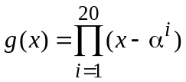
The relation between a symbol and a polynomial representation is given in Table 5.
TABLE 5
Relation between symbol and polynomial representation
Position | Symbol number | Multiply with
Least significant symbol | S1 | x0
 | S2 | x1
 | … | …
 | … | …
Most significant symbol | Sn | xn–1
The following steps should be used in the message encoding process:
Step 1: translation of the binary data to a symbol representation, using the primitive polynomial;
Step 2: translation of the symbol representation obtained in Step 1 to a polynomial;
Step 3: multiplication of the polynomial obtained in Step 2 with x20;
Step 4: division of the polynomial obtained in Step 3 by the generator polynomial;
Step 5: summation of the polynomial obtained in Step 3 with the remainder of the division in Step 4;
Step 6: translation of the polynomial obtained in Step 5 to a symbol or binary representation.

3.3 Order of transmission
The first transmitted pattern of an FEC-encoded message should correspond to the least significant symbol of that message.

3.4 Continuity of modulation
Messages should be transmitted consecutively without interleaving. The pattern transmitted in the first pulse group after the last pattern of a message shall be the first pattern of the next message.

4 Message coding layer

4.1 Generic structure
All message types should be defined with the same structure, consisting of a message type, a message body, and a cyclic redundancy check (CRC). The message type should identify the type of data contained in the message body. The generic structure is given in Table 6.
TABLE 6
Generic structure of data section
Field | Bits used | Bit numbers
Message type | 4 | I1 – I4
Message body | 52 | I5 – I56
CRC | 14 | I57 – I70
Total | 70

4.2 Message type identification
The message type should be in accordance with the information presented in Table 7.
TABLE 7
Interpretation of message type
.
Indication |  | Message type |  |  |  | Decimal
Type |  | I4 | I3 | I2 | I1
1 | DGPS corrections | 0 | 0 | 0 | 1 | 1
2 | DGLONASS corrections | 0 | 0 | 1 | 0 | 2
3 | Reserved | 0 | 0 | 1 | 1 | 3
4 | Reserved | 0 | 1 | 0 | 0 | 4
5 | Text message | 0 | 1 | 0 | 1 | 5
6 | Reserved | 0 | 1 | 1 | 0 | 6
7 | Reserved | 0 | 1 | 1 | 1 | 7
8 | Reserved | 1 | 0 | 0 | 0 | 8
9 | Reserved | 1 | 0 | 0 | 1 | 9
10 | Reserved | 1 | 0 | 1 | 0 | 10
11 | Reserved | 1 | 0 | 1 | 1 | 11
12 | Reserved | 1 | 1 | 0 | 0 | 12
13 | Reserved | 1 | 1 | 0 | 1 | 13
14 | Reserved | 1 | 1 | 1 | 0 | 14
15 | Reserved | 1 | 1 | 1 | 1 | 15
16 | Reserved | 0 | 0 | 0 | 0 | 0
DGPS: differential global positioning system
DGLONASS: differential global orbiting navigation satellite system

4.3 Message bodies
TABLE 8a
Message bit assignment table
Bit No. | Message type
Bit No. | 1 | 2 | 3 | 4 | 5 | 6 | 7 | 8
1 | 0001 | 0010 | 0011 | 0100 | 0101 | 0110 | 0111 | 1000
2
3
4
5 | Modified  Z-Count  13 bits | Modified  Z-Count  13 bits | Reserved | Reserved | Sequence number | Reserved | Reserved | Reserved
6
7
8 |  |  |  |  | End | Reserved | Reserved | Reserved
9 |  |  |  |  | Text  ASCII with Cyrillic  extensions  6 words  by 8 bits  per word | Reserved | Reserved | Reserved
10
11
12
13
14
15
16
17
18 | Scale | Scale
19 | User differential range error (UDRE) | UDRE
20
21 | Satellite pseudo-random noise (PRN) | Satellite PRN
22
23
24
25
26 | Pseudo-range correction (PRC)  15 bits | PRC  15 bits
27
28
29
30
31
32
33
34
35
36
37
38
39
40
41 | Range-rate correction (RRC)  8 bits | RRC  8 bits
42
43
44
45
46
47
48
49 | Issue of data  (IOD)  8 bits | Change
50 | Issue of data  (IOD)  8 bits | Tb of navigation data  (TOD)  7 bits
51
52
53
54
55
56
57-70 | CRC | CRC | CRC | CRC | CRC | CRC | CRC | CRC
TABLE 8b
Message bit assignment table
Bit No. | Message type
Bit No. | 9 | 10 | 11 | 12 | 13 | 14 | 15 | 16
1 | 1001 | 1010 | 1011 | 1100 | 1101 | 1110 | 1111 | 0000
2
3
4
5 | Reserved | Reserved | Reserved | Reserved | Reserved | Reserved | Reserved | Reserved
6
7
8
9
10
11
12
13
14
15
16
17
18
19
20
21
22
23
24
25
26
27
28
29
30
31
32
33
34
35
36
37
38
39
40
41
42
43
44
45
46
47
48
49
50
51
52
53
54
55
56
57-70 | CRC | CRC | CRC | CRC | CRC | CRC | CRC | CRC

4.4 Definitions

Modified Z-count
The Z-count represents the reference time for the differential data messages. The Z-count begins at 0, at the beginning of each hour in GPS or GLONASS time and ranges to a maximum value of 3 599.4 s, with a resolution of 0.6 s. It is used to compute the GPS time or GLONASS time of the corrections, in the same manner as other time calculations are made in the user’s receivers.

Scale factor
Two states of the scale factor for PRCs may be used and these are defined in Table 9. The rationale for the two-level scale factor is to maintain a high degree of precision most of the time, and the ability to increase the range of the corrections on those rare occasions when it is needed.
TABLE 9
Scale factor
Code | No. | Indication
0 | (0) | Scale factor for PRC is 0.02 m and for RRC is 0.002 m/s
1 | (1) | Scale factor for PRC is 0.32 m and for RRC is 0.032 m/s

4.4.3 User differential range error (UDRE)
An estimate of the root-mean-square error in the differential PRC. It is influenced by such factors as satellite S/N, multipath effects and data smoothing. Table 10 defines the format for the UDRE field.
TABLE 10
UDRE
Code | No. | 1 σ differential error  (m)
00 | (0) | ≤ 1
01 | (1) | > 1 and ≤ 4
10 | (2) | > 4 and ≤ 8
11 | (3) | Reference station not useable

4.4.4 Satellite identification
Standard format (1-32, 32 is indicated with all zeros).

4.4.5 Pseudorange correction (PRC)
The PRC describes the estimated correction at the time of measurement in the reference receiver. The relationship between PRC, RRC and reference time is defined by the following equation:
The PRC is given as a 2’s complement value. The resolution depends on the scale factor.

4.4.6 Range-rate correction (RRC)
The RRC describes the estimate of the rate of change of the PRC at the time of measurement in the reference receiver. The use of the RRC is described by the previous equation. The resolution depends on the scale factor.

4.4.7 Issue of data (IOD)
The IOD as broadcast by the reference station is the value in the GPS navigational messages which corresponds to the GPS ephemeris data used to compute corrections. This is a key to ensure that the user equipment calculations and reference station corrections are based on the same set of broadcast orbital and clock parameters.

4.4.8 Tb of navigation data (TOD)
The time within the current 24-h period by UTC(SU), which includes the operational information transmitted in the frame.

4.4.9 Sequence number
The message number should be equal for all portions of one text message. The message number should increase with unit step for subsequent text messages, restarting at “000” after “111”.

4.4.10 End of message (End)
The end of message indicates the last portion of a text message. A value of “0” should indicate that more portions are required to complete the text message. A value of “1” should indicate completion of the text message.

4.4.11 Text characters
Up to six (6) characters of eight (8) bits each are accommodated in each portion of a text message. Codes from 0-127 should correspond to standard ASCII codes. Cyrillic characters should be represented by codes greater than 127.

4.5 Cyclic redundancy check (CRC)
The CRC should be generated using the following polynomial:
G(x) = x14 + x13 + x7 + x5 + x4 + 1
The following steps should be used in the calculation of the CRC:
Step 1: translation of the data, including the message type field to a polynomial following the convention defined in Table 11. The resulting polynomial will not contain higher orders of x than x55;
Step 2: multiplication of the polynomial obtained in Step 1 with x14;
Step 3: division of the polynomial obtained in Step 2 by the generator polynomial;
Step 4: translation of the remainder of the division in Step 3 to a binary representation is the CRC.
TABLE 11
Relation between binary and polynomial representation
Position | Bit number | Multiply with
Least significant symbol | I1 | x0
 | I 2 | x1
 | … | …
 | … | …
Most significant symbol | In | xn–1

* This Recommendation should be brought to the attention of the International Maritime Organization (IMO), the International Civil Aviation Organization (ICAO), the International Association of Marine Aids to Navigation and Lighthouse Authorities (IALA) and Radiocommunication Study Group 7.
* * Radiocommunication Study Group 5 made editorial amendments to this Recommendation in 2008 in accordance with Resolution ITU-R 44.

