Recommendation ITU-R M.541-11
(11/2023)
M Series: Mobile, radiodetermination, amateur
and related satellite services
Operational procedures for the use of digital selective calling equipment in the maritime mobile service

Foreword
The role of the Radiocommunication Sector is to ensure the rational, equitable, efficient and economical use of the radio-frequency spectrum by all radiocommunication services, including satellite services, and carry out studies without limit of frequency range on the basis of which Recommendations are adopted.
The regulatory and policy functions of the Radiocommunication Sector are performed by World and Regional Radiocommunication Conferences and Radiocommunication Assemblies supported by Study Groups.

Policy on Intellectual Property Right (IPR)
ITU-R policy on IPR is described in the Common Patent Policy for ITU-T/ITU-R/ISO/IEC referenced in Resolution ITU-R 1. Forms to be used for the submission of patent statements and licensing declarations by patent holders are available from http://www.itu.int/ITU-R/go/patents/en where the Guidelines for Implementation of the Common Patent Policy for ITU-T/ITU-R/ISO/IEC and the ITU-R patent information database can also be found.

Series of ITU-R Recommendations
(Also available online at https://www.itu.int/publ/R-REC/en)
Series | Title
BO | Satellite delivery
BR | Recording for production, archival and play-out; film for television
BS | Broadcasting service (sound)
BT | Broadcasting service (television)
F | Fixed service
M | Mobile, radiodetermination, amateur and related satellite services
P | Radiowave propagation
RA | Radio astronomy
RS | Remote sensing systems
S | Fixed-satellite service
SA | Space applications and meteorology
SF | Frequency sharing and coordination between fixed-satellite and fixed service systems
SM | Spectrum management
SNG | Satellite news gathering
TF | Time signals and frequency standards emissions
V | Vocabulary and related subjects

Note: This ITU-R Recommendation was approved in English under the procedure detailed in Resolution ITU-R 1.

Electronic Publication
Geneva, 2023

© ITU 2023
All rights reserved. No part of this publication may be reproduced, by any means whatsoever, without written permission of ITU.

RECOMMENDATION ITU-R M.541-11*
Operational procedures for the use of digital selective calling
equipment in the maritime mobile service
(1978-1982-1986-1990-1992-1994-1995-1996-1997-2004-2015-2023)
Scope
The Recommendation contains the operational procedures for digital selective calling (DSC) equipment whose technical characteristics are given in Recommendation ITU-R M.493. The Recommendation contains six annexes. In Annexes 1 and 2 the provisions and procedures are described for distress, urgency and safety calls and for routine calls, respectively. In Annexes 3, 4, 5 and 6 the operational procedures for ships, for coast stations and man overboard (MOB) devices are described, and Annex 7 lists the frequencies to be used for DSC.
Keywords
Digital selective calling, equipment, operational procedures, GMDSS, distress alert
Abbreviations/Glossary
ACS Automatic connection system
AIS Automatic identification system
AMRD Autonomous maritime radio device
BQ End of sequence for an acknowledge message
DSC Digital selective calling
FEC Forward error correction
kHz Kilohertz
GMDSS Global maritime distress and safety system
HF High frequency
MF Medium frequency
MHz Megahertz
MMSI Maritime mobile service identity
MOB Man overboard
MSI Maritime safety information
NBDP Narrowband direct-printing
RCC Rescue coordination centre
RQ End of sequence acknowledge required
RR Radio Regulations
SOLAS International Convention for the Safety of Life at Sea
UTC Coordinated universal time
VHF Very high frequency
Related ITU Recommendations
Recommendation ITU-R M.493 – Digital selective-calling system for use in the maritime mobile service
Recommendation ITU-R M.585 – Assignment and use of identities in the maritime mobile service
Recommendation ITU-R M.689 – International maritime VHF radiotelephone system with automatic facilities based on DSC signalling format
Recommendation ITU-R M.1082 – International maritime MF/HF radiotelephone system with automatic facilities based on digital selective calling signalling format
Recommendation ITU-R M.1171 – Radiotelephony procedures in the maritime mobile service
Recommendation ITU-R M.1371 – Technical characteristics for an automatic identification system using time-division multiple access in the VHF maritime mobile band
Recommendation ITU-R M.2135 – Technical characteristics of autonomous maritime radio devices operating in the frequency band 156-162.05 MHz
The ITU Radiocommunication Assembly,
considering
a) that digital selective calling (DSC) will be used as described in Recommendation ITU-R M.493;
b) that the requirements of Chapter IV of the International Convention for the Safety of Life at Sea (SOLAS), 1974, as amended, for the global maritime distress and safety system (GMDSS) are based on the use of DSC for distress alerting and calling and that operational procedures are necessary for the use of that system;
c) that, as far as is practicable, operational procedures in all frequency bands and for all types of communications should be similar;
d) that DSC provides the primary means of transmitting a distress alert. Provisions of transmitting a distress alert by other methods and procedures are described in the Radio Regulations (RR);
e) that conditions when alarms have to be actuated should be specified,
recommends
1 that the technical characteristics of equipment used for DSC in the maritime mobile service should be in conformity with the relevant ITU-R Recommendations;
2 that the operational procedures to be observed in the MF, HF and VHF bands for DSC should be in accordance with Annex 1 for distress, urgency and safety calls and Annex 2 for other calls;
3 that provisions should be made at stations equipped for DSC for:
3.1 the manual entry of address, type of call, category and various messages into a DSC sequence;
3.2 displaying the information in a user readable format;
3.3 the verification and, if necessary, the correction of such manually formed sequences;
3.4 automatically set the information when possible;
3.5 a specific audible alarm to indicate receipt of a distress or urgency call or a call having distress category. It should not be possible to disable this alarm. Provisions should be made to ensure that they can be reset only manually;
3.6 audible indication: the term used to describe a brief self-terminating sound which is repeated once every 30 seconds until confirmation or self-terminating after 5 minutes indicating the reception of a DSC call of a category other than distress or urgency or a repetition of a call of categories distress or urgency already received;
3.7 visual indicators to indicate:
3.7.1 type of received call address (to all stations, to a group of stations, geographical, individual);
3.7.2 category of call;
3.7.3 identity of calling station;
3.7.4 numerical or alpha-numerical type of information, e.g. frequency information and telecommand;
3.7.5 type of “end of sequence” character;
3.7.6 detection of errors, if any;
4 that the equipment should be simple to operate;
5 that the operational procedures given in Annexes 3, 4 and 5, which are based on the relevant procedures from RR Chapter VII, Articles 30, 31, 32 and 33, be used as guidance for ships and coast stations;
6 that the operational characteristics of the automatic connection system (ACS) should be in conformity with Annex 5;
7 that the operational characteristics of the autonomous maritime radio devices (AMRD) Group A MOB devices should be in conformity with Annex 6;
8 that the frequencies used for DSC are those contained in Annex 7 to this Recommendation.
NOTE 1 – The following definitions are used throughout this Recommendation:
Single frequency: the same frequency is used for transmission and reception.
Paired frequencies: frequencies which are associated in pairs; each pair consisting of one transmitting and one receiving frequency.
International DSC frequencies: those frequencies designated in the RR for exclusive use for DSC on an international basis.
National DSC frequencies: those frequencies assigned to individual coast stations or a group of stations on which DSC is permitted (this may include working frequencies as well as calling frequencies). The use of these frequencies must be in accordance with the RR.
Automatic DSC operation at a ship station: a mode of operation employing automatic tuneable transmitters and receivers, suitable for unattended operation, which provide for automatic call acknowledgements upon reception of a DSC and automatic transfer to the appropriate working frequencies.
Call attempt: one or a limited number of call sequences directed to the same stations on one or more frequencies and within a relatively short time period (e.g. a few minutes). A call attempt is considered unsuccessful if a calling sequence contains the “acknowledge RQ” (symbol No. 117) at the end of the sequence and no acknowledgement is received in this time interval.

.
TABLE OF CONTENTS
Page

Annex 1 Operational procedures for distress, urgency and safety calls 7
A1-1 Introduction 7
A1-1.1 Method of calling 7
A1-2 Digital selective calling distress alert 7
A1-3 Procedures for digital selective calling distress alerts 7
A1-3.1 Transmission by a mobile unit in distress 7
A1-3.2 Reception 9
A1-3.3 Acknowledgement of distress alerts 9
A1-3.4 Distress alert relays 9
A1-4 Procedures for digital selective calling urgency and safety calls 10
A1-5 Testing the equipment used for distress and safety calls 10
Annex 2 Operational procedures for routine calls 10
A2-1 Frequency/channels 10
A2-1.2 International calling 10
A2-1.3 National calling 11
A2-1.4 Method of calling 11
A2-2 Operating procedures 11
A2-2.1 Coast station initiates call to ship station (see Note 1) 11
A2-2.2 The following procedures apply at the ship stations: 13
A2-2.3 Ship station initiates call to coast station (see Note 1) 14
A2-2.4 Ship station initiates call to ship station 16
Annex 3 Operational procedures for ships for digital selective calling communications on MF, HF and VHF 16
A3-1 Distress 16
A3-1.1 Transmission of digital selective calling distress alert 16
A3-1.2 Actions on receipt of a distress alert 17
A3-1.3 Distress traffic 17
A3-1.4 Transmission of a digital selective calling distress alert relay 18
A3-1.5 Acknowledgement of a digital selective calling distress alert relay received from a coast station 19
A3-1.6 Acknowledgement of a digital selective calling distress relay call received from another ship 19
A3-1.7 Cancellation of an inadvertent digital selective calling distress alert 19
A3-2 Urgency 19
A3-2.1 Transmission of urgency messages 19
A3-2.2 Reception of an urgency message 20
A3-3 Safety 20
A3-3.1 Transmission of safety messages 20
A3-3.2 Reception of a safety message 21
A3-4 Public correspondence 21
A3-4.1 Digital selective calling channels for public correspondence 21
A3-4.2 Transmission of a digital selective calling call for public correspondence to a coast station or another ship 21
A3-4.3 Repeating a call 22
A3-4.4 Acknowledgement of a received call and preparation for reception of
the traffic 22
A3-4.5 Reception of acknowledgement and further actions 22
A3-5 Testing the equipment used for distress and safety 22
A3-6 Special conditions and procedures for digital selective calling communication on HF 23
A3-6.1 Distress 23
A3-6.2 Urgency 25
A3-6.3 Safety 26
Annex 4 Operational procedures for coast stations for digital selective calling communications on MF, HF and VHF 27
A4-1 Distress (see Note 1) 27
A4-1.1 Reception of a digital selective calling distress alert 27
A4-1.2 Acknowledgement of a digital selective calling distress alert 27
A4-1.3 Transmission of a digital selective calling distress alert relay 27
A4-1.4 Reception of a distress alert relay 28
A4-2 Urgency 28
A4-2.1 Transmission of a digital selective calling announcement 28
A4-3 Safety 29
A4-3.1 Transmission of a digital selective calling announcement 29
A4-4 Public correspondence 29
A4-4.1 Digital selective calling frequencies/channels for public correspondence 29
A4-4.2 Transmission of a digital selective calling from a coast station call to a ship 30
A4-4.3 Repeating a call 30
A4-4.4 Preparation for exchange of traffic 30
A4-4.5 Acknowledgement of a received digital selective calling call 30
A4-5 Test calls using digital selective calling 31
A4-6 Special conditions and procedures for digital selective calling communication on HF 31
A4-6.1 Distress 31
A4-6.2 Safety 31
Annex 5 Operational procedures for both ship and coast stations for automatic connection system using digital selective calling communications on MF and HF 32
A5-1 Frequencies and method of calling for automatic connection system 33
A5-1.1 Frequencies for automatic connection system 33
A5-1.2 Method of calling 34
A5-2 Operating procedures 34
A5-2.1 Scanning 34
A5-2.2 Calling station 34
A5-2.3 Called station 35
A5-2.4 Frequency identification and following response to a calling station 36
A5-2.5 Selection of working frequency 43
Annex 6 Autonomous maritime radio devices Group A man overboard devices using VHF digital selective calling for alerting and automatic identification system technology for tracking 44
A6-1 Digital selective calling alert 44
A6-2 Identification 45
A6-3 Position updating 45
A6-4 Acknowledgment 45
A6-5 Cancellation of an inadvertent distress alert 45
Annex 7 Frequencies used for digital selective calling 46

Annex 1
Operational procedures for distress, urgency and safety calls

A1-1 Introduction
The terrestrial elements of the GMDSS adopted by the 1988 Amendments to the International Convention for SOLAS, 1974, are based on the use of DSC for distress, urgency and safety communications.

A1-1.1 Method of calling
The provisions of RR Chapter VII are applicable to the use of DSC in cases of distress, urgency or safety.

A1-2 Digital selective calling distress alert
The DSC distress alert provides for alerting, maritime mobile service identity (MMSI), ship’s position including time, and if entered nature of distress as defined in the RR (see RR Chapter VII).

A1-3 Procedures for digital selective calling distress alerts

A1-3.1 Transmission by a mobile unit in distress
A1-3.1.1 The DSC equipment should be capable of being pre-set to transmit the distress alert on at least one distress alerting frequency.
A1-3.1.2 The distress alert shall be composed in accordance with Recommendation ITU-R M.493. Although the equipment may be able to automatically include the ship’s position information and the time the position was valid, if this information is not available to the equipment then the operator has to manually enter the ship’s position and time at which it was valid. Enter the nature of distress as appropriate.

A1-3.1.3 Distress alert attempt
For MF/HF, a distress alert attempt should use multi-frequency call attempt (see § A3-6) by default, however, a single-frequency call attempt may be used when the operator wants to do so. A distress alert attempt for VHF can use single frequency call attempt only.

A1-3.1.3.1 Single frequency call attempt
A distress alert attempt should be transmitted as 5 consecutive calls on one frequency. To avoid call collision and the loss of acknowledgements, this call attempt may be transmitted on the same frequency again after a random delay of between 3 ½ and 4 ½ min from the beginning of the initial call. This allows acknowledgements arriving randomly to be received without being blocked by retransmission. The random delay should be generated automatically for each repeated transmission, however it should be possible to override the automatic repeat manually.
For MF/HF, single frequency call attempts may be repeated on different frequencies after a random delay of between 3 ½ and 4 ½ min from the beginning of the initial call. However, if a station is capable of receiving acknowledgements continuously on all distress frequencies except for the transmit frequency in use, then single frequency call attempts may be repeated on different frequencies without this delay.
FIGURE A1-1
Single-frequency call attempts
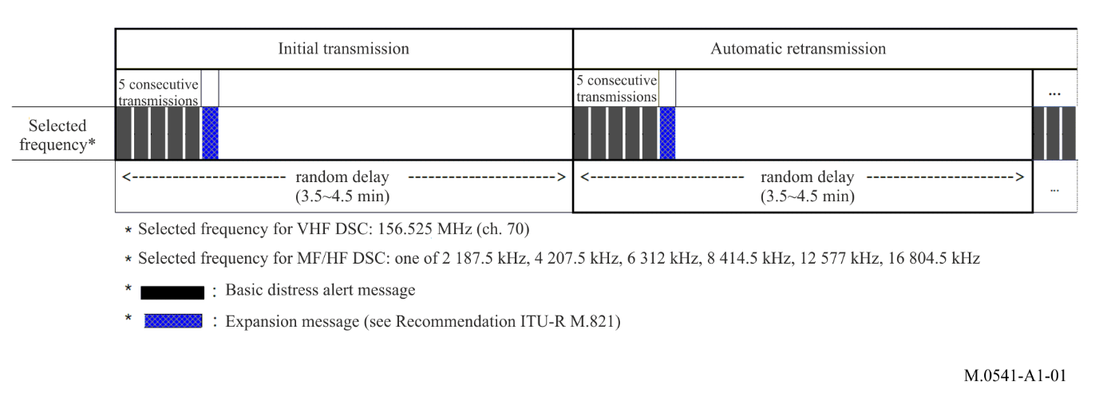

A1-3.1.3.2 Multi-frequency call attempt
A distress alert attempt may be transmitted as up to six consecutive calls dispersed over a maximum of six distress frequencies (one at MF and five at HF). A VHF call may be transmitted simultaneously with an MF/HF call. Stations transmitting multi-frequency distress alert attempts should be able to receive acknowledgements continuously on all frequencies except for the transmit frequency in use, or be able to complete the call attempt within 1 min.
Multi-frequency call attempts may be repeated after a random delay of between 3 ½ and 4 ½ min from the beginning of the previous call attempt.
FIGURE A1-2
Multi-frequency call attempts
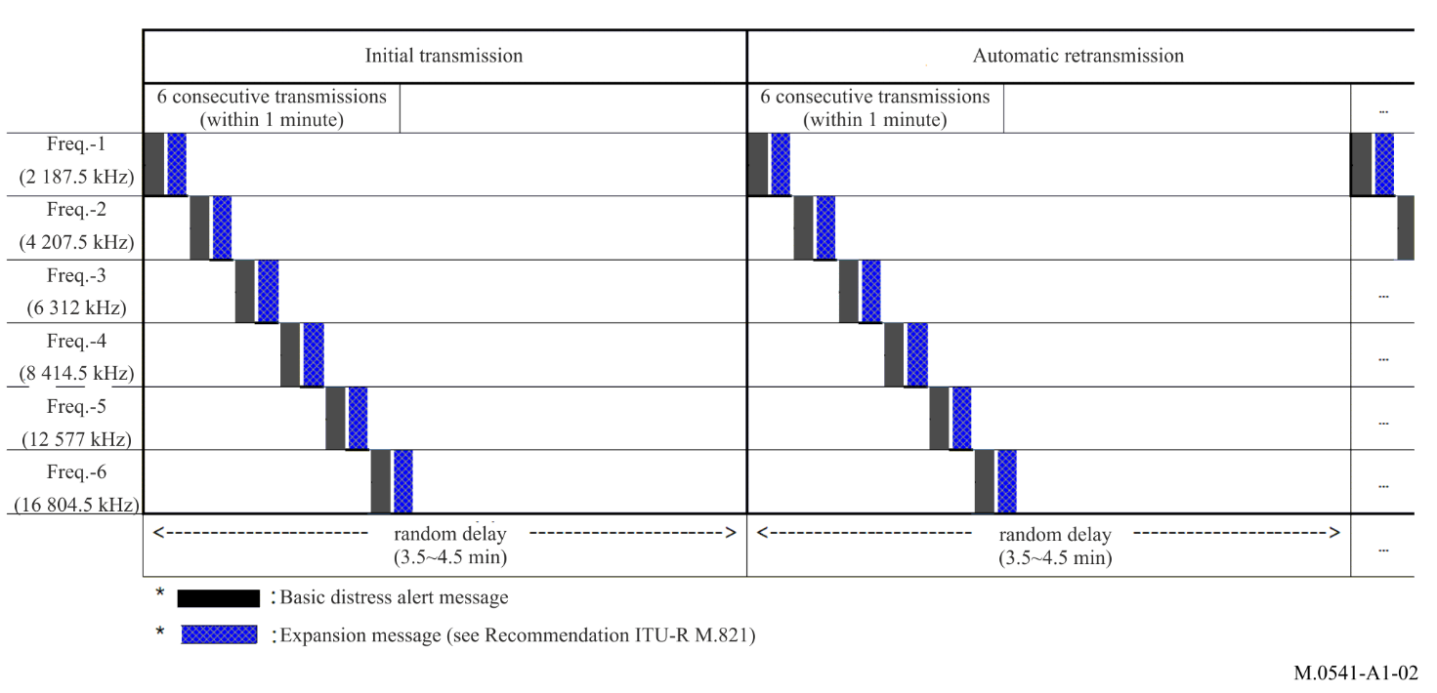

A1-3.1.4 Distress
In the case of distress the operator should transmit a distress alert as described in Annex 3.

A1-3.2 Reception
The DSC equipment, except AMRD Group A MOB devices, should be capable of maintaining a reliable watch on a 24-hour basis on appropriate DSC distress alerting frequencies.

A1-3.3 Acknowledgement of distress alerts
Acknowledgements of distress alerts should be initiated manually.
Acknowledgements by DSC should be transmitted on the same frequency as the distress alert was received.
A1-3.3.1 Distress alerts should normally be acknowledged by DSC only by appropriate coast stations. Coast stations should, in addition, set watch on frequencies associated with the frequency on which the distress alert was received.
A1-3.3.2 Acknowledgements by coast stations of DSC distress alerts transmitted on MF or HF should be initiated with a minimum delay of 1 min after receipt of a distress alert, and normally within a maximum delay of 2⅓ min. This allows all calls within a single frequency or multi-frequency call attempt to be completed and should allow sufficient time for coast stations to respond to the distress alert. Acknowledgements by coast stations on VHF should be transmitted as soon as practicable.
A1-3.3.3 The acknowledgement of a distress alert consists of a single DSC distress acknowledgement call and automatically includes the MMSI of the ship whose distress alert is being acknowledged.
A1-3.3.4 Ships receiving a DSC distress alert from another ship should set watch on an associated radiotelephone distress and safety traffic frequency in order to receive subsequent distress calls and messages. The acknowledgement of a DSC distress alert from another ship should be made by radiotelephony after a short interval so that a coast station may acknowledge receipt in the first instance (see RR Nos. 32.28 – 32.35).
A1-3.3.5 The automatic retransmission of a distress alert attempt should be terminated automatically on receipt of a DSC distress alert acknowledgement.

A1-3.4 Distress alert relays
Distress alert relays should be initiated manually.
A1-3.4.1 A distress alert relay should use the call format for distress alert relays as specified in Recommendation ITU-R M.493 and the calling attempt should follow the procedures described in §§ A1-3.1.3 to A1-3.1.3.2 for distress alerts, except that the distress relay is sent manually as a single call on a single frequency. Ship stations not provided with the DSC distress alert relay function should relay the alert by radio telephony.
A1-3.4.2 Any ship, receiving a distress alert on an HF channel which is not acknowledged by a coast station within 5 min, should transmit an individual distress alert relay addressed to the appropriate coast station or rescue coordination centre.
A1-3.4.3 Distress alert relays transmitted by coast stations, or by ship stations addressed to more than one vessel, should be acknowledged by ship stations using radiotelephony. Distress alert relays transmitted by ship stations should be acknowledged by a coast station transmitting a “distress alert relay acknowledgement” call in accordance with the procedures for distress acknowledgements given in §§ A1-3.3 to A1-3.3.3.

A1-4 Procedures for digital selective calling urgency and safety calls
A1-4.1 DSC, on the distress and safety calling frequencies, should be used by coast stations to advise shipping, and by ships to advise coast stations and/or ship stations, of the impending transmission of urgency, vital navigational and safety messages, except where the transmissions take place at routine times. The call should indicate the working frequency which will be used for the subsequent transmission of an urgent, vital navigational or safety message.
A1-4.2 The announcement and identification of medical transports should be carried out by DSC transmission, using appropriate distress and safety calling frequencies. Such calls should use the call format for an urgency call of the type medical transport and be addressed to all ships at VHF and Geographic Area at MF/HF.
A1-4.3 The operational procedures for urgency and safety calls should be in accordance with the relevant parts of §§ A3-2, A3-3, A3-6, A4-2, A4-3 and A4-6.

A1-5 Testing the equipment used for distress and safety calls
Testing on the exclusive DSC distress and safety calling frequencies should be limited as far as possible. DSC test calls should be in accordance with Recommendation ITU-R M.493 and the call should be acknowledged by the called station. Normally there would be no further communication between the two stations involved.

Annex 2
Operational procedures for routine calls

A2-1 Frequency/channels
A2-1.1 As a rule, paired frequencies should be used at HF and MF, in which case an acknowledgement is transmitted on the frequency paired with the frequency of the received call. In exceptional cases for national purposes a single frequency may be used. If the same call is received on several calling channels, the most appropriate shall be chosen to transmit the acknowledgement. A single frequency channel should be used at VHF.

A2-1.2 International calling
The paired frequencies listed in RR Appendix 17 and in Annex 6 of this Recommendation should be used for international DSC calling at HF.
A2-1.2.1 At HF and MF international DSC frequencies should only be used for shore-to-ship calls and for the associated call acknowledgements from ships fitted for automatic DSC operation where it is known that the ships concerned are not listening to the coast station’s national frequencies.
A2-1.2.2 All ship-to-shore DSC calling at HF and MF should preferably be done on the coast station’s national frequencies.

A2-1.3 National calling
Coast stations should avoid using the international DSC frequencies for calls that may be placed using national frequencies.
A2-1.3.1 Ship stations should keep watch on appropriate national and international channels. (Appropriate measures should be taken for an even loading of national and international channels.)
A2-1.3.2 Administrations are urged to find methods and negotiate terms to improve the utilization of the DSC channels available, e.g.:
– coordinated and/or joint use of coast station transmitters;
– optimizing the probability of successful calls by providing information to ships on suitable frequencies (channels) to be watched and by information from ships to a selected number of coast stations on the channels watched on-board.

A2-1.4 Method of calling
A2-1.4.1 The procedures set out in this section are applicable to the use of DSC techniques, except in cases of distress, urgency or safety, to which the provisions of RR Chapter VII are applicable.
A2-1.4.2 The call shall contain information indicating the station or stations to which the call is directed, and the identification of the calling station.
A2-1.4.3 The call should also contain information indicating the type of communication to be set up and may include supplementary information such as a proposed working frequency or channel; this information shall always be included in calls from coast stations, which shall have priority for that purpose.
A2-1.4.4 An appropriate digital selective calling channel chosen in accordance with the provisions of RR Nos. 52.128 to 52.137 or Nos. 52.145 to 52.153 as appropriate, shall be used for the call.

A2-2 Operating procedures
The technical format of the call sequence shall be in conformity with Recommendation ITU-R M.493.
The reply to a DSC call requesting an acknowledgement shall be made by transmitting an appropriate acknowledgement using DSC.
Acknowledgements may be initiated either manually or automatically. When an acknowledgement can be transmitted automatically, it shall be in conformity with Recommendation ITU-R M.493.
The technical format of the acknowledgement sequence shall be in conformity with Recommendation ITU-R M.493.
For communication between a coast station and a ship station, the coast station shall finally decide the working frequency or channel to be used.
The forwarding traffic and the control for working for radiotelephony shall be carried out in accordance with Recommendation ITU-R M.1171.

A2-2.1 Coast station initiates call to ship station (see Note 1)
If a ship station has to be called, the coast station selects the appropriate MMSI, frequency band and transmitter site, if available.
NOTE 1 – See Recommendations ITU-R M.689 and ITU-R M.1082 for further details of procedures applicable only to the automatic services.
A2-2.1.1 The call is composed by the coast station as follows:
– format specifier,
– address of the ship (MMSI),
– category of call,
– self-identification (MMSI) of the coast station, which is included automatically,
– telecommand information,
– working frequency information in the message part of the sequence, if appropriate,
– usually “end of sequence” signal “acknowledge RQ” (symbol No. 117). However, if the coast station knows that the ship station cannot respond or the call is to a group of ships the end of sequence signal should be 127, in which case the following procedures (§ A2-2.2) relating to an acknowledgement are not applicable.
A2-2.1.2 The coast station verifies the calling sequence.
The call shall be transmitted once on a single appropriate calling channel or frequency only. Only in exceptional circumstances may a call be transmitted simultaneously on more than one frequency.
A2-2.1.3 The coast station operator chooses the calling frequencies which are most suitable for the ship’s location.
A2-2.1.3.1 The coast station initiates the transmission of the sequence on one of the frequencies chosen. Transmission on any one frequency should be limited to no more than two call sequences separated by intervals of at least 45 s to allow for reception of an acknowledgement from the ship.
A2-2.1.3.2 If appropriate, a “call attempt” may be transmitted, which may include the transmission of the same call sequence on other frequencies (if necessary with a change of working frequency information to correspond to the same band as the calling frequency) made in turn at intervals of not less than 5 min, following the same pattern as in § A2-2.1.3.1.
A2-2.1.4 If an acknowledgement is received further transmission of the call sequence should not take place.
If the acknowledgement is positive, the coast station shall then prepare to transmit traffic on the working channel or frequency it has proposed. If the acknowledgement is negative, the coast station should await the call from the ship station.
A2-2.1.5 When a station called does not reply, the call attempt should not normally be repeated until after an interval of at least 10 min. The aggregate of the times for which frequencies are occupied in one call attempt, should normally not exceed 1 min.
FIGURE A2-1
Procedure for coast station which initiates call to ship station
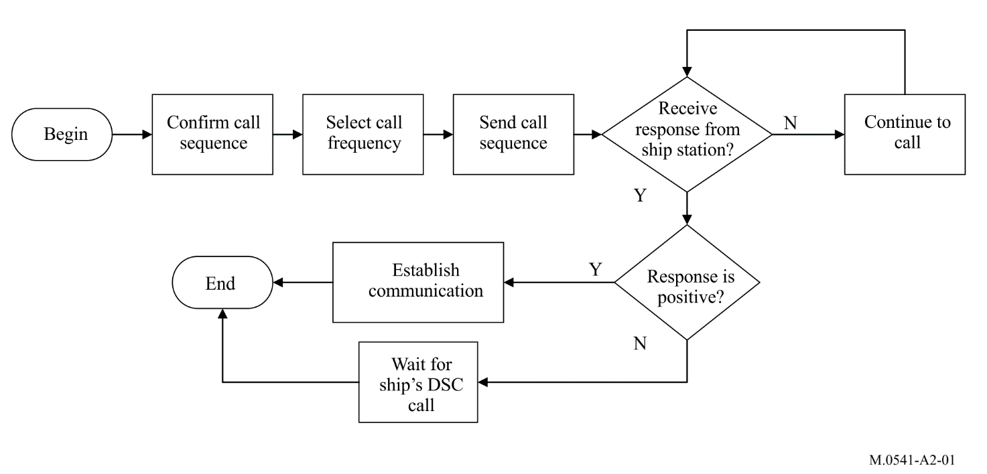

A2-2.2 The following procedures apply at the ship stations:
A2-2.2.1 Upon receipt of a calling sequence at the ship station, the received message should be displayed.
A2-2.2.2 When a received call sequence contains an end of sequence signal “acknowledge RQ” (symbol No. 117), an acknowledgement sequence should be composed and transmitted.
The format specifier and category information should be identical to that in the received calling sequence.
A2-2.2.3 If the ship station is not equipped for automatic DSC operation, the ship’s operator initiates an acknowledgement to the coast station after a delay of at least 5 s but no later than 4 ½ min of receiving the calling sequence. However the transmitted sequence should contain an “acknowledge BQ” (symbol No. 122) end of sequence signal in place of the “acknowledge RQ” (symbol No. 117) signal.
If such an acknowledgement cannot be transmitted within 5 min of receiving the calling sequence then the ship station should instead transmit a calling sequence to the coast station using the ship-to-shore calling procedure detailed in § A2-2.2.
A2-2.2.4 If the ship is equipped for automatic DSC operation, the ship station automatically transmits an acknowledgement with an end of sequence signal “acknowledge BQ” (symbol No. 122). The start of the transmission of this acknowledgement sequence should be within 30 s for HF and MF or within 3 s for VHF after the reception of the complete call sequence.
A2-2.2.5 If the ship is able to comply immediately the acknowledgement sequence should include a telecommand signal which is identical to that received in the calling sequence indicating that it is able to comply.
If no working frequency was proposed in the call, the ship station should include a proposal for a working frequency in its acknowledgement.
A2-2.2.6 If the ship is not able to comply immediately the acknowledgement sequence should include the first telecommand signal “unable to comply” (symbol No. 104), with a second telecommand signal giving additional information (see Recommendation ITU-R M.493).
At some later time when the ship is able to accept the traffic being offered, the ship station initiates a call to the coast station using the ship-to-shore calling procedures detailed in § A2-2.3.
A2-2.2.7 If a call is acknowledged indicating ability to comply immediately and communication between coast station and ship station on the working channel agreed is established, the DSC call procedure is considered to be completed.
A2-2.2.8 If the ship station transmits an acknowledgement which is not received by the coast station then this will result in the coast station repeating the call (in accordance with § A2-2.1.5). In this event the ship station should transmit a new acknowledgement.
FIGURE A2-2
Procedure for ship station which receives call from coast station
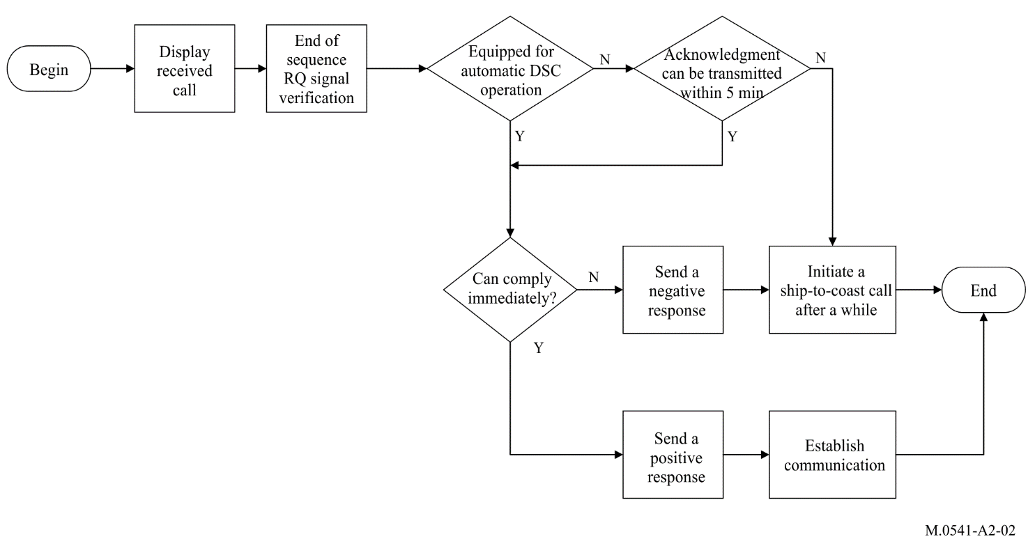

A2-2.3 Ship station initiates call to coast station (see Note 1)
This procedure should also be followed both as a delayed response to a call received earlier from the coast station (see § A2-2.2.2) and to initiate traffic from the ship station.
NOTE 1 – See Recommendations ITU-R M.689 and ITU-R M.1082 for further details of procedures applicable only to the automatic services.
A2-2.3.1 The call is composed by the ship station as follows:
– format specifier,
– address of the coast station (MMSI),
– category of call (default is routine),
– self-identification (MMSI) of the ship station, which is automatically included,
– telecommand information,
– working frequency, or position (for MF/HF only) information in the message part of the sequence if appropriate,
– telephone number required (automatic connections only),
– usually “end of sequence” signal “acknowledge RQ” (symbol No. 117).
A2-2.3.2 The ship station verifies the calling sequence.
A2-2.3.3 The ship station selects the single most appropriate calling frequency preferably using the coast station’s nationally assigned calling channels, for which purpose it shall send a single calling sequence on the selected frequency.
A2-2.3.4 If a called station does not reply, the call sequence from the ship station should not normally be repeated until after an interval of at least 5 min for manual connections, or 5 s or 35 s in the case automatic VHF or MF/HF connections respectively. These repetitions may be made on alternative frequencies if appropriate. Any subsequent repetitions to the same coast station should not be made until at least 15 min have elapsed.
A2-2.3.5 The coast station should transmit an acknowledgement, after a delay of at least 5 s but not later than 4 ½ min for manual connections, or, within 3 s for automatic connections, containing the format specifier, the address of the ship (MMSI), the category of call, the coast station self-identification and:
– if able to comply immediately on the working frequency suggested, the same telecommand and frequency information as in the call request;
– if no working frequency was suggested by the ship station then the acknowledgement sequence should include a channel/frequency proposal;
– if not able to comply on the working frequency suggested but able to comply immediately on an alternative frequency, the same telecommand information as in the call request but an alternative working frequency;
– if unable to comply immediately the first telecommand signal of “unable to comply” (symbol No. 104) with a second telecommand signal giving additional information. For manual connections only, this second telecommand signal may include a queue indication.
The end of sequence signal “acknowledge BQ” (symbol No. 122) should also be included.
A2-2.3.6 For manual connections, if a working frequency is proposed in accordance with § A2-2.3.5 but this is not acceptable to the ship station, then the ship station should immediately transmit a new call requesting an alternative frequency.
A2-2.3.7 If an acknowledgement is received further transmission of the same call sequence should not take place. On receipt of an acknowledgement which indicates ability to comply, the DSC procedures are complete and both coast station and ship station should communicate on the working frequencies agreed with no further exchange of DSC calls.
A2-2.3.8 If the coast station transmits an acknowledgement which is not received at the ship station then the ship station should repeat the call in accordance with § A2-2.3.4.
FIGURE A2-3
Procedure for ship station which initiates call to coast station
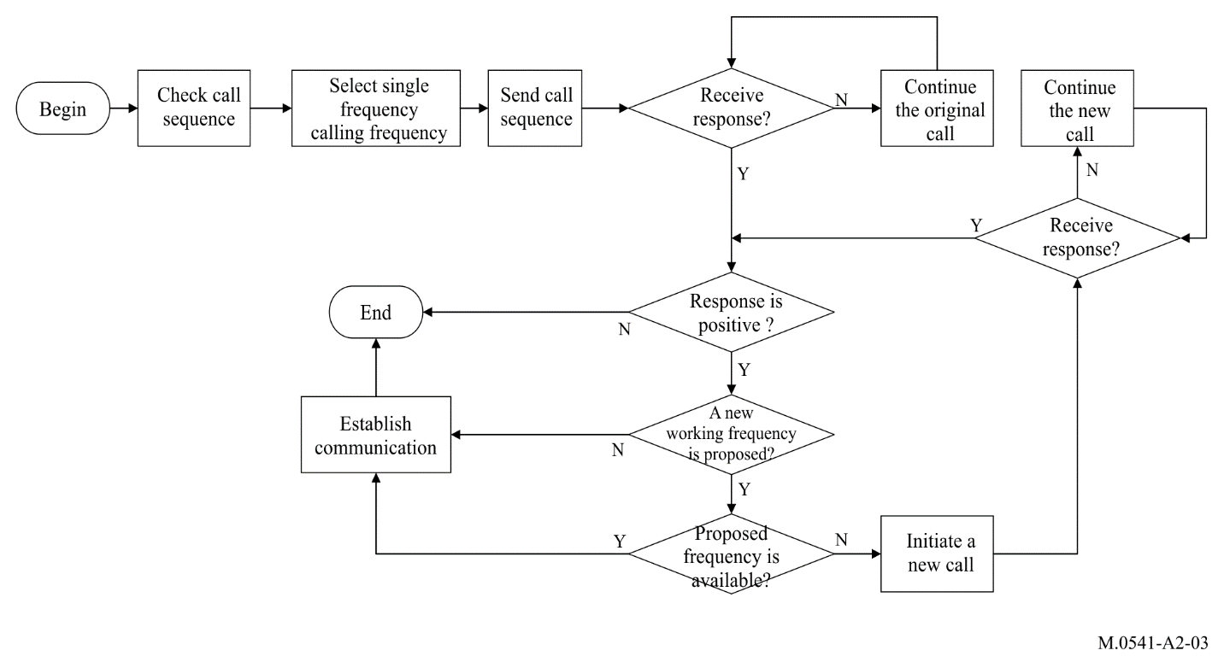

A2-2.4 Ship station initiates call to ship station
The ship-to-ship procedures should be similar to those given in § A2-2.3, where the receiving ship station complies with the procedures given for coast stations, as appropriate, except that, with respect to § A2-2.3.1, the calling ship should always insert working frequency information in the message part of the calling sequence.

Annex 3
Operational procedures for ships for digital selective calling communications
on MF, HF and VHF
Introduction
Procedures for DSC communications on MF and VHF are described in §§ A3-1 to A3-5 below.
The procedures for DSC communications on HF are in general the same as for MF and VHF. Special conditions to be taken into account when making DSC communications on HF are described in § A3-6 below.

A3-1 Distress

A3-1.1 Transmission of digital selective calling distress alert
A distress alert should be transmitted if, in the opinion of the Master, the ship or a person is in distress and requires immediate assistance.
A DSC distress alert should as far as possible include the ship’s last known position and the time (in UTC) when it was valid. The position and the time should be included automatically by the ship’s navigational equipment if this information is not included it should be inserted manually.
The DSC distress alert attempt is transmitted as follows:
– tune the transmitter to the DSC distress channel (2 187.5 kHz on MF, channel 70 on VHF) if not done automatically by the ship station.
– if time permits, key in or select on the DSC equipment
– the nature of distress,
– the ship’s last known position (latitude and longitude) if not provided automatically,
– the time (in UTC) the position was valid if not provided automatically,
– type of subsequent distress communication (telephony),
in accordance with the DSC equipment manufacturer’s instructions;
– transmit the DSC distress alert;
– prepare for the subsequent distress traffic by tuning the transmitter and the radiotelephony receiver to the distress traffic channel in the same band, i.e. 2 182 kHz on MF, channel 16 on VHF, while waiting for the DSC distress acknowledgement.

A3-1.2 Actions on receipt of a distress alert
Ships receiving a DSC distress alert from another ship should normally not acknowledge the distress alert by DSC since acknowledgement of a DSC distress alert by use of DSC is normally made by coast stations or rescue coordination centre only (see §§ A1-3.3.4 and A3-6.1.4).
If a ship station continues to receive a DSC distress alert on an MF or VHF channel, a DSC acknowledgement should be transmitted to terminate the call only after consulting with a coast station or rescue coordination centre and being directed to do so.
Ships receiving a DSC distress alert from another ship should also defer the acknowledgement of the distress alert by radiotelephony for a short interval, if the ship is within an area covered by one or more coast stations, in order to give the coast station time to acknowledge the DSC distress alert first.
Ships receiving a DSC distress alert from another ship shall:
– watch for the reception of a distress acknowledgement on the distress channel (2 187.5 kHz on MF and channel 70 on VHF);
– prepare for receiving the subsequent distress communication by tuning the radiotelephony receiver to the distress traffic frequency in the same band in which the DSC distress alert was received, i.e. 2 182 kHz on MF, channel 16 on VHF;
– in accordance with the provisions of RR No. 32.23 acknowledge the receipt of the distress alert by transmitting a message by radiotelephony on the distress traffic frequency in the same band in which the DSC distress alert was received, i.e. 2 182 kHz on MF, channel 16 on VHF.

A3-1.3 Distress traffic
On receipt of a DSC distress acknowledgement the ship in distress should commence the distress traffic by radiotelephony on the distress traffic frequency (2 182 kHz on MF, channel 16 on VHF) in accordance with the provisions of RR Nos. 32.13C and 32.13D.

A3-1.4 Transmission of a digital selective calling distress alert relay

A3-1.4.1 Transmission of a digital selective calling distress relay call on receipt of a digital selective calling distress alert
In no case is a ship permitted to transmit an all ships DSC distress alert relay on receipt of a DSC distress alert on either VHF or MF channels. If no aural watch is present on the relative channel (2 182 kHz on MF, channel 16 on VHF), the coast station or rescue coordination centre should be contacted by sending an individual DSC distress alert relay.
The DSC distress alert relay is transmitted as follows:
– select the distress alert relay format on the DSC equipment;
– key in or select on the DSC equipment:
• the address (MMSI) of the appropriate coast station or rescue coordination centre;
• the contents of the DSC distress alert received from the ship in distress (included automatically), i.e. MMSI of the ship station in distress, nature of distress, position and time information and type of subsequent communication;
– transmit the DSC distress alert relay;
– prepare for the subsequent distress traffic by tuning the transmitter and the radiotelephony receiver to the distress traffic channel in the same band, i.e. 2 182 kHz on MF and channel 16 on VHF, while waiting for the DSC distress acknowledgement.

A3-1.4.2 Transmission of a digital selective calling distress relay call on behalf of someone else
A ship knowing that another ship is in distress shall transmit a DSC distress alert relay if:
– the ship in distress is not itself able to transmit the distress alert,
– the Master of the ship considers that further help is necessary.
In accordance with RR No. 32.19B the DSC distress alert relay on behalf of somebody else should preferably be addressed to an individual coast station or rescue coordination centre.
The DSC distress alert relay is transmitted as follows:
– select the distress alert relay format on the DSC equipment,
– key in or select on the DSC equipment:
– the MMSI (9-digit identity) of the appropriate coast station or in special circumstances all ships call (VHF) or geographic area call (MF/HF),
– the MMSI (9-digit identity) of the ship in distress, if known,
– the nature of distress, if known,
– the latest position of the ship in distress, if known,
– the time (in UTC) the position was valid (if known),
– type of subsequent distress communication (telephony);
– transmit the DSC distress alert relay;
– prepare for the subsequent distress traffic by tuning the transmitter and the radiotelephony receiver to the distress traffic channel in the same band, i.e. 2 182 kHz on MF and channel 16 on VHF, while waiting for the DSC distress acknowledgement.
When the function of distress alert relay call by DSC is not implemented such as DSC class D or class E, distress alert relay should be transmitted to the appropriate coast station or rescue coordination centre using radiotelephony in accordance with the provisions of RR No. 32.19E when the DSC distress alert is not acknowledged by a coast station or another ship station within 5 minutes.

A3-1.5 Acknowledgement of a digital selective calling distress alert relay received from a coast station
Coast stations or rescue coordination centre, after having received and acknowledged a DSC distress alert, may if necessary, retransmit the information received as a DSC distress alert relay, addressed to all ships (VHF only), all ships in a specific geographical area (MF/HF only), or a specific ship.
Ships receiving a distress alert relay transmitted by a coast station shall not use DSC to acknowledge the call, but should acknowledge the receipt of the call by radiotelephony on the distress traffic channel in the same band in which the relay call was received, i.e. 2 182 kHz on MF, channel 16 on VHF.
Acknowledge the receipt of the distress alert relay by transmitting a message, in accordance with the provisions of RR No. 32.23, by radiotelephony on the distress traffic frequency in the same band in which the DSC distress alert relay was received.

A3-1.6 Acknowledgement of a digital selective calling distress relay call received from another ship
Ships receiving a distress alert relay from another ship shall follow the same procedure as for acknowledgement of a distress alert, i.e. the procedure given in § A3-1.2 above.

A3-1.7 Cancellation of an inadvertent digital selective calling distress alert
A station transmitting an inadvertent DSC distress alert shall cancel the distress alert using the following procedure:
A3-1.7.1 Immediately cancel the distress alert by transmitting a DSC self-cancel on all the frequencies where the inadvertent DSC distress alert was transmitted, if the ship station is capable hereof. A DSC self-cancel is a distress acknowledgement where the self-id and the distress id is identical as defined in Recommendation ITU-R M.493.
A3-1.7.2 Subsequently cancel the distress alert aurally over the telephony distress traffic channel associated with each DSC channel on which the “distress alert” was transmitted, by transmitting a message in accordance with the provisions of RR No. 32.53E.
A3-1.7.3 Monitor the telephony distress traffic channel associated with the DSC channel on which the distress alert was transmitted, and respond to any communications concerning that distress alert as appropriate.

A3-2 Urgency

A3-2.1 Transmission of urgency messages
Transmission of urgency messages shall be carried out in three steps:
– announcement of the urgency message using DSC;
– transmission of the urgency call; and
– transmission of the message using radiotelephony.
The announcement is carried out by transmission of a DSC urgency call on the DSC distress calling channel (2 187.5 kHz on MF, channel 70 on VHF).
The urgency call and message are transmitted on the distress traffic channel (2 182 kHz on MF, channel 16 on VHF).
The DSC urgency call may be addressed to all stations at VHF, or a geographic area at MF/HF, or to a specific station. The frequency on which the urgency message will be transmitted shall be included in the DSC urgency call.
The transmission of an urgency message is thus carried out as follows:

Announcement:
– select the appropriate calling format on the DSC equipment (all ships (VHF only), geographical area (MF/HF only) or individual);
– key in or select on the DSC equipment:
– specific area or MMSI (9-digit identity) of the specific station, if appropriate,
– the category of the call (urgency),
– the frequency or channel on which the urgency message will be transmitted,
– the type of communication in which the urgency message will be given (radiotelephony),
in accordance with the DSC equipment manufacturer’s instructions;
– transmit the DSC urgency announcement.

Transmission of the urgency call and message:
– tune the transmitter to the frequency or channel indicated in the DSC urgency announcement;
– transmit the urgency call and message using radiotelephony in accordance with the provisions of RR No. 33.12.

A3-2.2 Reception of an urgency message
Ships receiving a DSC urgency call announcing an urgency message addressed to more than one station shall NOT acknowledge the receipt of the DSC call, but should tune the radiotelephony receiver to the frequency indicated in the call and listen to the urgency message.

A3-3 Safety

A3-3.1 Transmission of safety messages
Transmission of safety messages shall be carried out in three steps:
– announcement of the safety message using DSC;
– transmission of the safety message call; and
– transmission of the message using radiotelephony.
The announcement is carried out by transmission of a DSC safety call on the DSC distress calling channel (2 187.5 kHz on MF, channel 70 on VHF).
In accordance with RR No. 33.32 safety messages should preferably be transmitted on a working frequency in the same band(s) as those used for the safety call or announcement.
The DSC safety call may be addressed to all ships (VHF only), ships in a specific geographical area (MF/HF only), or to a specific station.
The frequency on which the safety message will be transmitted shall be included in the DSC call.
The transmission of a safety message is thus carried out as follows:

Announcement:
– select the appropriate calling format on the DSC equipment (all ships (VHF only), geographical area (MF/HF only), or individual);
– key in or select on the DSC equipment:
– specific area or MMSI (9-digit identity) of specific station, if appropriate,
– the category of the call (safety),
– the frequency or channel on which the safety message will be transmitted,
– the type of communication in which the safety message will be given (radiotelephony), in accordance with the DSC equipment manufacturer’s instructions;
– transmit the DSC safety announcement.

Transmission of the safety call and message:
– tune the transmitter to the frequency or channel indicated in the DSC safety call;
– transmit the safety call and message in accordance with the provisions of RR No. 33.35.

A3-3.2 Reception of a safety message
Ships receiving a DSC safety call announcing a safety message addressed to more than one station shall NOT acknowledge the receipt of the DSC safety call, but should tune the radiotelephony receiver to the frequency indicated in the call and listen to the safety message.

A3-4 Public correspondence

A3-4.1 Digital selective calling channels for public correspondence

A3-4.1.1 VHF
VHF DSC channel 70 is used for DSC for distress and safety purposes as well as for DSC for public correspondence.

A3-4.1.2 MF
International and national DSC channels separate from the DSC distress and safety calling channel 2 187.5 kHz are used for digital selective calling on MF for public correspondence.
Ships calling a coast station by DSC on MF for public correspondence should preferably use the coast station’s national DSC channel.
The international DSC channel for public correspondence may as a general rule be used between ships and coast stations of different nationality. The ships transmitting frequency is 2 189.5 kHz, and the receiving frequency is 2 177 kHz.
The frequency 2 177 kHz is also used for DSC between ships for general communication.

A3-4.2 Transmission of a digital selective calling call for public correspondence to a coast station or another ship
A DSC call for public correspondence to a coast station or another ship is transmitted as follows:
– select the format for calling a specific station on the DSC equipment;
– key in or select on the DSC equipment:
– the MMSI (9-digit identity) of the station to be called,
– the category of the call (routine),
– the type of the subsequent communication (normally radiotelephony),
– a proposed working channel if calling another ship. A proposal for a working channel should NOT be included in calls to a coast station; the coast station will in its DSC acknowledgement indicate an appropriate working channel,
in accordance with the DSC equipment manufacturer’s instructions;
– transmit the DSC call.

A3-4.3 Repeating a call
A DSC call for public correspondence may be repeated on the same or another DSC channel, if no acknowledgement is received within 5 min.
Further call attempts should be delayed at least 15 min, if acknowledgement is still not received.

A3-4.4 Acknowledgement of a received call and preparation for reception of the traffic
On receipt of a DSC call from a coast station or another ship, a DSC acknowledgement is transmitted as follows:
– select the acknowledgement format on the DSC equipment;
– transmit an acknowledgement indicating whether the ship is able to communicate as proposed in the call (type of communication and working frequency);
– if able to communicate as indicated, tune the transmitter and the radiotelephony receiver to the indicated working channel and prepare to receive the traffic.

A3-4.5 Reception of acknowledgement and further actions
When receiving an acknowledgement indicating that the called station is able to receive the traffic, prepare to transmit the traffic as follows:
– tune the transmitter and receiver to the indicated working channel;
– commence the communication on the working channel by:
– the MMSI (9-digit identity) or call sign or other identification of the called station;
– “this is”;
– the MMSI (9-digit identity) or call sign or other identification of own ship.
It will normally rest with the ship to call again a little later in case the acknowledgement from the coast station indicates that the coast station is not able to receive the traffic immediately.
In case the ship, in response to a call to another ship, receives an acknowledgement indicating that the other ship is not able to receive the traffic immediately, it will normally rest with the called ship to transmit a call to the calling ship when ready to receive the traffic.

A3-5 Testing the equipment used for distress and safety
Testing on the exclusive DSC distress and safety calling frequency 2 187.5 kHz should be limited as far as possible. DSC test calls by ship stations should normally be transmitted using the DSC format specifier as “individual” and the category as “safety”. The test of a distress button itself should be performed without any emission of radio waves.
Test calls should be transmitted by the ship station and acknowledged by the called station. Normally there would be no further communication between the two stations involved.
A VHF and MF test call to a station is transmitted as follows:
– key in or select the format for the test call on the DSC;
– key in the MMSI (9-digit identity) of the station to be called;
– transmit the DSC test call;
– wait for acknowledgement.

A3-6 Special conditions and procedures for digital selective calling communication on HF
General
The procedures for DSC communication on HF are – with some additions described in §§ A3-6.1 to A3-6.3 below – equal to the corresponding procedures for DSC communications on MF/VHF.
Due regard to the special conditions described in §§ A3-6.1 to A3-6.3 should be given when making DSC communications on HF.

A3-6.1 Distress

A3-6.1.1 Transmission of digital selective calling distress alert and choice of HF bands
In sea areas A3 and A4 a DSC distress alert on HF is intended to be received by coast stations and a DSC distress alert on MF and VHF is intended to be received by other ships in the vicinity.
The DSC distress alert should as far as possible include the ship’s last known position and the time (in UTC) it was valid. If the position and time is not inserted automatically from the ship’s navigational equipment, it should be inserted manually.
Propagation characteristics of HF radio waves are impacted by the seasons time of the day, sea conditions, and the weather. All these conditions should be taken into account when choosing HF bands for transmission of DSC distress alert. To maximize the probability of the successful reception of the alert by coast stations, the distress alert should be sent as a multi-frequency call attempt (see § A1-3.1.3.2).
As a general rule the DSC distress channel in the 8 MHz maritime band (8 414.5 kHz) may in many cases be an appropriate first choice.
DSC distress alert may be sent on a number of HF bands in two different ways:
a) either by transmitting the DSC distress alert on one HF band, and waiting a few minutes for receiving acknowledgement by a coast station;
if no acknowledgement is received within 3 min, the process is repeated by transmitting the DSC distress alert on another appropriate HF band etc.;
b) or by transmitting the DSC distress alert at a number of HF bands with no, or only very short, pauses between the calls, without waiting for acknowledgement between the calls.
It is recommended to follow procedure a) in all cases, where time permits to do so; this will make it easier to choose the appropriate HF band for commencement of the subsequent communication with the coast station on the corresponding distress traffic channel.
Transmitting the DSC distress alert on HF:
– tune the transmitter to the chosen HF DSC distress channel (4 207.5, 6 312, 8 414.5, 12 577, 16 804.5 kHz);
– follow the instructions for keying in or selection of relevant information on the DSC equipment as described in § A3-1.1;
– transmit the DSC distress alert.
In special cases, for example in tropical zones, transmission of DSC distress alert on HF may, in addition to ship-to-shore alerting, also be useful for ship-to-ship alerting.

A3-6.1.2 Preparation for the subsequent distress traffic
After having transmitted the DSC distress alert on appropriate DSC distress channels (HF, MF and/or VHF), prepare for the subsequent distress traffic by tuning the radiocommunication set(s) (HF, MF and/or VHF as appropriate) to the corresponding distress traffic channel(s).
Where multiple frequency call attempts are transmitted the corresponding distress traffic frequency should be 8 291 kHz.
If method b) described in § A3-6.1.1 has been used for transmission of DSC distress alert on a number of HF bands:
– take into account in which HF band(s) acknowledgement has been successfully received from a coast station;
– if acknowledgements have been received on more than one HF band, commence the transmission of distress traffic on one of these bands, but if no response is received from a coast station then the other bands should be used in turn.
The distress traffic frequencies are (see RR Appendix 15, Table 15-1):
HF (kHz):
Telephony 4 125 6 215 8 291 12 290 16 420
MF (kHz):
Telephony 2 182
VHF: Channel 16 (156.800 MHz).

A3-6.1.3 Distress traffic
The procedures described in § A3-1.3 are used when the distress traffic on MF/HF is carried out by radiotelephony.

A3-6.1.4 Actions on reception of a digital selective calling distress alert on HF from another ship
Ships receiving a DSC distress alert on HF from another ship shall not acknowledge the alert, but should:
– watch for reception of a DSC distress acknowledgement from a coast station;
– while waiting for reception of a DSC distress acknowledgement from a coast station:
prepare for reception of the subsequent distress communication by tuning the HF radiocommunication set (transmitter and receiver) to the relevant distress traffic channel in the same HF band in which the DSC distress alert was received, observing the following conditions:
– if radiotelephony mode was indicated in the DSC distress alert, the HF radiocommunication set should be tuned to the radiotelephony distress traffic channel in the HF band concerned;
– if telex mode was indicated in the DSC distress alert, the HF radiocommunication set should be tuned to the radiotelex distress traffic channel in the HF band concerned. Ships able to do so should additionally watch the corresponding radiotelephony distress channel;
– if the DSC distress alert was received on more than one HF band, the radiocommunication set should be tuned to the relevant distress traffic channel in the HF band considered to be the best one in the actual case. If the DSC distress alert was received successfully on the 8 MHz band, this band may in many cases be an appropriate first choice;
– if no distress traffic is received on the HF channel within 1 to 2 min, tune the HF radiocommunication set to the relevant distress traffic channel in another HF band deemed appropriate in the actual case;
– if no DSC distress acknowledgement is received from a coast station within 5 min, and no distress communication is observed going on between a coast station and the ship in distress:
– inform an RCC via appropriate radiocommunications means,
− transmit a DSC distress alert relay if instructed to do so by a RCC or a coast station.

A3-6.1.5 Transmission of digital selective calling distress alert relay
In case it is considered appropriate to transmit a DSC distress alert relay:
− distress alert relays on HF should be initiated manually;
– follow the procedures described in § A3-6.1.1 above (except the call is sent manually as a single call on a single frequency) and should preferably be addressed to an individual coast station or rescue coordination centre;
– follow the instructions for keying in or selection of call format and relevant information on the DSC equipment as described in § A3-1.4;
– transmit the DSC distress alert relay.

A3-6.1.6 Acknowledgement of a HF digital selective calling distress alert relay received from a coast station
Ships receiving a DSC distress alert relay from a coast station on HF, addressed to all ships within a specified area, should NOT acknowledge the receipt of the relay alert by DSC, but by radiotelephony on the telephony distress traffic channel in the same band(s) in which the DSC distress relay call was received.

A3-6.2 Urgency
Transmission of urgency messages on HF should normally be addressed:
– either to all ships within a specified geographical area,
– or to a specific coast station.
Announcement of the urgency message is carried out by transmission of a DSC call with category urgency on the appropriate DSC distress channel.
The transmission of the urgency message itself on HF is carried out by radiotelephony on the appropriate distress traffic channel in the same band in which the DSC announcement was transmitted.

A3-6.2.1 Transmission of digital selective calling announcement of an urgency message on HF
– choose the HF band considered to be the most appropriate, taking into account that the propagation characteristics for HF radio waves are impacted by the seasons, time of the day, sea conditions and the weather; the 8 MHz band may in many cases be an appropriate first choice;
– key in or select call format for either geographical area call or individual call on the DSC equipment, as appropriate;
– key in or select relevant information on the DSC equipment keyboard as described in § A3-2.1;
– transmit the DSC call; and
– if the DSC call is addressed to a specific coast station, wait for DSC acknowledgement from the coast station. If acknowledgement is not received within a few minutes, repeat the DSC call on another HF frequency deemed appropriate.

A3-6.2.2 Transmission of the urgency message and subsequent action
– tune the HF transmitter to the distress traffic channel (radiotelephony) indicated in the DSC announcement;
– if the urgency message is to be transmitted using radiotelephony, follow the procedure described in § A3-2.1.
Announcement and transmission of urgency messages addressed to all HF equipped ships within a specified area may be repeated on a number of HF bands as deemed appropriate in the actual situation.

A3-6.3 Safety

A3-6.3.1 Transmission of digital selective calling announcement and safety messages on HF
The procedures for transmission of DSC safety announcement and for transmission of the safety message are the same as for urgency messages, described in § A3-6.2, except that:
– in the DSC announcement, the category SAFETY shall be used,
– in the safety message, the safety signal “SECURITE” shall be used instead of the urgency signal “PAN PAN”.

A3-6.3.2 Reception of safety messages
When the DSC safety announcement for unscheduled HF MSI addressed to a geographical area is received on one of distress and safety calling frequencies, the HF MSI receiver shall be tuned to the frequency specified in the DSC announcement.
The DSC safety announcement is received as follows:
– the format specifier (geographical area),
– address (geographical area),
– the category of the call (safety),
– the frequency or channel on which the HF MSI will be transmitted,
– the type of communication in which the HF MSI will be transmitted (forward error correction – FEC).

Annex 4
Operational procedures for coast stations for digital selective calling
communications on MF, HF and VHF
Introduction
Procedures for DSC communications on MF and VHF are described in §§ A4-1 to A4-5 below.
The procedures for DSC communications on HF are in general the same as for MF and VHF. Special conditions to be taken into account when making DSC communications on HF are described in § A4-6 below.

A4-1 Distress (see Note 1)

A4-1.1 Reception of a digital selective calling distress alert
The transmission of a distress alert indicates that a mobile unit (a ship, aircraft or other vehicle) or a person is in distress and requires immediate assistance. The distress alert is a digital selective call using a distress call format.
Coast stations in receipt of a distress alert shall ensure that it is routed as soon as possible to an RCC. The receipt of a distress alert is to be acknowledged as soon as possible by the appropriate coast station.
NOTE 1 – These procedures assume that the RCC is sited remotely from the DSC coast station; where this is not the case, appropriate amendments should be made locally.

A4-1.2 Acknowledgement of a digital selective calling distress alert
The coast station shall transmit the distress alert acknowledgement on the same DSC frequency on which the distress alert was received.
The acknowledgement of a DSC distress alert is transmitted as follows:
– key in or select on the DSC equipment:
– distress alert acknowledgement,
– MMSI (9-digit identity) of the ship in distress(will be inserted automatically, if available),
– nature of distress(will be inserted automatically, if available),
– distress coordinates(will be inserted automatically, if available),
– the time (in UTC) when the position was valid(will be inserted automatically, if available);
– transmit the acknowledgement;
– prepare to handle the subsequent distress traffic by setting watch on radiotelephony the radiotelephone frequencies should be those associated with the frequency on which the distress alert was received (on MF 2 182 kHz or on VHF 156.8 MHz/channel 16).

A4-1.3 Transmission of a digital selective calling distress alert relay
Coast stations shall initiate and transmit a distress alert relay in any of the following cases:
– when the distress of the mobile unit has been notified to the coast station by other means and a broadcast alert to shipping is required by the RCC; and
– when the person responsible for the coast station considers that further help is necessary (close cooperation with the appropriate RCC is recommended under such conditions).
In the cases mentioned above, the coast station shall transmit a shore-to-ship distress alert relay addressed, as appropriate, to all ships (VHF only), to a geographical area (MF/HF only) or to a specific ship.
The distress alert relay shall contain the identification of the mobile unit in distress, its position and other information which might facilitate rescue.
The distress alert relay is transmitted as follows:
– key in or select on the DSC equipment:
– distress alert relay,
– the format specifier (all ships (VHF only), geographical area (MF/HF only), or individual station),
– if appropriate, the address (MMSI) of the ship, or geographical area,
– MMSI (9-digit identity) of the ship in distress, if known,
– nature of distress, if known,
– distress coordinates, if known,
– the time (in UTC) when the position was valid, if known;
– transmit the distress alert relay;
– prepare for the reception of the acknowledgements by ship stations and for handling the subsequent distress traffic by switching over to the radiotelephony distress traffic channel in the same band, i.e. 2 182 kHz on MF, 156.8 MHz/channel 16 on VHF.

A4-1.4 Reception of a distress alert relay
If the distress alert relay is received from a ship station, coast stations on receipt of the distress alert relay shall ensure that the call is routed as soon as possible to an RCC. The receipt of the distress alert relay is to be acknowledged as soon as possible by the appropriate coast station using a DSC distress alert relay acknowledgement addressed to the ship station. If the distress relay call is received from a coast station, other coast stations will normally not have to take further action.

A4-2 Urgency

A4-2.1 Transmission of a digital selective calling announcement
The announcement of the urgency message shall be made on one or more of the distress and safety calling frequencies using DSC and the urgency call format.
The DSC urgency call may be addressed to all ships (VHF only), to a geographical area (MF/HF only), or to a specific ship. The frequency on which the urgency message will be transmitted after the announcement shall be included in the DSC urgency call.
The DSC urgency call is transmitted as follows:
– key in or select on the DSC equipment:
– the format specifier (all ships call (VHF), geographical area (MF/HF only), or individual station),
– if appropriate, the address (MMSI) of the ship, or geographical area,
– the category of the call (urgency),
– the frequency or channel on which the urgency message will be transmitted,
– the type of communication in which the urgency message will be transmitted (radiotelephony);
– transmit the DSC urgency call.
After the DSC announcement, the urgency message will be transmitted on the frequency indicated in the DSC call.

A4-3 Safety

A4-3.1 Transmission of a digital selective calling announcement
The announcement of the safety message shall be made on one or more of the distress and safety calling frequencies using DSC and the safety call format.
The DSC safety call may be addressed to all ships (VHF only), to a geographical area (MF/HF only), or to a specific ship. The frequency on which the safety message will be transmitted after the announcement shall be included in the DSC safety call.
The DSC safety call is transmitted as follows:
– key in or select on the DSC equipment:
– the format specifier (all ships call (VHF only), geographical area (MF/HF only), or individual station),
– if appropriate, the address (MMSI) of the ship, or geographical area,
– the category of the call (safety),
– the frequency or channel on which the safety message will be transmitted,
– the type of communication in which the safety message will be transmitted (radiotelephony);
– transmit the DSC safety call.
After the DSC announcement, the safety message will be transmitted on the frequency indicated in the DSC call.

A4-4 Public correspondence

A4-4.1 Digital selective calling frequencies/channels for public correspondence

A4-4.1.1 VHF
The frequency 156.525 MHz/channel 70 is used for DSC for distress and safety purposes. It may also be used for calling purposes other than distress and safety, e.g. public correspondence.

A4-4.1.2 MF
For public correspondence national and international DSC frequencies are used which are different from the frequencies used for distress and safety purposes.
When calling ship stations by DSC, coast stations should use for the call, in the order of preference:
– a national DSC channel on which the coast station is maintaining watch;
– the international DSC calling channel, with the coast station transmitting on 2 177 kHz and receiving on 2 189.5 kHz. In order to reduce interference on this channel, it may be used as a general rule by coast stations to call ships of another nationality, or in cases where it is not known on which DSC frequencies the ship station is maintaining watch.

A4-4.2 Transmission of a digital selective calling from a coast station call to a ship
The DSC call is transmitted as follows:
– key in or select on the DSC equipment:
– the MMSI (9-digit identity) of the ship to be called,
– the category of the call routine,
– the type of subsequent communication (radiotelephony),
– working frequency information;
– transmit the DSC call.

A4-4.3 Repeating a call
Coast stations may transmit the call twice on the same calling frequency with an interval of at least 45 s between the two calls, provided that they receive no acknowledgement within that interval.
If the station called does not acknowledge the call after the second transmission, the call may be transmitted again on the same frequency or another calling frequency after a period of at least 10 min.

A4-4.4 Preparation for exchange of traffic
On receipt of a DSC acknowledgement with the indication that the called ship station can use the proposed working frequency, the coast station transfers to the working frequency or channel and prepares to receive the traffic.

A4-4.5 Acknowledgement of a received digital selective calling call
Acknowledgements shall normally be transmitted on the frequency paired with the frequency of the received call. If the same call is received on several calling channels, the most appropriate channel shall be chosen for transmission of the acknowledgement.
The acknowledgement of a DSC call is transmitted as follows:
– key in or select on the DSC equipment:
– the format specifier (individual station),
– MMSI (9-digit identity) of the calling ship,
– the category of the call routine,
– if able to comply immediately on the working frequency suggested by the ship station, the same frequency information as in the received call,
– if no working frequency was suggested by the calling ship station, then the acknowledgement should include a channel/frequency proposal,
– if not able to comply on the working frequency suggested, but able to comply immediately on an alternative frequency, the alternative working frequency,
– if unable to comply immediately the appropriate information in that regard;
– transmit the acknowledgement after a delay of at least 5 s, but not later than 4 ½ min.
After having transmitted the acknowledgement, the coast station transfers to the working frequency or channel and prepares to receive the traffic.

A4-5 Test calls using digital selective calling
Perform VHF, MF and HF DSC test calls in accordance with Recommendation ITU-R M.493. DSC test calls by coast stations should normally be transmitted to a ship station using the DSC format specifier as “individual” and the category as “safety”. The test calls by coast station should be acknowledged by a ship station called. Normally there would be no further communication between the two stations involved.
Acknowledgement of a digital selective calling test call from a ship
The coast station should acknowledge test calls from a ship station.

A4-6 Special conditions and procedures for digital selective calling communication on HF
General
The procedures for DSC communication on HF are – with some additions described in §§ A4-6.1 to A4-6.3 below – equal to the corresponding procedures for DSC communications on MF/VHF.
Due regard to the special conditions described in §§ A4-6.1 to A4-6.3 should be given when making DSC communications on HF.

A4-6.1 Distress

A4-6.1.1 Reception and acknowledgement of a digital selective calling distress alert on HF
Ships in distress may in some cases transmit the DSC distress alert on a number of HF bands with only short intervals between the individual calls.
The coast station shall transmit DSC acknowledgement on all HF DSC distress channels on which the DSC distress alert was received in order to ensure as far as possible that the acknowledgement is received by the ship in distress and by all ships which received the DSC distress alert.

A4-6.1.2 Distress traffic
The distress traffic should, as a general rule, be initiated on the appropriate distress traffic channel (radiotelephony) in the same band in which the DSC distress alert was received.

A4-6.1.3 Transmission of digital selective calling distress alert relay on HF
HF propagation characteristics should be taken into account when choosing HF band(s) for transmission of DSC distress alert relay.
IMO Convention ships equipped with HF DSC for distress and safety purposes are required to keep continuous automatic DSC watch on the DSC distress channel in the 8 MHz band and on at least one of the other HF DSC distress channels.
In order to avoid creating on board ships uncertainty regarding on which band the subsequent establishment of contact and distress traffic should be initiated, the HF DSC distress alert relay should be transmitted on one HF band at a time and the subsequent communication with responding ships be established before eventually repeating the DSC distress alert relay on another HF band.

A4-6.2 Safety

A4-6.2.1 Transmission of safety announcements and messages on HF
The announcement for unscheduled HF MSI shall be made on all MF/HF distress and safety calling frequencies (§ A7-1) using DSC and the safety call format. The DSC safety call shall be addressed to a geographical area. The frequency on which the HF MSI will be transmitted after the announcement shall be included in the DSC safety call.
After the DSC announcement, the HF MSI message shall be transmitted on the frequency indicated in the DSC call.
The DSC announcement for unscheduled HF MSI is transmitted as follows:
– the format specifier (geographical area),
– address (geographical area),
– the category of the call (safety),
– the frequency or channel on which the HF MSI will be transmitted,
– the type of communication in which the HF MSI will be transmitted.
NOTE – For the announcements on all MF/HF DSC distress and safety calling frequencies, the frequency in message 2 should be the same MSI-HF frequency for narrowband direct-printing (NBDP) in Appendix 15 of Radio Regulations which is thought to be appropriate for the promulgation of the unscheduled HF NBDP MSI.

Annex 5
Operational procedures for both ship and coast stations for automatic connection system using digital selective calling communications on MF and HF
Introduction
The automatic connection system (ACS) means automatic connection function using DSC for shore-to-ship, ship-to-shore or ship-to-ship communication with the most appropriate working frequency (or channel) in the MF and HF bands of the maritime mobile service.
The procedures for ACS using DSC communications on MF and HF are described in this annex.
The procedure for ACS shall not interrupt a reliable watch on a 24-hour basis on appropriate DSC distress alerting frequencies unless while the equipment is transmitting.
An example of flowchart of ACS operational procedures is shown in Fig. A5-1.
Figure A5-1
Example of automatic connection system operational procedures
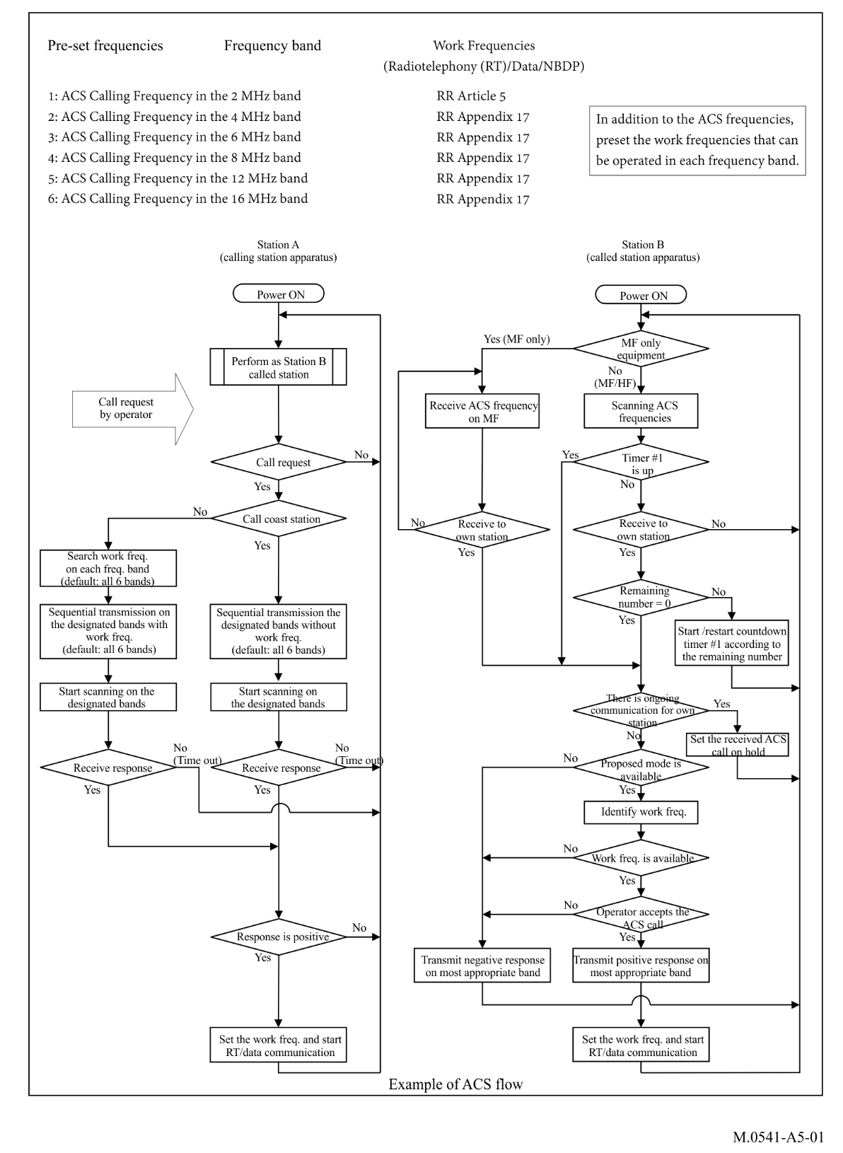

A5-1 Frequencies and method of calling for automatic connection system

A5-1.1 Frequencies for automatic connection system
The frequencies described in § A7-2.3 of this Recommendation should be used for ACS.

A5-1.2 Method of calling
A5-1.2.1 The procedures set out in this section are applicable to the use of DSC techniques, except in cases of distress, urgency or safety, to which the provisions of RR Chapter VII are applicable.
A5-1.2.2 The ACS call should contain information indicating the station or stations to which the call is directed, and the identification of the calling station.
A5-1.2.3 The ACS call should also contain information indicating the type of subsequent communication to be set up and should include supplementary information such as a proposed working frequency or channel which is identified as the most appropriate with low noise level. This process should be repeated for each ACS frequency bands.

A5-2 Operating procedures

A5-2.1 Scanning
The receiver designated for ACS (ACS receiver) while the equipment is in standby should:
– for MF only equipment, monitor only the ACS frequency in the MF Band (2 MHz band) without scanning;
– for MF/HF equipment, scan up to six ACS frequencies in MF and HF band specified in § A5-1.1;
– scan all of six ACS frequencies within two seconds per one cycle;
– when the DSC dot pattern is detected, pause scanning on that frequency and decode receiving signal;
– resume standard scanning when the identification of the received signal is not addressed to the own station or remaining ACS sequential transmission is not completed;
– stop scanning when an acknowledgement is received;
– restart scanning ACS frequencies after completing call set up.

A5-2.2 Calling station
The following procedures should apply at calling station of ACS:
A5-2.2.1 The operator enters the identification (MMSI) of the called station and selects the type of subsequent communication and then initiates ACS call.
A5-2.2.2 The ACS receiver stops scanning during the transmission of the ACS message.
A5-2.2.3 When the called station is a ship station, the receiver searches the appropriate working frequency which is unoccupied and with low noise in each frequency band. The ACS complements the identified channels or frequencies into Message 2 for the ACS sequential transmission in each frequency band.
ACS sequential transmission to a ship station is composed as follows:
– Category of call: ACS;
– Message 1 first telecommand: type of communication (e.g. J3E, F1B or Data);
– Message 1 second telecommand: number of remaining ACS sequential transmission;
– Message 2: proposed working frequency which is in the same frequency band of the ACS transmission.
ACS sequential transmission to a coast station is composed as follows:
– Category of call: ACS;
– Message 1 first telecommand: type of communication (e.g. J3E, F1B or Data);
– Message 1 second telecommand: number of remaining ACS sequential transmission;
– Message 2: own ship’s position information.
A5-2.2.4 ACS transmits up to six ACS sequential transmission using frequencies as specified in § A5-1.1. If there is a band for which no appropriate working frequency is found, the transmission is omitted for that band.
A5-2.2.5 The ACS receiver restarts scanning after up to six ACS sequential transmissions and then waits for a response from the called station.
A5-2.2.6 When calling station receives a response from called station within due time, the ACS receiver stops scanning.
A5-2.2.6.1 If the response is positive, ACS tune the transmitter using the working channel or frequency and type of communication in accordance with the received positive response. The ACS receiver restarts scanning after setting up communication the operator starts communication.
A5-2.2.6.2 If the response is negative, the ACS receiver restarts scanning, and the ACS procedure is terminated by operator.
A5-2.2.7 When calling station does not receive a response from called station within due time or operator selects the end of ACS calling, ACS procedure is terminated.

A5-2.3 Called station
The following procedures should apply at the called station when ACS receive call with its own identification:
A5-2.3.1 ACS checks the number of remaining ACS sequential transmissions calculating and updating the remaining time (Countdown Timer) according to the number of remaining ACS sequential transmissions, and records received signal conditions (e.g. received signal level, symbol error rate, noise level) for the received ACS frequency. If Countdown Timer or remaining number is zero, the procedure then goes to § A5-2.3.3. Otherwise, the procedure goes to § A5-2.3.2.
A5-2.3.2 The ACS receiver continues scanning ACS frequencies. During the scanning, if a call to own station on a different ACS frequency from the same calling station is received before Countdown Timer becomes zero, the procedure goes to A5-2.3.1. If no call to own station on a different ACS frequency from the same calling station is received before Countdown Timer becomes zero, the scanning ends and the procedure goes to § A5-2.3.3.
A5-2.3.3 ACS then makes audible indication and display that an ACS call request has been received. The system checks if there is on-going communication for own station. If all kinds of MF/HF radiocommunication (radiotelephone, data and so on) automated procedure are provided in the DSC equipment, the check can be made automatically according to the status (active or on hold) of every automated procedure. Otherwise, the check can be made by the operator manually. When there is on-going communication for own station, the received ACS call should be set as on hold and then the procedure goes to restart scanning. When there is no on-going communication for own station, the procedure goes to § A5-2.3.4.
A5-2.3.4 The proposed mode should be checked. If the proposed mode is unavailable for own station, a negative response should be transmitted on the most appropriate frequency as recorded in § A5-2.3.1 and then the procedure goes to restart scanning.
The negative response is composed as follows:
– Category: ACS
– Message 1 first telecommand: unable to comply
– Message 1 second telecommand: unable to use proposed mode
– Message 2: no information
If the proposed mode is available for own station, the frequency identification and following response should be made in accordance with § A5-2.4.
A5-2.3.5 When a suitable frequency has been identified and operator accept the ACS call, ACS initialises communication using designated working frequency and type of communication in accordance with the transmitted positive response.
A5-2.3.6 The receiver designated for ACS restarts scanning after setting up communication.
A5-2.3.7 The operator starts communication using the working frequency and type of communication in accordance with setting up communication.

A5-2.4 Frequency identification and following response to a calling station

A5-2.4.1 Response to a coast station
When the calling station is a coast station, the ACS of the called station (ship station) checks whether the working frequency (RX frequency for ship station) proposed by coast station is appropriate for the type of subsequent communication by using the receiver which is handling communication (e.g. the frequency is not busy, sufficient S/N etc.). When it is not suitable in the most appropriate frequency band as recorded in § A5-2.3.1, ACS of the called station (ship station) checks again the proposed working frequency for the selected type of communication in the second most appropriate frequency band as recorded in § A5-2.3.1.
When the proposed working frequency in most or second most appropriate working frequency band is suitable to use for subsequent communication, ACS notifies operator of the identified working frequency with proposed mode and the operator can decide whether to accept the ACS call.
If the operator decides to accept the ACS call, ACS responds to the calling station on the most appropriate ACS frequency as recorded in § A5-2.3.1 including the working frequency or channel positively. Then the procedure goes to § A5-2.3.5.
Positive response to a coast station with acceptance of the connection is composed as follows:
– Category of call: ACS
– Message 1 first telecommand: type of communication (e.g. J3E, F1B or Data)
– Message 1 second telecommand: no information
– Message 2: working frequency
If the operator decides to reject the ACS call, ACS responds to the calling station on the most appropriate ACS frequency as recorded in § A5-2.3.1 negatively and the procedure goes to restart scanning.
Negative response to a coast station when the operator decides to reject the call is composed is follows:
– Category: ACS
– Message 1 first telecommand: unable to comply
– Message 1 second telecommand: no operator available or Operator temporarily unavailable
– Message 2: position if available, or no information
When it is not suitable on most and second most appropriate frequency band, ACS responds to reject the connection to the calling station on the most appropriate ACS frequency as recorded in accordance with § A5-2.3.1, and then the ACS receiver restarts scanning.
Negative response to a coast station with when there is no identified working frequency is composed as follows:
– Category of call: ACS
– Message 1 first telecommand: unable to comply
– Message 1 second telecommand: unable to use proposed channel
– Message 2: position if available, or no information
FIGURE A5-2
Flowchart for the working frequency identification and following ACS response for the called station when calling station is a coast station and called station is a ship station
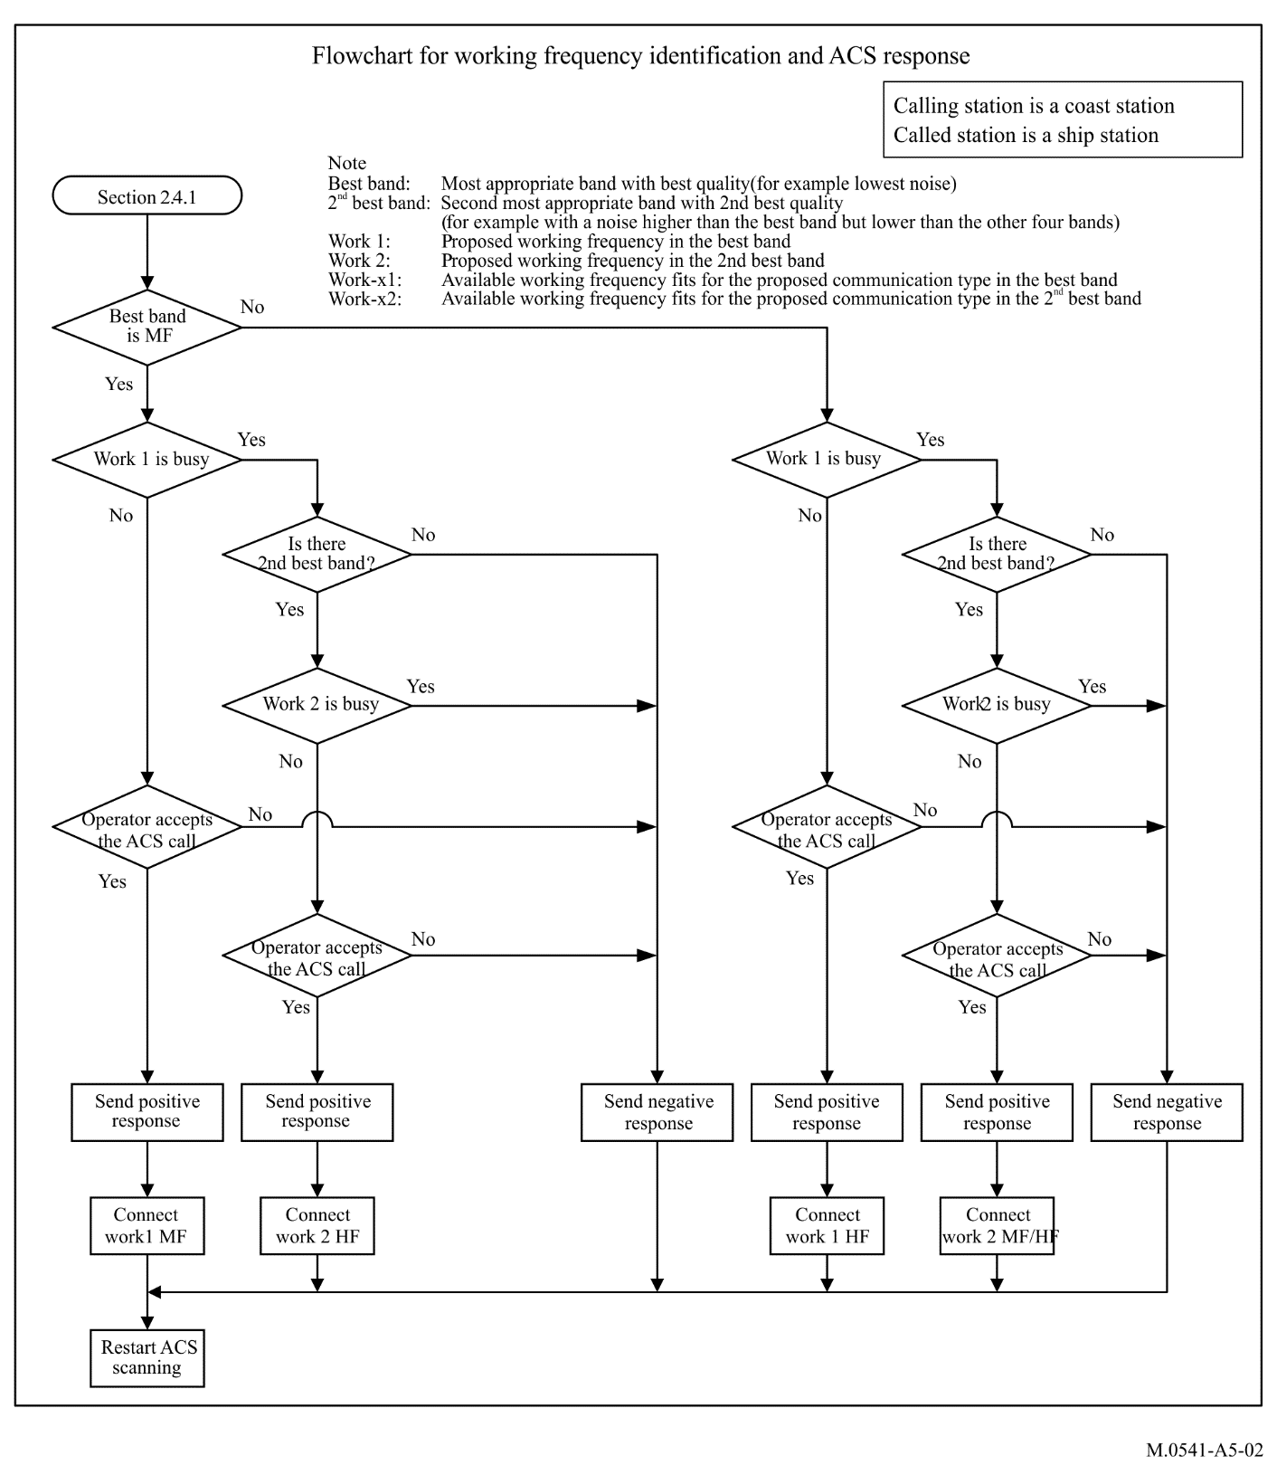

A5-2.4.2 Response to a ship station

A5-2.4.2.1 Response of a ship to a ship station
When the calling station is a ship station and the called station is a ship station, the ACS of the called station checks whether the proposed working frequency is suitable for the subsequent communication (e.g. the frequency is not busy) in the most appropriate frequency band recorded in § A5-2.3.1.
When the most appropriate band is a MF band and the proposed working frequency in the MF band is not suitable, ACS checks whether the proposed working frequency is appropriate for the type of communication in the second most appropriate frequency band (i.e. an HF band) as recorded in § A5-2.3.1. If the proposed working frequency in the HF band is not suitable, then ACS searches the HF band for another working frequency suitable for the type of communication.
NOTE – In MF band, ACS checks only proposed working frequency because frequencies are limited in MF band, therefore ACS does not search alternative working frequency in MF band.
When the most appropriate band is an HF band and the proposed working frequency in the HF band not suitable, ACS searches another working frequency suitable for the type of communication in the same frequency band. It should use the receiver which is handling communication.
When there is suitable working frequency in most or second most appropriate band for subsequent communication, ACS notifies operator of the identified working frequency with proposed mode and the operator can decide whether to accept the ACS call.
If the operator decides to accept the ACS call, ACS responds to the calling station on the most appropriate ACS frequency as recorded in § A5-2.3.1 including the working frequency or channel positively. Then the procedure goes to § A5-2.3.5.
The positive response from a ship station to a ship station with acceptance of the connection is composed as follows:
– Category of call: ACS
– Message 1 first telecommand: type of communication (e.g. J3E, F1B or Data)
– Message 1 second telecommand: no information
– Message 2: working frequency
If the operator decides to reject the ACS call, ACS responds to the calling station on the most appropriate ACS frequency as recorded in § A5-2.3.1 negatively and the procedure goes to restart scanning.
The negative response from a ship station to a ship station when the operator decides to reject the call is composed as follows:
– Category: ACS
– Message 1 first telecommand: unable to comply
– Message 1 second telecommand: no operator available or Operator temporarily unavailable
– Message 2: position if available, or no information
When there is no suitable working frequency in most and second most appropriate frequency bands ACS responds to reject the connection to the calling station on most appropriate ACS frequency as recorded in § A5-2.3.1.
The negative response from a ship station to a ship station when there is no identified working frequency is composed as follows:
– Category of call: ACS
– Message 1 first telecommand: unable to comply
– Message 1 second telecommand: unable to use proposed channel
– Message 2: position if available, or no information
When there is no identified working frequency, ACS responds for reject connection to the calling station on most appropriate ACS frequency as recorded in § A5-2.3.1 with the following conditions:
– when the most appropriate frequency band is MF band and the proposed working frequency is not suitable, and also there is no alternative suitable working frequency in the second most appropriate frequency band of HF; or
– when the most appropriate frequency band is HF band and the proposed working frequency is not suitable, and also there is no alternative suitable working frequency; or
– in the case of ACS for MF band only, the proposed working frequency is not suitable.
Then the receiver designated for ACS restarts scanning.
FIGURE A5-3
Flowchart for working frequency identification and following ACS response for the called station
when calling station and called station are both ship stations
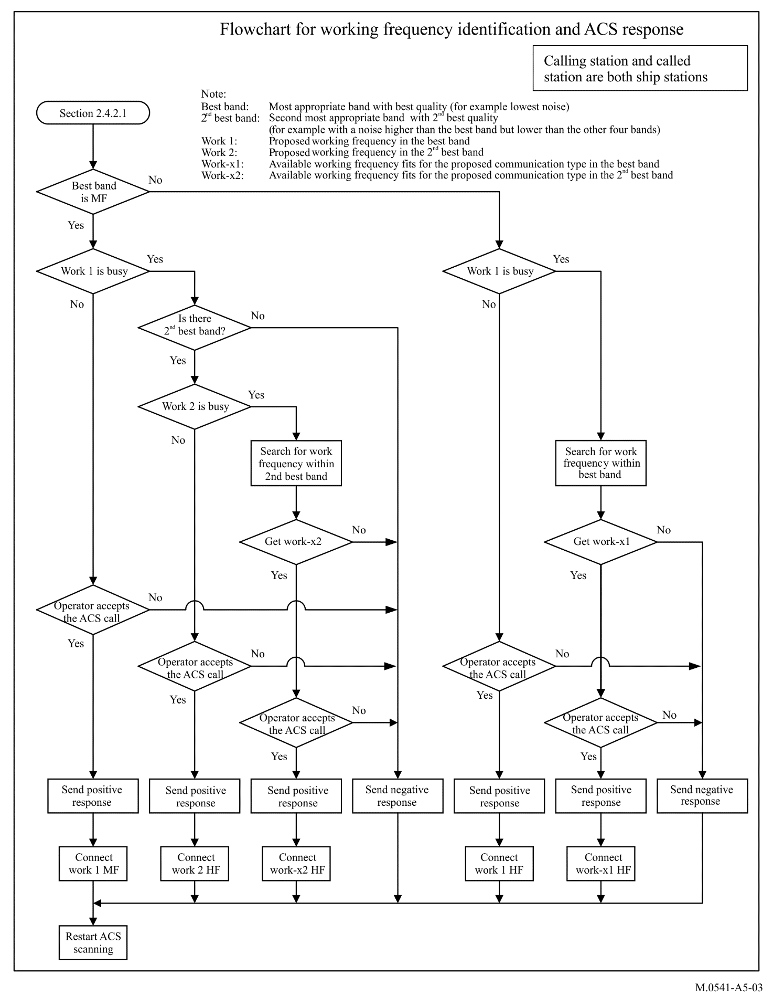

A5-2.4.2.2 Response of a coast station to a ship station
When the calling station is a ship station and the called station is a coast station, the following procedure in Fig. A5-4 applies to the frequency identification and following ACS response.
When the most appropriate band is MF band, ACS searches the MF band for available working frequency (e.g. the frequency is not busy) for the proposed communication type. If no suitable frequency in the MF band is identified, ACS searches the second most appropriate band for available working frequency.
When the most appropriate band is a HF band, ACS searches the HF band for available working frequency (e.g. the frequency is not busy) for the proposed communication type.
When a suitable frequency is not identified according to Fig. A5-4, ACS responds to reject the connection to a calling station on most appropriate ACS frequency as recorded in § A5-2.3.1 and the receiver designated for ACS restarts scanning.
The negative response from a coast station to a ship station when there is no identified working frequency is composed as follows:
– Category of call: ACS
– Message 1 first telecommand: unable to comply
– Message 1 second telecommand: busy
– Message 2: position if available, or no information
When a suitable frequency is identified according to Fig. A5-4, ACS notifies operator of the identified working frequency with proposed mode and the operator can decide whether to accept the ACS call.
If the operator decides to accept the ACS call, ACS responds to the calling station on the most appropriate ACS frequency as recorded in § A5-2.3.1 including the working frequency or channel positively. Then the procedure goes to § A5-2.3.5.
The positive response from a coast station to a ship station with acceptance of the connection is composed as follows:
– Category of call: ACS
– Message 1 first telecommand: type of communication (e.g. J3E, F1B or Data)
– Message 1 second telecommand: no information
– Message 2: working frequency
If the operator decides to reject the ACS call, ACS responds to the calling station on the most appropriate ACS frequency as recorded in § A5-2.3.1 negatively and the procedure goes to restart scanning.
The negative response from a coast station to a ship station when the operator decides to reject the call is composed as follows:
– Category: ACS
– Message 1 first telecommand: unable to comply
– Message 1 second telecommand: no operator available or operator temporarily unavailable
– Message 2: position if available, or no information
FIGURE A5-4
Flowchart for the working frequency identification and following ACS response for the called station
when calling station is a ship station and called station is a coast station
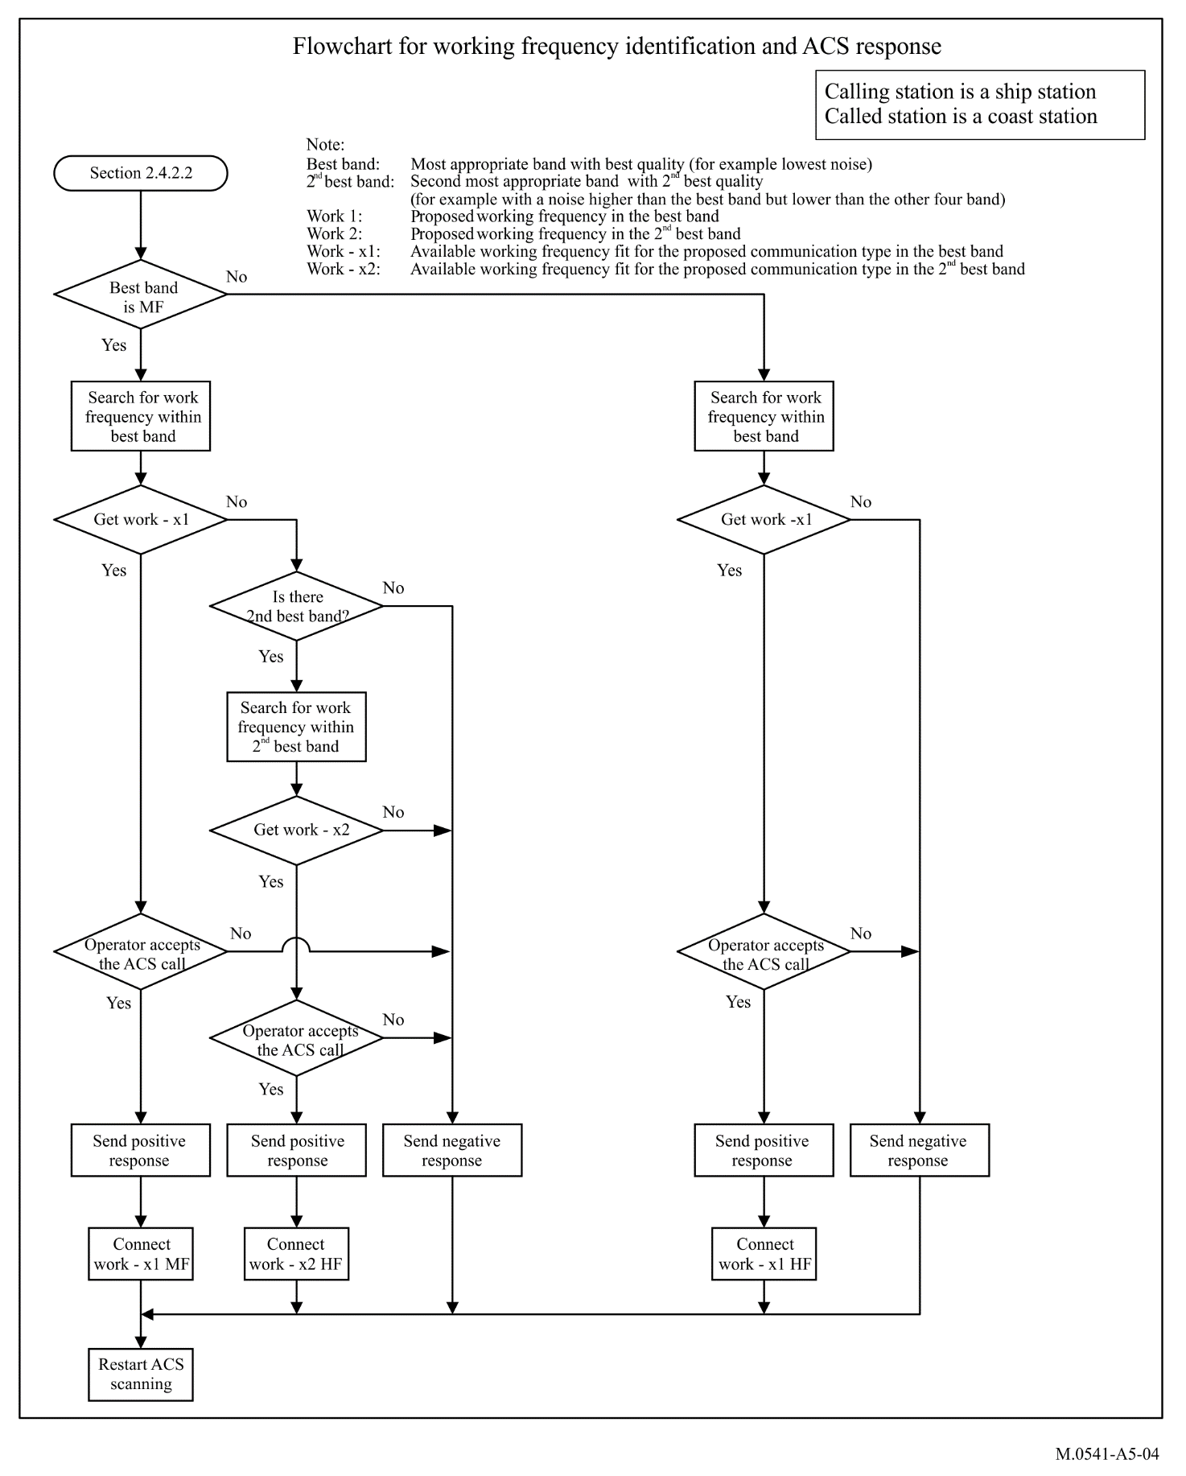

A5-2.5 Selection of working frequency
A5-2.5.1 The pre-setting of working frequencies in each MF/HF band is the basis for the search for the available working frequency in §§ A5-2.2.3 and A5-2.4. The working frequency for subsequent communication should be selected from Appendix 17 of the RR according to the type of subsequent communication. In radiotelephony, simplex operation using single frequency is recommended for ship-to-ship radiocommunication, however, duplex or semi-duplex operation using paired frequencies is recommended for public correspondence between coast station and ship station.
A5-2.5.2 If the subsequent type of communication is HF radiotelephony, the working frequency should be selected in the frequencies of section 1 of the RR Appendix 17, Part B. However, the frequencies for the distress and safety traffic or frequencies for calling should be avoided.
A5-2.5.3 In radiotelephony between coast station and ship station, working frequency should be proposed always by the coast station. If the proposed working frequency is not available for ship station called, then the ship station responds with its position information and wait for another proposal of working frequency by the coast station.
A5-2.5.4 To minimize interference of working frequencies for duplex communications, if the last digit of MMSI of ship station called is an even number, then it is recommended to use working frequency of even channel number in each frequency band of the RR Appendix 17. If the last digit of MMSI of ship station called is an odd number, then it is recommended to use working frequency of odd channel number in each frequency band.

Annex 6
Autonomous maritime radio devices Group A man overboard devices using VHF digital selective calling for alerting and automatic identification system technology for tracking
Introduction
AMRD Group A MOB devices operate on VHF channel 70 for alerting using VHF DSC and on automatic identification system (AIS) frequencies for tracking. The devices are fitted with a VHF DSC and an AIS transmitter. Technical characteristics are described in Recommendations ITU-R M.2135.

A6-1 Digital selective calling alert
AMRD Group A MOB devices may be activated manually or automatically if a person falls overboard. The device will transmit a DSC distress alert upon activation. The alert message is a distress alert with the nature of distress field set to man overboard and the subsequent communications field set to no information.
There are no voice communications from AMRD Group A MOB devices.
AMRD Group A MOB devices may operate in either:
– open loop mode, with the DSC distress alert addressed to all stations – i.e. a standard distress alert; or
– closed loop mode, with the DSC distress alert relay message addressed to a specific station or group of stations – normally the parent vessel.
In both cases, the AIS transmitter is activated and transmits AIS man overboard messages.

A6-2 Identification
AMRD Group A MOB devices are programmed with a distinctive maritime identifier, coded in accordance with Recommendation ITU-R M.585.

A6-3 Position updating
AMRD Group A MOB devices are fitted with an integrated electronic position fixing device. However, it should be noted that the initial distress alert from an AMRD Group A MOB device will not contain a position and time information, as the integrated electronic position fixing device will not have locked onto the satellite constellation.
As soon as the internal electronic position fixing device is able to provide an accurate position and time, the MOB device will transmit a further DSC distress alert and an AIS message with the position and time from the position fixing device automatically inserted.

A6-4 Acknowledgment
AMRD Group A MOB devices are fitted with a DSC receiver for reception of acknowledgment messages.
An acknowledgment message causes the AMRD Group A MOB device to stop transmitting DSC alerts. Accordingly, DSC acknowledgment messages should only be sent when the Master or person in charge of the recovery vessel considers it prudent to do so.
The AMRD Group A MOB device will continue transmitting its position using AIS functionality until manually turned off or the battery is exhausted.
As with other VHF DSC distress alerts, DSC acknowledgments to open loop AMRD Group A MOB devices alerts are normally only sent by coast stations, or under direction of a coast station. However, the recovery vessel may send a DSC acknowledgment message if the person in the water has been recovered.
Once the person in the water is recovered, the AMRD Group A MOB device should be switched off as soon as possible and an announcement cancelling the distress alert made on VHF channel 16 should be provided.

A6-5 Cancellation of an inadvertent distress alert
A station transmitting an inadvertent distress alert from an AMRD Group A MOB device should cancel the distress alert using the following procedure:
– immediately turn off the MOB device, which causes a DSC self-cancel message to be sent automatically;
– cancel the distress alert verbally on VHF channel 16 (see RR No. 32.53E) by the associated station;
– monitor VHF channel 16, and respond to any communications concerning that distress alert as appropriate.

Annex 7
Frequencies used for digital selective calling
A7-1 The frequencies used for distress, urgency, and safety purposes using DSC are as follows (RR Appendix 15):

2 187.5 | kHz
4 207.5 | kHz
6 312 | kHz
8 414.5 | kHz
12 577 | kHz
16 804.5 | kHz
156.525 | MHz (Note 1)
NOTE 1 – The frequency 156.525 MHz may also be used for DSC purposes other than distress, urgency, and safety.
A7-2 The frequencies assignable on an international basis to ship and coast stations for DSC, for purposes other than distress, urgency, safety and ACS, are as follows (see Note 2):
A7-2.1 Ship stations (see Note 2)

2 177 (Note 3) | 2 189.5 |  | kHz
4 208 | 4 208.5 | 4 209 | kHz
6 312.5 | 6 313 | 6 313.5 | kHz
8 415 | 8 415.5 | 8 416 | kHz
12 577.5 | 12 578 | 12 578.5 | kHz
16 805 | 16 805.5 | 16 806 | kHz
18 898.5 | 18 899 | 18 899.5 | kHz
22 374.5 | 22 375 | 22 375.5 | kHz
25 208.5 | 25 209 | 25 209.5 | kHz
 |  | 156.525 | MHz

A7-2.2 Coast stations (see Note 2)

2 177 |  |  | kHz
4 219.5 | 4 220 | 4 220.5 | kHz
6 331 | 6 331.5 | 6 332 | kHz
8 436.5 | 8 437 | 8 437.5 | kHz
12 657 | 12 657.5 | 12 658 | kHz
16 903 | 16 903.5 | 16 904 | kHz
19 703.5 | 19 704 | 19 704.5 | kHz
22 444 | 22 444.5 | 22 445 | kHz
26 121 | 26 121.5 | 26 122 | kHz
 |  | 156.525 | MHz

NOTE 2 – The following paired assigned frequencies (for ship/coast stations) 4 208/4 219.5 kHz, 6 312.5/6 331 kHz, 8 415/8 436.5 kHz, 12 577.5/12 657 kHz, 16 805/16 903 kHz, 18 898.5/19 703.5 kHz, 22 374.5/22 444 kHz and 25 208.5/26 121 kHz are the first choice international frequencies for DSC (see RR Appendix 17).
NOTE 3 – The frequency 2 177 kHz is available to ship stations for intership calling only.
A7-2.3 Frequencies for automatic connection system using digital selective calling for ship and coast stations
ACS calling in the 2 MHz frequency band
ACS calling in the 4 MHz frequency band
ACS calling in the 6 MHz frequency band
ACS calling in the 8 MHz frequency band
ACS calling in the 12 MHz frequency band
ACS calling in the 16 MHz frequency band.

* This Recommendation should be brought to the attention of the International Maritime Organization (IMO) and the ITU Telecommunication Standardization Sector (ITU-T).

