Recommendation ITU-R M.2162-0
(12/2023)
M Series: Mobile, radiodetermination, amateur
and related satellite services
Technical and operational characteristics of radiolocation systems operating in the frequency range 92-100 GHz and radionavigation systems operating in the frequency range 95-100 GHz

Foreword
The role of the Radiocommunication Sector is to ensure the rational, equitable, efficient and economical use of the radio-frequency spectrum by all radiocommunication services, including satellite services, and carry out studies without limit of frequency range on the basis of which Recommendations are adopted.
The regulatory and policy functions of the Radiocommunication Sector are performed by World and Regional Radiocommunication Conferences and Radiocommunication Assemblies supported by Study Groups.

Policy on Intellectual Property Right (IPR)
ITU-R policy on IPR is described in the Common Patent Policy for ITU-T/ITU-R/ISO/IEC referenced in Resolution ITU-R 1. Forms to be used for the submission of patent statements and licensing declarations by patent holders are available from http://www.itu.int/ITU-R/go/patents/en where the Guidelines for Implementation of the Common Patent Policy for ITU-T/ITU-R/ISO/IEC and the ITU-R patent information database can also be found.

Series of ITU-R Recommendations
(Also available online at https://www.itu.int/publ/R-REC/en)
Series | Title
BO | Satellite delivery
BR | Recording for production, archival and play-out; film for television
BS | Broadcasting service (sound)
BT | Broadcasting service (television)
F | Fixed service
M | Mobile, radiodetermination, amateur and related satellite services
P | Radiowave propagation
RA | Radio astronomy
RS | Remote sensing systems
S | Fixed-satellite service
SA | Space applications and meteorology
SF | Frequency sharing and coordination between fixed-satellite and fixed service systems
SM | Spectrum management
SNG | Satellite news gathering
TF | Time signals and frequency standards emissions
V | Vocabulary and related subjects

Note: This ITU-R Recommendation was approved in English under the procedure detailed in Resolution ITU-R 1.

Electronic Publication
Geneva, 2024

© ITU 2024
All rights reserved. No part of this publication may be reproduced, by any means whatsoever, without written permission of ITU.

RECOMMENDATION ITU-R M.2162-0
Technical and operational characteristics of radiolocation systems
operating in the frequency range 92-100 GHz and radionavigation
systems operating in the frequency range 95-100 GHz
(2023)
Scope
This Recommendation contains the technical and operational characteristics of the radiolocation and radionavigation systems operating in the frequency range 92-100 GHz. The parameters are intended to be used as a guideline in analysing compatibility between radars operating in the radiolocation service or in the radionavigation service with systems in other services.
Keywords
Radar, characteristics
Abbreviations/Glossary
EESS Earth exploration-satellite service
FMCW Frequency modulated carrier wave
FOD Foreign object debris
I/N Interference-to-noise ratio
RR Radio Regulations
Related ITU Recommendations and Reports
Recommendation ITU-R F.699 – Reference radiation patterns for fixed wireless system antennas for use in coordination studies and interference assessment in the frequency range from 100 MHz to 86 GHz
Recommendation ITU-R M.1851 – Mathematical models for radiodetermination radar systems antenna patterns for use in interference analyses
Recommendation ITU-R M.1461 – Procedures for determining the potential for interference between radars operating in the radiodetermination service and systems in other services
Recommendation ITU-R M.1466 – Characteristics of and protection criteria for radars operating in the radionavigation service in the frequency band 31.8-33.4 GHz
The ITU Radiocommunication Assembly,
considering
a) that antenna, signal propagation, target detection and large necessary bandwidth characteristics of radar to achieve their functions are optimum in certain frequency bands;
b) that the technical characteristics of radars operating in the radiolocation and radionavigation services are determined by the mission of the system and vary widely even within a frequency band;
c) that representative technical and operational characteristics of radars operating in the radiolocation and radionavigation services are required to determine, if necessary, the feasibility of introducing new types of systems into frequency bands allocated to the radiolocation and radionavigation services,
recognizing
a) that No. 5.554 of the Radio Regulations (RR) states that in the band 95-100 GHz, satellite links connecting land stations at specified fixed points are also authorized when used in conjunction with the mobile-satellite service or the radionavigation-satellite service;
b) that the frequency band 92-94 GHz is allocated to radio astronomy on a primary basis;
c) that the frequency band 94-94.1 GHz is allocated to the Earth exploration-satellite (active) service (EESS), space research (active) service, radiolocation service on a primary basis and radio astronomy on a secondary basis;
d) that the use of the band 94-94.1 GHz by the EESS (active) and space research (active) service is limited to spaceborne cloud radars;
e) that the frequency band 94.1-95 GHz is allocated to the fixed service, mobile service, radio astronomy, radiolocation services on a primary basis;
f) that the frequency band 95-100 GHz is allocated to the fixed service, mobile service, radio astronomy, radiolocation, radionavigation and radionavigation-satellite services on a primary basis;
g) that RR No. 5.149 applies in the frequency bands 92-94 GHz and 94.1-100 GHz, in which “the administrations are urged to take all practicable steps to protect the radio astronomy service from harmful interference. Emissions from spaceborne or airborne stations can be particularly serious sources of interference to the radio astronomy service”;
h) that RR No. 5.340, relative to the passive band in the frequency bands 86-92 GHz and 100-102 GHz in which all emissions are prohibited, applies,
noting
that Recommendation ITU-R M.1461 is also used as a guideline in analysing the compatibility between radars operating in the radiodetermination service and other services to which the frequency band is allocated,
recommends
1 that the technical and operational characteristics and protection criteria of the radiolocation and radionavigation systems described in the annex should be considered representative of those operating in the frequency range 92-100 GHz;
2 when conducting sharing and compatibility studies the characteristics contained in the Annex should be considered.

Annex
Technical and operational characteristics of radiolocation and radionavigation systems operating in the frequency range 92-100 GHz

1 Introduction
Different types of radars operate in the frequency range 92-100 GHz. Their operational and technical characteristics are described in the following paragraphs.

2 Characteristics of radars in the 92-100 GHz range
Representative characteristics of radiolocation systems in the range 92-100 GHz are provided in the following sections. The information presented in this Annex is sufficient for general calculations to assess the compatibility between these radars and other systems.

2.1 Ground weather radars at 94-100 GHz
The frequency range 94-100 GHz provides appropriate characteristics that can be used for dedicated study of clouds and fog. These radars use a low peak power transmitter and frequency modulated continuous wave technology. These radars, in vertical operation, provide access to the vertical distribution of clouds and the sedimentation velocity of hydrometeors and measure the energy backscattered by these hydrometeors. This energy can be related to the amount of water contained in the cloud (liquid and ice). The Doppler capability of these radars offers the possibility to measure the speed of hydrometeors along the line of sight.
A large variety of meteorological conditions and cloud types can then be observed, including low clouds, fog, cirrus, and liquid precipitation. For example, a set up based on a vertical resolution of 25 m, an integration time sets to 3 s (with a maximum range of 12 km), and a Nyquist velocity of 5 m s⁻¹, provides a capability of continuously detection of all types of clouds with its sensitivity of about −44 dBz at 1 km for an uninterrupted period of time.
Based on their characteristics and their detection capabilities, these radars are often deployed in the vicinity of an airport and offer important collected data for air traffic.
TABLE 1
Characteristics of radars in the 94-100 GHz range
Parameter | Radar A
Application | Weather (heavy rainfall detection)
Deployment area | Worldwide, fixed site
Tuning range (GHz) | 94-100
Transmitter type | Solid state
Tx power into antenna (peak) (W) | 0.5-1
Polarization | Linear
Pulse duration (ms) | 0.04-0.16
Frequency modulation | FMCW
Pulse repetition period (µs) | 80-160
Antenna type | Parabolic
Radar height relative to the ground (m) | 1
Antenna gain (dBi) | 54
Antenna diameter (m) | 0.6
Antenna beamwidth in azimuth (degrees) | 0.4
Antenna beamwidth in elevation (degrees) | 0.4
Antenna peak side-lobe (SL) levels (dBi) | 24
Antenna pattern type | Rec. ITU-R M.1851, COS² pattern

TABLE 1 (end)
Parameter | Radar A
Receiver noise floor (dBm)  (see M.1461 below eq. (4)) | −105 … −93.2
Receiver noise figure (dB) | 7
RF emission bandwidth (MHz) | Up to 24
Receiver IF 3 dB bandwidth (MHz) | 1.5-24
I/N protection criterion (dB) | −6

2.2 Airport foreign object debris detection system operating in the frequency range 92-100 GHz
Foreign object debris (FOD) detection system operating in the frequency range 92-100 GHz can provide such performance as high detection sensitivity, short detection response time, sufficient coverage of surveillance runway area and high location accuracy for safety airport operation. Table 2 summarizes the technical and operational characteristics of FOD detection system operating in the frequency range 92-100 GHz.
FOD is any object located in an inappropriate location in the airport environment that has the capacity to injure airport or airline personnel and damage aircraft. The presence of FOD on airport runways, taxiways, aprons and ramps poses a significant threat to the safety of air travel. FOD has the potential to damage aircraft during critical phases of flight, which can lead to catastrophic loss of life and airframe, and increased maintenance and operating costs. FOD hazards can be reduced, however, using FOD detection equipment.
FOD hazards can severely injure airport or airline personnel or damage equipment. Types of potential damage include: cutting aircraft tires; being ingested into engines; or becoming lodged in mechanisms affecting flight operations. Personnel injuries can occur when jet blast propels FOD through the airport environment at high velocities.
Dark-coloured items made up nearly 50% of the FOD collected. Common FOD dimensions can be 3 cm by 3 cm or smaller. Typical FOD includes the following:
– aircraft and engine fasteners (nuts, bolts, washers, safety wire, etc.)
– aircraft parts (fuel caps, landing gear fragments, oil sticks, metal sheets, trapdoors, and tire fragments)
– mechanics’ tools
– catering supplies
– flight line items (nails, personnel badges, pens, pencils, luggage tags, soda cans, etc.);
– apron items (paper and plastic debris from catering and freight pallets, luggage parts, and debris from ramp equipment)
– runway and taxiway materials (concrete and asphalt chunks, rubber joint materials, and paint chips)
– construction debris (pieces of wood, stones, fasteners and miscellaneous metal objects)
– plastic and/or polyethylene materials
– natural materials (plant fragments and wildlife) and
– contaminants from winter conditions (snow, ice).
TABLE 2
Technical and operational characteristics of foreign object debris
detection system operating in the frequency range 92-100 GHz
Parameters | Values
Frequency range (GHz) | 92 … 100
Channel bandwidth (GHz) | 0.58 … 7.98
Channel plan | See Fig. 1
Transmit peak power (mW) | 100-200
Sweep frequency (FMCW) (kHz) | 1.250
Antenna type | Cassegrain
Antenna gain (dBi) | 44
Antenna pattern | Rec. ITU-R F.699
Antenna height (m) | 4 … 8
Full width at half maximum antenna gain (3 dB beamwidth) (degrees) | Elevation: 1.0, Azimuth: 1.0
Antenna rotation speed (rpm) | 15
Detection distance (m) | 200 … 500
Radiated rotation angle in azimuth (degree) | ±60
Radar cross section specification (dB/m²) | −20
Range resolution (cm) | 3 … 50
Emission bandwidth (−3 dB) (MHz) | 1
Emission bandwidth (−20 dB) (MHz) | 3.5
Adjacent channel leakage ration (dBc) | < −70
Receiver noise figure (dB) | 10
I/N protection criteria (dB) | −6

FIGURE 1
Channel plan for foreign object debris detection system operating in the frequency range 92-100 GHz
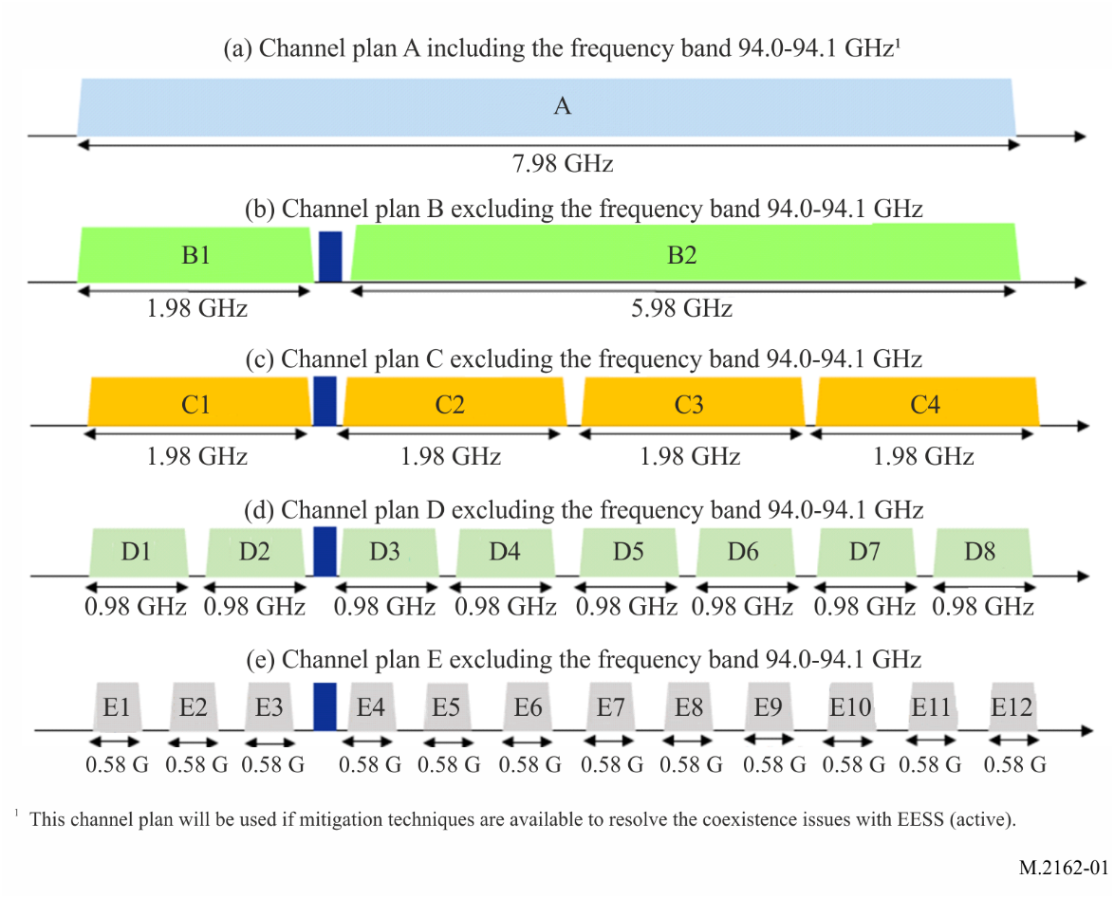

2.3 Landing assistance airborne millimetre wave radar operating in the frequency range 95-100 GHz
The frequency band 95-100 GHz offers a beneficial compromise between all-weather atmospheric penetration and angular resolution to achieve a small form factor airborne radar, suitable for landing assistance operation in the radionavigation service.
Landing assistance radar primarily addresses enhanced flight vision systems operation that aims at providing a radar video stream to help the pilots acquire visual references beyond their natural view, such as approach ramp, runway threshold or edges. Millimetre wave radar can also serve as a localization and navigation system to help guiding the aircraft toward the touchdown zone along the final approach segment. It constitutes an on-board autonomous alternative to the instrument landing systems on unequipped runways. The main goal is to ensure aircrafts can land in any weather condition (fog, heavy rain) to avoid missed approaches and their adverse effects on logistics.
These millimetre wave radars can equip different types of carrier, from large aircraft to smaller aircraft. The frequency band 95-100 GHz allows to meet the fine angular resolution and the range of detection of several kilometres required in front of the aircraft, within a small size, weight, and power equipment. Low peak power active electronically scanned array associated with a frequency modulated continuous waveform achieves suitable performances with the solid-state technologies available in this frequency band.

TABLE 3
Characteristics of landing assistance radars in the frequency range 95-100 GHz
Parameter | Radar A
Application | Landing assistance
Deployment area | Worldwide, airborne
Frequency range (GHz) | 95.1-99.5
Transmit peak power (W) | 0.5-1
Polarization | Linear
Pulse duration (µs) | 100-200
Frequency modulation | FMCW
Antenna type | Active electronically scanned array
Radar height relative to the ground (m) | 200..0 (Airborne – Final approach segment)
Antenna gain (dBi) | 34-38
Antenna width (m) | 0.4
Antenna beam width in azimuth (degree) | 0.5
Antenna scanning range in azimuth (degree) | ±15
Antenna beam width in elevation (degree) | 15
Antenna scanning range in elevation (degree) | ±30
Receiver noise figure (dB) | 8-10
RF emission bandwidth (MHz) | 30-60
Channel bandwidth (MHz) | 80
Maximum channels number | 4
I/N protection criterion (dB) | –6

The radar has no scanning in elevation, the beam is fixed with a down tilt of −6°, and the aircraft pitch variation is not compensated.
In the absence of performance requirements.
The protection criterion does not include aeronautical safety margin.

