Recommendation ITU-R M.2161-0
(12/2023)
M Series: Mobile, radiodetermination, amateur
and related satellite services
Guidelines to assist administrations to mitigate in-band interference from fixed-satellite service earth stations operating in the frequency bands 24.65-25.25 GHz, 27-27.5 GHz, 42.5-43.5 GHz and 47.2-48.2 GHz into IMT stations

Foreword
The role of the Radiocommunication Sector is to ensure the rational, equitable, efficient and economical use of the radio-frequency spectrum by all radiocommunication services, including satellite services, and carry out studies without limit of frequency range on the basis of which Recommendations are adopted.
The regulatory and policy functions of the Radiocommunication Sector are performed by World and Regional Radiocommunication Conferences and Radiocommunication Assemblies supported by Study Groups.

Policy on Intellectual Property Right (IPR)
ITU-R policy on IPR is described in the Common Patent Policy for ITU-T/ITU-R/ISO/IEC referenced in Resolution ITU-R 1. Forms to be used for the submission of patent statements and licensing declarations by patent holders are available from http://www.itu.int/ITU-R/go/patents/en where the Guidelines for Implementation of the Common Patent Policy for ITU-T/ITU-R/ISO/IEC and the ITU-R patent information database can also be found.

Series of ITU-R Recommendations
(Also available online at https://www.itu.int/publ/R-REC/en)
Series | Title
BO | Satellite delivery
BR | Recording for production, archival and play-out; film for television
BS | Broadcasting service (sound)
BT | Broadcasting service (television)
F | Fixed service
M | Mobile, radiodetermination, amateur and related satellite services
P | Radiowave propagation
RA | Radio astronomy
RS | Remote sensing systems
S | Fixed-satellite service
SA | Space applications and meteorology
SF | Frequency sharing and coordination between fixed-satellite and fixed service systems
SM | Spectrum management
SNG | Satellite news gathering
TF | Time signals and frequency standards emissions
V | Vocabulary and related subjects

Note: This ITU-R Recommendation was approved in English under the procedure detailed in Resolution ITU-R 1.

Electronic Publication
Geneva, 2024

© ITU 2024
All rights reserved. No part of this publication may be reproduced, by any means whatsoever, without written permission of ITU.

RECOMMENDATION ITU-R M.2161-0
Guidelines to assist administrations to mitigate in-band interference
from fixed-satellite service earth stations operating in the frequency
bands 24.65-25.25 GHz, 27-27.5 GHz, 42.5-43.5 GHz and
47.2-48.2 GHz into IMT stations
(2023)
Scope
The purpose of this Recommendation is to describe guidelines to assist administrations to mitigate in-band interference from fixed-satellite service (FSS) earth stations into International Mobile Telecommunications (IMT) stations. The frequency bands 24.65-25.25 GHz in ITU Regions 1 and 3, 24.75-25.25 GHz in ITU Region 2, and 27-27.5 GHz in ITU Regions 2 and 3 are allocated to the fixed-satellite service (FSS) (Earth-to-space) on a primary basis. The frequency bands 42.5-43.5 GHz and 47.2-48.2 GHz are allocated to the fixed-satellite service (FSS) (Earth-to-space) on a primary basis in the three ITU Regions. The frequency bands 24.65-25.25 GHz, 27-27.5 GHz and 42.5-43.5 GHz are identified for use by administrations wishing to implement the terrestrial component of IMT in the three ITU regions. The frequency band 47.2-48.2 GHz is identified for use by administrations wishing to implement the terrestrial component of IMT in ITU Region 2 and some countries in ITU Regions 1 and 3.
Keywords
IMT, FSS, earth stations, interference
Abbreviations/Glossary
IMT International Mobile Telecommunications
FSS Fixed-satellite service
EESS Earth exploration-satellite service
SRS Space research service
PFD Power flux-density
Related ITU Resolutions, Recommendations, Reports
Resolution 242 (WRC-19)
Resolution 243 (WRC-19)
Resolution 750 (Rev.WRC-19)
Recommendation ITU-R P.452-16 – Prediction procedure for the evaluation of interference between stations on the surface of the Earth at frequencies above about 0.1 GHz
Recommendation ITU-R P.2001 – A general purpose wide-range terrestrial propagation model in the frequency range 30 MHz to 50 GHz
Recommendation ITU-R P.2108 – Prediction of clutter loss
Recommendation ITU-R S.465 – Reference radiation pattern for earth station antennas in the fixed-satellite service for use in coordination and interference assessment in the frequency range from 2 to 31 GHz
Recommendation ITU-R S.580 – Radiation diagrams for use as design objectives for antennas of earth stations operating with geostationary satellites.
Recommendation ITU-R S.1855 – Alternative reference radiation pattern for earth station antennas used with satellites in the geostationary-satellite orbit for use in coordination and/or interference assessment in the frequency range from 2 to 31 GHz
The ITU Radiocommunication Assembly,
considering
a) that the frequency bands 24.65-25.25 GHz in ITU Regions 1 and 3, 24.75-25.25 GHz in ITU Region 2, and 27-27.5 GHz in ITU Regions 2 and 3 are allocated to the fixed-satellite service (FSS) (Earth-to-space) on a primary basis;
b) that the frequency bands 42.5-43.5 GHz and 47.2-48.2 GHz are allocated to the FSS (Earth-to-space) on a primary basis in the three ITU Regions;
c) that the frequency bands 24.65-25.25 GHz, 27-27.5 GHz, 42.5-43.5 GHz and 47.2-48.2 GHz are allocated to the mobile service (MS) on a primary basis in all three ITU Regions;
d) that technical studies conducted in the frequency bands 24.65-25.25 GHz, 27-27.5 GHz, 42.5-43.5 GHz and 47.2-48.2 GHz between International Mobile Telecommunications (IMT) systems and FSS earth stations assuming a known location the FSS earth station (and/or the IMT base station), and certain technical characteristics and propagation models, show that the co-existence can be achieved through the calculation of separation distances;
e) that administrations would benefit from guidelines to determine coordination areas based on the separation distances, in order to assess and ensure co-existence between FSS and IMT;
f) that the separation distances in considering d) may vary on a case-by-case basis, depending upon several factors, including earth station antenna diameter and its gain in the direction of the interference path, receiver characteristics, elevation angle, surrounding terrain, mechanisms of radio-wave propagation, clutter loss, site shielding, polarisation loss and IMT system characteristics and system design,
recognizing
a) that the bands 24.65-25.25 GHz in ITU Region 1 and 24.65-24.75 GHz in ITU Region 3 are limited to a minimum antenna diameter of 4.5 m for the FSS (Earth to Space) (see RR No. 5.532B);
b) that WRC-19 identified the frequency bands 24.25-27.5 GHz (in all three Regions), 42.5-43.5 GHz (in all three Regions) and 47.2-48.2 GHz (in Region 2 and some countries in Regions 1 and 3) for use by administrations wishing to implement the terrestrial component of IMT, and that this identification does not preclude the use of this frequency band by any application of the services to which it is allocated and does not establish priority in the Radio Regulations (see RR Nos. 5.532AB, 5.550B and 5.553B);
c) that Resolution 242 (WRC-19) invited the ITU-R to develop Recommendation(s) to assist administrations to mitigate interference from FSS earth stations into IMT stations operating in the frequency bands 24.65-25.25 GHz and 27-27.5 GHz, and encourages administrations to ensure that provisions for the implementation of IMT allow for the continued use of Earth exploration-satellite service (EESS), space research service (SRS) and FSS earth stations and their future development;
d) that Resolution 243 (WRC-19) invited the ITU-R to develop ITU-R Reports and Recommendations, as appropriate, to assist administrations in ensuring coexistence between IMT and broadcasting satellite service (BSS) and FSS, including high-density applications in the fixed-satellite service (HDFSS) as per No. 5.516B, within the frequency ranges 37-43.5 GHz and 47.2-48.2 GHz, as appropriate,
noting
a) that the impact of satellite earth stations on the deployment of IMT systems could be minimised if coexistence measures can be taken, or FSS gateways are deployed away from areas where the demand for IMT in the frequency bands 24.65/24.75-25.25 GHz, 27-27.5 GHz, 42.5-43.5 GHz and 47.2-48.2 GHz could be expected;
b) that the guidance provided in this Recommendation is not applicable in the case of a ubiquitous deployment of FSS earth-stations, where the location of the earth-stations are not at known fixed locations,
recommends
1 that the methodology and/or approach as described in Annexes should be considered by administrations as a guideline to determine geographic zones for the co-existence between IMT base stations and FSS transmitting earth stations in the frequency bands 24.65/24.75-25.25 GHz, 27-27.5 GHz, 42.5-43.5 GHz and 47.2-48.2 GHz;
2 that administrations should consider the proximity between FSS satellite gateways earth stations and IMT base stations in these bands where IMT base stations are expected to be deployed.

Annex 1
Example methodology for enabling the use of existing and planned FSS earth stations in the frequency bands 24.65/24.75-25.25 GHz, 27.0-27.5 GHz,
42.5-43.5 GHz and 47.2-48.2 GHz while mitigating their interference
into IMT base stations
TABLE OF CONTENTS
Page

A1.1 Introduction 3
A1.2 General methodology 4
A1.3 Determination of the parameters 4
A1.4 Interference calculation 6
A1.5 Maximum interference level acceptable for an IMT base station 6
A1.6 Determination of the coordination area 7
A1.7 Mitigation measures for the case that FSS earth station operates in the coordination area 8
A1.8 Example of calculated coordination areas 9

A1.1 Introduction
FSS earth stations transmitting in the 24.65/24.75 to 25.25 GHz, 27 to 27.5 GHz, 42.5 to 43.5 GHz and 47.2 to 48.2 GHz (where applicable) frequency ranges have the potential to cause interference to IMT systems. Therefore, this may require the establishment of coordination areas around IMT base stations to minimise the risk of interference to IMT systems. Calculation of these coordination areas needs to be site specific and on a case-by-case basis.
The coordination area which is determined through this methodology can be relatively large given worst-case analysis is used. Hence, such areas should be considered as coordination areas within which FSS earth stations/IMT base station could still be deployed, after more detailed analysis beyond this methodology is conducted or an agreement can be reached between the IMT and the FSS earth station operators.

A1.2 General methodology
The general methodology for calculating a co-ordination area is set out in the following steps:
Step 1: Determine the parameters for both the IMT base station and the FSS earth station. This is on a site-specific case by case basis where the specific details of the FSS earth station should be used as shown in § A1.3.
Step 2: Calculate the interference, I, (from the parameters determined in Step 1) for each pixel on a grid based on 20 × 20 m to 50 × 50 m pixel size (i.e. interference to be determined for each pixel in the grid). The area of the grid for the calculation should be set large enough to cover the entire coordination area. The interference I of a transmitting FSS earth station to a receiving IMT base station will be calculated by evaluating the transmit power and antenna gain of an FSS transmit earth station towards an IMT base station as shown in § A1.4.
Step 3: Compare the calculated interference for each pixel (on a grid based on 20 × 20 m to 50 × 50 m pixel size) with the maximum interference level acceptable for an IMT base station as shown in § A1.5.
Step 4: Determine and draw the coordination area based on the comparison of maximum interference level acceptable for an IMT base station for each pixel as shown in § A1.6.
Step 5: Consider a range of mitigations should an FSS earth station/IMT base station be located in the coordination area as shown in § A1.7.

A1.3 Determination of the parameters
The interference is a combination of fixed and variable parameters: IMT base station antenna gain towards the FSS earth station, propagation and clutter losses, site shielding, FSS earth station antenna gain towards the IMT base station, polarisation loss and IMT antenna ohmic losses. About FSS earth station antenna gain towards the IMT base station, it is variable for non-geostationary orbit (NGSO) and fixed for geostationary orbit (GSO).

A1.3.1 Satellite earth station antenna gain towards the IMT base station
Information on the FSS earth station antenna pattern is required for the interference calculation. The resulting gain towards the IMT base station will be a combination of the antenna pattern, elevation and azimuth (i.e. compound angle). This FSS earth station antenna gain towards the IMT base station will need to be calculated for each point on a grid based on 20 × 20 m to 50 × 50 m grid size (each pixel in the grid) in determining the coordination area.
In some cases, accurate information on the FSS earth station antenna pattern may be available from the manufacturer/operator.
Currently, the relevant Recommendations are made for the frequency band below 31 GHz:
• Recommendation ITU-R S.465
• Recommendation ITU-R S.1855
• Recommendation ITU-R S.580
Before the reference radiation pattern for the frequency bands 42.5-43.5 GHz and 47.2-48.2 GHz be formulated, the above three Recommendations could be taken as a reference.

A1.3.2 Calculation of propagation losses between the FSS earth station and the IMT base station
The signal propagating from the FSS earth station to the IMT base station is subject to the following propagation losses/attenuations:
• Free space path loss;
• Diffraction (i.e. from terrain);
• Clutter loss;
• Site shielding (where applicable).
For each pixel on a grid based on 20 × 20 m to 50 × 50 m pixel size (or each azimuth around the IMT base station/FSS earth station and each distance from the IMT base station/FSS earth station, depending on the simulation software) the propagation loss should be determined using an appropriate propagation model such as the one contained in Recommendation ITU-R P.452-16 or Recommendation ITU-R P.2001, considering the terrain elevation in the area of the grid for the calculation of the coordination area.
The terrain elevation model can be the 1-arcsec resolution terrain profile data of a digital surface model (DSM) such as the Shuttle Radar Topography Mission (SRTM); however more detailed terrain models, including built area models, may be used. The terrain profiles can be sampled with an azimuth step of 1 degree around the IMT base station/FSS earth station of interest and a distance step of 25 m. The losses from FSS earth station to IMT station can then be computed around the station with an azimuth step of 1 degree and a distance step of 100 m.
Higher resolution terrain data, or a surface database plus a built area model, and/or higher resolution sampling, may be used to more accurately reflect built up areas.
NOTE – The propagation losses consist of several elements. Recommendation ITU-R P.452 is the appropriate propagation model to use for terrestrial paths, and terrain information should be considered where existing DSM such as SRTM are available. The models within Recommendation ITU-R P.452 are designed to calculate the propagation losses not exceeded for time percentages over the range 0.001 and 50 % and therefore should be used accordingly. Recommendation ITU-R P.2001 could also be considered as it predicts the basic transmission loss due to both signal enhancements and fading effectively over the range from 0% to 100% of an average year. Sites where there is a specific shielding obstacle close to either station and the height and distance to the obstacle are known, § 4.5 of Recommendation ITU-R P.452 can be used to account for the clutter loss. Where specific information on the statistical distribution of clutter loss is needed, the method in § 3.2 of Recommendation ITU-R P.2108 should be used to calculate additional loss due to clutter for urban and suburban environments. It should be noted that the model is not applicable to stations in open areas.

A1.3.3 Polarisation losses
Polarisation loss will be specific to the FSS earth station and its polarisation, this will need to be looked at on a case-by-case basis. Where specific information is not available, the losses that could be considered are:
• 3 dB for circular to linear polarisation (or vice-versa);
• 1.5 dB for same polarisation;
• 0 dB for worst-case analysis.

A1.3.4 Site shielding
Some FSS gateway earth stations may have natural or man-made site shielding where the FSS earth station is located behind a building or there is a structure (e.g. a wall) that shields the antennas from locations of IMT systems. This will need to be considered on a case-by-case basis and an appropriate loss/attenuation figure will need to be determined.

A1.3.5 IMT base station antenna gain distribution towards FSS earth station
The IMT base station antenna gain is described in Recommendation ITU-R M.2101, § 5 “Implementation of IMT Base Station (BS) and User Equipment (UE) Beamforming Antenna Pattern”. Antenna height information is required as well, including the mechanical pointing of the antenna in elevation and azimuth.
Furthermore, the information on UE location is required to determine the IMT base station antenna gain. For evaluation of the worst-case scenario, the UE should be located at the same direction from IMT base station to FSS earth station and at the edge of a cell. Other scenarios could also be considered, for example, the arbitral choice of locations of UE over a cell area and the use of a modelling of UE locations distribution in azimuth and distance from an IMT base station.

A1.4 Interference calculation
To determine if an existing or planned FSS earth station could interfere with an IMT base station, a methodology is proposed to be used to calculate if the interference criteria of the IMT base station is exceeded. A separation distance or coordination area should be calculated around the IMT base station/FSS earth station, and if the FSS earth station/IMT base station would fall within such a separation distance or coordination area, potential further mitigations need to be assessed. This is therefore an approach in two steps.
As a first step the interference level from FSS needs to be calculated, using the following equation:
$I_{IMT}={EIRP}_{FSS}\left(θ_{FSS}\right)-Losses{+G}_{IMT}\left(θ_{IMT}\right)-PL$ (dB) (1)
where:
$I_{IMT}$: interference level at IMT base station
${EIRP}_{FSS}\left(θ_{FSS}\right)$: FSS transmit earth station off-axis e.i.r.p. density in the direction of the receive IMT base station in dBW/Hz
Losses: propagation loss in dB (including losses due to terrain, clutter and site shielding)
$G_{IMT}\left(θ_{IMT}\right)$: IMT base station receive antenna gain in direction of the FSS transmit earth station in dBi
$PL$: polarization losses in dB (related to IMT beam orientation related to the FSS earth station antenna (e.g. circular to linear or vertical to horizontal).

A1.5 Maximum interference level acceptable for an IMT base station
Based on I/N = −6 dB, the maximum interference level can be evaluated as follows:
For the 26 GHz frequency band:
Maximum interference level = IMT receiver noise floor − 6 dB
= Thermal noise + Noise figure − 6 dB
= −204 dB(W/Hz) + 10 dB − 6 dB
= −200 dB(W/Hz)
NOTE 1 – This is based on a noise temperature of 290 K and a noise figure of 10 dB (from the IMT parameters for the 26 GHz frequency band).
The maximum interference level acceptable for an IMT base station is −200 dB(W/Hz).
For the 42 GHz and 47 GHz frequency bands:
Maximum interference level = IMT base station receiver noise floor − 6 dB
= thermal noise + noise figure − 6 dB
= −204 dB(W/Hz) + 12 dB − 6 dB
= −198 dB(W/Hz).
NOTE 2 – This is based on a noise temperature of 290 K and a noise figure of 12 dB (from the IMT parameters for the 42 GHz and 47 GHz frequency bands).
The maximum interference level acceptable for an IMT base station is −198 dB(W/Hz).

A1.6 Determination of the coordination area
The calculation of all coordination areas should be on a case-by-case basis and site specific as the size and shape of the coordination area can vary significantly depending on the IMT base station site.
The calculation of interference for each pixel on a grid based on 20 × 20 m to 50 × 50 m pixel size is compared to the maximum interference level acceptable for an IMT base station to determine the risk of interference in each pixel. This is then used to determine the size and shape of the coordination area. Alternatively, depending on the simulation software being used, the coordination area could be calculated on radials. This is where for each azimuth around the IMT base station/FSS earth station, each of the distances from the IMT base station/FSS earth station location is calculated.
Figure 1 shows an example of coordination area around an IMT base station.
Figure 1
Example of coordination area around an IMT base station
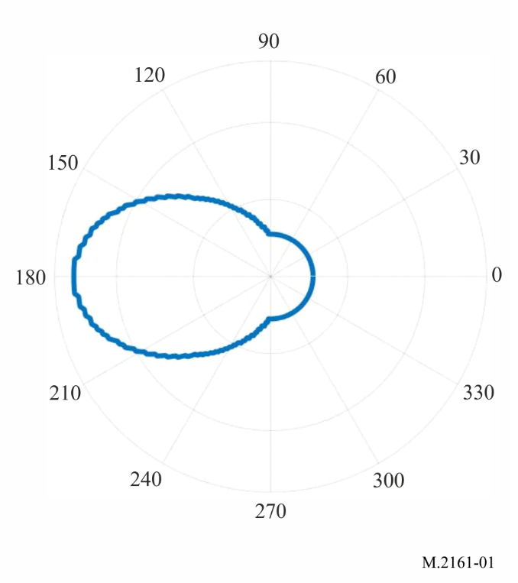
This contour is based on the worst-case. It was assumed that the IMT user equipment is always at the same direction from IMT base station to FSS earth station and at the edge of a cell. The main lobe of FSS earth station is horizontally pointing to the IMT base station.
Figure 2 shows an example of coordination area around an FSS earth station.
Figure 2
Example of coordination area around an FSS earth station
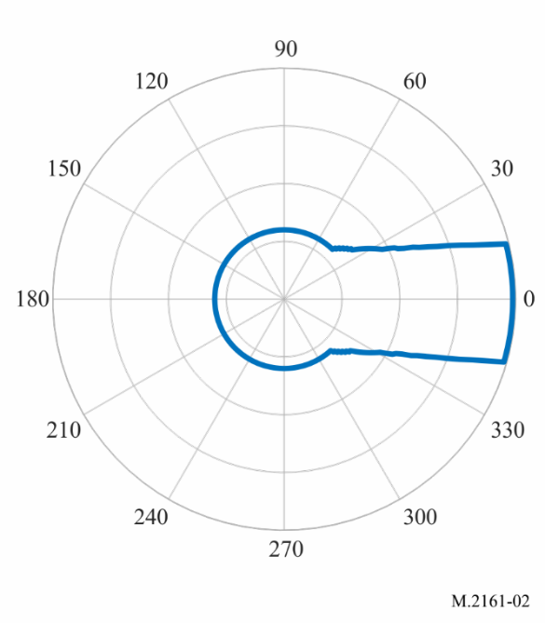
This contour is based on the worst-case. It was assumed that the boresight of the IMT BS is pointing to a UE at the edge of a cell, and that the main lobe of the FSS earth station has an elevation angle of 15 degrees. Also, the main lobe of the FSS earth station, the main lobe of IMT BS and the UE are assumed to be in the same vertical plane.

A1.7 Mitigation measures for the case that FSS earth station operates in the coordination area
If both the FSS earth station and IMT base station location are known, then the calculation of I/N will determine if additional mitigation techniques for such a specific case could be applied. If one of the two locations is not known in advance, a coordination area can be calculated by using the above equation (and generating grid points), that can show the area within which the I/N criteria would be exceeded.
The calculation of the coordination area will generally be based on worst-case assumptions. If an FSS earth station operates within the coordination area, then there are a number of mitigation measures that could be considered to minimise the risk of interference.
Administrations may consider to:
1 Undertake further detailed technical analysis to determine the level of interference risk; and/or
2 Ask/request that the FSS earth station and IMT operators undertake coordination and discussions.
Some of the technical mitigations that could be considered include:
a Make use of more detailed terrain data, or information on build areas that can provide additional blocking. Actual measured antenna patterns could also be used to consider feasibility in more detail;
b The presence of additional site shielding at the FSS gateway earth station site;
c Further considerations of the likely azimuth and elevations of the IMT base station main beam (e.g. sector pointing). It is noted that the general methodology as described in § A1.2 leads to a worst-case scenario wherein the IMT base station is pointed directly at the FSS earth station with its maximum gain to determine the coordination area;
Other technical mitigations may be available.

A1.8 Example of calculated coordination areas
Example A (26 GHz coordination areas around IMT base station)
A calculation is made of an example contour around an IMT base station in order to show the impact that using terrain data as a mitigation technique can assist administrations in ensuring compatibility between a transmit FSS earth station and a receive IMT base station.
The parameters used for this calculation for the FSS earth station and the IMT base station are provided in Tables 1 and 2. The FSS earth station antenna was assumed to have a diameter of 5.6 m, with an elevation angle of 15 degrees and an azimuth angle of −70 degrees (0 degrees is north). For the IMT base station, one antenna sector was assumed, with azimuth of 90 degrees and a 10 degrees mechanical down-tilt angle. Electronic steering was assumed towards a user terminal, and contours are generated for three different positions of the user terminal (in order to simulate different electronic steering scenarios). The azimuth for the electronic steering was simulated to be 48 degrees, 90 degrees, and 132 degrees. The elevation of the electronic steering was between −1.7 and −2.3 degrees. The choice for the position of the user terminals was arbitrary.
TABLE 1
IMT base station parameters
Parameter | Value
Antenna array configuration N_{H} × N_{V} | 8 × 8
Maximum element gain (dBi) | 5
Maximum composite antenna gain (dBi) | 23
H/V radiating element spacing | λ/2
Antenna height (above ground level) | 6 (suburban hotspot)
H/V 3 dB beamwidth (degree) | 65 for both
Azimuth angle (degree) | −90 degrees
Mechanical down-tilt (degree) | 10 (suburban hotspot)
Thermal noise (dB(W/Hz)) | −204
Noise figure (dB) | 10

TABLE 2
FSS earth station parameters
Parameter | Value
Transmit frequency (GHz) | 25.0
Earth station
Antenna diameter (m) | 5.6
Peak transmit antenna gain (dBi) | 61.8
Peak transmit power spectral density (clear sky) (dB(W/Hz)) | −59
Antenna gain pattern | Rec. ITU-R S.465-6
Antenna height (above ground level) (m) | 6
Elevation angle (degree) | 15
Azimuth angle (degree) | −70

The software tool “Visualyse” was used to generate the I/N contours. This was done by creating a grid of 20 m by 20 m around the IMT base station and placing the FSS earth station in each of those points and calculate the I/N for the IMT base station. Based on this grid calculation, contours can be generated for any specific I/N value.
Recommendation ITU-R P.452-16 was used to calculate the propagation losses. In particular, the time percentage was set to 10%, the average radio refractive index lapse rate through the lowest 1 km (N units per km) was set to 53, and the sea-level surface refractivity (N units) was set to 328. No polarization loss was assumed.
For clutter loss, the parameters as per § 4.5 of Recommendation ITU-R P.452-16 was used. In particular, the values were taken from Table 4 of the Recommendation for the suburban scenario. Clutter was assumed only at the IMT base station side.
The location for the FSS earth station and base station was random, together with the applied terrain data (SRTM).
Figure 3 shows in one overview the difference between performing the analysis without terrain data (red contours), and with terrain data (blue contours). This plot was created by exporting the generated contours from Visualyse in kml format into another (proprietary) tool in order to be able to clearly show the impact of applying terrain. The conclusion that could be drawn from this example is that the application of terrain data improves the potential for coexistence between the FSS earth station and the IMT base station, as there would be more areas where the FSS earth station could be deployed without exceeding the I/N threshold (the area covered by the blue contours is much smaller).
Clearly, any analysis to be done by an administration would have to take into account the parameters that apply locally, and results will differ on a case-by-case basis.
However, this example shows that making use of terrain data can help in mitigating the interference from an FSS earth station. If more localized data is available concerning clutter (both at the FSS earth station side and at the IMT base station side, the analysis can be further refined.
Figure 3
Example red contours are without terrain data, and blue contours are with terrain data
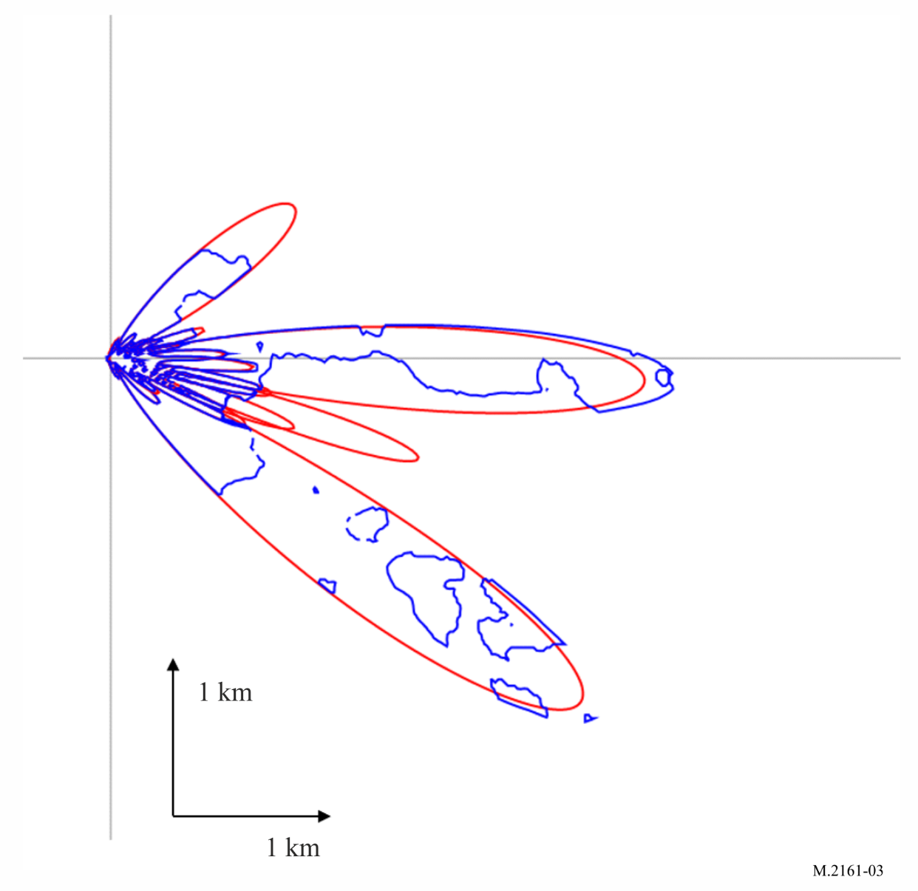
Example B (42 GHz coordination areas around IMT base station)
A calculation is made of an example contour around an IMT base station in order to show the impact of following factors can assist administrations in ensuring compatibility between a transmit FSS earth station and a receive IMT base station.
1) considering the pointing of FSS earth station;
2) using terrain data.
Parameters
The parameters of IMT base station are provided in Table 3. One antenna sector was assumed, with azimuth of 180 degrees (0 degree is east) and mechanical down-tilt angle of 10 degrees.
TABLE 3
IMT base station parameters
Parameter | Value
Antenna array configuration N_{H} × N_{V} | 8 × 16
Maximum element gain (dBi) | 5
Maximum composite antenna gain (dBi) | 26
H/V radiating element spacing | λ/2
Antenna height (above ground level) (m) | 6 (urban/suburban hotspot)
H/V 3 dB beamwidth (degree) | 65 for both
H/V front to back ration (dB) | 30 for both
Mechanical down-tilt | 10 (urban/suburban hotspot)
Thermal noise (dBW/Hz) | −204
Noise figure (dB) | 12
Antenna polarization (degree) | Linear ±45
Sectorization | Single sector
Azimuth angle (degree) | 180

To simulate the worst-case, electronic steering was assumed towards a user terminal. The position of the user terminals is at the line from IMT base station to FSS earth station and at the edge of a cell. The elevation of the electronic steering was among 1 to 7.9 degrees. The calculation chose the elevation value to obtain the biggest gain towards earth station as shown in Fig. 4. When electronic steering is the same azimuth as physical antenna angle, the horizontal gain towards the earth station can achieve the biggest value of 25.79 dBi.
Figure 4
Maximum gain from IMT base station to FSS earth station
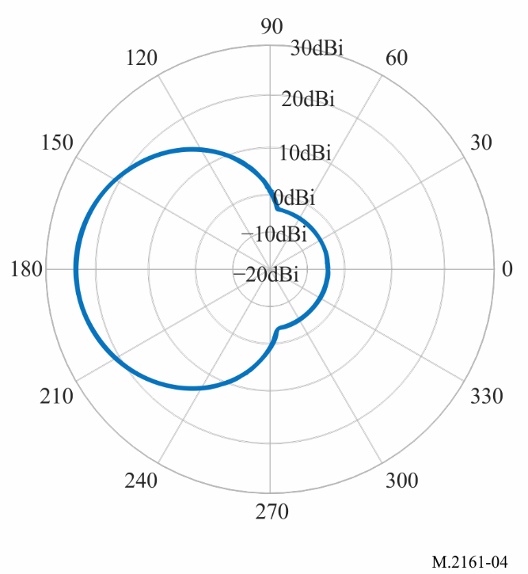
The parameters of FSS earth station are provided in Table 4. The FSS earth station antenna was assumed to have a size of 4.5 m, with an elevation angle of 10 degrees and off-axis angle towards IMT base station of 10/20/48 degrees.
TABLE 4
FSS earth station parameters
Parameter | Value
Transmit frequency (GHz) | 42.5
Antenna diameter (m) | 4.5
Peak transmit antenna gain (dBi) | 55
Peak transmit power spectral density (clear sky) (dB(W/Hz)) | −64.5
Antenna gain pattern | Rec. ITU-R S.580-6
Antenna height (above ground level) (m) | 6
Elevation angle (degree) | 10
Azimuth angle | off-axis angle towards IMT base station of 10/20/48 degrees

According to Recommendation ITU-R S.580-6, the antenna gain from FSS earth station to IMT base station is 4 dBi, −3.5 dBi, −10 dBi when the off-axis angle towards IMT base station is 10/20/48 degrees. If the off-axis angle is larger than 48 degree, the antenna gain is also −10 dBi.
Recommendation ITU-R P.452 was used to calculate the propagation losses. In particular, the time percentage was set to 50%, the average radio refractive index lapse rate through the lowest 1 km (N units per km) was set to 53, and the sea-level surface refractivity (N units) was set to 328. Polarization loss was assumed 3 dB.
Result A with statistical distribution of the clutter loss using Recommendation ITU-R P.2108-1
Recommendation ITU-R P.2108-1 was used to calculate the clutter loss. The location percentage was set to 50%.
Figure 5 shows the simulation result, in which the off-axis from FSS earth station to IMT base station was set to 10 degree (means FSS earth station main lobe towards IMT base station), 20 degree and 48 degree.
Figure 5
Example contours with statistical clutter loss (Rec. ITU-R P.2108-1)
(off-axis (FSS earth station-IMT base station) is 10/20/48 degrees)
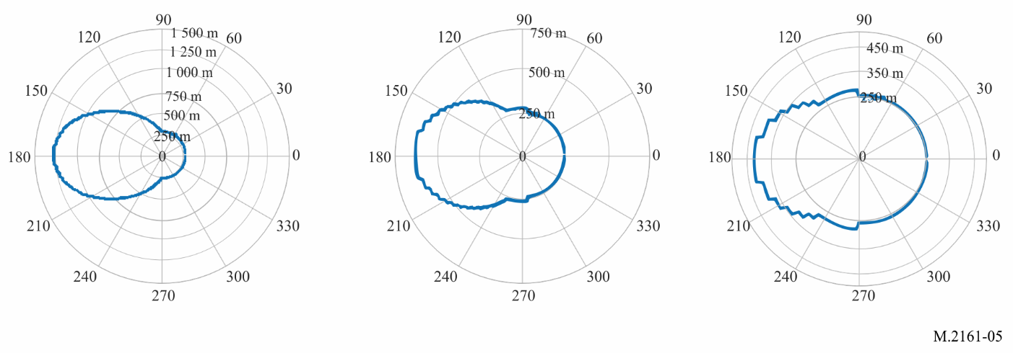
Result B: calculate clutter loss with random terrain profile using Recommendation ITU-R P.452-16
For clutter loss, the parameters as per § 4.5 of Recommendation ITU-R P.452 was used. In particular, the terrain profile was sampled with an azimuth step of 1 degree around the IMT base station and a distance step of 25 m, It was determined that he height of 25% (just an assumption) pixels is greater than 0, and the height of each pixel is determined randomly from 1 to 30 m (just an assumption).
Figure 6 shows the simulation result, in which the off-axis from FSS earth station to IMT base station was set to 10 degrees (means FSS earth station main lobe towards IMT base station), 20 degrees and 48 degrees.
Figure 6
Example contours with random terrain profile (Rec. ITU-R P.452-16)
(off-axis (FSS earth station-IMT base station) is 10/20/48 degrees)
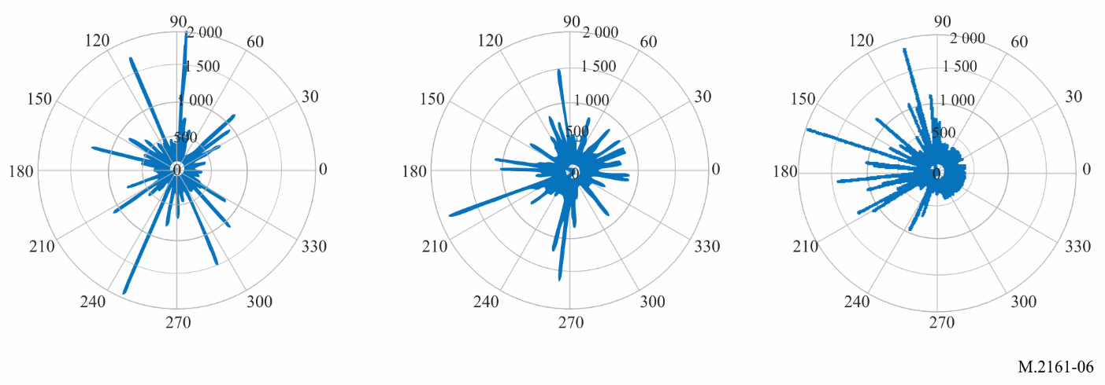
It was found that the antenna pointing is not the most important factor when the actual terrain profile was considered.
Result C: calculate clutter loss with terrain profile using Recommendation ITU-R P.452-16
For clutter loss, the parameters as per § 4.5 of Recommendation ITU-R P.452 were used. In particular, the terrain profile was sampled with a grid based on 50 × 50 m pixel size in which the height of each pixel was considered. Figure 7 shows the simulation result, in which the off-axis angle from FSS earth station to IMT base station was set to 10 degree, 20 degree and 48 degree.
Figure 7
Example contours with terrain profile (Rec. ITU-R P.452-16)
(off-axis angle (FSS earth station-IMT base station) is 10/20/48 degrees)
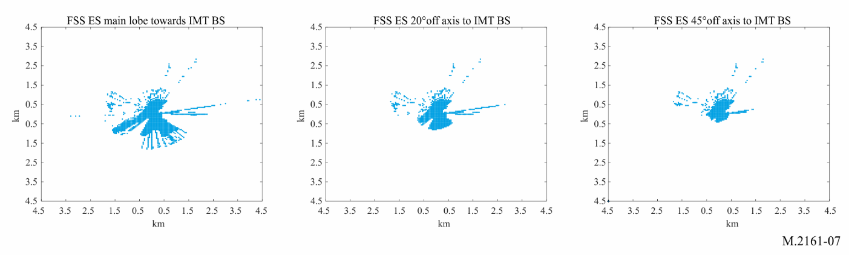
Example C (26 GHz coordination areas around FSS earth station)
A calculation is made of an example coordination area around an FSS earth station in order to show that the impact of following factors can assist administrations in ensuring compatibility between a transmit FSS earth station and a receive IMT base station:
1) Considering the pointing of FSS earth station.
Parameters
The parameters of IMT base station of this example are the same as those of Example B. It was assumed that the electronic steering of IMT BS is the same azimuth as physical antenna angle, the UE is located at the same direction from IMT BS to FSS ES and at the edge of a cell. The BS gain towards ES is always assumed to be 25.79 dBi.
The parameters of FSS earth station are provided in Table 5. The FSS earth station’ antenna was assumed to have a size of 5.6 m, with an elevation angle of 15 degrees.
TABLE 5
FSS earth station parameters
Parameter | Value
Transmit frequency (GHz) | 27.5
Antenna diameter (m) | 5.6
Peak transmit antenna gain (dBi) | 61.8
Peak transmit power spectral density (dB(W/Hz)) | −59
Antenna gain pattern | Rec. ITU-R S.465-6
Antenna height (above ground level) (m) | 6
Elevation angle (degree) | 15

According to Recommendation ITU-R S.465-6, the antenna gain from FSS earth station to IMT base station is 2.6 dBi, −5 dBi, −10 dBi when the off-axis angle towards IMT base station is 15/30/48 degrees, as shown in Fig. 8. If the off-axis angle is larger than 48 degree, the antenna gain is also −10 dBi. 15 degrees off-axis angle of earth station towards IMT base station is the worst case assumption because the elevation angle of earth station is 15 degrees.
Figure 8
FSS earth station antenna gain pattern
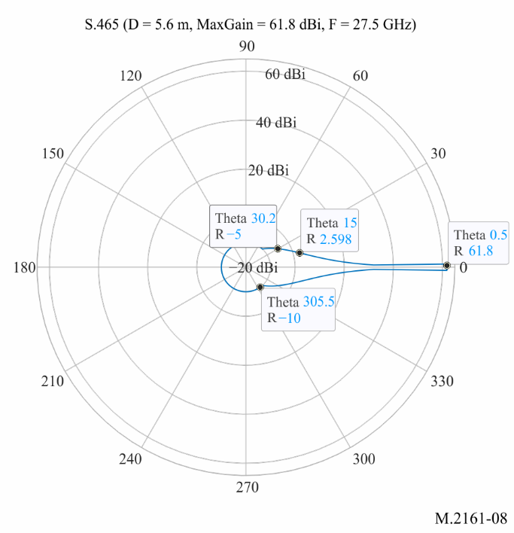
Recommendation ITU-R P.452 was used to calculate the propagation losses. In particular, the time percentage was set to 50%, the average radio refractive index lapse rate through the lowest 1 km (N units per km) was set to 53, and the sea-level surface refractivity (N units) was set to 328. Polarization loss was assumed 3 dB.
Result with statistical distribution of the clutter loss using Recommendation ITU-R P.2108-1
Recommendation ITU-R P.2108-1 was used to calculate the clutter loss. The location percentage was set to 50%.
Figure 9 shows the simulation result.
Figure 9
Example contours around FSS earth station with statistical clutter loss (Rec. ITU-R P.2108-1)
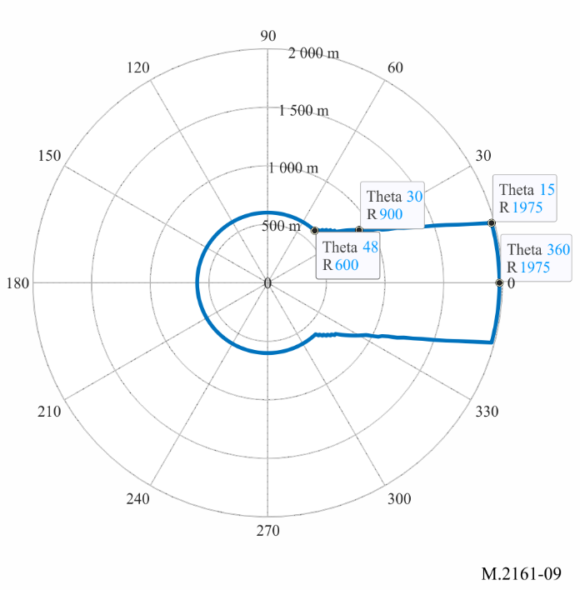

Annex 2
Example of approach for enabling the use of FSS earth stations in the frequency bands 24.65/24.75-25.25 GHz, 27.0-27.5 GHz, 42.5-43.5 GHz and 47.2-48.2 GHz while mitigating their interference into IMT base stations

A2.1 Introduction
This Annex provides relevant approach to facilitate sharing between individually licensed, transmitting FSS earth stations and deployment of IMT systems.
The approach includes siting considerations in the authorization of FSS earth stations and IMT operations and then further technical analysis based on the assumption that IMT stations and FSS ESs can share frequency band in the same geographical area, provided that the aggregate population inside the coordination contours around the FSS ESs does not exceed the established limit. To apply this approach, it is necessary to calculate the coordination contour, as well as to establish the allowable number of the aggregate population that can be within coordination contours.

A2.2 Deployment considerations
Geographic area considerations can promote the flexibility to provide a variety of services, expedite deployment, and can take into account the prospective use of IMT in these bands. Balancing domestic authorizations on wide areas can strike a balance between large and small IMT providers and simplifying frequency coordination while incentivizing investment in, and rapid deployment of, new technologies. Similarly, transmitting earth stations in the subject frequency bands may cause interference to IMT stations if there is no sufficient separation, thus consideration of limiting authorization to individually or area licensed earth stations can set a predictable initial threshold where further coordination can occur. Several regulatory tools to implement coordination are available to ensure the compatible co-frequency operation of FSS with IMT base stations. Examples are aggregate population limits within the specified earth station PFD contour or established maximum number of FSS earth stations that could operate in the same authorized IMT area. Further, population coverage requirements can balance the service requirements for IMT operators while providing geographic areas for FSS operations.

A2.3 Calculation of coordination contour
Interference level from an FSS earth station transmitter, located a certain distance from an IMT system deployment, is considered at IMT base station receiver. The calculation of contour is based on a certain maximum interference level acceptable for an IMT which is characterized as an FSS interference-to-thermal noise ratio (I/N) observed at the IMT base station receiver.
Based on the maximum interference level acceptable for an IMT as I/N = −6 dB and on parameters of existing transmit FSS earth stations, coordination contour around the ES could be defined as a line where PFD, at 10 m above ground level, produces by the ES equal to −77.6 dBm/m²/MHz.
As an example, an operator of a transmitting earth station in the band would be required to demonstrate the area in which the earth station generates a PFD, at 10 m above ground level, of greater than or equal to −77.6 dBm/m²/MHz, together with the area generated by of any other earth stations deployed in the same geographical area does not cover, in the aggregate, more than the amount of an established population limitation of the operational area within which the earth station is located.

A2.4 Aggregate population limit within coordination contours
Administrations have the flexibility to decide what conditions best accommodates the shared use of FSS earth station with the deployment of IMT stations.
TABLE 6
Example population coverage limitations
Population within IMT operational area | Maximum permitted aggregate population within  −77.6 dBm/m²/MHz pfd contour of earth stations
Greater than 450 000 | 0.1 percent of population in IMT operational area
Between 6 000 and 450 000 | 450 people
Fewer than 6 000 | 7.5 percent of population in IMT operational area

Based on the expected deployment for IMT system, it may require to check that the coordination contour does not infringe upon any major event venue, arterial street, interstate or highway, urban mass transit route, passenger railroad or cruise ship port.
Finally, before satellite earth station operators are allowed to operate, they must successfully complete frequency coordination with the IMT stations within the area in which the earth station generates a PFD coordination contour, at 10 m above ground level and equal to −77.6 dBm/m²/MHz with respect to existing facilities constructed and in operation by the IMT system.
In order to facilitate the compliance process for an FSS earth station operator, additional technical guidance is to be provided on computing the PFD coordination contours: the use of applicable propagation models, measured gain patterns, the effect of terrain, clutter and shielding and other conditions. Administrations could provide this information publicly to minimize the impact on IMT operations and provide a predictable operational environment to accommodate multiple earth station zones within an area of interest.

This is based on simulation software that uses a raster/grid/pixel basis in its calculation method. Alternatively, in some simulation software, the coordination area may be calculated on radials. This is where for each azimuth around the FSS earth station, the corresponding distance from the FSS earth station location is calculated.
Some calculation method of Recommendation ITU-R S.580 is quoted from Recommendation ITU-R S.465.
Other applicable percentages could be used by administrations.
The contours for each of the different positions of the user terminals were generated individually. The contours in Fig. 3 are a composite of the different simulation cases that were run.
Other applicable time percentages could be used by administrations.
Other applicable time percentages could be used by administrations.
This PFD, provided as an example, was calculated using assumptions to protection IMT networks from existing transmit FSS earth stations.
“Same geographic area” means territory of all or part of the country depending on licensing regime for IMT operations.
This example could vary administration to administration based on its geographic size, population metrics and existing/new licensing structure.

