|  |  |
| --- | --- |
| **Radiocommunication Study Groups** |  |
| **INTERNATIONAL TELECOMMUNICATION UNION** |  |
|  |  |
| Source: Document 5/199 | **Document 5/BL/22-E** |
| **21 July 2015** |
| **English only** |
| Working Party 5D | |
| DRAFT NEW RECOMMENDATION ITU-R M.[IMT.VISION] | |
| IMT Vision – “Framework and overall objectives of the future  development of IMT for 2020 and beyond” | |

Summary

This Recommendation describes in detail the framework of the future development of IMT for 2020 and beyond, including a broad variety of capabilities associated with envisaged usage scenarios.

Scope

This Recommendation defines the framework and overall objectives of the future development of International Mobile Telecommunications (IMT) for 2020 and beyond in light of the roles that IMT could play to better serve the needs of the networked society, for both developed and developing countries, in the future. In this Recommendation, the framework of the future development of IMT for 2020 and beyond, including a broad variety of capabilities associated with envisaged usage scenarios, is described in detail. Furthermore, this Recommendation addresses the objectives of the future development of IMT for 2020 and beyond, which includes further enhancement of existing IMT and the development of IMT-2020. It should be noted that this Recommendation is defined considering the development of IMT to date based on Recommendation ITU-R M.1645.

Keywords

IMT, IMT-2020

Abbreviations/Glossary

ICT Information and Communication Technology

IMT International Mobile Telecommunications

IoT Internet of Things

M2M Machine-to-Machine

MIMO Multiple Input Multiple Output

QoE Quality of Experience

QoS Quality of Service

RAT Radio access technology

RLAN Radio Local Area Network

Related ITU Recommendations, Reports

Recommendation ITU-R M.1645: Framework and overall objectives of the future development of IMT‑2000 and systems beyond IMT‑2000.

Recommendation ITU-R M.2012: Detailed specifications of the terrestrial radio interfaces of International Mobile Telecommunications Advanced (IMT-Advanced).

Report ITU-R M.[IMT.BEYOND2020.TRAFFIC]: IMT Traffic estimates for the years 2020 to 2030.

Report ITU-R M.2320: Future technology trends of terrestrial IMT systems.

Report ITU-R M.[IMT.ABOVE 6 GHz]: Technical feasibility of IMT in bands above 6 GHz.

Report ITU-R M.2134: Requirements related to technical performance for IMT‑Advanced radio interface(s).

The ITU Radiocommunication Assembly,

*considering*

*a)* that ITU has contributed to standardization and harmonized use of IMT, which has provided telecommunication services on a global scale;

*b)* that technological advancement and the corresponding user needs will promote innovation and accelerate the delivery of advanced communication applications to consumers;

*c)* that Question ITU-R 229/5 addresses further development of the terrestrial component of IMT and the relevant studies under this Question are in progress within ITU‑R;

*d)* that Recommendation ITU-R M.1645 defines the framework and overall objectives of the future development of IMT-2000 and systems beyond IMT-2000;

*e)* that for global operation and economies of scale, which are key requirements for the success of mobile telecommunication systems, it is desirable to establish a harmonized timeframe for future development of IMT considering technical, operational and spectrum related aspects;

*f)* that wireless communication applications are expected to expand into new market segments to facilitate the digital economy, e.g., smart grid, e-health, intelligent transport systems and traffic control, which would bring requirements beyond what can be addressed in today’s IMT application areas;

*g)* that rapid uptake of smart phones, tablets and innovative mobile applications created by users has resulted in a tremendous increase in the volume of mobile data traffic;

*h)* that the number of devices accessing the network are expected to increase due to the emerging applications of Internet of Things (IoT);

*i)* that technologies such as beamforming, massive-Multiple Input Multiple Output (MIMO) are easier to implement in higher frequencies due to short wavelength;

*j)* that wide contiguous bandwidth would enhance data delivery efficiency and ease the complexity of hardware implementation;

*k)* that the cell size is being reduced (e.g. the order of some tens of meters) to provide larger area traffic capacity in dense areas;

*l)* that IMT interworks with other radio systems,

*recognizing*

*a)* that some administrations had deployed IMT-Advanced systems before global deployment due to the rapid increase of data traffic;

*b)* that development of new radio interfaces that support the new capabilities of IMT-2020 is expected along with the enhancement of IMT-2000 and IMT-Advanced systems,

*noting*

that pursuant to Article 44 of the ITU Constitution, Member States shall endeavour to

apply the latest technical advances as soon as possible,

*recommends*

that the Annex should be used as the framework and the overall objectives for the future development of IMT for 2020 and beyond.

ANNEX

TABLE OF CONTENTS

1 Introduction 6

2 Observation of trends 6

2.1 User and application trends 6

2.1.1 Supporting very low latency and high reliability human-centric communication 6

2.1.2 Supporting very low latency and high reliability machine-centric communication 6

2.1.3 Supporting high user density 6

2.1.4 Maintaining high quality at high mobility 7

2.1.5 Enhanced multimedia services 7

2.1.6 Internet of Things 7

2.1.7 Convergence of applications 7

2.1.8 Ultra-accurate positioning applications 8

2.2 Growth in IMT traffic 8

2.3 Technology trends 8

2.3.1 Technologies to enhance the radio interface 8

2.3.2 Network technologies 9

2.3.3 Technologies to enhance mobile broadband scenarios 9

2.3.4 Technologies to enhance massive machine type communications 9

2.3.5 Technologies to enhance ultra-reliable and low latency communications 9

2.3.6 Technologies to improve network energy efficiency 10

2.3.7 Terminal technologies 10

2.3.8 Technologies to enhance privacy and security 10

2.3.9 Technologies enabling higher data rates 10

2.4 Studies on technical feasibility of IMT between 6 and 100 GHz 10

2.5 Spectrum implications 11

2.5.1 Spectrum harmonization 11

2.5.2 Importance of contiguous and wider spectrum bandwidth 12

3 Evolution of IMT 12

3.1 How IMT has developed 12

3.2 Role of IMT for 2020 and beyond 13

4 Usage scenarios for IMT for 2020 and beyond 14

5 Capabilities of IMT-2020 15

6 Framework and objectives 20

6.1 Relationships 20

6.1.1 Relationship between existing IMT and IMT-2020 20

6.1.2 Relationship between IMT-2020 and other access systems 20

6.2 Timelines 20

6.2.1 Medium term 21

6.2.2 Long term 22

6.3 Focus areas for further study 22

# **1 Introduction**

The socio-technical evolution in the last few decades has been significantly driven by the evolution of mobile communications and has contributed to the economic and social development of both developed and developing countries. Mobile communications has become closely integrated in the daily life of the whole society. It is expected that the socio-technical trends and the evolution of mobile communications systems will remain tightly coupled together and will form a foundation for society in 2020 and beyond.

In the future, however, it is foreseen that new demands, such as more traffic volume, many more devices with diverse service requirements, better quality of user experience (QoE) and better affordability by further reducing costs, will require an increasing number of innovative solutions.

The objective of this Recommendation is to establish the vision for IMT for 2020 and beyond, by describing potential user and application trends, growth in traffic, technological trends and spectrum implications, and by providing guidelines on the framework and the capabilities for IMT for 2020 and beyond.

# 2 Observation of trends

## **2.1 User and application trends**

Mobile devices play various, continuously evolving roles in everyday life. Future IMT systems should support emerging new use cases, including applications requiring very high data rate communications, a large number of connected devices, and ultra-low latency and high reliability applications. More specific user and application trends are explained in sections 2.1.1 to 2.1.8.

### 2.1.1 Supporting very low latency and high reliability human-centric communication

People expect the experience of instantaneous connectivity wherein applications need to exhibit “flash” behaviour without waiting times: a single click and the response is perceived as instantaneous. Flash behaviour will be a key factor for the success of cloud services and virtual reality and augmented reality applications. The low latency and high reliability communication that supports such behaviour thus becomes an enabler for the future development of new applications, e.g. in health, safety, office, entertainment, and other sectors.

### 2.1.2 Supporting very low latency and high reliability machine-centric communication

The reliability and latency in today’s communication systems have been designed with the human user in mind. For future wireless systems, the design of new applications is envisaged based on machine-to-machine (M2M) communication with real-time constraints. Driverless cars, enhanced mobile cloud services, real-time traffic control optimization, emergency and disaster response, smart grid, e-health or efficient industrial communications are examples of where low latency and high reliability can improve quality of life.

### 2.1.3 Supporting high user density

Users will expect a satisfactory end-user experience in the presence of a large number of concurrent users, for example in a crowd with a high traffic density per unit area and a large number of handsets and machines/devices per unit area. Examples are audio-visual content to be provided concurrently across an entire cell or infotainment applications in shopping malls, stadiums, open air festivals, or other public events that attract a lot of people. This includes users who use their phone while in unexpected traffic jams, or when travelling in public transportation systems, as well as professionals working in organisations such as police, fire brigades, and ambulances to exploit the public communication networks in crowded environments and machine-centric devices.

### 2.1.4 Maintaining high quality at high mobility

A connected society in the years beyond 2020 will need to accommodate a similar user experience for end-users on the move and when they are static e.g. at home or in the office. To offer the “best experience” to highly mobile users and communicating machine devices, robust and reliable connectivity solutions are needed as well as the ability to efficiently maintain service quality with mobility.

Maintaining high quality at high mobility will enable successful deployment of applications on user equipment located within a moving platform such as cars or high-speed trains which are being deployed in several countries. Connectivity on mobile platforms may be provided via IMT, Radio Local Area Network (RLAN) or another network on that platform using suitable backhaul.

### 2.1.5 Enhanced multimedia services

It is likely that demand for mobile high-definition multimedia will increase in many areas beyond entertainment, such as medical treatment, safety, and security.

User devices will get enhanced media consumption capabilities, such as Ultra-High Definition display, multi-view High Definition display, mobile 3D projections, immersive video conferencing, and augmented reality and mixed reality display and interface. This will all lead to a demand for significantly higher data rates. Media delivery will be both to individuals and to groups of users.

### 2.1.6 Internet of Things

In the future, every object that can benefit from being connected will be connected through wired or wireless internet technologies. Therefore, the number of connected devices will grow rapidly and is expected to exceed the number of human user devices in the future.

These connected “things” can be smart phones, sensors, actuators, cameras, vehicles, etc., ranging from low-complexity devices to highly complex and advanced devices. A significant number of connected devices are expected to use IMT systems.

As a result, the connected entities are bound to have varying levels of energy consumption, transmission power, latency requirements, cost, and many other indices critical for stable connection.

In addition, as more and more things get connected, various services that utilize the connection capabilities of things will appear. Smart energy distribution grid system, agriculture, healthcare, vehicle-to-vehicle and vehicle-to-road infrastructure communication are generally viewed as potential fields for further growth of the Internet of Things.

### 2.1.7 Convergence of applications

New applications are increasingly being delivered over IMT, including e-Government, public protection and disaster relief communication, education, linear[1] and on-demand audio-visual content, and e-health. This convergence of applications must take account of the requirements associated with these applications.

### 2.1.8 Ultra-accurate positioning applications

As the accuracy of positioning gets better, location-based service applications that provide improved emergency rescue services, as well as precise ground based navigation service for unmanned vehicles or drones may expand extensively.

## 2.2 Growth in IMT traffic

There are many drivers influencing the growth of future IMT traffic demand, especially the adoption of devices with enhanced capabilities that require increased bit rates and bandwidth usage. Similar drivers increased traffic in the transition from IMT-2000 to IMT-Advanced.

The main drivers behind the anticipated traffic growth include increased video usage, device proliferation and application uptake. These are expected to evolve over time, and this evolution will differ between countries due to social and economic differences. These drivers and other trends which impact traffic growth are detailed in Report ITU-R M.[IMT.2020BEYOND TRAFFIC].

This Report contains global IMT traffic estimates beyond 2020 from several sources. These estimates anticipate that global IMT traffic will grow in the range of 10-100 times from 2020 to 2030.

Traffic asymmetry aspects for this period are also presented in this Report. It is observed that the current average traffic asymmetry ratio of mobile broadband is in favour of the downlink, and this is expected to increase due to growing demand for audio-visual content.

2.3 Technology trends

Report ITU-R M.2320 provides a broad view of future technical aspects of terrestrial IMT systems considering the time frame 2015-2020 and beyond. It includes information on technical and operational characteristics of IMT systems, including the evolution of IMT through advances in technology and spectrally-efficient techniques, and their deployment. Report ITU-R M.2320 provides more detailed information on the following technical aspects presented in sections 2.3.1 to 2.3.8. In addition, technologies required to enable higher data rates are explained in section 2.3.9.

### 2.3.1 Technologies to enhance the radio interface

Advanced waveforms, modulation and coding, and multiple access schemes, e.g. filtered OFDM (FOFDM), filter bank multi-carrier modulation (FBMC), pattern division multiple access (PDMA), sparse code multiple access (SCMA), interleave division multiple access (IDMA) and low density spreading (LDS) may improve the spectral efficiency of the future IMT systems.

Advanced antenna technologies such as 3D-beamforming (3D-BF), active antenna system (AAS), massive MIMO and network MIMO will achieve better spectrum efficiency.

In addition, TDD-FDD joint operation, dual connectivity and dynamic TDD can enhance the spectrum flexibility.

Simultaneous transmission and reception on the same frequency with self-interference cancellation could increase spectrum efficiency.

Other techniques such as flexible backhaul and dynamic radio access configurations can also enable enhancements to the radio interface.

In small cells, higher-order modulation and modifications to the reference-signal structure with reduced overhead may provide performance enhancements due to lower mobility in small cell deployments and potentially higher signal-to interference ratios compared to the wide-area case.

Flexible spectrum usage, joint management of multiple radio access technologies (RATs) and flexible uplink/downlink resource allocation, can provide technical solutions to address the growing traffic demand in the future and may allow more efficient use of radio resources.

### 2.3.2 Network technologies

Future IMT will require more flexible network nodes which are configurable based on the Software-Defined Networking (SDN) architecture and network function virtualization (NFV) for optimal processing the node functions and improving the operational efficiency of network.

Featuring centralized and collaborative system operation, the cloud RAN (C-RAN) encompasses the baseband and higher layer processing resources to form a pool so that these resources can be managed and allocated dynamically on demand, while the radio units and antenna are deployed in a distributed manner.

The radio access network (RAN) architecture should support a wide range of options for inter-cell coordination schemes. The advanced self‑organizing network (SON) technology is one example solution to enable operators to improve the OPEX efficiency of the multi-RAT and multi-layer network, while satisfying the increasing throughput requirement of subscriber.

### 2.3.3 Technologies to enhance mobile broadband scenarios

A relay based multi-hop network can greatly enhance the Quality of Service (QoS) of cell edge users. Small-cell deployment can improve the QoS of users by decreasing the number of users in a cell and user quality of experience can be enhanced.

Dynamic adaptive streaming over HTTP (DASH) enhancement is expected to improve user experience and accommodate more video streaming content in existing infrastructure.

Bandwidth saving and transmission efficiency improvement is an evolving trend for Evolved Multimedia Broadcast and Multicast Service (eMBMS). Dynamic switching between unicast and multicast transmission can be beneficial.

IMT systems currently provide support for RLAN interworking, at the core network level, including seamless as well as non-seamless mobility, and can offload traffic from cellular networks into license-exempt spectrum bands.

Context aware applications may provide more personalized services that ensure high QoE for the end user and proactive adaptation to the changing context.

Proximity-based techniques can provide applications with information whether two devices are in close proximity of each other, as well as enable direct device-to-device (D2D) communication. Group communication, including push-to-talk type of communication, is highly desirable for public safety.

### 2.3.4 Technologies to enhance massive machine type communications

Future IMT systems are expected to connect a large number of M2M devices with a range of performance and operational requirements, with further improvement of low-cost and low‑complexity device types as well as extension of coverage.

### 2.3.5 Technologies to enhance ultra-reliable and low latency communications

To achieve ultra-low latency, the data and control planes may both require significant enhancements and new technical solutions addressing both the radio interface and network architecture aspects.

It is envisioned that future wireless systems will, to a larger extent, also be used in the context of machine-to-machine communications, for instance in the field of traffic safety, traffic efficiency, smart grid, e-health, wireless industry automation, augmented reality, remote tactile control and tele-protection, requiring high reliability techniques.

### 2.3.6 Technologies to improve network energy efficiency

In order to enhance energy efficiency, energy consumption should be considered in the protocol design.

The energy efficiency of a network can be improved by both reducing RF transmit power and saving circuit power. To enhance energy efficiency, the traffic variation characteristic of different users should be well exploited for adaptive resource management. Examples include discontinuous transmission (DTX), base station and antenna muting, and traffic balancing among multiple RATs.

### 2.3.7 Terminal technologies

The mobile terminal will become a more human friendly companion as a multi-purpose Information and Communication Technology (ICT) device for personal office and entertainment, and will also evolve from being predominantly a hand-held smart phone to also include wearable smart devices.

Technologies for chip, battery, and display should therefore be further improved.

### 2.3.8 Technologies to enhance privacy and security

Future IMT systems need to provide robust and secure solutions to counter the threats to security and privacy brought by new radio technologies, new services and new deployment cases.

### 2.3.9 Technologies enabling higher data rates

In order to achieve higher data rates and improvements in capacity, the following key techniques are needed:

Spectrum:

* Utilization of large blocks of spectrum in higher frequency bands
* Carrier aggregation

Physical Layer:

* Enhanced spectral efficiency by means of e.g. advanced physical layer techniques (modulation, coding) and advances in spatial processing (network MIMO and Massive MIMO), plus exploitation of other novel/alternative ideas.

Network:

* Network densification

## 2.4 **Studies on technical feasibility of IMT between 6 and 100 GHz**

The development of IMT for 2020 and beyond is expected to enable new use cases and applications, and addresses rapid traffic growth, for which contiguous and broader channel bandwidths than currently available for IMT systems would be desirable. This suggests the need to consider spectrum resources in higher frequency ranges.

Report ITU-R M.[IMT.ABOVE.6 GHz] provides information on the technical feasibility of IMT in the frequencies between 6 and 100 GHz. It includes information on potential new IMT radio technologies and system approaches, which could be appropriate for operation in this frequency range.

The Report presents measurement data on propagation in this frequency range in several different environments. Both line-of-sight and non-line-of-sight measurement results for stationary and mobile cases as well as outdoor-to-indoor results have been presented in the report. It also includes performance simulations results for several different deployment scenarios.

The Report describes solutions based on MIMO and beamforming with a large number of antenna elements, which compensate for the increasing propagation loss with frequency; these have become increasingly feasible due to the ability to exploit chip-scale antenna solutions and modular adaptive antenna arrays that do not require an ADC/DAC for each antenna element. The practicality of manufacturing commercial transmitters and receivers at these frequencies is investigated, as evidenced by availability of commercial 60 GHz multi-gigabit wireless systems (MGWS) products and prototyping activities that are already underway at frequencies such as 11, 15, 28, 44, 70 and 80 GHz.

The potential advantages of using the same spectrum for both access and fronthaul/backhaul, as compared with using two different frequencies for access and fronthaul/backhaul, are described in the Report.

The theoretical assessment, simulations, measurements, technology development and prototyping described in this Report indicate that utilizing the bands between 6 and 100 GHz is feasible for studied IMT deployment scenarios, and could be considered for the development of IMT for 2020 and beyond.

## 2.5 Spectrum implications

Report ITU-R M.2290 provides the results of studies on estimated global spectrum requirements for terrestrial IMT in the year 2020. The estimated total requirements include spectrum already identified for IMT plus additional spectrum requirements.

It is noted that no single frequency range satisfies all the criteria required to deploy IMT systems, particularly in countries with diverse geographic and population density: therefore, to meet the capacity and coverage requirements of IMT systems multiple frequency ranges would be needed.  
It should be noted that there are differences in the markets and deployments and timings of the mobile data growth in different countries.

For future IMT systems in the year 2020 and beyond, contiguous and broader channel bandwidths than available to current IMT systems would be desirable to support continued growth. Therefore, availability of spectrum resources that could support broader, contiguous channel bandwidths in this time frame should be explored. Research efforts must be continued to increase spectrum efficiency and to explore the availability of contiguous broad channels.

Furthermore, if additional spectrum is made available for IMT, the potential implications to the existing uses and users of that spectrum need to be addressed.

### 2.5.1 Spectrum harmonization

As the amount of spectrum required for mobile services increases, it becomes increasingly desirable for existing and newly allocated and identified spectrum to be harmonized. The benefits of spectrum harmonization include: facilitating economies of scale, enabling global roaming, reducing equipment design complexity, preserving battery life, improving spectrum efficiency and potentially reducing cross border interference. Typically, a mobile device contains multiple antennas and associated radio frequency front-ends to enable operation in multiple bands to facilitate roaming. While mobile devices can benefit from common chipsets, variances in frequency arrangements necessitate different components to accommodate these differences, which leads to higher equipment design complexity.

Therefore, harmonization of spectrum for IMT will lead to commonality of equipment and is desirable for achieving economies of scale and affordability of equipment.

### 2.5.2 Importance of contiguous and wider spectrum bandwidth

The proliferation of smart devices (e.g. smartphones, tablets, televisions, etc.) and a wide range of applications requiring a large amount of data traffic have accelerated demand for wireless data traffic. Future IMT systems are expected to provide significant improvement to accommodate this rapidly increasing traffic demand. In addition, future IMT systems are expected to provide gigabit‑per-second user data rate services. The currently available frequency bands and their bandwidth differ across countries and regions and this leads to many problems associated with device complexity and possible interference issues. Contiguous, broader and harmonized frequency bands, aligned with future technology development, would address these problems and would facilitate achievement of the objectives of future IMT systems.

In particular, bandwidths to support the different usage scenarios in section 4 (e.g. enhanced mobile broadband, ultra-reliable and low-latency communications, and massive machine type communications) would vary. For those scenarios requiring several hundred MHz up to at least 1 GHz, there would be a need to consider wideband contiguous spectrum above 6 GHz.

# 3 Evolution of IMT

3.1 How IMT has developed

Following the adoption by International Radio Consultative Committee (CCIR) of the Study Question on the Future Public Land Mobile Telecommunication Systems (FPLMTS) in 1985,  
 it took a total of 15 years for the identification of the radio spectrum in 1992 and development of IMT-2000 specifications (Recommendation ITU-R M.1457). After this development, deployment of IMT-2000 systems started.

The ITU then immediately started to develop the vision recommendation (Recommendation   
ITU-R M.1645, June 2003) on “Framework and overall objectives of the future development of IMT-2000 and systems beyond IMT-2000”. Based on this Recommendation, the ITU has released the Recommendation ITU-R M.2012 in the terrestrial radio interface of IMT-Advanced in 2012. It took 9 years for the ITU to develop the second phase of IMT after the completion of the vision recommendation. After this development, deployment of the IMT-Advanced systems started.

Figure 1

**Overview of timeline for IMT development and deployment**



## 3.2 Role of IMT for 2020 and beyond

IMT systems serve as a communication tool for people and a facilitator which assists the development of other industry sectors, such as medical science, transportation, and education. Considering the key trends described in section 2, IMT should continue to contribute to the following:

– **Wireless infrastructure to connect the world**: Broadband connectivity will acquire the same level of importance as access to electricity. IMT will continue to play an important role in this context as it will act as one of the key pillars to enable mobile service delivery and information exchanges. In the future, private and professional users will be provided with a wide variety of applications and services, ranging from infotainment services to new industrial and professional applications.

– **New ICT market**: The development of future IMT systems is expected to promote the emergence of an integrated ICT industry which will constitute a driver for economies around the globe. Some possible areas include: the accumulation, aggregation and analysis of big data; delivering customized networking services for enterprise and social network groups on wireless networks

– **Bridging the Digital Divide**: IMT will continue to help closing the gaps caused by an increasing Digital Divide. Affordable, sustainable and easy-to-deploy mobile and wireless communication systems can support this objective while effectively saving energy and maximizing efficiency.

– **New ways of communication**: IMT will enable sharing of any type of contents anytime, anywhere through any device. Users will generate more content and share this content without being limited by time and location.

– **New forms of education:** IMT can change the method of education by providing easy access to digital textbooks or cloud-based storage of knowledge on the internet, boosting applications such as e-learning, e‑health, and e-commerce.

– **Promote Energy Efficiency**: IMT enables energy efficiency across a range of sectors of the economy by supporting machine to machine communication and solutions such as smart grid, teleconferencing, smart logistics and transportation.

– **Social changes**: Broadband networks make it easier to quickly form and share public opinions for a political or social issue through social network service. Opinion formation of a huge number of connected people due to their ability to exchange information anytime anywhere will become a key driver of social changes.

– **New art and culture**: IMT will support people to create works of art or participate in group performances or activities, such as a virtual chorus, flash mob, co-authoring or song writing. Also, people connected to a virtual world are able to form new types of communities and establish their own cultures.

# **4 Usage scenarios for IMT for 2020 and beyond**

IMT for 2020 and beyond is envisaged to expand and support diverse usage scenarios and applications that will continue beyond the current IMT. Furthermore, a broad variety of capabilities would be tightly coupled with these intended different usage scenarios and applications for IMT for 2020 and beyond. The usage scenarios for IMT for 2020 and beyond include:

– **Enhanced Mobile Broadband:** Mobile Broadband addresses the human-centric use cases for access to multi-media content, services and data. The demand for mobile broadband will continue to increase, leading to enhanced Mobile Broadband. The enhanced Mobile Broadband usage scenario will come with new application areas and requirements in addition to existing Mobile Broadband applications for improved performance and an increasingly seamless user experience. This usage scenario covers a range of cases, including wide-area coverage and hotspot, which have different requirements. For the hotspot case, i.e., for an area with high user density, very high traffic capacity is needed, while the requirement for mobility is low and user data rate is higher than that of wide area coverage. For the wide area coverage case, seamless coverage and medium to high mobility are desired, with much improved user data rate compared to existing data rates. However the data rate requirement may be relaxed compared to hotspot.

– **Ultra-reliable and low latency communications:** This use case has stringent requirements for capabilities such as throughput, latency and availability. Some examples include wireless control of industrial manufacturing or production processes, remote medical surgery, distribution automation in a smart grid, transportation safety, etc.

– **Massive machine type communications**: This use case is characterized by a very large number of connected devices typically transmitting a relatively low volume of   
non-delay-sensitive data. Devices are required to be low cost, and have a very long battery life.

Additional use cases are expected to emerge, which are currently not foreseen. For future IMT, flexibility will be necessary to adapt to new use cases that come with a wide range of requirements.

Future IMT systems will encompass a large number of different features. Depending on the circumstances and the different needs in different countries, future IMT systems should be designed in a highly modular manner so that not all features have to be implemented in all networks.

Figure 2 illustrates some examples of envisioned usage scenarios for IMT for 2020 and beyond.

Figure 2

**Usage Scenarios of IMT for 2020 and beyond**

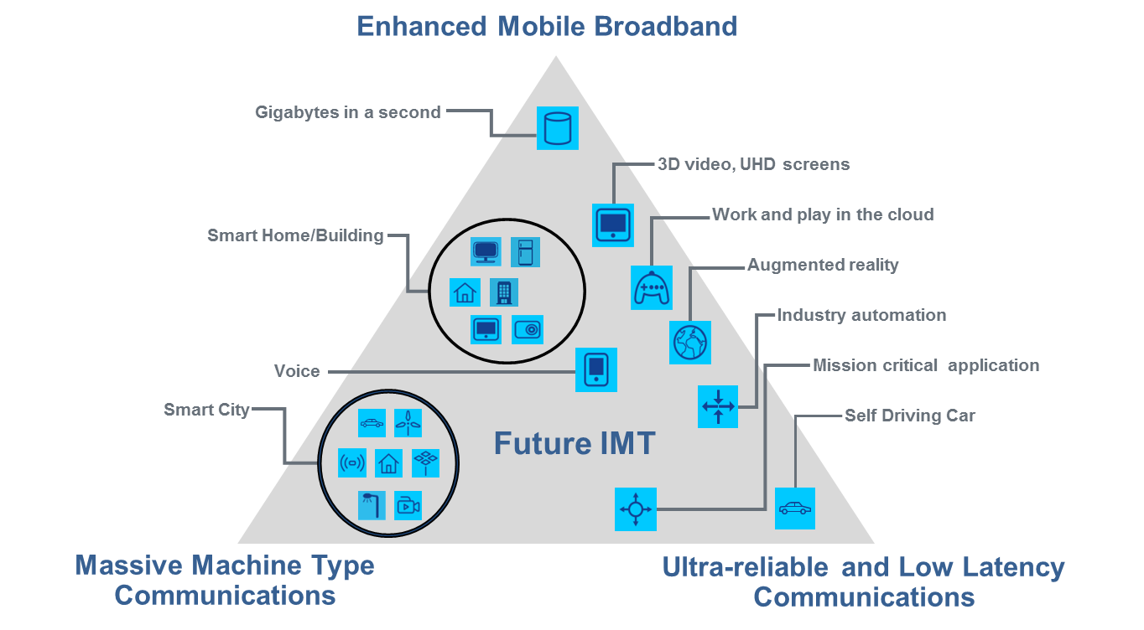

# 5 Capabilities of IMT-2020

IMT for 2020 and beyond is expected to provide far more enhanced capabilities than those described in Recommendation ITU-R M.1645, and these enhanced capabilities could be regarded as new capabilities of future IMT. As ITU-R will give a new term IMT-2020 to those systems, system components, and related aspects that support these new capabilities, the term IMT-2020 is used in the following sections.

A broad variety of capabilities, tightly coupled with intended usage scenarios and applications for IMT-2020 is envisioned. Different usage scenarios along with the current and future trends will result in a great diversity/variety of requirements. The key design principles are flexibility and diversity to serve many different use cases and scenarios, for which the capabilities of IMT-2020, described in the following paragraphs, will have different relevance and applicability. In addition, the constraints on network energy consumption and the spectrum resource will need to be considered.

The following eight parameters are considered to be key capabilities of IMT-2020:

Peak data rate

Maximum achievable data rate under ideal conditions per user/device (in Gbit/s).

User experienced data rate

Achievable data rate that is available ubiquitously[2] across the coverage area to a mobile user/device (in Mbit/s or Gbit/s).

Latency

The contribution by the radio network to the time from when the source sends a packet to when the destination receives it (in ms).

Mobility

Maximum speed at which a defined QoS and seamless transfer between radio nodes which may belong to different layers and/or radio access technologies (multi-layer/-RAT) can be achieved (in km/h).

Connection density

Total number of connected and/or accessible devices per unit area (per km2).

Energy efficiency

Energy efficiency has two aspects:

– on the network side, energy efficiency refers to the quantity of information bits transmitted to/ received from users, per unit of energy consumption of the radio access network (RAN) (in bit/Joule);

– on the device side, energy efficiency refers to quantity of information bits per unit of energy consumption of the communication module (in bit/Joule).

**Spectrum efficiency**

Average data throughput per unit of spectrum resource and per cell[3] (bit/s/Hz).

Area traffic capacity

Total traffic throughput served per geographic area (in Mbit/s/m2).

IMT-2020 is expected to provide a user experience matching, as far as possible, fixed networks. The enhancement will be realized by increased peak and user experienced data rate, enhanced spectrum efficiency, reduced latency and enhanced mobility support.

In addition to the conventional human-to-human or human-to-machine communication, IMT‑2020 will realize the Internet of Things by connecting a vast range of smart appliances, machines and other objects without human intervention.

IMT-2020 should be able to provide these capabilities without undue burden on energy consumption, network equipment cost and deployment cost to make future IMT sustainable and affordable.

The key capabilities of IMT-2020 are shown in Figure 3, compared with those of IMT‑Advanced.

Figure 3

**Enhancement of key capabilities from IMT-Advanced to IMT-2020**

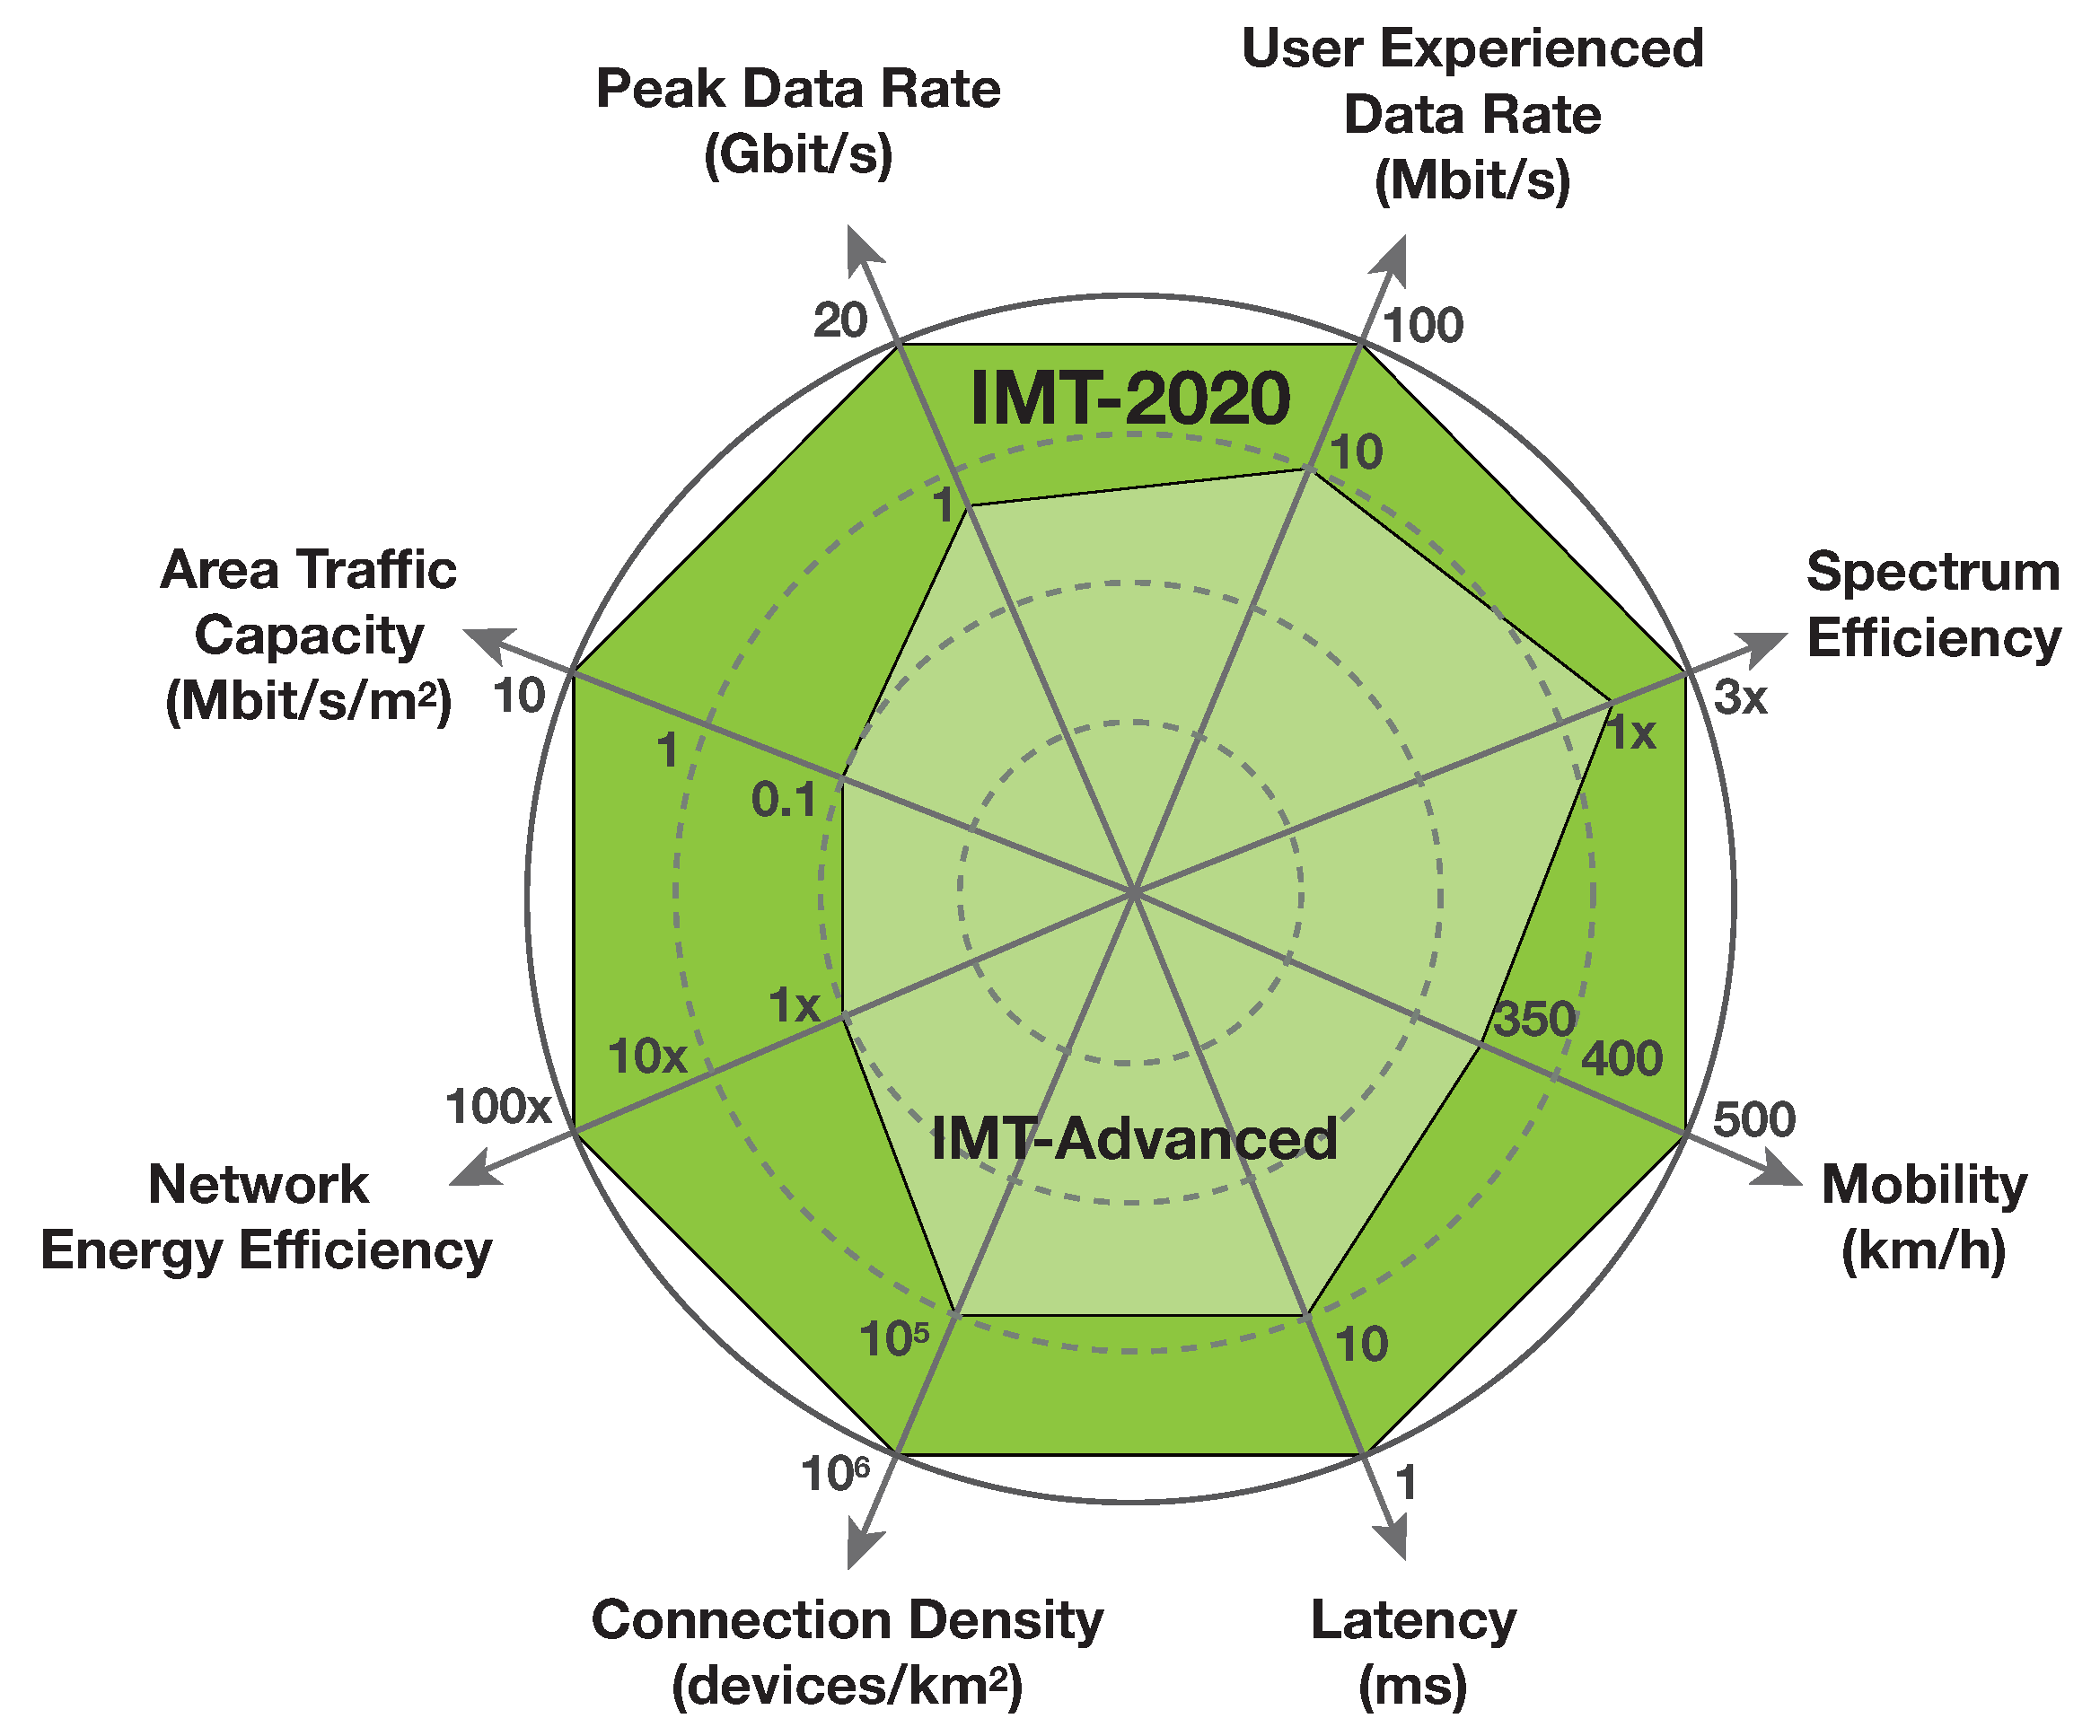

The values in the figure above are targets for research and investigation for IMT-2020 and may be further developed in other ITU-R Recommendations, and may be revised in the light of future studies. The targets are further described below.

The peak data rate of IMT-2020 for enhanced Mobile Broadband is expected to reach 10 Gbit/s. However under certain conditions and scenarios IMT-2020 would support up to 20 Gbit/s peak data rate, as shown in Figure 3. IMT-2020 would support different user experienced data rates covering a variety of environments for enhanced Mobile Broadband. For wide area coverage cases, e.g. in urban and sub-urban areas, a user experienced data rate of 100 Mbit/s is expected to be enabled. In hotspot cases, the user experienced data rate is expected to reach higher values (e.g. 1 Gbit/s indoor).

The spectrum efficiency is expected to be 3 times higher compared to IMT-Advanced for enhanced Mobile Broadband. The achievable increase in efficiency from IMT-Advanced will vary between scenarios and could be higher in some scenarios (for example 5 times subject to further research). IMT-2020 is expected to support 10 Mbit/s/m2 area traffic capacity, for example in hot spots.

The energy consumption for the radio access network of IMT-2020 should not be greater than IMT networks deployed today, while delivering the enhanced capabilities. The network energy efficiency should therefore be improved by a factor at least as great as the envisaged traffic capacity increase of IMT-2020 relative to IMT-Advanced for enhanced Mobile Broadband.

IMT-2020 would be able to provide 1 ms over-the-air latency, capable of supporting services with very low latency requirements. IMT-2020 is also expected to enable high mobility up to 500 km/h with acceptable QoS. This is envisioned in particular for high speed trains.

Finally, IMT-2020 is expected to support a connection density of up to 106 /km2, for example in massive machine type communication scenarios.

The reference values for IMT-Advanced shown in Figure 3 for the peak data rate, mobility, spectrum efficiency and latency are extracted from Report ITU-R M.2134; this was published in 2008 and was used for the evaluation of IMT-Advanced candidate radio interfaces described in Recommendation ITU-R M.2012.

As anticipated above, whilst all key capabilities may to some extent be important for most use cases, the relevance of certain key capabilities may be significantly different, depending on the use cases/scenario. The importance of each key capability for the usage scenarios *enhanced* *Mobile Broadband*, *ultra-reliable and low latency communication* and *massive machine-type communication* is illustrated in Figure 4. This is done using an indicative scaling in three steps as “high”, “medium” and “low”.

In the enhanced Mobile Broadband scenario, user experienced data rate, area traffic capacity,  
peak data rate, mobility, energy efficiency and spectrum efficiency all have high importance, but mobility and the user experienced data rate would not have equal importance simultaneously in all use cases. For example, in hotspots, a higher user experienced data rate, but a lower mobility, would be required than in wide area coverage case.

In some ultra-reliable and low latency communications scenarios, low latency is of highest importance, e.g. in order to enable the safety critical applications. Such capability would be required in some high mobility cases as well, e.g., in transportation safety, while, e.g. high data rates could be less important.

In the massive machine type communication scenario, high connection density is needed to support tremendous number of devices in the network that e.g. may transmit only occasionally, at low bit rate and with zero/very low mobility. A low cost device with long operational lifetime is vital for this usage scenario.

Figure 4

**The importance of key capabilities in different usage scenarios**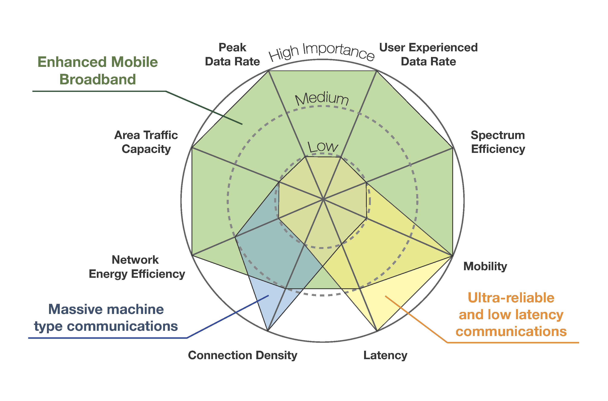

Other capabilities may be also required for IMT-2020, which would make future IMT more flexible, reliable, and secure when providing diverse services in the intended usage scenarios:

Spectrum and bandwidth flexibility

Spectrum and bandwidth flexibility refers to the flexibility of the system design to handle different scenarios, and in particular to the capability to operate at different frequency ranges, including higher frequencies and wider channel bandwidths than today.

Reliability

Reliability relates to the capability to provide a given service with a very high level of availability.

Resilience

Resilience is the ability of the network to continue operating correctly during and after a natural or man-made disturbance, such as the loss of mains power.

Security and privacy

Security and privacy refers to several areas such as encryption and integrity protection of user data and signalling, as well as end user privacy preventing unauthorized user tracking, and protection of network against hacking, fraud, denial of service, man in the middle attacks etc.

Operational lifetime

Operational life time refers to operation time per stored energy capacity. This is particularly important for machine-type devices requiring a very long battery life (e.g., more than 10 years) whose regular maintenance is difficult due to physical or economic reasons.

# **6 Framework and objectives**

The objective of the development of IMT-2020 is to address the anticipated needs of users of mobile services in the years 2020 and beyond. The goals for the capabilities of IMT-2020 system described in section 5 are only targets for research and investigation and may be further developed in other ITU Recommendations, and may be revised in the light of future studies. This section provides relationships between IMT-2020 and existing IMT/other access systems, timelines and focus areas for further study as framework and objectives for the development of IMT-2020.

## **6.1 Relationships**

### 6.1.1 Relationship between existing IMT and IMT-2020

In order to support emerging new scenarios and applications for 2020 and beyond, it is foreseen that development of IMT-2020 will be required to offer enhanced capabilities as those described in section 5. The values of these capabilities go beyond those described in Recommendation   
ITU-R M.1645. The minimum technical requirements (and corresponding evaluation criteria) to be defined by ITU-R based on these capabilities for IMT-2020 could potentially be met by adding enhancements to existing IMT, incorporating new technology components and functionalities, and/or the development of new radio interface technologies.

Furthermore, IMT-2020 will interwork with and complement existing IMT and its enhancements.

### 6.1.2 Relationship between IMT-2020 and other access systems

Users should be able to access services anywhere, anytime. To achieve this goal, interworking will be necessary among various access technologies, which might include a combination of different fixed, terrestrial and satellite networks. Each component should fulfil its own role, but also should be integrated or interoperable with other components to provide ubiquitous seamless coverage.

IMT-2020 will interwork with other radio systems, such as RLANs, broadband wireless access, broadcast networks, and their possible future enhancements. IMT systems will also closely interwork with other radio systems for users to be optimally and cost‑effectively connected.

## 6.2 Timelines

In planning for the development of IMT-2020 as well as future enhancement of the existing IMT,  
it is important to consider the timelines associated with their realization, which depend on a number of factors:

* user trends, requirements and user demand;
* technical capabilities and technology development;
* standards development and their enhancement;
* spectrum matters;
* regulatory considerations;
* system deployment.

All of these factors are interrelated. The first five have been and will continue to be addressed within ITU. System development and deployment relates to the practical aspects of deploying new networks, taking into account the need to minimize additional infrastructure investment and to allow time for customer adoption of the services of a new system. ITU will complete its work for standardization of IMT-2020 no later than the year 2020 to support IMT-2020 deployment by ITU members expected from the year 2020 onwards.

The timelines associated with these different factors are depicted in Figure 5. When discussing the phases and timelines for IMT-2020, it is important to specify the time at which the standards are completed, when spectrum would be available, and when deployment may start.

Figure 5

Phase and expected timelines for IMT-2020



### 6.2.1 Medium term

In the medium-term (up to about the year 2020) it is envisaged that the future development of IMT‑2000 and IMT-Advanced will progress with the ongoing enhancement of the capabilities of the initial deployments, as demanded by the marketplace in addressing user needs and allowed by the status of technical developments. This phase will be dominated by the growth in traffic within the existing IMT spectrum, and the development of IMT-2000 and IMT-Advanced during this time will be distinguished by incremental or evolutionary changes to the existing IMT‑2000 and IMT‑Advanced radio interface specifications (i.e. Recommendations ITU-R M.1457 for IMT-2000 and ITU‑R M.2012 for IMT-Advanced, respectively).

It is envisaged that the bands identified by WRCs will be made available for IMT within this timeframe subject to user demand and other consideration.

### 6.2.2 Long term

The long term (beginning around the year 2020) is associated with the potential introduction of IMT-2020 which could be deployed around the year 2020 in some countries. It is envisaged that IMT-2020 will add enhanced capabilities described in Section 5, and they may need additional frequency bands in which to operate.

## 6.3 Focus areas for further study

The research forums and other external organizations wishing to contribute to the future development of IMT-2020 are encouraged to focus especially in the following key areas:

a) radio interface(s) and their interoperability;

b) access network related issues;

c) spectrum related issues;

d) traffic characteristics.

______________

1. A linear audio-visual service refers to the “traditional” way of offering radio or TV services. Listeners and viewers “tune in” to the content organised as a scheduled sequence that may consist of e.g. news, shows, drama or movies on TV or various types of audio content on radio.   
   These sequences of programmes are set up by content providers and cannot be changed by a listener or a viewer. Linear services are not confined to a particular distribution technology. For example,   
   a live stream on the Internet is to be considered as a linear service as well.
2. The term “ubiquitous” is related to the considered target coverage area and is not intended to relate to an entire region or country.
3. The radio coverage area over which a mobile terminal can maintain a connection with one or more units of radio equipment located within that area. For an individual base station, this is the radio coverage area of the base station or of a subsystem (e.g. sector antenna).