Recommendation ITU-R M.2058-1
(02/2023)
Characteristics of a digital system, referred to as navigational data for broadcasting maritime safety and security related information from shore-to-ship in the maritime HF frequency band
M Series
Mobile, radiodetermination, amateur
and related satellite services

Foreword
The role of the Radiocommunication Sector is to ensure the rational, equitable, efficient and economical use of the radio-frequency spectrum by all radiocommunication services, including satellite services, and carry out studies without limit of frequency range on the basis of which Recommendations are adopted.
The regulatory and policy functions of the Radiocommunication Sector are performed by World and Regional Radiocommunication Conferences and Radiocommunication Assemblies supported by Study Groups.

Policy on Intellectual Property Right (IPR)
ITU-R policy on IPR is described in the Common Patent Policy for ITU-T/ITU-R/ISO/IEC referenced in Resolution ITU-R 1. Forms to be used for the submission of patent statements and licensing declarations by patent holders are available from http://www.itu.int/ITU-R/go/patents/en where the Guidelines for Implementation of the Common Patent Policy for ITU-T/ITU-R/ISO/IEC and the ITU-R patent information database can also be found.

Series of ITU-R Recommendations
(Also available online at http://www.itu.int/publ/R-REC/en)
Series | Title
BO | Satellite delivery
BR | Recording for production, archival and play-out; film for television
BS | Broadcasting service (sound)
BT | Broadcasting service (television)
F | Fixed service
M | Mobile, radiodetermination, amateur and related satellite services
P | Radiowave propagation
RA | Radio astronomy
RS | Remote sensing systems
S | Fixed-satellite service
SA | Space applications and meteorology
SF | Frequency sharing and coordination between fixed-satellite and fixed service systems
SM | Spectrum management
SNG | Satellite news gathering
TF | Time signals and frequency standards emissions
V | Vocabulary and related subjects

Note: This ITU-R Recommendation was approved in English under the procedure detailed in Resolution ITU-R 1.

Electronic Publication
Geneva, 2023

© ITU 2023
All rights reserved. No part of this publication may be reproduced, by any means whatsoever, without written permission of ITU.

RECOMMENDATION ITU-R M.2058-1
Characteristics of a digital system, referred to as navigational data for
broadcasting maritime safety and security related information
from shore-to-ship in the maritime HF frequency band
(2014-2023)
Scope
This Recommendation describes an HF radio system, referred to as Navigational Data HF (NAVDAT HF), for use in the maritime mobile service, operating in the frequency bands of Appendix 17 of the Radio Regulations (RR) for digital broadcasting of maritime safety and security related information from shore-to-ship. The operational characteristics and system architecture of this radio system are included in Annexes 1 and 2. Technical characteristics and transmission structure are detailed in Annexes 3 and 4. Message file structure and a broadcast mode are introduced in Annexes 5 and 6. The frequencies listed in Annex 7, which belong to RR Appendix 17, should be utilized for operating the NAVDAT HF system. The list of subject messages is on Annex 8.
The NAVDAT HF is complementary to the NAVDAT 500 kHz, described in Recommendation ITU-R M.2010 in terms of radio coverage.
Keywords
HF, Maritime, NAVDAT, broadcast, digital
Abbreviations/Acronyms
BER Bit error rate
BPSK Binary phase shift keying
BW Bandwidth
CDU Control and display unit
CRC Cyclic redundancy check
DRM Digital radio mondiale
DS Data stream
GF Galois field or finite field
GMDSS Global maritime distress and safety system
GNSS Global navigation satellite system
HF High frequency
IMO International Maritime Organization
ITU International Telecommunication Union
LDPC Low-density parity-check
LF Low frequency
MER Modulation error ratio
MF Medium frequency
MIS Modulation information stream
MMSI Maritime mobile service identity
NAVDAT Navigational Data (the system name)
NAVTEX Navigational Telex (the system name)
NBDP Narrow band direct printing
NM Nautical mile (1 852 metres)
OFDM Orthogonal frequency division multiplexing
PEP Peak envelope power
PRBS Pseudo-random binary sequence
rm: Root mean square
RS Reed-Solomon codes
SDR Software defined radio
SFN Single frequency network
SIM System of information and management
S/N or SNR Signal-to-noise ratio
TIS Transmitter information stream
WRC World Radiocommunication Conference
Related ITU Recommendations, Reports
Recommendation ITU-R P.368 – Ground-wave propagation curves for frequencies between 10 kHz and 30 MHz
Recommendation ITU-R P.372 – Radio noise
Recommendation ITU-R M.493 – Digital selective-calling system for use in the maritime mobile service
Recommendation ITU-R M.585 – Assignment and use of identities in the maritime mobile service; or the revised version
Recommendation ITU-R RA.769 – Protection criteria used for radio astronomical measurements
Recommendation ITU-R M.1371 – Technical characteristics for an automatic identification system using time-division multiple access in the VHF maritime mobile band
Recommendation ITU-R BS.1514 – System for digital sound broadcasting in the broadcasting bands below 30 MHz
Recommendation ITU-R M.2010 – Characteristics of a digital system, referred to as navigational data for broadcasting maritime safety and security related information from shore-to-ship in the 500 kHz band
Report ITU-R M.2443 – NAVDAT Guidelines
The ITU Radiocommunication Assembly,
considering
a) that high speed data broadcast from shore-to-ships enhances operational efficiency and maritime safety;
b) that the existing Maritime Safety Information (MSI) system operating in narrow band direct printing (NBDP) HF has limited capacity;
c) that emerging maritime navigation systems increase the demand for data transmission from shore-to-ship;
d) that the MF band provides a limited geographical coverage with high radio noise in some areas;
e) that it is not always easy to install efficient MF antennas with wide bandwidth,
noting
a) that Recommendation ITU-R M.2010 describes the NAVDAT system operating at 500 kHz;
b) that the NAVDAT system uses two international frequencies: 500 kHz in MF band and 4 226 kHz in HF band;
c) that the NAVDAT system may use other allocated frequencies in the maritime MF and HF bands for national or regional broadcasts,
noting further
that the digital radio mondiale (DRM) system referenced in Annexes 4 to 6 has been incorporated in Recommendation ITU-R BS.1514-2,
recommends
1 that the operational characteristics for the broadcasting of maritime safety and security related information in the HF frequency bands should be in accordance with Annex 1;
2 that the system architecture of the broadcasting system for maritime safety and security related information in the HF frequency bands should be in accordance with Annex 2;
3 that the technical characteristics and modem protocols for digital data transmission of maritime safety and security related information from shore-to-ships in the HF frequency band should be in accordance with Annexes 3 and 4;
4 that the data stream of the system and the message structure should be in accordance with Annex 5 (Message file structure);
5 that the single frequency network (SFN) mode described in Annex 6 should be used;
6 that the frequencies listed in Annex 7, which belongs to Appendix 17 of the Radio Regulations (RR), should be utilized for operating the NAVDAT HF system;
7 that information on subject message described in Annex 8 should be considered for use.

TABLE OF CONTENTS
Page
Policy on Intellectual Property Right (IPR) ii
Annex 1 Operational characteristics 5
A1-1 Type of messages and files 5
A1-2 Broadcast modes 5
A1-3 Broadcast priority 5
Annex 2 System architecture 6
A2-1 The broadcast transmission chain 6
Annex 3 NAVDAT HF technical characteristics 13
A3-1 Modulation principle 13
A3-2 Estimated usable data rate 23
A3-3 NAVDAT HF transmitter performance specification 26
A3-4 NAVDAT ship receiver 27
A3-5 Minimum NAVDAT ship receiver performance specifications 33
Annex 4 Transmission structure 34
A4-1 Frame structure 34
A4-2 Synchronization head 34
A4-3 Modulation information stream 36
A4-4 Transmitter information stream 37
A4-5 Data stream 41
A4-6 Low-density parity-check codes 46
A4-7 Cyclic redundancy check 47
Annex 5 Message file structure 47
Annex 6 Single frequency network mode of Digital Radio Mondiale 49
A6-1 Explanation of Digital Radio Mondiale 49
Annex 7 Frequencies for NAVDAT HF system 50
Annex 8 NAVDAT subject message codes 51

Annex 1
Operational characteristics
The NAVDAT HF system can use a simple time-slot allocation similar to the NAVTEX system which could be coordinated by the International Maritime Organization (IMO).
That NAVDAT HF system can also work on SFN as described in Annex 6. In this case, the transmitters are frequency synchronized and the transmit data must be the same for all transmitters.
The NAVDAT HF digital system offers a free broadcast transmission of any kind of message from shore-to-ships with possibility of encryption.

A1-1 Type of messages and files
Any broadcasting message should be provided by a secure and controlled source.
Message types broadcast can include, but are not limited to, the following:
– safety of navigation;
– security;
– piracy;
– search and rescue;
– meteorological messages;
– piloting or harbour messages;
– vessel traffic service files transfer;
– electronic chart update packages.
NOTE – See Annex 8, which gives the message subjects and their encoding.

A1-2 Broadcast modes

A1-2.1 General broadcast
These messages are broadcasted for the attention of all ships.

A1-2.2 Selective broadcast
These messages are broadcasted for the attention of a group of ships or in a specific navigation area. (See also § A3-4.1.9.)

A1-2.3 Dedicated message
These messages are addressed to one ship, using the maritime mobile service identity.

A1-3 Broadcast priority
NAVDAT is capable to broadcast messages with distress, urgency and safety in the order of priority of communications (refer to the documents published by IMO).

Annex 2
System architecture

A2-1 The broadcast transmission chain
The NAVDAT system is organized by performing the following functions:
– System of information and management (SIM):
– collects and controls all kinds of information;
– creates message files to be transmitted;
– creates transmitting program according to message files priority and need of repetition;
– ensures the operating status and broadcast quality of the shore transmitter;
– controls the operating parameters of the shore transmitter.
– Shore network:
– assures the transportation of the message files from sources to the transmitters.
– Shore transmitter:
– receives the message files from SIM;
– translates message files to orthogonal frequency division multiplexing (OFDM) signal;
– transmits RF signal to the antenna for broadcast to ships;
– ensures operating status and report to the SIM.
– Transmission channel:
– Transports the HF RF signal.
– Ship receiver:
– demodulates the RF OFDM signal;
– reconstructs the message files;
– sorts and makes the message files available for the dedicated equipment according to the message files applications or displays the contents of the message files.
Figures 1 and 2 show the diagram of the broadcast transmission chain.
Figure 1
NAVDAT HF broadcast transmission chain block diagram
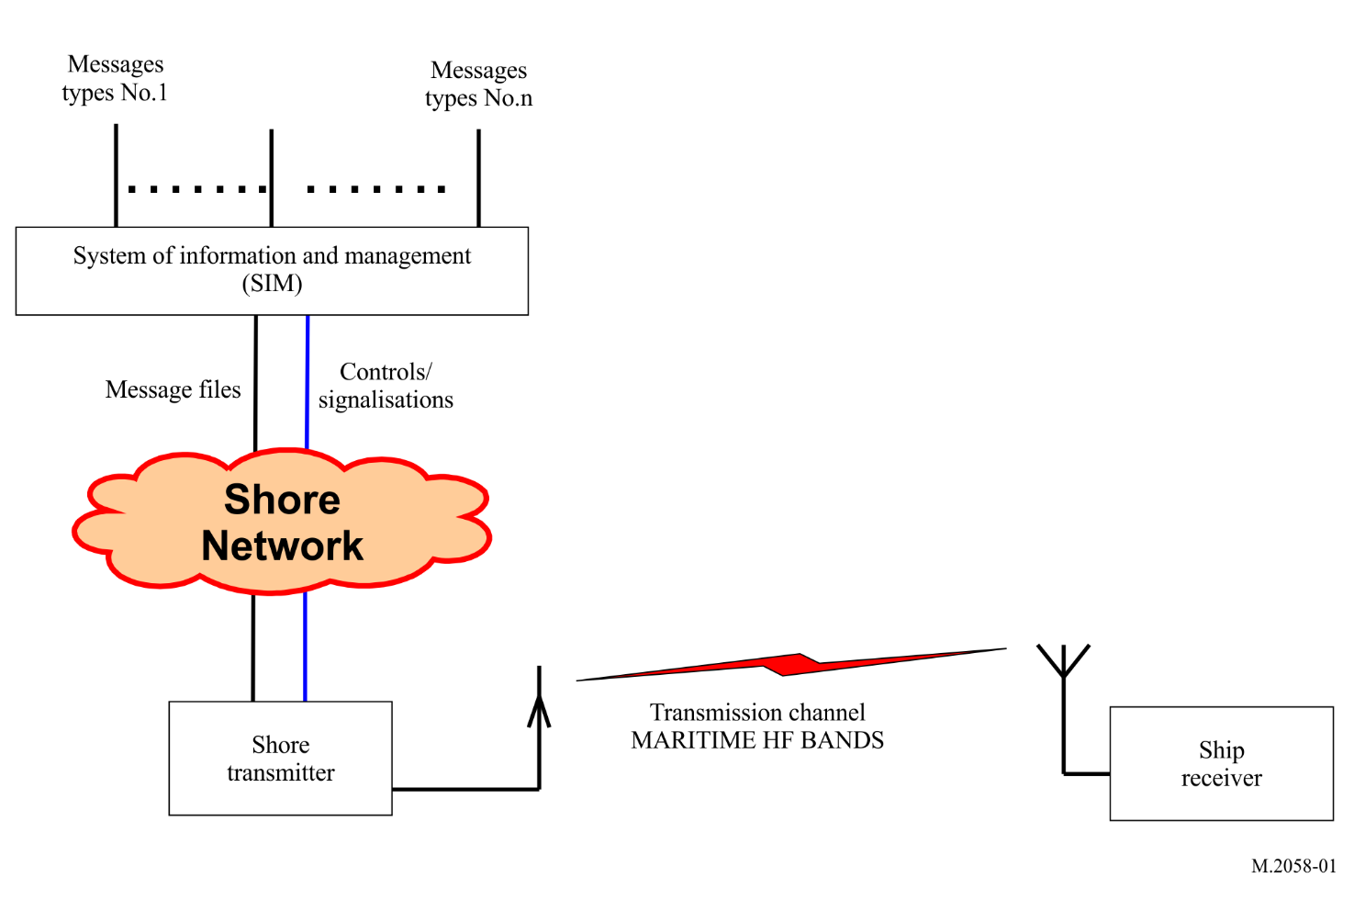
Figure 2
Global NAVDAT broadcast chain
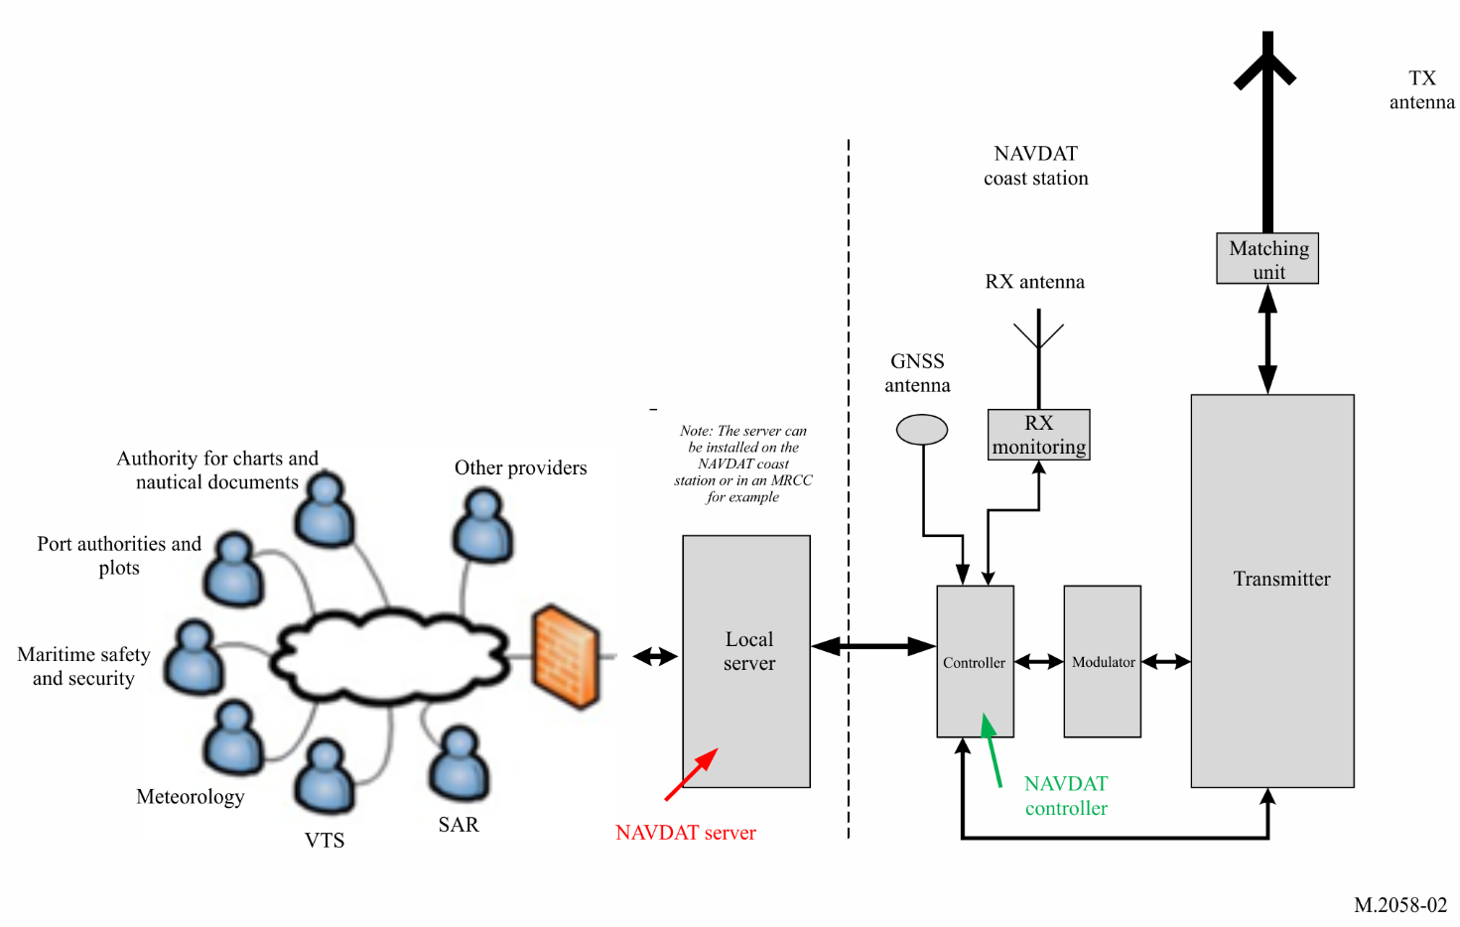

A2-1.1 System of information and management
The SIM term includes:
– all the sources that deliver file messages (e.g. meteorological office, safety and security organizations);
– the file multiplexer which is an application running on a server;
– the file multiplexer manager;
– the shore transmitter manager.
All the sources are connected to the file multiplexer through a network.
Figure 3 shows the general diagram of the SIM.
Figure 3
NAVDAT system of information and management block diagram
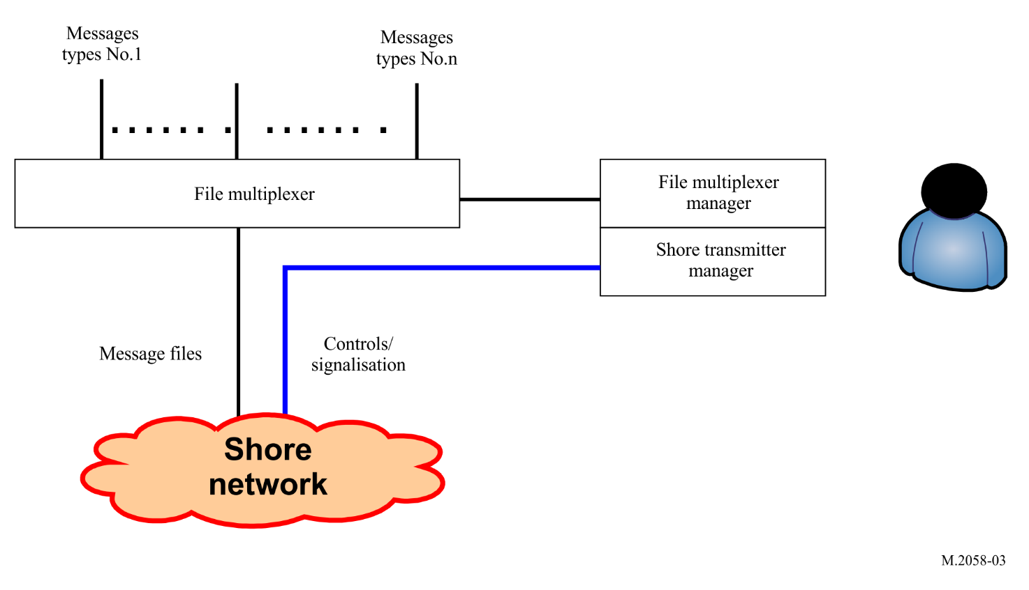

A2-1.1.1 File multiplexer
The file multiplexer:
– takes delivery of the message files from the data sources;
– encrypts the message files when required;
– formats the file messages with recipient information, priority status and time stamp;
– sends the message files to the transmitter.

A2-1.1.2 File multiplexer manager
The file multiplexer manager is a man-machine interface that enables the user to, among other tasks:
– have a look at the message files coming from any source;
– specify the priority and periodicity of any message file;
– specify the recipient of any message file;
– manage the file message encryption.
Some of these functionalities may be automated. As an example, the priority and the periodicity of a message may be selected according to the source it comes from or the source may specify the priority in the message.

A2-1.1.3 Shore transmitter manager
The shore station manager is a man-machine interface connected to the transmitter through the network; it makes it possible to supervise the transmitter status by indications such as:
– transmit acknowledgment;
– alarms;
– effective RF transmit power;
– synchronization report;
– quality of transmission;
and to change the transmitter parameters, such as:
– RF transmit power;
– OFDM parameters (e.g. pilot subcarriers, modulations error coding);
– transmission schedule.

A2-1.2 Shore network
The shore network can use a broadband link, a low data rate link or a local file sharing.

A2-1.3 Shore transmitter description
A coastal transmitting station consists of this minimum configuration:
– one controller, which is a local server with access protection;
– one OFDM modulator;
– one RF signal generator;
– one HF RF power amplifier;
– one or more transmit antenna with matching unit;
– one global navigation satellite system (GNSS) receiver or atomic clock for synchronization;
– one monitoring receiver with its antenna.

A2-1.3.1 Shore system architecture
Figure 4 shows the block diagram of an HF digital transmitter.
Figure 4
NAVDAT HF digital transmitter functional block diagram
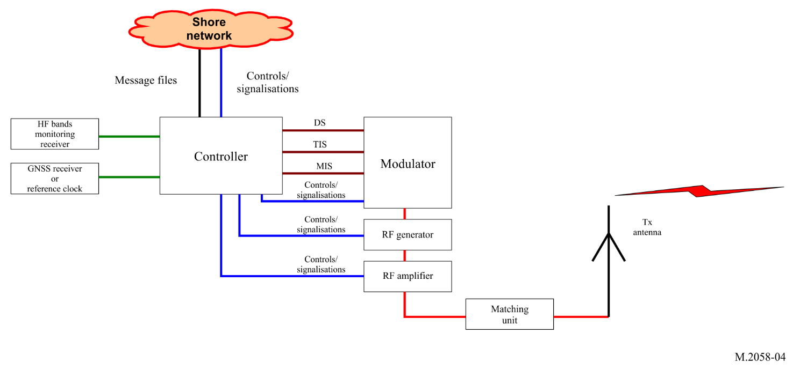

A2-1.3.2 Controller
This unit receives and transmits some pieces of information:
– message files from SIM;
– GNSS or atomic clock for synchronization;
– HF signal from monitoring receiver;
– HF signal generator, modulator and transmitter RF power amplifier control signals and monitoring;
– ensure signal from the RF signal generator and RF amplifier.
The function of the controller is:
– to check if the frequency band in use is free before transmission;
– to synchronize all signals on the coast station from synchronization clock;
– to control the transmission parameters, time and schedule;
– to format the message files to be transmitted (split files into packets).

A2-1.3.3 Modulator
Figure 5 shows the diagram of the modulator.
Figure 5
NAVDAT HF modulator functional block diagram
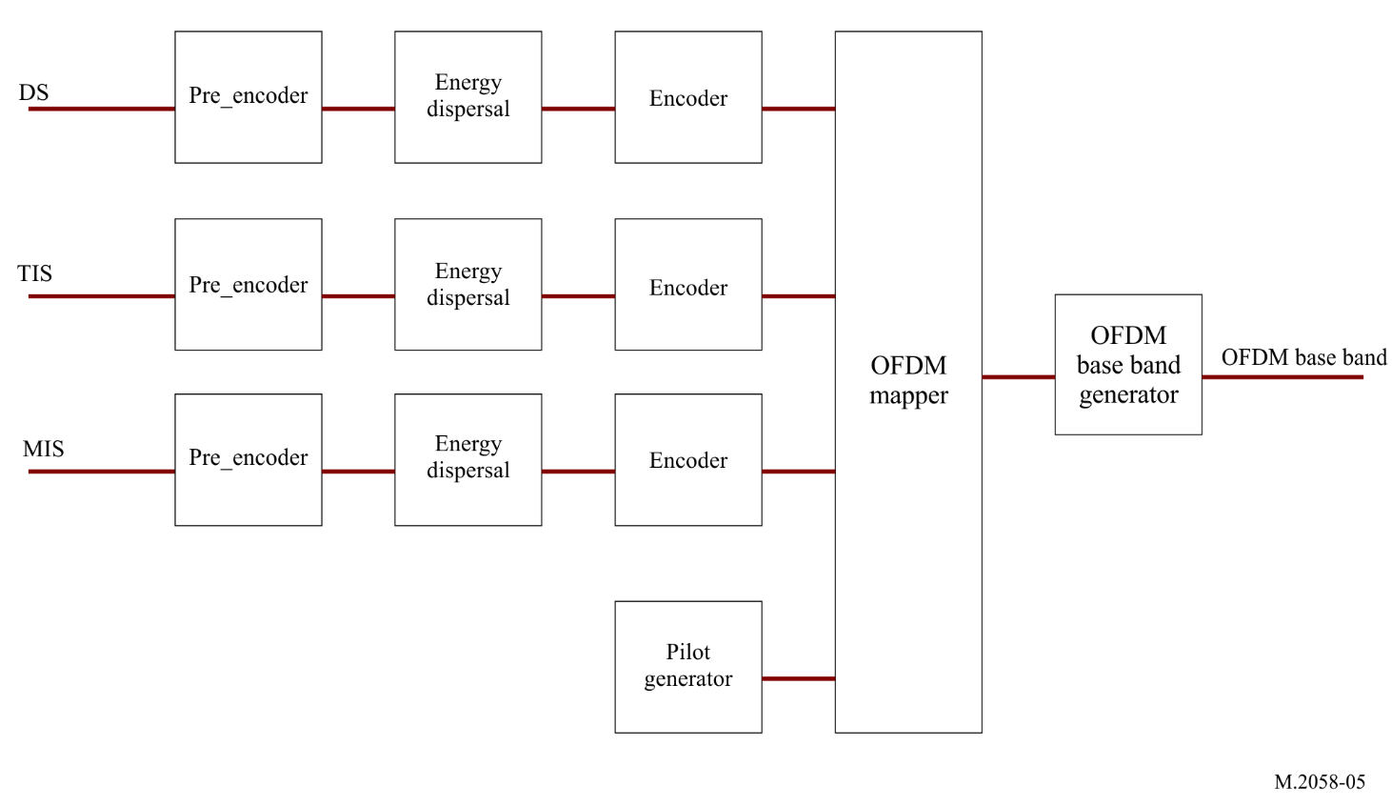

A2-1.3.3.1 Input streams
In order to operate, the modulator needs three input streams:
– modulation information stream (MIS);
– transmitter information stream (TIS);
– data stream (DS).
These streams are transcoded and then placed on the OFDM signal by the cell mapper (§ A2-1.3.3.3).

A2-1.3.3.1.1 Modulation information stream
This stream is used to provide information about:
– the channel bandwidth (1, 3, 5 or 10 kHz);
– the modulation for transmission information stream and data stream (4-, 16- or 64-QAM).
The MIS is always coded on 4-QAM subcarriers for good demodulation into the receiver.

A2-1.3.3.1.2 Transmitter information stream
This stream is used to provide information to the receiver about:
– error coding for data stream according radio propagation (should be different for surface wave propagation at daytime and for surface + sky wave propagation at night-time),
– identifier of the transmitter,
– time.
The TIS can be coded on 4- or 16-QAM.

A2-1.3.3.1.3 Data stream
It contains the message files to transmit (these message files were previously formatted by the file multiplexer).

A2-1.3.3.2 Error encoding
The error correction scheme determines the robustness of the coding. The code rate is the ratio between useful and raw data rate. It illustrates the transmission efficiency and can vary from 0.5 to 0.75 depending on the error correction schemes and modulation patterns.

A2-1.3.3.3 Orthogonal frequency division multiplexing generation
The three streams (MIS, TIS and DS) are formatted:
– encoding;
– energy dispersal.
A cell mapper organizes the OFDM cells with the formatted streams and the pilot cells. The pilot cells are transmitted for the receiver to estimate the radio channel and synchronize on the RF signal.
An OFDM signal generator creates the OFDM baseband according to the output of the cell mapper.

A2-1.3.4 HF RF generator
A HF RF generator transposes the baseband signal to the final frequency RF output carrier.
An amplifier brings the RF signal to the desired power.

A2-1.3.5 RF power amplifier
The function of this stage is to amplify the HF signal from the generator output to the necessary level to obtain the desired radio coverage.
The OFDM transmission introduces a crest factor on the RF signal. This crest factor must be less than 10 dB at the RF amplifier output for a correct modulation error ratio (MER).
The rms RF power of the transmitter must be adapted to the overall efficiency of the antenna and the desired radio coverage.
The output rms RF power of shore transmitter can be adjusted according to the frequency band.
Maximum rms output RF power: for 4 and 6 MHz: 5 kW; for 8, 12, 16, 18/19 and 22 MHz: 10 kW.

A2-1.3.6 Transmit antenna with matching unit
The RF amplifier is connected to the transmit antenna through the impedance matching unit.

A2-1.3.7 Global navigation satellite system receiver and a backup atomic reference clock
The clock is used to synchronize the local controller and configure a high-precision reference clock when working in SFN mode.

A2-1.3.8 Monitoring receiver
The monitoring receiver checks that the programmed frequency is free before transmission and offers possibility to check the transmission. A remote receiver is recommended for ensuring the local signal reception quality.

A2-1.4 Transmission channel: radio coverage estimation
The NAVDAT HF system uses surface wave propagation with vertically polarized antennas.
The ground plane of this vertical antennas should be designed to minimize the sky wave (by obtaining the lowest possible angle of radiation).
The radio coverage, in surface wave, (also known as ground wave) could be calculated based on the most recent version of Recommendations ITU-R P.368 and ITU-R P.372 or appropriate simulation software (“GRWAVE”, “NOISEDAT”, “LFMF-SmoothEarth”).
The NAVDAT HF system can also use mixed propagation, surface wave and sky wave, or sky wave only.

A2-1.5 Propagation channel
ITU has defined several criteria concerning the propagation channel from which 4 modes can be defined;
Mode A: Gaussian channels with minor fading; use with surface wave propagation
Mode B: Time and frequency selective channels, with longer delay spread. Use with mixed surface wave and sky wave propagation
Mode C: As mode B, but with higher Doppler spread: sky wave propagation with multi-hops
Mode D: As mode B, but with severe delay and Doppler spread. Use with sky wave with multi-hops on several ionospheric layers
Modes A and B are recommended for the main HF channel on 4 226 kHz.
In daytime, the ionospheric layer D is absorbent. During this period, the mode A should therefore be used.
At sunset the layer D disappears, and it is better to use the mode B during the night period.
The NAVDAT in HF frequency band can use all these modes of propagation according to the radio coverage sought.

Annex 3
NAVDAT HF technical characteristics

A3-1 Modulation principle
The system uses OFDM which is a modulation technology for digital transmissions.

A3-1.1 Introduction
The bandwidth of the radio transmission channel is divided in the frequency domain to form subcarriers.
The radio transmission channel occupancy is organized in the time to form OFDM symbols.
An OFDM cell is equivalent to one subcarrier in one OFDM symbol.
FIGURE 6
Orthogonal frequency division multiplexing introduction
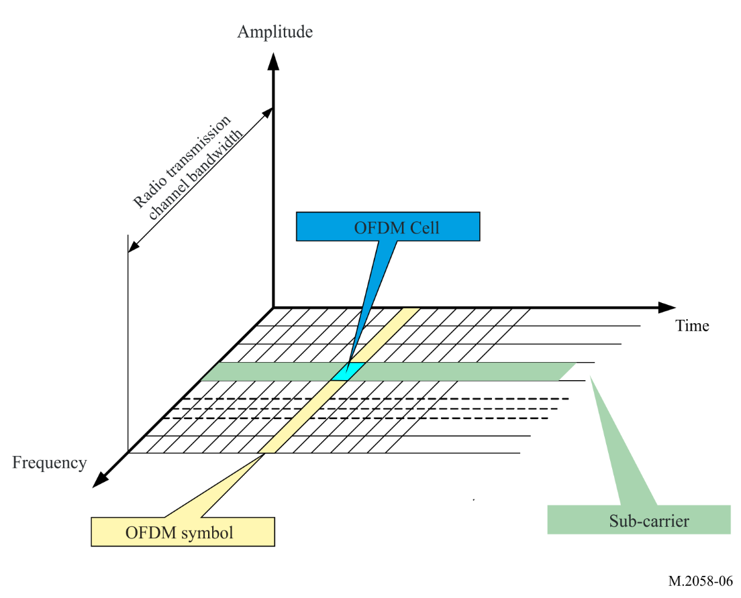

A3-1.2 Principle
The OFDM uses a large number of closely-spaced (41.666 Hz (mode A), 46.875 Hz (mode B) to 68.182 Hz in mode C) orthogonal subcarriers to obtain high spectral efficiency to transmit data. These subcarriers are frequency-spaced (F_{u} = 1/T_{u}), where T_{u} is the duration of the useful part of an OFDM symbol.
The phases of subcarriers are orthogonal one to each other to enhance signal diversity caused by the multipath, especially in long distance.
A guard interval (T_{d}) is inserted in the OFDM symbol to reduce multipath effect, thus reducing the inter-symbol interference.
The OFDM symbol duration is T_{s} = T_{u} + T_{d}.
The OFDM symbols are then concatenated to make an OFDM frame.
The OFDM frame duration is T_{f}.
Figure 7
Spectral representation of an orthogonal frequency division multiplexing frame
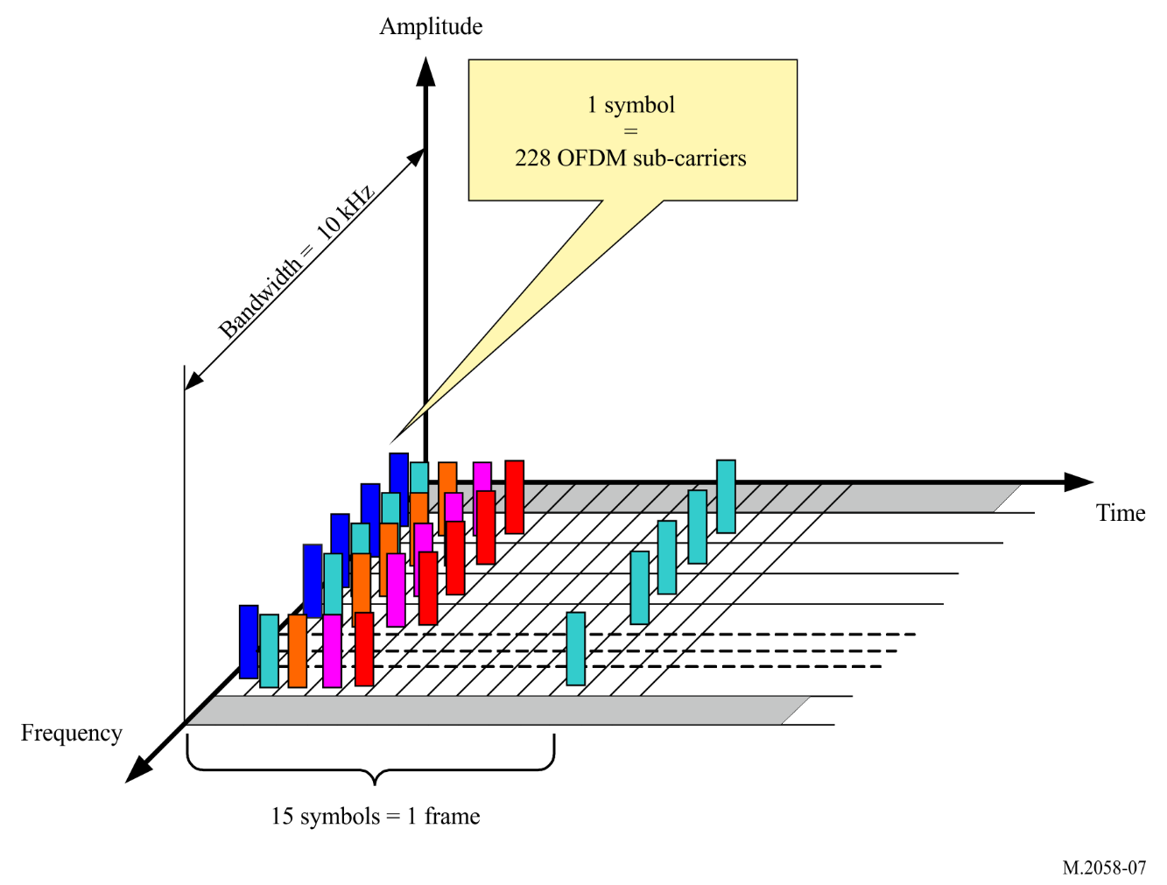
Figure 8
Temporal representation of an orthogonal frequency division multiplexing frame
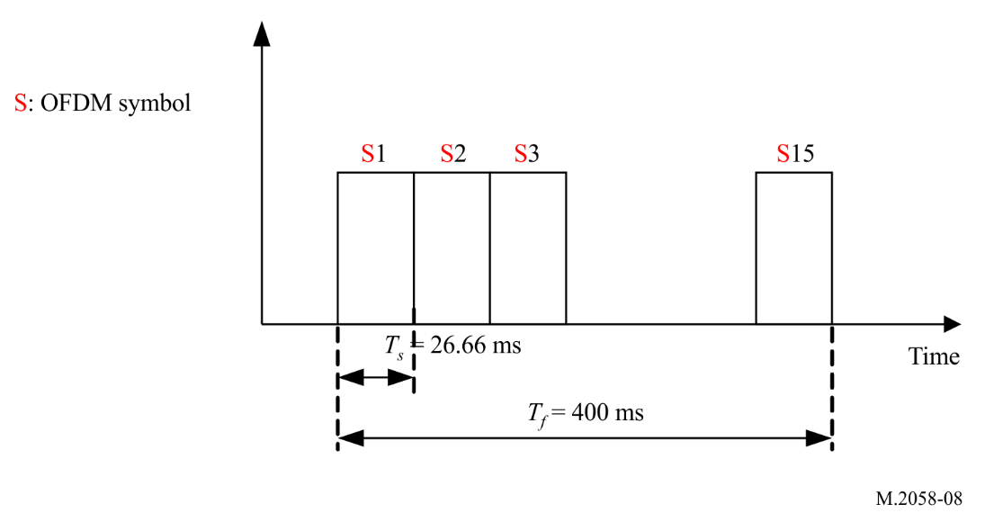

A3-1.3 Orthogonal frequency division multiplexing parameters
OFDM parameters values are listed in Table 1.
TABLE 1
Orthogonal frequency division multiplexing parameters for all bandwidth
Mode propagation mode | T_{u}  (ms) | 1 / T_{u}  (Hz) | T_{d}  (ms) | T_{s} = T_{u} + T_{d}  (ms) | Ns | T_{f}  (ms)
A: surface wave | 24 | 41.666 | 2.66 | 26.66 | 15 | 400
B: surface wave + sky wave | 21.33 | 46.875 | 5.33 | 26.66 | 15 | 400
C: skywave | 14.66 | 68.182 | 5.33 | 20 | 20 | 400

T_{u}: duration of the useful part of an OFDM symbol
1/T_{u}: carrier spacing
T_{d}: duration of the guard interval
T_{s}: duration of an OFDM symbol
N_{s}: the number of symbols per frame
T_{f}: duration of the transmission frame.

A3-1.4 Channel bandwidth
NAVDAT digital broadcast defines different channel bandwidths and determines subcarrier numbers corresponding to the channel bandwidth. Table 2 present the relationship between channel bandwidths and OFDM sub-carrier numbers.
TABLE 2
Relationship between channel bandwidth and orthogonal frequency division multiplexing subcarrier numbers
Propagation mode | Case | 1 | 2 | 3 | 4
Propagation mode | Channel bandwidth | 1 kHz | 3 kHz | 5 kHz | 10 kHz
A: surface wave | Numbers of subcarriers | 23 | 69 | 115 | 229
A: surface wave | No. of subcarriers | K −11 to 11 | K −34 to 34 | K −57 to 57 | K −114 to 114
B: surface wave + sky wave | Numbers of subcarriers | 19 | 61 | 103 | 207
B: surface wave + sky wave | No. of subcarriers | K −9 to 9 | K −30 to 30 | K −51 to 51 | K −103 to 103
C: sky wave | Numbers of subcarriers | 13 | 41 | 69 | 139
C: sky wave | No. of sub-carriers | K −6 to 6 | K −20 to 20 | K −34 to 34 | K −69 to 69

A3-1.5 Modulation
Every subcarrier is modulated in amplitude and phase (quadrature amplitude modulation (QAM)).
Modulation patterns can be either 64 states (6 bits, 64-QAM), 16 states (4 bits, 16-QAM), or 4 states (2 bits, 4-QAM).
The modulation pattern depends on the desired robustness of the signal.
FIGURE 9
BPSK modulation constellation
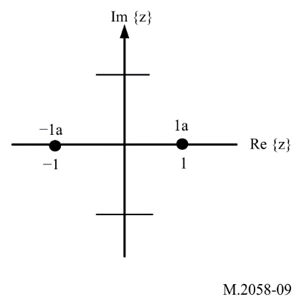
Figure 10
4-QAM constellation
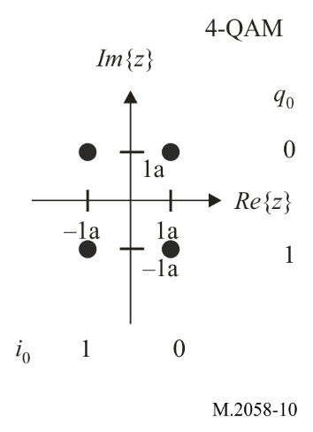
Figure 11
16-QAM constellation
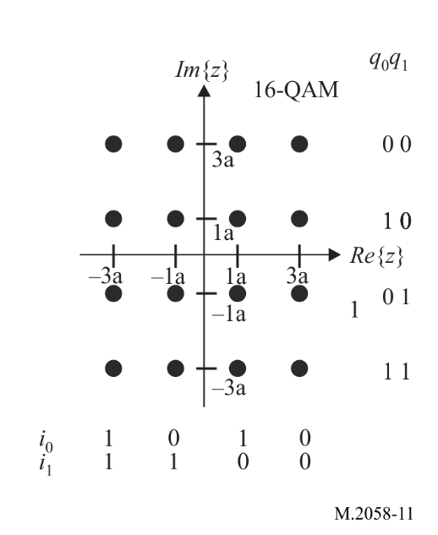
Figure 12
64-QAM constellation
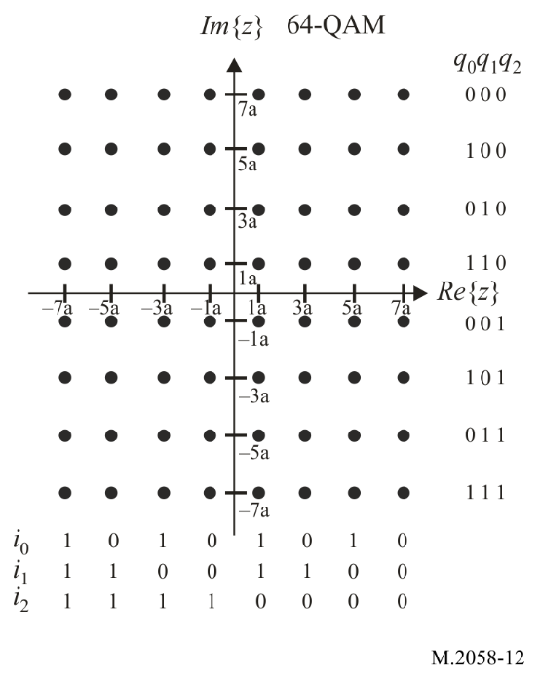

A3-1.6 Synchronization
In order to allow a good demodulation of each subcarrier, the radio transmission channel response must be determined for each subcarrier and equalization is applied. Some of the subcarriers of the OFDM symbols carry pilot signals.
The pilot signals allow the receiver to:
– detect if a signal is received;
– estimate the frequency offset;
– estimate the radio transmission channel.
The number of pilot signals depends on the desired robustness of the signal.
This pilot carriers are transmitted with a power gain factor of 2 in BPSK modulation.
Figure 13
Pilot orthogonal frequency division multiplexing signal
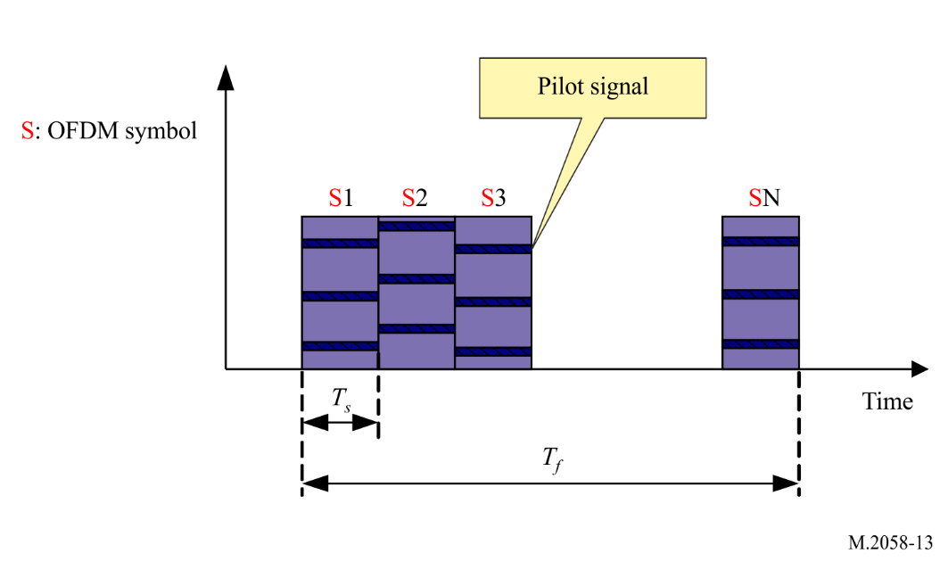
The pilot signal location in each OFDM symbol in a frame can be shown as follows:
Figure 14
The pilot signal location (in mode A)
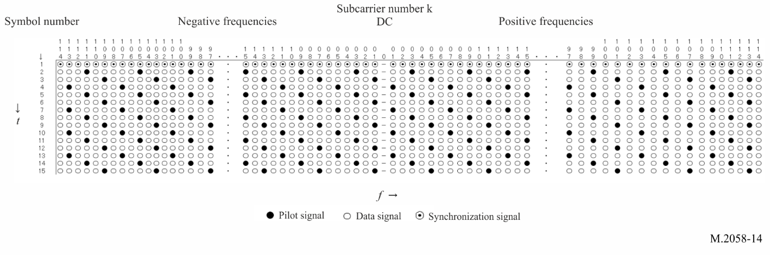
Figure 15
The pilot signal location (in mode B)
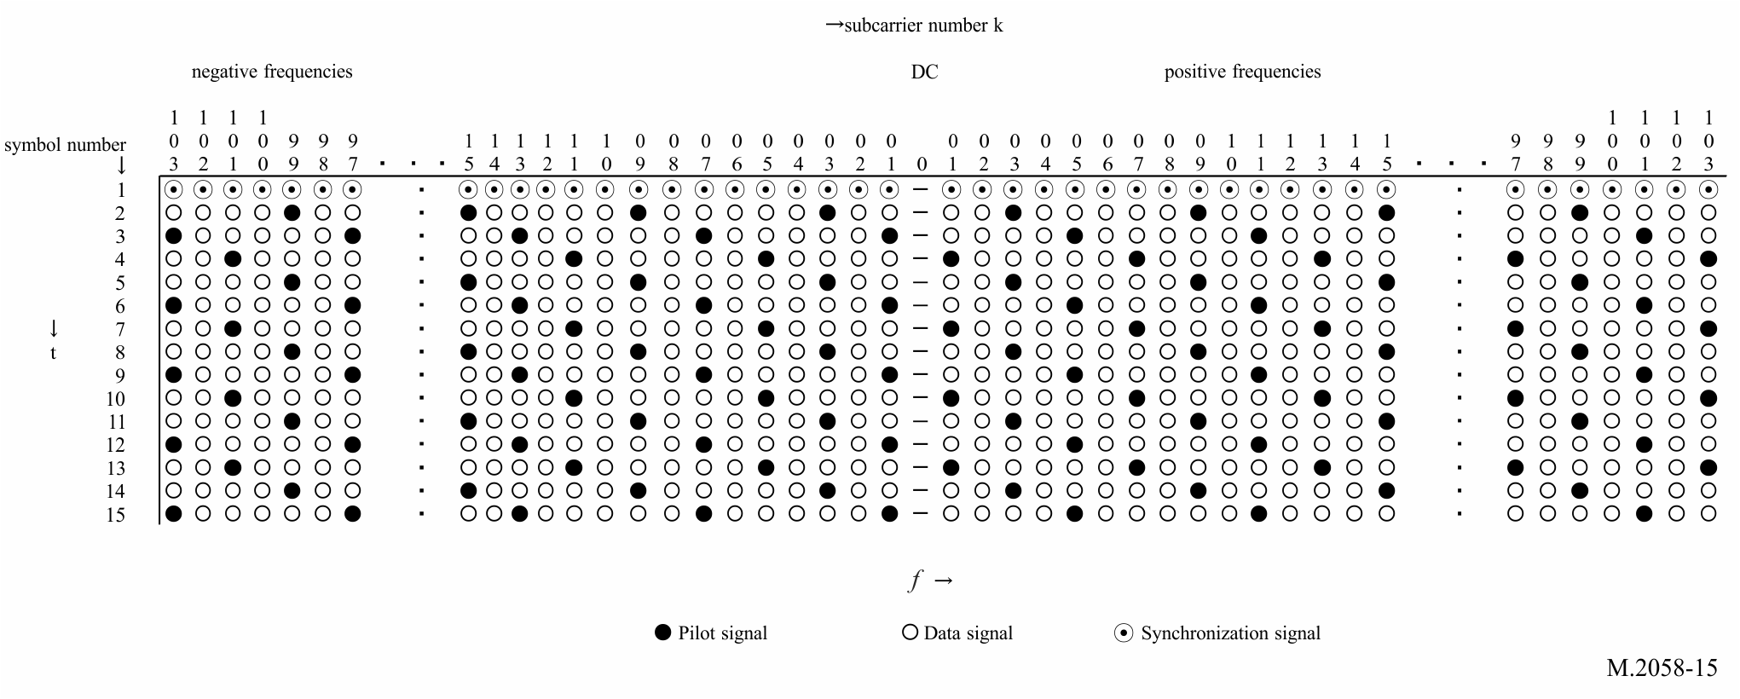
Figure 16
The pilot signal location (in mode C)
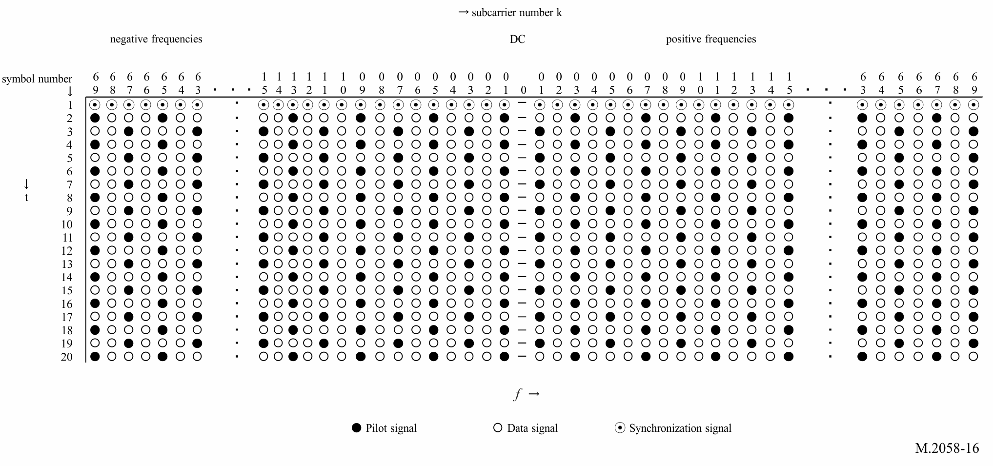
where t is the direction of time domain, f is the direction of frequency domain. The first symbol of each OFDM head frame should be filled by a sequence of synchronization signal that make up the synchronization head (refer to Table 11 in Annex 4), all of which are used as a time reference to provide synchronization for the receiver. The black cell and the white cell represent the pilot signal and the data signal respectively. The pilot signal value, which is modulated in 2-QAM (BPSK) in an OFDM, is show in Table 3.
TABLE 3
Pilot sequence (in mode A)
Number of subcarriers | Pilot sequence
229 | −1 1 −1 1 −1 1 1 1 −1 1 1 1 1 −1 −1 −1 1 1 −1 −1 −1 1 1 1 −1 −1 −1 −1 −1 −1 1 −1 1 −1 −1 1 1 1
115 | −1 1 −1 1 −1 1 1 1 −1 1 1 1 1 −1 −1 −1 1 1 −1 −1
69 | −1 1 −1 1 −1 1 1 1 −1 1 1 1
23 | −1 1 −1 1

Pilot sequence (in mode B)
Number of subcarriers | Pilot sequence
207 | −1 1 −1 1 −1 1 1 1 −1 1 1 1 1 −1 −1 −1 1 1 −1 −1 −1 1 1 1 −1 −1 −1 −1 −1 −1 1 −1 1 −1 −1
103 | −1 1 −1 1 −1 1 1 1 −1 1 1 1 1 −1 −1 −1 1
61 | −1 1 −1 1 −1 1 1 1 −1 1
19 | −1 1 −1 1

Pilot sequence (in mode C)
Number of subcarriers | Pilot sequence
139 | −1 1 −1 1 −1 1 1 1 −1 1 1 1 1 −1 −1 −1 1 1 −1 −1 −1 1 1 1 −1 −1 −1 −1 −1 −1 1 −1 1 −1 −1
69 | −1 1 −1 1 −1 1 1 1 −1 1 1 1 1 −1 −1 −1 1
41 | −1 1 −1 1 −1 1 1 1 −1 1
13 | −1 1 −1

In the first symbol of each OFDM head frame, any subcarriers are used as time reference for the receiver to synchronize.
Figure 17
Synchronization symbol
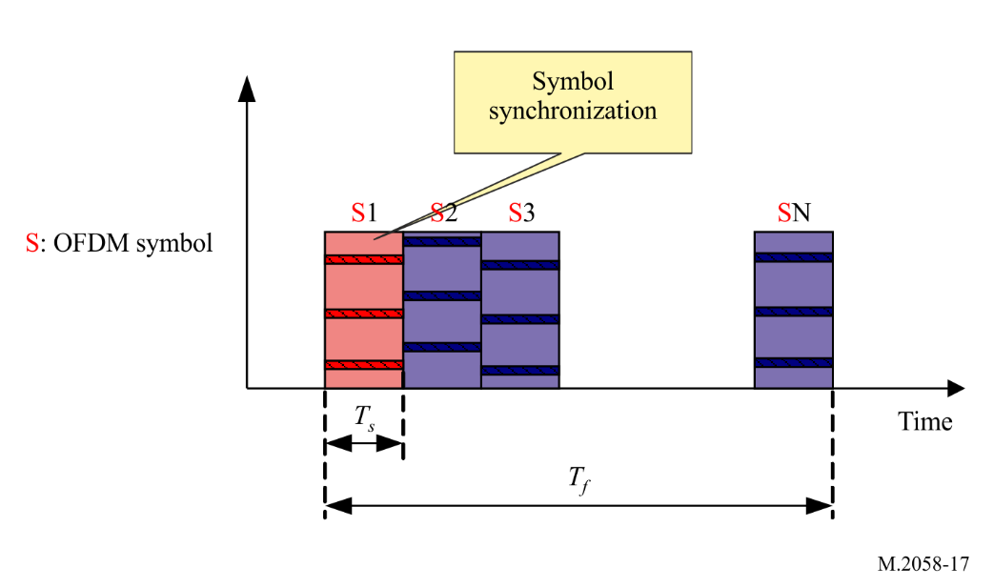

A3-1.7 Energy dispersal
The purpose of the energy dispersal is to avoid the transmission of signal patterns resulting in unwanted regularity. The individual inputs of energy dispersal scramblers should be scrambled by a modulo-2 with a pseudo-random binary sequence (PRBS), prior to channel encoding. The PRBS is defined as the output of the feedback shift register of Fig. 18. It should use a polynomial of degree 9, defined by:
$P\left(x\right)=x^{9}+x^{5}+1$
Figure 18
Pseudo-random binary sequence generator
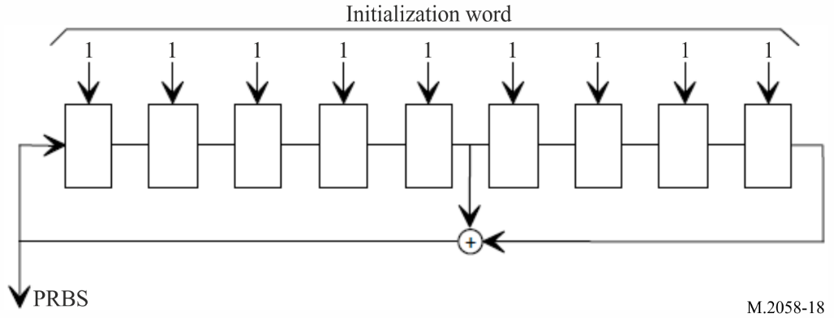

A3-1.8 Transmission mask of RF signal
Figure 19
Transmission spectral mask of NAVDAT RF signal with bandwidth F = 10 kHz
Emission mask for 5, 3 and 1 kHz should fit within the mask for 10 kHz
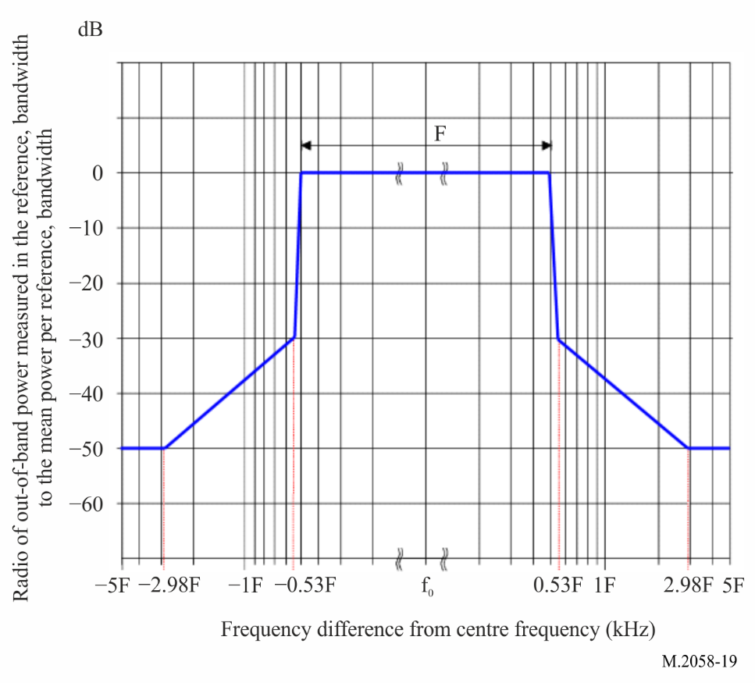

A3-1.9 Sequence for receiving scanning possibility
To allow reception of national or regional frequencies assigned to the NAVDAT system, the receiver uses a scan function.
Frequencies should then be scanned to monitor the reception of the pre-signal transmitted by the station before broadcast.
To ensure proper operation of the receiver scan function, the transmitters of active National or Regional NAVDAT coast stations should transmit, before the NAVDAT broadcast, a sequence of known data during 400 ms repeated eight times for a total duration of 3.2 seconds.
To ease receiver demodulation of the NAVDAT broadcast, known data is using the same bandwidth and the same constellation as the subsequent NAVDAT broadcast. Known data uses a super-frame pattern of length 1.
To enable evaluation of BER, DS stream is filled with PRBS data using the polynomial:
$P\left(x\right)=x^{20}+x^{17}+1$
Each cell of the shift register should be pre-set to a logical 1 at the beginning of the sequence and the start of the PRBS sequence is synchronized with the beginning of each frame.
Any text message included inside the know data must be in National and English language.
Figure 20
Transmission structure for scan facility
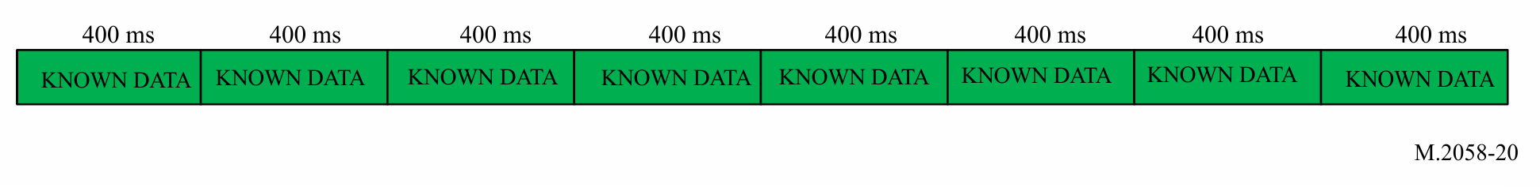
The frame structure is described in Annex 4.
Figure 21
Frame structure
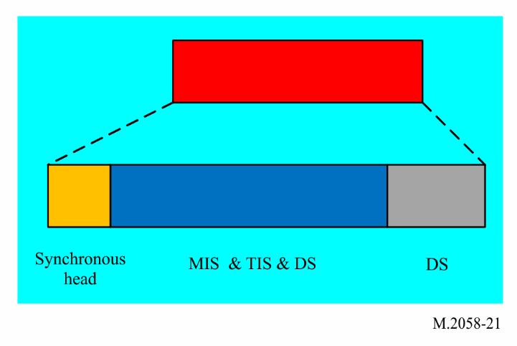

A3-2 Estimated usable data rate
In the 10 kHz channel bandwidth with HF surface wave propagation, the raw data rate available for the data stream (DS) is typically around 20 kbit/s with 16-QAM signal.
The number of subcarriers that hold data can be varied in order to adjust the channel protection. Higher channel protection (e.g. protection against multipath, fading, delay) results in a lower number of useful subcarriers.
Error correction coding must then be applied to the raw data rate to obtain the useful data rate. With a code rate of 0.5 to 0.75, the useful data rate is then between 6 and 29 kbit/s according to the mode with surface wave.
A higher code rate provides a higher useful data rate, but the radio coverage is accordingly reduced.
With the different modulation and code rate, the useful data rate is shown below.
TABLE 4
Estimated data rate for 10, 5, 3 and 1 kHz bandwidth for head frame for mode A
(given only for information)
Mode | Spectrum occupancy  (kHz) | Modulation  (n-QAM) | Code rate | Estimated data rate  (kbit/s)
0 | 10 | 4-QAM | 0.5 | 6.36
1 | 10 | 4-QAM | 0.75 | 9.56
2 | 10 | 16-QAM | 0.5 | 12.72
3 | 10 | 16-QAM | 0.75 | 19.12
4 | 10 | 64-QAM | 0.5 | 19.08
5 | 10 | 64-QAM | 0.75 | 28.68
6 | 5 | 4-QAM | 0.5 | 2.89
7 | 5 | 4-QAM | 0.75 | 4.35
8 | 5 | 16-QAM | 0.5 | 5.78
9 | 5 | 16-QAM | 0.75 | 8.69
10 | 5 | 64-QAM | 0.5 | 8.67
11 | 5 | 64-QAM | 0.75 | 13.04
12 | 3 | 4-QAM | 0.5 | 1.67
13 | 3 | 4-QAM | 0.75 | 2.52
14 | 3 | 16-QAM | 0.5 | 3.35
15 | 3 | 16-QAM | 0.75 | 5.03
16 | 3 | 64-QAM | 0.5 | 5.02
17 | 3 | 64-QAM | 0.75 | 7.55
18 | 1 | 4-QAM | 0.5 | 0.55
19 | 1 | 4-QAM | 0.75 | 0.84
20 | 1 | 16-QAM | 0.5 | 1.12
21 | 1 | 16-QAM | 0.75 | 1.68
22 | 1 | 64-QAM | 0.5 | 1.67
23 | 1 | 64-QAM | 0.75 | 2.52

TABLE 5
Estimated data rate for 10, 5, 3 and 1 kHz bandwidth for head frame for mode B
Mode | Spectrum occupancy  (kHz) | Modulation  (n-QAM) | Code rate | Estimated data rate  (kbit/s)
0 | 10 | 4-QAM | 0.5 | 5.705
1 | 10 | 4-QAM | 0.75 | 8.578
2 | 10 | 16-QAM | 0.5 | 11.41
3 | 10 | 16-QAM | 0.75 | 17.155
4 | 10 | 64-QAM | 0.5 | 17.115
5 | 10 | 64-QAM | 0.75 | 25.733
6 | 5 | 4-QAM | 0.5 | 2.67
7 | 5 | 4-QAM | 0.75 | 4.025
8 | 5 | 16-QAM | 0.5 | 5.34
9 | 5 | 16-QAM | 0.75 | 8.05
10 | 5 | 64-QAM | 0.5 | 8.01
11 | 5 | 64-QAM | 0.75 | 12.075
12 | 3 | 4-QAM | 0.5 | 1.46
13 | 3 | 4-QAM | 0.75 | 2.21
14 | 3 | 16-QAM | 0.5 | 2.92
15 | 3 | 16-QAM | 0.75 | 4.42
16 | 3 | 64-QAM | 0.5 | 4.38
17 | 3 | 64-QAM | 0.75 | 6.63
18 | 1 | 4-QAM | 0.5 | 0.22
19 | 1 | 4-QAM | 0.75 | 0.35
20 | 1 | 16-QAM | 0.5 | 0.44
21 | 1 | 16-QAM | 0.75 | 0.70
22 | 1 | 64-QAM | 0.5 | 0.66
23 | 1 | 64-QAM | 0.75 | 1.05

TABLE 6
Estimated data rate for 10, 5 and 3 kHz bandwidth for head frame for mode C
Mode | Spectrum occupancy  (kHz) | Modulation  (n-QAM) | Code rate | Estimated data rate  (kbit/s)
0 | 10 | 4-QAM | 0.5 | 4.60
1 | 10 | 4-QAM | 0.75 | 6.92
2 | 10 | 16-QAM | 0.5 | 9.20
3 | 10 | 16-QAM | 0.75 | 13.84
4 | 10 | 64-QAM | 0.5 | 13.80
5 | 10 | 64-QAM | 0.75 | 20.76
6 | 5 | 4-QAM | 0.5 | 2.13
7 | 5 | 4-QAM | 0.75 | 3.22
8 | 5 | 16-QAM | 0.5 | 4.26
9 | 5 | 16-QAM | 0.75 | 6.43
10 | 5 | 64-QAM | 0.5 | 6.39
11 | 5 | 64-QAM | 0.75 | 9.65
12 | 3 | 4-QAM | 0.5 | 1.14
13 | 3 | 4-QAM | 0.75 | 1.72
14 | 3 | 16-QAM | 0.5 | 2.27
15 | 3 | 16-QAM | 0.75 | 3.45
16 | 3 | 64-QAM | 0.5 | 3.41
17 | 3 | 64-QAM | 0.75 | 5.17

A3-3 NAVDAT HF transmitter performance specification
TABLE 7
Minimum NAVDAT HF transmitter performance specification
Parameters | Required results
Frequency band | 4 to 27.5 MHz
Carrier frequency error | Within ±2.5 Hz of the nominal frequency
Spectrum mask | Comply with the requirement of Fig. 18
Transmitter third order intermodulation rejection ratio | > 40 dBc
Transmitter emission spurious  (all power range) | −50 dB without exceeding the absolute level of 50 mW(17 dBm)
NOTE: The transmitter may also cover the MF band 415 to 526.5 kHz for International 500 kHz and future National NAVDAT frequencies.
Refer to Recommendation ITU-R M.2010 for technical specifications. The emission class used is W7D.

A3-4 NAVDAT ship receiver

A3-4.1 NAVDAT ship receiver description
The ship receiver block logical diagram is shown in Fig. 23.
A typical NAVDAT 500 kHz and NAVDAT HF digital receiver is composed of several basic blocks:
– reception antenna and optional GNSS antenna;
– RF front end;
– demodulator;
– file demultiplexer;
– controller;
– control and display unit (CDU);
– data interface;
– embedded table of frequencies, stations and areas (see § A3-4.1.10);
– power supply.
The NAVDAT ship receiver can receive and decode the main international MF channel (500 kHz) and the main international HF channel (4 226 kHz) at the same time with two complete independent channels.
The first channel is constantly listening to the 500 kHz.
The second channel is constantly listening to the 4 226 kHz.
A third channel should be watching and scanning all the other NAVDAT frequencies (International, national or regional in MF and attributed HF frequencies). The design of this third channel allows reception and decoding future potential national, regional or local transmitters using MF or HF channels:
1 The maritime MF band from 415 to 526.5 kHz (except 500 kHz).
2 The channels assigned to NAVDAT: 6 337.5, 8 443, 12 663.5, 16 909.5 and 22 450.5 kHz (except 4 226 kHz).
3 The frequency bands assigned to wideband digital transmissions of RR Appendix 17: 4, 6, 8, 12, 16, 19, 22 and 26 MHz.
The decoding of frequency(s) received by scanning can be demodulated in real time or with a time delay.
The choice of frequencies to be scanned should be based on information on the NAVDAT stations declared and stored by the receiver (table updated via message 63).
The receiver should first determine the NAVAREA and METAREA zone in which the vessel is located (from its position) with the possibility by the operator to add some NAVDAT stations outside of this NAVAREA / METAREA.
From the table (see § A3-4.1.10), the receiver should determine the future allocated slots and the frequencies used.
These frequencies should then be scanned to monitor the reception of the pre-signal transmitted by the station before broadcast.
The receiving antenna is common to the three channels. It is recommended that the antenna be equipped with two outputs for sharing with another MF/HF receiver.
Below is a generic block diagram of an SDR receiver given for information.
The design of NAVDAT receivers is left to the initiative of each manufacturer.
Figure 22
Model of generic software defined radio NAVDAT receiver
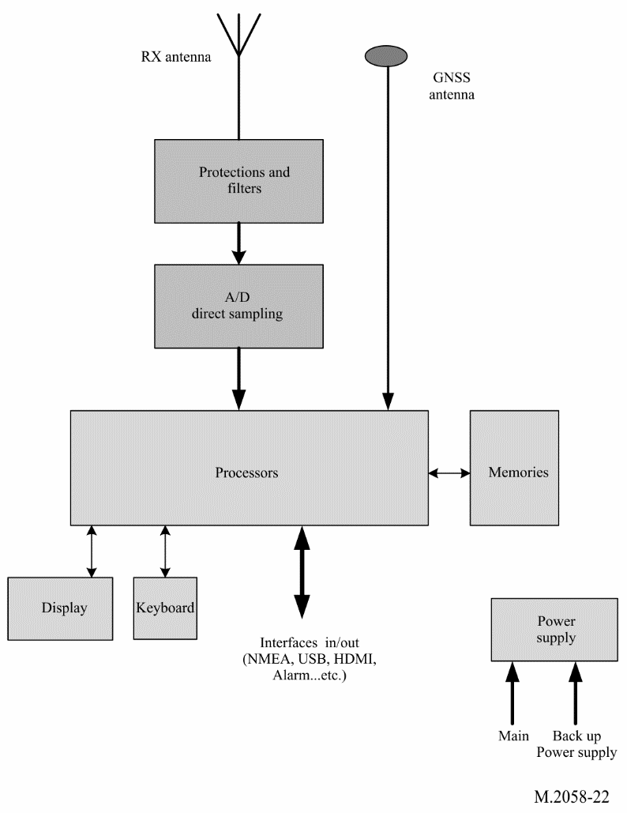
FIGURE 23
NAVDAT receiver logical diagram
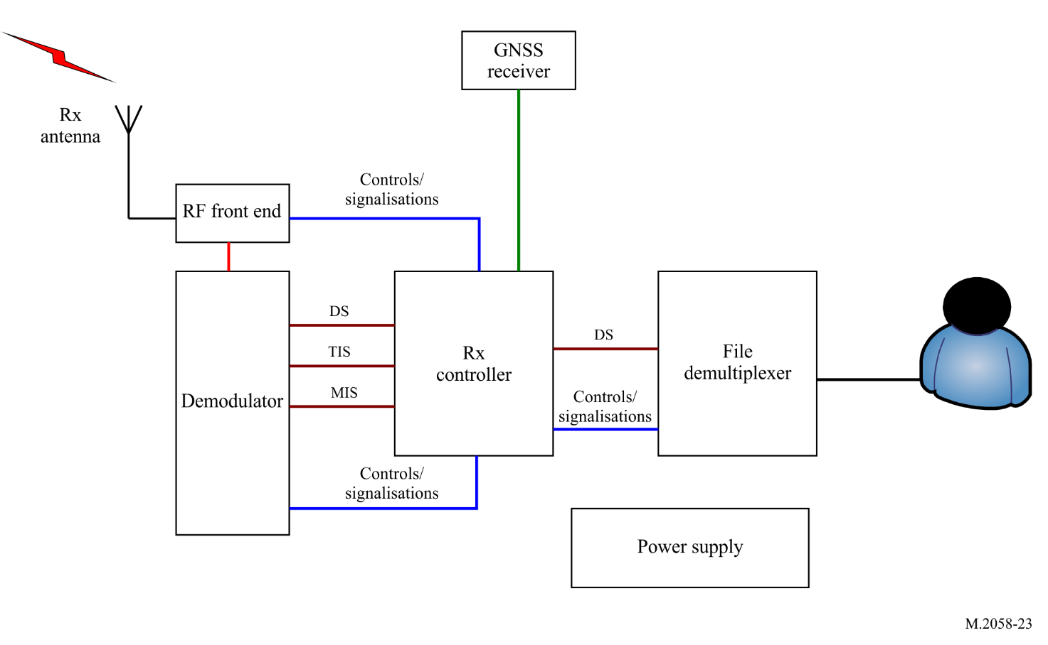

A3-4.1.1 Reception antenna and global navigation satellite antenna
The receiving antenna can be a vertical H field antenna (recommended on an EMC noisy ship) or an E field antenna. The ship’s NAVDAT receiver can also receive NAVDAT MF channels. It is recommended that the omnidirectional receiving antenna covers, at minimum, the frequency band 415 kHz to 27.5 MHz.
A GNSS antenna connected to an internal GNSS receiver, (or connection to the existing ship GNSS receiver) is also needed in order to obtain ship’s position and time.

A3-4.1.2 RF front end
This block includes the RF filter, RF amplifier and baseband output with for all a scanning possibility.
High sensitivity and high dynamic range are necessary with protection against strong RF fields from ship transmitting antennas or lightings.
The passband of the input filters must allow reception of the maritime MF band from 415 to 526.5 kHz and all maritime HF bands.
It is recommended to place a notch filter on the MF broadcasting band (from 526.5 kHz).
Receiver design can be classic or SDR type with at least three channels (not limited).

A3-4.1.3 Demodulator
This stage demodulates the baseband OFDM signal and recreates the data stream that holds the transmitted message files.
It implements:
– time/frequency synchronization;
– channel estimation;
– automatic modulation recovery;
– error correction.
The NAVDAT receiver should be able to detect the following modulation parameters automatically:
– 4-, 16- or 64-QAM;
– type of error coding.
In addition to the DS, it reports the information filled in the TIS and MIS. Furthermore, it reports complementary information about the channel such as:
– estimated SNR;
– BER;
– MER.

A3-4.1.4 File demultiplexer
The file demultiplexer:
– receives the message files from the controller;
– verifies that the message files are marked for its attention (type of broadcast mode);
– decrypts the message files if needed/able;
– makes the message files available for the terminal application that should use the message files;
– deletes the out-of-date message files.
Depending on the final application, the message file can be:
– stored on an onboard server accessible through the ship network;
– display on the receiver CDU directly;
– sent directly to the final application.

A3-4.1.5 Controller
The controller:
– extracts the message files from the DS (merge packets into files);
– interprets the TIS and MIS and the other pieces of information given by the demodulator;
– collects the following information from the file demultiplexer:
• total number of decoded message files;
• number of available message files;
• error event (e.g. decrypt errors).
A man-machine interface may be available in order to display and check the reception parameters.

A3-4.1.6 Control and display unit
The receiver can provide a display and control unit, the function of this unit is:
– display the special information and by configuring the interface to be connected to a dedicated equipment application (e.g. e-navigation) and manage the licensed contents of the ship (e.g. ship identification, encryption);
– display and check the receiving parameters;
– display the message content according to the application classification of the message file.
This CDU may be a special application running on an external computer, and the receiver may be a black-box device.

A3-4.1.7 Data interface
The receiver obtains the data from external devices such as GNSS through the data interface. The controller classifies the message files according to their applications and provides the message files to the application devices through the data interface.
The equipment should provide a data interface that complies with the requirements of the IEC 61162 series. It is advisable to provide Ethernet and USB interfaces for high-speed transmission of files and also provide a printer interface (not limited).
The equipment should be able to configure parameters of data ports for communication with other ship equipment.
The equipment should include an interface for alert management in accordance with IMO resolution MSC.302(87) on Performance standards for bridge alert management.

A3-4.1.8 Power supply
The connection to the ship’s power supply must be protected against surges and EMI.

A3-4.1.9 Receiver ID
It should be possible to configure the receiver with:
the identity of the vessel (according to Recommendation ITU-R M.585)
the main Group identity (according to Recommendation ITU-R M.585)
additional lists of identities (MMSI’S) may be provided.
See Table 20 and note.

A3-4.1.10 Stored tables
The receiver should have the possibility of storing information in different memorized tables which can be updated by the reception of the message 63. This message should be authenticated by the shore authority.
For example:
1 The list of coast stations with:
Area
Country
Longitude
Latitude
Name
Slots
Frequency used
This stored table is queried when the identities of the stations received are received and the complete parameters of the received NAVDAT coast station should be displayed in plain text.
2 The list of subject messages
Table with subject message 01 to 63
All the tables in memory can be updated by receiving the message 63.

A3-4.1.11 Storage

A3-4.1.11.1 Non-volatile files message memory
For each frequency provided it should be possible to record at least 100 message files in non-volatile memory. It should not be possible for the user to erase file messages from the memory. When the memory is full, the oldest file message must be replaced by the new messages.
The user should be able to mark the individual files of a message from permanent retention. These file messages can occupy up to 25% of available memory and should not be overwritten by new files. When no longer needed, the user must be able to delete the tag on these files, which can be overwritten normally.
Duplicate message could be recognized by the equipment and should not be stored.
The storage capacity of this memory should not be less than 1 GB.

A3-4.1.11.2 Programmable control memories
Information identifying the transmitter service area and the designator of each type of message in programmable memory should not be erased by interruptions in the power supply of less than 24 h.
The equipment should be able to store at least the time, transmitter identification, message type and message content. The storage capacity should not be less than 1 GB.
When power supply is interrupted unexpectedly, the equipment should protect the stored data and software parameters.
The equipment should be able to display, delete and query stored messages, and be able to output messages manually or automatically to appropriate ship equipment (such as the electronic chart and display information system (ECDIS).

A3-4.1.12 Alert
The receipt of SAR related information message should give a continuous audible alarm. It should only be possible to reset this alarm manually. The position information contained in the SAR messages may be transmitted to other navigation equipment (e.g. ECDIS, ENC plotter).

A3-4.1.13 Test facilities
The equipment should be provided with a facility to test that the radio receiver, the display and the non-volatile memory are functioning correctly and to display self-test results. In case of using a specific antenna it also must be checked by this process.

A3-4.1.14 Updates
The software/firmware of the equipment should be able to be updated. The update should be performed by using a USB port or reception of message 63 (update receiver software). This function is necessary to follow the evolutions of the GMDSS master plan for the new NAVDAT stations as well as for the future revisions of the ITU Recommendations.

A3-4.1.15 Scan function
As indicated in § A3-4.1 the ship's NAVDAT receiver permanently monitors the frequencies 500 and 4 226 kHz and can simultaneously decode the signals received on these two frequencies.
To allow reception of national or regional frequencies assigned to the NAVDAT system, the receiver uses a scan function on the following maritime frequency bands:
The MF band from 415 to 526.5 kHz (except 500 kHz).
The channels assigned to NAVDAT in Appendix 17: 6 337.5, 8 443, 12 663.5, 16 909.5 and 22 450.5 kHz (except 4 226 kHz).
The frequency bands assigned to wideband digital transmissions of RR Appendix 17 in the bands 4, 6, 8, 12, 16, 19, 22 and 26 MHz.
The receiver should search its stored NAVDAT station table (updated via message code 63) for all frequencies that can be sequentially scanned in relation to allocated slots (time reference).
The signals received on the frequency selected by scan can be decoded in real time or in time shifted according to the resources of the NAVDAT receiver computer at this moment.
To ensure proper operation of the receiver scan function, the transmitters of active National or Regional NAVDAT coast stations should broadcast, before the NAVDAT frames, a known data repeat 8 times for a total duration of 3.2 seconds (see § A3-1.9 and Fig. 20 in Annex 3).
This should allow the receiver to detect the transmission and tune to the frequency, measure its SNR, identify the station and its NAVAREA / METAREA area.

A3-5 Minimum NAVDAT ship receiver performance specifications
These assumed ship receiver specifications are set out below with the objective to obtain minimum S/N for a good OFDM demodulation (4-QAM, 16-QAM or 64-QAM).
The ship's NAVDAT receiver must receive the two international NAVDAT frequencies: 500 kHz and 4 226 kHz but also the MF and HF frequency band in scan mode (see Table 8).
TABLE 8
NAVDAT ship receiver minimum performance specifications
Total frequency band  Main MF frequency (centre frequency)  Main HF frequency (centre frequency) | 415 to 526.5 kHz and 4 to 27.5 MHz maritime band  500 kHz  4 226 kHz
MF maritime band | 415 to 526.5 kHz
HF maritime bands | Maritime HF bands RR Appendix 17
Adjacent channel protection | > 40 dB @ 5 kHz
Noise factor | < 10 dB (< 20 dB for MF band)
Usable sensitivity for BER = 10⁻⁴ after error correction | < −95 dBm
Dynamic | > 80 dB
Minimal usable RF field (with adapted receiving antenna) | 20 dB(µV/m)

Annex 4
Transmission structure

A4-1 Frame structure
NAVDAT head frame structure contains synchronization head (the first symbol), MIS, TIS and DS shown as follows:
FIGURE 24
NAVDAT Frame structure
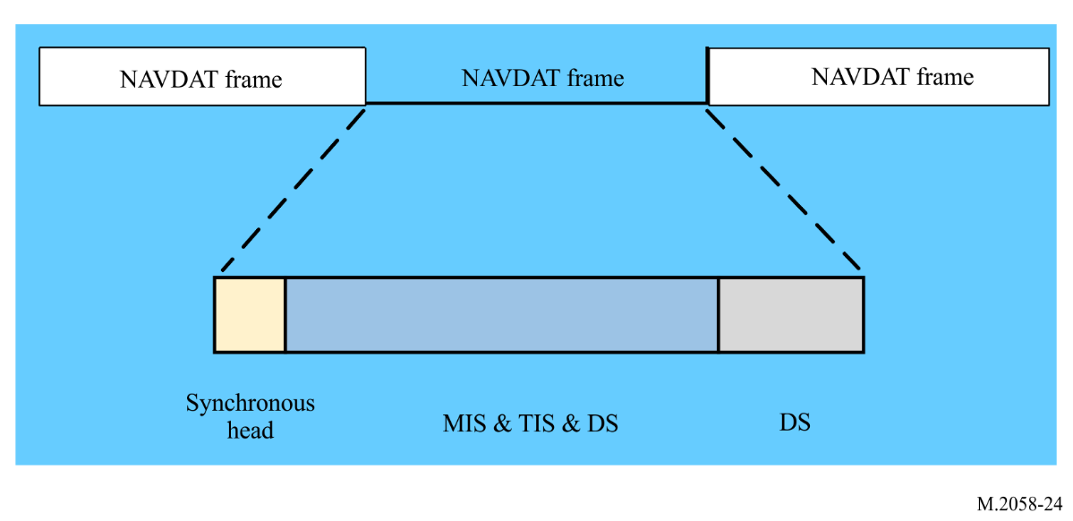
Head frame length is 400 ms.
Standard frame structure does not include DS stream without Synchronization head MIS or TIS.
Standard frame length is 400 ms. A sequence of one head frame and N-1 standard frame constitutes a super-frame of the length of N. The NAVDAT broadcast should use a super-frame pattern of the length of 5.

A4-2 Synchronization head
Synchronization head is the first OFDM symbol of each head frame for the receiver to synchronize and for the information on every subcarrier is shown in Table 9.
TABLE 9
Synchronization head sequence (in mode A)
Bandwidth and  number of subcarriers | Synchronization head sequence
10 kHz  229 | −1 1 1 1 1 1 1 −1 1 1 −1 −1 1 −1 1 1 1 1 1 −1 −1 1 −1 1 −1 −1 −1 1 1 1 1 −1 1 −1 −1 −1 −1 1 1 −1 1 1 1 −1 −1 −1 1 1 1 −1 1 −1 −1 1 1 −1 1 1 −1 1 1 −1 −1 −1 1 −1 1 −1 −1 1 −1 −1 1 −1 1 1 −1 −1 −1 −1 1 −1 −1 1 −1 −1 −1 1 −1 1 1 1 −1 −1 1 −1 −1 1 1 −1 −1 −1 1 1 −1 1 −1 −1 1 −1 1 −1 1 −1 0 −1 −1 −1 −1 1 −1 −1 −1 −1 −1 1 −1 −1 −1 1 1 −1 −1 1 1 1 1 −1 −1 1 1 −1 1 −1 1 −1 1 1 1 −1 1 −1 1 −1 −1 −1 −1 −1 −1 1 1 −1 −1 −1 −1 −1 1 1 1 1 1 −1 1 −1 1 1 1 1 −1 1 1 1 1 −1 −1 −1 −1 1 1 1 −1 −1 1 1 1 −1 1 1 1 −1 1 1 −1 1 −1 1 1 −1 −1 1 1 −1 −1 1 −1 −1 −1 −1 1 −1 1 −1 1 −1 1 −1 −1 1 1
5 kHz  115 | 1 −1 1 1 −1 −1 −1 1 −1 1 −1 −1 1 −1 −1 1 −1 1 1 −1 −1 −1 −1 1 −1 −1 1 −1 −1 −1 1 −1 1 1 1 −1 −1 1 −1 −1 1 1 −1 −1 −1 1 1 −1 1 −1 −1 1 −1 1 −1 1 −1 0 1 −1 −1 −1 1 −1 −1 −1 −1 −1 1 −1 −1 −1 1 1 −1 −1 1 1 1 1 −1 −1 1 1 −1 1 −1 1 −1 1 1 1 −1 1 −1 1 −1 −1 −1 −1 −1 −1 1 1 −1 −1 −1 −1 −1 1 1 1 1 1 −1
3 kHz  69 | 1 −1 −1 1 −1 −1 −1 1 −1 1 1 1 −1 −1 1 −1 −1 1 1 −1 −1 −1 1 1 −1 1 −1 −1 1 −1 1 −1 1 1 0 −1 −1 −1 −1 1 −1 −1 −1 −1 −1 1 −1 −1 −1 1 1 −1 −1 1 1 1 1 −1 −1 1 1 −1 1 −1 1 −1 1 1 1
1 kHz  23 | 1 −1 1 −1 −1 1 −1 1 −1 1 1 0 1 −1 −1 −1 1 −1 −1 −1 −1 −1 1

Synchronization head sequence (in mode B)
Bandwidth and  number of subcarriers | Synchronization head sequence
10 kHz  207 | −1 1 −1 1 1 1 1 1 −1 −1 1 −1 1 −1 −1 −1 1 1 1 1 −1 1 −1 −1 −1 −1 1 1 −1 1 1 1 −1 −1 −1 1 1 1 −1 1 −1 −1 1 1 −1 1 1 −1 1 1 −1 −1 −1 1 −1 1 −1 −1 1 −1 −1 1 −1 1 1 −1 −1 −1 −1 1 −1 −1 1 −1 −1 −1 1 −1 1 1 1 −1 −1 1 −1 −1 1 1 −1 −1 −1 1 1 −1 1 −1 −1 1 −1 1 −1 1 −1 0 −1 −1 −1 −1 1 −1 −1 −1 −1 −1 1 −1 −1 −1 1 1 −1 −1 1 1 1 1 −1 −1 1 1 −1 1 −1 1 −1 1 1 1 −1 1 −1 1 −1 −1 −1 −1 −1 −1 1 1 −1 −1 −1 −1 −1 1 1 1 1 1 −1 1 −1 1 1 1 1 −1 1 1 1 1 −1 −1 −1 −1 1 1 1 −1 −1 1 1 1 −1 1 1 1 −1 1 1 −1 1 −1 1 1 −1 −1 1 1 −1 −1 1 −1 −1 −1 −1
5 kHz  103 | −1 1 −1 1 −1 −1 1 −1 −1 1 −1 1 1 −1 −1 −1 −1 1 −1 −1 1 −1 −1 −1 1 −1 1 1 1 −1 −1 1 −1 −1 1 1 −1 −1 −1 1 1 −1 1 −1 −1 1 −1 1 −1 1 −1 0 1 −1 −1 −1 1 −1 −1 −1 −1 −1 1 −1 −1 −1 1 1 −1 −1 1 1 1 1 −1 −1 1 1 −1 1 −1 1 −1 1 1 1 −1 1 −1 1 −1 −1 −1 −1 −1 −1 1 1 −1 −1 −1 −1 −1
3 kHz  61 | −1 −1 −1 1 −1 1 1 1 −1 −1 1 −1 −1 1 1 −1 −1 −1 1 1 −1 1 −1 −1 1 −1 1 −1 1 1 0 −1 −1 −1 −1 1 −1 −1 −1 −1 −1 1 −1 −1 −1 1 1 −1 −1 1 1 1 1 −1 −1 1 1 −1 1 −1 1
1 kHz  19 | 1 −1 −1 1 −1 1 −1 1 1 0 1 −1 −1 −1 1 −1 −1 −1 −1

Synchronization head sequence (in mode C)
Bandwidth and  number of subcarriers | Synchronization head sequence
10 kHz  139 | −1 1 1 1 −1 1 −1 −1 1 1 −1 1 1 −1 1 1 −1 −1 −1 1 −1 1 −1 −1 1 −1 −1 1 −1 1 1 −1 −1 −1 −1 1 −1 −1 1 −1 −1 −1 1 −1 1 1 1 −1 −1 1 −1 −1 1 1 −1 −1 −1 1 1 −1 1 −1 −1 1 −1 1 −1 1 −1 0 −1 −1 −1 −1 1 −1 −1 −1 −1 −1 1 −1 −1 −1 1 1 −1 −1 1 1 1 1 −1 −1 1 1 −1 1 −1 1 −1 1 1 1 −1 1 −1 1 −1 −1 −1 −1 −1 −1 1 1 −1 −1 −1 −1 −1 1 1 1 1 1 −1 1 −1 1 1 1 1 −1 1 1 1 1 −1
5 kHz  69 | 1 −1 −1 1 −1 −1 −1 1 −1 1 1 1 −1 −1 1 −1 −1 1 1 −1 −1 −1 1 1 −1 1 −1 −1 1 −1 1 −1 1 −1 0 1 −1 −1 −1 1 −1 −1 −1 −1 −1 1 −1 −1 −1 1 1 −1 −1 1 1 1 1 −1 −1 1 1 −1 1 −1 1 −1 1 1 1
3 kHz  41 | 1 −1 −1 1 1 −1 −1 −1 1 1 −1 1 −1 −1 1 −1 1 −1 1 1 0 −1 1 −1 −1 −1 1 −1 −1 −1 −1 −1 1 −1 −1 −1 1 1 −1 −1 1 1
1 kHz  13 | 1 −1 1 −1 1 1 0 1 −1 −1 −1 1 −1

For the different channel bandwidth, the OFDM symbol index corresponding to the synchronization header is shown in Table 10.
TABLE 10
Index of the synchronization head symbols
Mode | Ns | Index of the OFDM symbol per frame
A | 15 | 1
B | 15 | 1
C | 20 | 1

A4-3 Modulation information stream

A4-3.1 Structure
MIS is used to provide the information about channel spectrum occupancy as well as TIS and DS modulation:
– information of channel bandwidth: 2 bits;
– information of TIS modulation: 1 bit;
– information of DS modulation: 2 bits;
– Cyclic redundancy check (CRC): 8 bits;
– Reserved: 3 bits (default: 0).
TABLE 11
Information of channel bandwidth
Case  (see Table 4 of Annex 3) | Patterns of bits | Spectrum occupancy  (kHz)
1 | 00 | 1
2 | 01 | 3
3 | 10 | 5
4 | 11 | 10

TABLE 12
Information of transmitter information stream modulation
Patterns of bits | Modulation
0 | 4-QAM
1 | 16-QAM

TABLE 13
Information of data stream modulation
Patterns of bits | Modulation
00 | 4-QAM
01 | 16-QAM
10 | 64-QAM

A4-3.2 Encoding
The MIS is encoded using a (16, 48) polar code, where the positions of the information subchannels are determined by the 0's in the following vector:
1 1 1 1 1 1 1 1 1 1 1 1 1 1 1 1 1 1 1 1 1 1 1 1 1 1 1 1 1 1 0 0 1 1 1 1 1 1 1 1 1 1 1 1 1 0 0 0 1 1 1 0 1 0 0 0 1 0 0 0 0 0 0 0.
After standard polar encoding, the codeword should be punctured from 64 to 48 bits by discarding the bits indexed by 1-16.

A4-4 Transmitter information stream

A4-4.1 Structure
TIS is used to provide the information about encoding of DS, transmitter, and time for the receiver:
– error encoding of DS: 5 bits;
– identifier of the transmitter: 32 bits;
– mode of robustness: 3 bits;
– day and time: 17 bits;
– reserved 1 (for 4-QAM): 11 bits (default: 0);
– reserved 2 (for 16-QAM): 87 bits (default: 0);
– CRC: 8 bits.
TABLE 14
Encoding of data stream
Patterns of bits | Transmission mode
Patterns of bits | Channel bandwidth (kHz) | Code rate | Modulation
00000 | 1 | 0.5 | 4-QAM
00001 | 1 | 0.75 | 4-QAM
00010 | 1 | 0.5 | 16-QAM
00011 | 1 | 0.75 | 16-QAM
00100 | 1 | 0.5 | 64-QAM
00101 | 1 | 0.75 | 64-QAM
01000 | 3 | 0.5 | 4-QAM
01001 | 3 | 0.75 | 4-QAM
01010 | 3 | 0.5 | 16-QAM
01011 | 3 | 0.75 | 16-QAM
01100 | 3 | 0.5 | 64-QAM
01101 | 3 | 0.75 | 64-QAM
10000 | 5 | 0.5 | 4-QAM
10001 | 5 | 0.75 | 4-QAM
10010 | 5 | 0.5 | 16-QAM
10011 | 5 | 0.75 | 16-QAM
10100 | 5 | 0.5 | 64-QAM
10101 | 5 | 0.75 | 64-QAM
11000 | 10 | 0.5 | 4-QAM
11001 | 10 | 0.75 | 4-QAM
11010 | 10 | 0.5 | 16-QAM
11011 | 10 | 0.75 | 16-QAM
11100 | 10 | 0.5 | 64-QAM
11101 | 10 | 0.75 | 64-QAM

TABLE 15
Identifier of the transmitter
Coding | Identifier of the transmitter
I | 8 bits ASCII
D | 8 bits ASCII
NAV/MET AREA | 5 bits
STATION NUMBER | 11 bits
Total | 32 bits

The encoding of the I and D header should be in 5 bits ASCII.
The coding of the areas should be done in binary on 8 bits (maximum 31 areas).
The station number allocated for a frequency should be coded on 11 bits (maximum of 2 047 stations by area).
Total of 32 bits should thus be used for the identification of each pair station/frequency
Examples of coast station identification code
A NAVDAT station located in NAVAREA/METAREA III (3) and transmitting on 4 226 kHz would have the following identity (with the numbering 85 allocated to the station):
I 01001001 8 bits ASCII
D 01000100 8 bits ASCII
3 00011 5 bits binary
85 00001010101 11 bits binary
Total 32 bits
TABLE 16
Information of time
Parameter | Bit number | Description
Hour of start time in UTC | 5 | hour
Minute of start time in UTC | 6 | minute
Duration of the broadcast | 6 | 0 to 59 minutes

TABLE 17
Mode of robustness
Mode | Pattern of bit
A | 000
B | 001
C | 010
D | 011

A4-4.2 Encoding
The TIS is encoded using a (76, 152) polar code, where the positions of the information subchannels are determined by the 0's in the following vector:
1 1 1 1 1 1 1 1 1 1 1 1 1 1 1 1 1 1 1 1 1 1 1 1 1 1 1 1 1 0 0 0 1 1 1 1 1 1 1 1 1 1 1 0 1 0 0 0 1 1 1 0 1 0 0 0 1 0 0 0 0 0 0 0 1 1 1 1 1 1 1 0 1 1 1 0 1 0 0 0 1 1 1 0 1 0 0 0 0 0 0 0 0 0 0 0 1 1 0 0 0 0 0 0 0 0 0 0 0 0 0 0 1 1 1 1 1 1 1 1 1 1 1 1 1 1 1 1 1 1 1 1 1 1 1 0 1 1 1 0 0 0 0 0 1 1 0 0 0 0 0 0 0 0 0 0 0 0 0 0 1 0 0 0 0 0 0 0 1 1 1 1 1 1 1 1 1 1 1 1 1 1 1 1 1 1 1 1 1 1 1 1 1 1 1 1 1 1 1 1 1 1 1 1 1 1 1 1 1 1 1 1 1 1 1 1 1 1 1 1 1 1 1 1 1 1 1 1 1 1 1 1 1 1 1 1 1 1 1 1 1 1 1 1 1 1 1 1 1 1 1 1 1 1 1 1.
After standard polar encoding, the codeword should be punctured from 256 bits to 152 bits by selecting the bits indexed by 1-112 and 129-168.

A4-4.3 Position
There are 100 (MIS:48, TIS:152) carriers for MIS and TIS transmission. Table 18 give the position of these carriers.
TABLE 18
Position of the modulation information stream and transmitter information stream carriers
For 3, 5 and 10 kHz bandwidth in mode A and B, and 1 kHz bandwidth in mode A
Symbol | Carrier number
2 | −10, −8, −6, −4, −2, 2, 4, 6, 8, 10
3 | −10, −8, −6, −4, −2, 2, 4, 6, 8, 10
4 | −10, −8, −6, −4, −2, 2, 4, 6, 8, 10
5 | −10, −8, −6, −4, −2, 2, 4, 6, 8, 10
6 | −10, −8, −6, −4, −2, 2, 4, 6, 8, 10
7 | −10, −8, −6, −4, −2, 2, 4, 6, 8, 10
8 | −10, −8, −6, −4, −2, 2, 4, 6, 8, 10
9 | −10, −8, −6, −4, −2, 2, 4, 6, 8, 10
10 | −10, −8, −6, −4, −2, 2, 4, 6, 8, 10
11 | −10, −8, −6, −4, −2, 2, 4, 6, 8, 10

For 1 kHz bandwidth in mode B
Symbol | Carrier number
2 | −8, −6, −4, −2, 2, 4, 6, 8
3 | −8, −6, −4, −2, 2, 4, 6, 8
4 | −8, −6, −4, −2, 2, 4, 6, 8
5 | −8, −6, −4, −2, 2, 4, 6, 8
6 | −8, −6, −4, −2, 2, 4, 6, 8
7 | −8, −6, −4, −2, 2, 4, 6, 8
8 | −8, −6, −4, −2, 2, 4, 6, 8
9 | −8, −6, −4, −2, 2, 4, 6, 8
10 | −8, −6, −4, −2, 2, 4, 6, 8
11 | −8, −6, −4, −2, 2, 4, 6, 8
12 | −8, −6, −4, −2, 2, 4, 6, 8
13 | −8, −6, −4, −2, 2, 4, 6, 8
14 | −4, −2, 2, 4

For 1 kHz bandwidth in mode C
Symbol | Carrier number
2 | −6, −4, −2, 2, 4, 6
3 | −6, −4, −2, 2, 4, 6
4 | −6, −4, −2, 2, 4, 6
5 | −6, −4, −2, 2, 4, 6
6 | −6, −4, −2, 2, 4, 6
7 | −6, −4, −2, 2, 4, 6
8 | −6, −4, −2, 2, 4, 6
9 | −6, −4, −2, 2, 4, 6
10 | −6, −4, −2, 2, 4, 6
11 | −6, −4, −2, 2, 4, 6
12 | −6, −4, −2, 2, 4, 6
13 | −6, −4, −2, 2, 4, 6
14 | −6, −4, −2, 2, 4, 6
15 | −6, −4, −2, 2, 4, 6
16 | −6, −4, −2, 2, 4, 6
17 | −6, −4, −2, 2, 4, 6
18 | −4, −2, 2, 4

A4-5 Data stream

A4-5.1 Structure
Data stream generally consist of either text information or files of information. A generalized packet delivery allows the delivery of text information and files for various services in the same data stream. Services can also be carried by a series of single packets.
The structure of a packet is as follows:
– Head 32 bits
– Data field n bytes
– CRC 16 bits.
The head is made up as follows:
– Data length 12 bits
– toggle bit 1 bit
– first flag 1 bit
– last flag 1 bit
– packet ID 10 bits
– padded packet indicator 1 bit
– reserved 6 bits.
Data length: This 12-bit indicates the length of a packet in bytes.
Toggle bit: This bit should be maintained in the same state as long as packets from the same text message or file are being transmitted. When a packet from a different text message or file is sent for the first time, this bit should be inverted with respect to its previous state. If a text message or file, which may consist of several packets, is repeated, then this bit should remain unchanged.
First flag, Last flag: These flags are used to identify particular packets which form a succession of packets. The flags are assigned as follows:
TABLE 19
Coding of first flag and last flag
First flag | Last flag | The packet is
0 | 0 | an intermediate packet
0 | 1 | the last packet of a data unit
1 | 0 | the first packet of a data unit
1 | 1 | the one and only packet of a data unit

Packet ID: This 8-bit field indicates the packet ID of this packet.
Padded Packet Indicator: This 1-bit flag indicates whether the data field carries padding or not, as follows:
0: no padding is present, all data bytes in the data field are useful;
1: padding is present, the first two bytes give the number of useful data bytes in the data field.
Reserved: This 6-bit field is reserved for future use.
Data field: It contains the useful data intended for a particular service. It can be text information or file information (see also Table 23).
The first information in the data field is broadcast mode, which is defined in Table 20.
TABLE 20
Broadcast mode
Mode | Pattern of bit | Coding | Comments
General | 00 | 36 bits
Selective ship | 01 | 36 bits | MMSI of the ship
Group of ships | 10 | 36 bits | Group of ship’s ID (main or secondary)
Selective area | 11 | 512 bits | Geographic coordinates of the defined area

In the case of selective broadcast over a specific area, this geographical area is defined as follows:
– The zone number assigned by the server (maximum 99) + space.
– The area is determined by four geographical points in degrees minutes seconds (DMS) starting from the highest point and turning clockwise (Latitude followed by Longitude).
– The + sign indicates North and East.
– The sign − indicates South and West.
For example for a zone 1 (Z01):
Position 1 47°42’22” N and 137°28’59” E
Position 2: 37°50’24” N and 139°00’10” E
Position 3: 32°04’57” N and 129°29’05”
Position 4: 33°04’56” N and 127°30’28”
Giving:
Z01 + 474222 + 1372859 + 375024 + 1390010 + 320457 + 1292905 + 330456 + 1273028,
the server converts this text in binary:
01011010 00110000 00110001 00100000 00101011 00110100 00110111 00110100 00110010 00110010 00110010 00101011 00110001 00110011 00110111 00110010 00111000 00110101 00111001 00101011 00110011 00110111 00110101 00110000 00110010 00110100 00101011 00110001 00110011 00111001 00110000 00110000 00110001 00110000 00101011 00110011 00110010 00110000 00110100 00110101 00110111 00101011 00110001 00110010 00111001 00110010 00111001 00110000 00110101 00101011 00110011 00110011 00110000 00110100 00110101 00110110 00101011 00110001 00110010 00110111 00110011 00110000 00110010 00111000
Total 512 bits.
The second information defines the level of the message: Routine, Important or Vital according to Table 21.
TABLE 21
Level of message
Coding | Definition level
00 | Routine
01 | Safety
10 | Urgency
11 | Distress

The third information gives the number of the message from 1 to 999 coded on 10 bits.
Example: 1 = 0000000001
999 = 1111100111
The fourth piece of information specifies the subject of the message according to Table 27 (from 1 to 63) coded on 6 bits:
1 = 000001
63 = 111111
CRC: This 16-bit CRC should be calculated on the header and the data field.

A4-5.2 Encoding
NAVDAT data stream is encoded by low-density parity-check (LDPC), and different encoding parameters should be adopted in different modes (see Table 14). Table 22 gives the LDPC parameters of mode A, B and C for all bandwidths.
TABLE 22
Low-density parity-check parameters of data stream for mode A
Bandwidth  (kHz) | Number of subcarriers | Number of pilots | Number of data subcarriers | Modulation | TIS and MIS | Information bits | Channel coding | Information rate  (kbit/s)
10 | 228*14 | 38*14 | 190*14 | 4-QAM | 100 | 2560*2 | (2560,5120) | 6.36
10 | 228*14 | 38*14 | 190*14 | 4-QAM | 100 | 2560*2 | (3840,5120) | 9.56
10 | 228*14 | 38*14 | 190*14 | 16-QAM | 100 | 2560*4 | (2560,5120) | 12.72
10 | 228*14 | 38*14 | 190*14 | 16-QAM | 100 | 2560*4 | (3840,5120) | 19.12
10 | 228*14 | 38*14 | 190*14 | 64-QAM | 100 | 2560*6 | (2560,5120) | 19.08
10 | 228*14 | 38*14 | 190*14 | 64-QAM | 100 | 2560*6 | (3840,5120) | 28.68
5 | 114*14 | 271 | 1325 | 4-QAM | 100 | 1224*2 | (1224,2448) | 3.02
5 | 114*14 | 271 | 1325 | 4-QAM | 100 | 1224*2 | (1836,2448) | 4.55
5 | 114*14 | 271 | 1325 | 16-QAM | 100 | 1224*4 | (1224,2448) | 6.04
5 | 114*14 | 271 | 1325 | 16-QAM | 100 | 1224*4 | (1836,2448) | 9.10
5 | 114*14 | 271 | 1325 | 64-QAM | 100 | 1224*6 | (1224,2448) | 9.06
5 | 114*14 | 271 | 1325 | 64-QAM | 100 | 1224*6 | (1836,2448) | 13.65
3 | 68*14 | 159 | 793 | 4-QAM | 100 | 692*2 | (692,1384) | 1.69
3 | 68*14 | 159 | 793 | 4-QAM | 100 | 692*2 | (1038,1384) | 2.555
3 | 68*14 | 159 | 793 | 16-QAM | 100 | 692*4 | (692,1384) | 3.38
3 | 68*14 | 159 | 793 | 16-QAM | 100 | 692*4 | (1038,1384) | 5.11
3 | 68*14 | 159 | 793 | 64-QAM | 100 | 692*6 | (692,1384) | 5.07
3 | 68*14 | 159 | 793 | 64-QAM | 100 | 692*6 | (1038,1384) | 7.665
1 | 22*14 | 4*14 | 252 | 4-QAM | 100 | 152*2 | (152,304) | 0.34
1 | 22*14 | 4*14 | 252 | 4-QAM | 100 | 152*2 | (228,304) | 0.53
1 | 22*14 | 4*14 | 252 | 16-QAM | 100 | 152*4 | (152,304) | 0.68
1 | 22*14 | 4*14 | 252 | 16-QAM | 100 | 152*4 | (228,304) | 1.06
1 | 22*14 | 4*14 | 252 | 64-QAM | 100 | 152*6 | (152,304) | 1.095
1 | 22*14 | 4*14 | 252 | 64-QAM | 100 | 152*6 | (228,304) | 1.59

TABLE 23
Low density parity check parameters of data stream for mode B
Bandwidth | Number of subcarriers | Number of pilots | Number of data subcarriers | Modulation | TIS and MIS | Information bits | Channel coding | Information rate  (kbit/s)
10 | 206*14 | 485 | 2399 | 4-QAM | 100 | 2298*2 | (2298,4596) | 5.705
10 | 206*14 | 485 | 2399 | 4-QAM | 100 | 2298*2 | (3447,4596) | 8.578
10 | 206*14 | 485 | 2399 | 16-QAM | 100 | 2298*4 | (2298,4596) | 11.41
10 | 206*14 | 485 | 2399 | 16-QAM | 100 | 2298*4 | (3447,4596) | 17.155
10 | 206*14 | 485 | 2399 | 64-QAM | 100 | 2298*6 | (2298,4596) | 17.115
10 | 206*14 | 485 | 2399 | 64-QAM | 100 | 2298*6 | (3447,4596) | 25.733
5 | 102*14 | 243 | 1185 | 4-QAM | 100 | 1084*2 | (1084,2168) | 2.67
5 | 102*14 | 243 | 1185 | 4-QAM | 100 | 1084*2 | (1626,2168) | 4.025
5 | 102*14 | 243 | 1185 | 16-QAM | 100 | 1084*4 | (1084,2168) | 5.34
5 | 102*14 | 243 | 1185 | 16-QAM | 100 | 1084*4 | (1626,2168) | 8.05
5 | 102*14 | 243 | 1185 | 64-QAM | 100 | 1084*6 | (1084,2168) | 8.01
5 | 102*14 | 243 | 1185 | 64-QAM | 100 | 1084*6 | (1626,2168) | 12.075
3 | 60*14 | 10*14 | 700 | 4-QAM | 100 | 600*2 | (600,1200) | 1.46
3 | 60*14 | 10*14 | 700 | 4-QAM | 100 | 600*2 | (900,1200) | 2.21
3 | 60*14 | 10*14 | 700 | 16-QAM | 100 | 600*4 | (600,1200) | 2.92
3 | 60*14 | 10*14 | 700 | 16-QAM | 100 | 600*4 | (900,1200) | 4.42
3 | 60*14 | 10*14 | 700 | 64-QAM | 100 | 600*6 | (600,1200) | 4.38
3 | 60*14 | 10*14 | 700 | 64-QAM | 100 | 600*6 | (900,1200) | 6.63
1 | 18*14 | 47 | 205 | 4-QAM | 100 | 104*2 | (104,208) | 0.22
1 | 18*14 | 47 | 205 | 4-QAM | 100 | 104*2 | (156,208) | 0.35
1 | 18*14 | 47 | 205 | 16-QAM | 100 | 104*4 | (104,208) | 0.44
1 | 18*14 | 47 | 205 | 16-QAM | 100 | 104*4 | (156,208) | 0.70
1 | 18*14 | 47 | 205 | 64-QAM | 100 | 104*6 | (104,208) | 0.66
1 | 18*14 | 47 | 205 | 64-QAM | 100 | 104*6 | (156,208) | 1.05

TABLE 24
Low density check parameters of data stream for mode C
Bandwidth  (kHz) | Number of subcarriers | Number of pilots | Number of data subcarriers | Modulation | TIS and MIS | Information bits | Channel coding | Information rate  (kbit/s)
10 | 138*19 | 35*19 | 1957 | 4-QAM | 100 | 1856*2 | (1856,3712) | 4.60
10 | 138*19 | 35*19 | 1957 | 4-QAM | 100 | 1856*2 | (2784,3712) | 6.92
10 | 138*19 | 35*19 | 1957 | 16-QAM | 100 | 1856*4 | (1856,3712) | 9.20
10 | 138*19 | 35*19 | 1957 | 16-QAM | 100 | 1856*4 | (2784,3712) | 13.84
10 | 138*19 | 35*19 | 1957 | 64-QAM | 100 | 1856*6 | (1856,3712) | 13.80
10 | 138*19 | 35*19 | 1957 | 64-QAM | 100 | 1856*6 | (2784,3712) | 20.76
5 | 68*19 | 17*19 | 969 | 4-QAM | 100 | 868*2 | (868,1736) | 2.13
5 | 68*19 | 17*19 | 969 | 4-QAM | 100 | 868*2 | (1302,1736) | 3.22
5 | 68*19 | 17*19 | 969 | 16-QAM | 100 | 868*4 | (868,1736) | 4.26
5 | 68*19 | 17*19 | 969 | 16-QAM | 100 | 868*4 | (1302,1736) | 6.43
5 | 68*19 | 17*19 | 969 | 64-QAM | 100 | 868*6 | (868,1736) | 6.39
5 | 68*19 | 17*19 | 969 | 64-QAM | 100 | 868*6 | (1302,1736) | 9.65
3 | 40*19 | 10*19 | 570 | 4-QAM | 100 | 470*2 | (470,940) | 1.14
3 | 40*19 | 10*19 | 570 | 4-QAM | 100 | 470*2 | (705,940) | 1.72
3 | 40*19 | 10*19 | 570 | 16-QAM | 100 | 470*4 | (470,940) | 2.27
3 | 40*19 | 10*19 | 570 | 16-QAM | 100 | 470*4 | (705,940) | 3.45
3 | 40*19 | 10*19 | 570 | 64-QAM | 100 | 470*6 | (470,940) | 3.41
3 | 40*19 | 10*19 | 570 | 64-QAM | 100 | 470*6 | (705,940) | 5.17
1 | 12*19 | 3*19 | 171 | 4-QAM | 100 | 70*2 | (70,140) | 0.14
1 | 12*19 | 3*19 | 171 | 4-QAM | 100 | 70*2 | (105,140) | 0.22
1 | 12*19 | 3*19 | 171 | 16-QAM | 100 | 70*4 | (70,140) | 0.27
1 | 12*19 | 3*19 | 171 | 16-QAM | 100 | 70*4 | (105,140) | 0.45
1 | 12*19 | 3*19 | 171 | 64-QAM | 100 | 70*6 | (70,140) | 0.41
1 | 12*19 | 3*19 | 171 | 64-QAM | 100 | 70*6 | (105,140) | 0.67

A4-6 Low-density parity-check codes
The LDPC code is a linear block code that can be uniquely defined by the parity check matrix H. Since the number of “1” in the parity check matrix H is much smaller than the number of “0”, it is called low density check code. The matrix H has double diagonal characteristics.
The check matrix H can be expressed as an exponential matrix shown as follows:
Each number represents an L × L matrix. (L = 160) −1 denotes an all-zero matrix, 0 denotes a unit matrix, and p denotes a permutation matrix obtained by shifting the unit matrix to the right by p. The double diagonal matrix can be divided into two parts: information block and check block, namely: H = [H_{s} H_{p}] and the vector of the encoded output symbols also can be divided into two parts, namely: C = [S P].
According to the check equation [H_{s} H_{p}] [S P]^{T} = 0, the corresponding parity bit can be obtained.
The code length of LDPC in mode A and mode B at 10 kHz bandwidth of NAVDAT is 5120, and the code rate is 1/2 and 3/4 respectively. The check matrix of the 1/2 code rate is:
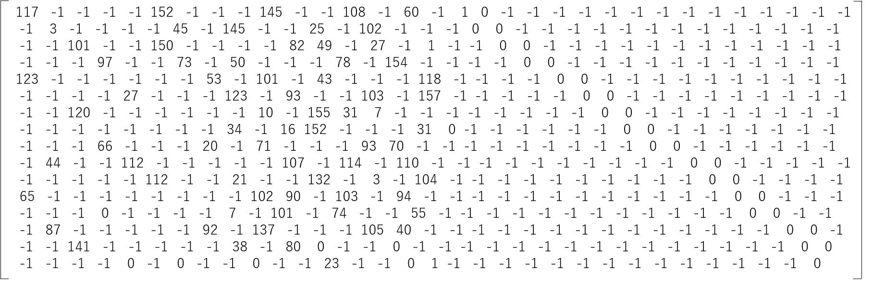
The check matrix of the 3/4 code rate is:
Encoded DS bits sequence should be interleaved in time and frequency before mapping.

A4-7 Cyclic redundancy check
For the bit error detection in DS, the 16-bit cyclic redundancy check should be calculated at the end of each DS. The generator polynomial should be $G_{16}\left(x\right)=x^{16}+x^{12}+x^{5}+1$.
For MIS and TIS, the 8-bit cyclic redundancy check should be calculated, and the generator polynomial should be $G_{8}\left(x\right)=x^{8}+x^{4}+x^{3}+x^{2}+1$.

Annex 5
Message file structure
Figure 25 shows an example of how a data group is built for a message file. In the first step, a header is created to describe the body (a message file). The header contains the file’s management data. Afterwards, the header, as well as the body, are split into equally sized segments (only the last segment of each item may be smaller). A segment header is attached to a segment, and each segment is mapped into one data group. Then each data group with its header is mapped directly to a data unit. The data unit is split into packets for transportation. FF and LF represent the state of the ‘first flag’ and ‘last flag’ bits for each packet.
FIGURE 25
Message file structure
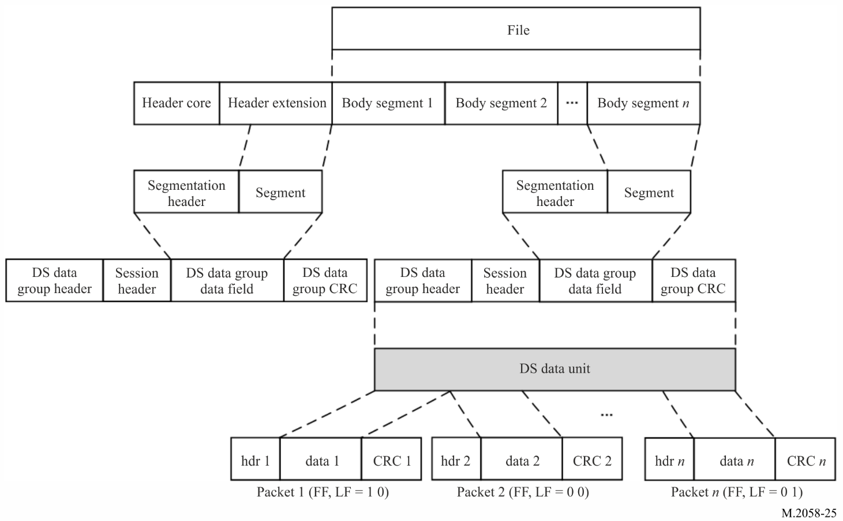

TABLE 25
The structure of the message head
Parameter | Number  of bits | Description
Broadcast mode | 2 | 00 General broadcast  01 Selective ship  10 Group of ship  11 Selective area
Detail of broadcast modes 00, 01 and 10 | 36 | 1 When broadcast mode = 00 All bits are = 0  2 While the Broadcast mode is 01 or 10, the identity is defined on 9 bits according to Rec. ITU-R M.493, each digit consist of 4 bits and the number of bits is 36.
Detail of broadcast mode 11 | 512 | The area is defined by four geographical positions on 512 bits (see Table 20 and note)
TABLE 25 (end)
Parameter | Number  of bits | Description
Priority (level of message) | 2 | 00 Routine  01 Safety  10 Urgency  11 Distress
Subject of message | 6 | Refer to Table 24
Numbering of the message | 10 | 1 to 999
Broadcast count | 4 | Used for multiple broadcasts of the same file (1 to 15)
Length of data | 24 | The total length of the data in bytes, and valid range = 1~16777216
Total packets | 10 | The total packets of the data segment, and valid range = 1~1024
Length of file | 16 | The total length of the message file in bytes, and valid range = 1~65535
Reserved | 16 | Reserved for future use (= 0)
CRC | 16 | The CRC calculation ranges from the Broadcast mode to the end of the reserved field

Note:
The body of the broadcast message contains the following information:
The subject of the message
The origin of the message (authority that wrote the message)
The date when the message was written (Year, Month, Day and Hour / minutes)
The message reference number (it is the numbering of the message) The NAVDAT server must be informed of this number when submitting the message. It should be used for the “Broadcast count” function.

Annex 6
Single frequency network mode of Digital Radio Mondiale

A6-1 Explanation of Digital Radio Mondiale
The international digital radio broadcast standard DRM is used for digital radio broadcasting in the MF and HF bands. DRM is a proven technology that provides superior coverage, improves signal fidelity (through digital error correction coding), eliminates multi-path interference (including sky-wave interference) and thus extends coverage from sky-wave propagated signals. DRM broadcasts are implemented in both 16-QAM and 64-QAM modulation modes, depending on coverage requirements, transmitter location, power and antenna height.

A6-1.1 Single frequency network operating mode
The NAVDAT system is capable of supporting what is called “single frequency network (SFN) operation”. This is the case where a number of transmitters transmit on the same frequency, and at the same time, identical data signals. Generally, these transmitters are arranged to have overlapped coverage areas, within which a radio should receive signals from more than one transmitter. Provided that these signals arrive within a time difference of less than the guard interval, they should provide positive signal reinforcement. Thus, the service coverage should be improved at that location compared to that obtained if there was only a single transmitter providing service to that location. By careful design, and using a number of transmitters in a SFN, a region or country may be completely covered using a single frequency, and in this application, a single time slot, thus drastically improving spectrum efficiency and release broadcast slots.
In a single frequency network all the individual transmitters must be exactly time synchronized. Every transmitter must broadcast absolutely identical OFDM symbol at the same time.
Time synchronization of all transmitted packets in the transport stream of the final data multiplex is ensured by the time signal 1 pps (pulse per second), which is acquired from the GNSS system.
The frequency stability of transmitters should be better than 2 Hz.
The basic parameter that defines the size of the SFN area is the guard interval Tg.
In OFDM modulation method, its great robustness against inter-symbol interference as an effect of multipath reception (an impact of time delayed signals – echoes) consists in largely extending the very short bit time interval Tb in the serial original data stream.
This guard interval must be carefully configured according to the position of the transmitters in relation with the coverage areas.
When building an SFN network, particular attention should be paid so that the flux of the MIS, TIS and DS are preferably generated by a common server.

Annex 7
Frequencies for NAVDAT HF system
TABLE 26
Frequencies for NAVDAT HF system
Channel | Maritime frequency  band | Central frequency  (kHz) | Limits  (kHz)
C1 | 4 MHz band | 4 226 | 4 221 to 4 231
C2 | 6 MHz band | 6 337.5 | 6 332.5 to 6 342.5
C3 | 8 MHz band | 8 443 | 8 438 to 8 448
C4 | 12 MHz band | 12 663.5 | 12 658.5 to 12 668.5
C5 | 16 MHz band | 16 909.5 | 16 904.5 to 16 914.5
C6 | 22 MHz band | 22 450.5 | 22 445.5 to 22 455.5
The main international NAVDAT HF frequency is 4 226 kHz.

Annex 8
NAVDAT subject message codes
This list is given only for information.
Refer to documents published by IMO.
TABLE 27
List of NAVDAT subject message codes
Maritime Safety Information (MSI)
Subject message code | Type of message | Coding | can be rejected
Subject message code | Type of message | Coding | YES | NO
NAVIGATIONAL WARNINGS
1 | Sub-area warning |  |  | X
2 | Coastal warning | 000001 |  | X
3 | Local warning (only on national NAVDAT services) | 000010 |  | X
4 | drifting hazards (including derelict ships, ice, mines, containers, other large items over 6 metres in length, etc.) | 000011 |  | X
5 | reserve | 000100
6 | reserve | 000101
7 | No message on hand | 000110 |  | X
NAVIGATIONAL WARNINGS (following) – Positioning system Significant malfunctioning of radio-navigation services and shore-based maritime safety information radio or satellite services
8 | GNSS and RNSS | 001000 |  | X
9 | LORAN and E LORAN/ Chayka and e Chayka | 001001 |  | X
10 | Differential correction information | 001010 |  | X
11 | Operating anomalies identified within ECDIS including ENC issues | 001011
12 | areas where search and rescue (SAR) and anti-pollution operations are being carried out (for avoidance of such areas) | 001100 |  | X
13 | reserve | 001101
14 | reserve | 001110

TABLE 27 (continued)
Maritime Safety Information (MSI)
Subject message code | Type of message | Coding | can be rejected
Subject message code | Type of message | Coding | YES | NO
NAVIGATIONAL WARNINGS (following) – Act of piracy and arm robbery
15 | Acts of piracy and armed robbery against ships | 001111 |  | X
16 | Chart of piracy attacks | 010000 |  | X
17 | reserve | 010001
NAVIGATIONAL WARNINGS (following) – Tsunamis and other natural phenomena warnings
18 | Tsunami warning / Abnormal changes to sea level | 010010 |  | X
19 | reserve | 010011
NAVIGATIONAL WARNINGS (following) – Security In accordance with the requirements of the international Ship and port facility Security Code
20 | Security-related information | 010100 |  | X
21 | Chart of security level areas | 010101 |  | X
22 | reserve | 010110
23 | reserve | 010111
NAVIGATIONAL WARNINGS (following) – HEALTH Implementation of the International Health Regulation – IHR
24 | World Health Organization (WHO) health advisory information | 011000 |  | X
25 | Pandemic warning | 011001 |  | X
26 | reserve | 011010
METEOROLOGICAL
27 | Meteorological warning (Including tropical cyclone, storm, gale warning) | 011011 |  | X
28 | Meteorological synopses (including weather chart) | 011100 | X
29 | Meteorological forecast | 011101 | X
30 | Current and tide | 011110 | X
31 | Wave hight and direction | 011111 | X
32 | reserve | 100000 |  | X
33 | reserve | 100001 |  | X
ICE REPORT
34 | Ice chart | 100010 | X
35 | Iceberg | 100011 | X
36 | Polar Road Information | 100100 | X
37 | Icebreaker patrol information | 100101 | X

TABLE 27 (continued)
Maritime Safety Information (MSI)
Subject message code | Type of message | Coding | can be rejected
Search and Rescue related information
38 | Distress alert relay to all ships (MAYDAY RELAY) | 100110 |  | X
39 | Ship overdue (description and/or picture of the missing ship) | 100111 |  | X
40 | SAR coordination (to ships involved in the SAR operation) | 101000 |  | X
41 | SAR pattern (to ships involved in the SAR operation) | 101001 |  | X
42 | reserve | 101010
43 | reserve | 101011
Other safety-related information
 | Pilot service
44 | Pilot service information | 101100 | X
 | Tug services
45 | Tug service information | 101101 | X
 | Port support service
46 | Time and height of the tide | 101110 | X
47 | Local port information | 101111 | X
48 | Hydrographic and environmental information | 110000 | X
 | Vessel Traffic Service (VTS)
49 | VTS information | 110001 | X
50 | reserve | 110010
51 | reserve | 110011
 | Pollution
52 | Pollution information | 110100
53 | Pollution chart | 110101
Other information
 | AIS and LRIT messages
55 | AIS | 110111 | X
56 | LRIT | 111000 | X
 | Nautical chart and publications service
57 | Electronic nautical chart and publications corrections | 111001 | X
58 | Electronic Nautical chart and publications update | 111010 | X
 | Fishing information (only on national NAVDAT services)
59 | Regulations | 111011 | X
TABLE 27 (end)
Maritime Safety Information (MSI)
Subject message code | Type of message | Coding | can be rejected
60 | Special maps | 111100 | X
61 | Fishing Quota information | 111101 | X
 | Encrypted message
62 | Receiving an encrypted message | 111110
63 | Update receiver software | 111111 |  | X

Information is grouped by subject in the NAVDAT broadcast and each subject group is allocated a subject message code from 1 to 63.
The subject message code is used by the receiver to identify the different classes of messages as listed in this Table (from memorized information tables).
The software/firmware of the receiver should be able to be updated. The update should be performed by using a USB port or reception of message 63 (update receiver software).
This function is necessary to follow the evolutions of the GMDSS master plan for new NAVDAT stations as well as for the future revisions of the ITU Recommendations.

The group call identification format of the ship station is defined in part 1 of the Annex 1 of Recommendation ITU-R M.585.

