Recommendation ITU-R M.2010-3
(02/2026)
M Series: Mobile, radiodetermination, amateur
and related satellite services
Characteristics of a digital system, referred to as navigational data for broadcasting maritime safety and security related information from shore-to-ship in the 500 kHz band

Foreword
The role of the Radiocommunication Sector is to ensure the rational, equitable, efficient and economical use of the radio-frequency spectrum by all radiocommunication services, including satellite services, and carry out studies without limit of frequency range on the basis of which Recommendations are adopted.
The regulatory and policy functions of the Radiocommunication Sector are performed by World and Regional Radiocommunication Conferences and Radiocommunication Assemblies supported by Study Groups.

INTELLECTUAL PROPERTY RIGHTS
ITU draws attention to the possibility that the practice or implementation of this Recommendation may involve the use of a claimed Intellectual Property Right. ITU takes no position concerning the evidence, validity or applicability of claimed Intellectual Property Rights, whether asserted by ITU members or others outside of the Recommendation development process.
As of the date of approval of this Recommendation, ITU had received notice of intellectual property, protected by patents, which may be required to implement this Recommendation. However, implementers are cautioned that this may not represent the latest information and are therefore strongly urged to consult the appropriate ITU-R patent information available at https://www.itu.int/en/ITU-R/study-groups/Pages/itu-r-patent-information.aspx.

Series of ITU-R Recommendations
(Also available online at https://www.itu.int/publ/R-REC/en)
Series | Title
BO | Satellite delivery
BR | Recording for production, archival and play-out; film for television
BS | Broadcasting service (sound)
BT | Broadcasting service (television)
F | Fixed service
M | Mobile, radiodetermination, amateur and related satellite services
P | Radio-wave propagation
RA | Radio astronomy
RS | Remote sensing systems
S | Fixed-satellite service
SA | Space applications and meteorology
SF | Frequency sharing and coordination between fixed-satellite and fixed service systems
SM | Spectrum management
SNG | Satellite news gathering
TF | Time signals and frequency standards emissions
V | Vocabulary and related subjects

Note: This ITU-R Recommendation was approved in English under the procedure detailed in Resolution ITU-R 1.

Electronic Publication
Geneva, 2026
© ITU 2026
All rights reserved. No part of this publication may be reproduced, by any means whatsoever, without written permission of ITU.

RECOMMENDATION ITU-R M.2010-3
Characteristics of a digital system, referred to as navigational data for broadcasting maritime safety and security related information from shore-to-ship in the 500 kHz band
(2012-2019-2023-2026)
Scope
This Recommendation describes an MF radio system, referred to as navigational data (NAVDAT), for use in the maritime mobile service, operating in the 500 kHz band for digital broadcasting of maritime safety and security related information from shore-to-ship. The operational characteristics and system architecture of this radio system are included in Annexes 1 and 2. Technical characteristics and transmission structure are detailed in Annexes 3 and 4. Message file structure and a broadcast mode are introduced in Annexes 5 and 6. The list of subject messages is in Annex 7. Annex 8 provides information on the implementation of the NAVDAT shore infrastructure.
Keywords
500 kHz, broadcasting, NAVDAT
Abbreviations/Glossary
BER Bit error rate
BPSK Binary phase shift keying
BW Bandwidth
CDU Control and display unit
CRC Cyclic redundancy check
DRM Digital Radio Mondiale
DS Data stream
ECDIS Electronic chart and display information system
GF Galois Field or finite field
GMDSS Global maritime distress and safety system
GNSS Global navigation satellite system
HF High frequency
IMO International Maritime Organization
ITU International Telecommunication Union
LDPC Low density parity-check
MER Modulation error ratio
MF Medium frequency
MIS Modulation information stream
MMSI Maritime mobile service identity
NAVDAT Navigational data (the system name)
NAVTEX Navigational telex (the system name)
NM Nautical mile (1 852 metres)
OFDM Orthogonal frequency division multiplexing
PEP Peak envelope power
PRBS Pseudo-random binary sequence
QAM Quadrature amplitude modulation
rms Root mean square
RS Reed-Solomon codes
S/N or SNR Signal-to-noise ratio
SAR Search and rescue
SDR Software defined radio
SFN Single frequency network
SIM System of information and management
TIS Transmitter information stream
WRC World radiocommunication conference
Related ITU Recommendations, Reports
Recommendation ITU-R P.368 – Ground-wave propagation prediction method for frequencies between 10 kHz and 30 MHz
Recommendation ITU-R P.372 – Radio noise
Recommendation ITU-R M.493 – Digital selective-calling system for use in the maritime mobile service
Recommendation ITU-R M.585 – Assignment and use of identities in the maritime mobile service
Recommendation ITU-R·M.1080 – Digital selective calling system enhancement for multiple equipment installations
Recommendation ITU-R BS.1514 – System for digital sound broadcasting in the broadcasting bands below 30 MHz
Recommendation ITU-R M.2058 – Characteristics of a digital system, referred to as navigational data for broadcasting maritime safety and security related information from shore-to-ship in the maritime HF frequency band
Report ITU-R M.2201 – Utilization of the 495-505 kHz band by the maritime mobile service for the digital broadcasting of safety and security related information from shore-to-ships
Report ITU-R M.2443 – NAVDAT Guidelines
The ITU Radiocommunication Assembly,
considering
a) that high speed data broadcast from shore-to-ships enhances operational efficiency and maritime safety;
b) that the navigational telex NAVTEX system has limited capacity;
c) that the e-Navigation system of the International Maritime Organization (IMO) increases the demand for data transmission from shore-to-ship;
d) that the 500 kHz band provides good coverage for digital systems,
recognizing
a) that Recommendation ITU-R M.2058 describes the NAVDAT system operating in HF band;
b) that Recommendation ITU-R BS.1514 contains the information on the digital radio mondiale (DRM) system referenced in Annex 6;
noting
a) that Report ITU-R M.2201 provides the basis for the NAVDAT system;
b) that the NAVDAT system uses two international frequencies: 500 kHz in MF band and 4 226 kHz in HF band;
c) that the NAVDAT system may use other allocated frequencies in the maritime MF and HF bands for national or regional broadcasts,
recommends
1 that the operational characteristics for the broadcasting of maritime safety and security related information should be in accordance with Annex 1;
2 that the system architecture of the broadcasting system for maritime safety and security related information should be in accordance with Annex 2;
3 that the technical characteristics and modem protocols for digital data transmission from shore-to-ships in the 500 kHz band should be in accordance with Annexes 3 and 4;
4 that the data stream of the system and the message structure should be in accordance with Annex 5;
5 that the single frequency network (SFN) mode of operation as described in Annex 6 should be used;
6 that information on subject message as given in Annex 7 should be used;
7 that Annex 8 should be used to determine the minimum height of antenna towers in the shore infrastructure to support NAVDAT transmission modes and the associated bandwidths.

TABLE OF CONTENTS
Page
Annex 1 – Operational characteristics 6
1 Type of messages and files 6
2 Broadcast modes 6
2.1 General broadcast 6
2.2 Selective broadcast 6
2.3 Dedicated message 6
3 Broadcast priority 7
Annex 2 – System architecture 7
1 The broadcast chain 7
1.1 System of information and management 9
1.2 Shore network 10
1.3 Shore transmitter description 10
1.4 Transmission channel: Radio coverage estimation 13
Annex 3 – NAVDAT technical characteristics 14
1 Modulation principle 14
1.1 Introduction 14
1.2 Principle 15
1.3 Orthogonal frequency division multiplexing parameters 16
1.4 Channel bandwidth 17
1.5 Modulation 17
1.6 Synchronization 19
1.7 Energy dispersal 22
1.8 Spectral occupancy of RF signal 22
1.9 Sequence for receiving scanning possibility 23
2 Estimated usable data rate 23
3 NAVDAT transmitter performance specification 25
4 NAVDAT ship receiver 26
4.1 NAVDAT ship receiver description 26
5 Minimum NAVDAT ship receiver performance specifications 32
Annex 4 – Transmission structure 33
1 Frame structure 33
2 Synchronization head 33
3 Modulation information stream 35
3.1 Structure 35
3.2 Encoding 36
4 Transmitter information stream 36
4.1 Structure 36
4.2 Encoding 37
4.3 Position 38
5 Data stream 39
5.1 Structure 39
5.2 Encoding 42
6 Low-density parity-check codes 44
6.1 Code shortening and puncturing 45
6.2 LDPC of mode A 45
6.3 LDPC of Mode B 48
7 Cyclic redundancy check 50
Annex 5 – Message file structure 50
Annex 6 – Single frequency network for simultaneous broadcasting from
multiple NAVDAT locations (taken from Digital Radio Mondiale) 53
1 Explanation of Digital Radio Mondiale 53
1.1 Single frequency network operating mode 53
Annex 7 – NAVDAT subject message codes 54
Annex 8 – Implementation of NAVDAT shore infrastructure 57
A8.1 Purpose of this Annex 57
A8.2 Antenna characteristics of radio towers of various heights 57
A8.3 Antenna requirements for NAVTEX and NAVDAT systems 58
A8.4 NAVDAT estimated data rates for various transmission modes 58

Annex 1
Operational characteristics
The NAVDAT system uses a time-slot allocation similar to the NAVTEX system which could be coordinated by IMO in the same manner.
That NAVDAT system can also work on a SFN as described in Annex 6. In this case transmitters are frequency synchronized and the transmit data must be the same for all transmitters.
The NAVDAT 500 kHz digital system offers a broadcast transmission of any kind of message from shore-to-ships with possibility of encryption.

1 Type of messages and files
Any broadcasting message should be provided by a secure and controlled source.
Message types broadcast can include, but are not limited to, the following:
– safety of navigation;
– security;
– piracy;
– search and rescue;
– meteorological messages;
– piloting or harbour messages;
– vessel traffic system files transfer;
– electronic chart update packages.
See Annex 7 which gives the message subjects and their encoding.

2 Broadcast modes

2.1 General broadcast
These messages are broadcasted for the attention of all ships.

2.2 Selective broadcast
These messages are broadcasted for the attention of a group of ships or in a specific navigation area. (see also Annex 3 § 4.1.9.)

2.3 Dedicated message
These messages are addressed to one ship, using the maritime mobile service identity.

3 Broadcast priority
NAVDAT is capable of prioritizing messages (refer to the NAVDAT documents published by IMO) (see also Table 19).

Annex 2
System architecture

1 The broadcast chain
The NAVDAT system is organized upon five vectors performing the following functions:
– System of information and management (SIM):
• collects and controls all kinds of information;
• creates message files to be transmitted;
• creates transmitting programme according to message files priority and need of repetition;
• monitors the operating status and broadcast quality of the shore transmitter;
• controls the operating parameters of shore transmitter.
– Shore network:
• assures the transportation of the message files and monitor data from sources to the transmitters.
– Shore transmitter:
• receives the message files from SIM;
• translates message files to orthogonal frequency division multiplexing (OFDM) signal;
• transmits RF signal to the antenna for broadcast to ships;
• monitors operating status and reports to the SIM.
– Transmission channel:
• Transports the 500 kHz RF signal.
– Ship receiver:
• demodulates the RF OFDM signal;
• reconstructs the message files;
• sorts and makes the message files available for the dedicated equipment according to the message files applications, or displays the contents of the message files.
Figures 1 and 2 show the diagram of the broadcast chain.
Figure 1
NAVDAT 500 kHz broadcast chain block diagram
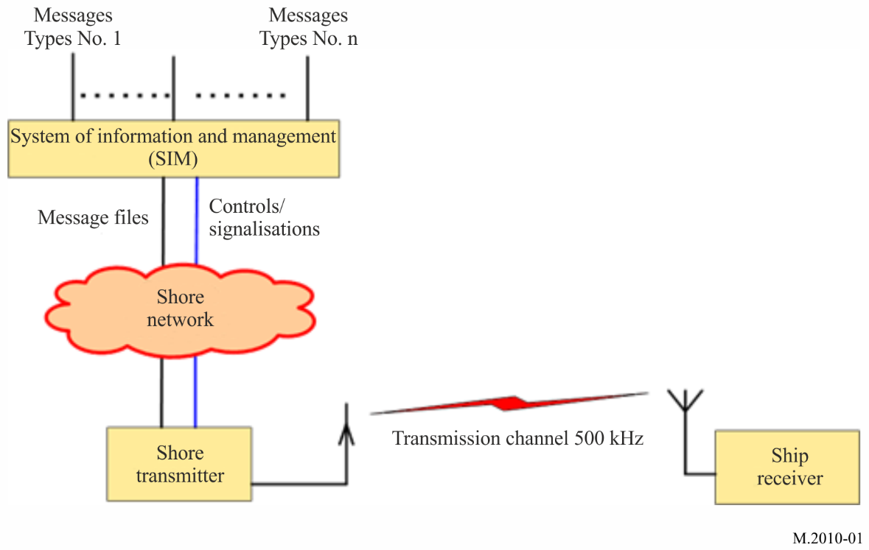
Figure 2
Global NAVDAT broadcast chain
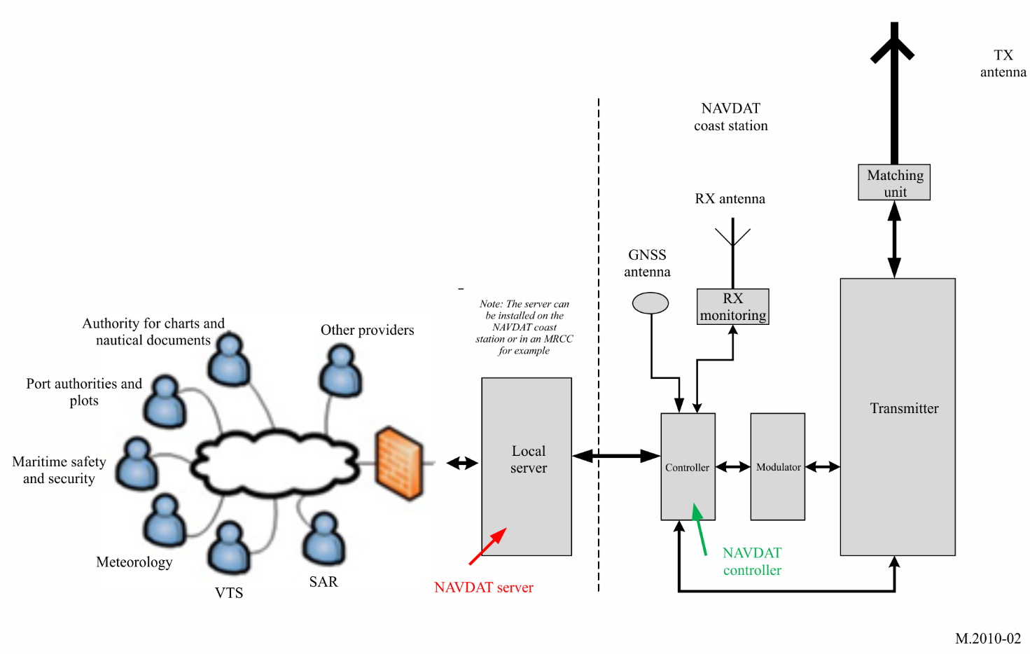

1.1 System of information and management
The SIM term includes:
– all the sources that deliver file messages (e.g. meteorological office, safety and security organizations);
– the file multiplexer which is an application running on a server;
– the file multiplexer manager;
– the shore transmitter manager.
All the sources are connected to the file multiplexer through a network.
Figure 3 shows the general diagram of the SIM.
Figure 3
NAVDAT system of information and management block diagram
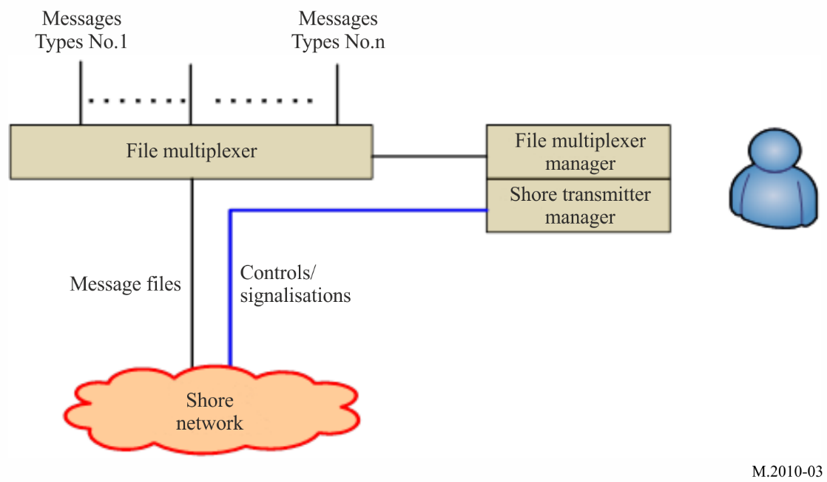

1.1.1 File multiplexer
The file multiplexer:
– takes delivery of the message files from the data sources;
– encrypts the message files if asked;
– formats the file messages with recipient information, priority status and time validity;
– sends the message files to the transmitter.

1.1.2 File multiplexer manager
The file multiplexer manager is a man machine interface that enables the user to, among other tasks:
– have a look at the message files coming from any source;
– specify the priority and periodicity of the any message file;
– specify the recipient of any message file;
– manage the file message encryption.
Some of these functionalities may be automated. As an example, the priority and the periodicity of a message may be selected according to the source it comes from or the source may specify the priority in the message.

1.1.3 Shore transmitter manager
The shore station manager is a man machine interface connected to the transmitter through the network; it makes it possible to supervise the transmitter status indications such as:
– transmit acknowledgment;
– alarms;
– effective RF transmit power;
– synchronization report;
– quality of transmission;
and to change the transmitter parameters, such as:
– RF transmit power;
– OFDM parameters (e.g. pilot subcarriers, modulation, error coding);
– transmission schedule.

1.2 Shore network
The shore network can use a broadband link, a low data rate link or a local file sharing.

1.3 Shore transmitter description
A coastal transmitting station consists of this minimum configuration:
– one controller, which is a local server with access protection;
– one OFDM modulator;
– one RF generator;
– one RF power amplifier;
– one transmit antenna with matching unit;
– one global navigation satellite system (GNSS) receiver or atomic clock for synchronization;
– one monitoring receiver with its antenna.

1.3.1 Shore system architecture
Figure 4 shows the block diagram of a 500 kHz digital transmitter.
Figure 4
NAVDAT 500 kHz transmitter functional block diagram
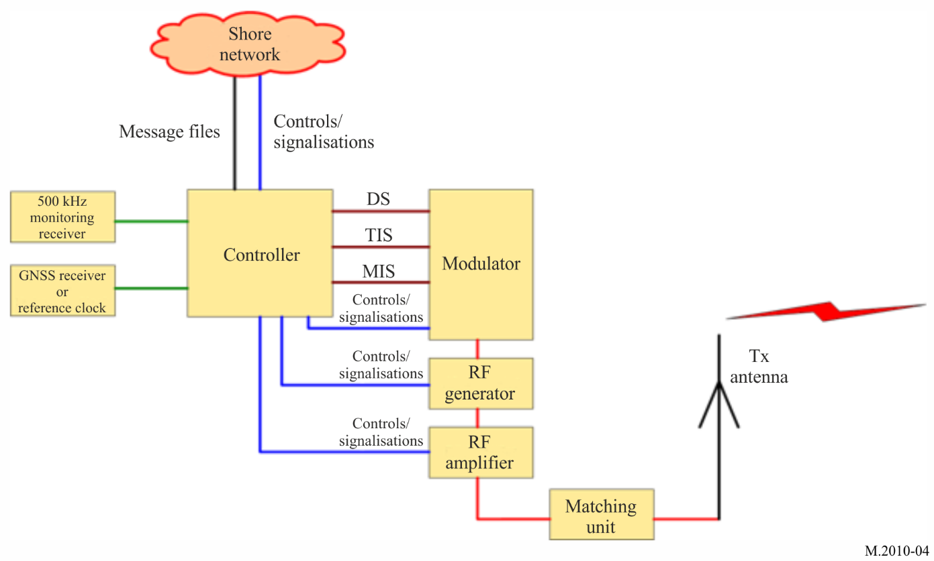

1.3.2 Controller
This unit receives and transmits some pieces of information:
– message files from SIM;
– GNSS or reference clock for synchronization;
– 500 kHz signal from monitoring receiver;
– modulator, 500 kHz signal RF generator, RF power amplifier control signals and monitoring;
– monitor signal from the RF signal generator and RF power amplifier.
The function of the controller is:
– to check if the frequency band 495-505 kHz is free before transmission;
– to synchronize all signals on the coast station from synchronization clock;
– to control the transmission parameters, time and schedule;
– to format the message files to be transmitted (split files into packets).

1.3.3 Modulator
Figure 5 shows the diagram of the modulator.
Figure 5
NAVDAT 500 kHz modulator functional block diagram
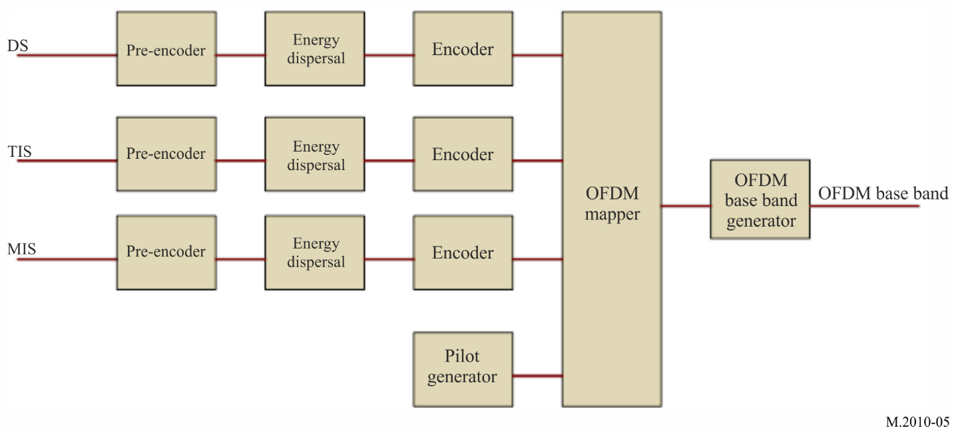

1.3.3.1 Input streams
In order to operate, the modulator needs three input streams:
– modulation information stream (MIS);
– transmitter information stream (TIS);
– data stream (DS).
These streams are transcoded and then placed on the OFDM signal by the cell mapper.

1.3.3.1.1 Modulation information stream
This stream is used to provide information about:
– the channel bandwidth (1, 3, 5 or 10 kHz);
– the modulation for transmission information stream and data stream (4, 16 or 64-QAM).
This MIS stream is always coded on 4-QAM subcarriers for good demodulation into the receiver.

1.3.3.1.2 Transmitter information stream
This stream is used to provide information to the receiver about:
– error coding for data stream (should be different for surface wave propagation at daytime, mode A, and for surface + sky wave propagation at night-time, mode B);
– identifier of the transmitter;
– time.
This TIS stream can be coded on 4 or 16-QAM.

1.3.3.1.3 Data stream
It contains the message files to transmit (these message files were previously formatted by the file multiplexer).

1.3.3.2 Error encoding
The error correction scheme determines the robustness of the coding. The code rate is the ratio between useful and raw data rate. It illustrates the transmission efficiency and can vary between 0.5 and 0.75 depending on the error correction schemes and modulation patterns.

1.3.3.3 Orthogonal frequency division multiplexing generation
The three streams (MIS, TIS and DS) are formatted:
– encoding;
– energy dispersal.
A cell mapper organizes the OFDM cells with the formatted streams and the pilot cells. The pilot cells are transmitted for the receiver to estimate the radio channel and synchronize on the RF signal.
An OFDM signal generator creates the OFDM base band according to the output of the cell mapper.

1.3.4 500 kHz RF generator
A 500 kHz RF generator transposes the base band signal to 500 kHz RF output carrier.
An amplifier brings the RF signal to the desired power.

1.3.5 RF power amplifier
The function of this stage is to amplify the 500 kHz signal from the generator output to the necessary level to obtain the desired radio coverage.
The OFDM transmission introduces a crest factor on the RF signal. This crest factor must be less than 10 dB at the RF amplifier output for a correct modulation error rate (MER).
The rms RF power of the transmitter must be adapted to the overall efficiency of the antenna and the desired radio coverage.
The output RF power of a shore transmitter may be adjusted up to 10 kW rms.

1.3.6 Transmit antenna with matching unit
The RF amplifier is connected to the transmit antenna through the impedance matching unit.

1.3.7 Global navigation satellite receiver and a backup atomic reference clock
The clock is used to synchronize the local controller and configure a high-precision reference clock when working in SFN mode.

1.3.8 Monitoring receiver
The monitoring receiver checks that the frequency band 495-505 kHz is free before transmission and offers possibility to check the transmission. A remote receiver is recommended to ensure the local signal reception quality.

1.4 Transmission channel: Radio coverage estimation
The coverage could be calculated based on the most recent version of Recommendations ITU-R P.368 and ITU-R P.372 via appropriate simulation software. See Reports ITU-R M.2201 and ITU-R M.2443 for examples.

1.4.1 Propagation channel
The ITU has defined several criteria concerning the propagation channel from which four modes can be defined:
Mode A: Gaussian channels with minor fading. Use with surface wave propagation.
Mode B: Time and frequency selective channels, with longer delay spread. Use with mixed surface wave and sky wave propagation.
Mode C: As mode B, but with higher Doppler spread. Use with sky wave propagation with multi-hops (not used for 500 kHz MF NAVDAT).
Mode D: As mode B, but with severe delay and Doppler spread. Use with sky wave with multi hops on several ionospheric layers (not used for 500 kHz MF NAVDAT).
Only modes A and B are to be used for 500 kHz with surface wave propagation.
The NAVDAT in MF frequency band has two modes of propagation:
Mode A: Surface wave propagation with vertical polarization. Normal mode during the daytime. In this mode the coverages can be calculated with the “GRWAVE” or “LFMF-SmoothEarth” software in connection with the most recent version of Recommendation ITU-R P.368, and NOISEDAT software in connection with the most recent version of Recommendation ITU-R P.372.
Mode B: Propagation by combination of surface wave and sky wave. This mode can be used during the night-time.
In daytime, the ionospheric layer D is absorbent. During this period, the mode A will therefore be used.
At sunset the layer D disappears and it’s better to use the mode B during the night period.
The station’s radio coverage is closely related to the overall performance of the transmit antenna.

Annex 3
NAVDAT technical characteristics

1 Modulation principle
The system uses OFDM which is a modulation technology for digital transmissions.

1.1 Introduction
The bandwidth of the radio transmission channel is divided in the frequency domain to form subcarriers.
The radio transmission channel occupancy is organized in the time to form OFDM symbols.
An OFDM cell is equivalent to one subcarrier in one OFDM symbol.
FIGURE 6
OFDM introduction
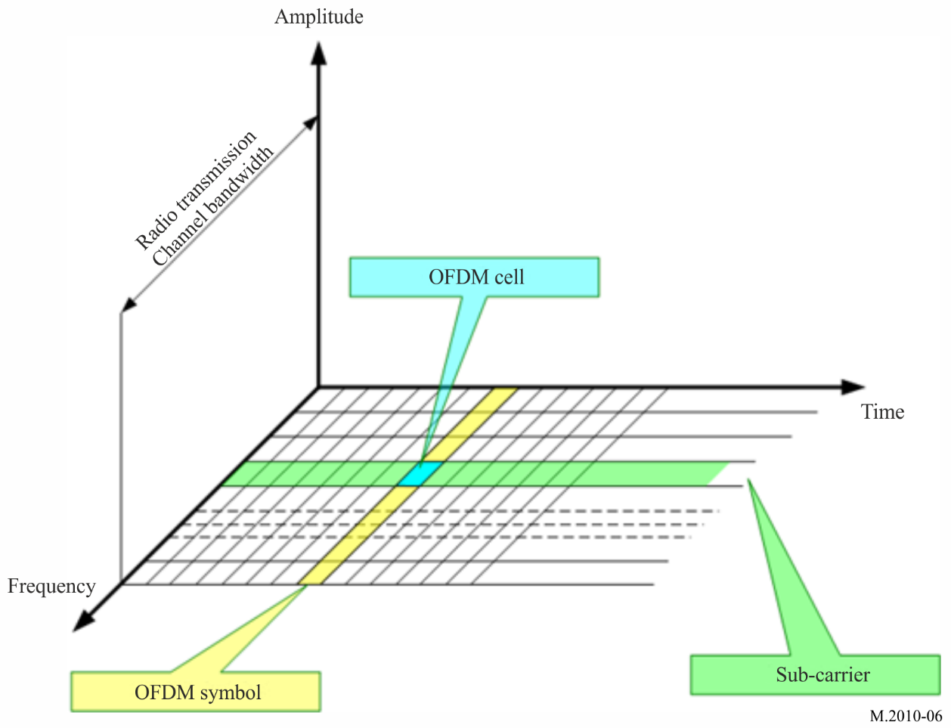

1.2 Principle
The OFDM uses a large number of closely spaced (either 41.666 Hz (mode A) or 46.875 Hz (mode B) in Table 1) orthogonal subcarriers to obtain high spectral efficiency to transmit data. These subcarriers are frequency-spaced (Fu = 1/Tu), where T_{U} is the OFDM symbol duration of the useful part.
The phases of subcarriers are orthogonal one to each other to enhance signal diversity caused by the multipath, especially in long distance.
A guard interval (Td) is inserted in the OFDM symbol to reduce multipath effect, thus reducing the inter-symbol interference.
The OFDM symbol duration is Ts = Tu + Td
The OFDM symbols are then concatenated to make an OFDM frame.
The OFDM frame duration is Tf.
Figure 7
Spectral representation of an OFDM frame
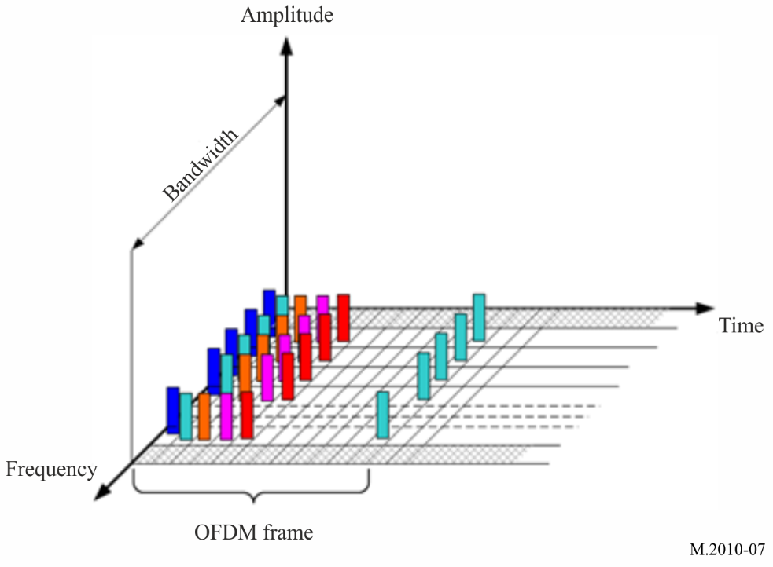
Figure 8
Temporal representation of an OFDM frame
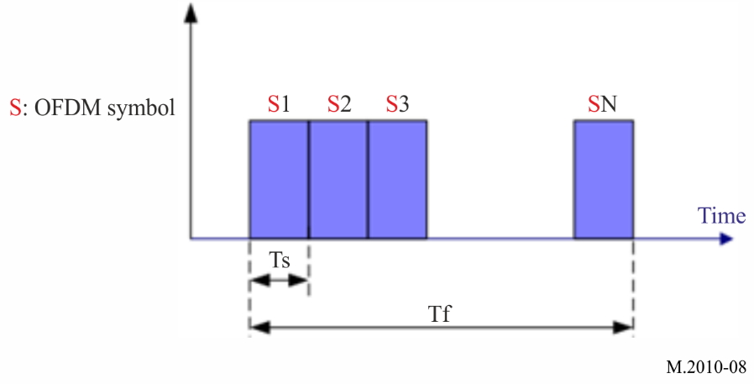

1.3 Orthogonal frequency division multiplexing parameters
OFDM parameter values are listed in Table 1.
TABLE 1
OFDM parameter values
Propagation mode | T_{u}  (ms) | 1 / T_{u}  (Hz) | T_{d}  (ms) | T_{s} = T_{u}+T_{d}  (ms) | N_{s} | T_{f}  (ms)
A: surface wave | 24 | 41.666 | 2.66 | 26.66 | 15 | 400
B: surface wave + sky wave | 21.33 | 46.875 | 5.33 | 26.66 | 15 | 400

T_{u}: duration of the useful part of an OFDM symbol
1/T_{u}: carrier spacing
T_{d}: duration of the guard interval
T_{s}: duration of an OFDM symbol
N_{s}: the number of symbols per frame
T_{f}: duration of the transmission frame.

1.4 Channel bandwidth
NAVDAT digital broadcast defines different channel bandwidths and determines subcarrier numbers corresponding to different spectrum occupancy rates. Table 2 presents the channel bandwidth value and subcarrier numbers.
TABLE 2
Relationship between channel bandwidth and OFDM sub-carrier numbers
Propagation mode | Case | 1 | 2 | 3 | 4
Propagation mode | Channel bandwidth | 1 kHz | 3 kHz | 5 kHz | 10 kHz
A: surface wave | Number of subcarriers | 23 | 69 | 115 | 229
A: surface wave | Number of subcarriers | K −11 to 11 | K −34 to 34 | K −57 to 57 | K −114 to 114
B: surface wave + sky wave | Number of subcarriers | 19 | 61 | 103 | 207
B: surface wave + sky wave | Number of subcarriers | K −9 to 9 | K −30 to 30 | K −51 to 51 | K −103 to 103

1.5 Modulation
Every subcarrier is modulated in amplitude and phase (QAM: Quadrature amplitude modulation).
Modulation patterns can be either 64 states (6 bits, 64-QAM), 16 states (4 bits, 16-QAM), or 4 states (2 bits, 4-QAM).
The modulation pattern depends on the desired robustness of the signal.
Figure 9
Binary phase shift keying modulation constellation, where: a = 1
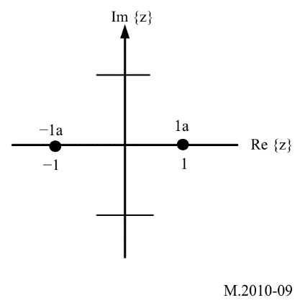
FIGURE 10
4-QAM constellation, where: a= 1√ 2 ; bit ordering: {i₀ q₀} = { y’₀ y’₁ }
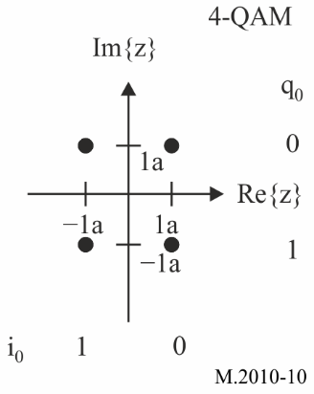
Figure 11
16-QAM constellation, where: a = 1 √ 10 ; Bit ordering: {i₀ i₁ q₀ q₁} = { y’₀ y’₁ y’₂ y’₃ }
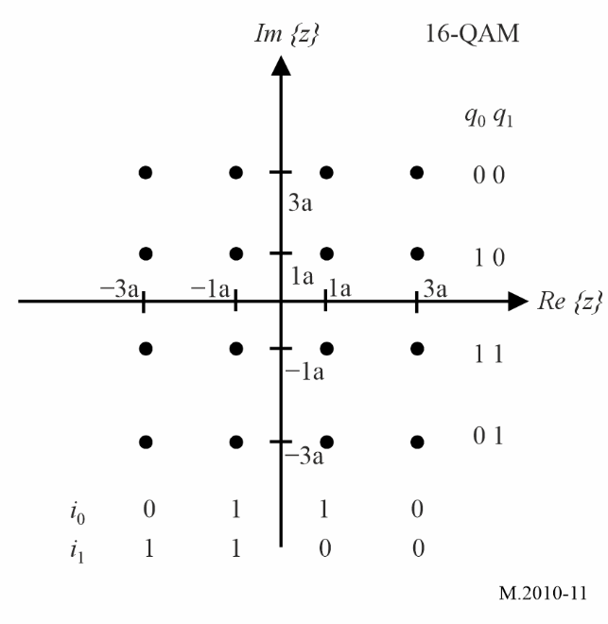
Figure 12
64-QAM constellation
where: a = 1 √ 42 ; Bit ordering: {i₀ i₁ i₂ q₀ q₁ q₂} = { y’₀ y’₁ y’₂ y’₃ y’₄ y’₅} ; y’₀ precedes y’₁, y’₁ precedes y’₂, etc.
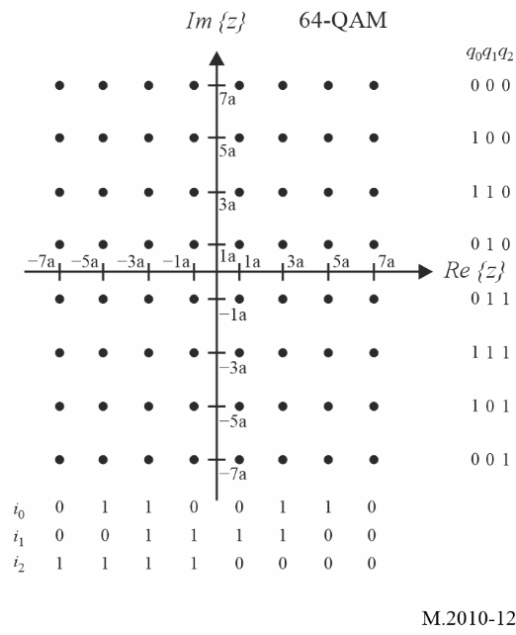

1.6 Synchronization
In order to allow a good demodulation of each subcarrier, the radio transmission channel response must be determined for each subcarrier and the equalization should be applied. For this, some of the subcarriers of the OFDM symbols may carry pilot signals.
The pilot signals allow the receiver to:
– detect if a signal is received;
– estimate the frequency offset;
– estimate the radio transmission channel.
The number of pilot signals depends on the desired robustness of the signal.
The pilot cells have a power gain of factor 2 in BPSK modulation.
Figure 13
Pilot OFDM signal
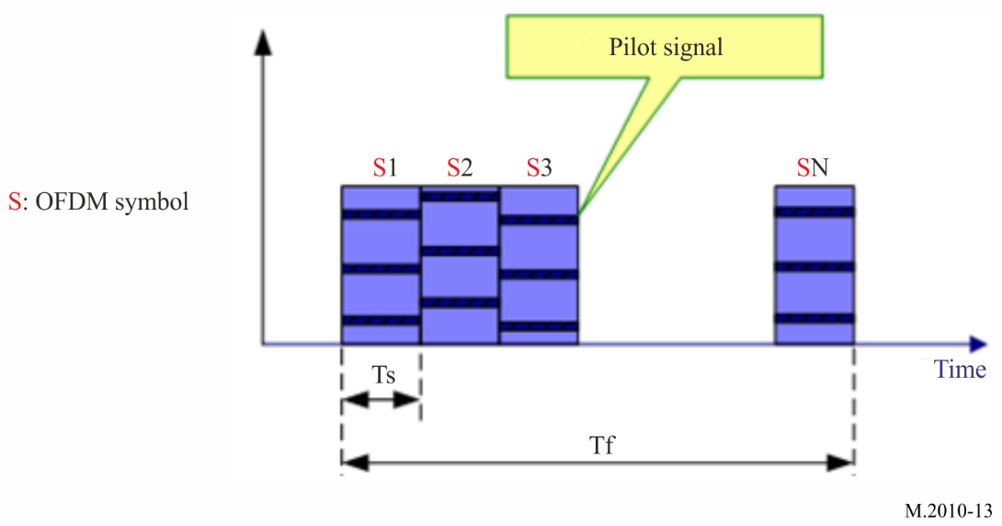
The pilot signal location in each OFDM symbol in a frame can be shown as follows:
Figure 14
The pilot signal location in mode A
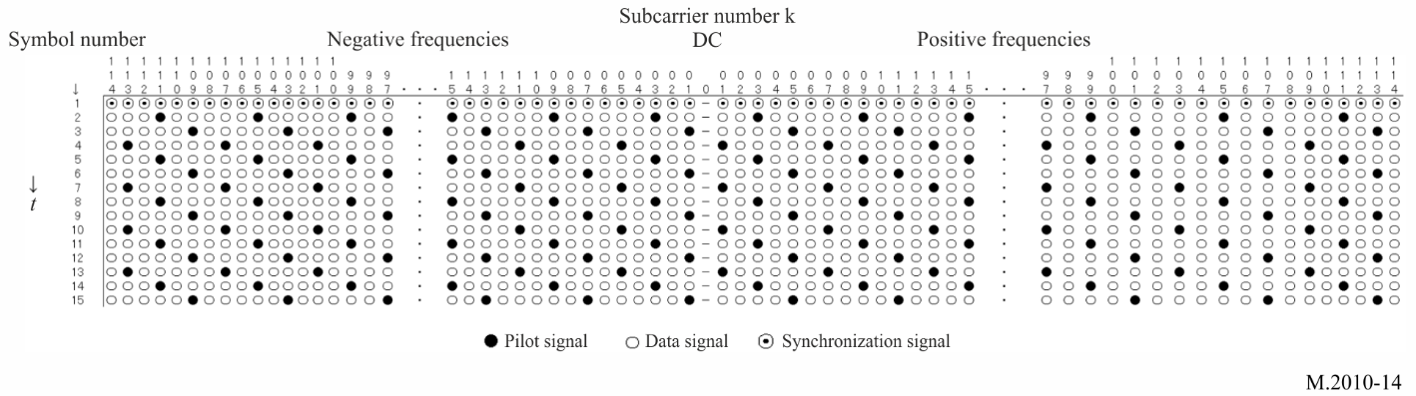
Figure 15
The pilot signal location in mode B
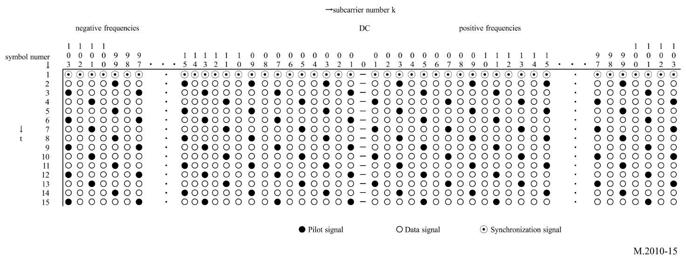
Here, t is the direction of time domain, f is the direction of frequency domain. The first symbol of each OFDM head frame should be filled by a sequence of synchronization signals that make up the synchronization head (refer to Tables 9 and 10), all of which are used as a time reference to provide synchronization for the receiver. The black cell and the white cell represent the pilot signal and the data signal, respectively. The pilot signal value which is modulated in 2-QAM (BPSK) in an OFDM symbol is shown in Tables 3 and 4.
TABLE 3
Pilot sequence (mode A)
Number of subcarriers | Pilot sequence
229 | -1 1 -1 1 -1 1 1 1 -1 1 1 1 1 -1 -1 -1 1 1 -1 -1 -1 1 1 1 -1 -1 -1 -1 -1 -1 1 -1 1 -1 -1 1 1 1
115 | -1 1 -1 1 -1 1 1 1 -1 1 1 1 1 -1 -1 -1 1 1 -1 -1
69 | -1 1 -1 1 -1 1 1 1 -1 1 1 1
23 | -1 1 -1 1

TABLE 4
Pilot sequence (mode B)
Number of subcarriers | Pilot sequence
207 | -1 1 -1 1 -1 1 1 1 -1 1 1 1 1 -1 -1 -1 1 1 -1 -1 -1 1 1 1 -1 -1 -1 -1 -1 -1 1 -1 1 -1 -1
103 | -1 1 -1 1 -1 1 1 1 -1 1 1 1 1 -1 -1 -1 1
61 | -1 1 -1 1 -1 1 1 1 -1 1
19 | -1 1 -1 1

In the first symbol of each OFDM head frame, any subcarriers are used as time reference for the receiver to synchronize.
Figure 16
Synchronization symbol
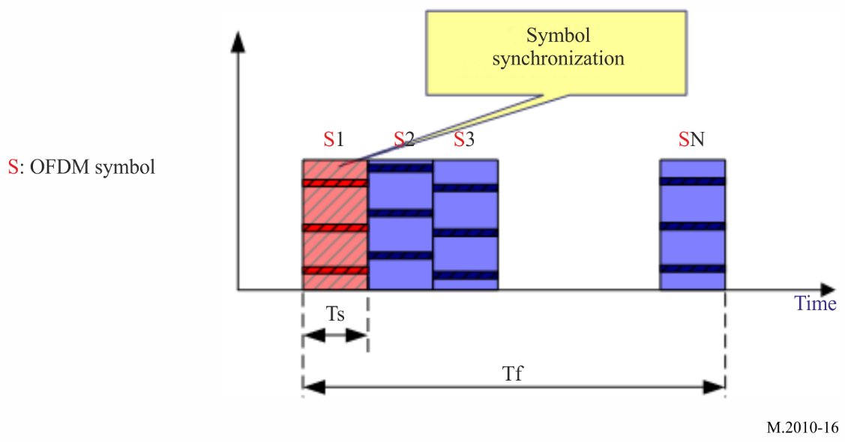

1.7 Energy dispersal
The purpose of the energy dispersal is to avoid the transmission of signal patterns resulted in an unwanted regularity. The individual inputs of energy dispersal scramblers should be scrambled by a modulo-2 with a pseudo-random binary sequence (PRBS), prior to channel encoding. The PRBS is defined as the output of the feedback shift register of Fig. 17. It should use a polynomial of degree 9, defined by:
$P\left(X\right)=X^{9}+X^{5}+1$
Figure 17
Pseudo-random binary sequence generator
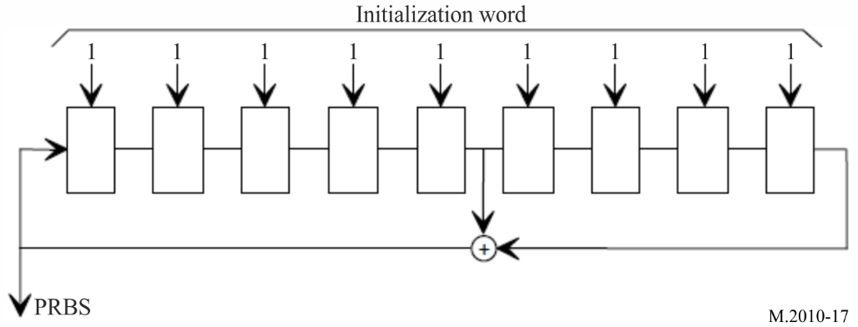

1.8 Spectral occupancy of RF signal
Figure 18
Spectral emission mask of NAVDAT RF signal with bandwidth F = 10 kHz
Emission masks for 5 kHz, 3 kHz and 1 kHz should fit within the mask for 10 kHz
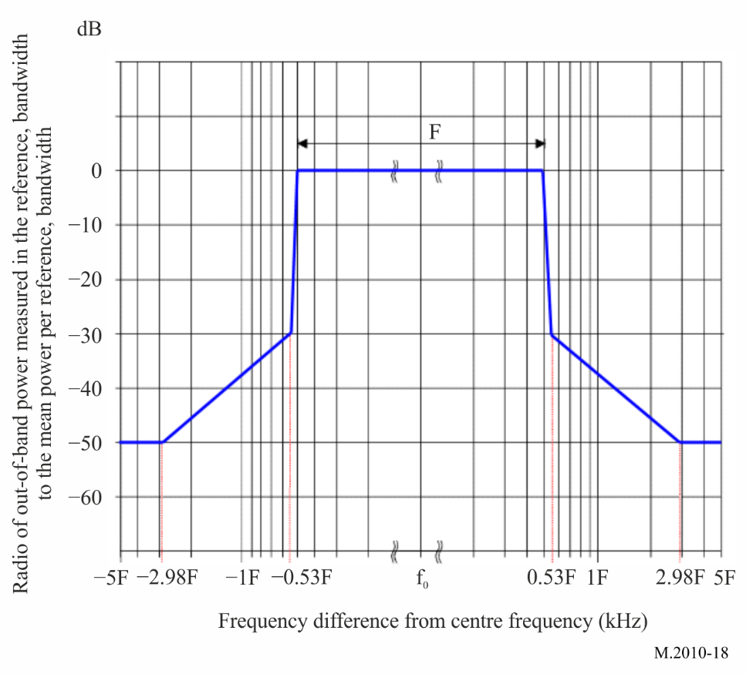

1.9 Sequence for receiving scanning possibility
To allow reception of national or regional frequencies assigned to the NAVDAT system, the receiver uses a scan function.
Frequencies should then be scanned to monitor the reception of the pre-signal transmitted by the station before broadcast.
To ensure proper operation of the receiver scan function, the transmitters of active National or Regional NAVDAT coast stations should transmit, before the NAVDAT broadcast, a sequence of known data during 400 ms (pre scanning) repeated eight times for a total duration of 3.2 seconds.
To ease receiver demodulation of the NAVDAT broadcast, known data is using the same bandwidth and the same constellation as the subsequent NAVDAT broadcast.
Parameters:
Mode A during the day and Mode B at night; 10 kHz Bandwidth; 4 QAM;
The MIS and TIS will be identical to those used to broadcast messages from the NAVDAT station after the pre-scan sequence.
Known data uses a 1 length super-frame pattern.
To enable evaluation of BER, DS stream is filled with PRBS (Pseudo-Random Binary Sequence) data using the polynomial:
$P\left(X\right)=X^{20}+X^{17}+1$
Each cell of the shift register should be pre-set to a logical 1 at the beginning of the sequence and the start of the PRBS sequence is synchronized with the beginning of each frame.
Figure 19
Transmission structure for scan facility
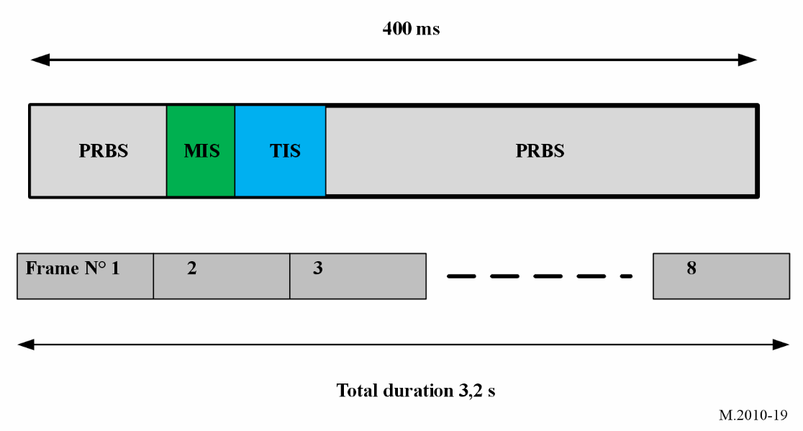
Insertion of MIS and TIS conforming to Table 18. The frame structure is described in Annex 4.

2 Estimated usable data rate
In the 10 kHz channel bandwidth with 500 kHz propagation, the raw data rate available for the DS is typically around 25 kbit/s with 16-QAM signal.
The number of subcarriers that hold data can be varied in order to adjust the channel protection. Higher channel protection (protection against multipath, fading, delay, etc.) results in a lower number of useful subcarriers.
Error coding must then be applied to the raw data rate to obtain the useful data rate. With a code rate of 0.5 to 0.75, the useful data rate is then between 5 and 27 kbit/s.
A higher code rate provides a higher useful data rate, but the radio coverage is accordingly reduced.
With the different modulation and code rate, the useful data rate is shown as below.
TABLE 5
Estimated data rate for 10, 5, 3 and 1 kHz bandwidth for head frame for mode A
(given only for information)
Mode | Spectrum occupancy  (kHz) | Modulation  (nQAM) | Code rate | Estimated data rate  (kbit/s)
0 | 10 | 4-QAM | 0.5 | 6.36
1 | 10 | 4-QAM | 0.75 | 9.56
2 | 10 | 16-QAM | 0.5 | 12.72
3 | 10 | 16-QAM | 0.75 | 19.12
4 | 10 | 64-QAM | 0.5 | 19.08
5 | 10 | 64-QAM | 0.75 | 28.68
TABLE 5 (end)
Mode | Spectrum occupancy  (kHz) | Modulation  (nQAM) | Code rate | Estimated data rate  (kbit/s)
6 | 5 | 4-QAM | 0.5 | 2.89
7 | 5 | 4-QAM | 0.75 | 4.35
8 | 5 | 16-QAM | 0.5 | 5.78
9 | 5 | 16-QAM | 0.75 | 8.69
10 | 5 | 64-QAM | 0.5 | 8.67
11 | 5 | 64-QAM | 0.75 | 13.04
12 | 3 | 4-QAM | 0.5 | 1.67
13 | 3 | 4-QAM | 0.75 | 2.52
14 | 3 | 16-QAM | 0.5 | 3.35
15 | 3 | 16-QAM | 0.75 | 5.03
16 | 3 | 64-QAM | 0.5 | 5.02
17 | 3 | 64-QAM | 0.75 | 7.55
18 | 1 | 4-QAM | 0.5 | 0.55
19 | 1 | 4-QAM | 0.75 | 0.84
20 | 1 | 16-QAM | 0.5 | 1.12
21 | 1 | 16-QAM | 0.75 | 1.68
22 | 1 | 64-QAM | 0.5 | 1.67
23 | 1 | 64-QAM | 0.75 | 2.52

TABLE 6
Estimated data rate for 10, 5, 3 and 1 kHz bandwidth for head frame for mode B
Mode | Spectrum occupancy  (kHz) | Modulation  (nQAM) | Code rate | Estimated data rate  (kbit/s)
0 | 10 | 4-QAM | 0.5 | 5.705
1 | 10 | 4-QAM | 0.75 | 8.578
2 | 10 | 16-QAM | 0.5 | 11.41
3 | 10 | 16-QAM | 0.75 | 17.155
4 | 10 | 64-QAM | 0.5 | 17.115
5 | 10 | 64-QAM | 0.75 | 25.733
6 | 5 | 4-QAM | 0.5 | 2.67
7 | 5 | 4-QAM | 0.75 | 4.025
8 | 5 | 16-QAM | 0.5 | 5.34
9 | 5 | 16-QAM | 0.75 | 8.05
10 | 5 | 64-QAM | 0.5 | 8.01
11 | 5 | 64-QAM | 0.75 | 12.075
12 | 3 | 4-QAM | 0.5 | 1.46
13 | 3 | 4-QAM | 0.75 | 2.21
TABLE 6 (end)
Mode | Spectrum occupancy  (kHz) | Modulation  (nQAM) | Code rate | Estimated data rate  (kbit/s)
14 | 3 | 16-QAM | 0.5 | 2.92
15 | 3 | 16-QAM | 0.75 | 4.42
16 | 3 | 64-QAM | 0.5 | 4.38
17 | 3 | 64-QAM | 0.75 | 6.63
18 | 1 | 4-QAM | 0.5 | 0.22
19 | 1 | 4-QAM | 0.75 | 0.35
20 | 1 | 16-QAM | 0.5 | 0.44
21 | 1 | 16-QAM | 0.75 | 0.70
22 | 1 | 64-QAM | 0.5 | 0.66
23 | 1 | 64-QAM | 0.75 | 1.05

3 NAVDAT transmitter performance specification
TABLE 7
Minimum international NAVDAT MF transmitter performance specification
Parameters | Required results
Frequency band | 495 to 505 kHz
Carrier frequency error | Within ±2.5 Hz of the nominal frequency
Spectrum mask | Comply with the requirements of Fig. 18
Transmitter third-order intermodulation rejection ratio | ≥40 dBc
Transmitter emission spurious  (all power range) | −50 dB without exceeding the absolute level of 50 mW (17 dBm)
Note: The transmitter may also cover the HF band. Refer to Rec. ITU-R M.2058 for technical specification.
The transmitter may also cover the MF band 415 to 526.5 kHz for future National NAVDAT frequencies.
The Emission class used is W7D.

4 NAVDAT ship receiver

4.1 NAVDAT ship receiver description
The ship receiver block diagram is shown in Fig. 21.
A typical NAVDAT digital receiver is composed of several basic blocks:
– Reception antenna and GNSS antenna;
– RF front end;
– Demodulator;
– File demultiplexer;
– Controller;
– Control and display unit (CDU);
– Data interface;
– Power supply.
The NAVDAT ship receiver can receive and decode the main MF channel (500 kHz) and the main international HF channel (4 226 kHz) at the same time with two complete independent channels.
The first channel should constantly listen to 500 kHz and the second channel should constantly listen to 4 226 kHz.
A third channel should scan all the other NAVDAT frequencies (regional in MF and attributed HF frequencies). The design of this third channel allows reception and decoding future potential national, regional or local transmitters using MF or HF channels:
1 The maritime MF band from 415 to 526.5 kHz (except 500 kHz).
2 The frequencies assigned to NAVDAT in RR Appendix 15: 6 337.5, 8 443, 12 663.5, 16 909.5 and 22 450.5 kHz.
3 The HF-bands of RR Appendix 17 assignable for wideband data transmissions and usable by NAVDAT: 4, 6, 8, 12, 16, and 22 MHz.
The demodulated signal(s) received by scanning can be decoded simultaneously or non-simultaneously.
The choice of frequencies to be scanned should be based on information on the NAVDAT stations declared and stored by the receiver (table updated via message 63).
The receiver should first determine the NAVAREA and METAREA zone in which the vessel is located (from its position) with the possibility by the operator to add some NAVDAT stations outside of this NAVAREA / METAREA.
From the table, the receiver should determine the future allocated slots and the frequencies used.
These frequencies should then be scanned to monitor the reception of the pre-signal transmitted by the station before broadcast.
The operator can select the national or regional NAVDAT stations of interest. As soon as the receiver detects the pre-scanning of these stations, it will notify the operator and decode the broadcast message.
The receiving antenna is common to the three channels. It is recommended that the antenna be equipped with two outputs for sharing with another MF/HF receiver.
Figure 20 describes a generic block diagram of a software defined radio (SDR) receiver.
The design of NAVDAT receivers is left to the initiative of each manufacturer.
Figure 20
Model of generic software defined radio NAVDAT receiver
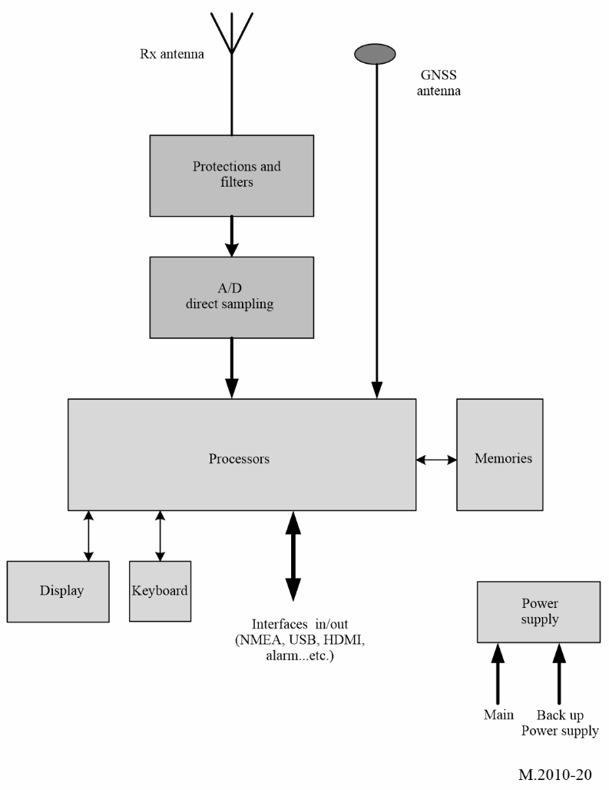
FIGURE 21
NAVDAT receiver logical diagram
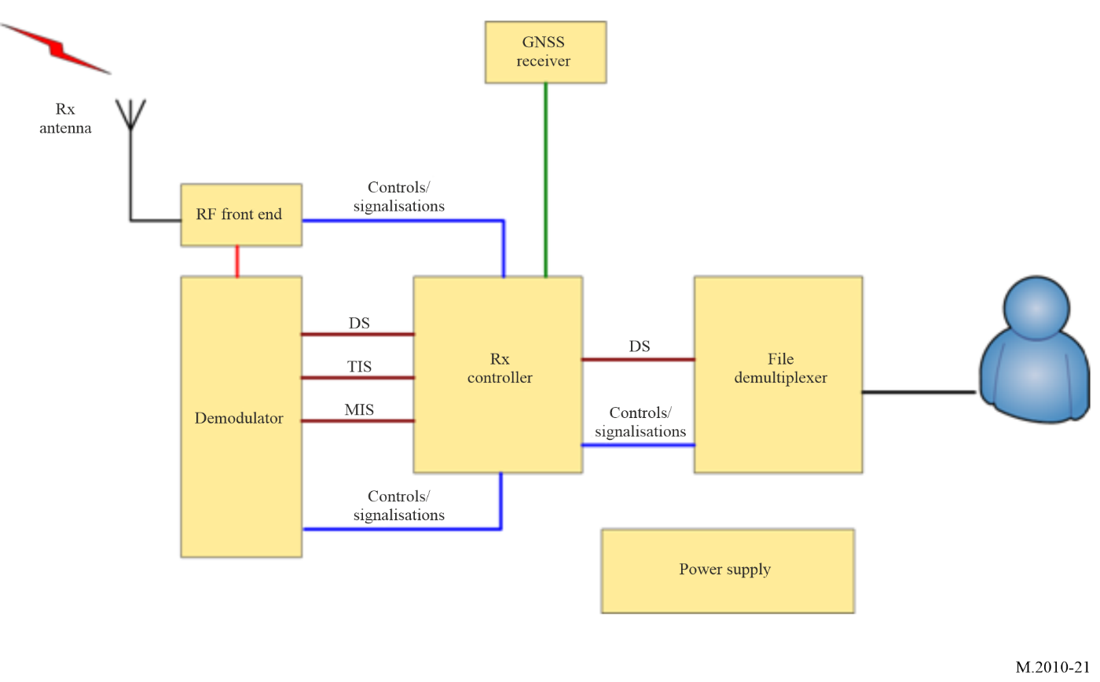

4.1.1 Receiving antenna and global navigation satellite system antenna
The omnidirectional receiving antenna system should have a minimum band from 415 kHz to 27.5 MHz to allow reception of MF and HF bands. It may be a H-field antenna (recommended on a EMC noisy ship) or a vertical E-field antenna.
A GNSS antenna connected to an internal GNSS receiver, (or connection to an existing GNSS receiver onboard), is also needed in order to obtain ship’s position and time.

4.1.2 RF front end
The RF front end includes the RF filter, RF amplifier and base band output.
High sensitivity and high dynamic range are necessary with protection against strong RF fields from ship transmitting antennas or lighting.
The passband of the input filters must allow reception of the maritime MF band from 415 to 526.5 kHz and for all maritime HF bands.
It is recommended to place a notch filter on the MF broadcasting band (from 526.5 kHz).
The receiver design can either be conventional or SDR type with at least three channels.

4.1.3 Demodulator
This stage demodulates the base band OFDM signal and recreates the data stream that holds the transmitted message files.
It implements:
– time/frequency synchronization;
– channel estimation;
– automatic modulation recovery;
– error correction.
The NAVDAT receiver should be able to detect the following modulation parameters automatically:
– 4, 16 or 64-QAM;
– type of error coding.
In addition to the DS, it reports the information filled in the TIS and MIS. Furthermore, it reports complementary information about the channel such as:
– estimated SNR;
– BER;
– MER.

4.1.4 File demultiplexer
The file demultiplexer:
– receives the message files from the controller;
– verifies that the message files are marked for its attention (type of broadcast mode);
– decrypts the message files if needed/able;
– makes the message files available for the terminal application that will use the message files;
– deletes the out-of-date message files.
Depending on the final application, the message file can be:
– stored on an onboard server accessible through the ship network;
– display on the receiver CDU directly;
– sent directly to the final application.

4.1.5 Controller
The controller:
– extracts the message files from the DS (merge packets into files);
– interprets the TIS and MIS and the other pieces of information given by the demodulator;
– collects the following information from the file demultiplexer:
• total number of decoded message files;
• number of available message files;
• error event (e.g. decrypt errors).

4.1.6 Control and display unit
The receiver can provide a display and control unit, the function of this unit is:
– display the special information and by configuring the interface to be connected to a dedicated equipment application (e.g. e-navigation) and manage the licensed contents of the ship (e.g. ship identification, encryption);
– display and check the receiving parameters;
– display the message content according to the application classification of the message file.
This CDU may be a special application running on an external computer, and the receiver may be a black-box device.

4.1.7 Data interface
The receiver gets the data from external devices such as GNSS through the data interface. The controller classifies the message files according to their applications and provides the message files to the application devices through the data interface.
The receiver should provide a configurable data interface that complies with the requirements of the IEC 61162 series. This data interface is for the purposes of connection to other onboard equipment. It is also recommended to provide Ethernet and USB interfaces for high-speed transmission of files and provide connectivity for printers.
When required the receiver should include an interface for alert management in accordance with the IMO performance standards for bridge alert management (IMO resolution MSC.302(87)).

4.1.8 Power supply
The connection to the ship’s power supply must be protected against surges and EMI.

4.1.9 Receiver ID
It should be possible to configure the receiver with:
– The identity (MMSI) of the vessel (according to Recommendation ITU-R M.585).
– The group identity (MMSI) (according to Recommendation ITU-R M.585).
– Additional lists of identities (MMSI’s) may be provided.
See Table 21 and Note.

4.1.10 Stored tables
The receiver should have the possibility of storing information in different memorized tables which can be updated by the reception of the message 63. This message should be authenticated by the shore authority.
For example:
1 The list of coast stations with:
– Area
– Country
– Longitude
– Latitude
– Name
– Slots
– Frequency used.
This stored table is queried when the identities (MMSI) of the transmitter stations are received and the complete parameters of the received NAVDAT coast station should be displayed in plain text.
2 The list of subject messages:
Table with subject message 01 to 63.
All the tables in memory can be updated by receiving the message 63.

4.1.11 Storage

4.1.11.1 Non-volatile files message memory
For each frequency provided it should be possible to record at least 100 message files in non-volatile memory. It should not be possible for the user to erase file messages from the memory. When the memory is full, the oldest file message must be replaced by the new messages.
The user should be able to mark the individual files of a message from permanent retention. These file messages can occupy up to 25% of available memory and should not be overwritten by new files. When no longer needed, the user must be able to delete the tag on these files, which can be overwritten normally.
Duplicate message could be recognized by the equipment and should not be stored.
The storage capacity of this memory should not be less than 1 GB.

4.1.11.2 Programmable control memories
Information identifying the transmitter service area and the designator of each type of message in programmable memory should not be erased by interruptions in the power supply of less than 24 h.
The equipment should be able to store at least the time, transmitter identification, subject and content of received message. The storage capacity should not be less than 1 GB.
When the power supply is unexpectedly interrupted, the equipment should protect the stored data and software parameters.
The equipment should be able to display, delete and query stored messages, and be able to output messages manually or automatically to appropriate ship equipment (such as the electronic chart and display information system (ECDIS)).

4.1.12 Alert
Upon receipt of a new search and rescue (SAR) related information message with distress or urgency priority, the receiver should give a continuous audible alarm. It should only be possible to reset this alarm manually. The position information contained in the SAR messages may be transmitted to other navigation equipment (e.g. ECDIS, electronic navigational chart plotter).

4.1.13 Test facilities
The equipment should be provided with a facility to test that the radio receiver, the display and the non-volatile memory are functioning correctly and to display self-test results. In case of using a specific antenna it also must be checked by this process.

4.1.14 Updates
The software/firmware of the equipment should be able to be updated. The update should be performed by using the appropriate interface or reception of message 63 (update receiver software). This function is necessary to follow the evolutions of the GMDSS master plan for the new NAVDAT stations as well as for the future revisions of the ITU recommendations.

4.1.15 Scan function
As indicated in § 4.1 the shipʼs NAVDAT receiver permanently monitors the frequencies 500 and 4 226 kHz and can simultaneously decode the signals received on these two frequencies. These two frequencies are listed in RR Appendix 15.
To allow reception of national or regional frequencies assigned to the NAVDAT system, the receiver uses a scan function on the following maritime frequency bands:
– The MF band from 415 to 526.5 kHz (except 500 kHz).
– The frequencies assigned to NAVDAT in RR Appendix 15: 6 337.5, 8 443, 12 663.5, 16 909.5 and 22 450.5 kHz.
– The HF-bands of RR Appendix 17 assignable for wideband data transmissions and usable by NAVDAT: 4, 6, 8, 12,16,and 22 MHz.
The receiver should search its stored NAVDAT station table (updated via message code 63) for all frequencies that can be sequentially scanned in relation to allocated slots (time reference).
The demodulated signal(s) received by scanning can be decoded simultaneously or non-simultaneously according to the resources of the NAVDAT receiver at that moment.
To ensure proper operation of the receiver scan function, the transmitters of active National or Regional NAVDAT coast stations should broadcast, before the NAVDAT frames, a known data repeated 8 times for a total duration of 3.2 seconds (see § 1.9 and Fig. 19 in Annex 3).
This should allow the receiver to detect the transmission and tune in to the frequency, measure its SNR, identify the station and its NAVAREA / METAREA area.

5 Minimum NAVDAT ship receiver performance specifications
These assumed ship receiver specifications are set out below with the objective to obtain minimum SNR for a good OFDM demodulation (4-QAM, 16-QAM or 64-QAM).
The shipʼs NAVDAT receiver must receive the two international NAVDAT frequencies: 500 kHz and 4 226 kHz, but also the MF and HF frequency bands in scan mode (see Table 8).
TABLE 8
NAVDAT ship receiver minimum performance specifications
Parameters | Requirements
Total frequency band  Main MF frequency (centre frequency)  Main HF frequency (centre frequency) | 415 to 526.5 kHz and 4 to 27.5 MHz maritime band  500 kHz  4 226 kHz
MF maritime band | 415 to 526.5 kHz
HF maritime bands | Maritime HF bands RR Appendix 17
Adjacent channel protection | > 40 dB @ 5 kHz
Noise factor | < 10 dB (< 20 dB for MF band)
Usable sensitivity for BER = 10⁻⁴ after error correction | < −95 dBm
Dynamic | > 80 dB
Minimal usable RF field (with adapted receiving antenna) | 20 dB(µV/m)

Annex 4
Transmission structure

1 Frame structure
NAVDAT head frame structure contains synchronization head (the first symbol), MIS, TIS, and DS (data stream) shown as follows.
FIGURE 22
NAVDAT frame structure
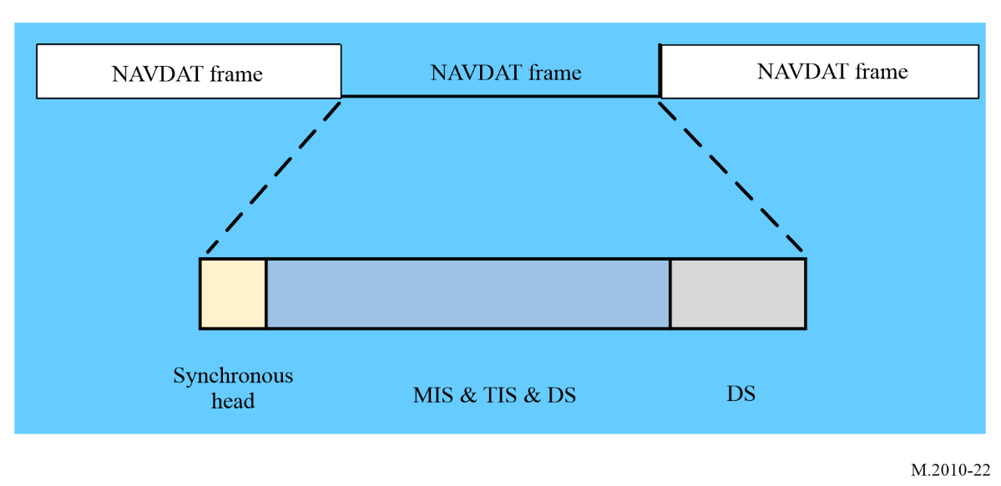
Head frame length is 400 ms.
Standard frame structure does not include DS stream without Synchronization head, MIS or TIS. Standard frame length is 400 ms. A sequence of one head frame and N-1 standard frame constitutes a super-frame of the length of N. The NAVDAT broadcast should use a super-frame pattern of the length of 5.

2 Synchronization head
Synchronization head is the first OFDM symbol of each head frame for the receiver to synchronize and for the information on every subcarrier is shown in Tables 9 and 10.
TABLE 9
Synchronization head sequence in mode A
Bandwidth and number of subcarriers | Synchronization head sequence
229 (10 kHz) | -1 1 1 1 1 1 1 -1 1 1 -1 -1 1 -1 1 1 1 1 1 -1 -1 1 -1 1 -1 -1 -1 1 1 1 1 -1 1 -1 -1 -1 -1 1 1 -1 1 1 1 -1 -1 -1 1 1 1 -1 1 -1 -1 1 1 -1 1 1 -1 1 1 -1 -1 -1 1 -1 1 -1 -1 1 -1 -1 1 -1 1 1 -1 -1 -1 -1 1 -1 -1 1 -1 -1 -1 1 -1 1 1 1 -1 -1 1 -1 -1 1 1 -1 -1 -1 1 1 -1 1 -1 -1 1 -1 1 -1 1 -1 0 -1 -1 -1 -1 1 -1 -1 -1 -1 -1 1 -1 -1 -1 1 1 -1 -1 1 1 1 1 -1 -1 1 1 -1 1 -1 1 -1 1 1 1 -1 1 -1 1 -1 -1 -1 -1 -1 -1 1 1 -1 -1 -1 -1 -1 1 1 1 1 1 -1 1 -1 1 1 1 1 -1 1 1 1 1 -1 -1 -1 -1 1 1 1 -1 -1 1 1 1 -1 1 1 1 -1 1 1 -1 1 -1 1 1 -1 -1 1 1 -1 -1 1 -1 -1 -1 -1 1 -1 1 -1 1 -1 1 -1 -1 1 1
115 (5 kHz) | 1 -1 1 1 -1 -1 -1 1 -1 1 -1 -1 1 -1 -1 1 -1 1 1 -1 -1 -1 -1 1 -1 -1 1 -1 -1 -1 1 -1 1 1 1 -1 -1 1 -1 -1 1 1 -1 -1 -1 1 1 -1 1 -1 -1 1 -1 1 -1 1 -1 0 1 -1 -1 -1 1 -1 -1 -1 -1 -1 1 -1 -1 -1 1 1 -1 -1 1 1 1 1 -1 -1 1 1 -1 1 -1 1 -1 1 1 1 -1 1 -1 1 -1 -1 -1 -1 -1 -1 1 1 -1 -1 -1 -1 -1 1 1 1 1 1 -1
69 (3 kHz) | 1 -1 -1 1 -1 -1 -1 1 -1 1 1 1 -1 -1 1 -1 -1 1 1 -1 -1 -1 1 1 -1 1 -1 -1 1 -1 1 -1 1 1 0 -1 -1 -1 -1 1 -1 -1 -1 -1 -1 1 -1 -1 -1 1 1 -1 -1 1 1 1 1 -1 -1 1 1 -1 1 -1 1 -1 1 1 1
23 (1 kHz) | 1 -1 1 -1 -1 1 -1 1 -1 1 1 0 1 -1 -1 -1 1 -1 -1 -1 -1 -1 1

TABLE 10
Synchronization head sequence in mode B
Bandwidth and number of subcarriers | Synchronization head sequence
207 (10 kHz) | -1 1 1 1 1 1 1 -1 1 1 -1 -1 1 -1 1 1 1 1 1 -1 -1 1 -1 1 -1 -1 -1 1 1 1 1 -1 1 -1 -1 -1 -1 1 1 -1 1 1 1 -1 -1 -1 1 1 1 -1 1 -1 -1 1 1 -1 1 1 -1 1 1 -1 -1 -1 1 -1 1 -1 -1 1 -1 -1 1 -1 1 1 -1 -1 -1 -1 1 -1 -1 1 -1 -1 -1 1 -1 1 1 1 -1 -1 1 -1 -1 1 1 -1 -1 -1 1 1 -1 1 -1 -1 1 -1 1 -1 1 -1 0 -1 -1 -1 -1 1 -1 -1 -1 -1 -1 1 -1 -1 -1 1 1 -1 -1 1 1 1 1 -1 -1 1 1 -1 1 -1 1 -1 1 1 1 -1 1 -1 1 -1 -1 -1 -1 -1 -1 1 1 -1 -1 -1 -1 -1 1 1 1 1 1 -1 1 -1 1 1 1 1 -1 1 1 1 1 -1 -1 -1 -1 1 1 1 -1 -1 1 1 1 -1 1 1 1 -1 1 1 -1 1 -1 1 1 -1 -1 1 1 -1 -1 1 -1 -1 -1 -1 1 -1 1 -1 1 -1 1 -1 -1 1 1
103 (5 kHz) | 1 -1 1 1 -1 -1 -1 1 -1 1 -1 -1 1 -1 -1 1 -1 1 1 -1 -1 -1 -1 1 -1 -1 1 -1 -1 -1 1 -1 1 1 1 -1 -1 1 -1 -1 1 1 -1 -1 -1 1 1 -1 1 -1 -1 1 -1 1 -1 1 -1 0 1 -1 -1 -1 1 -1 -1 -1 -1 -1 1 -1 -1 -1 1 1 -1 -1 1 1 1 1 -1 -1 1 1 -1 1 -1 1 -1 1 1 1 -1 1 -1 1 -1 -1 -1 -1 -1 -1 1 1 -1 -1 -1 -1 -1 1 1 1 1 1 -1
TABLE 10 (end)
Bandwidth and number of subcarriers | Synchronization head sequence
61 (3 kHz) | 1 -1 -1 1 -1 -1 -1 1 -1 1 1 1 -1 -1 1 -1 -1 1 1 -1 -1 -1 1 1 -1 1 -1 -1 1 -1 1 -1 1 1 0 -1 -1 -1 -1 1 -1 -1 -1 -1 -1 1 -1 -1 -1 1 1 -1 -1 1 1 1 1 -1 -1 1 1 -1 1 -1 1 -1 1 1 1
19 (1 kHz) | 1 -1 1 -1 -1 1 -1 1 -1 1 1 0 1 -1 -1 -1 1 -1 -1 -1 -1 -1 1

For the different channel bandwidth, the OFDM symbol index corresponding to the synchronization header is shown in Table 11.
TABLE 11
Index of the synchronization head symbols
Mode | Ns | Index of the OFDM symbol per frame
A | 15 | 1
B | 15 | 1

3 Modulation information stream

3.1 Structure
MIS is used to provide the information about channel spectrum occupancy as well as TIS and DS modulation:
– information of channel bandwidth: 2 bits;
– information of robustness 2 bits;
– information of TIS modulation: 1 bit;
– information of DS modulation: 2 bits;
– error encoding of DS 1 bit;
– Cyclic redundancy check (CRC): 8 bits;
Total bits: 16 bits
TABLE 12
Information of spectrum occupancy
Case  (refer to Table 2 above) | Patterns of bits | Channel bandwidth  (kHz)
1 | 00 | 1
2 | 01 | 3
3 | 10 | 5
4 | 11 | 10

TABLE 13
Information of transmitter information stream TIS modulation
Patterns of bit | Modulation
0 | 4-QAM
1 | 16-QAM

TABLE 14
Information of data stream modulation
Patterns of bits | Modulation
00 | 4-QAM
01 | 16-QAM
10 | 64-QAM

TABLE 15
Mode of robustness
Mode | Pattern of bit
A | 00
B | 01
C | 10
D | 11
Modes A and B are recommended for MF bands

TABLE 16
Information of data stream (DS) code rate
Pattern of bits | Code rate
0 | 0.5
1 | 0.75

3.2 Encoding
The MIS is encoded using a (16, 48) polar code, where the positions of the information subchannels are determined by the 0's in the following vector:
1 1 1 1 1 1 1 1 1 1 1 1 1 1 1 1 1 1 1 1 1 1 1 1 1 1 1 1 1 1 0 0 1 1 1 1 1 1 1 1 1 1 1 1 1 0 0 0 1 1 1 0 1 0 0 0 1 0 0 0 0 0 0 0.
After standard polar encoding, the codeword should be punctured from 64 bits to 48 bits by discarding the bits indexed by 1-16.

4 Transmitter information stream

4.1 Structure
TIS is used to provide the information about encoding of DS, transmitter, and time for the receiver:
– identifier of the transmitter: 32 bits;
– day and time: 17 bits;
– reserved 1 (for 4-QAM): 19 bits (default: 0);
– reserved 2 (for 16-QAM): 95 bits (default: 0);
– CRC: 8 bits.
Total of bits: 76 for 4 QAM and 152 for 16 QAM
TABLE 17
Identifier of the transmitter
Coding | Identifier of the transmitter
I | 8 bits ASCII
D | 8 bits ASCII
NAV/MET AREA | 5 bits
STATION NUMBER | 11 bits
Total | 32 bits

The header is two 8-bits ASCII encoded characters with the capital letters I and D.
The coding of the NAV/MET areas should be done in binary on 5 bits (maximum 31 areas).
The station number allocated for a frequency should be coded on 11 bits (maximum of 2 047 stations by area).
Total of 32 bits should thus be used for the identification of each NAVDAT transmitter.
Examples of coast station identification code:
A NAVDAT station located in NAVAREA/METAREA III (3) and transmitting on 500 kHz would have the following identity (with the numbering 85 allocated to the station):
I 01001001 8 bits ASCII
D 01000100 8 bits ASCII
3 00011 5 bits binary
85 00001010101 11 bits binary
Total 32 bits

TABLE 18
Information of time
Parameter | Bit number | description
Hour of start time in UTC | 5 | hour
minute of start time in UTC | 6 | minute
Duration of broadcast | 6 | 0-59 minutes  (Round up to next minute)

4.2 Encoding
The TIS is encoded using a (76, 152) polar code. For the 4 QAM, the total bits of TIS is 76, so the 76, 152 polar code is used once; while for 16 QAM, the total bits of TIS is 152, so the 76, 152 polar code is used twice where the positions of the information subchannels are determined by the 0's in the following vector:
1 1 1 1 1 1 1 1 1 1 1 1 1 1 1 1 1 1 1 1 1 1 1 1 1 1 1 1 1 0 0 0 1 1 1 1 1 1 1 1 1 1 1 0 1 0 0 0 1 1 1 0 1 0 0 0 1 0 0 0 0 0 0 0 1 1 1 1 1 1 1 0 1 1 1 0 1 0 0 0 1 1 1 0 1 0 0 0 0 0 0 0 0 0 0 0 1 1 0 0 0 0 0 0 0 0 0 0 0 0 0 0 1 1 1 1 1 1 1 1 1 1 1 1 1 1 1 1 1 1 1 1 1 1 1 0 1 1 1 0 0 0 0 0 1 1 0 0 0 0 0 0 0 0 0 0 0 0 0 0 1 0 0 0 0 0 0 0 1 1 1 1 1 1 1 1 1 1 1 1 1 1 1 1 1 1 1 1 1 1 1 1 1 1 1 1 1 1 1 1 1 1 1 1 1 1 1 1 1 1 1 1 1 1 1 1 1 1 1 1 1 1 1 1 1 1 1 1 1 1 1 1 1 1 1 1 1 1 1 1 1 1 1 1 1 1 1 1 1 1 1 1 1 1 1 1.
After standard polar encoding, the codeword should be punctured from 256 bits to 152 bits by selecting the bits indexed by 1-112 and 129-168.

4.3 Position
There are 100 (MIS:48, TIS:152) carriers for MIS and TIS transmission. Tables 19 and 20 give the position of these carriers.
TABLE 19
Position of the modulation information stream and transmitter information stream carriers
for 10 kHz, 5 kHz and 3 kHz in mode A and B, and 1 kHz in mode A
Symbol | Carrier number
2 | −10, −8, −6, −4, −2, 2, 4, 6, 8,10
3 | −10, −8, −6, −4, −2, 2, 4, 6, 8,10
4 | −10, −8, −6, −4, −2, 2, 4, 6, 8,10
5 | −10, −8, −6, −4, −2, 2, 4, 6, 8,10
6 | −10, −8, −6, −4, −2, 2, 4, 6, 8,10
7 | −10, −8, −6, −4, −2, 2, 4, 6, 8,10
8 | −10, −8, −6, −4, −2, 2, 4, 6, 8,10
9 | −10, −8, −6, −4, −2, 2, 4, 6, 8,10
10 | −10, −8, −6, −4, −2, 2, 4, 6, 8,10
11 | −10, −8, −6, −4, −2, 2, 4, 6, 8,10

TABLE 20
For 1 kHz bandwidth in mode B
Symbol | Carrier number
2 | −8, −6, −4, −2, 2, 4, 6, 8
3 | −8, −6, −4, −2, 2, 4, 6, 8
4 | −8, −6, −4, −2, 2, 4, 6, 8
5 | −8, −6, −4, −2, 2, 4, 6, 8
6 | −8, −6, −4, −2, 2, 4, 6, 8
7 | −8, −6, −4, −2, 2, 4, 6, 8
8 | −8, −6, −4, −2, 2, 4, 6, 8
9 | −8, −6, −4, −2, 2, 4, 6, 8
10 | −8, −6, −4, −2, 2, 4, 6, 8
11 | −8, −6, −4, −2, 2, 4, 6, 8
12 | −8, −6, −4, −2, 2, 4, 6, 8
13 | −8, −6, −4, −2, 2, 4, 6, 8
14 | −4, −2, 2, 4

5 Data stream

5.1 Structure
Data stream generally consist of either text information or files of information. A generalized packet delivery allows the delivery of text information and files for various services in the same data stream. And services can be carried by a series of single packets.
The structure of a packet is as follows:
– Head 16 bits
– Data field n bytes
– CRC 16 bits.
The head is made up as follows:
– toggle bit 1 bit
– first flag 1 bit
– last flag 1 bit
– packet ID 10 bits
– padded packet indicator 1 bit
– reserved 2 bits.
Total 16 bits The packet length is fixed for each transmission and given in Table 26.
Toggle bit: This bit should be maintained in the same state as long as packets from the same text message or file are being transmitted. When a packet from a different text message or file is sent for the first time, this bit should be inverted with respect to its previous state. If a text message or file, which may consist of several packets, is repeated, then this bit should remain unchanged.
First flag, Last flag: These flags are used to identify particular packets which form a succession of packets. The flags are assigned as follows:
TABLE 21
Coding of first flag and last flag
First flag | Last flag | The packet is
0 | 0 | an intermediate packet
0 | 1 | the last packet of a data unit
1 | 0 | the first packet of a data unit
1 | 1 | the one and only packet of a data unit

Packet ID: This 10 bit field indicates the packet ID of this packet. Initial value at the start of increments by 1 for each packet and re-cycles to zero after reaching the maximum value of 1023.
Padded Packet Indicator: This 1-bit flag indicates whether the data field carries padding or not, as follows:
0: no padding is present: all data bytes in the data field are useful;
1: padding is present: the first two bytes give the number of useful data bytes in the data field.
Reserved: This 2 bit field is reserved for future use.
Data field: It contains the useful data intended for a particular service. It can be text information or file information (see also Table 27).
The first information in the Data Field is Broadcast mode, which is defined in Table 22.
TABLE 22
Broadcast mode
MODE | Pattern of bit | Coding | Comments
General | 00 | 40 bits
Selective ship | 01 | 40 bits | MMSI of the ship
Group of ships | 10 | 40 bits | Group of ship’s ID (main or additional for future use)
Selective area | 11 | 176 bits | Geographic coordinates and radius of the defined area

Note:
In the case of selective broadcast over a specific area, this geographical area is defined as follows:
The zone number assigned by the server (maximum 99) + space
The area is determined by four geographical points in degrees minutes seconds (DMS) starting from the highest point and turning clockwise (Latitude followed by Longitude).
For General, Selective ship and Group of ships, use 40 bits.
Recommendation ITU-R M.585 recommends that X10 be reserved for future use. Recommendation ITU-R M.1080 recommends that X10 be used for multiple installations on a boat. Each digit coded on 4 bits.
To reduce the number of bits used for the broadcast selective area, it is coded in binary (instead of ASCII).
Table 23 shows the coding possibilities (in binary) with a total of 176 bits (instead of initial 512 bits).
TABLE 23
Geographical zone coding
 | Zone | Latitude |  |  | Longitude |  |  | Complement
 |  | Degrees | Minutes | Seconds | Degrees | Minutes | Seconds
Bits | 7 | 8 | 6 | 6 | 9 | 6 | 6 | 5
Range | 0-127 | −90° – +90° | 0 – 59’ | 0 – 59” | −180° – +180° | 0 – 59’ | 0 – 59”

All numbers are unsigned integer, except degrees which are signed integers (one’s complement).
For example, for a zone N°1:
Position 1 47°42’22” N and 137°28’59” E
Position 2: 37°50’24” N and 139°00’10” E
Position 3: 32°04’57” N and 129°29’05” E
Position 4: 33°04’56” N and 127°30’28” E
Giving:
0000001
00101111 101010 010110 010001001 011100 111011
00100101 110010 011000 010001011 000000 001010
00100000 000100 111001 010000001 011101 000101
00100001 000100 111000 001111111 011110 011100
00000
And, for a zone N°2:
Position 1: 47°42’22” S and 137°28’59” W
Position 2: 37°50’24” S and 139°00’10” W
Position 3: 32°04’57” S and 129°29’05” W
Position 4: 33°04’56” S and 127°30’28” W
Giving
0000010
11010000 101010 010110 101110110 011100 111011
11011010 110010 011000 101110100 000000 001010
11011111 000100 111001 101111110 011101 000101
11011110 000100 111001 110000000 011110 011100
00000
To define a circle with a given radius, the first geographic position only should be used (the bits of the other three positions are set to 0) and the radius is determined by the five complementary bits.
These 5 bits are used to give the radius to be drawn from this point with a multiplication coefficient of 10 (minimum 10 NM and maximum 310 NM).
Example for a radius of 100 NM: 100/10 = 10 = 01010 and for a radius of 50 NM: 50/10 = 5 = 00101.
TABLE 24
Level of the message
Coding | Definition level
00 | Routine
01 | Safety
10 | Urgency
11 | Distress

The third piece of information specifies the subject of the message according to Table 29 (from 1 to 63) coded on 6 bits:
1 = 000001
63 = 111111
The fourth information gives the number of the message from 1 to 999 coded on 10 bits.
Example: 1 = 0000000001
999 = 1111100111
CRC: This 16-bit CRC should be calculated on the header and the data field.

5.2 Encoding
NAVDAT data stream is encoded by low-density parity-check (LDPC), and different encoding parameters will be adopted in different modes (see Table 15). Tables 25 and 26 give the LDPC parameters in 10 kHz, 5 kHz, 3 kHz and 1 kHz for modes A and B.
TABLE 25
LDPC parameters of data stream for mode A
Bandwidth (kHz) | Number of subcarriers per ofdm | Number of pilots | Number of data subcarriers | Modulation | TIS and MIS subcarriers | LDPC code | Code blocks
10 | 228 | 532 | 2660 | 4-QAM | 100 | LDPC (5120,2560) | 1
10 | 228 | 532 | 2660 | 4-QAM | 100 | LDPC (5120,3840) | 1
10 | 228 | 532 | 2660 | 16-QAM | 100 | LDPC (5120,2560) | 2
10 | 228 | 532 | 2660 | 16-QAM | 100 | LDPC (5120,3840) | 2
10 | 228 | 532 | 2660 | 64-QAM | 100 | LDPC (5120,2560) | 3
TABLE 25 (end)
Bandwidth (kHz) | Number of subcarriers per ofdm | Number of pilots | Number of data subcarriers | Modulation | TIS and MIS subcarriers | LDPC code | Code blocks
10 | 228 | 532 | 2660 | 64-QAM | 100 | LDPC (5120,3840) | 3
5 | 114 | 271 | 1325 | 4-QAM | 100 | LDPC (2450,1225) | 1
5 | 114 | 271 | 1325 | 4-QAM | 100 | LDPC (2450,1838) | 1
5 | 114 | 271 | 1325 | 16-QAM | 100 | LDPC (2450,1225) | 2
5 | 114 | 271 | 1325 | 16-QAM | 100 | LDPC (2450,1838) | 2
5 | 114 | 271 | 1325 | 64-QAM | 100 | LDPC (2450,1225) | 3
5 | 114 | 271 | 1325 | 64-QAM | 100 | LDPC (2450,1838) | 3
3 | 68 | 159 | 793 | 4-QAM | 100 | LDPC (1386,693) | 1
3 | 68 | 159 | 793 | 4-QAM | 100 | LDPC (1386,1040) | 1
3 | 68 | 159 | 793 | 16-QAM | 100 | LDPC (1386,693) | 2
3 | 68 | 159 | 793 | 16-QAM | 100 | LDPC (1386,1040) | 2
3 | 68 | 159 | 793 | 64-QAM | 100 | LDPC (1386,693) | 3
3 | 68 | 159 | 793 | 64-QAM | 100 | LDPC (1386,1040) | 3
1 | 22 | 56 | 252 | 4-QAM | 100 | LDPC (304,152) | 1
1 | 22 | 56 | 252 | 4-QAM | 100 | LDPC (304,228) | 1
1 | 22 | 56 | 252 | 16-QAM | 100 | LDPC (304,152) | 2
1 | 22 | 56 | 252 | 16-QAM | 100 | LDPC (304,228) | 2
1 | 22 | 56 | 252 | 64-QAM | 100 | LDPC (304,152) | 3
1 | 22 | 56 | 252 | 64-QAM | 100 | LDPC (304,228) | 3

TABLE 26
LDPC parameters of data stream for mode B
Bandwidth (kHz) | Number of subcarriers per ofdm | Number of pilots | Number of data subcarriers | Modulation | TIS and MIS subcarriers | LDPC code | Code blocks
10 | 206 | 485 | 2399 | 4-QAM | 100 | LDPC (4598,2299) | 1
10 | 206 | 485 | 2399 | 4-QAM | 100 | LDPC (4598,3449) | 1
10 | 206 | 485 | 2399 | 16-QAM | 100 | LDPC (4598,2299) | 2
10 | 206 | 485 | 2399 | 16-QAM | 100 | LDPC (4598,3449) | 2
10 | 206 | 485 | 2399 | 64-QAM | 100 | LDPC (4598,2299) | 3
10 | 206 | 485 | 2399 | 64-QAM | 100 | LDPC (4598,3449) | 3
5 | 102 | 243 | 1185 | 4-QAM | 100 | LDPC (2170,1085) | 1
5 | 102 | 243 | 1185 | 4-QAM | 100 | LDPC (2170,1628) | 1
5 | 102 | 243 | 1185 | 16-QAM | 100 | LDPC (2170,1085) | 2
5 | 102 | 243 | 1185 | 16-QAM | 100 | LDPC (2170,1628) | 2
5 | 102 | 243 | 1185 | 64-QAM | 100 | LDPC (2170,1085) | 3
5 | 102 | 243 | 1185 | 64-QAM | 100 | LDPC (2170,1628) | 3
3 | 60 | 140 | 700 | 4-QAM | 100 | LDPC (1200,600) | 1
3 | 60 | 140 | 700 | 4-QAM | 100 | LDPC (1200,900) | 1
3 | 60 | 140 | 700 | 16-QAM | 100 | LDPC (1200,600) | 2
3 | 60 | 140 | 700 | 16-QAM | 100 | LDPC (1200,900) | 2
3 | 60 | 140 | 700 | 64-QAM | 100 | LDPC (1200,600) | 3
3 | 60 | 140 | 700 | 64-QAM | 100 | LDPC (1200,900) | 3
1 | 18 | 47 | 205 | 4-QAM | 100 | LDPC (210,105) | 1
1 | 18 | 47 | 205 | 4-QAM | 100 | LDPC (210,158) | 1
TABLE 26 (end)
Bandwidth (kHz) | Number of subcarriers per ofdm | Number of pilots | Number of data subcarriers | Modulation | TIS and MIS subcarriers | LDPC code | Code blocks
1 | 18 | 47 | 205 | 16-QAM | 100 | LDPC (210,105) | 2
1 | 18 | 47 | 205 | 16-QAM | 100 | LDPC (210,158) | 2
1 | 18 | 47 | 205 | 64-QAM | 100 | LDPC (210,105) | 3
1 | 18 | 47 | 205 | 64-QAM | 100 | LDPC (210,158) | 3

6 Low-density parity-check codes
The LDPC code is a linear block code that can be uniquely defined by the parity check matrix H. Since the number of “1” in the parity check matrix H is much smaller than the number of “0”, it is called low density check code. The matrix H has double diagonal characteristic.
The check matrix H can be expressed as an exponential matrix shown as follows:
Each number represents an L x L matrix. −1 denotes an all-zero matrix, 0 denotes a unit matrix, and p denotes a permutation matrix obtained by shifting the unit matrix to the right by p. The double diagonal matrix can be divided into two parts: information block and check block, namely: $H=\left[H_{s} H_{p}\right]$. And the vector of the encoded output symbols also can be divided into two parts, namely: $C=\left[S P\right]$.
According to the check equation $\left[H_{s} H_{p}\right]{\left[S P\right]}^{T}=0$, the corresponding parity bit can be obtained.

6.1 Code shortening and puncturing
Figure 23 illustrates the shortening of information bits by padding N_{pad} zero bits after the K information bits, and the puncturing of N_{punc} parity bits from right to left.
FIGURE 23
Shortening by zero-padding and puncturing
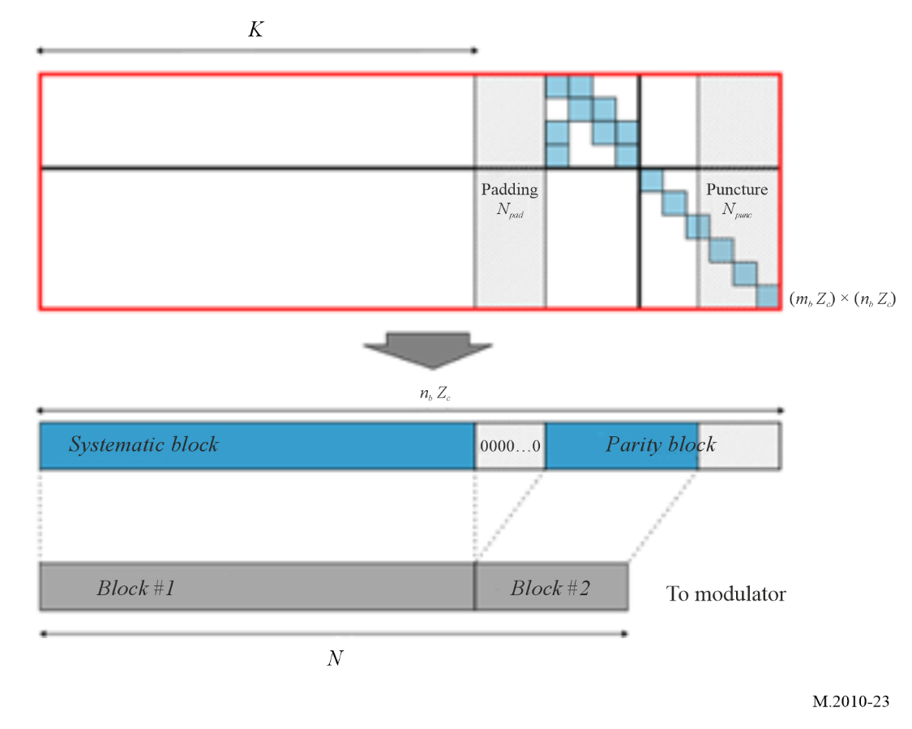
For instance, the LDPC (2450,1225) code employs an LDPC encoder with a block size of 2560 and 1280 information bits. Prior to encoding, the 1225 information bits are padded with 55 zero bits to match the required encoder information block size. After encoding, the codeword is shortened by removing the 55 padded information bits, and further punctured by eliminating 55 parity bits from the end of the encoded sequence.

6.2 LDPC of mode A

6.2.1 LDPC (5120,2560)
Rate 1/2 LDPC (5148,2574) of mode A in 10 kHz bandwidth with 22×44 parity-check matrix (lifting factor L=117), see below:
$$\left[\begin{matrix}103 & -1 & 13 & -1 & 116 & -1 & 55 & 0 & 93 & 54 & 15 & 81 & 22 & 25 & 28 & 60 & 87 & 75 & -1 & -1 & 22 & 46 & 1 & 0 & -1 & -1 & -1 & -1 & -1 & -1 & -1 & -1 & -1 & -1 & -1 & -1 & -1 & -1 & -1 & -1 & -1 & -1 & -1 & -1 \\ -1 & 0 & 18 & 0 & -1 & 2 & 97 & 102 & 6 & 46 & 17 & -1 & -1 & 31 & -1 & 93 & 17 & -1 & 41 & 98 & 19 & 22 & 0 & 0 & 0 & -1 & -1 & -1 & -1 & -1 & -1 & -1 & -1 & -1 & -1 & -1 & -1 & -1 & -1 & -1 & -1 & -1 & -1 & -1 \\ 105 & 52 & -1 & 1 & 18 & 100 & -1 & -1 & -1 & 79 & 56 & 115 & 37 & 19 & 33 & -1 & 24 & 31 & 100 & 36 & 8 & 69 & -1 & -1 & 0 & 0 & -1 & -1 & -1 & -1 & -1 & -1 & -1 & -1 & -1 & -1 & -1 & -1 & -1 & -1 & -1 & -1 & -1 & -1 \\ 0 & 57 & 1 & 23 & 76 & 4 & 40 & 116 & 40 & -1 & -1 & 5 & 98 & -1 & 0 & 14 & -1 & 0 & 30 & 82 & -1 & 65 & 1 & -1 & -1 & 0 & -1 & -1 & -1 & -1 & -1 & -1 & -1 & -1 & -1 & -1 & -1 & -1 & -1 & -1 & -1 & -1 & -1 & -1 \\ 30 & -1 & 33 & -1 & -1 & -1 & 25 & 81 & -1 & -1 & -1 & -1 & -1 & -1 & -1 & -1 & -1 & -1 & -1 & -1 & -1 & 89 & 46 & 18 & -1 & -1 & 0 & -1 & -1 & -1 & -1 & -1 & -1 & -1 & -1 & -1 & -1 & -1 & -1 & -1 & -1 & -1 & -1 & -1 \\ -1 & -1 & -1 & -1 & -1 & -1 & -1 & -1 & 20 & -1 & -1 & -1 & -1 & 90 & -1 & 30 & -1 & -1 & -1 & -1 & -1 & 79 & 91 & -1 & -1 & -1 & -1 & 0 & -1 & -1 & -1 & -1 & -1 & -1 & -1 & -1 & -1 & -1 & -1 & -1 & -1 & -1 & -1 & -1 \\ 52 & -1 & -1 & -1 & -1 & -1 & -1 & 0 & -1 & -1 & 110 & 5 & 64 & -1 & -1 & -1 & -1 & -1 & -1 & -1 & -1 & -1 & -1 & -1 & -1 & -1 & -1 & -1 & 0 & -1 & -1 & -1 & -1 & -1 & -1 & -1 & -1 & -1 & -1 & -1 & -1 & -1 & -1 & -1 \\ 108 & -1 & -1 & -1 & 68 & -1 & -1 & -1 & -1 & -1 & -1 & 64 & 101 & -1 & -1 & -1 & -1 & -1 & -1 & -1 & -1 & 113 & -1 & -1 & -1 & 42 & -1 & -1 & -1 & 0 & -1 & -1 & -1 & -1 & -1 & -1 & -1 & -1 & -1 & -1 & -1 & -1 & -1 & -1 \\ 47 & -1 & -1 & 62 & 113 & -1 & -1 & -1 & -1 & -1 & -1 & 90 & 46 & -1 & 36 & 109 & -1 & -1 & -1 & -1 & -1 & 105 & -1 & -1 & -1 & -1 & -1 & -1 & -1 & -1 & 0 & -1 & -1 & -1 & -1 & -1 & -1 & -1 & -1 & -1 & -1 & -1 & -1 & -1 \\ 73 & -1 & -1 & -1 & 0 & -1 & -1 & -1 & -1 & -1 & -1 & 112 & 116 & -1 & -1 & 11 & -1 & -1 & -1 & -1 & -1 & 0 & -1 & -1 & -1 & -1 & -1 & -1 & -1 & -1 & -1 & 0 & -1 & -1 & -1 & -1 & -1 & -1 & -1 & -1 & -1 & -1 & -1 & -1 \\ 15 & -1 & 52 & -1 & -1 & -1 & 98 & -1 & -1 & -1 & -1 & -1 & -1 & -1 & 13 & -1 & 57 & -1 & -1 & -1 & -1 & -1 & -1 & -1 & -1 & -1 & -1 & -1 & -1 & -1 & -1 & -1 & 0 & -1 & -1 & -1 & -1 & -1 & -1 & -1 & -1 & -1 & -1 & -1 \\ -1 & -1 & -1 & -1 & -1 & 4 & -1 & -1 & 48 & -1 & -1 & -1 & -1 & -1 & 57 & -1 & -1 & -1 & -1 & -1 & -1 & 109 & -1 & 109 & -1 & -1 & -1 & -1 & -1 & -1 & -1 & -1 & -1 & 0 & -1 & -1 & -1 & -1 & -1 & -1 & -1 & -1 & -1 & -1 \\ 105 & -1 & 96 & -1 & -1 & -1 & 27 & 81 & 6 & -1 & -1 & -1 & -1 & -1 & -1 & -1 & -1 & -1 & -1 & -1 & -1 & 62 & 97 & -1 & -1 & -1 & -1 & -1 & -1 & -1 & -1 & -1 & -1 & -1 & 0 & -1 & -1 & -1 & -1 & -1 & -1 & -1 & -1 & -1 \\ 87 & 96 & -1 & -1 & 58 & 47 & -1 & -1 & -1 & -1 & -1 & -1 & -1 & -1 & -1 & -1 & -1 & -1 & -1 & -1 & -1 & 83 & -1 & -1 & -1 & -1 & -1 & -1 & -1 & -1 & -1 & -1 & -1 & -1 & -1 & 0 & -1 & -1 & -1 & -1 & -1 & -1 & -1 & -1 \\ 82 & -1 & 106 & -1 & -1 & -1 & 40 & 47 & 67 & -1 & 64 & -1 & -1 & -1 & -1 & -1 & -1 & -1 & -1 & -1 & -1 & 27 & 7 & -1 & 37 & -1 & -1 & -1 & -1 & -1 & -1 & -1 & -1 & -1 & -1 & -1 & 0 & -1 & -1 & -1 & -1 & -1 & -1 & -1 \\ 35 & 20 & -1 & -1 & -1 & 64 & -1 & -1 & -1 & -1 & -1 & -1 & -1 & -1 & -1 & -1 & -1 & -1 & 48 & 14 & -1 & 5 & -1 & -1 & -1 & -1 & -1 & -1 & -1 & -1 & -1 & -1 & -1 & -1 & -1 & -1 & -1 & 0 & -1 & -1 & -1 & -1 & -1 & -1 \\ -1 & -1 & 72 & 21 & -1 & -1 & 46 & 82 & -1 & 70 & -1 & -1 & -1 & -1 & -1 & -1 & -1 & -1 & -1 & -1 & -1 & 93 & -1 & -1 & -1 & -1 & -1 & -1 & -1 & -1 & -1 & -1 & -1 & -1 & -1 & -1 & -1 & -1 & 0 & -1 & -1 & -1 & -1 & -1 \\ 17 & -1 & -1 & -1 & -1 & -1 & -1 & -1 & 74 & -1 & -1 & -1 & -1 & -1 & 51 & 43 & -1 & -1 & -1 & -1 & -1 & -1 & 47 & -1 & -1 & -1 & -1 & -1 & -1 & -1 & -1 & -1 & -1 & -1 & -1 & -1 & -1 & -1 & -1 & 0 & -1 & -1 & -1 & -1 \\ 12 & -1 & -1 & -1 & -1 & -1 & -1 & -1 & -1 & -1 & -1 & -1 & -1 & -1 & -1 & -1 & -1 & -1 & -1 & -1 & -1 & 27 & -1 & -1 & -1 & -1 & -1 & -1 & -1 & -1 & -1 & -1 & -1 & -1 & -1 & -1 & -1 & -1 & -1 & -1 & 0 & -1 & -1 & -1 \\ -1 & -1 & -1 & 17 & 26 & -1 & -1 & -1 & -1 & -1 & -1 & 104 & 52 & -1 & 33 & 91 & -1 & 1 & -1 & -1 & -1 & 97 & -1 & -1 & -1 & -1 & -1 & -1 & -1 & -1 & -1 & -1 & -1 & -1 & -1 & -1 & -1 & -1 & -1 & -1 & -1 & 0 & -1 & -1 \\ 12 & 24 & -1 & -1 & -1 & 53 & -1 & -1 & -1 & -1 & -1 & -1 & -1 & -1 & -1 & -1 & -1 & -1 & 47 & 58 & 105 & -1 & -1 & -1 & -1 & -1 & -1 & -1 & -1 & -1 & -1 & -1 & -1 & -1 & -1 & -1 & -1 & -1 & -1 & -1 & -1 & -1 & 0 & -1 \\ -1 & -1 & 96 & 113 & -1 & -1 & 76 & -1 & -1 & -1 & -1 & -1 & -1 & -1 & -1 & -1 & -1 & -1 & 48 & -1 & -1 & 66 & -1 & -1 & -1 & -1 & -1 & -1 & -1 & -1 & -1 & -1 & -1 & -1 & -1 & -1 & -1 & -1 & -1 & -1 & -1 & -1 & -1 & 0\end{matrix}\right]$$
After encoding, the code is shortened by deleting the 14 padded bits, and punctured by deleting the last 14 parity bits.

6.2.2 LDPC (5120,3840)
Rate 3/4 LDPC (5250,3850) of mode A in 10 kHz bandwidth with 8×30 parity-check matrix (lifting factor L=175), see below:
$$\left[\begin{matrix}-1 & 115 & 105 & 8 & 114 & -1 & 7 & 137 & -1 & 18 & -1 & 173 & 0 & -1 & 63 & 20 & 65 & 165 & 155 & 148 & 22 & 35 & 1 & 0 & -1 & -1 & -1 & -1 & -1 & -1 \\ 23 & -1 & 78 & 103 & 3 & 18 & 166 & 122 & 119 & -1 & 39 & 149 & -1 & 65 & 144 & 2 & -1 & -1 & 62 & 59 & -1 & 158 & 0 & 0 & 0 & -1 & -1 & -1 & -1 & -1 \\ 0 & 137 & 102 & -1 & -1 & 111 & 47 & 69 & 87 & 138 & 172 & -1 & 53 & 22 & 24 & 31 & 41 & 149 & -1 & -1 & 14 & 139 & -1 & -1 & 0 & 0 & -1 & -1 & -1 & -1 \\ 164 & 174 & -1 & 71 & 28 & 166 & -1 & -1 & 105 & 117 & 116 & 118 & 5 & 127 & -1 & -1 & 64 & 85 & 131 & 116 & 34 & 21 & 1 & -1 & -1 & 0 & -1 & -1 & -1 & -1 \\ -1 & -1 & -1 & -1 & 8 & -1 & -1 & -1 & -1 & -1 & -1 & 139 & 137 & -1 & -1 & -1 & -1 & -1 & 16 & 161 & -1 & 17 & 45 & -1 & -1 & -1 & 0 & -1 & -1 & -1 \\ 84 & -1 & -1 & -1 & -1 & 150 & -1 & -1 & 83 & -1 & -1 & -1 & 135 & 54 & -1 & -1 & -1 & -1 & -1 & -1 & -1 & 81 & -1 & -1 & -1 & -1 & -1 & 0 & -1 & -1 \\ -1 & -1 & -1 & -1 & -1 & -1 & -1 & -1 & -1 & -1 & -1 & -1 & 167 & -1 & -1 & -1 & -1 & -1 & -1 & -1 & -1 & 71 & -1 & -1 & -1 & -1 & -1 & -1 & 0 & -1 \\ -1 & 37 & -1 & 48 & -1 & -1 & -1 & -1 & -1 & 13 & 152 & -1 & -1 & -1 & -1 & -1 & 130 & 119 & -1 & -1 & 170 & 47 & -1 & -1 & -1 & -1 & -1 & -1 & -1 & 0\end{matrix}\right]$$
Before encoding, 10 zero bits are padded to the 3840 information bits. After encoding, the code is shortened by deleting the 10 padded bits, and punctured by deleting the last 120 parity bits.

6.2.3 LDPC (2450,1225)
Rate 1/2 LDPC (2464,1232) of mode A in 5 kHz bandwidth with 22×44 parity-check matrix (lifting factor L=56), see below:
$$\left[\begin{matrix}47 & -1 & 48 & -1 & 0 & -1 & 4 & 0 & 2 & 0 & 1 & 1 & 36 & 20 & 5 & 12 & 42 & 7 & -1 & -1 & 15 & 32 & 1 & 0 & -1 & -1 & -1 & -1 & -1 & -1 & -1 & -1 & -1 & -1 & -1 & -1 & -1 & -1 & -1 & -1 & -1 & -1 & -1 & -1 \\ -1 & 0 & 6 & 36 & -1 & 0 & 2 & 49 & 45 & 53 & 3 & -1 & -1 & 31 & -1 & 1 & 1 & -1 & 31 & 32 & 5 & 1 & 0 & 0 & 0 & -1 & -1 & -1 & -1 & -1 & -1 & -1 & -1 & -1 & -1 & -1 & -1 & -1 & -1 & -1 & -1 & -1 & -1 & -1 \\ 4 & 5 & -1 & 13 & 2 & 22 & -1 & -1 & -1 & 10 & 38 & 40 & 30 & 51 & 31 & -1 & 0 & 42 & 29 & 42 & 43 & 35 & -1 & -1 & 0 & 0 & -1 & -1 & -1 & -1 & -1 & -1 & -1 & -1 & -1 & -1 & -1 & -1 & -1 & -1 & -1 & -1 & -1 & -1 \\ 2 & 11 & 1 & 3 & 10 & 18 & 2 & 29 & 15 & -1 & -1 & 2 & 2 & -1 & 0 & 26 & -1 & 33 & 13 & 22 & -1 & 9 & 1 & -1 & -1 & 0 & -1 & -1 & -1 & -1 & -1 & -1 & -1 & -1 & -1 & -1 & -1 & -1 & -1 & -1 & -1 & -1 & -1 & -1 \\ 31 & -1 & 18 & -1 & -1 & -1 & 46 & 53 & -1 & -1 & -1 & -1 & -1 & -1 & -1 & -1 & -1 & -1 & -1 & -1 & -1 & 41 & 46 & 48 & -1 & -1 & 0 & -1 & -1 & -1 & -1 & -1 & -1 & -1 & -1 & -1 & -1 & -1 & -1 & -1 & -1 & -1 & -1 & -1 \\ -1 & -1 & -1 & -1 & -1 & -1 & -1 & -1 & 0 & -1 & -1 & -1 & -1 & 40 & -1 & 29 & -1 & -1 & -1 & -1 & -1 & 45 & 54 & -1 & -1 & -1 & -1 & 0 & -1 & -1 & -1 & -1 & -1 & -1 & -1 & -1 & -1 & -1 & -1 & -1 & -1 & -1 & -1 & -1 \\ 2 & -1 & -1 & -1 & -1 & -1 & -1 & 42 & -1 & -1 & 49 & 55 & 18 & -1 & -1 & -1 & -1 & -1 & -1 & -1 & -1 & -1 & -1 & -1 & -1 & -1 & -1 & -1 & 0 & -1 & -1 & -1 & -1 & -1 & -1 & -1 & -1 & -1 & -1 & -1 & -1 & -1 & -1 & -1 \\ 0 & -1 & -1 & -1 & 44 & -1 & -1 & -1 & -1 & -1 & -1 & 54 & 1 & -1 & -1 & -1 & -1 & -1 & -1 & -1 & -1 & 3 & -1 & -1 & -1 & 7 & -1 & -1 & -1 & 0 & -1 & -1 & -1 & -1 & -1 & -1 & -1 & -1 & -1 & -1 & -1 & -1 & -1 & -1 \\ 38 & -1 & -1 & 28 & 43 & -1 & -1 & -1 & -1 & -1 & -1 & 5 & 12 & -1 & 28 & 17 & -1 & -1 & -1 & -1 & -1 & 27 & -1 & -1 & -1 & -1 & -1 & -1 & -1 & -1 & 0 & -1 & -1 & -1 & -1 & -1 & -1 & -1 & -1 & -1 & -1 & -1 & -1 & -1 \\ 12 & -1 & -1 & -1 & 32 & -1 & -1 & -1 & -1 & -1 & -1 & 51 & 22 & -1 & -1 & 9 & -1 & -1 & -1 & -1 & -1 & 28 & -1 & -1 & -1 & -1 & -1 & -1 & -1 & -1 & -1 & 0 & -1 & -1 & -1 & -1 & -1 & -1 & -1 & -1 & -1 & -1 & -1 & -1 \\ 10 & -1 & 1 & -1 & -1 & -1 & 17 & -1 & -1 & -1 & -1 & -1 & -1 & -1 & 55 & -1 & 20 & -1 & -1 & -1 & -1 & -1 & -1 & -1 & -1 & -1 & -1 & -1 & -1 & -1 & -1 & -1 & 0 & -1 & -1 & -1 & -1 & -1 & -1 & -1 & -1 & -1 & -1 & -1 \\ -1 & -1 & -1 & -1 & -1 & 27 & -1 & -1 & 1 & -1 & -1 & -1 & -1 & -1 & 0 & -1 & -1 & -1 & -1 & -1 & -1 & 12 & -1 & 24 & -1 & -1 & -1 & -1 & -1 & -1 & -1 & -1 & -1 & 0 & -1 & -1 & -1 & -1 & -1 & -1 & -1 & -1 & -1 & -1 \\ 19 & -1 & 42 & -1 & -1 & -1 & 1 & 2 & 13 & -1 & -1 & -1 & -1 & -1 & -1 & -1 & -1 & -1 & -1 & -1 & -1 & 3 & 48 & -1 & -1 & -1 & -1 & -1 & -1 & -1 & -1 & -1 & -1 & -1 & 0 & -1 & -1 & -1 & -1 & -1 & -1 & -1 & -1 & -1 \\ 39 & 45 & -1 & -1 & 36 & 2 & -1 & -1 & -1 & -1 & -1 & -1 & -1 & -1 & -1 & -1 & -1 & -1 & -1 & -1 & -1 & 6 & -1 & -1 & -1 & -1 & -1 & -1 & -1 & -1 & -1 & -1 & -1 & -1 & -1 & 0 & -1 & -1 & -1 & -1 & -1 & -1 & -1 & -1 \\ 29 & -1 & 40 & -1 & -1 & -1 & 17 & 34 & 17 & -1 & 13 & -1 & -1 & -1 & -1 & -1 & -1 & -1 & -1 & -1 & -1 & 2 & 53 & -1 & 2 & -1 & -1 & -1 & -1 & -1 & -1 & -1 & -1 & -1 & -1 & -1 & 0 & -1 & -1 & -1 & -1 & -1 & -1 & -1 \\ 0 & 30 & -1 & -1 & -1 & 38 & -1 & -1 & -1 & -1 & -1 & -1 & -1 & -1 & -1 & -1 & -1 & -1 & 44 & 39 & -1 & 2 & -1 & -1 & -1 & -1 & -1 & -1 & -1 & -1 & -1 & -1 & -1 & -1 & -1 & -1 & -1 & 0 & -1 & -1 & -1 & -1 & -1 & -1 \\ -1 & -1 & 51 & 20 & -1 & -1 & 8 & 50 & -1 & 7 & -1 & -1 & -1 & -1 & -1 & -1 & -1 & -1 & -1 & -1 & -1 & 0 & -1 & -1 & -1 & -1 & -1 & -1 & -1 & -1 & -1 & -1 & -1 & -1 & -1 & -1 & -1 & -1 & 0 & -1 & -1 & -1 & -1 & -1 \\ 55 & -1 & -1 & -1 & -1 & -1 & -1 & -1 & 0 & -1 & -1 & -1 & -1 & -1 & 40 & 37 & -1 & -1 & -1 & -1 & -1 & -1 & 4 & -1 & -1 & -1 & -1 & -1 & -1 & -1 & -1 & -1 & -1 & -1 & -1 & -1 & -1 & -1 & -1 & 0 & -1 & -1 & -1 & -1 \\ 28 & -1 & -1 & -1 & -1 & -1 & -1 & -1 & -1 & -1 & -1 & -1 & -1 & -1 & -1 & -1 & -1 & -1 & -1 & -1 & -1 & 10 & -1 & -1 & -1 & -1 & -1 & -1 & -1 & -1 & -1 & -1 & -1 & -1 & -1 & -1 & -1 & -1 & -1 & -1 & 0 & -1 & -1 & -1 \\ -1 & -1 & -1 & 38 & 13 & -1 & -1 & -1 & -1 & -1 & -1 & 35 & 39 & -1 & 29 & 13 & -1 & 13 & -1 & -1 & -1 & 34 & -1 & -1 & -1 & -1 & -1 & -1 & -1 & -1 & -1 & -1 & -1 & -1 & -1 & -1 & -1 & -1 & -1 & -1 & -1 & 0 & -1 & -1 \\ 51 & 54 & -1 & -1 & -1 & 17 & -1 & -1 & -1 & -1 & -1 & -1 & -1 & -1 & -1 & -1 & -1 & -1 & 36 & 13 & 55 & -1 & -1 & -1 & -1 & -1 & -1 & -1 & -1 & -1 & -1 & -1 & -1 & -1 & -1 & -1 & -1 & -1 & -1 & -1 & -1 & -1 & 0 & -1 \\ -1 & -1 & 17 & 18 & -1 & -1 & 39 & -1 & -1 & -1 & -1 & -1 & -1 & -1 & -1 & -1 & -1 & -1 & 3 & -1 & -1 & 45 & -1 & -1 & -1 & -1 & -1 & -1 & -1 & -1 & -1 & -1 & -1 & -1 & -1 & -1 & -1 & -1 & -1 & -1 & -1 & -1 & -1 & 0\end{matrix}\right]$$
Before encoding, 7 zero bits are padded to the 1225 information bits. After encoding, the code is shortened by deleting the 7 padded bits, and punctured by deleting the last 7 parity bits.

6.2.4 LDPC (2450,1838)
Rate 3/4 LDPC (2520,1848) of mode A in 5 kHz bandwidth with 8×30 parity-check matrix (lifting code L=84), see below:
$$\left[\begin{matrix}-1 & 66 & 28 & 64 & 23 & -1 & 63 & 81 & -1 & 67 & -1 & 1 & 76 & -1 & 77 & 6 & 2 & 81 & 1 & 57 & 78 & 42 & 1 & 0 & -1 & -1 & -1 & -1 & -1 & -1 \\ 79 & -1 & 71 & 82 & 38 & 0 & 82 & 31 & 14 & -1 & 74 & 72 & -1 & 58 & 81 & 2 & -1 & -1 & 13 & 1 & -1 & 67 & 0 & 0 & 0 & -1 & -1 & -1 & -1 & -1 \\ 43 & 18 & 25 & -1 & -1 & 62 & 54 & 13 & 10 & 12 & 67 & -1 & 81 & 15 & 66 & 10 & 41 & 30 & -1 & -1 & 70 & 62 & -1 & -1 & 0 & 0 & -1 & -1 & -1 & -1 \\ 31 & 20 & -1 & 43 & 56 & 33 & -1 & -1 & 21 & 26 & 25 & 62 & 54 & 43 & -1 & -1 & 15 & 64 & 47 & 18 & 13 & 49 & 1 & -1 & -1 & 0 & -1 & -1 & -1 & -1 \\ -1 & -1 & -1 & -1 & 22 & -1 & -1 & -1 & -1 & -1 & -1 & 6 & 18 & -1 & -1 & -1 & -1 & -1 & 51 & 77 & -1 & 73 & 3 & -1 & -1 & -1 & 0 & -1 & -1 & -1 \\ 70 & -1 & -1 & -1 & -1 & 38 & -1 & -1 & 34 & -1 & -1 & -1 & 30 & 47 & -1 & -1 & -1 & -1 & -1 & -1 & -1 & 81 & -1 & -1 & -1 & -1 & -1 & 0 & -1 & -1 \\ -1 & -1 & -1 & -1 & -1 & -1 & -1 & -1 & -1 & -1 & -1 & -1 & 20 & -1 & -1 & -1 & -1 & -1 & -1 & -1 & -1 & 78 & -1 & -1 & -1 & -1 & -1 & -1 & 0 & -1 \\ -1 & 9 & -1 & 62 & -1 & -1 & -1 & -1 & -1 & 13 & 33 & -1 & -1 & -1 & -1 & -1 & 81 & 35 & -1 & -1 & 65 & 12 & -1 & -1 & -1 & -1 & -1 & -1 & -1 & 0\end{matrix}\right]$$
Before encoding, 10 zero bits are padded to the 1838 information bits. After encoding, the code is shortened by deleting the 10 padded bits, and punctured by deleting the last 60 parity bits.

6.2.5 LDPC (1386,693)
Rate 1/2 LDPC (1408,704) of mode A in 3 kHz bandwidth with 22×44 parity-check matrix (lifting factor L=32), see below:
$$\left[\begin{matrix}2 & -1 & 2 & -1 & 8 & -1 & 8 & 7 & 18 & 19 & 0 & 3 & 28 & 1 & 19 & 28 & 2 & 15 & -1 & -1 & 15 & 0 & 1 & 0 & -1 & -1 & -1 & -1 & -1 & -1 & -1 & -1 & -1 & -1 & -1 & -1 & -1 & -1 & -1 & -1 & -1 & -1 & -1 & -1 \\ -1 & 2 & 22 & 28 & -1 & 1 & 12 & 25 & 21 & 21 & 19 & -1 & -1 & 31 & -1 & 7 & 8 & -1 & 1 & 16 & 29 & 1 & 0 & 0 & 0 & -1 & -1 & -1 & -1 & -1 & -1 & -1 & -1 & -1 & -1 & -1 & -1 & -1 & -1 & -1 & -1 & -1 & -1 & -1 \\ 10 & 1 & -1 & 4 & 1 & 2 & -1 & -1 & -1 & 0 & 6 & 24 & 14 & 27 & 23 & -1 & 0 & 10 & 3 & 10 & 3 & 19 & -1 & -1 & 0 & 0 & -1 & -1 & -1 & -1 & -1 & -1 & -1 & -1 & -1 & -1 & -1 & -1 & -1 & -1 & -1 & -1 & -1 & -1 \\ 6 & 27 & 9 & 9 & 3 & 10 & 2 & 5 & 7 & -1 & -1 & 31 & 18 & -1 & 0 & 6 & -1 & 1 & 4 & 30 & -1 & 9 & 1 & -1 & -1 & 0 & -1 & -1 & -1 & -1 & -1 & -1 & -1 & -1 & -1 & -1 & -1 & -1 & -1 & -1 & -1 & -1 & -1 & -1 \\ 23 & -1 & 2 & -1 & -1 & -1 & 30 & 13 & -1 & -1 & -1 & -1 & -1 & -1 & -1 & -1 & -1 & -1 & -1 & -1 & -1 & 25 & 30 & 8 & -1 & -1 & 0 & -1 & -1 & -1 & -1 & -1 & -1 & -1 & -1 & -1 & -1 & -1 & -1 & -1 & -1 & -1 & -1 & -1 \\ -1 & -1 & -1 & -1 & -1 & -1 & -1 & -1 & 0 & -1 & -1 & -1 & -1 & 0 & -1 & 13 & -1 & -1 & -1 & -1 & -1 & 5 & 22 & -1 & -1 & -1 & -1 & 0 & -1 & -1 & -1 & -1 & -1 & -1 & -1 & -1 & -1 & -1 & -1 & -1 & -1 & -1 & -1 & -1 \\ 10 & -1 & -1 & -1 & -1 & -1 & -1 & 2 & -1 & -1 & 25 & 0 & 10 & -1 & -1 & -1 & -1 & -1 & -1 & -1 & -1 & -1 & -1 & -1 & -1 & -1 & -1 & -1 & 0 & -1 & -1 & -1 & -1 & -1 & -1 & -1 & -1 & -1 & -1 & -1 & -1 & -1 & -1 & -1 \\ 27 & -1 & -1 & -1 & 2 & -1 & -1 & -1 & -1 & -1 & -1 & 6 & 8 & -1 & -1 & -1 & -1 & -1 & -1 & -1 & -1 & 27 & -1 & -1 & -1 & 15 & -1 & -1 & -1 & 0 & -1 & -1 & -1 & -1 & -1 & -1 & -1 & -1 & -1 & -1 & -1 & -1 & -1 & -1 \\ 1 & -1 & -1 & 20 & 11 & -1 & -1 & -1 & -1 & -1 & -1 & 21 & 12 & -1 & 4 & 9 & -1 & -1 & -1 & -1 & -1 & 27 & -1 & -1 & -1 & -1 & -1 & -1 & -1 & -1 & 0 & -1 & -1 & -1 & -1 & -1 & -1 & -1 & -1 & -1 & -1 & -1 & -1 & -1 \\ 12 & -1 & -1 & -1 & 8 & -1 & -1 & -1 & -1 & -1 & -1 & 19 & 22 & -1 & -1 & 9 & -1 & -1 & -1 & -1 & -1 & 4 & -1 & -1 & -1 & -1 & -1 & -1 & -1 & -1 & -1 & 0 & -1 & -1 & -1 & -1 & -1 & -1 & -1 & -1 & -1 & -1 & -1 & -1 \\ 10 & -1 & 1 & -1 & -1 & -1 & 25 & -1 & -1 & -1 & -1 & -1 & -1 & -1 & 15 & -1 & 20 & -1 & -1 & -1 & -1 & -1 & -1 & -1 & -1 & -1 & -1 & -1 & -1 & -1 & -1 & -1 & 0 & -1 & -1 & -1 & -1 & -1 & -1 & -1 & -1 & -1 & -1 & -1 \\ -1 & -1 & -1 & -1 & -1 & 19 & -1 & -1 & 3 & -1 & -1 & -1 & -1 & -1 & 1 & -1 & -1 & -1 & -1 & -1 & -1 & 28 & -1 & 8 & -1 & -1 & -1 & -1 & -1 & -1 & -1 & -1 & -1 & 0 & -1 & -1 & -1 & -1 & -1 & -1 & -1 & -1 & -1 & -1 \\ 0 & -1 & 10 & -1 & -1 & -1 & 17 & 10 & 5 & -1 & -1 & -1 & -1 & -1 & -1 & -1 & -1 & -1 & -1 & -1 & -1 & 13 & 8 & -1 & -1 & -1 & -1 & -1 & -1 & -1 & -1 & -1 & -1 & -1 & 0 & -1 & -1 & -1 & -1 & -1 & -1 & -1 & -1 & -1 \\ 15 & 21 & -1 & -1 & 4 & 10 & -1 & -1 & -1 & -1 & -1 & -1 & -1 & -1 & -1 & -1 & -1 & -1 & -1 & -1 & -1 & 30 & -1 & -1 & -1 & -1 & -1 & -1 & -1 & -1 & -1 & -1 & -1 & -1 & -1 & 0 & -1 & -1 & -1 & -1 & -1 & -1 & -1 & -1 \\ 21 & -1 & 16 & -1 & -1 & -1 & 1 & 10 & 25 & -1 & 5 & -1 & -1 & -1 & -1 & -1 & -1 & -1 & -1 & -1 & -1 & 10 & 13 & -1 & 10 & -1 & -1 & -1 & -1 & -1 & -1 & -1 & -1 & -1 & -1 & -1 & 0 & -1 & -1 & -1 & -1 & -1 & -1 & -1 \\ 1 & 6 & -1 & -1 & -1 & 30 & -1 & -1 & -1 & -1 & -1 & -1 & -1 & -1 & -1 & -1 & -1 & -1 & 12 & 7 & -1 & 26 & -1 & -1 & -1 & -1 & -1 & -1 & -1 & -1 & -1 & -1 & -1 & -1 & -1 & -1 & -1 & 0 & -1 & -1 & -1 & -1 & -1 & -1 \\ -1 & -1 & 11 & 28 & -1 & -1 & 24 & 18 & -1 & 31 & -1 & -1 & -1 & -1 & -1 & -1 & -1 & -1 & -1 & -1 & -1 & 0 & -1 & -1 & -1 & -1 & -1 & -1 & -1 & -1 & -1 & -1 & -1 & -1 & -1 & -1 & -1 & -1 & 0 & -1 & -1 & -1 & -1 & -1 \\ 7 & -1 & -1 & -1 & -1 & -1 & -1 & -1 & 0 & -1 & -1 & -1 & -1 & -1 & 16 & 29 & -1 & -1 & -1 & -1 & -1 & -1 & 28 & -1 & -1 & -1 & -1 & -1 & -1 & -1 & -1 & -1 & -1 & -1 & -1 & -1 & -1 & -1 & -1 & 0 & -1 & -1 & -1 & -1 \\ 28 & -1 & -1 & -1 & -1 & -1 & -1 & -1 & -1 & -1 & -1 & -1 & -1 & -1 & -1 & -1 & -1 & -1 & -1 & -1 & -1 & 2 & -1 & -1 & -1 & -1 & -1 & -1 & -1 & -1 & -1 & -1 & -1 & -1 & -1 & -1 & -1 & -1 & -1 & -1 & 0 & -1 & -1 & -1 \\ -1 & -1 & -1 & 22 & 5 & -1 & -1 & -1 & -1 & -1 & -1 & 11 & 7 & -1 & 5 & 21 & -1 & 21 & -1 & -1 & -1 & 10 & -1 & -1 & -1 & -1 & -1 & -1 & -1 & -1 & -1 & -1 & -1 & -1 & -1 & -1 & -1 & -1 & -1 & -1 & -1 & 0 & -1 & -1 \\ 27 & 6 & -1 & -1 & -1 & 9 & -1 & -1 & -1 & -1 & -1 & -1 & -1 & -1 & -1 & -1 & -1 & -1 & 4 & 13 & 15 & -1 & -1 & -1 & -1 & -1 & -1 & -1 & -1 & -1 & -1 & -1 & -1 & -1 & -1 & -1 & -1 & -1 & -1 & -1 & -1 & -1 & 0 & -1 \\ -1 & -1 & 1 & 2 & -1 & -1 & 15 & -1 & -1 & -1 & -1 & -1 & -1 & -1 & -1 & -1 & -1 & -1 & 19 & -1 & -1 & 21 & -1 & -1 & -1 & -1 & -1 & -1 & -1 & -1 & -1 & -1 & -1 & -1 & -1 & -1 & -1 & -1 & -1 & -1 & -1 & -1 & -1 & 0\end{matrix}\right]$$
Before encoding, 11 zero bits are padded to the 693 information bits. After encoding, the code is shortened by deleting the 11 padded bits, and punctured by deleting the last 11 parity bits.

6.2.6 LDPC (1386,1040)
Rate 3/4 LDPC (1440,1056) of mode A in 3 kHz bandwidth with 8×30 parity-check matrix (lifting factor L=48), see below:
$$\left[\begin{matrix}-1 & 42 & 4 & 40 & 23 & -1 & 15 & 0 & -1 & 1 & -1 & 2 & 16 & -1 & 29 & 30 & 14 & 0 & 25 & 33 & 30 & 42 & 1 & 0 & -1 & -1 & -1 & -1 & -1 & -1 \\ 31 & -1 & 23 & 10 & 14 & 1 & 0 & 43 & 26 & -1 & 26 & 0 & -1 & 10 & 9 & 26 & -1 & -1 & 1 & 0 & -1 & 19 & 0 & 0 & 0 & -1 & -1 & -1 & -1 & -1 \\ 19 & 42 & 37 & -1 & -1 & 14 & 6 & 37 & 0 & 12 & 7 & -1 & 33 & 15 & 42 & 10 & 41 & 30 & -1 & -1 & 46 & 26 & -1 & -1 & 0 & 0 & -1 & -1 & -1 & -1 \\ 31 & 44 & -1 & 19 & 0 & 33 & -1 & -1 & 9 & 38 & 25 & 38 & 6 & 31 & -1 & -1 & 15 & 16 & 47 & 42 & 37 & 37 & 1 & -1 & -1 & 0 & -1 & -1 & -1 & -1 \\ -1 & -1 & -1 & -1 & 22 & -1 & -1 & -1 & -1 & -1 & -1 & 6 & 30 & -1 & -1 & -1 & -1 & -1 & 3 & 29 & -1 & 1 & 3 & -1 & -1 & -1 & 0 & -1 & -1 & -1 \\ 34 & -1 & -1 & -1 & -1 & 38 & -1 & -1 & 46 & -1 & -1 & -1 & 30 & 35 & -1 & -1 & -1 & -1 & -1 & -1 & -1 & 21 & -1 & -1 & -1 & -1 & -1 & 0 & -1 & -1 \\ -1 & -1 & -1 & -1 & -1 & -1 & -1 & -1 & -1 & -1 & -1 & -1 & 8 & -1 & -1 & -1 & -1 & -1 & -1 & -1 & -1 & 30 & -1 & -1 & -1 & -1 & -1 & -1 & 0 & -1 \\ -1 & 33 & -1 & 14 & -1 & -1 & -1 & -1 & -1 & 1 & 9 & -1 & -1 & -1 & -1 & -1 & 9 & 23 & -1 & -1 & 29 & 36 & -1 & -1 & -1 & -1 & -1 & -1 & -1 & 0\end{matrix}\right]$$
Before encoding, 16 zero bits are padded to the 1040 information bits. After encoding, the code is shortened by deleting the 16 padded bits, and punctured by deleting the last 38 parity bits.

6.2.7 LDPC (304,152)
Rate 1/2 LDPC (320,160) of mode A in 1 kHz bandwidth with 10×20 parity-check matrix (lifting factor L=16), see below:
$$\left[\begin{matrix}0 & 1 & -1 & 0 & -1 & -1 & -1 & 14 & 12 & 1 & 1 & 0 & -1 & -1 & -1 & -1 & -1 & -1 & -1 & -1 \\ 3 & 0 & 1 & -1 & 14 & 15 & 5 & -1 & 6 & 7 & -1 & 0 & 0 & -1 & -1 & -1 & -1 & -1 & -1 & -1 \\ -1 & 12 & -1 & 3 & 1 & -1 & 10 & -1 & -1 & 9 & 0 & -1 & 0 & 0 & -1 & -1 & -1 & -1 & -1 & -1 \\ 2 & -1 & 4 & 14 & 6 & 6 & 14 & 15 & 1 & -1 & 1 & -1 & -1 & 0 & -1 & -1 & -1 & -1 & -1 & -1 \\ -1 & -1 & -1 & 7 & -1 & -1 & -1 & -1 & -1 & 9 & -1 & -1 & 8 & -1 & 0 & -1 & -1 & -1 & -1 & -1 \\ -1 & -1 & -1 & 14 & -1 & -1 & 9 & -1 & -1 & -1 & 6 & 0 & -1 & -1 & -1 & 0 & -1 & -1 & -1 & -1 \\ -1 & -1 & 7 & 0 & -1 & 6 & -1 & -1 & -1 & 4 & -1 & 1 & -1 & -1 & -1 & -1 & 0 & -1 & -1 & -1 \\ 2 & -1 & 5 & -1 & -1 & 9 & -1 & -1 & -1 & 0 & -1 & 6 & -1 & -1 & -1 & -1 & -1 & 0 & -1 & -1 \\ -1 & -1 & -1 & 6 & -1 & -1 & -1 & -1 & -1 & 6 & -1 & 14 & -1 & -1 & -1 & -1 & -1 & -1 & 0 & -1 \\ -1 & -1 & 8 & 4 & -1 & 11 & -1 & -1 & -1 & -1 & -1 & 14 & -1 & 10 & -1 & -1 & -1 & -1 & -1 & 0\end{matrix}\right]$$
Before encoding, 8 zero bits are padded to the 152 information bits. After encoding, the code is shortened by deleting the 8 padded bits, and punctured by deleting the last 8 parity bits.

6.2.8 LDPC (304,228)
Rate 3/4 LDPC (322,230) of mode A in 1 kHz bandwidth with 4×14 parity-check matrix (lifting factor L=23), see below:
$$\left[\begin{matrix}14 & 1 & 21 & -1 & -1 & 9 & 1 & -1 & -1 & 22 & 1 & 0 & -1 & -1 \\ -1 & 11 & 13 & 18 & 22 & 3 & -1 & 4 & 12 & 11 & -1 & 0 & 0 & -1 \\ 18 & -1 & 3 & -1 & 0 & -1 & -1 & 18 & -1 & 20 & 0 & -1 & 0 & 0 \\ 9 & 8 & -1 & 7 & 15 & 1 & 3 & 0 & 6 & -1 & 1 & -1 & -1 & 0\end{matrix}\right]$$
Before encoding, 2 zero bits are padded to the 228 information bits. After encoding, the code is shortened by deleting the 2 padded bits, and punctured by deleting the last 16 parity bits.

6.3 LDPC of Mode B

6.3.1 LDPC (4598,2299)
Rate 1/2 LDPC (4620,2310) of mode B in 10 kHz bandwidth with 22×44 parity-check matrix (lifting factor L=105), see below:
$$\left[\begin{matrix}103 & -1 & 55 & -1 & 62 & -1 & 0 & 21 & 30 & 21 & 24 & 90 & 85 & 97 & 103 & 54 & 0 & 63 & -1 & -1 & 64 & 88 & 1 & 0 & -1 & -1 & -1 & -1 & -1 & -1 & -1 & -1 & -1 & -1 & -1 & -1 & -1 & -1 & -1 & -1 & -1 & -1 & -1 & -1 \\ -1 & 16 & 48 & 78 & -1 & 17 & 70 & 42 & 0 & 67 & 80 & -1 & -1 & 94 & -1 & 45 & 53 & -1 & 80 & 11 & 40 & 7 & 0 & 0 & 0 & -1 & -1 & -1 & -1 & -1 & -1 & -1 & -1 & -1 & -1 & -1 & -1 & -1 & -1 & -1 & -1 & -1 & -1 & -1 \\ 1 & 103 & -1 & 97 & 33 & 22 & -1 & -1 & -1 & 73 & 38 & 103 & 58 & 79 & 3 & -1 & 84 & 49 & 22 & 21 & 8 & 84 & -1 & -1 & 0 & 0 & -1 & -1 & -1 & -1 & -1 & -1 & -1 & -1 & -1 & -1 & -1 & -1 & -1 & -1 & -1 & -1 & -1 & -1 \\ 0 & 18 & 65 & 71 & 31 & 25 & 37 & 92 & 85 & -1 & -1 & 11 & 44 & -1 & 98 & 26 & -1 & 33 & 69 & 64 & -1 & 86 & 1 & -1 & -1 & 0 & -1 & -1 & -1 & -1 & -1 & -1 & -1 & -1 & -1 & -1 & -1 & -1 & -1 & -1 & -1 & -1 & -1 & -1 \\ 66 & -1 & 60 & -1 & -1 & -1 & 88 & 81 & -1 & -1 & -1 & -1 & -1 & -1 & -1 & -1 & -1 & -1 & -1 & -1 & -1 & 83 & 25 & 27 & -1 & -1 & 0 & -1 & -1 & -1 & -1 & -1 & -1 & -1 & -1 & -1 & -1 & -1 & -1 & -1 & -1 & -1 & -1 & -1 \\ -1 & -1 & -1 & -1 & -1 & -1 & -1 & -1 & 71 & -1 & -1 & -1 & -1 & 12 & -1 & 78 & -1 & -1 & -1 & -1 & -1 & 52 & 61 & -1 & -1 & -1 & -1 & 0 & -1 & -1 & -1 & -1 & -1 & -1 & -1 & -1 & -1 & -1 & -1 & -1 & -1 & -1 & -1 & -1 \\ 58 & -1 & -1 & -1 & -1 & -1 & -1 & 0 & -1 & -1 & 56 & 104 & 88 & -1 & -1 & -1 & -1 & -1 & -1 & -1 & -1 & -1 & -1 & -1 & -1 & -1 & -1 & -1 & 0 & -1 & -1 & -1 & -1 & -1 & -1 & -1 & -1 & -1 & -1 & -1 & -1 & -1 & -1 & -1 \\ 2 & -1 & -1 & -1 & 2 & -1 & -1 & -1 & -1 & -1 & -1 & 19 & 92 & -1 & -1 & -1 & -1 & -1 & -1 & -1 & -1 & 59 & -1 & -1 & -1 & 0 & -1 & -1 & -1 & 0 & -1 & -1 & -1 & -1 & -1 & -1 & -1 & -1 & -1 & -1 & -1 & -1 & -1 & -1 \\ 38 & -1 & -1 & 35 & 8 & -1 & -1 & -1 & -1 & -1 & -1 & 54 & 40 & -1 & 0 & 73 & -1 & -1 & -1 & -1 & -1 & 48 & -1 & -1 & -1 & -1 & -1 & -1 & -1 & -1 & 0 & -1 & -1 & -1 & -1 & -1 & -1 & -1 & -1 & -1 & -1 & -1 & -1 & -1 \\ 103 & -1 & -1 & -1 & 60 & -1 & -1 & -1 & -1 & -1 & -1 & 37 & 71 & -1 & -1 & 44 & -1 & -1 & -1 & -1 & -1 & 63 & -1 & -1 & -1 & -1 & -1 & -1 & -1 & -1 & -1 & 0 & -1 & -1 & -1 & -1 & -1 & -1 & -1 & -1 & -1 & -1 & -1 & -1 \\ 87 & -1 & 88 & -1 & -1 & -1 & 101 & -1 & -1 & -1 & -1 & -1 & -1 & -1 & 76 & -1 & 27 & -1 & -1 & -1 & -1 & -1 & -1 & -1 & -1 & -1 & -1 & -1 & -1 & -1 & -1 & -1 & 0 & -1 & -1 & -1 & -1 & -1 & -1 & -1 & -1 & -1 & -1 & -1 \\ -1 & -1 & -1 & -1 & -1 & 55 & -1 & -1 & 27 & -1 & -1 & -1 & -1 & -1 & 21 & -1 & -1 & -1 & -1 & -1 & -1 & 19 & -1 & 73 & -1 & -1 & -1 & -1 & -1 & -1 & -1 & -1 & -1 & 0 & -1 & -1 & -1 & -1 & -1 & -1 & -1 & -1 & -1 & -1 \\ 75 & -1 & 84 & -1 & -1 & -1 & 69 & 51 & 6 & -1 & -1 & -1 & -1 & -1 & -1 & -1 & -1 & -1 & -1 & -1 & -1 & 74 & 13 & -1 & -1 & -1 & -1 & -1 & -1 & -1 & -1 & -1 & -1 & -1 & 0 & -1 & -1 & -1 & -1 & -1 & -1 & -1 & -1 & -1 \\ 60 & 66 & -1 & -1 & 43 & 86 & -1 & -1 & -1 & -1 & -1 & -1 & -1 & -1 & -1 & -1 & -1 & -1 & -1 & -1 & -1 & 104 & -1 & -1 & -1 & -1 & -1 & -1 & -1 & -1 & -1 & -1 & -1 & -1 & -1 & 0 & -1 & -1 & -1 & -1 & -1 & -1 & -1 & -1 \\ 1 & -1 & 61 & -1 & -1 & -1 & 10 & 83 & 73 & -1 & 55 & -1 & -1 & -1 & -1 & -1 & -1 & -1 & -1 & -1 & -1 & 9 & 67 & -1 & 100 & -1 & -1 & -1 & -1 & -1 & -1 & -1 & -1 & -1 & -1 & -1 & 0 & -1 & -1 & -1 & -1 & -1 & -1 & -1 \\ 86 & 65 & -1 & -1 & -1 & 94 & -1 & -1 & -1 & -1 & -1 & -1 & -1 & -1 & -1 & -1 & -1 & -1 & 9 & 53 & -1 & 86 & -1 & -1 & -1 & -1 & -1 & -1 & -1 & -1 & -1 & -1 & -1 & -1 & -1 & -1 & -1 & 0 & -1 & -1 & -1 & -1 & -1 & -1 \\ -1 & -1 & 30 & 6 & -1 & -1 & 64 & 43 & -1 & 70 & -1 & -1 & -1 & -1 & -1 & -1 & -1 & -1 & -1 & -1 & -1 & 84 & -1 & -1 & -1 & -1 & -1 & -1 & -1 & -1 & -1 & -1 & -1 & -1 & -1 & -1 & -1 & -1 & 0 & -1 & -1 & -1 & -1 & -1 \\ 62 & -1 & -1 & -1 & -1 & -1 & -1 & -1 & 14 & -1 & -1 & -1 & -1 & -1 & 54 & 58 & -1 & -1 & -1 & -1 & -1 & -1 & 32 & -1 & -1 & -1 & -1 & -1 & -1 & -1 & -1 & -1 & -1 & -1 & -1 & -1 & -1 & -1 & -1 & 0 & -1 & -1 & -1 & -1 \\ 63 & -1 & -1 & -1 & -1 & -1 & -1 & -1 & -1 & -1 & -1 & -1 & -1 & -1 & -1 & -1 & -1 & -1 & -1 & -1 & -1 & 87 & -1 & -1 & -1 & -1 & -1 & -1 & -1 & -1 & -1 & -1 & -1 & -1 & -1 & -1 & -1 & -1 & -1 & -1 & 0 & -1 & -1 & -1 \\ -1 & -1 & -1 & 38 & 41 & -1 & -1 & -1 & -1 & -1 & -1 & 98 & 25 & -1 & 57 & 55 & -1 & 76 & -1 & -1 & -1 & 13 & -1 & -1 & -1 & -1 & -1 & -1 & -1 & -1 & -1 & -1 & -1 & -1 & -1 & -1 & -1 & -1 & -1 & -1 & -1 & 0 & -1 & -1 \\ 30 & 75 & -1 & -1 & -1 & 59 & -1 & -1 & -1 & -1 & -1 & -1 & -1 & -1 & -1 & -1 & -1 & -1 & 92 & 34 & 27 & -1 & -1 & -1 & -1 & -1 & -1 & -1 & -1 & -1 & -1 & -1 & -1 & -1 & -1 & -1 & -1 & -1 & -1 & -1 & -1 & -1 & 0 & -1 \\ -1 & -1 & 87 & 53 & -1 & -1 & 67 & -1 & -1 & -1 & -1 & -1 & -1 & -1 & -1 & -1 & -1 & -1 & 3 & -1 & -1 & 45 & -1 & -1 & -1 & -1 & -1 & -1 & -1 & -1 & -1 & -1 & -1 & -1 & -1 & -1 & -1 & -1 & -1 & -1 & -1 & -1 & -1 & 0\end{matrix}\right]$$
Before encoding, 11 zero bits are padded to the 2 299 information bits. After encoding, the code is shortened by deleting the 11 padded bits, and punctured by deleting the last 11 parity bits.

6.3.2 LDPC (4598,3449)
Rate 3/4 LDPC (4710,3454) of mode B in 10 kHz bandwidth with 8×30 parity-check matrix (lifting factor L=157), see below:
$$\left[\begin{matrix}-1 & 69 & 66 & 1 & 78 & -1 & 152 & 112 & -1 & 125 & -1 & 100 & 89 & -1 & 0 & 102 & 42 & 67 & 0 & 72 & 9 & 15 & 1 & 0 & -1 & -1 & -1 & -1 & -1 & -1 \\ 10 & -1 & 100 & 50 & 15 & 36 & 10 & 26 & 145 & -1 & 12 & 110 & -1 & 8 & 62 & 42 & -1 & -1 & 113 & 148 & -1 & 42 & 0 & 0 & 0 & -1 & -1 & -1 & -1 & -1 \\ 86 & 67 & 42 & -1 & -1 & 25 & 26 & 44 & 146 & 130 & 0 & -1 & 47 & 122 & 15 & 18 & 42 & 41 & -1 & -1 & 42 & 80 & -1 & -1 & 0 & 0 & -1 & -1 & -1 & -1 \\ 20 & 54 & -1 & 117 & 120 & 21 & -1 & -1 & 106 & 100 & 80 & 93 & 92 & 128 & -1 & -1 & 57 & 149 & 73 & 62 & 138 & 153 & 1 & -1 & -1 & 0 & -1 & -1 & -1 & -1 \\ -1 & -1 & -1 & -1 & 124 & -1 & -1 & -1 & -1 & -1 & -1 & 152 & 127 & -1 & -1 & -1 & -1 & -1 & 67 & 25 & -1 & 122 & 96 & -1 & -1 & -1 & 0 & -1 & -1 & -1 \\ 147 & -1 & -1 & -1 & -1 & 21 & -1 & -1 & 95 & -1 & -1 & -1 & 141 & 135 & -1 & -1 & -1 & -1 & -1 & -1 & -1 & 140 & -1 & -1 & -1 & -1 & -1 & 0 & -1 & -1 \\ -1 & -1 & -1 & -1 & -1 & -1 & -1 & -1 & -1 & -1 & -1 & -1 & 123 & -1 & -1 & -1 & -1 & -1 & -1 & -1 & -1 & 130 & -1 & -1 & -1 & -1 & -1 & -1 & 0 & -1 \\ -1 & 83 & -1 & 7 & -1 & -1 & -1 & -1 & -1 & 151 & 82 & -1 & -1 & -1 & -1 & -1 & 83 & 119 & -1 & -1 & 39 & 36 & -1 & -1 & -1 & -1 & -1 & -1 & -1 & 0\end{matrix}\right]$$
Before encoding, 5 zero bits are padded to the 3449 information bits. After encoding, the code is shortened by deleting the 5 padded bits, and punctured by deleting the last 107 parity bits.

6.3.3 LDPC (2170,1085)
Rate 1/2 LDPC (2200,1100) of mode B in 5 kHz bandwidth with 22×44 parity-check matrix (lifting factor L=50), see below:
$$\left[\begin{matrix}4 & -1 & 4 & -1 & 1 & -1 & 0 & 21 & 1 & 1 & 2 & 15 & 10 & 12 & 23 & 24 & 40 & 23 & -1 & -1 & 29 & 0 & 1 & 0 & -1 & -1 & -1 & -1 & -1 & -1 & -1 & -1 & -1 & -1 & -1 & -1 & -1 & -1 & -1 & -1 & -1 & -1 & -1 & -1 \\ -1 & 0 & 8 & 8 & -1 & 17 & 1 & 47 & 37 & 47 & 35 & -1 & -1 & 0 & -1 & 15 & 8 & -1 & 15 & 16 & 35 & 37 & 0 & 0 & 0 & -1 & -1 & -1 & -1 & -1 & -1 & -1 & -1 & -1 & -1 & -1 & -1 & -1 & -1 & -1 & -1 & -1 & -1 & -1 \\ 0 & 23 & -1 & 17 & 18 & 12 & -1 & -1 & -1 & 8 & 18 & 18 & 1 & 49 & 13 & -1 & 4 & 34 & 2 & 26 & 33 & 19 & -1 & -1 & 0 & 0 & -1 & -1 & -1 & -1 & -1 & -1 & -1 & -1 & -1 & -1 & -1 & -1 & -1 & -1 & -1 & -1 & -1 & -1 \\ 3 & 43 & 7 & 31 & 46 & 0 & 32 & 7 & 15 & -1 & -1 & 11 & 14 & -1 & 2 & 26 & -1 & 43 & 0 & 34 & -1 & 21 & 1 & -1 & -1 & 0 & -1 & -1 & -1 & -1 & -1 & -1 & -1 & -1 & -1 & -1 & -1 & -1 & -1 & -1 & -1 & -1 & -1 & -1 \\ 1 & -1 & 40 & -1 & -1 & -1 & 0 & 11 & -1 & -1 & -1 & -1 & -1 & -1 & -1 & -1 & -1 & -1 & -1 & -1 & -1 & 3 & 0 & 22 & -1 & -1 & 0 & -1 & -1 & -1 & -1 & -1 & -1 & -1 & -1 & -1 & -1 & -1 & -1 & -1 & -1 & -1 & -1 & -1 \\ -1 & -1 & -1 & -1 & -1 & -1 & -1 & -1 & 26 & -1 & -1 & -1 & -1 & 22 & -1 & 23 & -1 & -1 & -1 & -1 & -1 & 27 & 46 & -1 & -1 & -1 & -1 & 0 & -1 & -1 & -1 & -1 & -1 & -1 & -1 & -1 & -1 & -1 & -1 & -1 & -1 & -1 & -1 & -1 \\ 38 & -1 & -1 & -1 & -1 & -1 & -1 & 14 & -1 & -1 & 1 & 0 & 48 & -1 & -1 & -1 & -1 & -1 & -1 & -1 & -1 & -1 & -1 & -1 & -1 & -1 & -1 & -1 & 0 & -1 & -1 & -1 & -1 & -1 & -1 & -1 & -1 & -1 & -1 & -1 & -1 & -1 & -1 & -1 \\ 0 & -1 & -1 & -1 & 4 & -1 & -1 & -1 & -1 & -1 & -1 & 34 & 12 & -1 & -1 & -1 & -1 & -1 & -1 & -1 & -1 & 49 & -1 & -1 & -1 & 25 & -1 & -1 & -1 & 0 & -1 & -1 & -1 & -1 & -1 & -1 & -1 & -1 & -1 & -1 & -1 & -1 & -1 & -1 \\ 28 & -1 & -1 & 10 & 33 & -1 & -1 & -1 & -1 & -1 & -1 & 9 & 0 & -1 & 30 & 33 & -1 & -1 & -1 & -1 & -1 & 13 & -1 & -1 & -1 & -1 & -1 & -1 & -1 & -1 & 0 & -1 & -1 & -1 & -1 & -1 & -1 & -1 & -1 & -1 & -1 & -1 & -1 & -1 \\ 8 & -1 & -1 & -1 & 30 & -1 & -1 & -1 & -1 & -1 & -1 & 47 & 16 & -1 & -1 & 39 & -1 & -1 & -1 & -1 & -1 & 28 & -1 & -1 & -1 & -1 & -1 & -1 & -1 & -1 & -1 & 0 & -1 & -1 & -1 & -1 & -1 & -1 & -1 & -1 & -1 & -1 & -1 & -1 \\ 2 & -1 & 18 & -1 & -1 & -1 & 21 & -1 & -1 & -1 & -1 & -1 & -1 & -1 & 31 & -1 & 12 & -1 & -1 & -1 & -1 & -1 & -1 & -1 & -1 & -1 & -1 & -1 & -1 & -1 & -1 & -1 & 0 & -1 & -1 & -1 & -1 & -1 & -1 & -1 & -1 & -1 & -1 & -1 \\ -1 & -1 & -1 & -1 & -1 & 15 & -1 & -1 & 17 & -1 & -1 & -1 & -1 & -1 & 41 & -1 & -1 & -1 & -1 & -1 & -1 & 14 & -1 & 28 & -1 & -1 & -1 & -1 & -1 & -1 & -1 & -1 & -1 & 0 & -1 & -1 & -1 & -1 & -1 & -1 & -1 & -1 & -1 & -1 \\ 5 & -1 & 2 & -1 & -1 & -1 & 19 & 0 & 1 & -1 & -1 & -1 & -1 & -1 & -1 & -1 & -1 & -1 & -1 & -1 & -1 & 49 & 48 & -1 & -1 & -1 & -1 & -1 & -1 & -1 & -1 & -1 & -1 & -1 & 0 & -1 & -1 & -1 & -1 & -1 & -1 & -1 & -1 & -1 \\ 45 & 21 & -1 & -1 & 18 & 46 & -1 & -1 & -1 & -1 & -1 & -1 & -1 & -1 & -1 & -1 & -1 & -1 & -1 & -1 & -1 & 4 & -1 & -1 & -1 & -1 & -1 & -1 & -1 & -1 & -1 & -1 & -1 & -1 & -1 & 0 & -1 & -1 & -1 & -1 & -1 & -1 & -1 & -1 \\ 31 & -1 & 26 & -1 & -1 & -1 & 35 & 28 & 3 & -1 & 35 & -1 & -1 & -1 & -1 & -1 & -1 & -1 & -1 & -1 & -1 & 44 & 27 & -1 & 20 & -1 & -1 & -1 & -1 & -1 & -1 & -1 & -1 & -1 & -1 & -1 & 0 & -1 & -1 & -1 & -1 & -1 & -1 & -1 \\ 36 & 10 & -1 & -1 & -1 & 24 & -1 & -1 & -1 & -1 & -1 & -1 & -1 & -1 & -1 & -1 & -1 & -1 & 4 & 3 & -1 & 16 & -1 & -1 & -1 & -1 & -1 & -1 & -1 & -1 & -1 & -1 & -1 & -1 & -1 & -1 & -1 & 0 & -1 & -1 & -1 & -1 & -1 & -1 \\ -1 & -1 & 45 & 16 & -1 & -1 & 44 & 8 & -1 & 35 & -1 & -1 & -1 & -1 & -1 & -1 & -1 & -1 & -1 & -1 & -1 & 4 & -1 & -1 & -1 & -1 & -1 & -1 & -1 & -1 & -1 & -1 & -1 & -1 & -1 & -1 & -1 & -1 & 0 & -1 & -1 & -1 & -1 & -1 \\ 27 & -1 & -1 & -1 & -1 & -1 & -1 & -1 & 34 & -1 & -1 & -1 & -1 & -1 & 4 & 13 & -1 & -1 & -1 & -1 & -1 & -1 & 22 & -1 & -1 & -1 & -1 & -1 & -1 & -1 & -1 & -1 & -1 & -1 & -1 & -1 & -1 & -1 & -1 & 0 & -1 & -1 & -1 & -1 \\ 28 & -1 & -1 & -1 & -1 & -1 & -1 & -1 & -1 & -1 & -1 & -1 & -1 & -1 & -1 & -1 & -1 & -1 & -1 & -1 & -1 & 2 & -1 & -1 & -1 & -1 & -1 & -1 & -1 & -1 & -1 & -1 & -1 & -1 & -1 & -1 & -1 & -1 & -1 & -1 & 0 & -1 & -1 & -1 \\ -1 & -1 & -1 & 8 & 11 & -1 & -1 & -1 & -1 & -1 & -1 & 33 & 35 & -1 & 37 & 5 & -1 & 21 & -1 & -1 & -1 & 8 & -1 & -1 & -1 & -1 & -1 & -1 & -1 & -1 & -1 & -1 & -1 & -1 & -1 & -1 & -1 & -1 & -1 & -1 & -1 & 0 & -1 & -1 \\ 35 & 30 & -1 & -1 & -1 & 29 & -1 & -1 & -1 & -1 & -1 & -1 & -1 & -1 & -1 & -1 & -1 & -1 & 2 & 9 & 37 & -1 & -1 & -1 & -1 & -1 & -1 & -1 & -1 & -1 & -1 & -1 & -1 & -1 & -1 & -1 & -1 & -1 & -1 & -1 & -1 & -1 & 0 & -1 \\ -1 & -1 & 47 & 48 & -1 & -1 & 37 & -1 & -1 & -1 & -1 & -1 & -1 & -1 & -1 & -1 & -1 & -1 & 3 & -1 & -1 & 35 & -1 & -1 & -1 & -1 & -1 & -1 & -1 & -1 & -1 & -1 & -1 & -1 & -1 & -1 & -1 & -1 & -1 & -1 & -1 & -1 & -1 & 0\end{matrix}\right]$$
Before encoding, 15 zero bits are padded to the 1085 information bits. After encoding, the code is shortened by deleting the 15 padded bits, and punctured by deleting the last 15 parity bits.

6.3.4 LDPC (2170,1628)
Rate 3/4 LDPC (2220,1628) of mode B in 5 kHz bandwidth with 8×30 parity-check matrix (lifting factor L=74), see below:
$$\left[\begin{matrix}-1 & 40 & 34 & 22 & 0 & -1 & 3 & 1 & -1 & 51 & -1 & 10 & 10 & -1 & 43 & 1 & 38 & 45 & 0 & 21 & 16 & 46 & 1 & 0 & -1 & -1 & -1 & -1 & -1 & -1 \\ 17 & -1 & 71 & 24 & 28 & 0 & 20 & 2 & 4 & -1 & 46 & 4 & -1 & 20 & 15 & 22 & -1 & -1 & 4 & 65 & -1 & 11 & 0 & 0 & 0 & -1 & -1 & -1 & -1 & -1 \\ 3 & 12 & 19 & -1 & -1 & 1 & 56 & 59 & 62 & 26 & 1 & -1 & 51 & 51 & 58 & 46 & 43 & 8 & -1 & -1 & 30 & 58 & -1 & -1 & 0 & 0 & -1 & -1 & -1 & -1 \\ 43 & 8 & -1 & 19 & 72 & 43 & -1 & -1 & 33 & 18 & 9 & 34 & 28 & 55 & -1 & -1 & 7 & 60 & 31 & 56 & 29 & 11 & 1 & -1 & -1 & 0 & -1 & -1 & -1 & -1 \\ -1 & -1 & -1 & -1 & 28 & -1 & -1 & -1 & -1 & -1 & -1 & 18 & 0 & -1 & -1 & -1 & -1 & -1 & 59 & 25 & -1 & 67 & 35 & -1 & -1 & -1 & 0 & -1 & -1 & -1 \\ 4 & -1 & -1 & -1 & -1 & 18 & -1 & -1 & 34 & -1 & -1 & -1 & 10 & 1 & -1 & -1 & -1 & -1 & -1 & -1 & -1 & 35 & -1 & -1 & -1 & -1 & -1 & 0 & -1 & -1 \\ -1 & -1 & -1 & -1 & -1 & -1 & -1 & -1 & -1 & -1 & -1 & -1 & 54 & -1 & -1 & -1 & -1 & -1 & -1 & -1 & -1 & 46 & -1 & -1 & -1 & -1 & -1 & -1 & 0 & -1 \\ -1 & 59 & -1 & 68 & -1 & -1 & -1 & -1 & -1 & 5 & 27 & -1 & -1 & -1 & -1 & -1 & 53 & 45 & -1 & -1 & 55 & 24 & -1 & -1 & -1 & -1 & -1 & -1 & -1 & 0\end{matrix}\right]$$
No shortening or puncturing.

6.3.5 LDPC (1200,600)
Rate 1/2 LDPC (1232,616) of mode B in 3 kHz bandwidth with 22×44 parity-check matrix (lifting factor L = 28), see below:
$$\left[\begin{matrix}7 & -1 & 5 & -1 & 0 & -1 & 13 & 0 & 7 & 0 & 1 & 15 & 8 & 0 & 1 & 12 & 14 & 7 & -1 & -1 & 15 & 4 & 1 & 0 & -1 & -1 & -1 & -1 & -1 & -1 & -1 & -1 & -1 & -1 & -1 & -1 & -1 & -1 & -1 & -1 & -1 & -1 & -1 & -1 \\ -1 & 6 & 6 & 8 & -1 & 4 & 18 & 21 & 17 & 25 & 3 & -1 & -1 & 3 & -1 & 4 & 5 & -1 & 3 & 3 & 5 & 26 & 0 & 0 & 0 & -1 & -1 & -1 & -1 & -1 & -1 & -1 & -1 & -1 & -1 & -1 & -1 & -1 & -1 & -1 & -1 & -1 & -1 & -1 \\ 26 & 0 & -1 & 13 & 1 & 0 & -1 & -1 & -1 & 10 & 0 & 12 & 4 & 23 & 3 & -1 & 0 & 0 & 1 & 14 & 15 & 7 & -1 & -1 & 0 & 0 & -1 & -1 & -1 & -1 & -1 & -1 & -1 & -1 & -1 & -1 & -1 & -1 & -1 & -1 & -1 & -1 & -1 & -1 \\ 2 & 11 & 12 & 4 & 18 & 18 & 2 & 1 & 15 & -1 & -1 & 7 & 2 & -1 & 0 & 26 & -1 & 5 & 13 & 22 & -1 & 9 & 1 & -1 & -1 & 0 & -1 & -1 & -1 & -1 & -1 & -1 & -1 & -1 & -1 & -1 & -1 & -1 & -1 & -1 & -1 & -1 & -1 & -1 \\ 0 & -1 & 18 & -1 & -1 & -1 & 18 & 25 & -1 & -1 & -1 & -1 & -1 & -1 & -1 & -1 & -1 & -1 & -1 & -1 & -1 & 13 & 18 & 20 & -1 & -1 & 0 & -1 & -1 & -1 & -1 & -1 & -1 & -1 & -1 & -1 & -1 & -1 & -1 & -1 & -1 & -1 & -1 & -1 \\ -1 & -1 & -1 & -1 & -1 & -1 & -1 & -1 & 0 & -1 & -1 & -1 & -1 & 12 & -1 & 1 & -1 & -1 & -1 & -1 & -1 & 17 & 26 & -1 & -1 & -1 & -1 & 0 & -1 & -1 & -1 & -1 & -1 & -1 & -1 & -1 & -1 & -1 & -1 & -1 & -1 & -1 & -1 & -1 \\ 2 & -1 & -1 & -1 & -1 & -1 & -1 & 0 & -1 & -1 & 21 & 27 & 18 & -1 & -1 & -1 & -1 & -1 & -1 & -1 & -1 & -1 & -1 & -1 & -1 & -1 & -1 & -1 & 0 & -1 & -1 & -1 & -1 & -1 & -1 & -1 & -1 & -1 & -1 & -1 & -1 & -1 & -1 & -1 \\ 4 & -1 & -1 & -1 & 16 & -1 & -1 & -1 & -1 & -1 & -1 & 0 & 1 & -1 & -1 & -1 & -1 & -1 & -1 & -1 & -1 & 3 & -1 & -1 & -1 & 7 & -1 & -1 & -1 & 0 & -1 & -1 & -1 & -1 & -1 & -1 & -1 & -1 & -1 & -1 & -1 & -1 & -1 & -1 \\ 10 & -1 & -1 & 7 & 15 & -1 & -1 & -1 & -1 & -1 & -1 & 5 & 12 & -1 & 0 & 17 & -1 & -1 & -1 & -1 & -1 & 27 & -1 & -1 & -1 & -1 & -1 & -1 & -1 & -1 & 0 & -1 & -1 & -1 & -1 & -1 & -1 & -1 & -1 & -1 & -1 & -1 & -1 & -1 \\ 12 & -1 & -1 & -1 & 4 & -1 & -1 & -1 & -1 & -1 & -1 & 23 & 22 & -1 & -1 & 9 & -1 & -1 & -1 & -1 & -1 & 0 & -1 & -1 & -1 & -1 & -1 & -1 & -1 & -1 & -1 & 0 & -1 & -1 & -1 & -1 & -1 & -1 & -1 & -1 & -1 & -1 & -1 & -1 \\ 10 & -1 & 1 & -1 & -1 & -1 & 17 & -1 & -1 & -1 & -1 & -1 & -1 & -1 & 27 & -1 & 20 & -1 & -1 & -1 & -1 & -1 & -1 & -1 & -1 & -1 & -1 & -1 & -1 & -1 & -1 & -1 & 0 & -1 & -1 & -1 & -1 & -1 & -1 & -1 & -1 & -1 & -1 & -1 \\ -1 & -1 & -1 & -1 & -1 & 27 & -1 & -1 & 1 & -1 & -1 & -1 & -1 & -1 & 0 & -1 & -1 & -1 & -1 & -1 & -1 & 12 & -1 & 24 & -1 & -1 & -1 & -1 & -1 & -1 & -1 & -1 & -1 & 0 & -1 & -1 & -1 & -1 & -1 & -1 & -1 & -1 & -1 & -1 \\ 19 & -1 & 14 & -1 & -1 & -1 & 1 & 5 & 13 & -1 & -1 & -1 & -1 & -1 & -1 & -1 & -1 & -1 & -1 & -1 & -1 & 3 & 20 & -1 & -1 & -1 & -1 & -1 & -1 & -1 & -1 & -1 & -1 & -1 & 0 & -1 & -1 & -1 & -1 & -1 & -1 & -1 & -1 & -1 \\ 11 & 17 & -1 & -1 & 8 & 2 & -1 & -1 & -1 & -1 & -1 & -1 & -1 & -1 & -1 & -1 & -1 & -1 & -1 & -1 & -1 & 6 & -1 & -1 & -1 & -1 & -1 & -1 & -1 & -1 & -1 & -1 & -1 & -1 & -1 & 0 & -1 & -1 & -1 & -1 & -1 & -1 & -1 & -1 \\ 1 & -1 & 12 & -1 & -1 & -1 & 17 & 6 & 17 & -1 & 13 & -1 & -1 & -1 & -1 & -1 & -1 & -1 & -1 & -1 & -1 & 2 & 25 & -1 & 2 & -1 & -1 & -1 & -1 & -1 & -1 & -1 & -1 & -1 & -1 & -1 & 0 & -1 & -1 & -1 & -1 & -1 & -1 & -1 \\ 2 & 2 & -1 & -1 & -1 & 10 & -1 & -1 & -1 & -1 & -1 & -1 & -1 & -1 & -1 & -1 & -1 & -1 & 0 & 11 & -1 & 2 & -1 & -1 & -1 & -1 & -1 & -1 & -1 & -1 & -1 & -1 & -1 & -1 & -1 & -1 & -1 & 0 & -1 & -1 & -1 & -1 & -1 & -1 \\ -1 & -1 & 23 & 20 & -1 & -1 & 8 & 22 & -1 & 7 & -1 & -1 & -1 & -1 & -1 & -1 & -1 & -1 & -1 & -1 & -1 & 0 & -1 & -1 & -1 & -1 & -1 & -1 & -1 & -1 & -1 & -1 & -1 & -1 & -1 & -1 & -1 & -1 & 0 & -1 & -1 & -1 & -1 & -1 \\ 27 & -1 & -1 & -1 & -1 & -1 & -1 & -1 & 0 & -1 & -1 & -1 & -1 & -1 & 12 & 9 & -1 & -1 & -1 & -1 & -1 & -1 & 4 & -1 & -1 & -1 & -1 & -1 & -1 & -1 & -1 & -1 & -1 & -1 & -1 & -1 & -1 & -1 & -1 & 0 & -1 & -1 & -1 & -1 \\ 0 & -1 & -1 & -1 & -1 & -1 & -1 & -1 & -1 & -1 & -1 & -1 & -1 & -1 & -1 & -1 & -1 & -1 & -1 & -1 & -1 & 10 & -1 & -1 & -1 & -1 & -1 & -1 & -1 & -1 & -1 & -1 & -1 & -1 & -1 & -1 & -1 & -1 & -1 & -1 & 0 & -1 & -1 & -1 \\ -1 & -1 & -1 & 10 & 13 & -1 & -1 & -1 & -1 & -1 & -1 & 7 & 11 & -1 & 1 & 13 & -1 & 13 & -1 & -1 & -1 & 6 & -1 & -1 & -1 & -1 & -1 & -1 & -1 & -1 & -1 & -1 & -1 & -1 & -1 & -1 & -1 & -1 & -1 & -1 & -1 & 0 & -1 & -1 \\ 23 & 26 & -1 & -1 & -1 & 17 & -1 & -1 & -1 & -1 & -1 & -1 & -1 & -1 & -1 & -1 & -1 & -1 & 8 & 13 & 27 & -1 & -1 & -1 & -1 & -1 & -1 & -1 & -1 & -1 & -1 & -1 & -1 & -1 & -1 & -1 & -1 & -1 & -1 & -1 & -1 & -1 & 0 & -1 \\ -1 & -1 & 17 & 18 & -1 & -1 & 11 & -1 & -1 & -1 & -1 & -1 & -1 & -1 & -1 & -1 & -1 & -1 & 3 & -1 & -1 & 17 & -1 & -1 & -1 & -1 & -1 & -1 & -1 & -1 & -1 & -1 & -1 & -1 & -1 & -1 & -1 & -1 & -1 & -1 & -1 & -1 & -1 & 0\end{matrix}\right]$$
Before encoding, 16 zero bits are padded to the 600 information bits. After encoding, the code is shortened by deleting the 16 padded bits, and punctured by deleting the last 16 parity bits.

6.3.6 LDPC (1200,900)
Rate 3/4 LDPC (1230,902) of mode B in 3 kHz bandwidth with 8×30 parity-check matrix (lifting factor L = 41), see below:
$$\left[\begin{matrix}-1 & 23 & 5 & 27 & 15 & -1 & 3 & 16 & -1 & 0 & -1 & 21 & 2 & -1 & 3 & 0 & 1 & 10 & 0 & 36 & 28 & 13 & 1 & 0 & -1 & -1 & -1 & -1 & -1 & -1 \\ 29 & -1 & 39 & 2 & 12 & 1 & 33 & 24 & 30 & -1 & 25 & 8 & -1 & 31 & 30 & 15 & -1 & -1 & 12 & 0 & -1 & 33 & 0 & 0 & 0 & -1 & -1 & -1 & -1 & -1 \\ 0 & 27 & 26 & -1 & -1 & 8 & 35 & 30 & 19 & 2 & 24 & -1 & 10 & 29 & 21 & 1 & 4 & 6 & -1 & -1 & 23 & 12 & -1 & -1 & 0 & 0 & -1 & -1 & -1 & -1 \\ 40 & 22 & -1 & 4 & 17 & 11 & -1 & -1 & 13 & 14 & 17 & 1 & 0 & 35 & -1 & -1 & 36 & 2 & 1 & 6 & 32 & 23 & 1 & -1 & -1 & 0 & -1 & -1 & -1 & -1 \\ -1 & -1 & -1 & -1 & 15 & -1 & -1 & -1 & -1 & -1 & -1 & 15 & 26 & -1 & -1 & -1 & -1 & -1 & 7 & 14 & -1 & 0 & 0 & -1 & -1 & -1 & 0 & -1 & -1 & -1 \\ 2 & -1 & -1 & -1 & -1 & 36 & -1 & -1 & 10 & -1 & -1 & -1 & 19 & 24 & -1 & -1 & -1 & -1 & -1 & -1 & -1 & 8 & -1 & -1 & -1 & -1 & -1 & 0 & -1 & -1 \\ -1 & -1 & -1 & -1 & -1 & -1 & -1 & -1 & -1 & -1 & -1 & -1 & 4 & -1 & -1 & -1 & -1 & -1 & -1 & -1 & -1 & 3 & -1 & -1 & -1 & -1 & -1 & -1 & 0 & -1 \\ -1 & 11 & -1 & 14 & -1 & -1 & -1 & -1 & -1 & 17 & 1 & -1 & -1 & -1 & -1 & -1 & 7 & 37 & -1 & -1 & 40 & 28 & -1 & -1 & -1 & -1 & -1 & -1 & -1 & 0\end{matrix}\right]$$
Before encoding, 2 zero bits are padded to the 900 information bits. After encoding, the code is shortened by deleting the 2 padded bits, and punctured by deleting the last 28 parity bits.

6.3.7 LDPC (210,105)
Rate 1/2 LDPC (220,110) of mode B in 1 kHz bandwidth with 10×20 parity-check matrix (lifting factor L = 11), see below:
$$\left[\begin{matrix}0 & 3 & -1 & 2 & -1 & -1 & -1 & 8 & 1 & 2 & 1 & 0 & -1 & -1 & -1 & -1 & -1 & -1 & -1 & -1 \\ 3 & 7 & 3 & -1 & 1 & 0 & 1 & -1 & 0 & 0 & -1 & 0 & 0 & -1 & -1 & -1 & -1 & -1 & -1 & -1 \\ -1 & 10 & -1 & 2 & 3 & -1 & 0 & -1 & -1 & 5 & 0 & -1 & 0 & 0 & -1 & -1 & -1 & -1 & -1 & -1 \\ 4 & -1 & 1 & 1 & 7 & 4 & 6 & 6 & 8 & -1 & 1 & -1 & -1 & 0 & -1 & -1 & -1 & -1 & -1 & -1 \\ -1 & -1 & -1 & 3 & -1 & -1 & -1 & -1 & -1 & 0 & -1 & -1 & 9 & -1 & 0 & -1 & -1 & -1 & -1 & -1 \\ -1 & -1 & -1 & 6 & -1 & -1 & 9 & -1 & -1 & -1 & 1 & 9 & -1 & -1 & -1 & 0 & -1 & -1 & -1 & -1 \\ -1 & -1 & 0 & 10 & -1 & 0 & -1 & -1 & -1 & 4 & -1 & 1 & -1 & -1 & -1 & -1 & 0 & -1 & -1 & -1 \\ 2 & -1 & 9 & -1 & -1 & 3 & -1 & -1 & -1 & 1 & -1 & 7 & -1 & -1 & -1 & -1 & -1 & 0 & -1 & -1 \\ -1 & -1 & -1 & 5 & -1 & -1 & -1 & -1 & -1 & 6 & -1 & 9 & -1 & -1 & -1 & -1 & -1 & -1 & 0 & -1 \\ -1 & -1 & 5 & 3 & -1 & 9 & -1 & -1 & -1 & -1 & -1 & 8 & -1 & 9 & -1 & -1 & -1 & -1 & -1 & 0\end{matrix}\right]$$
Before encoding, 5 zero bits are padded to the 105 information bits. After encoding, the code is shortened by deleting the 5 padded bits, and punctured by deleting the last 5 parity bits.

6.3.8 LDPC (210,158)
Rate 3/4 LDPC (224,160) of mode B in 1 kHz bandwidth with 4×14 parity-check matrix (lifting factor L = 16), see below:
$$\left[\begin{matrix}1 & 2 & 12 & -1 & -1 & 1 & 4 & -1 & -1 & 2 & 1 & 0 & -1 & -1 \\ -1 & 10 & 3 & 7 & 8 & 7 & -1 & 4 & 6 & 6 & -1 & 0 & 0 & -1 \\ 3 & -1 & 4 & -1 & 10 & -1 & -1 & 14 & -1 & 9 & 0 & -1 & 0 & 0 \\ 15 & 10 & -1 & 5 & 3 & 14 & 6 & 1 & 15 & -1 & 1 & -1 & -1 & 0\end{matrix}\right]$$
Before encoding, 2 zero bits are padded to the 158 information bits. After encoding, the code is shortened by deleting the 2 padded bits, and punctured by deleting the last 12 parity bits.

7 Cyclic redundancy check
For the bit error detection in DS, the 16-bit cyclic redundancy check should be calculated at the end of each DS packet and message head. The generator polynomial should be $G_{16}\left(x\right)=x^{16}+x^{12}+x^{5}+1$.
For MIS and TIS, the 8-bit cyclic redundancy check should be calculated, and the generator polynomial should be $G_{8}\left(x\right)=x^{8}+x^{4}+x^{3}+x^{2}+1$.

Annex 5
Message file structure
Figure 24 shows an example of how a data group is built for a message file. In the first step, a header is created to describe the body (a message file). The header contains the file’s management data. Afterwards, the header, as well as the body, are split into equally sized packets for transportation. FF and LF represent the state of the ‘first flag’ and ‘last flag’ bits for each packet.
FIGURE 24
Message file structure
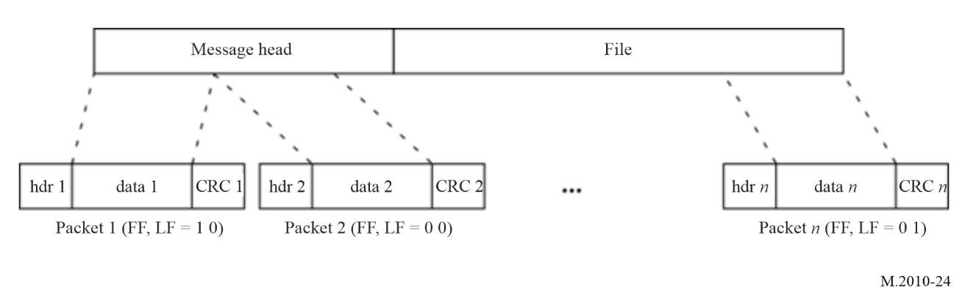
TABLE 27
The structure of the message head
Parameter | Number  of bits | Description
Broadcast mode | 2 | 00 General broadcast  01 Selective ship  10 Group of ship  11 Selective area
Priority (level of message) | 2 | 00 Routine  01 Safety  10 Urgency  11 Distress
Subject of the message | 6 | Refer to table 28
Numbering of the message | 10 | 1 to 999
Broadcast count | 4 | Used for multiple broadcasts of the same file (1 to 15)
Length of data | 24 | The total length of the data in Bytes, and valid range = 1 ≈16777215
Total packets | 14 | The total packets of the data segment and valid range 1≈ 16383
Type of data | 2 | 00 Text  01 Archive file format GNU tar.gz  10 Archive file zip format  11 Reserved
TABLE 27 (end)
Parameter | Number  of bits | Description
Reserved | 8 | Reserved for future use (=0)
Detail of broadcast modes 00, 01 and 10 | 40 | 1 When broadcast mode = 00 All bits are = 0  2 While the Broadcast mode is 01 or 10, the identity is defined on 10 bits according to Recs. ITU-R M.585 and ITU-R M.1080, each digit consists of 4 bits and the number of bits is 40.
Detail of broadcast mode 11 | 176 | The area is defined by four geographical positions on 176 bits with the ability to define a circle (see Table 20 and note)
CRC | 16 | The CRC calculation ranges from the Broadcast mode to the end of the detail of broadcast field.

Total of bits: 128 (Broadcast mode 00 /01/ 10) or 264 (Broadcast mode 11).
Note:
The body of the broadcast message contains the following information:
The subject of the message
The origin of the message (authority that wrote the message)
The date when the message was written (year, month, day and hour / minutes)
The message reference number (it is the numbering of the message) The NAVDAT server must be informed of this number when submitting the message. It should be used for the “Broadcast count” function.
The 14 bits of the total packets are determined by the length of the file to be transmitted.
The receiver must know the packet length in advance to validate the received data. This includes the message header, which specifies the data length (length of data).
Table 28 gives the fixed packet length for the different transmission modes.
The NAVDAT server assigns each message to be broadcast a unique 10-bits number (i.e. a possibility of 999 messages by day) by incrementing from 1 to 999.
This number is totally independent of the message identification given by each authority originating the message and in the message body header.
If the same message is repeated one or more times during the day, this is indicated by the Broadcast count on 4 bits (i.e. a maximum of 15 repetitions).
PACKET LENGTH
Table 28 summarizes the integer number of bytes in each configuration. To obtain an integer number of bytes, it may be necessary to aggregate a number of frames. For example:
MODE B, 4 QAM code rate 0.5, each frame contains 2299 bits, i.e. 287.375 bytes
To obtain an integer number of bytes, a minimum of 8 frames must be aggregated, giving a total of 2299 bytes per packet (287.375 × 8).
The packet lengths given in Table 27 include the 2 CRC bytes and the 2 header bytes.
TABLE 28
Packet length (bytes)
Bandwidth (kHz) | Modulation | Channel coding rate | Mode A |  | Mode B
Bandwidth (kHz) | Modulation | Channel coding rate | Packet length | Number of aggregated frames | Packet length | Number of aggregated frames
10 | 4-QAM | 0.5 | 320 | 1 | 2299 | 8
10 | 4-QAM | 0.75 | 480 | 1 | 3449 | 8
10 | 16-QAM | 0.5 | 640 | 1 | 2299 | 4
10 | 16-QAM | 0.75 | 960 | 1 | 3449 | 4
10 | 64-QAM | 0.5 | 960 | 1 | 2299 | 2 + 2/3
10 | 64-QAM | 0.75 | 1440 | 1 | 3449 | 2 + 2/3
5 | 4-QAM | 0.5 | 1225 | 8 | 1085 | 8
5 | 4-QAM | 0.75 | 919 | 4 | 407 | 2
5 | 16-QAM | 0.5 | 1225 | 4 | 1085 | 4
5 | 16-QAM | 0.75 | 919 | 2 | 814 | 2
5 | 64-QAM | 0.5 | 3675 | 8 | 3255 | 8
5 | 64-QAM | 0.75 | 2757 | 4 | 1221 | 2
3 | 4-QAM | 0.5 | 693 | 8 | 150 | 2
3 | 4-QAM | 0.75 | 260 | 2 | 225 | 2
3 | 16-QAM | 0.5 | 693 | 4 | 300 | 2
3 | 16-QAM | 0.75 | 260 | 1 | 225 | 1
3 | 64-QAM | 0.5 | 2079 | 8 | 450 | 2
3 | 64-QAM | 0.75 | 390 | 1 | 675 | 2
1 | 4-QAM | 0.5 | 114 | 6 | 105 | 16
1 | 4-QAM | 0.75 | 114 | 4 | 158 | 8
1 | 16-QAM | 0.5 | 114 | 3 | 210 | 8
1 | 16-QAM | 0.75 | 114 | 2 | 158 | 4
1 | 64-QAM | 0.5 | 114 | 2 | 315 | 8
1 | 64-QAM | 0.75 | 171 | 2 | 237 | 4

Annex 6
Single frequency network for simultaneous broadcasting from multiple NAVDAT locations (taken from Digital Radio Mondiale)

1 Explanation of Digital Radio Mondiale
The international digital radio broadcast standard DRM is used for digital radio broadcasting at MF and HF. DRM is a proven technology that provides superior coverage, improves signal fidelity (through digital error correction coding), eliminates multi-path interference (including sky-wave interference) and thus extends coverage from sky-wave propagated signals. DRM broadcasts are implemented in both 16-QAM and 64-QAM modulation modes, depending on coverage requirements, transmitter location, power and antenna height.

1.1 Single frequency network operating mode
The NAVDAT system is capable of supporting what is called SFN operation. This is the case where a number of transmitters transmit on the same frequency, and at the same time, identical data signals. Generally, these transmitters are arranged to have overlapping coverage areas, within which a radio should receive signals from more than one transmitter. Provided that these signals arrive within a time difference of less than the guard interval, they should provide positive signal reinforcement. Thus, the service coverage should be improved at that location compared to that obtained if there was only a single transmitter providing service to that location. By careful design, and using a number of transmitters in a SFN, a region or country may be completely covered using a single frequency, and in this application, a single time slot, thus drastically improving spectrum efficiency and release broadcast slots.
In a single frequency network all the individual transmitters must be exactly time synchronized. Every transmitter must broadcast absolutely identical OFDM symbol at the same time.
Time synchronization of all transmitted packets in the transport stream of the final data multiplex is ensured by the time signal 1 pps (pulse per second), which is acquired from the GNSS system.
The frequency stability of transmitters should be better than 2 Hz.
The basic parameter that defines the size of the SFN area is the guard interval Tg.
In OFDM modulation method, its great robustness against inter-symbol interference as an effect of multipath reception (an impact of time delayed signals – echoes) consists in largely extending the very short bit time interval Tb in the serial original data stream.
This guard interval must be carefully configured according to the position of the transmitters in relation with the coverage areas.
When building an SFN network, particular attention will be paid so that the flux of the MIS, TIS and DS are preferably generated by a common server.

Annex 7
NAVDAT subject message codes
This list of subject messages codes is given only for information.
Refer to the documents published by IMO.
TABLE 29
List of NAVDAT subject message codes
Maritime Safety Information (MSI)
Subject message code | Type of message | Coding | can be rejected
Subject message code | Type of message | Coding | YES | NO
Navigational warnings
1 | Sub-area warning | 000001 |  | X
2 | Coastal warning | 000010 |  | X
3 | Local warning (only on national NAVDAT services) | 000011 |  | X
4 | Drifting hazards (including derelict ships, ice, mines, containers, other large items over 6 metres in length, etc.) | 000100 |  | X
5 | Reserved | 000101
6 | Reserved | 000110
7 | No message on hand | 000111 |  | X
Navigational warnings (following) – Positioning system Significant malfunctioning of radio-navigation services and shore-based maritime safety information radio or satellite services
8 | GNSS and RNSS | 001000 |  | X
9 | LORAN and E LORAN/ Chayka and e Chayka | 001001 |  | X
10 | Differential correction information | 001010 |  | X
11 | Operating anomalies identified within ECDIS including ENC issues | 001011
12 | Areas where search and rescue (SAR) and anti-pollution operations are being carried out (for avoidance of such areas) | 001100 |  | X
13 | Reserved | 001101
14 | Reserved | 001110
Navigational warnings (following) – Act of piracy and arm robbery
15 | Acts of piracy and armed robbery against ships | 001111 |  | X
16 | Chart of piracy attacks | 010000 |  | X
17 | Reserved | 010001
Navigational warnings (following) – Tsunamis and other natural phenomena warnings
18 | Tsunami warning/Abnormal changes to sea level | 010010 |  | X
19 | Reserved | 010011
TABLE 29 (continued)
Maritime Safety Information (MSI)
Subject message code | Type of message | Coding | can be rejected
Subject message code | Type of message | Coding | YES | NO
Navigational warnings (following) – Security In accordance with the requirements of the international Ship and port facility Security Code
20 | Security-related information | 010100 |  | X
21 | Chart of security level areas | 010101 |  | X
22 | Reserved | 010110
23 | Reserved | 010111
Navigational warnings (following) – HEALTH Implementation of the International Health Regulation – IHR
24 | World Health Organization (WHO) health advisory information | 011000 |  | X
25 | Pandemic warning | 011001 |  | X
26 | Reserved | 011010
Meteorological
27 | Meteorological warning (Including tropical cyclone, storm, gale warning) | 011011 |  | X
28 | Meteorological synopses (including weather chart) | 011100 | X
29 | Meteorological forecast | 011101 |  | X
30 | Current and tide | 011110 | X
31 | Wave height and direction | 011111 | X
32 | Reserved | 100000
33 | Reserved | 100001
Ice Report
34 | Ice chart | 100010 | X
35 | Iceberg | 100011 | X
36 | Polar Road Information | 100100 | X
37 | Icebreaker patrol information | 100101 | X
Search and Rescue related information
38 | Distress alert relay to all ships (MAYDAY RELAY) | 100110 |  | X
39 | Ship overdue (description and/or picture of the missing ship) | 100111 |  | X
40 | SAR coordination (to ships involved in the SAR operation) | 101000 |  | X
41 | SAR pattern (to ships involved in the SAR operation) | 101001 |  | X
42 | Reserved | 101010
43 | Reserved | 101011
TABLE 29 (end)
Maritime Safety Information (MSI)
Subject message code | Type of message | Coding | can be rejected
Subject message code | Type of message | Coding | YES | NO
Other safety-related information
 | Pilot service
44 | Pilot service information | 101100 | X
 | Tug services
45 | Tug service information | 101101 | X
 | Port support service
46 | Time and height of the tide | 101110 | X
47 | Local port information | 101111 | X
48 | Hydrographic and environmental information | 110000 | X
 | Vessel Traffic Service (VTS)
49 | VTS information | 110001 | X
50 | MMS (RTCM SC139) | 110010
51 | Reserved | 110011
 | Pollution
52 | Pollution information | 110100
53 | Pollution chart | 110101
Other information
 | AIS and LRIT messages
55 | AIS | 110111 | X
56 | LRIT | 111000 | X
 | Nautical chart and publications service
57 | Electronic nautical chart and publications corrections | 111001 | X
58 | Electronic Nautical chart and publications update | 111010 | X
 | Fishing information (only on national NAVDAT services)
59 | Regulations | 111011 | X
60 | Special maps | 111100 | X
61 | Fishing Quota information | 111101 | X
 | Encrypted message
62 | Receiving an encrypted message | 111110
63 | Update receiver software | 111111 |  | X

Information is grouped by subject in the NAVDAT broadcast and each subject group is allocated a subject message code from 1 to 63.
The subject message code is used by the receiver to identify the different classes of messages as listed in this table (from memorized information tables).
The software/firmware of the receiver should be able to be updated. The update should be performed by using an appropriate interface or reception of message 63 (update receiver software).
This function is necessary to follow the evolutions of the GMDSS master plan for new NAVDAT stations as well as for the future revisions of the ITU Recommendations.

Annex 8
Implementation of NAVDAT shore infrastructure

1 Purpose of this Annex
This Annex provides guidance for implementation of MF NAVDAT (495-505 kHz) on shore facilities, which may integrate NAVTEX to support the NAVTEX/NAVDAT transition.

2 Antenna characteristics of radio towers of various heights
Antenna characteristics of radio towers of various heights are shown in Fig. 25 below.
FIGURE 25
Antenna impedance characteristics of radio towers of various heights
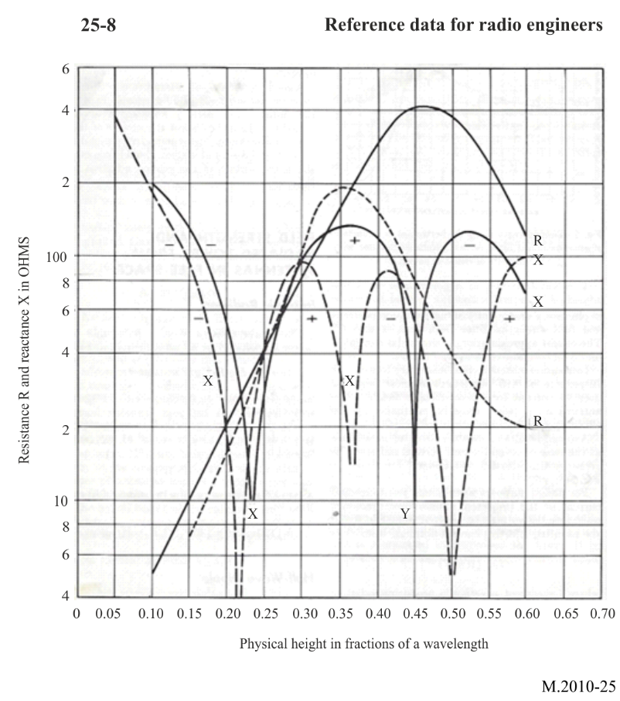
Figure 25 describes resistance and reactance components of impedance between tower base and ground of vertical radiators as given by Chamberlain and Lodge. Solid lines show average results for five guyed towers; dashed lines show average results for three self-supporting towers. Courtesy of Proceedings of the IRE, in the public domain.

3 Antenna requirements for NAVTEX and NAVDAT systems
The antenna requirements for NAVTEX and NAVDAT are different, but it is possible to transmit both NAVTEX and NAVDAT from the same transmitter and tower that is designed and configured for NAVDAT. This would provide a backward compatible system to serve in the transition period. For digital systems such as NAVDAT, a low-Q (Q = X/R, where Q = 1 or less) antenna is ideal to provide linear phase shift across the transmission bandwidth. Low-Q is achieved when the reactance Y is less than the resistance R such as in the vicinity of 0.25 wavelength antenna height as shown above. For NAVTEX and NAVDAT, this occurs at a height of approximately 150 m for both guyed and self-supporting towers.

4 NAVDAT estimated data rates for various transmission modes
Lower tower heights, e.g. 90 m (0.15 wavelengths), can be impedance matched to the transmitter using a series matching inductor. This would result in a Q of 13, according to Fig. 25, where Q = X/R = 130/10 = 13. Although this is acceptable for NAVTEX, which is a narrow-band analogue system, its application for NAVDAT should be carefully evaluated. Tables 5 and 6 describe the various NAVDAT transmission modes and the associated spectrum occupancy. For NAVDAT transmission, the 3 dB bandwidth of the antenna tower should be at least three times the spectrum occupancy to avoid inter-symbol interference caused by nonlinear group delay within the occupied bandwidth. For the 90-metre tower example above, the Q of 13 provides a 3 dB bandwidth of 500 kHz/13 = 38.4 kHz, which is adequate to support the NAVDAT transmission modes 0-23.

The group call identification format of the ship station is defined in part 1 of Annex 1 of Recommendation ITU-R M.585.
Reference Data for Radio Engineers, Howard W. Sams & Co., Inc., Fifth Edition.

