|  |
| --- |
| **Recommendation ITU-R M.1849-3**  **(02/2023)** |
| **Technical and operational aspects of ground-based meteorological radars** |
| **M Series**  **Mobile, radiodetermination, amateur**  **and related satellite services** |

Foreword

The role of the Radiocommunication Sector is to ensure the rational, equitable, efficient and economical use of the radio-frequency spectrum by all radiocommunication services, including satellite services, and carry out studies without limit of frequency range on the basis of which Recommendations are adopted.

The regulatory and policy functions of the Radiocommunication Sector are performed by World and Regional Radiocommunication Conferences and Radiocommunication Assemblies supported by Study Groups.

# Policy on Intellectual Property Right (IPR)

ITU-R policy on IPR is described in the Common Patent Policy for ITU-T/ITU-R/ISO/IEC referenced in Resolution ITU-R 1. Forms to be used for the submission of patent statements and licensing declarations by patent holders are available from <http://www.itu.int/ITU-R/go/patents/en> where the Guidelines for Implementation of the Common Patent Policy for ITU‑T/ITU‑R/ISO/IEC and the ITU-R patent information database can also be found.

|  |  |
| --- | --- |
| Series of ITU-R Recommendations  (Also available online at <http://www.itu.int/publ/R-REC/en>) | |
| **Series** | Title |
| **BO** | Satellite delivery |
| **BR** | Recording for production, archival and play-out; film for television |
| **BS** | Broadcasting service (sound) |
| **BT** | Broadcasting service (television) |
| **F** | Fixed service |
| M | Mobile, radiodetermination, amateur and related satellite services |
| **P** | Radiowave propagation |
| **RA** | Radio astronomy |
| **RS** | Remote sensing systems |
| **S** | Fixed-satellite service |
| **SA** | Space applications and meteorology |
| **SF** | Frequency sharing and coordination between fixed-satellite and fixed service systems |
| **SM** | Spectrum management |
| **SNG** | Satellite news gathering |
| **TF** | Time signals and frequency standards emissions |
| **V** | Vocabulary and related subjects |

|  |
| --- |
|  |

|  |
| --- |
| ***Note***: *This ITU-R Recommendation was approved in English under the procedure detailed in Resolution ITU-R 1.* |

*Electronic Publication*

Geneva, 2023

© ITU 2023

All rights reserved. No part of this publication may be reproduced, by any means whatsoever, without written permission of ITU.

RECOMMENDATION ITU-R M.1849-3

Technical and operational aspects of ground-based meteorological radars

(2009-2015-2019-2023)

Scope

This Recommendation addresses the technical and operational characteristics of meteorological radars, describes the related products provided, highlights their specificities, discusses the effects of interference on meteorological radars and develops related interference protection criteria. This text is limited to ground-based weather radars and does not include wind profiler radars, also used for meteorological purposes, which are covered in other ITU‑R Recommendations.

Related ITU-R Recommendations, Reports

Recommendation ITU-R [F.699](https://www.itu.int/rec/R-REC-F.699/en) – Reference radiation patterns for fixed wireless system antennas for use in coordination studies and interference assessment in the frequency range from 100 MHz to about 70 GHz

Recommendation ITU-R [F.1245](https://www.itu.int/rec/R-REC-F.1245/en) – Mathematical model of average and related radiation patterns for line-of-sight point-to-point fixed wireless system antennas for use in certain coordination studies and interference assessment in the frequency range from 1 GHz to about 70 GHz

Recommendation ITU-R [RS.1280](https://www.itu.int/rec/R-REC-RS.1280/en) – Selection of active spaceborne sensor emission characteristics to mitigate the potential for interference to terrestrial radars operating in frequency bands 1‑10 GHz

Recommendation ITU-R [M.1461](https://www.itu.int/rec/R-REC-M.1461/en) – Procedures for determining the potential for interference between radars operating in the radiodetermination service and systems in other services

Recommendation ITU-R [M.1638](https://www.itu.int/rec/R-REC-M.1638/en) – Characteristics of and protection criteria for sharing studies for radiolocation (except ground based meteorological radars) and aeronautical radionavigation radars operating in the frequency bands between 5 250 and 5 850 MHz

Recommendation ITU-R [M.1652](https://www.itu.int/rec/R-REC-M.1652/en) – Dynamic frequency selection in wireless access systems including radio local area networks for the purpose of protecting the radiodetermination service in the 5 GHz band

Recommendation ITU-R [M.1851](https://www.itu.int/rec/R-REC-M.1851/en) – Mathematical models for radiodetermination radar systems antenna patterns for use in interference analyses

Report [ITU-R M.2136](http://www.itu.int/rep/R-REP-M.2136/en) – Theoretical analysis and testing results pertaining to the determination of relevant interference protection criteria of ground-based meteorological radars

Keywords

Radar, meteorological, protection

Abbreviations/Glossary

CASA: Centre for collaborative adaptive sensing of the atmosphere

CW: Carrier wave

FM: Frequency modulated

GC: Ground clutter

*I*/*N*: Interference-to-noise ratio

pps: Pulses per second

PRF: Pulse repetition frequency

RR: Radio Regulations

*S*/*N*: Signal to noise ratio

SAR: Synthetic aperture radar

WTC: Wind turbine clutter

The ITU Radiocommunication Assembly,

considering

*a)* that antenna, signal propagation, target detection, and large necessary bandwidth characteristics of radar to achieve their functions are optimum in certain frequency bands;

*b)* that representative technical and operational characteristics of meteorological radars are required to determine the feasibility of introducing new types of systems into frequency bands in which meteorological radars are operated;

*c)* that procedures and methodologies are needed to analyse compatibility between meteorological radars and other services to which the frequency band is allocated;

*d)* that technical and operational characteristics of meteorological radars are specific compared to other radar types and justify a separate ITU‑R Recommendation;

*e)* that meteorological radars mainly operate in the frequency bands 2 700-2 900 MHz, 5 250‑5 725 MHz and 9 300-9 500 MHz;

*f)* that meteorological radars are key observation stations used for meteorological observing and environmental monitoring;

*g)* that meteorological radars play a crucial role in providing warnings of imminent severe weather conditions, such as flooding, cyclones and hurricanes, that can endanger populations and damage strategic economic infrastructure;

*h)*that the application of protection criteria requires consideration for inclusion of the statistical nature of the criteria and other elements of the methodology for performing compatibility studies (e.g. antenna scanning and propagation path loss). Further development of these statistical considerations may be incorporated into future revisions of this Recommendation, as appropriate,

recognizing

*a)* that Radio Regulations (RR) No. **5.423** states that ground-based meteorological radars in the frequency band 2 700-2 900 MHz are authorized to operate on a basis of equality with stations of the aeronautical radionavigation service;

*b)* that RR No. **5.452** states that ground-based meteorological radars in the frequency band 5 600-5 650 MHz are authorized to operate on a basis of equality with stations of the maritime radionavigation service;

*c)* that RR No. **5.475B** states that ground-based meteorological radars in the frequency band 9 300-9 500 MHz have priority over other radiolocation uses,

noting

*a)* that Recommendation [ITU‑R M.1461](http://www.itu.int/rec/R-REC-M.1641/en) is also used as a guideline in analysing the compatibility between radars and other services to which the frequency band is allocated;

*b)* that radar protection criteria depend on the specific types of interfering signals, such as those described in Annex 1,

recommends

**1** that the technical and operational aspects of meteorological radars described in Annex 1 and the characteristics given in Annex 2 should be considered when conducting sharing studies;

**2** that for the aggregate protection criteria for ground-based meteorological radars an interference-to-noise ratio (*I*/*N*) of −10 dB should be used.

Annex 1  
  
Technical and operational aspects of ground-based meteorological radars

TABLE OF CONTENTS

Page

1 Introduction 4

2 Overview 5

2.1 Radar equation for single target 5

2.2 Meteorological radar equation 6

3 General meteorological radars principles 7

[3.1 Example of meteorological radar operation in the frequency band   
2.7-2.9 GHz 7](#_Toc124326861)

3.2 Wind measurements principle 11

3.3 Example of meteorological radar operation in portions of the frequency range 8.5‑10.5 GHz 12

4 Comparison of meteorological radars to other radars 12

4.1 Specificities with regards to emission schemes and scanning strategies 13

4.2 Specificities related to noise calibration 16

5 Operational modes for meteorological radar 17

5.1 Clear air mode 17

5.2 Precipitation mode 17

6 Meteorological radar data products 17

6.1 Conventional meteorological radar base data products 18

6.2 Dual polarization meteorological radar products 19

6.3 Derived data products 19

7 Antenna pattern and antenna dynamics 19

7.1 Volume scan antenna movement 20

7.2 Other antenna movement strategies 20

7.3 Antenna patterns 20

8 Effects of interference and solar noise on meteorological radars 20

8.1 Impact of interference on modes of operation 21

8.2 Impact of interference upon base products 21

8.3 Mathematical derivation of meteorological radar protection criteria 23

8.4 Types of possible interference 23

8.4.2 Impact of pulsed interference 27

8.5 Conclusions on meteorological radars protection criteria 33

9 Impact of wind turbines 33

9.1 Masking 33

9.2 Clutter 34

9.3 Backscattered energy from turbulent eddies 34

9.4 Examples of wind turbine clutter 34

9.5 Impact of wind turbine clutter on meteorological radar operations and forecasting accuracy 36

10 Previous tests of meteorological radar systems 37

11 Future tests 38

12 Propagation models 38

13 Future trends 38

14 Summary 39

# 1 Introduction

Ground-based meteorological radars are used for operational meteorology and weather prediction, atmospheric research, and aeronautical and maritime navigation, and play a crucial role in the immediate meteorological and hydrological alert processes. These radars are also in operation continuously 24 h/day. Meteorological radar networks represent the last line of detection of weather that can cause loss of life and property in flash flood or severe storms events.

The theory of operation and the products generated by meteorological radars are remarkably different from other radars. These differences are important to understand when evaluating the compatibility between meteorological radars and other services to which the frequency band is allocated. The technical and operational characteristics of meteorological radars result in different effects from permissible interference in comparison to other radar systems.

# 2 Overview

Meteorological radars are used to sense the conditions of the atmosphere for routine forecasting, severe weather detection, wind and precipitation detection, precipitation estimates, detection of aircraft icing conditions and avoidance of severe weather for navigation.

Some meteorological radars transmit horizontally polarized pulses which measure the horizontal dimension of a cloud (cloud water and cloud ice) and precipitation (snow, ice pellets, hail and rain particles).

Other meteorological radars, called polarimetric radars or, dual-polarization radars, transmit pulses in both horizontal and vertical polarizations. These radars provide significant improvements in rainfall estimation, precipitation classification, data quality and weather hazard detection over non-polarimetric systems.

Meteorological radars are not an individual radio service within the ITU-R, but fall under the radiolocation and/or radionavigation service in the RR. The determination of whether radiolocation and/or radionavigation apply depends on how the particular radar is used. A ground-based meteorological radar used for atmospheric research or weather forecasting would be operated under the radiolocation service. Airborne meteorological radar on a commercial aircraft would operate under the radionavigation service. A ground-based meteorological radar can also operate under the radionavigation service if, for example, it is used by air traffic control for routing aircraft around severe weather. As a result, meteorological radars could operate in a variety of allocated radiolocation and radionavigation frequency bands, as long as the use is consistent with the radio service definition. The RR contain three specific references to meteorological radars in the Table of Frequency Allocations. The three references are contained in footnotes associated with the frequency bands 2 700-2 900 MHz (RR No. **5.423**), 5 600‑5 650 MHz (RR No. **5.452**) and 9 300‑9 500 MHz (RR No. **5.475**).

## 2.1 Radar equation for single target[1]

Meteorological radars do not track point targets. However, the radar equation can be adapted to be used with meteorological radars. The amount of power returned from a volume scan performed by the meteorological radar determines if weather phenomena will be detectable. The radar range equation expresses the relationship between the power returned from a target, and characteristics of the particular target and the transmitting radar.

The typical point target will have the following radar equation variables:

*PR*: received power by the radar

*PT*: radar peak transmit power

*AT*: area of target

*R*: range of target from radar

*G*: gain of the transmit antenna.

These variables combine to create the general radar equation for a point target:



The above equation assumes isotropic radiation and an isotropic scatter. However, most targets do not scatter incident radiation isotropically, and thus the backscatter cross-section, σ, of the target is necessary:



## 2.2 Meteorological radar equation

With the equation for a single-point target derived, the next step is to edit the equation above to account for meteorological radar targets. Raindrops, snowflakes and cloud droplets are examples of an important radar class of targets, known as distributed targets.

The incident radar pulse creates the transmitted resolution volume of the meteorological radar by simultaneously illuminating the volume containing weather particles. The mean power received from weather targets results in the equation below, where Σσ is the sum of the backscatter cross‑sections of all the particles within the resolution volume.



Since the volume of the radar beam continues to expand with increasing range, the radar beam includes more and more targets. The defined volume of the radar beam is equivalent to:



where *h* = *c*τ is the pulse length and θ is the antenna beamwidth. By combining the general radar equation with the volume of the radar beam, the mean power returned becomes:



where η denotes the radar reflectivity per unit volume. The above equation, however, assumes the antenna gain is uniform within its 3 dB limits, which is untrue. By assuming a Gaussian beam pattern, the effective volume is more appropriately defined over the radar beam pattern, instead of within the 3 dB limits. Using a Gaussian beam pattern, the mean power returned becomes:



By accounting for a single spherical particle that is small compared to the radar wavelength, the backscatter cross section can be represented by σ = 64 π5/λ4|*K*|2*ro*2, where *K* is the complex index of refraction and *ro* represents the sphere radius. Weather particles small enough for the Rayleigh scattering law to apply are known as Rayleigh scatterers. Raindrops and snowflakes are considered Rayleigh scatterers measured to accurate approximation when the radar wavelength is between 5 cm and 10 cm, common operating wavelengths for weather radars. At a 3 cm wavelength, the approximate scattering can still be useful, but is less accurate.

For a group of spherical drops, which are small compared to the radar wavelength, the average returned power changes to:



where Σ is a summation of the spherical radius for each the weather scatterers. By allowing (*D*/2)6 to equal , the mean power returned can be reflected in terms of drop diameters for spherical scatterers:



Thus for spherical scatterers that are considerably smaller than the radar wavelength, the mean power received by the weather radar is determined by the radar characteristics, range, the scatterer index of refraction (|*K*|2), and the diameter of the scatterer (*D*6).

Finally, the target reflectivity factor, *Z*, can be introduced as *Z* = Σ*V D*6 = ∫ *N*(*D*)*D*6d*D*, where Σ*V* is the summation over a unit volume and *N*(*D*)*D*6 is the number of scatterers per unit volume. The final form of the radar equation for weather radars, including the corrections made previously to represent a Gaussian beam pattern, results in:



# 3 General meteorological radars principles

Meteorological radars primarily perform two types of measurements:

– precipitation measurements;

– wind measurements.

These measurements are performed over pixel grids that allow presenting cartography of the above-mentioned meteorological events.

## 3.1 Example of meteorological radar operation in the frequency band 2.7-2.9 GHz

Radar 1 in Annex 2, Table 1 is a system representative of meteorological radars operated at frequencies around 2.8 GHz. The 0 dBz curve for this radar intersects the receiver noise level at a range of 200 km.

### 3.1.1 Precipitation estimation

Representative radars operated near 2.8 GHz use a variety of reflectivity-range (Z-R) and reflectivity- rainfall-rate (Z-S) formulas for precipitation estimation. Depending on the specific algorithm, the effect of interference on operational range can vary.

Example of meteorological radar operation in the frequency band 5.6-5.65 GHz

On a typical basis, radar coverage extends over 200 km, presenting a pixel resolution of 1 km × 1 km. In some instances, a more detailed grid is presented over 250 m × 250 m pixels.

For each pixel, the radar measurements are calculated over all the pulse responses corresponding to this pixel, i.e. for each pulse pair and each range gate and then projected directly onto a Cartesian grid (see Fig. 1).

Figure 1

Pulse pair and range gate cartesian projection

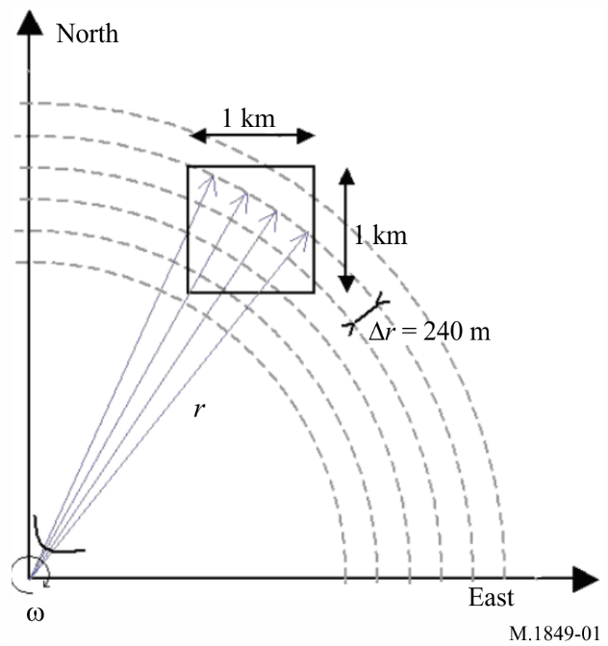

As a consequence, the number of estimates per pixel varies according to the distance. These numbers are related to the mean pulse repetition frequency (PRF) and the antenna rotation speed. On average, with a typical antenna rotation rate of 6 degrees/s, a mean PRF of 333 Hz and a gate spacing of 240 m, this leads, at 10 and 100 km, to about 1 000 and 100 estimates, respectively, for a 1 km2 pixel.

Figure 2 provides simplified calculation of such number of estimates versus distance for 250 m × 250 m and 1 km × 1 km pixels that confirm that radar measurements are more sensitive at higher distances, as well as for smaller pixels.

figure 2

Pixel estimate versus distance

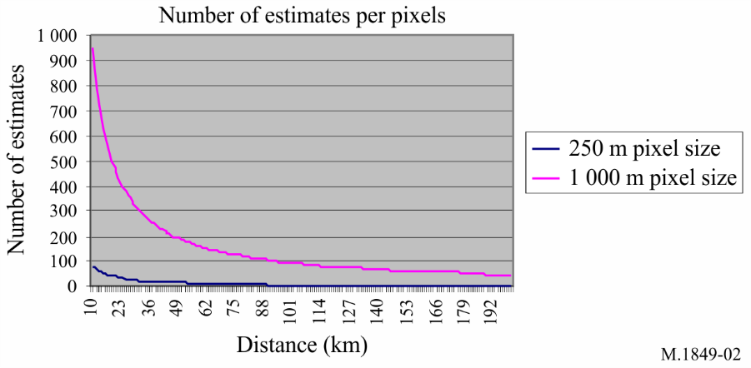

### 3.1.2 Precipitation measurements principle

Weather radars perform precipitation measurements that are expressed in reflectivity (dBz). The principles of these measurements are given below, based on an example of a particular radar design. Other radar designs will operate in a similar manner, but the signal levels will vary by design.

The radars deployed in a network of one administration are calibrated in order to coincide with the level of receiver noise (i.e. about −113 dBm) with the 0 dBz reflectivity level at 100 km. In addition, the minimal detection level of a rain cell is fixed at 8 dBz.

Figure 3 gives the relative levels (dBz) of minimal detection (8 dBz), of a significant convective cell (60 dBz) and level equivalent to the noise of the receiver.

figure 3

Relative levels of minimum detection

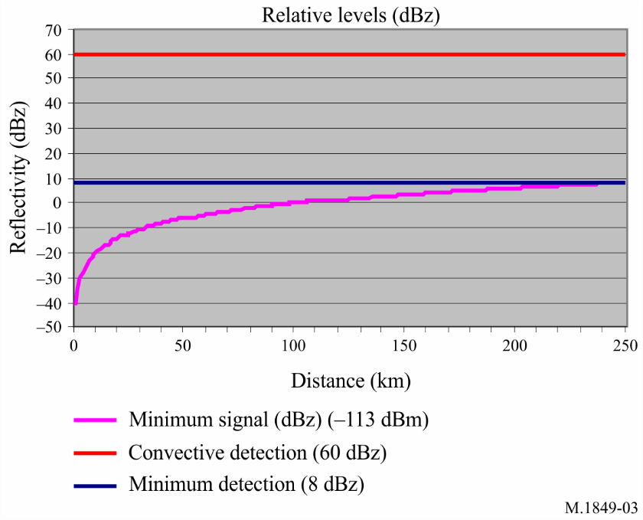

The relationship of power to reflectivity is given by the following formula:

$P=\frac{Cz}{r^{2}}$

with:

*P* : power (mW)

*C* : constant (about 10−7 or −70 dB)

*Z* : reflectivity

*r* : distance (km)

that gives (dB) the following formula:

dBm = dBz + *C* – 20 log *I*

On this basis, Fig. 4 gives (dBm) the receiving levels corresponding to the levels of reflectivity in Fig. 3.

Figure 4

Relative signal levels corresponding to levels of reflectivity and distance

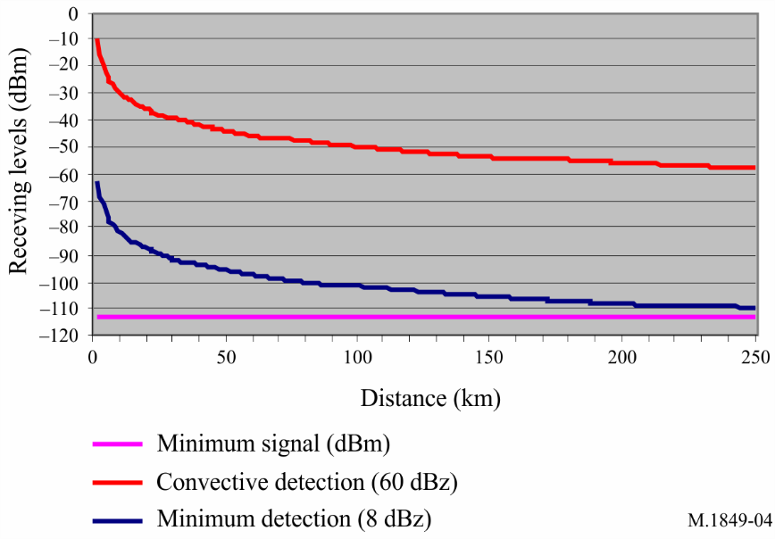

Finally, the reflectivity figures are translated in rain rate levels using the following equation (for typical rain):



It has to be noted that this translation formula is valid for typical rain rate (*a* = 1.6), but that other formulas are defined for different precipitation types (tropical rain, snow, hail, etc.), where the value of *a* would be adjusted accordingly.

For a given pixel of the radar grid, the reflectivity figures for each estimate (corresponding to a pulse response and a gate) are considered in determining the following elements:

– the average (dBz) over all estimates;

– the standard deviation.

Rain cell responses are characterized by a certain variability, which is used to discriminate them from clutter, using the standard deviation figure.

For the radars deployed in one administration, the reflectivity values are hence corrected using the following algorithm:

figure 5

Attenuation slope

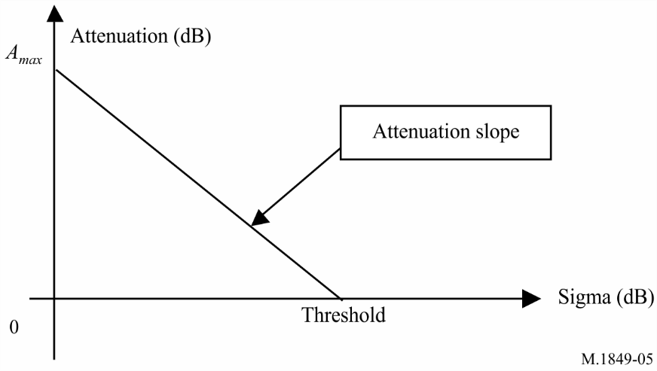



σ: standard deviation (dB)

*Zseef* : reflectivity value before correction

*Zaeef* : reflectivity value after correction.

Slope is the attenuation slope as on Fig. 5 above, given by:



In operational applications, the values of both the threshold and the slope are defined to ensure almost no attenuation on meteorological signals (actually less than 5%), currently fixed, based on experiments, at 20 dB for the slope and within the range 2.3-2.7 dB for the sigma threshold. Finally, it should be noted that, when the calculated attenuation is above 25 dB, then the resulting reflectivity is set to 0.

## 3.2 Wind measurements principle

Unlike reflectivity (dBz), which is a measurement of signal intensity, wind measurements are based on Doppler detection carried out on the phase and phase rate of the signal and can take place as soon as the received signal is higher than the level of noise (i.e. −113 dBm).

In order to avoid phase detection that may be caused by noise variation or non‑meteorological sources, a 3 dB threshold over the noise (i.e. –110 dBm) is considered for some radars whereas, some other meteorological radars are capable of processing signal-to-noise ratios (*S*/*N)* down to −3 dB to −6 dB.

It must also be noted that such measurements are performed both under rain and clear-sky conditions. In rain conditions, receiving levels are similar to those described in Fig. 2. Whereas under clear-sky conditions, it can easily be understood that the corresponding reflectivity levels are very low, and would not allow wind measurements at distances greater than roughly 30 to 50 km.

For each estimate (corresponding to a pulse response and a gate), the phase and reflectivity figures are considered as a vector and, for a given pixel of the radar grid, the resulting wind vector is obtained as the combination of all single vectors.

This means that the phase of each estimate is balanced with the corresponding reflectivity module and that a single estimate presenting a high reflectivity (i.e. the vector module) is able to control the pixel measurement.

Wind measurements are used to derive two different set of wind products:

– the radial speed over the radar grid, similar to the precipitation display;

– the vertical azimuth display for which the whole of the data (for all altitudes) in a radius of a few km or a few tens of km are integrated in order to calculate the wind profile in the vertical direction from the radar.

## 3.3 Example of meteorological radar operation in portions of the frequency range 8.5‑10.5 GHz

Meteorological radars that operate in portions of the frequency range 8.5-10.5 GHz (i.e. on a wavelength of 2.5 cm to 4 cm) can detect smaller particles. These meteorological radars are generally used for studies on cloud development because of their ability to detect very small water particles and light precipitation. They have a typical range of 30 km for 10 dBz weather targets and operate at relatively low power levels (e.g. 12 kW).

Networks of radars that operate in portions of the frequency range 8.5-10.5 GHz are also being investigated as a means of complementing existing weather radar systems by detecting precursors to severe weather events.

“A disadvantage of using radars that operate in portions of the frequency range 8-12 GHz for weather detection is the amount of signal attenuation that can be experienced in rain. The attenuation is particularly severe in moderate-to-heavy rain, where the reflectivity factor is greater than 40 dBz. As long as the radar can obtain a detectable signal after attenuation, velocity measurements can be made and estimates of the attenuation rate can be applied to correct the reflectivity values. Dual-polarimetric measurements can be particularly effective for correction of attenuation. (e.g. Lim and Chandrasekar, 2005).”

Once the attenuated signal falls below the sensitivity of the radar, velocity measurements are unobtainable. When velocity measurements are not available the ability of the radar to detect weather hazards is compromised.

Additional analytical studies and field measurements will need to be undertaken in order to quantify the impact of localized interference on these systems and to determine the magnitude of the I/N levels that are required to protect these systems.

# 4 Comparison of meteorological radars to other radars

Most radars are used for detection and tracking of point targets within the radar’s detection range. In comparison, meteorological radars do not concentrate on detection of discrete targets. They measure the entire atmosphere around the radar. A return from every range bin along each radial is processed to provide a complete measurement of the atmosphere, commonly referred to as a volume scan. For this reason, the term probability of detection (*pd*) is not used in characterizing meteorological radars. In fact, a lack of a signal return is also information to the data user as it indicates clear atmospheric conditions.

As the term volume scan indicates, the radar conducts a scan of the atmospheric volume in order to build a complete representation of the atmospheric conditions. While many types of radars track discrete targets do derive information (velocity, radar cross section, etc.) from the characteristics of return pulses, it is the characteristics of the return pulses for a meteorological radar that provide almost all the information. Unless the air is absolutely clear, meteorological radars receive and process returns for almost all of the range bins along a radial.

The criteria for the operational evaluation of a typical weather radar system include:

a) technical aspects;

b) warning performance, and

c) quality and reliability of derived products.

Technical aspects include factors such as coverage at specific altitudes, spatial and temporal resolution, sensitivity, Doppler coverage and radar availability. Warning performance can be viewed as an objective measure, but is, in fact, directly linked to detection capability. The quality and the reliability of the key derived products – reflectivity, mean radial velocity and spectral width-impact a forecaster’s ability to provide hazardous weather warnings and timely and accurate forecasts.

## 4.1 Specificities with regards to emission schemes and scanning strategies

To ensure volume scan processing (typically in a range of 15 min), meteorological radars make use of a variety of different emission schemes at different elevations, using sets of different pulse width, PRF and rotation speeds, in so-called “scanning strategies”. There are unfortunately no typical schemes, as they vary based on a number of factors, such as the radar capabilities and the radar environment for the required meteorological products.

This has been confirmed following an enquiry on C-Band and X-Bandmeteorological radars in Europe that showed large ranges of different emission scheme parameters:

– Operational elevation ranging from 0° to 90°.

– Pulse width ranging from 0.5 to 2.5 μs (for operational radars). Existing radars are capable of pulse width from 0.33 to 4.5 μs for uncompressed pulses, whereas some radars use pulse compression with pulse width of about 40 μs and expected 100 μs in the future.

– PRF ranging from 250 to 1 200 Hz (for operational radars). Existing radars are capable of PRF up to 3 000 Hz.

– Rotation speed ranging from 1 to 6 rpm.

– Use on a given radar of different emission schemes mixing different pulse width and PRF, and in particular the use of fixed, staggered or interleaved PRF (i.e. different PRF during a single scheme).

Some examples of such different emission schemes are provided below.

FIGURE 6

Fixed pulse repetition frequency

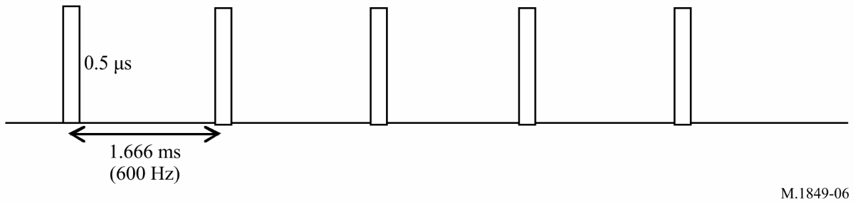

FIGURE 7

Staggered pulse repetition frequency

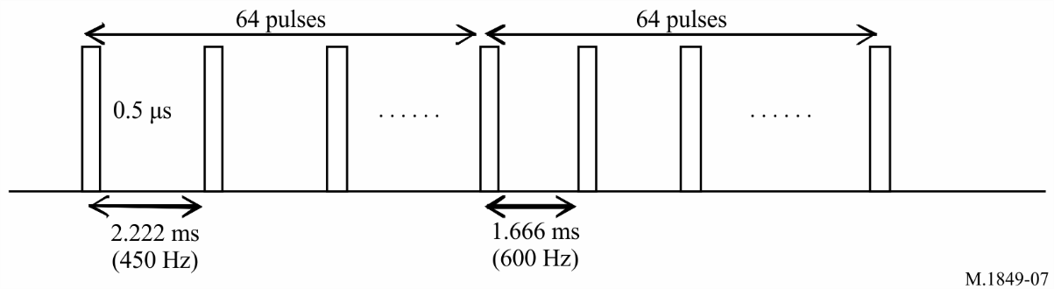

FIGURE 8

Double interleaved pulse repetition frequency (double pulse repetition time)

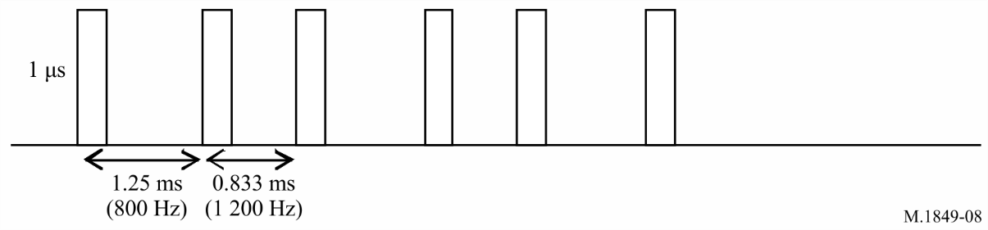

FIGURE 9

Triple interleaved pulse repetition frequency (triple pulse repetition time)

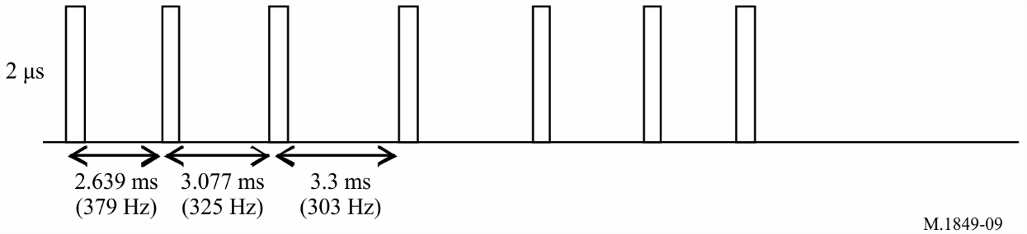

These different emission schemes are used on a number of radars in their scanning strategy, during which, at different elevations and rotation speeds, one emission scheme is transmitted.

It has to be stressed that, from one radar to another, the PRF and pulse width values associated with these example schemes vary within the ranges defined above. In addition, for a given scheme, pulse widths can vary on a pulse to pulse basis.

Below is an example of such scanning strategy:

FIGURE 10

Typical meteorological radar scan strategy

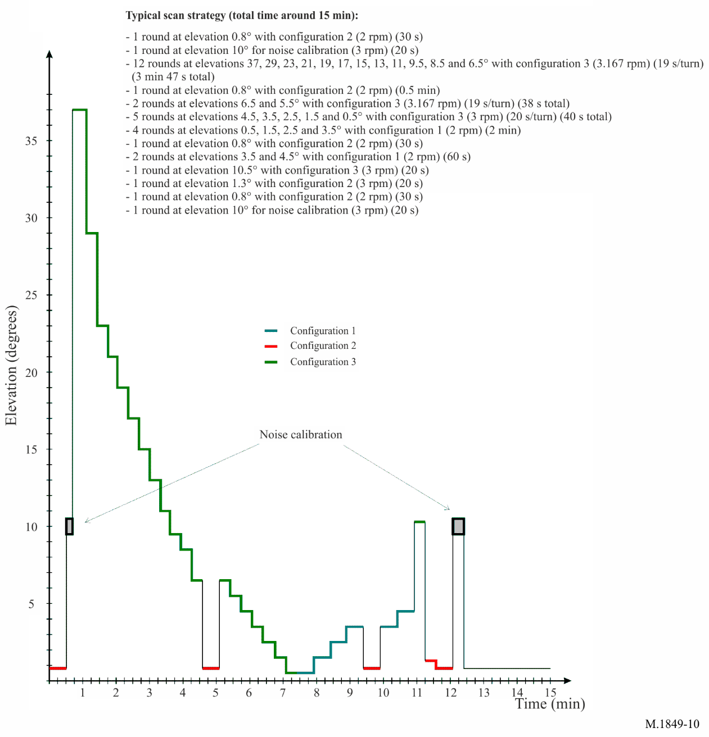

FIGURE 11

Typical meteorological radar scan strategy

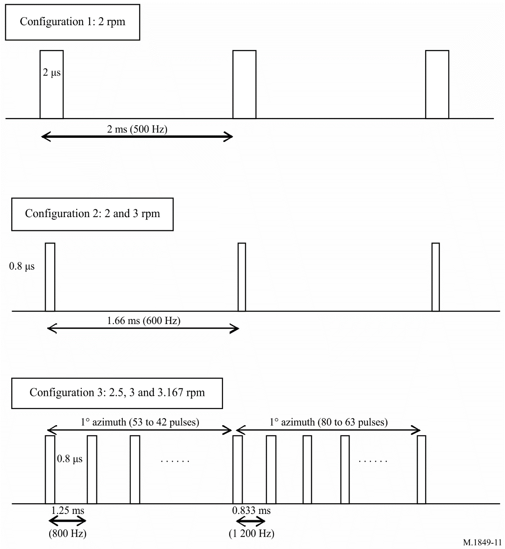

## 4.2 Specificities related to noise calibration

Considering the weakness of the return signal to meteorological radars, the noise level has to be extracted from the signal in order to achieve the most accurate measurements, and retrieve relevant meteorological products.

Noting *N*, the noise level and *S*,the useful signal (i.e. meteorological signal return), meteorological radars perform the following process:

1 For each gate, the radar measures the return signal hence corresponding to the useful signal (*S*) and the noise (*N*), i.e. *N + S.*

2 To get the *S*, the radar extracts from *N + S* the noise level, *N.*

3 Then, from the *S* (dBm), the radar is able to determine all meteorological products, such as the precipitation (derived from the reflectivity factor (dBz)) or wind velocity, by Doppler analysis.

In order to get the more precise meteorological products, the signal *S* has to be as accurate as possible, which means that the noise calibration of the radar is a crucial issue.

This noise calibration, also called “Zero Check”, is therefore performed on a regular basis, either during regular radar emissions (by estimation) or during specific periods of time (see the example scanning strategy above) during which the noise is measured.

In many cases, this noise measurement is performed without any radar emission (this could in particular have an impact on the design of certain radio systems that aim at detecting radar signal to mitigate interference).

In all cases, interference received during the noise check calibration will corrupt all data collection until the next interference free calibration is performed.

# 5 Operational modes for meteorological radar

The typical Doppler meteorological radar operates in two user selectable modes: Clear air mode and precipitation mode. Clear air mode requires manual selection by the user. The precipitation mode may be selected manually at any time during operation or can be automatically operated whenever the weather radar detects precipitation (based upon pre-determined values and area coverage of reflectivity). In general, meteorological radars take advantage of both modes.

## 5.1 Clear air mode

Clear air mode provides meteorological radars the ability to detect early signs of precipitation activity.

There exist certain variables in low-level velocity and air density that allow for detection of potential precipitation. The radar utilizes a slow scan rate, coupled with a low pulse repetition frequency (PRF), to employ a high sensitivity capability. This high sensitivity is ideal for very subtle changes in atmospheric conditions at long ranges. The clear air mode is especially useful when there is little to no convective activity within the transmit range of the radar, and is ideally suited for detecting the signs of developing thunderstorms or other types of severe weather.

Meteorological radar’s high sensitivity is due to the volume scan pattern within the clear air mode. By selecting a pattern in the clear air mode; the radar antenna is capable of dwelling for an extended period in any given volume of space and receives multiple returns, while allowing operation at a lower *S*/*N*. The use of a wide pulse width and a low PRF provides approximately 8 dB echo power for a given dBz of reflectivity.

## 5.2 Precipitation mode

The precipitation mode performs a distinctly different purpose than the clear air mode. The scan rate for the precipitation mode is a function of the elevation angle. This dependence allows for the highest number of elevation angles possible in sampling the total radar volume. The precipitation mode takes advantage of multiple volume coverage patterns to implement different types of scan strategies (see example in § 4.2) with different elevation sampling. Weather events normally monitored in the precipitation mode are associated with the development of precipitation involving convective storms (rain showers, hail, severe thunderstorms, tornadoes, etc.) and large-scale synoptic systems.

# 6 Meteorological radar data products

To provide a better understanding of meteorological radars for the purpose of interference analysis and spectrum management, two categories of meteorological radar data products must be considered: base data products and derived data products.

## 6.1 Conventional meteorological radar base data products

A Doppler meteorological radar generates three categories of base data products from the signal returns: base reflectivity, mean radial velocity and spectrum width. All higher-level products are generated from these three base products. The base product accuracy is often specified as a primary performance requirement for radar design. Without the required accuracy at this low level, the higher-level derived product accuracy cannot be achieved. Previous ITU‑R studies on meteorological radars contained in Report ITU-R M.2136, used the impact of permissible interference on the base product data was used as a metric for the protection criteria. For example, a representative radar with the base data accuracies shown in Table 1 was used in a study to determine the interference-to-noise ratio that caused the radar to no longer meet its design requirements. Section 8.3 and Annex 1 of Report [ITU-R M.2136](http://www.itu.int/rec/R-REP-M.2136/en) address the details of determining meteorological radar protection criteria.

TABLE 1

Representative met radar (2 700-2 900 MHz) base data accuracy requirements

|  |  |
| --- | --- |
| Base data product | Design accuracy requirement |
| Base reflectivity | < 1 dB |
| Mean radial velocity | < 1 m/s |
| Spectrum width | >1 000 Hz |

### 6.1.1 Base reflectivity

Base reflectivity is used in multiple weather radar applications, the most important of which is rainfall rate estimation. Base reflectivity is the intensity of the return pulses, and is calculated from a linear average of return power. Any interference to the radar adds to the return pulse power and biases the reflectivity values. Reflectivity measurements can be compromised if the bias exceeds the base data accuracy requirements.

### 6.1.2 Mean radial velocity

Mean radial velocity is also known as the mean Doppler velocity, and represents the reflectivity weighted average velocity of targets within a given volume sample. Mean radial velocity refers to the spectral density first moment; radial velocity to the base data. It is usually determined from a large number of successive pulses and is calculated from the argument of the single lag complex variance. The complex covariance argument provides an estimate of the Doppler signal vector angular displacement from radar pulse to radar pulse. The Doppler vector angular velocity is equal to the displacement divided by the time interval between pulses. The Doppler spectrum reveals the reflectivity and radar weighting distribution of velocities within the radar volume. An interference signal appearing as broadband noise has uniform probability over the complex plane, and consequently does not introduce a systematic rotation of the Doppler vector nor does it introduce a bias in the estimate. However, the randomness of the composite signals plus interference increases the variance of the Doppler signal estimate.

### 6.1.3 Spectrum width

In meteorological radar design, spectrum width is calculated from the single lag correlation assuming a Gaussian spectral density. It is a measure of the dispersion of velocities within the radar sample volume and is the standard deviation of the velocity spectrum. Spectral width depends on reflectivity and velocity gradients across the pulse volume and turbulence within the pulse volume[2]. There is no averaging of samples used in spectrum width calculations. There is however an accumulation of the real and imaginary parts of the sample series, i.e. the samples taken over the radial.

## 6.2 Dual polarization meteorological radar products

### 6.2.1 Differential reflectivity

Differential reflectivity is a product that is associated with polarimetric meteorological radars, and is a ratio of the reflected horizontal and vertical power returns. Among other things, it is a good indicator of drop shape. In turn the shape is a good estimate of average drop size.

### 6.2.2 Correlation coefficient

Correlation coefficient is a polarimetric meteorological radar product and is a statistical correlation between the reflected horizontal and vertical power returns. The correlation coefficient describes the similarities in the backscatter characteristics of the horizontally and vertically polarized echoes. It is a good indicator of regions where there is a mixture of precipitation types, such as rain and snow.

### 6.2.3 Linear depolarization ratio

Another polarimetric radar product is linear depolarization ratio, which is a ratio of a vertical power return from a horizontal pulse or a horizontal power return from a vertical pulse. It, too, is a good indicator of regions where mixtures of precipitation types occur.

### 6.2.4 Specific differential phase

The specific differential phase is also a polarimetric meteorological radar product. It is a comparison of the returned phase difference between the horizontal and vertical pulses. This phase difference is caused by the difference in the number of wave cycles (or wavelengths) along the propagation path for horizontal and vertically polarized waves. It should not be confused with the Doppler frequency shift, which is caused by the motion of the cloud and precipitation particles. Unlike the differential reflectivity, correlation coefficient and linear depolarization ratio, which are all dependent on reflected power, the specific differential phase is a “propagation effect”. It is also a very good estimator of rain rate.

## 6.3 Derived data products

Using the base data products, the processor produces higher-level derived data products for the radar user. This text will not address the derived data products in detail as the products vary from radar to radar and the number of products is quite large. To ensure accuracy of the derived data products, the base data products need to be accurately maintained.

# 7 Antenna pattern and antenna dynamics

Meteorological radars typically use parabolic reflector antennas that produce a pencil beam antenna pattern. Standard ITU antenna patterns for parabolic antennas are not applicable to antennas used for meteorological radars, as the generated main beam pattern is often much wider than the actual pencil beam pattern. Use of a broader antenna pattern often provides sharing results indicating more significant interference problems than an accurate antenna pattern.

## 7.1 Volume scan antenna movement

The horizontal and vertical coverage required for a volume scan to produce an elevation cut is achieved by rotating the antenna in the horizontal plane at a constant elevation angle. The antenna elevation is increased by a pre-set amount after each elevation cut. The lowest elevation cut is typically in the range of 0º to 1º, and the highest elevation is in the 20º to 40º range, though some applications can use elevations of 60º or more. For a differential reflectivity calibration (Zdr) the antenna is usually pointing at 90° elevation and rotates at least 360°.

Rotation speed of the antenna varies depending on weather conditions and the product required at the time. The rotation speed as well as range of elevation, intermediate elevation steps, and pulse repetition frequency, is adjusted for optimum performance. Slow antenna rotation provides a long per-radial dwell time for maximum sensitivity.

High antenna rotation speed allows the operator to generate a volume scan in a short period of time when it is desirable to cover the entire volume as quickly as possible. Variation of the elevation steps and rotation speed can result in volume scan acquisition times ranging from one minute up to 15 min. The long periods of time for a complete volume scan, compared to other radars that rotate at a constant elevation, make it necessary to run dynamic simulations much longer to obtain a statistically significant sampling of results.

## 7.2 Other antenna movement strategies

Meteorological radars also use other antenna movement strategies for special applications and research. Sector scans are used to get part of an elevation cut. Sector volume scans perform a volume scan for a fraction of the 360º azimuth where the antenna takes multiple elevations cuts. The third mode holds the antenna at a constant azimuth and elevation to monitor a specific point in the atmosphere. All three strategies allow the radar operator to concentrate on a specific part of the atmosphere.

## 7.3 Antenna patterns

Whenever possible, sharing studies should be conducted using the actual antenna pattern of the radar under study. But in cases where actual antenna pattern data is not available, a generic set of curves or formulas for deriving representative antenna characteristics would be beneficial.

Currently there are no defined radar antenna radiation pattern equations within ITU-R to represent meteorological pencil beam antennas. In the absence of measured data, four mathematical models for antenna patterns may be used, as appropriate, in interference analysis with radars as referenced in Recommendations [ITU-R F.1245](http://www.itu.int/rec/R-REC-F.1245/en), [ITU‑R F.699](http://www.itu.int/rec/R-REC-F.699/en), Appendix 1 to Annex 6 of Recommendation [ITU-R M.1652](http://www.itu.int/rec/R-REC-M.1652/en), or provided in Table 5 of Annex 1 of Recommendation ITU-R [M.1851](https://www.itu.int/rec/R-REC-M.1851/en). Although representative of parabolic antennas, the first three Recommendations tend to overestimate the beamwidth of a pencil beam antenna pattern, similar to that generally used by meteorological radars.

# 8 Effects of interference and solar noise on meteorological radars

Determining the effects of interference on radars used for detecting point targets is fairly straightforward. Testing can be accomplished by injecting simulated known targets into the radar, and visually determining the interference level at which the targets are lost or false targets are generated. Visual inspection of the derived data products from a meteorological radar volume scan, as displayed on an operator console, does not provide obvious indication whether interference has degraded the radar’s performance. For example, if interference were to cause a 1 dB bias in the base reflectivity data, it will not be obvious on a graphical display of rainfall. However, if the interference is present for a large part of the volume scan, each and every range bin will be biased within the affected volume. The cumulative effect is a significant overestimation of rainfall in a geographic region.

All meteorological radars experience sun strobes during the periods of sunrise and sunset. A sun strobe is caused whenever the antenna main beam aligns with the sun during a volume scan. The effect of sun strobes, in the particular case of meteorological radars, results in the total loss of data along one to two radials in the direction of the sun. It should be noted that the predictability of sun strobes may allow for the calibration in azimuth of the radars pointing direction.

The effects of the sun are undesirable, but predictable. With other forms of interference and noise the location and intensity are unknown and cannot be predicted or easily addressed through processing or operator interpretation.

Base products are affected by interference in two different ways. First, values can be biased which decreases the accuracy of the system, and second, the variance of the outputs can be affected. In the presence of interference, reflectivity is sensitive to bias, mean radial velocity is sensitive to variance errors, and spectrum width is affected by both bias and variance errors. For spectrum width, the errors due to biasing are more significant than the errors due to variance because the bias, or offset, represents a velocity measurement error, while the variance represents the uncertainty of the velocities measured.

## 8.1 Impact of interference on modes of operation

In the clear air mode, the signal-to-noise-ratio of the returns is the lowest, and the data is most vulnerable to corruption by interference. Typically when operating in clear air mode, the meteorologist is looking for the initial signs of convection, as it may develop into severe weather and possibly tornadoes. Detection of convection requires the detection of fine lines caused by scatterers, indicating discontinuity boundaries that initiate convection. The width of these areas of convection is often on the order of one to two radials in width, and interference along those radials would prevent detection. Therefore interference for even very brief periods of time could result in loss of detection of forming severe weather. If that information is lost along a critical radial during a volume scan, detection will be delayed on the order of 10 min until the volume scan returns the antenna position to that area of the atmosphere.

The precipitation mode is the more demanding mode in terms of communications, radar product generation, and user processing and display. For the precipitation mode, nearly all of the algorithms rely on the base data of reflectivity, mean velocity, and spectrum width to generate derived products for use by the operator.

## 8.2 Impact of interference upon base products

Base products are affected by interference in two different ways. First, values can be biased, which decreases the accuracy of the system, and second, the variance of the outputs can be affected. In the presence of interference, reflectivity is sensitive to bias, mean radial velocity is sensitive to variance errors, and spectrum width is affected by both bias and variance errors. For spectrum width, the errors due to biasing are more significant than the errors due to variance because the bias, or offset, represents a velocity measurement error while the variance represents the uncertainty of the velocities measured.

Reflectivity is calculated from a linear average of power. In some meteorological radars reflectivity estimates are formed for range bins that span 250 m in depth by one radial wide (approximately 1.0º in azimuth). These systems average range bins to produce a reflectivity estimate output at specified intervals. This averaging of four to one can further mitigate effects of interference occurring on a single pulse. Next generation meteorological radar systems have plans to add a “super-resolution” reflectivity product, which will eliminate the averaging and produce reflectivity estimates at 250-m intervals. Additionally, the radial will be reduced to half (0.5º), which will use only half the samples. The total affect will be to reduce the sample size by eight. Thus, interference may be more pronounced in the “super resolution” reflectivity product than in current estimates.

For Doppler moments the interference effects are non-linear. Velocity is calculated from the complex covariance argument and spectrum width from the autocorrelation. A mix of signal and interference does not scale linearly, as with the average for reflectivity. These estimates result from accumulation of signal measurements consisting of both magnitude and phase angle information. Interfering sources would likely have random phases with respect to the coherent met radar signal, and their contribution to the estimate accuracy is difficult to predict.

In terms of spectrum width, interference introduces both a bias and an increase in the variance of the spectrum width estimation. The bias in the estimation is more detrimental than the increase in variance.

Measurement errors need to be specified so that radar observations can be properly assimilated for numerical weather prediction. There are two related aspects to this problem:

1 errors in the original measurements within each radar pulse volume that are in part caused by interfering signals, and

2 representative of the radar data estimates used in the assimilation process.

For radial velocities, the first error source depends on the strength of the return signal and the spread or width of the Doppler velocity spectrum. Spectral width in turn depends mainly on reflectivity and velocity gradients within and across the pulse volume and turbulence within the pulse volume [Doviak and Zrnic, 1984]. Estimation of these errors is complicated by the fact that the components needed for reliable error estimation are themselves only measured and, therefore, has inherent uncertainties.

The concept has been raised that, for a given range resolution cell, meteorological radars average multiple pulse returns over the dwell time of a radial. It has been suggested that in the case where interference occurs for a short part of the radial dwell time, the effect of the interference will be averaged with the interference-free pulse returns, thereby reducing the effects of the interference. For instance, if the radar operates at an interference to noise ratio well below −10 dB, but the −10 dB is violated for a short period of time (small percentage of radial dwell time), the effect of the interference will then be averaged with the interference free-returns. If the –10 dB I/N is violated, but not by a high level of interference, the possible result is that the reflectivity bias of the averaged returns may stay within the design objective of the given radar. Unfortunately, this approach can only be effective if the interfering signal or signals are coherent over the dwell time. Since this does not happen often, averaging techniques may not be the most effective way of mitigating the effects of interference upon Doppler moments. However, with the exception of meteorological radars that employ spectral processing, averaging can be an effective way to mitigate interference given that the average interference over the dwell time has an I/N of less than −10 dB.

The impact of interference upon polarimetric or dual-polarization meteorological radar products, such as differential reflectivity, correlation coefficient, linear depolarization ratio and specific differential phase, needs additional study from both a mathematical and a measurement based perspective in order to quantify the protection criteria levels that are required to assure that polarimetric radar products are not compromised by interference.

It should be concluded that interference to meteorological radars should be minimized, with the objective of mitigating or preventing all interference. Unlike communication systems that use redundancy and error correction, meteorological radars cannot reacquire lost information. However, when considering the use of radar characteristics for ITU-R sharing studies, other factors do need to be considered and are addressed in the following sections.

## 8.3 Mathematical derivation of meteorological radar protection criteria

Weather radars perform three basic measurements, which, in conjunction with operator information, are used to derive meteorological products. The three base products from which other products are derived are volume reflectivity, radial velocity and spectrum width.

Section 2 of Annex 1 of Report [ITU-R M.2136](http://www.itu.int/rec/R-REP-M.2136/en) provides a detailed discussion of mathematically deriving meteorological radar interference criteria for these three products, further supported by test results to validate the derivations.

While it is convenient, and often done, a single protection criteria value cannot be accurately applied to all meteorological radars operating in a single frequency band. Meteorological radars are designed with varying performance objectives, where those objectives are optimized for specific meteorological conditions. The base product accuracy and the radar minimum *S*/*N* vary from radar application to radar application. The lower the minimum *S*/*N* used by the radar, the lower the required protection criteria.

Signal processing removes many of the effects of radar system noise from the reflectivity and spectrum width measurements and, as a result, some systems can provide estimates of these base products for signal levels that are below the receivers’ noise level. The radar operator selects the desired *S*/*N* threshold[3], that can range from −12 dB to 6 dB.

The typical meteorological radar used in the examples developed in § 2 of Annex 1 of Report [ITU‑R M.2136](http://www.itu.int/rec/R-REP-M.2136/en) provides useful measurements down to an *S*/*N* of −3 dB. Interference at this signal level and above will degrade the quality of the base products. This highlights the need to establish an I/N that protects the integrity of these products.

Given the technical specifications and base data accuracy requirements of any given meteorological radar one can derive the theoretical I/N which are required in order to assure that the base products are not compromised in terms of bias and variance.

## 8.4 Types of possible interference

Interference experienced by meteorological radars can be of different types:

– constant;

– time-varying;

– pulse-like.

As a first step, it is proposed to determine the impact of a constant interference corresponding to a protection criteria of I/N = −10 dB, and then to assess the possible protection criteria for the other interference sources to ensure a similar level of the radar performance degradation.

### 8.4.1 Impact of a constant interference

A protection criteria of I/N = −10 dB corresponds to a noise or energy increase of 0.5 dB.

On the principle that radars are calibrated to coincide with the level of receiver noise (i.e. about −113 dBm) with the 0 dBz reflectivity level at 100 km, a noise increase changes the nominal conditions of the radar, decreasing the range of the radar.

On this basis, assuming a current coverage of typical frequency range 5 250-5 725 MHz meteorological radars that roughly extend up to 200 km, Table 2 summarizes the losses in range and coverage versus the *I*/*N* interference and noise increase.

TABLE 2

Loss in range and coverage

|  |  |  |  |
| --- | --- | --- | --- |
| Noise increase  (dB) | Corresponding *I*/*N* (dB) | Loss in coverage (km) | Loss in coverage  (% relative to surface) |
| 0.5 | –10 | 11 | 11% |
| 1 | –6 | 22 | 21% |
| 2 | –2.3 | 42 | 38% |
| 3 | 0 | 59 | 50% |
| 4 | 1.8 | 75 | 61% |
| 5 | 3.3 | 88 | 69% |
| 6 | 4.7 | 100 | 75% |
| 7 | 6 | 111 | 80% |
| 8 | 7.3 | 121 | 84% |
| 9 | 8.4 | 130 | 88% |
| 10 | 9.5 | 137 | 90% |

On the other hand, a constant interference also creates an increase of the energy received by the radar that will be considered in the reflectivity calculation.

Following the description in § 2.2, the precipitation rate corresponding to a certain reflectivity level (dB) is given by:

z*= AR^B*

where:

z: reflectivity

*A*: scattering constant

*B*: rate multiplier

and

z = 10 log z (dBz)

where:

dBz: reflectivity (dB).

Rearranging terms and solving for *R* yields the following equation:



Assuming a constant energy increase, *C*, the resulting rain rate is:



The rain rate increase in percentage is then a constant that is given by:



Table 3 lists typical scattering constants and rate multipliers for several types of precipitation[4].

TABLE 3

Scattering constants and rate multipliers for various precipitation events

|  |  |  |  |  |
| --- | --- | --- | --- | --- |
| Variables | Stratiform rain | Convection rain | Snow | Hail |
| Scattering constant (A) | 200 | 500 | 2 000 | 2 000 |
| Rate multiplier (B) | 1.6 | 1.5 | 2 | 1.29 |

Table 4 summarizes the percentage rain increase for several precipitation events.

TABLE 4

Summary of precipitation overestimation

|  |  |  |  |  |  |
| --- | --- | --- | --- | --- | --- |
| Noise increase (dB) | Corresponding *I*/*N*  (dB) | Stratiform rate increase  (%) | Convection rate increase (%) | Snow rate increase (%) | Hail rate increase (%) |
| 0.5 | –10 | 7.5 | 8.0 | 5.9 | 9.3 |
| 1 | –6 | 15.5 | 16.6 | 12.2 | 19.5 |
| 2 | –2.3 | 33.4 | 35.9 | 25.9 | 42.9 |
| 3 | 0 | 54.0 | 58.5 | 41.3 | 70.8 |
| 4 | 1.8 | 77.8 | 84.8 | 58.5 | 104.2 |
| 5 | 3.3 | 105.4 | 115.4 | 77.8 | 144.1 |
| 6 | 4.7 | 137.1 | 151.2 | 99.5 | 191.8 |
| 7 | 6 | 173.8 | 192.9 | 123.9 | 248.8 |
| 8 | 7.3 | 216.2 | 241.5 | 151.2 | 317 |
| 9 | 8.4 | 265.2 | 298.1 | 181.8 | 398.5 |
| 10 | 9.5 | 321.7 | 364.2 | 216.2 | 495.9 |

These calculations show that, irrespective of the rain value and precipitation type, the percentage of overestimation corresponding to a given constant energy increase is also constant, and hence cannot be neglected.

Also, considering the reflectivity calculation for a given pixel that are based on the average (dBz), over all estimates, and the related standard deviation, it is worth noting that a constant energy increase of all estimates will increase the average but will not change the standard deviation. This means that it would not modify the radar rain detection (i.e. a measurement not considered as a rain cell will still not be considered as such), but would only have an impact on the rain rate.

It is also interesting to note that for either the loss in coverage or the rain rate overestimation, a protection criteria of −10 dB represents radar performance degradation in a range of 7 to 11%, which are generally agreed figures for all radiocommunication services.

In the case of Doppler measurements, the assessment of the impact of a given constant interference is somehow different, and would, in particular, depend on how the phase of the interfering signal could modify the phase of the wanted signal.

This latter assumption is certainly not trivial to determine and will be signal and/or environmentally dependent. Both situations are considered in the following cases.

– *Case 1*: If the phase of the interfering signal detected by the radar is random, it means that the resulting vector would be statistically null, whatever its level. Hence, it would theoretically not have any impact on the wind measurements.

– *Case 2*: If the detected phase is not random and almost constant, it would result in a constant vector with a certain module and the impact on the wind measurement will depend on both the phase and module of such vector.

In addition, one can also assume that, when the level of interference is much lower than the wanted signal, the phase of the wanted signal is not modified. If the interfering signal is much higher, then the phase detected by the radar will be the phase of the interfering signal, and the discussion on Cases 1 and 2 above will remain. In between these two situations, i.e. when the levels of both the interfering and wanted signals are consistent, it seems quite difficult to assess which of the signals will control the phase detection.

## 8.4.2 Impact of pulsed interference

Pulsed interference can have a significant impact on the reflectivity data that a meteorologist uses to forecast severe weather events. In some cases pulsed interference could result in returned data that cannot reliably produce an image of targets in the atmosphere. Examples of this can be seen in Fig. 12.

Figure 12

Interference-free versus interference-corrupted meteorological   
radar imagery (precipitation mode)

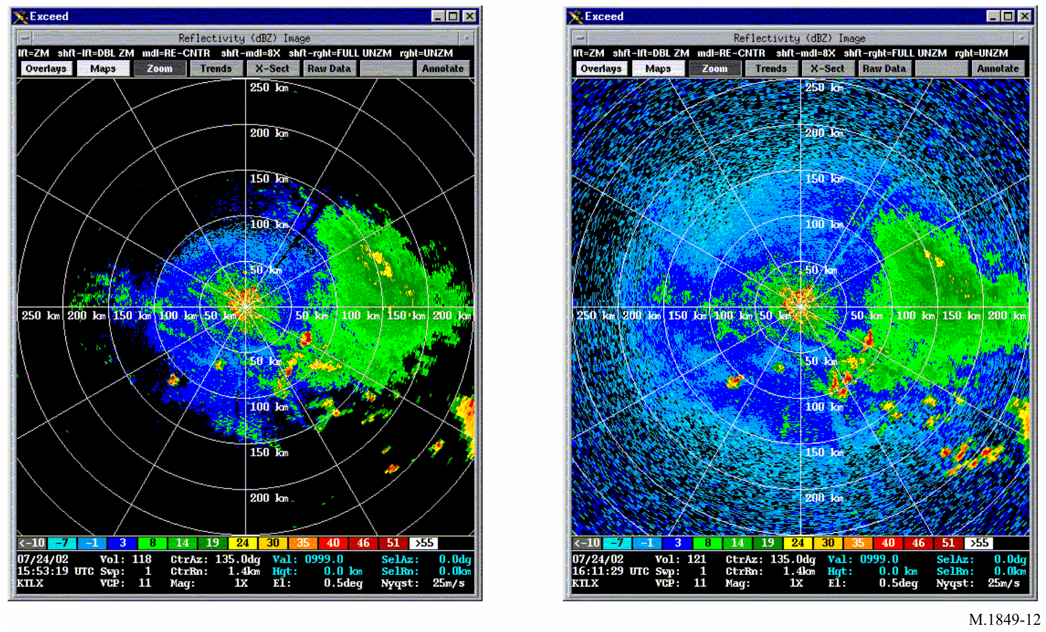

An additional example of interference to meteorological radar from a single indoor low power transmitter can be seen in Fig. 13.

Figure 13

Interference to meteorological radar (precipitation mode)

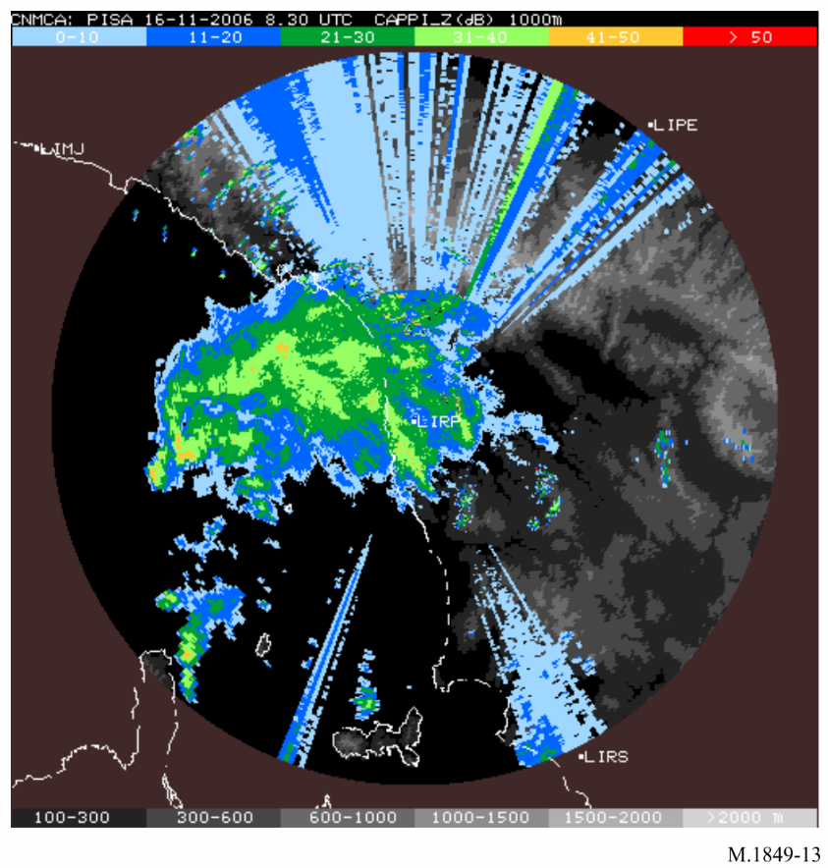

In the case of an interfering application transmitting pulse signals, and due to the principle of the rain and wind measurements that are based on average over numerous radar pulses, it seems likely that the ratio of the PRF of the meteorological radar gates (pulse width) and the interfering source will control the impact on meteorological radars.

On a first approach, it is assumed that this ratio can be calculated from the formula given in § 3.2 of Recommendation ITU-R [RS.1280](https://www.itu.int/rec/R-REC-RS.1280/en), providing the fraction of coinciding pulses between two pulse applications that will depend upon whether the desired and undesired pulse repetition frequencies are related by integer multiples (Case I) or not (Case II). The fraction of coinciding pulses, *fc*, is found from:

 for Case I

 for Case II

where:

*PRFi* : interfering pulse frequency; units Hz or pulses per second (pps)

*PRFg* : gate repetition frequency

*GCF* (*PRFi*, *PRFg*) : greatest common factor of *PRFi* and *PRFg*

τ*I* : interfering pulse width; units second

τ*g* : gate width.

Note that when τ*I* > τ*g*, and the desired and undesired PRFs are not related by integer multiples (Case II), *fc* is approximately the duty cycle of the interfering pulses.

On this basis, in order to maintain the same level of degradation (about 10%) as for a constant interference where *I*/*Nconstant* = −10 dB applies, it is assumed that the maximum *I*/*N* related to a pulse interference could be given by:

${I/N}_{pulse}={I/N}_{constant}-10\log\left(f_{c}\right)$

In fact, if the fraction of coinciding pulses is 0.5, meaning that one of two radar estimates will be polluted by the interference, and that the interfering signal is doubled (+3 dB) compared to the situation pertaining to an *I*/*N* = −10 dB, it is obvious that the average calculated by the radar will be the same.

On the other hand, the standard deviation will increase which will, in some cases, make a non‑meteorological event be taken as a rain situation. In this case, it is assumed that 10% degradation would be acceptable, but this still needs to be validated and justified by calculation as well as by testing.

It has to be noted that the above principle that higher *I*/*N* corresponding to peak power of pulsed interference can be accepted by meteorological radars has been confirmed by recent testing (see Annex 2 of Report [ITU-R M.2136](http://www.itu.int/pub/R-REP-M.2136)). Even though the above formula was not fully validated in all cases, it is hence assumed to represent a relevant approach. Further analysis to determine the relationship between victim and interferer signal characteristics (PRF and pulse width) could, however, be appropriate.

#### 8.4.2.1 An alternative method for deriving the *I*/*N* levels for pulsed interference

Meteorological radars process signal returns to measure precipitation and wind patterns. The processing involves collecting and processing base products; reflectivity, mean radial velocity, and spectrum width. In simplest terms, the radar averages a sample of signal returns to derive the estimates needed for production of meteorological products. The averaging function will provide the meteorological radar the ability to process higher pulsed interference levels relative to CW or noise-like interference signals.

Meteorological radars process multiple pulse returns falling within a range bin to form a sample of a size defined by the user. The multiple pulse returns forming a range bin sample are averaged to derive the range bin estimate. The proposed EESS systems and meteorological radars operate on significantly different pulse repetition frequencies, so the likelihood of more than one interfering pulse falling within a single meteorological radar range bin sample set is small, given a small sample size.The approach is to determine the maximum level of a single pulse that will not corrupt the average of the sample size beyond the base data product performance objectives of the radar.

Determination of a protection criterion requires an understanding of the radar’s receiver noise level, the minimum signal-to-noise ratio used for processing, and the radar’s base products (reflectivity, man radial velocity and spectrum width) accuracy requirements. Since a variety of meteorological radars are operated in the frequency band, some assumptions must be made. The radar used in the analysis has a receiver noise floor of –110 dBm at the narrowest IF bandwidth.

The minimum signal-to-noise ratio is probably the most difficult value to establish without reference to specific radars. For radars operated in the frequency band 2 700-2 900 MHz signal‑to‑noise ratios of 0 to 3 dB are typical, since the lower frequency radars are generally operated for detection at long ranges. Meteorological radars operated in the frequency band 9 300‑9 500 MHz are generally used for shorter-range, higher-resolution detection, and may operate at higher minimum signal-to-noise ratios. For this analysis, an *S*/*N* of +3 dB and a noise floor of ‑110 dBm result in the values of the base data product accuracy requirements which are shown in Table 5.

TABLE 5

Data accuracy requirements

|  |  |
| --- | --- |
| Base data accuracy requirements | |
| Reflectivity estimate | 1 dB |
| Velocity estimate | 1 m/s |
| Spectrum width estimate | 1 000 Hz |

As shown in Table 5, the maximum reflectivity bias limit for the meteorological radar used in this example is assumed to be 1 dB; this translates to interference to minimum signal ratio, *I*/*S*, of 0.26, or a power ratio of 1.26. A reflectivity sample size of 25 will be assumed. A sample size larger than 25 is possible, further reducing the effects of a single pulse, but a larger sample size also increases the probability of a second interfering pulse occurring in the same sample.

#### 8.4.2.2 Calculation of the *I*/*N* for a pulsed interferer (single hit)

##### 8.4.2.2.1 Assumptions

– The minimum signal level normally recovered has a signal-to-noise-ratio of 2 dB.

– The bias is dependent upon the signal to interference mean power ratio. Therefore it is dependent upon both interference level and the number of “hits” in the estimate periodogram.

– Maximum interference level for reflectivity is defined by the reflectivity bias.

– A reflectivity bias (*Rb*) of 1 dB yields a power ratio of 1.2589.

Power Ratio = 10(*Rb*/10) = 10(0.1) = 1.2589

Subtracting the unbiased power ratio from the power ratio at which a 1 dB bias occurs yields an interference to signal ratio of 0.2589.

*I*/*S* = [10(*Rb*/10) – 10(*Rb*/10)] = [1.2589 – 1] = 0.2589

The interference power level can be computed from the following formula:



This value translates to a 6.17 dB signal.

*IL* (dB) = 10 log (4.14) = 6.17 dB

For a signal-to-noise-ratio of 3 dB, *I*/*N* can be computed as follows:

*I*/*N* = 6.17 dB + 3 dB = 9.17 dB

Combining these factors into a function that describes *I*/*N* in relationship to *Ns*, *I*/*N* and *Rb* results in an equation that yields the maximum required *I*/*N* for a single “hit”:



where:

*Ns*: number of samples in the estimate

*Smp*:signal mean power

*S*/*N*: receiver signal-to-noise ratio

*I*/*S*: interference-to-signal ratio

and *I*/*S* is expressed as:



where:

*Rb*: reflectivity bias

*Nnf*: normalized noise floor level.

Combining the equations yields:



An example calculation that is based upon the previous assumptions follows.

##### 8.4.2.2.2 Example calculation

Assumptions:

*Ns* = 16

*S*/*N* = 3 dB

*Rb* = 1 dB

*Nnf* = 0 dB[5]





### 8.4.3 Impact of a time-varying interference

Figures 14 and 15 describe the potential interference from a SAR system to meteorological radar, and present a time-varying interference.

Figure 14

Peak *I*/*N* cumulative distribution function

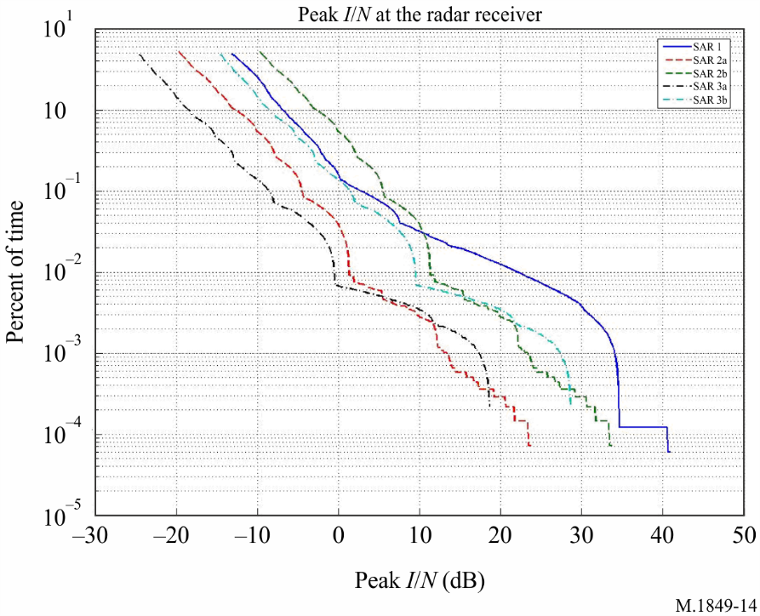

Figure 15

Peak *I*/*N* vs. time for one passage over the meteorological radar

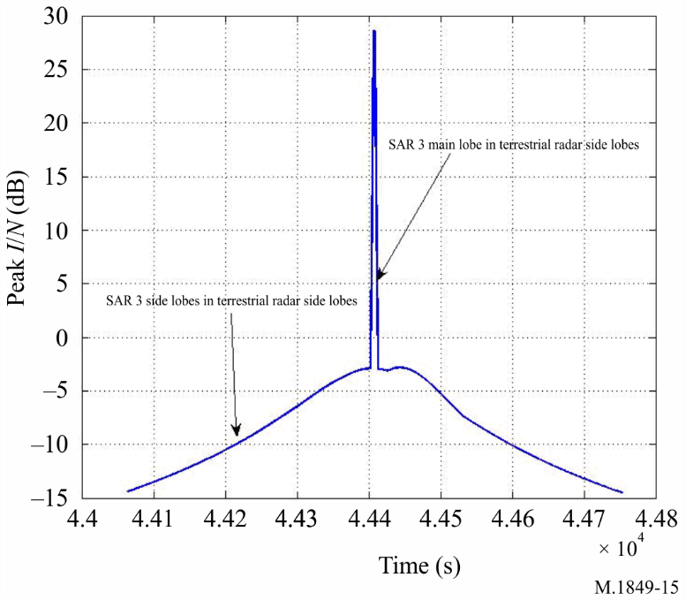

Based on these Figures, it appears that two situations are likely to occur:

a) in the first one, a high *I*/*N* level will be produced for a short time duration, which is likely to render the met radar inoperable for this time duration, either blocking the rain measurements capabilities or presenting a large overestimation of the rain rate;

b) in the second one, over a larger time period (roughly 400 s), the interference criteria will be exceeded.

It is difficult to assess the impact of this type of interference on meteorological radars. However, it should be assumed that, due to the short duration of pixel integration, a time-varying interference is likely to present, on a short-term basis (i.e. on a pixel per pixel analysis), the same impact as for a constant interference (pulsed or not) as described in §§ 8.4.1 and 8.4.2 could apply. On a case by case and pixel by pixel basis, determining the impact of time-varying interference is not a trivial task.

Recognizing the need of further and more detailed analysis, it should be noted that an *I*/*N* level of 30 dB (without taking into account the pulse aspect of the SAR emission) that could pertain in situation 1 may produce, in a given area, a large overestimation of the instantaneous rain rate, which will corrupt the long-term (1 hour up to several days) rain statistics that are used in hydrological alert processes. An interference time duration of about 400 s roughly corresponds to 7 radar rotations and relates to radar side lobes. In this case, a large number of pixels (and hence, a large geographical area) will be impacted over several occurrences making approximation of the pixels impossible. The size of the geographical area obviously depends on the interference level that is assumed to first impact the edge of the radar coverage. Even a slight interference can present a loss in coverage of several tens of per cent.

Determining the impact of time-varying interference is not a trivial task and would require a case by case analysis that would take into account dynamic simulation results upon which interference criteria used for either constant or pulse interference sources would have to be applied.

## 8.5 Conclusions on meteorological radars protection criteria

Even though the protection requirements of meteorological radars are heavily dependent on their characteristics and specifications, the analysis developed above in § 8, and the elements in Report [ITU-R M.2136](http://www.itu.int/rec/R-REP-M.2136/en), consider impacts on both radars range and base product accuracy and confirms that, for constant interference, an *I*/*N* = −10 dB is relevant and hence should be used to ensure the protection of meteorological radars. This criterion is consistent with existing ITU‑R Recommendations.

Analysis and tests on the impact of pulsed interference concluded that a different *I*/*N* may apply, depending on the characteristics of the interfering transmitter and victim receiver (primarily PRF and pulse width). Pending further studies on the impact of pulsed interference, this *I*/*N* may be estimated using one of the methods described in §§ 8.4.2 or 8.4.2.1.

At present, a generic formula for time-varying interference has not yet been developed. Depending on whether the interference source is continuous or pulsed, is short term (impact on radar radials), or if the interference is long term (overall volume scan), the analysis should be performed on a case‑by-case basis and from results of dynamic simulations, taking into account the relevant abovementioned criteria for either constant or pulse like interference.

# 9 Impact of wind turbines

For accurate weather forecasting, weather radars are designed to look at a relatively narrow altitude band. Due to the sensitivity of the radars, wind turbines, if deployed with line of site of a weather radar facility, can block the onward propagation of the radar signals, cause reflectivity clutter returns, and produce wake-turbulence-induced radar echoes. These interference mechanisms can result in false radar estimates of precipitation accumulation, false tornadic and mesocycle signatures, misidentification of thunderstorm features and incorrect storm cell identification. In addition, the interference mechanisms can result in degraded radar performance and negatively impact forecast and warning operations.

## 9.1 Masking

Any geographical feature or structure which lies between the radar and the target will cause a shadowing or masking effect. It is possible that, depending on their size, wind turbines may cause shadowing effects. Such shadowing effects may be expected to vary, depending on the turbine dimensions, the type of transmitting radar and the aspect (height, blade angle, rotation rate, and position relative to the radar of the turbine).

## 9.2 Clutter

Radar returns may be received from any radar-reflective surface. In certain geographical areas, or under particular meteorological conditions, radar performance may be adversely affected by unwanted returns, which may mask those of interest. Such unwanted returns are known as radar clutter. For a weather forecaster, a wind turbine or turbines in the vicinity of weather radar can present operational problems.

Ground clutter signals exhibit large reflectivity, near-zero Doppler shift, small spectrum width, and are consistently localized. Compared to commonly occurring ground clutter (GC), interference caused by wind turbines is a much more difficult challenge. Direct reflections will be received from both the tower (stationary) and the blades (non-stationary). Like GC, the wind turbine clutter (WTC) signal should still have a significantly large reflectivity, with a possible modulation due to blade rotation causing a systematic variation in radar cross-section.

The Doppler shift will be affected by several factors, including the blade rotation speed and rotor orientation with respect to the radar beam. Doppler velocities should be at a maximum when the rotor is oriented 90° from the radar line-of-sight, and near zero when the rotor is facing either away or toward the radar. Since the resolution volume of the radar will likely encompass the entire wind turbine structure, it is expected that the spectrum width will be significantly enlarged. This is due to the blade rotation away and toward the radar. Multiple turbines within one resolution volume would only exacerbate this effect.

## 9.3 Backscattered energy from turbulent eddies

In addition to WTC signals caused by reflections from the actual wind turbines, backscattered energy from turbulent eddies in the wake of the wind farm may be observed. It is expected that these echoes would exhibit characteristics similar to clear-air backscatter from discontinuities in the refractive index at the Bragg scale of the radar. These wake echoes would drift with the wind field, and would likely have much lower reflectivity compared to the direct reflections from the turbines. Nevertheless, they could significantly enlarge the radar coverage area affected by WTC and thus exacerbate the problem.

## 9.4 Examples of wind turbine clutter

Images of how a wind farm (a collection of wind turbines) appears on meteorological radar display can be found in Fig. 16. (This Figure is a reflectivity image showing returns from a wind farm that is approximately 40 km southwest of the meteorological radar.)

Figure 16

Meteorological radar imagery showing a wind farm southwest of the radar location

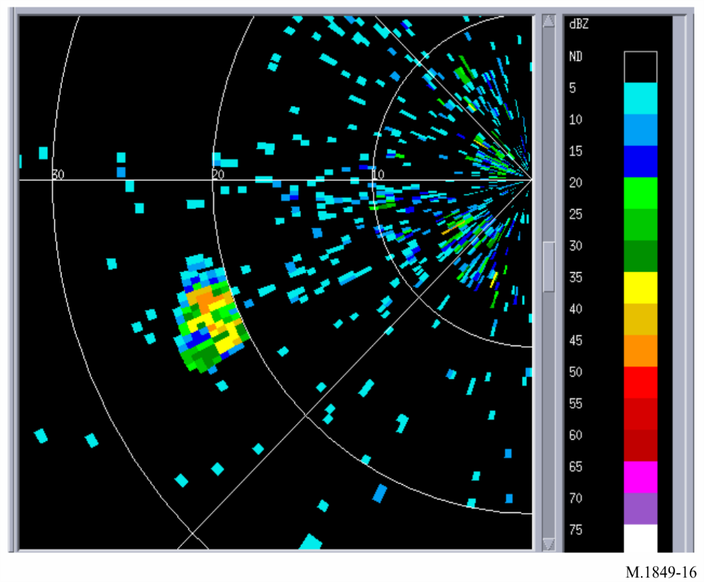

Figure 17 shows level II data, where echoes from isolated storms are mixed with the wind turbine clutter echoes. The wind turbine signals are characterized by random radial velocity and large spectrum width.

FIGURE 17

Impact of interference from a wind farm on level II data

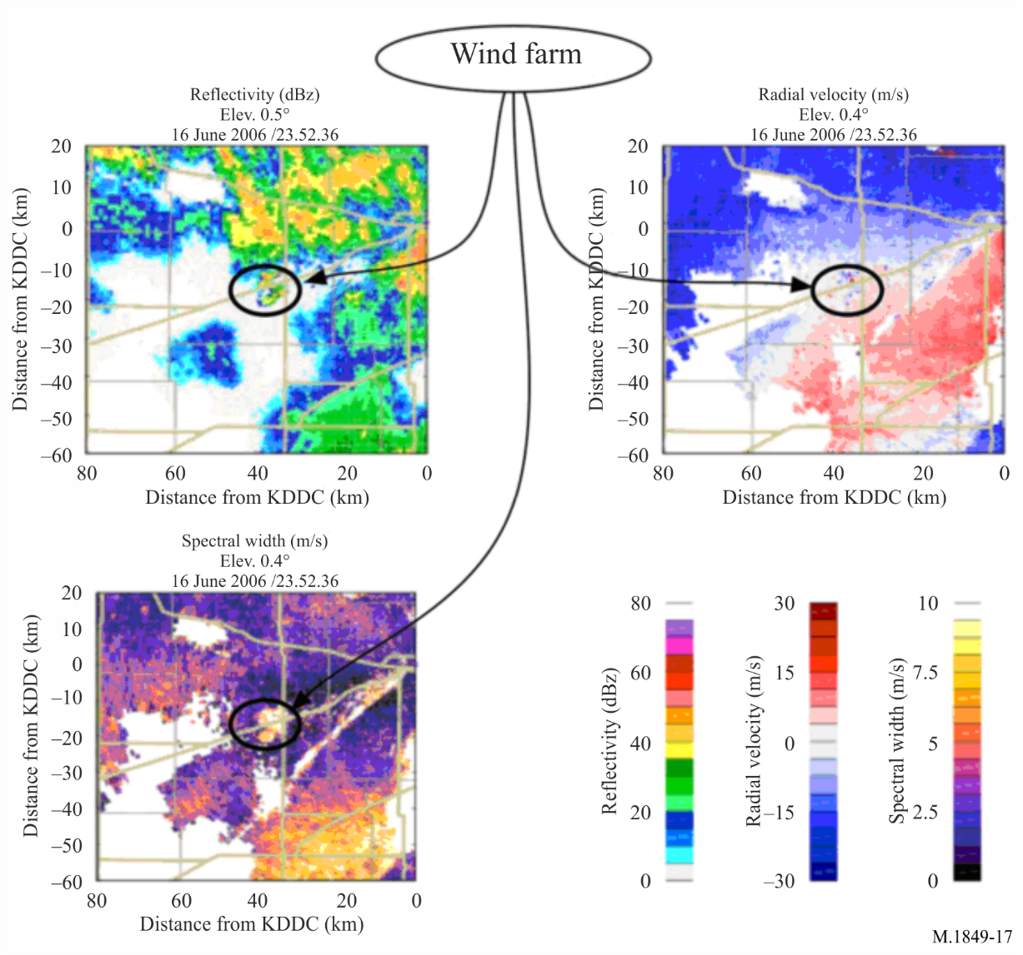

Without prior knowledge, it would be extremely difficult to distinguish between the WTC and the thunderstorms. Since the blades rotate toward and away from the radar, one would expect a near‑zero mean Doppler velocity. The large spectrum widths will reduce the accuracy of the Doppler velocity estimates as illustrated in Fig. 17 by small deviations from zero.

## 9.5 Impact of wind turbine clutter on meteorological radar operations and forecasting accuracy

Field studies have been conducted that illustrate the impact of WTC upon meteorological radars. These studies have shown that wind turbine farms can have a significant effect upon meteorological radars, and as such can degrade severe weather event forecasting.

These analyses have clearly shown that the clutter produced by a wind turbine will be present in very significant azimuths (several tens of degrees) compared to the direction of the wind turbine, even at quite large distances. Thus the impact of the wind turbines on reflectivity operation of weather radars cannot be neglected.

The analyses have also shown that the impact of one single wind turbine on a meteorological radar’s Doppler mode is very significant, in particular at distances less than 10 km, within which all data will be erroneous at every azimuth.

Some form of WTC mitigation will be required in order to protect meteorological radars from harmful interference from wind turbine farms.

Before any final conclusions can be made regarding processing methods to mitigate WTC, additional studies of WTC should be conducted in order to understand the full extent and the impact of WTC on meteorological radars. Once this has been defined, methods to mitigate WTC may need to be developed given the expected growth of wind-power based generation systems.

Pending the result of ongoing studies on mitigating WTC interference to meteorological radars,   
the current solution to avoid or limit the impact of wind farms is to ensure separation distances between the two systems. For example, some European countries are currently considering the following recommendations:

a) that no wind turbine should be deployed at a range from radar antenna lower than:

– 5 km for radars operating in the frequency range 5 250-5 725 MHz;

– 10 km for radars operating in the frequency band 2 700-2 900 MHz;

b) that projects of wind parks should be submitted to an impact study when they concern ranges lower than:

– 20 km for radars operating in the frequency range 5 250-5 725 MHz;

– 30 km for radars operating in the frequency band 2 700-2 900 MHz.

# 10 Previous tests of meteorological radar systems

Previous testing was conducted on meteorological radar with the objective of determining the radar’s protection criteria. The procedure and data analysis methodology is defined in detail in Annex 1 of Report [ITU-R M.2136](http://www.itu.int/rec/R-REP-M.2136/en). The testing involved injecting an interference signal into the receiver at a known level. The radar was allowed to perform a partial (1 or 2 antenna rotations) or full volume scan without interference present. The radar would then be reset to perform the same partial or full volume scan, with the interference signal injected into the receive path using an RF combiner. The base products data for the non-interference and the interference partial or full volume scan was stored to disk. The alternating non-interference and interference partial or full volume scans were conducted at interference signal levels providing *I*/*N* ranging from +6 dB to −15 dB.

Data analysis was then conducted by making an interference-free range bin to interference-present range bin comparison along each radial. From the regressed data, the *I*/*N* level at which the interference causes the base products accuracy to fall outside acceptable limits could be determined.

The testing provided insight into potential testing improvements. The testing documented in Annex 1 of Report [ITU‑R M.2136](http://www.itu.int/rec/R-REP-M.2136/en) was performed with the radar collecting data from the atmosphere. The assumption was the atmospheric conditions would not change significantly in the 3 to 5 minutes required to perform the non-interference and interference partial or full volume scans. Data analysis revealed this assumption was not always correct.

It is important to note that, across a broader range of meteorological radars, the sensitivity to interference may vary as each individual radar’s tolerable interference level is dependent upon the minimum signal-to-noise ratio of interest, estimate bias, and variance performance requirements.

More recent interference testing was performed to determine, for one type of meteorological radar operating in the frequency range 5 250-5 725 MHz, interference sensitivity corresponding to different interference signals (constant, CW or FM and pulsed) and confirmed the above analysis in § 8, as well as previous testing related to meteorological radars operating in the frequency band 2 700-2 900 MHz. A summary of these testing results is given in Annex 2 of Report [ITU‑R M.2136](http://www.itu.int/rec/R-REP-M.2136/en).

# 11 Future tests

Future testing methods should examine the use of a signal acquisition and regeneration system where the radar IF or I and Q signals can be captured, digitized and stored to disk. The signals of a single interference-free volume scan can be captured and digitized.

With use of arbitrary waveform generator(s) and an RF signal generator, the digitized received radar signal can be recreated and injected into the radar receiver as many times as necessary to conduct the testing, simulating return signals from the atmosphere. Such an approach may provide identical test conditions for the non-interference and interference partial or full volume scans.

Testing with pulsed type interference and/or time-varying interference may need to be performed to assess and confirm susceptibility of meteorological radars to this type of interference. This testing should be conducted on both non-polarimetric (horizontally polarized) and polarimetric (horizontally and vertically polarized) meteorological radars.

# 12 Propagation models

Previous sections discuss the need to minimize the amount of permissible interference received by meteorological radars. However, it is also recognized that the appropriate propagation models, as identified by ITU-R Study Group 3 on propagation, should be considered when performing sharing studies.

# 13 Future trends

Major hardware upgrades to various administrations’ meteorological radar systems are in progress. The next improvement will be polarimetric radar, which adds vertical polarization to the currently used horizontal radar waves.

Additional techniques to further improve the performance of meteorological radars are also under way. Foremost among these are various algorithms for resolving range/velocity ambiguities, increasing data acquisition speed, reducing the effects of artefacts, decreasing clutter and efficient processing of signals to provide meteorological estimates that are as accurate as possible. Other endeavours include combined use of weather and profiling radars. A modest effort is devoted to studies of lightning and its hazards, to determine whether its onset and termination might be predictable.

Another future trend is the use of solid state transmitters instead of tube based amplifiers like magnetrons or klystrons. Due to the lower peak output power of solid state transmitters, pulse compressions schemes have to be used to achieve the same sensitivity as seen with tube based meteorological radar systems. With pulse compression, the transmitted pulse is frequency and/or phase modulated. By using pulse compression schemes, a relatively long transmitter pulse with comparable low peak power can achieve a better sensitivity, resulting in longer detection range, than expected from the radar equation. This is because the received signal is correlated with the transmitted pulse during reception to increase the signal to noise ratio. The probability is very low that a received noise pattern is similar to the transmitted pulse and that the noise signal would therefore form an output signal in pulse compression. The transmitted pulse length can range between 10 and 100 µs resulting in a blind range of 1.5 to 15 km where the receiver does not receive echoes due to the transmitter still active. This blind range will be filled with by using a short pulse of, for example, 1 or 2 µs in length.

Researchers will soon begin adapting phased array radar technology for use in weather surveillance applications. The phased array will replace mechanically steered parabolic dish antennas with an electronically steered array antenna. This change will enable more flexible scanning strategies and more rapid updates of changing weather conditions. Early tests of the phased array radar system have proved promising. Phased array technology will increase fundamental understanding of storm evolution, in turn leading to improved computer models, more accurate forecasts and earlier warnings. In addition, this technology has the potential to increase the average lead-time for tornado warnings well beyond the current average of 13 min. System enhancements are more economically implemented via improvements to the receiver and signal processing subsystems. Although phased array implementation is not anticipated within the next ten years, there is a possibility that the phased array upgrade (if implemented) will not reuse the existing transmitter, which will be replaced by distributed transmit/receive modules in the phased array.

These future trends will need to be tracked and, as technologies evolve, will have an impact on any future interference mitigation strategies and protection criteria definitions.

# 14 Summary

Ground-based meteorological radars operate and process signals differently than other radars, and produce products much different than other radar types. These differences may affect how interference analyses should be conducted, and how analysis results should be assessed.

Ground-based meteorological radars are specific, using different antenna movement strategies to conduct a scan of the atmospheric volume around that radar, where a complete representation of the atmospheric conditions is measured. In comparison, most other radar types track discrete targets and are only concerned with returns for range cells that are associated with the targets. In meteorological radar, all range cells in all radials are processed.

Annex 2  
  
Characteristics of meteorological radars

TABLE OF CONTENTS

Page

1 Meteorological radars in the frequency band 2 700-2 900 MHz 40

2 Meteorological radars in the frequency range 5 250-5 725 MHz 44

3 Meteorological radars in the frequency band 9 300-9 500 MHz 51

# 1 Meteorological radars in the frequency band 2 700-2 900 MHz

The technical characteristics of representative weather radars that operate in the frequency band 2 700-2 900 MHz are depicted in Table 6. However, radar 1 can operate up to 3 000 MHz. These are the primary weather radar systems which are used for flight planning activities. They are, on a worldwide basis, often collocated at airports and provide accurate assessments of weather conditions which are used to manage flight operations. These radars are in operation 24 h/day.

Radar 1 utilizes Doppler radar technology to observe the presence and calculate the speed and direction of the motion of severe weather elements, such as tornadoes, hurricanes and violent thunderstorms. Radar 1 also provides quantitative area precipitation measurements that play an important role in hydrologic forecasting. The severe weather and motion detection capabilities offered by this radar contribute towards an increase in the accuracy and timeliness of warning services. Radar 1 excels in the early detection of damaging winds and in the estimation of rainfall amounts which are used in river and flood forecasting.

Radar 1 is used in an integrated network spanning the entire United States of America, Guam, Puerto Rico, Japan, South Korea, China and Portugal. The frequency band 2 700-2 900 MHz offers excellent meteorological and propagation characteristics for weather forecast and warning capabilities. Planned enhancements to the radar should extend its service life to the year 2040. The World Meteorological Organization reports that more than 320 meteorological radars operate in this frequency band in at least 52 countries throughout the world.

Radar 2 is a non-Doppler radar which is used in many countries.

Radars 3 and 4 combine aviation weather and meteorological applications into a single radar.

TABLE 6

| Characteristics | | Radar 1* | Radar 2* | Radar 3 | Radar 4 | Radar 5 | Radar 6 |
| --- | --- | --- | --- | --- | --- | --- | --- |
| Tuning range (MHz) | | 2 700-3 000 | 2 700-2 900 | 2 700-3 000(2) | 2 700-3 000(2) | 2 700-3 000(2) | 2 700-3 000(2) |
| Modulation | | P0N | P0N | P0N, Q3N | P0N, Q3N | P0N | P0N |
| Transmitter power into antenna (kW) | | 500 | 400 or 556 | 40 | 160 | 850 | 1000 |
| Pulse width (µs) | | 1.6 (short pulse) 4.7 (long pulse) | 1.0 (short pulse) 4.0 (long pulse) | 1.0 (short pulse) 60.0 (long pulse) | 1.0 (short pulse) ≤ 250.0  (long pulse) | 0.5-3.3 | 0.4-4.5 |
| Pulse rise/fall time (µs) | | 0.12 | Unknown | 0.2 (SP), 3  (long pulse) | 0.2 (SP), 3  (long pulse) | Unkonwn | 0.05 / 0.06 |
| Pulse repetition rate or pulses per second (Hz or pps) | | 318-1 304 (short pulse) 318-452  (long pulse) | 539  (short pulse) 162  (long pulse) | 320-6 100  (short pulse)  320-1 300  (long pulse) (3) | 320-4 300  (short pulse)  320-1 500  (long pulse) (3) | 250-2 000 | 250-1 400 |
| Duty cycle (%) | | 0.21 maximum | Unknown | 0.2(4)-0.6  (short pulse)  ≤ 12.0 (5)  (long pulse) | 0.2 (4) -0.4  (short pulse)  ≤ 12.0 (5)  (long pulse) | 0.11 | 0.11 |
| Chirp bandwidth (MHz) | | N/A | N/A | 3 | 3 | N/A | N/A |
| Phase-coded sub-pulse width | | N/A | N/A | N/A | N/A | N/A | N/A |
| Compression ratio | | N/A | N/A | 180 | ≤ 750 | N/A | N/A |
| RF emission bandwidth (MHz) | –3 dB | 0.6 |  |  |  | 2 | 1.5 |
| –6 dB |  |  | 1.3 (short pulse)/2.0 (long pulse) | 1.3 (short pulse)/2.0 (long pulse) | 3.5 | 2 |
| –20 dB | 4.6 |  |  |  | 10 | 8 |
| –40 dB |  |  | 10.4 (short pulse)/6.2  (long pulse) | 10.4 (short pulse)/6.2  (long pulse) | 20 | 25 |
| Output device | | Klystron | Coaxial magnetron | Solid state | Solid state | Magnetron | Klystron |

TABLE 6 (*continued*)

| Characteristics | Radar 1* | Radar 2* | Radar 3 | | Radar 4 | | Radar 5 | | Radar 6 | |
| --- | --- | --- | --- | --- | --- | --- | --- | --- | --- | --- |
| Antenna pattern type (pencil, fan, cosecant-squared, etc.) | Pencil beam | Pencil beam | Pencil beam coverage to  70 000 feet | | Pencil beam coverage to 100  000 feet | | Pencil beam | | Pencil beam | |
| Antenna type (reflector, phased array, slotted array, etc.) | Parabolic reflector | Parabolic reflector | phased array,  4 faces (4 m diameter phased array per face) | | phased array,  4 faces (8 m diameter phased array per face) | | Parabolic reflector | | Parabolic reflector | |
| Antenna polarization | Linear: vertical and horizontal, simultaneous transmit/receive | Linear: horizontal | Linear horizontal and vertical; circular | | Linear horizontal and vertical; circular | | Linear (dual polarisation) | | Linear (dual polarisation) | |
| Antenna main beam gain (dBi) | 45.0 | 38.0 | 41 | | 46 | | max. 46 | | max. 46 | |
| Antenna elevation beamwidth (degrees) | 0.92 | 2.0 | 1.6-2.7 | | 0.9-1.5 | | 0.9-1.25 | | 0.9-1.25 | |
| Antenna azimuthal beamwidth (degrees) | 0.92 | 2.0 | 1.6-2.7 | | 0.9-1.4 | | 0.9-1.25 | | 0.9-1.25 | |
| Antenna horizontal scan rate (degrees/s) | Variable between 4 and 30 | 18 and full manual slewing | N/A | | N/A | | 0 to 36 | | 0 to 36 | |
| Antenna horizontal scan type (continuous, random, 360°, sector, etc.) | 360° | 360° and sector | Irregular to cover 360° | | Irregular to cover 360° | | 360° | | 360° | |
| Antenna vertical scan rate (degrees/s) | 14 steps in 5 min |  | N/A | N/A | | 0 to 36 | | 0 to 36 | |
| Antenna vertical scan type (degrees) (continuous, random, 360°, sector, etc.) | Fixed steps: 0.5-20 | −2.0 to +60 | Irregular to cover required volume | Irregular to cover required volume | | Volume | | Volume | |
| Antenna side lobe (SL) levels (1st SLs and remote SLs) (dB) | 20 | +15 (estimated) | 17 on transmit,  25 on receive | 17 on transmit,  25 on receive | | −26 | | −26 | |
| Antenna height (m) | Variable  (2.5 to 30) | 30 | Variable | Variable | | Variable | | Variable | |

TABLE 6 (*end*)

| Characteristics | Radar 1* | Radar 2* | Radar 3 | | Radar 4 | | Radar 5 | | Radar 6 | |
| --- | --- | --- | --- | --- | --- | --- | --- | --- | --- | --- |
| Receiver IF bandwidth (MHz) | 0.714 at –3 dB | 0.25 at –3 dB  (long pulse) 0.5 at –3 dB (short pulse) | 1.2 at –6 dB  (short pulse) 1.8 at –6 dB  (long pulse) | 1.2 at –6 dB  (short pulse) 1.6 at –6 dB  (long pulse) | | 20 at −3 dB | | 20 at −3 dB | |
| Receiver noise figure (dB) | 2.7 | 9.0 | < 6 | < 6 | | < 2.5 | | < 2.5 | |
| Minimum discernible signal  (dBm/MHz) | –112 | −110 | –110 | –110 | | −112 | | −112 | |
| Receiver front-end 1 dB gain compression point (dBm) | –17 | −32 | 10 | 10 | | 0 | | 0 | |
| Receiver on-tune saturation level (dBm) | –10 |  | N/A | N/A | | N/A | | N/A | |
| Receiver RF 3 dB bandwidth (MHz) | 18 | 0.5 (long pulse) 1.5 (short pulse) | 200 | 300 | | 20 | | 20 | |
| Receiver RF and IF saturation levels (dBm) | –10 |  | 13 | 13 | | N/A | | N/A | |
| Recovery times (µs) | 1 |  | < 0.5 | < 0.5 | | 1 | | 1 | |
| Doppler filtering bandwidth (Hz) | 95(1) (estimate) |  |  |  | |  | |  | |
| Geographical distribution | Worldwide | | | | | | | | |
| Fraction of time in use (%) | 100 | | | | | | | | |
| *Notes to Table 6*:  (1) Doppler filtering and saturating pulse removal.  (2) Tuning range of 2.7-2.9 GHz when performing the aeronautical radionavigation function.  (3) Very high PRFs only used at high elevation angles.  (4) Duty cycle for short pulse is 0.2% at lowest elevation (horizon) scan.  (5) Combination of pulse width and PRF will be matched to keep duty cycle under 12%. | | | | | | | | | |

|  |
| --- |
|  |

# 2 Meteorological radars in the frequency range 5 250-5 725 MHz

Both airborne and ground-based meteorological radars operate within the frequency range 5 250‑5 850 MHz. The technical characteristics for ground-based radars are given in Table 7.

One can also note that some meteorological services operate specific non-rotating radars in this frequency range to track and locate radiosondes that do not implement a radionavigation feature. These radars mainly differ from meteorological radars in that they make use of shorter pulse width (down to 0.2 μs) and, once locked on a radiosonde, will follow its trajectory up to the end of the launch. These radars are not covered in this Recommendation.

It should be noted that ground meteorological radars can theoretically operate in the whole frequency range 5 250‑5 850 MHz, but their operation is, in general, limited to the frequency range 5 430‑5 725 MHz. Most of these radars operate within the frequency band 5 600-5 650 MHz.

TABLE 7

| Characteristics | Radar 1 | Radar 2 | Radar 3 | Radar 4 | Radar 5 |
| --- | --- | --- | --- | --- | --- |
| Tuning range (MHz) | 5 300-5 700 | 5 600-5 650 | 5 600-5 650 | 5 300-5 700 | 5 600-5 650 |
| Tx power into antenna (kW peak) | 250 | 250 | 250 | 250 | 250 |
| Pulse width (µs) | 2.0 | 0.05-18 | 0.4-4.5 | 0.8-2.0 | 3.0 |
| Pulse rise/fall time (µs) | 0.2 | 0.005 | 0.05 / 0.05 | 0.08 | 0.3 |
| Pulse repetition rate (pps) | 50, 250 and 1 200 | 0-4 000 | 250-2 000 | 250-1 180 | 259 |
| Output device | Coaxial magnetron | Klystron | Klystron | Tunable magnetron | Coaxial magnetron |
| Antenna pattern type (pencil, fan, cosecant-squared, etc.) | Conical beam | Pencil beam | Pencil beam | Pencil beam | Pencil beam |
| Antenna type (reflector, phased array, slotted array, etc.) | Solid parabolic reflector | Parabolic reflector | Parabolic reflector | Parabolic reflector | Solid parabolic reflector |
| Antenna polarization | Vertical | Horizontal | Linear (dual polarisation) | Horizontal | Horizontal |
| Antenna main beam gain (dBi) | 39 | 44 | max. 50 | 40 | 40 |
| Antenna elevation beamwidth (degree) | 4.8 | 0.95 | 0.5-1 | < 1.0 | 1.65 |
| Antenna azimuthal beamwidth (degree) | 0.65 | 0.95 | 0.5-1 | < 1.0 | 1.65 |
| Antenna horizontal scan rate (degree/s) | 0.65 | 0-36 (0-6 rpm) | 0-36 | 30-48 | 30-48 |
| Antenna horizontal scan type (degree) (continuous, random, 360⁰, sector, etc.) | 360 | 360 | 360 | 360 | 360 |
| Antenna vertical scan rate (degree/s) | N/A | N/A | 0-36 | 15 | 15 |
| Antenna vertical scan type (degree) (continuous, random, 360⁰, sector, etc.) | N/A | N/A | Volume | Stepwise,  –2 to +60 | –1 to +60 |
| Antenna side‑lobe (SL) levels (1st SLs and remote SLs) (dB) | –26 | –35 | –28 | –25 | –25 |
| Antenna height (m) | 30 | 10 | variable | 30 | 30 |
| Receiver IF 3 dB bandwidth (MHz) | 0.5 | 20 | 20 | 0.6 | 0.25 to 0.5 |
| Receiver noise figure (dB) | 7 | 4 | ≤ 2.5 | 3 | 3 |
| Minimum discernable signal (dBm) | –110 | –97 | –112 | –109 to –112 | –114 |

TABLE 7 *(continued)*

| Characteristics | Radar 6 | Radar 7 | Radar 8 | Radar 9 | Radar 10 |
| --- | --- | --- | --- | --- | --- |
| Tuning range (MHz) | 5 600-5 650 | 5 600-5 650 | 5 250-5 725 | 5 600-5 650 | 5 600-5 650 |
| Modulation | Conventional | With Doppler capability | With Doppler capability | With Doppler capability | With Doppler capability (including noise calibration w/o emission) |
| Transmitter power into antenna  (kW peak) | 250 | 250 | 2.25 | 250 | 250-400 |
| Pulse width (s) | 0.8-5 | 0.8-5 | 0.1 | 0.8-2, 5 and 10 | 0.5 to 3.5 |
| Pulse rise/fall time (s) | 0.2-2 | 0.2-2 | 0.005 |  | 0.1 / 0.2 |
| Pulse repetition rate (pps) | 250-1 200 | 50-1 200 | 100 000 | 50-1 200  Fixed and staggered | 250-2 400 |
| Output device | Coaxial magnetron or Klystron | Coaxial magnetron | Coaxial magnetron | Coaxial magnetron | Coaxial magnetron |
| Antenna pattern type (pencil, fan, cosecant-squared, etc.) | Pencil beam | Pencil beam | Pencil beam | Pencil beam | Pencil beam |
| Antenna type (reflector, phased array, slotted array, etc.) | Solid parabolic reflector | Solid parabolic reflector | Solid parabolic reflector | Solid parabolic reflector | Parabolic reflector |
| Antenna polarization | Horizontal and/or vertical | Horizontal or vertical | Horizontal or vertical | Horizontal | Linear (dual polarisation) |
| Antenna main beam gain (dBi) | 40-50 | 40-50 | 35-45 | 44-48 | max. 50 |
| Antenna elevation beamwidth (degree) | 0.5-2 | 0.5-2 | 2.4-12 | 0.65-1 | 0.5-1.0 |
| Antenna azimuthal beamwidth (degree) | 0.5-2 | 0.5-2 | 1.5-12 | 0.65-1 | 0.5-1.0 |
| Antenna horizontal scan rate degrees/s  rpm | 6-18 1-3 | 6-18 1-3 | 1.2 | 3-36 0.5-6 | 0-36 |
| Antenna horizontal scan type (degree) (continuous, random, 360⁰, sector, etc.) | 360 | 360 | 360 | 360 | 360 |
| Antenna vertical scan rate (degree/s) | 1-10 | 1-14 | N/A |  | 0-36 |

TABLE 7 *(continued)*

| Characteristics | Radar 6 | Radar 7 | Radar 8 | Radar 9 | Radar 10 |
| --- | --- | --- | --- | --- | --- |
| Antenna vertical scan type (degree) (continuous, random, 360⁰, sector, etc.) | –1 to +90 | –5 to +90 | N/A | –2 to +90 | Volume |
| Antenna side‑lobe (SL) levels (1st SLs and remote SLs) (dB) | –25 to –35 | –25 to –35 | –20 | –25 to –45 | –28 |
| Antenna height (m) | 6-30 | Variable | 10 | 6-30 | Variable |
| Receiver IF 3 dB bandwidth (MHz) | 0.7 to 4 | 0.1 to 3.0 | 10 | 0.1 to 1.25 | 20 |
| Receiver noise figure (dB) | 3.5-8 | ≤ 2.5 | 3 | 3 | ≤ 2.5 |
| Minimum discernable signal (dBm) | −113 to −120 | −112 | −113 to −118 | −30 to −54  (at 1 km) | −112 |

TABLE 7 *(continued)*

| Characteristics | Radar 11 | Radar 12 | Radar 13 | Radar 14 | Radar 15 |
| --- | --- | --- | --- | --- | --- |
| Tuning range (MHz) | 5 250-5 350 | 5 330-5 370 | 5 250-5 370 | 5 430-5 470 | 5 250-5 370 |
| Modulation | Conventional | With Doppler capability | With Doppler capability | With Doppler capability | P0N, Q0N |
| Transmitter power into antenna  (kW peak) | 250 | 250 | 200 | 240 for each polarisation | 6 |
| Pulse width (s) | 2.5-2.8 | 1 and 2.5 | 1 | 0.5 | 1.0 (short pulse)  32-256 (long pulse) |
| Pulse rise/fall time (s) | 0.1-0.8 | 0.1-0.9 | 0.2-0.5 | 0.25-0.30 | 0.2 (short pulse)  2.4 (long pulse) |
| Pulse repetition rate (pps) | 260 | 260-1 500 | 400-2 000 | 600-1 500 | 260-2 000 |
| Output device | Coaxial magnetron | Klystron | Klystron | Coaxial magnetron | Solid state |
| Antenna pattern type (pencil, fan, cosecant-squared, etc.) | Pencil beam | Pencil beam | Pencil beam | Pencil beam | Pencil beam |
| Antenna type (reflector, phased array, slotted array, etc.) | Parabolic | Parabolic | Parabolic | Parabolic | Parabolic |

TABLE 7 *(continued)*

| Characteristics | Radar 11 | Radar 12 | Radar 13 | | Radar 14 | | Radar 15 |
| --- | --- | --- | --- | --- | --- | --- | --- |
| Antenna polarization | Horizontal | Horizontal | Horizontal | Horizontal and vertical | | Dual pol (horizontal and vertical) | |
| Antenna main beam gain (dBi) | 41-45 | 42-45 | 48-50 | 45 | | 43 | |
| Antenna elevation beamwidth (degree) | 1-1.5 | 1-1.2 | 0.58-0.65 | 1 | | 1.1 | |
| Antenna azimuthal beamwidth (degree) | 1-1.5 | 1-1.2 | 0.6-0.65 | 1 | | 1.1 | |
| Antenna horizontal scan rate (degree/s) | 24 | 6-36 | 12/24 | 18-36 | | 3-60 | |
| Antenna horizontal scan type (degree) (continuous, random, 360, sector, etc.) | 360 | 360 | 360 | 360 | | 360 | |
| Antenna vertical scan rate (degree) | –2 to +45 within  15 s | –2 to +45 within  15 s | −2 to +90 within  10 s | 20 steps in 5 min | | 6 | |
| Antenna vertical scan type (continuous, random, 360, sector, etc.) (degree) | –2 to +45 | –2 to +45 | –2 to +90 | –0.2 to +40 | | –2 to +90 | |
| Antenna side‑lobe (SL) levels (1st SLs and remote SLs) (dB) | –25 to –33 | –26 to –35 | –28 to –34 | –28 | | –26 | |
| Antenna height (m) | 18 to 53 | 10 to 60 | 33 to 44 | 5-45 | | 10-40 | |
| Receiver IF 3 dB bandwidth (MHz) | 1.2 to 1.6 | 0.4 to 1.4 | 1.0 to 1.4 | 2.5 | | 1.2 | |
| Receiver noise figure (dB) | 1.2-5 | 1.9- 3 | 1-2 | 1.8 | | 2 | |
| Minimum discernable signal (dBm) | –108 to –114 | –110 to –114 | –110 to –112 | –113 | | –111 | |

TABLE 7 *(continued)*

| Characteristics | Radar 16 | Radar 17 | | Radar 18 | Radar 19 | Radar 20 |
| --- | --- | --- | --- | --- | --- | --- |
| Tuning range (MHz) | 5 250-5 370 | 5 300-5 850 | | 5 330-5 370 | 5 300-5 700 | 5 600-5 650 |
| Modulation | P0N, Q0N | P0N, Q0N | | P0N, Q0N | Unmodulated radar pulse | Pulse modulated |
| Tx power into antenna (kW peak)  W (average) | 10 | 6 | 12 | 4 | 0.250 | 250 |
| 600 | 1 200 | 400 | 0.005 | 150 000 |
| Pulse width (s) | 1.0 (short pulse)  32-200 (long pulse) | 1.0 (short pulse)  32-200 (long pulse) | | 1.0 (short pulse)  32-200 (long pulse) | 0.05 to 24 | 0.4 to 2; 5 to 12 |
| Pulse rise/fall time (s) | 0.2(short pulse)  3.5(long pulse) | 0.2 (short pulse)  3.0 (long pulse) | | 0.2 (short pulse)  3.0 (long pulse) | 0.25/0.25 | 0.104/0.112 |
| Pulse repetition rate (pps) | 200-2 000 | 100-2 000  20 000 (only short pulse) | | 200-1 800 | 100-2000 | 100-500; 100‑2000 |
| Output device | Solid state | Solid state | | Solid state | Coaxial magnetron | Coaxial magnetron |
| Antenna pattern type (pencil, fan, cosecant-squared, etc.) | Pencil beam | Pencil beam | | Pencil beam | Fan beam | Pencil beam |
| Antenna type (reflector, phased array, slotted array, etc.) | Parabolic reflector | Parabolic reflector | | Parabolic reflector | Phased array | Parabolic reflector |
| Antenna polarization | Dual pol (horizontal and vertical) | Dual pol (horizontal and vertical) | | Single pol (horizontal) | Horizontal | Horizontal and vertical |
| Antenna main beam gain (dBi) | 48 | 45 | | 43 | 30 | 45 |
| Antenna elevation beamwidth (degree) | 0.65 | 0.95 | | 1.1 | <7 | 1 |
| Antenna azimuthal beamwidth (degree) | 0.65 | 0.95 | | 1.1 | <7 | 1 |
| Antenna horizontal scan rate (degree/s) | 6-42 | 3-36 | | 6-60 | 0.1-10 | 36 |
| Antenna horizontal scan type (degree) (continuous, random, 360, sector, etc.) | 360 | 360 | | 360 | 360 | 360 |
| Antenna vertical scan rate (degree) | 24 | 15 | | N/A | 0.1-10 | 20 |

TABLE 7 *(continued)*

| Characteristics | Radar 16 | Radar 17 | Radar 18 | Radar 19 | Radar 20 |
| --- | --- | --- | --- | --- | --- |
| Antenna vertical scan type (continuous, random, 360, sector, etc.) (degree) | –2 to +90 | –2 to +90 | –2 to +90 | –2 to 90 | 5 to 90 |
| Antenna side‑lobe (SL) levels (1st SLs and remote SLs) (dB) | –23 | –26 | –26 | –20 | –20 to -35 |
| Antenna height (m) | 10-40 | 10-40 | 10-40 | 30 | 6-30 |
| Receiver IF 3 dB bandwidth (MHz) | 1.2 | 1.2 | 1.2 | 6 to 8 | 0.3 to 3.5 |
| Receiver noise figure (dB) | 2 | 2 | 2 | 5 | 3 |
| Minimum discernable signal (dBm) | –111 | –111 | –111 | –100 to –125 | –100 to –119 |

TABLE 7 *(end)*

| Characteristics | Radar 21 |
| --- | --- |
| Tuning range (MHz) | 5 430-5 750 |
| Modulation | With Doppler capability |
| Transmitter power into antenna (kW peak) | 250-400 |
|
| Pulse width (s) | 0.5-3.5 |
| Pulse rise/fall time (s) | 0.1 / 0.2 |
| Pulse repetition rate (pps) | 250-2 400 |
| Output device | Magnetron |
| Antenna pattern type (pencil, fan, cosecant-squared, etc.) | Pencil beam |
| Antenna type (reflector, phased array, slotted array, etc.) | Parabolic reflector |
| Antenna polarization | Linear (dual polarisation) |
| Antenna main beam gain (dBi) | 44-50 |
| Antenna elevation beamwidth (degree) | 0.5-1.0 |
| Antenna azimuthal beamwidth (degree) | 0.5-1.0 |
| Antenna horizontal scan rate (degree/s) | 0-36 |
| Antenna horizontal scan type (continuous, random, 360, sector, etc.) (degree) | 360 |
| Antenna vertical scan rate (degree) | 0-36 (20 steps in 5 min) |
| Antenna vertical scan type (continuous, random, 360, sector, etc.) (degree) | –2 to +90 |
| Antenna side‑lobe (SL) levels (1st SLs and remote SLs) (dB) | –28 |
| Antenna height (m) | 5-45 |
| Receiver IF 3 dB bandwidth (MHz) | 20 |
| Receiver noise figure (dB) | 2.5 |
| Minimum discernable signal (dBm) | –112 |

# 3 Meteorological radars in the frequency band 9 300-9 500 MHz

It should be noted that ground-based meteorological radars can theoretically operate in the frequency range 8 500‑10 500 MHz, but they are, in general, limited to the frequency band 9 300‑9 500 MHz. Their technical characteristics are given in Table 8.

TABLE 8

| Characteristics | Radar 1 | Radar 2 | Radar 3 |
| --- | --- | --- | --- |
| Tuning range (MHz) | 9 300-9 375 | 9 200-9 500 | 9 375 |
| Modulation | Pulse | Pulse | Pulse |
| Tx power into antenna (kW peak) | 50 | 250 | 75 |
| Pulse width (s) | 0.1, 0.25 and 1.0 | 0.5, 1.0, 0.8 and 2.0 | 0.33-2.5 |
| Pulse repetition rate (pps) | 1 000 to 2 000 | 1 500 to 250 | 250-3 000 |
| Maximum duty cycle (%) | 0.002 | Not specified | 0.1 |
| Pulse rise/fall time (s) | 0.05 | Not specified | 0.08 / 0.1 |
| Output device | Klystron or magnetron | Magnetron | Magnetron |
| Antenna pattern type | Pencil beam | Pencil beam | Pencil beam |
| Antenna type | Parabolic reflector with Cassegrain feed | Parabolic reflector | Parabolic reflector |
| Antenna polarization | Linear (dual polarization) | Linear | Linear (dual polarization) |
| Antenna main beam gain (dBi | 46 | 45 | max. 45 |
| Antenna elevation beamwidth (degree) | 0.9 | < 1.0 | 1.0-1.5 |
| Antenna azimuthal beamwidth (degree) | 0.9 | < 1.0 | 1.0-1.5 |
| Antenna horizontal scan rate (degree/s) | 0 to 20 | 0 to 36 | 0 to 36 |
| Antenna horizontal scan type (continuous, random, sector, etc.) (degree) | Volume, sector volume, stationary and tracking | Volume | 360 |
| Antenna vertical scan rate (degree/s) | 0 to 20 | Not specified | 0 to 36 |
| Antenna vertical scan type (degree) | Steps to next elevation after horizontal rotation or elevation change at constant azimuth | Steps to next elevation after horizontal rotation | –2 to –90 |
| Antenna side-lobe (SL) levels (1st SLs and remote SLs) (dBi) | 26 | 16 | –27 |
| Antenna height (m) | 4 | 2 to 30 | Variable |
| Receiver IF 3 dB bandwidth (MHz) | 10, 4 or 1 | Not specified | 20 |
| Minimum discernible signal (dBm) | –110 | –114 | –112 |
| Receive loss (dBm) | Not specified | Not specified | Not specified |
| RF emission bandwidth (MHz)  –3 dB  –20 dB | Not specified 6 to 60 – dependent on pulse width | Not specified Not specified | 5   15 |

1. Information and derivation of the equations in these sections is found in YAU, M. K. and ROGERS, R. R. [1 January 1989] *A Short Course in Cloud Physics*, Chapter 11.
2. DOVIAK, R. J. and ZRNIC. D. S. *Doppler and Weather Observations*. Academic Press, Inc. San Diego, United States of America 1984.
3. The *S*/*N* threshold is the lowest level for which the return signal is processed.
4. Stratiform rain, convection rain, snow and hail scattering constants and rate multipliers are derived from measurements.
5. In this example, the noise floor level is normalized to the unbiased signal level and set equal to 0 dB.