Recommendation ITU-R M.1826-1
(11/2019)
Harmonized frequency channel plan for broadband public protection and disaster relief operations at 4 940-4 990 MHz in Regions 2 and 3
M Series
Mobile, radiodetermination, amateur
and related satellite services

Foreword
The role of the Radiocommunication Sector is to ensure the rational, equitable, efficient and economical use of the radio-frequency spectrum by all radiocommunication services, including satellite services, and carry out studies without limit of frequency range on the basis of which Recommendations are adopted.
The regulatory and policy functions of the Radiocommunication Sector are performed by World and Regional Radiocommunication Conferences and Radiocommunication Assemblies supported by Study Groups.

Policy on Intellectual Property Right (IPR)
ITU-R policy on IPR is described in the Common Patent Policy for ITU-T/ITU-R/ISO/IEC referenced in Resolution ITU-R 1. Forms to be used for the submission of patent statements and licensing declarations by patent holders are available from http://www.itu.int/ITU-R/go/patents/en where the Guidelines for Implementation of the Common Patent Policy for ITU-T/ITU-R/ISO/IEC and the ITU-R patent information database can also be found.

Series of ITU-R Recommendations
(Also available online at http://www.itu.int/publ/R-REC/en)
Series | Title
BO | Satellite delivery
BR | Recording for production, archival and play-out; film for television
BS | Broadcasting service (sound)
BT | Broadcasting service (television)
F | Fixed service
M | Mobile, radiodetermination, amateur and related satellite services
P | Radiowave propagation
RA | Radio astronomy
RS | Remote sensing systems
S | Fixed-satellite service
SA | Space applications and meteorology
SF | Frequency sharing and coordination between fixed-satellite and fixed service systems
SM | Spectrum management
SNG | Satellite news gathering
TF | Time signals and frequency standards emissions
V | Vocabulary and related subjects

Note: This ITU-R Recommendation was approved in English under the procedure detailed in Resolution ITU-R 1.

Electronic Publication
Geneva, 2019

© ITU 2019
All rights reserved. No part of this publication may be reproduced, by any means whatsoever, without written permission of ITU.

RECOMMENDATION ITU-R M.1826-1
Harmonized frequency channel plan for broadband public protection
and disaster relief operations at 4 940-4 990 MHz in Regions 2 and 3
(2007-2019)
Scope
This Recommendation addresses harmonized frequency channel plans in the band 4 940-4 990 MHz for broadband public protection and disaster relief radiocommunications in Regions 2 and 3.
The ITU Radiocommunication Assembly,
considering
a) that growing telecommunication and radiocommunication needs of public protection and disaster relief (PPDR) agencies and organizations is vital to the maintenance of law and order, protection of life and property, disaster relief and emergency response;
b) that many administrations wish to facilitate interoperability and interworking between systems used for PPDR radiocommunication, both nationally and for cross-border operations in emergency situations and for disaster relief;
c) that existing systems for PPDR applications mainly support narrowband/wideband voice and data applications;
d) that, although narrowband and wideband systems will continue to be used to meet PPDR requirements, there is a growing need for broadband applications to support improved data and multimedia capabilities, which require higher data rates and higher capacity, and appropriate spectrum may need to be made available on a national basis to meet these growing needs;
e) that some terrestrial and satellite systems, offered by operators, are complementing the dedicated systems in support of PPDR, and that the use of commercial solutions will be in response to technology development and market demands;
f) that some administrations may have different operational needs and spectrum requirements for PPDR applications depending on the circumstances;
g) that national spectrum planning for PPDR radiocommunication systems needs to have regard for cooperation and bilateral consultation with other concerned administrations, in order to facilitate greater levels of spectrum harmonization;
h) that usage of the same frequencies of the same allocation will enable administrations to benefit from harmonization while continuing to meet national planning requirements,
recognizing
a) that Resolution 646 (Rev.WRC-15) identifies particular bands/ranges, including the range 4 940-4 990 MHz in Region 3, and encourages administrations to consider parts of these regionally harmonized frequency ranges for their PPDR applications;
b) that Resolution 646 (Rev.WRC-15) does not identify the range 4 940-4 990 MHz for Region 2;
c) that Resolution 646 (Rev.WRC-15) states that the use of the frequency ranges in the Resolution in resolves 2 and 3, as well as the use of the countries’ frequency arrangements for PPDR, as described in the most recent version of Recommendation ITU-R M.2015, “must not cause unacceptable interference, nor constrain the use of these frequency ranges by applications of the services to which these ranges are allocated in the Radio Regulations”,
noting
a) the benefits of spectrum harmonization, such as:
– increased potential for interoperability;
– increased volume of equipment resulting in economies of scale, more cost-efficient equipment availability;
– improved spectrum management and planning;
– the enhancement of international aid during disasters and major events; and
– enhanced cross-border coordination and circulation of equipment;
b) that national spectrum planning for PPDR needs to have regard to cooperation and bilateral consultation with other concerned administrations, which should be facilitated by greater levels of spectrum harmonization;
c) the benefits of cooperation between countries for the provision of effective and appropriate humanitarian assistance in case of disasters, particularly in view of the special operational requirements of such activities involving multinational response;
d) the needs of countries, particularly the developing countries, for cost-efficient communication equipment;
e) that not all frequencies within an identified common frequency range will be available within each country of the relevant Region;
f) that flexibility must be afforded to administrations to determine:
– how much spectrum to make available at a national level for PPDR within the band 4 940-4 990 MHz in order to meet their particular national requirements; and
– the need and timing of availability as well as the conditions of usage of the band 4 940-4 990 MHz for PPDR in order to meet specific national situations;
g) that CITEL approved PCC.II/Rec. 16(VII-06) on the use of the 4 940-4 990 MHz band in Region 2 for PPDR, which includes the frequency channel plan in Annex 1 of this Recommendation;
h) that the APT approved No. APT/AWF/REC-01(Rev.1) (Edition September 2006) on use of the band 4 940-4 990 MHz for PPDR applications in Region 3, which includes the example frequency channel plan in Annex 2 of this Recommendation,
recommends
1 that harmonized bands for PPDR should be used to the maximum extent possible, taking into account the national and regional requirements and also having regard to any needed consultation and cooperation with other concerned countries;
2 that, for the purposes of achieving harmonized frequency bands/ranges for PPDR, administrations in Regions 2 and 3 should consider using the band 4 940-4 990 MHz, or parts thereof, when undertaking their national planning for broadband PPDR applications;
3 that administrations in Regions 2 and 3 should consider using the frequency channelling plans indicated in Annexes 1 and 2 when allocating spectrum for use by users who are directly involved with PPDR.

Annex 1
Channelling plan A for the band 4 940-4 990 MHz for broadband
public protection and disaster relief operations
This frequency channelling plan consists of ten 1 MHz channels, at the edges of the allocation, and eight 5 MHz channels in the centre of the allocation, as detailed below in Fig. 1 and Table 1. Channels may be aggregated into channel bandwidths of up to 50 MHz for higher capacity or higher bandwidth applications to allow maximum flexibility and implementation of broadband technologies.
Figure 1
Channelling plan A
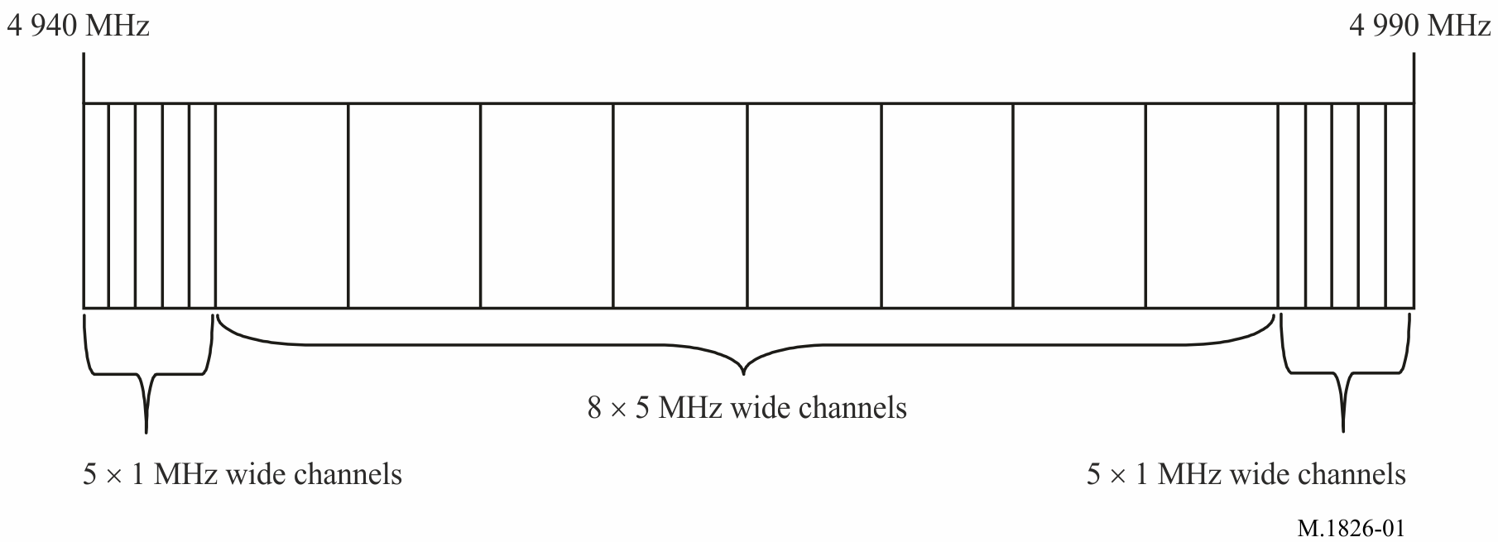
TABLE 1
Channelling plan A
Channel | Lower frequency  (MHz) | Upper frequency  (MHz)
1 | 4 940 | 4 941
2 | 4 941 | 4 942
3 | 4 942 | 4 943
4 | 4 943 | 4 944
5 | 4 944 | 4 945
6 | 4 945 | 4 950
7 | 4 950 | 4 955
8 | 4 955 | 4 960
9 | 4 960 | 4 965
10 | 4 965 | 4 970
11 | 4 970 | 4 975
12 | 4 975 | 4 980
13 | 4 980 | 4 985
14 | 4 985 | 4 986

TABLE 1 (end)
Channel | Lower frequency  (MHz) | Upper frequency  (MHz)
15 | 4 986 | 4 987
16 | 4 987 | 4 988
17 | 4 988 | 4 989
18 | 4 989 | 4 990

Annex 2
Channelling plan B for the band 4 940-4 990 MHz for broadband
public protection and disaster relief operations
The following channelling plan (see Table 2), which supports channel widths from 5 MHz to 50 MHz, to provide the flexibility needed for administrations to support a variety of PPDR operational requirements. Because these channels overlap one another, administrations may take precautions in their assignment procedures to ensure that overlapping channels do not occur in close enough proximity to cause conflicts between multiple PPDR users. Note that not all of the channels are available in some countries.
TABLE 2
Channelling plan B for 4 940-4 990 MHz
Channel number  (n_{ch}) | Channel centre  5 MHz | Channel centre  10 MHz | Channel centre  20 MHz | Channel centre  40 MHz | Channel  centre  50 MHz
1 | 4 942.5
2 |  | 4 945.0
3 | 4 947.5
4 |  | 4 950.0 | 4 950.0
5 | 4 952.5
6 |  | 4 955.0 | 4 955.0
7 | 4 957.5
8 |  | 4 960.0 | 4 960.0 | 4 960.0
9 | 4 962.5
10 |  | 4 965.0 | 4 965.0 | 4 965.0 | 4 965.0
11 | 4 967.5
12 |  | 4 970.0 | 4 970.0 | 4 970.0
13 | 4 972.5

TABLE 2 (end)
Channel number  (n_{ch}) | Channel centre  5 MHz | Channel centre  10 MHz | Channel centre  20 MHz | Channel centre  40 MHz | Channel  centre  50 MHz
14 |  | 4 975.0 | 4 975.0
15 | 4 977.5
16 |  | 4 980.0 | 4 980.0
17 | 4 982.5
18 |  | 4 985.0
19 | 4 987.5

