Recommendation ITU-R M.1450-6
(02/2026)
M Series: Mobile, radiodetermination, amateur
and related satellite services
Characteristics of broadband radio local area networks

Foreword
The role of the Radiocommunication Sector is to ensure the rational, equitable, efficient and economical use of the radio-frequency spectrum by all radiocommunication services, including satellite services, and carry out studies without limit of frequency range on the basis of which Recommendations are adopted.
The regulatory and policy functions of the Radiocommunication Sector are performed by World and Regional Radiocommunication Conferences and Radiocommunication Assemblies supported by Study Groups.

INTELLECTUAL PROPERTY RIGHTS
ITU draws attention to the possibility that the practice or implementation of this Recommendation may involve the use of a claimed Intellectual Property Right. ITU takes no position concerning the evidence, validity or applicability of claimed Intellectual Property Rights, whether asserted by ITU members or others outside of the Recommendation development process.
As of the date of approval of this Recommendation, ITU had received notice of intellectual property, protected by patents, which may be required to implement this Recommendation. However, implementers are cautioned that this may not represent the latest information and are therefore strongly urged to consult the appropriate ITU-R patent information available at https://www.itu.int/en/ITU-R/study-groups/Pages/itu-r-patent-information.aspx.

Series of ITU-R Recommendations
(Also available online at https://www.itu.int/publ/R-REC/en)
Series | Title
BO | Satellite delivery
BR | Recording for production, archival and play-out; film for television
BS | Broadcasting service (sound)
BT | Broadcasting service (television)
F | Fixed service
M | Mobile, radiodetermination, amateur and related satellite services
P | Radio-wave propagation
RA | Radio astronomy
RS | Remote sensing systems
S | Fixed-satellite service
SA | Space applications and meteorology
SF | Frequency sharing and coordination between fixed-satellite and fixed service systems
SM | Spectrum management
SNG | Satellite news gathering
TF | Time signals and frequency standards emissions
V | Vocabulary and related subjects

Note: This ITU-R Recommendation was approved in English under the procedure detailed in Resolution ITU-R 1.

Electronic Publication
Geneva, 2026
© ITU 2026
All rights reserved. No part of this publication may be reproduced, by any means whatsoever, without written permission of ITU.

RECOMMENDATION ITU-R M.1450-6
Characteristics of broadband radio local area networks
(Questions ITU-R 212/5 and ITU-R 238/5)
(2000-2002-2003-2008-2010-2014-2026)
Scope
This Recommendation provides the characteristics of broadband radio local area networks (RLANs) including technical parameters, and information on RLAN standards and some operational characteristics. Basic characteristics of broadband RLANs and information for their system design are also provided.
Abbreviations/Glossary
Access method Scheme used to provide multiple access to a channel
AP Access point
ARIB Association of Radio Industries and Businesses
ATM Asynchronous transfer mode
Bit rate The rate of transfer of a bit of information from one network device to another
BPSK Binary phase-shift keying
BRAN Broadband Radio Access Networks (A technical committee of ETSI)
Channelization Bandwidth of each channel and number of channels that can be contained in the RF bandwidth allocation
Channel indexing The frequency difference between adjacent channel centre frequencies
CSMA/CA Carrier sensing multiple access with collision avoidance
DAA Detect and avoid
DFS Dynamic frequency selection
DFT Discrete Fourier Transform
DFT-S OFDM DFT-spread OFDM
DSSS Direct sequence spread spectrum
e.i.r.p. Equivalent isotropically radiated power
ENG Electronic News Gathering
ETSI European Telecommunications Standards Institute
Frequency band Nominal operating spectrum of operation
FHSS Frequency hopping spread spectrum
HIPERLAN2 High performance radio LAN 2
HiSWANa High speed wireless access network – type a
HSWA High speed wireless access
IEEE Institute of Electrical and Electronics Engineers
IETF Internet Engineering Task Force
LAN Local area network
LBT Listen before talk
LPI Low power indoor
MIMO Multiple input multiple output
MMAC Multimedia mobile access communication
Modulation The method used to put information onto an RF carrier
MU Medium utilisation
OFDM Orthogonal frequency division multiplexing
OFDMA Orthogonal frequency division multiple access
PSD Power spectral density
PSTN Public switched telephone network
QAM Quadrature amplitude modulation
QoS Quality of Service
QPSK Quaternary phase-shift keying
RF Radio frequency
RLAN Radio local area network
RU Resource unit
SLB SparkLink Basic
SSMA Spread spectrum multiple access
Tx power Transmitter power – RF power in Watts produced by the transmitter
TCP Transmission control protocol
TDD Time division duplex
TDMA Time-division multiple access
TPC Transmit power control
TTA Telecommunications Technology Association (A standards developing organization in the Republic of Korea)
VLP Very low power
WATM Wireless asynchronous transfer mode
The ITU Radiocommunication Assembly,
considering
a) that broadband radio local area networks (RLANs) are widely used for fixed, semi-fixed (transportable) and portable computer equipment for a variety of broadband applications;
b) that broadband RLANs are used for fixed, nomadic and mobile wireless access applications;
c) that broadband RLAN standards currently being developed are compatible with current wired LAN standards;
d) that it is desirable to establish guidelines for broadband RLANs in various frequency bands;
e) that broadband RLANs should be implemented with careful consideration to compatibility with other radio applications,
recognizing
a) that the use of the frequency bands 5 150-5 250 MHz, 5 250-5 350 MHz and 5 470-5 725 MHz by RLANs is covered in Resolution 229 (Rev.WRC-23);
b) that the frequency band 6 425-7 125 MHz may be used by various mobile service applications as described in the Radio Regulations (see RR Nos. 5.457E and 5.457F);
c) that the frequency band 6 425-7 125 MHz, or parts thereof, is also used by other radiocommunication services including the fixed service and fixed-satellite service;
d) that other characteristics of broadband WAS, including RLANs, are contained in Recommendations ITU-R F.1763, ITU-R M.1652, ITU-R M.1739 and ITU-R M.1801;
e) that measures may need to be considered by administrations to protect other radiocommunication services when implementing broadband RLANs;
f) that the use of the frequency bands 2 400-2 500 MHz and 5 725-5 875 MHz is addressed in RR No. 5.150, which states that radiocommunication services operating within these bands must accept harmful interference which may be caused by ISM applications;
g) that, depending on national regulations, broadband RLANs typically operate on a non-interference/non-protection basis with respect to other applications of allocated radiocommunication services,
noting
a) that Annex 2 provides information on how to obtain the standards described in Table 1 of Annex 1;
b) that Annex 3 provides basic characteristics of broadband RLANs and general characteristics for deployment and system design applicable in certain administrations and/or regions,
recommends
1 that the broadband RLAN standards in Annex 1 should be considered by administrations wishing to implement broadband RLANs, taking into account recognizing g);
1bis that administrations wishing to implement broadband RLANs should carefully assess their interference environment in the considered frequency band(s) in order to ensure coexistence with other systems and applications, taking into account the relevant national, regional, or ITU-R study results where appropriate;
2 that Annex 3 should be considered for information on broadband RLAN technical requirements applied by certain administrations and/or regions to facilitate consideration of coexistence with current and planned use of incumbent services;
3 that the following Note should be considered as part of this Recommendation.
NOTE – The implementation of this Recommendation is subject to compliance with the provisions of the Radio Regulations.

Annex 1
Broadband RLAN standards
TABLE 1
Characteristics including technical parameters associated with broadband RLAN standards: IEEE and ATIS
Characteristics | IEEE Std 802.11-2020  (Clause 16, commonly known  as 802.11b) | IEEE Std 802.11-2020  (Clause 17, commonly known  as 802.11a⁽¹⁾) | IEEE Std 802.11-2020  (Clause 18, commonly known as 802.11g⁽¹⁾) | IEEE Std 802.11-2020  (Clause 17,  Annex D and Annex E, commonly known as 802.11j) | IEEE Std 802.11-2020  (Clause 19, commonly known as 802.11n) | IEEE Std 802.11-2020- (Clause 20, commonly known as 802.11ad) | IEEE Std 802.11-2020  (Clause 21, commonly known  as 802.11ac) | IEEE Std 802.11-2020 (Clause 23, commonly known  as 802.11ah) | IEEE Std 802.11ax-2021 | IEEE Std 802.11ay-2021 | ATIS  RLAN ⁽²⁾
Access method | CSMA/  CA, SSMA | CSMA/CA |  |  |  | Scheduled, CSMA/CA | CSMA/CA | CSMA/CA | CSMA/CA,  Trigger-based access and OFDMA | Scheduled, CSMA/CA | Scheduled, CSMA, TDMA/TDD
Modulation | CCK (8 complex chip spreading) | 64-QAM-OFDM  16-QAM-OFDM  QPSK-OFDM  BPSK-OFDM  52 subcarriers  (see Fig. 1) | DSSS/CCK  OFDM  PBCC  DSSS-OFDM | 64-QAM-OFDM  16-QAM-OFDM  QPSK-OFDM  BPSK-OFDM  52 subcarriers  (see Fig. 1) | 64-QAM-OFDM  16-QAM-OFDM  QPSK-OFDM  BPSK-OFDM  56 subcarriers in 20 MHz  114 subcarriers in 40 MHz  MIMO, 1-4 spatial streams | Single Carrier: DPSK,  π/2-BPSK, π/2-QPSK, π/2-16QAM  OFDM:  64-QAM,  16-QAM, QPSK, SQPSK  352 subcarriers | 256-QAM-OFDM  64-QAM-OFDM  16-QAM-OFDM  QPSK-OFDM  BPSK-OFDM  56 subcarriers in 20 MHz  114 subcarriers in 40 MHz  242 subcarriers in 80 MHz  484 subcarriers in 160 MHz and 80+80 MHz  MIMO, 1-8 spatial streams | 256-QAM-OFDM  64-QAM-OFDM  16-QAM-OFDM  QPSK-OFDM  BPSK-OFDM  26 subcarriers in 1 MHz  56 subcarriers in 2 MHz  114 subcarriers in 4 MHz  242 subcarriers in 8 MHz  484 subcarriers in 16 MHz  MIMO, 1-4 spatial streams | 1024-QAM  256-QAM-OFDM  64-QAM-OFDM  16-QAM-OFDM  QPSK-OFDM  BPSK-OFDM  Non-OFDMA:  242 subcarriers/frequency segment in 20 MHz  484 subcarriers/frequency segment in 40 MHz  996 subcarriers/frequency segment in 80 and 80+80 MHz  1992 subcarriers/frequency segment in 160 MHz  OFDMA RU Size:  26, 52, 106,  242, 484, 996, 1992 subcarriers/RU  MIMO, 1-8 spatial streams | Single Carrier: DPSK,  π/2-BPSK, π/2-QPSK, π/2-8-PSK, π/2-16QAM, π/2-64-QAM, π/2-64-NUC  OFDM:  DCM BPSK,  DCM QPSK,  16-QAM,  64-QAM  355 subcarrriers in 2.16 GHz  773 subcarrriers in 4.32 GHz  1193 subcarrriers in 6.48 GHz  1611 subcarrriers in 8.64 GHz | OFDM:  256-QAM, 64-QAM, 16-QAM, QPSK  MIMO 1-4 spatial streams  DFT-S-OFDM:  256-QAM, 64-QAM, 16-QAM, QPSK, π/2-BPSK
TABLE 1 (continued)
Characteristics | IEEE Std 802.11-2020  (Clause 16, commonly known as 802.11b) | IEEE Std 802.11-2020  (Clause 17, commonly known as 802.11a⁽¹⁾) | IEEE Std 802.11-2020  (Clause 18, commonly known as 802.11g⁽¹⁾) | IEEE Std 802.11-2020  (Clause 17,  Annex D and Annex E, commonly known as 802.11j) | IEEE Std 802.11-2020  (Clause 19, commonly known as 802.11n) | IEEE Std 802.11-2020 (Clause 20, commonly known as 802.11ad) | IEEE Std 802.11-2020  (Clause 21, commonly known as 802.11ac) | IEEE Std 802.11-2020 (Clause 23, commonly known as 802.11ah) | IEEE Std 802.11ax-2021 | IEEE Std 802.11ay-2021 | ATIS  RLAN ⁽²⁾
Data rate | 1, 2, 5.5 and 11 Mbit/s | 6, 9, 12, 18, 24, 36, 48 and 54 Mbit/s | 1, 2, 5.5, 6, 9, 11, 12, 18, 22, 24, 33, 36, 48 and 54 Mbit/s | 3, 4.5, 6, 9, 12, 18, 24 and 27 Mbit/s for 10 MHz channel spacing  6, 9, 12, 18, 24, 36, 48 and 54 Mbit/s for 20 MHz channel spacing | From 6.5 to 288.9 Mbit/s for 20 MHz channel spacing  From 6 to 600 Mbit/s for 40 MHz channel spacing | From 693.00 to  6756.75 Mbit/s | From 6.5 to 693.3 Mbit/s for 20 MHz channel spacing  From 13.5 to 1 600 Mbit/s for 40 MHz channel spacing  From 29.3 to 3 466.7 Mbit/s for 80 MHz channel spacing  From 58.5 to 6 933.3 Mbit/s for 160 MHz and 80+80 MHz channel spacing | From 0.300 to 17.7778 Mbit/s for 1 MHz channel spacing  From 0.650 to 34.6667 Mbit/s for 2 MHz channel spacing  From 1.350 to 80.000 Mbit/s for 4 MHz channel spacing  From 2.925 to 173.3333 Mbit/s for 8 MHz channel spacing  From 5.850 to 346.6667 Mbit/s for 16 MHz channel spacing | From 0.4 to 117.6 Mbit/s for 26-tone RU  From 0.8 to 235.3 Mbit/s for 52-tone RU  From 1.6 to 500.0 Mbit/s for 106-tone RU  From 3.6 to 1 147.1 Mbit/s for 242-tone RU and  20 MHz non-OFDMA channel spacing  From 7.3 to 2 294.1 Mbit/s for 484-tone RU and non-OFDMA 40 MHz channel spacing  From 15.3 to 4 803.9 Mbit/s for 996-tone RU and non-OFDMA 80 MHz channel spacing  From 30.6 to 9 607.8 Mbit/s for 2×996-tone RU and 160 MHz and 80+80 MHz channel spacing | From 630.00 to 8 316.00 Mbit/s for 2.16 GHz  From 1 376.25 to 18 166.50 Mbit/s for 3.32 GHz  From 2 126.25 to 28 066.50 Mbit/s for 6.48 GHz  From 2 872.50 to 37 917.00 Mbit/s for 8.64 GHz | Up to 453 Mbit/s for 20 MHz channel  Up to 907 Mbit/s for 40 MHz channel  Up to 1 386 Mbit/s for 60 MHz channel  Up to 1 857 Mbit/s for 80 MHz channel

TABLE 1 (continued)
Characteristics | IEEE Std 802.11-2020  (Clause 16, commonly known  as 802.11b) | IEEE Std 802.11-2020  (Clause 17, commonly known  as 802.11a⁽¹⁾) | IEEE Std 802.11-2020  (Clause 18, commonly known as 802.11g⁽¹⁾) | IEEE Std 802.11-2020  (Clause 17,  Annex D and Annex E, commonly known as 802.11j) | IEEE Std 802.11-2020  (Clause 19, commonly known as 802.11n) | IEEE Std 802.11-2020- (Clause 20, commonly known  as 802.11ad) | IEEE Std 802.11-2020  (Clause 21, commonly known  as 802.11ac) | IEEE Std 802.11-2020  (Clause 23, commonly known  as 802.11ah) | IEEE Std 802.11ax-2021 | IEEE Std 802.11ay-2021 | ATIS  RLAN ⁽²⁾
Frequency band  ⁽³⁾ | 2 400-2 483.5 MHz | 5 150-5 250 MHz  5 250-5 350 MHz  5 470-5 725 MHz  5 725-5 825 MHz | 2 400-2 483.5 MHz | 4 940-  4 990 MHz  5 150-5 250 MHz  5 250-5 350 MHz  5 470-5 725 MHz  5 725-5 825 MHz | 2 400-2 483.5 MHz  5 150-5 250 MHz  5 250-5 350 MHz  5 470-5 725 MHz  5 725-5 825 MHz | 57-71 GHz | 5 150-5 250 MHz  5 250-5 350 MHz  5 470-5 725 MHz  5 725-5 825 MHz | 755-787 MHz  779-787 MHz  863-868.6 MHz  902-928 MHz  916.5-927.5 MHz  917.5-923.5 MHz | 2 400-2 483.5 MHz  5 150-5 250 MHz  5 250-5 350 MHz  5 470-5 725 MHz  5 725-5 825 MHz  5 825-5 850 MHz  5 850-5 895 MHz  5 925-7 125 MHz  5 945–6 425 MHz | 57-71 GHz | 5 150-5 925  MHz
Channel indexing | 5 MHz |  |  |  | 5 MHz in 2.4 GHz  20 MHz in 5 GHz | 2 160 MHz | 20 MHz | 1 MHz | 20 MHz | 2 160 MHz | 20 MHz
Spectrum mask | 802.11b mask  (Fig. 4) | OFDM mask (Fig. 1) |  |  | OFDM mask  (Figs. 2a, 2b for 20 MHz and Figs. 3a, 3b for 40 MHz) | 802.11ad mask (Fig. 5) | OFDM mask  (Fig. 2b for 20 MHz, Fig. 3b for 40 MHz,  Fig. 3c for 80 MHz, Fig. 3d for 160 MHz, and Fig. 3e for 80+80 MHz) | 802.11ah mask (Fig. 6a for 1 MHz, Fig. 6b for 2 MHz, Fig. 6c for 4 MHz, Fig. 6d for 8 MHz and Fig. 6e for 16 MHz) | Spectrum Mask (Fig. 7a for 20 MHz, Fig. 7b for 40 MHz, Fig. 7c for 80 MHz, Fig. 7d for 160 MHz and Fig. 7e for 80+80 MHz) | 802.11ay mask (Fig .8a for 2.16 GHz, Fig. 8b for 4.32 GHz, Fig. 8c for 6.48 GHz, Fig. 8d for 8.64 GHz and Fig. 8e for 2.16+2.16 GHz)  Fig. 8f for 4.32+4.32 GHz) | Fig. 9a for 20 MHz, Fig. 9b for 40 MHz, Fig. 9c for 60 MHz, Fig. 9d for 80 MHz
Transmitter

TABLE 1 (end)
Characteristics | IEEE Std 802.11-2020  (Clause 16, commonly known  as 802.11b) | IEEE Std 802.11-2020  (Clause 17, commonly known  as 802.11a⁽¹⁾) | IEEE Std 802.11-2020  (Clause 18, commonly known as 802.11g⁽¹⁾) | IEEE Std 802.11-2020  (Clause 17,  Annex D and Annex E, commonly known as 802.11j) | IEEE Std 802.11-2020  (Clause 19, commonly known as 802.11n) | IEEE Std 802.11-2020- (Clause 20, commonly known  as 802.11ad) | IEEE Std 802.11-2020  (Clause 21, commonly known  as 802.11ac) |  | IEEE Std 802.11-2020  (Clause 23, commonly known  as 802.11ah) | IEEE Std 802.11ax-2021 |  | IEEE Std 802.11ay-2021 | ATIS  RLAN ⁽²⁾
Interference mitigation | LBT | LBT/DFS/  TPC | LBT |  | LBT/DFS/TPC | Entergy Detect,  Frequency, Time and Spatial sharing |  | LBT/DFS/TPC | Entergy Detect CCA, Frequency, Time and Spatial sharing |  | LBT/DFS/TPC/AFC* | Entergy Detect, Frequency, Time and Spatial sharing | LBT/DFS/TPC
Receiver
Sensitivity | Listed in Standard | Listed in Standard | Listed in Standard |  | Listed in Standard | Listed in Standard |  | Listed in Standard | Listed in Standard |  | Listed in Standard | Listed in Standard | Listed in Standard
Notes to Table 1:
⁽¹⁾ Parameters for the physical layer are common between IEEE 802.11a and ARIB HiSWANa.
⁽²⁾ See 3GPP TS 37.213 Release 16 and related ATIS Standards.
- TTA also issued RLAN standards as identical as the IEEE Std 801.11-2020, IEEE Std 802.11ax-2021 and IEEE Std 802.11ay-2021 listed in the Table.
⁽³⁾ The frequency bands in this Table are those that are supported by the respective broadband RLAN standards and are presented here for information. The frequency bands for the use of broadband RLANs may vary depending on each administration’s regulation, which may use portions, none or all of the bands supported by the respective broadband RLAN standards.

TABLE 2
Characteristics including technical parameters associated with broadband RLAN standards: ETSI, ARIB and CCSA
Characteristics | ETSI  EN 300 328⁽¹⁾ | ETSI  EN 301 893 (V2.1.1)⁽¹⁾ | ARIB  HiSWANa⁽²⁾ | ETSI EN 302 567  (V2.2.1)⁽¹⁾ | ETSI EN 303 722  (V1.2.1) | ETSI EN 303 687 (V1.1.1)⁽¹⁾ | YD/T 4007  (commonly known as SparkLink Basic, SLB)
Access method | Unspecified | See clause 4.2.7 of the standard | TDMA/TDD | See clause 4.2.5 of the standard | See clause 4.2.5 of the standard | See clause 4.3.6 of the standard | OFDMA
Modulation | No restriction on the type of modulation | Unspecified | 64-QAM-OFDM  16-QAM-OFDM  QPSK-OFDM  BPSK-OFDM  52 subcarriers  (see Fig. 1) | Unspecified | Unspecified | Unspecified | 1024-QAM-OFDM  256-QAM-OFDM  64-QAM-OFDM  16-QAM-OFDM  QPSK-OFDM

TABLE 2 (end)
Characteristics | ETSI  EN 300 328⁽¹⁾ | ETSI  EN 301 893 (V2.1.1)⁽¹⁾ | ARIB  HiSWANa⁽²⁾ | ETSI EN 302 567  (V2.2.1)⁽¹⁾ | ETSI EN 303 722  (V1.2.1) | ETSI EN 303 687 (V1.1.1)⁽¹⁾ | YD/T 4007  (commonly known as SparkLink Basic, SLB)
Data rate | Unspecified | Unspecified | 6, 9, 12, 18, 27, 36 and 54 Mbit/s | Unspecified | Unspecified | Unspecified | From 4.3 to  1249.0 Mbit/s for 20 MHz channel spacing  From 34.6 to 9992.3 Mbit/s for max 160 MHz channel spacing  (8 CC carrier aggregation)
Frequency band ⁽³⁾ | 2 400-2 483.5 MHz | 5 150-5 350 MHz and  5 470-5 725 MHz ⁽⁴⁾ | 4 900 to 5 000 MHz⁽⁵⁾  5 150 to 5 250 MHz ⁽⁶⁾ | 57-71 GHz | 57-71 GHz | 5 945-6 425 MHz | 2 400-2 483.5 MHz  5 150-5 350 MHz and 5 725-5 850 MHz
Channel indexing | Unspecified | 20 MHz | 20 MHz channel spacing 4 channels in 100 MHz | Unspecified | Unspecified | 20 MHz | 20 MHz
Spectrum mask | Figs. 1 and 3 | Fig. 1x | OFDM mask  (Fig. 1) | Fig. 2x | Fig. 3x | Fig. 1x ⁽⁷⁾ | Fig. 11
Transmitter
Interference mitigation | DAA/LBT, DAA/non-LBT, MU | See standard | LBT | See standard | See standard | See standard | FISA (Fast Interference Sensing and Avoidance). See standard
Receiver
Sensitivity | Unspecified | See standard |  | See standard | See standard | See standard | See standard
Notes to Table 2
⁽¹⁾ These Harmonized Standards (HS) are not technology standards, but rather are used to demonstrate that products, services, or processes comply with relevant EU legislation.
⁽²⁾ Parameters for the physical layer are common between IEEE 802.11a and ARIB HiSWANa.
⁽³⁾ The frequency bands in this Table are those that are supported by the respective broadband RLAN standards and are presented here for information. The frequency bands for the use of broadband RLANs may vary depending on each administration’s regulation, which may use portions, none or all of the bands supported by the respective broadband RLAN standards.
⁽⁴⁾ DFS rules apply in the 5 250-5 350 and 5 470-5 725 MHz bands in many administrations and administrations must be consulted.
⁽⁵⁾ See IEEE 802.11j-2004 and JAPAN MIC ordinance for Regulating Radio Equipment, Articles 49-20 and 49-21.
⁽⁶⁾ Resolution 229 (Rev.WRC-23) applies.
⁽⁷⁾ Additional masks are specified for multi-channel use cases.

Figure 1a
OFDM transmit spectrum mask for 802.11a, 11g, 11j, and HiSWANa systems
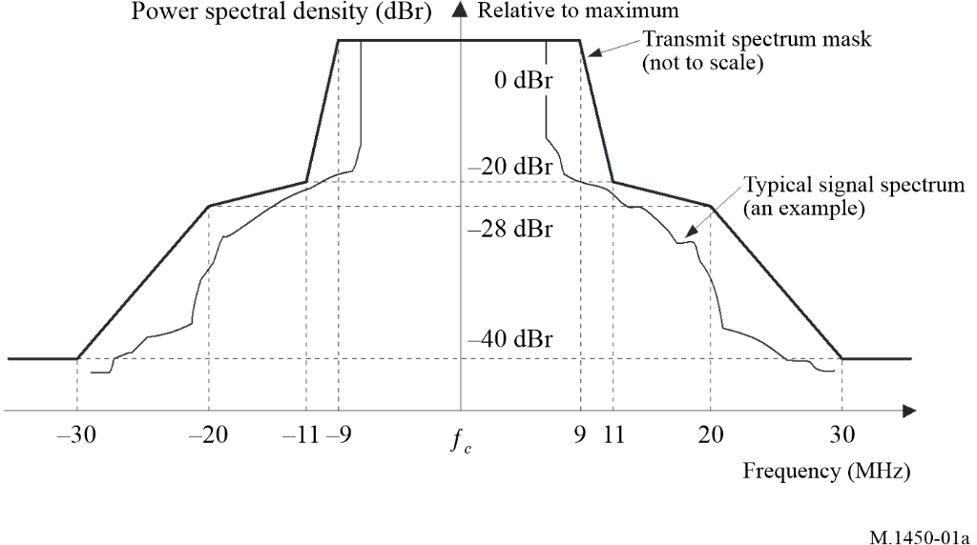
NOTE 1 – The outer heavy line is the spectrum mask for 802.11a, 11g, 11j, HiSWANa and the inner thin line is the envelope spectrum of OFDM signals with 52 subcarriers.

NOTE 2 – The measurements shall be made using a 100 kHz resolution bandwidth and a 30 kHz video bandwidth.
NOTE 3 – In the case of the 10 MHz channel spacing in 802.11j, the frequency scale shall be half.
Figure 1b
Transmit spectrum mask for EN 301 893
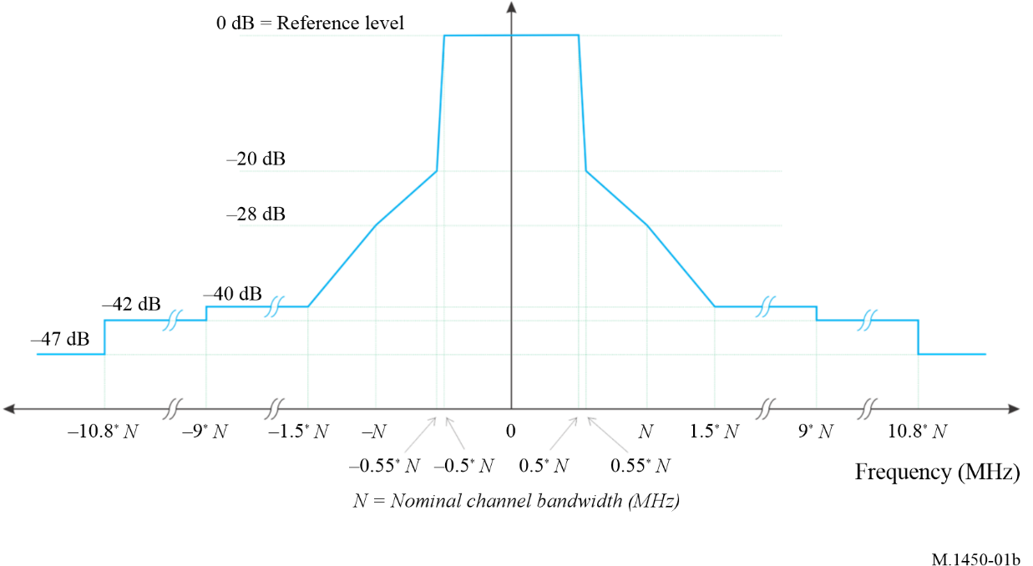
NOTE – dBc is the spectral density relative to the maximum spectral power density of the transmitted signal.
FIGURE 2a
Transmit spectral mask for 20 MHz 802.11n transmission in 2.4 GHz band
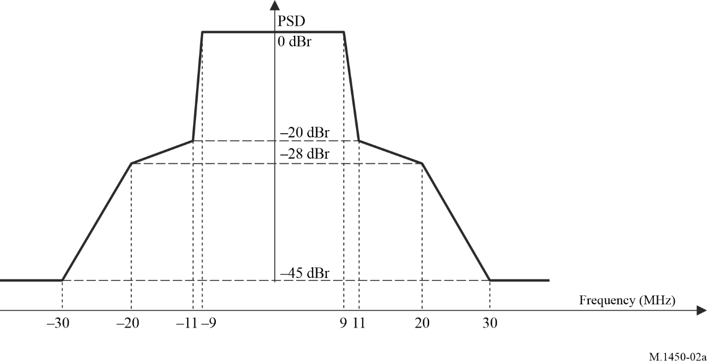
NOTE – Maximum of −45 dBr and −53 dBm/MHz at 30 MHz frequency offset and above.
FIGURE 2b
Transmit spectral mask for a 20 MHz 802.11n transmission in 5 GHz band and transmit spectral mask for 802.11ac
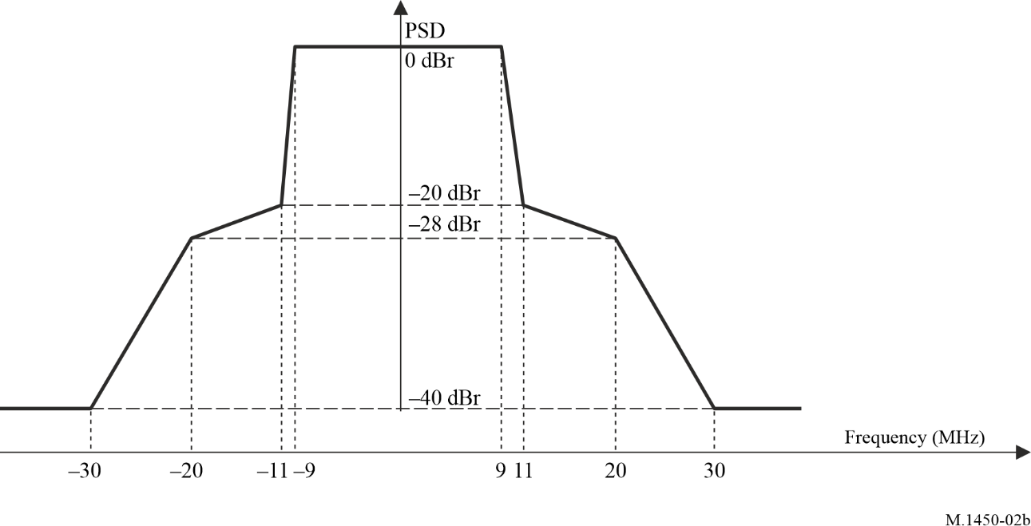
NOTE – For 802.11n, the maximum of −40 dBr and −53 dBm/MHz at 30 MHz frequency offset and above. For 802.11ac, the transmit spectrum shall not exceed the maximum of the transmit spectral mask and −53 dBm/MHz at any frequency offset.
FIGURE 3a
Transmit spectral mask for a 40 MHz 802.11n channel in 2.4 GHz band
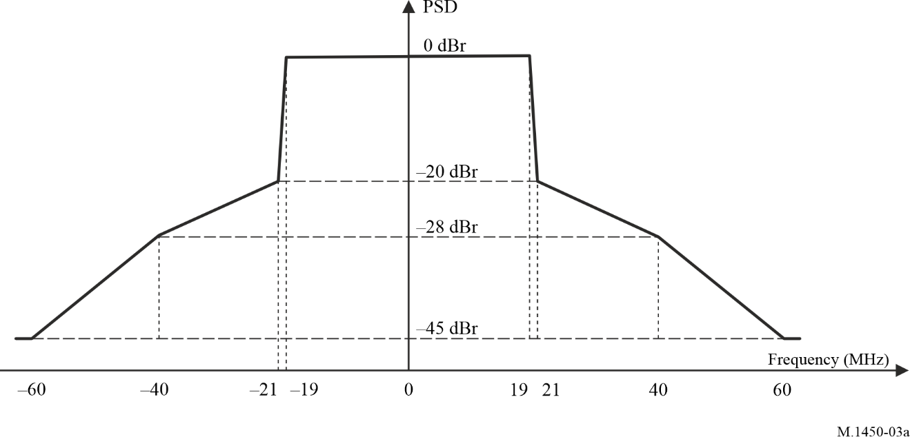
NOTE – Maximum of −45 dBr and −56 dBm/MHz at 60 MHz frequency offset and above.
FIGURE 3b
Transmit spectral mask for a 40 MHz 802.11n channel in 5 GHz band and transmit spectral mask for 802.11ac
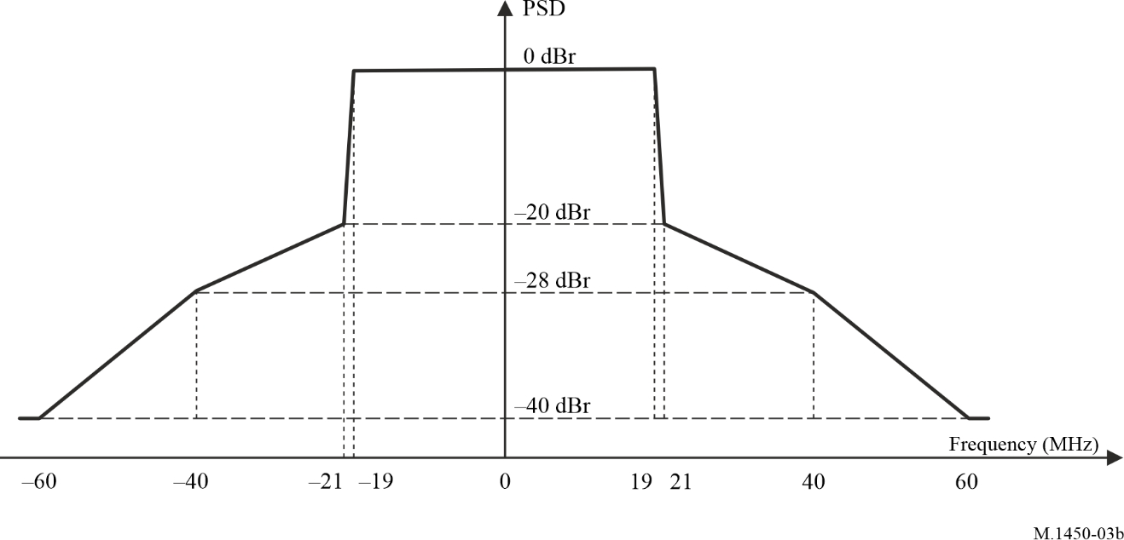
NOTE – For 802.11n, maximum of −40 dBr and −56 dBm/MHz at 60 MHz frequency offset and above. For 802.11ac, the transmit spectrum shall not exceed the maximum of the transmit spectral mask and −56 dBm/MHz at any frequency offset.
FIGURE 3c
Transmit spectral mask for an 80 MHz 802.11ac channel
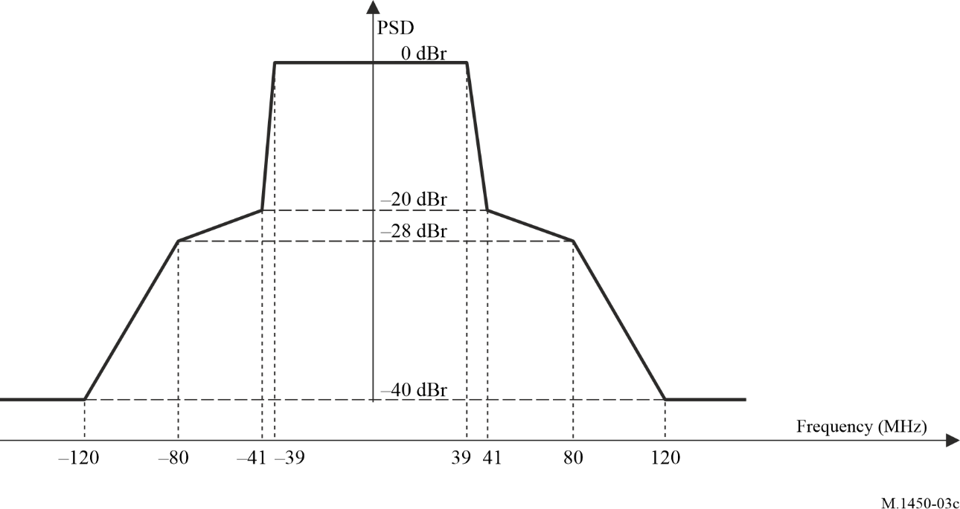
NOTE – The transmit spectrum shall not exceed the maximum of the transmit spectral mask and −59 dBm/MHz at any frequency offset.
FIGURE 3d
Transmit spectral mask for a 160 MHz 802.11ac channel
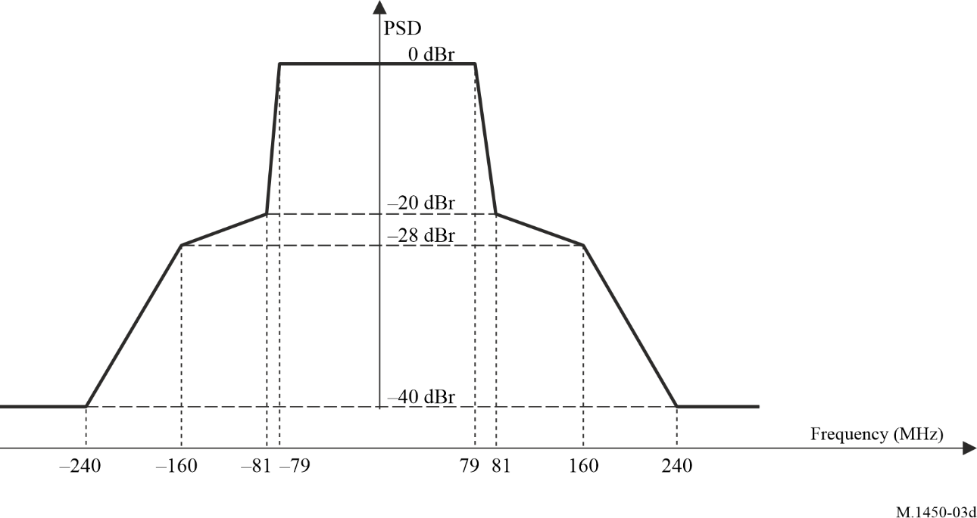
NOTE – The transmit spectrum shall not exceed the maximum of the transmit spectral mask and −59 dBm/MHz at any frequency offset.
FIGURE 3e
Transmit spectral mask for a 80+80 MHz 802.11ac channel
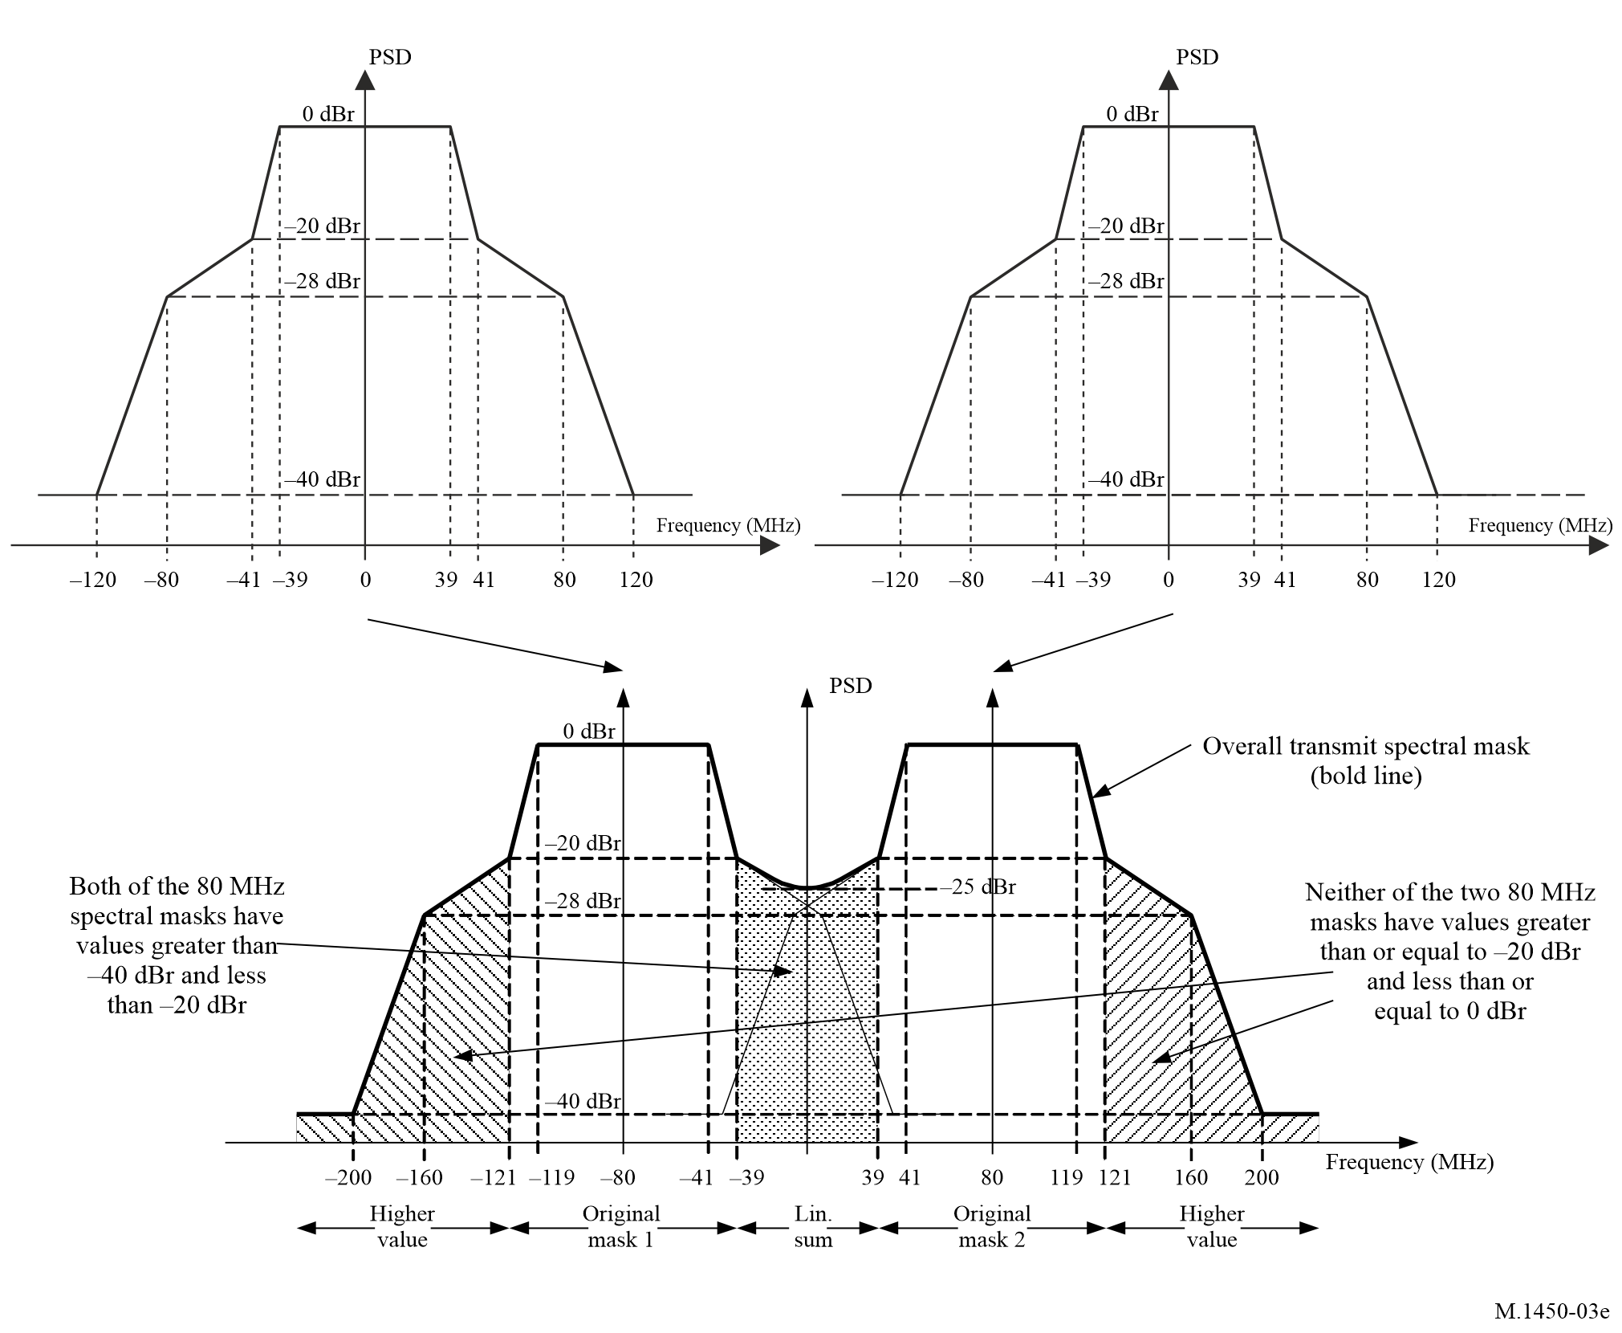

NOTE – The transmit spectrum shall not exceed the maximum of the transmit spectral mask and −59 dBm/MHz at any frequency offset.
Figure 4
Transmit spectrum mask for 802.11b
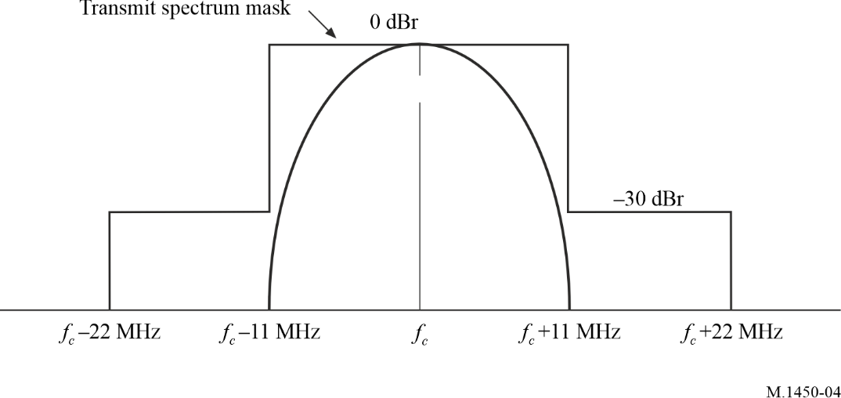
Figure 5
Transmit spectrum mask for 802.11ad
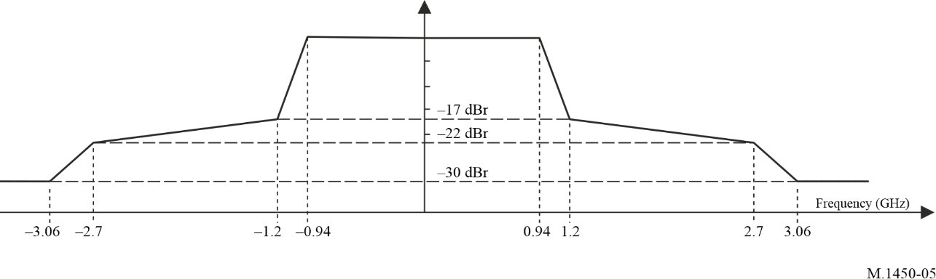
FIGURE 6a
Transmit spectrum mask for 1 MHz 802.11ah channel
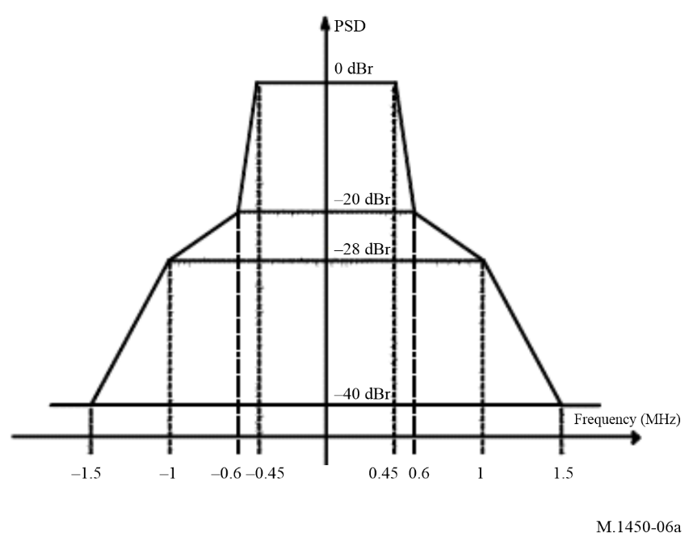
FIGURE 6b
Transmit spectrum mask for 2 MHz 802.11ah channel
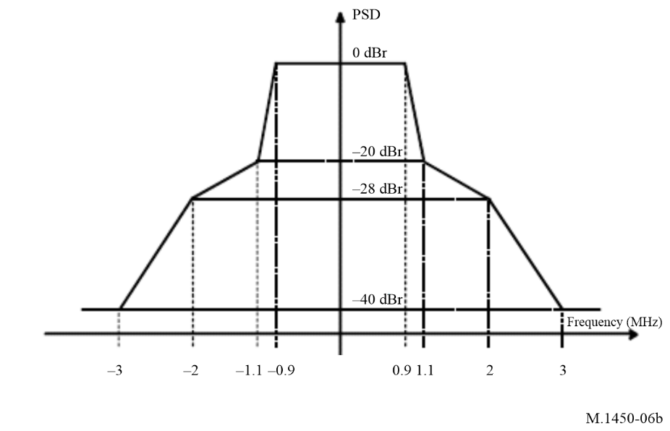
FIGURE 6c
Transmit spectrum mask for 4 MHz 802.11ah channel
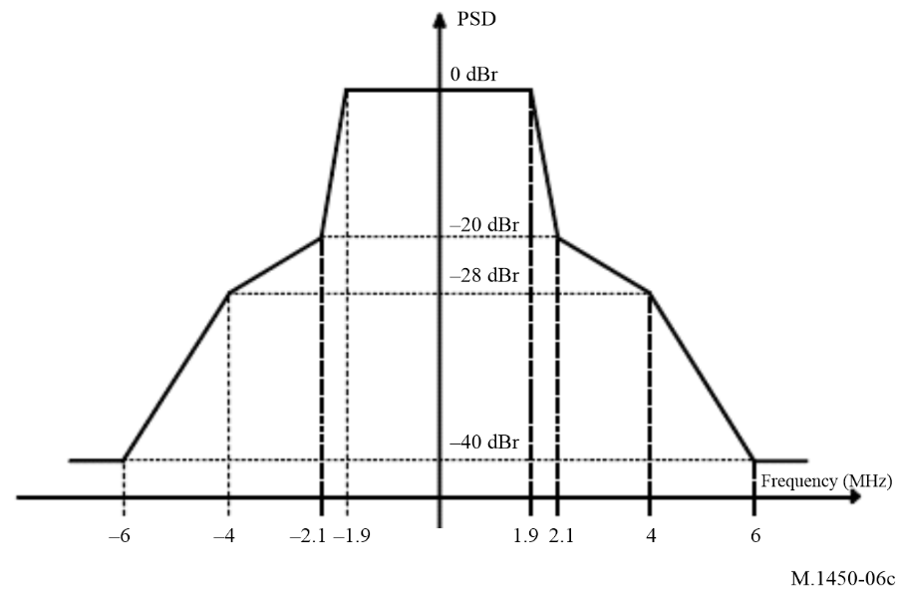
FIGURE 6d
Transmit spectrum mask for 8 MHz 802.11ah channel
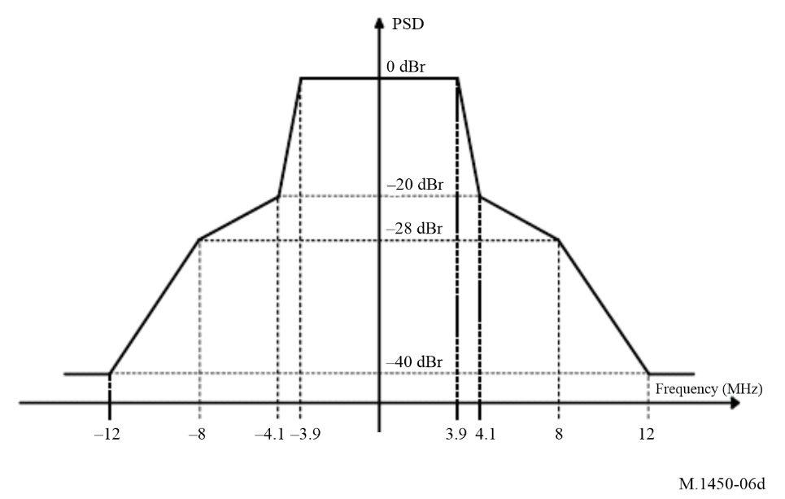
FIGURE 6e
Transmit spectrum mask for 16 MHz 802.11ah channel
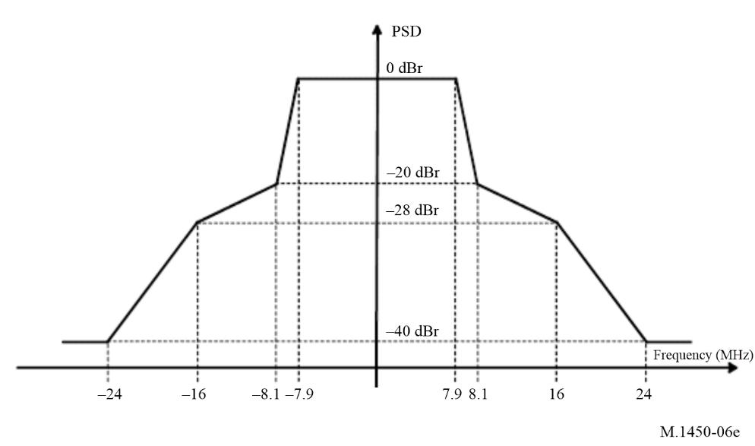
FIGURE 7a
Transmit spectrum mask for 20 MHz 802.11ax channel
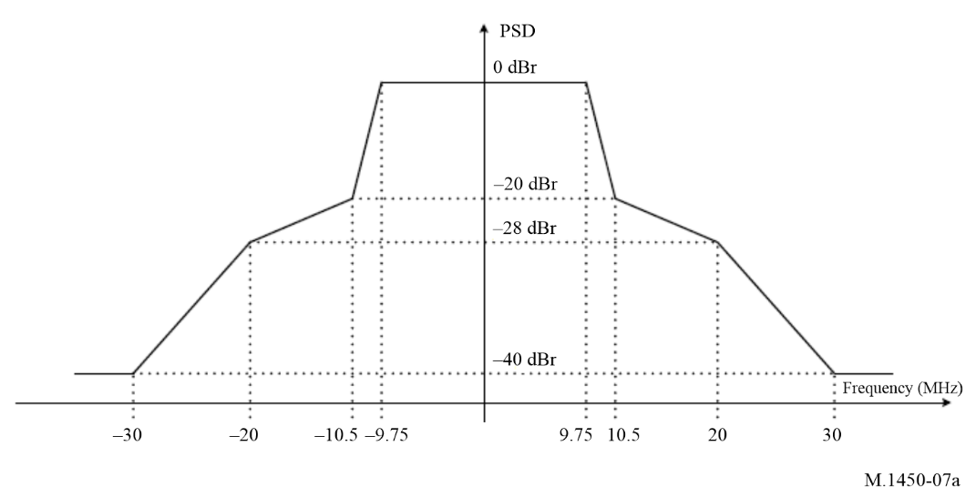
FIGURE 7b
Transmit spectrum mask for 40 MHz 802.11ax channel
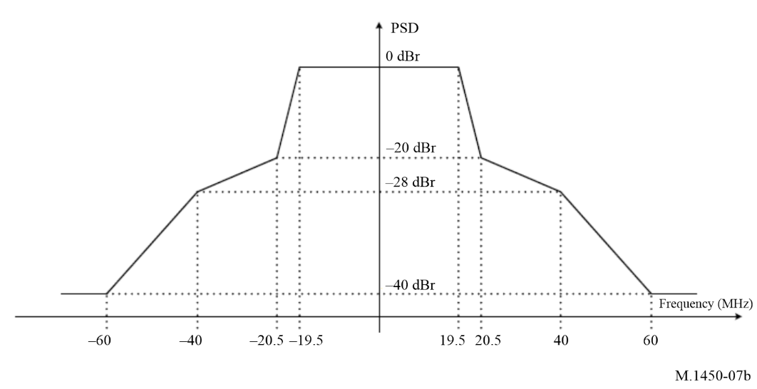
FIGURE 7c
Transmit spectrum mask for 80 MHz 802.11ax channel
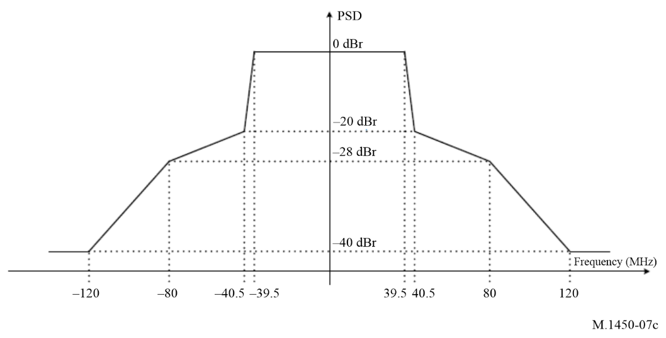
FIGURE 7d
Transmit spectrum mask for 160 MHz 802.11ax channel
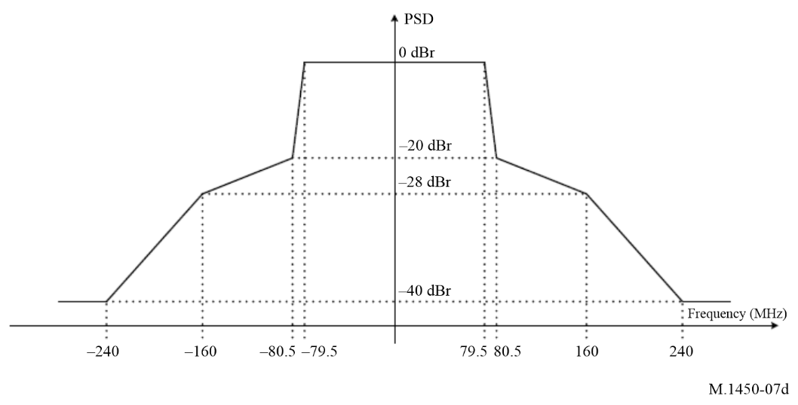
FIGURE 7e
Transmit spectrum mask for 80+80 MHz 802.11ax channel
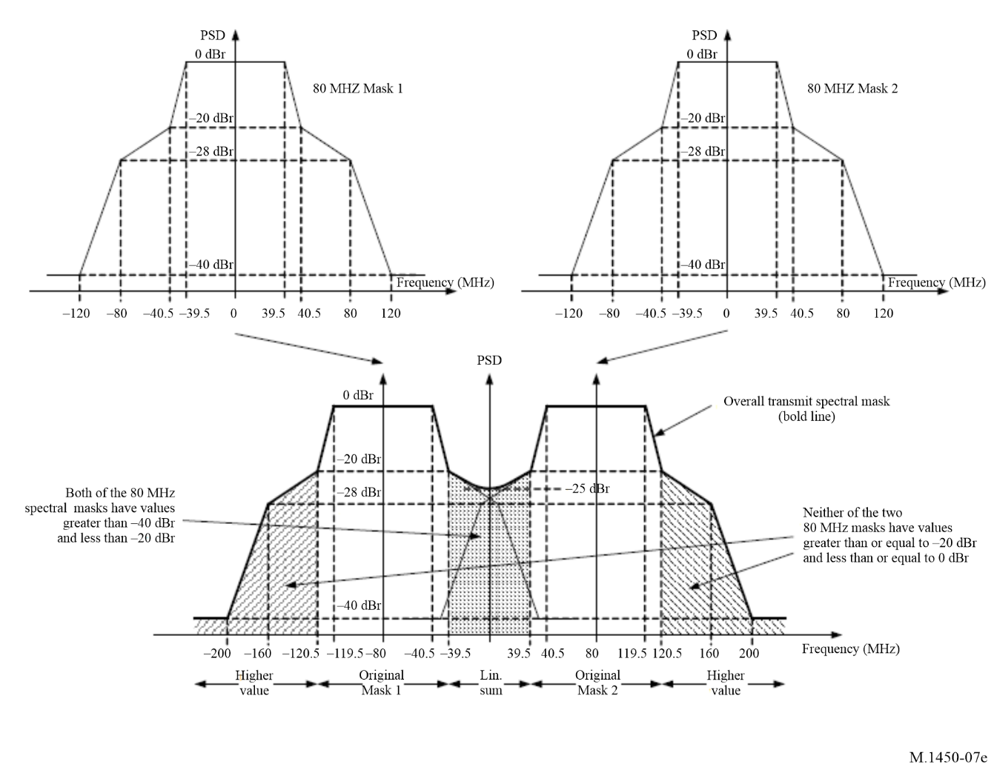
FIGURE 8a
Transmit spectrum mask for 2.16 GHz P802.11ay channel
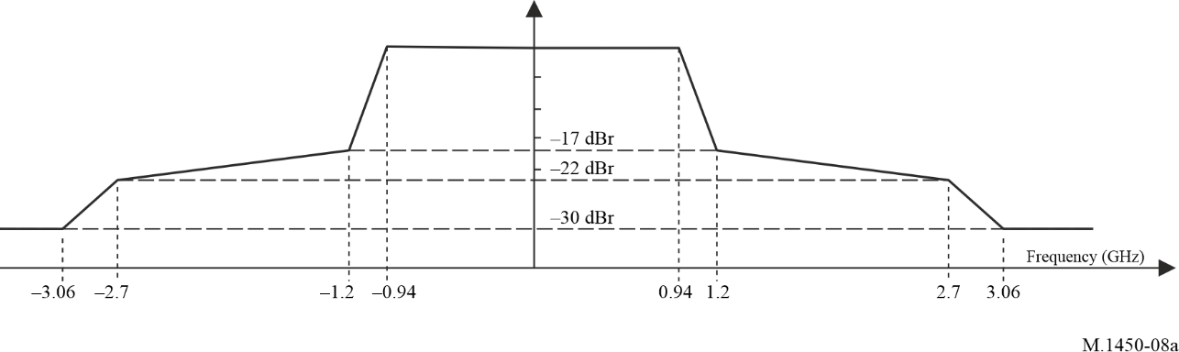
FIGURE 8b
Transmit spectrum mask for 4.32 GHz P802.11ay channel
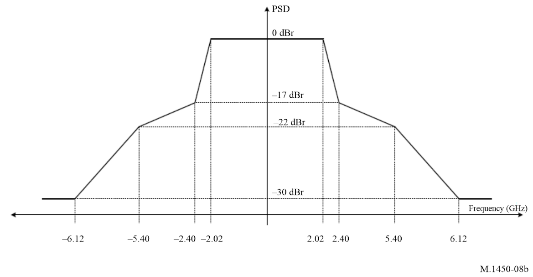
FIGURE 8c
Transmit spectrum mask for 6.48 GHz P802.11ay channel
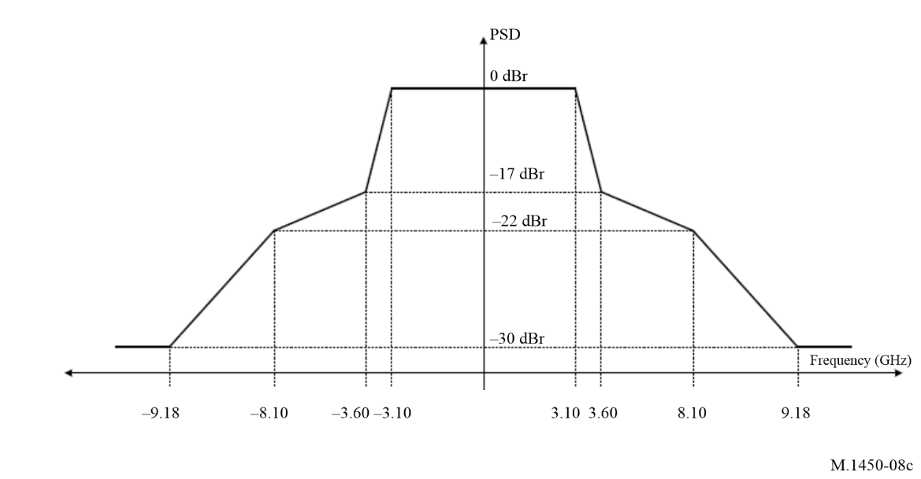
FIGURE 8d
Transmit spectrum mask for 8.64 GHz P802.11ay channel
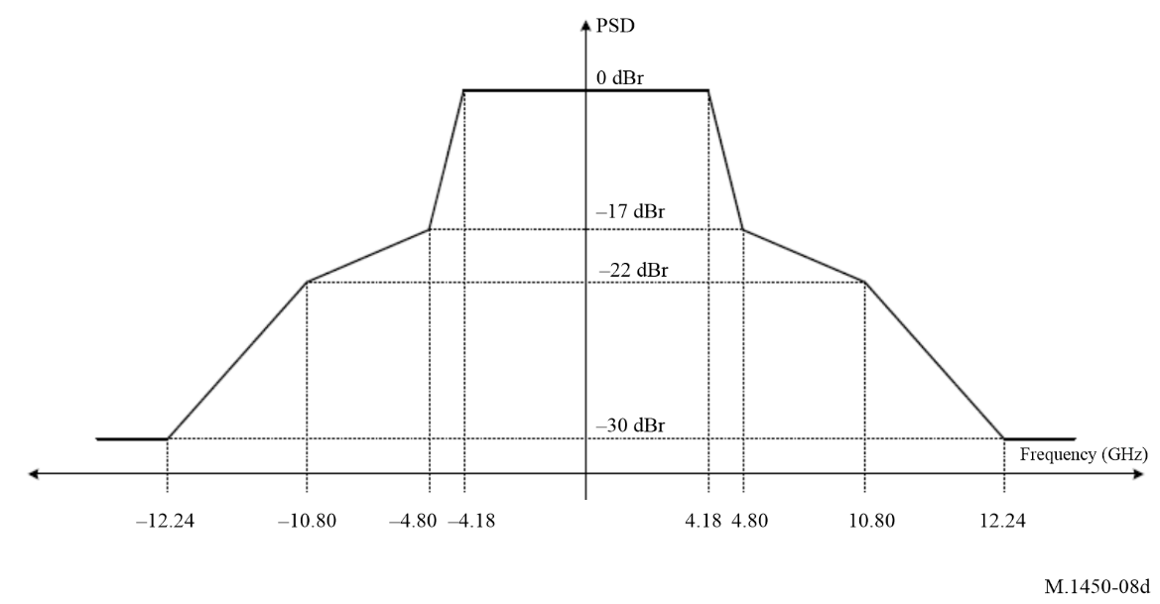
FIGURE 8e
Transmit spectrum mask for 2.16+2.16 GHz P802.11ay channel
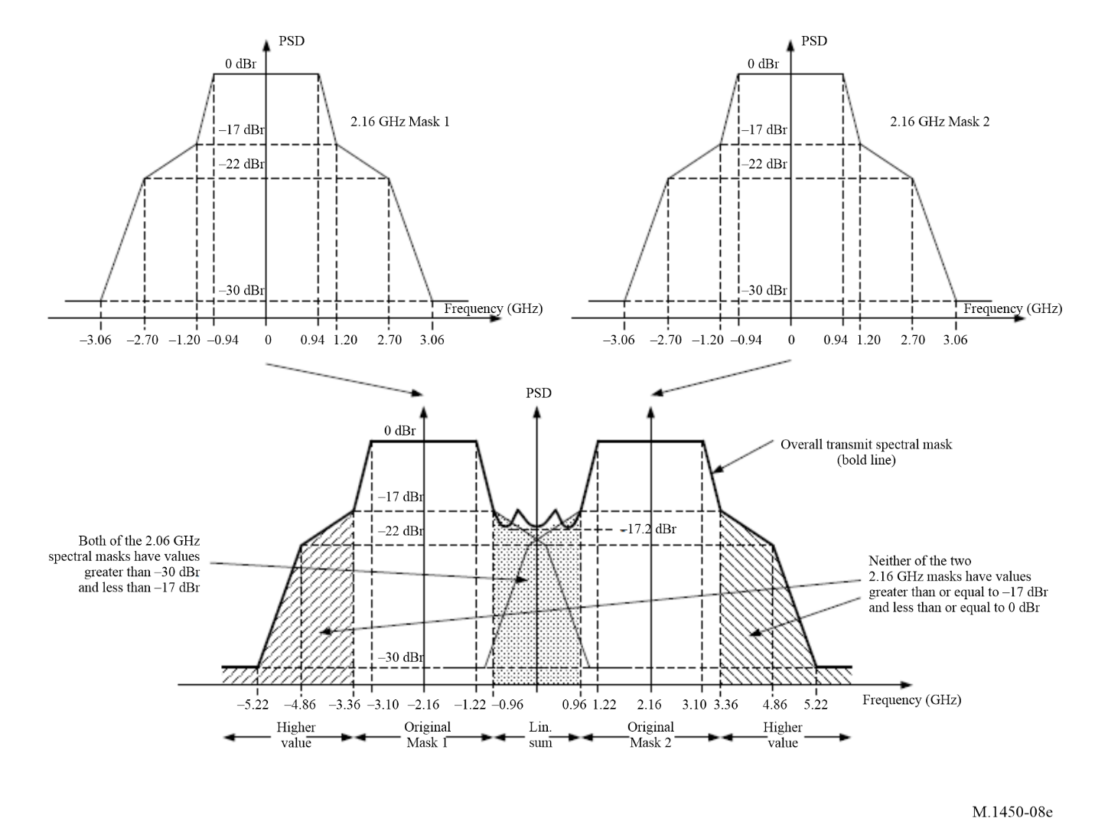
FIGURE 8f
Transmit spectrum mask for 4.32+4.32 GHz P802.11ay channel
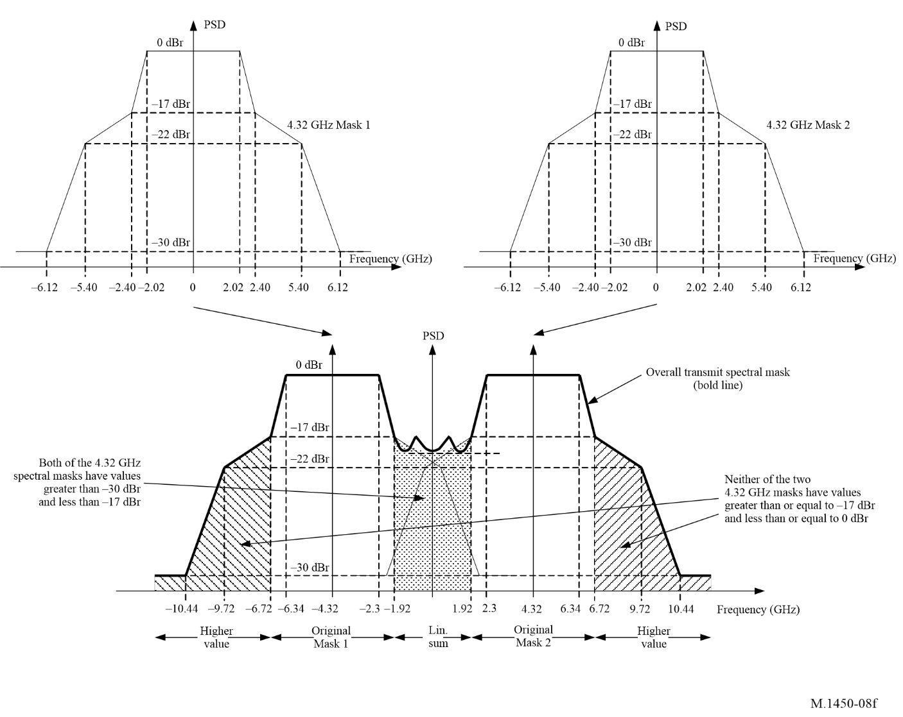
Figure 9a
Transmit spectrum mask for 20 MHz ATIS RLAN
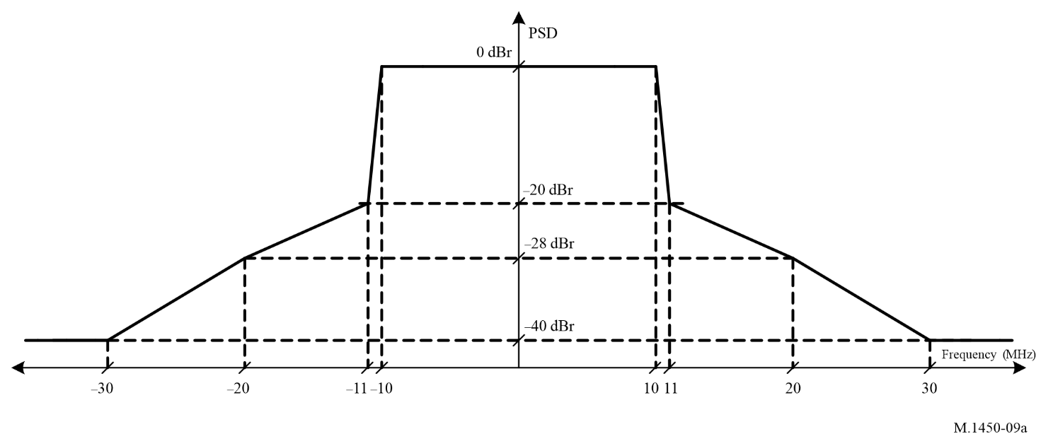
NOTE – The spectrum emission mask is defined relative to the maximum power density in a 1 MHz measurement bandwidth within the channel bandwidth. The relative power of any transmitter emission shall not exceed the levels indicated by the mask or −30 dBm/MHz whichever is the greatest.
Figure 9b
Transmit spectrum mask for 40 MHz ATIS RLAN
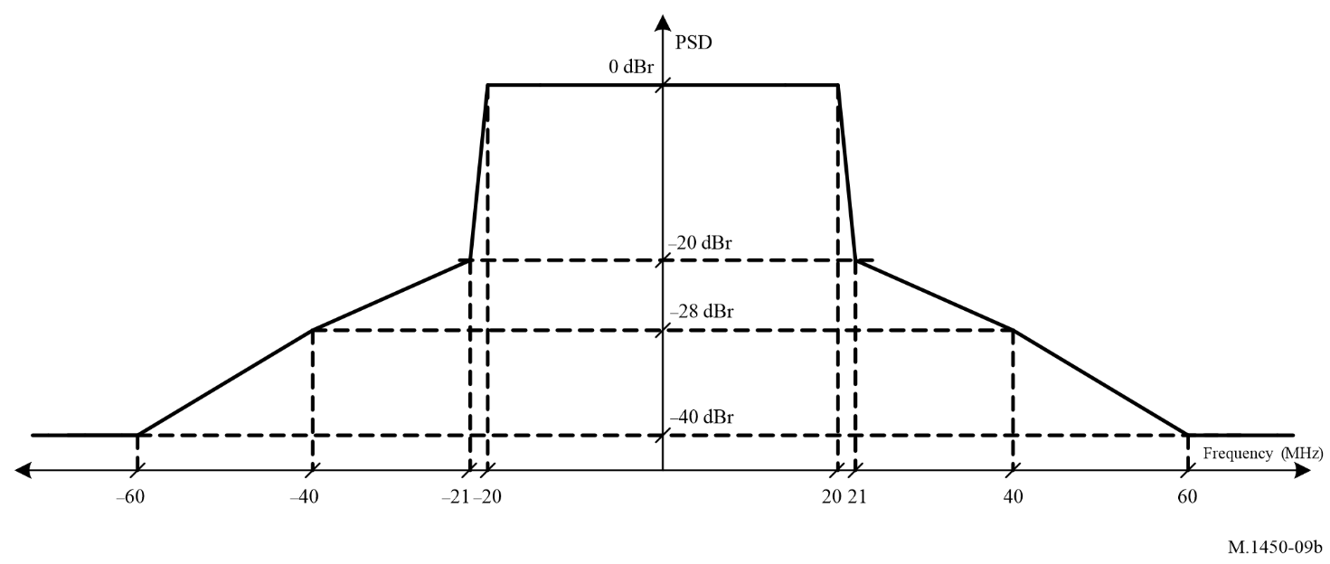
NOTE – The spectrum emission mask is defined relative to the maximum power density in a 1 MHz measurement bandwidth within the channel bandwidth. The relative power of any transmitter emission shall not exceed the levels indicated by the mask or −30 dBm/MHz whichever is the greatest.
Figure 9c
Transmit spectrum mask for 60 MHz ATIS RLAN
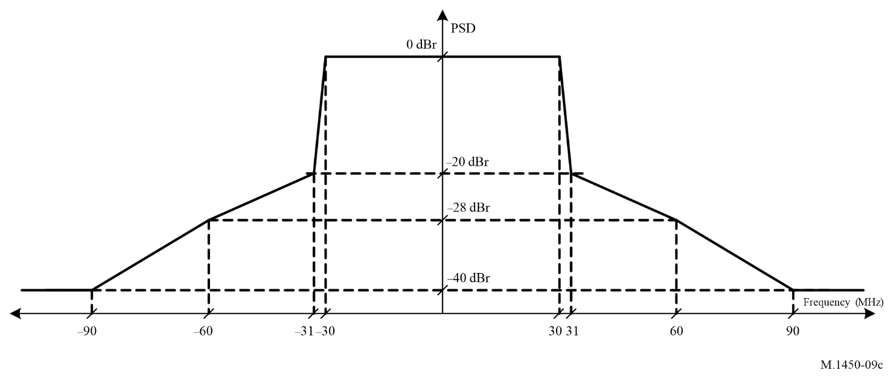
NOTE – The spectrum emission mask is defined relative to the maximum power density in a 1 MHz measurement bandwidth within the channel bandwidth. The relative power of any transmitter emission shall not exceed the levels indicated by the mask or −30 dBm/MHz whichever is the greatest.
Figure 9d
Transmit spectrum mask for 80 MHz ATIS RLAN
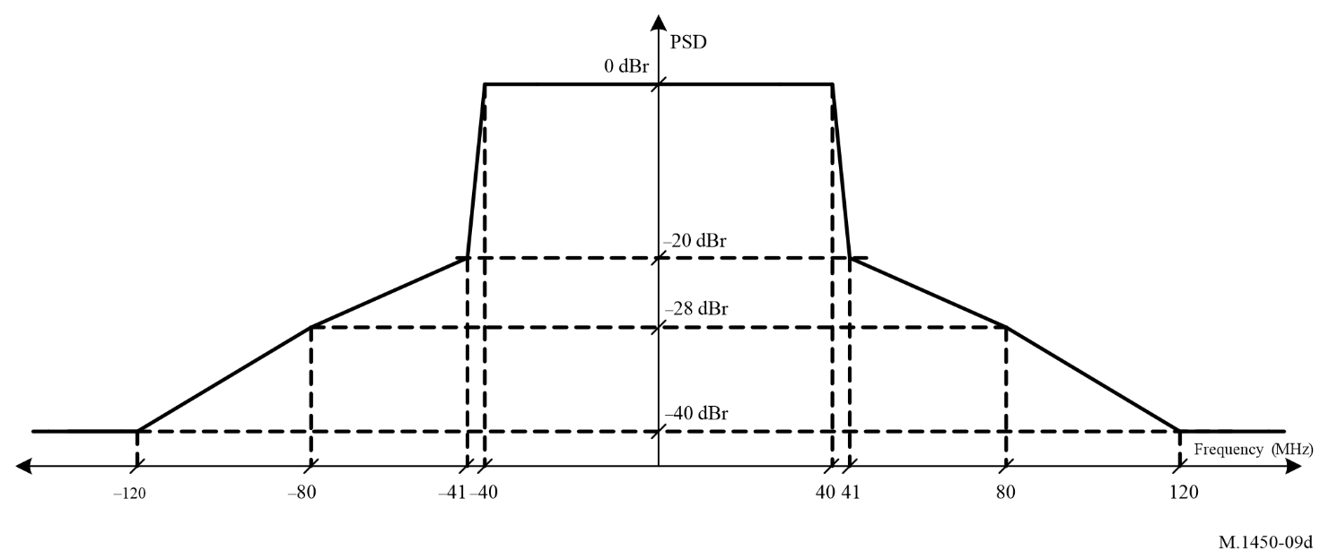
NOTE – The spectrum emission mask is defined relative to the maximum power density in a 1 MHz measurement bandwidth within the channel bandwidth. The relative power of any transmitter emission shall not exceed the levels indicated by the mask or −30 dBm/MHz whichever is the greatest.
Figure 10a
Transmit Mask for EN 302 567
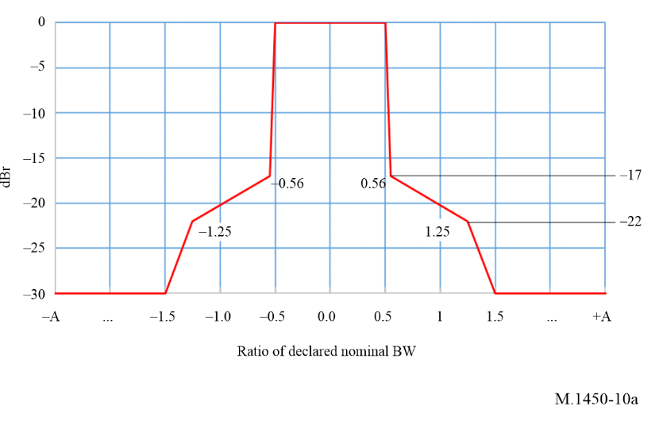
Figure 10b
Transmit Mask for EN 303 722
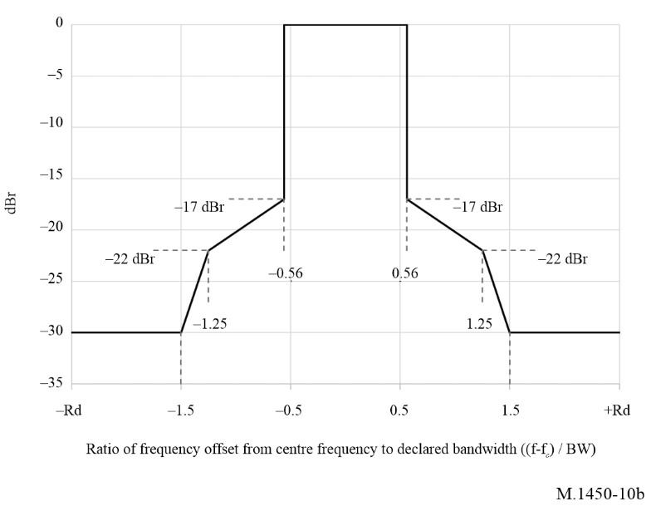
Figure 11
Transmit spectrum mask for 20 MHz CCSA SLB channel
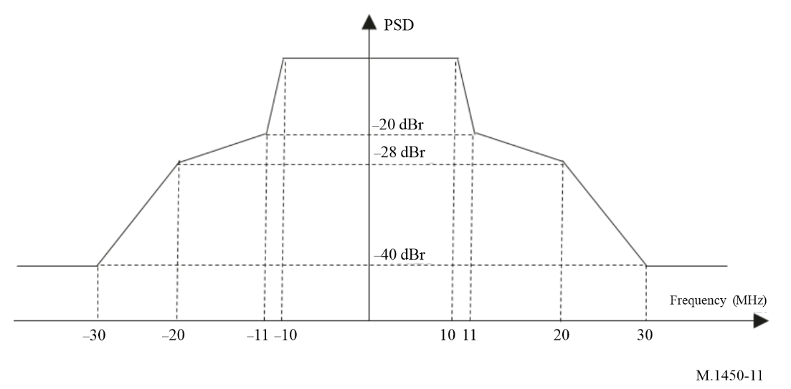
NOTE – The relative power of any transmitter emission shall not exceed the levels indicated by the mask or
−53 dBm/MHz whichever is the greatest.

Annex 2
Obtaining additional information on RLAN standards
The ETSI EN 300 328, EN 301 893 and EN 302 567 standards can be downloaded from http://pda.etsi.org/pda/queryform.asp. In addition to these standards, the Hiperlan type 2 standards can still be downloaded from the above link.
The IEEE 802.11 standards can be downloaded from: http://standards.ieee.org.
IEEE 802.11 has developed a set of standards for RLANs, IEEE Std 802.11 – 2020, which has been adopted by ISO as ISO/IEC/IEEE 8802-11:2022. The medium access control (MAC) and physical characteristics for wireless local area networks (LANs) are specified in ISO/IEC/IEEE 8802-11:2022, which is part of a series of standards for local and metropolitan area networks. The medium access control unit in ISO/IEC/IEEE 8802-11:2022 is designed to support physical layer units as they may be adopted dependent on the availability of spectrum. Approved amendments to the IEEE Std 802.11-2020 base standard include IEEE Std 802.11ax-2021, IEEE Std 802.11ay-2021, IEEE Std 802.11ba-2021, IEEE Std 802.11az-2022, and IEEE 802.11bd-2022. This ISO/IEC/IEEE 8802-11:2022 standard can be downloaded from https://ieeexplore.ieee.org/document/9930960
The ATIS RLAN standards can be downloaded from: https://atis.org/wp-content/uploads/3gpp-documents/Rel16/
The CCSA SLB standard can be accessed from: https://hbba.sacinfo.org.cn/attachment/onlineRead/198120e63978b9bd9868adac9c4a71a450859b17efd1e82a14c5be02f823fe24

Annex 3
Basic characteristics of broadband RLANs and information for deployment and system design

TABLE OF CONTENTS
Page

1 Introduction 25
2 Mobility 25
3 Operational environment and considerations of interface 26
4 System architecture including fixed applications 26
5 Interference mitigation techniques under frequency sharing environments 27
6 General technical characteristics 28

1 Introduction
Broadband RLAN standards have been designed to allow compatibility with wired LANs such as IEEE 802.3 and ATM at comparable data rates. Some broadband RLANs have been developed to be compatible with current wired LANs and are intended to function as a wireless extension of wired LANs using TCP/IP and ATM protocols. License-exempt use of spectrum allocations globally further promoted development of broadband RLANs allowing many applications such as cellular offload, voice/video over RLAN, audio/video streaming, mobile hotspot, real-time gaming, AR/VR to be supported in various segments including enterprise and residential connectivity, health, education, retail, leisure/hospitality, smart cities, transportation, IoT and Industrial IoT.
Portability is a feature provided by broadband RLANs but not wired LANs. Laptop computers and palmtop are portable and have the ability, when connected to a wired LAN, to provide interactive services. However, when they are connected to wired LANs they are no longer portable. Broadband RLANs allow portable computing devices such as notebooks, tablets, smartphones and wearable devices to remain portable and operate at maximum potential.
Advanced applications such as cellular offload, voice/video over RLAN, audio/video streaming, mobile hotspot, real-time gaming, AR/VR require higher level of performance characteristics of RLAN such as throughput and latency.

2 Mobility
Broadband RLAN technology is primarily designed for and is capable of supporting fixed and nomadic/portable devices.
Broadband RLANs may be either pseudo fixed as in the case of a desktop computer that may be transported from place to place or portable as in the case of battery operated notebooks, tablets, smartphones and wearable devices with integrated wireless LAN connectivity.
The latest broadband RLAN technology is capable to support not only fixed devices, but also portable/mobile devices indoors and outdoors. In some RLAN technologies, the relative velocity between these devices and an RLAN wireless access point remains low. In warehousing applications, RLANs may be used to maintain contact with lift trucks at speeds of up to 6 m/s. RLAN devices are generally not designed to be used at automotive or higher speeds.

3 Operational environment and considerations of interface
Broadband RLANs are predominantly deployed inside buildings, in offices, factories, warehouses, etc. For RLAN devices deployed inside buildings, emissions are attenuated by the structure. In order to better support the outdoor operations, broadband RLAN has developed various features including longer Orthogonal Frequency Division Multiple (OFDM) symbol, preamble including repeated Legacy Signal field (L-SIG), extended range preamble including repeated High Efficiency Signal A field (HE-SIG-A), dual carrier modulation improving robustness in the data field. Some administrations have used mitigation techniques for the use of broadband RLAN operating in the outdoor environment in certain frequency bands under the condition of not causing interference nor claiming protection from others and the provisions of the RR are fully observed. Mitigation techniques are described in section 5 below. The technical requirements as described in § 6 include information from administrations on use of mitigation techniques of broadband RLAN outdoor use, for information purposes only. Resolution 229 (Rev.WRC-23) defines the use conditions for 5 GHz broadband RLAN, including the conditions for outdoor use.
RLANs utilize low power levels because of the short distances inside buildings. Power spectral density requirements are based on the basic service area of a single RLAN, defined by a circle with a radius from 10 to 50 m. When larger networks are required, RLANS may be logically concatenated via bridge or router function to form larger networks without increasing their composite power spectral density.
One of the most useful RLAN features is the connection of mobile computer users to a wireless LAN network. In other words, a mobile user can be connected to his own LAN subnetwork anywhere within the RLAN service area. The service area may expand to other locations under different LAN subnetworks, enhancing the mobile user’s convenience.
There are several remote access network techniques to enable the RLAN service area to extend to other RLANs under different subnetworks. The Internet Engineering Task Force (IETF) has developed a number of the protocol standards on this subject.
To achieve the coverage areas specified above, it is assumed that RLANs require a peak power spectral density of e.g. approximately 10 mW/MHz in the 5 GHz operating frequency range (see Table 3). For data transmission, some standards use higher power spectral density for initialization and control the transmit power according to evaluation of the RF link quality. This technique is referred to as transmit power control (TPC). The required power spectral density is proportional to the square of the operating frequency. The large scale, average power spectral density will be substantially lower than the peak value. RLAN devices share the frequency spectrum on a time basis. Activity Factor will vary depending on the usage, in terms of application and period of the day.
Broadband RLAN devices are normally deployed in high-density configurations and may use an etiquette such as listen before talk and dynamic channel selection (referred to here as dynamic frequency selection, DFS) or TPC to facilitate spectrum sharing between devices.

4 System architecture including fixed applications
Broadband RLANs are often point-to-multipoint architecture. Point-to-multipoint applications commonly use omnidirectional, down-looking antennas. The multipoint architecture employs several system configurations:
– point-to-multipoint centralized system (multiple devices connecting to a central device or access point via a radio interface);
– point-to-multipoint non-centralized system (multiple devices communicating in a small area on an ad hoc basis);
– RLAN technology is sometimes used to implement fixed applications, which provide point-to-multipoint (P-MP) or point-to-point (P-P) links, e.g. between buildings in a campus environment. P-MP systems usually adopt cellular deployment using frequency reuse schemes similar to mobile applications. Technical examples of such schemes are given in Report ITU-R F.2086 (see § 6.6). Point-to-point systems commonly use directional antennas that allow greater distance between devices with a narrow lobe angle. This allows band sharing via channel and spatial reuse with a minimum of interference with other applications;
– RLAN technology is sometimes used for multipoint-to-multipoint (fixed and/or mobile mesh network topology, in which multiple nodes relay a message to its destination). Omnidirectional and/or directional antennas are used for links between the nodes of the mesh network. These links may use one or multiple RF channels. The mesh topology enhances the overall reliability of the network by enabling multiple redundant communications paths throughout the network. If one link fails for any reason (including the introduction of strong RF interference), the network automatically routes messages through alternate paths.

5 Interference mitigation techniques under frequency sharing environments
RLANs are generally intended to operate in unlicensed or license-exempt spectrum and must allow adjacent uncoordinated networks to coexist whilst providing high service quality to users. In the 5 GHz bands, sharing with primary services must also be possible. Whilst multiple access techniques might allow a single frequency channel to be used by several nodes, support of many users with high service quality requires that enough channels are available to ensure access to the radio resource is not limited through queuing, etc. One technique that achieves a flexible sharing of the radio resource is DFS.
Dynamic frequency selection (DFS) is an interference mitigation technique, usable in frequency sharing environments, that dynamically detects presence of signals from priority systems, such as radar systems, and avoids co-channel operation. In DFS all radio resources are available at all RLAN nodes. A node (usually a controller node or access point (AP)) can temporarily allocate a channel and the selection of a suitable channel is performed based on interference detected or certain quality criteria, e.g. received signal strength, C/I. To obtain relevant quality criteria both the mobile terminals and the access point make measurements at regular intervals and report this to the entity making the selection.
In the 5 250-5 350 MHz and 5 470-5 725 MHz frequency bands, DFS must be implemented to ensure compatible operation with systems in the co-primary services, i.e. the radiolocation service.
DFS can also be implemented to ensure that all available frequency channels are utilized with equal probability. This maximizes the availability of a channel to node when it is ready to transmit, and it also ensures that the RF energy is spread uniformly over all channels when integrated over a large number of users. The latter effect facilitates sharing with other services that may be sensitive to the aggregated interference in any particular channel, such as satellite-borne receivers.
TPC is intended to reduce unnecessary device power consumption, but also aids in spectrum reuse by reducing the interference range of RLAN nodes, the RF link quality and/or extend the battery life.
Some administrations have authorized broadband RLANs to share spectrum with incumbent services under rules that are carefully crafted to enable both RLANs and incumbent operations to co-exist.
Administrations may consider some of the following RLAN mitigation techniques: requiring RLANs to implement contention-based protocol, limiting RLAN e.i.r.p., adopting exclusion zones around specific sites, restricting operation to indoor locations only, restricting the use of access points on oil platforms and aboard ships, allowing higher power fixed RLAN access points to operate subject to an antenna pointing restriction, and/or specifically for the 6 GHz band, the use of an Automatic Frequency Coordination (AFC) system, etc. Administrations may consider the need to use mitigation techniques in order to facilitate coexistence with other services, e.g. RAS, electronic news gathering (ENG), EESS, satellite services, fixed service.
Some administrations have considered broadband RLAN operation on an unlicensed or license-exempt and a non-interference, non-protected basis as outlined in their national regulation and without engaging with other administrations in this regard.
Antenna Pointing Restriction is a form of a more stringent limit on maximum e.i.r.p. at angles above a specified elevation in degrees, relative to near horizon direction, for outdoor devices to protect satellite operations in the band.
For fixed RLAN access points outdoor use, Automated Frequency Coordination (AFC) is a geolocation aware spectrum use coordination system that uses databases of registered terrestrial incumbent services/links to determine frequency/channel availability and maximum permissible power level for RLAN Access Points based on their reported 3D locations. AFC System is intended to protect incumbent Fixed Services from harmful interference from RLAN license-exempt operation. AFC Systems may be used to enforce exclusion zones around radio observatories for protection of Radio Astronomy Services. AFC System is used for Wi-Fi Standard Power mode at 6 GHz band.
Contention-Based Protocol (CBP) is a protocol that allows multiple wireless communication devices to use the same frequency/channel, without pre-coordination, by specifying the events that must occur when two or more transmitters attempt to simultaneously access the same channel and establishing rules by which various devices will have reasonable transmit opportunities to use the spectrum. Listen Before Talk protocol in IEEE 802.11 is one example of CBP. Contention Based Protocol may also be used to detect presence of incumbent services in close proximity of RLAN as an interference mitigation technique.

6 General technical characteristics
Table 3 summarizes technical characteristics applicable to operation of RLANs in certain frequency bands and in certain geographic areas. Operation in the 5 150-5 250 MHz, 5 250-5 350 MHz and 5 470-5 725 MHz frequency bands are in accordance with Resolution 229 (Rev.WRC-23). Administrations allow RLAN use in the 2 400-2 500 MHz and 5 725-5 850 MHz frequency bands, which are designated in the RR for industrial, scientific and medical applications under No. 5.150.

TABLE 3
General technical requirements applied by certain administrations and/or regions
General band designation | Administration or region | Specific frequency band  (MHz) | Transmitter output power  (mW)  (except as noted) | Antenna gain  (dBi) | Other use conditions
 | USA | 2 400-2 483.5 | 1 000 | 0-6 (Omni)
 | Canada | 2 400-2 483.5 | 4 W e.i.r.p. | N/A | Canada permits point-to-point systems in this band with e.i.r.p. > 4 W provided that the higher e.i.r.p. is achieved by employing higher gain antenna, but not higher transmitter output power.
 | CEPT | 2 400-2 483.5 | 100 mW (e.i.r.p.) | N/A | The transmitter output power requirement refers to ETSI EN 300 328
 | China | 2 400-2 483.5 | 20 dBm (e.i.r.p. for integrated antenna gain < 10 dBi)  10 dBm/MHz (e.i.r.p. for Integrated antenna gain < 10 dBi)  27 dBm (e.i.r.p. for antenna gain ≥ 10 dBi)  17 dBm/MHz (e.i.r.p. for Integrated antenna gain ≥ 10 dBi) |  | Interference Avoidance mechanism is mandatory  Additional out of band emission limit applies in order to protect the service in the adjacent band and in specific bands.
2.4 GHz band | Japan | 2 471-2 497  2 400-2 483.5 | 10 mW/MHz  10 mW/MHz | 0-6 (Omni)  0-6 (Omni) | See Japan MIC ordinance for Regulating Radio Equipment, Articles 49-20, 49-20-2 and 49-21 for details.
 | Republic of Korea | 2 400-2 483.5 | 10 mW/MHz at OBW 0.5-26 MHz  5 mW/MHz at OBW 26-40 MHz  2.5 mW/MHz at OBW 60-80 MHz | 6 max  6 max  6 max | In the Republic of Korea, for RLANs operating in the 2.4 GHz band, for antenna gains greater than 6 dBi, some reduction in output power required.
 | Brazil | 2 400-2 483.5 | 1 000 | 0-6 (Omni) | For antenna gains greater than 6 dBi, some reduction in output power is required.
 | Mexico | 2 400-2 483.5 | 1 000 | 6 | For antenna gains greater than 6 dBi, some reduction in output power is required.
 | Colombia | 2 400-2 483.5 | Maximum conducted output power:  1 W for devices using at least 75 non-overlapping frequency-hopping channels and 0.125 W for other devices using frequency-hopping.  1 W for devices using digital modulation |  | See section 3.6 of Resolution ANE 105 of 2020 about specific operation conditions for frequency-hopping devices, digital modulation or hybrid  https://ane.gov.co/SitePages/normatividad/index.aspx?p=741  Have to complain the specific operation conditions defined at section 3.6 of Resolution ANE 105 of 2020
 | Argentina | 2 400-2 483.5 | 1 000  4 W (e.i.r.p.) | 6 | Point-to-point systems: for antenna gains greater than 6 dBi, some reduction in output power is required.
TABLE 3 (cont.)
General band designation | Administration or region | Specific frequency band  (MHz) | Transmitter output power  (mW)  (except as noted) | Antenna gain  (dBi) | Other use conditions
 | Nigeria | 2 400-2 483.5 | • 1 000 mW e.i.r.p.  • FHSS: ≤ 100 mW/100 kHz e.i.r.p.  • DSSS/OFDM: ≤ 10 mW/MHz e.i.r.p. | 0–6 (omni) | • Peak PSD ≤ 17 dBm in any 1 MHz  • ATPC (automatic transmit power control) mandatory  • Dynamic frequency selection (≥ 75 hops; max dwell 0.4 s/30 s)  • BW ≤ 1 MHz; channel sep ≥ 25 kHz  • Max coverage ≤ 200 m (indoor/outdoor)
5 GHz band | USA | 5 150-5 250  5 250-5 350  5 470-5 725  5 725-5 850  5 850-5 895 | 50  2.5 mW/MHz  250  12.5 mW/MHz  250  12.5 mW/MHz  1 000  50.1 mW/MHz | 0-6  (Omni)  0-6  (Omni)  0-6  (Omni)  0-6  (Omni) | In the United States of America, providers deploying more than 1 000 outdoor access points in the 5 150-5 250 MHz band must notify the FCC and ensure that the maximum e.i.r.p. at any elevation angle above 30 degrees as measured from the horizon shall not exceed 125 mW.  In the United States of America, for RLANs operating in the 5 GHz band, for antenna gains greater than 6 dBi, some reduction in output power required. See sections 15.407 and 15.247 of the FCC’s rules for details.
 | Canada | 5 150-5 250  5 250-5 350  5 470-5 725  5 725-5 850 | 200 mW e.i.r.p.  10 dBm/MHz e.i.r.p.  250  12.5 mW/MHz  (11 dBm/MHz)  1 000 mW e.i.r.p.  250  12.5 mW/MHz  (11 dBm/MHz)  1 000 mW e.i.r.p.  1 000  50.1 mW/MHz |  | See RSS-247 section 6.2 for the detailed rules on devices with maximum e.i.r.p. greater than 200 mW
 | CEPT | 5 150-5 250  5 250-5 350  5 470-5 725 | 200 mW (e.i.r.p.)  10 mW/MHz (e.i.r.p.)  200 mW (e.i.r.p.)  10 mW/MHz (e.i.r.p.)  1 000 mW (e.i.r.p.)  50 mW/MHz (e.i.r.p.) | N/A | Operation in the 5 150-5 250 MHz band: no fixed outdoor use.  Operation in the 5 250-5 350 MHz band is limited to indoor use.  See ECC Decision (04)08.
TABLE 3 (cont.)
General band designation | Administration or region | Specific frequency band  (MHz) | Transmitter output power  (mW)  (except as noted) | Antenna gain  (dBi) | Other use conditions
5 GHz band | China | 5 150-5 350 | 23 dBm (e.i.r.p.)  10 dBm/MHz (e.i.r.p.) |  | Indoor use only (use within vehicle is prohibited).  5 250-5 350 MHz, TPC and DFS are mandatory.  Interference Avoidance mechanism is mandatory  Additional out of band emission limit applies in order to protect the service in the adjacent band and in specific bands.
5 GHz band | China | 5 725-5 850 | 33 dBm (e.i.r.p.)  19 dBm/MHz (e.i.r.p.) |  | Interference Avoidance mechanism is mandatory  Additional out of band emission limit applies in order to protect the service in the adjacent band and in specific bands
5 GHz band | Japan | 4 900-5 000  5 150-5 250  5 250-5 350  5 470-5 730 | 250 mW  50 mW/MHz  1 W (e.i.r.p.)  200 mW (e.i.r.p.)  1 W (e.i.r.p.) | 13  N/A  N/A  N/A | 4 900-5 000 MHz is for fixed wireless access, registered.  For 5 150-5 250 MHz, registration is required for RLAN access points with a maximum e.i.r.p. greater than 200 mW, and operations inside automobiles are allowed with a maximum e.i.r.p. of 40 mW.  Operation in the 5 250-5 350 MHz band is limited to indoor use
 | Republic of Korea | 5 150-5 350  and 5 470-5 850 | 10 mW/MHz at OBW 0.5-20 MHz  5 mW/MHz at OBW 20-40 MHz  2.5 mW/MHz at OBW 40-80 MHz  1.25 mW/MHz at OBW 80-160 MHz | 7 max  7 max  7 max  7 max | In the Republic of Korea, for the device using OBW 40 MHz in 5 230-5 250 MHz, power density is limited to 2.5 mW/MHz or less.  In the Republic of Korea, for RLANs operating in 5 150-5 350 MHz, 5 470-5 850 MHz, for antenna gains greater than 7 dBi, some reduction in output power required. And in this case OBW can use maximum 160 MHz, power density is limited to 1.25 mW/MHz or less.
 | Brazil | 5 150-5 250  5 250-5 350  5 470-5 725  5.725-5.850 | 1 000  250  1 000 (e.i.r.p.)  1 000 | 6  6  N/A  N/A | For 5 150-5 350 MHz, limited to indoor use only.

TABLE 3 (cont.)
General band designation | Administration or region | Specific frequency band  (MHz) | Transmitter output power  (mW)  (except as noted) | Antenna gain  (dBi) | Other use conditions
 | Nigeria | 5 250-5 350  5 470-5 725  5 725-5 850 | 200 mW mean e.i.r.p.  4 000 mW e.i.r.p.  4 000 mW e.i.r.p. (≤ 1 000 mW TX) | N/A  ≤ 6 (point to multipoint)  ≤ 6 (point to multipoint) | • 5 250-5 350 MHz and 5 725-5 850 MHz are designated for License-exempt, shared, uncoordinated and unprotected use of wireless access system(WAS).  • DFS & TPC mandatory (Outdoor)  • PSD ≤ 50 mW/MHz  • Out of band emissions < −27 dBm/MHz  • 5 470-5 725 MHz is designated as licensable (Exclusive assignment), unshared, coordinated and protected use of Wireless Access System(WAS)  • Peak PSD ≤ 17 dBm/MHz  • Channel sep ≥ 25 kHz; max hop dwell 0.4 s/30 s  • Outdoor/indoor use; elevation mask applies if e.i.r.p.> 200 mW  • Same technical conditions as 5.47-5.725 GHz  • License exempt; no exclusive assignments  • Equipment type approved; site registration required  • DFS & TPC mandatory (Outdoor)
 | Argentina | 5 150-5 250  5 250-5 350  5 470-5 600  5 650-5725  5 725-5 850 | 50  200 (e.i.r.p.)  250  1 000 (e.i.r.p.)  250  1 000 (e.i.r.p.)  250  1 000 (e.i.r.p.)  1 000  4 W (e.i.r.p.) | 6 | Point-to-point systems:  5 1250-5 250 MHz: for antenna gains greater than 23 dBi, some reduction in output power is required.  5 250-5 350 MHz, 5 470-5 600 MHz and 5 650-5 725 MHz: for antenna gains greater than 6 dBi, some reduction in output power is required.  5 725-5 850 MHz: for antenna gains greater than 6 dBi, reduction is not required.
TABLE 3 (cont.)
General band designation | Administration or region | Specific frequency band  (MHz) | Transmitter output power  (mW)  (except as noted) | Antenna gain  (dBi) | Other use conditions
 | Colombia | 5 150-5 250  5 250-5 350  5470-5 725  5 725-5 850 | Maximum conducted output power:  1 W for access devices  250 mW for client devices  1 W for point to point devices  Maximum conducted output power: 250 mW  Maximum conducted output power: 1 W |  | See section 3.8 of Resolution ANE 105 of 2020 about specific operation conditions for WAS  https://ane.gov.co/SitePages/normatividad/index.aspx?p=741
 | Mexico | 5 150-5 250  5 250-5 350  5 470-5 600  5 650-5 725  5 725-5 850 | 50  10 mW/MHz (e.i.r.p.)  250  50 mW/MHz (e.i.r.p.)  250  50 mW/MHz (e.i.r.p.)  250  50 mW/MHz (e.i.r.p.)  1 000  200 mW/MHz (e.i.r.p.) | 6 dBi | For antenna gains greater than 6 dBi, some reduction in output power is required.  For 5 470-5 600 MHz and 5 650-5 725 MHz subbands, TPC (or e.i.r.p. reduction by 3 dB) and DFS are mandatory.

TABLE 3 (cont.)
General band designation | Administration or region | Specific frequency band  (MHz) | Transmitter output power  (mW)  (except as noted) | Antenna gain  (dBi) | Other use conditions
6 GHz band | CEPT | 5 945-6 425 | Low Power Indoor (LPI)  23 dBm (e.i.r.p.)  10 dBm /MHz (e.i.r.p.)  Very Low Power (VLP)  14 dBm (e.i.r.p.)  1 dBm/MHz (e.i.r.p.) | N/A | LPI equipment use is limited to indoor only use.  No fixed outdoor use is allowed by VLP equipment.  Narrowband VLP devices that operate in channels bandwidths below 20 MHz can operate at a higher e.i.r.p. density up to 10 dBm/MHz if they implement a frequency hopping mechanism based on at least 15 hop channels  See ECC Decision (20)01
 | Republic of Korea | 5 925-6 425  5 925-7 125  5 925-6 425 | 14 dBm (e.i.r.p.) and 1 dBm/MHz (VLP)  2 dBm/MHz (LPI)  2 dBm/MHz (only for subway train) | N/A | In the Republic of Korea, the band 5 925-6 425 MHz is not allowed for using in drone. And for device built in vehicle, only 6 085-6 425 MHz band is allowed. And it is applicable for both indoor and outdoor usage.  In the Republic of Korea, the band 5 925-7 125 MHz is only applicable for indoor usage. This band is not allowed for using in moving objects, such as vehicle, aircraft, railway, ship and drone.  In the Republic of Korea, the band 5 925-6 425 MHz is only applicable for inside subway train.
 | USA | 5 925-7 125 | Low Power Indoor (LPI): 30 dBm (max. e.i.r.p.); 5 dBm/MHz and  Client Connected to Low Power Access Point (AP): 24 dBm (max e.i.r.p.);  –1 dBm/ MHz  Very Low Power (VLP – indoor/outdoor):  14 dBm (max. e.i.r.p.); −5 dBm/MHz | N/A | Applicable USA rules can be found: https://www.ecfr.gov/current/title-47/chapter-I/subchapter-A/part-15/subpart-E/section-15.407. Full discussion available: https://docs.fcc.gov/public/attachments/FCC-20-51A1.pdf and https://docs.fcc.gov/public/attachments/FCC-23-86A1.pdf
 |  | 5 925-6 425 | Standard Power (SP) AP (AFC Controlled): 36 dBm (max. e.i.r.p.); 23 dBm/MHz and Client Connected to SP AP: 30 dBm (max e.i.r.p.); 17 dBm/MHz
 |  | 6 525-6 875 | SP AP (AFC Controlled): 36 dBm (max. e.i.r.p.); 23 dBm/MHz and Client Connected to SP AP: 30 dBm (max. e.i.r.p.); 17 dBm/MHz

TABLE 3 (cont.)
General band designation | Administration or region | Specific frequency band  (MHz) | Transmitter output power  (mW)  (except as noted) | Antenna gain  (dBi) | Other use conditions
 | Brazil | 5 925-7 125 | Indoor access point and subordinate access point  30 dBm (e.i.r.p.)  5 dBm/MHz (e.i.r.p.)  Client equipment under control of indoor access point  24 dBm (e.i.r.p.)  −1 dBm/MHz (e.i.r.p.)  Very Low Power  17 dBm (e.i.r.p.)  −5 dBm/MHz (e.i.r.p.) | N/A | Indoor access point and subordinate access point must be directly connected to the power grid
 | Japan | 5 925-6 425 | Low Power Indoor (LPI): 200 mW (e.i.r.p.)  Very Low Power (VLP): 25 mW (e.i.r.p.) | N/A | LPI equipment use is limited to indoor only use.
 | Canada | 5 925-7 125  5 925-6 875 | Low-power indoor access-points and indoor subordinate devices  30 dBm (e.i.r.p.)  5 dBm/MHz (e.i.r.p.)  Low-power client devices  24 dBm (e.i.r.p.)  −1 dBm/MHz (e.i.r.p.)  Standard-power access points and fixed client devices (AFC Controlled)  36 dBm (e.i.r.p.)  23 dBm/MHz (e.i.r.p.)  Standard client devices  30 dBm (e.i.r.p.)  17 dBm/MHz (e.i.r.p.) | N/A | The maximum e.i.r.p. for a device not enclosed by walls and a ceiling, measured at any elevation angle greater than 30 degrees above the horizon, shall not exceed 21 dBm over the 5 925-6 875 MHz frequency band.  For standard client devices, the maximum power limits shall remain at least 6 dB below the power levels authorized for the associated standard-power access point.  See RSS-248 for more details

TABLE 3 (cont.)
General band designation | Administration or region | Specific frequency band  (MHz) | Transmitter output power  (mW)  (except as noted) | Antenna gain  (dBi) | Other use conditions
 | Mexico | 5 925-6 425 | Low Power Indoor (LPI):  30 dBm (e.i.r.p.)  5 dBm /MHz  Client Connected to Low Power Access Point:  24 dBm (max e.i.r.p.) −1 dBm/MHz  Very Low Power (VLP):  14 dBm (e.i.r.p.)  1 dBm/MHz | N/A | LPI equipment:  – Limited to indoor use.  – Must have an integrated non-removable antenna and no possibility of connecting external antennas.  – The maximum channel bandwidth allowed for transmission is 320 MHz.  – The use in communications for unmanned aerial vehicle systems, on ships, oil platforms, automobiles, trains and airplanes is prohibited, unless its operation is within large aircraft that fly at altitudes of more than 10,000 feet.  – The use of containment-based protocols is mandatory.  – Access Points and Slave Access Points cannot be weather resistant, cannot use batteries, and the power supply must be connected directly to the electrical outlet.
 | Russian Federation | 5 925-6 425 | Low Power DSS:  200 mW (e.i.r.p.) and 10 mW/MHz  Very Low Power DSS:  25 mW (e.i.r.p.) and 1.3 mW/MHz  Very Low Power FHSS:  10 mW/MHz (e.i.r.p.) | N/A | Limited to indoor use only.  For Low Power DSS – Automatic power control shall be implemented.  For Very Low Power FHSS - Channel bandwidths shall be below 20 MHz and at least 15 hop channels shall be implemented.
 | Argentina | 5 925-7 125 | Indoor access points and subordinated devices:  30 dBm (e.i.r.p.)  5 dBm/MHz (e.i.r.p.)  Indoor client devices:  24 dBm (e.i.r.p.)  −1 dBm/MHz (e.i.r.p.) | N/A | Restricted to indoor use only.  Use in vehicles (cars, trains, ships and airplanes) is prohibited, unless its operation is within aircraft that fly at altitudes above 10 000 feet.
 | Colombia | 5 925-7 125 | Maximum e.i.r.p. 30 dBm and maximum density spectrum of e.i.r.p. 5 dBm/MHz for access devices  Maximum e.i.r.p. 24 dBm and maximum density spectrum of e.i.r.p. −1 dBm/MHz for client devices |  | For indoor use only (LPI).  See section 3.8 of Resolution ANE 105 of 2020 about specific operation conditions for WAS

TABLE 3 (cont.)
General band designation | Administration or region | Specific frequency band  (MHz) | Transmitter output power  (mW)  (except as noted) | Antenna gain  (dBi) | Other use conditions
 | Kenya, South Africa, Uganda, Zimbabwe | 5 925-6 425 | Low Power Indoor (LPI)  23 dBm (e.i.r.p.)  Very Low Power (VLP)  14 dBm (e.i.r.p.) |  | LPI:  • An LPI access point or bridge is a device that is supplied power from a wired connection, has an integrated antenna and is not battery powered.  • An LPI client device is a device that is connected to an LPI access point or another LPI client device and may or may not be battery powered.  • Restricted to indoor use only.  • Low Power Indoor (LPI) use only (including trains where metal coated windows (Note 1) are fitted and aircraft.  • Outdoor use (including in road vehicles) is not permitted.  • An adequate spectrum sharing mechanism shall be implemented for channel access and occupation.  • Mean e.i.r.p. density for in-band emissions  −10 dBm/ MHz.  VLP:  • Very Low Power (VLP) device is a portable device.  • Very Low Power (VLP) Indoor and outdoor use.  • Use on drones is prohibited.  • An adequate spectrum sharing mechanism shall be implemented for channel access and occupation.  • Maximum mean e.i.r.p. for in-band emissions (Note 2).  • Mean e.i.r.p. density for in-band emissions −1 dBm/MHz (Note 2).

TABLE 3 (end)
General band designation | Administration or region | Specific frequency band  (MHz) | Transmitter output power  (mW)  (except as noted) | Antenna gain  (dBi) | Other use conditions
60 GHz band | CEPT | 57-71 GHz (C1)  57-71 GHz (C2) | 40 dBm (e.i.r.p.)  23 dBm/MHz (e.i.r.p.)  40 dBm (e.i.r.p.)  23 dBm/MHz (e.i.r.p.) | N/A  Max conducted power 27 dBm | For c1: fixed outdoor installations are not allowed.  See ERC Recommendation 70-03 Annex 3 (Table 3) entries c1 and c2
60 GHz band | Brazil | 57-71 GHz | 40 dBm (e.i.r.p.) average  43 dBm (e.i.r.p.) peak  13 dBm/MHz (e.i.r.p.) | N/A | Point-to-area indoor and outdoor
60 GHz band | Mexico | 57-64 GHz  64-71 GHz | 40 dBm (e.i.r.p.) average  43 dBm (e.i.r.p.) peak  40 dBm (e.i.r.p.) average  43 dBm (e.i.r.p.) peak | N/A
60 GHz band | Argentina | 57-71 GHz | 40 dBm (average e.i.r.p.)  43 dBm (peak e.i.r.p.) | N/A | Point-to-point outdoor systems:  Average e.i.r.p.= 82 dBm  Peak e.i.r.p.= 85 dBm  Some reduction in output power is required for antenna gains lower than 51 dBi.
60 GHz band | Colombia | 57-71 GHz | 43 dBm (e.i.r.p.) peak  40 dBm (e.i.r.p.) average |  | See section 3.8 of Resolution ANE 105 of 2020 about specific operation conditions for WAS
60 GHz band | Canada | 57-71 GHz | 40 dBm (e.i.r.p.) average  43 dBm (e.i.r.p.) peak | N/A | See Annex J of RSS-210 Licence-Exempt Radio Apparatus: Category 1 Equipment

____________

Annex 3 is provided for information, which can be used for consideration at national level.
Information technology – Telecommunications and information exchange between systems – Local and metropolitan area networks – Specific requirements – Part 11: Wireless LAN Medium Access Control (MAC) and Physical Layer (PHY) specifications.

