Recommendation ITU-R M.1371-6
(02/2026)
M Series: Mobile, radiodetermination, amateur
and related satellite services
Technical characteristics for VHF automatic identification system using time division multiple access in the maritime mobile service

Foreword
The role of the Radiocommunication Sector is to ensure the rational, equitable, efficient and economical use of the radio-frequency spectrum by all radiocommunication services, including satellite services, and carry out studies without limit of frequency range on the basis of which Recommendations are adopted.
The regulatory and policy functions of the Radiocommunication Sector are performed by World and Regional Radiocommunication Conferences and Radiocommunication Assemblies supported by Study Groups.

INTELLECTUAL PROPERTY RIGHTS
ITU draws attention to the possibility that the practice or implementation of this Recommendation may involve the use of a claimed Intellectual Property Right. ITU takes no position concerning the evidence, validity or applicability of claimed Intellectual Property Rights, whether asserted by ITU members or others outside of the Recommendation development process.
As of the date of approval of this Recommendation, ITU had received notice of intellectual property, protected by patents, which may be required to implement this Recommendation. However, implementers are cautioned that this may not represent the latest information and are therefore strongly urged to consult the appropriate ITU-R patent information available at https://www.itu.int/en/ITU-R/study-groups/Pages/itu-r-patent-information.aspx.

Series of ITU-R Recommendations
(Also available online at https://www.itu.int/publ/R-REC/en)
Series | Title
BO | Satellite delivery
BR | Recording for production, archival and play-out; film for television
BS | Broadcasting service (sound)
BT | Broadcasting service (television)
F | Fixed service
M | Mobile, radiodetermination, amateur and related satellite services
P | Radio-wave propagation
RA | Radio astronomy
RS | Remote sensing systems
S | Fixed-satellite service
SA | Space applications and meteorology
SF | Frequency sharing and coordination between fixed-satellite and fixed service systems
SM | Spectrum management
SNG | Satellite news gathering
TF | Time signals and frequency standards emissions
V | Vocabulary and related subjects

Note: This ITU-R Recommendation was approved in English under the procedure detailed in Resolution ITU-R 1.

Electronic Publication
Geneva, 2026
© ITU 2026
All rights reserved. No part of this publication may be reproduced, by any means whatsoever, without written permission of ITU.

RECOMMENDATION ITU-R M.1371-6*
Technical characteristics for VHF automatic identification system using time division multiple access in the maritime mobile service
(Question ITU-R 232/5)
(1998-2001-2006-2007-2010-2014-2026)
Scope
This Recommendation provides the technical characteristics of an automatic identification system (AIS) using time division multiple access in the very high frequency (VHF) maritime mobile band.
Keywords
TDMA, AIS, Identification, Maritime, Navigation, VHF
Abbreviations/Glossary
ACK Acknowledge
AI Application identifier
AIS Automatic identification system
AIS-AMRD AMRD using AIS technology
AIS-SART AIS Search and Rescue Transmitter
AMRD Autonomous maritime radio devices
ASCII American standard code for information interchange
AtoN Aid to navigation
BDS BeiDou navigation satellite system
CIRM International Maritime Radio Association (Comité International Radio Maritime)
COG Course over ground
CP Candidate period
CRC Cyclic redundancy check
CS Carrier sense
CSTDMA Carrier sense time division multiple access
DAC Designated area code
CHAYKA: Special version of Loran C
DG Dangerous goods
DGNSS Differential global navigation satellite system
DLS Data link service
DSC Digital selective calling
DTE Data terminal equipment
EPFS Electronic position fixing system
EPIRB Emergency position-indicating radio beacon
FATDMA Fixed access time-division multiple access
FCS Frame check sequence
FI Function identifier
FIFO First-in, first-out
FM Frequency modulation
FTBS FATDMA block size
FTI FATDMA increment
FTST FATDMA start slot
GALILEO Global navigation satellite system named “Galileo”
GLONASS Global navigation satellite system (GLONASS)
GMSK Gaussian filtered minimum shift keying
GNSS Global navigation satellite system
GPS Global positioning system
HDG Heading
HDLC High level data link control
HS Harmful substances
HSC High speed craft
IAI International application identifier
IALA International Organisation for Marine Aids to Navigation
ID Identifier
IEC International Electrotechnical Commission
IFM International function message
IMO International Maritime Organization
INS Integrated navigation system
ISO International Standardization Organization
ITDMA Incremental time division multiple access
ITINC ITDMA slot increment
ITKP ITDMA keep flag
ITSL ITDMA number of slots
ITU International Telecommunication Union
knots Knots and is equivalent to 1.852 km/h
LME Link management entity
LORAN Long range navigation, version C or E-LORAN
LSB Least significant bit
MAC Medium access control
MAX Maximum
MHz Megahertz
MID Maritime identification digits
MKD Minimum keyboard and display
MMS Maritime mobile service
MMSI Maritime mobile service identity
MOB Man overboard
MATON Mobile AtoN
MSB Most significant bit
NI Nominal increment
NM Nautical mile and is equivalent to 1.852 km
NRZI Non return zero inverted
NS Nominal slot
NSS Nominal start slot
NTS Nominal transmission slot
NTT Nominal transmission time
OSI Open systems interconnection
PI Presentation Interface
PNT Positioning, navigation and timing
ppm Parts per million
RAI Regional application identifier
RAIM Receiver autonomous integrity monitoring
RATDMA Random access time-division multiple access
RF Radio frequency
RI Reporting interval(s)
ROT Rate of turn
RR Radio Regulations
Rr Reporting rate (position reports per minute)
RTA RATDMA attempts
RTCSC RATDMA candidate slot counter
RTES RATDMA end slot
RTP1 RATDMA calculated probability for transmission
RTP2 RATDMA current probability for transmission
RTPI RATDMA probability increment
RTPRI RATDMA priority
RTPS RATDMA start probability
Rx Receiver
RXBT Receive BT-product
SAR Search and rescue
SI Selection interval
SOG Speed over ground
SOTDMA Self organized time division multiple access
MSSA Multi-channel slot selection access
TDMA Time division multiple access
TI Transmission interval
TMO Time-out
TST Transmitter settling time
Tx Transmitter
TXBT Transmit BT-product
TXP Transmitter output power
UTC Coordinated universal time
VDL VHF data link
VHF Very high frequency
VTS Vessel traffic services
WGS World geodetic system
WIG Wing in ground
Related ITU Recommendations, Reports
Recommendation ITU-R M.585 – Assignment and use of identities in the maritime mobile service
Recommendation ITU-R M.823 – Technical characteristics of differential transmissions for global navigation satellite systems from maritime radio beacons in the frequency band 283.5-315 kHz in Region 1 and 285-325 kHz in Regions 2 and 3
Recommendation ITU-R M.1080 – Digital selective calling system enhancement for multiple equipment installations
Recommendation ITU-R M.1084 – Interim solutions for improved efficiency in the use of the band 156-174 MHz by stations in the maritime mobile service
Recommendation ITU-R M.2092 – Technical characteristics for a VHF data exchange system in the VHF maritime mobile band
Recommendation ITU-R M.2135 – Technical characteristics of autonomous maritime radio devices operating in the frequency band 156-162.05 MHz
Report ITU-R M.2169 – Improved satellite detection of AIS
Report ITU-R M.2287 – Automatic identification system VHF data link loading
The ITU Radiocommunication Assembly,
considering
a) that the use of a universal shipborne automatic identification system (AIS) is an essential element in the International Maritime Organization (IMO);
b) that the use of a universal shipborne AIS allows efficient exchange of navigational data between ships and between ships and shore stations, thereby improving safety of navigation;
c) that a system using self-organized time division multiple access (SOTDMA) accommodates all users and meets the likely future requirements for efficient use of the spectrum;
d) that although the system described in a) above primarily used for surveillance and safety of navigation purposes in ship to ship use, ship reporting and vessel traffic services (VTS) applications, it may also be used for other maritime safety related communications, provided that the primary functions are not impaired;
e) that the system described in a) above is autonomous, automatic, continuous and operate primarily in a broadcast, but also in an assigned and in an interrogation mode using time division multiple access (TDMA) techniques;
f) that the system described in a) above is capable of expansion to accommodate future expansion in the number of users and diversification of applications, including vessels which are not subject to IMO AIS carriage requirements, aids to navigation and search and rescue;
g) that the International Organisation for Marine Aids to Navigation (IALA) maintains and publishes recommendations and guidelines for the aid to navigation (AtoN) authorities, manufacturers of AIS and other interested parties,
recommends
1 that the AIS should be designed in accordance with the operational characteristics given in Annex 1 and the technical characteristics given in Annexes 2, 3, 5, 6, 7 and 8;
2 that applications of the AIS which make use of application specific messages of the AIS, as defined in Annex 2, should comply with the characteristics given in Annex 4;
3 that the AIS applications should take into account the international application identifier branch, as specified in Annex 4, maintained and published by IMO;
4 that the AIS design should take into account technical guidelines maintained and published by IALA.

Annex 1
Operational characteristics of an automatic identification system using time division multiple access techniques in the VHF maritime mobile frequency band

A1-1 General
A1-1.1 The system should automatically broadcast ships dynamic and some other information to all other stations in a self-organized manner.
A1-1.2 The system should be capable of receiving and processing specified interrogating calls.
NOTE – Some devices are not capable of responding to interrogating calls.
A1-1.3 The system should be capable of transmitting additional safety information on request.
A1-1.4 The system installation should be able to operate continuously while under way or at anchor.
NOTE – Some devices only start operating when activated.
A1-1.5 The system should use TDMA techniques in a synchronized manner.
A1-1.6 The system should be capable of four modes of operation: silent, autonomous, assigned and polled.

A1-2 Automatic identification system equipment

A1-2.1 Automatic identification system VHF data link non-controlling stations

A1-2.1.1 Automatic identification system shipborne station
A1-2.1.1.1 Class A shipborne mobile station using SOTDMA technology as described in Annex 2 will comply with relevant IMO AIS carriage requirement:
A1-2.1.1.2 Class B shipborne mobile station will provide facilities not necessarily in full accordance with IMO AIS carriage requirement.
– Class B “SO” using SOTDMA technology as described in Annex 2;
– Class B “CS” using Carrier sense time division multiple access (CSTDMA) as described in Annex 6.

A1-2.1.2 Automatic identification system Aids to navigation station

A1-2.1.2.1 Automatic identification system mobile aids to navigation station

A1-2.1.3 Automatic identification system aircraft station in maritime mobile service
The AIS aircraft station in maritime mobile service should be able to be switched to silent mode. When the aircraft station is configured to transmit, then it should transmit position report Message 9, and Messages 24A and 24B.

A1-2.1.4 Automatic identification system repeater station

A1-2.1.5 Automatic identification system locating devices

A1-2.1.5.1 Automatic identification system search and rescue transmitter
The AIS-SART should transmit Message 1 and Message 14 using the burst transmissions as described in Annex 8.
Its Message 1 and Message 14 transmissions should comply with Annex 7, and it Message 14 should have the following content:
When active: SART ACTIVE mpp
Under test: SART TEST mpp
When manually deactivated: SART OFF mpp
where <m=manufacturer ID suffix><pp=serial number prefix>
NOTE – Manufacturer ID suffix and the serial number prefix are defined in Recommendation ITU-R M.585. MPP is written in message 14 when the AIS-SART has a 12-character free form maritime identity as defined in Recommendation ITU-R M.585.

A1-2.1.5.2 Man overboard device
When the burst transmission technology in Annex 8 is integrated within a man overboard (MOB) device, its Message 1 and Message 14 transmissions should comply with Annex 7, and its Message 14 should have the following content:
When active: MOB ACTIVE mpp
Under test: MOB TEST mpp
When manually deactivated: MOB OFF mpp
When cancel function is activated (if available): MOB CANCEL mpp
where <m=manufacturer ID suffix><pp=serial number prefix>
NOTE – Manufacturer ID suffix and the serial number prefix are defined in Recommendation ITU-R M.585. MPP is written in message 14 when the MOB has a 12-character free form maritime identity as defined in Recommendation ITU-R M.585.
NOTE – The cancel function is optional for the MOB. When the distress event is over, the alerting will be cancelled by the DSC sub-system by the user. The AIS provides this status as information only.

A1-2.1.5.3 Emergency position indicating radio beacon with automatic identification system
The EPIRB-AIS uses the burst transmission technology as described in Annex 8 and is integrated within a 406 MHz emergency position indicating radio beacons (EPIRB). Its Message 1 and Message 14 transmissions should comply with Annex 7, and its Message 14 should have the following content:
When active: EPIRB ACTIVE mpp
Under test: EPIRB TEST mpp
When manually deactivated: EPIRB OFF mpp
When cancel function is activated (if available): EPIRB CANCEL mpp
where <m=manufacturer ID suffix><pp=serial number prefix>
NOTE – Manufacturer ID suffix and the serial number prefix are defined in Recommendation ITU-R M.585. MPP is written in message 14 when the EPIRB AIS has a 12-character free form maritime identity as defined in Recommendation ITU-R M.585
NOTE – The cancel function is optional for the EPIRB. When the distress event is over, the alerting will be cancelled by the EPIRB sub-system by the user. The AIS provides this status as information only.
These devices should broadcast the Cospas-Sarsat beacon 15 HEX-ID or 23 HEX-ID in the AIS message 14, alternating with the text “EPIRB ACTIVE mpp” on AIS1 and AIS2.

A1-2.1.5.4 Presentation for test mode for automatic identification system locating devices
In the test mode the presentation of the AIS symbol and messages on the MKD and associated equipment should only occur on request by the user.

A1-2.1.6 AMRD Group B
The technical and operational characteristics of AMRD Group B using AIS technology are detailed in Recommendation ITU-R M.2135.

A1-2.2 Automatic identification system VHF data link controlling stations

A1-2.2.1 Base station

A1-3 Identification
For the purpose of identification, the appropriate maritime identities should be used, as defined in Radio Regulations (RR) Article 19 and Recommendation ITU-R M.585. Recommendation ITU-R M.1080 is not applicable as the 10th digit cannot be implemented with AIS. AIS stations should not transmit without an appropriate MMSI.

A1-4 Reporting schedule for transmitting information
AIS shipborne stations should provide static, dynamic and voyage related data in accordance with the following schedule:
The different information types are valid for different time periods and thus need different update intervals.
Static information: Every 6 min, on request, or when data has been amended.
Dynamic information: according to Tables 1 and 2.
Every 3 min for AIS satellite broadcast message specified in Annex 3.
Voyage related information: Every 6 min, on request or, when data has been amended.
TABLE 1
Class A shipborne mobile station reporting intervals⁴
Ship’s dynamic conditions | Nominal reporting interval
at anchor or moored and not moving faster than 3 knots, or no speed available⁽²⁾ | 3 min⁽¹⁾
at anchor or moored and moving faster than 3 knots or at anchor and if within 10 seconds⁽³⁾ 0.2 knots < SOG ≤ 3 knots and -10°≤∆COG≤ +10° and 90°<|COG-HDG|<270° | 10 s⁽¹⁾
0-14 knots, or no speed available⁽²⁾ | 10 s⁽¹⁾
0-14 knots and changing course | 3 1/3 s⁽¹⁾
14-23 knots | 6 s⁽¹⁾
14-23 knots and changing course | 2 s
> 23 knots | 2 s
⁽¹⁾ When a mobile station determines that it is the semaphore (see § A2-3.1.1.4), the reporting interval should decrease to 2 s (see § A2-3.1.3.3.2).
⁽²⁾ Default reporting interval depending on the navigation status
⁽³⁾ |COG-HDG| and SOG should be averaged over a 10 second window
⁽⁴⁾ 1 Nautical mile = 1 852 metres; 1 knot = 1 852 m/h; 3 knots = 5 556 m/h; 14 knots = 25 928 m/h; 23 knots = 42 596 m/h.

NOTE 1 – If the autonomous mode requires a shorter reporting interval than the assigned mode, the Class A station should use the reporting interval of autonomous mode.
TABLE 2
Reporting intervals for equipment other than Class A shipborne mobile equipment ⁽⁷⁾
Platform’s condition | Nominal  reporting interval | Modified reporting interval
Class B “SO” shipborne mobile station
Not moving faster than 2 knots (default)⁽⁵⁾ | 3 min | 3 min
Moving 2−14 knots | 30 s | 30 s
Moving 14−23 knots | 15 s | 30 s⁽³⁾
Moving 14−23 knots and changing course | 5 s | 15 s⁽³⁾
Moving >23 knots | 5 s | 15 s⁽³⁾
Class B “CS” shipborne mobile station
Not moving faster than 2 knots (default)⁽⁵⁾ | 3 min | –
Moving faster than 2 knots | 30 s | 15 s⁽⁴⁾
Other AIS stations
Aircraft (airborne station) in maritime mobile service | 10 s⁽²⁾ | 2 s⁽²⁾
Aids to navigation | 3 min⁽⁶⁾ | –
Mobile aids to navigation stations moving faster than 2 knots | 30 s
AIS base station | 10 s⁽¹⁾ | 3 1/3 s⁽¹⁾
Notes to Table 2:
⁽¹⁾ The base station’s reporting interval (RI) should decrease to 3 1/3 s after the station detects that one or more stations are synchronizing to the base station (see § A2-3.1.3.3.1).
⁽²⁾ The aircraft RI should decrease to 2 s when changing course, speed and/or altitude.
⁽³⁾ Class B “SO” AIS shall report at the “Modified reporting interval” only when the last four consecutive frames each have less than 50% Free slots. Class B “SO” AIS shall not return to the “Normal reporting interval” until 65% or more of the slots of each of the last four consecutive frames are free.
⁽⁴⁾ Class B “CS” station moving faster than 14 knots.
⁽⁵⁾ If speed information is lost during normal operation, the reporting schedule should revert to the default reporting interval.
⁽⁶⁾ Shorter RI could be used when an Aid to Navigation is deficient, i.e. off-position, signal outage, etc.
⁽⁷⁾ 1 Nautical mile = 1 852 metres; 1 knot = 1 852 m/h; 2 knots = 3 704 m/h; 14 knots = 25 928 m/h; 23 knots = 42 596 m/h.

A1-5 Frequency band
AIS stations should be designed for operation in the VHF maritime mobile band, with 25 kHz bandwidth, in accordance with RR Appendix 18.
Four international channels have been allocated for AIS use:
– AIS 1 161.975 MHz
– AIS 2 162.025 MHz
– 75 156.775 MHz for AIS satellite uplink
– 76 156.825 MHz for AIS satellite uplink

Annex 2
Technical characteristics of an automatic identification system using time division multiple access techniques in the maritime mobile band

A2-1 Structure of the automatic identification system
This Annex describes the characteristics of SOTDMA, random access TDMA (RATDMA), incremental TDMA (ITDMA) and fixed access TDMA (FATDMA) techniques (see Annex 6 for CSTDMA technique).

A2-1.1 Automatic identification system layer module
This Recommendation covers layers 1 to 4 (physical layer, link layer, network layer, transport layer) of the open system interconnection (OSI) model.
Figure 1 illustrates the layer model of an AIS station (physical layer to transport layer) and the layers of the applications (session layer to application layer).
figure 1
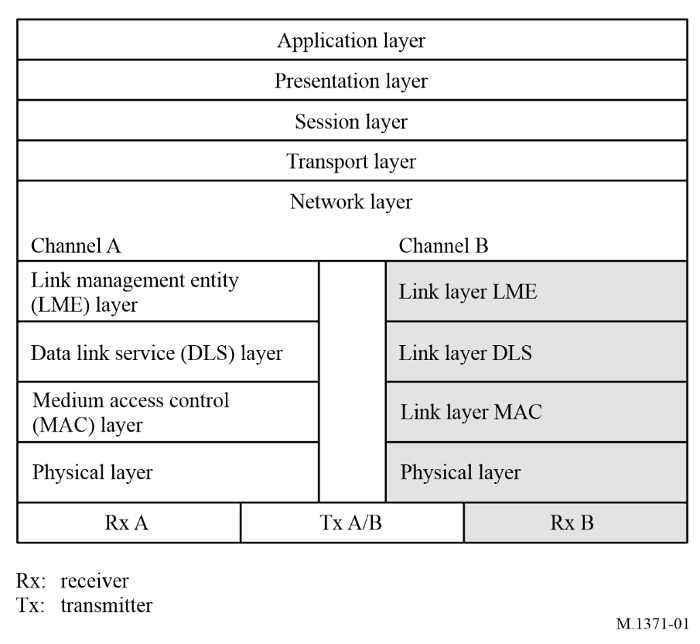

A2-1.2 Responsibilities of automatic identification system layers for preparing automatic identification system data for transmission

A2-1.2.1 Transport layer
The transport layer is responsible for converting data into transmission packets of correct size and sequencing of data packets.

A2-1.2.2 Network layer
The network layer is responsible for the management of priority assignments of messages, distribution of transmission packets between channels, and data link congestion resolution.

A2-1.2.3 Link layer
The link layer specifies how data is packaged in order to apply error detection and correction to the data transfer. The link layer is divided into three sub-layers with the following tasks:

A2-1.2.3.1 Link management entity
Assemble AIS message bits, see Annex 7.
Order AIS message bits into 8-bit bytes for assembly of transmission packet, see § A2-3.3.7.

A2-1.2.3.2 Data link services
Calculate frame check sequence (FCS) for AIS message bits, see § A2-3.2.2.6.
Append FCS to AIS message to complete creation of transmission packet contents see § A2-3.2.2.2.
Apply bit stuffing process to transmission packet contents, see § A2-3.2.2.1.
Complete assembly of transmission packet, see § A2-3.2.2.2.

A2-1.2.3.3 Media access control
Provides a method for granting access to the data transfer to the VHF data link (VDL). The method used is a TDMA scheme using a common time reference.

A2-1.2.4 Physical layer
The physical layer is responsible for the transfer of a bit-stream from an originator, out on to the data link.
Non return to zero inverted (NRZI) encode assembled transmission packet see § A2-2.3.1.1 or § A2-2.6.
Convert digital NRZI coded transmission packet to analogue Gaussian-filtered minimum shift keying (GMSK) signal to modulate transmitter, see § A2-2.3.1.1.

A2-2 Physical layer

A2-2.1 Parameters

A2-2.1.1 General
The physical layer is responsible for the transfer of a bit-stream from an originator, out on to the data link. The performance requirements for the physical layer are summarized in Tables 3 to 7.
For transmit output power see also § A2-2.12.2.
The low setting and the high setting for each parameter is independent of the other parameters.
TABLE 3
Symbol | Parameter name | Units | Low setting | High setting
PH.CHS | Channel spacing (encoded according to RR Appendix 18 with footnotes) | kHz | 25 | 25
PH.AIS1 | AIS 1 (see § A2-2.3.3) | MHz | 161.975 | 161.975
PH.AIS2 | AIS 2 (see § A2-2.3.3) | MHz | 162.025 | 162.025
PH.BR | Bit rate | bit/s | 9 600 | 9 600
PH.TS | Training sequence | Bits | 24 | 24
PH.TXBT | Transmit BT product |  | ~0.4 | ~0.4
PH.RXBT | Receive BT product |  | ~0.5 | ~0.5
PH.MI | Modulation index |  | ~0.5 | ~0.5
PH.TXP | Transmit output power | W | 1 | 12.5⁽¹⁾ / 5⁽²⁾
⁽¹⁾ Except for Class B “SO”.
⁽²⁾ For Class B “SO”.

A2-2.1.2 Constants
TABLE 4
Symbol | Parameter name | Value
PH.DE | Data encoding | NRZI
PH.FEC | Forward error correction | Not used
PH.IL | Interleaving | Not used
PH.BS | Bit scrambling | Not used
PH.MOD | Modulation | GMSK/FM
GMSK/FM: see § A2-2.3.

A2-2.1.3 Transmission media
Data transmissions are made in the VHF maritime mobile band. Data transmissions should operate on) AIS 1 and AIS 2 for standard operation and channel 75 and channel 76 for AIS satellite broadcast messages.

A2-2.1.4 Multi-channel operation
The shipborne AIS should be capable of receiving on two parallel channels and transmitting on four independent channels in accordance with § A2-4.1. Two separate TDMA receiving processes should be used to simultaneously receive on two independent frequency channels. One TDMA transmitter should be used to alternate TDMA transmissions on four independent frequency channels.
Shore-based AIS stations use AIS 1 and AIS 2 channels for transmission and reception.
The AIS transmitters of the AIS-SART, AIS-MOB, and EPIRB-AIS shall transmit exclusively on AIS 1 and AIS 2 channels. These devices do not have AIS receivers.

A2-2.2 Transceiver characteristics
The transceiver should perform in accordance with the characteristics set forth herein.
TABLE 5
Minimum required time division multiple access transmitter characteristics
Transmitter parameters | Requirements
Carrier power error | ± 1.5 dB
Carrier frequency error | ± 500 Hz
Slotted modulation mask | ∆fc < ±10 kHz: 0 dBc  ±10 kHz < ∆fc < ±25 kHz: below the straight line between −25 dBc at ±10 kHz and –70 dBc at ±25 kHz  ±25 kHz < ∆fc < ±62.5 kHz: –70 dBc

TABLE 5 (end)
Transmitter parameters | Requirements
Transmitter test sequence and modulation accuracy | < 3 400 Hz for Bit 0, 1 (normal and extreme)  2 400 Hz ± 480 Hz for Bit 2, 3 (normal and extreme)  2 400 Hz ± 240 Hz for Bit 4 … 31 (normal, 2 400 ± 480 Hz extreme)  For Bits 32 … 199  1 740 ± 175 Hz (normal, 1 740 ± 350 Hz extreme) for a bit pattern of 0101  2 400 Hz ± 240 Hz (normal, 2 400 ± 480 Hz extreme) for a bit pattern of 00001111
Transmitter output power versus time | Power within mask shown in Fig. 2 and timings given in Table 6
Spurious emissions | −36 dBm 9 kHz ... 1 GHz  −30 dBm 1 GHz ... 4 GHz
Intermodulation attenuation  (base station only) | ≥ 40 dB
TABLE 6
Definitions of timing for Fig. 2
Reference |  |  | Bits | Time  (ms) | Definition
T₀ |  |  | 0 | 0 | Start of transmission slot. Power should NOT exceed –50 dB of P_{ss} before T₀
T_{A} |  |  | 0-6 | 0-0.625 | Power exceeds –50 dB of P_{ss}
T_{B} |  | T_{B1} | 6 | 0.625 | Power should be within +1.5 or –3 dB of P_{ss}
 |  | T_{B2} | 8 | 0.833 | Power should be within +1.5 or –1 dB of Pss (start of training sequence)
T_{E} (includes 1 stuffing bit) |  |  | 233 | 24.271 | Power should remain within +1.5 or −1 dB of P_{ss} during the period T_{B2} to T_{E}
T_{F} (includes 1 stuffing bit) |  |  | 241 | 25.104 | Power should be −50 dB of P_{ss} and stay below this
 | T_{G} |  | 256 | 26.667 | Start of next transmission time period
TABLE 7
Minimum required time division multiple access receiver characteristics⁽¹⁾
Receiver parameters | Requirements
Sensitivity | 20% PER at –107 dBm
Error behaviour at high input levels | 1% PER at –77 dBm  1% PER at –7 dBm
Adjacent channel selectivity | 20% PER at 70 dB
Co-channel selectivity | 20% PER at 10 dB
Spurious response rejection | 20% PER at 70 dB

TABLE 7 (end)
Receiver parameters | Requirements
Intermodulation response rejection | 20% PER at 74 dB
Spurious emissions | –57 dBm (9 kHz to 1 GHz)  –47 dBm (1 GHz to 4 GHz)
Blocking | 20% PER at 86 dB
⁽¹⁾ For Class B “SO”, Table 36 applies.
NOTE – COMSAR.1/Circ.32/Rev 3 § 5.2.8 “AIS VHF antennas should be mounted directly above or below the ship’s primary VHF radiotelephone antenna, with no horizontal separation and with minimum 2 metres vertical separation. If it is located on the same level as other antennas, the distance apart should be at least 5 metres.”

A2-2.3 Modulation scheme
The modulation scheme is frequency modulated Gaussian filtered minimum shift keying (GMSK/FM).

A2-2.3.1 Gaussian minimum shift keying
A2-2.3.1.1 The NRZI encoded data should be Gaussian minimum shift keying (GMSK) coded before frequency modulating the transmitter.
A2-2.3.1.2 The GMSK modulator BT-product used for transmission of data should be 0.4 maximum (highest nominal value).
A2-2.3.1.3 The GMSK demodulator used for receiving of data should be designed for a BT-product of maximum 0.5 (highest nominal value).

A2-2.3.2 Frequency modulation
The GMSK coded data should frequency modulate the VHF transmitter. The modulation index should be 0.5.

A2-2.3.3 Frequency stability
The frequency stability of the VHF radio transmitter/receiver should be ± 500 Hz or better.

A2-2.4 Data transmission bit rate
The transmission bit rate should be 9 600 bit/s ± 50 ppm.

A2-2.5 Training sequence
Data transmission should begin with a 24-bit demodulator training sequence (preamble) consisting of one segment synchronization. This segment should consist of alternating zeros and ones (0101....). This sequence may begin with a 1 or a 0 since NRZI encoding is used.

A2-2.6 Data encoding
The NRZI waveform is used for data encoding. The waveform is specified as giving a change in the level when a zero (0) is encountered in the bit stream.

A2-2.7 Forward error correction
Forward error correction is not used.

A2-2.8 Interleaving
Interleaving is not used.

A2-2.9 Bit scrambling
Bit scrambling is not used.

A2-2.10 Data link sensing
Data link occupancy and data detection are entirely controlled by the link layer.

A2-2.11 Transmitter transient response
The attack, settling and decay characteristics of the RF transmitter should comply with the mask shown in Fig. 2 and defined in Table 6.
Figure 2
Transmitter output envelope versus time
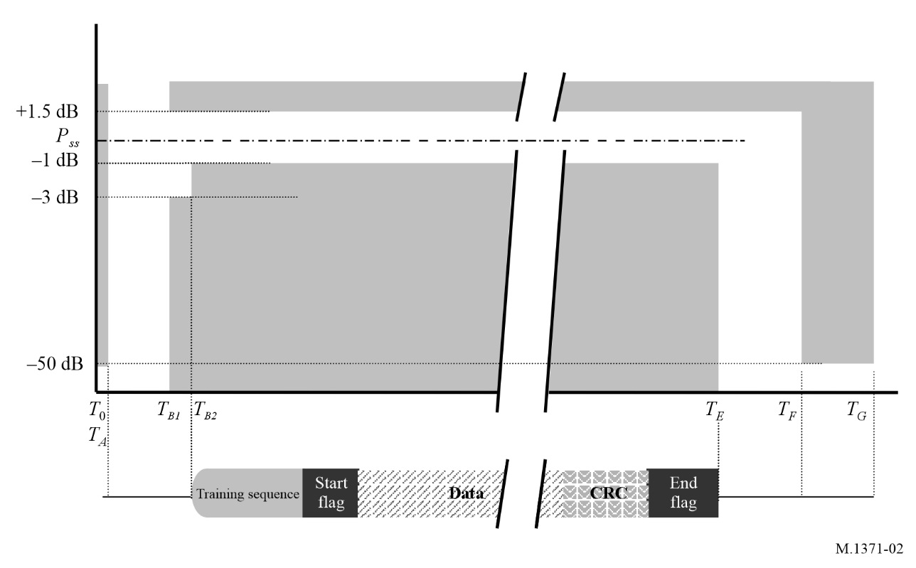

A2-2.11.1 Switching time
The channel switching time should be less than 25 ms (see Fig. 8).
The time taken to switch from transmit to receive conditions, and vice versa, should not exceed the transmit attack or release time. It should be possible to receive a message from the slot directly after or before own transmission.
The equipment should not be able to transmit during channel switching operation.
The equipment is not required to transmit on the other AIS channel in the adjacent time slot.

A2-2.12 Transmitter power
The power level is determined by the link management entity (LME) of the link layer.
A2-2.12.1 Provision should be made for two levels of nominal power (high power, low power) as required by some applications. The default operation of the AIS station should be on the high nominal power level. Changes to the power level should be done by manual means or by an AIS base station using AIS Message 22. The power setting should be indicated on the MKD.
A2-2.12.2 The nominal levels for the two power settings should be 1 W and 12.5 W or 1 W and 5 W for Class B “SO”. Tolerance should be within ±1.5 dB.

A2-2.13 Shutdown procedure
A2-2.13.1 An automatic transmitter hardware shutdown procedure and indication should be provided in case a transmitter continues to transmit for more than 2 s. This shutdown procedure should be independent of software control.

A2-2.14 Safety precautions
The AIS stations, when operating, should not be damaged by the effects of open circuited or short-circuited antenna terminals.

A2-3 Link layer
The link layer specifies how data is packaged in order to apply error detection and correction to the data transfer. The link layer is divided into three (3) sub-layers.

A2-3.1 Sub-layer 1: medium access control
The medium access control (MAC) sub layer provides a method for granting access to the data transfer medium, i.e. the VHF data link. The method used is a TDMA scheme using a common time reference.

A2-3.1.1 Time division multiple access synchronization
TDMA synchronization is achieved using an algorithm based on a synchronization state as described below. The sync state flag within SOTDMA communication state (see § A2-3.3.7.2.1) and within ITDMA communication state (see § A2-3.3.7.3.2), indicates the synchronization state of a station (see Figs 3 and 4).
The TDMA receiving process should not be synchronized to slot boundaries.
Parameters for TDMA synchronization:
TABLE 8
Symbol | Parameter name/description | Nominal
MAC.SyncBaseRate | Sync support increased update rate  (base station) | Once per 3 1/3 s
MAC.SyncMobileRate | Sync support increased update rate  (mobile station) | Once per 2 s

A2-3.1.1.1 Coordinated universal time direct
A station, which has direct access to coordinated universal time (UTC) timing with the required accuracy should indicate this by setting its synchronization state to UTC direct.

A2-3.1.1.2 Coordinated universal time indirect
A station, which is unable to get direct access to UTC, but can receive other stations that indicate UTC direct, should synchronize to those stations. It should then change its synchronization state to UTC indirect. Only one level of UTC indirect synchronization is allowed.

A2-3.1.1.3 Synchronized to base station (direct or indirect)
Mobile stations, which are unable to attain direct or indirect UTC synchronization, but are able to receive transmissions from base stations, should synchronize to the base station which indicates the highest number of received stations, provided that two reports have been received from that station in the last 40 s. Once base station synchronization has been established, this synchronization shall be discontinued if fewer than two reports are received from the selected base station in the last 40 s. When the parameter slot time-out of the SOTDMA communication state has one of the values three (3), five (5), or seven (7), the number of received stations should be contained within the SOTDMA communication state sub-message. The station which is thus synchronized to a base station should then change its synchronization state to “base direct” to reflect this. A station that has Sync. State = 3 (see § A2-3.1.3.4.3) shall synchronize to a station that has Sync. State = 2 (see § A2-3.1.3.4.3) if no base station or station with UTC direct is available. Only one level of indirect access to the base station is allowed.
When a station is receiving several other base stations, which indicate the same number of received stations, synchronization should be based on the station with the lowest MMSI.

A2-3.1.1.4 Number of received stations
A station, which is unable to attain UTC direct or UTC indirect synchronization and is also unable to receive transmissions from a base station, should synchronize to the station indicating the highest number of other stations received during the last nine frames, provided that two reports have been received from that station in the last 40 s (see § A2-3.3.7.2.2 for SOTDMA communication state and § A2-3.3.7.3.2 for ITDMA communication state). This station should then change its synchronization state to “Mobile as semaphore” (see § A2-3.3.7.2.2 for SOTDMA communication state and § A2-3.3.7.3.2 for ITDMA communication state). When a station is receiving several other stations, which indicate the same number of received stations, synchronization should be based on the station with the lowest MMSI. That station becomes the semaphore on which synchronization should be performed.

A2-3.1.2 Time division
The system uses the concept of a frame. A frame equals one (1) min and is divided into 2 250 slots. Access to the data link is, by default, given at the start of a slot. The frame start and stop coincide with the UTC minute, when UTC is available. When UTC is unavailable the procedure, described below should apply.

A2-3.1.3 Slot phase and frame synchronization

A2-3.1.3.1 Slot phase synchronization
Slot phase synchronization is the method whereby one station uses the messages from other stations or base stations to re-synchronize itself, thereby maintaining a high level of synchronization stability, and ensuring no message boundary overlapping or corruption of messages.
Decision to slot phase synchronize should be made after receipt of end flag and valid FCS. (State T3, Fig. 8). At T5, the station resets its Slot_Phase_Synchronization_Timer, based on Ts, T3 and T5 (Fig. 8).

A2-3.1.3.2 Frame synchronization
Frame synchronization is the method whereby one station uses the current slot number of another station or base station, adopting the received slot number as its own current slot number. When the parameter slot time-out of the SOTDMA communication state has one of the values two (2), four (4), or six (6), the current slot number of the transmitting station should be contained within the sub message of the SOTDMA communication state.

A2-3.1.3.3 Synchronization –transmitting stations (see Fig. 3)
Figure 3
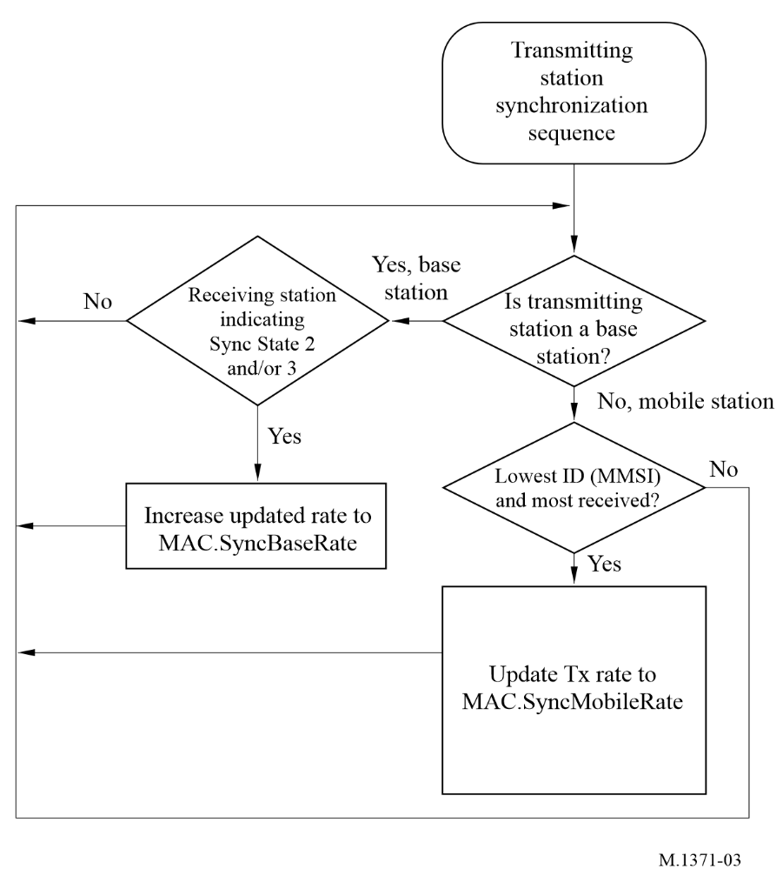

A2-3.1.3.3.1 Base station operation
The base station should normally transmit the base station report (Message 4) with a minimum reporting interval of 10 s.
The base station should decrease its reporting interval of Message 4 to MAC.SyncBaseRate when it fulfils the semaphore qualifying conditions according to the Tables in § A2-3.1.3.4.3. It should remain in this state until the semaphore qualifying conditions have been invalid for the last 3 min.

A2-3.1.3.3.2 Mobile station operation as a semaphore
When a mobile station determines that it is the semaphore (see § A2-3.1.1.4 and § A2-3.1.3.4.3), it should decrease its reporting interval to MAC.SyncMobileRate. It should remain in this state until the semaphore qualifying conditions have been invalid for the last 3 min. The Class B “SO” and AIS SAR aircraft station should not act as the semaphore.

A2-3.1.3.4 Synchronization – receiving stations (see Fig. 4)
Figure 4
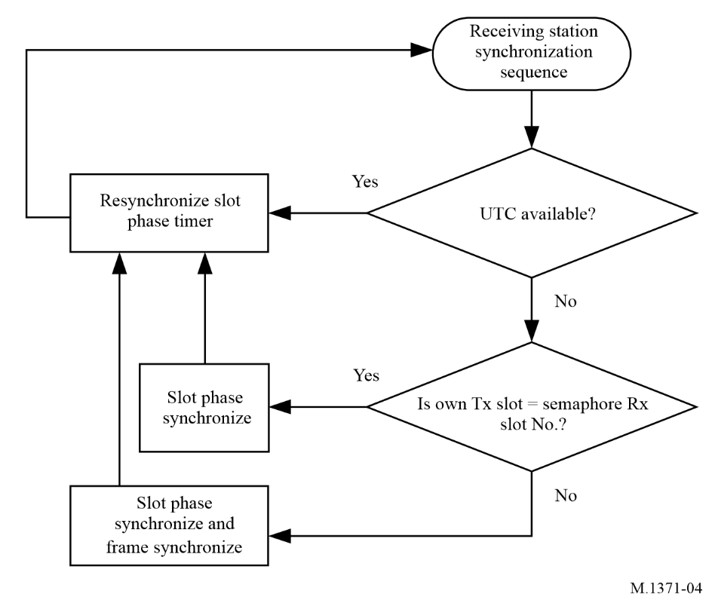

A2-3.1.3.4.1 Coordinated universal time available
A station, which has direct access to UTC, should continuously re-synchronize its transmissions based on UTC source. A station, which has indirect access to UTC should continuously resynchronize its transmissions based on those UTC sources (see § A2-3.1.1.2).

A2-3.1.3.4.2 Coordinated universal time not available
When the station determines that its own internal slot number is equal to the semaphore slot number, it is already in frame synchronization and it should continuously slot phase synchronize.

A2-3.1.3.4.3 Synchronization sources
The primary source for synchronization should be the internal UTC source (UTC direct). If this source should be unavailable the following external synchronization sources, listed below in the order of priority, should serve as the basis for slot phase and frame synchronizations:
– a station which has UTC time;
– a base station which is semaphore qualified;
– other station(s) which are synchronized to a base station;
– a mobile station, which is semaphore qualified.
Table 9 illustrates the different sync mode priorities and the contents of the sync state fields in the communication state.
TABLE 9
Synchronization mode
Sync mode of own station | Priority | Illustration | Sync state  (in communication state) of own station | May be used as source for indirect sync by other station(s)
UTC direct | 1 | UTC | 0 | Yes
UTC indirect | 2 | UTC | 1 | No
Base direct | 3 |  | 2 | Yes
Base indirect | 4 |  | 3 | No
Mobile as semaphore | 5 |  | 3 | No
AIS station to be synchronized.
AIS mobile station which indicates synchronization.
AIS base station.

A mobile station should only be semaphore qualified under following condition:
TABLE 10
 |  | Highest received synchronization state value
Mobile station’s synchronization state value | Own mobile station’s sync state | 0 | 1 | 2 | 3
Mobile station’s synchronization state value | 0 | No | No | No | No
Mobile station’s synchronization state value | 1 | No | No | No | Yes
Mobile station’s synchronization state value | 2 | No | No | No | No
Mobile station’s synchronization state value | 3 | No | No | No | Yes
0 = UTC direct (see § A2-3.1.1.1).
1 = UTC indirect (see § A2-3.1.1.2).
2 = Station is synchronized to a base station (see § A2-3.1.1.3).
3 = Station is synchronized to another station based on the highest number of received stations (see § A2-3.1.1.4) or indirect to a base station.
Note: The highest received synchronisation state value does not include the station to which own mobile station is synchronised.
If more than one station is semaphore qualified, then the station indicating the highest number of received stations should become the active semaphore station. If more than one station indicates the same number of received stations, then the one with the lowest MMSI number becomes the active semaphore station.
A base station should only be semaphore qualified under following condition:
TABLE 11
 |  | Highest received synchronization state value
Base station’s synchronization state value | Own base station’s sync state | 0 | 1 | 2 | 3
Base station’s synchronization state value | 0 | No | No | No | No
Base station’s synchronization state value | 1 | No | No | Yes | Yes
Base station’s synchronization state value | 2 | No | No | Yes | Yes
Base station’s synchronization state value | 3 | No | No | Yes | Yes
0 = UTC direct (see § A2-3.1.1.1).
1 = UTC indirect (see § A2-3.1.1.2).
2 = Station is synchronized to a base station (see § A2-3.1.1.3).
3 = Station is synchronized to another mobile station based on the highest number of received stations (see § A2-3.1.1.4) or indirect to a base station.
A base station which is semaphore qualified according to Table 11 should act as a semaphore.
See also § A2-3.1.1.3, § A2-3.1.1.4 and § A2-3.1.3.3 for semaphore qualification.
Note: The highest received synchronisation state value does not include the station to which own mobile station is synchronised.

A2-3.1.4 Slot identification
Each slot is identified by its index (0-2249). Slot zero (0) should be defined as the start of the frame.

A2-3.1.5 Slot access
The transmitter should begin transmission by turning on the RF power at slot start.
The transmitter should be turned off after the last bit of the transmission packet has left the transmitting unit. This event must occur within the slots allocated for own transmission. The default length of a transmission occupies one (1) slot. The slot access is performed as shown in Fig. 5.
Figure 5
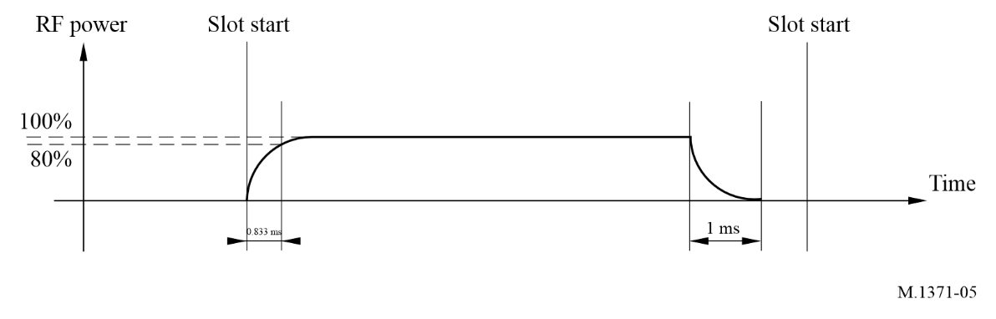

A2-3.1.6 Slot state
Each slot can be in one of the following states:
– Free: meaning that the slot is unused within the receiving range of the own station. Slots reserved by a station beyond 120 nautical miles (NM) are considered to be also free slots. Slots reserved by SOTDMA that have not been used during the preceding three frames are also considered to be free slots. This slot may be considered as a candidate slot for use by own station (see § A2-3.3.1.2).
– Internal allocation: meaning that the slot is allocated by own station and can be used for transmission.
– External allocation: meaning that the slot is allocated for transmission by another station.
– Garbled: A slot shall be considered garbled if it contains no decodable message and has a receiver signal strength indicator of greater than 16 dB above the background noise (see § A6-4.3.1.3) Garbled slots are only considered different from Free slots in the AIS repeater station.

A2-3.2 Sub layer 2: data link service
The data link service (DLS) sub layer provides methods for:
– data link activation and release;
– data transfer; or
– error detection and control.

A2-3.2.1 Data link activation and release
Based on the MAC sub layer the DLS will listen, activate or release the data link. Activation and release should be in accordance with § A2-3.1.5. A slot, marked as free or externally allocated, indicates that own equipment should be in receive mode and listen for other data link users. This should also be the case with slots, marked as available and not to be used by own station for transmission (see § A2-4.4.1).

A2-3.2.2 Data transfer
Data transfer should use a bit-oriented protocol which is based on the high-level data link control (HDLC) as specified by ISO/IEC 13239:2002 – Definition of packet structure. Information packets (I-Packets) should be used with the exception that the control field is omitted (see Fig. 6).

A2-3.2.2.1 Bit stuffing
The bit stream of the data portion and the FCS, see Fig. 6, § A2-3.2.2.5 and § A2-3.2.2.6, should be subject to bit stuffing. On the transmitting side, this means that if five (5) consecutive ones (1’s) are found in the output bit stream, a zero should be inserted after the five (5) consecutive ones (1’s). This applies to all bits between the HDLC flags (start flag and end flag, see Fig. 6). On the receiving side, the first zero after five (5) consecutive ones (1’s) should be removed.

A2-3.2.2.2 Packet format
Data is transferred using a transmission packet as shown in Fig. 6:
Figure 6
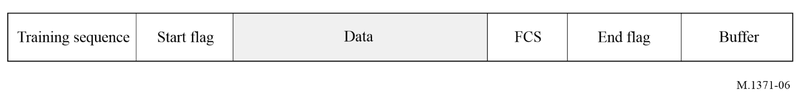
The packet should be sent from left to right. This structure is identical to the general HDLC structure, except for the training sequence. The training sequence should be used in order to synchronize the VHF receiver and is discussed in § A2-3.2.2.3. The total length of the default packet is 256 bits. This is equivalent to one (1) slot.

A2-3.2.2.3 Training sequence
The training sequence should be a bit pattern consisting of alternating 0’s and 1’s (010101010…). Twenty-four bits of preamble are transmitted prior to sending the flag. This bit pattern is modified due to the NRZI mode used by the communication circuit (see Fig. 7).
Figure 7
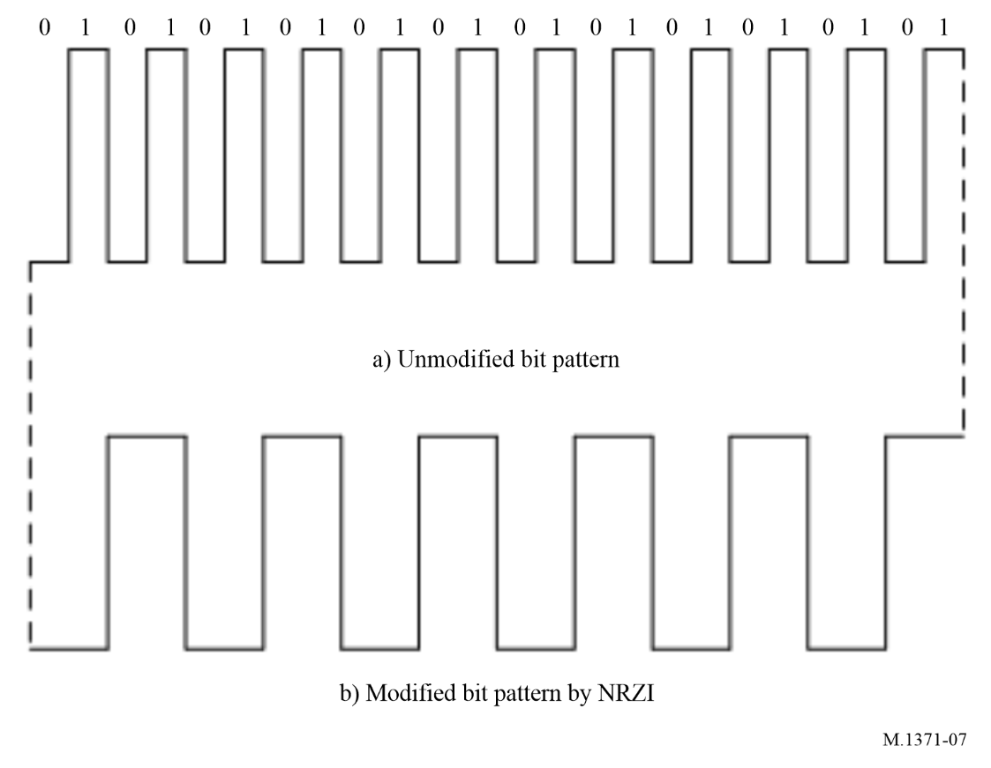
The preamble should not be subject to bit stuffing.

A2-3.2.2.4 Start flag
The start flag should be 8 bits long and consists of a standard HDLC flag. It is used in order to detect the start of a transmission packet. The start flag consists of a bit pattern, 8 bits long: 01111110 (7Eh). The flag should not be subject to bit stuffing, although it consists of 6 bits of consecutive ones (1’s).

A2-3.2.2.5 Data
The data portion is 168 bits long in the default transmission packet. The content of data is undefined at the DLS. Transmission of data, which occupy more than 168 bits, is described in § A2-3.2.2.11.

A2-3.2.2.6 Frame check sequence
The FCS uses the cyclic redundancy check (CRC) 16-bit polynomial to calculate the checksum as defined in ISO/IEC 13239:2002. The CRC bits should be pre-set to one (1) at the beginning of a CRC calculation. Only the data portion should be included in the CRC calculation (see Fig. 7).

A2-3.2.2.7 End flag
The end flag is identical to the start flag as described in § A2-3.2.2.4.

A2-3.2.2.8 Buffer
The buffer is normally 24 bits long and should be used as follows:
– bit stuffing: 4 bits (normally, for all messages except safety related messages and binary messages)
– distance delay: 14 bits
– synchronization jitter: 6 bits

A2-3.2.2.8.1 Bit stuffing
A statistical analysis of all possible bit combinations in the data field of the fixed length messages shows that 76% of combinations use 3 bits or less, for bit stuffing. Adding the logically possible bit combinations shows, that 4 bits are sufficient for these messages. Where variable length messages are used, additional bit stuffing could be required. For the case where additional bit stuffing is required, see § A2-5.2 and Table 21.

A2-3.2.2.8.2 Distance delay
A buffer value of 14 bits is reserved for distance delay. This is equivalent to 235.9 NM. This distance delay provides protection for a propagation range of over 120 NM.

A2-3.2.2.8.3 Synchronization jitter
For a mobile station the synchronization jitter bits preserve integrity on the TDMA data link, by allowing a jitter in each time slot, which is equivalent to ±3 bits. Transmission timing error should be within ±104 μs of the synchronization source. Since timing errors are additive, the accumulated timing error can be as much as ±312 μs.
For a base station, transmission timing error should be within ±52 μs of the synchronization source. Since timing errors are additive, the accumulated timing error can be as much as ±104 μs.

A2-3.2.2.9 Summary of the default transmission packet
The data packet is summarized as shown in Table 12.
TABLE 12
Ramp up | 8 bits | T0 to TTS in Fig. 8
Training sequence | 24 bits | Necessary for synchronization
Start flag | 8 bits | In accordance with HDLC (7E_{h})
Data | 168 bits | Default
TABLE 12 (end)
Ramp up | 8 bits | T0 to TTS in Fig. 8
CRC | 16 bits | In accordance with HDLC
End flag | 8 bits | In accordance with HDLC (7E_{h})
Buffer | 24 bits | Bit stuffing, distance delays, and synchronization jitter
Total | 256 bits

A2-3.2.2.10 Transmission timing
Figure 8 shows the timing events of the default transmission packet (one slot). At the situation where the ramp down of the RF power overshoots into the next slot, there should be no modulation of the RF after the termination of transmission. This prevents undesired interference, due to false locking of receiver modems, with the succeeding transmission in the next slot.
figure 8
Transmission timing
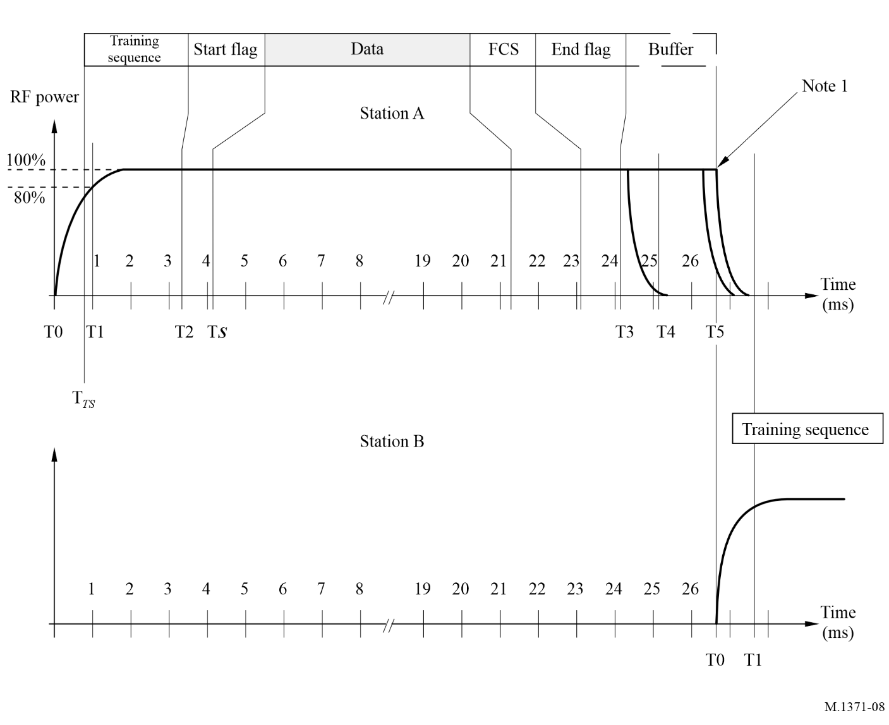
T(n) | Time (ms) | Description
T0 | 0.000 | Slot start. RF power is applied
T_{TS} | 0.833 | Beginning of training sequence
T1 | 1.000 | RF power and frequency stabilization time
T2 | 3.333 | Start of transmission packet (start flag). This event can be used as a secondary synchronization source should the primary source (UTC) be lost.
T_{s} | 4.167 | Slot phase synchronization marker. End of start flag, beginning of data.
T3 | 24.167 | End of transmission, assuming zero bit stuffing. No modulation is applied after termination of transmission.  In case of a shorter data block, the transmission may end earlier.
T4 | T3 + 1.0000 | The time when RF power should have reached zero
T5 | 26.667 | End of slot. Beginning of next slot.
NOTE 1 – Should a transmission end exactly at the beginning of the next slot, the Tx-down period for station A will overlap into the next slot as shown in Fig. 8. Transmission of the training sequence is not impaired by this. This occasion would be extremely rare, and it would occur only in the event of a propagation anomaly. Even in this case, the operation of the AIS is not impaired due to the range discrimination characteristics of the receiver.

A2-3.2.2.11 Long transmission packets
An AIS station may occupy at maximum five consecutive slots for one (1) continuous transmission. Only a single application of the overhead (ramp up, training sequence, flags, FCS, buffer) is required for a long transmission packet. The length of a long transmission packet should not be longer than necessary to transfer the data; i.e. the AIS station should not add filler.

A2-3.2.3 Error detection and control
Error detection and control should be handled using the CRC polynomial as described in § A2-3.2.2.6. CRC errors should result in no further action by the AIS station.

A2-3.3 Sub layer 3 – link management entity
The LME controls the operation of the DLS, MAC and the physical layer.

A2-3.3.1 Access to the data link
There are five different access schemes for controlling access to the data transfer medium. The application and mode of operation determine the access scheme to be used. The access schemes are SOTDMA, ITDMA, RATDMA, MSSA and FATDMA. SOTDMA is the basic scheme used for scheduled repetitive transmissions from an autonomous station. When, for example, the reporting interval has to be changed, or a non-repetitive message is to be transmitted, other access schemes may be used.

A2-3.3.1.1 Cooperation on the data link
The access schemes operate continuously, and in parallel, on the same physical data link. They all conform to the rules set up by the TDMA (see § 3.1).

A2-3.3.1.2 Candidate slots
Slots, used for transmission, are selected from candidate slots in the selection interval (SI) (see Fig. 10). The selection process uses received data. There should always be at minimum four candidate slots to choose from unless the number of candidate slots is otherwise restricted due to loss of position information (see § A2-4.4.1). For Class A AIS stations when selecting candidates for messages longer than one (1) slot (see § A2-3.2.2.11) a candidate slot should be the first slot in a consecutive block of free or available slots. For Class B “SO” AIS stations the candidate slots for Messages 6, 8, 12 and 14 should be free. When no candidate slot is available, the use of the current slot is allowed. The candidate slots are primarily selected from free slots (see § A2-3.1.6). When required, available slots are included in the candidate slot set. When selecting a slot from the candidates, any candidate has the same probability of being chosen, regardless of its slot state (see § A2-3.1.6). If the station cannot find any candidate slots at all, because all slots in the SI are restricted from slot reuse (see § A2-4.4.1), the station should not reserve a slot in the SI until there is at least one candidate slot.
Example:
0 | 1 | 2 | 3 | 4 | 5 | 6 | 7
E | E | F | F | F | F | F | E
A three-slot-message is to be sent. Only slot Nos. 2, 3 and 4 should be considered candidates.
When selecting among candidate slots for transmission in one channel, the slot usage of other channels should be considered. If the candidate slot in the other channel is used by another station, the use of the slot should follow the same rules as for slot reuse (see § A2-4.4.1). If a slot in either channel is occupied by or allocated by other base station or mobile station, that slot should be reused only in accordance with § A2-4.4.1.
The slots of another station should be used as candidate slots for intentional slot reuse.
The own station is unable to transmit on an adjacent slot on the two parallel channels because of the necessary switching time (see § A2-2.11.1). Thus, the two adjacent slots on either side of a slot that is being used by the own station on one channel should not be considered as candidate slots on the other channel.
The purpose of intentionally reusing slots and maintaining a minimum of four candidate slots within the same probability of being used for transmission is to provide high probability of access to the link. To further provide high probability of access, time-out characteristics are applied to the use of the slots so that slots will continuously become available for new use.
Figure 9 illustrates the process of selecting among candidate slots for transmission on the link.
figure 9
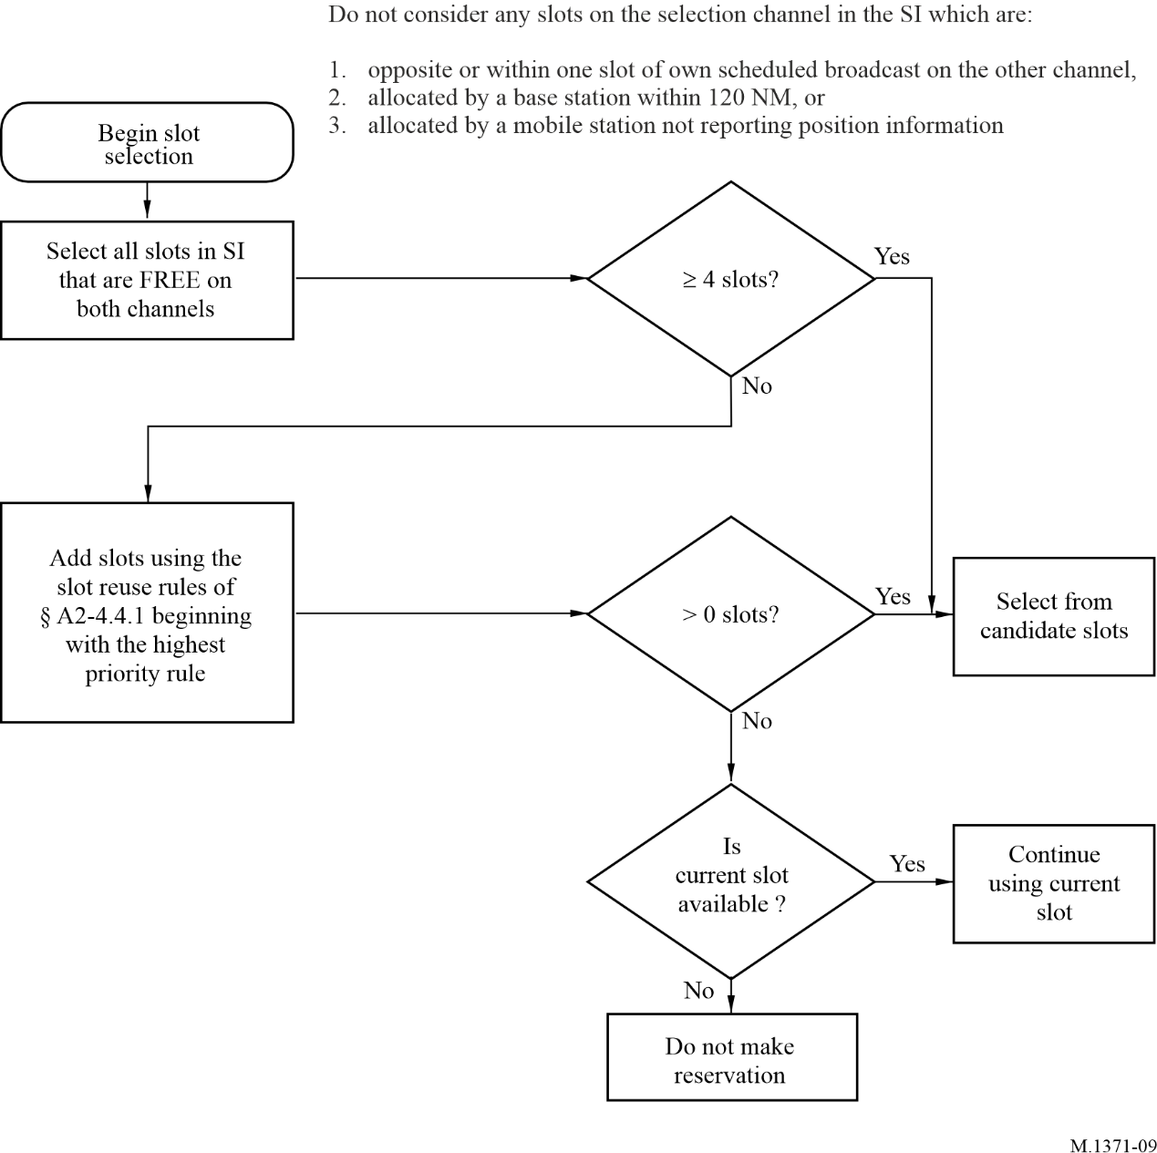

A2-3.3.2 Modes of operation
There should be four modes of operation. The default mode should be autonomous and may be switched to/from other modes. For a simplex repeater there should only be two modes of operation: autonomous and assigned, but no polled mode.

A2-3.3.2.1 Autonomous
A station operating autonomously should determine its own schedule for transmission. The station should automatically resolve scheduling conflicts with other stations.

A2-3.3.2.2 Assigned
A station operating in the assigned mode takes into account the transmission schedule of the assigning message when determining when it should transmit (see § A2-3.3.6).

A2-3.3.2.3 Polled
A station operating in polled mode should automatically respond to interrogation messages (Message 15). Operation in the polled mode should not conflict with operation in the other two modes. The response should be transmitted on the channel where the interrogation message was received.

A2-3.3.2.4 Silent
A station operating in the silent mode receives all messages on the VDL but does not transmit any VDL messages.

A2-3.3.3 Initialization
At power on, a station should monitor the TDMA channels for one (1) min to determine channel activity, other participating member IDs, current slot assignments and reported positions of other users, and possible existence of shore stations. During this time period, a dynamic directory of all stations operating in the system should be established. A frame map should be constructed, which reflects TDMA channel activity. After one (1) min has elapsed, the station should enter the operational mode and start to transmit according to its own schedule.

A2-3.3.4 Channel access schemes
The access schemes, as defined below, should coexist and operate simultaneously on the TDMA channel.

A2-3.3.4.1 Incremental time division multiple access
The ITDMA access scheme allows a station to pre-announce transmission slots of non-repeatable character, with two exceptions: during data link network entry and periodic transmission of the mobile station less than once per frame., ITDMA slots should be marked so that they are reserved for one additional frame or a given increment afterward. This allows a station to pre-announce its allocations for autonomous and continuous operation.
ITDMA should be used on four occasions:
– data link network entry;
– temporary changes and transitions in periodical reporting intervals;
– pre-announcement of safety related messages;
– periodic transmission of the mobile station with a report rate of less than two reports per min.

A2-3.3.4.1.1 Incremental time division multiple access algorithm
A station can begin its ITDMA transmission by either substituting a SOTDMA allocated slot or, by allocating a new, unannounced slot, using RATDMA. Either way, this becomes the first ITDMA slot.
The first transmission slot, during data link network entry, should be allocated using RATDMA. That slot should then be used as the first ITDMA transmission.
When higher layers dictate a temporary change of reporting interval or the need to transmit a safety related message, the next scheduled SOTDMA slot may pre-emptively be used for an ITDMA transmission.
Prior to transmitting in the first ITDMA slot, the station randomly selects the next following ITDMA slot and calculates the increment to that location. This increment should be inserted into the ITDMA communication state. Receiving stations will be able to mark the slot, indicated by this increment, as externally allocated (see § A2-3.3.7.3.2 and § A2-3.1.5). The communication state is transmitted as a part of the ITDMA transmission. During network entry, the station also indicates that the ITDMA slots should be reserved for one additional frame. The process of allocating slots continues as long as required. In the last ITDMA slot, the relative increment is set to zero.

A2-3.3.4.1.2 Incremental time division multiple access parameters
The parameters of Table 13 control ITDMA scheduling.
TABLE 13
Symbol | Name | Description | Minimum | Maximum
LME.ITINC | Slot increment | The slot increment is used to allocate a slot in the frame or in the next frame. It is a relative offset from the current transmission slot. If it is set to zero, no more ITDMA allocations should be done | 0 | 8 191
LME.ITSL | Number of slots | Indicates the number of consecutive slots, which are allocated, starting at the slot increment | 1 | 5
LME.ITKP | Keep flag | This flag should be set to TRUE when the present slot(s) should be reserved in the next frame also. The keep flag is set to FALSE when the allocated slot should be freed immediately after transmission | False = 0 | True = 1

A2-3.3.4.2 Random access time division multiple access
RATDMA is used when a station needs to allocate a slot, which has not been pre-announced. This is generally done for the first transmission slot during data link network entry, or for messages of a non-repeatable character.

A2-3.3.4.2.1 Random access time division multiple access algorithm
The RATDMA access scheme should use a probability persistent (p-persistent) algorithm as described in this paragraph (see Table 14), except the network entry phase (see § A2-3.3.5.2).
An AIS station should avoid using RATDMA. A scheduled message should primarily be used to announce a future transmission to avoid RATDMA transmissions.
Messages, which use the RATDMA access scheme, are stored in a priority first-in first-out (FIFO). When a candidate slot (see § A2-3.3.1.2) is detected, the station randomly select a probability value (LME.RTP1) between 0 and 100. This value should be compared with the current probability for transmission (LME.RTP2). If LME.RTP1 is equal to, or less than LME.RTP2, transmission should occur in the candidate slot. If not, LME.RTP2 should be incremented with a probability increment (LME.RTPI) and the station should wait for the next candidate slot in the frame.
The SI for RATDMA should be 150 time slots, which is equivalent to 4 s. The candidate slot set should be chosen within the SI, so that the transmission occurs within 4 s.
Each time that a candidate slot is entered, the p-persistent algorithm is applied. If the algorithm determines that a transmission shall be inhibited, then the parameter LME.RTCSC is decremented by one and LME.RTA is incremented by one.
LME.RTCSC can also be decremented as a result of another station allocating a slot in the candidate set. If LME.RTCSC + LME.RTA < 4 then the candidate set shall be complemented with a new slot within the range of the current slot and LME.RTES following the slot selection criteria.
Figure 10 illustrates the process of selecting among candidate slots for transmission using p-persistent algorithm.
Figure 10
Selecting among candidate slots for transmission using p-persistent algorithm
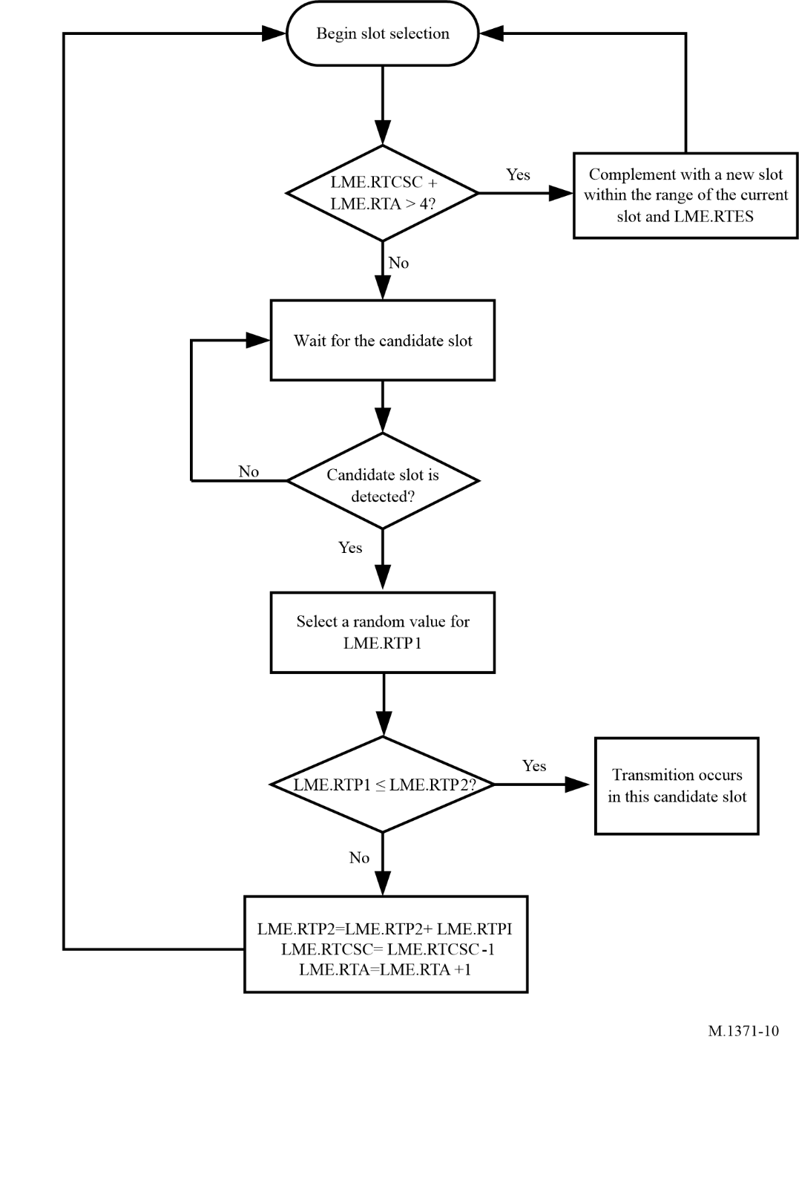

A2-3.3.4.2.2 Random access time division multiple access parameters
The parameters of Table 14 control RATDMA scheduling.
TABLE 14
Symbol | Name | Description | Minimum | Maximum
LME.RTCSC | Candidate slot counter | The number of slots currently available in the candidate set.  NOTE 1 – The initial value is always 4 or more (see § A2-3.3.1.2). However, during the cycle of the p-persistent algorithm the value may be reduced below 4 | 1 | 150
LME.RTES | End slot | Defined as the slot number of the last slot in the initial SI, which is 150 slots ahead | 0 | 2 249
LME.RTPRI | Priority | The priority that the transmission has when queuing messages. The priority is highest when LME.RTPRI is lowest. Safety related messages should have highest service priority (refer to § A2-4.2.3) | 1 | 0
LME.RTPS | Start probability | Each time a new message is due for transmission, LME.RTP2 should be set equal to LME.RTPS. LME.RTPS shall be equal to 100/LME.RTCSC.  NOTE 2 – LME.RTCSC is set to 4 or more initially. Therefore LME.RTPS has a maximum value of −25 (100/4) | 0 | 25
LME.RTP1 | Derived probability | Calculated probability for transmission in the next candidate slot. It should be less than or equal to LME.RTP2 for transmission to occur, and it should be randomly selected for each transmission attempt | 0 | 100
LME.RTP2 | Current probability | The current probability that a transmission will occur in the next candidate slot | LME.RTPS | 100
LME.RTA | Number of attempts | Initial value set to 0. This value is incremented by one each time the p-persistent algorithm determines that a transmission shall not occur | 0 | 149
LME.RTPI | Probability increment | Each time the algorithm determines that transmission should not occur, LME.RTP2 should be incremented with LME.RTPI. LME.RTPI shall be equal to (100 – LME.RTP2)/LME.RTCSC | 1 | 25

A2-3.3.4.3 Fixed access time division multiple access
FATDMA reservations should be done by base stations only. FATDMA allocated slots should be used for repetitive messages. For base stations use of FATDMA refer to § A2-4.5 and § A2-4.6.

A2-3.3.4.3.1 Fixed access time division multiple access algorithm
Access to the data link should be achieved with reference to the first slot in the reserved block. Each allocation should be pre-configured by the competent authority and not changed for the duration of the operation of the station, or until re-configured. Except where the time-out value is otherwise determined, receivers of data link management message (Message 20) should set a slot time-out value in order to determine when the FATDMA slot will become free. The slot time-out should be reset with each reception of the message.
FATDMA reservations should consist of a base station report (message 4) in conjunction with a data link management message with the same base station ID (MMSI). FATDMA reservations apply within a range of 120 nautical miles from the reserving base station. AIS stations (except when using FATDMA) should not use FATDMA reserved slots within this range. A data link management message (Message 20) without a base station report (Message 4) should be ignored. Base stations may reuse FATDMA reserved slots within this range for their own FATDMA transmissions but may not reuse FATDMA reserved slots for RATDMA transmissions.
FATDMA reservations do not apply beyond 120 nautical miles from the reserving base station. All stations may consider these slots as free.

A2-3.3.4.3.2 Fixed access time division multiple access parameters
The parameters of Table 15 control FATDMA scheduling:
TABLE 15
Symbol | Name | Description | Minimum | Maximum
LME.FTST | Start slot | The first slot (referenced to frame start) to be used by the station | 0 | 2 249
LME.FTI | Increment | Increment to next block of allocated slots. An increment of zero indicates that the station transmits one time per frame, in the start slot | 0 | 1 125
LME.FTBS | Block size | Default block size. Determines the default number of consecutive slots which are to be reserved at each increment | 1 | 5

A2-3.3.4.4 Self-organizing time division multiple access
The purpose of the access scheme is to offer an access algorithm which quickly resolves conflicts without intervention from controlling stations. Messages which use the SOTDMA access scheme are of a repeatable character and are used near real-time situational awareness to other users of the data link.

A2-3.3.4.4.1 Self-organizing time division multiple access algorithm
The access algorithm and continuous operation of SOTDMA is described in § A2-3.3.5.

A2-3.3.4.4.2 Self-organizing time division multiple access parameters
The parameters of Table 16 control SOTDMA scheduling:
TABLE 16
Symbol | Name |  | Description |  | Minimum | Maximum
NSS | Nominal start slot |  | This is the first slot used by a station to announce itself on the data link. Other repeatable transmissions are generally selected with the NSS as a reference.  When transmissions with the same reporting rate (Rr) are made using two channels (A and B), the NSS for the second channel (B) is offset from the first channel’s NSS by NI:  NSSB = NSSA + NI |  | 0 | 2 249
NS | Nominal slot |  | The nominal slot is used as the centre around which slots are selected for transmission of position reports. For the first transmission in a frame, the NSS and NS are equal. The NS when using only one channel is:  NS = NSS + (n × NI); (0 ≤ n < Rr)  When transmissions are made using two channels (A and B), the slot separation between the nominal slots on each channel is doubled and offset by NI:  NSA = NSSA + (n × 2 ×NI)  where: 0 ≤ n < 0.5 × Rr  NSB = NSSA + NI + (n × 2 × NI)  where: 0 ≤ n < 0.5 × Rr |  | 0 | 2 249
NI | Nominal increment |  | The nominal increment is given in number of slots and is derived using the equation below:  NI = 2 250/Rr |  | 75⁽¹⁾ | 1 225
Rr | Report rate |  | This is the desired number of position reports per minute.  Rr = 60/RI; (where RI is the reporting interval (s)) |  | 2^{(2), (3)} | 30⁽⁴⁾
SI | Selection interval |  | The SI is the collection of slots which can be candidates for position reports. The SI is derived using the equation below:  SI = {NS – (0.1 × NI) to NS + (0.1 × NI)} |  | 0.2 × NI | 0.2 × NI
NTS |  | Nominal  transmission slot |  | The slot, within a selection interval, currently used for transmissions within that interval | 0 | 2 249
TMO_MIN |  | Minimum time-out |  | The minimum SOTDMA slot time-out | 3 frames | NA

TABLE 16 (end)
Symbol | Name |  | Description |  | Minimum | Maximum
TMO_MAX |  | Maximum time-out |  | The maximum SOTDMA slot time-out | NA | 7 frames
⁽¹⁾ 37.5 when operating in the assigned mode using report rate assignment; 45 when operating in the assigned mode using slot increment assignment and the SOTDMA communication state.
⁽²⁾ When a station uses a report rate of less than two reports per min, ITDMA allocations should be used.
⁽³⁾ Also when operating in the assigned mode using SOTDMA as given by Table 61.
⁽⁴⁾ Sixty reports per min when operating in the assigned mode using SOTDMA as given by Table 44.

A2-3.3.5 Autonomous and continuous operation
This section describes how a station operates in the autonomous and continuous mode. Figure 11 shows the slot map accessed using SOTDMA.
figure 11
Uniform reporting rate using two channels
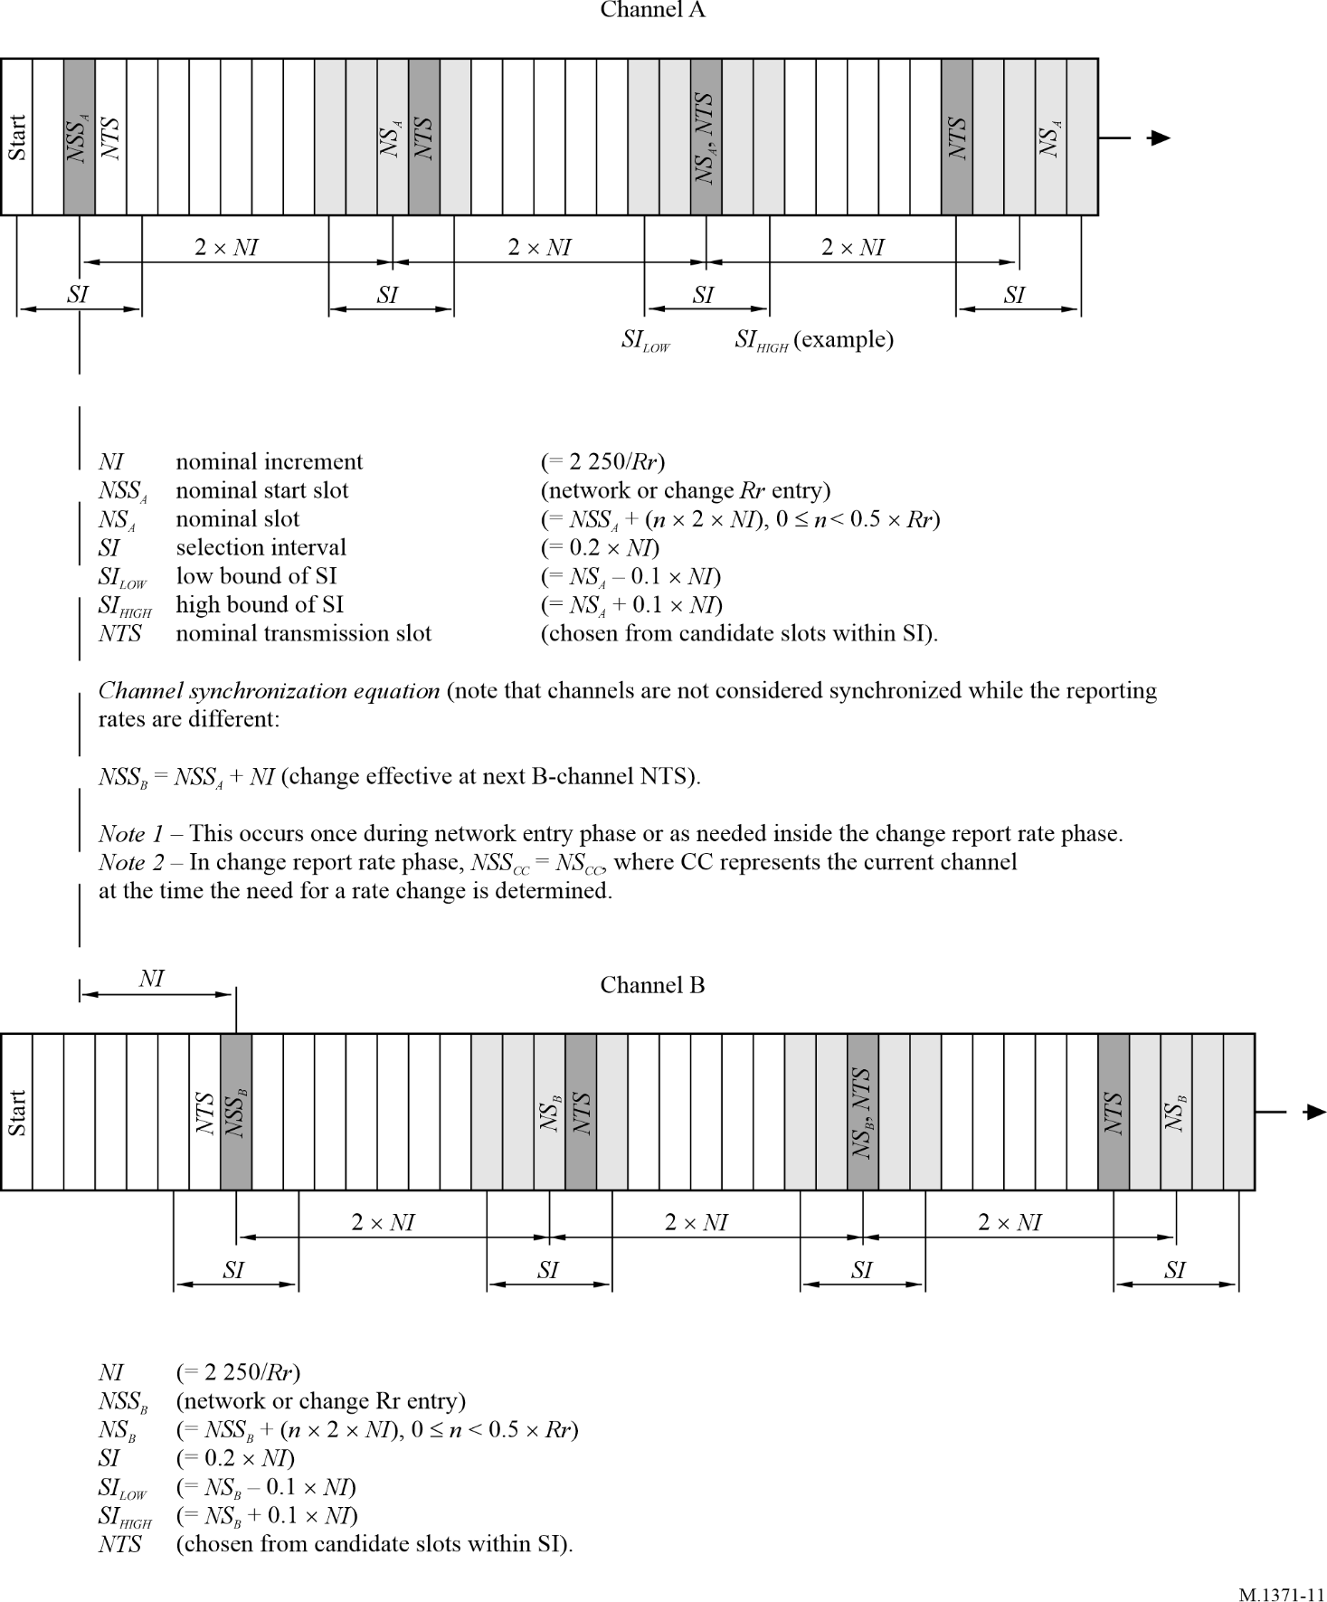

A2-3.3.5.1 Initialization phase
The initialization phase is described using the flowchart shown in Fig. 12.
figure 12
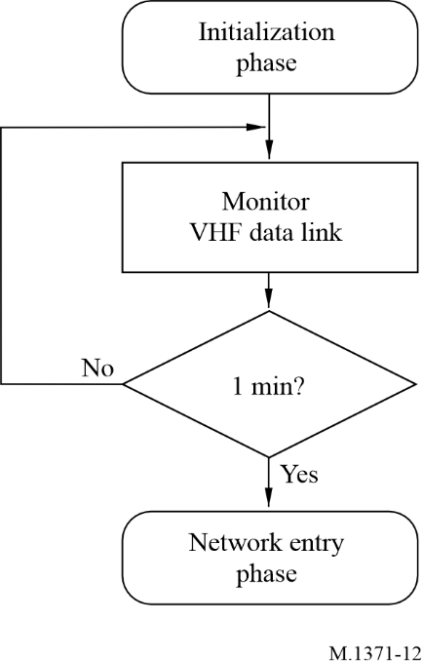

A2-3.3.5.1.1 Monitor VHF data link
At power on, a station should monitor the TDMA channel for one (1) min interval to determine channel activity, other participating member IDs, current slot assignments and reported positions of other users, and possible existence of base stations. During this time period, a dynamic directory of all members operating in the system should be established. A frame map should be constructed, which reflects TDMA channel activity.

A2-3.3.5.1.2 Network entry after one minute
After one (1) min interval has elapsed, the station should enter the network and start to transmit according to its own schedule, as described below.

A2-3.3.5.2 Network entry phase
During the network entry phase, the station should select its first slot for transmission in order to make itself visible to other participating stations. The first transmission of a Class A AIS station should always be the special position report (Message 3, see Fig. 13).
figure 13
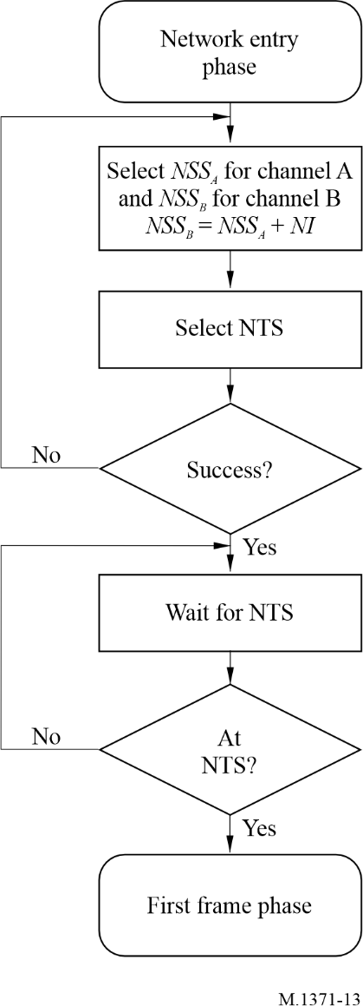

A2-3.3.5.2.1 Select nominal start slot
The nominal start slot (NSS) should be randomly selected between current slot and nominal increment (NI) slots forward. This slot should be the reference when selecting nominal slots (NS) during the first frame phase. The first NS should always be equal to NSS.

A2-3.3.5.2.2 Select nominal transmission slot
Within the SOTDMA algorithm, the nominal transmission slot (NTS) should be randomly selected among candidate slots within the SI. This is the NTS, which should be marked as internally allocated and assigned a random time-out between and including TMO_MIN and TMO_MAX.
If no available NTS can be selected, restart the process of selecting a new NSS, as described in § A2-3.3.5.2.1.

A2-3.3.5.2.3 Wait for nominal transmission slot
The station should wait until the NTS is approached.

A2-3.3.5.2.4 At nominal transmission slot
When the frame map indicates that the NTS is approaching, the station should enter the first frame phase.

A2-3.3.5.3 First frame phase
During the first frame phase which is equal to a 1 min interval, the station should continuously allocate its transmission slots and transmit special position reports (Message 3) using ITDMA (see Fig. 14).
figure 14
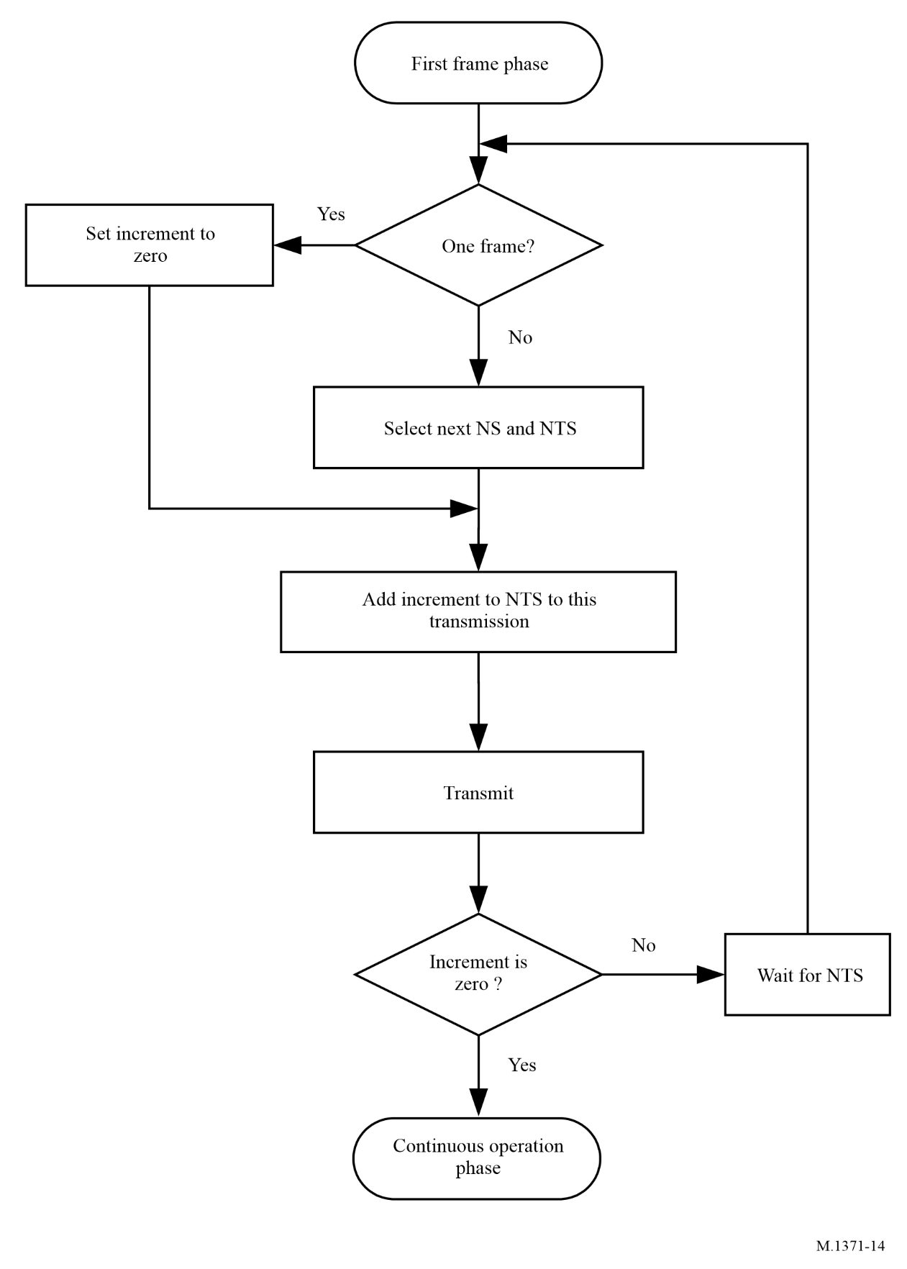

A2-3.3.5.3.1 Normal operation after one frame
When a 1 min interval has elapsed, the initial transmissions should have been allocated and normal operation should commence.

A2-3.3.5.3.2 Set increment to zero
When all allocations have been made after one frame, the increment should be set to zero in the last transmission to indicate that no more allocations will be made.

A2-3.3.5.3.3 Select next nominal slot and nominal transmission slot
Prior to transmitting, the next NS should be selected. This should be done by keeping track of the number of transmissions performed so far on the channel (from n to Rr – 1). The NS should be selected using the equation described in Table 16.
Nominal transmission slot should be selected using the SOTDMA algorithm to select among candidate slots within SI. The NTS should then be marked as internally allocated. The offset to next NTS should be calculated and saved for the next step.

A2-3.3.5.3.4 Add increment to this transmission
All transmissions in the first frame phase should use the ITDMA access scheme. This structure contains an increment from the current transmission to the next slot in which a transmission is due to occur. The transmission also sets the keep flag so that receiving stations will allocate the occupied slot for one additional frame.

A2-3.3.5.3.5 Transmit
The Message 3 should be entered into the ITDMA packet and transmitted in the allocated slot.

A2-3.3.5.3.6 Increment is zero
If the increment has been set to zero, the first frame phase should be considered to have ended. The station should now enter the continuous operation phase.

A2-3.3.5.3.7 Wait for nominal transmission slot
If the increment was non-zero, the station should wait for the next NTS and repeat the sequence.

A2-3.3.5.4 Continuous operation phase
The station should remain in the continuous operation phase until it shuts down, enters assigned mode or is changing its reporting interval (see Fig. 15).
figure 15
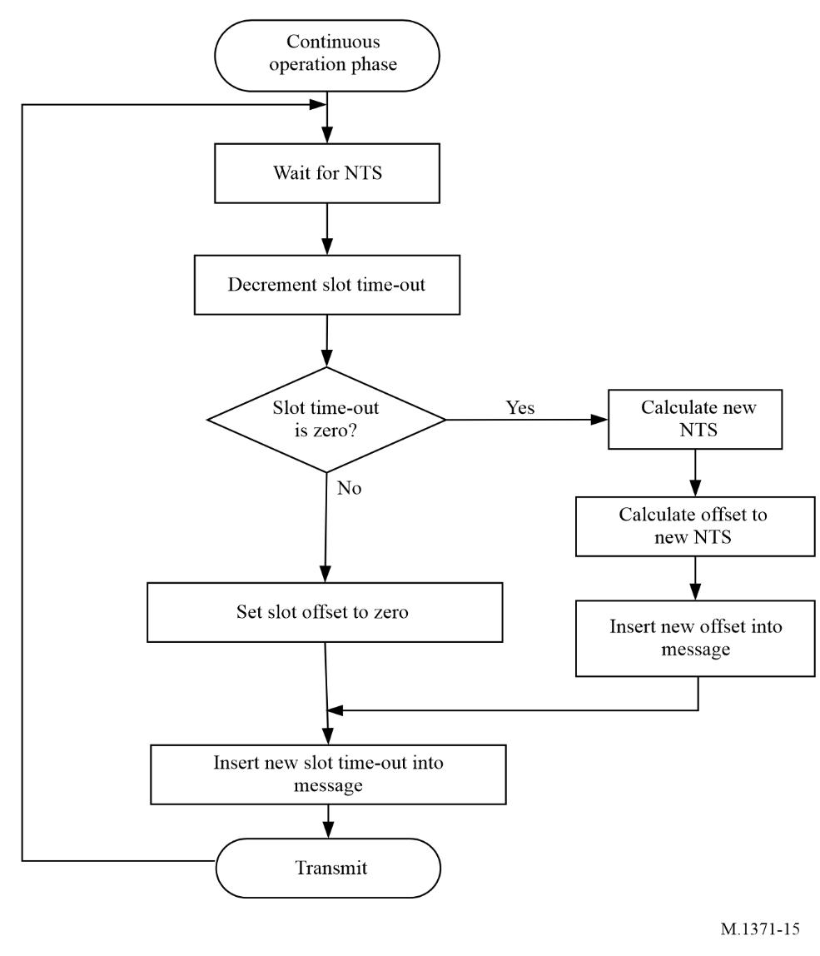

A2-3.3.5.4.1 Wait for nominal transmission slot
The station should now wait until this slot is approached.

A2-3.3.5.4.2 Decrement slot time-out
Upon reaching the NTS, the SOTDMA time-out counter, for that slot, should be decremented. This slot time-out specifies how many frames the slot is allocated for. The slot time-out should always be included as part of the SOTDMA transmission.

A2-3.3.5.4.3 Slot time-out is zero
If the slot time-out is zero, a new NTS should be selected. The SI around the NS should be searched for candidate slots and one of the candidates should be randomly selected. The offset from the current NTS and the new NTS should be calculated and assigned as a slot offset value:
(slot offset = NTS_{new} – NTS_{current} + 2 250)
The new NTS should be assigned a time-out value with a randomly selected value between and including TMO_MIN and TMO_MAX.
If the slot time-out is more than zero, the slot offset value should be set to zero.

A2-3.3.5.4.4 Assign time-out and offset to packet
The time-out and slot offset values are inserted into the SOTDMA communication state (see § A2-3.3.7.2.2).

A2-3.3.5.4.5 Transmit
A scheduled position report is inserted into the SOTDMA packet and transmitted in the allocated slot. The slot time-out should be decremented by one. The station should then wait for the next NTS.

A2-3.3.5.5 Changing reporting interval
When the nominal reporting interval is required to change, the station should enter change reporting interval phase (see Fig. 16). During this phase, it will reschedule its periodic transmissions to suit the new desired reporting interval.
The procedure, described in this section, should be used for changes which will persist for at least two frames. For temporary changes, ITDMA transmissions should be inserted between SOTDMA transmissions for the duration of the change.

A2-3.3.5.5.1 Wait for next transmit slot
Prior to changing its reporting interval, the station should wait for the next slot, which has been allocated for own transmission. Upon reaching this slot, the associated NS is set to the new NSS. The slot, which was allocated for own transmission, should be checked to make sure that the slot time-out is non-zero. If it is zero, the slot time-out should be set to one or the keep flag should set to true.

A2-3.3.5.5.2 Scan next selection interval
When using the new reporting interval, a new NI should be derived. With the new NI, the station should examine the area which is covered by the next SI. If a slot is found, which is allocated for own transmission, it should be checked to see if it is associated with the NSS. If so, the phase is complete and the station should return to normal operation. If not, the slot should be kept with a time-out above zero or the keep flag should set to TRUE.
If a slot was not found within the SI, a slot should be allocated. The offset, in slots, between the current transmit slot and the new allocated slot, should be calculated. The current transmit slot should be converted into an ITDMA transmission which should hold the offset with the keep flag set to TRUE.
The current slot should then be used for transmission of periodic messages such as a position report.
figure 16
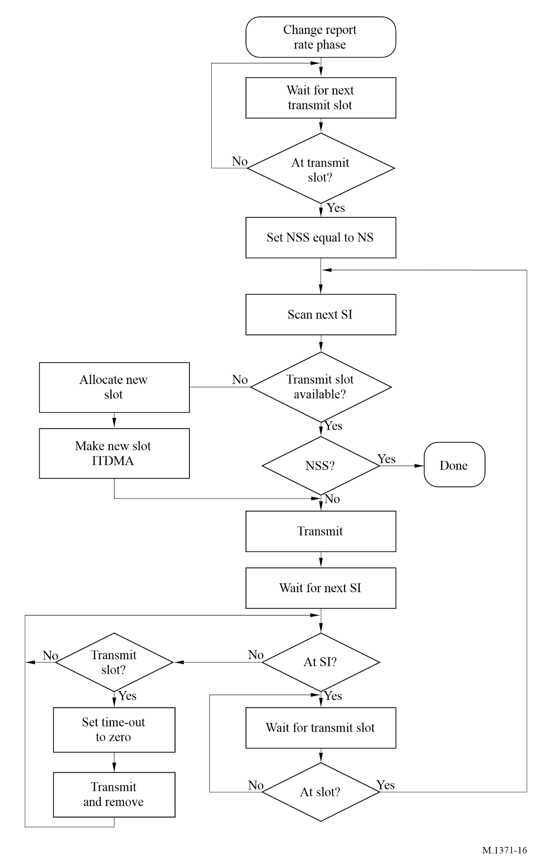

A2-3.3.5.5.3 Wait for next selection interval
While waiting for the next SI, the station continuously scans the frame for slots which are allocated for own transmission. If a slot is found, the slot time-out should be set to zero. After transmission in that slot, the slot should be freed.
When the next SI is approached, the station should begin to search for the transmit slot allocated within the SI. When found, the process should be repeated.

A2-3.3.6 Assigned operation
A station operating in the autonomous mode, may be commanded to operate according to a specific transmission schedule as defined in Message 16 or 23. Assigned mode applies to alternating operation between both channels.
When operating in the assigned mode, the Class B “SO” AIS station, Class B “CS” station and the SAR aircraft station should set their assign mode flag to “station operating in assigned mode”. The assigned mode should affect only the station’s transmission of position reports, and no other behaviour of the station should be affected. Mobile stations, other than Class A should transmit position reports as directed by Message 16 or 23, and the station should not change its reporting interval for changing course and speed.
Class A AIS stations should apply the same rule unless the autonomous mode requires a shorter reporting interval than the reporting interval as directed by Message 16 or 23. When operating in the assigned mode, the Class A AIS station should use Message 2 for transmission of position reports instead of Message 1.
If the autonomous mode requires a shorter reporting interval than that directed by Message 16 or 23, the Class A AIS station should use the reporting interval of the autonomous mode. If a temporary change of the autonomous reporting interval requires a shorter reporting interval than that directed by Message 16 or 23, ITDMA transmissions should be inserted between the assigned transmissions for the duration of the change. If a slot offset is given, it should be relative to the assignment transmission received. Assignments are limited in time and will be re-issued by the competent authority as needed. The last received assignment should continue or overwrite the previous assignment. This should also be the case, when two assignments are made in the same message 16 for the same station. Two levels of assignments are possible.

A2-3.3.6.1 Assignment of reporting interval
When assigned a new RI, the mobile station should continue to autonomously schedule its transmissions according to the rules of § A2-3.3.6. The process of changing to a new RI is described in § A2-4.3.

A2-3.3.6.2 Assignment of transmission slots
A station may be assigned the exact slots to be used for repeatable transmissions by a base station using the assigned mode command Message 16 (see § A2-4.5).

A2-3.3.6.2.1 Entering assigned mode
Upon receipt of the assigned mode command Message 16, the station should allocate the specified slots and begin transmission in these. It should continue to transmit in the autonomously allocated slots with a zero slot time-out and a zero slot offset, until those slots have been removed from the transmission schedule. A transmission with a zero slot time-out and a zero slot offset indicates that this is the last transmission in that slot with no further allocation in that SI.

A2-3.3.6.2.2 Operating in the assigned mode
The assigned slots should use the SOTDMA communication state, with the time-out value set to the time-out of the assigned slot. The assigned slot time-out should be between 3 and 7 for all assigned slots. For each frame, the slot time-out should be decremented.

A2-3.3.6.2.3 Returning to autonomous and continuous mode
Unless a new assignment is received, the assignment should be terminated, when the slot time-out reaches zero. At this stage, the station should return to autonomous and continuous mode.
The station should initiate the return to autonomous and continuous mode as soon as it detects an assigned slot with a zero slot time-out. This slot should be used to re-enter the network. The station should randomly select an available slot from candidate slots within a NI of the current slot and make this the NSS. It should then substitute the assigned slot for an ITDMA slot and should use this to transmit the relative increment to NTS. From this point on, the process should be identical to the network entry phase (see § A2-3.3.5.2).

A2-3.3.7 Message structure
Messages, which are part of the access schemes, should have the following structure shown in Fig. 17 inside the data portion of a data packet:
Figure 17
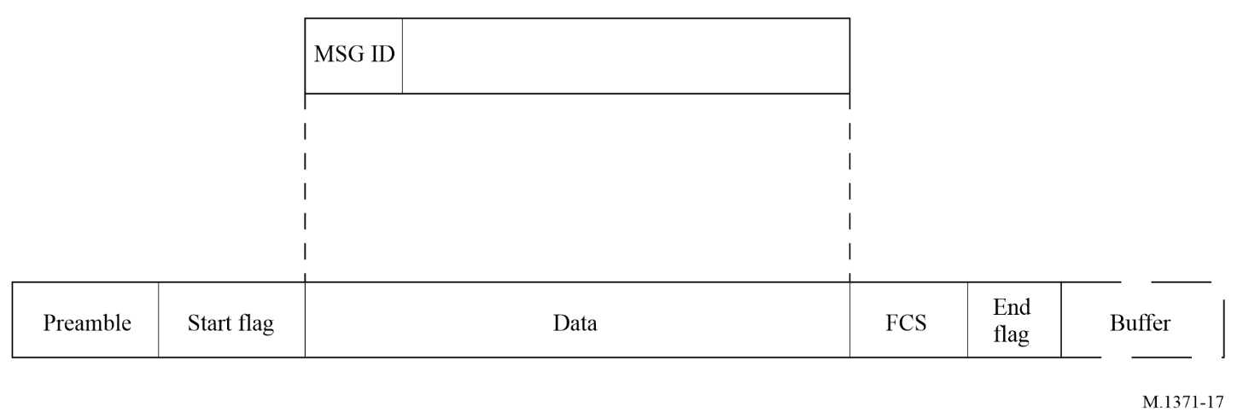
Each message is described using a table with parameter fields listed from top to bottom. Each parameter field is defined with the most significant bit first.
Parameter fields containing sub-fields (e.g. communication state) are defined in separate tables with sub-fields listed top to bottom, with the most significant bit first within each sub-field.
Character strings are presented left to right most significant bit first. All unused characters should be represented by the @ symbol, and they should be placed at the end of the string.
When data is output on the VHF data link it should be grouped in bytes of 8 bits from top to bottom of the table associated with each message in accordance with ISO/IEC 13239:2002. Each byte should be output with least significant bit first. During the output process, data should be subject to bit-stuffing (see § A2-3.2.2) and NRZI coding (see § A2-2.6).
Unused bits in the last byte should be set to zero in order to preserve byte boundary.
Table 17 shows a generic example for a message table.
TABLE 17
Parameter | Symbol | Number of bits | Description
P1 | T | 6 | Parameter 1
P2 | D | 1 | Parameter 2
P3 | I | 1 | Parameter 3
P4 | M | 27 | Parameter 4
P5 | N | 2 | Parameter 5
Unused | 0 | 3 | Unused bits

Logical view of data as described in § A2-3.3.7:

Bit order | M----L-- | M------- | -------- | -------- | --LML000
Symbol | TTTTTTDI | MMMMMMMM | MMMMMMMM | MMMMMMMM | MMMNN000
Byte order | 1 | 2 | 3 | 4 | 5

Output order to VHF data link (bit-stuffing is disregarded in the example):

Bit order | --L----M | -------M | -------- | -------- | 000LML--
Symbol | IDTTTTTT | MMMMMMMM | MMMMMMMM | MMMMMMMM | 000NNMMM
Byte order | 1 | 2 | 3 | 4 | 5

A2-3.3.7.1 Message identification
The message ID should be 6 bits long and should range between 0 and 63. The message ID should identify the message type.

A2-3.3.7.2 Self-organizing time division multiple access message structure
The SOTDMA message structure should supply the necessary information in order to operate in accordance with § A2-3.3.4.4. The message structure is shown in Fig. 18.
Figure 18
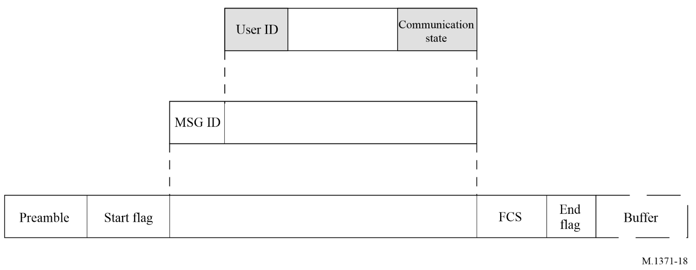

A2-3.3.7.2.1 Source identification
The source identification (source ID) should be the MMSI (Rec. ITU-R M.585 series). The MMSI is 30 bits long. Only numbers within 999999999 should be used.
The tenth digit as stated in Recommendation ITU-R M.1080 is not implemented.

A2-3.3.7.2.2 Self-organizing time division multiple access communication state
The communication state provides the following functions:
– it contains information used by the slot allocation algorithm in the SOTDMA concept;
– it also indicates the synchronization state.
The SOTDMA communication state is structured as shown in Table 18.
TABLE 18
Parameter | Number of bits | Description
Sync state | 2 | 0 UTC direct (see § A2-3.1.1.1)  1 UTC indirect (see § A2-3.1.1.2)  2 Station is synchronized to a base station (base direct) (see § A2-3.1.1.3)  3 Station is synchronized to another station based on the highest number of received stations or to another mobile station, which is directly synchronized to a base station  (see § A2-3.1.1.3 and § A2-3.1.1.4)
Slot time-out | 3 | Specifies frames remaining until a new slot is selected  0 means that this was the last transmission in this slot  1-7 means that 1 to 7 frames respectively are left until slot change
Sub message | 14 | The sub message depends on the current value in slot time-out as described in Table 19

The SOTDMA communication state should apply only to the slot in the channel where the relevant transmission occurs.

A2-3.3.7.2.3 Sub-messages
TABLE 19
Slot time-out | Sub-message | Description
3, 5, 7 | Received stations | Number of other stations (not own station) which the station currently is receiving (between 0 and 16 383).
2, 4, 6 | Slot number | Slot number used for this transmission (between 0 and 2 249).
1 | UTC hour and minute | If the station has access to UTC, the hour and minute should be indicated in this sub message. Hour (0-23) should be coded in bits 13 to 9 of the sub message (bit 13 is MSB). Minute (0-59) should be coded in bit 8 to 2 (bit 8 is MSB). Bit 1 and bit 0 are not used.
0 | Slot offset | If the slot time-out value is 0 (zero) then the slot offset should indicate the offset to the slot in which transmission will occur during the next frame. If the slot offset is zero, the slot should be de-allocated after transmission.

A2-3.3.7.3 Incremental time division multiple access message structure
The ITDMA message structure supplies the necessary information in order to operate in accordance with § A2-3.3.4.1. The message structure is shown in Fig. 19.
figure 19
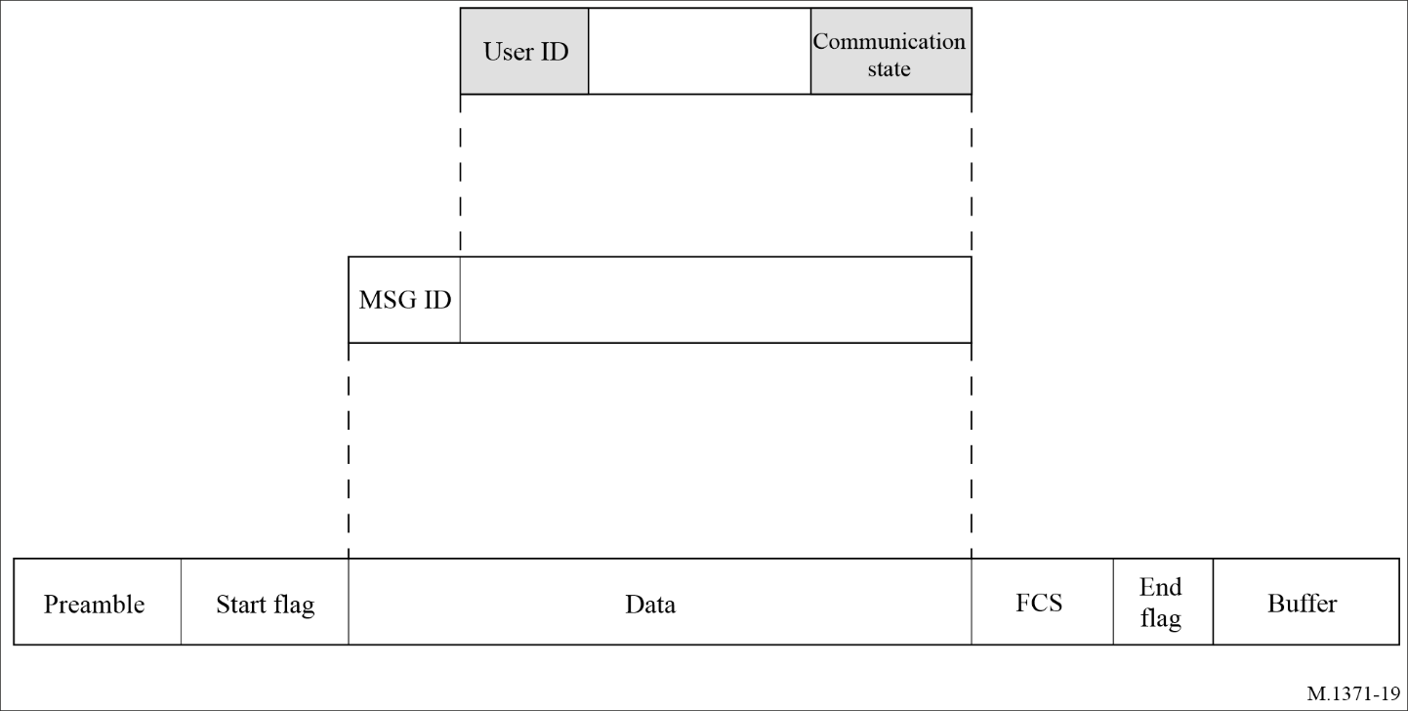

A2-3.3.7.3.1 Source identification
The source ID should be the MMSI (Rec. ITU-R M.585 series). The MMSI is 30 bits long. The first 9 digits (most significant digits) should be used only. The tenth digit as stated in Recommendation ITU-R M.1080 is not implemented.

A2-3.3.7.3.2 Incremental time division multiple access communication state
The communication state provides the following functions:
– it contains information used by the slot allocation algorithm in the ITDMA concept;
– it also indicates the synchronization state.
The ITDMA communication state is structured as shown in Table 20.
TABLE 20
Parameter | Number of bits | Description
Sync state | 2 | 0 UTC direct (see § A2-3.1.1.1)  1 UTC indirect (see § A2-3.1.1.2)  2 Station is synchronized to a base station (base direct) (see § A2-3.1.1.3)  3 Station is synchronized to another station based on the highest number of received stations or to another mobile station, which is directly synchronized to a base station (see § A2-3.1.1.3 and § A2-3.1.1.4)
Slot increment | 13 | Offset to next slot to be used, or zero (0) if no more transmissions
TABLE 20 (end)
Parameter | Number of bits | Description
Number of slots | 3 | Number of consecutive slots to allocate.  0 = 1 slot,  1 = 2 slots,  2 = 3 slots,  3 = 4 slots,  4 = 5 slots,  5 = 1 slot; offset = slot increment + 8 192,  6 = 2 slots; offset = slot increment + 8 192,  7 = 3 slots; offset = slot increment + 8 192.  Use of 5 to 7 removes the need for RATDMA broadcast for scheduled transmissions up to 6 min intervals
Keep flag | 1 | Set to TRUE = 1 if the slot remains allocated for one additional frame (see Table 13)

The ITDMA communication state should apply only to the slot in the channel where the relevant transmission occurs.

A2-3.3.7.4 Random access time division multiple access message structure
The RATDMA access scheme may use message structures determined by message ID and may thus lack a uniform structure.
A message with a communication state may be transmitted using RATDMA in the following situations:
– When initially entering the network (refer to § A2-3.3.4.1.1).
– When repeating a message.
A2-3.3.7.4.1 The communication state when initially entering the network should be set in accordance with § A2-3.3.4.1.1 and § A2-3.3.7.3.2.
A2-3.3.7.4.2 The communication state when repeating a message should be set in accordance with § A2-4.6.2.

A2-3.3.7.5 Fixed access time division multiple access message structure
The FATDMA access scheme may use message structures determined by message ID and may thus lack a uniform structure.
A message with a communication state may be transmitted using FATDMA, e.g. when repeated. In this situation, the communication state should be set in accordance with § A2-4.6.2.

A2-4 Network layer
The network layer should be used for:
– establishing and maintaining channel connections;
– management of priority assignments of messages;
– distribution of transmission packets between channels;
– data link congestion resolution.

A2-4.1 Multi-channel operation
In order to satisfy the requirements for multi-channel operation (see § A2-2.1.4), the following should apply.

A2-4.1.1 Operating frequency channels
Four frequencies have been designated in RR Appendix 18 for AIS use worldwide, on the high seas and in all other areas. The four designated frequencies are:
– AIS 1 (161.975 MHz);
– AIS 2 (162.025 MHz
– channel 75 (156.775 MHz), Message 27 transmission only; and
– channel 76 (156.825 MHz), Message 27 transmission only.

A2-4.1.2 Normal default mode of multi-channel operation
The normal default mode of operation should be two-channel receiving and four-channel transmitting, for shipborne AIS stations, where the AIS simultaneously receives on AIS 1 and AIS 2 in parallel.
Channel access is performed independently on each of the two parallel channels.
For periodic repeated messages, including the initial link access, the transmissions should alternate between AIS 1 and AIS 2 and also between channel 75 and channel 76 for the long-range AIS broadcast message by AIS stations defined in § A3-3.2. This alternating behaviour is on a transmission-by-transmission basis, without respect to time frames.
Transmissions of own station following slot allocation announcements of own station, responses of own station to interrogations, responses of own station to requests, and acknowledgements of own station should be transmitted on the same channel as the initial message received.
For addressed messages, transmissions should utilize the channel in which messages from the addressed station were last received.
For non-periodic messages other than those referenced above, the transmissions of each message, regardless of message type, should alternate between AIS 1 and AIS 2.
Base stations could alternate their transmissions between AIS 1 and AIS 2 for the following reasons:
– To increase link capacity.
– To balance channel loading between AIS 1 and AIS 2.
– To mitigate the harmful effects of RF interference.

A2-4.1.3 Regional operating areas
Regional operating areas should be designated by a Mercator projection rectangle with two reference points (WGS-84). The first reference point should be the geographical coordinate address of the north-eastern corner (to the nearest tenth of a minute) and the second reference point should be the geographical coordinate address of the south-western corner (to the nearest tenth of a minute) of the rectangle.
When a station is subject to the regional boundaries, it should immediately set its operating power level to the values as commanded. When a station is not subject to the regional boundaries, the station should utilize the default settings, which are defined in the following sections:
Power settings: § A2-2.12
Operating frequency channel numbers: § A2-4.1.1
Transmitter/receiver mode: § A2-4.1.2
If regional operating areas are used, the areas should be defined in such a way that these areas will be covered completely by transmissions by Message 22 from at least one base station.

A2-4.1.4 Geographical area power control
Power control by manual input should include the geographical area along with the designated power setting for use in that area (refer to Message 22). Manual input should be subject to override by Message 22 or shipborne system command, i.e. via Presentation Interface, in accordance with the rules laid out in § A2-4.1.6.
When the user requires a manual input of a regional operating setting, the regional operating settings in use, which may be the default operating settings, should be presented to the user. The user should then be allowed to edit these settings partly or in full. The AIS station should ensure that a regional operating area is always input and that it conforms to the rules for regional operating areas (see § A2-4.1.3). After completion of input of an acceptable regional operating settings set, the AIS should require the user to confirm a second time that the input data should be stored and possibly used instantaneously.

A2-4.1.5 Resumption of operation after power on
After power on, a mobile station should resume operation using the default settings, unless the own position is within any of the stored regions.
In this case, the mobile station should operate using the stored operating settings of that identified region.

A2-4.1.6 Priority of channel management commands and clearing of stored regional operating settings
The most current and applicable commands received should override previous channel management commands in accordance with the following rules:
The mobile AIS station should constantly check, if the nearest boundary of the regional operating area of any stored regional operating setting is more than 500 nautical miles away from the current position of own station, or if any stored regional operating setting was older than 24 hours. Any stored regional operating setting which fulfils any one of these conditions should be erased from the memory.
The regional operating settings set should be handled as a whole, i.e. a change requested for any parameter of the regional operating settings should be interpreted as a new regional operating setting.
The mobile AIS station should not accept, i.e. ignore, any new regional operating setting which includes a regional operating area, which does not conform to the rules for regional operating areas laid out in § A2-4.1.3.
The mobile AIS station should not accept a new regional operating setting which was input to it from a shipborne system command, i.e. via the Presentation Interface, if the regional operating area of this new regional operating setting partly or totally overlaps or matches the regional operating area of any of the stored regional operating settings, which were received from a base station either by Message 22 within the last two hours.
A Message 22 addressed to own station should be accepted only if the mobile AIS station is in a region defined by one of the stored regional operating settings. In this case the set of regional operating settings should be composed by combining the received parameters with the regional operating area in use.
If the regional operating area of the new, accepted regional operating setting overlaps in part or in total or matches the regional operating areas of one or more older regional operating settings, this or these older regional operating settings should be erased from the memory. The regional operating area of the new, accepted regional operating setting may be neighbouring tightly and may thus have the same boundaries as older regional operating settings. This should not lead to the erasure of the older regional operating settings.
Subsequently, the mobile AIS station should store a new, accepted regional operating setting in one free memory location of the eight memories for regional operating settings. If there is no free memory location, the most distant regional operating setting should be replaced by the new, accepted one. If the AIS station does not have position, it should delete the area most distant from the position provided in the channel management command.
No means other than defined herein should be allowed to clear any or all of the stored regional operating settings. In particular, it should not be possible to solely clear any or all of the stored regional operating settings by a manual input or by an input via the Presentation Interface without inputting a new regional operating setting.

A2-4.2 Distribution of transmission packets

A2-4.2.1 The user directory
The user directory is internal to the AIS, and it is used to facilitate slot selection and synchronization. It is also used to select the proper channel for the transmission of an addressed message.

A2-4.2.2 Routing of transmission packets
The following tasks are fulfilled with regard to packet routing:
– Position reports should be distributed to the presentation interface.
– Own position should be reported to the presentation interface and it should also be transmitted over the VDL.
– A priority is assigned to messages if message queuing is necessary.
– Received global navigation-satellite system (GNSS) corrections are output to the presentation interface.

A2-4.2.3 Management of priority assignments for messages
Messages are serviced in order of priority. This applies to both messages received and messages to be transmitted. Messages with the same priority are dealt with in FIFO order. There are 4 (four) levels of message priority, with Level 1 being the highest and Level 4 being the lowest (refer to Table 44).

A2-4.3 Changing reporting interval
The parameter, Rr, is defined in § A2-3.3.4.4.2 (Table 16) and should be directly related to reporting interval as defined in Tables 1 and 2. Rr should be determined by the network layer, either autonomously or as a result of an assignment by Message 16 (see § A7-3.3.14) or 23 (see § A7-3.21). The default value of the Rr should be as stated in Tables 1 and 2.
A mobile station should, when accessing the VDL for the first time, use the default value (refer to § A2-3.3.5.2). When a mobile station uses an Rr of less than one report per frame, it should use ITDMA for scheduling. Otherwise SOTDMA should be used.

A2-4.3.1 Autonomously changed Rr (continuous and autonomous mode)
This paragraph, including subparagraphs, applies to Class A and Class B “SO” AIS station.

A2-4.3.1.1 Speed
The Rr should be affected by changes of speed as described in this paragraph. Speed should be determined by speed over ground (SOG). When an increase in speed results in a higher Rr (see Tables 1 and 2) than the currently used Rr, the station should increase the Rr using the algorithm described in § A2-3.3.5. When a station has maintained a speed, which should result in an Rr lower than the currently used Rr, the station should reduce Rr when this state has persisted for three (3) min.
If speed information is lost during normal operation, the reporting schedule should revert to the default reporting interval, unless a new transmission schedule is ordered by assigned mode command.

A2-4.3.1.2 Changing course (applicable to Class A shipborne mobile and Class B “SO” station, only)
When a ship changes course, a shorter reporting interval should be required according to Table 1. Rr should be affected by changing course as described in this paragraph.
A change of course should be determined by calculating the mean value of the heading information (HDG) for the last 30 s and comparing the result with the present heading. When HDG is unavailable, the Course Over Ground (COG) may be used in place of the HDG when the station’s SOG is faster than 2 knots. If HDG is unavailable and SOG is slower than 2 knots, the Rr should not be affected.
If the difference exceeds 5 degrees, a higher Rr should be applied in accordance with Table 1. The higher Rr should be maintained by using ITDMA to complement SOTDMA scheduled transmissions in order to derive the desired Rr. When 5 degrees is exceeded, the reporting interval should be decreased beginning with a broadcast within the next 150 slots (see § A2-3.3.4.2.1) using either a scheduled SOTDMA slot, or a ITDMA access slot (see § A2-3.3.5.5).
The increased Rr should be maintained until the difference between the mean value of heading and present heading has been less than 5 degrees for more than 20 s.
If HDG is unavailable and SOG is slower than 2 knots during normal operation, the reporting schedule should revert to the default reporting interval, unless a new transmission schedule is ordered by assigned mode command.
When in assigned mode and a course change is requiring a shorter reporting interval than the interval that has been assigned, the station should:
– continue assigned mode (transmitting Message 2);
– keep the assigned mode schedule (slot or interval assigned); and
– add two additional Messages 3 between the basic Message 2, like in autonomous mode.

A2-4.3.1.3 Navigational status
Rr should be affected by navigational status (refer to Messages 1, 2 and 3) as described in this paragraph when the vessel is not moving faster than 3 knots (to be determined by using SOG). When the vessel is at anchor, or moored, which is indicated by the navigational status, and not moving faster than 3 knots, Message 3 should be used with an Rr of 3 min.
The navigational status should be set by the user via the appropriate user interface. The Rr should be maintained until the navigational status is changed or SOG increases to more than 3 knots.
When the vessel is at anchor, which is indicated by the navigational status, and anchor dragging with a speed of less than 3 knots, the reporting interval of Class A AIS should be automatically changed to 10 seconds (see Table 1 for details).

A2-4.3.2 Assigned Rr
A competent authority may assign an Rr to any mobile station by transmitting assignment Message 16 from a base station. Except for the Class A AIS station, an assigned Rr should have precedence over all other reasons for changing Rr. If the autonomous mode requires a higher Rr than that directed by Message 16, the Class A AIS station should use the Rr of autonomous mode.

A2-4.4 Data link congestion resolution
When the data link is loaded to such a level that no free slots are available for transmission, one of the following methods should be used to resolve the congestion.

A2-4.4.1 Intentional slot reuse by the own station
A station should reuse time slots only in accordance with this paragraph and only when own position is available.
When selecting new slots for transmission, the station should select from its candidate slot set (see § A2-3.3.1.2) within the desired SI. When the candidate slot set has less than 4 slots, the station should intentionally reuse available slots, in order to make the candidate slot set equal to 4 slots. Slots may not be intentionally reused from stations that indicate no position available. This may result in fewer than 4 candidate slots. The intentionally reused slots should be taken from the most distant station(s) within the SI. Slots allocated or used by base stations should not be used unless the base station is located over 120 NM from the own station. When a distant station has been subject to intentional slot reuse, that station should be excluded from further intentional slot reuse during a time period equal to one frame.
Slot reuse provides candidate slots for random selection. This process attempts to increase the candidate slot set to a maximum of four. When the candidate slot set has reached four, the candidate slot selection process is complete. If four slots have not been identified after all the rules have been applied, this process may report less than four slots. Candidate slots for reuse should be selected using the following priorities beginning with Rule 1 (see also the Slot selection rules flow diagram – Fig. 21).
Add to the candidate slot set all slots that are:
Rule 1: Free (see § A2-3.1.6) on selection channel and Available⁽¹⁾ (see § A2-3.1.6) on the other channel.
Rule 2: Available⁽¹⁾ on selection channel and Free on the other channel.
Rule 3: Available⁽¹⁾ on both channels.
Rule 4: Free on selection channel and Unavailable⁽²⁾ on the other channel.
Rule 5: Available⁽¹⁾ on selection channel and Unavailable⁽²⁾ on the other channel.
⁽¹⁾ Available – meaning that the slot is externally allocated by a station and is a possible candidate for slot reuse (see § A2-4.4.1).
⁽²⁾ Unavailable – meaning that the slot is externally allocated by a station and cannot be a candidate for slot reuse (see § A2-4.4.1).
Figure 20 is an example applying these rules.
figure 20
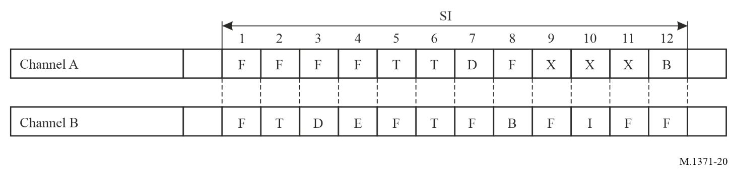
It is intended to reuse one slot within the SI of frequency channel A. The current status of the use of the slots within the SI on both frequency channels A and B is given as follows:
F: The slot is unused within the receiving range of the own station or allocated by a station beyond 120 NM (Free1)
I: Internally allocated (allocated by own station, not in use)
E: Externally allocated (allocated by another mobile station except most distant mobile station within 120 NM of own station) (Available2))
B: Allocated by a base station within 120 NM of own station, or a mobile station reporting without position information (Unavailable)
T: Another station under way that has not been received for 3 min or more (Free2)
D: Allocated by the most distant mobile station(s) within 120 NM of own station (Available1)
X: Should not be used.
The slot for intentional slot reuse should then be selected by the following priority (indicated by the number of the slot combination as given in Fig. 20):
Highest Selection Priority: No. 1
No. 2
No. 5
No. 6
No. 3
No. 4
No. 7
Lowest Selection Priority No. 8
Combinations 9, 10, 11 and 12 should not be used.
Rationale for not using slot combinations:
No. 9 Adjacent slot rule
No. 10 Opposite channel rule
No. 11 Adjacent slot rule
No. 12 Base station rule.
Figure 21
Slot selection rules flow diagram
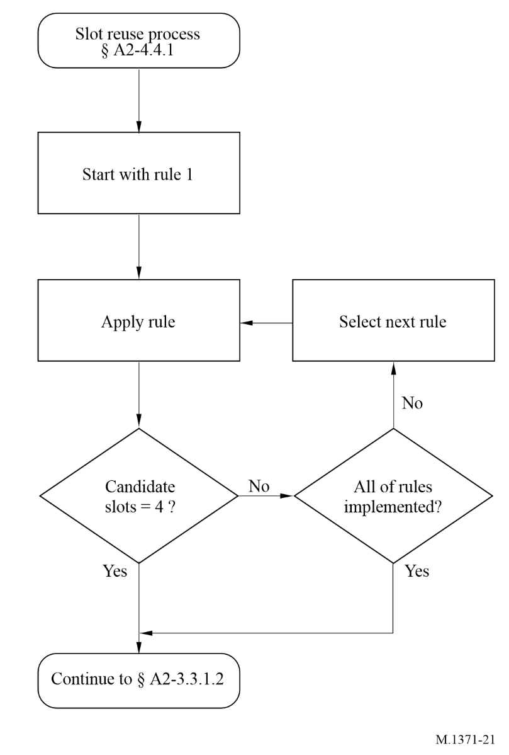

A2-4.4.2 Use of assignment for congestion resolution
A base station may assign Rr to all mobile stations except Class A AIS stations to resolve congestion and can thus protect the viability of the VDL. To resolve congestion for Class A AIS stations, the base station may use slot assignments to redirect slots used by the Class A AIS station to FATDMA reserved slots.

A2-4.5 Base station operation
A Base station accomplishes the following tasks:
– provides synchronization for stations not directly synchronized: base station reports (Message 4) with the default reporting interval;
– provides transmission slot assignments (see §§ A2-3.3.6.2 and A2-4.4.2);
– provides assignment of Rr to mobile station(s) (see §§ A2-3.3.6.1 and A2-4.3.2);
– transmits channel management messages, but does not respond to a Message 22;
– optionally provides GNSS corrections via the VDL by Message 17.

A2-4.6 Repeater application
Where it is necessary to provide extended coverage, repeater stations should be considered. The extended AIS environment may contain one or more repeaters. Base station may include a repeater function.
In order to implement this function efficiently and safely, the competent authority should perform a comprehensive analysis of the required coverage area and user traffic load, applying the relevant engineering standards and requirements.

A2-4.6.1 Repeat indicator

A2-4.6.1.1 Mobile station use of repeat indicator
When mobile station is transmitting a message, it should always set the repeat indicator to default = 0.

A2-4.6.1.2 Repeater station use of repeat indicator
The repeat indicator should be increased whenever the transmitted message is a repeat of a message already transmitted from another station.
When a base station is used to transmit messages on behalf of another entity (authority, AtoN, or a virtual or synthetic AtoN), that uses an MMSI other than the base station’s own MMSI, the repeat indicator of the transmitted message should be set to a non-zero value (as appropriate) in order to indicate that the message is a retransmission. The message can be communicated to the base station for retransmission using the VDL, network connection, station configuration, or other methods.

A2-4.6.1.2.1 Number of repeats
The number of repeats should be a repeater station configurable function, implemented by the competent authority.
The number of repeats should be set to either 1 or 2, indicating the number of further repeats required.
All repeaters within coverage of one another should be set to the same number of repeats, in order to ensure that “Binary acknowledgement” Message 7 and “Safety related acknowledgement” Message 13 are delivered to the originating station.
Each time a received message is processed by the repeater station, the repeat indicator value should be incremented by one (+1) before retransmitting the message. If the processed repeat indicator equals 3, the relevant message should not be retransmitted.

A2-4.6.2 Repeater operation
This is not a real-time application – additional use of slots is required (store-and-forward).
Retransmission of messages should be performed as soon as possible after receiving the relevant messages which are required to be retransmitted.
Retransmission (repeat) should be performed on the same channel in which the original message was received by the repeater station.

A2-4.6.2.1 Received messages
A received message requires additional processing before being retransmitted. The following processing is required:
– Select additional slot(s), required for re-transmitting message(s).
– Use the appropriate access scheme necessary to minimize conflicts on the VDL.
– The communication state of relevant received messages should be changed, and is subject to parameters required by the slot(s) selected for retransmission by the repeater station.

A2-4.6.2.2 Additional processing functionality
Filtering should be a function that is configurable by the repeater station, implemented by the competent authority.
Filtering of retransmissions should be applied, considering the following as parameters:
– Message types.
– Coverage area.
– Required message reporting interval (possibly increasing the reporting interval).

A2-4.6.2.3 Synchronization and slot selection
Intentional slot reuse (see § A2-4.4.1) should be performed when required. In order to assist in slot selection, measurement of received signal strength by the repeater station should be considered. The received signal strength indicator will indicate when two or more stations are transmitting in the same slot at approximately the same distance from the repeater station. A high level of received signal strength will indicate that the transmitting stations are close to the repeater, and a low level of received signal strength will indicate that the transmitting stations are farther away.
Congestion resolution on the VDL may be applied.

A2-4.7 Handling of errors related to packet sequencing and groups of packets
It should be possible to group transmission packets, which are addressed to another station (refer to addressed binary and addressed safety related messages) based on sequence number. Addressed packets should be assigned a sequence number by the transmitting station. The sequence number of a received packet should be forwarded together with the packet to the transport layer. Also, when errors related to packet sequencing and groups of packets are detected (see § A2-3.2.3), they should be handled by the transport layer as described in § A2-5.3.1.

A2-5 Transport layer
The transport layer is responsible for:
– converting data into transmission packets of correct size;
– sequencing of data packets;
– interfacing protocol to upper layers.
The interface between the transport layer and higher layers should be performed by the presentation interface.

A2-5.1 Definition of transmission packet
A transmission packet is an internal representation of some information which can ultimately be communicated to external systems. The transmission packet is dimensioned so that it conforms to the rules of data transfer.

A2-5.2 Conversion of data into transmission packets

A2-5.2.1 Conversion to transmission packets
The transport layer should convert data, received from the presentation interface, into transmission packets. If the length of the data requires a transmission using FATDMA reserved slots exceeding five (5) slots (see Table 21 for guidance) or, for a mobile AIS station, if the total number of RATDMA transmissions of Messages 6, 8, 12 and 14 in this frame exceeds 20 slots the AIS should not transmit the data, and it should respond with a negative acknowledgement to the presentation interface.
If the length of the data requires a transmission, without using FATDMA reserved slots, exceeding three (3) slots (see Table 21 for guidance) or, for a mobile AIS station, if the total number of RATDMA transmissions of Messages 6, 8, 12 and 14 in this frame exceeds 20 slots the AIS should not transmit the data, and it should respond with a negative acknowledgement to the presentation interface.
Table 21 is based on the assumption that the theoretical maximum of stuffing bits will be needed. A mechanism may be applied, which determines, prior to transmission, what the actually required bit stuffing will be with reference to § A2-3.2.2.1, depending on the actual content of the input for transmission from the presentation interface. If this mechanism determines that less stuffing bits than indicated in Table 21 would be needed, more data bits than indicated in Table 21 may be transmitted, applying the actually required number of stuffing bits. However, the total number of slots required for this transmission should not be increased by this optimization.
Taking into account that safety related and binary messages should be used, it is of importance that the variable messages are set on byte boundaries. In order to ensure that the required bit stuffing for the variable length messages is provided for in the worst-case condition, with reference to the packet format (see § A2-3.2.2.2) the following parameters should be used as a guideline:
TABLE 21
Number of slots | Maximum data bits | Stuffing bits | Total buffer bits
1 | 136 | 36 | 56
2 | 360 | 68 | 88
3 | 584 | 100 | 120
4 | 808 | 132 | 152
5 | 1 032 | 164 | 184

A2-5.3 Transmission packets

A2-5.3.1 Addressed Messages 6 and 12
Addressed messages should have a destination ID. The source station should anticipate an acknowledgement message (Message 7 or Message 13). If an acknowledgement is not received the station excluding Class B “SO” should retry the transmission. The station should wait 4 s before attempting retries. When a transmission is retried, the retransmit flag should be set to retransmitted. The number of retries should be 3, but it could be configurable between 0 and 3 retries by an external application via the presentation interface. When set to a different value by an external application, the number of retries should default to 3 retries after 8 min. The overall result of the data transfer should be forwarded to above layers. The acknowledgement should be between transport layers in two stations.
Each data transfer packet on the presentation interface should have a unique packet identifier consisting of the message type (binary or safety related messages), the source-ID, the destination-ID, and a sequence number.
The sequence number should be assigned in the appropriate presentation interface message which is input to the station.
The destination station should return the same sequence number in its acknowledgement message on the VDL.
The source station should not reuse a sequence number until it has been acknowledged or time-out has occurred.
The acknowledgement should be put first in the data transfer queue both on the presentation interface and on the VDL.
These acknowledgements are applicable only to the VDL. Other means must be employed for acknowledging applications.
See Fig. 22 and Annex 5.
figure 22
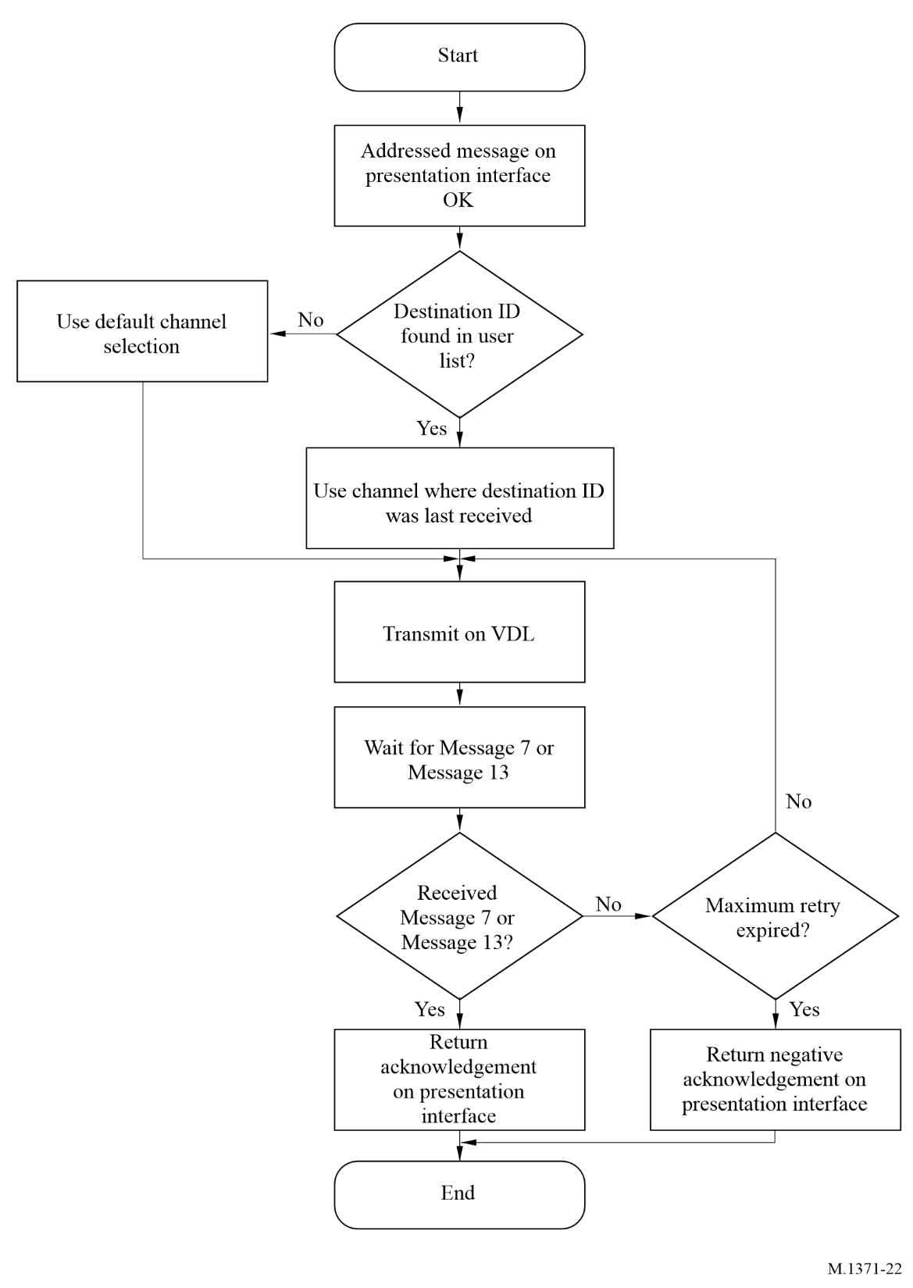

A2-5.3.2 Broadcast messages
A broadcast message lacks a destination identifier ID. Therefore, receiving stations should not acknowledge a broadcast message.

A2-5.3.3 Conversion to presentation interface messages
Each received transmission packet should be converted to a corresponding presentation interface message and presented in the order they were received regardless of message category. Applications utilizing the presentation interface should be responsible for their own sequencing numbering scheme, as required. For a mobile station, addressed messages should not be output to the presentation interface, if destination ID (destination MMSI) is different to the ID of own station (own MMSI).

A2-5.4 Presentation interface protocol
Data, which is to be transmitted by the AIS device, should be input via the presentation interface; data, which is received by the AIS device, should be output through the presentation interface. The formats and protocol used for this data stream are defined by IEC 61162.

Annex 3
Long-range applications

A3-1 General
Long-range applications should be by broadcast.

A3-2 Long-range applications by broadcast
Satellites with AIS receivers may receive AIS Message 27.

A3-2.1 Packet bit structure for the automatic identification system satellite uplink
Satellites with AIS receivers require suitable buffering in order to preserve the integrity of the AIS message in the AIS slot boundaries. Table 22 shows a modified packet bit structure that is designed to support reception of AIS messages by satellites with orbital altitudes up to 1 000 km.
TABLE 22
Modified packet bit structure for AIS satellite message reception
Slot composition | Bits | Notes
Ramp up | 8 | Standard
Training sequence | 24 | Standard
Start flag | 8 | Standard
Data field | 96 | Data field is 168 bits for other single-slot AIS messages. This field is shortened by 72 bits to support the long-range receiving system buffer
CRC | 16 | Standard
End flag | 8 | Standard
Long-range AIS receiving system buffer | 96 | Bit stuffing = 4 bits  Synch jitter (mobile station) = 3 bits  Synch jitter (mobile/satellite) = 1 bit  Propagation time delay difference = 87 bits  Spare = 1 bit
Total | 256 | Standard  NOTE – Only 160 bits are used in the 17 ms transmission

A3-2.2 Automatic identification system satellite message
The AIS satellite message – Message 27 – data field is shown in Table 83.
This message should be transmitted by shipborne mobile AIS classes A and B-SOTDMA only.

A3-2.3 Transmission method for automatic identification system satellite message
The AIS Message 27 should be transmitted using the multi-channel slot selection access (MSSA) (see § A3-2.3.2) at the current power setting. The AIS Message 27 may be controlled using AIS Message 4’s “transmission control for AIS satellite message” field, and AIS Message 23 used to define the AIS base stations’ control area. If the receiving station is within the control area and the transmission control is set to “disabled”, then the receiving station should not transmit the AIS Message 27. Channels 75 and 76 in RR Appendix 18 should be used to perform the long-range AIS broadcast as a transmit-only function.

A3-2.3.1 Transmission interval
The nominal transmission interval for the AIS Message 27 should be 3 min.

A3-2.3.2 Access scheme
The access scheme for transmitting the AIS Message 27 should be MSSA which defines the access algorithm, using the AIS terrestrial channels (AIS 1, AIS 2), should be used to select a slot, but the transmission is on Channels 75 and 76.
NOTE – The purpose is to avoid transmitting during slots when the unit expects to receive messages from other AIS stations.

A3-2.3.3 Automatic identification system shore station qualifier
The transmission of the AIS Message 27 should normally be active. When the AIS station identifies that it is within the base station coverage area the transmission should be left to the decision of the competent authority. This is done by using Message 4 in conjunction with Message 23 with station type 10 to define the “base station coverage area”; all other fields will be ignored. This base station coverage area should be calculated according to the rules described in § A2-4.1.3.
Control of the AIS Message 27 requires the reception of both the Message 4 with the control setting “off” for the transmission of Message 27 and a Message 23 with the definition of the base station coverage area. After verification that the AIS station is within the base station coverage area it should stop transmission of Message 27. Control of the AIS station by the base station will time out within 3 minutes of the last Message 4 from that base station. If the AIS station does not receive a Message 4 and Message 23, it should revert to its nominal behaviour after 3 min.

A3-2.3.4 Transmitting the AIS Message 27
The AIS Message 27 should be transmitted only on channels 75 and 76 and not on the AIS channels (AIS 1, AIS 2 or regional channels). The transmissions should alternate between these two channels such that each channel is used once every 6 min.

Annex 4
Application specific messages

A4-1 General
AIS messages where the data content is defined by the application are application specific messages. Examples of this are the binary Messages 6, 8, 25 and 26. The data content does not affect the operation of the AIS. AIS is a means for transferring the data content between stations. A functional message’s data structure consists of an application identifier (AI) followed by the application data.

A4-1.1 Binary messages
A binary message consists of three parts:
– Standard AIS framework (message ID, repeat indicator, source ID, and, for addressed binary messages, a destination ID)
– 16-bit application identifier (AI = DAC + FI), consisting of:
– 10-bit designated area code (DAC) – based on the maritime identification digit (MID);
– 6-bit function identifier (FI) – allows for 64 unique application specific messages.
– Data content (variable length up to a given maximum).

A4-1.2 Definition of application identifiers
The application identifier uniquely identifies the message and its contents. The application identifier is a 16-bit number used to identify the meaning of the bits making up the data content. The use of application identifiers is defined in § A4-2.
The DAC is a 10-bit number. DAC assignments are:
– international (DAC = 1-9), maintained by international agreement for global use;
– regional (10 ≤ DAC ≤ 999), maintained by the regional authorities affected;
– future use (1000 ≤ DAC ≤ 1023), reserved for future use;
– test (DAC = 0), used for test purposes.
It is recommended that DAC 2-9 be used to identify subsequent versions of international specific messages and that the administrator of application specific messages base the DAC selection on the MID of the administrator’s country or region. It is the intention that any application specific message can be utilized worldwide. The choice of the DAC does not limit the area where the message can be used.
The function identifier (FI) is a 6-bit number assigned to uniquely identify the data content structure within an application under a DAC assignment. Each DAC can support up to 64 applications.
– The definition of the technical characteristics, as defined in Annexes 2 and 3, of any AIS station covers layers 1 to 4 of the open systems interconnection (OSI) model, only (see § A2-1).
– The layers 5 (session layer), 6 (presentation layer) and 7 (application layer, that includes the human-machine-interface) should be in accordance with the definitions and guidelines given in this Annex in order to avoid application conflicts.

A4-1.3 Definition of function messages
Each unique combination of application identifier (AI) and application data forms a functional message. The coding and decoding of the data content of a binary message is based on a table identified by the AI value. Tables identified by an International AI (IAI) value should be maintained and published by the international authority responsible for defining international function messages (IFM). Maintenance and publication of regional AI tables (RAI), defining regional function messages should be the responsibility of national or regional authorities.
Table 24 identifies up to ten IFM designed to provide support for any implementation of broadcast and addressed binary messages (system applications). These are defined and maintained by ITU.

A4-2 Binary data structure
This chapter provides general guidance for developing the structure of the data content for broadcast and addressed binary messages.

A4-2.1 Application identifier
Addressed and broadcast binary messages should contain a 16-bit application identifier, structured as follows:
TABLE 23
Bit | Description
15-6 | Designated area code (DAC). This code is based on the maritime identification digits (MID). Exceptions are 0 (test) and 1-9 (international). Although the length is 10 bits, the DAC codes equal to or above 1 000 are reserved for future use
5-0 | Function identifier. The meaning should be determined by the authority which is responsible for the area given in the designated area code

Whereas the application identifier allows for regional applications, the application identifier should have the following special values for international compatibility.

A4-2.1.1 Test application identifier
The test application identifier (DAC = 0) with any function identifier (0 to 63) should be used for testing purposes. The function identifier is arbitrary.

A4-2.1.2 International application identifier
The international application identifier (DAC = 1-9) should be used for international applications of global relevance. Specific international applications are identified by a unique function identifier (see Table 24).
TABLE 24
Application identifier (decimal) |  | Application identifier (binary) |  | Description
DAC | Function identifier | DAC | Function identifier | Description
001 | 00 | 0000 0000 01 | 00 0000 | IFM 0 = Text telegram 6-bit ASCII (§ A4-5.1)
001 | 01 | 0000 0000 01 | 00 0001 | Discontinued
001 | 02 | 0000 0000 01 | 00 0010 | IFM 2 = Interrogation on specific IFM (§ A4-5.2)
001 | 03 | 0000 0000 01 | 00 0011 | IFM 3 = Capability interrogation (§ A4-5.3)
001 | 04 | 0000 0000 01 | 00 0100 | IFM 4 = Capability interrogation reply (§ A4-5.4)
001 | 05 | 0000 0000 01 | 00 0101 | IFM 5 = Application acknowledgement to an addressed binary message (§ A4-5.5)
001 | 06 to 09 | 0000 0000 01 | – | Reserved for future system applications
001 | 10 to 63 | 0000 0000 01 | – | Reserved for international operational applications

A4-3 Guidelines for creating functional messages
Slot use by functional messages should take into account the system level impact on the VHF data link loading.

A4-3.1 International functional messages
The following should be considered when creating international functional messages:
– published international functional messages (see IMO(1) and ITU documents);
– legacy and compatibility issues with current, superseded, or obsolete message structures;
– period of time needed to formally introduce a new functionality;
– each functional message should have a unique identifier (AI);
– limited number of available international functional identifiers.

A4-3.2 Regional functional messages
The following should be considered when creating regional functional messages:
– published regional and international functional messages;
– legacy and compatibility issues with current, superseded or obsolete message structures (e.g. 3-bit FI version indicator);
– period of time needed and cost to formally introduce a new functionality;
– each functional message should have a unique identifier (AI);
– limited number of functional identifiers allocated for local, regional, national, or multinational use;
– requirements for encrypted messages.
NOTE – IMO Safety of Navigation Circular, SN.1/Circ. 289, Guidance on the use of AIS application-specific messages.

A4-4 Guidelines for drafting functional messages
When developing functional messages, the following should be considered:
– a message for test and evaluation purposes to ensure integrity in an operational system;
– rules given in § A2-3.3.7 (Message structure), and § A7-3 (Message descriptions);
– values for not available, normal, or malfunctioning should be defined for every data field, as appropriate;
– default values should be defined for each data field.
When position information is included, in addition to latitude and longitude, and if applicable, it should comprise data fields in the following order (see AIS Messages 1 and 5):
– position accuracy;
– longitude;
– latitude;
– precision;
– type of electronic position fixing device;
– time stamp.
When transmitting time and/or date information, other than time stamp for position information, this information should be as defined as follows (see AIS Message 4):
– UTC year: 1-9999; 0 = UTC year not available = default (14 bits)
– UTC month: 1-12; 0 = UTC month not available = default (4 bits)
– UTC day: 1-31; 0 = UTC day not available = default (5 bits)
– UTC hour: 0-23; 24 = UTC hour not available = default (5 bits)
– UTC minute: 0-59; 60 = UTC minute not available = default (6 bits)
– UTC second: 0-59; 60 = UTC second not available = default (6 bits).
When transmitting information on direction of movement, this should be defined as direction of movement over ground (see AIS Message 1).
All data fields of the functional messages should observe byte boundaries. If needed to align with byte boundaries, spares should be inserted.
Applications should minimize slot use, taking into account buffering and bit-stuffing, see Annex 2 at the appropriate definition of the binary message.

A4-5 Definitions of system related international function messages

A4-5.1 International function message 0: Text using 6-bit ASCII
IFM 0 is used by applications that use AIS stations to transfer 6-bit ASCII text between applications. The text can be sent with binary Message 6, 8, 25 or 26. The parameter, “acknowledge required flag”, should be set to 0 when broadcast with Message 8, 25 or 26.
When long text strings are sub-divided, an 11-bit “text sequence number” is used. The text sequence number is used by the originating application to sub-divide the text and by the recipient application to re-assemble the text. The text sequence numbers for each sub-division should be selected to be contiguous and always increasing (110, 111, 112, …). If multiple texts are being transferred, the text sequence numbers should be chosen to associate correctly the sub-divided text with the correct text strings.
TABLE 25
International function message 0 using Message 6, addressed binary message
Parameter | Number of bits | Description
Message ID | 6 | Identifier for Message 6; always 6
Repeat indicator | 2 | Used by the repeater to indicate how many times a message has been repeated. See § A2-4.6.1; 0-3; 0 = default;  3 = do not repeat any more
Source ID | 30 | Identity (in the maritime mobile service) of the source of the message (see RR Art. 19 and Rec. ITU-R M.585)
Sequence number | 2 | 0-3; see § A2-5.3.1
Destination ID | 30 | Identity (in the maritime mobile service) of the destination of the message (see RR Art. 19 and Rec. ITU-R M.585)
Retransmit flag | 1 | Retransmit flag should be set upon retransmission: 0 = no retransmission = default; 1 = retransmitted
Spare | 1 | Should be set to zero. Reserved for future use.
DAC | 10 | International DAC = 1₁₀ = 0000000001₂
FI | 6 | Function identifier = 0₁₀ = 000000₂
Acknowledge required flag | 1 | 1 = reply is required, optional for addressed binary messages and not used for binary broadcast messages  0 = reply is not required, optional for an addressed binary message and required for binary broadcast messages
Text sequence number | 11 | Sequence number to be incremented by the application.  All zeros indicates that sequence numbers are not being used
Text string | 6-906 | 6-bit ASCII as defined in Table 45. When using this IFM, the number of slots used for transmission should be minimized taking into account Table 29.  For Message 6 the maximum is 906.
Spare bits | Max 6 | Not used for data and should be set to zero. The number of bits should be either 0, 2, 4, or 6 to maintain byte boundaries.  NOTE 1 – When a 6-bit spare is needed to satisfy the 8-bit byte boundary rule, the 6-bit spare will be interpreted as a valid 6-bit character (all zeros is the “@” character). This is the case when the number of characters is: 1, 5, 9, 13,17, 21, 25, etc.
Total number of application data bits | 112-1 008 | For Message 6 the maximum is 920.

TABLE 26
International function message 0 using Message 8, broadcast binary message
Parameter | Number of bits | Description
Message ID | 6 | Identifier for Message 8; always 8
Repeat indicator | 2 | Used by the repeater to indicate how many times a message has been repeated. See § A2-4.6.1; 0-3; 0 = default;  3 = do not repeat any more
Source ID | 30 | Identity (in the maritime mobile service) of the source of the message (see RR Art. 19 and Rec. ITU-R M.585)
Spare | 2 | Should be set to zero. Reserved for future use.
DAC | 10 | International DAC = 1₁₀ = 0000000001₂
FI | 6 | Function identifier = 0₁₀ = 000000₂
Acknowledge required flag | 1 | 1 = reply is required, optional for addressed binary messages and not used for binary broadcast messages  0 = reply is not required, optional for an addressed binary message and required for binary broadcast messages
Text sequence number | 11 | Sequence number to be incremented by the application.  All zeros indicate that sequence numbers are not being used
Text string | 6-936 | 6-bit ASCII as defined in Table 45. When using this IFM, the number of slots used for transmission should be minimized taking into account Table 29.  For Message 8 the maximum is 936.
Spare bits | Max 6 | Not used for data and should be set to zero. The number of bits should be either 0, 2, 4, or 6 to maintain byte boundaries.  NOTE 1 – When a 6-bit spare is needed to satisfy the 8-bit byte boundary rule, the 6-bit spare will be interpreted as a valid 6-bit character (all zeros is the “@” character). This is the case when the number of characters is: 1, 5, 9, 13,17, 21, 25, etc.
Total number of application data bits | 80-1 008

TABLE 27
International function message 0 using Message 25, broadcast or addressed binary message
Parameter | Number of bits | Description
Message ID | 6 | Identifier for Message 25; always 25
Repeat indicator | 2 | Used by the repeater to indicate how many times a message has been repeated. See § A2-4.6.1; 0-3; 0 = default;  3 = do not repeat any more
Source ID | 30 | Identity (in the maritime mobile service) of the source of the message (see RR Art. 19 and Rec. ITU-R M.585)
Destination indicator | 1 | 0 = Broadcast (no Destination ID field used)  1 = Addressed (Destination ID uses 30 data bits for MMSI)
Binary data flag | 1 | Always 1
Destination ID | 0/30 | Identity (in the maritime mobile service) of the destination of the message (see RR Art. 19 and Rec. ITU-R M.585) | If Destination indicator = 0 (Broadcast), no data bits are needed for Destination ID.  If Destination indicator = 1, 30 bits are used for Destination ID and spare bits for byte alignment.
Spare | 0/2 | Spare (if Destination ID used)
DAC | 10 | International DAC = 1₁₀ = 0000000001₂
FI | 6 | Function identifier = 0₁₀ = 000000₂
Text sequence number | 11 | Sequence number to be incremented by the application.  All zeros indicate that sequence numbers are not being used.
Text string | 6-66/6-96 | 6-bit ASCII as defined in Table 45. When using this IFM, the number of slots used for transmission should be 1 taking into account Table 29.  For Message 25 the maximum is 66 for Addressed or 96 for Broadcast.
Spare bits | Max 7 | Not used for data and should be set to zero. The number of bits should be either 1, 3, 5 or 7 to maintain byte boundaries.  NOTE 1 – When a 7-bit spare is needed to satisfy the 8-bit byte boundary rule, the 6-bit spare will be interpreted as a valid 6-bit character (all zeros is the “@” character). This is the case when the number of characters is: 1, 5, 9 and 13.
Total number of application data bits | 112-168/  80-168 | 112-168 bits for Addressed, or 80-168 bits for Broadcast.

TABLE 28
International function message 0 using Message 26, broadcast or addressed binary message
Parameter | Number of bits | Description
Message ID | 6 | Identifier for Message 26; always 26
Repeat indicator | 2 | Used by the repeater to indicate how many times a message has been repeated. See § A2-4.6.1; 0-3; 0 = default;  3 = do not repeat any more
Source ID | 30 | Identity (in the maritime mobile service) of the source of the message (see RR Art. 19 and Rec. ITU-R M.585)
Destination indicator | 1 | 0 = Broadcast (no Destination ID field used)  1 = Addressed (Destination ID uses 30 data bits for MMSI)
Binary data flag | 1 | Always 1
Destination ID | 0/30 | Identity (in the maritime mobile service) of the destination of the message (see RR Art. 19 and Rec. ITU-R M.585). | If Destination indicator = 0 (Broadcast), no data bits are needed for Destination ID.  If Destination indicator = 1, 30 bits are used for Destination ID and spare bits for byte alignment.
Spare | 0/2 | Spare (if Destination ID used)
DAC | 10 | International DAC = 1₁₀ = 0000000001₂
FI | 6 | Function identifier = 0₁₀ = 000000₂
Text sequence number | 11 | Sequence number to be incremented by the application.  All zeros indicate that sequence numbers are not being used
Text string | 6-936/972 | 6-bit ASCII as defined in Table 45. When using this IFM, the number of slots used for transmission should be minimized taking into account Table 29.  For Message 26 the maximum is 936 for Addressed or 972 for Broadcast.
Spare bits | Max 7 | Not used for data and should be set to zero. The number of bits should be either 1, 3, 5 or 7 to maintain byte boundaries.  NOTE 1 – When a 7-bit spare is needed to satisfy the 8-bit byte boundary rule, the 6-bit spare will be interpreted as a valid 6-bit character (all zeros is the “@” character). This is the case when the number of characters is: 3, 7, 11, 15, 19, 23, 27, etc.
Communication state selector | 1 | 0 = SOTDMA communication state follows  1 = ITDMA communication state follows
Spare | 4 | Should be set to zero. Reserved for future use.
Communication state | 19 | SOTDMA communication state (see § A2-3.3.7.2.1),  if communication state selector flag is set to 0, or ITDMA communication state (§ A2-3.3.7.3.2), if communication state selector flag is set to 1
Total number of application data bits | 136-1 064/  104-1 064 | 136-1 064 bits for Addressed, or 104-1064 bits for Broadcast.

Table 29 gives an estimate of the maximum number of 6-bit-ASCII characters that can be in the application data field of the binary data parameter of Messages 6, 8, 25 and 26. The number of slots used will be affected by the bit stuffing process.
TABLE 29
Estimated number  of slots | Maximum number of 6-bit ASCII characters  based upon typical bit stuffing
Estimated number  of slots | Addressed binary  Message 6 | Broadcast binary  Message 8 | Message 25 |  | Message 26
Estimated number  of slots | Addressed binary  Message 6 | Broadcast binary  Message 8 | Addressed  binary | Broadcast  binary | Addressed  binary | Broadcast  binary
1 | 6 | 11 | 11 | 16 | 7 | 12
2 | 43 | 48 | − | − | 44 | 50
3 | 80 | 86 | − | − | 82 | 87
4 | 118 | 123 | − | − | 119 | 124
5 | 151 | 156 | − | − | 156 | 162
NOTE 1 – The 5-slot value accounts for the worst-case bit stuffing condition.

A4-5.2 International function message 2: Interrogation for a specific functional message
IFM 2 should be used by an application to interrogate (using Message 6) another application for the specified functional message.
The application responding to this interrogation should use an addressed binary message to reply.
TABLE 30
Parameter | Number of bits | Description
Message ID | 6 | Identifier for Message 6; always 6
Repeat indicator | 2 | Used by the repeater to indicate how many times a message has been repeated. See § A2-4.6.1; 0-3; 0 = default;  3 = do not repeat any more
Source ID | 30 | Identity (in the maritime mobile service) of the source of the message (see RR Art. 19 and Rec. ITU-R M.585)
Sequence number | 2 | 0-3; see § A2-5.3.1
Destination ID | 30 | Identity (in the maritime mobile service) of the destination of the message (see RR Art. 19 and Rec. ITU-R M.585)
Retransmit flag | 1 | Retransmit flag should be set upon retransmission:  0 = no retransmission = default; 1 = retransmitted
Spare | 1 | Should be set to zero. Reserved for future use.
DAC | 10 | International DAC = 1₁₀ = 0000000001₂
FI | 6 | Function identifier = 2₁₀ = 000010₂
Requested DAC code | 10 | IAI, RAI or test
Requested FI code | 6 | See appropriate FI reference document(s)
Spare bits | 64 | Should be set to zero, reserved for future use
Total number of bits | 168 | The resulting Message 6 occupies 1 slot.

A4-5.3 International function message 3: Capability interrogation
IFM 3 should be used by an application to interrogate (using Message 6) another application for the availability of application identifiers for the specified DAC. The request is made separately for each DAC.
IFM 3 can only be used as the data content of an addressed binary message.
TABLE 31
Parameter | Number of bits | Description
Message ID | 6 | Identifier for Message 6; always 6
Repeat indicator | 2 | Used by the repeater to indicate how many times a message has been repeated. See § A2-4.6.1; 0-3; 0 = default;  3 = do not repeat any more
Source ID | 30 | Identity (in the maritime mobile service) of the source of the message (see RR Art. 19 and Rec. ITU-R M.585)
Sequence number | 2 | 0-3; see § A2-5.3.1
Destination ID | 30 | Identity (in the maritime mobile service) of the destination of the message (see RR Art. 19 and Rec. ITU-R M.585)
Retransmit flag | 1 | Retransmit flag should be set upon retransmission:  0 = no retransmission = default; 1 = retransmitted
Spare | 1 | Should be set to zero. Reserved for future use.
DAC | 10 | International DAC = 1₁₀ = 0000000001₂
FI | 6 | Function identifier = 3₁₀ = 000011₂
Requested DAC code | 10 | IAI, RAI or test
Spare bits | 70 | Should be set to zero, reserved for future use
Total number of bits | 168 | The resulting Message 6 occupies 1 slot

A4-5.4 International function message 4: Capability reply
IFM 4 should be used by an application to reply (using Message 6) to a capability interrogation (IFM 3) function message. The reply contains the availability status of the application for each function identifier for the specified DAC.
The application should use an addressed binary message to reply to the interrogating application.
TABLE 32
Parameter | Number of bits | Description
Message ID | 6 | Identifier for Message 6; always 6
Repeat indicator | 2 | Used by the repeater to indicate how many times a message has been repeated. See § A2-4.6.1; 0-3; 0 = default;  3 = do not repeat any more
Source ID | 30 | Identity (in the maritime mobile service) of the source of the message (see RR Art. 19 and Rec. ITU-R M.585)
Sequence number | 2 | 0-3; see § A2-5.3.1

TABLE 32 (end)
Parameter | Number of bits | Description
Destination ID | 30 | Identity (in the maritime mobile service) of the destination of the message (see RR Art. 19 and Rec. ITU-R M.585)
Retransmit flag | 1 | Retransmit flag should be set upon retransmission:  0 = no retransmission = default; 1 = retransmitted
Spare | 1 | Should be set to zero. Reserved for future use.
DAC | 10 | International DAC = 1₁₀ = 0000000001₂
FI | 6 | Function identifier = 4₁₀ = 000100₂
DAC code | 10 | IAI, RAI or test
FI availability | 128 | FI capability table, pair of two consecutive bits should be used for every FI, in the order FI 0, FI 1, … FI 63.  First bit of pair:  0 = FI not available (default)  1 = FI available.  Second bit of the pair: reserved for future use; should be set to zero
Spare | 126 | Should be set to zero, reserved for future use
Total number of bits | 352 | The resulting Message 6 occupies 2 slots

A4-5.5 International function message 5: Application acknowledgement to an addressed binary message
When requested, IFM 5 should be used by an application to confirm the reception of an addressed binary message. An application should never acknowledge a binary broadcast message.
If the interrogating application does not receive an IFM 5, when requested, then the application should assume that addressed AIS station does not have an application attached to its Presentation Interface (PI).
If there is any application at the AIS station, it should not respond if the “Acknowledge Required Flag” is set to 0.
TABLE 33
Parameter | Number of bits | Description
Message ID | 6 | Identifier for Message 6; always 6
Repeat indicator | 2 | Used by the repeater to indicate how many times a message has been repeated. See § A2-4.6.1; 0-3; 0 = default;  3 = do not repeat any more
Source ID | 30 | Identity (in the maritime mobile service) of the source of the message (see RR Art. 19 and Rec. ITU-R M.585)
Sequence number | 2 | 0-3; see § A2-5.3.1
Destination ID | 30 | Identity (in the maritime mobile service) of the destination of the message (see RR Art. 19 and Rec. ITU-R M.585)
Retransmit flag | 1 | Retransmit flag should be set upon retransmission:  0 = no retransmission = default; 1 = retransmitted
TABLE 33 (end)
Parameter | Number of bits | Description
Spare | 1 | Should be set to zero. Reserved for future use.
DAC | 10 | International DAC = 1₁₀ = 0000000001₂
FI | 6 | Function identifier = 5₁₀ = 000101₂
DAC code of received functional message | 10 | Recommended to be spare
FI code of received functional message | 6
Text sequence number | 11 | Sequence number in the message being acknowledged as properly received  0 = default (no sequence number)  1-2 047 = sequence number of received functional message
AI available | 1 | 0 = received but AI not available  1 = AI available
AI response | 3 | 0 = unable to respond  1 = reception acknowledged  2 = response to follow  3 = able to respond but currently inhibited  4-7 = spare for future use
Spare | 49 | Should be set to zero, reserved for future use
Total number of bits | 168 | The resulting Message 6 occupies 1 slot

Annex 5
Sequencing of transmission packets
This Annex describes the method by which information should be exchanged between stations’ application layers (Application A and Application B) over the VDL through the PI.
The originating application assigns a sequence number to each transmission packet, using the addressed message. The sequence numbers can be 0, 1, 2 or 3. This number together with message type and destination gives the transmission a unique transaction identifier. This transaction identifier is communicated to the receiving application.
figure 23
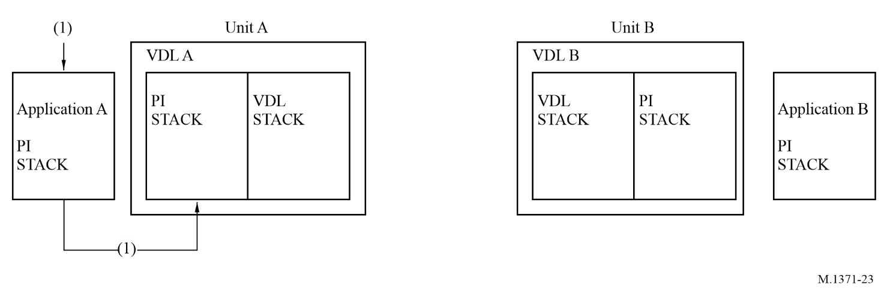
Step 1: Application A delivers four addressed messages addressed to B with sequence numbers 0, 1, 2 and 3 via PI.
figure 24
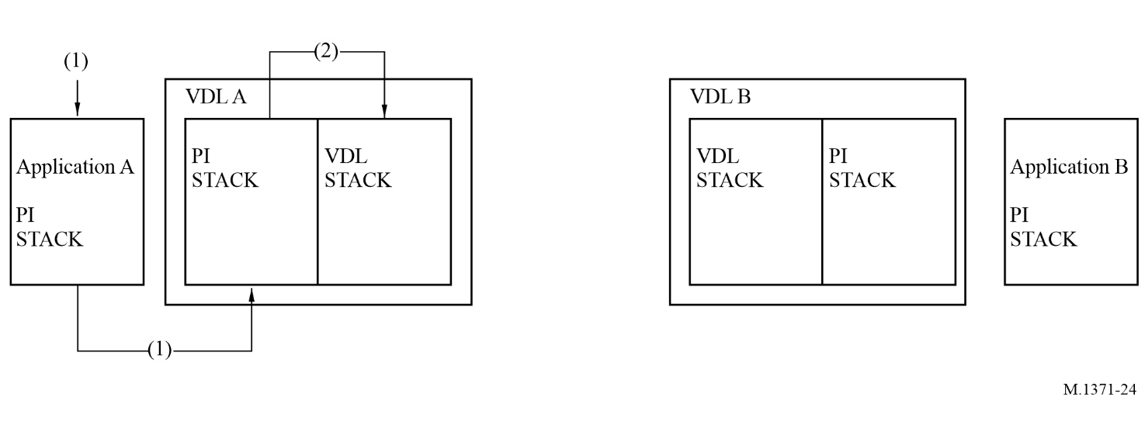
Step 2: VDL A receives addressed messages and puts them in the transmit queue.
figure 25
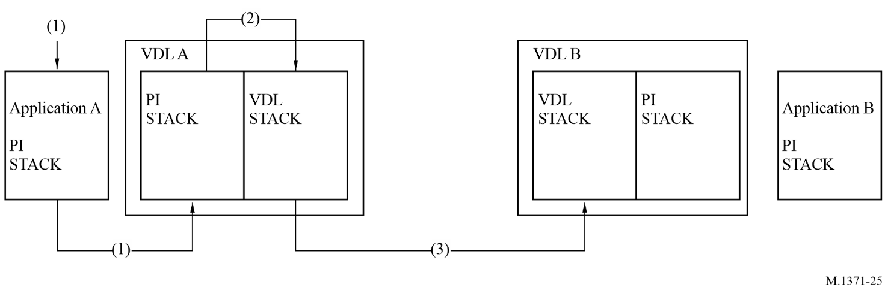
Step 3: VDL A transmits the messages to VDL B, which only receives messages with sequence numbers 0 and 3.
figure 26
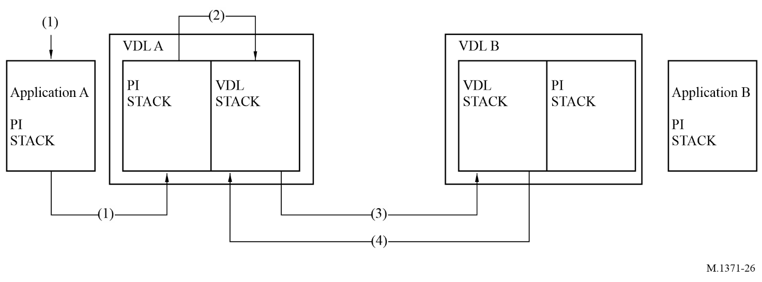
Step 4: DL B returns VDL-ACK messages with sequence numbers 0 and 3 to VOL A.
figure 27
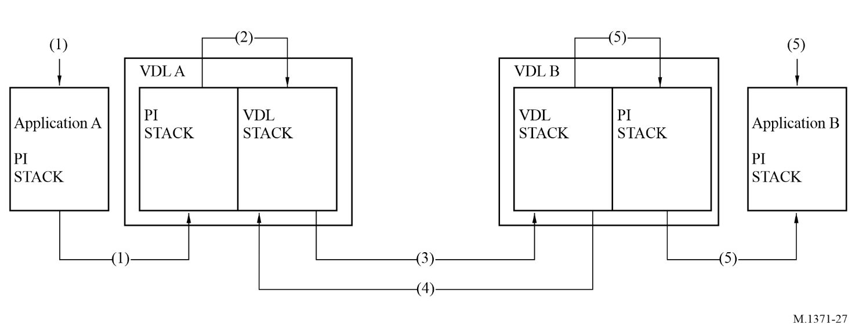
Step 5: VDL B delivers addressed messages with sequence numbers 0 and 3 to Application B.
figure 28
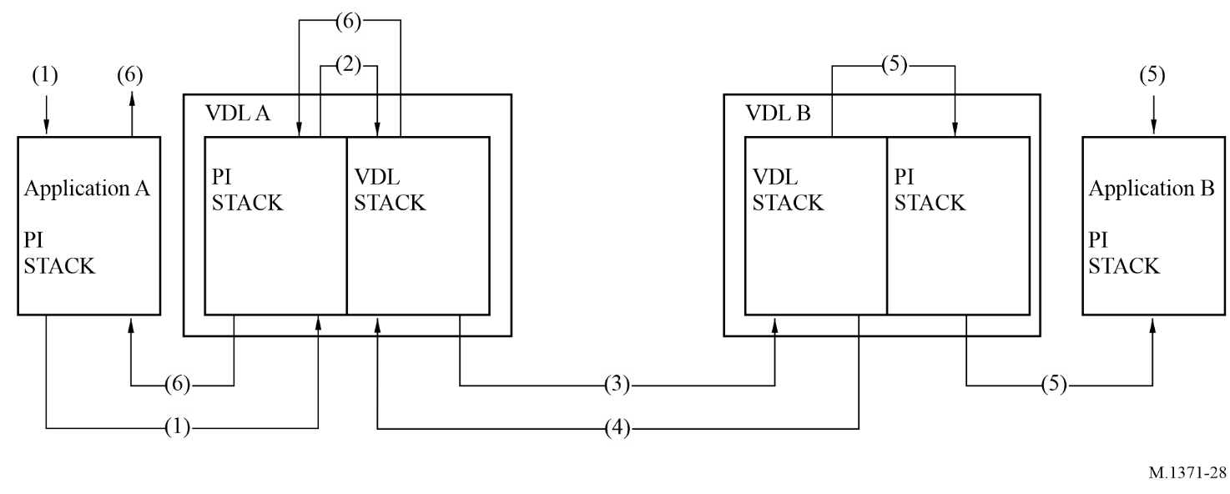
Step 6: VDL A returns PI-ACK (OK) to Application A with sequence numbers 0 and 3.
figure 29
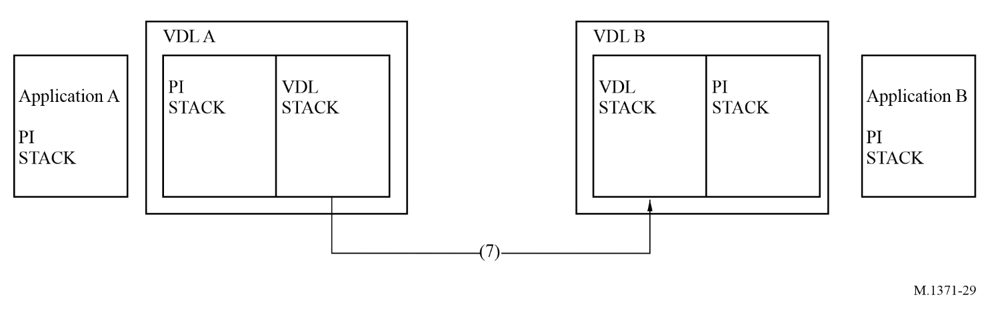
Step 7: VDL A times out on sequence numbers 1 and 2 and retransmits the addressed messages to VDL B.
figure 30
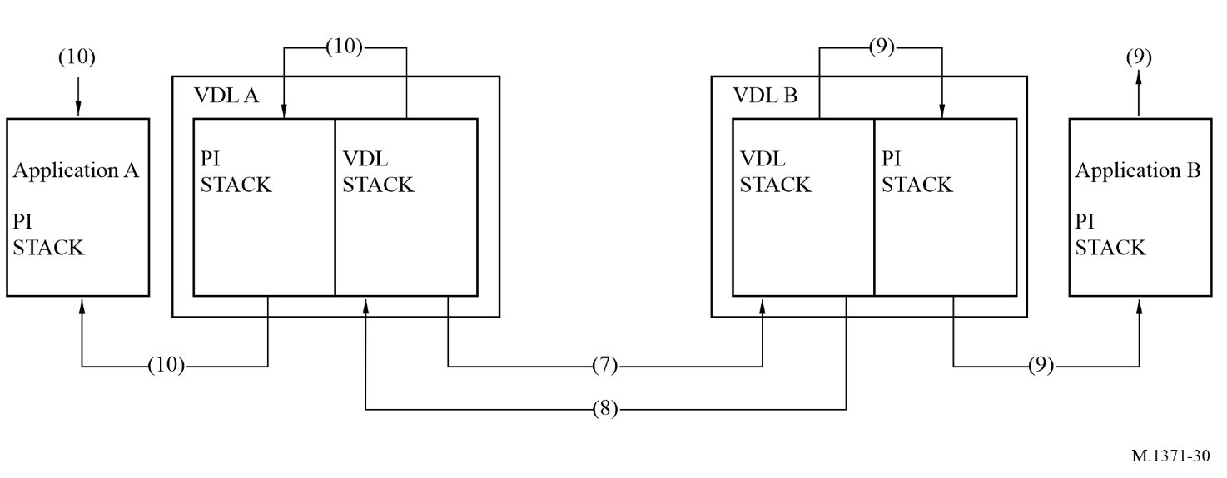
Step 8: VDL B successfully receives Message 2 and returns a VDL-ACK with sequence number 2.
Step 9: VDL B delivers ABM (addressed binary message) message with sequence number 2 to Application B.
Step 10: VDL A delivers PI-ACK (OK) with sequence number 2 to Application A.
figure 31
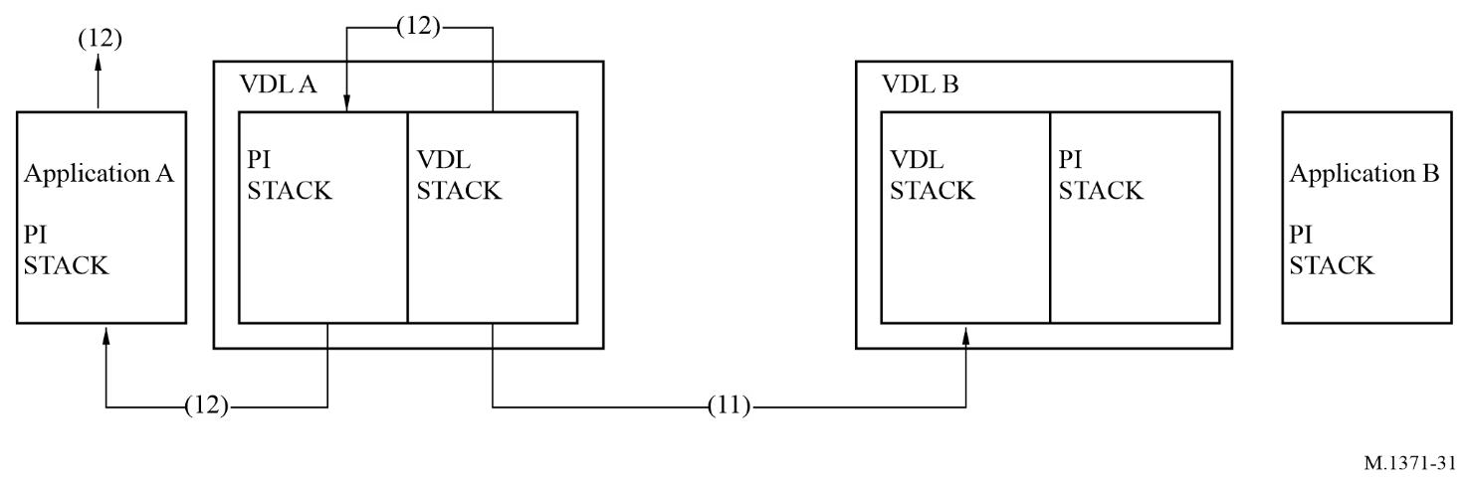
Step 11: VDL A retransmits message, with sequence number 1, but does not receive a VDL-ACK from VDL B. It does this two times and is unsuccessful in delivering message.
Step 12: VDL A, upon failing the transmit transaction of message with sequence number 1, delivers a PI-ACK (FAIL) to Application

Annex 6
Class B automatic identification system using carrier sense time division multiple access technology

A6-1 Definition
This Annex describes a Class B AIS using CSTDMA technology, subsequently referred to as Class B “CS”. The CSTDMA technology requires that the Class B “CS” unit listens to the AIS network to determine if the network is free of activity and transmits only when the network is free. The Class B “CS” unit is also required to listen for reservation messages and comply with these reservations. This polite operation ensures that a Class B “CS” will be interoperable and will not interfere with equipment that complies with Annex 2.

A6-2 General requirements

A6-2.1 General

A6-2.1.1 Capabilities of the Class B “CS” automatic identification system
The Class B “CS” AIS station should be inter-operable and compatible with Class A or other Class B AIS stations or any other AIS station operating on the AIS VHF data link. In particular, Class B “CS” AIS stations should receive other stations, should be received by other stations and should not degrade the integrity of the AIS VHF data link.
Transmissions from Class B “CS” AIS stations should be organized in “time periods” that are synchronized to VDL activity.
The Class B “CS” AIS should only transmit if it has verified that the time period intended for transmission does not interfere with transmissions made by equipment complying with Annex 2. Transmissions of the Class B “CS” AIS should not exceed one nominal time period.
An AIS station intended to operate in receive-only mode should not be considered a Class B AIS station.

A6-2.1.2 Modes of operation
The system should be capable of operating in a number of modes as described below subject to the transmission of messages by a competent authority. It should not retransmit received messages.

A6-2.1.2.1 Autonomous and continuous mode
An “autonomous and continuous” mode for operation in all areas transmitting Message 18 for scheduled position reporting and Message 24 for static data.
The Class B “CS” AIS should be able to receive and process messages at any time except during time periods of own transmission.

A6-2.1.2.2 Assigned mode
An “assigned” mode for operation in an area subject to a competent authority responsible for traffic monitoring such that:
– the reporting interval, silent mode and/or transceiver behaviour may be set remotely by that authority using group assignment by Message 23; or
– time periods are reserved by Message 20 (see § A7-3.18).

A6-2.1.2.3 Interrogation mode
A “polling” or controlled mode where the Class B “CS” AIS responds to interrogations for Messages 18 and 24 from a Class A AIS or a base station. An interrogation overrides a silent period defined by Message 23 (see § A7-3.21).
A Class B “CS” AIS should not interrogate other stations.

A6-3 Performance requirements

A6-3.1 Composition
The Class B “CS” AIS should comprise:
– A communication processor, capable of operating in a part of the VHF maritime mobile service (MMS) frequency band, in support of short-range, VHF, applications.
– At least one transmitter and two receiving processes for TDMA. The two TDMA receiving processes should work independently and simultaneously on AIS channels A and B.
– An internal GNSS position sensor, which provides a resolution of one ten thousandth of a minute of arc and uses the WGS-84 datum (see § A6-3.3).

A6-3.2 Operating frequency channels
The Class B “CS” AIS station should operate at AIS 1 and AIS 2.

A6-3.3 Internal global navigation satellite system receiver for position reporting
The Class B “CS” AIS should have an internal GNSS receiver as source for position, COG, and SOG.
The internal GNSS receiver may be capable of being differentially corrected, e.g. by evaluation of Message 17.
If the internal GNSS receiver is inoperative, the unit should not transmit Messages 18 and 24 unless interrogated by a base station.

A6-3.4 Identification
For the purpose of ship and message identification, the appropriate MMSI number should be used. The unit should only transmit if an appropriate MMSI is programmed.

A6-3.5 Automatic identification system Information

A6-3.5.1 Information content
The information provided by the Class B “CS” AIS should include (see Message 18, Table 68):

A6-3.5.1.1 Static
– Identification (MMSI)
– Name of ship
– Type of ship
– Manufacturer ID
– Call sign
– Dimensions of ship and reference for position.

A6-3.5.1.2 Dynamic
– Ship’s position with accuracy indication and integrity status
– Time (UTC seconds)
– Course over ground (COG)
– Speed over ground (SOG)
– True heading (optional).

A6-3.5.1.3 Configuration information
The following information about configuration and options active in the specific unit should be provided:
– AIS Class B “CS” unit
– Availability of minimum keyboard/display facility
– Ability to process channel management Message 22.

A6-3.5.1.4 Short safety-related messages
– Short safety-related messages, if transmitted, should be in compliance with, § A7-3.12.

A6-3.5.2 Information reporting intervals
The Class B “CS” AIS should transmit position reports (Message 18) in reporting intervals of:
– 15 s if SOG > 14 knots
– 30 s if SOG > 2 and SOG < = 14 knots
– 3 min if SOG ≤ 2 knots
provided that transmission time periods are available. A command received by Message 23 should override the reporting interval; a reporting interval of less than 5 s is not required.
Static data sub-messages 24A and 24B should be transmitted every 6 min in addition to and independent of the position report (see § A6-4.4.1). Message 24B should be transmitted within 1 min following Message 24A.

A6-3.5.3 Transmitter shutdown procedure
An automatic transmitter shutdown should be provided in the case that a transmitter does not discontinue its transmission within 1 s of the end of its nominal transmission. This procedure should be independent of the operating software.

A6-3.5.4 Static data input
Means should be provided to input and verify the static data prior to use. Among the static data it should not be possible for the user to alter the MMSI once programmed.

A6-4 Technical requirements

A6-4.1 General
This section covers layers 1 to 4 (physical layer, link layer, network layer, transport layer) of the OSI model (see § A2-1).

A6-4.2 Physical layer
The physical layer is responsible for the transfer of a bit stream from an originator to the data link.

A6-4.2.1 Transceiver characteristics
General transceiver characteristics should be as specified in Table 34.
TABLE 34
Transceiver characteristics
Symbol | Parameter name | Value | Tolerance
PH.CHS | Channel spacing (encoded according to RR Appendix 18 with footnotes) (kHz)  Channel bandwidth | 25 | –
PH.AIS1 | AIS 1 (MHz) | 161.975 | ±3 ppm
PH.AIS2 | AIS 2 (MHz) | 162.025 | ±3 ppm
PH.BR | Bit rate (bit/s) | 9 600 | ±50 ppm
PH.TS | Training sequence (bits) | 24 | –
TABLE 34 (end)
Symbol | Parameter name | Value | Tolerance
 | GMSK transmitter BT-product | 0.4
 | GMSK receiver BT-product | 0.5
 | GMSK modulation index | 0.5
⁽¹⁾ See Recommendation ITU-R M.1084, Annex 4.

A6-4.2.1.1 Dual channel operation
The AIS should be capable of operating on two parallel channels in accordance with § A6-4.4.1. Two separate TDMA receive channels or processes should be used to simultaneously receive information on two independent frequency channels. One TDMA transmitter should be used to alternate TDMA transmissions on two independent frequency channels.

A6-4.2.1.2 Bandwidth
The Class B AIS should operate on 25 kHz channels according to Recommendation ITU-R M.1084 and RR Appendix 18.

A6-4.2.1.3 Modulation scheme
The modulation scheme is bandwidth adapted frequency modulated Gaussian filtered minimum shift keying (GMSK/FM). The NRZI encoded data should be GMSK coded before frequency modulating the transmitter.

A6-4.2.1.4 Training sequence
Data transmission should begin with a 24-bit demodulator training sequence (preamble) consisting of one segment synchronization. This segment should consist of alternating zeros and ones (0101....). This sequence always starts with a 0.

A6-4.2.1.5 Data encoding
The NRZI waveform is used for data encoding. The waveform is specified as giving a change in the level when a zero (0) is encountered in the bit stream.
Forward-error correction, interleaving or bit scrambling is not used.

A6-4.2.2 Transmitter requirements

A6-4.2.2.1 Transmitter parameters
Transmitter parameters should be as given in Table 35.
TABLE 35
Minimum required carrier sense time division multiple access transmitter characteristics
Transmitter parameters | Value | Condition
Frequency error | ±500 Hz
Carrier power | 33 dBm ±1.5 dB | Conducted
TABLE 35 (end)
Transmitter parameters | Value | Condition
Slotted modulation mask | –25 dBc  –60 dBc | ∆fc < ±10 kHz: 0 dBc  ±10 kHz < ∆fc < ±25 kHz: below the straight line between –25 dBc at ±10 kHz and –60 dBc at ±25 kHz  ±25 kHz < ∆fc < ±62.5 kHz: –60 dBc
Modulation accuracy | < 3 400 Hz for Bit 0, 1 (normal and extreme  2 400 Hz ± 480 Hz for Bit 2, 3 (normal and extreme)  2 400 Hz ± 240 Hz for Bit 4 … 31 (normal, 2 400 ± 480 Hz extreme)  For Bits 32 …199 | Bit 0, 1  Bit 2, 3  Bit 4 … 31  Bit 32 … 199:
 | 1 740 ± 175 Hz (normal, 1 740 ± 350 Hz extreme)  for a bit pattern of 0101  2 400 Hz ± 240 Hz (normal, 2 400 ± 480 Hz extreme) for a bit pattern of 00001111 | For a bit pattern of 0101…  For a bit pattern of 00001111…
Power versus time characteristics | Transmission delay: 2 083 µs  Ramp up: ≤ 313 µs  Ramp down: ≤ 313 µs  Transmission duration: ≤ 23 333 µs | Nominal 1-time period transmission
Spurious emissions | –36 dBm  –30 dBm | 9 kHz … 1 GHz  1 GHz … 4 GHz

A6-4.2.3 Receiver parameters
Receiver parameters should be as given in Table 36.

A6-4.3 Link layer
The link layer specifies how data should be packaged in order to apply error detection to the data transfer. The link layer is divided into three sub-layers.

A6-4.3.1 Link sub-layer 1: medium access control
The MAC sub-layer provides a method for granting access to the data transfer medium, i.e. the VHF data link. The method used should be TDMA.

A6-4.3.1.1 Synchronization
Synchronization should be used to determine the nominal start of the carrier sense (CS) time period (T₀).
TABLE 36
Receiver parameters
Receiver parameters | Values
Receiver parameters | Results | Wanted signal | Unwanted signal(s)
Sensitivity | 20% per | –107 dBm  –104 dBm at ±500 Hz offset
Error at high input levels | 2% per | –77 dBm | –
Error at high input levels | 10% per | –7 dBm | –
Co-channel rejection | 20% per | –101 dBm | –111 dBm  –111 dBm at  ±1 kHz offset
Adjacent channel selectivity | 20% per | –101 dBm | –31 dBm
Spurious response rejection | 20% per | –101 dBm | –31 dBm
Intermodulation response rejection | 20% per | –101 dBm | –36 dBm
Blocking and desensitization | 20% per | –101 dBm | –23 dBm (< 5 MHz)  –15 dBm (> 5 MHz)
Spurious emissions | –57 dBm  –47 dBm | 9 kHz … 1 GHz  1 GHz … 4 GHz

A6-4.3.1.1.1 Sync mode 1: Automatic identification system stations other than Class B “CS” are received
If signals from other AIS stations complying with Annex 2 are received, the Class B “CS” should synchronize its time periods to their scheduled position reports (suitable account should be taken of the propagation delays from the individual stations). This applies to message types 1, 2, 3, 4 and 18 as far as they are providing position data and have not been repeated (repeat indicator = 0).
Synchronization jitter should not exceed ±3 bits (±312 μs) from the average of the received position reports. That average should be calculated over a rolling 60 s period.
If these AIS stations are no longer received, the unit should maintain synchronization for a minimum of 30 s and switch back to sync mode 2 after that.
Other synchronization sources fulfilling the same requirements are allowed (optionally) instead of the above.

A6-4.3.1.1.2 Sync mode 2: no station other than Class B “CS” is received
In the case of a population of Class B “CS” stations alone (in the absence of any other class of station that can be used as a synchronization source) the Class B “CS” station should determine the start of time periods (T₀) according to its internal timing.
If the Class B “CS” unit receives an AIS station that can be used as a synchronization source (being in sync mode 2) it should evaluate timing and synchronize its next transmission to this station.
Time periods reserved by a base station should still be respected.

A6-4.3.1.2 Carrier sense detection method
Within a time window of 1 146 µs starting at 833 µs and ending at 1 979 µs after the start of the time period intended for transmission (T₀) the AIS Class B “CS” should detect if that time period is used (CS detection window).
NOTE 1 – Signals within the first 8 bits (833 µs) of the time period are excluded from the decision (to allow for propagation delays and ramp down periods of other units).
The Class B “CS” AIS should not transmit on any time period in which, during the CS detection window, a signal level greater than the “CS detection threshold” (§ A6-4.3.1.3) is detected.
The transmission of a CSTDMA packet should commence 20 bits (T_{A} = 2 083 µs + T₀) after the nominal start of the time period (see Fig. 32).
Figure 32
Carrier sense timing
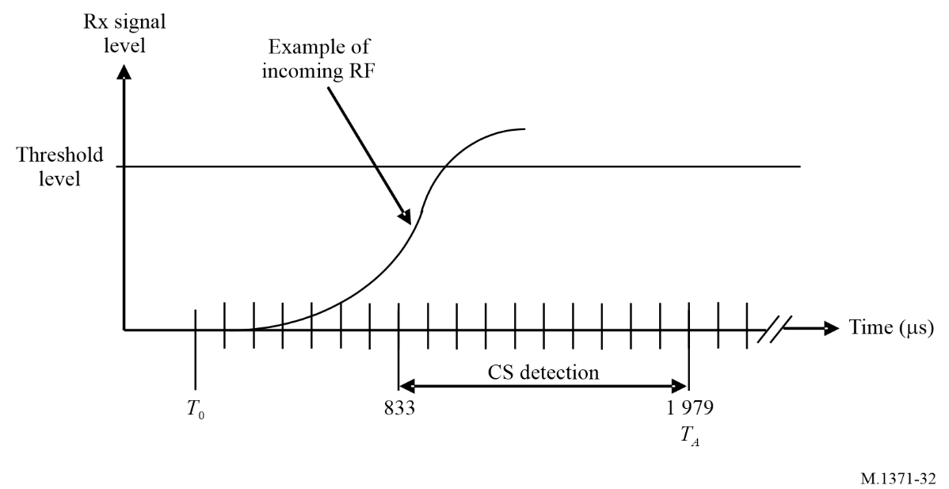

A6-4.3.1.3 Carrier sense detection threshold
The carrier sense (CS) detection threshold should be determined over a rolling 60 s interval on each Rx channel separately. The threshold should be determined by measuring the minimum energy level (representing the background noise) plus an offset of 10 dB. The minimum CS detection threshold should be −107 dBm and background noise should be tracked for a range of at least 30 dB (which results in a maximum threshold level of −77 dBm).

A6-4.3.1.4 VHF data link access
The transmitter should begin transmission by turning on the RF power immediately after the duration of the carrier sense window (T_{A}).
The transmitter should be turned off after the last bit of the transmission packet has left the transmitting unit (nominal transmission end T_{E} assuming no bit stuffing).
The access to the medium is performed as shown in Fig. 33 and Table 37.
Figure 33
Power versus time mask
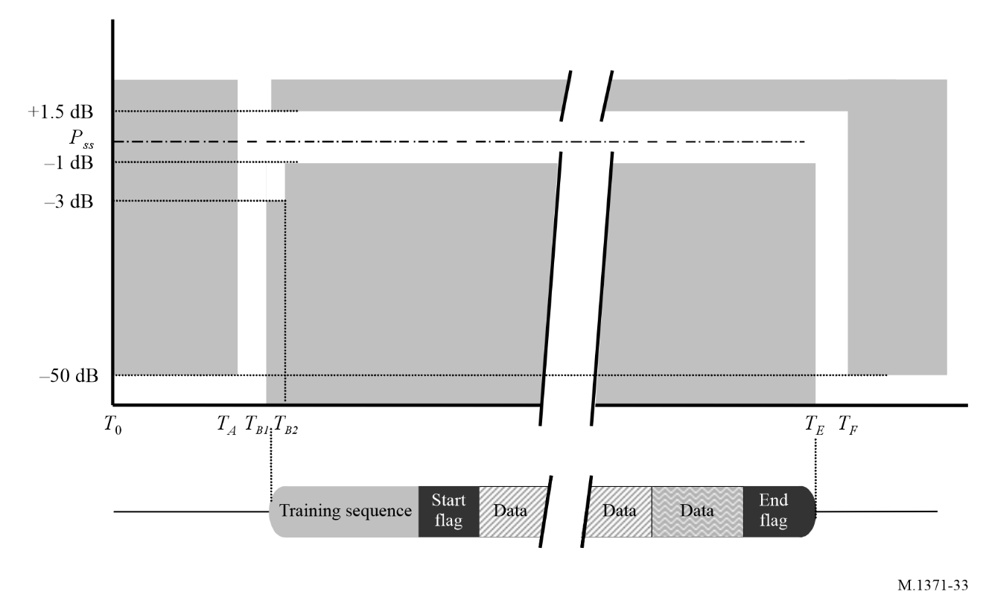
TABLE 37
Definition of timings for Fig. 33
Reference |  | Bits | Time  (μs) | Definition
T₀ to T_{A} |  | 0 | 0 | Start of candidate transmission time period  Power should not exceed –50 dB of P_{ss}
T_{A} to T_{B} |  | 20 | 2 083 | Begin of upramping
T_{B} | T_{B1} | 23 | 2 396 | Power should reach within +1.5 or –3 dB of P_{ss}
T_{B} | T_{B2} | 25 | 2 604 | Power should reach within +1.5 or –1 dB of P_{ss}
T_{E} (plus 1 stuffing bit) |  | 248 | 25 833 | Power should still remain within +1.5 or –1 dB of P_{ss}
T_{F} (plus 1 stuffing bit) |  | 251 | 26 146 | Power should reach –50 dB of steady state RF output power (P_{ss}) and stay below this

There should be no modulation of the RF after the termination of transmission (T_{E}) until the power has reached zero and next time period begins (T_{G}).

A6-4.3.1.5 VHF data link state
The VDL state is based on the result of the carrier sense detection (see § A6-4.3.1.2) for a time period. A VDL time period can be in one of the following states:
– FREE: time period is available and has not been identified as used in reference to § A6-4.3.1.2.
– USED: VDL has been identified as used in reference to § A6-4.3.1.2.
– UNAVAILABLE: time periods should be indicated as “UNAVAILABLE” if they are reserved by base stations using Message 20 regardless of their range.
Time periods indicated as “UNAVAILABLE” should not be considered as a candidate time period for use by own station and may be used again after a time-out. The time-out should be as specified in Message 20.

A6-4.3.2 Link sub-layer 2: data link service
The DLS sub-layer provides methods for:
– data link activation and release;
– data transfer; or
– error detection and control.

A6-4.3.2.1 Data link activation and release
Based on the MAC sub-layer the DLS will listen, activate or release the data link. Activation and release should be in accordance with § A6-4.3.1.4.

A6-4.3.2.2 Data transfer
Data transfer should use a bit-oriented protocol which is based on the high-level data link control (HDLC) as specified by ISO/IEC 13239:2002 – Definition of packet structure. Information packets (I-Packets) should be used with the exception that the control field is omitted (see Fig. 34).
FIGURE 34
Transmission packet
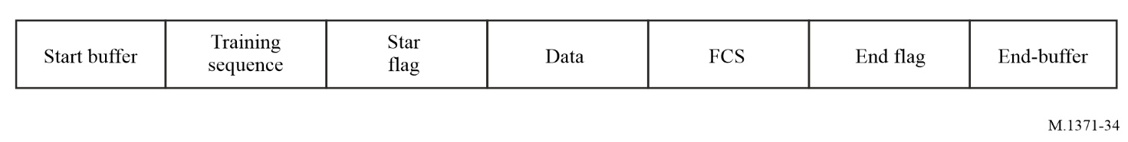

A6-4.3.2.2.1 Bit stuffing
The bit stream should be subject to bit stuffing. This means that if five consecutive ones (1’s) are found in the output bit stream, a zero should be inserted. This applies to all bits except the data bits of HDLC flags (start flag and end flag, see Fig. 34).

A6-4.3.2.2.2 Packet format
Data is transferred using a transmission packet as shown in Fig. 34.
The packet should be sent from left to right. This structure is identical to the general HDLC structure, except for the training sequence. The training sequence should be used in order to synchronize the VHF receiver as described in § A6-4.2.1.4. The total length of the default packet is 256 bits. This is equivalent to 26.7 ms.

A6-4.3.2.2.3 Start-buffer
The start-buffer (refer to Table 38) is 23 bits long and consists of:
– CS-delay 20 bits
– Reception delay (sync jitter + distance delay)
– Own synchronization jitter (relative to synchronization source)
– Ramp-up (received message)
– CS detection window
– Internal processing delay
– Ramp-up (own transmitter) 3 bits.
TABLE 38
Start buffer
Sequence | Description | Bits | Note
1 | Reception delay (synchronization jitter + distance delay) | 5 | Class A: 3 bits of jitter + 2 bits (30 NM) distance delay; base station: 1 bit of jitter + 4 bits (60 NM) distance delay
2 | Own synchronization jitter (relative to synchronization source) | 3 | 3 bits according to § A6-4.3.1.1
3 | Ramp-up (received message) | 8 | Refer to Annex 2, start of detection window
4 | Detection window | 3
5 | Internal processing delay | 1
6 | Ramp-up (own transmitter) | 3
 | Total | 23

A6-4.3.2.2.4 Training sequence
The training sequence should be a bit pattern consisting of alternating 0’s and 1’s (010101010...).
Twenty-four bits of preamble are transmitted prior to sending the flag. This bit pattern is modified due to the NRZI mode used by the communication circuit (see Fig. 35).
Figure 35
Training sequence
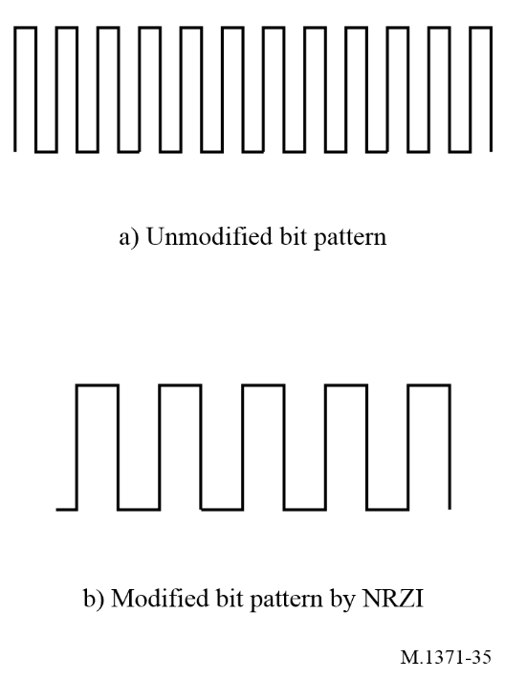

A6-4.3.2.2.5 Start flag
The start flag should be 8 bits long and consists of a standard HDLC flag. It is used to detect the start of a transmission packet. The start flag consists of a bit pattern, 8 bits long: 01111110 (7E_{h}). The flag should not be subject to bit stuffing, although it consists of 6 bits of consecutive ones (1’s).

A6-4.3.2.2.6 Data
The data portion in the default transmission packet transmitted in one-time period is a maximum of 168 bits.

A6-4.3.2.2.7 Frame check sequence
The FCS uses the CRC 16-bit polynomial to calculate the checksum as defined in ISO/IEC 13239:2002. All the CRC bits should be pre-set to one (1) at the beginning of a CRC calculation. Only the data portion should be included in the CRC calculation (see Fig. 36).
FIGURE 36
Transmission timing
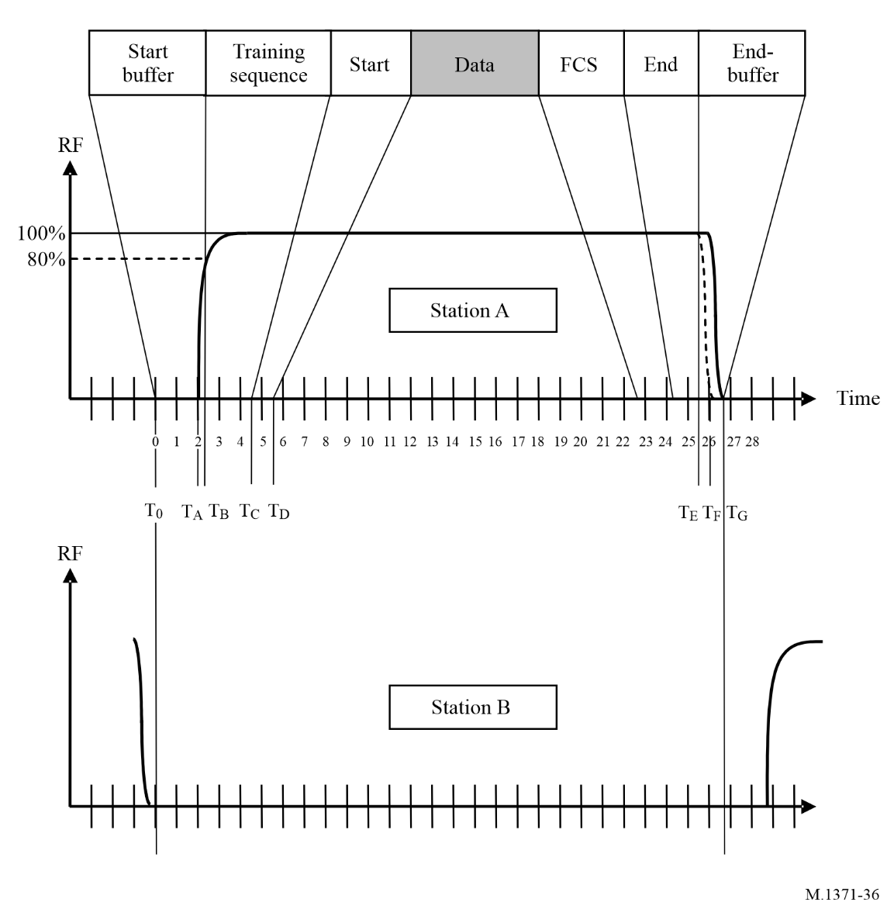

A6-4.3.2.2.8 End flag
The end flag is identical to the start flag as described in § A6-4.3.2.2.5.

A6-4.3.2.2.9 End-buffer
– bit stuffing: 4 bits.
(The probability of 4 bits of bit stuffing is only 5% greater than that of 3 bits; refer to
§ A2-3.2.2.8.1.)
– ramp down: 3 bits
– distance delay: 2 bits.
(A buffer value of 2 bits is reserved for a distance delay equivalent to 30 NM for own transmission.)

A6-4.3.2.3 Summary of the transmission packet
The data packet is summarized as shown in Table 39.
TABLE 39
Summary of the transmission packet
Action | Bits | Explanation
Start-buffer:
CS-delay | 20 | T₀ to T_{A} in Fig. 37
Ramp up | 3 | T_{A} to T_{B} in Fig. 37
Training sequence | 24 | Necessary for synchronization
Start flag | 8 | In accordance with HDLC (7E_{h})
Data | 168 | Default
CRC | 16 | In accordance with HDLC
End flag | 8 | In accordance with HDLC (7E_{h})
End-buffer:
Bit stuffing | 4
Ramp down | 3
Distance delay | 2
Total | 256

A6-4.3.2.4 Transmission timing
Table 40 and Fig. 36 show the timing of the default transmission packet (one-time division).
TABLE 40
Transmission timing
T(n) | Time  (µs) | Bit | Description
T0 | 0 | 0 | Start of time division; beginning of start buffer
TA | 2 083 | 20 | Start of transmission (RF power is applied)
TB | 2 396 | 23 | End of start buffer; RF power and frequency stabilization time, beginning of training sequence
TC | 4 896 | 47 | Beginning of start flag
TD | 5 729 | 55 | Beginning of data
TABLE 40 (end)
T(n) | Time  (µs) | Bit | Description
TE | 25 729 | 247 | Beginning of end buffer; nominal end of transmission  (assuming 0 bit stuffing)
TF | 26 042 | 250 | Nominal end of ramp down (power reaches −50 dBc)
TG | 26 667 | 256 | End of time period, start of next time period

A6-4.3.2.5 Long transmission packets
Autonomous transmissions are limited to one-time period.

A6-4.3.2.6 Error detection and control
Error detection and control should be handled using the CRC polynomial as described in
§ A6-4.3.2.2.7.
CRC errors should result in no further action by the Class B “CS”.

A6-4.3.3 Link sub-layer 3 – link management entity
The LME controls the operation of the DLS, MAC and the physical layer.

A6-4.3.3.1 Access algorithm for scheduled transmissions
The Class B “CS” should use a CSTDMA access using transmission periods, which are synchronized to periods of RF activity on the VDL.
The access algorithm is defined by the following parameters in Table 41:
TABLE 41
Access parameters
Term | Description | Value
Reporting interval (RI) | Reporting interval as specified in § A6-3.5.2 | 5 s … 10 min
Nominal transmission time (NTT) | Nominal time period for transmission defined by RI
Transmission interval (TI) | Time interval of possible transmission periods, centred around NTT | TI = RI/3 or 10 s, whichever is less
Candidate period (CP) | Time period where a transmission attempt is made (excluding time periods indicated unavailable)
Number of CP in TI |  | 10

The CSTDMA algorithm should follow the rules given below (see Fig. 37):
1) Randomly define 10 CP in the TI.
2) Starting with the first CP in TI, test for CS, § A6-4.3.1.2, and transmit if the status of CP is “free”, otherwise wait for the next CP.
3) Transmission should be abandoned if all 10 CPs are “used”.
FIGURE 37
Example of carrier sense time division multiple access
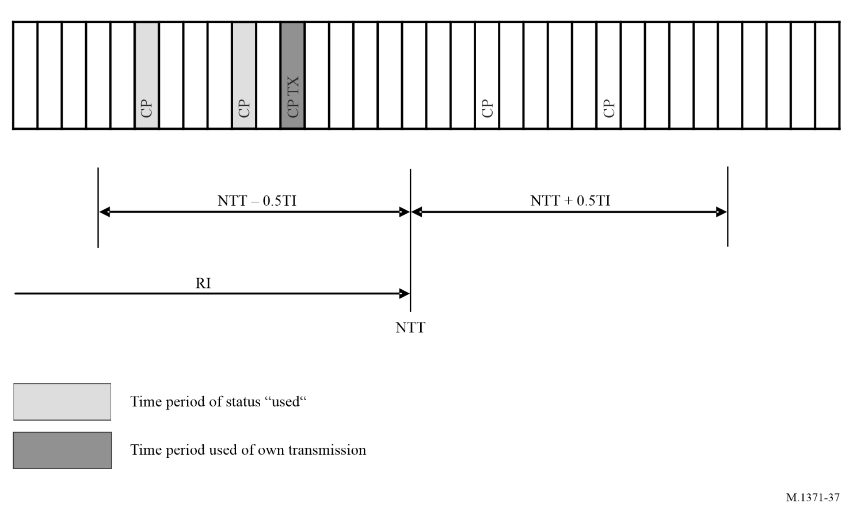

A6-4.3.3.2 Access algorithm for unscheduled transmissions
Unscheduled transmissions, except responses to interrogations by a base station, should be performed by assigning a nominal transmission time within 25 s of the request and should use the access algorithm described in § A6-4.3.2.1.
If the option to process Message 12 is implemented, an acknowledgement Message 13 should be transmitted in response to Message 12 on the same channel with up to 3 repetitions of the access algorithm if needed.

A6-4.3.3.3 Modes of operation
There should be three modes of operation.
– Autonomous (default mode)
– Assigned
– Interrogation

A6-4.3.3.3.1 Autonomous
A station operating autonomously should determine its own schedule for the transmission of its position reports.

A6-4.3.3.3.2 Assigned
A station operating in the assigned mode should use a transmission schedule assigned by a competent authority’s base station. This mode is initiated by a group assignment command (Message 23).
The assigned mode should affect the transmission of scheduled position reports, except the Tx/Rx mode and the quiet time command, which also affect static reports.
If a station receives this group assignment command and belongs to the group addressed by region and selection parameters, it should enter into assigned mode which should be indicated by setting the “Assigned Mode Flag” to “1”.
To determine whether this group assignment command applies to the recipient station it should evaluate all selector fields concurrently.
When commanded to a specific transmission behaviour (Tx/Rx mode or reporting interval), the mobile station should tag it with a time-out, randomly selected between 4 and 8 min after the first transmission. After the time-out has elapsed the station should return to autonomous mode.
When commanded to a specific reporting rate, the AIS should transmit the first position report with assigned rate after a time randomly selected between the time the Message 23 has been received and the assigned interval to avoid clustering.
When a Class B “CS” station receives a quiet time command, it should continue to schedule NTT periods but should not transmit Messages 18 and 24 on either channel for the time commanded. Interrogations should be answered during the quiet period. Transmissions of safety related messages may still be possible. After the quiet time has elapsed, transmissions should be resumed using the transmission schedule as maintained during the quiet period.
Subsequent quiet time commands received during the first commanded quiet time should be ignored.
The quiet time command should override a reporting rate command.

A6-4.3.3.3.3 Interrogation mode
A station should automatically respond to interrogation messages (Message 15) from an AIS station (see Table 63). Operation in the interrogation mode should not conflict with operation in the other two modes. The response should be transmitted on the channel where the Interrogation message was received.
If interrogated for Message 18 or 24 with no offset specified in Message 15, the response should be transmitted within 30 s using the access algorithm as described in § A6-4.3.3.2. If no free candidate period has been found, one transmission retry should be performed after 30 s.
If interrogated by a base station with an offset given in Message 15, the response should be transmitted in the specified time period without applying the access algorithm as described in § A6-4.3.3.2.
Interrogations for the same message received before own response has been transmitted may be ignored.

A6-4.3.3.4 Initialization
At power on, a station should monitor the TDMA channels for one (1) minute to synchronize on received VDL-transmissions (§ A6-4.3.1.1) and to determine the CS detection threshold level (§ A6-4.3.1.3). The first autonomous transmission should always be the scheduled position report (Message 18), see § A7-3.16.

A6-4.3.3.5 Communication state for carrier sense access
Because Class B “CS” does not use any Communication state information, the communication state field in Message 18 should be filled with the default value “1100000000000000110” and the communication state selector flag field filled with “1”.

A6-4.3.3.6 VHF data link message use
Table 42 shows how the messages defined in Annex 7 should be used by a Class B “CS” shipborne mobile AIS device.
TABLE 42
Use of VHF data link messages by a Class B “CS” automatic identification system
Message No. | Name of message | Annex 7 reference | Receive and process ⁽¹⁾ | Transmit by own station | Remark
0 | Undefined
1 | Position report (Scheduled) | § 3.1 | Optional | No
2 | Position report (Assigned) | § 3.1 | Optional | No
3 | Position report (When interrogated) | § 3.1 | Optional | No
4 | Base station report | § 3.2 | Yes | No | Class B “CS” should obey the 120 NM rule.
5 | Static and voyage related data | § 3.3 | Optional | No
6 | Addressed binary message | § 3.4 | No | No
7 | Binary acknowledge | § 3.5 | No | No
8 | Binary broadcast message | § 3.6 | Optional | No
9 | Standard SAR aircraft position report | § 3.7 | Optional | No
10 | UTC and date inquiry | § 3.8 | No | No
11 | UTC/Date response | § 3.2 | Optional | No
12 | Safety related addressed message | § 3.10 | Optional | No | NOTE 1 – Information can also be transferred via Message 14
13 | Safety related acknowledge | § 3.5 | No | Optional | Should be transmitted if the option to process Message 12 is implemented

TABLE 42 (cont.)
Message No. | Name of message | Annex 7 reference | Receive and process ⁽¹⁾ | Transmit by own station | Remark
14 | Safety related broadcast message | § 3.12 | Optional | Optional⁽²⁾ | The Message 14 should have precedence over Message 18
15 | Interrogation | § 3.13 | Yes | No | Class B “CS” should respond to interrogations for Message 18 and Message 24.
16 | Assigned mode command | § 3.21 | No | No | Message 23 is applicable to the “CS”
17 | DGNSS broadcast binary message | § 3.15 | Optional | No
18 | Standard Class B equipment position report | § 3. 16 | Optional | Yes | A Class B “CS” AIS should indicate “1” for “CS” in the parameter field “Class B unit flag”
19 | Extended Class B equipment position report | § 3.17 | Optional | No
20 | Data link management message | § 3.18 | Yes | No | Message 4 should be received and evaluated for the 120 NM rule before responding.
21 | Aids-to-navigation report | § 3.19 | Optional | No | 2 slots message
22 | Channel management message | § 3.20 | Yes | No | Use of that function may be different. Response based upon the station capabilities in certain regions. The 120 NM rule does not apply
23 | Group assignment | § 3.21 | Yes | No | Message 4 should be received and evaluated for the 120 NM rule before responding.
24 | Static data report | § 3.22 | Optional | Yes | Part A and Part B
25 | Single slot binary message | § 3.23 | Optional | No
26 | Mult. Slot binary message with Communications State | § 3.24 | No | No
27 | Position report for long-range applications | § 3.25 | No | No

TABLE 42 (end)
Message No. | Name of message | Annex 7 reference | Receive and process ⁽¹⁾ | Transmit by own station | Remark
28 | Single slot Aids-to-navigation report | § 3.27 | Optional | No
29-59 | Undefined | None | No | No | Reserved for future use
60 | AMRD Position report | This message is used in Rec. ITU-R M.2135 |  |  | Not used by AIS Class B
61 | AMRD Identity report | This message is used in Rec. ITU-R M.2135 |  |  | Not used by AIS Class B
62 | AMRD Static information report | This message is used in Rec. ITU-R M.2135 |  |  | Not used by AIS Class B
63 | AMRD Application specific message | This message is used in Rec. ITU-R M.2135 |  |  | Not used by AIS Class B
⁽¹⁾ “Receive and process” in this table means functionality visible for the user, e.g. output to an interface or display. For synchronization it is necessary to receive and internally process messages according to § A6-4.3.1.1; this applies to Messages 1, 2, 3, 4 and 18.
⁽²⁾ Cannot use pre-formatted messages.

A6-4.3.3.7 Use of safety related message, Message 14 (optional)
The data contents of Message 14 if implemented should not exceed one-time period. Table 43 specifies the maximum number of data bits used for Message 14 and is based on the assumption that the theoretical maximum of stuffing bits will be needed.
TABLE 43
Number of data bits for use with message 14
Number of time periods | Maximum data bits | Stuffing bits | Total buffer bits
1 | 136 | 36 | 56

The Class B “CS” AIS should only accept the initiation of a Message 14 once a minute by a user manual input. Automatic repetition is not allowed.
The Message 14 should have precedence over Message 18.

A6-4.4 Network layer
The network layer should be used for:
– establishing and maintaining channel connections;
– management of priority assignments of messages;
– distribution of transmission packets between channels;
– data link congestion resolution.

A6-4.4.1 Dual channel operation
The normal default mode of operation should be a two-channel operating mode, where the AIS simultaneously receives on both channels A and B in parallel.
The two TDMA receiving processes should work independently and simultaneously on channels A and B.
For periodic repeated messages, the transmissions should alternate between channels A and B. The alternating process should be independent for Messages 18 and 24.
Transmission of complete Message 24 should alternate between channels (all sub-messages to be transmitted on the same channel before alternating to the other channel).
Channel access is performed independently on each of the two parallel channels.
Responses to interrogations should be transmitted on the same channel as the initial message.
For non-periodic messages other than those referenced above, the transmissions of each message, regardless of message type, should alternate between channels A and B.

A6-4.4.2 Channel management
Channel management should be done according to § A2-4.1 except:
– Channel management should be by Message 22. No other means should be used.

A6-4.4.3 Distribution of transmission packets

A6-4.4.3.1 Assigned reporting intervals
A competent authority may assign reporting intervals to any mobile station by transmitting group assignment Message 23. An assigned reporting interval should have precedence over the nominal reporting rate; a reporting interval of less than 5 s is not required.
The Class B “CS” should react on next shorter/next longer commands only once until time-out.

A6-4.4.4 Data link congestion resolution
The Class B “CS” AIS access algorithm as described in § A6-4.3.3.1 guarantees that the time period intended for transmission does not interfere with transmissions made by stations complying with Annex 2. Additional congestion resolution methods are not required and should not be used.

A6-4.5 Transport layer
The transport layer should be responsible for:
– converting data into transmission packets of correct size;
– sequencing of data packets;
– interfacing protocol to upper layers.

A6-4.5.1 Transmission packets
A transmission packet is an internal representation of some information, which can ultimately be communicated to external systems. The transmission packet is dimensioned so that it conforms to the rules of data transfer.
The transport layer should convert data intended for transmission, into transmission packets.
The Class B “CS” AIS should only transmit Messages 18 and 24 and may optionally transmit Messages 13 and 14.

A6-4.5.2 Sequencing of data packets
The Class B “CS” AIS is periodically transmitting the standard position report Message 18.
This periodic transmission should use the access scheme described in § A6-4.3.3.1. If a transmission attempt fails because of, e.g. high channel load, this transmission should not be repeated. Additional sequencing is not necessary.

Annex 7
Automatic identification system messages

A7-1 Message types
This Annex describes all messages on the TDMA data link. The messages in Table 44 uses the following columns:
Message ID: Message identifier as defined in § A2-3.3.7.1.
Name: Name of the message. Can also be found in § A7-3.
Description: Brief description of the message. See § A7-3 for detailed description of each message.
Priority: Priority as defined in § A2-4.2.3.
Access scheme: This column indicates how a station may select slots for transmission of this message. The access scheme used for the selection of slots does not determine the message type nor the communication state of the message transmissions in those slots.
Communication state: Specifies which communication state is used in the message. If a message does not contain a communication state, it is stated as not applicable, N/A. Communication state, where applicable, indicates an expected future use of that slot. Where no communication state is indicated the slot is immediately available for future use.
M/B: M: transmitted by mobile station
B: transmitted by Base station.

A7-2 Message summary
The defined messages are summarized in Table 44.
TABLE 44
Message  ID | Name | Description | Priority | Access scheme | Communi-cation state | M/B
1 | Position report | Scheduled position report;  (Class A AIS station) | 1 | SOTDMA, RATDMA, ITDMA⁽¹⁾ | SOTDMA | M
2 | Position report | Assigned scheduled position report; (Class A AIS station) | 1 | SOTDMA⁽⁹⁾  FATDMA | SOTDMA | M
3 | Position report | Special position report, response to interrogation; (Class A AIS station) | 1 | RATDMA⁽¹⁾  ITDMA  SOTDMA | ITDMA | M
4 | Base station report | Position, UTC, date and current slot number of base station | 1 | FATDMA⁽³⁾, ⁽⁷⁾, RATDMA⁽²⁾ | SOTDMA | B
5 | Static and voyage related data | Scheduled static and voyage related vessel data report; (Class A AIS station) | 4⁽⁵⁾ | RATDMA, ITDMA⁽¹¹⁾ | N/A | M
6 | Binary addressed message | Binary data for addressed communication | 4 | RATDMA⁽¹⁰⁾, FATDMA, ITDMA⁽²⁾ | N/A | M/B
7 | Binary acknowledge-ment | Acknowledgement of received addressed binary data | 1 | RATDMA, FATDMA, ITDMA⁽²⁾ | N/A | M/B
8 | Binary broadcast message | Binary data for broadcast communication | 4 | RATDMA⁽¹⁰⁾, FATDMA, ITDMA⁽²⁾ | N/A | M/B
9 | Standard SAR aircraft position report | Position report for airborne stations involved in SAR operations, only | 1 | SOTDMA, RATDMA, ITDMA⁽¹⁾ | SOTDMA ITDMA | M
10 | UTC/date inquiry | Request UTC and date | 3 | RATDMA, FATDMA, ITDMA⁽²⁾ | N/A | M/B
11 | UTC/date response | Current UTC and date if available | 3 | RATDMA, ITDMA⁽²⁾ | SOTDMA | M
12 | Addressed safety related message | Safety related data for addressed communication | 2 | RATDMA⁽¹⁰⁾, FATDMA, ITDMA⁽²⁾ | N/A | M/B
13 | Safety related acknowledge-ment | Acknowledgement of received addressed safety related message | 1 | RATDMA, FATDMA, ITDMA⁽²⁾ | N/A | M/B
14 | Safety related broadcast message | Safety related data for broadcast communication | 2⁽¹³⁾ | RATDMA⁽¹⁰⁾, FATDMA, ITDMA⁽²⁾  CSTDMA ⁽¹²⁾ | N/A | M/B
15 | Interrogation | Request for a specific message type (can result in multiple responses from one or several stations)⁽⁴⁾ | 3 | RATDMA, FATDMA, ITDMA⁽²⁾ | N/A | M/B
TABLE 44 (cont.)
Message  ID | Name | Description | Priority | Access scheme | Communi-cation state | M/B
16 | Assignment mode command | Assignment of a specific report behaviour by competent authority using a Base station | 1 | RATDMA, FATDMA⁽²⁾ | N/A | B
17 | DGNSS broadcast binary message | DGNSS corrections provided by a base station | 2 | FATDMA⁽³⁾, RATDMA⁽²⁾ | N/A | B
18 | Standard Class B equipment position report | Standard position report for Class B station to be used instead of Messages 1, 2, 3⁽⁸⁾ | 1 | SOTDMA, ITDMA⁽¹⁾,  CSTDMA  RATDMA | SOTDMA, ITDMA | M
19 | Extended Class B equipment position report | No longer required;  Extended position report for Class B AIS station; contains additional static information⁽⁸⁾ | 1 | ITDMA | N/A | M
20 | Data link management message | Reserve slots for Base station(s) | 1 | FATDMA⁽³⁾, RATDMA | N/A | B
21 | Aids-to-navigation report | Position and status report for aids-to-navigation | 1 | FATDMA⁽³⁾, RATDMA⁽²⁾ | N/A | M/B
22 | Channel management⁽⁶⁾ | Management of channels and transceiver modes by a Base station | 1 | FATDMA⁽³⁾, RATDMA⁽²⁾ | N/A | B
23 | Group assignment command | Assignment of a specific report behaviour by competent authority using a Base station to a specific group of mobiles | 1 | FATDMA, RATDMA | N/A | B
24 | Static data report | Additional data assigned to an MMSI  Part A: Name  Part B: Static Data | 4 | RATDMA, ITDMA,  CSTDMA,  FATDMA | N/A | M/B
25 | Single slot binary message | Short unscheduled binary data transmission (Broadcast or addressed) | 4 | RATDMA, ITDMA,  CSTDMA,  FATDMA | N/A | M/B
26 | Multiple slot binary message with Communications State | Scheduled binary data transmission (Broadcast or addressed) | 4 | SOTDMA, RATDMA, ITDMA  FATDMA | SOTDMA,  ITDMA | M/B
27 | AIS satellite message | Class A and Class B “SO” AIS station outside base station coverage | 1 | MSSA | N/A | M
28 | Aids-to-Navigation Report (Single slot message) | Position and identification report for an aids to navigation | 1 | RATDMA, ITDMA,  CSTDMA,  FATDMA | N/A | M
TABLE 44 (end)
Message  ID | Name | Description | Priority | Access scheme | Communi-cation state | M/B
29-59 | Undefined | Reserved for future use
60 | AMRD Position report | This message is only used in Rec. ITU-R M.2135.
61 | AMRD Identity report | This message is only used in Rec. ITU-R M.2135.
62 | AMRD Static information report | This message is only used in Rec. ITU-R M.2135.
63 | AMRD Application specific message | This message is only used in Recommendations ITU-R M.2135.
Notes to Table 44:
⁽¹⁾ ITDMA is used during the first frame phase (see § A2-3.3.5.3) and during a change of Rr. SOTDMA is used during the continuous operation phase (see § A2-3.3.5.4). RATDMA can be used at any time to transmit additional position reports.
⁽²⁾ This message type should be broadcast within 4 s. The RATDMA access scheme is the default method (see § A2-3.3.4.2.1) for allocating the slot(s) for this message type. Alternatively, an existing SOTDMA allocated slot should, when possible, use the ITDMA access scheme for allocating the slot(s) for this message (this statement applies to mobiles only). A base station may use an existing FATDMA allocated slot for allocating the slot(s) for transmission of this message type.
⁽³⁾ A base station is always operating in assigned mode using a fixed transmission schedule (FATDMA) for its periodic transmissions. The data link management message should be used to announce the Base station’s fixed allocation schedule (see Message 20). If necessary RATDMA may be used to transmit non-periodic broadcasts.
⁽⁴⁾ For interrogation of UTC and date, message identifier 10 should be used.
⁽⁵⁾ Priority 3, if in response to interrogation.
⁽⁶⁾ In order to satisfy the requirements for dual channel operation (see § A2-4.1), the following should apply, unless otherwise specified by Message 22:
– For periodic repeated messages, including the initial link access, the transmissions should alternate between AIS 1 and AIS 2.
– Transmissions following slot allocation announcements, responses to interrogations, responses to requests, and acknowledgements should be transmitted on the same channel as the initial message.
– For addressed messages, transmissions should utilize the channel in which a message from the addressed station was last received.
– For non-periodic messages other than those referenced above, the transmissions of each message, regardless of message type, should alternate between AIS 1 and AIS 2.
⁽⁷⁾ Recommendations for base stations (dual channel operations): base stations should alternate their transmissions between AIS 1 and AIS 2 for the following reasons:
– to increase link capacity;
– to balance channel loading between AIS 1 and AIS 2; and
– to mitigate the harmful effects of RF interference.
⁽⁸⁾ Station other than Class B shipborne mobile should not transmit Message 18. Class B shipborne mobile equipment should only use Messages 18, 24A and 24B for position reporting and static data.
⁽⁹⁾ When using reporting rate assignment by Message 16 the Access Scheme should be SOTDMA. When using assignment of transmission slots by Message 16 the Access Scheme should be assigned operation (see § A2-3.3.6.2) using SOTDMA communication state.
⁽¹⁰⁾ For Messages 6, 8, 12, 14 and 25 RATDMA transmissions from a mobile station should not exceed a total of 20 slots in a frame with a maximum of 3 consecutive slots per message; however when using FATDMA reservations a total of 20 slots in a frame with a maximum of 5 consecutive slots per message is allowed (see § A2-5.2.1).
Notes to Table 44 (end):
⁽¹¹⁾ This message type should be broadcast within 4 s in response to an interrogation. The ITDMA access scheme is the default method (see § A2-3.3.4.1) for allocating the slot(s) for this message type. An existing SOTDMA allocated slot should, when possible, use the ITDMA access scheme for allocating the slot(s) for this message. If no SOTDMA/ITDMA slot is available then use RATDMA.
⁽¹²⁾ CSTDMA should only be used for one slot messages.
⁽¹³⁾ For Class B CS the Message 14 should have precedence over Message 18.

A7-3 Message descriptions
All positions should be transmitted in WGS 84 datum.
Some messages specify the inclusion of character data, such as ship’s name, destination, call sign, and more. These fields should use a 6-bit ASCII as defined in Table 45.
TABLE 45
6-Bit ASCII |  |  |  | Standard ASCII |  |  | 6-Bit ASCII |  |  |  | Standard ASCII
Chr | Dec | Hex | Binary | Dec | Hex | Binary | Chr | Dec | Hex | Binary | Dec | Hex | Binary
@ | 0 | 0x00 | 00 0000 | 64 | 0x40 | 0100 0000 | ! | 33 | 0x21 | 10 0001 | 33 | 0x21 | 0010 0001
A | 1 | 0x01 | 00 0001 | 65 | 0x41 | 0100 0001 | ” | 34 | 0x22 | 10 0010 | 34 | 0x22 | 0010 0010
B | 2 | 0x02 | 00 0010 | 66 | 0x42 | 0100 0010 | # | 35 | 0x23 | 10 0011 | 35 | 0x23 | 0010 0011
C | 3 | 0x03 | 00 0011 | 67 | 0x43 | 0100 0011 | $ | 36 | 0x24 | 10 0100 | 36 | 0x24 | 0010 0100
D | 4 | 0x04 | 00 0100 | 68 | 0x44 | 0100 0100 | % | 37 | 0x25 | 10 0101 | 37 | 0x25 | 0010 0101
E | 5 | 0x05 | 00 0101 | 69 | 0x45 | 0100 0101 | & | 38 | 0x26 | 10 0110 | 38 | 0x26 | 0010 0110
F | 6 | 0x06 | 00 0110 | 70 | 0x46 | 0100 0110 | ‘ | 39 | 0x27 | 10 0111 | 39 | 0x27 | 0010 0111
G | 7 | 0x07 | 00 0111 | 71 | 0x47 | 0100 0111 | ( | 40 | 0x28 | 10 1000 | 40 | 0x28 | 0010 1000
H | 8 | 0x08 | 00 1000 | 72 | 0x48 | 0100 1000 | ) | 41 | 0x29 | 10 1001 | 41 | 0x29 | 0010 1001
I | 9 | 0x09 | 00 1001 | 73 | 0x49 | 0100 1001 | * | 42 | 0x2A | 10 1010 | 42 | 0x2A | 0010 1010
J | 10 | 0x0A | 00 1010 | 74 | 0x4A | 0100 1010 | + | 43 | 0x2B | 10 1011 | 43 | 0x2B | 0010 1011
K | 11 | 0x0B | 00 1011 | 75 | 0x4B | 0100 1011 | , | 44 | 0x2C | 10 1100 | 44 | 0x2C | 0010 1100
L | 12 | 0x0C | 00 1100 | 76 | 0x4C | 0100 1100 | – | 45 | 0x2D | 10 1101 | 45 | 0x2D | 0010 1101
M | 13 | 0x0D | 00 1101 | 77 | 0x4D | 0100 1101 | . | 46 | 0x2E | 10 1110 | 46 | 0x2E | 0010 1110
N | 14 | 0x0E | 00 1110 | 78 | 0x4E | 0100 1110 | / | 47 | 0x2F | 10 1111 | 47 | 0x2F | 0010 1111
O | 15 | 0x0F | 00 1111 | 79 | 0x4F | 0100 1111 | 0 | 48 | 0x30 | 11 0000 | 48 | 0x30 | 0011 0000
P | 16 | 0x10 | 01 0000 | 80 | 0x50 | 0101 0000 | 1 | 49 | 0x31 | 11 0001 | 49 | 0x31 | 0011 0001
Q | 17 | 0x11 | 01 0001 | 81 | 0x51 | 0101 0001 | 2 | 50 | 0x32 | 11 0010 | 50 | 0x32 | 0011 0010
R | 18 | 0x12 | 01 0010 | 82 | 0x52 | 0101 0010 | 3 | 51 | 0x33 | 11 0011 | 51 | 0x33 | 0011 0011
S | 19 | 0x13 | 01 0011 | 83 | 0x53 | 0101 0011 | 4 | 52 | 0x34 | 11 0100 | 52 | 0x34 | 0011 0100
T | 20 | 0x14 | 01 0100 | 84 | 0x54 | 0101 0100 | 5 | 53 | 0x35 | 11 0101 | 53 | 0x35 | 0011 0101
U | 21 | 0x15 | 01 0101 | 85 | 0x55 | 0101 0101 | 6 | 54 | 0x36 | 11 0110 | 54 | 0x36 | 0011 0110
V | 22 | 0x16 | 01 0110 | 86 | 0x56 | 0101 0110 | 7 | 55 | 0x37 | 11 0111 | 55 | 0x37 | 0011 0111
W | 23 | 0x17 | 01 0111 | 87 | 0x57 | 0101 0111 | 8 | 56 | 0x38 | 11 1000 | 56 | 0x38 | 0011 1000
X | 24 | 0x18 | 01 1000 | 88 | 0x58 | 0101 1000 | 9 | 57 | 0x39 | 11 1001 | 57 | 0x39 | 0011 1001
Y | 25 | 0x19 | 01 1001 | 89 | 0x59 | 0101 1001 | : | 58 | 0x3A | 11 1010 | 58 | 0x3A | 0011 1010
Z | 26 | 0x1A | 01 1010 | 90 | 0x5A | 0101 1010 | ; | 59 | 0x3B | 11 1011 | 59 | 0x3B | 0011 1011
[ | 27 | 0x1B | 01 1011 | 91 | 0x5B | 0101 1011 | < | 60 | 0x3C | 11 1100 | 60 | 0x3C | 0011 1100
\ | 28 | 0x1C | 01 1100 | 92 | 0x5C | 0101 1100 | = | 61 | 0x3D | 11 1101 | 61 | 0x3D | 0011 1101
] | 29 | 0x1D | 01 1101 | 93 | 0x5D | 0101 1101 | > | 62 | 0x3E | 11 1110 | 62 | 0x3E | 0011 1110
^ | 30 | 0x1E | 01 1110 | 94 | 0x5E | 0101 1110 | ? | 63 | 0x3F | 11 1111 | 63 | 0x3F | 0011 1111
– | 31 | 0x1F | 01 1111 | 95 | 0x5F | 0101 1111
Space | 32 | 0x20 | 10 0000 | 32 | 0x20 | 0010 0000
Unless otherwise specified all fields are binary. All numbers expressed are in decimal notation. Negative numbers are expressed using 2’s complement.

A7-3.1 Messages 1, 2, 3: Position reports
The position report should be output periodically by mobile stations.
TABLE 46
Parameter | Number of bits | Description
Message ID | 6 | Identifier for this Message 1, 2 or 3
Repeat indicator | 2 | Used by the repeater to indicate how many times a message has been repeated. See § A2-4.6.1; 0-3; 0 = default; 3 = do not repeat any more
Source ID | 30 | Identity (in the MMS) of the source of the message (see RR Art. 19 and Rec. ITU-R M.585)
Navigational status | 4 | 0 = under way,  1 = at anchor,  2 = not under command,  3 = restricted manoeuvrability,  4 = constrained by her draught,  5 = moored,  6 = aground,  7 = engaged fishing,  8 = under way under sailing only,  9 = reserved for future use ,  10 = reserved for future use ,  11 = power-driven vessel towing astern (regional use),  12 = power-driven vessel pushing ahead or towing alongside (regional use),  13 = reserved for future use,  14 = active AIS-SART, active MOB-AIS or active EPIRB-AIS,  15 = undefined (default) (also used by AIS-SART under test, MOB-AIS under test or EPIRB-AIS under test)
Rate of turn  ROTAIS | 8 | 0 to +126 = turning right at up to 708° per min or higher  0 to –126 = turning left at up to 708° per min or higher  Values between 0 and 708° per min coded by  ROT_{AIS} = 4.733 SQRT(ROT_{sensor}) degrees per min  where ROT_{sensor} is the Rate of Turn as input by an external Rate of Turn Indicator (TI). ROT_{AIS} is rounded to the nearest integer value.  +127 = turning right at more than 5° per 30 s (No TI available)  –127 = turning left at more than 5° per 30 s (No TI available)  –128 (80 hex) indicates no turn information available (default).  ROT data should not be derived from COG information.

TABLE 46 (end)
Parameter | Number of bits | Description
SOG | 10 | Speed over ground in 1/10 knot steps (0-102.2 knots)  1 023 = not available = default, 1 022 = 102.2 knots or higher
Position accuracy | 1 | The position accuracy (PA) flag should be determined in accordance with Table 48  1 = high (≤ 10 m)  0 = low (>10 m)  0 = default
Longitude | 28 | Longitude in 1/10 000 min (±180°, East = positive (as per 2’s complement), West = negative (as per 2’s complement).  181 = (6791AC0_{h}) = not available = default)
Latitude | 27 | Latitude in 1/10 000 min (±90°, North = positive (as per 2’s complement), South = negative (as per 2’s complement). 91° (3412140_{h}) = not available = default)
COG | 12 | Course over ground in 1/10 = (0-3 599). 3 600 (E10_{h}) = not available = default. 3 601-4 095 should not be used
True heading | 9 | Degrees (0-359) (360-510 should not be used)  511 = not available = default
Time stamp | 6 | UTC second when the report was generated by the electronic position system (EPFS) (0-59, or 60 if time stamp is not available, which should also be the default value, or 61 if positioning system is in manual input mode, or 62 if electronic position fixing system operates in estimated (dead reckoning) mode, or 63 if the positioning system is inoperative)
Special manoeuvre indicator | 2 | 0 = not available = default  1 = not engaged in special manoeuvre  2 = engaged in special manoeuvre  (i.e. regional passing arrangement on Inland Waterway)  3 = reserved for regional use
Spare | 2 | Not used. Should be set to zero. Reserved for future use.
Transmit power | 1 | 0 = default = high power  1 = low power
RAIM-flag | 1 | Receiver autonomous integrity monitoring (RAIM) flag of electronic position fixing device; 0 = RAIM not in use = default; 1 = RAIM in use. See Table 48
Communication state | 19 | See Table 47
Number of bits | 168

TABLE 47
Message ID | Communication state
1 | SOTDMA communication state as described in § A2-3.3.7.2.2
2 | SOTDMA communication state as described in § A2-3.3.7.2.2
3 | ITDMA communication state as described in § A2-3.3.7.3.2

TABLE 48
Determination of position accuracy information
Accuracy status from RAIM  (for 95% of position fixes)⁽¹⁾ | RAIM flag | Differential correction status⁽²⁾ | Resulting value of PA flag
No RAIM process available | 0 | Uncorrected | 0 = low (> 10 m)
EXPECTED RAIM error is ≤ 10 m | 1 | Uncorrected | 1 = high (≤ 10 m)
EXPECTED RAIM error is > 10 m | 1 | Uncorrected | 0 = low (> 10 m)
No RAIM process available | 0 | Corrected | 1 = high (≤ 10 m)
EXPECTED RAIM error is ≤ 10 m | 1 | Corrected | 1 = high (≤ 10 m)
EXPECTED RAIM error is > 10 m | 1 | Corrected | 0 = low (> 10 m)
⁽¹⁾ The connected GNSS receiver indicates the availability of a RAIM process by a valid sentence of IEC 61162; in this case the RAIM-flag should be set to “1”. The threshold for evaluation of the RAIM information is 10 m. The RAIM expected error is calculated based on “expected error in latitude” and “expected error in longitude” using the following formula:
⁽²⁾ The quality indicator or the mode indicator, in the position sentences of IEC 61162 received from the connected GNSS receiver indicates the correction status.

A7-3.2 Message 4: Base station report
Message 11: coordinated universal time and date response
Should be used for reporting UTC time and date and, at the same time, position. A base station should use Message 4 in its periodical transmissions. Message 4 is used by AIS stations for determining if it is within 120 NM for response to Messages 20 and 23. A mobile station should output Message 11 only in response to interrogation by Message 10.
Message 11 is only transmitted by a limited base station or as a result of a UTC request message (Message 10). The UTC and date response should be transmitted on the channel, where the UTC request message was received.
TABLE 49
Parameter | Number of bits | Description
Message ID | 6 | Identifier for this Message 4 or 11  4 = UTC and position report from base station:  11 = UTC and position response from mobile station
Repeat indicator | 2 | Used by the repeater to indicate how many times a message has been repeated. Refer to § A2-4.6.1; 0-3; 0 = default; 3 = do not repeat any more
Source ID | 30 | Identity (in the MMS) of the source of the message (see RR Art. 19 and Rec. ITU-R M.585)
UTC year | 14 | 1-9999; 0 = UTC year not available = default
UTC month | 4 | 1-12; 0 = UTC month not available = default; 13-15 not used
UTC day | 5 | 1-31; 0 = UTC day not available = default
UTC hour | 5 | 0-23; 24 = UTC hour not available = default; 25-31 not used
UTC minute | 6 | 0-59; 60 = UTC minute not available = default; 61-63 not used
UTC second | 6 | 0-59; 60 = UTC second not available = default; 61-63 not used
Position accuracy | 1 | 1 = high (≤ 10 m)  0 = low (> 10 m)  0 = default  The PA flag should be determined in accordance with Table 48
Longitude | 28 | Longitude in 1/10 000 min (±180°, East = positive (as per 2’s complement), West = negative (as per 2’s complement);  181 = (6791AC0_{h}) = not available = default)
Latitude | 27 | Latitude in 1/10 000 min (±90°, North = positive (as per 2’s complement), South = negative (as per 2’s complement);  91 = (3412140_{h}) = not available = default)
Type of electronic position fixing device | 4 | 0 = not available = default  1 = GPS  2 = GLONASS  3 = combined GNSS  4 = Loran  5 = Chayka  6 = INS  7 = manually inputted = surveyed or charted position  8 = Galileo  9 = BDS  10 and 11 = not used, reserved for future use  12 = integrated PNT system  13 = inertial navigation system  14 = terrestrial radio navigation system  15 = internal GNSS

TABLE 49 (end)
Parameter | Number of bits | Description
Transmission control for AIS satellite broadcast message | 1 | 0 = default – Class-A station stops transmission of Message 27 within an AIS base station coverage area.  1 = Request Class-A station to transmit Message 27 within an AIS base station coverage area.  Base station coverage area should be defined by Message 23; If Message 23 is not received, an AIS station which is allowed to transmit on CH75 and 76 (see A3-3.2) should ignore this bit and transmit Message 27.
Spare | 9 | Should be set to zero. Reserved for future use
RAIM-flag | 1 | RAIM (Receiver autonomous integrity monitoring) flag of electronic position fixing device; 0 = RAIM not in use = default; 1 = RAIM in use see Table 48
Communication state | 19 | SOTDMA communication state as described in § A2-3.3.7.2.1
Number of bits | 168

A7-3.3 Message 5: Ship static and voyage related data
Should only be used by Class A shipborne stations when reporting static or voyage related data. Existing AIS stations on SAR aircrafts may use Message 5 as described in Recommendation ITU-R M.1371. In future implementations SAR aircraft AIS stations should use either Message 5 or Message 24A.
TABLE 50
Parameter | Number of bits | Description
Message ID | 6 | Identifier for this Message 5
Repeat indicator | 2 | Used by the repeater to indicate how many times a message has been repeated. Refer to §A2- 4.6.1; 0-3; 0 = default; 3 = do not repeat any more
Source ID | 30 | Identity (in the MMS) of the source of the message (see RR Art. 19 and Rec. ITU-R M.585)
AIS version indicator | 2 | 0 = station compliant with Recommendation ITU-R M.1371-1  1 = station compliant with Recommendation ITU-R M.1371-3  2 = station compliant with Recommendation ITU-R M.1371-5  3 = station compliant with Recommendation ITU-R M.1371-6 (or later)
IMO number (1) | 30 | 0000000001-0000999999 not used  0001000000-0009999999 = valid IMO number;  0010000000-1073741823 = official flag state number.
Call sign | 42 | 7 x 6 bit ASCII characters, @@@@@@@ = not available = default.  Craft associated with a parent vessel, should use “A” followed by the last 6 digits of the MMSI of the parent vessel. Examples of these craft include towed vessels, rescue boats, tenders, lifeboats and liferafts.
TABLE 50 (end)
Parameter | Number of bits | Description
Name | 120 | Maximum 20 characters 6 bit ASCII, as defined in Table 45 “@@@@@@@@@@@@@@@@@@@@” = not available = default.  The Name should be as shown on the station radio license.
Type of ship and cargo type | 8 | 0 = not available or no ship = default  1-99 = as defined in § A7-3.3.2  100-199 = reserved, for regional use  200-255 = reserved, for future use
Overall dimension/  reference for position | 30 | Reference point for reported position.  Also indicates the dimension of ship (m) (see Fig. 44 and § A7-3.3.3).  0 = not available = default A = B = C = D be set to “0”
Type of electronic position fixing device | 4 | 0 = not available = default  1 = GPS  2 = GLONASS  3 = combined GNSS  4 = Loran  5 = Chayka  6 = INS  7 = manually inputted = surveyed or charted position  8 = Galileo,  9 = BDS  10 and 11 = not used = reserved for future use  12 = integrated PNT system  13 = inertial navigation system  14 = terrestrial radio navigation system  15 = internal GNSS
ETA | 20 | Estimated time of arrival; MMDDHHMM UTC  Bits 19-16: month; 1-12; 0 = not available = default  Bits 15-11: day; 1-31; 0 = not available = default  Bits 10-6: hour; 0-23; 24 = not available = default  Bits 5-0: minute; 0-59; 60 = not available = default
Maximum present static draught | 8 | In 1/10 m, 255 = draught 25.5 m or greater, 0 = not available = default;  in accordance with IMO Resolution A.851
Destination | 120 | Maximum 20 characters using 6-bit ASCII;  @@@@@@@@@@@@@@@@@@@@ = not available
DTE | 1 | Data terminal equipment (DTE) ready (see § A7-3.3.1)  0 = available  1 = not available = default
Spare | 1 | Spare. Not used. Should be set to zero. Reserved for future use
Number of bits | 424 | Occupies 2 slots
⁽¹⁾ “IMO number parameter should be in accordance with the IMO ship identification number scheme adopted by IMO (Resolution A.1117(30)). If the ship does not have an IMO number, an official flag State number should be used.”

A7-3.3.1 The data terminal equipment indicator
The purpose of the DTE indicators is to indicate to an application on the receiving side that, if set to available, the transmitting station conforms at least to the minimum keyboard and display requirements. On the transmitting side, the DTE indicator may also be set by an external application via the Presentation Interface. On the receiving side, the DTE indicator is only used as information provided to the application layer, that the transmitting station is available for communications.

A7-3.3.2 Type of ship
TABLE 51
Identifier No. | Type of ship
Special purpose ship
01 | Science / Research vessel
02 | Training vessel
03 | Ship owned or operated by a government
04 | Ice breaker
05 | Buoy (Aids to Navigation) tender
06 | Cable layer
07 | Pipe layer
08 | Reserved for future use
09 | Special purpose ship, no additional information
Support vessel
10 | Reserved for future use
11 | FPSO (Floating, Production, Storage, Offloading) vessel
12 | Fish factory ship
13 | Fish farm support vessel
14 | Offshore support vessel, etc.
15 | Reserved for future use
16 | Reserved for future use
17 | Construction vessel
18 | Crew boat
19 | Support vessel, no additional information
Wing-in-ground vessel
20 | WIG, all ships of this type
21 | WIG, carrying DG and/or MHB, HS, or MP, IMO hazard or pollutant category X
22 | WIG, carrying DG and/or MHB, HS, or MP, IMO hazard or pollutant category Y
23 | WIG, carrying DG and/or MHB, HS, or MP, IMO hazard or pollutant category Z
24 | WIG, carrying DG and/or MHB, HS, or MP, IMO hazard or pollutant category OS
25 | Reserved for future use
26 | Reserved for future use
27 | Reserved for future use
TABLE 51 (cont.)
Identifier No. | Type of ship
28 | Reserved for future use
29 | WIG vessel, no additional information
Special craft
30 | Fishing vessel
31 | Towing
32 | Towing and length of the tow exceeds 200 m or breadth exceeds 25 m
33 | Dredger
34 | Diving vessel
35 | Warship or naval auxiliary
36 | Sailing vessel
37 | Pleasure motor craft
38 | Trawler
39 | Patrol vessel
High-speed craft (HSC)
40 | HSC, all ships of this type
41 | HSC, carrying DG and/or MHB, HS, or MP, IMO hazard or pollutant category X
42 | HSC, carrying DG and/or MHB, HS, or MP, IMO hazard or pollutant category Y
43 | HSC, carrying DG and/or MHB, HS, or MP, IMO hazard or pollutant category Z
44 | HSC, carrying DG and/or MHB, HS, or MP, IMO hazard or pollutant category OS
45 | HSC, carrying passengers
46 | HSC Ro-Ro ship (vehicle / rail)
47 | Reserved for future use
48 | Reserved for future use
49 | HSC, no additional information
Special craft
50 | Pilot vessel
51 | Search and rescue vessels
52 | Tugs
53 | Port or fish tenders
54 | Anti-pollution or firefighting responder
55 | Law enforcement vessels
56 | Spare 1 – for assignments to local vessels
57 | Spare 2 – for assignments to local vessels
58 | Medical transports (as defined in the 1949 Geneva Conventions and Additional Protocols)
59 | Ships of States not parties to an armed conflict
TABLE 51 (cont.)
Identifier No. | Type of ship
Passenger ships
60 | Passenger ships, all ships of this type
61 | Passenger ships, carrying DG and/or MHB, HS, or MP cargo, IMO hazard or pollutant category X
62 | Passenger ships, carrying DG and/or MHB, HS, or MP cargo, IMO hazard or pollutant category Y
63 | Passenger ships, carrying DG and/or MHB, HS, or MP cargo, IMO hazard or pollutant category Z
64 | Passenger ships, carrying DG and/or MHB, HS, or MP cargo, IMO hazard or pollutant category OS
65 | Passenger (cruise) ship
66 | Passenger (ferry) ship
67 | Passenger (excursion) ship (i.e. harbour cruise boat, whale watcher, etc.)
68 | Reserved for future use
69 | Passenger ships, no additional information
Cargo ships
70 | Cargo ships, all ships of this type
71 | Cargo ships, carrying DG and/or MHB, HS, or MP, IMO hazard or pollutant category X
72 | Cargo ships, carrying DG and/or MHB , HS, or MP, IMO hazard or pollutant category Y
73 | Cargo ships, carrying DG and/or MHB, HS, or MP, IMO hazard or pollutant category Z
74 | Cargo ships, carrying DG and/or MHB, HS, or MP, IMO hazard or pollutant category OS
75 | Cargo ship, bulk carrier
76 | Cargo ship, container ship
77 | Cargo ship, roll-on-roll-off carrier
78 | Cargo ship, landing craft
79 | Cargo ships, no additional information
Tanker(s)
80 | Tanker(s), all ships of this type
81 | Tanker(s), carrying DG and/or MHB , HS, or MP, IMO hazard or pollutant category X
82 | Tanker(s), carrying DG and/or MHB, HS, or MP, IMO hazard or pollutant category Y
83 | Tanker(s), carrying DG and/or MHB, HS, or MP, IMO hazard or pollutant category Z
84 | Tanker(s), carrying DG and/or MHB, HS, or MP, IMO hazard or pollutant category OS
85 | Tanker(s), non-hazardous or non-pollutant carrier
TABLE 51 (end)
Identifier No. | Type of ship
86 | Integrated / articulated tug and tank barge (ABCD values should reflect tug and barge dimensions)
87 | Reserved for future use
88 | Reserved for future use
89 | Tanker(s), no additional information
Other types of ship
90 | Other types of ship
91 | Other types of ships, carrying DG and/or MHB , HS, or MP, IMO hazard or pollutant category X
92 | Other types of ships, carrying DG and/or MHB, HS, or MP, IMO hazard or pollutant category Y
93 | Other types of ships, carrying DG and/or MHB, HS, or MP, IMO hazard or pollutant category Z
94 | Other types of ships, carrying DG and/or MHB, HS, or MP, IMO hazard or pollutant category OS
95 | Reserved for future use
96 | Reserved for future use
97 | Reserved for future use
98 | Reserved for future use
99 | Other types of ship, no additional information
DG: dangerous goods.
HS: harmful substances.
MP: marine pollutants.
MHB: materials hazardous only in bulk.
Note: IMO hazard or pollutant categories X, Y, Z and OS formerly were categories A, B, C and D.

A7-3.3.3 Reference point for reported position and overall dimensions of ship
Figure 38
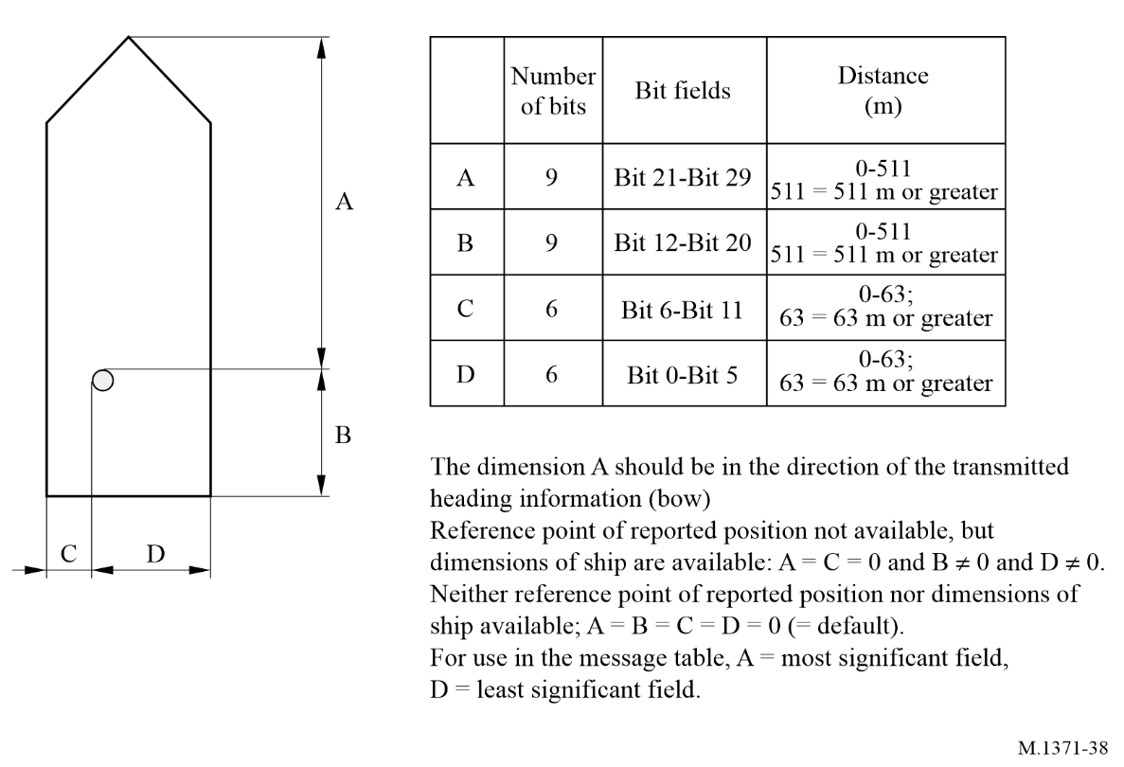
NOTE 1 – Towing vessels pushing ahead or alongside overall dimensions should include its tow.

A7-3.4 Message 6: Addressed binary message
The addressed binary message should be variable in length, based on the amount of binary data. The length should vary between 1 and 5 slots. See application identifiers in § A4-2.1.
TABLE 52
Parameter | Number of bits | Description
Message ID | 6 | Identifier for Message 6; always 6
Repeat indicator | 2 | Used by the repeater to indicate how many times a message has been repeated. Refer to § A2-4.6.1; 0-3; default = 0; 3 = do not repeat any more
Source ID | 30 | Identity (in the MMS) of the source of the message (see RR Art. 19 and Rec. ITU-R M.585)
Sequence number | 2 | 0-3; refer to § A2-5.3.1
Destination ID | 30 | Identity (in the MMS) of the destination of the message (see RR Art 19 and Rec. ITU-R M.585)
Retransmit flag | 1 | Retransmit flag should be set upon retransmission: 0 = no retransmission = default; 1 = retransmitted
Spare | 1 | Should be set to zero. Reserved for future use.

TABLE 52 (end)
Parameter | Number of bits | Description
Binary data | Maximum 936 | Application identifier | 16 bits | Should be as described in § A4-2.1
Binary data | Maximum 936 | Application data | Maximum 920 bits | Application specific data
Maximum number of bits | Maximum 1 008 | Occupies up to 3 slots, or up to 5 slots when able to use FATDMA reservations. For Class B “SO” mobile AIS stations the length of the message should not exceed 3 slots  For Class B “CS” mobile AIS stations should not transmit;

Additional bit stuffing will be required for these message types. For details refer to transport layer, § A2-5.2.1.
Table 53 gives the number of binary data bytes (including application ID and application data), so that the whole message fits into a given number of slots. It is recommended that any application minimizes the use of slots by limiting the number of binary data bytes to the numbers given, if possible:
TABLE 53
Number of slots | Maximum binary data bytes
1 | 8
2 | 36
3 | 64
4 | 92
5 | 117

These numbers also take bit stuffing into account.

A7-3.5 Message 7: Binary acknowledge
Message 13: Safety related acknowledge
Message 7 should be used as an acknowledgement of up to four Message 6 messages received (see § A2-5.3.1) and should be transmitted on the channel, where the addressed message to be acknowledged was received.
Message 13 should be used as an acknowledgement of up to four Message 12 messages received (see § A2-5.3.1) and should be transmitted on the channel, where the addressed message to be acknowledged was received.
These acknowledgements should be applicable only to the VHF data link (see § A2-5.3.1). Other means must be employed for acknowledging applications.
TABLE 54
Parameter | Number of bits | Description
Message ID | 6 | Identifier for Messages 7 or 13  7 = binary acknowledge  13 = safety related acknowledge
Repeat indicator | 2 | Used by the repeater to indicate how many times a message has been repeated. See § A2-4.6.1; 0-3; 0 = default; 3 = do not repeat any more
Source ID | 30 | Identity (in the MMS) of the source of the message (see RR Art. 19 and Rec. ITU-R M.585)
Spare | 2 | Should be set to zero. Reserved for future use
Destination ID1 | 30 | Identity (in the MMS) of the destination of the message (see RR Art. 19 and Rec. ITU-R M.585)
Sequence number for ID1 | 2 | Sequence number of message to be acknowledged; 0-3
Destination ID2 | 30 | Identity (in the MMS) of the destination of the message (see RR Art. 19 and Rec. ITU-R M.585)of this ACK; should be omitted if no destination ID2
Sequence number for ID2 | 2 | Sequence number of message to be acknowledged; 0-3; should be omitted if no destination ID2
Destination ID3 | 30 | Identity (in the MMS) of the destination of the message (see RR Art. 19 and Rec. ITU-R M.585)of this ACK; should be omitted if no destination ID3
Sequence number for ID3 | 2 | Sequence number of message to be acknowledged; 0-3; should be omitted if no destination ID3
Destination ID4 | 30 | Identity (in the MMS) of the destination of the message (see RR Art. 19 and Rec. ITU-R M.585)of this ACK; should be omitted if no destination ID4
Sequence number for ID4 | 2 | Sequence number of message to be acknowledged; 0-3. Should be omitted if there is no destination ID4
Number of bits | 72-168

A7-3.6 Message 8: Binary broadcast message
This message will be variable in length, based on the amount of binary data. The length should vary between 1 and 5 slots.
TABLE 55
Parameter | Number of bits | Description
Message ID | 6 | Identifier for Message 8; always 8
Repeat indicator | 2 | Used by the repeater to indicate how many times a message has been repeated. See § A2-4.6.1; 0-3; default = 0; 3 = do not repeat any more
Source ID | 30 | Identity (in the MMS) of the source of the message (see RR Art. 19 and Rec. ITU-R M.585)
Spare | 2 | Should be set to zero. Reserved for future use
Binary data | Maximum 968 | Application identifier | 16 bits | Should be as described in § A4-2.1
Binary data | Maximum 968 | Application data | Maximum 952 bits | Application specific data
Maximum number of bits | Maximum 1 008 | Occupies up to 3 slots, or up to 5 slots when able to use FATDMA reservations.  For Class B “SO” mobile AIS stations the length of the message should not exceed 3 slots  For Class B “CS” mobile AIS stations should not transmit

Table 56 gives the number of binary data bytes (including application ID and application data), so that the whole message fits into a given number of slots. It is recommended that any application minimizes the use of slots by limiting the number of binary data bytes to the numbers given, if possible.
TABLE 56
Number of slots | Maximum binary data bytes
1 | 12
2 | 40
3 | 68
4 | 96
5 | 121

These numbers also take into account bit stuffing.
Additional bit stuffing will be required for this message type. For details refer to transport layer, § A2-5.2.1.

A7-3.7 Message 9: Standard aircraft station in the maritime mobile service position report
This message should be used as a standard position report for aircraft involved in SAR operations and other safety-related communications. Aircraft involved in other activities should not transmit this message. The default reporting interval for this message should be 10 s.
TABLE 57
Parameter | Number of bits | Description
Message ID | 6 | Identifier for Message 9; always 9
Repeat indicator | 2 | Used by the repeater to indicate how many times a message has been repeated. See § A2-4.6.1; 0-3; 0 = default; 3 = do not repeat any more
Source ID | 30 | Identity (in the MMS) of the source of the message (see RR Art. 19 and Rec. ITU-R M.585)
Altitude (GNSS) | 12 | Altitude (derived from GNSS or barometric (see altitude sensor parameter below)) (m) (0-4 094 m) 4 095 = not available,  4 094 = 4 094 m or higher
SOG | 10 | Speed over ground in knot steps (0-1 022 knots)  1 023 = not available, 1 022 = 1 022 knots or higher
Position accuracy | 1 | 1 = high (≤ 10 m)  0 = low (> 10 m)  0 = default  The PA flag should be determined in accordance with Table 48
Longitude | 28 | Longitude in 1/10 000 min (±180°, East = positive (as per 2’s complement), West = negative (as per 2’s complement);  181 = (6791AC0_{h}) = not available = default)
Latitude | 27 | Latitude in 1/10 000 min (±90°, North = positive (as per 2’s complement), South = negative (as per 2’s complement);  91 = (3412140_{h}) = not available = default)
COG | 12 | Course over ground in 1/10 = (0-3 599). 3 600 (E10_{h}) = not available = default; 3 601-4 095 should not be used
Time stamp | 6 | UTC second when the report was generated by the EPFS (0-59 or 60 if time stamp is not available, which should also be the default value  or 61 if positioning system is in manual input mode or 62 if electronic position fixing system operates in estimated (dead reckoning) mode  or 63 if the positioning system is inoperative)
Altitude sensor | 1 | 0 = GNSS  1 = barometric source
Spare | 7 | Should be set to zero. Reserved for future use
DTE | 1 | Data terminal ready (0 = available 1 = not available = default)  (see § A7-3.3.1)
Spare | 3 | Not used. Should be set to zero. Reserved for future use
Assigned mode flag | 1 | 0 = Station operating in autonomous and continuous mode = default  1 = Station operating in assigned mode
RAIM-flag | 1 | RAIM flag of electronic position fixing device; 0 = RAIM not in use = default; 1 = RAIM in use see Table 48
Communication state selector flag | 1 | 0 = SOTDMA communication state follows  1 = ITDMA communication state follows
TABLE 57 (end)
Parameter | Number of bits | Description
Communication state | 19 | SOTDMA communication state (see § A2-3.3.7.2.1), if communication state selector flag is set to 0, or ITDMA communication state (see § A2-3.3.7.3.2), if communication state selector flag is set to 1
Number of bits | 168

A7-3.8 Message 10: Coordinated universal time and date inquiry
This message should be used when a station is requesting UTC and date from another station.
TABLE 58
Parameter | Number of bits | Description
Message ID | 6 | Identifier for Message 10; always 10
Repeat indicator | 2 | Used by the repeater to indicate how many times a message has been repeated. See § A2-4.6.1; 0-3; 0 = default; 3 = do not repeat any more
Source ID | 30 | Identity (in the MMS) of the source of the message (see RR Art. 19 and Rec. ITU-R M.585) which inquires UTC
Spare | 2 | Not used. Should be set to zero. Reserved for future use
Destination ID | 30 | Identity (in the MMS) of the destination of the message (see RR Article 19 and Rec. ITU-R M.585) which is inquired
Spare | 2 | Not used. Should be set to zero. Reserved for future use
Number of bits | 72

A7-3.9 Message 11: Coordinated universal time/date response
For Message 11 refer to description of Message 4.

A7-3.10 Message 12: Addressed safety related message
The addressed safety related message could be variable in length, based on the amount of safety related text. The length should vary between 1 and 5 slots.
TABLE 59
Parameter | Number of bits | Description
Message ID | 6 | Identifier for Message 12; always 12
Repeat indicator | 2 | Used by the repeater to indicate how many times a message has been repeated. See § A2-4.6.1; 0-3; 0 = default; 3 = do not repeat any more
Source ID | 30 | Identity (in the MMS) of the source of the message (see RR Art. 19 and Rec. ITU-R M.585)
TABLE 59 (end)
Parameter | Number of bits | Description
Sequence number | 2 | 0-3; see § A2-5.3.1
Destination ID | 30 | Identity (in the MMS) of the destination of the message (see RR Art. 19 and Rec. ITU-R M.585)
Retransmit flag | 1 | Retransmit flag should be set upon retransmission: 0 = no retransmission = default; 1 = retransmitted
Spare | 1 | Should be set to zero. Reserved for future use
Safety related text | Maximum 936 | 6-bit ASCII as defined in Table 45
Maximum number of bits | Maximum 1 008 | Occupies up to 3 slots, or up to 5 slots when able to use FATDMA reservations.  For Class B “SO” mobile AIS stations the length of the message should not exceed 3 slots  For Class B “CS” mobile AIS stations the length of the message should not exceed 1 slot

Additional bit stuffing will be required for this message type. For details refer to transport layer, § A2-5.2.1.
Table 60 gives the number of 6-bit-ASCII characters, so that the whole message fits into a given number of slots. It is recommended that any application minimizes the use of slots by limiting the number of characters to the numbers given, if possible:
TABLE 60
Number of slots | Maximum 6-bit ASCII characters
1 | 10
2 | 48
3 | 85
4 | 122
5 | 156

These numbers also take bit stuffing into account.

A7-3.11 Message 13: Safety related acknowledge
For Message 13 refer to description of Message 7.

A7-3.12 Message 14: Safety related broadcast message
The safety related broadcast message could be variable in length, based on the amount of safety related text. The length should vary between 1 and 5 slots.
TABLE 61
Parameter | Number of bits | Description
Message ID | 6 | Identifier for Message 14; always 14.
Repeat indicator | 2 | Used by the repeater to indicate how many times a message has been repeated. See § A2-4.6.1; 0-3; 0 = default; 3 = do not repeat any more
Source ID | 30 | Identity (in the MMS) of the source of the message (see RR Art. 19 and Rec. ITU-R M.585)
Spare | 2 | Should be set to zero. Reserved for future use
Safety related text | Maximum 968 | 6-bit ASCII as defined in Table 45
Maximum number of bits | Maximum 1 008 | Occupies up to 3 slots, or up to 5 slots when able to use FATDMA reservations.  For Class B “SO” mobile AIS stations the length of the message should not exceed 3 slots  For Class B “CS” mobile AIS stations the length of the message should not exceed 1 slot

Additional bit stuffing will be required for this message type. For details refer to transport layer, § A2-5.2.1.
Table 62 gives the number of 6-bit ASCII characters, so that the whole message fits into a given number of slots. It is recommended that any application minimizes the use of slots by limiting the number of characters to the numbers given, if possible:
TABLE 62
Number of slots | Maximum 6-bit ASCII characters
1 | 16
2 | 53
3 | 90
4 | 128
5 | 161

These numbers also take bit stuffing into account.

A7-3.13 Message 15: Interrogation
This message should be used for interrogations via the TDMA VHF data link except for requests for UTC and date. The response should be transmitted on the channel where the interrogation was received.
TABLE 63
Interrogator | Class A | Class B “SO” | Class B “CS” | SAR aircraft | AtoN | Base station
Interrogated
Class A | 3, 5, 24⁽¹⁾ | N | N | 3, 5, 24⁽¹⁾ | N | 3, 5, 24⁽¹⁾
Class B “SO” | 18, 24⁽¹⁾ | N | N | 18, 24⁽¹⁾ | N | 18, 24⁽¹⁾
Class B “CS” | 18, 24⁽¹⁾ | N | N | 18, 24⁽¹⁾ | N | 18, 24⁽¹⁾
SAR-aircraft | 9, 24⁽¹⁾ | N | N | 9 | N | 9, 24⁽¹⁾
AtoN | 21⁽²⁾ | N | N | N | N | 21⁽²⁾
Base Station | 4, 24⁽¹⁾ | N | N | 4, 24⁽¹⁾ | N | 4, 24⁽¹⁾
⁽¹⁾ An Interrogation for Message 24 shall be answered either with a Part A or a Part B or with both Part A and Part B depending on the capability of the unit. Some mobile stations may be configured for scheduled broadcast of Message 24A or Message 24B or both.
⁽²⁾ Some AtoN stations are not able to respond due to their operational behaviour.
– The parameter slot offset should be set to zero, if slot should autonomously be allocated by the responding station. An interrogating mobile station should always set the parameter “slot offset” to zero. Slot assignments for the reply to an interrogation should only be used by a base station. If a slot offset is given, it should be relative to the start slot of this transmission. A mobile station should be able to process a minimum slot offset of 10 slots. There should be the following four (4) possibilities to use this message:
– One (1) station is interrogated one (1) message: The parameters destination ID1, message ID1.1 and slot offset 1.1 should be defined. All other parameters should be omitted.
– One (1) station is interrogated two (2) messages: The parameters destination ID1, message ID1.1, slot offset 1.1, message ID1.2, and slot offset 1.2 should be defined. The parameters destination ID2, message ID2.1, and slot offset 2.1 should be omitted. See § A2-3.3.7 for byte boundaries.
– The first station and the second station are interrogated one (1) message each: The parameters destination ID1, message ID1.1, slot offset 1.1, destination ID2, message ID2.1, and slot offset 2.1 should be defined. The parameters message ID1.2 and slot offset 1.2 should be set to zero (0).
– The first station is interrogated two (2) messages, and the second station is interrogated one (1) message: All parameters should be defined.

TABLE 64
Parameter | Number of bits | Description
Message ID | 6 | Identifier for Message 15; always set to 15
Repeat indicator | 2 | Used by the repeater to indicate how many times a message has been repeated. See § A2-4.6.1; 0-3; 0 = default; 3 = do not repeat any more
Source ID | 30 | Identity (in the MMS) of the source of the message (see RR Art. 19 and Rec. ITU-R M.585)
Spare | 2 | Should be set to zero.
Destination ID1 | 30 | Identity (in the MMS) of the destination of the message (see RR Art. 19 and Rec. ITU-R M.585) of first interrogated station
Message ID1.1 | 6 | First requested message type from first interrogated station
Slot offset 1.1 | 12 | Response slot offset for first requested message from first interrogated station
Spare | 2 | Should be set to zero.
TABLE 64 (end)
Parameter | Number of bits | Description
Message ID1.2 | 6 | Second requested message type from first interrogated station
Slot offset 1.2 | 12 | Response slot offset for second requested message from first interrogated station
Spare | 2 | Should be set to zero.
Destination ID 2 | 30 | Identity (in the MMS) of the destination of the message (see RR Article 19 and Rec. ITU-R M.585) of second interrogated station
Message ID 2.1 | 6 | Requested message type from second interrogated station
Slot offset 2.1 | 12 | Response slot offset for requested message from second interrogated station
Spare | 2 | Should be set to zero.
Number of bits | 88-160 | Total number of bits depends upon number of messages requested

A7-3.14 Message 16: Assigned mode command
Assignment should be transmitted by a base station when operating as a controlling entity. Other stations can be assigned a transmission schedule, other than the currently used one. If a station is assigned a schedule, it will also enter assigned mode.
Two stations can be assigned simultaneously.
When receiving an assignment schedule, the station should tag it with a time-out, randomly selected between 4 and 8 min after the first transmission. Slot assignment should alternate on both channels and the start slot should be on the channel transmitting Message 16.
When a Class A AIS station receives an assignment, it should revert to either the assigned reporting rate or the resulting reporting rate (when slot assignment is used) or the autonomously derived reporting rate (see § A2-4.3.1), whatever is higher. The Class A AIS station should indicate that it is in assigned mode (by using the appropriate messages), even if it reverts to a higher autonomously derived reporting rate.
NOTE 1 – The assigning station should monitor the mobile station’s transmissions in order to determine when the mobile station will time-out.
For bounds of assignment settings see Table 16.
Transmissions of Message 16 by base stations using assignment of transmission slots should consider directing transmissions to slots which have previously been reserved by the base station by FATDMA (Message 20).
If continued assignment is required, the new assignment should be transmitted before the start of the last frame of the previous assignment.
TABLE 65
Parameter | Number of bits | Description
Message ID | 6 | Identifier for Message 16. Always 16
Repeat indicator | 2 | Used by the repeater to indicate how many times a message has been repeated. See § A2-4.6.1; 0-3; 0 = default; 3 = do not repeat any more
Source ID | 30 | Identity (in the MMS) of the source of the message (see RR Article 19 and Rec. ITU-R M.585)
Spare | 2 | Should be set to zero. Reserved for future use
Destination ID A | 30 | Identity (in the MMS) of the destination of the message (see RR Article 19 and Rec. ITU-R M.585). Destination identifier A
Offset A | 12 | Offset from current slot to first assigned slot⁽¹⁾
Increment A | 10 | Increment to next assigned slot⁽¹⁾
Destination ID B | 30 | Identity (in the MMS) of the destination of the message (see RR Article 19 and Rec. ITU-R M.585). Destination identifier B. Should be omitted if there is assignment to station A, only
Offset B | 12 | Offset from current slot to first assigned slot. Should be omitted if there is assignment to station A, only⁽¹⁾
Increment B | 10 | Increment to next assigned slot⁽¹⁾. Should be omitted, if there is assignment to station A, only
Spare | Maximum 4 | Should be set to zero. The number of spare bits, which should be 0 or 4, should be adjusted in order to observe byte boundaries.
Number of bits | 96 or 144 | Should be 96 or 144 bits
⁽¹⁾ To assign a reporting rate for a station, the parameter increment should be set to zero. The parameter offset should then be interpreted as the number of reports in a time interval of 10 min.

When number of reports per 10 min are assigned, only multiples of 20 between 20 and 600 should be used. If a mobile station received a value which is not a multiple of 20 but below 600, it should use the next higher multiple of 20. If a mobile station receives a value greater than 600 it should use 600.
When slot increments are assigned, one of the following increment parameter settings should be used:
0 = see above
1 = 1 125 slots
2 = 375 slots
3 = 225 slots
4 = 125 slots
5 = 75 slots
6 = 45 slots
7 = undefined.
If a station receives the value 7, the station should disregard this assignment. Class B mobile AIS stations should not be assigned a reporting interval of less than 2 s.

A7-3.15 Message 17: Global navigation-satellite system broadcast binary message
This message should be transmitted by a base station, which is connected to a differential global navigation satellite system (DGNSS) reference source, and configured to provide DGNSS data to receiving stations. The contents of the data should be in accordance with Recommendation ITU-R M.823, excluding preamble and parity formatting.
TABLE 66
Parameter | Number of bits | Description
Message ID | 6 | Identifier for Message 17; always 17
Repeat indicator | 2 | Used by the repeater to indicate how many times a message has been repeated. See § A2-4.6.1; 0-3; 0 = default; 3 = do not repeat any more
Source ID | 30 | Identity (in the MMS) of the source of the message (see RR Art. 19 and Rec. ITU-R M.585)
Spare | 2 | Should be set to zero. Reserved for future use
Longitude | 18 | Surveyed longitude of DGNSS reference station in 1/10 min (±180°, East = positive, West = negative). If interrogated and differential correction service not available, the longitude should be set to 181°
Latitude | 17 | Surveyed latitude of DGNSS reference station in 1/10 min (±90°, North = positive, South = negative). If interrogated and differential correction service not available, the latitude should be set to 91°
Spare | 5 | Should be set to zero. Reserved for future use
Data | 0-736 | Differential correction data (see below). If interrogated and differential correction service not available, the data field should remain empty (zero bits). This should be interpreted by the recipient as DGNSS data words set to zero
Number of bits | 80-816 | 80 bits: assumes N = 0; 816 bits: assumes N = 29 (maximum value); see Table 69

The differential correction data section should be organized as listed below.
TABLE 67
Parameter | Number of bits | Description
Message type | 6 | Rec. ITU-R M.823
Station ID | 10 | Rec. ITU-R M.823 station identifier
Z count | 13 | Time value in 0.6 s (0-3 599.4)
Sequence number | 3 | Message sequence number (cyclic 0-7)
N | 5 | Number of DGNSS data words following the two-word header, up to a maximum of 29
Health | 3 | Reference station health (specified in Rec. ITU-R M.823)
DGNSS data word | N = 24 | DGNSS message data words excluding parity
Number of bits | 736 | Assuming N = 29 (the maximum value)

Notes to Table 67:
NOTE 1 – It is necessary to restore preamble and parity in accordance with Rec. ITU-R M.823 before using this message to differentially correct GNSS positions to DGNSS positions.
NOTE 2 – Where DGNSS corrections are received from multiple sources, the DGNSS corrections from the nearest DGNSS reference station should be used taking into account the Z count, and the health of the DGNSS reference station.
NOTE 3 – Transmissions of Message 17 by base stations should take into account ageing, update rate and the resulting accuracy of the DGNSS service. Because of the resulting effects of VDL channel loading, the transmission of Message 17 should be no more than necessary to provide the necessary DGNSS service accuracy.

A7-3.16 Message 18: Standard Class B equipment position report
The Standard Class B station position report should be output periodically and autonomously instead of Messages 1, 2, or 3 by Class B AIS station, only. The reporting interval should default to the values given in Table 2 unless otherwise specified by reception of a Message 16 or 23.
TABLE 68
Parameter | Number of bits | Description
Message ID | 6 | Identifier for Message 18; always 18
Repeat indicator | 2 | Used by the repeater to indicate how many times a message has been repeated. See § A2-4.6.1; 0-3; 0 = default; 3 = do not repeat anymore; should be 0 for “CS” transmissions
Source ID | 30 | Identity (in the MMS) of the source of the message (see RR Art. 19 and Rec. ITU-R M.585)
Spare | 8 | Should be set to zero. Reserved for future use
SOG | 10 | Speed over ground in 1/10 knot steps (0-102.2 knots)  1 023 = not available, 1 022 = 102.2 knots or higher
Position accuracy | 1 | 1 = high (≤ 10 m)  0 = low (> 10 m)  0 = default  The PA flag should be determined in accordance with Table 48
Longitude | 28 | Longitude in 1/10 000 min (±180°, East = positive (as per 2’s complement), West = negative (as per 2’s complement);  181° (6791AC0_{h}) = not available = default)
Latitude | 27 | Latitude in 1/10 000 min (±90°, North = positive (as per 2’s complement), South = negative (as per 2’s complement);  91 = (3412140_{h}) = not available = default)
COG | 12 | Course over ground in 1/10= (0-3 599). 3 600 (E10_{h}) = not available = default; 3 601-4 095 should not be used
True heading | 9 | Degrees (0-359) (360-510 should not be used)  511 = not available = default
TABLE 68 (end)
Parameter | Number of bits | Description
Time stamp | 6 | UTC second when the report was generated by the EPFS (0-59 or 60 if time stamp is not available, which should also be the default value or 61 if positioning system is in manual input mode or 62 if electronic position fixing system operates in estimated (dead reckoning) mode or 63 if the positioning system is inoperative) 61, 62, 63 are not used by “CS” AIS.
Transmit power | 1 | 0 = default = high power  1 = low power
Spare | 1 | Should be set to zero. Reserved for future use
Class B unit flag | 1 | 0 = Class B SOTDMA unit  1 = Class B “CS” unit
Class B display flag | 1 | 0 = No display available; not capable of displaying Message 12 and 14  1 = Equipped with integrated display displaying Message 12 and 14
Class B DSC flag | 1 | Not for future use.  0 = Not equipped with DSC function  1 = Equipped with DSC function (dedicated or time-shared)
Class B band flag | 1 | 0 = Capable of operating over the upper 525 kHz band of the marine band  1 = Capable of operating over the whole marine band  (irrelevant if “Class B Message 22 flag” is 0)
Class B Message 22 flag | 1 | 0 = No frequency management via Message 22, operating on AIS 1, AIS 2 only  1 = Frequency management via Message 22
Mode flag | 1 | 0 = Station operating in autonomous and continuous mode = default  1 = Station operating in assigned mode
RAIM-flag | 1 | RAIM (Receiver autonomous integrity monitoring) flag of electronic position fixing device; 0 = RAIM not in use = default; 1 = RAIM in use see Table 48
Communication state selector flag | 1 | 0 = SOTDMA communication state follows  1 = ITDMA communication state follows  (always “1” for Class-B “CS”)
Communication state | 19 | SOTDMA communication state (see § A2-3.3.7.2.1), if communication state selector flag is set to 0, or ITDMA communication state (see § A2-3.3.7.3.2), if communication state selector flag is set to 1  Because Class B “CS” does not use any Communication State information, this field should be filled with the following value: 1100000000000000110
Number of bits | 168 | Occupies one slot

A7-3.17 Message 19: Extended Class B equipment position report
For future equipment: this message is not needed and should not be used. All content is covered by Message 18, Messages 24A and 24B.
For legacy equipment: this message should be used by Class B AIS station. This message should be transmitted once every 6 min in two slots allocated by the use of Message 18 in the ITDMA communication state. This message should be transmitted immediately after the following parameter values change: dimension of ship/reference for position or type of electronic position fixing device.
TABLE 69
Parameter | Number of bits | Description
Message ID | 6 | Identifier for Message 19; always 19
Repeat indicator | 2 | Used by the repeater to indicate how many times a message has been repeated. See § A2-4.6.1; 0-3; 0 = default; 3 = do not repeat any more
Source ID | 30 | Identity (in the MMS) of the source of the message (see RR Article 19 and Rec. ITU-R M.585)
Spare | 8 | Should be set to zero. Reserved for future use
SOG  Provided by Message 18 | 10 | Speed over ground in 1/10 knot steps (0-102.2 knots)  1 023 = not available, 1 022 = 102.2 knots or higher
Position accuracy  Provided by Message 18 | 1 | 1 = high (≤ 10 m)  0 = low (> 10 m)  0 = default  The PA flag should be determined in accordance with Table 48
Longitude  Provided by Message 18 | 28 | Longitude in 1/10 000 min (±180°, East = positive (as per 2’s complement), West = negative (as per 2’s complement);  181° (6791AC0_{h}) = not available = default)
Latitude  Provided by Message 18 | 27 | Latitude in 1/10 000 min (±90°, North = positive (as per 2’s complement), South = negative (as per 2’s complement);  91 = (3412140_{h}) = not available = default)
COG  Provided by Message 18 | 12 |  | Course over ground in 1/10 = (0-3 599). 3 600 (E10_{h}) = not available = default; 3 601-4 095 should not be used
True heading Provided by Message 18 | 9 |  | Degrees (0-359) (360-510 should not be used)  511 = not available = default
Time stamp Provided by Message 18 | 6 |  | UTC second when the report was generated by the EPFS (0-59  or 60) if time stamp is not available, which should also be the default value  or 61 if positioning system is in manual input mode or 62 if electronic position fixing system operates in estimated (dead reckoning) mode, or 63 if the positioning system is inoperative)
Spare | 4 |  | Should be set to zero. Reserved for future use
Name  Provided by Message 24A | 120 |  | Maximum 20 characters 6-bit ASCII, as defined in Table 45.  @@@@@@@@@@@@@@@@@@@@ = not available = default
TABLE 69 (end)
Parameter | Number of bits | Description
Type of ship and cargo type Provided by Message 24B | 8 |  | 0 = not available or no ship = default  1-99 = as defined in § A7-3.3.2  100-199 = reserved, for regional use  200-255 = reserved, for future use
Dimension of ship/reference for position Provided by Message 24B | 30 |  | Dimensions of ship in metres and reference point for reported position (see Fig. 38 and § A7-3.3.3)
Type of electronic position fixing device  Provided by Message 24B | 4 |  | 0 = not available = default;  1 = GPS,  2 = GLONASS,  3 = combined GNSS,  4 = Loran  5 = Chayka,  6 = INS,  7 = manually inputted = surveyed or charted position;  8 = Galileo,  9 = BDS  10 and 11 = not used, reserved for future use  12 =integrated PNT system  13 = inertial navigation system  14 = terrestrial radio navigation system,  15 = internal GNSS
RAIM-flag Provided by Message 18 | 1 |  | RAIM (Receiver autonomous integrity monitoring) flag of electronic position fixing device; 0 = RAIM not in use = default; 1 = RAIM in use see Table 48
DTE  Provided by Message 18 (Display Flag) | 1 |  | Data terminal ready (see § A7-3.3.1)  0 = available  1 = not available; = default
Assigned mode flag  Provided by Message 18  (Mode Flag) | 1 |  | 0 = Station operating in autonomous and continuous mode = default  1 = Station operating in assigned mode
Spare | 4 |  | Not used. Should be set to zero. Reserved for future use
Number of bits | 312 |  | Occupies two slots

A7-3.18 Message 20: Data link management message
This message should be used by base station(s) to pre-announce the fixed allocation schedule (FATDMA) for one or more base station(s) and it should be repeated as often as required. This way the system can provide a high level of integrity for base station(s). This is especially important in regions where several base stations are located adjacent to each other and mobile station(s) move between these different regions. These reserved slots cannot be autonomously allocated by mobile stations.
The mobile station, within 120 nautical miles should then reserve the slots for transmission by the base station(s) until time-out occurs. The base station should refresh the time-out value with each transmission of Message 20 in order to allow mobile stations to terminate their reservation for the use of the slots by the base stations (refer to § A2-3.3.1.2).
The parameters: offset number, number of slots, time-out, and increment should be treated as a unit, meaning that if one parameter is defined all other parameters should be defined within that unit. The parameter offset number should denote the offset from the slot in which Message 20 was received to the first slot to be reserved. The parameter number of slots should denote the number of consecutive slots to be reserved starting with the first reserved slot. This defines a reservation block.
This reservation block should not exceed 5 slots. The parameter increment should denote the number of slots between the starting slot of each reservation block. An increment of zero indicates one reservation block per frame. The values recommended for increment are as follows: 2, 3, 5, 6, 9, 10, 15, 18, 25, 30, 45, 50, 75, 90, 125, 150, 225, 250, 375, 450, 750, or 1125. Use of one of these values guarantees symmetric slot reservations throughout each frame. This message applies only to the frequency channel in which it is transmitted.
TABLE 70
Parameter | Number of bits | Description
Message ID | 6 | Identifier for Message 20; always 20
Repeat indicator | 2 | Used by the repeater to indicate how many times a message has been repeated. See § A2-4.6.1; 0-3; 0 = default; 3 = do not repeat any more
Source ID | 30 | Identity (in the MMS) of the source of the message (see RR Art. 19 and Rec. ITU-R M.585)
Spare | 2 | Should be set to zero. Reserved for future use
Offset number 1 | 12 | Reserved offset number
Number of slots 1 | 4 | Number of reserved consecutive slots: 1-15
Time-out 1 | 3 | Time-out value in minutes
Increment 1 | 11 | Increment to repeat reservation block 1;  0 = one reservation block per frame⁽¹⁾
Offset number 2 | 12 | Reserved offset number (optional)
Number of slots 2 | 4 | Number of reserved consecutive slots: 1-15; optional
Time-out 2 | 3 | Time-out value in minutes (optional)
Increment 2 | 11 | Increment to repeat reservation block 2 (optional)
Offset number 3 | 12 | Reserved offset number (optional)
Number of slots 3 | 4 | Number of reserved consecutive slots: 1-15; optional
Time-out 3 | 3 | Time-out value in minutes (optional)
Increment 3 | 11 | Increment to repeat reservation block 3 (optional)
TABLE 70 (end)
Parameter | Number of bits | Description
Offset number 4 | 12 | Reserved offset number (optional)
Number of slots 4 | 4 | Number of reserved consecutive slots: 1-15; optional
Time-out 4 | 3 | Time-out value in minutes (optional)
Increment 4 | 11 | Increment to repeat reservation block 4 (optional)
Spare | Maximum 6 | Not used. Should be set to zero. The number of spare bits which may be 0, 2, 4 or 6 should be adjusted in order to observe byte boundaries.
Number of bits | 72-160

A7-3.19 Message 21: Aids-to-navigation report
This message should be used by an AIS Aids to navigation (AtoN) to report the position and status of an AtoN. This station may be mounted on an aid-to-navigation or this message may be transmitted by a fixed station when the functionality of an AtoN station is integrated into the fixed station. This message should be transmitted autonomously at a Rr of once every three (3) min or it may be assigned by an assigned mode command (Message 16) via the VHF data link, or by an external command, or after any parameter value has changed. This message should not occupy more than two slots.
The IALA NAVGUIDE stipulates: “A floating aid to navigation, which is out of position, adrift or during the night is unlighted, may itself become a danger to navigation. When a floating aid is out of position or malfunctioning, navigational warnings must be given.” Therefore, a station, which transmits Message 21 should also transmit a safety related broadcast message (Message 14) upon detecting that the floating AtoN has gone out of position or is malfunctioning, at the Competent Authority’s discretion.
TABLE 71
Parameter | Number of bits | Description
Message ID | 6 | Identifier for Message 21
Repeat indicator | 2 | Used by the repeater to indicate how many times a message has been repeated. See § A2-4.6.1; 0-3; 0 = default; 3 = do not repeat any more
Source ID | 30 | Identity (in the MMS) of the source of the message (see RR Art. 19 and Rec. ITU-R M.585)
Type of aids-to-navigation | 5 | 0 = not available = default; refer to appropriate definition set up by IALA; see Table 72
Name of Aids-to-Navigation | 120 | Maximum 20 characters 6-bit ASCII, as defined in Table 45  The name of the AtoN may be extended up to 14 additional 6-bit-ASCII characters in the “Name of Aid-to-Navigation Extension” parameter  “@@@@@@@@@@@@@@@@@@@@” = not available = default.  Additional characters (up to 14) may be added using the “Name of Aid-to-Navigation Extension” parameter.
TABLE 71 (cont.)
Parameter | Number of bits | Description
Position accuracy | 1 | The PA flag should be determined in accordance with Table 48.  0 = low (> 10 m) = default  1 = high (≤ 10 m)
Longitude | 28 | Longitude in 1/10 000 min of position of an AtoN (±180°, East = positive, West = negative  181 = (6791AC0_{h}) = not available = default)
Latitude | 27 | Latitude in 1/10 000 min of an AtoN (±90°, North = positive, South = negative  91 = (3412140_{h}) = not available = default)
Dimension/  reference for position | 30 | Reference point for reported position; also indicates the dimension of an AtoN (m) (see Fig. 45 and § A7-3.19.1)
Type of electronic position fixing device | 4 | 0 = not available = default  1 = GPS  2 = GLONASS  3 = Combined GNSS  4 = Loran  5 = Chayka  6 = INS  7 = manually inputted = surveyed or charted position. (The accurate position enhances its function as a radar reference target)  8 = Galileo  9 = BDS  10 and 11 = not used, reserved for future use  12 = integrated PNT system  13 = inertial navigation system  14 = terrestrial radio navigation system  15 = internal GNSS
Time stamp | 6 | UTC second when the report was generated by the EPFS (0-59, 60) if time is not available, which should also be the default value or 61 if positioning system is in manual input mode or 62 if electronic position fixing system operates in estimated (dead reckoning) mode or 63 if the positioning system is inoperative)
Off-position indicator | 1 | 0 = on position; 1 = off position.  This flag should only be considered if time stamp is equal to or below 59. For a floating aid, it denotes that the AtoN exceeds the zone parameters set on installation when the field value is 1.  For a fixed aid, it denotes that internal GNSS position of the AtoN exceeds the zone parameter set on installation when the field value is 1, i.e. suspected GNSS anomaly.
AtoN status | 8 | Reserved for the indication of the AtoN status, refer to IALA Recommendation R0126, The Use of the AIS in Marine AtoN Services  00000000 = default
RAIM-flag | 1 | RAIM (Receiver autonomous integrity monitoring) flag of electronic position fixing device; 0 = RAIM not in use = default; 1 = RAIM in use see Table 48

TABLE 71 (end)
Parameter | Number of bits | Description
Virtual  AtoN flag | 1 | 0 = default = physical AtoN at indicated position; 1 = virtual AtoN, does not physically exist.
Assigned mode flag | 1 | 0 = Station operating in autonomous and continuous mode = default  1 = Station operating in assigned mode
Spare | 1 | Should be set to zero. Reserved for future use
Name of Aid-to-Navigation Extension | 0, 6, 12, 18, 24, 30, 36, … 84 | This parameter may be used to add up to 14 additional 6-bit-ASCII characters to the “Name of Aid-to-Navigation” parameter: to extend the Name of the Aid-to-Navigation or to provide its AtoN’s designator, e.g. LB1, for Lighted Buoy 1;  When preceded by @@@, it denotes that this parameter’s text should be portrayed as its label and not the “Name of Aid-to-Navigation” parameter, not including the @@@.  This parameter should not be padded, i.e. with @-characters, and omitted when not used.
Spare | 0, 2, 4, or 6 | Used only when parameter “Name of Aid-to-Navigation Extension” is used. Should be set to zero. The number of spare bits should be adjusted in order to observe byte boundaries
Number of bits | 272-360 | Occupies two slots

A7-3.19.1 Dimension/reference for position of AtoNs
1) When using Fig. 39 for AtoN the following should be observed:
– For fixed Aids-to-Navigation, virtual AtoN, and for off-shore structures, the orientation established by the dimension A should point to true north.
– For floating aids larger than 2 m * 2 m the dimensions of the AtoN should always be given approximated to a circle, i.e. the dimensions should always be as follows A = B = C = D ≠ 0. (This is due to the fact that the orientation of the floating Aid to Navigation is not transmitted. The reference point for reported position is in the centre of the circle.)
– A = B = C = D = 1 should indicate objects (fixed or floating) smaller than or equal to 2 m * 2 m. (The reference point for reported position is in the centre of the circle.)
– Floating off-shore structures that are not fixed, such as rigs, should be considered as Code 31 type from Table 72 AtoN. These structures should have their “Dimension/reference for position” parameter as determined above in Note (1).
– For fixed off-shore structures, Code 3 type from Table 72, should have their “Dimension/reference for position” parameter as determined above in Note (1). Hence, all off-shore AtoN and structures have the dimension determined in the same manner and the actual dimensions are contained in Message 21.
2) When transmitting virtual AtoN information, i.e. the virtual/pseudo AtoN Target Flag is set to one (1), the dimensions should be set to A=B=C=D=0 (default). This should also be the case, when transmitting “reference point” information (see Table 71).
Figure 39
Reference point for reported position of a maritime aid to navigation, or the dimension of an aid to navigation
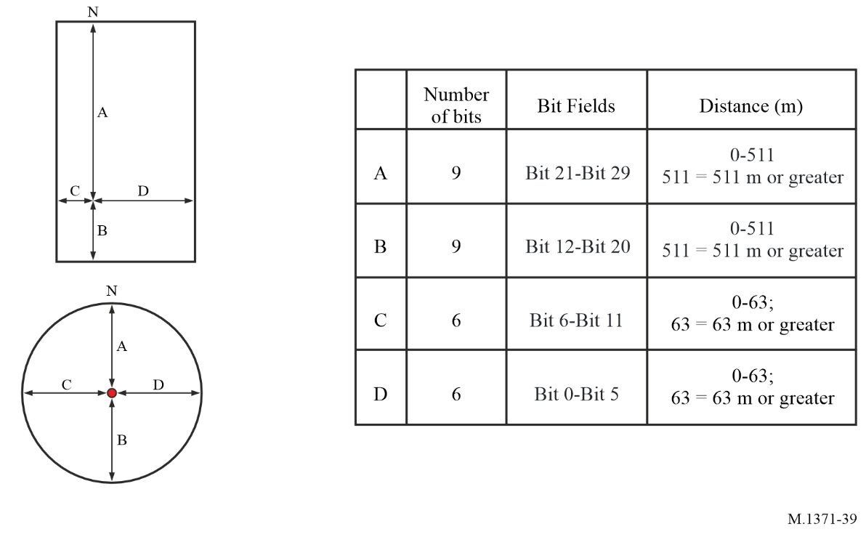
This message should be transmitted immediately after any parameter value was changed.
Note on AtoN within AIS:
The competent international body for aids-to-navigation, IALA, defines an AtoN as: “a device or system external to vessels designed and operated to enhance safe and efficient navigation of vessels and/or vessel traffic.” (IALA Navguide).
The IALA Navguide stipulates: “A floating aid to navigation, which is out of position, adrift or during the night is unlighted, may itself become a danger to navigation. When a floating aid is out of position or malfunctioning, navigational warnings must be given.” Therefore, a station, which transmits Message 21, could also transmit safety related broadcast message (Message 14) upon detecting that the floating AtoN has gone out of position or is malfunctioning, at the competent authority’s discretion.
TABLE 72
The nature and type of aids to navigation can be indicated with 32 different codes
 | Code | Definition
 | 0 | Default, Type of AtoN not specified
 | 1 | Reference point
 | 2 | RACON or MatoN
 | 3 | Fixed structures, such as oil platforms, wind farms.  (NOTE 1 – This code should identify an obstruction that is fitted with an AIS AtoN station)
 | 4 | Emergency Wreck Marking Buoy
Fixed AtoN | 5 | Light, without sectors
 | 6 | Light, with sectors
 | 7 | Leading Light Front
TABLE 72 (end)
 | Code | Definition
 | 8 | Leading Light Rear
 | 9 | Beacon, Cardinal N
 | 10 | Beacon, Cardinal E
 | 11 | Beacon, Cardinal S
 | 12 | Beacon, Cardinal W
 | 13 | Beacon, Port hand
 | 14 | Beacon, Starboard hand
 | 15 | Beacon, Preferred Channel port hand
 | 16 | Beacon, Preferred Channel starboard hand
 | 17 | Beacon, Isolated danger
 | 18 | Beacon, Safe water
 | 19 | Beacon, Special mark
Floating AtoN | 20 | Cardinal Mark N
 | 21 | Cardinal Mark E
 | 22 | Cardinal Mark S
 | 23 | Cardinal Mark W
 | 24 | Port hand Mark
 | 25 | Starboard hand Mark
 | 26 | Preferred Channel Port hand
 | 27 | Preferred Channel Starboard hand
 | 28 | Isolated danger
 | 29 | Safe Water
 | 30 | Special Mark
 | 31 | Light Vessel/LANBY/Rigs  NOTE: This code should be used only when the Light Vessel/LANBY/Rigs is moored and functioning as an AtoN (this includes when off station flag is triggered)
NOTE 1 – The types of aids to navigation listed above are based on the IALA Maritime Buoyage System, where applicable.
NOTE 2 – There is potential for confusion when deciding whether an aid is lighted or unlighted. Competent authorities may wish to use the regional/local section of the message to indicate this.

A7-3.20 Message 22: Channel management
This message should be transmitted by a base station (as a broadcast message) to command the VHF data link parameters for the geographical area designated in this message and should be accompanied by a Message 4 transmission for evaluation of the message within 120 NM. The geographical area designated by this message should be as defined in § A2-4.1. Alternatively, this message may be used by a base station (as an addressed message) to command individual AIS mobile stations to adopt the specified VHF data link parameters. When interrogated and no channel management performed by the interrogated base station, the not available and/or international default settings should be transmitted (see § A2-4.1).
TABLE 73
Parameter |  | Number of bits | Description
Message ID |  | 6 | Identifier for Message 22; always 22
Repeat indicator |  | 2 | Used by the repeater to indicate how many times a message has been repeated. See § A2-4.6.1; 0-3; 0 = default; 3 = do not repeat any more
Source ID |  | 30 | Identity (in the MMS) of the source of the message (see RR Art. 19 and Rec. ITU-R M.585)
Spare |  | 2 | Should be set to zero. Reserved for future use
Channel A |  | 12 | Channel A = AIS 1 (2087)
Channel B |  | 12 | Channel B = AIS 2 (2088)
Tx/Rx mode |  | 4 | 0 = Tx A/Tx B, Rx A/Rx B (default)
Power |  | 1 | 0 = high (default), 1 = low
Longitude 1,  (or 18 most significant bits (MSBs) of addressed  station ID 1) |  | 18 | Longitude of area to which the assignment applies; upper right corner  (North-East); in 1/10 min, or 18 MSBs of addressed station ID 1  (±180°, East = positive, West = negative)  181 = not available
Latitude 1,  (or 12 least significant bits (LSBs) of addressed  station ID 1) |  | 17 | Latitude of area to which the assignment applies; upper right corner (North-East); in 1/10 min, or 12 LSBs of addressed station ID 1, followed by 5 zero bits  (±90°, North = positive, South = negative)  91° = not available
Longitude 2,  (or 18 MSBs of addressed  station ID 2) |  | 18 | Longitude of area to which the assignment applies; lower left corner  (South-West); in 1/10 min, or 18 MSBs of addressed station ID 2  (±180°, East = positive, West = negative)
Latitude 2,  (or 12 LSBs of addressed  station ID 2) |  | 17 | Latitude of area to which the assignment applies; lower left corner  (South-West); in 1/10 min, or 12 LSBs of addressed station ID 2, followed by 5 zero bits (±90°, North = positive, South = negative)
Addressed or broadcast message indicator | 1 |  | 0 = broadcast geographical area message = default; 1 = addressed message  (to individual station(s))
Channel A bandwidth | 1 |  | 0 = default (always 25 kHz)
Channel B bandwidth | 1 |  | 0 = default (always 25 kHz)
Transitional zone size | 3 |  | 0 = default (always)
Spare | 23 |  | Should be set to zero. Reserved for future use
Number of bits | 168
NOTE: If the precision provided within the Latitude and Longitude field of an IEC 61162 exceeds a resolution of 1/10 min the value should be truncated for Message 22 content.

A7-3.21 Message 23: Group assignment command
The Group assignment command is transmitted by a base station when operating as a controlling entity(see § A6-4.3.3.3.2 and § A7-3.20). This message should be applied to a mobile station within the defined region and as selected by “Ship and Cargo Type” or “Station type”. The receiving station should consider all selector fields concurrently. It controls the following operating parameters of a mobile station:
– transmit/receive mode;
– reporting interval;
– the duration of a quiet time.
Station type 10 should be used to define the base station coverage area for control of Message 27 transmissions by Class A and Class B “SO” mobile stations. When station type is 10 only the fields latitude, longitude are used, all other fields should be ignored. This information will be relevant until three minutes after the last reception of controlling Message 4 from the same base station (same MMSI).
TABLE 74
Parameter | Number of bits | Description
Message ID | 6 | Identifier for Message 23; always 23
Repeat indicator | 2 | Used by the repeater to indicate how many times a message has been repeated.  See § A2-4.6.1;0-3; default = 0; 3 = do not repeat any more
Source ID | 30 | Identity (in the MMS) of the source of the message (see RR Art. 19 and Rec. ITU-R M.585)
Spare | 2 | Spare. Should be set to zero
Longitude 1 | 18 | Longitude of area to which the group assignment applies; upper right corner (north-east); in 1/10 min  (±180°, East = positive, West = negative)
Latitude 1 | 17 | Latitude of area to which the group assignment applies; upper right corner (north-east); in 1/10 min  (±90°, North = positive, South = negative)
Longitude 2 | 18 | Longitude of area to which the group assignment applies; lower left corner (south-west); in 1/10 min  (±180°, East = positive, West = negative)
Latitude 2 | 17 | Latitude of area to which the group assignment applies; lower left corner (south-west); in 1/10 min  (±90°, North = positive, South = negative)
Station type | 4 | 0 = all types of mobiles (default); 1 = Class A AIS stations only; 2 = all types of Class B mobile stations; 3 = SAR airborne mobile station;  4 = Class B “SO” mobile stations only; 5 = Class B “CS” AIS station only;  6 = inland waterways; 7 to 9 = regional use; 10 = base station coverage area  (see Message 4 and Message 27); 11 to 15 = for future use
Type of ship and cargo type | 8 | 0 = all types (default)  1…99 see Table 51  100…199 reserved for regional use  200…255 reserved for future use
Spare | 22 | Should be set to zero. Reserved for future use
TABLE 74 (end)
Parameter | Number of bits | Description
Tx/Rx mode | 2 | This parameter commands the respective stations to one of the following modes:  0 = TxA/TxB, RxA/RxB (default); 1 = TxA, RxA/RxB, 2 = TxB, RxA/RxB,  3 = reserved for future use
Reporting interval | 4 | This parameter commands the respective stations to the reporting interval given in Table 75
Quiet time | 4 | 0 = default = no quiet time commanded; 1-15 = quiet time of 1 to 15 min
Spare | 6 | Should be set to zero. Reserved for future use
Number of bits | 160 | Occupies one-time period

TABLE 75
Reporting interval settings for use with message 23
Reporting interval field setting | Reporting interval for Message 23
0 | As given by the autonomous mode
1 | 10 min
2 | 6 min
3 | 3 min
4 | 1 min
5 | 30 s
6 | 15 s
7 | 10 s
8 | 5 s
9 | Next shorter reporting interval (only applicable if in autonomous mode)
10 | Next longer reporting interval (only applicable if in autonomous mode)
11 | 2 s (not applicable to the Class B “CS” and Class B “SO”)
12-15 | Reserved for future use
NOTE 1 – When the dual channel transmission is suspended by Tx/Rx mode command 1 or 2, the required reporting interval should be maintained using the remaining transmission channel.

A7-3.22 Message 24: Static data report
Equipment that supports Message 24, part A, shall transmit once every 6 min alternating between channels.
Message 24 Part A may be used by any AIS station to associate a MMSI with a name.
Message 24 Part A and Part B should be transmitted once every 6 min by Class B “CS” and Class B “SO” AIS station. The message consists of two parts. Message 24B should be transmitted within 1 min following Message 24A.
When the parameter value of dimension of ship/reference for position or type of electronic position fixing device is changed, Class B “CS” and Class B “SO” should transmit Message 24B.
When requesting the transmission of a Message 24 from a Class B “CS” or Class B “SO”, the AIS station should respond with part A and part B.
When requesting the transmission of a Message 24 from a Class A, the AIS station should respond with part B, which should contain the Manufacturer ID only.
Class A shall send out Message 24B within 12 min after starting up and every 24 h thereafter.
TABLE 76
Message 24, part A
Parameter | Number of bits | Description
Message ID | 6 | Identifier for Message 24; always 24
Repeat indicator | 2 | Used by the repeater to indicate how many times a message has been repeated. See § A2-4.6.1; 0-3; 0 = default; 3 = do not repeat any more
Source ID | 30 | Identity (in the MMS) of the source of the message (see RR Art. 19 and Rec. ITU-R M.585)
Part number | 2 | Identifier for the message part number; always 0 for Part A
Name | 120 | Name of the MMSI-registered vessel. Maximum 20 characters 6-bit ASCII, @@@@@@@@@@@@@@@@@@@@ = not available = default.  For SAR aircraft, it should be set to “SAR AIRCRAFT NNNNNNN” where NNNNNNN equals the aircraft registration number
Number of bits | 160 | Occupies one-time period

TABLE 77
Message 24, part B
Parameter | Number of bits | Description
Message ID | 6 | Identifier for Message 24; always 24
Repeat indicator | 2 | Used by the repeater to indicate how many times a message has been repeated. See § A2-4.6.1; 0-3; 0 = default; 3 = do not repeat any more
Source ID | 30 | MMSI number
Part number | 2 | Identifier for the message part number; always 1 for Part B
Type of ship and cargo type | 8 | 0 = not available or no ship = default  1-99 = as defined in § A7-3.3.2  100-199 = reserved, for regional use  200-255 = reserved, for future use  Not applicable to SAR aircraft

TABLE 77 (end)
Parameter | Number of bits | Description
Manufacturer ID | 42 | Unique numerical identification of the Unit programmed by the manufacturer  See Table 78
Call sign | 42 | Call sign of the MMSI-registered vessel. 7 x 6 bit ASCII characters, “@@@@@@@” = not available = default.  Craft associated with a parent vessel should use “A” followed by the last  6 digits of the MMSI of the parent vessel. Examples of these craft include towed vessels, rescue boats, tenders, lifeboats and life rafts.
Dimension of ship/reference for position | 30 | Dimensions of ship in metres and reference point for reported position  (see Fig. 38 and § A7-3.3.3).  For SAR aircraft, the use of this field may be decided by the responsible administration. If used it should indicate the maximum dimensions of the craft. As default should A = B = C = D be set to “0”.
Type of electronic position fixing device | 4 | 0 = not available = default;  1 = GPS,  2 = GLONASS,  3 = combined GNSS,  4 = Loran,  5 = Chayka,  6 = INS,  7 = manually inputted = surveyed or charted position;  8 = Galileo,  9 = BDS,  10 & 11 = not used, reserved for future use,  12 = integrated PNT system  13 = inertial navigation system  14 = terrestrial radio navigation system  15 = internal GNSS
VDES capabilities | 2 | 0 –AIS only  1 – supports VDES ASM  2 – supports VDES ASM/VDE-TER  3 – supports VDES ASM/VDE-TER/VDE-SAT
Number of bits | 168 | Occupies one-time period

TABLE 78
Manufacturer identification field
Bit | Information | Description
(MSB)  41 ……... 24  (18 bits) | Manufacturer’s ID | The Manufacturer’s ID bits indicate the manufacture’s mnemonic code consisting of three 6-bit ASCII characters ⁽¹⁾
23 ……... 20  (4 bits) | Unit Model Code | The Unit Model Code bits indicate the binary coded series number of the model. The first model of the manufacture uses “1” and the number is incremented at the release of a new model. The code reverts to “1” after reaching to “15”. The “0” is not used
19 ……... 0  (LSB)  (20 bits) | Unit Serial Number | The Unit Serial Number bits indicate the manufacture traceable serial number. When the serial number is composed of numeric only, the binary coding should be used. If it includes figure(s), the manufacture can define the coding method. The coding method should be mentioned in the manual
⁽¹⁾ NMEA mnemonic manufacturer codes should be used for Message 24B Manufacturer ID. Manufacturers may request this code via NMEA at https://www.nmea.org/nmea-0183.html.

A7-3.23 Message 25: Single slot binary message
This message is primarily intended short infrequent data transmissions. The single slot binary message can contain up to 128 data-bits depending on the coding method used for the contents, and the destination indication of broadcast or addressed. The length should not exceed one slot. See application identifiers in § A4-2.1.
This message should not be acknowledged by either Message 7 or 13.
TABLE 79
Parameter | Number of bits | Description
Message ID | 6 | Identifier for Message 25; always 25
Repeat indicator | 2 | Used by the repeater to indicate how many times a message has been repeated. Refer to § A2-4.6.1; 0-3; default = 0; 3 = do not repeat any more
Source ID | 30 | Identity (in the MMS) of the source of the message (see RR Article 19 and Rec. ITU-R M.585)
Destination indicator | 1 | 0 = Broadcast (no Destination ID field used)  1 = Addressed (Destination ID uses 30 data bits for MMSI)
Binary data flag | 1 | 0 = unstructured binary data (no Application Identifier bits used)  1 = binary data coded as defined by using the  16-bit Application identifier
TABLE 79 (end)
Parameter | Number of bits | Description
Destination ID | 0/30 | Destination ID (if used) |  | If Destination indicator = 0 (Broadcast); no data bits are needed for the Destination ID.  If Destination indicator = 1; 30 bits are used for Destination ID and spare bits for byte alignment.
Spare | 0/2 | Spare (if Destination ID used)
Binary data | Broadcast Maximum 128  Addressed Maximum 96 | Application identifier  (if used) | 16 bits | Should be as described in § A4-2.1
Binary data | Broadcast Maximum 128  Addressed Maximum 96 | Application binary data | Broadcast Maximum 112 bits  Addressed Maximum 80 bits | Application specific data
Maximum number of bits | Maximum 168 | Occupies up to 1 slot subject to the length of sub-field message content  Class B “CS” mobile AIS stations should not transmit

Table 80 gives the maximum number of binary data-bits for settings of destination indicator and coding method flags, such that, the message does not exceed one slot.
TABLE 80
Destination indicator | Coding method | Binary data  (maximum bits)
0 | 0 | 128
0 | 1 | 112
1 | 0 | 96
1 | 1 | 80

A7-3.24 Message 26: Multiple slot binary message with communications state
This message is primarily intended for scheduled binary data transmissions by applying either the SOTDMA or ITDMA access scheme. This multiple slot binary message can contain up to 1 004 data-bits (using 5 slots) depending on the coding method used for the contents, and the destination indication of broadcast or addressed. See application identifiers in § A4-2.1.
This message should not be acknowledged by either Message 7 or 13.

TABLE 81
Parameter | Number of bits | Description
Message ID | 6 | Identifier for Message 26; always 26
Repeat indicator | 2 | Used by the repeater to indicate how many times a message has been repeated. Refer to § A2-4.6.1; 0-3; default = 0; 3 = do not repeat any more
Source ID | 30 | Identity (in the MMS) of the source of the message (see RR Art. 19 and Rec. ITU-R M.585)
Destination indicator | 1 | 0 = Broadcast (no Destination ID field used)  1 = Addressed (Destination ID uses 30 data bits for MMSI)
Binary data flag | 1 | 0 = unstructured binary data (no Application Identifier bits used)  1 = binary data coded as defined by using the  16-bit Application identifier
Destination ID | 0/30 | Identity (in the MMS) of the destination of the message (see RR Art. 19 and Rec. ITU-R M.585) (if used) |  | If Destination indicator = 0 (Broadcast); no data bits are needed for the Destination ID.  If Destination indicator = 1; 30 bits are used for the Destination ID and 2 spare bits for byte alignment.
Spare bits | 0/2 | Spare (if Destination ID used)
Binary data⁽¹⁾ ⁽²⁾ | Broadcast Maximum 1000 | Application identifier  (if used) | 16 bits | Should be as described in § A4-2.1
 | Addressed Maximum 968 | Application binary data | Broadcast Maximum 984 bits  Addressed Maximum 952 bits | Application specific data
Spare | 4 | Needed for byte alignment
Communication state selector flag | 1 | 0 = SOTDMA communication state follows  1 = ITDMA communication state follows
Communication state | 19 | SOTDMA communication state (see § A2-3.3.7.2.1), if communication state selector flag is set to 0, or ITDMA communication state (§ A2-3.3.7.3.2), if communication state selector flag is set to 1
Maximum number of bits | Maximum 1 064 | Occupies up to 3 slots, or up to 5 slots when able to use FATDMA reservations. For Class B “SO” mobile AIS stations the length of the message should not exceed 3 slots. Class B “CS” mobile AIS stations should not transmit
⁽¹⁾ Binary data should always end to the byte boundary.
⁽²⁾ This allows for up to 128 stuffing bits.

Table 82 gives the maximum number of binary data-bits for settings of destination indicator and coding method flags, such that, the message does not exceed the indicated number of slots.
TABLE 82
Destination indicator | Binary data flag | Binary data (maximum bits)
Destination indicator | Binary data flag | 1-slot | 2-slot | 3-slot | 4-slot | 5-slot
0 | 0 | 104 | 328 | 552 | 776 | 1000
0 | 1 | 88 | 312 | 536 | 760 | 984
1 | 0 | 72 | 296 | 520 | 744 | 968
1 | 1 | 56 | 280 | 504 | 728 | 952

A7-3.25 Message 27: Automatic identification system satellite message
This message is primarily intended for long-range detection of AIS Class A and Class B “SO” equipped vessels (typically by satellite). This message has a similar content to Messages 1, 2 and 3, but the total number of bits has been compressed to allow for increased propagation delays associated with long-range detection. Refer to Annex 3 for details on Long-Range applications.
TABLE 83
Parameter | Number of bits | Description
Message ID | 6 | Identifier for this message; always 27
Repeat indicator | 2 | Always 3
Source ID | 30 | Identity (in the MMS) of the source of the message (see RR Art. 19 and Rec. ITU-R M.585)
Position accuracy | 1 | As defined for Message 1
RAIM flag | 1 | As defined for Message 1
Navigational status | 4 | As defined for Message 1
Longitude | 18 | Longitude in 1/10 min (±180°, East = positive (as per 2’s complement), West = negative (as per 2’s complement)  181° (1A838_{h}) = position older than 6 hours or not available = default)
Latitude | 17 | Latitude in 1/10 min (±90°, North = positive (as per 2’s complement), South = negative (as per 2’s complement)  91° (D548h) = position older than 6 hours or not available = default)
SOG | 6 | Knots (0-62); 62=62 knots or faster, 63 = not available = default
COG | 9 | Degrees (0-359); 360-510 should not be used, 511 = not available = default
Position latency | 1 | 0 = Reported position latency is less than 5 seconds; 1 = Reported position latency is greater than 5 seconds = default
Spare | 1 | Set to zero, to preserve byte boundaries
Total number of bits | 96
NOTE 1 – There is no time stamp in this message. The receiving system is expected to provide the time stamp when this message is received.

A7-3.26 Message 28: Aid-to-Navigation Report (Single-slot message)
Message 28 provides similar information as AIS Message 21, but in one slot versus two slot, and can be used to report MAtoN direction and speed or provide extended information on the AtoN (i.e. its height) and what it’s marking (i.e. hazardous area). It may be accompanied by Message 24A - Static Data Report, Part A to provide the charted name of the AtoN.
TABLE 84
Parameter | Bits | Description
Message ID | 6 | Identifier for this message; always 28.
Repeat Indicator | 2 | Used by the repeater to indicate how many times a message has been repeated. See § A2-4.6.1 0-3; 0 = default; 3 = do not repeat any more.
Source ID | 30 | Identity (in the MMS) of the source of the message (see RR Art. 19 and Rec. ITU-R M.585)
Time stamp | 6 | UTC second when the report was generated by the electronic positioning fixing system (EPFS), (0-59); 60 = time stamp is not available = default; 61 = EPFS is in manual input mode; 62 = EPFS is in dead reckoning mode; 63 = EPFS is inoperative
Longitude | 28 | Longitude in 1/10 000 min of position of an AtoN (±180°, East = positive, West = negative, 181 = (6791AC0h) = not available = default)
Latitude | 27 | Latitude in 1/10 000 min of an AtoN (±90°, North = positive, South = negative, 91 = (3412140h) = not available = default)
Restricted Use Indicator | 2 | Indicates where the AtoN may be operated.  0 = unrestricted use = default  1 = use restricted to the territorial waters of the flag state (of MMSI MID)  2 = use restricted to the Exclusive Economic Zone (EEZ) of the flag state (of MMSI MID)  3 = use restricted as defined by its flag state (of MMSI MID)  NOTE – Use outside of a restricted area requires permission of the AtoN’s flag state (of MMSI MID) competent authority.
AIS AtoN Station Type | 3 | Indicates the type of AIS AtoN station. See IALA Recommendation R0126, The Use of the AIS in Marine AtoN Services, R1016, Mobile Marine Aids to Navigation (MAtoN) and IMO MSC Circular 1473, Policy on Use of AIS Aids to Navigation.  0 = a physical AIS AtoN (floating)  1 = a physical AIS AtoN (fixed)  2 = a synthetic predicted AIS AtoN  3 = a synthetic monitored AIS AtoN  4 = a virtual AIS AtoN  5 = a mobile AIS AtoN  6-7 = reserved for future use
Types of AtoN | 7 | 0 = not available = default in maritime service 1-127 = refer to message 21 Table 72 or Table 85).
IALA AtoN MRN | 17 | AtoN unique IALA Marine Resource Name (MRN). national identification number. The MMSI MID represents the nationality.  000001-131 071, 0 = not available or unassigned = default  See IALA Guideline G1143, IALA MRN for AtoN, e.g. urn:mrn:iala:aton:<ISO 3166-1 alpha-2 code for its nationality>:<national identification number>.

TABLE 84 (cont.)
Parameter | Bits | Description
AtoN Dimensions Type | 4 | Defines what Dimensions A and B represent.  0 = AtoN Dimensions Type = default (see Message 21 and § A7-3.19.1)  1 = AtoN Height and Structural Area. The reported position represents the midpoint of a shape that encompasses the structural area of the AtoN (i.e. buoy, ODAS, platform, bridge, building, tower, wind turbine, etc.).  - Dimension A = radius of the circle, in 1-metre steps, 0-511, 511 = 511 metres or greater.  - Dimension B = its height above sea level, in 0.1-metre steps, 0-204.7, 204.7 = 204.7 metres or greater. Intended to convey the physical dimensions of a large AtoN or the structure it resides on and assists its sightings.  2 = AtoN Swing Circle. If Type of AtoN > 19 < 31, the reported position also represents the centre of its swing circle.  - Dimension A (in 100-metre steps, 0–51 100) + Dimension B (in 1-metre steps, 0–100) = its radius. Dimension B = 101-2 047 reserved for future use.  3 = Mobile AtoN Vector. Dimension A = COG, in true degrees: 0-359 in 1-degree steps, 360 = COG unreported; 361 = dynamically positioned on station, COG unreported, 362 = purposedly adrift, COG unreported, 363 = tethered, COG unreported, 364 = COG unknown = default, 365-511 reserved for future use; Dimension B = SOG, in 1 knot steps, 0-59; 60 = SOG unreported;, 61-2 047 reserved for future use.  4 = AtoN Area-Polygon. The reported position represents the starting point of a vertex, whose endpoint should be the reported position of the subsequent vertex broadcast from the same MMSI/MRN, to form a polygon area of navigational interest, i.e.  - Dimension A is the sequence number of each vertex, starting from 1, 1-8; 9-511 reserved for future use. If Dimension A = 0, then this vertex endpoint should connect to the start point of vertex 1 to form a closed polygon.  - Dimension B indicates the total number of lines in the polygon, up to 9 lines; 0-8; 9-2 047 reserved for future use.  5 = AtoN Area-Circle. The reported position represents the centre of a circular area encompassing a navigational interest, i.e. aquaculture farm, wind farm, etc.  - Dimension A (in 1-metre steps, 0-99; 100-511 reserved for future use.) + Dimension B (in 100-metre steps, 100–204 700) = its radius.  6 = AtoN Boundary Line 1. The reported position represents the starting point of a right-hand line that bounds an area of navigational interest, i.e. (ice sheet, reported shoaling).  - Dimension A defines its orientation, clockwise from true North, in 1-degree steps: 0–359; 360–511 reserved for future use.  - Dimension B defines the length of this diagonal, in 10-metre steps, 10-20 470.  7 = AtoN Area-Sector. If AtoN Dimension Type Additional Data Flag = 1, the reported position represents the starting point of a line that is to be connected clockwise with an accompanying AtoN Dimension Type 6 with the same reported position to form a sector area of navigational interest.  - Dimension A defines its orientation, clockwise from true North, in 1-degree steps: 0–359; 360–511 reserved for future use.  - Dimension B defines the length of this line, in 10-metre steps, 10-20 470.  8 = AtoN Boundary Line 2. The reported position represents the midpoint of a line that bounds an area of navigational interest, i.e. (ice sheet, reported shoaling, water).  - Dimension A defines its orientation, clockwise from true North, in 1-degree steps: 0–359; 360–511 reserved for future use.  - Dimension B defines the length of this line, in 10-metre steps, 10-20 470.  9 = AtoN Area-Quadrilateral. If AtoN Dimension Type Additional Data Flag = 1, the reported position represents the midpoint of one side of a quadrilateral area of navigational interest, created by connecting its endpoints clockwise with the endpoints of an accompanying AtoN Dimension Type 8 or 12.

TABLE 84 (cont.)
Parameter | Bits | Description
- Dimension A defines its orientation, clockwise from to true North, in 1-degree steps: 0–359; 361 (360–511 reserved for future use).
- Dimension B defines the length of this diagonal, in 10-metre steps, from 10-20 470.
10 = AtoN Large Boundary Line 1. The reported position represents the starting point of a right-hand line that bounds an area of navigational interest, i.e. (ice sheet, reported shoaling).
- Dimension A defines its orientation, clockwise from true North, in 1-degree steps: 0–359; 360–511 reserved for future use.
- Dimension B defines the length of this diagonal, in 200-metre steps, 0-409 400.
11 = AtoN Large Area-Sector. If AtoN Dimension Type Additional Data Flag = 1, the reported position represents the starting point of line that is to be connected clockwise with an accompanying AtoN Dimension Type 10 with the same reported position to form a sector area of navigational interest.
- Dimension A defines its orientation, clockwise from true North, in 1-degree steps: 0–359; 360–511 reserved for future use.
- Dimension B defines the length of this line, in 200-metre steps, 0-409 400.
12 = AtoN Large Boundary Line 2. The reported position represents the midpoint of a line that bounds an area of navigational interest, i.e. (ice sheet, reported shoaling, water).
- Dimension A defines its orientation, clockwise from true North, in 1-degree steps: 0–359; 360–511 reserved for future use.
- Dimension B defines the length of this line, in 200-meter steps, 0-409 400.
13 = AtoN Large Area-Quadrilateral. If AtoN Dimension Type Additional Data Flag = 1, the reported position represents the midpoint of one side of a quadrilateral area of navigational interest, created by connecting its endpoints clockwise with the endpoints of an accompanying AtoN Dimension Type 12 line.
- Dimension A defines its orientation, clockwise from true North, in 1-degree steps: 0–359; 361(360–511 reserved for future use).
- Dimension B defines the length of this diagonal, in 200-meter steps, 0-409 400.
14-15 reserved for future use.
NOTE 1: Portrayal systems should only override AtoN Dimension Type data of the same AtoN Dimension Type. AtoN Dimension Type 4 and 5 require an AtoN Dimension Type 6 for their portrayal and vice versa.
NOTE 2: Use of IMO Application Specific Message Area Notice (DAC=001, FI=22) should be considered to define greater or more complex AtoN Description Areas than can be defined by this parameter.
AtoN Dimensions A | 9 | As defined by its AtoN Dimension Type (0 = unknown or unreported = default)
AtoN Dimension B | 11 | As defined by its AtoN Dimension Type (0 = unknown or unreported = default)
AtoN Dimension Type Additional Data Flag | 1 | To convey that this AtoN has multiple Dimension Types, i.e.  Type 1 + Type 2 (physical dimensions and swing circle of the reported AtoN)  Type 1 + Type 3 (mobile AtoN physical dimension and its vector)  Type 4 + Type 4 (to define a polygon area)  Type 6 + Type 7 (to define a sector area)  Type 8 + Type 9 or 12 (to define a quadrilateral area)  Type 10 + Type 11 (to define a sector area)  Type 12 + Type 13 (to define a quadrilateral area)  0 = This AtoN has a single AtoN Dimension Type = default.  1 = This AtoN has multiple AtoN Dimension Types.  NOTE: The report rate of Message 28 may be shortened to reduce the latency of multiple AtoN Dimension Types, particularly for AtoN Dimension Type 8 (AtoN Area-Polygon) which should broadcast all its vertices within the same frames.
AtoN Charted Status | 1 | Indicates whether the AtoN is charted or not.  0 = AtoN is uncharted = default  1 = AtoN charted

TABLE 84 (end)
Parameter | Bits | Description
AtoN On-station Status | 4 | Indicates whether the AtoN is on-station or not.  0 = on-station = default  1 = on-station or on course (Mobile AtoN)  2 = on-station, but damaged, occulted, submerged or otherwise not properly visible  3 = off-station, a virtual AtoN reporting the intended position of this AtoN that is reporting itself off-position  4 = off-station location unknown  5 = off-station but reporting its current position  6 = off-station adrift  7 = off-station, removed or relocated  8 = on-station, as a new or temporary AtoN  9 = unmarked navigation hazard, used by a vessel to inform of an unmarked navigation hazard. The type of AtoN should be indicated as 1 = reference point. Should be accompanied by a message 14 that provides a description of the hazard, e.g. floating container.  10 = unmarked obstruction (anything that restricts, endangers, or interferes with navigation). Type of AtoN should be denoted as 1 = reference point. Should be accompanied by a message 14 that provides a description of the hazard, e.g. vessel aground.  11-15 = reserved for future use.  NOTE – AtoN off-station may accompany their report with a Message 14 stating: OFF_STATION.
AtoN Status bits | 8 | Reserved for the indication of the AtoN status. See IALA Recommendation R0126, The Use of the AIS in Marine AtoN Services.  00000000 = default
Spare | 1 | Not uses, set to 0. Reserved for future use.
Authentication Flag | 1 | 0 = this AtoN message is not authenticated = default  1 = this AtoN message has been authenticated per IALA G1192
Number of bits | 168 | Occupies one slot

TABLE 85
Type of aids-to-navigation
Code | Definition (Type of aid to navigation)
0-31 | Refer to Table 72
32 | Ocean Data Acquisition System (ODAS)
33 | Water Sampling and/or Monitoring equipment
34 | Research equipment
35 | Towed Cable, Pipe or Semi-submerged Object Marker
36 | Towed Vessel or Object
37 | Flotsam Marker, Large (greater than 5 metres)
38 | Flotsam Marker, Small (less than 5 metres)
39 | Navigation hazard
40 | Synthetic Target Marker
41 | Protected Species Marker
42 | Military Operation Target Marker
43 | Dangerous Object
44 | Pollution Spill Marker
TABLE 85 (end)
Code | Definition (Type of aid to navigation)
45 | Search & Rescue Datum Mark
46 | Datum Mark
47 | Operating Underwater (at times)
48 | Underwater Operations Marker
49 | Military Operation or Restricted Area
50 | Dynamic Area
51-63 | Reserved for future use
64-127 | Reserved for regional use

Annex 8
Requirements for stations using burst transmissions

A8-1 Requirements for stations using burst transmissions
This Annex specifies how data should be formatted and transmitted for units that have limited range and operate in a low volume VDL. Burst transmission behaviour will increase the probability of reception and is required for units such as an AIS-SART.
The burst behaviour channel access does not consider the current VDL activity and as such does not conform to the self-organizing rules for the VDL. The burst behaviour channel access is disruptive to the VDL. This type of channel access should be limited to “safety of life” applications which are designed to be floating on the surface of the water for a limited duration.
Burst behaviour conforms with Annex 2 with the minor modifications in the following sections:
– Transceiver characteristics.
– Transmitter transient response.
– Synchronization accuracy.
– Channel access scheme.
– Source ID (Unique identifier).

A8-2 Transceiver characteristics
TABLE 86
Required parameter settings
Symbol | Parameter name | Setting
PH.AIS1 | Channel 1 (default channel 1) | 161.975 MHz
PH.AIS2 | Channel 2 (default channel 2) | 162.025 MHz
PH.BR | Bit rate | 9 600 bit/s
PH.TS | Training sequence | 24 bits
PH.TST | Transmitter settling time (transmit power within 20% of final value. Frequency stable to within ±1 kHz of final value). Tested at manufacturers declared transmit power | ≤ 0.833 ms
 | Ramp down time | ≤ 1.0 ms
 | Transmission duration | ≤ 26.6 ms
 | Transmitter output power | Nominal 1W e.i.r.p.

In addition, the constants of the physical layer the AIS station should comply with the values given in Tables 87 and 88.
TABLE 87
Required settings of physical layer constants
Symbol | Parameter name | Value
PH.DE | Data encoding | NRZI
PH.FEC | Forward error correction | Not used
PH.IL | Interleaving | Not used
PH.BS | Bit scrambling | Not used
PH.MOD | Modulation | Bandwidth adapted GMSK

TABLE 88
Modulation parameters of the physical layer
Symbol | Name | Value
PH.TXBT | Transmit BT-product | 0.4
PH.MI | Modulation index | 0.5

A8-3 Transmitter requirements
The technical characteristics as specified in Table 89 should apply to the transmitter.
TABLE 89
Minimum required transmitter characteristics
Transmitter parameters | Requirements
Carrier power | Nominal radiated power 1 W
Carrier frequency error | ±500 Hz (normal). ±1 000 Hz (extreme)
Slotted modulation mask | ∆fc < ±10 kHz: 0 dBc  ±10 kHz < ∆fc < ±25 kHz: below the straight line between –20 dBc at ±10 kHz and –40 dBc at ±25 kHz  ±25 kHz < ∆fc < ±62.5 kHz: –40 dBc
Transmitter test sequence and modulation accuracy | < 3 400 Hz for Bit 0, 1 (normal and extreme)  2 400 Hz ± 480 Hz for Bit 2, 3 (normal and extreme)  2 400 Hz ± 240 Hz for Bit 4 … 31 (normal, 2 400 ± 480 Hz extreme)  For Bits 32 … 199  1 740 ± 175 Hz (normal, 1 740 ± 350 Hz extreme) for a bit pattern of 0101  2 400 Hz ± 240 Hz (normal, 2 400 ± 480 Hz extreme) for a bit pattern of 00001111
Transmitter output power versus time | Power within mask shown in Fig. A2-2 and timings given in Table 6
Spurious emissions | Maximum 25 μW  108 MHz to 137 MHz, 156 MHz to 161.5 MHz, and  1 525 MHz to 1 610 MHz
For information the emission mask specified above is shown in Fig. 40.
Figure 40
Emission mask
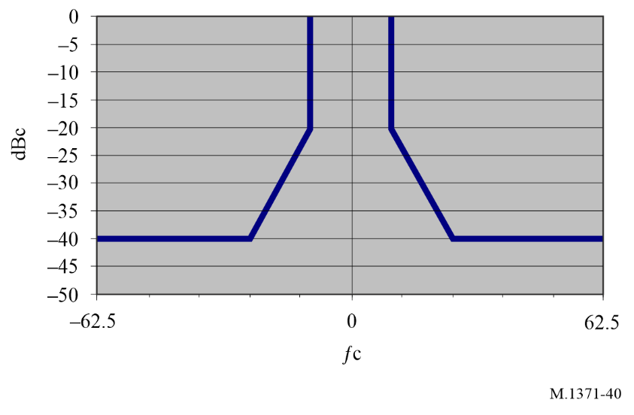

A8-4 Synchronization accuracy
During UTC direct synchronization, the transmission timing error, including jitter, of the AIS station should be ±3 bits (±312 μs).

A8-5 Channel access scheme
The AIS station should operate autonomously and determine its own schedule for transmission of its messages based on random selection of the first slot of the first burst. The other 7 slots within the first burst should be fixed referenced to the first slot of the burst. The increment between transmissions slots within a burst should be 75 slots and the transmissions should alternate between AIS 1 and AIS 2. The AIS station transmits messages in a burst of 8 messages no more than once per minute.
In active mode the AIS station should use messages with a communication state in the first burst. The communication state should set a slot-time-out = 7 in the first burst, thereafter the slot-time-out should be decreased according to the rules of SOTDMA. All slots should be regarded as candidates in the selection process. When time out occurs, the offset to the next set of 8 bursts is randomly selected between 1 min ± 6 s.
Figure 41 illustrates the burst transmissions in active mode starting on AIS 1. It is permissible to start the sequence on AIS 2.
Figure 42 illustrates in test or deactivated mode, messages with a communication state should set slot-time-out = 0 and sub-message = 0 in the first and only burst.
The slot-time-out values of all messages’ communication state within every burst should be the same.
Messages should be transmitted alternately on AIS 1 and AIS 2.
If Message 1 and Message 14 are separated by a multiple of 75 slots and the gap is under 450 slots, they should be deemed to have originated from the same transmitter. The association timeout for linking Message 1 and Message 14 shall be 8 minutes.
Figure 41
Burst transmissions in active mode
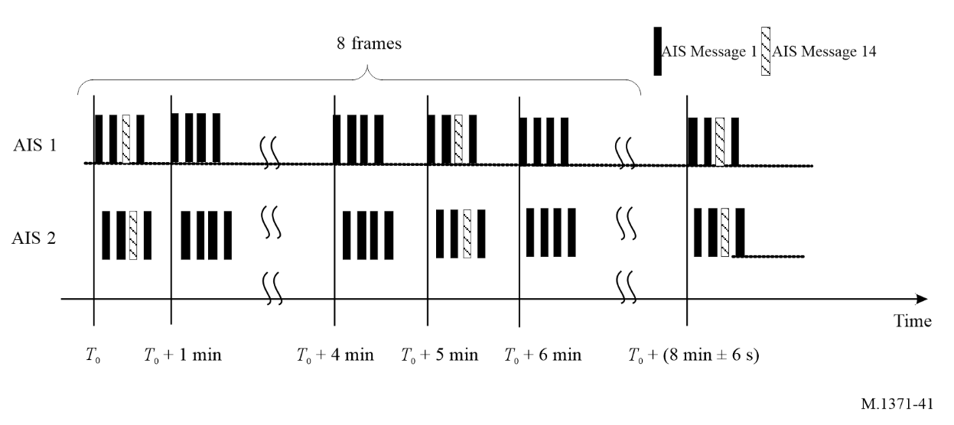
Figure 42
Burst transmissions in test/deactivated mode
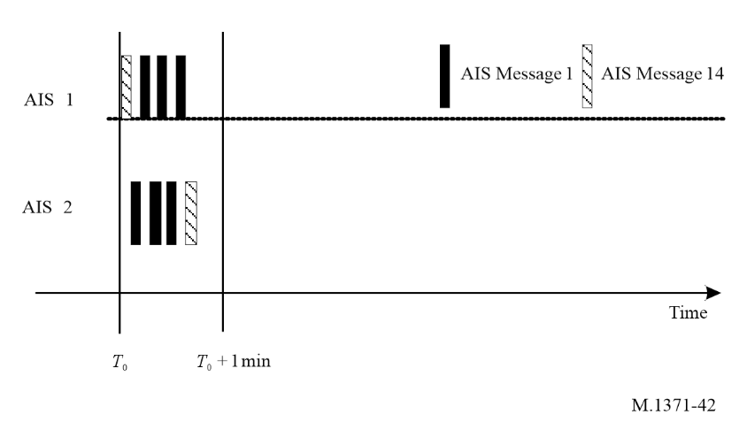

A8-6 Supplemental ID information
The source ID should have a unique scheme such as the AIS-SART where the source ID is 970xxyyyy (where xx = manufacturer ID 01 to 99; xx = 00 is reserved for test purposes; yyyy = the sequence number 0000 to 9999, see §§ A1-2.1.6 to A1-2.1.8).
The 12-character identity shown below can be used to uniquely identify AIS-SART, MOB-AIS and EPIRB-AIS during burst transmission. For AIS message 1 using burst transmission, 9₁7₂T₃X₄X₅Y₉Y₁₀Y₁₁Y₁₂ is used as the Source ID. For AIS message 14 using burst transmission, the three alphanumeric characters M₆P₇P₈ are appended to the end of the safety related text (see § A1-2.1.6).
9₁7₂T₃X₄X₅M₆P₇P₈Y₉Y₁₀Y₁₁Y₁₂
where T₃ = device type 0, 2 or 4(0 indicates AIS-SART, 2 indicates MOB-AIS, 4 indicates EPIRB-AIS); X₄X₅ = manufacturer ID 01 to 99; M₆ = supplementary manufacturer ID suffix alphanumeric character; P₇P₈ = supplementary sequence number prefix alphanumeric character; Y₉Y₁₀Y₁₁Y₁₂ = the sequence number 0000 to 9999.

* This Recommendation should be brought to the attention of the International Maritime Organization (IMO), the International Civil Aviation Organization (ICAO), the International Association of Marine Aids to Navigation and Lighthouse Authorities (IALA), the International Electrotechnical Commission (IEC) and the Comité International Radio Maritime (CIRM).
IMO Safety of Navigation Circular, SN.1/Circ. 289, Guidance on the use of AIS application-specific messages.
Man overboard (MOB) device means a device in accordance with Recommendation ITU-R M.2135 AMRD Group A, using DSC for alerting and AIS for locating.
For the second-generation beacons, the 15 HEX-ID is truncated from the 23 HEX-ID to indicate the identity of the beacon.
1 Nautical mile = 1 852 metres 235.9 Nautical miles = 436 886.8 metres; 120 Nautical miles = 222 240 metres.
Note: IMO Resolution A.1106 (29) states that AIS should always be in operation when a ship is underway or at anchor; unless the master believes its continual operation might compromise the safety or security of the ship.
1 Nautical mile = 1 852 metres 500 Nautical miles = 926 000 metres
Depending on the basic reporting interval, this may temporarily result in a shorter reporting interval as required by speed and course change, but this seems to be acceptable.
1 Nautical mile = 1 852 metres 1 knot = 1 852 m/h 3 knots = 5 556 m/h.
Note that in this case the synchronization process will not take into account distance delays.
1 Nautical mile = 1 852 metres 1 knot = 1 852 m/h 2 knots = 3 704 m/h.
The following example is compliant with the requirement: Sample the RF signal strength at a rate > 1 kHz, average the samples over a sliding 20 ms period and over a 4 s interval determine the minimum period value. Maintain a history of 15 such intervals. The minimum of all 15 intervals is the background level. Add a fixed 10 dB offset to give the CS detection threshold.
1 Nautical mile = 1 852 metres; 30 Nautical miles = 55 560 metres; 60 Nautical miles = 111 120 metres.
Because of the time-out, assignments may be reissued by the competent authority as needed. If a Message 23 commanding a reporting interval of 6 or 10 min is not refreshed by the base station, the assigned station will resume normal operation after time-out and thus not establish the assigned rate.
A Class B“CS” station by default reports sync state 3 and does not report “number of received stations”. Therefore it will not be used as sync source for other stations.
1 Nautical mile = 1 852 metres; 120 Nautical miles = 222 240 metres.
1 Nautical mile = 1 852 metres. 1 knot = 1 852 m/hr.
1 Nautical mile = 1 852 metres. 1 knot = 1 852 m/h.
1 Nautical mile = 1 852 metres. 1 knot = 1 852 m/h.
1 Nautical mile = 1 852 metres. 1 knot = 1 852 m/h.
A base station report (Message 4) in conjunction with a data link management message (Message 20) with the same base station ID (MMSI) must be received by the mobile station so that it can determine its distance from the transmitting base station.
The AIS satellite broadcast message was previously named as long range broadcast message.
1 Nautical mile = 1 852 metres 1 knot = 1 852 m/h.
The manufacturer ID for devices using freeform maritime identity can be obtained via CIRM website at www.cirm.org.

