Recommendation ITU-R M.1036-7
(12/2023)
M Series: Mobile, radiodetermination, amateur
and related satellite services
Frequency arrangements for implementation of the terrestrial component of International Mobile Telecommunications in the bands identified for IMT in the Radio Regulations

Foreword
The role of the Radiocommunication Sector is to ensure the rational, equitable, efficient and economical use of the radio-frequency spectrum by all radiocommunication services, including satellite services, and carry out studies without limit of frequency range on the basis of which Recommendations are adopted.
The regulatory and policy functions of the Radiocommunication Sector are performed by World and Regional Radiocommunication Conferences and Radiocommunication Assemblies supported by Study Groups.

Policy on Intellectual Property Right (IPR)
ITU-R policy on IPR is described in the Common Patent Policy for ITU-T/ITU-R/ISO/IEC referenced in Resolution ITU-R 1. Forms to be used for the submission of patent statements and licensing declarations by patent holders are available from http://www.itu.int/ITU-R/go/patents/en where the Guidelines for Implementation of the Common Patent Policy for ITU-T/ITU-R/ISO/IEC and the ITU-R patent information database can also be found.

Series of ITU-R Recommendations
(Also available online at https://www.itu.int/publ/R-REC/en)
Series | Title
BO | Satellite delivery
BR | Recording for production, archival and play-out; film for television
BS | Broadcasting service (sound)
BT | Broadcasting service (television)
F | Fixed service
M | Mobile, radiodetermination, amateur and related satellite services
P | Radiowave propagation
RA | Radio astronomy
RS | Remote sensing systems
S | Fixed-satellite service
SA | Space applications and meteorology
SF | Frequency sharing and coordination between fixed-satellite and fixed service systems
SM | Spectrum management
SNG | Satellite news gathering
TF | Time signals and frequency standards emissions
V | Vocabulary and related subjects

Note: This ITU-R Recommendation was approved in English under the procedure detailed in Resolution ITU-R 1.

Electronic Publication
Geneva, 2024

© ITU 2024
All rights reserved. No part of this publication may be reproduced, by any means whatsoever, without written permission of ITU.

RECOMMENDATION ITU-R M.1036-7
Frequency arrangements for implementation of the terrestrial component of International Mobile Telecommunications in the bands
identified for IMT in the Radio Regulations
(Question ITU-R 229-5/5)
(1994-1999-2003-2007-2012-2015-2019-2023)
Scope
This Recommendation provides guidance on the selection of transmitting and receiving frequency arrangements for the terrestrial component of IMT systems as well as the arrangements themselves, with a view to assisting administrations on spectrum-related technical issues relevant to the implementation and use of the terrestrial component of IMT in the bands identified in the Radio Regulations (RR).
The frequency arrangements are recommended from the point of view of enabling the most effective and efficient use of the spectrum to deliver IMT services – while minimizing the impact on other systems or services in these bands – and facilitating the growth of IMT systems.
This Recommendation is complemented by other ITU-R Recommendations and Reports on IMT that provide additional details on a number of aspects including unwanted emission characteristics for the bands addressed in this Recommendation and radio interface specifications.
Keywords
IMT, frequency arrangements, terrestrial component of IMT
The ITU Radiocommunication Assembly,
considering
a) that the ITU is the internationally recognized organization that has sole responsibility, in conformity with the ITU Constitution, Convention, and the Radio Regulations, to define and to recommend the standards and globally harmonized frequency arrangements for IMT systems, with the collaboration of other relevant organizations;
b) that globally harmonized spectrum and globally harmonized frequency arrangements for IMT are desirable to reduce the overall cost of IMT networks and terminals by providing economies of scale, facilitating deployment and cross-border coordination;
c) that the use of the bands identified for IMT may not be harmonized globally due to different uses by other services in some countries;
d) that a common base and/or mobile transmit band would facilitate the development of terminal equipment for global roaming. A common base transmit band, in particular, provides the possibility to broadcast to roaming users all information necessary to establish a call;
e) that guardbands for IMT systems should be minimized to avoid wasting of spectrum taking into account the coexistence with other services and applications;
f) that individual subscriber traffic and capacity dimensioning in IMT systems is expected to be dynamically asymmetric where the direction of asymmetry can vary rapidly within short (ms) time-frames, while IMT network traffic may vary in asymmetry over the longer term (see Annex);
g) that a number of ITU-R Reports are available that can assist in determining means to facilitate coexistence and compatibility between systems in other services and the terrestrial components of IMT as shown in Attachment 3 to the Annex;
h) that the capabilities of IMT systems are being continuously enhanced in line with user needs and technology trends,
considering further
a) that the IMT-2000 radio interfaces are detailed in Recommendation ITU-R M.1457 and currently include two modes of operation – frequency division duplex (FDD) and time division duplex (TDD);
b) that the IMT-Advanced radio interfaces are detailed in Recommendation ITU-R M.2012 and include both FDD and TDD modes;
c) that the IMT-2020 radio interfaces are detailed in Recommendation ITU-R M.2150 and include both FDD and TDD modes;
d) that IMT technologies could support various applications (e.g. PPDR, MTC/IoT/M2M, ITS). Specific frequency arrangements for those applications may be addressed in other Reports and or Recommendations,
noting
a) that Attachments 2 through 3 to the Annex provide information on specific vocabulary and terms utilized in this Recommendation and a listing of related Recommendations and Reports;
b) that consideration should be taken by neighbouring countries that are implementing different services (e.g. IMT system and other services/applications), considering technical and operational measures to facilitate coexistence in such cases. See Attachment 3 to the Annex,
noting further
a) that the detailed specifications in Recommendations ITU-R M.1457, ITU-R M.2012 and ITU-R M.2150 might include technical details that could be interpreted as “frequency arrangements for implementation of the terrestrial component of International Mobile Telecommunications”;
b) that technical details referred to in noting further a) above, are understood to be those necessary for “proper design and technical operation of the IMT system, and the establishment of minimum RF characteristics and minimum performance requirements”,
recognizing
a) that No. 92 of the ITU Constitution stipulates that “The decisions of a World Radiocommunication Conference, of a Radiocommunication Assembly and of a Regional Radiocommunication Conference shall in all circumstances be in conformity with this Constitution and the Convention. The decisions of a Radiocommunication Assembly or of a Regional Radiocommunication Conference shall also in all circumstances be in conformity with the Radio Regulations”;
b) that frequency allocation and associated footnotes in force are contained in Article 5 of the RR. See also Attachment 1 to the Annex, which summarizes the frequency bands and associated footnotes identifying the bands for IMT;
c) that key features of IMT-2000, IMT-Advanced and IMT-2020 are contained in Recommendations ITU-R M.1645, ITU-R M.1822 and ITU-R M.2083;
d) that implementation of IMT in the frequency bands 1 885-2 025 MHz and 2 110-2 200 MHz is addressed in Resolution 212 (Rev.WRC-19), which notes among other aspects that the availability of the satellite component of IMT in the bands 1 980-2 010 MHz and 2 170-2 200 MHz simultaneously with the terrestrial component of IMT in the bands identified in RR No. 5.388 would improve the overall use of IMT;
e) that Resolution 235 (WRC-15) resolves to invite ITU-R to review the spectrum use and study the spectrum needs of existing services within the frequency band 470-960 MHz in Region 1, and to consider possible regulatory actions in the frequency band 470-694 MHz in Region 1, at WRC-23, as appropriate;
f) that, in the frequency band 1 427-1 452 MHz, mitigation measures (e.g. filters, guardbands, etc.) may be necessary in order to meet the limits of unwanted emission applicable to IMT stations in the mobile service specified in Table 1 of Resolution 750 (Rev.WRC-19);
g) that Resolution 225 (Rev.WRC-12) invites ITU-R to study the sharing and coordination issues in the bands 2 500-2 520 MHz and 2 670-2 690 MHz as identified for IMT in RR No. 5.384A and allocated to the mobile-satellite service in Region 3;
h) that for IMT in the frequency band 24.25-27.5 GHz Resolution 242 (WRC-19) encourages administrations to consider additional mitigation techniques beyond the limits specified in Resolution 750 (Rev.WRC-19) for the future development of Earth exploration satellite service (EESS) (passive) in the frequency band 23.6-24 GHz;
i) that in order to protect the EESS (passive) in the frequency band 36-37 GHz, the unwanted emissions of IMT stations operating in the frequency band 37-40.5 GHz are specified in Resolution 243 (WRC-19),
recommends
that the frequency arrangements and implementations aspects contained in the Annex should be considered for the deployment of IMT in the bands identified for IMT in the RR.

Annex
Implementation aspects and frequency arrangements applicable for IMT
TABLE OF CONTENTS
Page

SECTION 1 – Implementation aspects applicable to the frequency arrangements 5
SECTION 2 – Frequency arrangements in the band 450-470 MHz 8
SECTION 3 – Frequency arrangements in the 470-960 MHz frequency range 9
SECTION 4 – Frequency arrangements in the band 1 427-1 518 MHz 14
SECTION 5 – Frequency arrangements in the band 1 710-2 200 MHz 15
SECTION 6 – Frequency arrangements in the band 2 300-2 400 MHz 17
SECTION 7 – Frequency arrangements in the band 2 500-2 690 MHz 18
SECTION 8 – Frequency arrangements in the 3 300-3 700 MHz frequency range 19
SECTION 9 – Frequency arrangements in the band 4 800-4 990 MHz 20
SECTION 10 – Frequency arrangements in the band 24.25-27.5 GHz 21
SECTION 11 – Frequency arrangements in the band 37-43.5 GHz 22
SECTION 12 – Frequency arrangements in the band 45.5-47 GHz 23
SECTION 13 – Frequency arrangements in the band 47.2-48.2 GHz 24
SECTION 14 – Frequency arrangements in the band 66-71 GHz 25
Attachment 1 to the Annex 26
Attachment 2 to the Annex Vocabulary of terms 27
Attachment 3 to the Annex Related Recommendations and Reports 27

SECTION 1

Implementation aspects applicable to the frequency arrangements
Frequency arrangements in the sections below should be considered as harmonized arrangements for implementation and deployment of the terrestrial component of International Mobile Telecommunications with due account of noting further a) and noting further b). The order of the frequency arrangements within each Section does not imply any priority. Administrations may implement any of the recommended frequency arrangements to suit their national conditions taking into account the relevant provisions of the RR. Administrations may implement all or part of each frequency arrangement.
It is noted that Administrations may implement other frequency arrangements (for example, arrangements which include different duplex schemes, different FDD/TDD boundaries, etc.) to fulfil their requirements. These administrations should consider geographical neighbouring and regional deployments as well as matters related to achieving economies of scale, facilitating roaming, and measures to minimize interference.
Administrations should take into account the fact that some of the different frequency arrangements in the same band have an overlap of base station transmitter and mobile station transmitter bands. Interference problems may result if different frequency arrangements with such overlaps are implemented by neighbouring administrations.
Sections 1 to 14 in the Annex are parts of this Recommendation, and should be considered in their entirety when implementing frequency arrangements as appropriate.
Traffic asymmetry implications
It is recommended that administrations and operators consider asymmetric traffic requirements when assigning spectrum or implementing systems. Applications supported by IMT may have various degrees of asymmetry. Report ITU-R M.2072 describes not only download dominant applications such as e-newspaper, but also upload dominant applications such as observation (network-camera) and upload file transfer. Also, the degree of asymmetry of other applications such as high-quality video telephony, mobile multicasting, and videoconference depends on their requirements.
In this context, asymmetry means that the basic amount of traffic may differ between the uplink and the downlink direction. As a possible consequence, the amount of resources needed for the downlink may differ from that of the uplink. Estimates for a mix of traffic are described in Report ITU-R M.2023, Report ITU-R M.2078 and Recommendation ITU-R M.1822. Suitable techniques to support asymmetric traffic are described in Report ITU-R M.2038.
It is noted that traffic asymmetry can be accommodated by a variety of techniques including flexible timeslot allocation, different modulation formats, and different coding schemes for the uplink and downlink. With equal FDD pairing for uplink and downlink, downlink-only paired with an external FDD uplink, or TDD, varying degrees of traffic asymmetry can be accommodated.
Segmentation of the spectrum
It is recommended that the frequency arrangements not be segmented for different IMT radio interfaces or services except where necessary for technical and regulatory reasons.
It is recommended that the frequency arrangements should, to maintain flexibility of deployment, be available for use in either FDD mode, TDD mode, or both, and should not, ideally, be segmented between FDD and TDD modes in paired spectrum except where necessary for technical and regulatory reasons.
Duplex arrangement and separation
IMT systems operating in FDD mode could operate using the conventional duplex direction: mobile terminals transmit at the lower frequencies and base stations transmit at the higher frequencies. This is because the system performance is generally constrained by the uplink link budget due to the limited transmit power of terminals.
In order to facilitate coexistence with adjacent services, in some instances it may be desirable to reverse the duplex direction, with the mobile terminal transmit within the upper band and base station transmit within the lower band. These cases are specified in the applicable sections.
It is recommended that for administrations wishing to implement only part of an IMT frequency arrangement, the channel pairing should be consistent with the duplex frequency separations of the full frequency arrangement.
Dual duplexer
The duplex separation, the duplexer bandwidth, and the centre gap in an FDD frequency arrangement influence the duplexer performance:
– larger duplex separation brings better isolation performance between downlink and uplink (i.e. less self-desensitization);
– larger duplexer bandwidth reduces the overall duplexer performance, resulting in both worse self-desensitization and higher interference from MS to MS or BS to BS;
– smaller centre gap may lead to higher interference from MS to MS or BS to BS.
One way to reduce the duplexer’s bandwidth in an FDD system, while keeping a larger duplex separation and total bandwidth, is to use a dual duplexer. From an implementation point of view, a dual duplexer arrangement can be implemented according to Fig. 1 below.
Figure 1
Duplexer arrangements in an FDD frequency arrangement
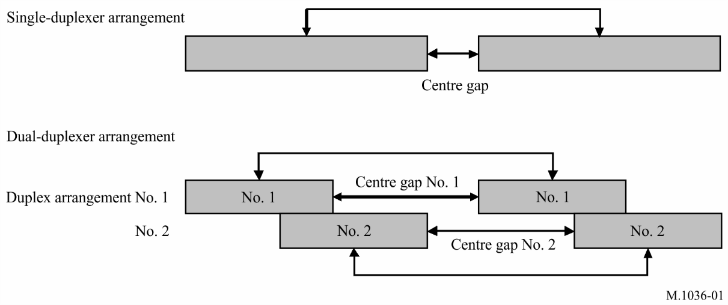
A fixed overlap between duplex arrangement #1 and #2 enables the use of common equipment to meet the operational requirements of deployments. The size of the overlap is likely to be the same for all implementations, and it would be decided in accordance with filter design when establishing the band plan.
Due to the two adjacent duplex arrangements, the gap between downlink (DL) and uplink (UL) blocks can be made smaller than the duplex gap in a single duplexer FDD arrangement. Such two-duplexer arrangement can be implemented by standard filter technology. This would minimize the cost and complexity of equipment.
However, the small gap between UL and DL blocks will put additional filtering requirements on the terminals to avoid MS-MS interference. The BS-BS interference can be handled by additional filtering using conventional technologies.
Unwanted emission and compatibility with other services
Frequency aspects and unwanted emission parameters are contained in Recommendations ITU-R M.1580, ITU-R M.1581, ITU-R M.2070 and ITU-R M.2071.
Limits on the maximum unwanted emission characteristics according to the relevant WRC Resolutions and ITU-R Recommendations are necessary to protect other radio systems including those in adjacent bands and to help establish the coexistence between different technologies for the bands addressed in this Recommendation.
As a technique to further improve compatibility with, and mitigate the risk of any potential interference into, space receivers in the frequency bands 24.35-27.5 GHz, 40-43.5 GHz, 45.5-47 GHz, 47.2-48.2 GHz and 66-71 GHz, administrations may consider selection of channel bandwidths for IMT stations with the minimum power spectral density.

SECTION 2

Frequency arrangements in the band 450-470 MHz
The recommended frequency arrangements for implementation of IMT in the band 450-470 MHz are summarized in Table 1 and in Fig. 2, noting the implementation aspects in Section 1 above.
TABLE 1
Frequency arrangements in the band 450-470 MHz
Frequency arrangements | Paired arrangements (FDD) |  |  |  | Un-paired arrangements (TDD) (MHz)
Frequency arrangements | Mobile station transmitter  (MHz) | Centre gap (MHz) | Base station transmitter (MHz) | Duplex separation (MHz) | Un-paired arrangements (TDD) (MHz)
D8 |  |  |  |  | 450.0-470.0
D12 | 450.0-455.0 | 5.0 | 460.0-465.0 | 10 | None
D13 | 451.0-456.0 | 5.0 | 461.0-466.0 | 10 | None
D14 | 452.5-457.5 | 5.0 | 462.5-467.5 | 10 | None

FIGURE 2
Frequency arrangements D8, D12, D13 and D14
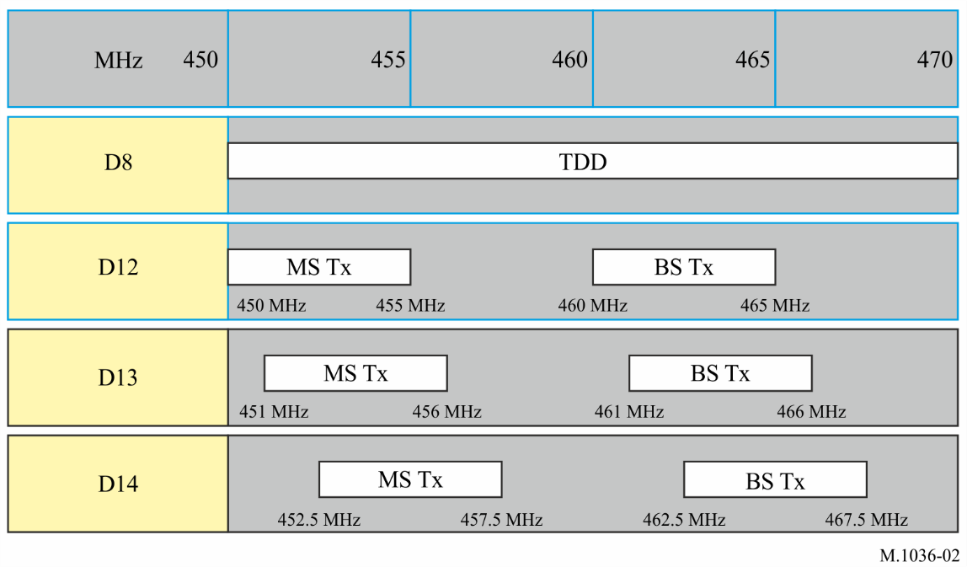

SECTION 3

Frequency arrangements in the 470-960 MHz frequency range
The recommended frequency arrangements for implementation of IMT in the band 470-960 MHz are summarized in Table 2 and in Fig. 3, noting the implementation aspects in Section 1 above.
TABLE 2
Frequency arrangements in the 610-960 MHz frequency range
Frequency arrangements | Paired arrangements (FDD) |  |  |  | Un-paired arrangements  (TDD)  (MHz)
Frequency arrangements | Mobile station  transmitter  (MHz) | Centre gap  (MHz) | Base station  transmitter  (MHz) | Duplex separation  (MHz) | Un-paired arrangements  (TDD)  (MHz)
A1 | 824-849 | 20 | 869-894 | 45 | None
A2 | 880-915 | 10 | 925-960 | 45 | None
A3 | 832-862 | 11 | 791-821 | 41 | None
A4 | 698-716  776-793 | 12  13 | 728-746  746-763 | 30  30 | 716-728
A5 | 703-748 | 10 | 758-803 | 55 | None
A6 |  |  |  |  | 698-806
A7 | 703-733 | 25 | 758-788 | 55 | None
A8 | 698-703 | 50 | 753-758 | 55 | None
A9 | 733-736 | 52 | 788-791 | 55 | None
A10 | External |  | 738-758 |  | None
A11 (harmonized with A7 and A10) | 703-733  External | 25 | 758-788  738-758 | 55 | None
A12 | 663-698 | 11 | 617-652 | 46 | None
A13 | 663-703 | 11 | 612-652 | 51 | None
Notes to Table 2:
Note 1: In A3, IMT systems are operating in FDD mode and use a reversed duplex direction, with mobile terminal transmit within the upper band and base station transmit within the lower band. Such an arrangement provides better conditions for coexistence with the lower adjacent broadcasting service. It is noted that Administrations which do not wish to use this plan or which do not have the full band 790-862 MHz available may consider other frequency arrangements including, e.g. partial implementation of frequency arrangement described in A3, a TDD frequency arrangement (with a guardband of at least 7 MHz above 790 MHz) or a mixed introduction of TDD and FDD frequency arrangements.
Note 2: In A4, administrations can use the band solely for FDD or TDD, or some combination of FDD and TDD. Administrations can use any FDD duplex spacing or FDD duplex direction. However, when administrations choose to deploy mixed FDD/TDD channels with a fixed duplex separation for FDD, the duplex separation and duplex direction as shown in A4 are preferred. Individual band blocks in the mixed channel arrangement may include further subdivisions to accommodate both duplex methods.
Note 3: The frequency arrangements for the band 698-960 MHz have been developed taking into consideration the recognizing above. The frequency arrangements for PPDR systems using IMT technologies in the bands identified in Resolution 646 (Rev.WRC-19), are outside the scope of this Recommendation and are covered by Recommendation ITU-R M.2015. There are inherent benefits of deploying IMT technologies for PPDR applications in this band, including advantages of large coverage area and possible interoperability across the 700 and 800 MHz bands, noting the differences in operational requirements and implementations.
Note 4: In A5, 2 × 45 MHz FDD arrangement is implemented by using sub-blocks with dual duplexer solution and conventional duplex arrangement. Internal guardbands of 5 MHz and 3 MHz are provided at the lower and upper edge of the band for better co-existence with adjacent radiocommunication services.
Note 5: In A6, taking into account the external 4 MHz guardband (694-698 MHz), a minimum internal guardband of 5 MHz at the lower edge (698 MHz) and 3 MHz at the upper edge (806 MHz) needs to be considered.
Note 6: The frequency arrangement in A7 aligns with the lower duplexer from A5.
Note 7: Administrations can implement the A8 arrangement alone or in combination with parts of A7 (e.g. UL: 698-718/DL: 753-773 MHz), provided that coexistence with the services below 694 MHz is ensured.
Note 8: The frequency arrangement in A9 aligns with part of the upper duplexer of A5.
Note 9: For A10 and A11, zero to four frequency blocks of 5 MHz in 738-758 MHz could be used to complement the downlink capacity of a frequency arrangement in this or other bands.
Note 10: For administrations having implemented the A7 arrangement, this arrangement can be combined with the A10 arrangement, i.e. A11.
Note 11: The frequency arrangement A12 is based on a reverse FDD configuration. This will guarantee compatibility with A5 arrangement since upper A12 block and lower A5 block will be both transmitting in uplink direction.
Note 12: Frequency arrangement A12 may not align with the channelization schemes of other services in all regions.
Note 13: The frequency arrangement A13 is based on a reverse FDD configuration. This will guarantee compatibility with A5 arrangement since upper A13 block and lower A5 block will be both Mobile station transmitters transmitting in uplink direction.
FIGURE 3
Frequency arrangements A1 to A13
(see Notes to Table 2)
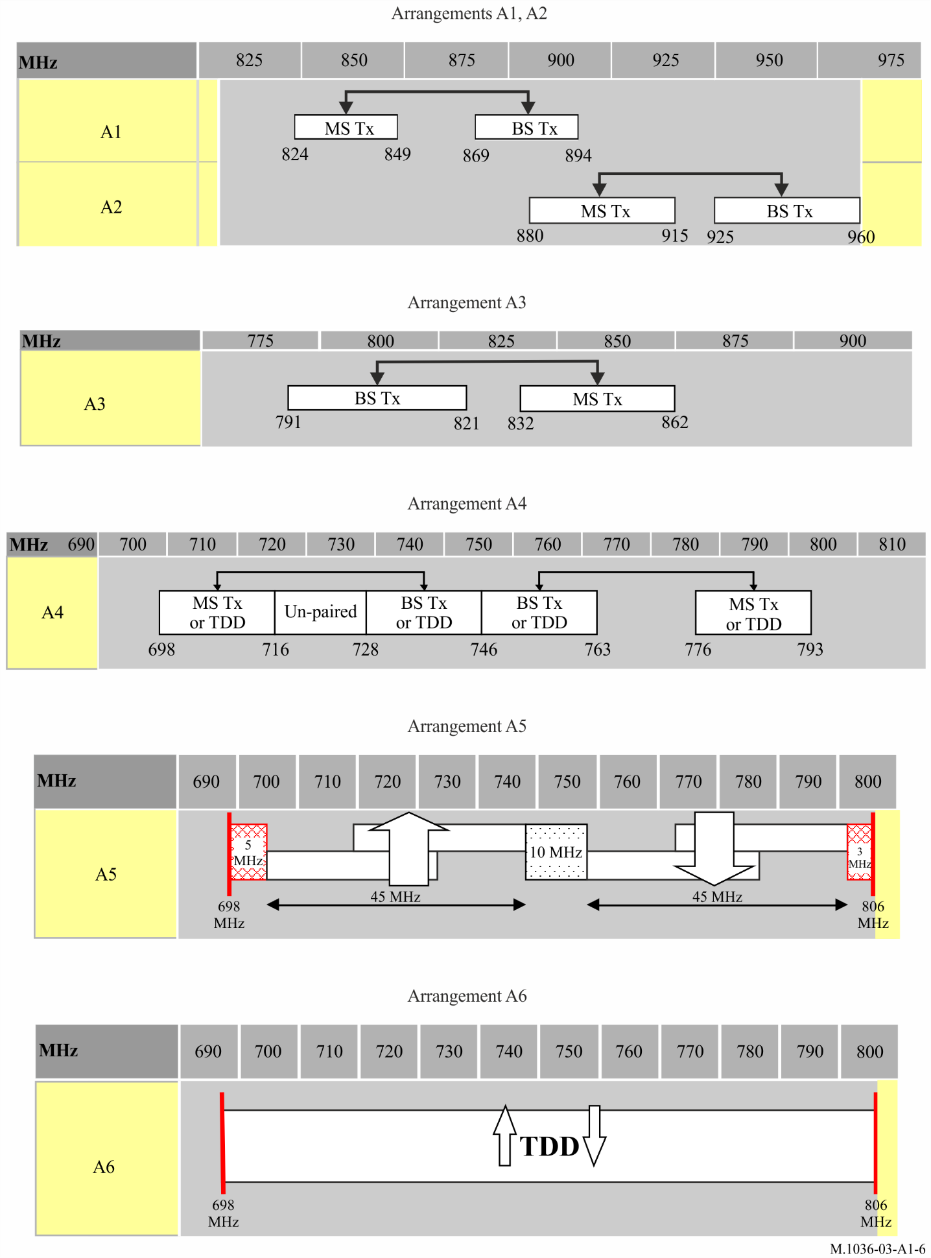
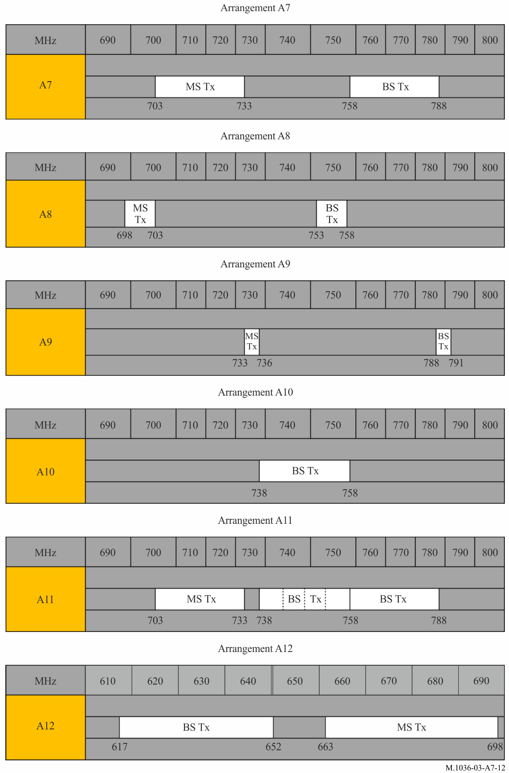
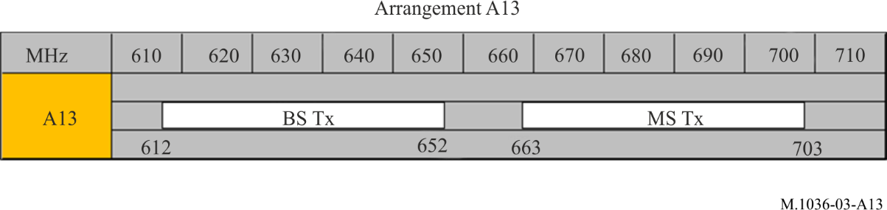

SECTION 4

Frequency arrangements in the band 1 427-1 518 MHz
The recommended frequency arrangements for implementation of IMT in the band 1 427-1 518 MHz are provided in Table 3 and in Fig. 4, noting the implementation aspects in Section 1 above, as well as the Note 1 below.
TABLE 3
Frequency arrangements in the band 1 427-1 518 MHz
Frequency arrangements | Paired arrangements (FDD) |  |  |  | Un-paired arrangements  (TDD)  (MHz)
Frequency arrangements | Mobile station transmitter  (MHz) | Centre gap  (MHz) | Base station transmitter  (MHz) | Duplex separation  (MHz)
G1 | External | – | 1 427-1 517 | – | None
G2 | 1 427-1 470 | 5 | 1 475-1 518 | 48 | None
G3 |  |  |  |  | 1 427-1 517
Note to Table 3:
Note 1: With respect to IMT in the frequency band 1 492-1 518 MHz and the MSS in the frequency band 1 518-1 525 MHz, ITU-R studies are being conducted in accordance with Resolution 223 (Rev.WRC-19) to provide possible technical measures to facilitate adjacent band compatibility. The implementation of the frequency arrangements and the text of this Note may need to be reviewed and revised taking into account the results of these studies, which are intended to be included in ITU-R Reports and ITU-R Recommendations, as appropriate.
Based on the current results of these ongoing studies, one of a number of possible measures to facilitate adjacent band compatibility, is for administrations to consider additional frequency separation below 1 518 MHz at the upper part of G1, G2, or G3 (e.g. a total separation of different values up to 6 MHz). Moreover, when implementing these frequency arrangements, administrations are also encouraged to take into account the results of the compatibility studies, e.g. in order to address IMT-MSS coexistence in certain areas (around seaports and airports, etc.).
fIGURE 4
Frequency arrangements G1 to G3
(see Note 1 to Table 3)
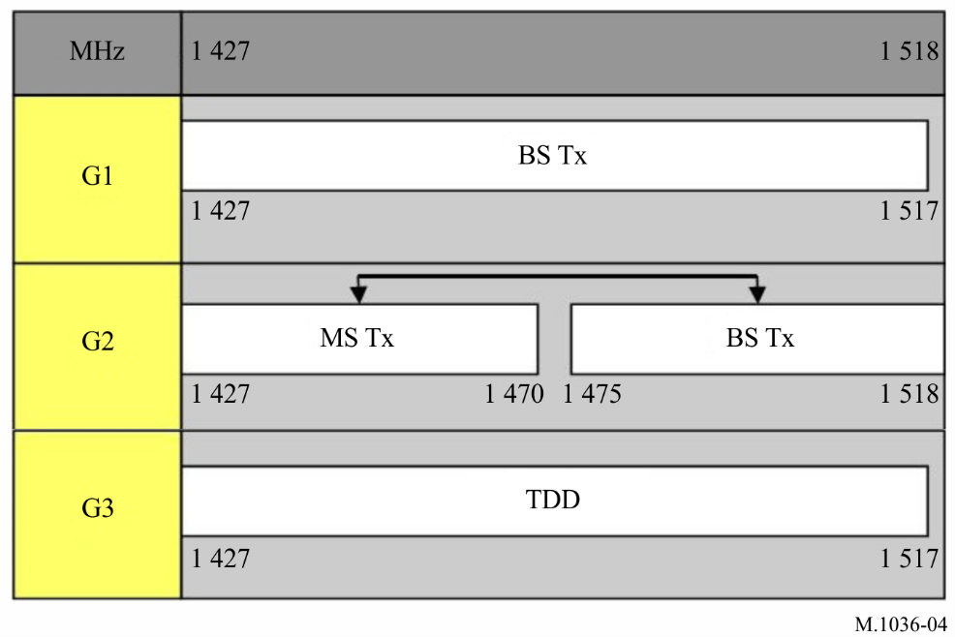

SECTION 5

Frequency arrangements in the band 1 710-2 200 MHz
The recommended frequency arrangements for implementation of IMT in the band 1 710-2 200 MHz are summarized in Table 4 and in Fig. 5, noting the implementation aspects in Section 1 above.
TABLE 4
Frequency arrangements in the band 1 710-2 200 MHz
Frequency  arrangements | Paired arrangements (FDD) |  |  |  | Un-paired arrangements  (TDD)  (MHz) | Relevant  Notes
Frequency  arrangements | Mobile station transmitter  (MHz) | Centre gap  (MHz) | Base station transmitter  (MHz) | Duplex separation  (MHz) | Un-paired arrangements  (TDD)  (MHz) | Relevant  Notes
B1 | 1 920-1 980 | 130 | 2 110-2 170 | 190 | 1 880-1 920;  2 010-2 025 | 1, 2, 4
B2 | 1 710-1 785 | 20 | 1 805-1 880 | 95 | None | 1
B3 | 1 850-1 920 | 10 | 1 930-2 000 | 80 | 1 920-1 930 | 1, 2, 5
B4 (harmonized with  B1 and B2) | 1 710-1 785  1 920-1 980 | 20  130 | 1 805-1 880  2 110-2 170 | 95  190 | 1 880-1 920;  2 010-2 025 | 1, 2, 4
B5 (harmonized with B3 and partially harmonized with the downlink of B1 and the uplink of B2) | 1 850-1 920  1 710-1 780 | 10  330 | 1 930-2 000  2 110-2 180 | 80  400 | 1 920-1 930 | 1, 2, 3, 5
B6 | 1 980-2 010 | 160 | 2 170-2 200 | 190 | None | 4, 5
B7 | 2 000-2 020 | 160 | 2 180-2 200 | 180 | None | 5
Notes to Table 4:
Note 1: In the band 1 710-2 025 MHz and 2 110-2 200 MHz three basic frequency arrangements (B1, B2 and B3) are already in use or planned to be used by public mobile cellular systems including IMT. Based on these three arrangements, different combinations of arrangements are recommended as described in B4 and B5. The B1 arrangement and the B2 arrangement are fully complementary, whereas the B3 arrangement partly overlaps with the B1 and B2 arrangements.
For administrations having implemented the B1 arrangement, B4 enables optimization of the use of spectrum for paired IMT operation.
For administrations having implemented the B3 arrangement, the B1 arrangement can be combined with the B2 arrangement. B5 is therefore recommended to optimize the use of the spectrum:
– B5 enables the use of spectrum to be maximized for IMT in administrations where B3 is implemented and where the band 1 770-1 850 MHz is not available in the initial phase of deployment of IMT in this frequency band.
Note 2: TDD may be introduced in unpaired bands and also under certain conditions in the uplink bands of paired frequency arrangements and/or in the centre gap between paired bands.
Note 3: If selectable/variable duplex technology is implemented within terminals as the most efficient way to manage different frequency arrangements, the fact that neighbouring administrations could select B5 will have no impact on the complexity of the terminal. Further studies are necessary.
Note 4: The bands 1 980-2 010 MHz and 2 170-2 200 MHz in the frequency arrangement B6 are intended to be used in combination with the frequency arrangements B1 or B4 which provides even further optimization of the use of spectrum for paired IMT operation (see Note 1).
Note 5: A unique situation exists for the frequency arrangements B6 and B7 and parts of arrangements B3 and B5 in the bands 1 980-2 010 MHz and 2 170-2 200 MHz, which have been identified for the terrestrial component of IMT and the satellite component of IMT as outlined in recognizing d). Co-coverage, co-frequency deployment of independent satellite and terrestrial IMT components is not feasible unless appropriate mitigation techniques are applied. When these components are deployed in adjacent geographical areas in the same frequency bands, technical or operational measures need to be implemented if harmful interference is reported. Further studies may be carried out by ITU-R, as appropriate, taking into account the results of WRC-19.
FIGURE 5
Frequency arrangements B1 to B7
(see Notes to Table 4)
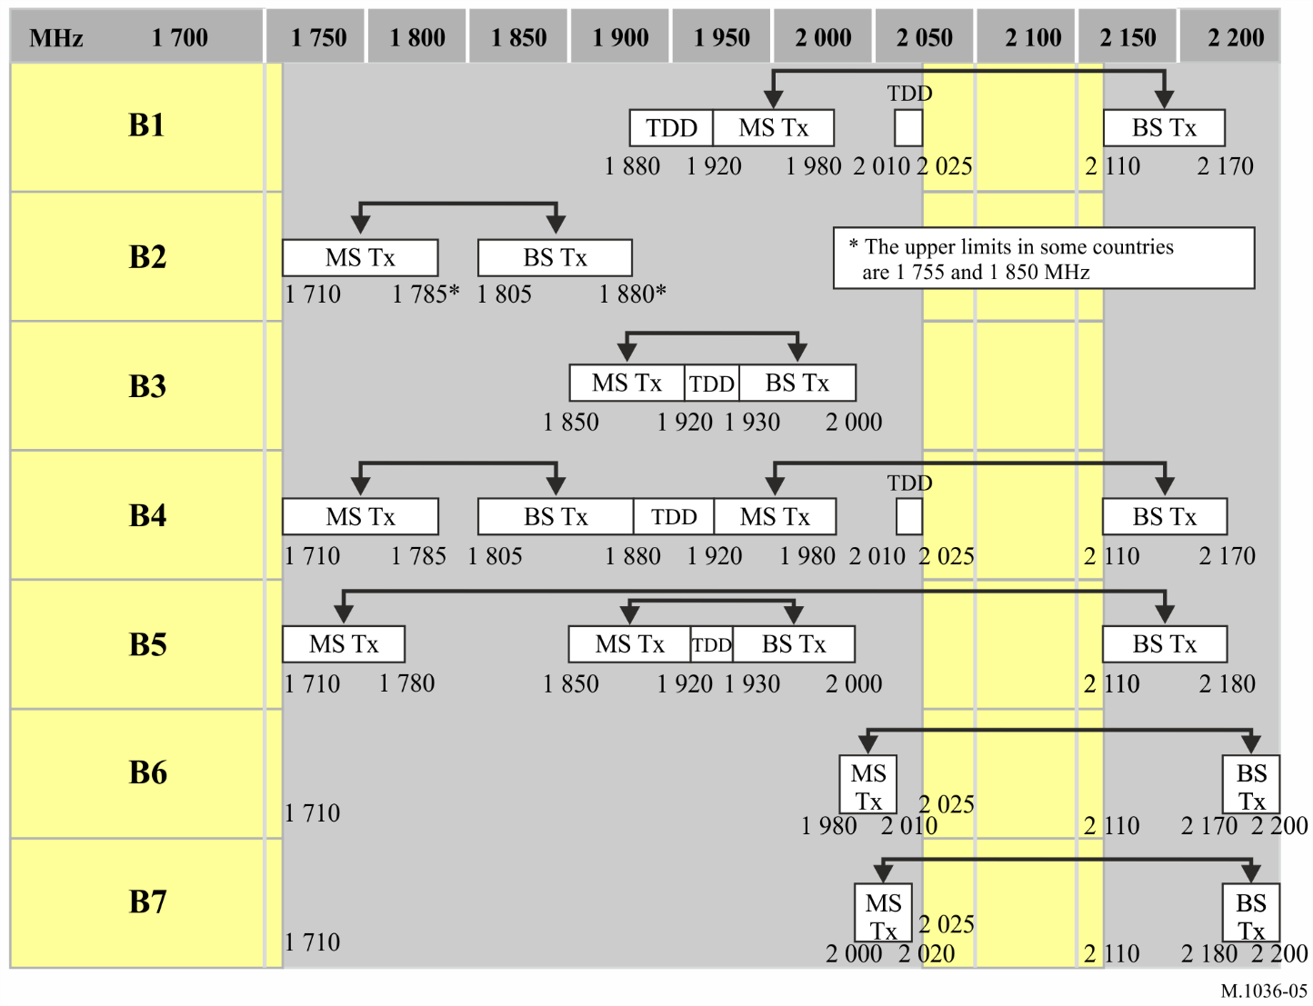

SECTION 6

Frequency arrangements in the band 2 300-2 400 MHz
The recommended frequency arrangements for implementation of IMT in the band 2 300-2 400 MHz are summarized in Table 5 and in Fig. 6, noting the implementation aspects in Section 1 above.
TABLE 5
Frequency arrangements in the band 2 300-2 400 MHz
Frequency arrangement | Paired arrangements (FDD) |  |  |  | Un-paired arrangements  (TDD)  (MHz)
Frequency arrangement | Mobile station transmitter  (MHz) | Centre gap  (MHz) | Base station transmitter  (MHz) | Duplex separation  (MHz) | Un-paired arrangements  (TDD)  (MHz)
E1 |  |  |  |  | 2 300-2 400

FIGURE 6
Frequency arrangement E1
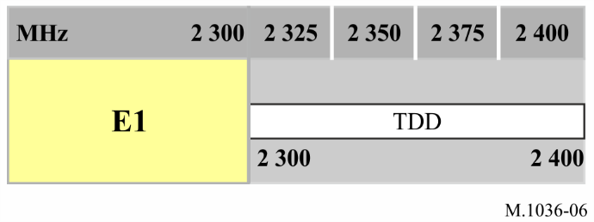

SECTION 7

Frequency arrangements in the band 2 500-2 690 MHz
The recommended frequency arrangements for implementation of IMT in the band 2 500-2 690 MHz are summarized in Table 6 and in Fig. 7, noting the implementation aspects in Section 1 above.
TABLE 6
Frequency arrangements in the band 2 500-2 690 MHz (not including the satellite component)
Frequency arrangements | Paired arrangements (FDD) |  |  |  |  | Un-paired arrangements (TDD)  (MHz)
Frequency arrangements | Mobile station transmitter  (MHz) | Centre gap  (MHz) | Base station transmitter  (MHz) | Duplex separation  (MHz) |  | Un-paired arrangements (TDD)  (MHz)
C1 | 2 500-2 570 | 50 | 2 620-2 690 | 120 |  | 2 570-2 620
C2 | 2 500-2 570  External | 50 | 2 620-2 690  2 570-2 620 | 120 |  | None
C3 | Flexible FDD/TDD
Notes to Table 6:
Note 1: In C1, in order to facilitate deployment of FDD equipment, any guardbands required to ensure adjacent band compatibility at the 2 570 MHz and 2 620 MHz boundaries will be decided on a national basis and will be taken within the band 2 570-2 620 MHz and should be kept to the minimum necessary, based on Report ITU-R M.2045.
Note 2: In C3, administrations can use the band solely for FDD or TDD or some combination of TDD and FDD. Administrations can use any FDD duplex spacing or FDD duplex direction. However, when administrations choose to deploy mixed FDD/TDD channels with a fixed duplex separation for FDD, the duplex separation and duplex direction as shown in C1 are preferred.
Figure 7
Frequency arrangements C1 to C3
(see Notes to Table 6)
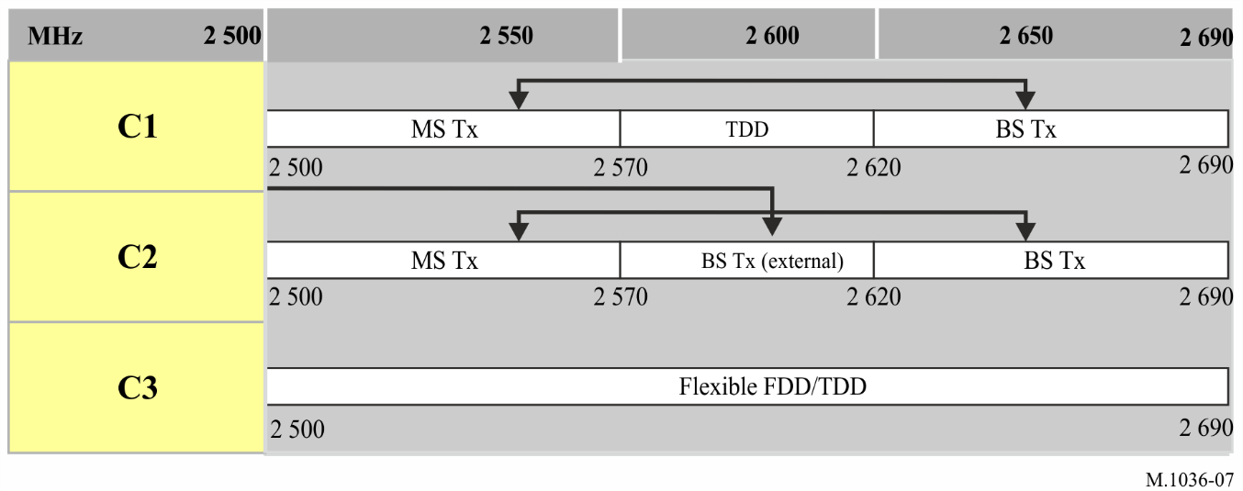

SECTION 8

Frequency arrangements in the 3 300-3 700 MHz frequency range
The recommended frequency arrangements for implementation of IMT in the 3 300-3 700 MHz frequency range are summarized in Table 7 and in Fig. 8, noting the implementation aspects in Section 1 above.
TABLE 7
Frequency arrangements in the 3 300-3 700 MHz frequency range
Frequency arrangements | Paired arrangements (FDD) |  |  |  | Un-paired arrangements  (TDD)  (MHz)
Frequency arrangements | Mobile station transmitter  (MHz) | Centre gap  (MHz) | Base station transmitter  (MHz) | Duplex separation  (MHz)
F1 |  |  |  |  | 3 400-3 600
F2 | 3 410-3 490 | 20 | 3 510-3 590 | 100 | None
F3 |  |  |  |  | 3 300-3 700
Note to Table 7:
Note 1: Frequency arrangement F3 could provide the possibility for administrations to implement IMT in the whole or parts of the bands identified in the RR (3 300-3 400 MHz, 3 400-3 600 MHz and 3 600-3 700 MHz), with any possible frequency separation, if required, taking into account the use of the bands by other services and applications. The frequency arrangement F1 is harmonized with F3. This frequency arrangement F1 has been implemented by some administrations.
FIGURE 8
Frequency arrangements F1 to F3
(see Note to Table 7)
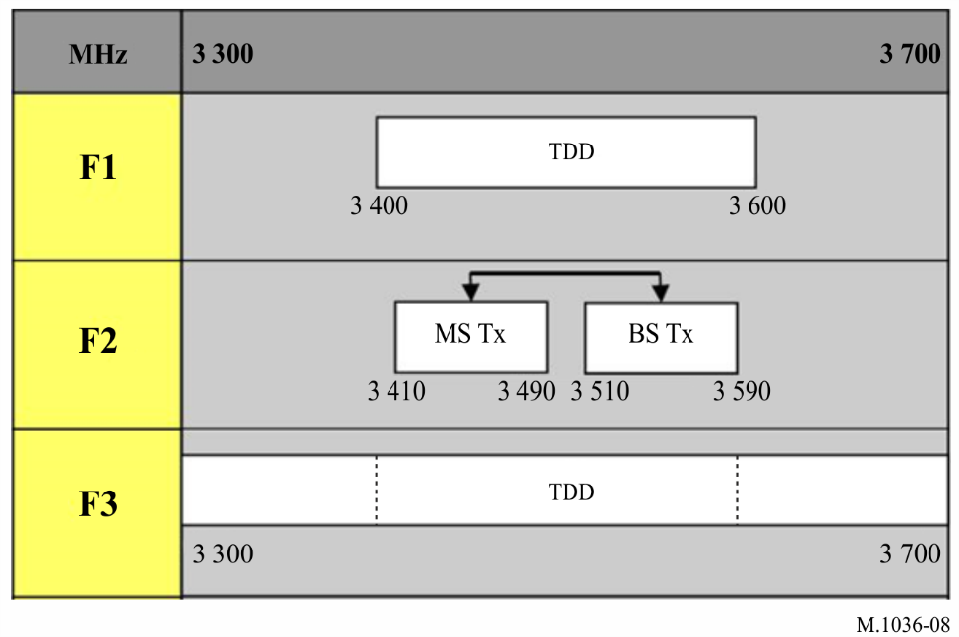

SECTION 9

Frequency arrangements in the band 4 800-4 990 MHz
The recommended frequency arrangements for implementation of IMT in the band 4 800-4 990 MHz are summarized in Table 8 and in Fig. 9, noting the implementation aspects in Section 1 above.
TABLE 8
Frequency arrangements in the 4 800-4 990 MHz frequency range
Frequency arrangements | Paired arrangements (FDD) |  |  |  | Un-paired arrangements  (TDD)  (MHz)
Frequency arrangements | Mobile station transmitter  (MHz) | Centre gap  (MHz) | Base station transmitter  (MHz) | Duplex separation  (MHz)
H1 |  |  |  |  | 4 800-4 990

FIGURE 9
Frequency arrangement H1
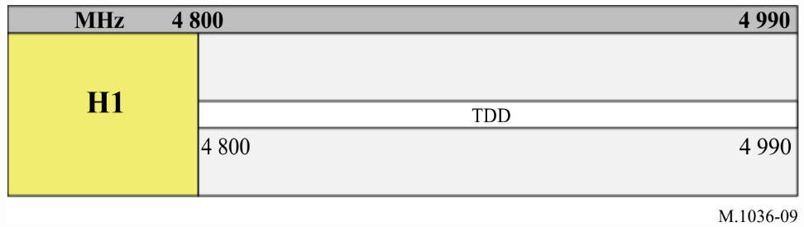

SECTION 10

Frequency arrangements in the band 24.25-27.5 GHz
The recommended frequency arrangements for implementation of IMT in the band 24.25-27.5 GHz are summarized in Table 9 and in Fig. 10, noting the implementation aspects in Section 1 above.
TABLE 9
Frequency arrangements in the 24.25-27.5 GHz frequency range
Frequency arrangements | Paired arrangements (FDD) |  |  |  | Un-paired arrangements  (TDD)  (GHz)
Frequency arrangements | Mobile station transmitter  (GHz) | Centre gap  (GHz) | Base station transmitter  (GHz) | Duplex separation  (GHz)
I1 | NOT APPLICABLE |  |  |  | 24.25-27.5
Notes to Table 9:
Note 1: Only TDD arrangements are recommended in this band.
Note 2: As an additional mitigation technique (see recognizing h)), administrations could consider selection for IMT stations, such a channel bandwidth that emissions of IMT stations in out-of-band (OOB) domain would not fall into the band 23.6-24 GHz.
FIGURE 10
Frequency arrangement I1
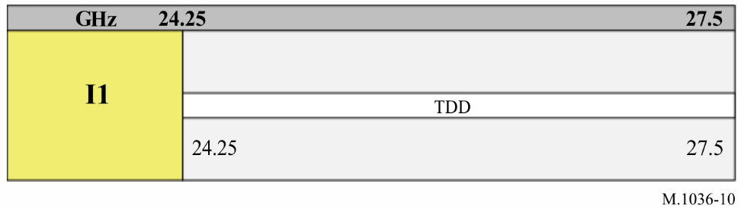

SECTION 11

Frequency arrangements in the band 37-43.5 GHz
The recommended frequency arrangements for implementation of IMT in the band 37-43.5 GHz are summarized in Table 10 and in Fig. 11, noting the implementation aspects in Section 1 above.
TABLE 10
Frequency arrangements in the 37-43.5 GHz frequency range
Frequency arrangements | Paired arrangements (FDD) |  |  |  | Un-paired arrangements  (TDD)  (GHz)
Frequency arrangements | Mobile station transmitter  (GHz) | Centre gap  (GHz) | Base station transmitter  (GHz) | Duplex separation  (GHz)
J1 | NOT APPLICABLE |  |  |  | 37-43.5
Note to Table 10:
Note 1: Only TDD arrangements are recommended in this band.
FIGURE 11
Frequency arrangement J1
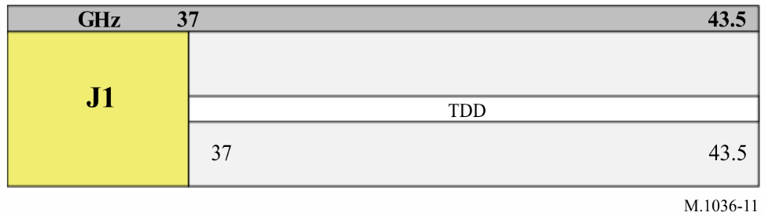

SECTION 12

Frequency arrangements in the band 45.5-47 GHz
The recommended frequency arrangements for implementation of IMT in the band 45.5-47 GHz are summarized in Table 11 and in Fig. 12, noting the implementation aspects in Section 1 above.
TABLE 11
Frequency arrangements in the 45.5-47 GHz frequency range
Frequency arrangements | Paired arrangements (FDD) |  |  |  | Un-paired arrangements  (TDD)  (GHz)
Frequency arrangements | Mobile station transmitter  (GHz) | Centre gap  (GHz) | Base station transmitter  (GHz) | Duplex separation  (GHz)
K1 | NOT APPLICABLE |  |  |  | 45.5-47
Note to Table 11:
Note 1: Only TDD arrangements are recommended in this band.
FIGURE 12
Frequency arrangement K1
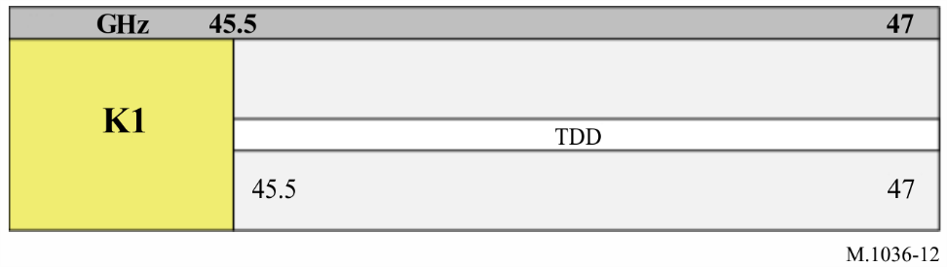

SECTION 13

Frequency arrangements in the band 47.2-48.2 GHz
The recommended frequency arrangements for implementation of IMT in the band 47.2-48.2 GHz are summarized in Table 12 and in Fig. 13, noting the implementation aspects in Section 1 above.
TABLE 12
Frequency arrangements in the 47.2-48.2 GHz frequency range
Frequency arrangements | Paired arrangements (FDD) |  |  |  | Un-paired arrangements  (TDD)  (GHz)
Frequency arrangements | Mobile station transmitter  (GHz) | Centre gap  (GHz) | Base station transmitter  (GHz) | Duplex separation  (GHz)
L1 | NOT APPLICABLE |  |  |  | 47.2-48.2
Note to Table 12:
Note 1: Only TDD arrangements are recommended in this band.
FIGURE 13
Frequency arrangement L1
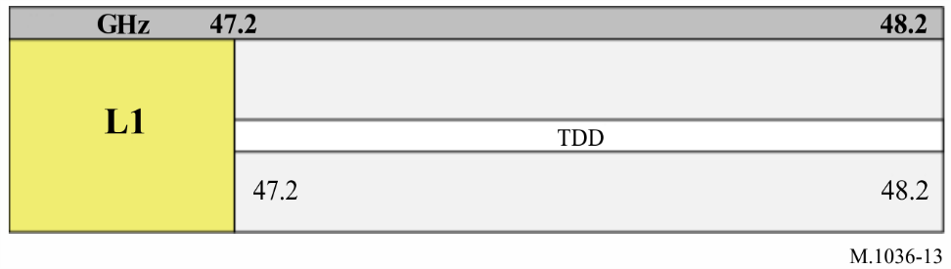

SECTION 14

Frequency arrangements in the band 66-71 GHz
The recommended frequency arrangements for implementation of IMT in the band 66-71 GHz are summarized in Table 13 and in Fig. 14, noting the implementation aspects in Section 1 above.
TABLE 13
Frequency arrangements in the 66-71 GHz frequency range
Frequency arrangements | Paired arrangements (FDD) |  |  |  | Un-paired arrangements  (TDD)  (GHz)
Frequency arrangements | Mobile station transmitter  (GHz) | Centre gap  (GHz) | Base station transmitter  (GHz) | Duplex separation  (GHz)
M1 | NOT APPLICABLE |  |  |  | 66-71
Note to Table 13:
Note 1: Only TDD arrangements are recommended in this band.
FIGURE 14
Frequency arrangement M1
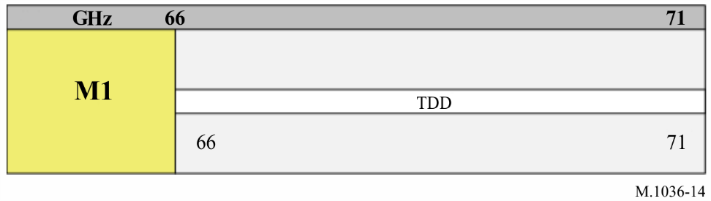

Attachment 1
to the Annex
Frequency bands and associated footnotes identifying the band for IMT in Table 14 are extracted from the edition 2020 of the RR, Article 5 for ease of reference.
1 Also, administrations may deploy IMT systems in bands allocated to the mobile service other than those identified in the RR, and administrations may deploy IMT systems only in some or parts of the bands identified for IMT in the RR.
2 However, it is emphasized that the use of IMT in any band allocated to the mobile service on a primary basis but not identified for IMT should also comply with the objectives of the relevant technical and regulatory provisions of the RR, as well as with the latest version of applicable ITU-R Recommendation(s).
TABLE 14
Band | Footnotes identifying the band for IMT
Band | Region 1 | Region 2 | Region 3
450-470 MHz | 5.286AA
470-698 MHz | - | 5.295, 5.308A | 5.296A
694/698-960 MHz | 5.317A | 5.317A | 5.313A, 5.317A
1 427-1 518 MHz | 5.341A, 5.346 | 5.341B | 5.341C, 5.346A
1 710-2 025 MHz | 5.384A, 5.388
2 110-2 200 MHz | 5.388
2 300-2 400 MHz | 5.384A
2 500-2 690 MHz | 5.384A
3 300-3 400 MHz | 5.429B | 5.429D | 5.429F
3 400-3 600 MHz | 5.430A | 5.431B | 5.432A, 5.432B, 5.433A
3 600-3 700 MHz | - | 5.434 | -
4 800-4 990 MHz | 5.441B | 5.441A, 5.441B | 5.441B
24.25-27.5 GHz | 5.532AB
37-43.5 GHz | 5.550B
45.5-47 GHz | 5.553A | 5.553A | 5.553A
47.2-48.2 GHz | 5.553B | 5.553B | 5.553B
66-71 GHz | 5.559AA

Attachment 2
to the Annex
Vocabulary of terms
Centre gap – The frequency separation between the upper edge of the lower band and the lower edge of the upper band in an FDD paired frequency arrangement.
Duplex band frequency separation – The frequency separation between a reference point in the lower band and the corresponding point in the upper band of an FDD arrangement.
Duplex channel frequency separation – The frequency separation between a specific channel carrier in the lower band and its paired channel carrier in the upper band of an FDD arrangement.
Conventional duplex arrangement – Duplex arrangement with mobile terminal transmit within the lower band and base station transmit within the upper band.
Reverse duplex arrangement – Duplex arrangement with the mobile terminal transmit within the upper band and base station transmit within the lower band.
Acronyms and abbreviations
DL Downlink
UL Uplink
BS Base station
MS Mobile station
FDD Frequency division duplex
IMT International Mobile Telecommunications
TDD Time division duplex

Attachment 3
to the Annex
Related Recommendations and Reports

Recommendation ITU-R SM.329 – Unwanted emissions in the spurious domain
Recommendation ITU-R M.687 – International Mobile Telecommunications-2000 (IMT-2000)
Recommendation ITU-R M.816 – Framework for services supported on International Mobile Telecommunications-2000 (IMT-2000)
Recommendation ITU-R M.818 – Satellite operation within International Mobile Telecommunications-2000 (IMT-2000)
Recommendation ITU-R M.819 – International Mobile Telecommunications-2000 (IMT-2000) for developing countries
Recommendation ITU-R M.1033 – Technical and operational characteristics of cordless telephones and cordless telecommunication systems
Recommendation ITU-R M.1034 – Requirements for the radio interface(s) for International Mobile Telecommunications-2000 (IMT-2000)
Recommendation ITU-R M.1035 – Framework for the radio interface(s) and radio sub-system functionality for International Mobile Telecommunications-2000 (IMT-2000)
Recommendation ITU-R M.1073 – Digital cellular land mobile telecommunication systems
Recommendation ITU-R M.1167 – Framework for the satellite component of International Mobile Telecommunications-2000 (IMT-2000)
Recommendation ITU-R M.1224 – Vocabulary of terms for International Mobile Telecommunications (IMT)
Recommendation ITU-R M.1308 – Evolution of land mobile systems towards IMT-2000
Recommendation ITU-R M.1390 – Methodology for the calculation of IMT-2000 terrestrial spectrum requirements
Recommendation ITU-R M.1457 – Detailed specifications of the radio interfaces of International Mobile Telecommunications-2000 (IMT-2000)
Recommendation ITU-R M.1579 – Global circulation of IMT terrestrial terminals
Recommendation ITU-R M.1580 – Generic unwanted emission characteristics of base stations using the terrestrial radio interfaces of IMT-2000
Recommendation ITU-R M.1581 – Generic unwanted emission characteristics of mobile stations using the terrestrial radio interfaces of IMT-2000
Recommendation ITU-R M.1645 – Framework and overall objectives of the future development of IMT-2000 and systems beyond IMT-2000
Recommendation ITU-R M.1768 – Methodology for calculation of spectrum requirements for the terrestrial component of International Mobile Telecommunications
Recommendation ITU-R M.1797 – Vocabulary of terms for the land mobile service
Recommendation ITU-R M.1822 – Framework for services supported by IMT
Recommendation ITU-R M.2012 – Detailed specifications of the terrestrial radio interfaces of International Mobile Telecommunications Advanced (IMT-Advanced)
Recommendation ITU-R M.2015 – Frequency arrangements for public protection and disaster relief radiocommunication systems in accordance with Resolution 646 (Rev.WRC-15)
Recommendation ITU-R M.2070 – Generic unwanted emission characteristics of base stations using the terrestrial radio interfaces of IMT-Advanced
Recommendation ITU-R M.2071 – Generic unwanted emission characteristics of mobile stations using the terrestrial radio interfaces of IMT-Advanced
Recommendation ITU-R M.2083 – IMT Vision – “Framework and overall objectives of the future development of IMT for 2020 and beyond”
Recommendation ITU-R M.2090 – Specific unwanted emission limit of IMT mobile stations operating in the frequency band 694-790 MHz to facilitate protection of existing services in Region 1 in the frequency band 470-694 MHz
Recommendation ITU-R M.2150 – Detailed specifications of the terrestrial radio interfaces of International Mobile Telecommunications-2020 (IMT-2020)
Report ITU-R M.2030 – Coexistence between IMT-2000 time division duplex and frequency division duplex terrestrial radio interface technologies around 2 600 MHz operating in adjacent bands and in the same geographical area
Report ITU-R M.2031 – Compatibility between WCDMA 1800 downlink and GSM 1900 uplink
Report ITU-R M.2038 – Technology trends
Report ITU-R M.2041 – Sharing and adjacent band compatibility in the 2.5 GHz band between the terrestrial and satellite components of IMT-2000
Report ITU-R M.2045 – Mitigating techniques to address coexistence between IMT-2000 time division duplex and frequency division duplex radio interface technologies within the frequency range 2 500-2 690 MHz operating in adjacent bands and in the same geographical area
Report ITU-R M.2072 – World mobile telecommunication market forecast
Report ITU-R M.2078 – Estimated spectrum bandwidth requirements for the future development of IMT-2000 and IMT-Advanced
Report ITU-R M.2109 – Sharing studies between IMT-Advanced systems and geostationary satellite networks in the fixed-satellite service in the 3 400-4 200 MHz and 4 500-4 800 MHz frequency bands
Report ITU-R M.2110 – Sharing studies between radiocommunication services and IMT systems operating in the 450-470 MHz band
Report ITU-R M.2113 – Report on sharing studies in the 2 500-2 690 MHz band between IMT-2000 and fixed broadband wireless access systems including nomadic applications in the same geographical area
Report ITU-R M.2320 – Future technology trends of terrestrial IMT systems
Report ITU-R M.2324 – Sharing studies between potential International Mobile Telecommunication systems and aeronautical mobile telemetry systems in the frequency band 1 429-1 535 MHz
Report ITU-R RS.2336 – Consideration of the frequency bands 1 375-1 400 MHz and 1 427-1 452 MHz for the mobile service - Compatibility with systems of the Earth exploration-satellite service within the 1 400-1 427 MHz frequency band
Report ITU-R BT.2337 – Sharing and compatibility studies between digital terrestrial television broadcasting and terrestrial mobile broadband applications, including IMT, in the frequency band 470-694/698 MHz
Report ITU-R BT.2339 – Co-channel sharing and compatibility studies between digital terrestrial television broadcasting and international mobile telecommunication in the frequency band 694-790 MHz in the GE06 planning area
Report ITU-R S.2368 – Sharing studies between International Mobile Telecommunication-Advanced systems and geostationary satellite networks in the fixed-satellite service in the 3 400-4 200 MHz and 4 500-4 800 MHz frequency bands in the WRC study cycle leading to WRC-15
Report ITU-R M.2374 – Coexistence of two TDD networks in the 2 300-2 400 MHz band
Report ITU-R M.2375 – Architecture and topology of IMT networks
Report ITU-R M.2481 – In-band and adjacent band coexistence and compatibility studies between IMT systems in 3 300-3 400 MHz and radiolocation systems in 3 100-3 400 MHz

International Mobile Telecommunications (IMT) encompasses IMT-2000, IMT-Advanced and IMT-2020, as specified in Resolution ITU-R 56-2.
See also Attachment 1 to the Annex.
The 2 025-2 110 MHz band is not part of the frequency arrangements.
See also Summary Report of the 6th Plenary Meeting of the Radiocommunication Assembly 2019 (Friday, 25 October 2019).

