Recommendation ITU-R F.746-11
(12/2023)
F Series: Fixed service
Radio-frequency arrangements for fixed service systems

Foreword
The role of the Radiocommunication Sector is to ensure the rational, equitable, efficient and economical use of the radio-frequency spectrum by all radiocommunication services, including satellite services, and carry out studies without limit of frequency range on the basis of which Recommendations are adopted.
The regulatory and policy functions of the Radiocommunication Sector are performed by World and Regional Radiocommunication Conferences and Radiocommunication Assemblies supported by Study Groups.

Policy on Intellectual Property Right (IPR)
ITU-R policy on IPR is described in the Common Patent Policy for ITU-T/ITU-R/ISO/IEC referenced in Resolution ITU-R 1. Forms to be used for the submission of patent statements and licensing declarations by patent holders are available from http://www.itu.int/ITU-R/go/patents/en where the Guidelines for Implementation of the Common Patent Policy for ITU-T/ITU-R/ISO/IEC and the ITU-R patent information database can also be found.

Series of ITU-R Recommendations
(Also available online at https://www.itu.int/publ/R-REC/en)
Series | Title
BO | Satellite delivery
BR | Recording for production, archival and play-out; film for television
BS | Broadcasting service (sound)
BT | Broadcasting service (television)
F | Fixed service
M | Mobile, radiodetermination, amateur and related satellite services
P | Radiowave propagation
RA | Radio astronomy
RS | Remote sensing systems
S | Fixed-satellite service
SA | Space applications and meteorology
SF | Frequency sharing and coordination between fixed-satellite and fixed service systems
SM | Spectrum management
SNG | Satellite news gathering
TF | Time signals and frequency standards emissions
V | Vocabulary and related subjects

Note: This ITU-R Recommendation was approved in English under the procedure detailed in Resolution ITU-R 1.

Electronic Publication
Geneva, 2024

© ITU 2024
All rights reserved. No part of this publication may be reproduced, by any means whatsoever, without written permission of ITU.

RECOMMENDATION ITU-R F.746-11
Radio-frequency arrangements for fixed service systems
(Question ITU-R 247-1/5)
(1991-1994-1995-1997-1999-2001-2002-2003-2006-2007-2012-2023)
Scope
This Recommendation provides general guidelines for developing radio-frequency arrangements for fixed wireless systems. It also presents a summary of all the current radio-frequency arrangements contained in various Recommendations and provides in various Annexes specific radio-frequency channel arrangements not covered in the scope of other specific Recommendations.
Keywords
Fixed service, fixed wireless system, point to point, channel bandwidth, channel arrangement
Abbreviations
FWS Fixed wireless system
NFD Net filter discrimination
XPD Cross-polar discrimination
Related ITU Recommendations
Recommendation ITU-R P.310 – Definitions of terms relating to propagation in non-ionized media
Recommendation ITU-R F.382 – Radio-frequency channel arrangements for fixed wireless systems operating in the 2 and 4 GHz bands
Recommendation ITU-R F.383 – Radio-frequency channel arrangements for high-capacity fixed wireless systems operating in the lower 6 GHz (5 925 to 6 425 MHz) band
Recommendation ITU-R F.384 – Radio-frequency channel arrangements for medium- and high-capacity digital fixed wireless systems operating in the 6 425-7 125 MHz band
Recommendation ITU-R F.385 – Radio-frequency channel arrangements for fixed wireless systems operating in the 7 110-7 900 MHz band
Recommendation ITU-R F.386 – Radio-frequency channel arrangements for fixed wireless systems operating in the 8 GHz (7 725 to 8 500 MHz) band
Recommendation ITU-R F.387 – Radio-frequency channel arrangements for fixed wireless systems operating in the 10.7-11.7 GHz band
Recommendation ITU-R F.497 – Radio-frequency channel arrangements for fixed wireless systems operating in the 13 GHz (12.75-13.25 GHz) frequency band
Recommendation ITU-R P.530 – Propagation data and prediction methods required for the design of terrestrial line-of-sight systems
Recommendation ITU-R F.595 – Radio-frequency channel arrangements for fixed wireless systems operating in the 14.4-15.35 GHz band
Recommendation ITU-R F.635 – Radio-frequency channel arrangements based on a homogeneous pattern for fixed wireless systems operating in the 4 GHz (3 400-4 200 MHz) band
Recommendation ITU-R F.636 – Radio-frequency channel arrangements for fixed wireless systems operating in the 14.4-15.35 GHz band
Recommendation ITU-R F.637 – Radio-frequency channel arrangements for fixed wireless systems operating in the 21.2-23.6 GHz band
Recommendation ITU-R F.701 – Radio-frequency channel arrangements for digital point-to-multipoint radio systems operating in frequency bands in the range 1 350 to 2 690 MHz (1.5, 1.8, 2.0, 2.2, 2.4 and 2.6 GHz)
Recommendation ITU-R F.747 – Radio-frequency channel arrangements for fixed wireless system operating in the 10.0-10.68 GHz band
Recommendation ITU-R F.748 – Radio-frequency arrangements for systems of the fixed service operating in the 25, 26 and 28 GHz bands
Recommendation ITU-R F.749 – Radio-frequency channel arrangements for systems of the fixed service operating in sub-bands in the 36-40.5 GHz band
Recommendation ITU-R F.1093 – Effects of multipath propagation on the design and operation of line-of-sight digital fixed wireless systems
Recommendation ITU-R F.1098 – Radio-frequency channel arrangements for fixed wireless systems in the 1 900-2 300 MHz band
Recommendation ITU-R F.1099 – Radio-frequency channel arrangements for high- and medium-capacity digital fixed wireless systems in the upper 4 GHz (4 400-5 000 MHz) band
Recommendation ITU-R F.1101 – Characteristics of digital fixed wireless systems below about 17 GHz
Recommendation ITU-R F.1191 – Necessary and occupied bandwidths and unwanted emissions of digital fixed service systems
Recommendation ITU-R F.1242 – Radio-frequency channel arrangements for digital radio systems operating in the range 1 350 MHz to 1 530 MHz
Recommendation ITU-R F.1243 – Radio-frequency channel arrangements for digital radio systems operating in the range 2 290-2 670 MHz
Recommendation ITU-R F.1488 – Frequency block arrangements for fixed wireless access systems in the range 3 400-3 800 MHz
Recommendation ITU-R F.1496 – Radio-frequency channel arrangements for fixed wireless systems operating in the band 51.4-52.6 GHz
Recommendation ITU-R F.1497 – Radio-frequency channel arrangements for fixed wireless systems operating in the band 55.78-66 GHz
Recommendation ITU-R F.1520 – Radio-frequency arrangements for systems in the fixed service operating in the band 31.8-33.4 GHz
Recommendation ITU-R F.1567 – Radio-frequency channel arrangement for digital fixed wireless systems operating in the frequency band 406.1-450 MHz
Recommendation ITU-R F.1568 – Radio-frequency block arrangements for fixed wireless access systems in the range 10.15-10.3/10.5-10.65 GHz
Recommendation ITU-R F.2004 – Radio-frequency channel arrangements for fixed service systems operating in the 92-95 GHz range
Recommendation ITU-R F.2005 – Radio-frequency channel and block arrangements for fixed wireless systems operating in the 42 GHz (40.5 to 43.5 GHz) band
Recommendation ITU-R F.2006 – Radio-frequency channel and block arrangements for fixed wireless systems operating in the 71-76 and 81-86 GHz bands

The ITU Radiocommunication Assembly,
considering
a) that according to Article 5 of the Radio Regulations several frequency bands are allocated to the fixed service (FS) on a worldwide basis;
b) that other frequency bands are also allocated to the FS on a regional basis;
c) that systems are already in use and expected to be used more extensively in the future;
d) that it may be desirable to interconnect fixed wireless systems (FWSs) on international circuits in these frequency bands;
e) that in studies carried out so far, some bands have not been the subject of Recommendations for specific radio-frequency channel arrangements which might be fitted into an international pattern as has already been done in other parts of the frequency spectrum;
f) that an index of recommended radio-frequency channel arrangements would be of assistance to the ITU-R;
g) that single- and multi-carrier digital FWSs are both useful concepts to achieve the best technical and economic trade-off in system design,
recommends
1 that homogeneous patterns are preferred as the basis for radio-frequency channel arrangements;
2 that the preferred radio-frequency channel arrangements should be developed from the homogeneous pattern in accordance with the alternated, co-channel band reuse, or interleaved band reuse radio-frequency channel arrangements (see Note 1) as shown in Figs 1a), 1b) and 1c) respectively.
The main parameters affecting the choice of radio-frequency channel arrangements are:
XS defined as the radio-frequency separation between the centre frequencies of adjacent radio-frequency channels on the same polarization and in the same direction of transmission; Recommendation ITU-R F.1191 defines that XS is equal to twice the channel separation for the alternated radio-frequency channel arrangement of Fig. 1a), and is equal to the channel separation for the co-channel and interleaved band reuse radio-frequency channel arrangements of Figs 1b) and 1c).
The channel separation is sometimes identified with the term radio-frequency channel spacing and also considered equal to the channel bandwidth.
YS defined as the radio-frequency separation between the centre frequencies of the go and return radio-frequency channels which are nearest to each other (also named innermost channels). In the case where go and return frequency sub-bands are not contiguous, such that there is a (are) band(s) allocated: for (an)other service(s) in the gap between, YS shall be considered to include the band separation (BS) equal to the total width of the allocated band(s) used by this (these) service(s).
ZS defined as the radio-frequency separation between the centre frequencies of the outermost radio-frequency channels and the edge of the frequency band (also defined as guardband by Recommendation ITU-R F.1191). In the case where the lower and upper separations differ in value, Z₁S refers to the lower separation and Z₂S refers to the upper separation. In the case where go and return frequency sub-bands are not contiguous, such that there is a (are) band(s) allocated for (an)other service(s) in the gap between, ZS_{i} will be defined for the innermost edges of both sub-bands and will be included in YS.
DS Tx/Rx duplex spacing, defined as the radio-frequency separation between corresponding go and return channels, constant for each couple of i-th and i'-th frequencies, within a given channel arrangement.
figure 1
Radio-frequency channel arrangements for the three possible schemes considered in the text
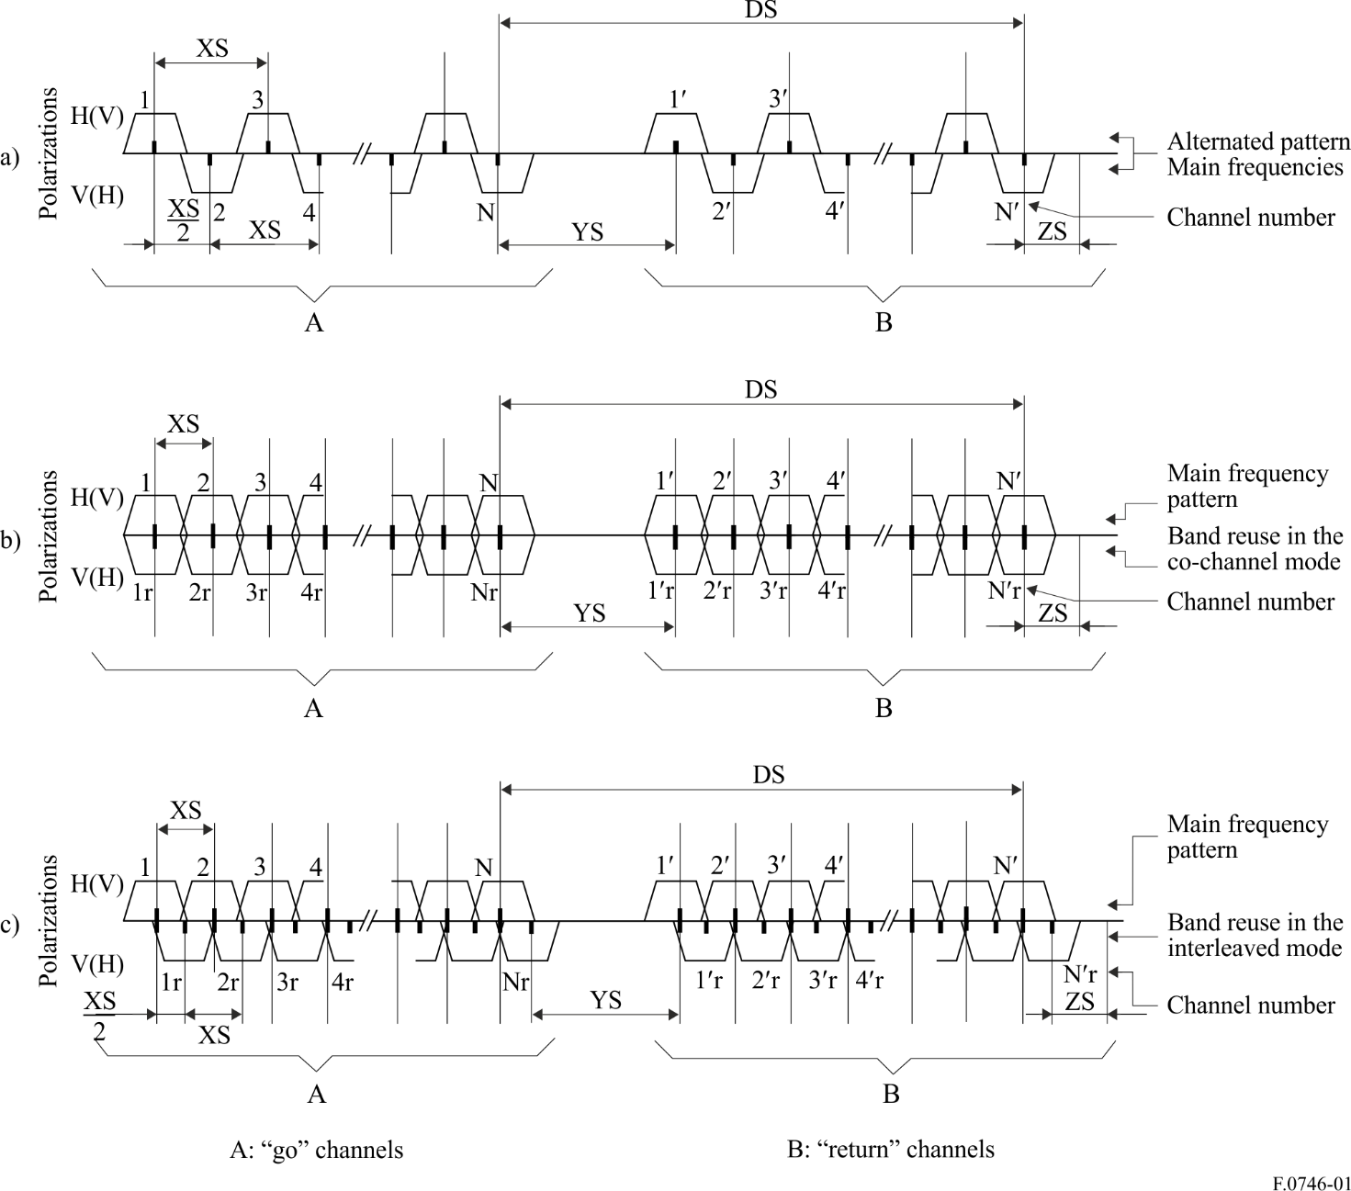
The choice of radio-frequency channel arrangement depends on the values of cross-polar discrimination (XPD) and on the net filter discrimination (NFD) where these parameters are defined as:
The XPD and NFD parameters (dB) contribute to the value of carrier-to-interference ratio.
If XPD_{min} is the minimum value reached for the percentage time required, from this value and from the adjacent channel NFD, the total amount of interfering power can be evaluated, and this result must be compared with the minimum value of carrier-to-interference (C/I )_{min} acceptable to the modulation adopted (see Note 4).
Alternated channel arrangements can be used (neglecting the co-polar adjacent channel interference contribution) if:
XPDmin + (NFD – 3) ≥ (C/I )min dB
Co-channel arrangements can be used if:
dB
Interleaved channel arrangements can be used if:
dB
where:
NFD_{a} : net filter discrimination evaluated at XS frequency spacing
NFD_{b} : net filter discrimination evaluated at XS / 2 frequency spacing
XIF : XPD improvement factor of any cross-polar interference countermeasure, if implemented in the interfered receiver;
3 that the channel arrangements reported in Fig. 1 may be used for digital FWSs either with single carrier or multi-carrier transmission (see Note 5);
4 that when multi-carrier transmission is employed, the overall number of carriers will be regarded as a single channel whose centre frequency and channel spacing will be that defined according to Fig. 1 disregarding the actual centre frequency of the carriers, which may vary, for technical reasons, according to practical implementations;
5 that where practicable (e.g. in newly exploited or rearranged bands with comparable width) it is useful to have the same duplex separation in different nearby frequency bands;
6 that the following categorization with respect to the transmission capacity may be used in ITU-R Recommendations on digital fixed wireless systems (see also Annex 1 to Recommendation ITU-R F.1101):
– “low-capacity fixed wireless systems” for the transmission of digital signals with gross bit rates up to and including 10 Mbit/s;
– “medium-capacity fixed wireless systems” for the transmission of digital signals with gross bit rates ranging from 10 Mbit/s up to about 100 Mbit/s;
– “high-capacity fixed wireless systems” for the transmission of digital signals with gross bit rates greater than 100 Mbit/s;
7 that Tables 1 and 2 report the summary of presently ITU-R defined radio-frequency channel arrangements with reference to the relevant Recommendation. Some radio-frequency channel arrangements in bands that are not covered by a specific Recommendation, and which are nevertheless used by administrations, are described in Annexes 1 to 8.
TABLE 1
Radio-frequency channel arrangement for fixed service
systems in frequency bands below about 17 GHz
Band  (GHz) | Frequency range  (GHz) | Recommendations ITU-R  F Series | Channel separation  (MHz)
0.4 | 0.4061-0.430  0.41305-0.450 | 1567, Annex 1  1567, Annex 1 | 0.05; 0.1; 0.15; 0.2; 0.25; 0.6; 0.25; 0.3; 0.5; 0.6; 0.75; 1; 1.75; 3.5
1.4 | 1.35-1.53 | 1242 | 0.25; 0.5; 1; 2; 3.5
2 | 1.427-2.69  1.7-2.1; 1.9-2.3  1.9-2.3  1.9-2.3  1.9-2.3  2.3-2.5  2.29-2.67 | 701  382  1098  1098, Annexes 1, 2  1098, Annex 3  746, Annex 1  1243 | 0.5 (pattern)  29  3.5; 2.5 (patterns)  14  10  1; 2; 4; 14; 28  0.25; 0.5; 1; 1.75;  2; 3.5; 7; 14;  2.5 (pattern)
3.6 | 3.4-3.8  3.4-3.8 | 1488, Annex 1  1488, Annex 2 | 25⁽¹⁾  0.25⁽²⁾
4 | 3.8-4.2  3.7-4.2  3.4-4.2  3.6-4.2  3.4-4.2 | 382  382, Annex 1  635  635, Annex 1  635, Annex 1 | 29  28  10 (pattern)  40; 30  80
U4 | 4.4-5.0  4.4-5.0  4.4-5.0  4.54-4.9 | 1099  1099, Annex 1  1099, Annex 3  1099, Annex 2 | 10 (pattern)  40; 80  28  40; 20
L6 | 5.925-6.425  5.925-6.425  5.925-6.425  5.925-6.425 | 383  383, Annex 1  383, Annex 2  383, Annex 3 | 29.65; 59.3  40  28  40; 20; 10; 5
U6 | 6.425-7.11  6.425-7.11  6.425-7.11 | 384  384, Annex 1  384, Annex 2 | 40; 30; 20; 10; 5  80  30; 14; 7; 3.5
7 | 7.25-7.55  7.425-7.725 (7.125-7.425)(3)  (7.250-7.550)(3) (7.550-7.850)(3)  7 125-7 425  7.425-7.725  7.435-7.75  7.11-7.75  7.425-7.90 | 385, Annex 5  385  385, Annex 1  385, Annex 1  385, Annex 2  385, Annex 3  385, Annex 4 | 3.5  7; 14; 28  1.75; 3.5; 7; 14; 28  1.75; 3.5; 7; 14; 28  5; 10; 20  28  28

TABLE 1 (end)
Band  (GHz) | Frequency range  (GHz) | Recommendations ITU-R  F Series | Channel separation  (MHz)
8 | 7.725-8.275  7.725-8.275  8.275-8.5  7.9-8.4  7.725-8.275  8.025-8.5  7.725-8.275 | 386, Annex 1  386, Annex 2  386, Annex 2  386, Annex 3  386, Annex 4  386, Annex 5  386, Annex 6 | 30; 20; 10; 5; 2.5; 1.25  28; 14; 7  28; 14; 7  28; 14; 7  40; 20; 10; 5  28; 14; 7  29.65
10 | 10.0-10.68  10.0-10.68  10.15-10.65  10.15-10.65  10.15-10.65  10.5-10.68  10.55-10.68 | 747  747, Annex 4  747, Annex 3  1568, Annex 1  1568, Annex 2  747, Annex 1  747, Annex 2 | 1.25 and 3.5 patterns  3.5; 7; 14; 28 (patterns)  3.5; 7; 14; 28 (patterns)  28⁽¹⁾  30⁽¹⁾  7; 3.5 (patterns)  5; 2.5; 1.25 (patterns)
11 | 10.7-11.7  10.7-11.7  10.7-11.7  10.7-11.7  10.7-11.7 | 387  387, Annex 2  387, Annex 1  387, Annex 3  387, Annex 4 | 40  60  80  5; 10; 20  7; 14; 28; 56; 112
12 | 11.7-12.5  12.2-12.7 | 746, Annex 2, § 3  746, Annex 2, § 2 | 19.18  20 (pattern)
13 | 12.75-13.25  12.7-13.25 | 497  746, Annex 2, § 1 | 28; 14; 7; 3.5  25; 12.5
14 | 14.25-14.5  14.25-14.5 | 746, Annex 3  746, Annex 4 | 28; 14; 7; 3.5  7; 14; 28
15 | 14.4-15.35  14.5-15.35  14.5-15.35 | 636  636, Annex 1  636, Annex 2  636, Annex 3 | 112; 56; 28; 14; 7; 3.5  2.5 (pattern)  2.5  5; 10; 20; 30; 40; 50
⁽¹⁾ Frequency block bandwidth.
⁽²⁾ Basic frequency slot for aggregating wider frequency block bandwidth.
⁽³⁾ Alternative bands in parentheses.

TABLE 2
Radio-frequency channel arrangements for fixed service
systems in frequency bands above about 17 GHz
Band  (GHz) | Frequency range  (GHz) | Recommendations ITU-R  F Series | Channel separation  (MHz)
18 | 17.7-19.7  17.7-19.7  17.7-19.7  17.7-19.7  17.7-19.7  17.7-19.7  17.7-19.7  17.7-19.7  18.58-19.16 | 595  595, Annex 1  595, Annex 2  595, Annex 3  595, Annex 4  595, Annex 5  595, Annex 6  595, Annex 7  595, Annex 7 | 220; 110; 55; 27.5  60 (block)  50; 40; 30; 20; 10; 5; 2.5  7; 3.5  27.5; 13.75; 7.5;  7; 3.5; 1.75  55; 110  55; 27.5; 13.75  60
23 | 21.2-23.6  21.2-23.6  22.0-23.6  21.2-23.6  21.2-23.6 | 637  637, Annex 1  637, Annex 2  637, Annex 3  637, Annex 4 | 3.5; 2.5 (patterns)  224 to 3.5  224 to 3.5  2.5; 5; 7.5; 10; 15; 20; 40; 50  112 to 3.5
27 | 24.25-25.25  24.25-25.25  25.25-27.5  25.27-26.98  24.5-26.5  27.5-29.5  27.5-29.5 | 748  748, Annex 3  748  748, Annex 3  748, Annex 1  748  748, Annex 2 | 3.5; 2.5 (patterns)  40⁽¹⁾  3.5; 2.5 (patterns)  60⁽¹⁾  112 to 3.5  3.5; 2.5 (patterns)  112 to 3.5
31 | 31.0-31.3  31.0-31.3 | 746, Annex 5  746, Annex 6 | 25; 50  28; 14; 7; 3.5
32 | 31.8-33.4  31.8-33.4 | 1520, Annex 1  1520, Annex 2 | 3.5; 7; 14; 28; 56; 112; 224  56⁽¹⁾
38 | 36.0-40.5  36.0-37.0  37.0-39.5  38.6-39.48  38.6-40.0  39.5-40.5 | 749  749, Annex 2  749, Annex 1  749, Annex 2  749, Annex 2  749, Annex 3 | 3.5; 2.5 (patterns)  112 to 3.5  224; 112; 56; 28; 14; 7; 3.5  60⁽¹⁾  50⁽¹⁾  112 to 3.5
42 | 40.5-43.5  40.5-43.5  40.5-43.5 | F.2005, Annex 1  F.2005, Annex 2  F.2005, Annex 3 | 224; 112; 56; 28; 14; 7  Variable size blocks  Mixed 112 to 7 and blocks
52 | 51.4-52.6 | 1496, Annex 1 | 56; 28; 14; 7; 3.5
62 | 55.78-57.0  57.0-64.0  64.0-66.0 | 1497, Annex 1  1497, Annex 2  1497, Annex 3 | 56; 28; 14; 7; 3.5  50 × n (n = 1, …50)  30 × n (n = 1, …, 33 for FDD,  n = 1, …, 66 for TDD)  50 × n (n = 1, …, 19 for FDD,  n = 1, …, 38 for TDD)

TABLE 2 (end)
Band  (GHz) | Frequency range  (GHz) | Recommendations ITU-R  F Series | Channel separation  (MHz)
70/80 | 71-76 /81-86  71-76 /81-86  71-76 /81-86  74-76 /84-86 | F.2006  F.2006, Annex 1  F.2006, Annex 2  F.2006, Annex 2 | 125 MHz (pattern)  n × 250 MHz blocks  (n = 1, …, 20)  n × 250 MHz channels  (n = 1, …, 18)  n × 250 MHz channels  (n = 1, …, 7)
94 | 92.0-94 / 94.1-95 | F.2004 | 50, 100, N × 100
⁽¹⁾ Frequency block bandwidth.
NOTE 1 – A given frequency channel arrangement can be regarded as either alternated or interleaved as a consequence of the symbol rate transmitted by the radio systems. Alternated frequency channel arrangements may be, in principle, further implemented with co-channel band reuse.
NOTE 2 – The definition and application of XPD is different from that of cross-polarization isolation (XPI) as defined in Recommendation ITU-R P.310.
NOTE 3 – In the definition of NFD the following assumptions are made:
– adjacent channels XPD, if any, has not been taken into account;
– a single side interfering channel only is considered; for double side like-modulated interferences a NFD value 3 dB lower should be taken into account.
NOTE 4 – This argument is covered by the outage and propagation behaviour prediction methods covered by Recommendations ITU-R F.1093 and ITU-R P.530.
NOTE 5 – A multi-carrier system is a system with n (where n > 1) digitally modulated carrier signals simultaneously transmitted (or received) by the same radio-frequency equipment within an assigned channel of the relevant channel arrangement or a specifically dedicated spectrum slot. The centre frequency should be regarded as the arithmetic average of the n individual carrier frequencies of the multi-carrier system. When applying a multi-carrier system in an already existing radio-frequency channel arrangement, it may be convenient to shift the centre frequency of the multi-carrier system to the middle of two adjacent channels (representing a dedicated spectrum slot) of the basic arrangement.

Annex 1
Radio-frequency channel arrangement in the band 2 300-2 500 MHz
(Table 1)
1 The radio-frequency channel arrangement for the above FWSs is based on an adjacent-channel spacing of 1 MHz, and is derived as follows:
Let f₀ be the reference frequency of the frequency pattern (MHz),
f_{n} be the centre frequency of one radio-frequency channel in the lower half of the band (MHz),
be the centre frequency of one radio-frequency channel in the upper half of the band (MHz),
then the centre frequencies of the individual channels can be expressed by the following relationships:
lower half of the band: f_{n} = f₀ – 87 + n
upper half of the band: f₀ + 7 + n
where:
n = 1, 2, 3, ..., 80.
This is illustrated in Fig. 2.
figure 2
Radio-frequency channel arrangement for up to 300 telephone channel
FWSs operating in the 2 300-2 500 MHz band
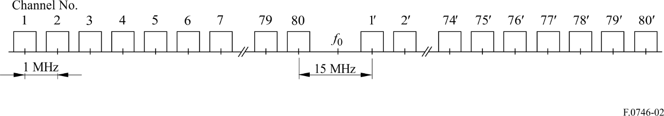
2 The reference frequency should preferably be f₀ = 2 394 MHz.
3 In a section over which an international or rural connection is arranged, as well as in a network node, all the go channels should be in one half of the radio-frequency band, and all the return channels in the other half.
4 The preferred adjacent co-polar channel separations for various channel capacities are listed in Table 3.
TABLE 3
Channel capacity | RF channel separation  (MHz) | n
12 FDM | 1 | 1, 2, 3, 4, ...
24 FDM | 2 | 1, 3, 5, 7, ...
60 FDM | 4 | 1, 5, 9, 13, ...
120 FDM | 14 | 1, 15, 29, 43, ...
300 FDM | 28 | 1, 29, 57
24 PCM | 2 | 1, 3, 5, 7, ...
30 PCM | 2 | 1, 3, 5, 7, ...
48 PCM | 4 | 1, 5, 9, 13, ...
60 PCM | 4 | 1, 5, 9, 13, ...
30 PCM⁽¹⁾ | 1 | 1, 2, 3, 4, ...
60 PCM⁽¹⁾ | 2 | 1, 3, 5, 7, ...
⁽¹⁾ Using multi-state modulation (e.g. 16-QAM).

5 When, for example, either at a nodal point or within an artery (using cross-polar discrimination), and for capacities of 24 telephone channels or more, additional radio-frequency channels are required, the channel numbers should be as follows:
24 telephone channels: n = 2, 4, 6, 8, ... (n ≤ 80)
60 telephone channels: n = 3, 7, 11, 15, ... (n ≤ 79)
120 telephone channels: n = 8, 22, 36, 50, ... (n ≤ 78)
300 telephone channels: n = 15, 43, 71.
6 For capacities of 60 telephone channels or more, additional frequencies with channel number:
n = 2, 4, 6, 8, ... for 60 telephone channels
n = 5, 12, 19, 26, ... for 120 telephone channels
n = 8, 22, 36, 50, ... for 300 telephone channels
are available for use as offset frequencies. Use of these frequencies may help to reduce interference along a route due to over-reach, or to reduce the requirements for antenna discrimination in a network node.
NOTE 1 – Further studies are required to evaluate interference problems caused by intermodulation products between different systems working on the same route.

Annex 2
Utilization of the band 11.7-13.25 GHz
(Table 1)
Recommendation ITU-R F.497 gives radio-frequency channel arrangements for digital and analogue systems in the band 12.75-13.25 GHz. However, some administrations use also parts of the band 11.7-13.25 GHz. Examples are as follows:

1 12.5/25 MHz plan
In the United States of America, extensive use is being made of the 12.7-12.95 GHz range primarily for television transmission to feed wired distribution systems (cable television). These systems, often traversing distances of 100 to 500 km, are typically unidirectional, hence a frequency pattern without a guardband is used, utilizing a 25 MHz spaced main channel plan and a mid-spaced interstitial plan for coordination purposes (e.g. branch routes).
This frequency range is also available for multiple television channel transmission – both vestigial sideband (VSB)/SSB and VSB/FM. These are typically of a short-haul type (5-15 km) and feed multiple receiving points. The rest of the band (12.95-13.25 GHz) uses a similar channelling pattern, but in this case the prime use is to feed television broadcasting systems, both in fixed, as well as in mobile, configurations. In Japan, the entire frequency range of 12.7-13.25 GHz is used for television pick-up and studio transmitter links with the same 25 MHz channel separations.

2 20 MHz plan
In the United States of America and Japan, the 12.2-12.7 GHz range is used for both television and telephony data transmission. The channelling arrangement is based on a 20 MHz pattern. These channels are used for FDM telephony (to 1 200 channels) or for digital data streams up to 45 Mbit/s. Users of this band include utilities, educational entities, civil government and commerce.

3 The band 11.7-12.5 GHz
The development of a channel arrangement with a frequency spacing of 19.18 MHz (the selection of radio-frequency channels from the 19.18 MHz spacing plan should be determined by agreement between the administrations concerned) in the 11.7-12.5 GHz band will need to take into account the requirements of the broadcasting-satellite service (BSS) to which the band or parts thereof are also allocated, in accordance with the decisions of the World Administrative Radio Conference for the Planning of the Broadcasting-Satellite Service (Geneva, 1977) (WARC BS-77), the World Administrative Radio Conference (Geneva, 1979) (WARC-79) and the First Session of the World Administrative Radio Conference on the Use of the Geostationary-Satellite Orbit and the Planning of the Space Services Utilizing It (Geneva, 1985) (WARC Orb-85). For Regions 1 and 3, studies indicate that a channel arrangement should have the following basic characteristics in order to facilitate sharing between the two services:
– adjacent channel spacing should be the same as, or a multiple of, the spacing agreed for the BSS (19.18 MHz);
– channel frequencies should coincide or be interleaved with the BSS frequencies, that is:
f = 11 708.3 + 19.18 n MHz
or f = 11 717.89 + 19.18 n MHz
where:
n = 1, 2, 3, ..., 40;
– go and return channel separations should be compatible with BSS frequency grouping.
In the band 11.7-12.5 GHz, certain countries propose to use FWSs with SSB modulation for the simultaneous transmission of several television and sound-broadcasting signals by one or more transmitters to a number of receiving stations. The frequencies indicating the channel to be used for an individual television plus sound signal should correspond to the centre of the modulating band of the individual signal.

Annex 3
Radio-frequency channel arrangement in the band 14.25-14.5 GHz
using a 14/28 MHz channel spacing
(Table 1)
In the United Kingdom, the basic 14/28 MHz pattern is used in the band 14.25-14.5 GHz, as an extension of the 13 GHz band in Recommendation ITU-R F.497, to provide analogue television or medium and low capacity digital channels with channel spacings of 28, 14, 7 and 3.5 MHz.
Recommendation ITU-R F.636 shows preferred channel arrangements in the band 14.4-15.35 GHz, using the basic pattern which takes account of the differing restrictions imposed by various administrations in the centre of the band.
The basic 28 MHz channel arrangement is as follows:
lower half of the band: f_{n} = f_{r} + 2 534 + 28 n MHz
upper half of the band: = f_{r} + 2 674 + 28 n MHz
where:
f_{r} : reference frequency
n = 1, 2, 3, 4.
The frequency arrangement with f_{r} = 11 701 MHz is shown in Fig. 3.
figure 3
Radio-frequency channel arrangement in the frequency band 14.25-14.5 GHz
(All frequencies in MHz)
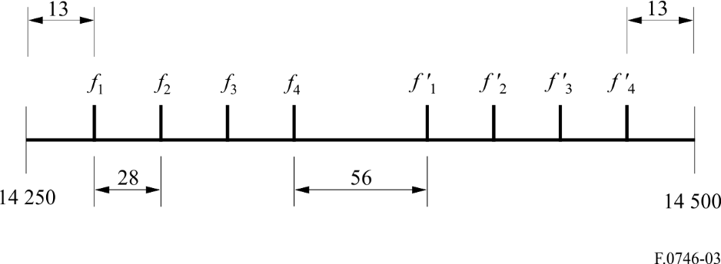
NOTE 1 – Due to the narrow edge and centre guardbands, channels 1 and 4 are unsuitable for use at 34 Mbit/s on a 28 MHz channel spacing. These channels are, therefore, restricted to use for 625-line analogue television or low capacity digital systems, with the channels subdivided to 7 and 3.5 MHz, in a similar manner to that adopted in Recommendation ITU-R F.497, § 10, Alternatives I and III.

Annex 4
Radio-frequency channel arrangement in the band 14.25-14.5 GHz
using 7, 14 and 28 MHz channel spacing
(Table 1)
In Italy, the band 14.25-14.5 GHz is used, with radio channels of various width, for the transmission of digital TV signals with different coding formats.
The basic 28 MHz channel arrangement is derived as follows:
lower half of the band: f_{n} = f_{r} + 2 536 + 28 n MHz
upper half of the band: f_{n’} = f_{r} + 2 672 + 28 n MHz
where:
f_{r} : reference frequency
n = 1, 2, 3, 4.
The frequency arrangement with f_{r} = 11 701 MHz is shown in Fig. 4.
Channel arrangements with the lower 7 and 14 MHz are obtained by subdivision of the basic 28 MHz channels.
FIGURE 4
Radio-frequency channel arrangements for FWSs operating in the 14 GHz band with 28 MHz separation
(All frequencies in MHz)
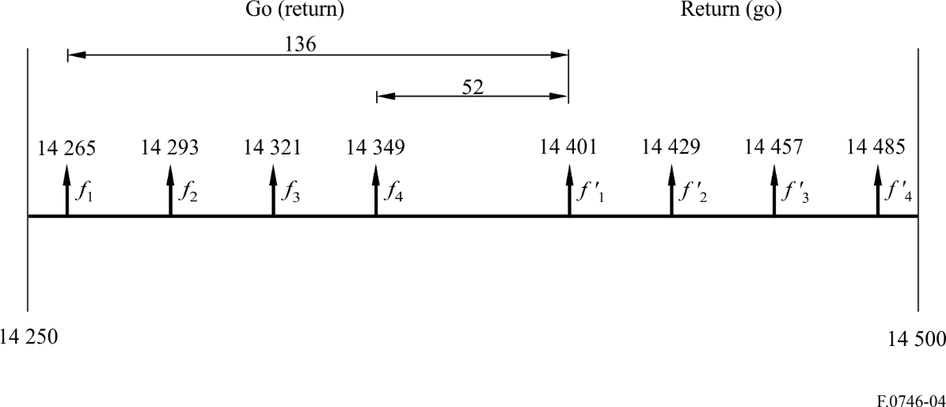

Annex 5
Radio-frequency channel arrangement in the band 31.0-31.3 GHz
(Table 2)
This band is intended, in the United States of America, for use without prior frequency coordination and without protection against harmful interference. Either 25 MHz or 50 MHz channels can be used.
The radio-frequency channel arrangement with 25 MHz channels can be represented as follows:
where:
n = 1, 2, 3, ..., 12
f_{r} (reference frequency) = 30 987.5 MHz.
The corresponding arrangement for 50 MHz channels is as follows:
where:
n = 1, 2, 3, 4, 5, 6
f_{r} (reference frequency) = 30 975 MHz.
For two-way operation in either radio-frequency channel arrangement, the go-return separation is 150 MHz.

Annex 6
Radio-frequency channel arrangements in the band 31.0-31.3 GHz
(Table 2)
This band is intended to be used in some CEPT countries, according to the following channel arrangements for TDD or FDD FWS systems.

1 Channel arrangement in the band 31.0-31.3 GHz for TDD systems
The centre frequencies for channel separations of 3.5 MHz, 7 MHz, 14 MHz and 28 MHz shall be derived as follows:
Let f_{r} be the reference frequency of 31 000 MHz,
f_{n} be the centre frequency of a radio-frequency channel in the band 31.0-31.3 GHz,
then the centre frequencies of individual channels are expressed by the following relationships:
a) for systems with a channel separation of 28 MHz:
f_{n} = f_{r} + 3 + 28 n MHz
where:
n = 1, 2, 3, …......9
b) for systems with a channel separation of 14 MHz:
f_{n} = f_{r} + 10 + 14 n MHz
where:
n = 1, 2, 3, …......18
c) for systems with a channel separation of 7 MHz:
f_{n} = f_{r} + 13.5 + 7 n MHz
where:
n = 1, 2, 3, …......36
d) for systems with a channel separation of 3.5 MHz:
f_{n} = f_{r} + 15.25 + 3.5 n MHz
where:
n = 1, 2, 3, …......72.
TABLE 4
XS  (MHz) | n | f₁  (MHz) | f_{n}  (MHz) | Z₁S  (MHz) | Z₂S  (MHz)
28 | 1,…9 | 31 031 | 31 255 | 31 | 45
14 | 1,…18 | 31 024 | 31 262 | 24 | 38
7 | 1,…36 | 31 020.5 | 31 265.5 | 20.5 | 34.5
3.5 | 1,…72 | 31 018.75 | 31 267.25 | 18.75 | 32.75

2 Channel arrangement in the band 31.0-31.3 GHz for FDD systems
The centre frequencies for channel separations of 3.5 MHz, 7 MHz, 14 MHz and 28 MHz shall be derived as follows:
Let f_{r} be the reference frequency of 31 150 MHz,
f_{n} be the centre frequency (MHz) of the radio-frequency channel in the lower half of the band,
be the centre frequency (MHz) of the radio-frequency channel in the upper half of the band,
Duplex spacing = 140 MHz,
Centre gap = 28 MHz.
Then the frequencies (MHz) of individual channels are expressed by the following relationships:
a) for a channel separation of 28 MHz:
lower half of the band: f_{n} = f_{r} – 147 + 28 n
upper half of the band: = f_{r} – 7 + 28 n
where:
n = 1, 2, … 4
b) for a channel separation of 14 MHz:
lower half of the band: f_{n} = f_{r} – 140 + 14 n
upper half of the band: = f_{r} + 0 + 14 n
where:
n = 1, 2, … 8
c) for a channel separation of 7 MHz:
lower half of the band: f_{n} = f_{r} – 136.5 + 7 n
upper half of the band: = f_{r} + 3.5 + 7 n
where:
n = 1, 2, … 16
d) for a channel separation of 3.5 MHz:
lower half of the band: f_{n} = f_{r} – 134.75 + 3.5 n
upper half of the band: = f_{r} + 5.25 + 3.5 n
where:
n = 1, 2, … 32.
TABLE 5
XS  (MHz) | n | f₁  (MHz) | f_{n}  (MHz) |  |  | ZS₁  (MHz) | ZS₂  (MHz) | YS  (MHz) | DS  (MHz)
28 | 1…4 | 31 031 | 31 115 | 31 171 | 31 255 | 31 | 45 | 56 | 140
14 | 1…8 | 31 024 | 31 122 | 31 164 | 31 262 | 24 | 38 | 42 | 140
7 | 1…16 | 31 020.5 | 31 125.5 | 31 160.5 | 31 265.5 | 20.5 | 34.5 | 35 | 140
3.5 | 1…32 | 31 018.75 | 31 127.25 | 31 158.75 | 31 267.25 | 18.75 | 32.75 | 31.5 | 140

