Recommendation ITU-R F.699-9
(02/2026)
F Series: Fixed service
Reference radiation patterns for fixed wireless system antennas for use in coordination studies and interference assessment in the frequency range from 100 MHz to 174.8 GHz

Foreword
The role of the Radiocommunication Sector is to ensure the rational, equitable, efficient and economical use of the radio-frequency spectrum by all radiocommunication services, including satellite services, and carry out studies without limit of frequency range on the basis of which Recommendations are adopted.
The regulatory and policy functions of the Radiocommunication Sector are performed by World and Regional Radiocommunication Conferences and Radiocommunication Assemblies supported by Study Groups.

INTELLECTUAL PROPERTY RIGHTS
ITU draws attention to the possibility that the practice or implementation of this Recommendation may involve the use of a claimed Intellectual Property Right. ITU takes no position concerning the evidence, validity or applicability of claimed Intellectual Property Rights, whether asserted by ITU members or others outside of the Recommendation development process.
As of the date of approval of this Recommendation, ITU had received notice of intellectual property, protected by patents, which may be required to implement this Recommendation. However, implementers are cautioned that this may not represent the latest information and are therefore strongly urged to consult the appropriate ITU-R patent information available at https://www.itu.int/en/ITU-R/study-groups/Pages/itu-r-patent-information.aspx.

Series of ITU-R Recommendations
(Also available online at https://www.itu.int/publ/R-REC/en)
Series | Title
BO | Satellite delivery
BR | Recording for production, archival and play-out; film for television
BS | Broadcasting service (sound)
BT | Broadcasting service (television)
F | Fixed service
M | Mobile, radiodetermination, amateur and related satellite services
P | Radio-wave propagation
RA | Radio astronomy
RS | Remote sensing systems
S | Fixed-satellite service
SA | Space applications and meteorology
SF | Frequency sharing and coordination between fixed-satellite and fixed service systems
SM | Spectrum management
SNG | Satellite news gathering
TF | Time signals and frequency standards emissions
V | Vocabulary and related subjects

Note: This ITU-R Recommendation was approved in English under the procedure detailed in Resolution ITU-R 1.

Electronic Publication
Geneva, 2026
© ITU 2026
All rights reserved. No part of this publication may be reproduced, by any means whatsoever, without written permission of ITU.

RECOMMENDATION ITU-R F.699-9
Reference radiation patterns for fixed wireless system antennas for use in coordination studies and interference assessment in the frequency range from 100 MHz to 174.8 GHz
(Question ITU-R 110-3/5)
(1990-1992-1994-1995-1997-2000-2004-2006-2018-2026)
Scope
This Recommendation provides reference radiation patterns for, and information on, fixed wireless system antennas in the frequency range from 100 MHz to 174.8 GHz. This information may be used in coordination studies and interference assessments when particular information concerning the fixed wireless system (FWS) antenna is not available.
Keywords
Reference antenna radiation pattern, azimuth and elevation beamwidths, side-lobe peaks, cross polarization, frequency sharing
Abbreviations/Glossary
λ wave length
φ Off-axis angle (mainly in azimuth)
ϴ Off-axis angle (mainly in elevation)
D Diameter
FSS Fixed satellite service
FWS Fixed wireless system
G Antenna gain
H Horizontal
P-P Point to point
V Vertical
Related ITU Recommendations
Recommendation ITU-R F.1245 – Mathematical model of average and related radiation patterns for point-to-point fixed wireless system antennas for use in interference assessment in the frequency range from 1 GHz to 86 GHz
Recommendation ITU-R F.1336 – Reference radiation patterns of omnidirectional, sectoral and other antennas for the fixed and mobile services for use in sharing studies in the frequency range from 400 MHz to about 70 GHz
The ITU Radiocommunication Assembly,
considering
a) that the reference radiation pattern of point-to-point fixed wireless system (FWS) antennas stated in Recommendation ITU-R F.1245 provides the antenna radiation pattern representing average side-lobe levels;
b) that if the average side-lobe radiation pattern is used in the assessment of the interference from a single source, the predicted interference will result in values that may be less than values that would be experienced in practice;
c) that, therefore, it is necessary to use the antenna radiation pattern of side-lobe peaks for FWS stations in the following cases:
– to predict the single-entry interference between a geostationary satellite and single FWS station, where the aggregation of interference from multiple sources is not considered;
– to predict the single-entry interference between FWS stations, where the aggregation of interference from multiple sources is not considered;
– to predict the single-entry interference between FWS stations and stations in space radiocommunication and other services sharing the same frequency band, where variable interference from a moving source or the aggregation of interference from multiple sources are not considered;
d) that, for the above studies, radiation patterns based on the level exceeded by a small percentage of the side-lobe peaks may be appropriate;
e) that the side-lobe patterns of antennas of different sizes are strongly influenced by the ratio of the antenna diameter to the operating wavelength;
f) that the antenna gain may be estimated by the ratio of the antenna diameter to the operating wavelength;
g) that in cases where only the maximum antenna gain is known, the ratio between the antenna diameter and the wavelength (D/λ) may be estimated for antennas with circular symmetry;
h) that reference radiation patterns are required for the case where information concerning the antenna diameter is not available;
i) that, at large angles, the likelihood of local ground reflections must be considered;
j) that the use of antennas with the best available radiation patterns will lead to the most efficient use of the radio-frequency spectrum,
recommends
1 that, in the absence of particular information concerning the radiation pattern of the FWS antenna involved (see Note 1), and taking into account considering c), the reference radiation pattern as stated below should be considered for:
1.1 interference assessment between FWS;
1.2 coordination studies and interference assessment between FWS stations and stations in space radiocommunication and other services sharing the same frequency band;
2 that the following reference radiation pattern should be adopted for frequencies in the range 100 MHz to 174.8 GHz;
2.1 in cases where the ratio between the antenna diameter and the wavelength is greater than 100, the following equations should be used (see Notes 6 and 7):
2.1.1 for frequencies in the range 1 GHz to 70 GHz,
$G\left(φ\right)=G_{max}-2.5×{10}^{-3}{\left(\frac{D}{λ}φ\right)}^{2}$ for $0°<φ<φ_{m}$
$G\left(φ\right)=G_{1}$ for $φ_{m}≤φ<φ_{r}$
$G\left(φ\right)=32-25\log{φ}$ for $φ_{r}≤φ<48°$
$G\left(φ\right)=-10$ for $48°≤φ≤180°$
2.1.2 for frequencies in the range 70 GHz to 86 GHz,
$G\left(φ\right)=G_{max}-2.5×{10}^{-3}{\left(\frac{D}{λ}φ\right)}^{2}$ for $0°<φ<φ_{m}$
$G\left(φ\right)=G_{1}$ for $φ_{m}≤φ<φ_{r}$
$G\left(φ\right)=32-25\log{φ}$ for $φ_{r}≤φ<120°$
$G\left(φ\right)=-20$ for $120°≤φ≤180°$
where:
G(ϕ) : gain relative to an isotropic antenna (dBi)
ϕ : off-axis angle (degrees)
G₁ : gain of the first side-lobe = 2 + 15 log (dBi)
2.2 in cases where the ratio between the antenna diameter and the wavelength is less than or equal to 100, the following equations should be used (see Notes 6 and 7):
2.2.1 for frequencies in the range 1 GHz to 70 GHz
$G\left(φ\right)=G_{max}-2.5×{10}^{-3}{\left(\frac{D}{λ}φ\right)}^{2}$ for $0°<φ<φ_{m}$
$G\left(φ\right)=G_{1}$ for $φ_{m}≤φ<100\frac{λ}{D}$
for 100 ≤ ϕ < 48°
for 48° ≤ ϕ ≤ 180°
2.2.2 for frequencies in the range 70 GHz to 86 GHz,
for 0° < ϕ < ϕ_{m}
for ϕ_{m} ≤ ϕ < 100
$G\left(φ\right)=52-10\log{\frac{D}{λ}}-25\log{φ}$ for 100 ≤ ϕ < 120°
$G\left(φ\right)=-10\log{\frac{D}{λ}}$ for 120° ≤ ϕ ≤ 180°
2.3 for frequencies in the range 100 MHz to less than 1 GHz, in cases where the ratio between the antenna diameter and the wavelength is greater than 0.63 (G_{max} is greater than 3.7 dBi), the following equations should be used:
for 0° < ϕ < ϕ_{m}
for ϕ_{m} ≤ ϕ < 100
for 100 ≤ ϕ < ϕ_{s}
for ϕ_{s} ≤ ϕ ≤ 180°
where:
2.4 that for frequencies between 86 and 174.8 GHz, the same equations given in recommends 2 for frequencies between 70 GHz and 86 GHz (see recommends 2.1.2 and 2.2.2) should be used (see Note 8);
3 that in cases where only the maximum antenna gain is known, D/λ (both D and λ expressed in the same unit) may be estimated from the following expression (see Note 5):
$20\log{\frac{D}{λ}}≈G_{max}-7.7$
where G_{max} is the main lobe antenna gain (dBi). Where only the ratio D/λ is known, the maximum antenna gain may be estimated from the following expression: $G_{max}≈20\log{\frac{D}{λ}}+7.7$.
Therefore, G_{max} approximates 48 dBi for D/λ = 100;
4 that in cases where only the beamwidths of the antenna are known:
4.1 D/λ (expressed in the same unit) may be estimated approximately by the following expression:
$D/λ≈{70}/θ$
where θ is the beamwidth (−3 dB) (degrees);
4.2 given θ, G_{max} may be estimated approximately by:
$G_{max} \left(dBi\right)≈44.5-20\log{θ}$
5 that the ITU-R membership submit measured radiation patterns or specifications to allow new and improved reference radiation patterns for use in coordination studies and interference assessment to be developed and proposed (see Attachment 1 to Annex 1);
6 that Annex 1 should be referred to for additional information concerning reference radiation patterns for FWS antennas;
7 that for the detailed calculation of interference levels on interference paths, it is necessary to consider the cross-polar response of the victim and interfering system antennas;
7.1 that for the calculation in recommends 7, including the component of signal radiated on the intended polarity by the transmitting antenna and the co-polar response of the victim receive antenna to the component of signal radiated on the unintended polarity by the transmitting antenna, the following equation may be used:
dBi
where the following parameters refer to antenna gain (dBi):
G_{t}(ϕ_{t}): transmit antenna effective gain in the direction of the victim antenna
G_{r}(ϕ_{r}): receive antenna effective gain in the direction of the interfering antenna
G_{tH}(ϕ_{t}): horizontally polarized gain component of the transmit antenna
G_{rV}(ϕ_{r}): vertically polarized gain component of the receive antenna
G_{tV}(ϕ_{t}): vertically polarized gain component of the transmit antenna
G_{rH}(ϕ_{r}): horizontally polarized gain component of the receive antenna.
ϕ_{t} and ϕ_{r}: are the angles between the direction of main beam and direction towards victim and transmitting antenna respectively.
Further information and numerical examples on using the equation above is given in Annex 2.
8 that the following Notes should be regarded as part of this Recommendation.
NOTE 1 – It is essential that every effort be made to utilize the actual antenna pattern in coordination studies and interference assessment.
NOTE 2 – It should be noted that the radiation pattern of an actual antenna may be worse than the reference radiation pattern over a certain range of angles (see Note 3). Therefore, the reference radiation pattern in this Recommendation should not be interpreted as establishing the maximum limit for radiation patterns of existing or planned FWS antennas. Noting that for certification purpose, administrations may adopt standards, usually based on statistical measurements of real antennas, that may represent different values for the side-lobe radiation pattern levels.
NOTE 3 – The reference radiation pattern should be used with caution over the range of angles for which the particular feed system may give rise to relatively high levels of spill-over.
NOTE 4 – The reference pattern in recommends 2 is only applicable for one polarization (horizontal or vertical). Reference patterns for two polarizations (horizontal and vertical) are under study.
NOTE 5 – The reference radiation pattern included in this Recommendation is only for antennas which are rotationally symmetrical. It can be applied also to square/polygonal reflectors and flat panel antennas, provided that their equivalent D/λ ratio is derived from the maximum gain, using formula in recommends 3. The reference radiation pattern for antennas with asymmetrical apertures and for non-aperture FWS antennas in the frequency range from 100 MHz to 1 GHz requires further study. For such antennas, the above reference patterns may be considered to be provisionally valid. In this case, the D/λ value computed from G_{max} is an equivalent D/λ and not the actual D/λ.
NOTE 6 – Mathematical models of average radiation patterns for use in certain coordination studies and interference assessment are given in Recommendation ITU-R F.1245.
NOTE 7 – Reference radiation patterns of omnidirectional and sectoral antennas in point-to-multipoint systems are given in Recommendation ITU-R F.1336.
NOTE 8 – Further study is required to ensure that reference radiation patterns continue to develop to take account of advances in antenna design.
NOTE 9 – While generally applicable, the reference pattern in recommends 2 does not suitably model some practical fixed service antennas and it should be treated with caution over a range of angles from 5° to 70° (see also NOTES 2 and 3).
NOTE 10 – In Annex 1, for some Figures representing antennas above 70 GHz, the patterns for equations in recommends 2.1 and 2.2 referring to antennas below 70 GHz are provided only for information.

Annex 1
Reference radiation patterns for FWS antennas
TABLE OF CONTENTS
Page
Annex 1 6
Reference radiation patterns for FWS antennas 6
1 Introduction 7
2 Uses of reference radiation patterns 7
2.1 Preliminary studies within the coordination area 7
2.2 Frequency reuse in a fixed wireless network 7
3 Results of measurements on the antennas of fixed wireless links 7
Attachment 1 to Annex 1 Measured patterns for use in the further development of this Recommendation 8
1 Introduction 8
Annex 2 Information on the application of recommends 7 20
1 Introduction 20
2 Situation 20
3 The numerical example 21
4 Alternative equation for cross-polarized case 22
5 Alternative equation for co-polarized case 22

1 Introduction
For the study of frequency sharing between FWS and the FSS or of the possibility of frequency reuse in a FWS network, it is often necessary to use a reference diagram, because the actual radiation pattern of the antennas is not always accurately known or gives too many details. The reference pattern should therefore represent the side-lobe peaks in a simplified fashion.
The reference radiation pattern to be selected may, however, vary according to the use for which it is intended.
In general, the reference radiation patterns in the main text of this Recommendation shall be used.

2 Uses of reference radiation patterns
The two main uses of reference radiation patterns are the following:

2.1 Preliminary studies within the coordination area
In the determination of the coordination area around an earth station, FWS station antennas are assumed to point directly at the earth station. However, in most cases there will be some angular discrimination. The use of a simple reference radiation diagram makes it possible to eliminate from further consideration FWS stations situated in the coordination area but not likely to produce interference.
This diagram, must, of necessity, be conservative to prevent the elimination of critical contributing sources of interference. The precise calculation of the interference level, of course, requires more accurate information on the antenna diagram.

2.2 Frequency reuse in a fixed wireless network
In a fixed wireless network, the same frequency may be used many times, either on sections sufficiently distant from each other or on sections starting from the same station and lying in different directions, or on the same section using cross-polarization.
In the last two cases, the performance of the antenna is of great importance, and a fairly precise reference radiation pattern must be used for the network project; this pattern may be less simple than that considered in § 2.1, administrations are encouraged to use high performance antenna types in high spectrum use areas.

3 Results of measurements on the antennas of fixed wireless links
Measurements with numerous antennas provide adequate confirmation of the reference radiation patterns in the main text of this Recommendation at least up to a value of D/λ of approximately 180. However, the following points must be borne in mind:
3.1 Some antennas of relatively old designs have less satisfactory performance characteristics than more recent models. The existence of such medium performance antennas should be taken into account for frequency sharing.
3.2 The above computation is based on the assumption that the antennas operate in free-space conditions. The performance characteristics of antennas installed in the field may, however, be slightly less satisfactory owing to reflection from neighbouring obstacles or from other antennas installed on the same mast.

Attachment 1
to Annex 1
Measured patterns for use in the further development of this Recommendation

1 Introduction
There is a continuing need to review and update the reference radiation patterns contained in this Recommendation. This Attachment contains comparisons of some practical antenna pattern envelopes and radiation patterns with the corresponding reference patterns derived from this Recommendation and Recommendation ITU-R F.1245.
It is noted that in some cases, a portion of the side lobes of the measured patterns exceed the reference pattern of this Recommendation. This observation is further described in Notes 2 and 3 to the recommends section, which points out that this Recommendation provides appropriate reference patterns to be used in studies, and not maximum limits for real antennas.
FIGURE 1
2 150 MHz point-to-point antenna of 1 m diameter (D/λ= 7.14; gain= 22.4 dBi)
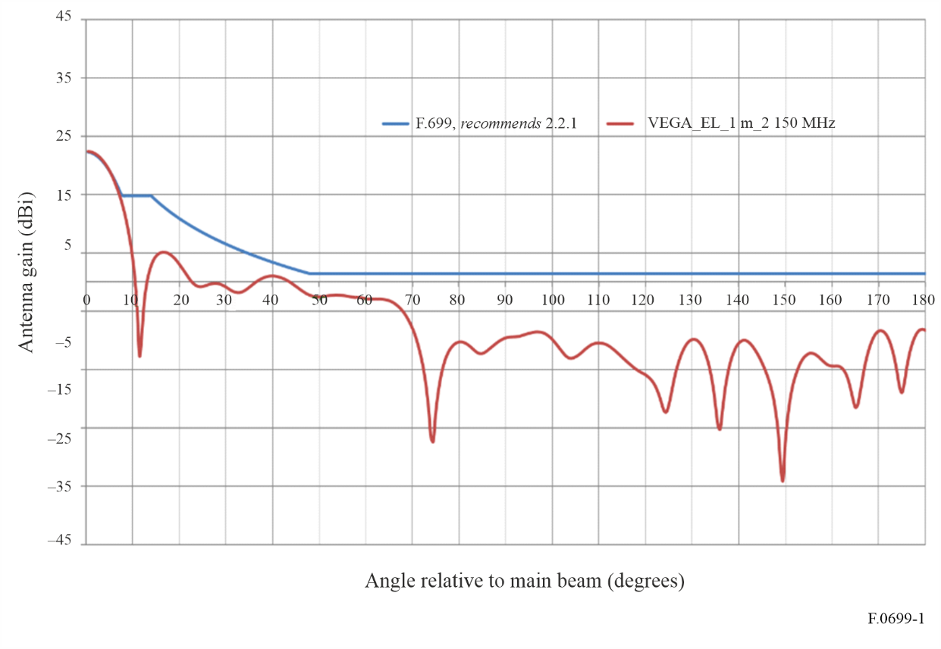
Figure 2
10.7 GHz point-to-point antenna of 3 m diameter (D/λ = 114; gain = 49.8 dBi) (H: horizontal polarization, V: vertical polarization)
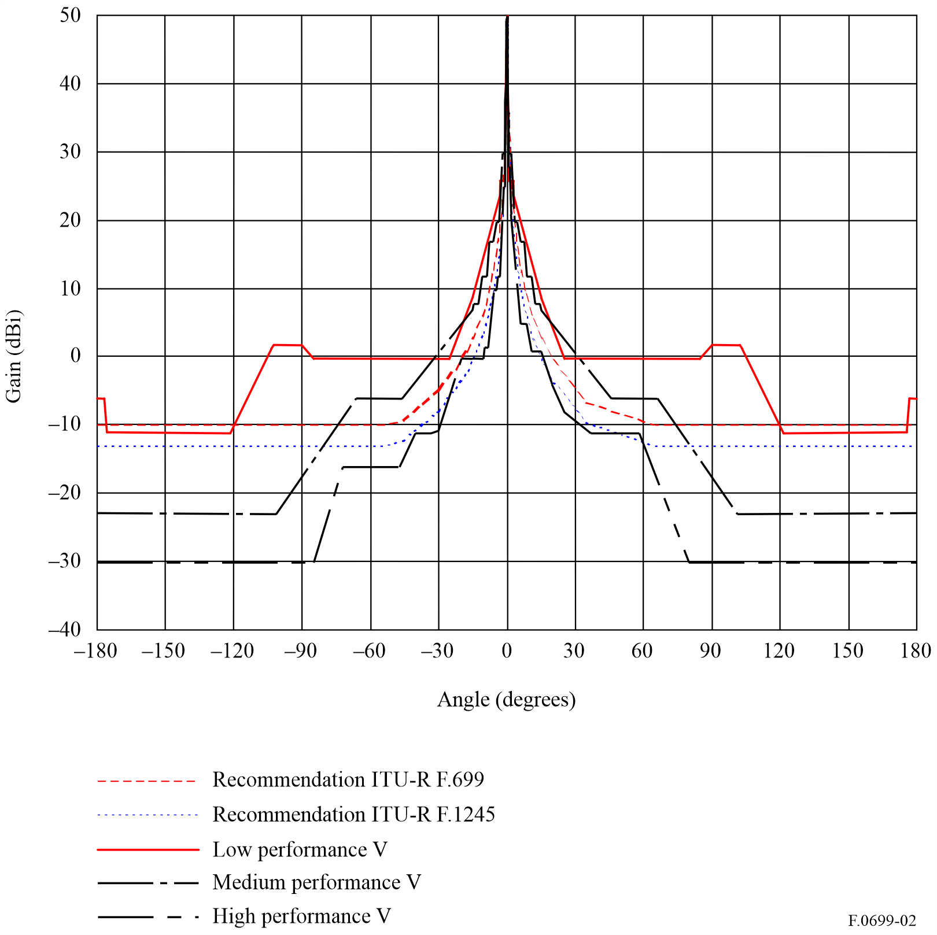
FIGURE 3
10.7 GHz point-to-point antennas of 1.8 m diameter (D/λ = 14.6; Patterns for a sample of production antennas with horizontal polarization)
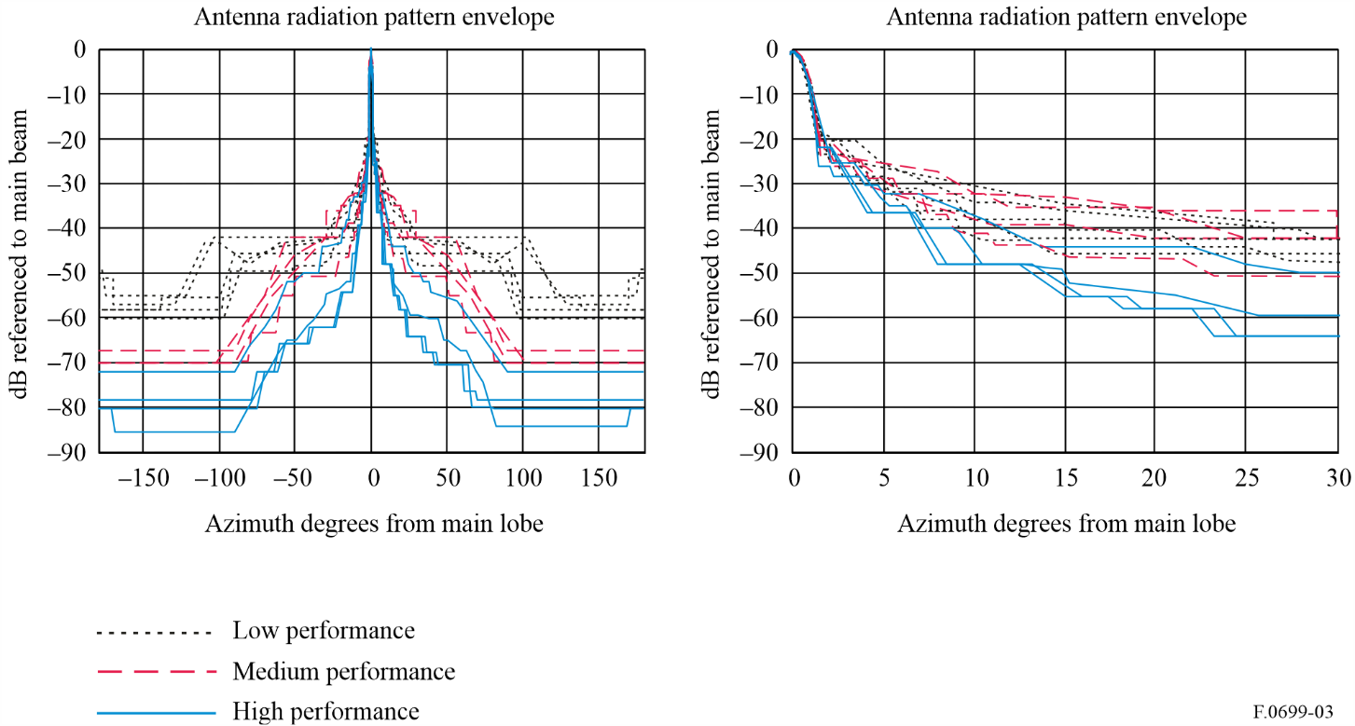
FIGURE 4
10.5 GHz point-to-point antenna of 1.2 m diameter (D/λ = 43; gain = 39.9 dBi) (H: horizontal polarization, V: vertical polarization)
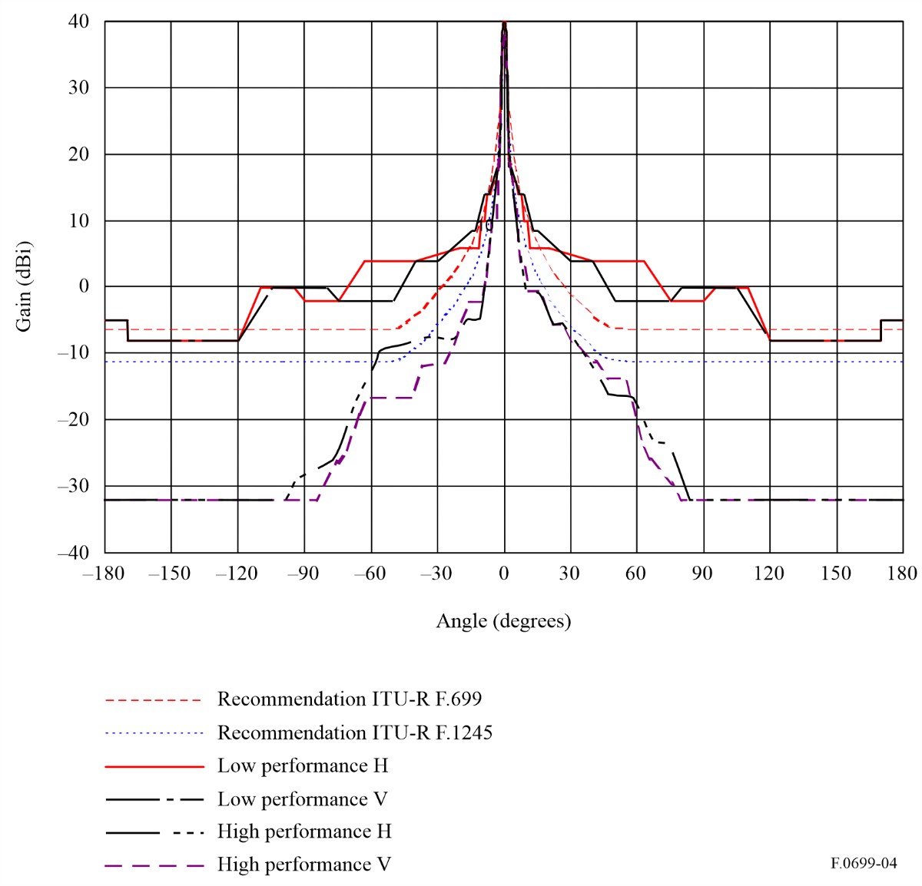
FIGURE 5
21 GHz lens horn point-to-point antenna of 50 cm diameter (D/λ = 37; gain = 40 dBi)
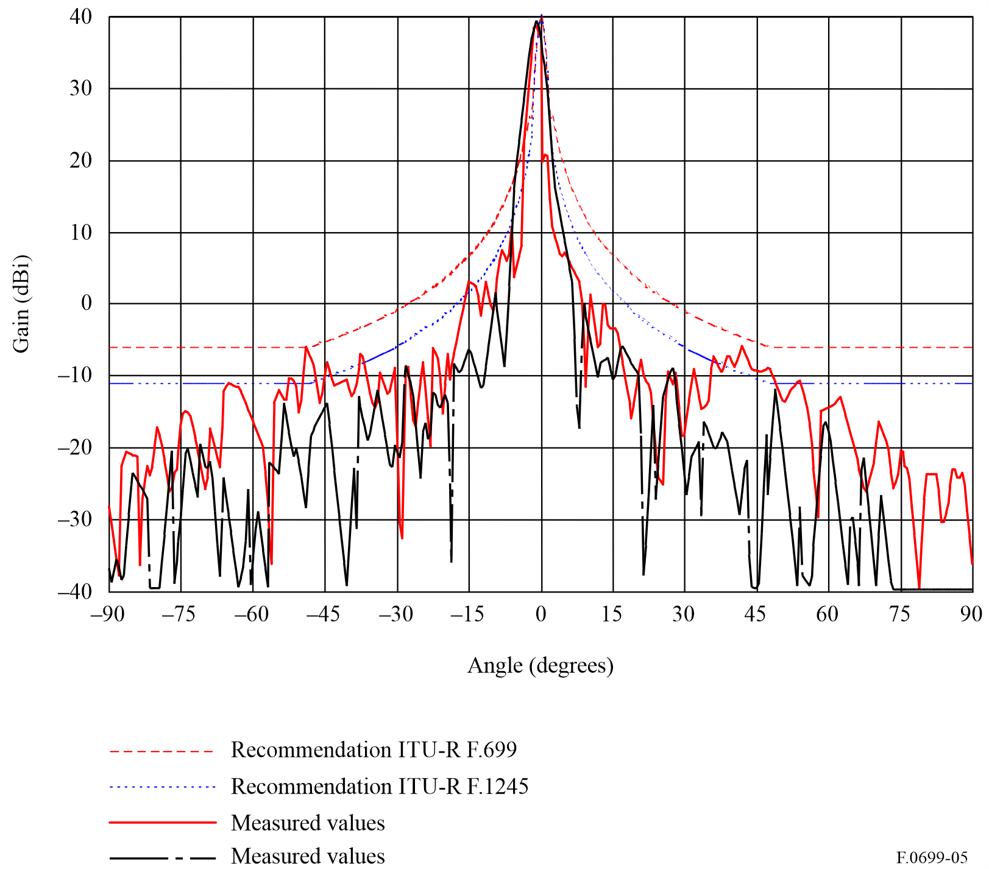
figure 6
31 GHz point-to-point antenna of 0.3 m diameter (D/λ = 32; gain = 36.9 dBi) (H: horizontal polarization, V: vertical polarization)
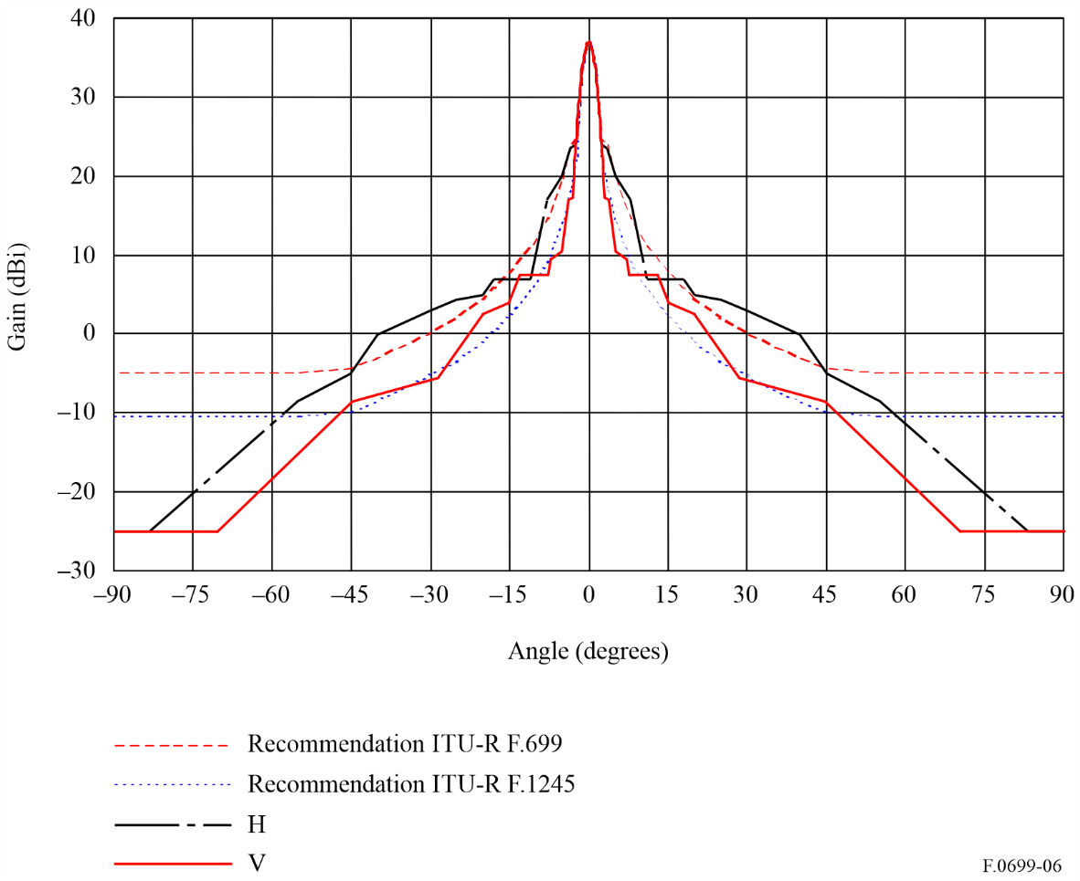
figure 7
55 GHz point-to-point antenna of 0.3 m diameter (D/λ = 57; gain = 42.4 dBi) (H: horizontal polarization, V: vertical polarization)
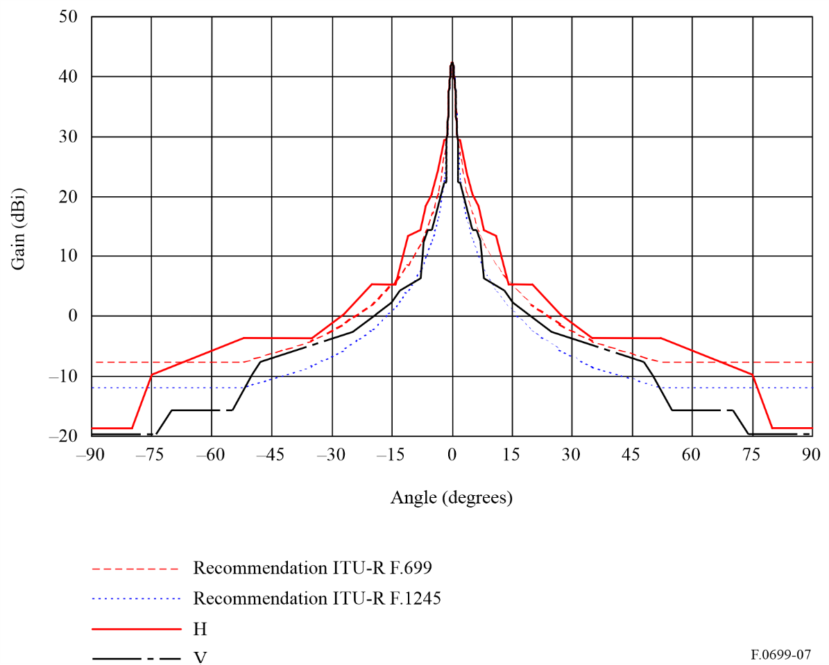
The following Figures depict measured patterns of antennas operating above 70 GHz, compared to the equations in recommends 2.1.2 (for D/λ >100) and 2.2.2 (for D/λ ≤100) (see Note 10). Antenna patterns at and above 275 GHz are available in the Report ITU-R F.2416.
FIGURE 8
Example of 76 GHz point-to-point antenna of 1 foot diameter (D/λ = 96; gain = 44.4 dBi; θ₃ = 1.0°) compared to recommends 2.2.2 (see Note 10)
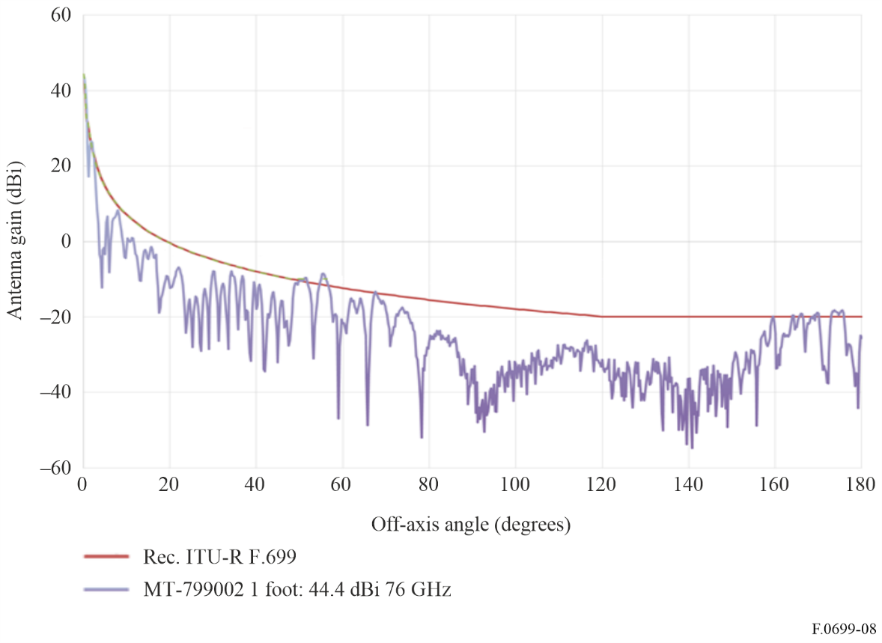
FIGURE 9
Example of 71 GHz point-to-point antenna of 65 cm diameter (D/λ = 154; gain = 49.2 dBi; θ₃ = 0.5°) compared to recommends 2.1.1 and 2.1.2 (see Note 10)
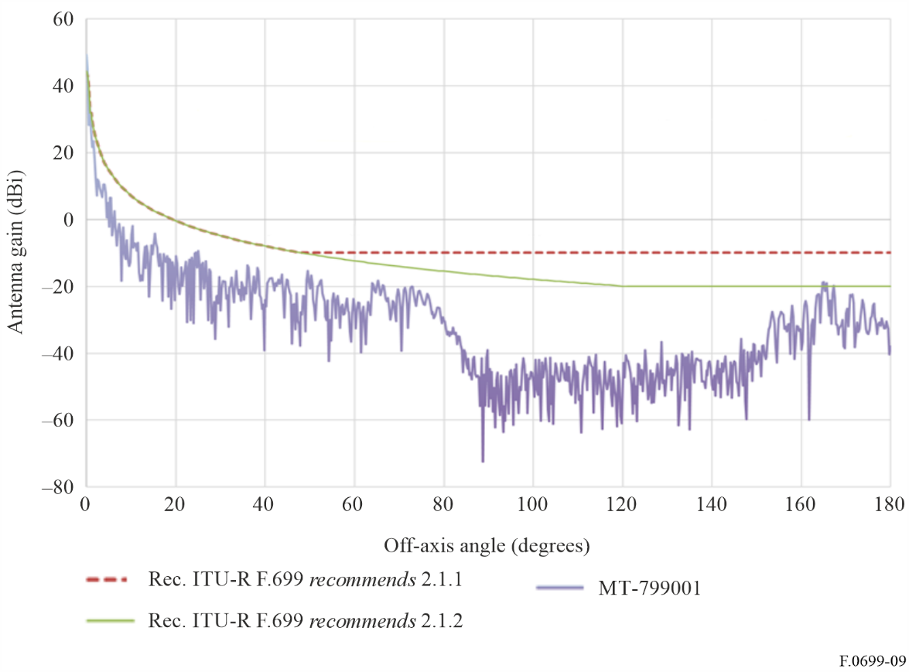
FIGURE 10
Example of 72 GHz point-to-point antenna of 2 foot diameter (D/λ = 144; gain = 50 dBi; θ₃ = 0.5°) compared to recommends 2.1.2 (see Note 10)
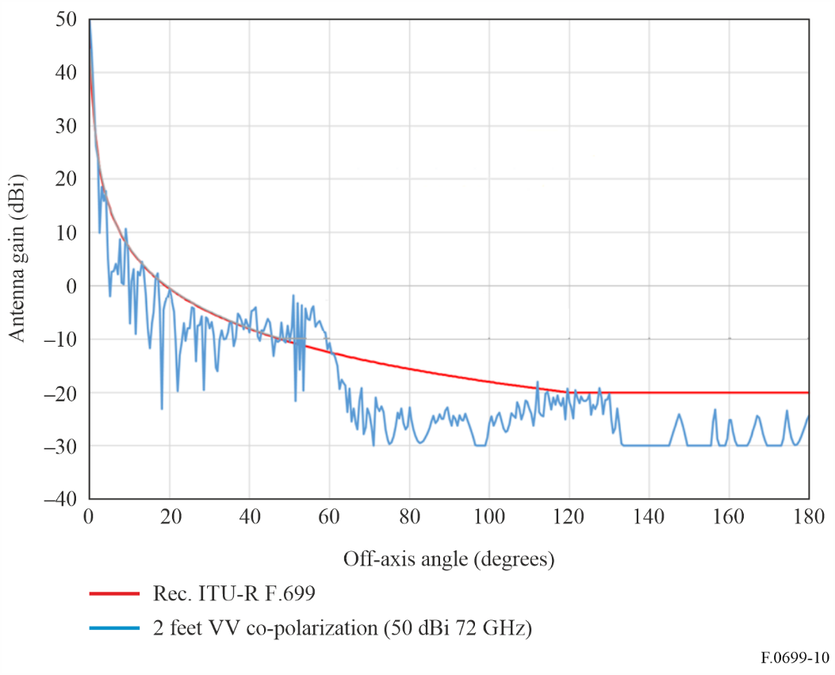
FIGURE 11
Example of 72 GHz point-to-point antenna of 1 foot diameter (D/λ = 72; gain = 44 dBi; θ₃ = 1°) compared to recommends 2.2.2 (see Note 10)
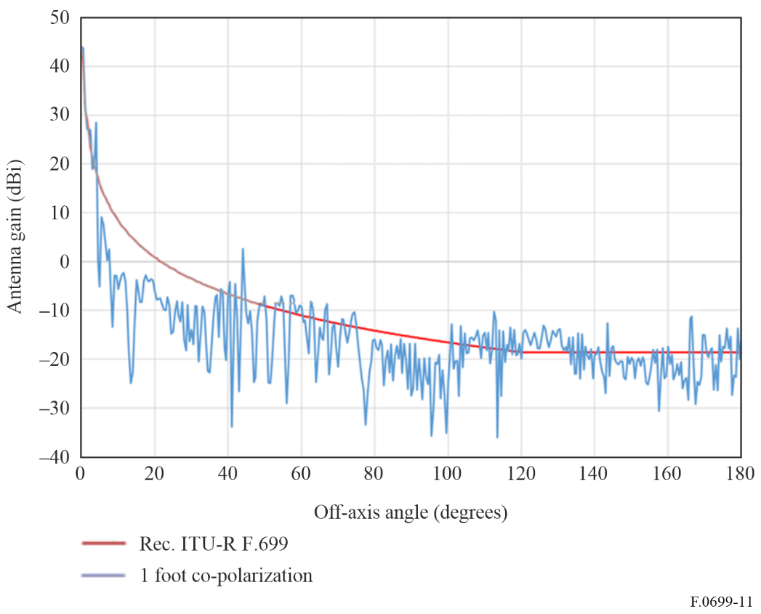
FIGURE 12
Example of 86 GHz square point-to-point antenna of 70 mm × 70 mm × 4 mm approximate dimensions (D/λ = 16.4; gain = 32 dBi) compared to recommends 2.1.1 and 2.1.2 (see Notes 5 and 10)
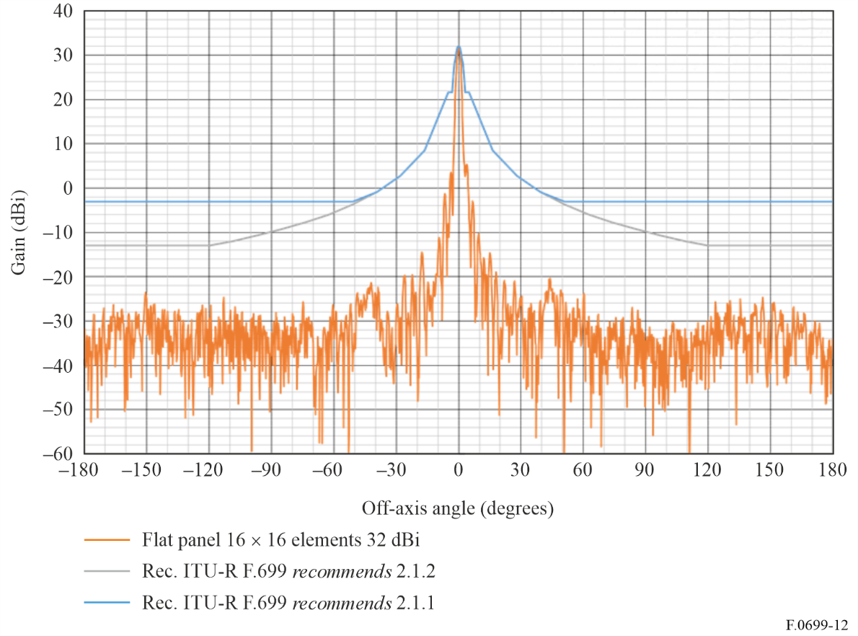
FIGURE 13
Example of 83.5 GHz flat square point-to-point antenna (D/λ = 40.7; gain = 39.9 dBi), horizontal co-polar attenuation (not gain) pattern (in blue), compared to recommends 2.2.2 (in black) (see Notes 5 and 10)
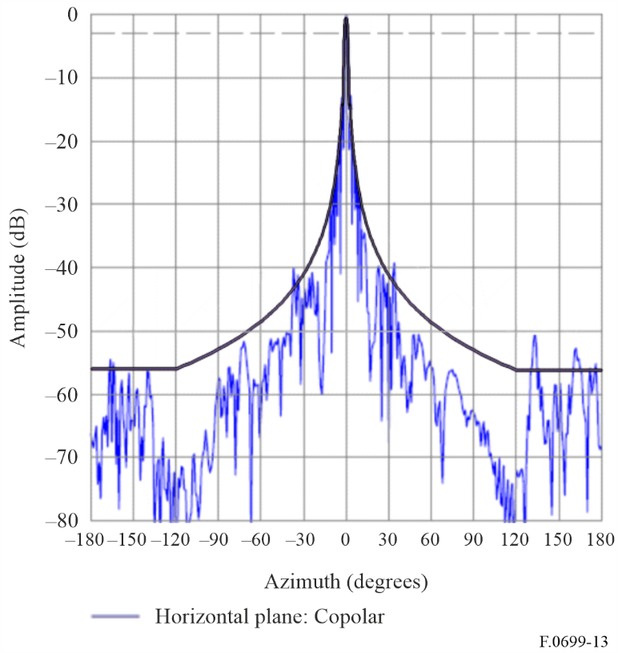
Figure 14
Example of 86 GHz 2 foot point-to-point antenna with vertical polarization (D/λ=172) compared to recommends 2.1.2 (see Note 10)
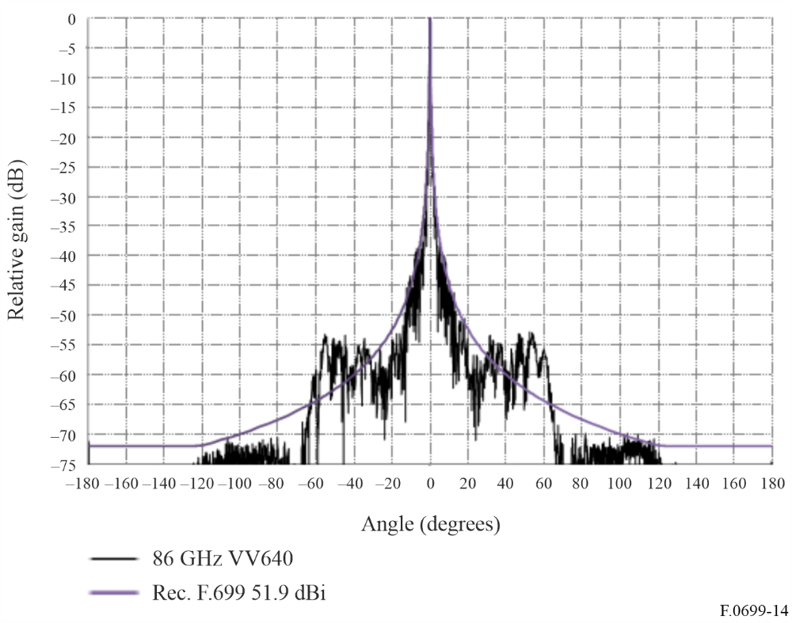
Figure 15
Example of 96 GHz Cassegrain point-to-point antenna of 20 cm diameter (D/λ = 64; gain = 44 dBi) compared to recommends 2.2.2
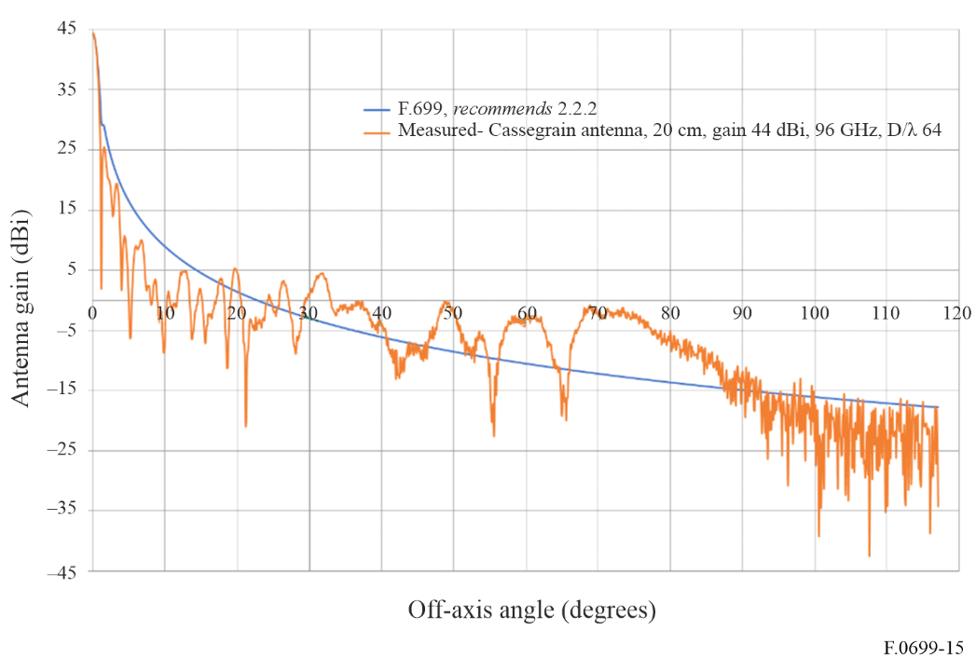
Figure 16
Example of 152 GHz 16 × 16 slot array with H-plane (D/λ = 40.7; gain = 31 dBi) compared to recommends 2.2.2
(see Notes 5 and 10)
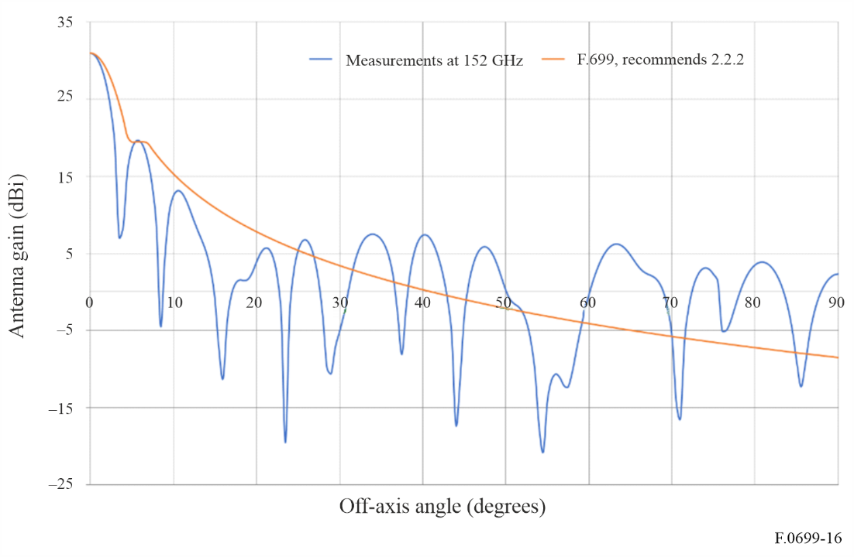
Figure 17
Example of 157 GHz Gaussian optics lens-horn antenna; diameter 150 mm, D/λ 78.5, Gain 44.9 dBi, 3 dB beamwidth 0.810. Relative V and H gains, dB versus angle in degrees
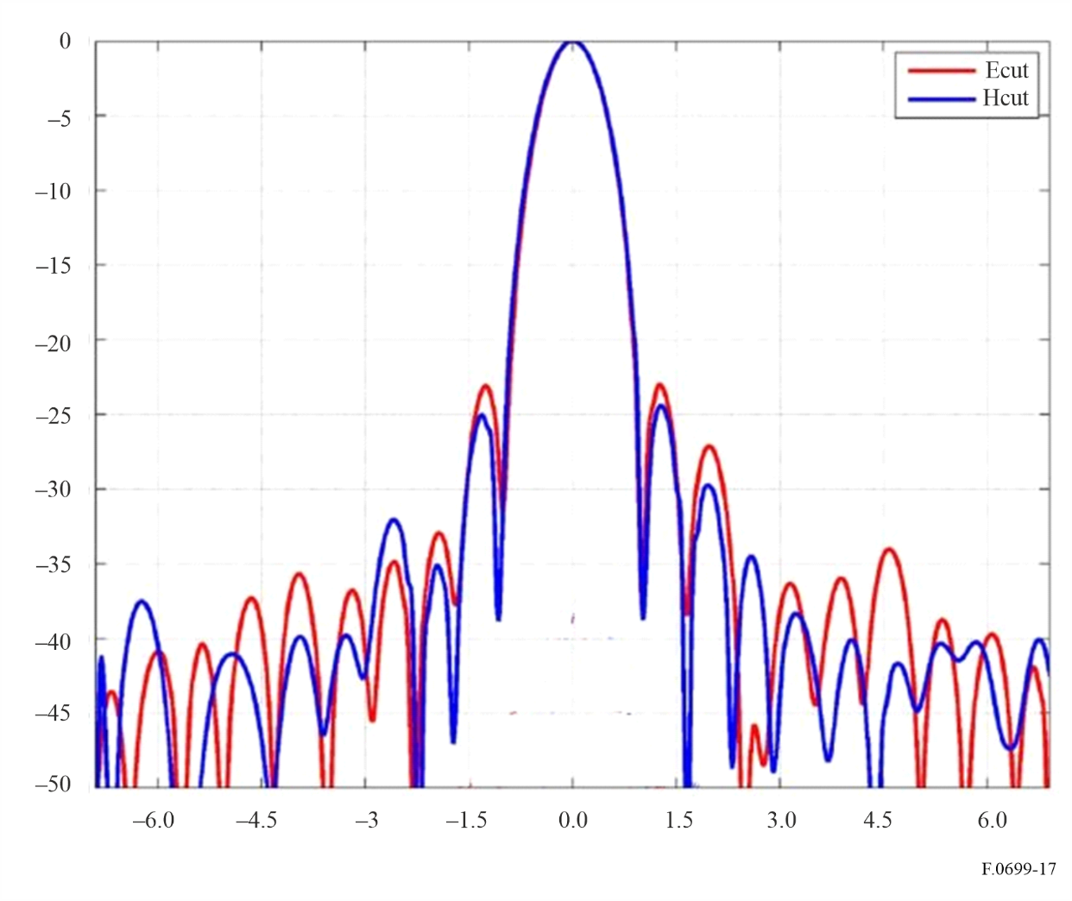

Annex 2
Information on the application of recommends 7

1 Introduction
Some Figures and numerical examples are given with the aim to support the designations used in the equation of recommends 7.1.
An alternative equation (see § 4) can be used if relative antenna gains data are given.
In the case of a mutual gain calculation between co-polar antennas the alternative equation shall be used (see § 5).

2 Situation
Figure 18
Generic example of mutual situation and orientation of transmitting antenna and victim receiving antenna
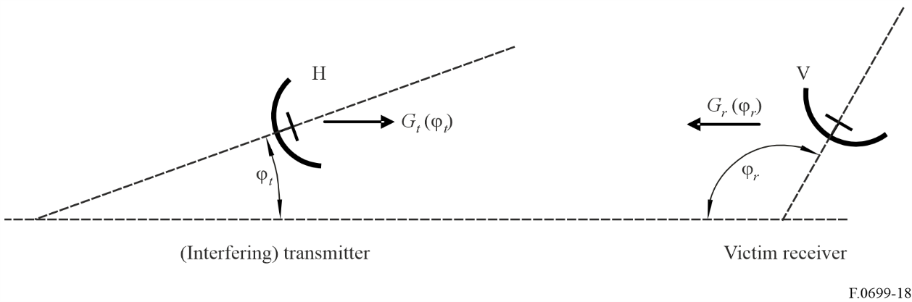

3 The numerical example
Figure 19
Example of transmitter antenna mask for co- and cross-polarization
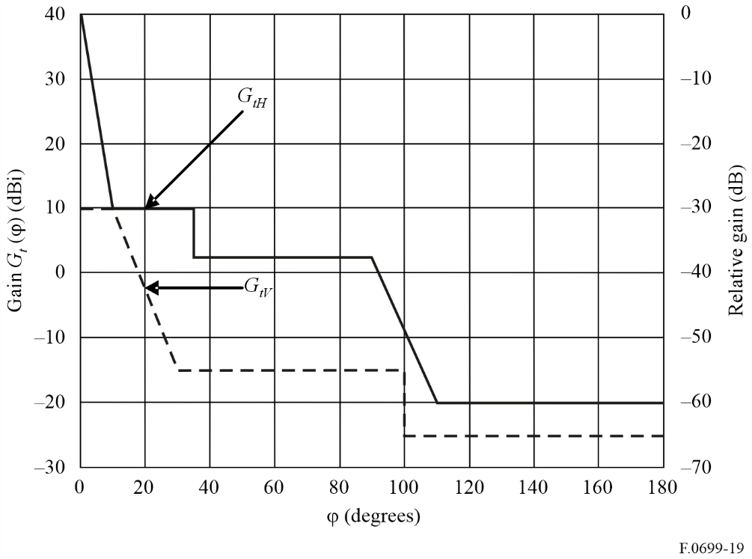
Figure 20
Example of receiver antenna mask for co- and cross-polarization
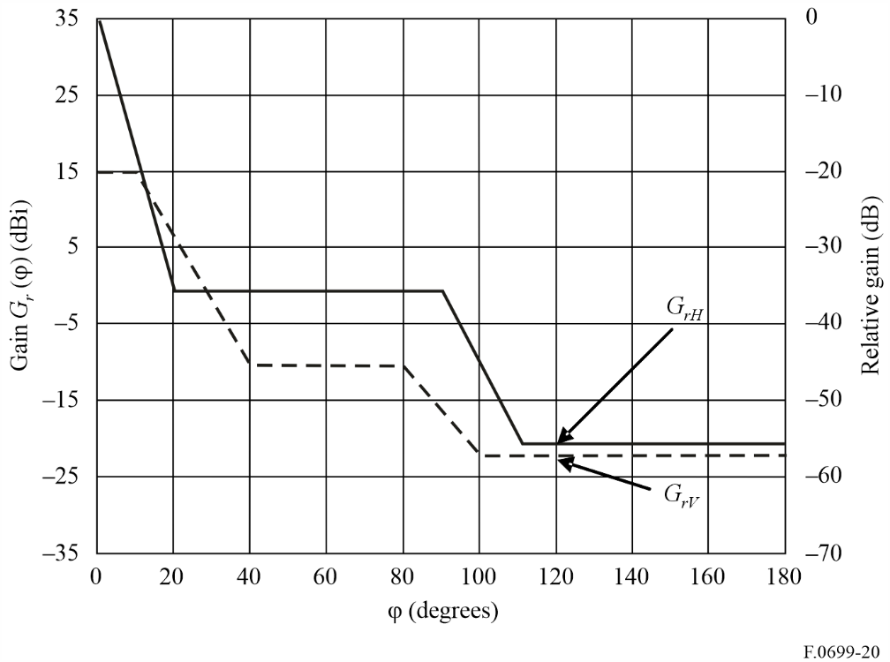
The example for cross-polarized antennas is given below.
The following values can be obtained from Figs 18, 19 and 20:
ϕ_{t} = 20°
ϕ_{r} = 120°
G_{tH}(ϕ_{t}) = 10 dBi
G_{rV}(ϕ_{r}) = −21.6 dBi
G_{tV}(ϕ_{t}) = −2 dBi
G_{rH}(ϕ_{r}) = −20 dBi
Using these values in the equation gives us the following result: G_{t} (20°) + G_{r} (120°) = −11.6 dBi.
Due to the reciprocity theorem the result of a mutual gain calculation is the same if the transmitter and receiver antennas are exchanged.

4 Alternative equation for cross-polarized case
In the case that G_{tmax}, G_{rmax} and relative gain of sideband lobes are given (as shown in the right side scale in Figs 19 and 20), equation (2) is applicable:
dBi (1)
In equation (1) G_{tmax}, G_{rmax} and the result are given in dBi, but the side lobes’ relative gain in dB.

5 Alternative equation for co-polarized case
If both antennas are co-polar the values should be changed accordingly and the equation will become:
dBi (2)
The numerical example gives, in the co-polar case, a common gain of −9.8 dBi with the same antennas as used above (Figs 19 and 20).

