|  |
| --- |
| **Recommendation ITU-R F.636-5**  **(11/2019)** |
| **Radio-frequency channel arrangements for fixed wireless systems operating in the 14.4-15.35 GHz band** |
| **F Series**  **Fixed service** |

Foreword

The role of the Radiocommunication Sector is to ensure the rational, equitable, efficient and economical use of the radio-frequency spectrum by all radiocommunication services, including satellite services, and carry out studies without limit of frequency range on the basis of which Recommendations are adopted.

The regulatory and policy functions of the Radiocommunication Sector are performed by World and Regional Radiocommunication Conferences and Radiocommunication Assemblies supported by Study Groups.

# Policy on Intellectual Property Right (IPR)

ITU-R policy on IPR is described in the Common Patent Policy for ITU-T/ITU-R/ISO/IEC referenced in Resolution ITU‑R 1. Forms to be used for the submission of patent statements and licensing declarations by patent holders are available from <http://www.itu.int/ITU-R/go/patents/en> where the Guidelines for Implementation of the Common Patent Policy for ITU‑T/ITU‑R/ISO/IEC and the ITU-R patent information database can also be found.

|  |  |
| --- | --- |
| Series of ITU-R Recommendations  (Also available online at <http://www.itu.int/publ/R-REC/en>) | |
| **Series** | Title |
| **BO** | Satellite delivery |
| **BR** | Recording for production, archival and play-out; film for television |
| **BS** | Broadcasting service (sound) |
| **BT** | Broadcasting service (television) |
| F | Fixed service |
| **M** | Mobile, radiodetermination, amateur and related satellite services |
| **P** | Radiowave propagation |
| **RA** | Radio astronomy |
| **RS** | Remote sensing systems |
| **S** | Fixed-satellite service |
| **SA** | Space applications and meteorology |
| **SF** | Frequency sharing and coordination between fixed-satellite and fixed service systems |
| **SM** | Spectrum management |
| **SNG** | Satellite news gathering |
| **TF** | Time signals and frequency standards emissions |
| **V** | Vocabulary and related subjects |

|  |
| --- |
|  |

|  |
| --- |
| ***Note***: *This ITU-R Recommendation was approved in English under the procedure detailed in Resolution ITU-R 1.* |

*Electronic Publication*

Geneva, 2019

© ITU 2019

All rights reserved. No part of this publication may be reproduced, by any means whatsoever, without written permission of ITU.

RECOMMENDATION ITU-R F.636-5

Radio-frequency channel arrangements for fixed wireless systems   
operating in the 14.4-15.35 GHz band[1]*, [2]**

(Question ITU-R 247-1/5)

(1986-1990-1992-1994-2012-2019)

Scope

This Recommendation provides radio frequency (RF) channel arrangements for fixed wireless systems operating in the 15 GHz (14.4-15.35 GHz) band. The main text of this Recommendation presents RF channel arrangements with separations of 3.5, 7, 14, 28, 56 and 112 MHz. Annexes 1 and 2 present arrangements with a separation of 2.5, 5, 10, 20, 30, 40 and 50 MHz based on a homogeneous 2.5 MHz pattern.

Keywords

Channel arrangement, channel bandwidth, fixed service, point to point, 15 GHz

Related ITU Recommendations and Reports

Recommendation ITU-R F.746 – Radio-frequency arrangements for fixed service systems

Abbreviations

RF Radio frequency

The ITU Radiocommunication Assembly,

considering

*a)* that the band 14.4-15.35 GHz is allocated to the fixed service and that in some countries only the band 14.5‑15.35 GHz is used for fixed wireless systems;

*b)* that, at these frequencies, fixed wireless systems for digital transmissions are feasible with repeater spacing and other features chosen according to rainfall conditions;

*c)* that in various countries there are restrictions on the use of various portions of the whole band 14.4‑15.35 GHz;

*d)* that the continuously capacity growing request as part of the evolution to IMT-2020 has been increasingly addressed in recent years,

recommends

**1** that the preferred radio-frequency channel arrangement for digital fixed wireless systems operating with a 28 MHz channel spacing should be derived as follows:

Let *N*28  be the number of RF channels;

then the frequencies (MHz) of individual channels are expressed by the following relationships:

lower half of the band: *fn*  *fr*  *a*  28 *n* MHz

upper half of the band:      *fr*  3 626 – 28 (*N*28 – *n*) MHz

where:

*fr*: reference frequency

*a* = 2 688 MHz for the band 14.4-15.35 GHz and

*a* = 2 786 MHz for the band 14.5-15.35 GHz

*n* = 1, 2, . . . *N*28, with *N*28 ≤ 16 for the band 14.4-15.35 GHz

and  *N*28 ≤ 15 for the band 14.5-15.35 GHz.

The channel arrangement with *fr* = 11 701 MHz and a frequency spacing of 28 MHz is illustrated in Fig. 1;

**2** that the preferred radio-frequency channel arrangement for digital fixed wireless systems operating with a 14 MHz channel spacing should be derived as follows:

Let *N*14 be the number of RF channels;

lower half of the band: *fn* = *fr* + *a* + 14 *n* MHz

upper half of the band:     = *fr* + 3 640 – 14 (*N*14 – *n*) MHz

where:

*fr*: reference frequency

*a* = 2 702 MHz for the band 14.4-15.35 GHz, and

*a* = 2 800 MHz for the band 14.5-15.35 GHz

*n* = 1, 2, . . . *N*14 with *N*14 ≤ 32 for the band 14.4-15.35 GHz

*n* and *N*14 ≤ 30 for the band 14.5-15.35 GHz.

The channel arrangement with *fr* = 11 701 MHz and a frequency spacing of 14 MHz is illustrated in Fig. 2;

**3** that the preferred radio-frequency channel arrangement for medium-capacity digital fixed wireless systems operating with a 56 MHz channel spacing should be derived as follows:

Let *N*56 be the number of RF channels;

then the frequencies (MHz) of individual channels are expressed by the following relationships:

lower half of the band: *fn* = *fr* + *a* + 56 *n* MHz

upper half of the band: two options are possible for maintaining a common duplex separations with lower size channels arrangements:

Option 1:  = *fr* + 3 612 – 56 (*N*56– *n*) MHz

Option 2:  = *fr* + 3 584 – 56 (*N*56 – *n*) MHz

Option 1 should be used when corresponding 28 MHz arrangement provides *N*28 = even number of channels, or when no lower channel arrangements are used.

Option 2 should to be used when corresponding 28 MHz arrangement provides *N*28 = odd number of channels,

where:

*fr*: reference frequency

*a* = 2 674 MHz for the band 14.4-15.35 GHz, and

*a* = 2 772 MHz for the band 14.5-15.35 GHz

*n* = 1, 2, . . . *N*56, with *N*56≤ 8 for the band 14.4-15.35 GHz

and  *N*56≤ 7 for the band 14.5-15.35 GHz.

The channel arrangement with *fr* = 11 701 MHz and a frequency spacing of 56 MHz is illustrated in Fig. 3;

**4** that the preferred radio-frequency channel interleaved arrangement for medium-capacity digital fixed wireless systems operating with a 112 MHz channel spacing should be derived as follows:

Let *N*112 be the number of RF channels;

then the frequencies (MHz) of individual channels are expressed by the following relationships:

lower half of the band: *fn* = *fr* + *a* + 56 *n* MHz

upper half of the band: two options are possible for maintaining a common duplex separations with lower size channels arrangements:

Option 1:  = *fr* + 3 584 – 56 (*N*112– *n*) MHz

Option 2:  = *fr* + 3 556 – 56 (*N*112 – *n*) MHz

Option 1 should be used when corresponding 28 MHz arrangement provides *N*28 = even number of channels, or when no lower channel arrangements are used.

Option 2 should to be used when corresponding 28 MHz arrangement provides *N*28 = odd number of channels,

where:

*fr*: reference frequency

*a* = 2 702 MHz for the band 14.4-15.35 GHz and

*a* = 2 800 MHz for the band 14.5-15.35 GHz

*n* = 1, 2, . . . *N*112, with *N*112≤ 7 for the band 14.4-15.35 GHz

and  *N*112≤ 6 for the band 14.5-15.35 GHz.

The channel arrangement with *fr* = 11 701 MHz and a frequency spacing of 112 MHz is illustrated in Fig. 4.

FIGURE 1

Radio-frequency channel arrangement for radio-relay systems operating in the 15 GHz band: 28 MHz spacing

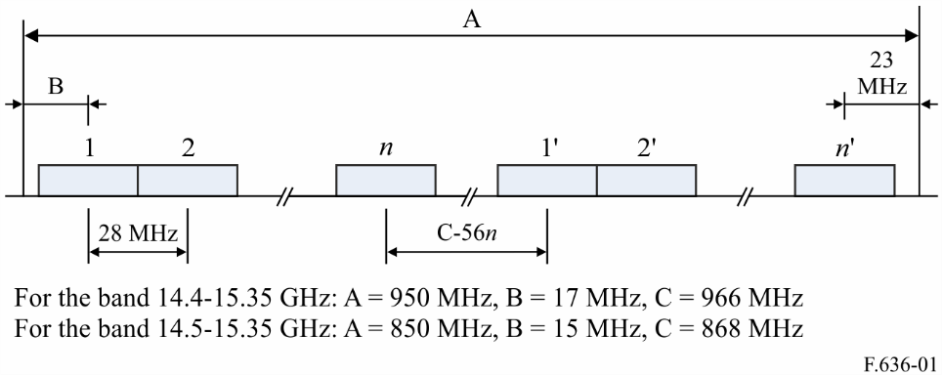

FIGURE 2

Radio-frequency channel arrangement for radio-relay systems operating in the 15 GHz band: 14 MHz spacing

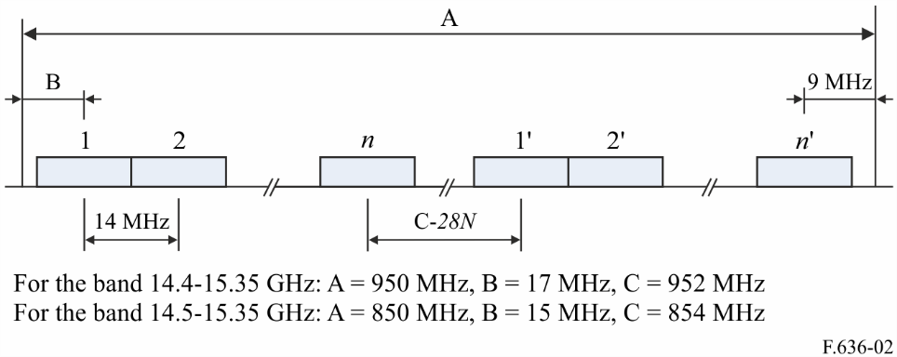

FIGURE 3

Radio-frequency channel arrangement for fixed wireless systems operating in the 15 GHz band: 56 MHz spacing

FIGURE 4

Radio-frequency channel arrangement for fixed wireless systems operating in the 15 GHz band:  
112 MHz spacing with interleaved arrangement

FIGURE 2/F.6363... **D02]** = 6.5 CM

**5** that, in cases where low-capacity radio channels with 7 or 3.5 MHz channel spacing are required, either the channel arrangement given in § 2, in conjunction with similar arrangements shifted respectively by 7 MHz or 3.5, 7 and 10.5 MHz with respect to it, or one of the following channel arrangements, occupying some of the radio channels of the 28 MHz channel arrangements, should be used:

*Frequency spacing of 7 MHz*:

lower half of the band: *fm* = *fr* + *a* + 28 *n* + 7 *m* MHz

upper half of the band:           = *fr* + 3 608.5 – 28 (*N*28 – *n*) + 7 *m* MHz

where:

*fr*: reference frequency

*m* = 1, 2, 3 or 4

*n:* channel number from the basic plan which is being subdivided

*a* = 2 670.5 MHz for the band 14.4-15.35 GHz

*a* = 2 768.5 MHz for the band 14.5-15.35 GHz.

Frequency spacing of 3.5 MHz:

lower half of the band: *fm* = *fr* + *a* + 28 *n* + 3.5 *m* MHz

upper half of the band:           = *fr* + 3 610.25 – 28 (*N*28 – *n*) + 3.5 *m* MHz

where:

*fr*: reference frequency

*m* = 1, 2, 3, 4, 5, 6, 7 or 8

*n*: channel number from the basic plan which is being subdivided

*a* = 2 672.25 MHz for the band 14.4-15.35 GHz

*a* = 2 770.25 MHz for the band 14.5-15.35 GHz.

**6** that due regard should be taken of the fact that in some countries, in most of Region 2 and in certain other areas, other radio-frequency channel arrangements are used with a preferred 2.5 MHz channel spacing, or multiples thereof, derived from an homogeneous frequency pattern defined by the relationship:

*fp* = *fr* + 2 697.75 + 2.5 *p*

where:

1 ≤ *p* ≤ 380

Based on this pattern, two examples of specific frequency plans are described in Annex 1 and Annex 2;

**7** that, in a section through which an international connection is arranged, all the go channels should be in one half of the band and all the return channels should be in the other half of the band;

**8** that both horizontal and vertical polarization shall be used, where possible, for each radio-frequency channel;

**9** that for digital systems with a capacity of 70 to 140 Mbit/s the same radio-frequency channel arrangement given in § 2 may be used utilizing channel numbers *n* = 2 and 6 in case of co-channel arrangement and *n* = 1, 3, 5, 7 in case of an alternated arrangement (see Note 3);

**10** that, when common transmit-receive antennas are used and no more than half the available channels are accommodated on a single antenna, it is preferred that the channel frequencies should be either odd or even numbered;

**11** that, for international connections, the reference frequency should preferably be 11 701 MHz. Other values may be used by agreement between the administrations concerned.

NOTE 1 – In order to reduce the possibility of an unacceptable degradation in performance occurring, care should be exercised in using mixed channel arrangement in a fixed wireless network. This would especially apply if small-capacity fixed wireless links using the channel arrangements described in § 3 and medium-capacity fixed wireless links operating in accordance with the main channel arrangements described in § 1 and 2 are both present in close geographical proximity.

NOTE 2 – In using the band 14.47-14.5 GHz, it is necessary to take all practicable steps to protect spectral line observations of the radio astronomy service from harmful interference (see No. **5.149** of the Radio Regulations).

NOTE 3 – In the case of utilization with digital systems with a symbol rate of more than about 25 MBd care should be taken when using the RF channel 1 at the lower band edge with a guard band of 15 or 17 MHz.

Annex 1  
  
Description of a radio-frequency channel arrangement based  
on 2.5 MHz homogeneous pattern referred to in *recommends* 5

This radio-frequency channel arrangement uses the 14 500.0-14 714.5 MHz and 15 136.5‑15 350.0 MHz portions of the available band with 2.5 MHz channel spacing as follows:

Let *N* be the number of RF channels pairs;

then the frequencies (MHz) of the individual channels are expressed by the following relationships:

lower half of the band: *fn* = *fr* + 2 797.75 + 2.5 *n* MHz

upper half of the band:          = *fr* + 3 647.75 – 2.5 (*N* – *n*) MHz

where:

*fr*: reference frequency

*n* = 1, 2, . . ., *N* with *N* ≤ 84.

The frequency arrangement with *fr* = 11 701 MHz is illustrated in Fig. 5.

FIGURE 5

Radio-frequency channel arrangement for radio-relay systems operating  
in the 15 GHz band with 2.5 MHz spacing and *N* = 84

(All frequencies in MHz)

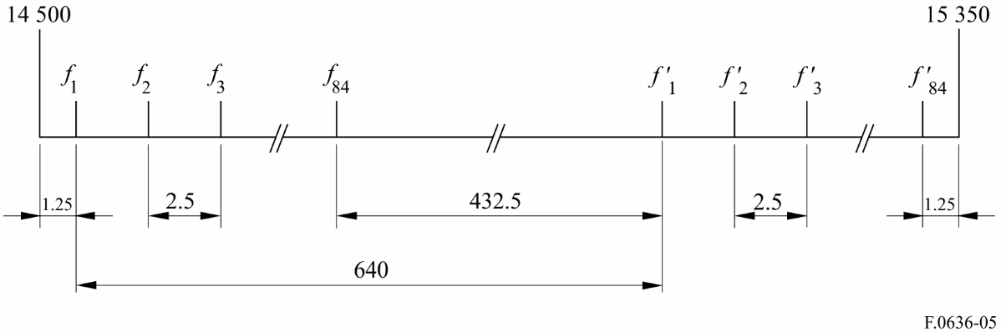

Annex 2  
  
Description of channel arrangements used in Canada with channel spacing   
of 5, 10, 20, 30, 40 and 50 MHz based on the 2.5 MHz homogeneous  
pattern referred to in *recommends* 5

a) The centre frequencies of the 43 paired channels which allow RF channel bandwidths of 5 MHz and less are expressed by the following relationships:

Lower half of the band *An* = 14 877.5 – 5 *n* for *n* = 1 to 11

*An* = 14 717.5 – 5 *n* for *n* = 12 to 43

Upper half of the band          = 15 352.5 – 5 *n* for *n* = 1 to 11

= 15 192.5 – 5 *n* for *n* = 12 to 43

where *n* is the channel number and *An* and are the centre frequencies in MHz of the paired channels.

b) The centre frequencies of the 21 paired channels which allow RF channel bandwidths of greater than 5 MHz and less than or equal to 10 MHz are expressed by the following relationships:

Lower half of the band *Bn* = 14 875 – 10 *n* for *n* = 1 to 5

*Bn* = 14 715 – 10 *n* for *n* = 6 to 21

Upper half of the band          = 15 350 – 10 *n* for *n* = 1 to 5

           = 15 190 – 10 *n* for *n* = 6 to 21

where *n* is the channel number and *Bn* and are the centre frequencies in MHz of the paired channels.

c) The centre frequencies of the 10 paired channels which allow RF channel bandwidths of greater than 10 MHz and less than or equal to 20 MHz are expressed by the following relationships:

Lower half of the band *Cn* = 14 490 + 20 *n* for *n* = 1 to 8

*Cn* = 14 650 + 20 *n* for *n* = 9 to 10

Upper half of the band          = 14 965 + 20 *n* for *n* = 1 to 8

= 15 125 + 20 *n* for *n* = 9 to 10

where *n* is the channel number and *Cn* and are the centre frequencies in MHz of the paired channels.

d) The centre frequencies of the six paired channels which allow RF channels bandwidths of greater than 20 MHz and less than or equal to 30 MHz are expressed by the following relationships:

Lower half of the band *Dn* = 14 485 + 30 *n* for *n* = 1 to 5

*Dn* = 14 655 + 30 *n* for *n* = 6

Upper half of the band          = 14 960 + 30 *n* for *n* = 1 to 5

           = 15 130 + 30 *n* for *n* = 6

where *n* is the channel number and *Dn* and are the centre frequencies in MHz of the paired channels.

e) The centre frequencies of the five paired channels which allow RF channels bandwidths of greater than 30 MHz and less than or equal to 40 MHz are expressed by the following relationships:

Lower half of the band *En* = 14 480 + 40 *n* for *n* = 1 to 4

*En* = 14 640 + 40 *n* for *n* = 5

Upper half of the band          = 14 955 + 40 *n* for *n* = 1 to 4

           = 15 115 + 40 *n* for *n* = 5

where *n* is the channel number and *En* and are the centre frequencies in MHz of the paired channels.

f) The centre frequencies of the four paired channels which allow RF channels bandwidths of greater than 40 MHz and less than or equal to 50 MHz are expressed by the following relationships:

Lower half of the band *Fn* = 14 475 + 50 *n* for *n* = 1 to 3

*Fn* = 14 645 + 50 *n* for *n* = 4

Upper half of the band          = 14 950 + 50 *n* for *n* = 1 to 3

           = 15 120 + 50 *n* for *n* = 4

where *n* is the channel number and *Fn* and are the centre frequencies in MHz of the paired channels.

1. * *Note by the Secretariat:* Following a comment received, an error has been identified in *recommends* 4 that would generate inconsistencies when applying channel separation of 112 MHz. In consultation with Working Party 5C management, the error has been corrected in this version so that the Recommendation can be used appropriately.
2. ** The structure and format of this Recommendation may need to be revised in the future to include the detailed technical information from the *recommends* part to a separate Annex.