RECOMMENDATION ITU-R F.384-10
Radio-frequency channel arrangements for medium- and high-
capacity digital fixed wireless systems operating in the upper
6 GHz (6 425-7 125 MHz) band
(Question ITU-R 136/9)

(1963-1966-1974-1982-1986-1990-1995-1999-2003-2006-2007)

Scope
This Recommendation provides radio-frequency channel arrangements for fixed wireless systems operating in the upper 6 GHz band (6 425-7 125 MHz), which may be used for high-, medium- and low- capacity fixed systems. The channel separation recommended in the main text are 40, 30, 20, 10 and 5 MHz with the interleaved arrangements with possible use of the co-channel arrangements. Multi-carrier transmission based on these arrangements are also recommended in the Annex 1 providing detailed description of this application.
The ITU Radiocommunication Assembly,
considering
a) that fixed wireless systems (FWSs) with medium and high capacity should prove to be feasible in the upper 6 GHz band, if due care is exercised in the planning of radio paths to reduce multipath effects;
b) that it is sometimes desirable to be able to interconnect, at radio frequencies, FWSs on international links in the upper 6 GHz band;
c) that a common RF channel arrangement for FWS offers considerable advantages;
d) that the use of digital modulation (see Recommendation ITU-R F.1101) permits the use of the RF channel arrangement for the transmission of a bit rate of the order of 140 Mbit/s or synchronous digital hierarchy (SDH) bit rates;
e) that for these digital radio systems, further economies are possible by accommodating up to eight go and return channels on a single antenna with suitable performance characteristics;
f) that many interfering effects can be reduced substantially by a carefully planned arrangement of the radio frequencies in FWS employing several RF channels;
g) that single- and multi-carrier digital FWS are both useful concepts to achieve the best technical and economic trade-off in system design;
h) that digital techniques such as cross-polar interference cancellers (XPIC) may significantly contribute to the cross-polar discrimination improvement factor (XIF, defined in Recommendation ITU-R F.746), thus counteracting the multipath-induced propagation depolarization,
recommends
1 that the preferred RF channel arrangement for up to eight go and eight return channels, each accommodating a bit rate of the order of 140 Mbit/s, or synchronous digital hierarchy bit rates (see Note 2), and operating at frequencies in the upper 6 GHz band, should be derived as follows:
Let f₀ be the frequency of the centre of the band of frequencies occupied (MHz),
f_{n} be the centre frequency of one RF channel in the lower half of the band (MHz),
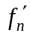 be the centre frequency of one RF channel in the upper half of the band (MHz),
then the frequencies of individual channels are expressed by the following relationships:
lower half of the band: f_{n} = f₀ – 350 + 40 n MHz
upper half of the band: = f₀ – 10 + 40 n MHz
where:
n = 1, 2, 3, 4, 5, 6, 7 or 8;
1.1 that, in the section over which the international connection is arranged, all the go channels should be in one half of the band, and all the return channels should be in the other half of the band;
1.2 that different polarizations may be used alternately for adjacent RF channels in the same half of the band;
1.3 that, when common transmit-receive antennas are used, and not more than four channels are accommodated on a single antenna, it is preferred that the channel frequencies be selected by making either:
n = 1, 3, 5 and 7 in both halves of the band
or
n = 2, 4, 6 and 8 in both halves of the band;
1.4 that the preferred arrangement of RF polarization should be one of those shown in Fig. 1 (see Note 2);
1.5 that for improving the spectral efficiency a co-channel arrangement may also be used for digital FWS which can be derived from the arrangements given in Figs. 1a) or 1b);
2 that the preferred radio-frequency channel arrangement for up to 16 go and 16 return channels, each accommodating digital plesiochronous or synchronous medium capacity rates, should be obtained by interleaving additional channels between those of the main pattern and should be expressed by the following relationship:
lower half of the band: fn = f0 – 350 + 20 n MHz
upper half of the band: 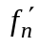 = f0 – 10 + 20 n MHz
where:
n = 1, 2, 3, . . . 15, 16;
2.1 that, in the section over which international connection is arranged, all the go channels should be in one half of the band and all the return channels in the other half of the band;
2.2 that different polarizations may be used alternately for adjacent RF channels in the same half of the band;
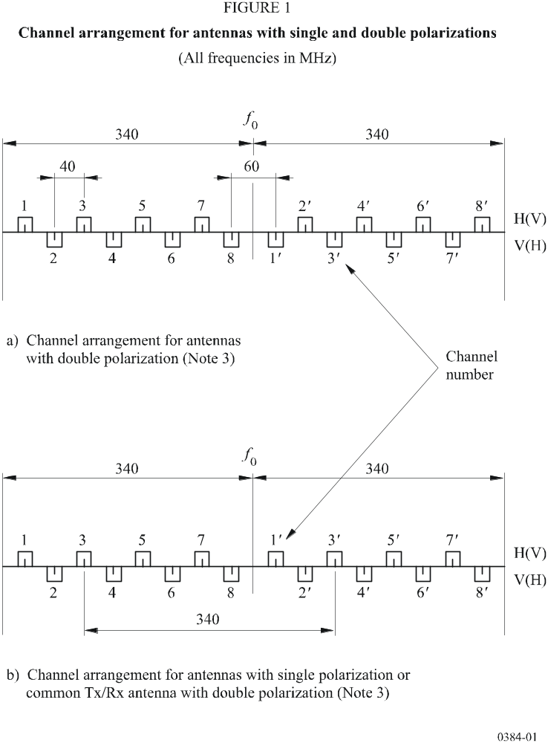

2.3 that when common transmit-receive antennas are used, and not more than four RF channels are accommodated on a single antenna, it is preferred that the channel frequencies be selected by making either:
n = 1, 5, 9, 13 or
n = 2, 6, 10, 14 or
n = 3, 7, 11, 15 or
n = 4, 8, 12, 16,
in both halves of the bands and the preferred arrangement of RF polarization is as shown in Fig. 2;
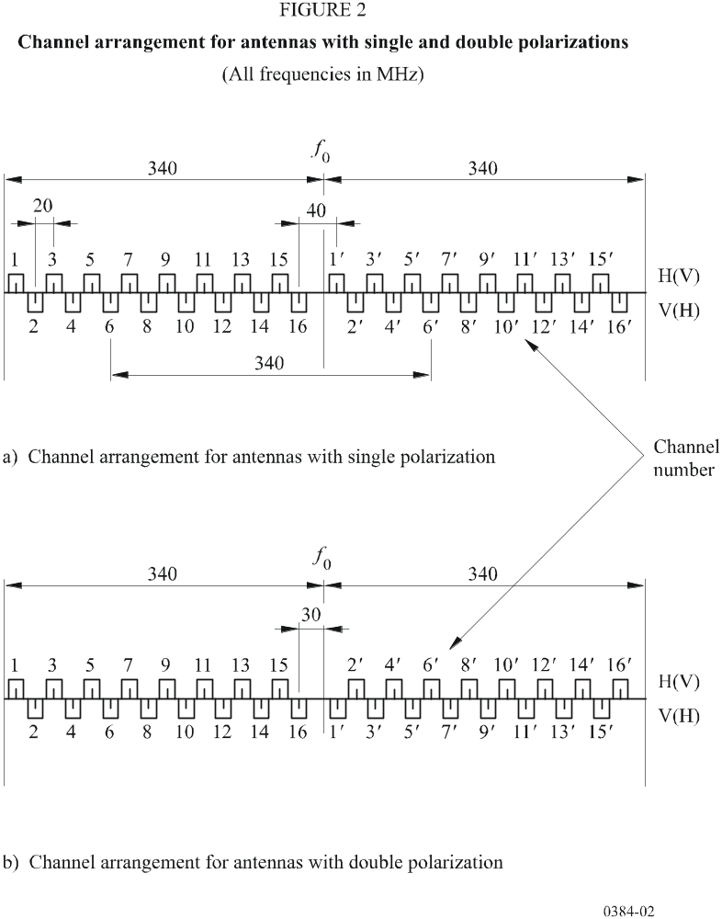
3 that if multi-carrier transmission (Note 3) is employed, the overall number of n carriers will be regarded as a single channel. The centre frequency of that channel should be derived from recommends 1 or 2, disregarding the actual centre frequencies of the individual carriers, which may vary, for technical reasons, according to practical implementations. Operation of multi-carrier systems is addressed in greater detail in Annex 1;
4 that the preferred RF channel arrangement for up to ten go and ten return 30 MHz channels, each accommodating a bit rate of the order of 155 Mbit/s, or SDH bit rates (see Note 1), should be derived as follows:
Let f₀ be the frequency of the centre of the band of frequencies occupied (MHz),
f_{n} be the centre frequency of one RF channel in the lower half of the band (MHz),
be the centre frequency of one RF channel in the upper half of the band (MHz),
then the frequencies of individual channels are expressed by the following relationships:
lower half of the band: f_{n} = 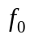 – 340 + 30 n MHz
upper half of the band: = + 30 n MHz
where:
n = 1, 2, 3, 4, 5, 6, 7, 8, 9 and 10;
4.1 that when the equipment and network characteristics permit, co-channel frequency reuse can be employed, with the agreement of the administrations concerned, for improving spectral efficiency;
4.2 that when very high capacity links (e.g. twice Synchronous Transfer Mode-1 (STM-1)) are required and network coordination permits, with the agreement of the administrations concerned, the use of any two adjacent 30 MHz channels specified in recommends 4 is possible, for wider bandwidth system, with centre frequency lying in the central point of the distance between the two 30 MHz adjacent channels;
5 that the preferred RF channel arrangement for up to 32 go and 32 return 10 MHz channels, each accommodating digital synchronous medium capacity rates, should be expressed by the following relationships:
lower half of the band: fn = f0 – 340 + 10 n MHz
upper half of the band: = f0 + 10 n MHz
where:
n = 1, 2, 3, . . . 31, 32;
6 that the preferred RF channel arrangement for up to 64 go and 64 return 5 MHz channels, each accommodating digital synchronous medium capacity rates, should be expressed by the following relationships:
lower half of the band: fn = f0 – 340 + 5 n MHz
upper half of the band: = f0 + 5 + 5 n MHz
where:
n = 1, 2, 3, . . . 63, 64;
7 that the preferred centre frequency f₀, is 6 770 MHz; in addition, other centre frequencies may be used by agreement between the administrations concerned;
8 that RF channel arrangements with 20 MHz, 10 MHz, and 5 MHz may also be alternatively obtained by subdividing the 40 MHz RF channels of the arrangement in recommends 1.
NOTE 1 – Actual gross bit rates including overhead may be as much as 5% or more higher than net transmission rates.
NOTE 2 – The use of a single antenna working allows for seven go and return channels with the channel arrangement of Fig. 1a). The channel arrangement of Fig. 1b) and suitable antenna performance gives higher isolation between transmit and receive channels, allowing the use of the eight go and return channels.
NOTE 3 – A multi-carrier system is a system with n (where n > 1) digitally modulated carrier signals simultaneously transmitted (or received) by the same RF equipment. The centre frequency should be regarded as the arithmetic average of the n individual carrier frequencies of the multi-carrier system.

Annex 1
Description of a multi-carrier system

A multi-carrier system is a system with n (where n > 1) digitally modulated carrier signals simultaneously transmitted (or received) by the same RF equipment.
For high capacity multi-carrier transmission, the centre frequency of the channel should coincide with one of the corresponding frequencies of the basic channel arrangements given in recommends 1 or 2. The channel spacing may be an integer multiple of the basic values defined by recommends 1 or 2. Compatibility with existing configurations has to be taken into account when choosing the appropriate alternative.
Examples of co-polar channel arrangements using a two-carrier system with 64-QAM are shown below. Each carrier is modulated with 155.52 Mbit/s (STM-1).
In a mixed analogue/digital environment the arrangement shown in Fig. 3a) is preferred because it places the carrier frequencies of the existing analogue system in the middle of the digital carrier pairs.
The centre frequencies of this channel arrangement are derived from recommends 1 by setting n = 2, 4, 6, 8. Channel spacing is 80 MHz. Each RF-channel contains 2 × 2 carriers allocated at ±17.5 MHz around the centre frequency using both polarizations.
Figure 3b) shows an interleaved channel arrangement where centre frequencies are derived from recommends 2 by setting n = 3, 7, 11, 15. This channel arrangement is adequate in a purely digital environment and is preferred because it provides more symmetrical guardbands at the band edges.



