Recommendation ITU-R F.383-10
(02/2021)
Radio-frequency channel arrangements for high-capacity fixed wireless systems operating in the lower 6 GHz
(5 925 to 6 425 MHz) band

F Series
Fixed service

Foreword
The role of the Radiocommunication Sector is to ensure the rational, equitable, efficient and economical use of the radio-frequency spectrum by all radiocommunication services, including satellite services, and carry out studies without limit of frequency range on the basis of which Recommendations are adopted.
The regulatory and policy functions of the Radiocommunication Sector are performed by World and Regional Radiocommunication Conferences and Radiocommunication Assemblies supported by Study Groups.

Policy on Intellectual Property Right (IPR)
ITU-R policy on IPR is described in the Common Patent Policy for ITU-T/ITU-R/ISO/IEC referenced in Resolution ITU-R 1. Forms to be used for the submission of patent statements and licensing declarations by patent holders are available from http://www.itu.int/ITU-R/go/patents/en where the Guidelines for Implementation of the Common Patent Policy for ITU-T/ITU-R/ISO/IEC and the ITU-R patent information database can also be found.

Series of ITU-R Recommendations
(Also available online at http://www.itu.int/publ/R-REC/en)
Series | Title
BO | Satellite delivery
BR | Recording for production, archival and play-out; film for television
BS | Broadcasting service (sound)
BT | Broadcasting service (television)
F | Fixed service
M | Mobile, radiodetermination, amateur and related satellite services
P | Radiowave propagation
RA | Radio astronomy
RS | Remote sensing systems
S | Fixed-satellite service
SA | Space applications and meteorology
SF | Frequency sharing and coordination between fixed-satellite and fixed service systems
SM | Spectrum management
SNG | Satellite news gathering
TF | Time signals and frequency standards emissions
V | Vocabulary and related subjects

Note: This ITU-R Recommendation was approved in English under the procedure detailed in Resolution ITU-R 1.

Electronic Publication
Geneva, 2021

© ITU 2021
All rights reserved. No part of this publication may be reproduced, by any means whatsoever, without written permission of ITU.

RECOMMENDATION ITU-R F.383-10
Radio-frequency channel arrangements for high-capacity fixed wireless systems operating in the lower 6 GHz (5 925 to 6 425 MHz) band
(Question ITU-R 247-1/5)
(1959-1963-1966-1982-1986-1990-1992-1999-2001-2007-2013-2021)
Scope
This Recommendation provides radio frequency (RF) channel arrangements for high-capacity fixed wireless systems (FWSs) operating in the 5 925 to 6 425 MHz band, which may also be used for low- and medium-capacity systems through high-capacity channel subdivision. The main text of as well as Annexes 1 to 3 to this Recommendation present a number of RF arrangements with channel separation of 5, 10, 20, 28, 29.65, 40, 59.3 and 80 MHz in this frequency band.
Keywords
Fixed service, point to point, channel bandwidth, channel arrangement, 6 GHz
Abbreviations
FWS Fixed wireless system
STM Synchronous transfer mode
Related ITU Recommendations and Reports
Recommendation ITU-R F.746 – Radio-frequency arrangements for fixed service systems
The ITU Radiocommunication Assembly,
considering
a) that it is desirable to interconnect fixed wireless systems (FWSs) on international links in the 6 GHz band at radio frequencies (RF);
b) that many interfering effects can be substantially reduced by a carefully planned arrangement of the radio frequencies in FWS employing several RF channels;
c) that the use of digital modulation permits the use of the RF channel arrangements, originally defined for 1 800 telephone channel systems, for the transmission of digital channels with a bit rate of the order of synchronous digital hierarchy bit rates or equivalent or higher data rate traffic;
d) that for these digital radio systems, further economies are possible by accommodating forward and return channels on a single antenna;
e) that digital techniques such as cross-polar interference cancellers (XPIC) may significantly contribute to the cross-polar discrimination improvement factor (XIF, defined in Recommendation ITU-R F.746), thus counteracting multipath propagation-induced depolarization;
f) that when very high-capacity links (e.g. twice STM-1, Synchronous Transfer Mode-1 or equivalent or higher data rate traffic) are required, further economy may be achieved using system bandwidths wider than the recommended channel separation, associated to high efficient modulation formats;
g) that some administrations may need to deploy also low- and medium-capacity systems,
recommends
1 that the preferred RF channel arrangement for up to eight 29.65 MHz forward and return channels with each channel accommodating a capacity of the order of synchronous digital hierarchy bit rates or equivalent or higher data rate traffic and operating at frequencies in the lower 6 GHz band (Note 5), as shown in Figs 1A, 1B or 1C and should be derived as follows:
Let f0 be the frequency (MHz) of the centre of the band of frequencies occupied (see recommends 6);
fn be the centre frequency (MHz) of one RF channel in the lower half of the band;
be the centre frequency (MHz) of one RF channel in the upper half of the band;
then the frequencies of individual channels are expressed by the following relationships:
lower half of the band: fn = f0 – 259.45 + 29.65 n MHz
upper half of the band: = f0 – 7.41 + 29.65 n MHz
where:
n = 1, 2, 3, 4, 5, 6, 7 or 8;
FIGURE 1A
Radio-frequency alternated channel arrangement for fixed wireless systems
operating in the 6 GHz band for use in international connections
(All frequencies in MHz)
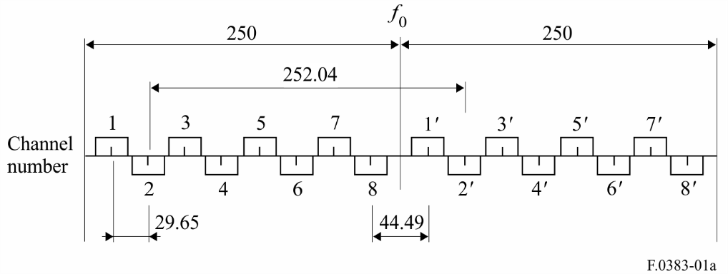
FIGURE 1b
Radio-frequency alternated channel arrangement for fixed wireless systems
operating in the 6 GHz band for use in international connections
(All frequencies in MHz)
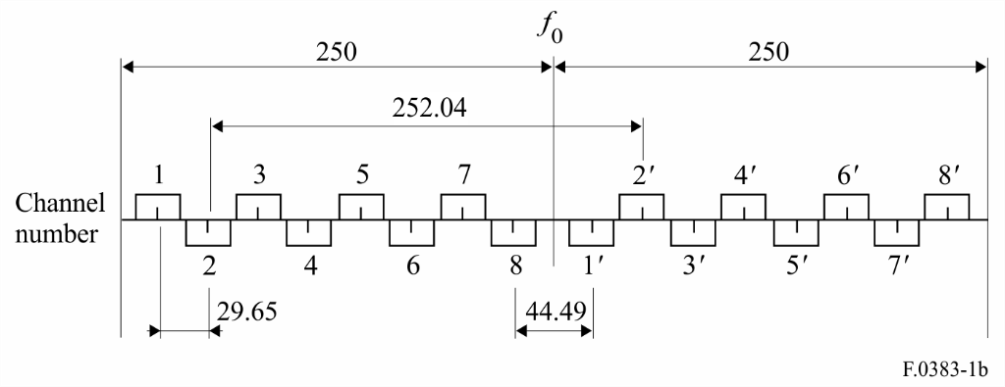
FIGURE 1c
Radio-frequency co-channel arrangement for fixed wireless systems
operating in the 6 GHz band for use in international connections
(All frequencies in MHz)
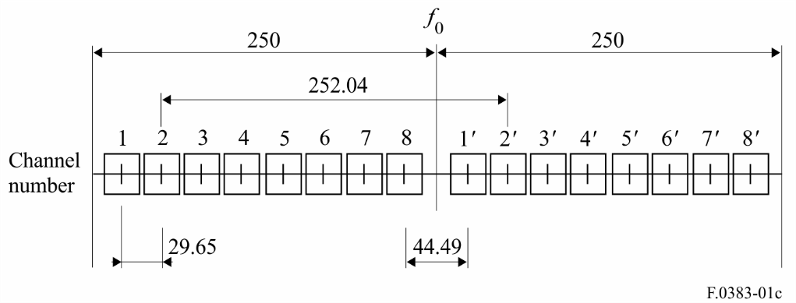
2 that, in a section over which the international connection is arranged, all the forward channels should be in one half of the band, and all the return channels should be in the other half of the band;
3 that the forward and return channels on a given section should preferably use polarizations as shown below and in Fig. 1A (see Note 1):
Forward Return
H(V) 1, 3, 5, 7 1’, 3’, 5’, 7’
V(H) 2, 4, 6, 8 2’, 4’, 6’, 8’.
In past deployment of analogue systems up to 1 800 channels, the following alternative arrangement of polarization, shown also in Fig. 1B, has been used and possibly maintained in the initial migration to digital systems; it might still be in use by agreement between the administrations concerned (see Note 1):
Forward Return
H(V) 1, 3, 5, 7 2’, 4’, 6’, 8’
V(H) 2, 4, 6, 8 1’, 3’, 5’, 7’.
4 that when the equipment and network characteristics permit, co-channel frequency reuse of the arrangement in Fig. 1C should be employed, with the explicit agreement of the administrations concerned, for improving spectral efficiency, once such concerns were expressed;
5 that when very high capacity links (e.g. twice STM-1 or equivalent of higher data rate traffic) are required, channel width of 59.3 MHz should be used as follows:
5.1 RF channel arrangement for up to four forward and return channels using a RF channel width of 59.3 MHz defined as follows (see Fig. 2):
lower half of the band: fn = f0 – 274.275 + 59.3 n MHz
upper half of the band: = f0 – 22.235 + 59.3 n MHz
where:
n = 1, 2, 3, 4;
fIGURE 2
59.3 MHz radio-frequency channel arrangement for radio-relay
systems operating in the lower 6 GHz band
(All frequencies in MHz)
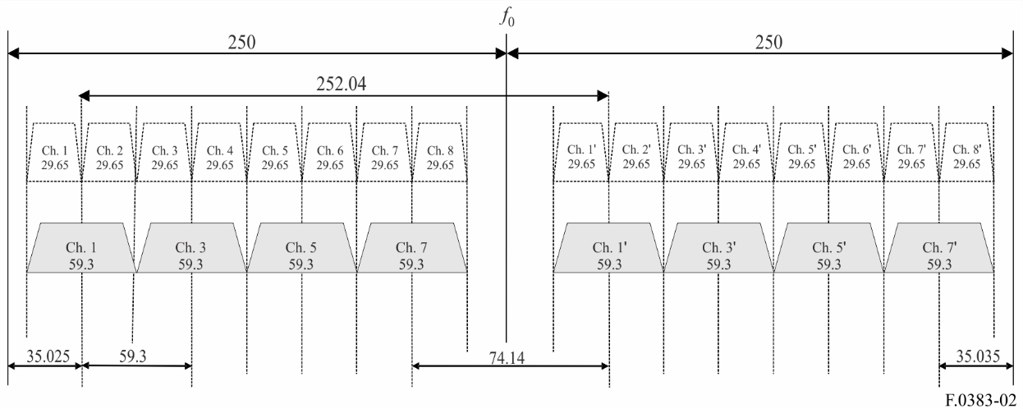
5.2 administrations desiring more flexible use of 59.3 MHz channels for easing the planning of dense networks in combination with existing 29.65 MHz links, may consider the use of an interleaved RF channels arrangement for up to seven 59.3 MHz forward and return channels defined as follows (see Fig. 3):
lower half of the band: fn = f₀ – 244.625 + 29.65n MHz
upper half of the band: fn’ = f₀ + 7.415 + 29.65n MHz
where:
n = 1, 2, …7
It should be noted that odd channels (n = 1, 3, 5, 7) are the same of the four channels provided by recommends 5.1 above.
FIGURE 3
RF interleaved channel arrangements for channels with 59.3 MHz separation
(All frequencies in MHz)
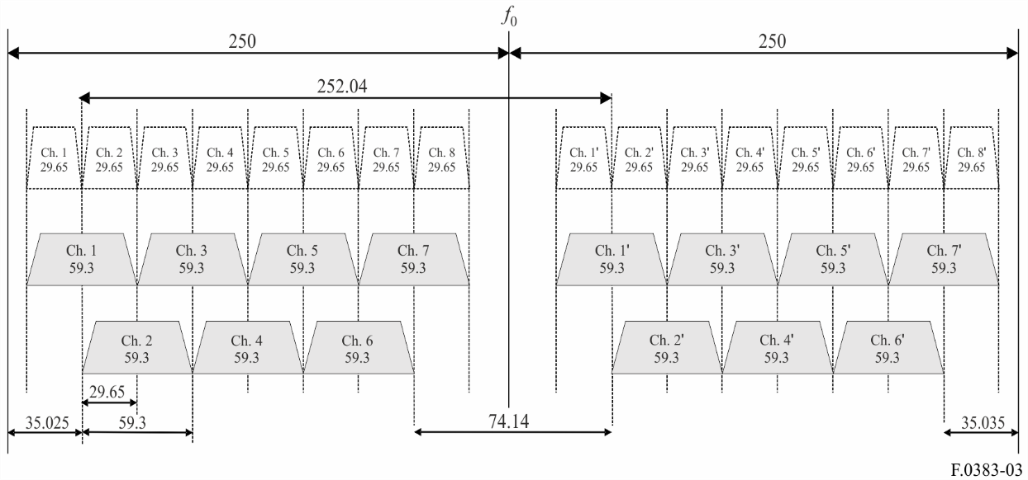

6 that the preferred centre frequency is 6 175.0 MHz; in addition, other centre frequencies may be used by agreement between the administrations concerned.
NOTE 1 – When common transmit-receive antennas are used and channel 8 is used together with channel 1’, either in the arrangement of Fig. 1A or in the even more problematic arrangement of Figs 1B and 1C, special branching and filters arrangement may be needed for limiting mutual impairments and permitting their common operation.
NOTE 2 – In a number of administrations in Region 1, a RF channel arrangement given in Annex 2 to this Recommendation is used in the frequency band 5 925 to 6 425 MHz.
NOTE 3 – Some administrations use different RF channel arrangement in the frequency band 5 925-6 425 MHz for high capacity digital FWS with a capacity of up to 2 × STM-1 or equivalent or higher data rate traffic (see Annex 1).
NOTE 4 – Some administrations use different RF channel arrangements in the frequency band 5 925-6 425 MHz for digital FWS with various capacities up to STM-1 or equivalent or higher data rate traffic (see Annex 3).
NOTE 5 – Actual bit rates including overhead may be as much as 5% or more higher than net transmission rates.

Annex 1
Frequency arrangements derived from a homogeneous frequency pattern
for the 6 GHz band with channel separations of 40 MHz
RF channel arrangements, derived from Recommendation ITU-R F.635, for the 6 GHz band are described below.

1 40 MHz RF channel arrangement for the lower 6 GHz band
The following RF channel arrangement provides six go and six return channels with a transmission capacity up to 2 × 155 Mbit/s for systems with a suitable higher level modulation and spectrum efficiency up to 7.75 bit/s/Hz. The RF channel arrangement should be derived as follows:
Let f0 be the frequency (MHz) of the centre of the band of frequencies occupied, f0 = 6 175;
fn be the centre frequency (MHz) of one RF channel in the lower half of the band;
be the centre frequency (MHz) of one RF channel in the upper half of the band;
then the frequencies of individual channels are expressed by the following relationships:
lower half of the band: fn = f0 – 260 + 40 n MHz
upper half of the band: = f0 – 20 + 40 n MHz
where:
n = 1, 2, 3, 4, 5, or 6.
In the above arrangement band reuse by “co-channel dual polarization” may be utilized as shown in Fig. 4.
fIGURE 4
40 MHz radio-frequency channel arrangement for radio-relay
systems operating in the lower 6 GHz band
(All frequencies in MHz)
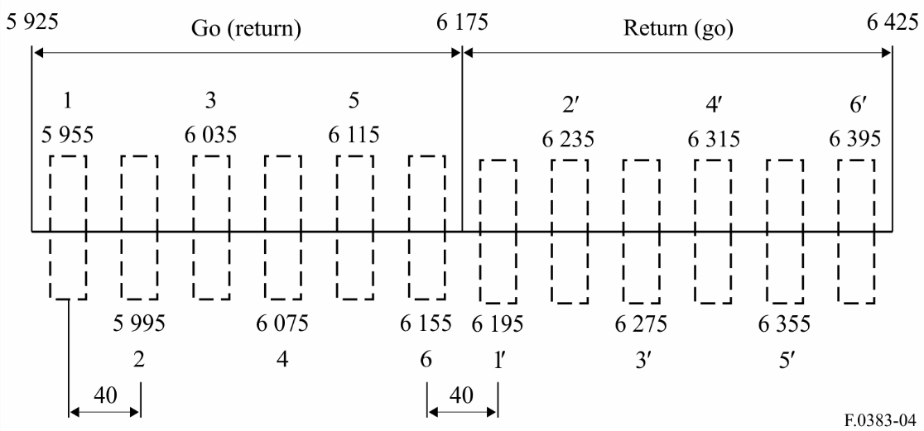

Annex 2
RF channel arrangement for FWS operating in the 6 GHz band
with a channel separation of 28 MHz
This Annex describes a RF channel arrangement suitable for digital FWS with a channel bandwidth of 28 MHz. The RF channel arrangement is shown in Fig. 5, and is derived as follows:
Let f0 be the frequency (MHz) of the centre of the band of frequencies occupied;
fn be the centre frequency (MHz) of one RF channel in the lower half of the band;
be the centre frequency (MHz) of one RF channel in the upper half of the band;
f0 = 6 172 MHz;
duplex spacing = 266 MHz,
then the frequencies (MHz) of individual channels are expressed by the following relationships:
lower half of band: fn = f0 – 259 + 28 n
upper half of band: = f0 + 7 + 28 n
where:
n = 1, 2, … 8.
FIGURE 5
RF channel arrangement for FWS operating
in the 6 GHz band with a channel separation of 28 MHz
(All frequencies in MHz)
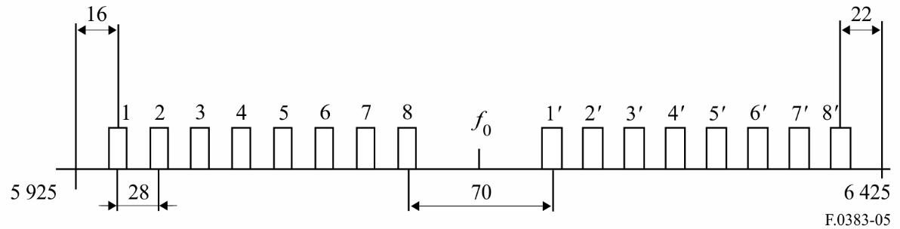

Annex 3
RF channel arrangements in the lower 6 GHz band
using 5, 10, 20 and 40 MHz channel separation
Some administrations may use the band 5 925-6 425 MHz, with radio channels of various width, for the transmission of digital TV signals and trunk networks between remote areas.
The basic 40 MHz channel arrangement shall be derived as follows:
Let f0 be the frequency (MHz) of the centre of the band of frequencies occupied, f0 = 6 175;
fn be the centre frequency (MHz) of one RF channel in the lower half of the band;
be the centre frequency (MHz) of one RF channel in the upper half of the band;
Duplex spacing = 260 MHz;
Centre gap = 60 MHz;
then the centre frequencies of 40 MHz channels are expressed by the following relationships:
lower half of the band: fn = f0 – 270 + 40 n MHz
upper half of the band: = f0 – 10 + 40 n MHz
where:
n = 1, 2, 3, 4, 5, 6.
The preferred channel separations for the basic 40 MHz are shown in Fig. 6. This arrangement may also be used for co-channel dual polarization (CCDP) to increase the whole capacity accommodated in this frequency band.
Channel arrangements with lower 5, 10 and 20 MHz are obtained by subdividing the basic 40 MHz channels.
FIGURE 6
RF channel arrangements for digital FWS operating
in the lower 6 GHz band with 40 MHz separation
(All frequencies in MHz)
